Sts. Peter & Paul
Evangelical Lutheran Church
Lutheran Church-Missouri Synod
Founded-1917
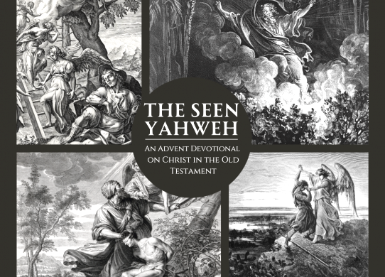

“The Seen Yahweh”

2023 VESPERS ADVENT SERVICE

699 Stambaugh Avenue
Sharon, Pennsylvania 16146

“I was glad when they said to me,
Let us go to the house of the LORD!”
Psalm 122:1

VESPERS
Opening Hymn:
December 6, 2023 LSB #357 “O Come, O Come, Emmanuel”
December 13, 2023 LSB # 349 “Hark the Glad Sound”
December 20, 2023 LSB #916 “Only-Begotten Word of God Eternal”

Stand

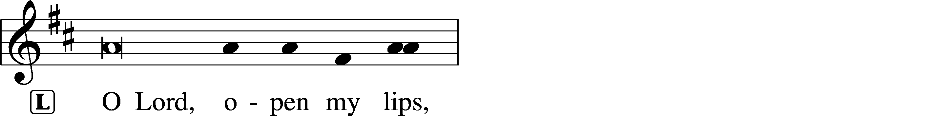
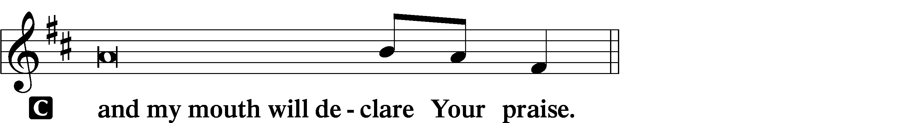

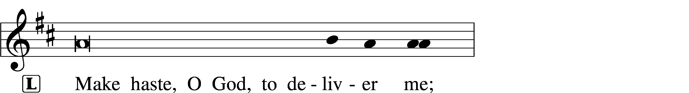
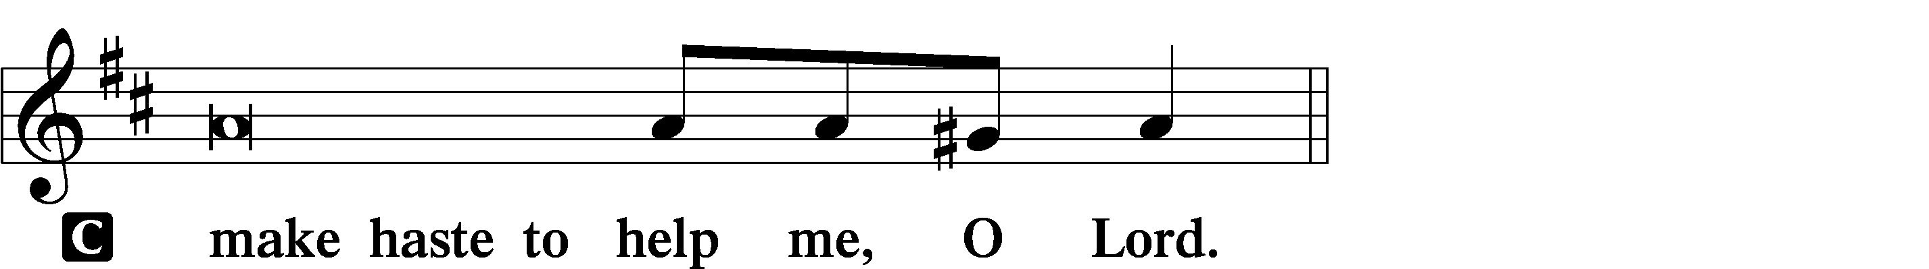

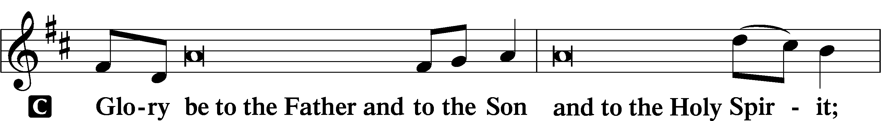
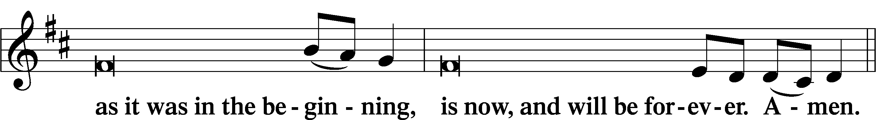
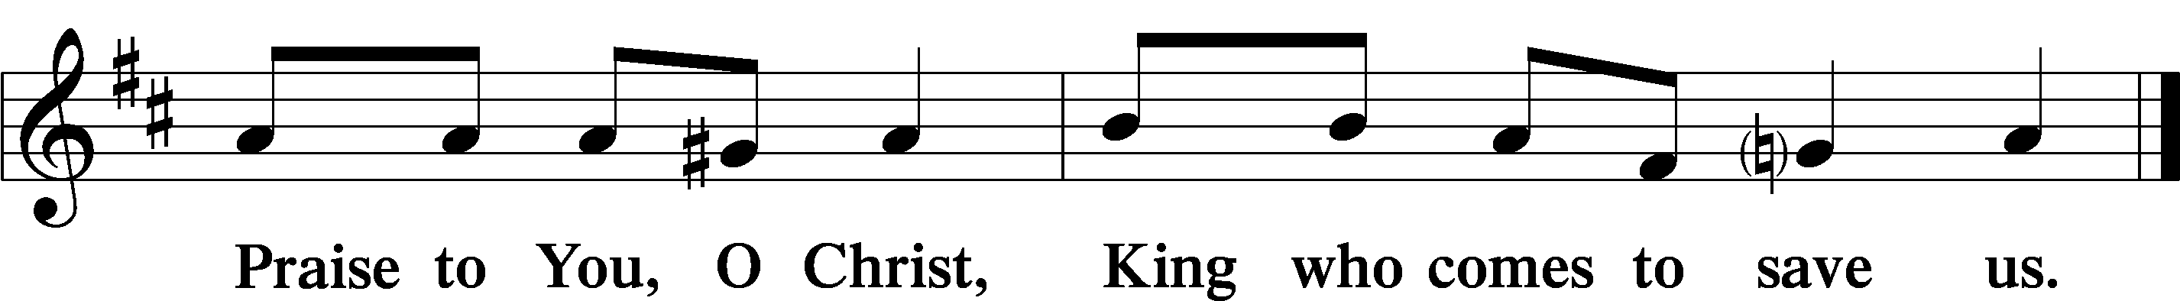

Psalmody
Psalm Reading: (See insert)

Sit
Hymn of the Day:
December 6, 2023 LSB #522 “Lord God, to Thee We Give All Praise”
December 13, 2023 LSB #334 “O Lord, How Shall I Meet You”
December 20, 2023 LSB #332 “Savior of the Nations, Come”
Readings

Prophecy: (See insert)

P O Lord, have mercy on us.
C Thanks be to God.

New Testament: (See insert)

P O Lord, have mercy on us.
C Thanks be to God.

Responsory (Advent) LSB 230
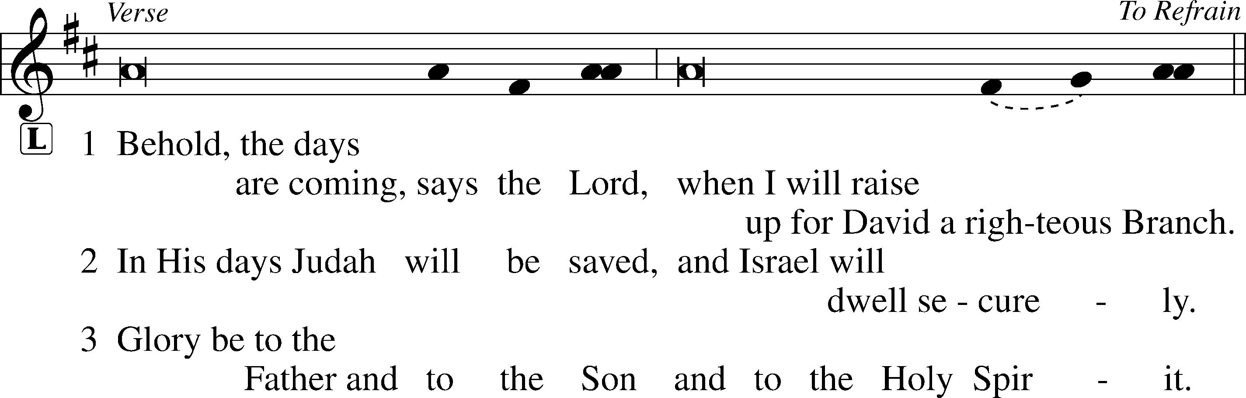
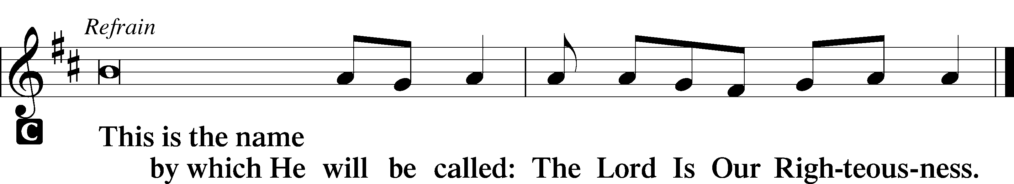

Sermon

Canticle
Stand

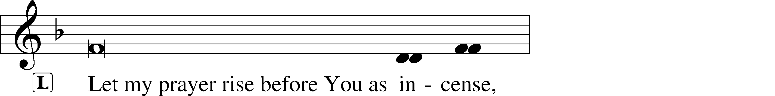
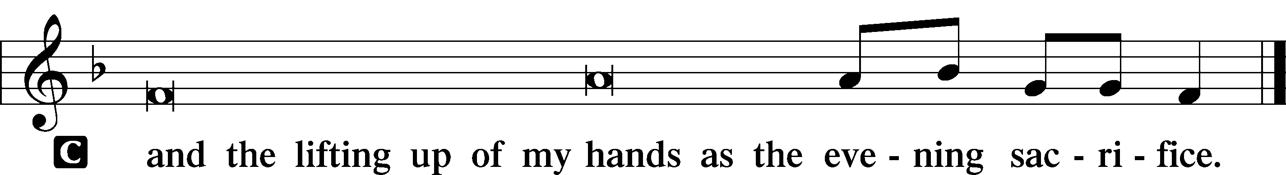

Magnificat LSB 231
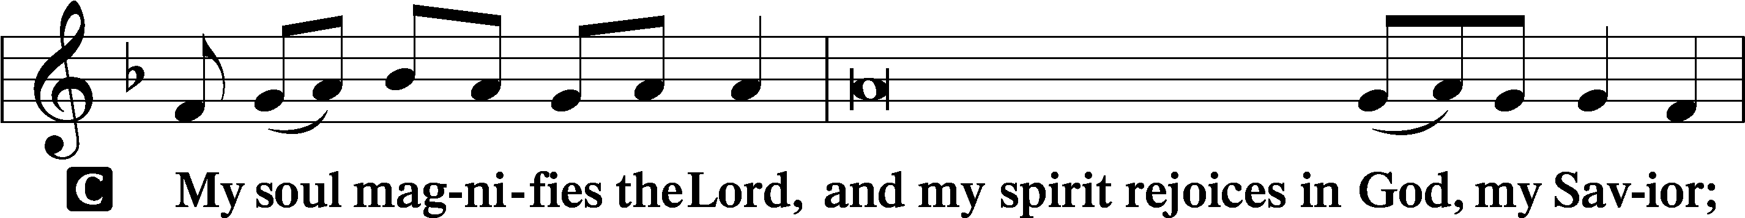
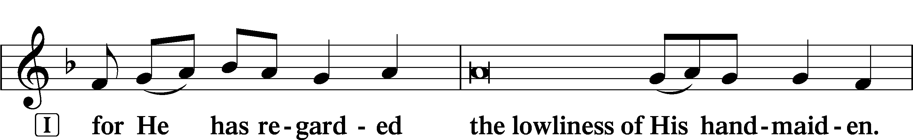
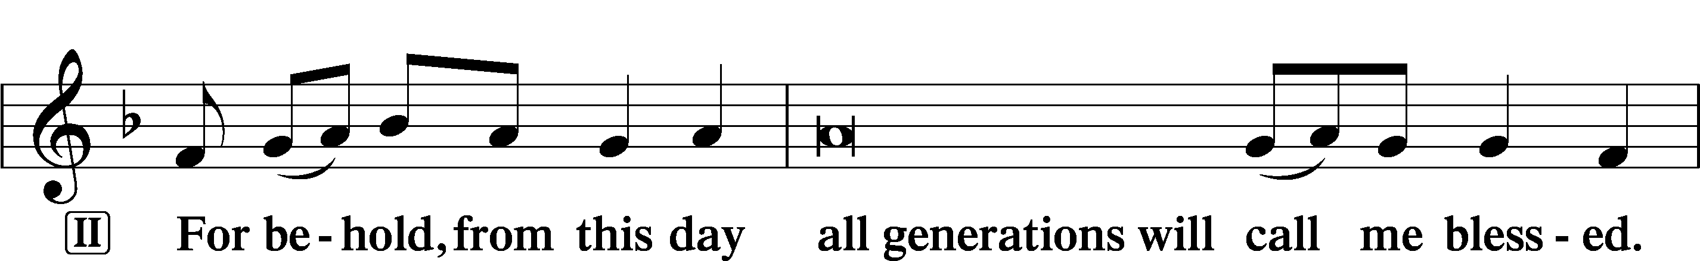
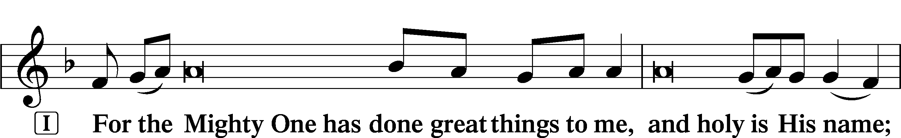
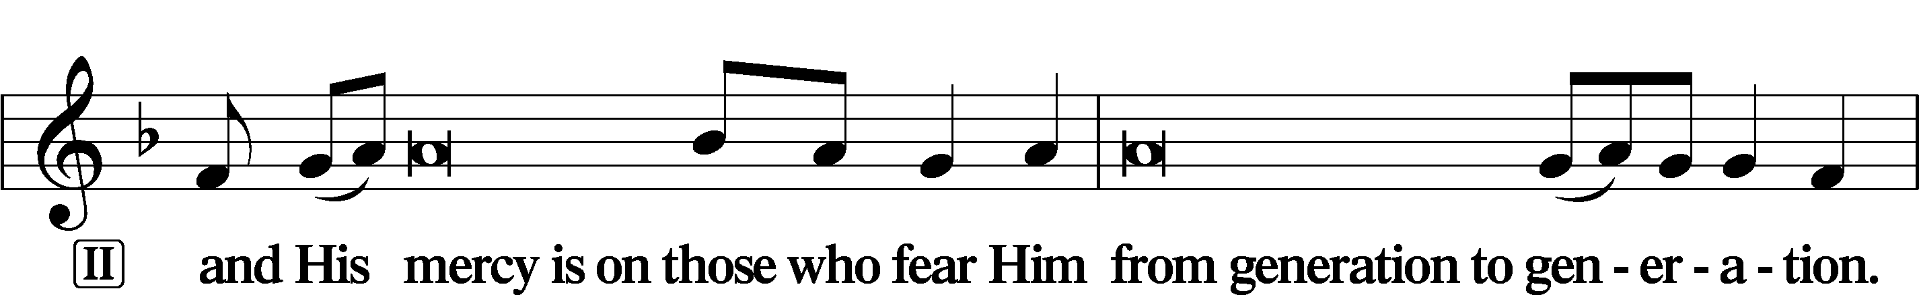
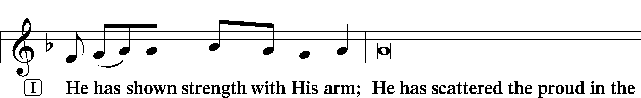
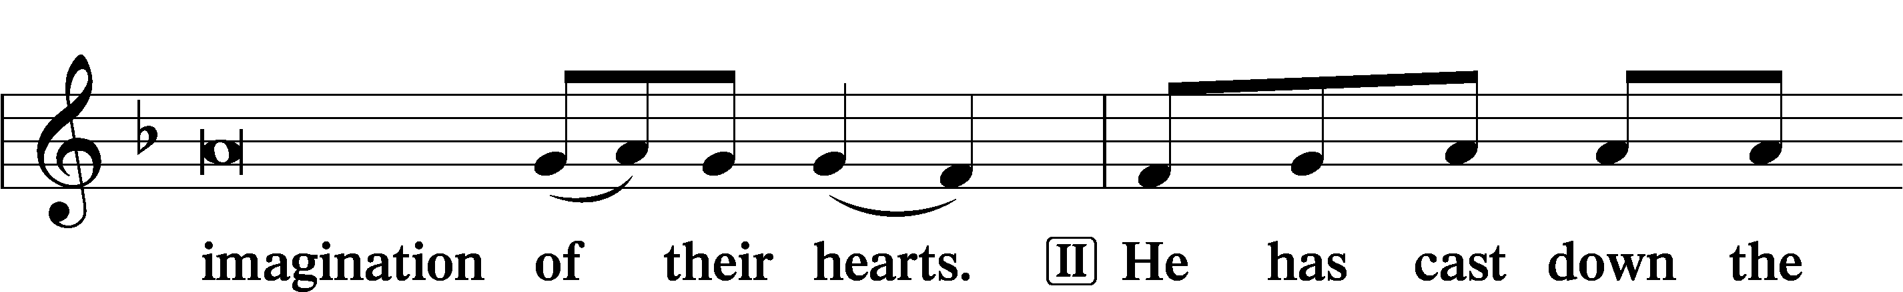
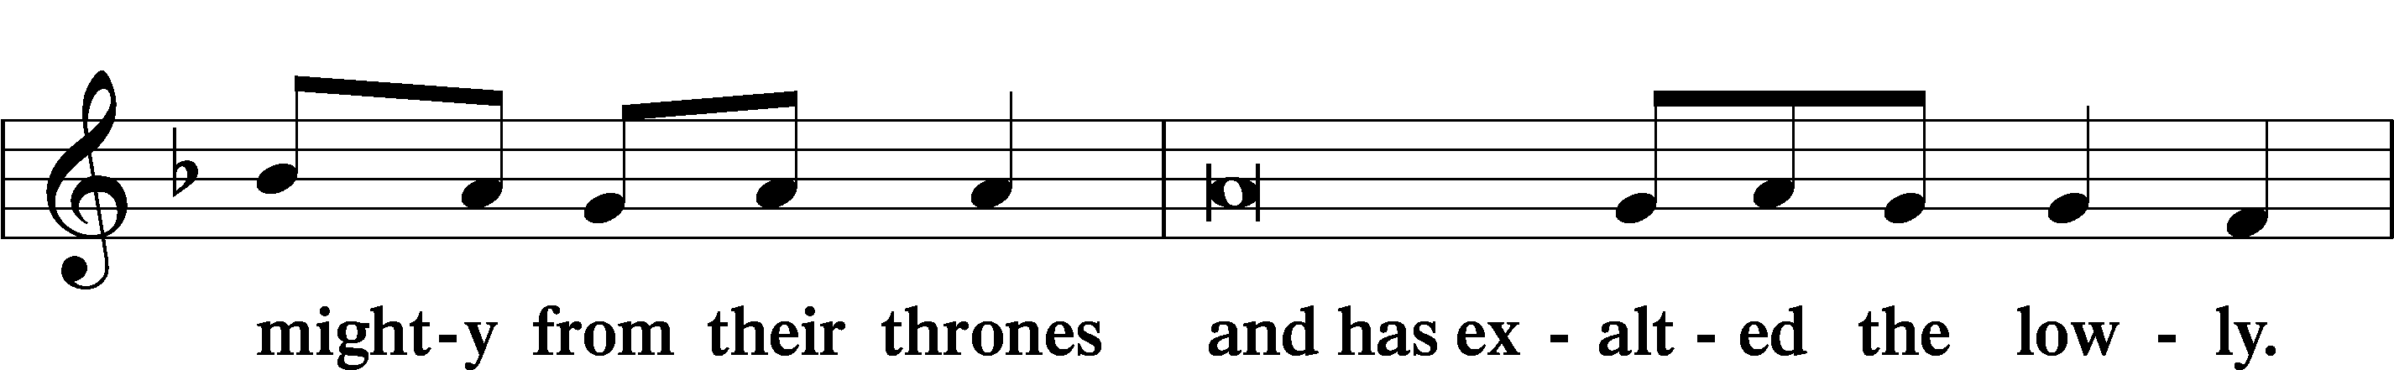
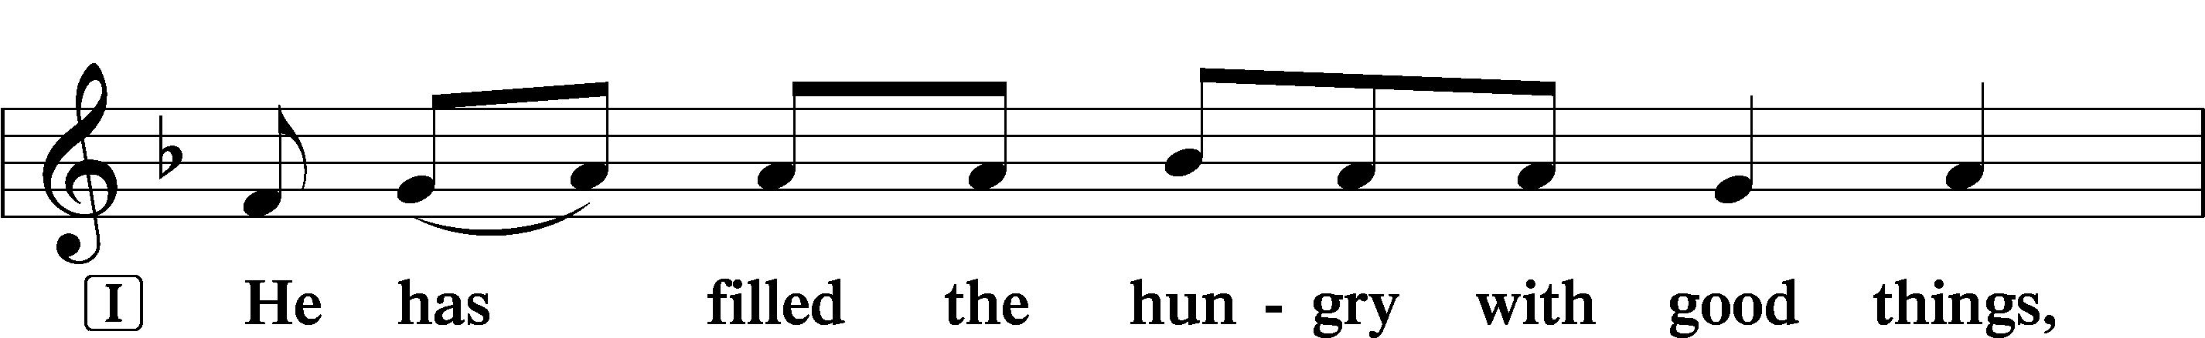
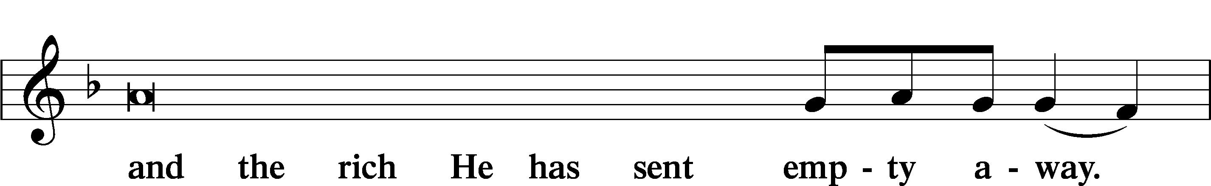
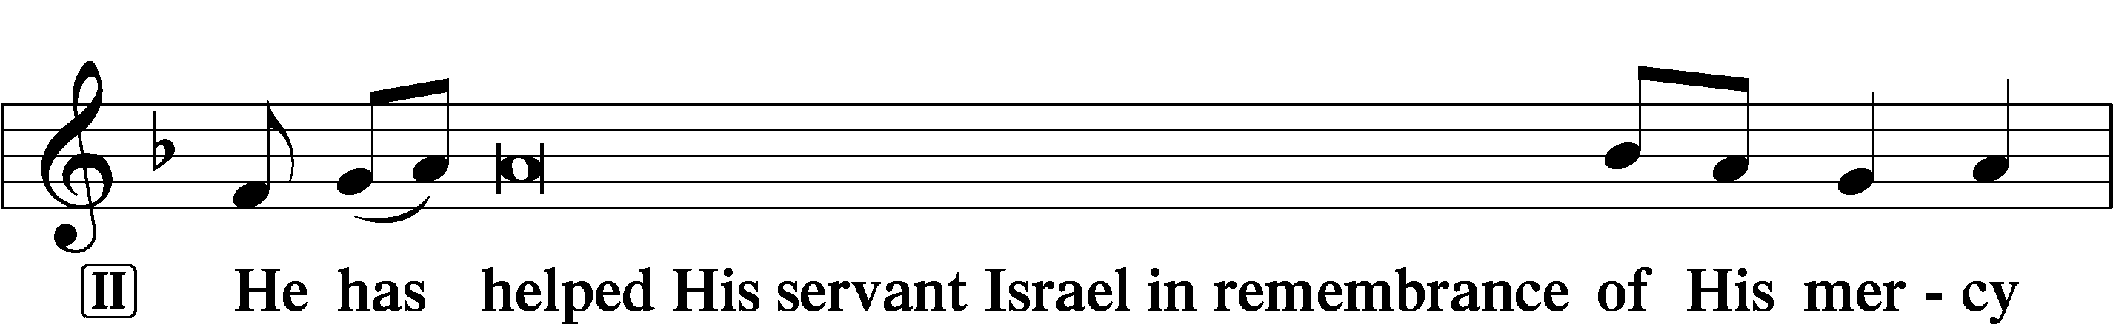
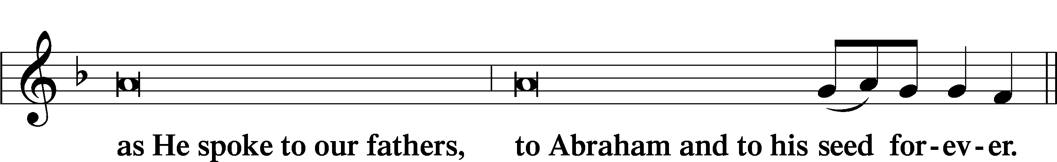
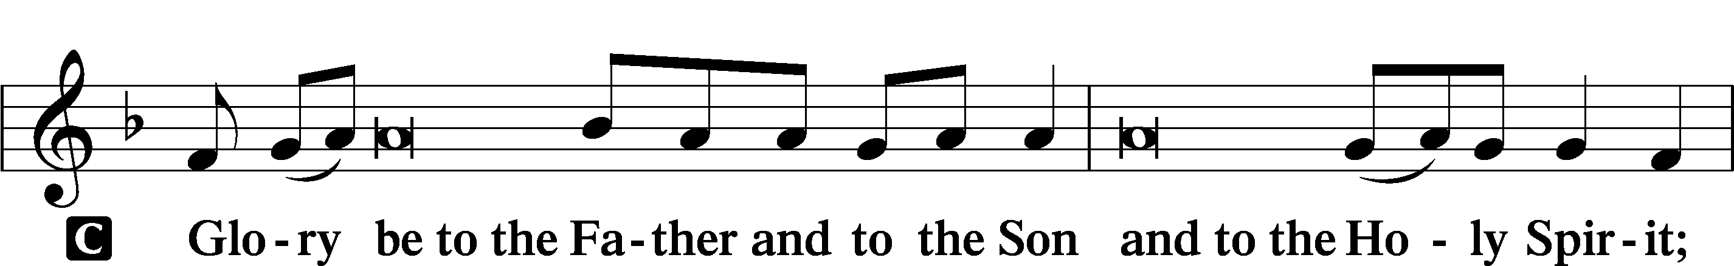
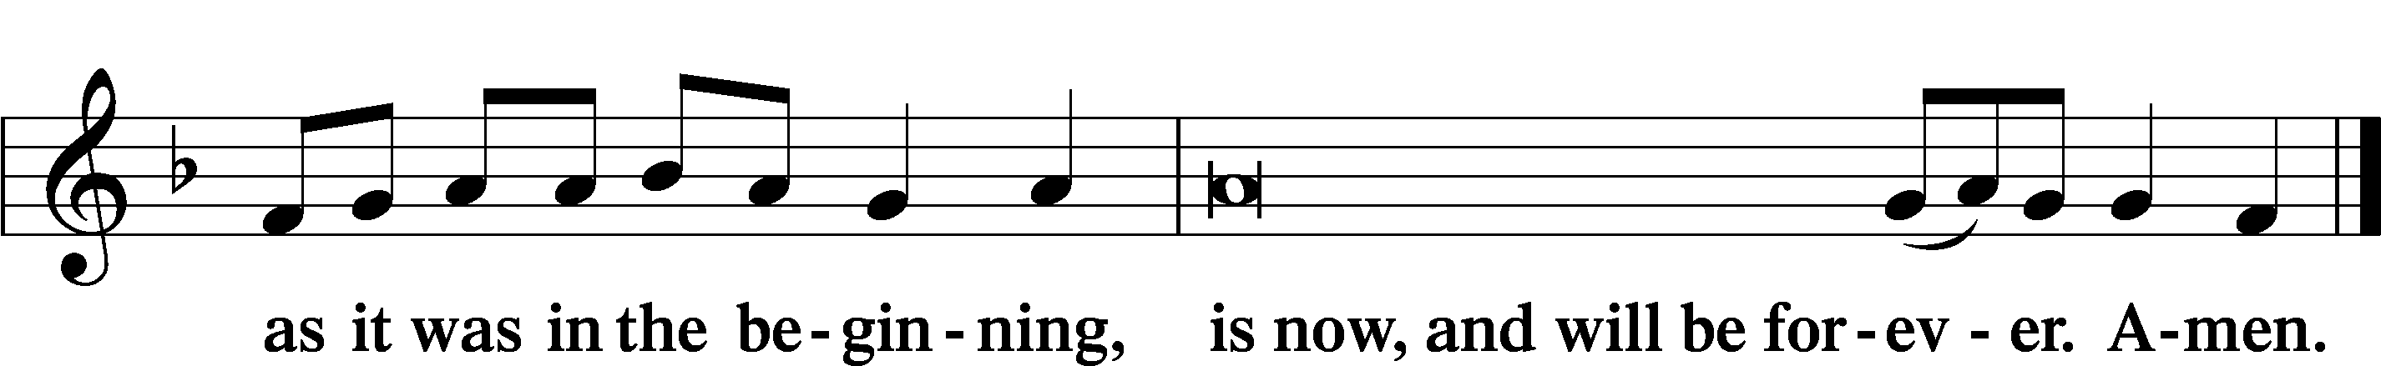
Sit

Prayer

Kyrie LSB 233
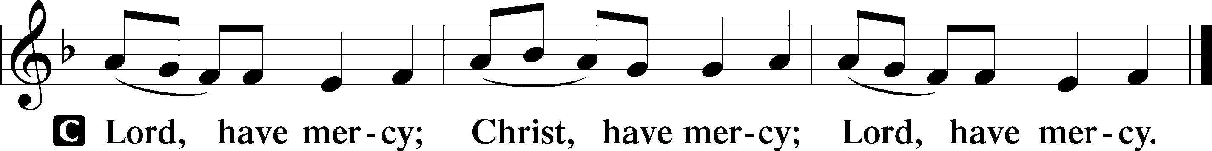

The Lord’s Prayer LSB 957
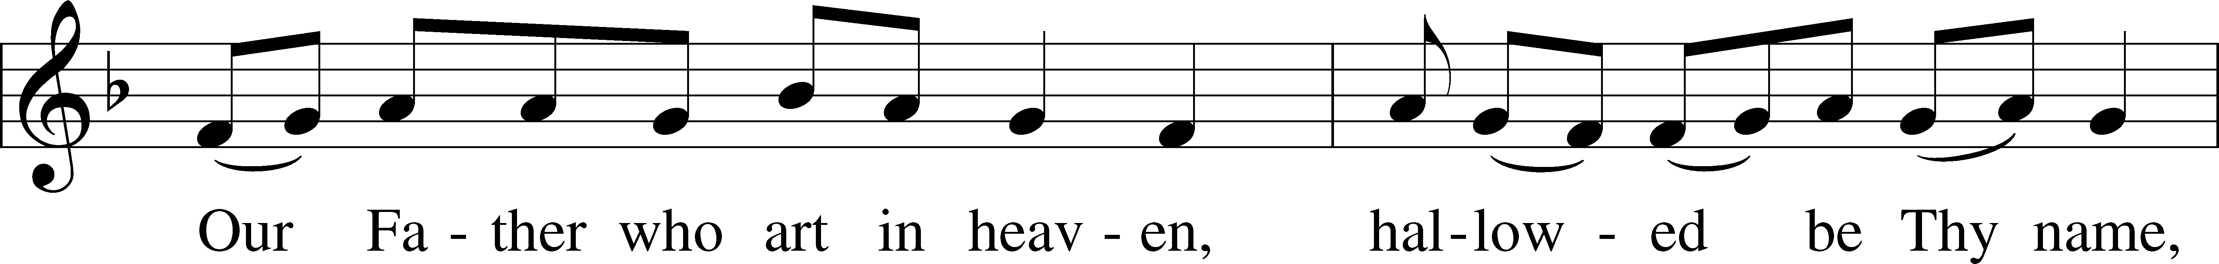
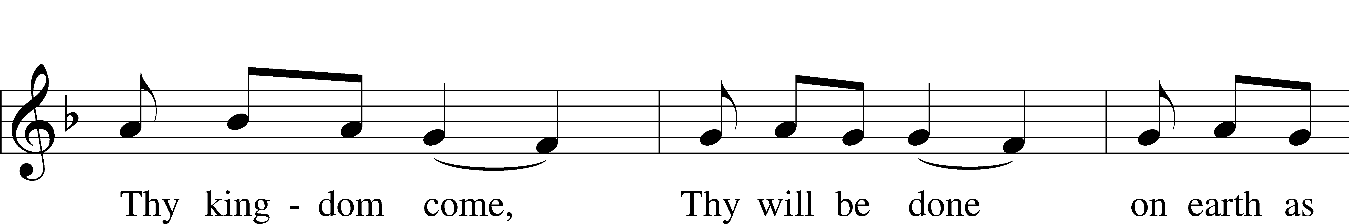
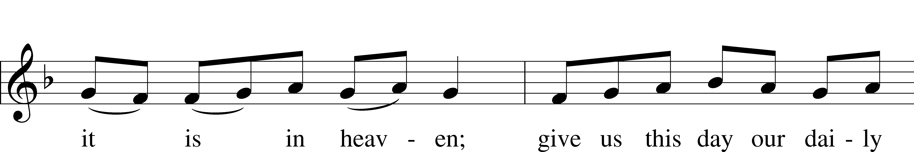
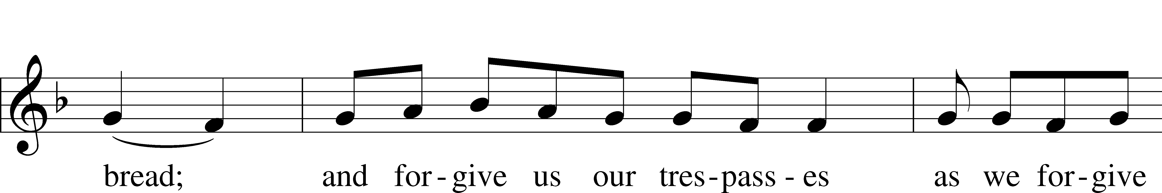
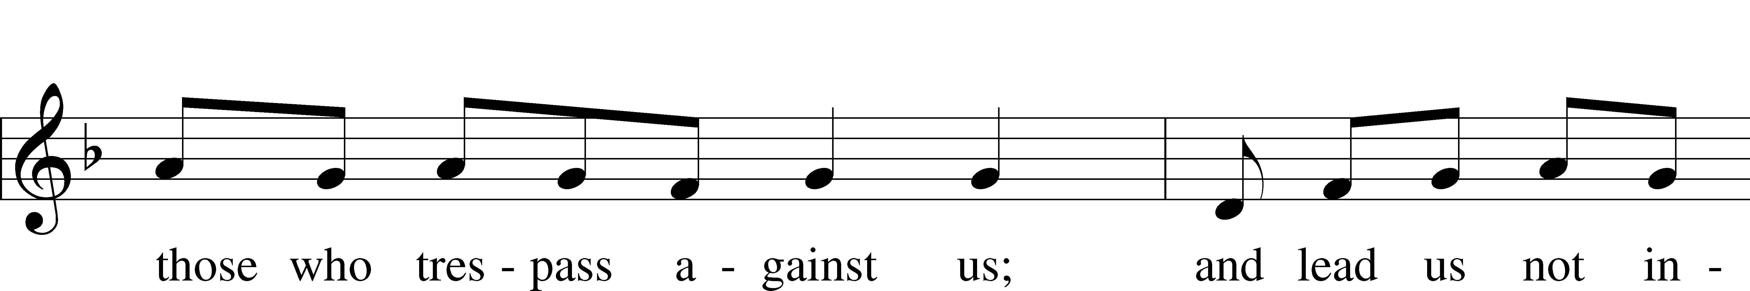
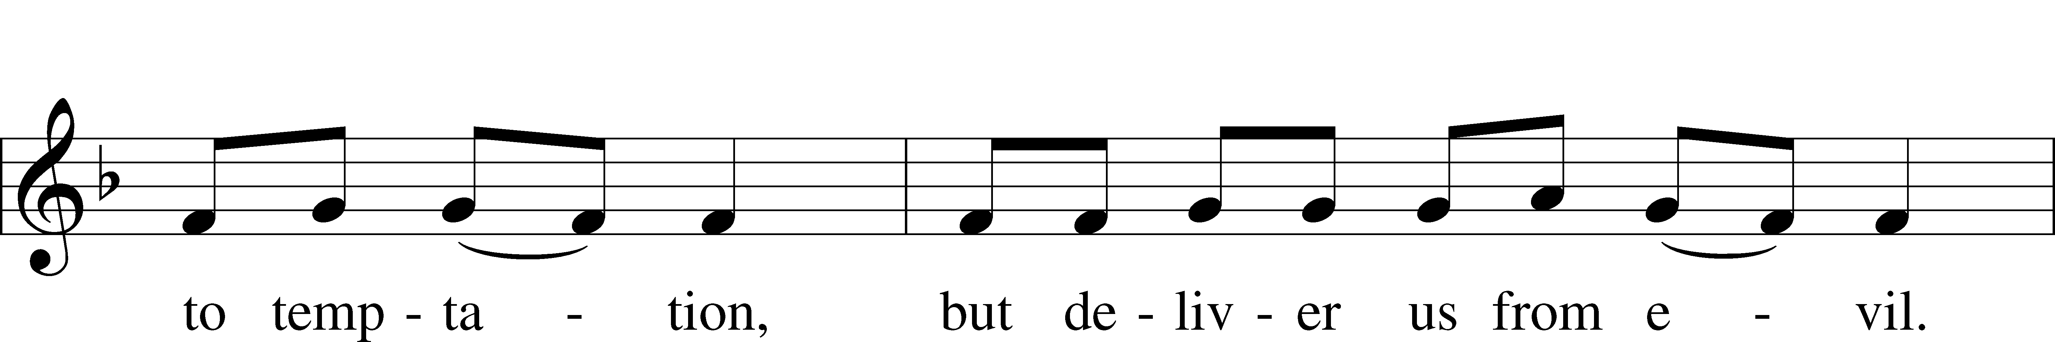
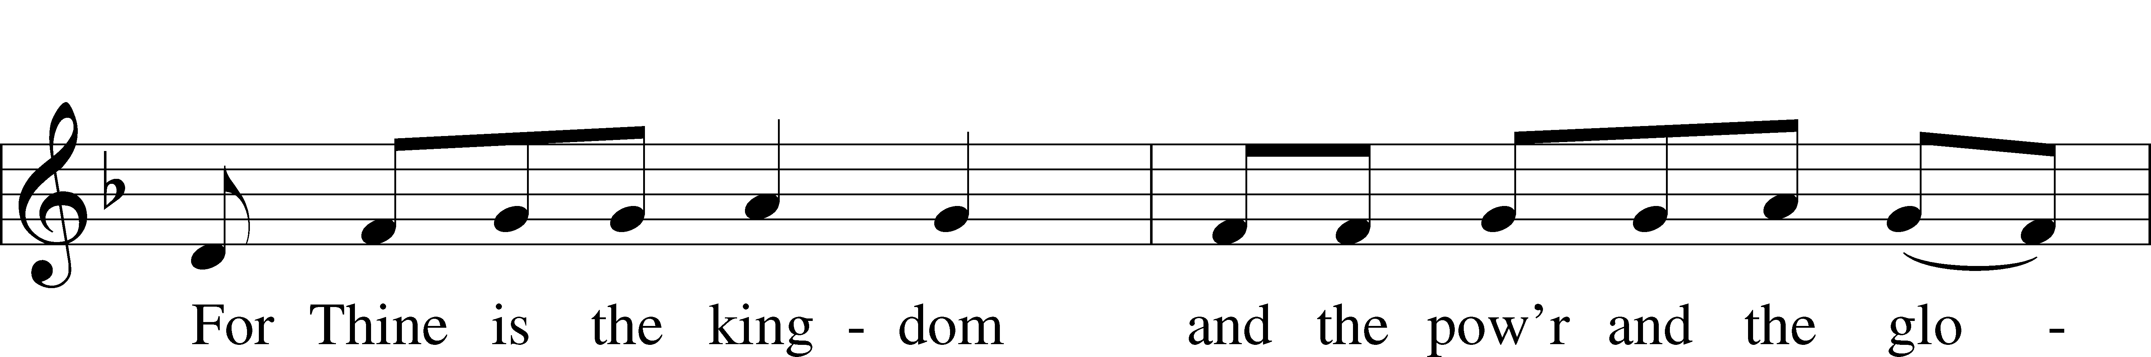
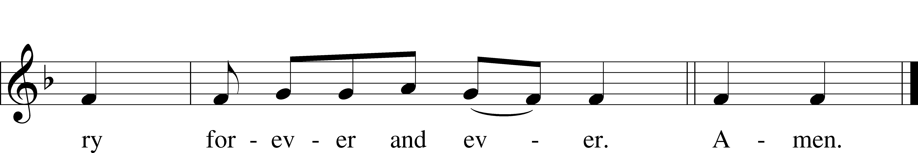

Collects
L O Lord, hear my prayer.
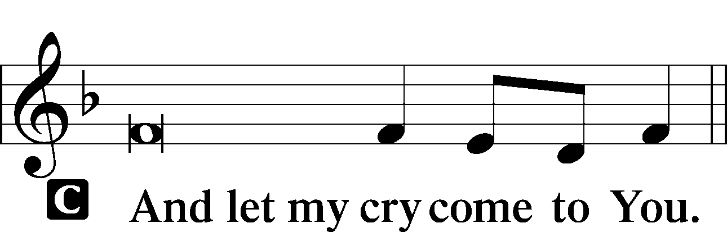

Collect of the Day (See insert)
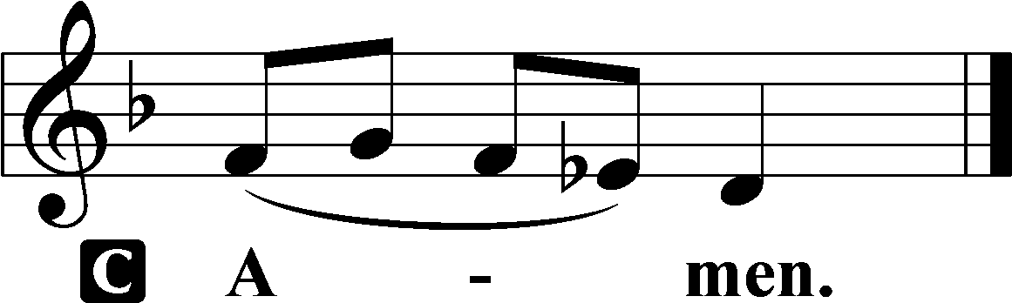

Collect for Peace
L O God, from whom come all holy desires, all good counsels, and all just works, give to us, Your servants, that peace which the world cannot give, that our hearts may be set to obey Your commandments and also that we, being defended from the fear of our enemies, may live in peace and quietness; through Jesus Christ, Your Son, our Lord, who lives and reigns with You and the Holy Spirit, one God, now and forever.

Stand

Benedicamus LSB 234
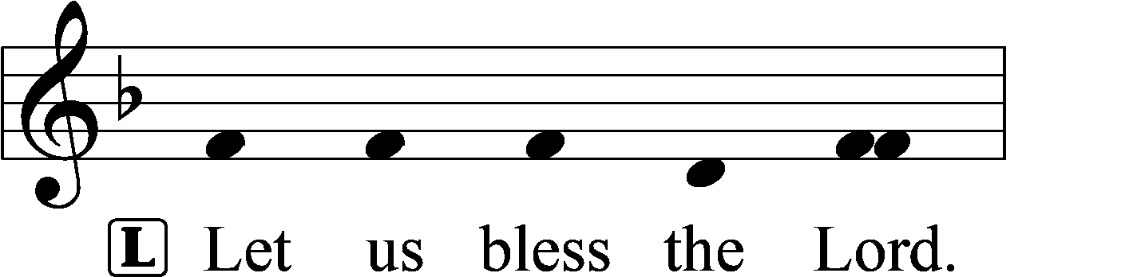
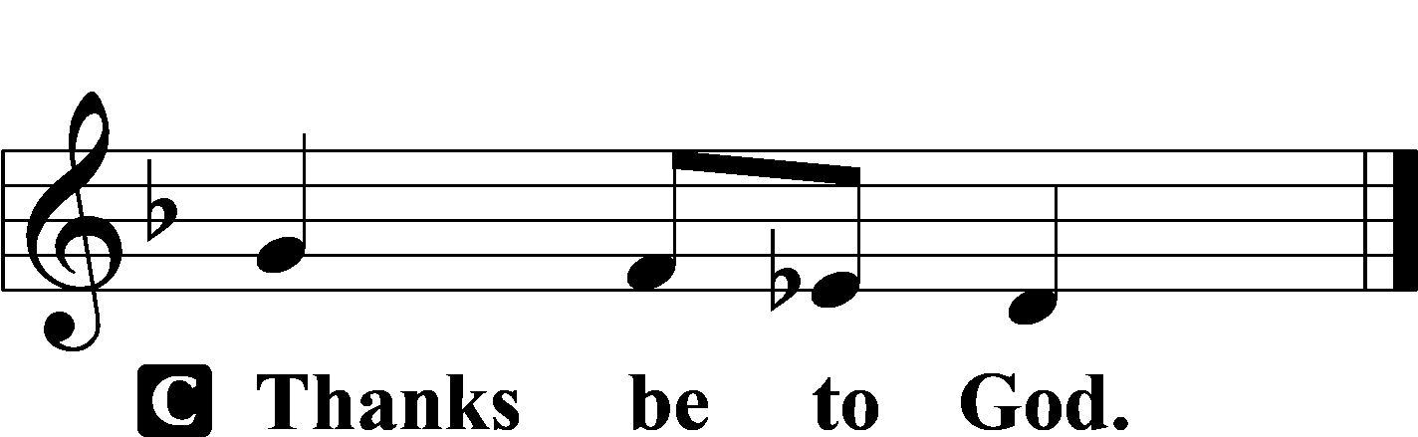

Benediction LSB 234
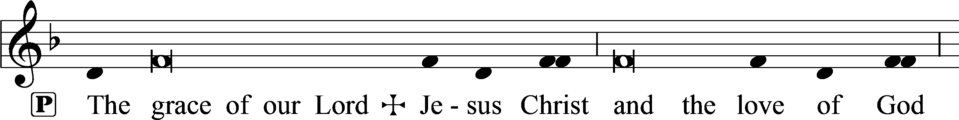
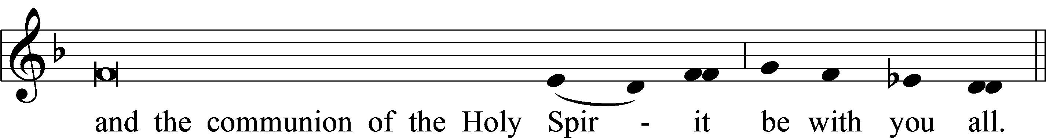

Closing Hymn:
December 6, 2023 LSB #339 “Lift Up Your Heads, You Everlasting Doors”
December 13, 2023 LSB # 352“Let the Earth Now Praise the Lord”
December 20, 2023 LSB #346 “When All the World Was Cursed”
sssssssssssssssssssssssssssssssssssssssssssssssssssssssssssssssssssssssssssss
Acknowledgments
Vespers from Lutheran Service Book
Unless otherwise indicated, Scripture quotations are from the ESV® Bible (The Holy Bible, English Standard Version®), copyright © 2001 by Crossway, a publishing ministry of Good News Publishers. Used by permission. All rights reserved.
Created by Lutheran Service Builder © 2023 Concordia Publishing House.

