Sts. Peter & Paul
Evangelical Lutheran Church
Lutheran Church-Missouri Synod
Founded-1917

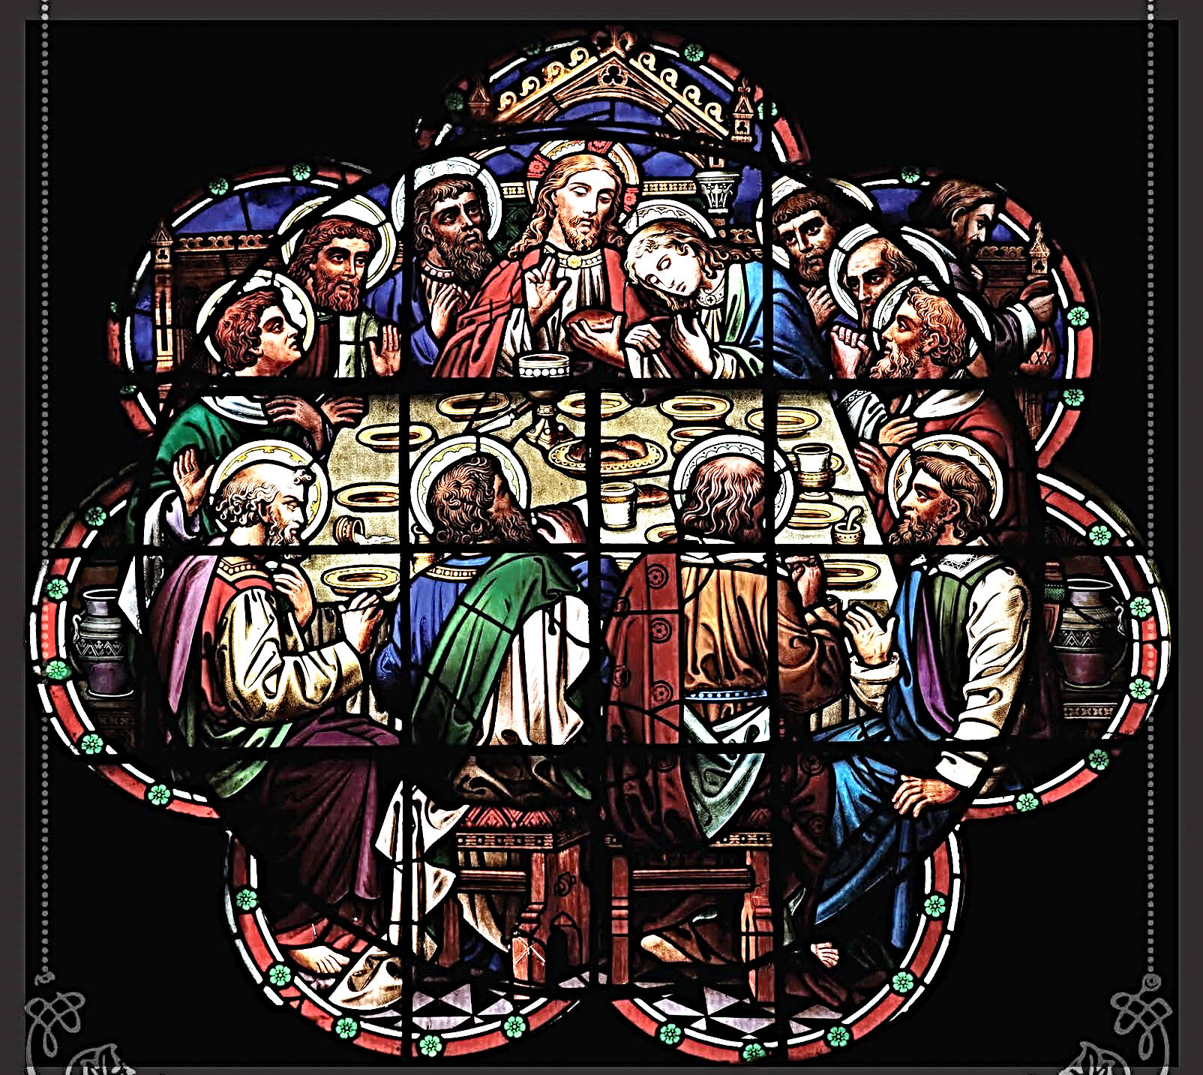

2023 Lenten Midweek Vespers Service

699 Stambaugh Avenue
Sharon, Pennsylvania 16146

“I was glad when they said to me,
Let us go to the house of the LORD!”
Psalm 122:1
Sts. Peter & Paul Evangelical Lutheran Church, LC-MS
LENTEN MIDWEEK VESPERS SERVICE

Opening Hymns:
March 1: LSB #619 “Thy Body, Given for Me, O Savior”
March 8: LSB #433 “Glory Be to Jesus”
March 15: LSB #618 “I Come, O Savior, to Thy Table”
March 22: LSB #623 “Lord Jesus Christ, We Humbly Pray”
March 29: LSB #636 “Soul, Adorn Yourself with Gladness”

Stand
Lent Versicles
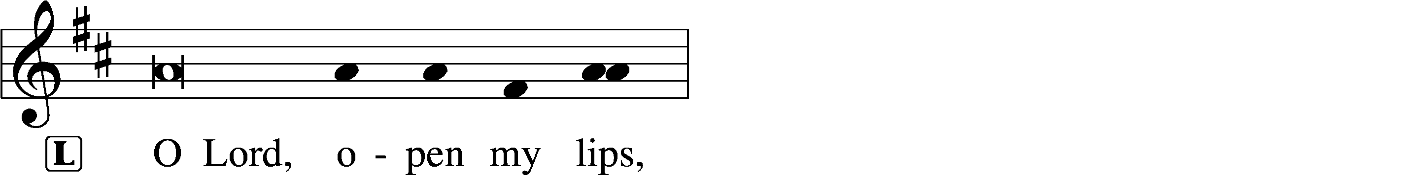
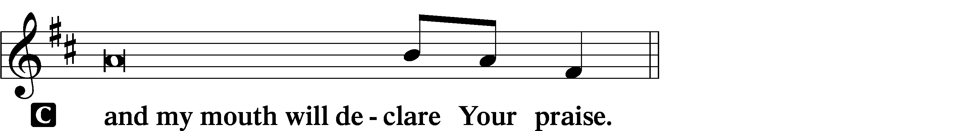

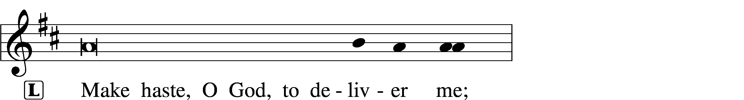
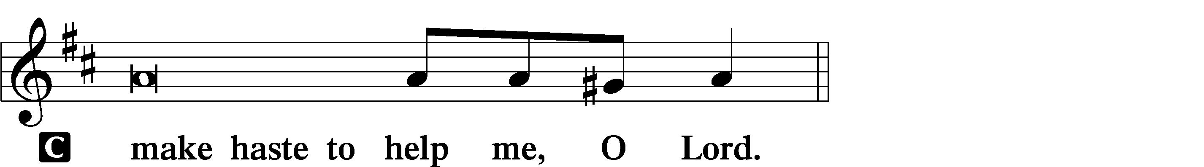

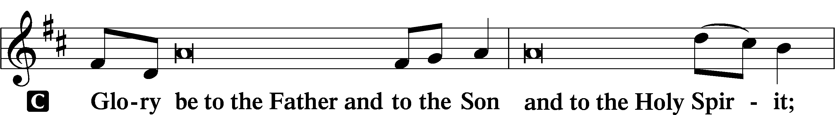
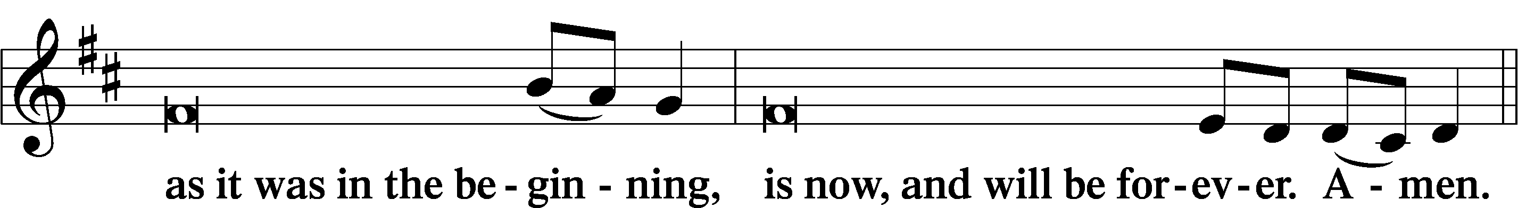
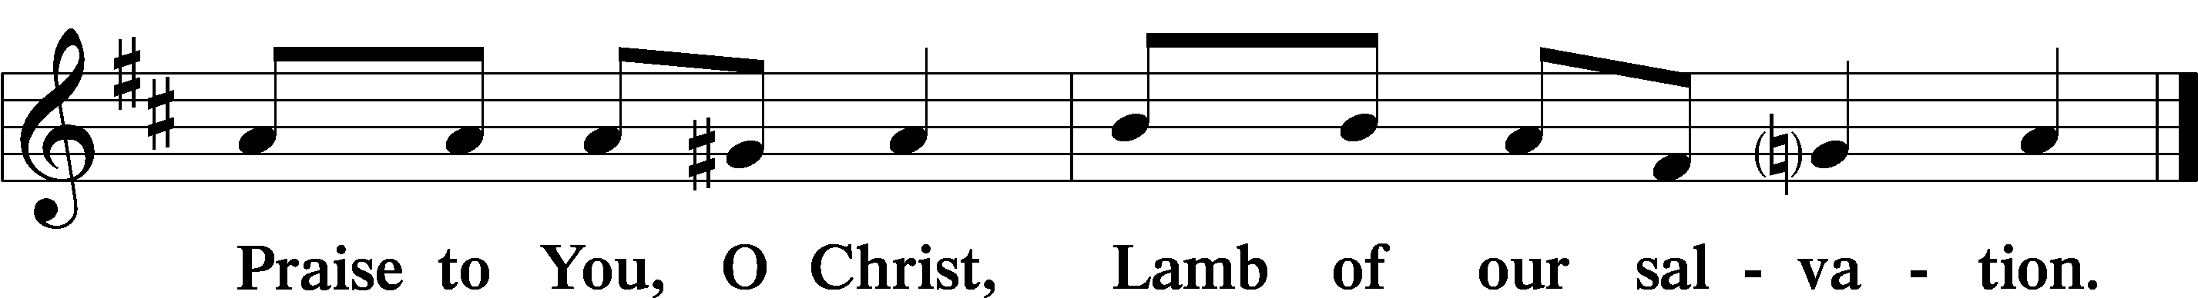
Psalmody

Psalms:
March 1: Psalm 23
March 8: Psalm 111
March 15: Psalm 116
March 22: Psalm 34
March 29: Psalm 50
Sit

Hymn of the Day:
March 1: LSB #627 “Jesus Christ, Our Blessed Savior”
March 8: LSB #634 “The Death of Jesus Christ, Our Lord”
March 15: LSB #620 “Jesus Comes Today with Healing”
March 22: LSB #622 “Lord Jesus Christ, You Have Prepared”
March 29: LSB #625 “Lord Jesus Christ, Life-Giving Bread”
Readings

First Reading:
March 1: 1 Corinthians 10:1–22
March 8: Exodus 12:43-51
March 15: Acts 2:42-47
March 22: Exodus 16:1-35
March 29: John 6:47-58

Reading Response:
P O Lord, have mercy on us.
C Thanks be to God.

Second Reading:
March 1: Matthew 26:26–29
March 8: Mark 14:22-25
March 15: Luke 22:19-20
March 22: 1 Corinthians 11:23-26
March 29: 1 Corinthians 11:27-34

Reading Response:
P O Lord, have mercy on us.
C Thanks be to God.

Responsory (Lent) LSB 231
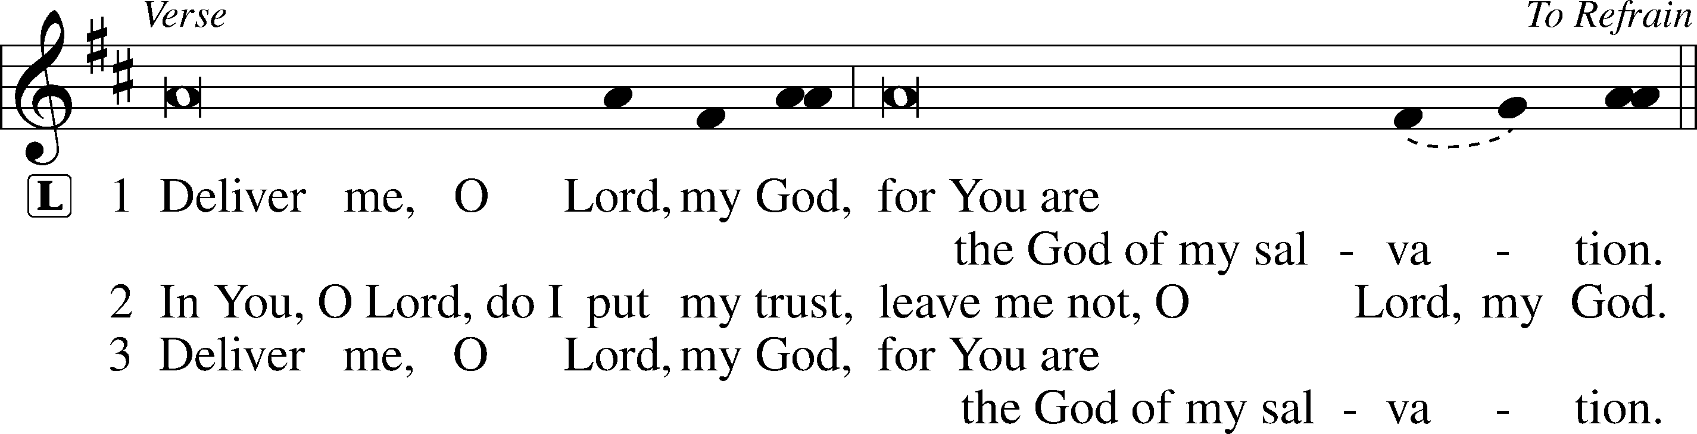
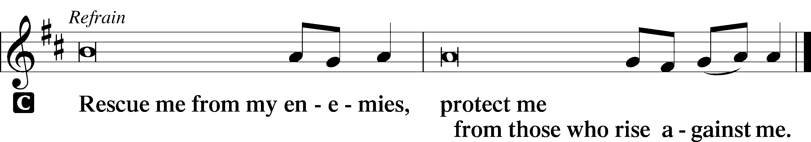

Sermon
Canticle
Stand

Antiphon (Common) 231
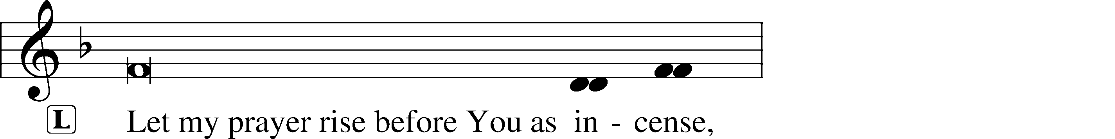
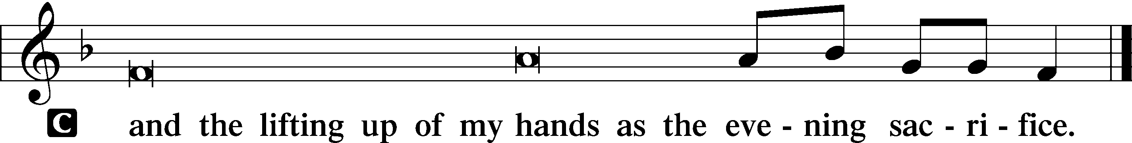
Magnificat 231
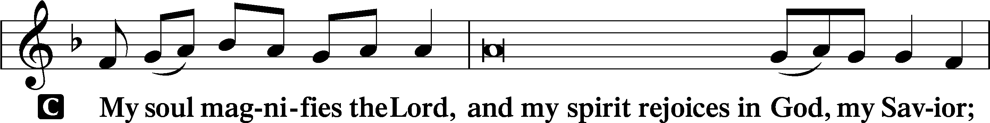
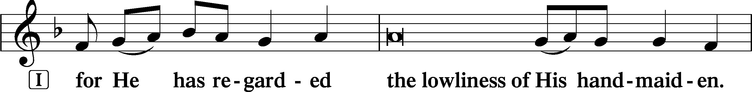
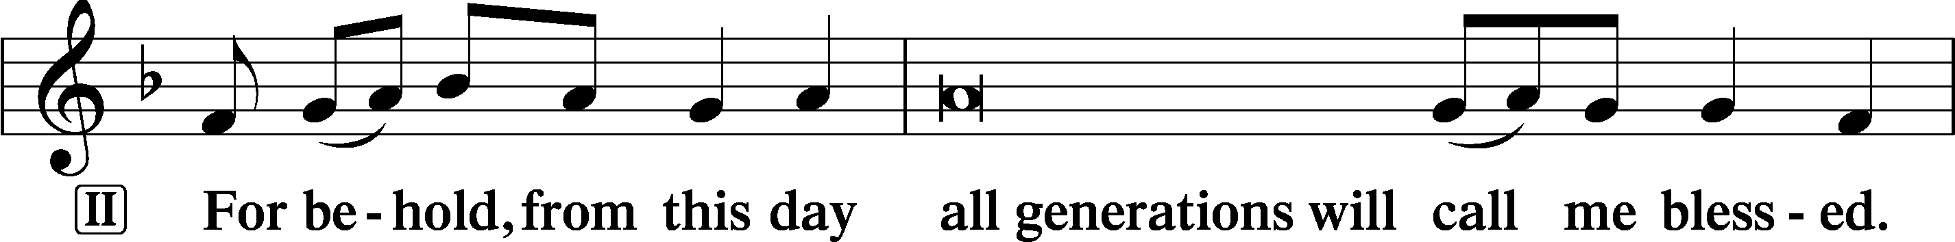
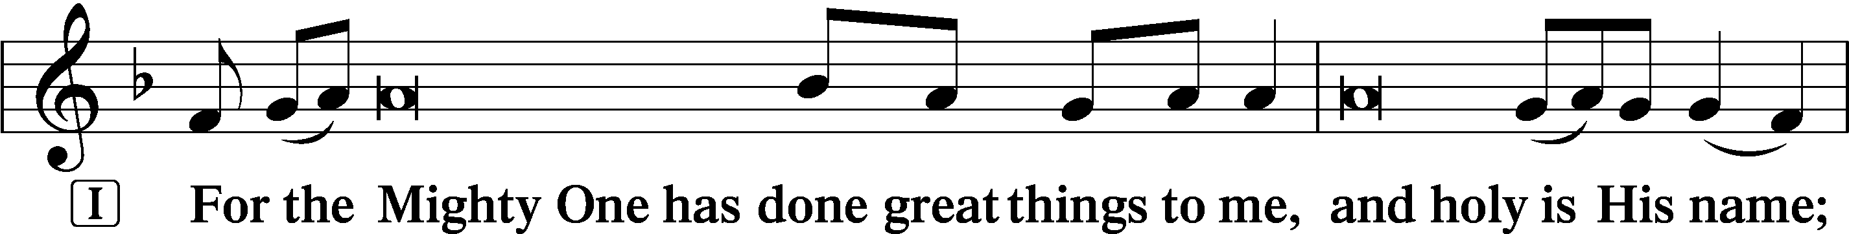
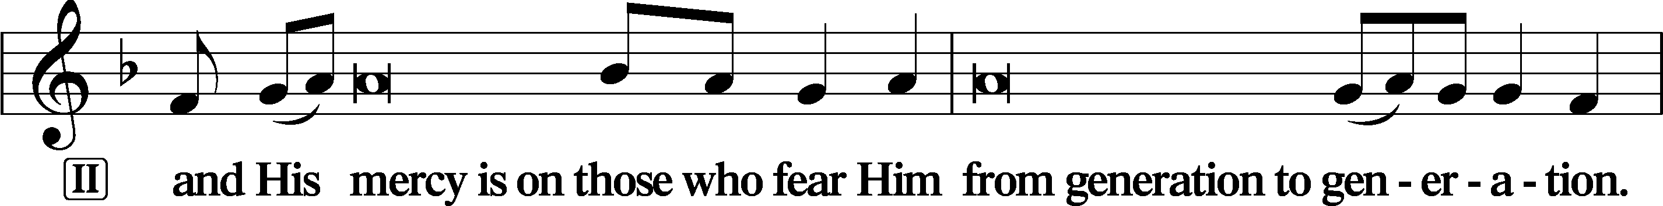
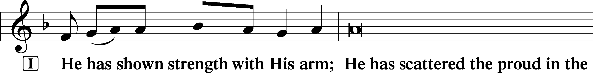
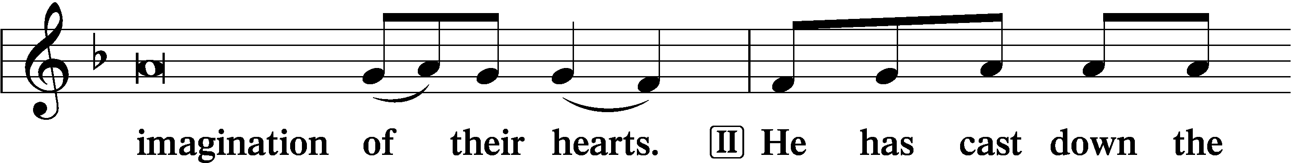
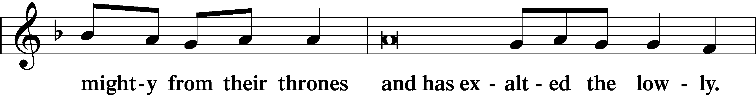
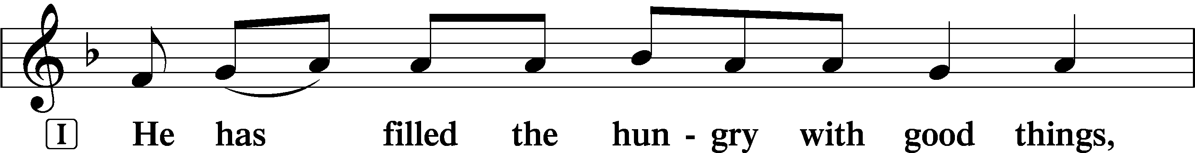
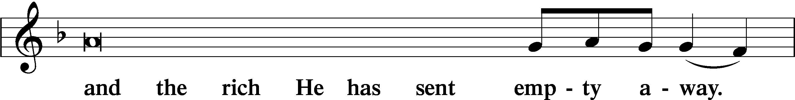
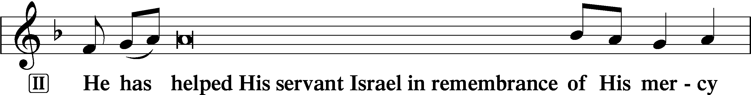
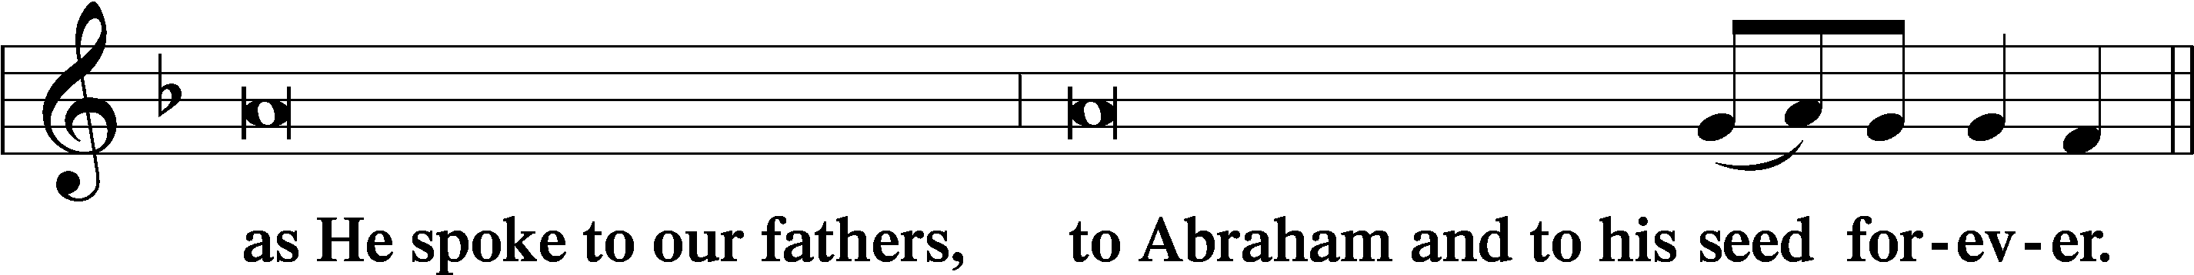
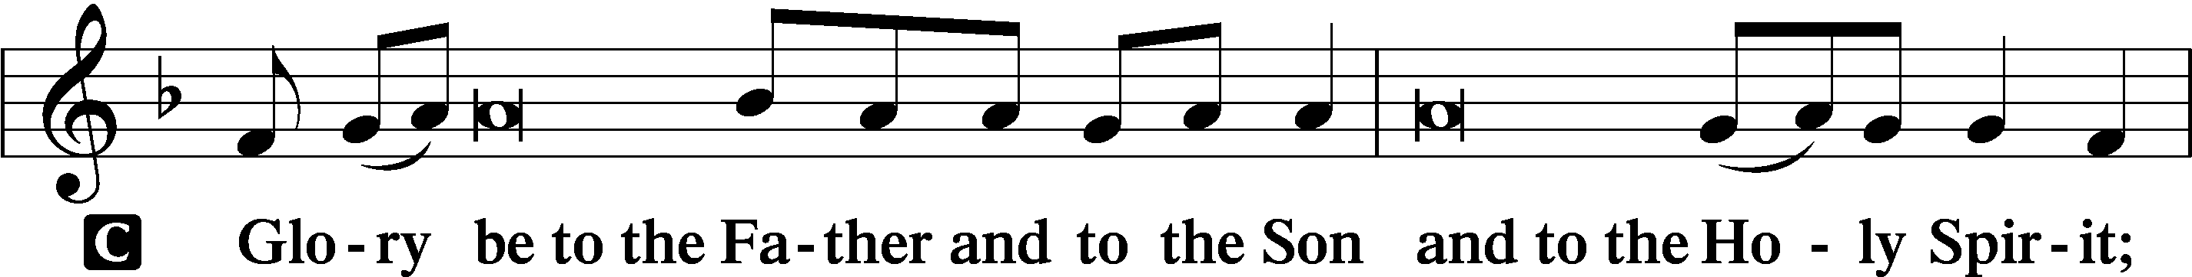
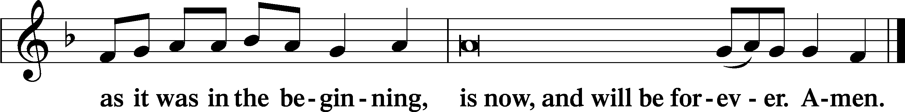

Prayer

Kyrie LSB 233
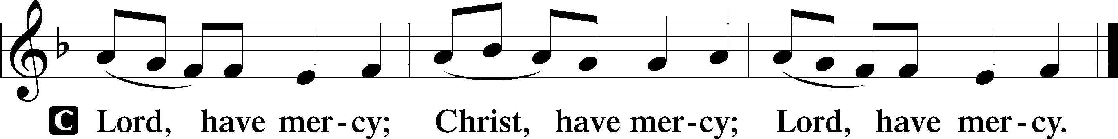

The Lord’s Prayer: LSB #957 “Our Father Who Art in Heaven” LSB 957
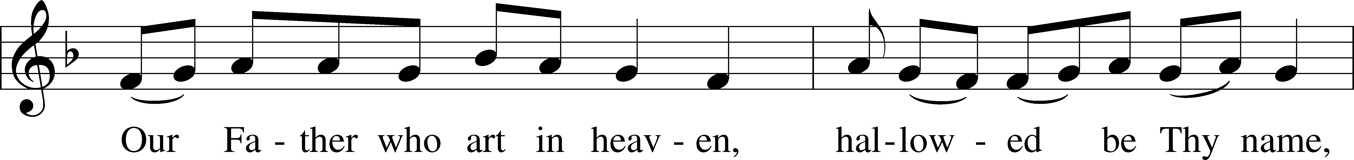
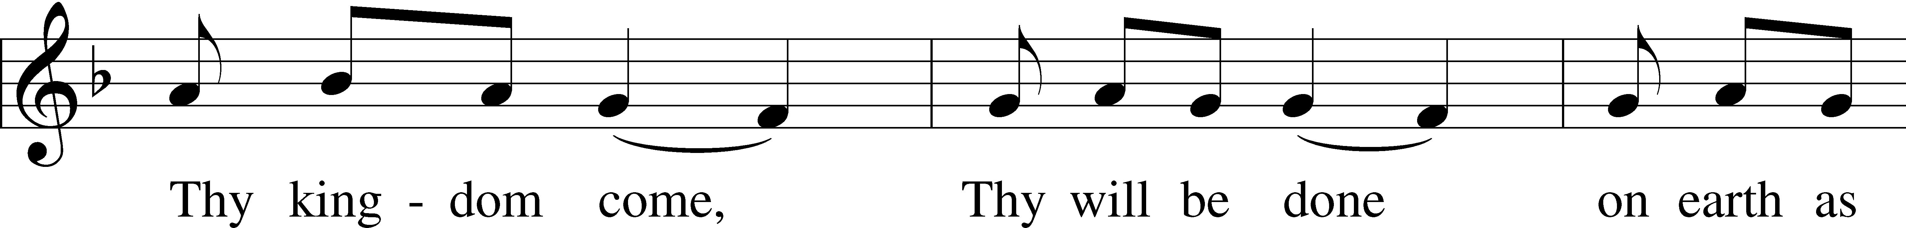
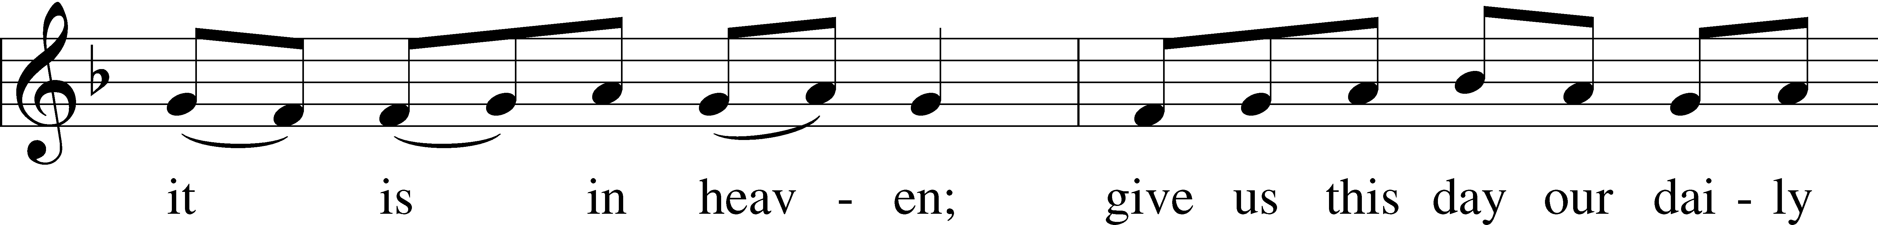
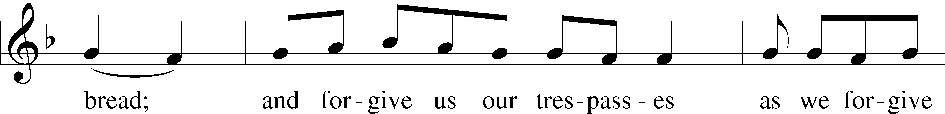
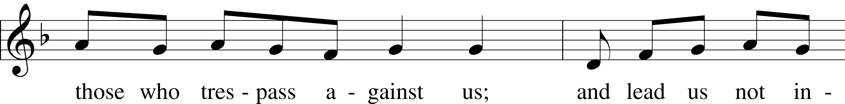
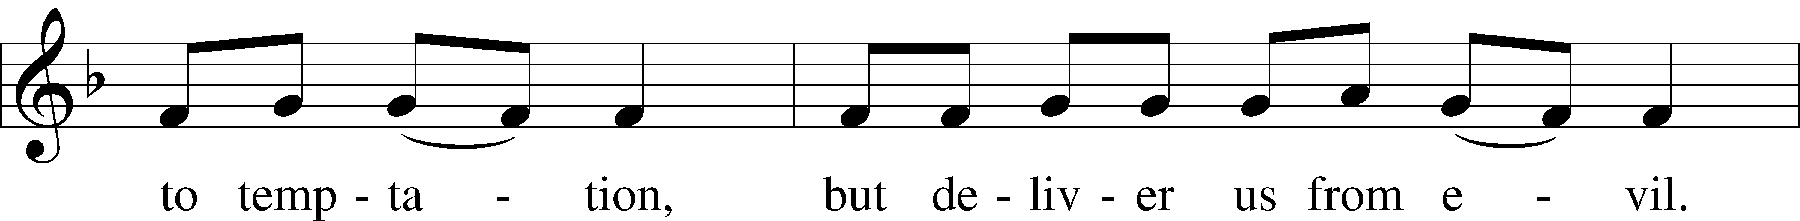
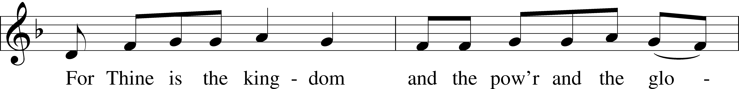
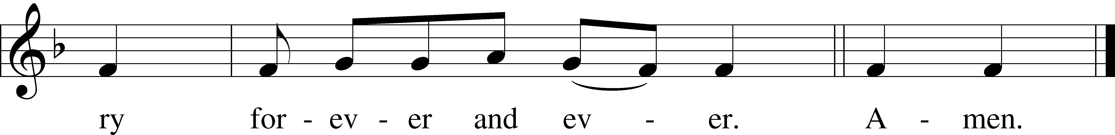
Text: Traditional
Tune: Plainsong, mode VII
Text and tune: Public domain

Collects LSB 233
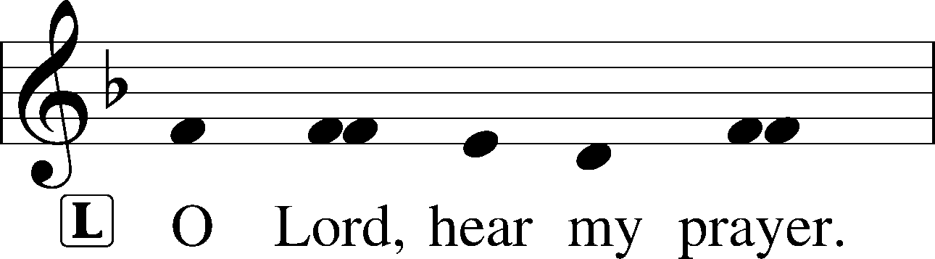
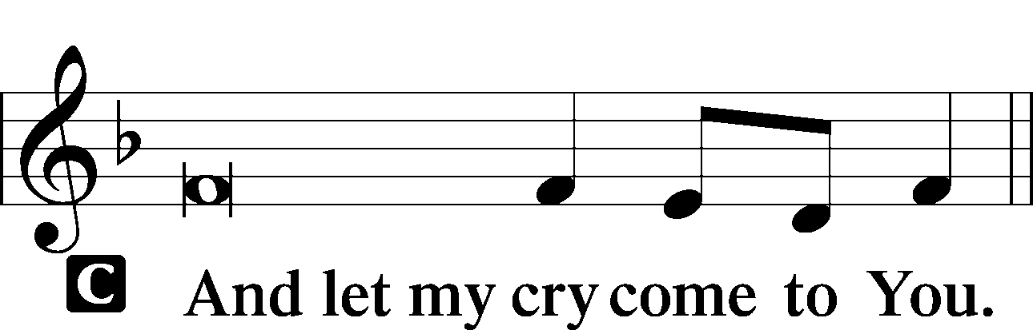

Collect of the Day
P … through Jesus Christ, Your Son, our Lord, who lives and reigns with You and the Holy Spirit, one God, now and forever.
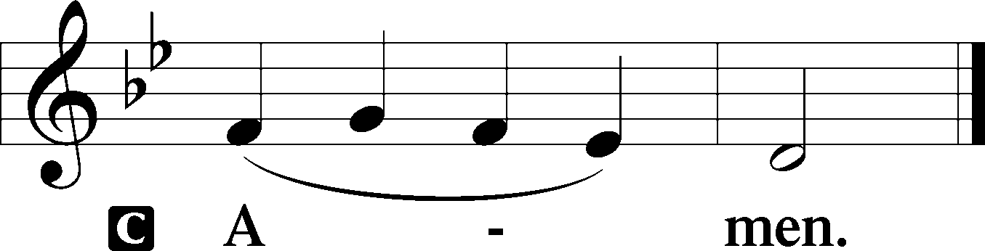

Collect for Peace
P O God, from whom come all holy desires, all good counsels, and all just works, give to us, Your servants, that peace which the world cannot give, that our hearts may be set to obey Your commandments and also that we, being defended from the fear of our enemies, may live in peace and quietness; through Jesus Christ, Your Son, our Lord, who lives and reigns with You and the Holy Spirit, one God, now and forever.
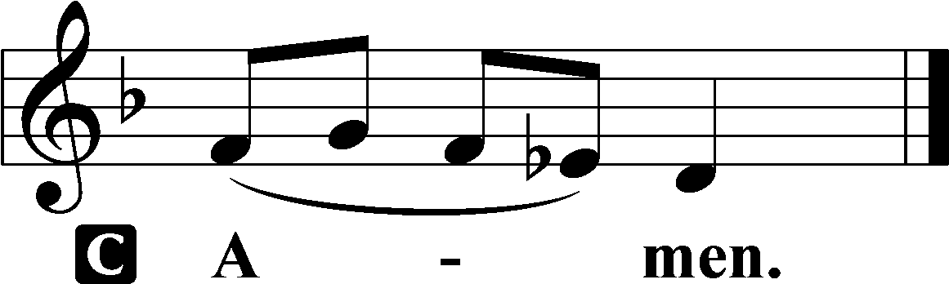

Stand

Benedicamus LSB 234
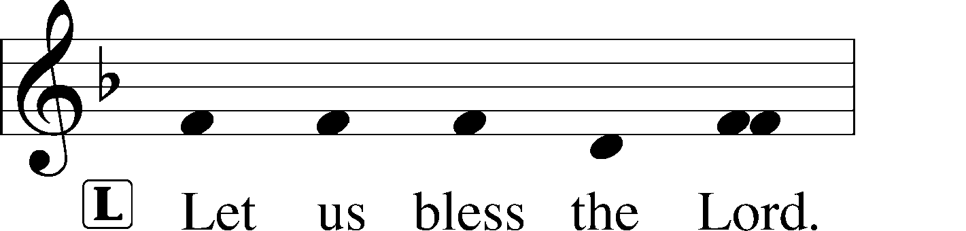
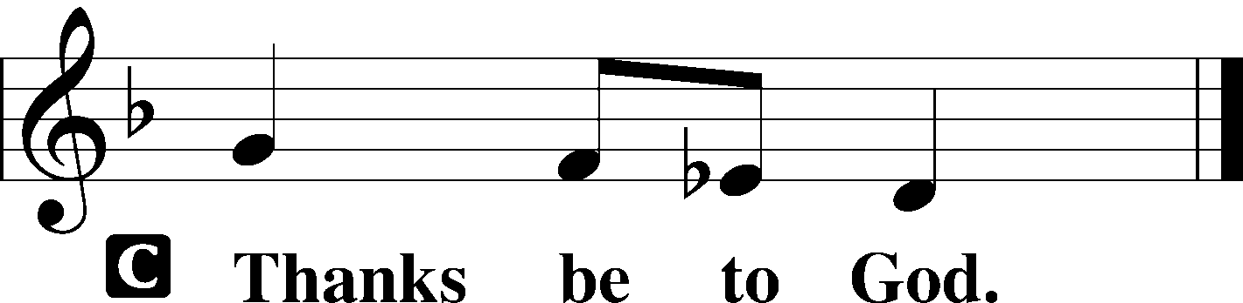

Benediction LSB 234
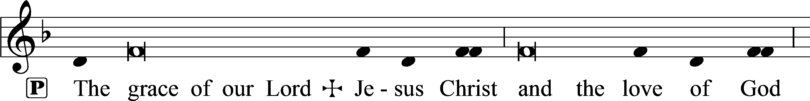
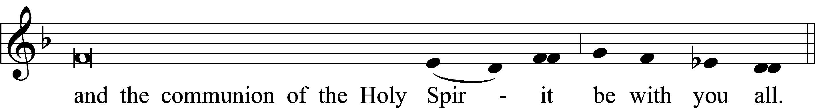

Closing Hymn:
March 1: LSB #585 “Lord Jesus Christ, with Us Abide”
March 8: LSB #559 “Oh, How Great Is Your Compassion”
March 15: LSB #617 “O Lord, We Praise Thee”
March 22: LSB #865 “Lord, Help Us Ever to Retain”
March 29: LSB #627 “Jesus Christ, Our Blessed Savior”

Acknowledgments
Unless otherwise indicated, Scripture quotations are from the ESV® Bible (The Holy Bible, English Standard Version®), copyright © 2001 by Crossway, a publishing ministry of Good News Publishers. Used by permission. All rights reserved.
Created by Lutheran Service Builder © 2023 Concordia Publishing House.

