Sts. Peter & Paul
Evangelical Lutheran Church
Lutheran Church-Missouri Synod
Founded-1917

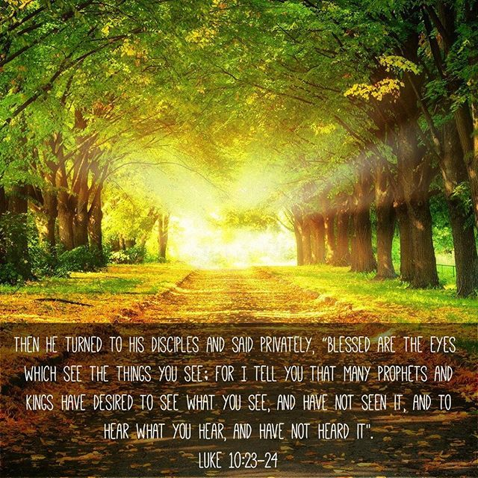

September 3, 2023

699 Stambaugh Ave.
Sharon, Pennsylvania 16146

“I was glad when they said to me,
Let us go to the house of the LORD!”
Psalm 122:1
Sts. Peter & Paul Evangelical Lutheran Church, LC-MS
THE THIRTEENTH SUNDAY AFTER TRINITY
September 3, 2023
A special welcome to our guests this day! If you would like more information about The Lutheran Church - Missouri Synod, or this congregation, please speak with Pastor Deal or an Elder after the service.
Members & Guests: Don’t be embarrassed if your children make noise during the worship service, all children do. We encourage families to worship together but, if you feel the need, there are pews in the rear of the Church which are reserved for young families on both sides of the sanctuary. There is also a quiet room available to you, located next to the sanctuary (formerly the Pastor’s office), where you would be able to follow along with the service.

Today’s service includes the Sacrament of Holy Communion. If during this past year, you have not worshipped with us and been communed, we respectfully ask that you do not partake of this sacrament this day before first speaking with Pastor Deal.
If visiting from a sister congregation of the LC-MS and are in good standing, please inform Pastor Deal of your desire to commune prior to the service.
If wishing to receive a blessing during communion, please approach with your arms crossed.

CONTACT INFORMATION
Pastor Deal: pastordeal@saintspeterandpaul.net or 724-347-3620 (opt. 2)
Church Office: church@saintspeterandpaul.net or 724-347-3620 (opt. 3)
Secretary’s Office: Please see bulletin information for this week’s days/times.

Silent prayer before worship Father of mercy and might, open my ears and my heart to Your Holy Word. Give me the assurance that through Christ I have forgiveness, life and salvation. In Jesus’ name. Amen.

Confession and Absolution

Opening Hymn: LSB #876 “O Blessed, Holy Trinity”

Stand

The sign of the cross may be made by all in remembrance of their Baptism.

Invocation
P In the name of the Father and of the T Son and of the Holy Spirit.
C Amen.

Exhortation Hebrews 10:22; Psalm 124:8; Psalm 32:5
P Beloved in the Lord! Let us draw near with a true heart and confess our sins unto God our Father, beseeching Him in the name of our Lord Jesus Christ to grant us forgiveness.

P Our help is in the name of the Lord,
C who made heaven and earth.
P I said, I will confess my transgressions unto the Lord,
C and You forgave the iniquity of my sin.

Silence for reflection on God’s Word and for self-examination.

Confession of Sins
P O almighty God, merciful Father,
C I, a poor, miserable sinner, confess unto You all my sins and iniquities with which I have ever offended You and justly deserved Your temporal and eternal punishment. But I am heartily sorry for them and sincerely repent of them, and I pray You of Your boundless mercy and for the sake of the holy, innocent, bitter sufferings and death of Your beloved Son, Jesus Christ, to be gracious and merciful to me, a poor, sinful being.

Absolution [John 20:19–23]
P Upon this your confession, I, by virtue of my office, as a called and ordained servant of the Word, announce the grace of God unto all of you, and in the stead and by the command of my Lord Jesus Christ I forgive you all your sins in the name of the Father and of the T Son and of the Holy Spirit.
C Amen.

Service of the Word

Introit Psalm 74:1–2, 19b, 21b; antiphon: vv. 20a, 21a, 22a, 23a
Have regard for the covenant, | [O Lord];*
let not the downtrodden turn | back in shame.
Arise, O God, de- | fend your cause;*
do not forget the clamor | of your foes.
O God, why do you cast us off for- | ever?*
Why does your anger smoke against the sheep of your | pasture?
Remember your congre- | gation,*
which you have pur- | chased of old,
which you have redeemed to be the tribe of your | heritage!*
Remember Mount Zion, where | you have dwelt.
Do not forget the life of your poor for- | ever.*
Let the poor and needy | praise your name.
Have regard for the covenant, | [O Lord];*
let not the downtrodden turn | back in shame.
Arise, O God, de- | fend your cause;*
do not forget the clamor | of your foes.

Gloria Patri
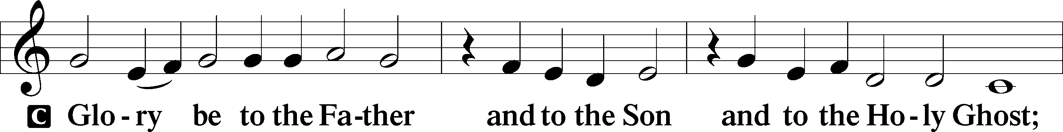
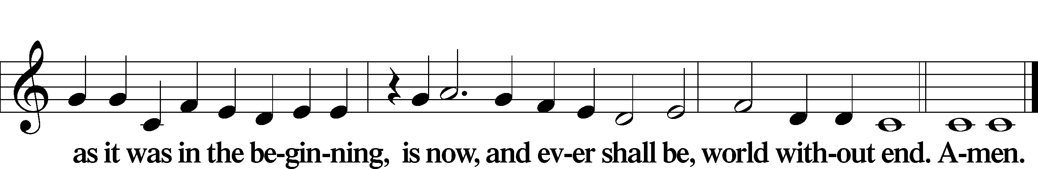

Kyrie Mark 10:47
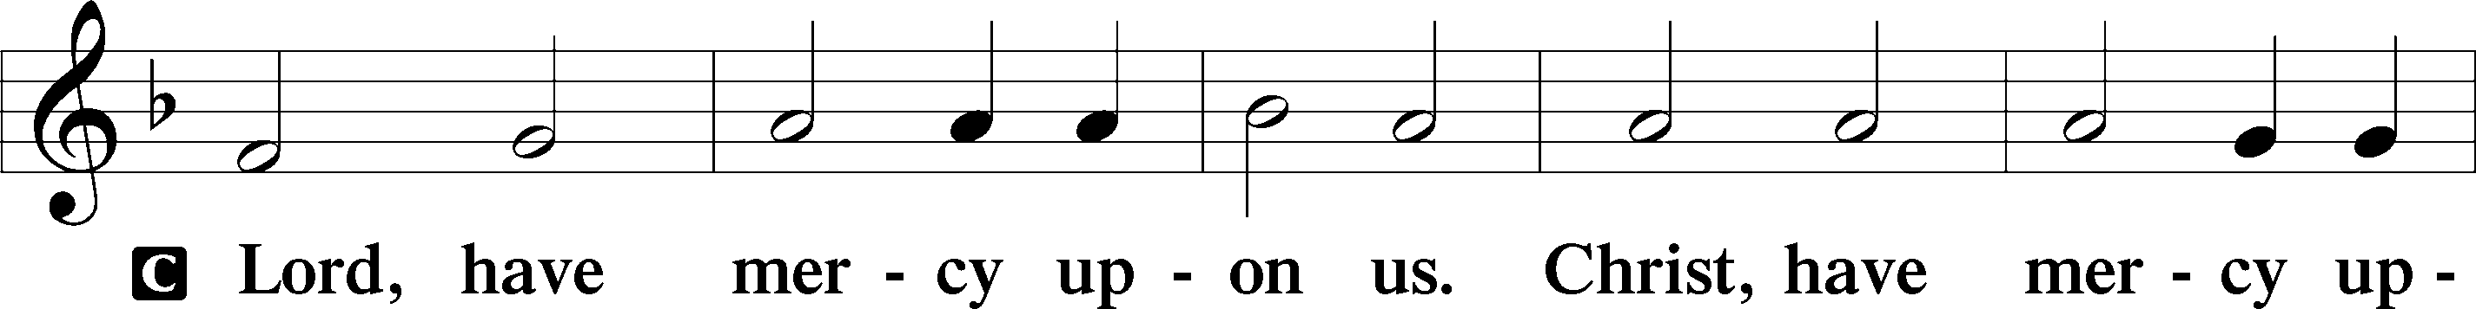
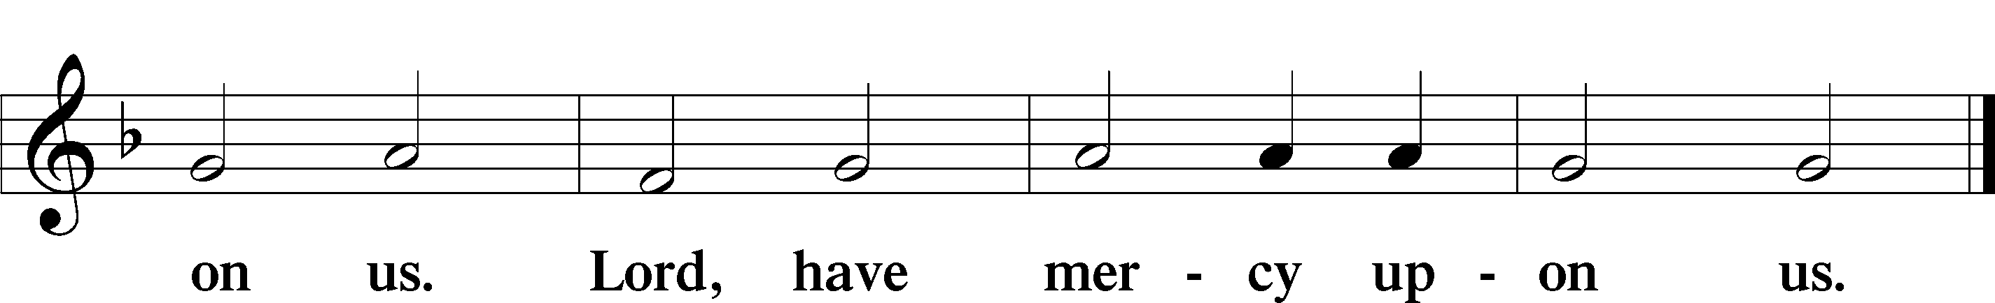

Gloria in Excelsis Luke 2:14; John 1:29
P Glory be to God on high:
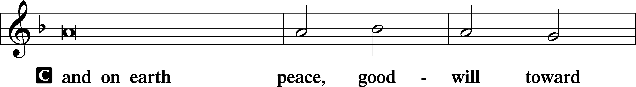
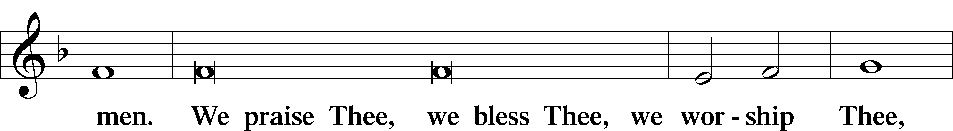
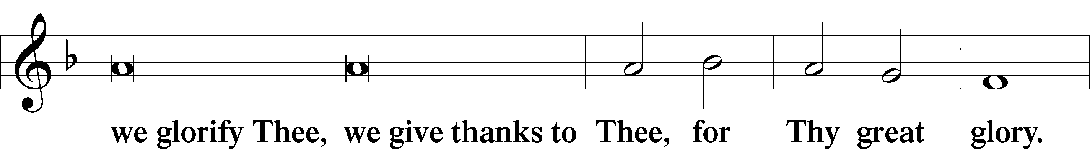
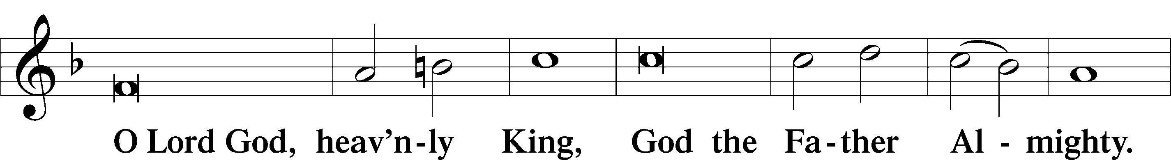
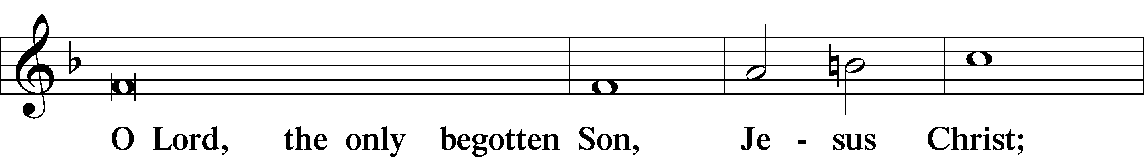
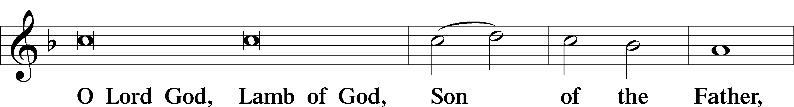
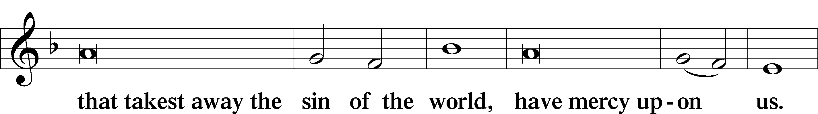
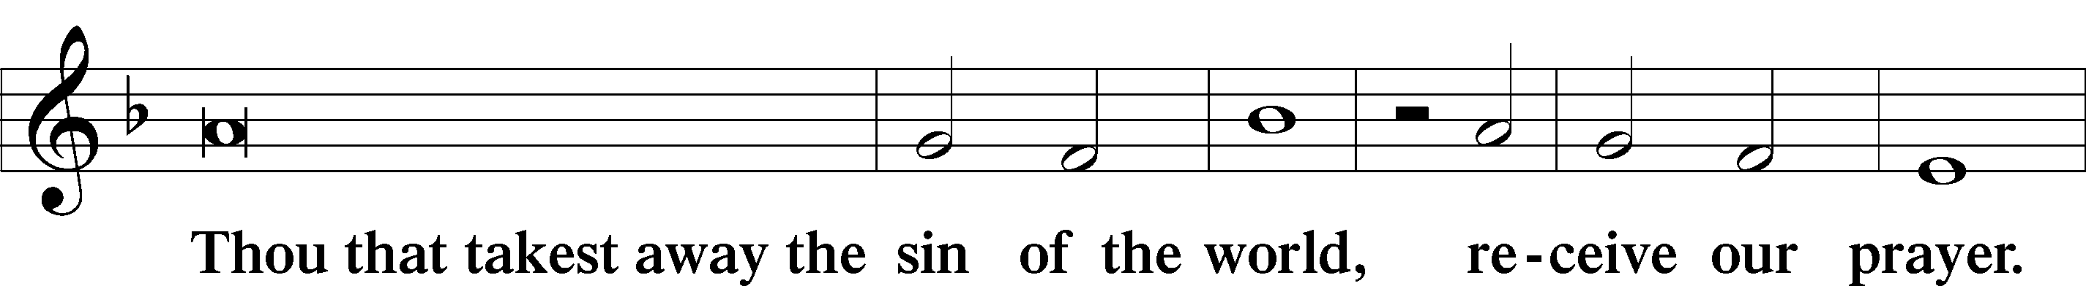
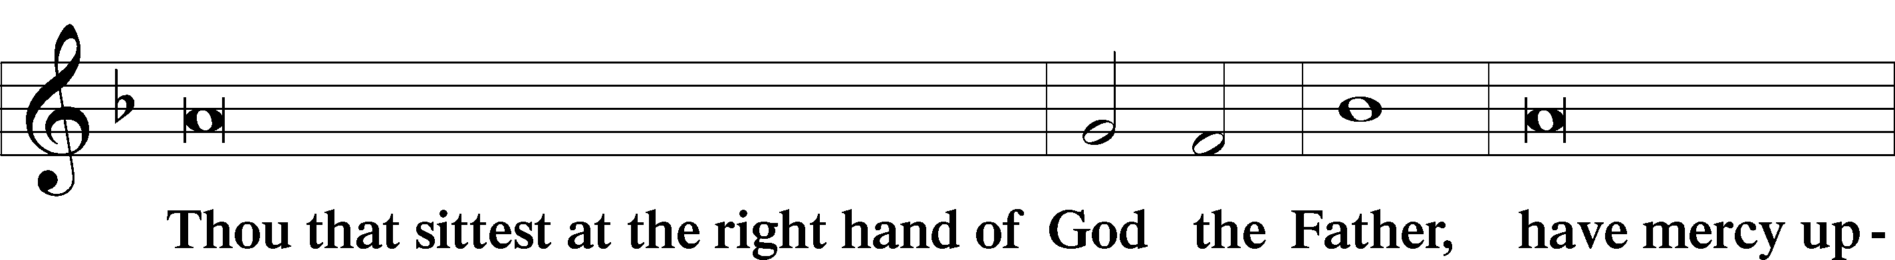
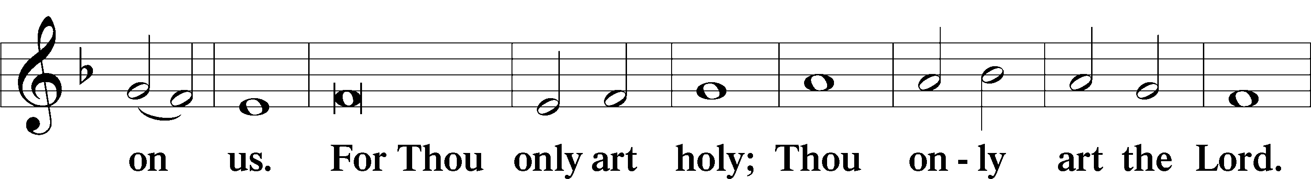
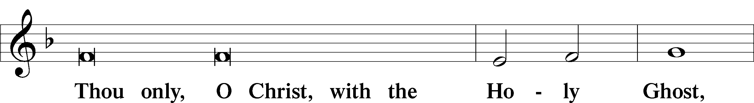
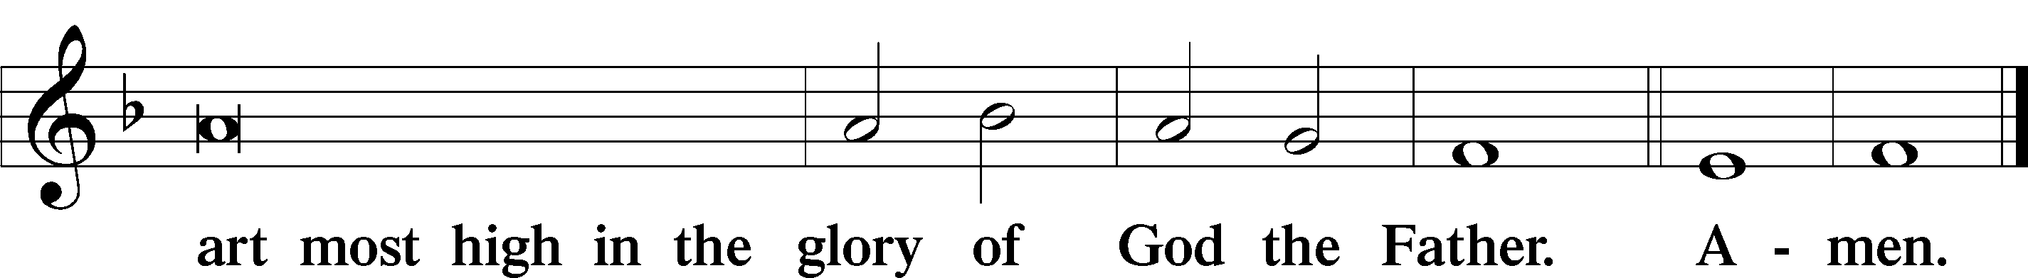

Salutation and Collect of the Day: Trinity 13
P The Lord be with you.
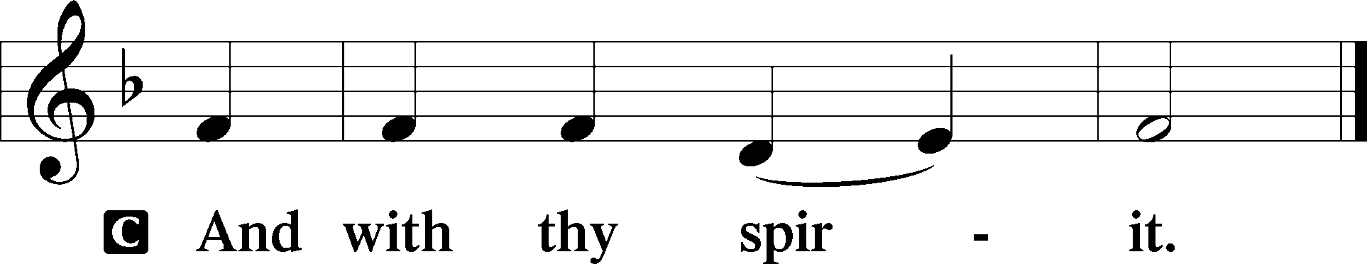

P Let us pray.
Almighty and everlasting God, give us an increase of faith, hope, and charity; and that we may obtain what You have promised, make us love what You have commanded; through Jesus Christ, Your Son, our Lord, who lives and reigns with You and the Holy Spirit, one God, now and forever.
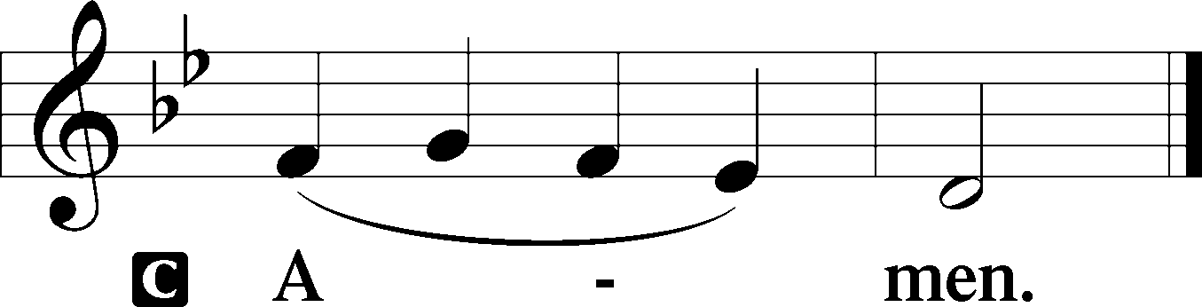
Sit

Prophecy: Leviticus 9:9-18 (NKJV)
Thus says the Lord God: “When you reap the harvest of your land, you shall not wholly reap the corners of your field, nor shall you gather the gleanings of your harvest. And you shall not glean your vineyard, nor shall you gather every grape of your vineyard; you shall leave them for the poor and the stranger: I am the Lord your God. You shall not steal, nor deal falsely, nor lie to one another. And you shall not swear by My name falsely, nor shall you profane the name of your God: I am the Lord. You shall not cheat your neighbor, nor rob him. The wages of him who is hired shall not remain with you all night until morning. You shall not curse the deaf, nor put a stumbling block before the blind, but shall fear your God: I am the Lord. You shall do no injustice in judgment. You shall not be partial to the poor, nor honor the person of the mighty. In righteousness you shall judge your neighbor. You shall not go about as a talebearer among your people; nor shall you take a stand against the life of your neighbor: I am the Lord. You shall not hate your brother in your heart. You shall surely rebuke your neighbor, and not bear sin because of him. You shall not take vengeance, nor bear any grudge against the children of your people, but you shall love your neighbor as yourself: I am the Lord.”

P This is the Word of the Lord.
C Thanks be to God.

Gradual Psalm 77:14–15
You are the God who works | wonders;*
you have made known your might among the | peoples.
You with your arm redeemed your | people,*
the children of Jacob and | Joseph.
Epistle: Galatians 3:16–22 (NKJV)
Brethren: To Abraham and his Seed were the promises made. He does not say, “And to seeds,” as of many, but as of one, “And to your Seed,” who is Christ. And this I say, that the law, which was four hundred and thirty years later, cannot annul the covenant that was confirmed before by God in Christ, that it should make the promise of no effect. For if the inheritance is of the law, it is no longer of promise; but God gave it to Abraham by promise. What purpose then does the law serve? It was added because of transgressions, till the Seed should come to whom the promise was made; and it was appointed through angels by the hand of a mediator. Now a mediator does not mediate for one only, but God is one. Is the law then against the promises of God? Certainly not! For if there had been a law given which could have given life, truly righteousness would have been by the law. But the Scripture has confined all under sin, that the promise by faith in Jesus Christ might be given to those who believe.

P This is the Word of the Lord.
C Thanks be to God.

Stand

Verse Psalm 88:1
Alleluia. O Lord, God of my salvation; I cry out day and night before you. Alleluia.

Alleluia
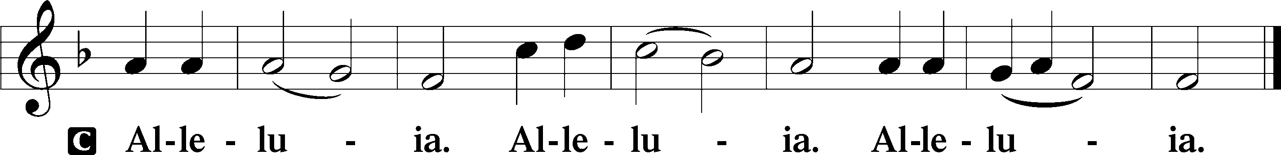

Holy Gospel: Luke 10:23–37 (NKJV)
P The Holy Gospel according to St. Luke, the tenth chapter.
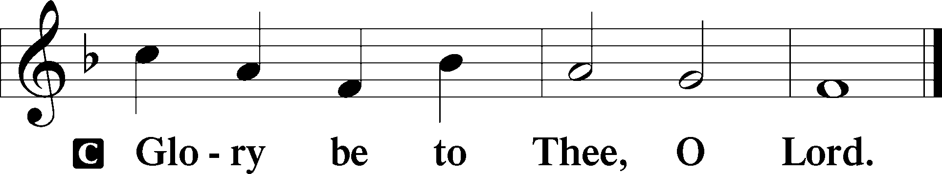

At that time Jesus said to His disciples: “Blessed are the eyes which see the things you see; for I tell you that many prophets and kings have desired to see what you see, and have not seen it, and to hear what you hear, and have not heard it.” And behold, a certain lawyer stood up and tested Him, saying, “Teacher, what shall I do to inherit eternal life?” He said to him, “What is written in the law? What is your reading of it?” So he answered and said, “ ‘You shall love the Lord your God with all your heart, with all your soul, with all your strength, and with all your mind,’ and ‘your neighbor as yourself.’ ” And He said to him, “You have answered rightly; do this and you will live.” But he, wanting to justify himself, said to Jesus, “And who is my neighbor?” Then Jesus answered and said: “A certain man went down from Jerusalem to Jericho, and fell among thieves, who stripped him of his clothing, wounded him, and departed, leaving him half dead. Now by chance a certain priest came down that road. And when he saw him, he passed by on the other side. Likewise a Levite, when he arrived at the place, came and looked, and passed by on the other side. But a certain Samaritan, as he journeyed, came where he was. And when he saw him, he had compassion. So he went to him and bandaged his wounds, pouring on oil and wine; and he set him on his own animal, brought him to an inn, and took care of him. On the next day, when he departed, he took out two denarii, gave them to the innkeeper, and said to him, ‘Take care of him; and whatever more you spend, when I come again, I will repay you.’ So which of these three do you think was neighbor to him who fell among the thieves?” And he said, “He who showed mercy on him.” Then Jesus said to him, “Go and do likewise.”

P This is the Gospel of the Lord.
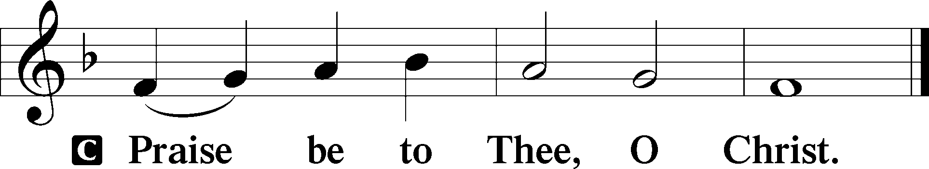

Nicene Creed
C I believe in one God,
the Father Almighty,
maker of heaven and earth
and of all things visible and invisible.
And in one Lord Jesus Christ,
the only-begotten Son of God,
begotten of His Father before all worlds,
God of God, Light of Light,
very God of very God,
begotten, not made,
being of one substance with the Father,
by whom all things were made;
who for us men and for our salvation came down from heaven
and was incarnate by the Holy Spirit of the virgin Mary
and was made man;
and was crucified also for us under Pontius Pilate.
He suffered and was buried.
And the third day He rose again according to the Scriptures
and ascended into heaven
and sits at the right hand of the Father.
And He will come again with glory to judge both the living and the dead,
whose kingdom will have no end.

And I believe in the Holy Spirit,
the Lord and giver of life,
who proceeds from the Father and the Son,
who with the Father and the Son together is worshiped and glorified,
who spoke by the prophets.
And I believe in one holy Christian and apostolic Church,
I acknowledge one Baptism for the remission of sins,
and I look for the resurrection of the dead
and the life T of the world to come. Amen.
Sit

Hymn of the Day: LSB #683 “Jesus, Thy Boundless Love to Me”

Sermon

Stand

Offertory Psalm 51:10–12
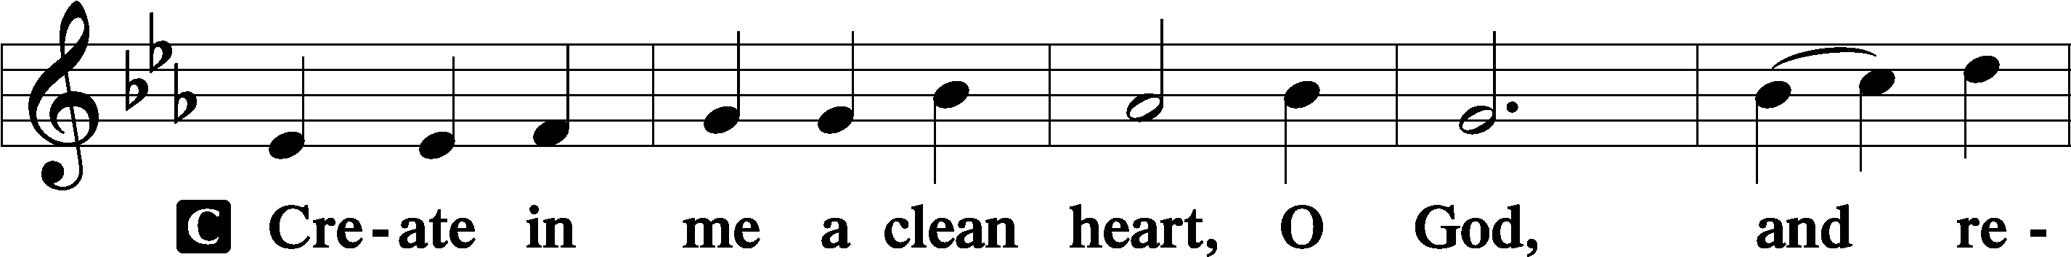
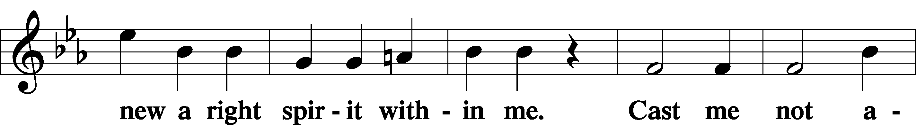
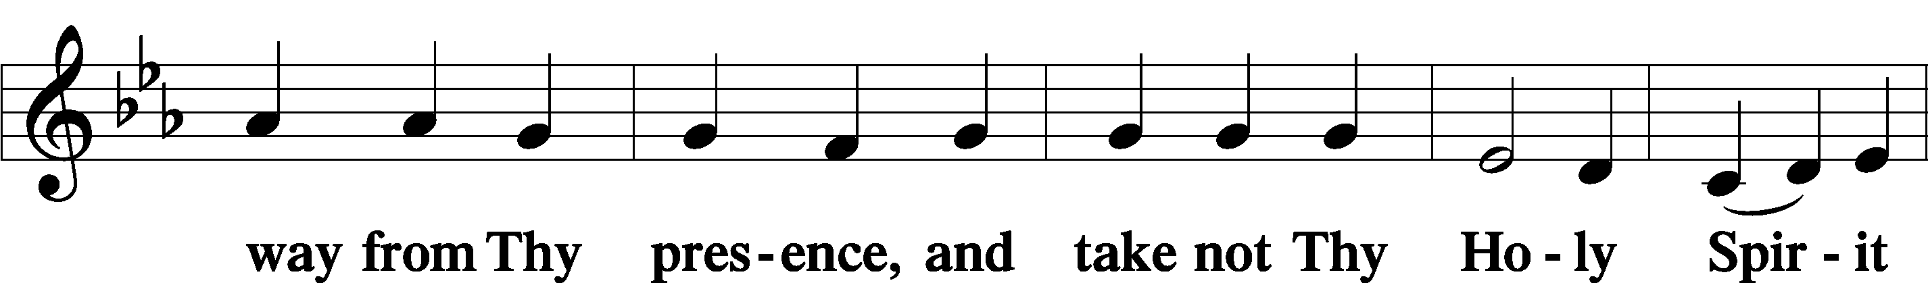
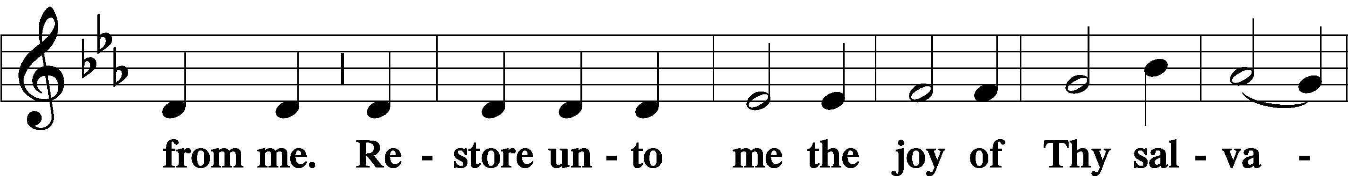
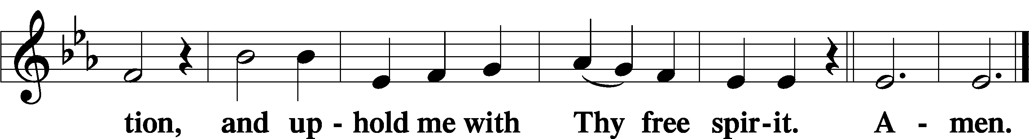

Prayer of the Church

Sit

Preparatory Hymn: LSB #852 “O God of Mercy, God of Might”

Stand

Service of the Sacrament

Preface 2 Timothy 4:22; Colossians 3:1 Psalm 136
P The Lord be with you.
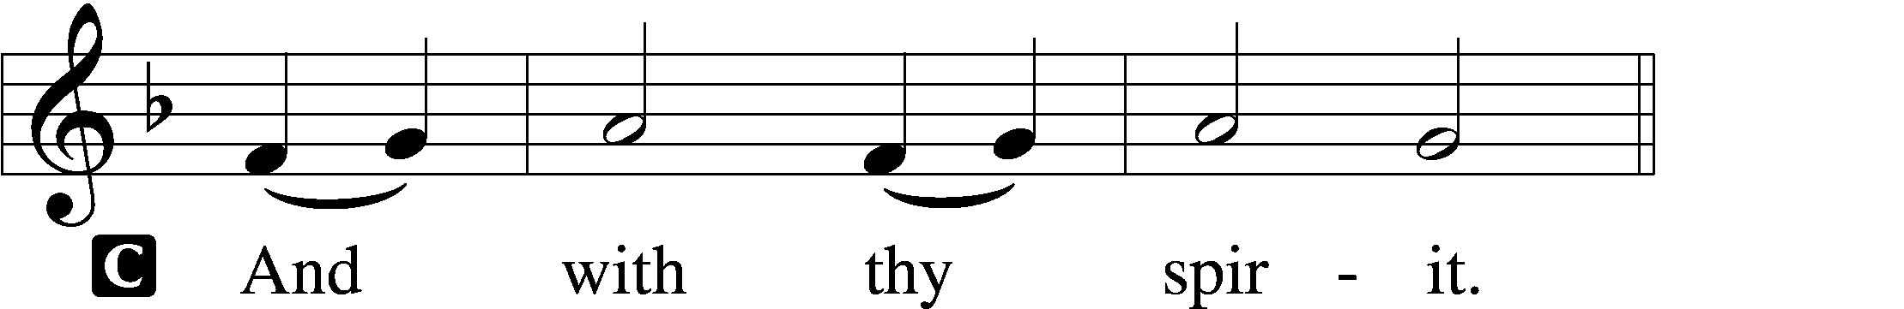
P Lift up your hearts.
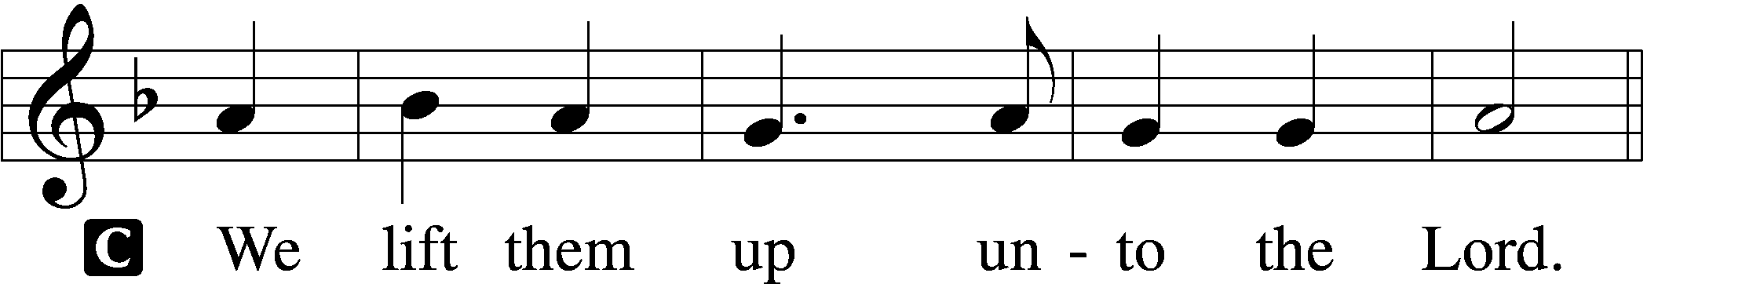

P Let us give thanks unto the Lord, our God.
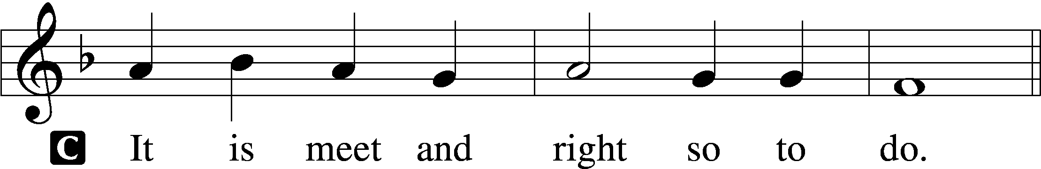

Proper Preface (Abbreviated) LSB 194
P It is truly meet, right, and salutary . . . evermore praising You and saying:

Sanctus Isaiah 6:3; Matthew 21:9
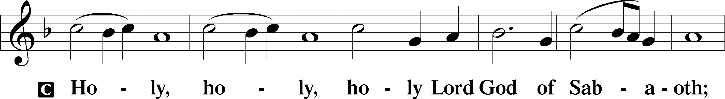
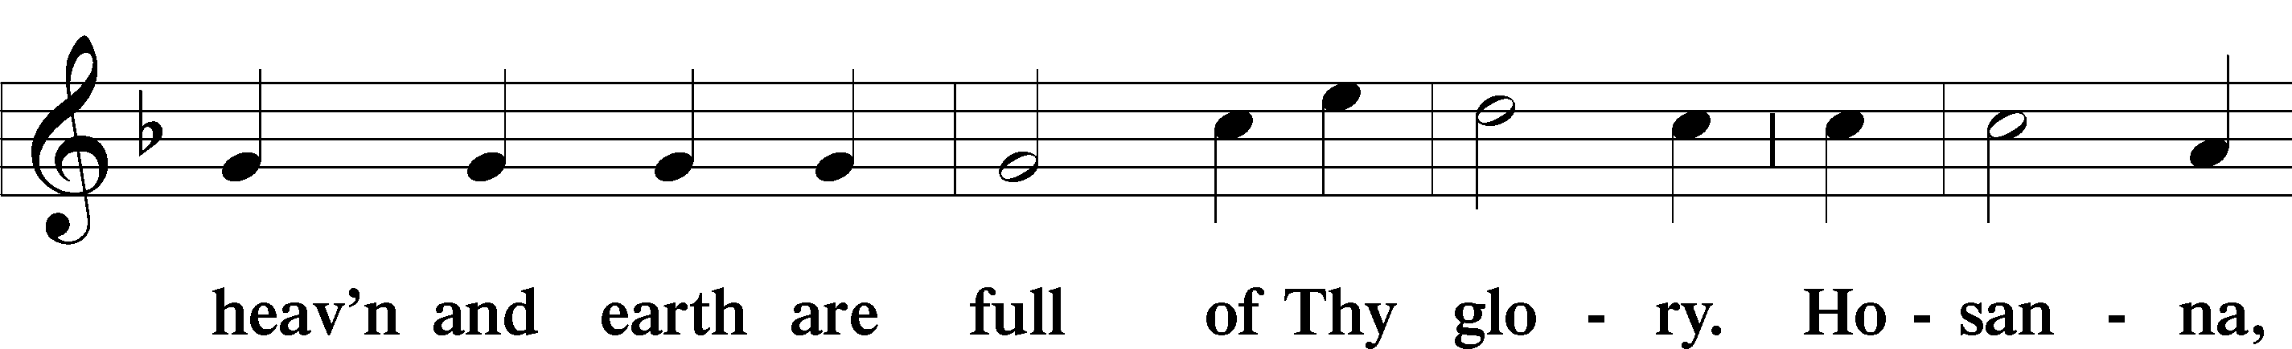
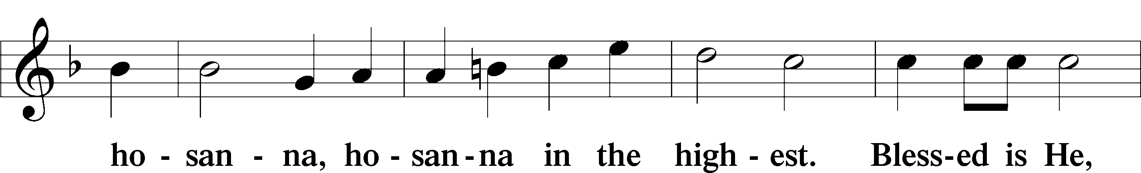
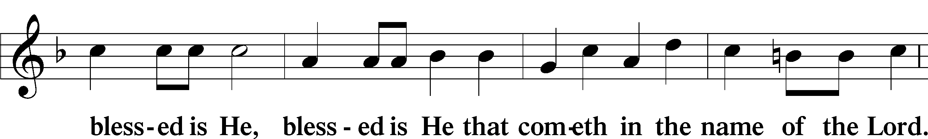
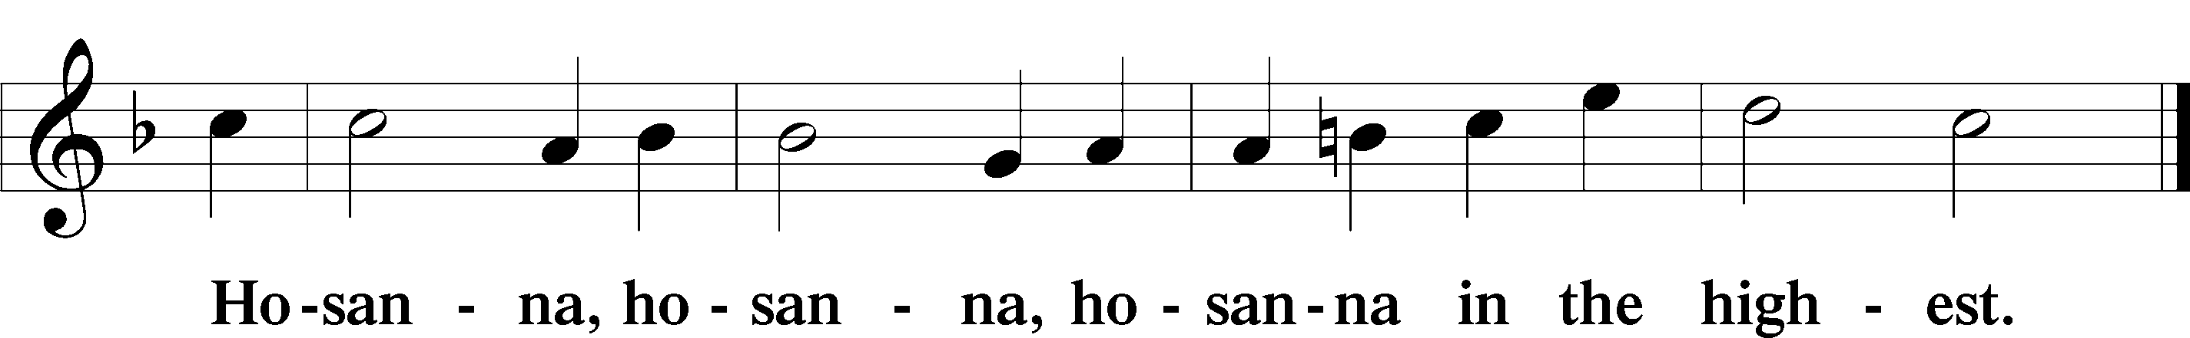

Lord’s Prayer Matthew 6:9–13
C Our Father who art in heaven,
hallowed be Thy name,
Thy kingdom come,
Thy will be done on earth as it is in heaven;
give us this day our daily bread;
and forgive us our trespasses as we forgive those who trespass against us;
and lead us not into temptation,
but deliver us from evil.
For Thine is the kingdom and the power and the glory forever and ever. Amen.

The Words of Our Lord Matthew 26:26–28; Mark 14:22–24; Luke 22:19–20; 1 Corinthians 11:23–25
P Our Lord Jesus Christ, on the night when He was betrayed, took bread, and when He had given thanks, He broke it and gave it to the disciples and said: “Take, eat; this is My T body, which is given for you. This do in remembrance of Me.”

In the same way also He took the cup after supper, and when He had given thanks, He gave it to them, saying: “Drink of it, all of you; this cup is the new testament in My T blood, which is shed for you for the forgiveness of sins. This do, as often as you drink it, in remembrance of Me.”

Pax Domini John 20:19
P The peace of the Lord be with you always.
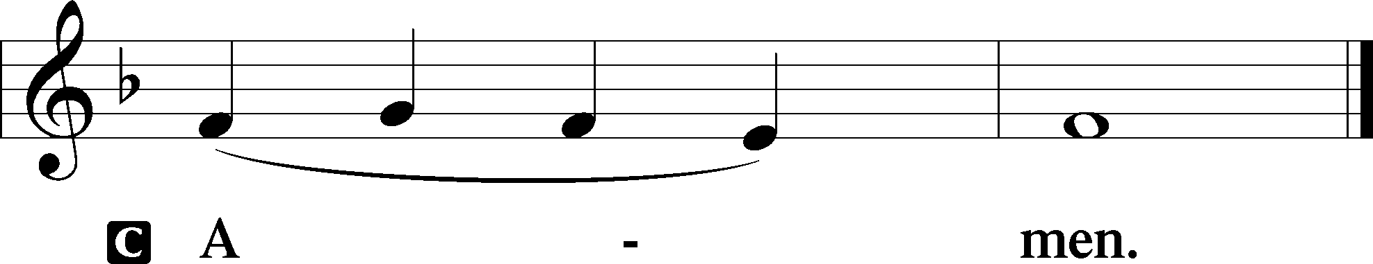

Agnus Dei John 1:29
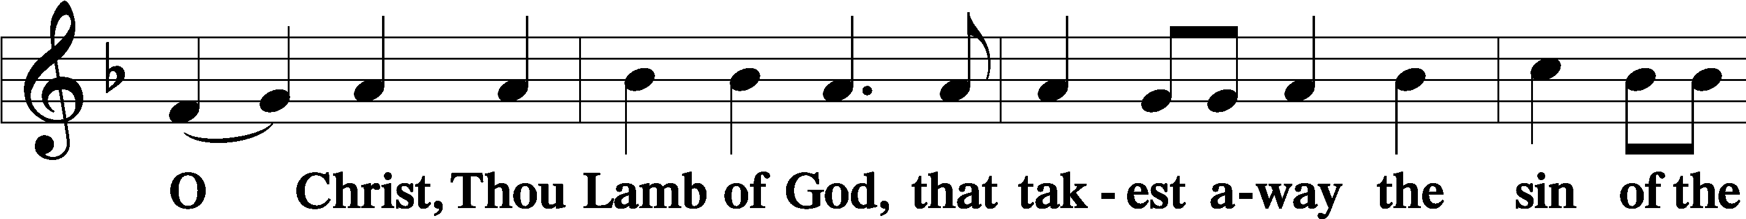
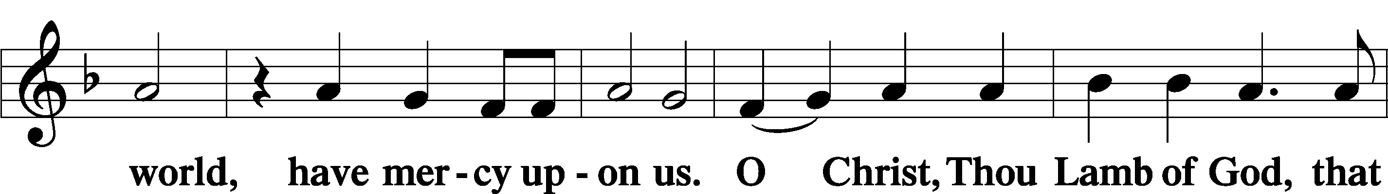
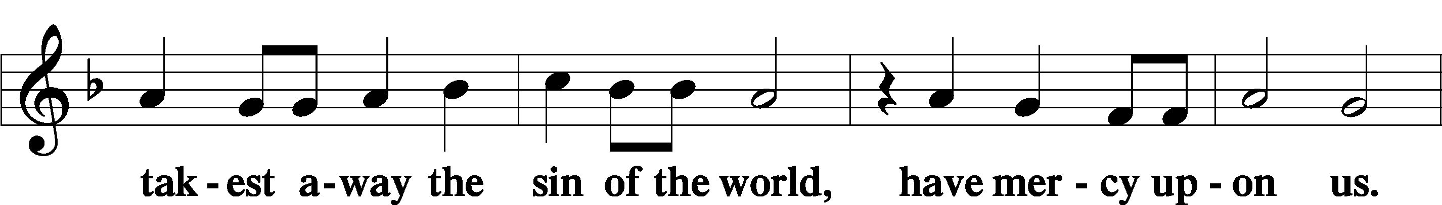
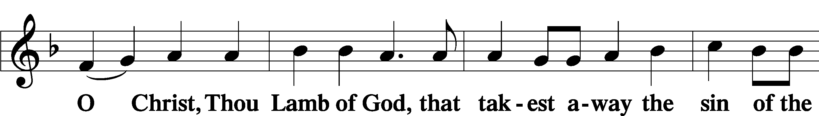
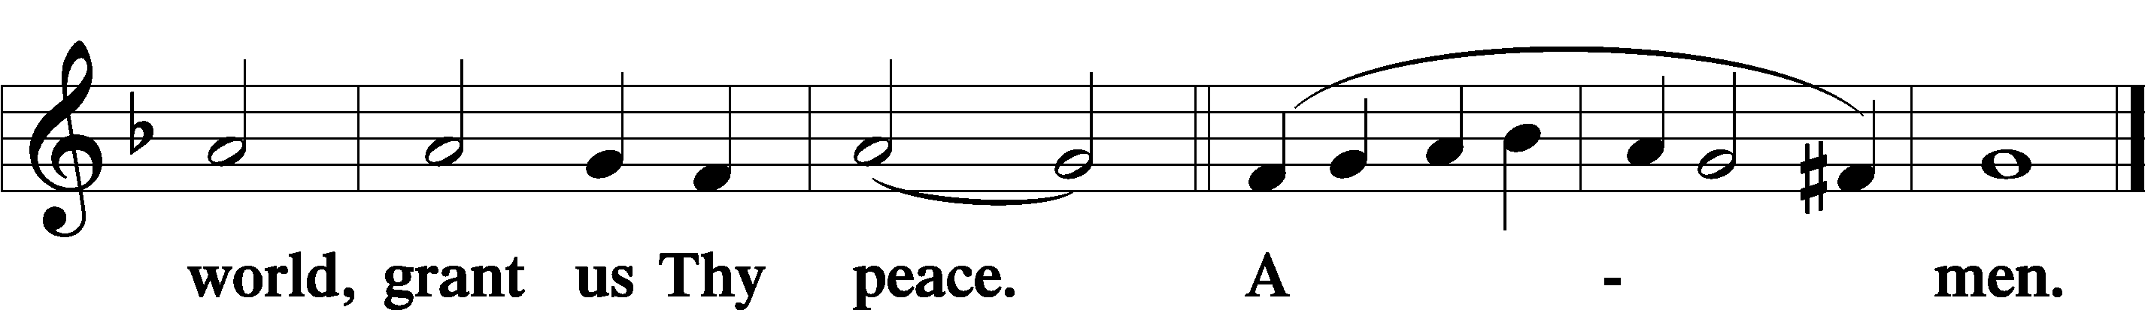
Sit

Distribution
The pastor and those who assist him receive the body and blood of Christ first and then distribute them to those who come to receive, saying:
Take, eat; this is the true body of our Lord and Savior Jesus Christ, given into death for your sins.
Amen.

Take, drink; this is the true blood of our Lord and Savior Jesus Christ, shed for the forgiveness of your sins.
Amen.

In dismissing the communicants, the following is said:
The Dismissal
P The body and blood of our Lord Jesus Christ strengthen and preserve you in body and soul to life everlasting. Depart T in peace.
C Amen.

Distribution Hymn: LSB #637 “Draw Near and Take the Body of the Lord”

Distribution Hymn: LSB #798 “The God of Abraham Praise”

Nunc Dimittis Luke 2:29–32
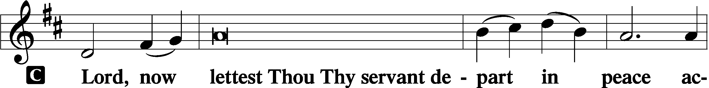
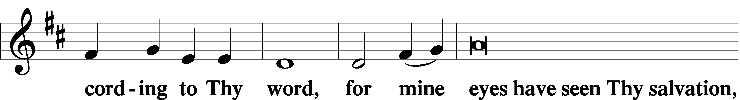
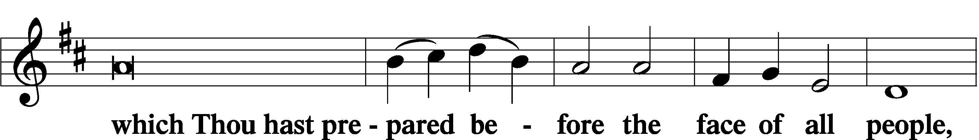
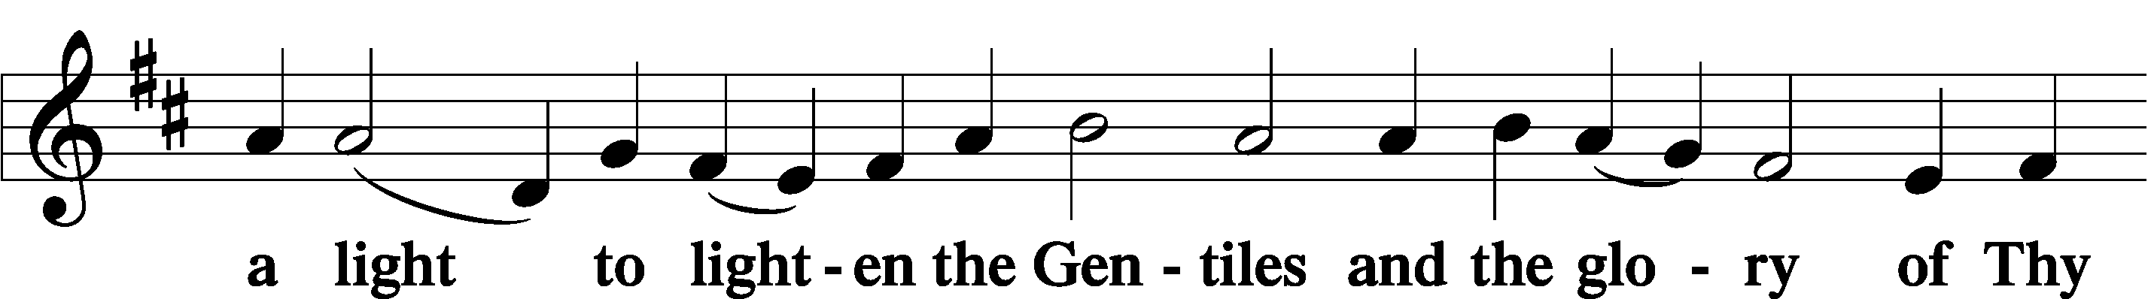
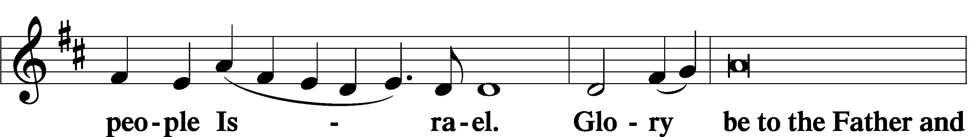
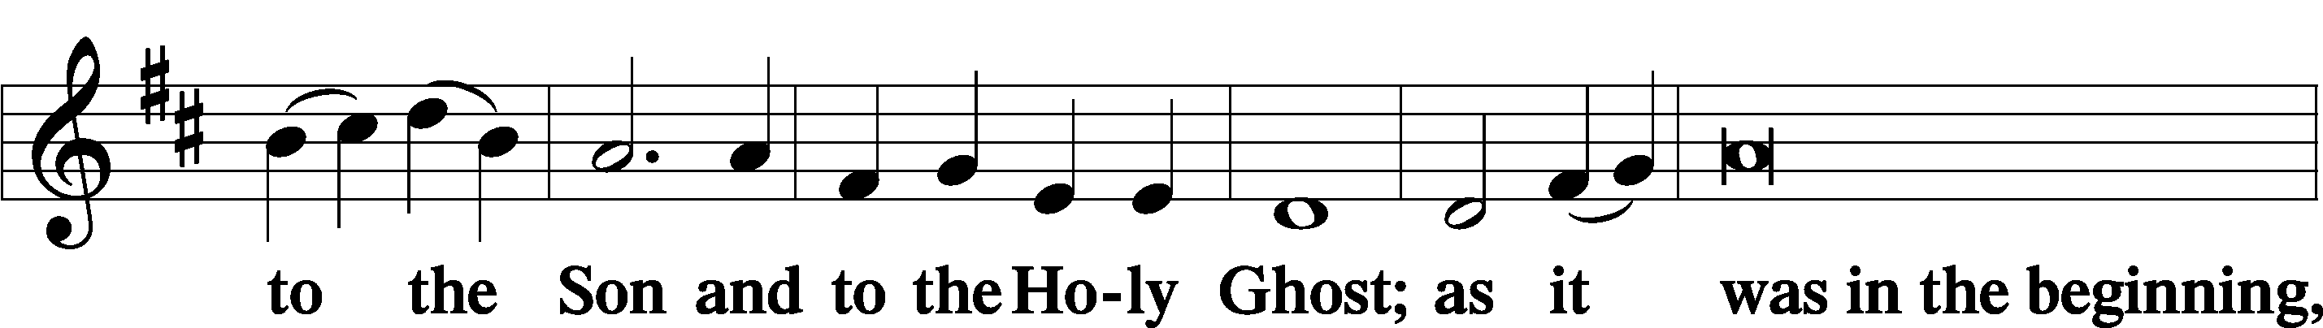
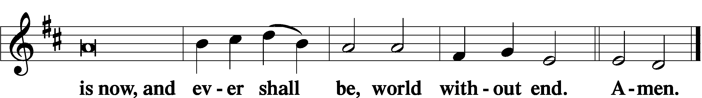

Thanksgiving Psalm 107:1
P O give thanks unto the Lord, for He is good,
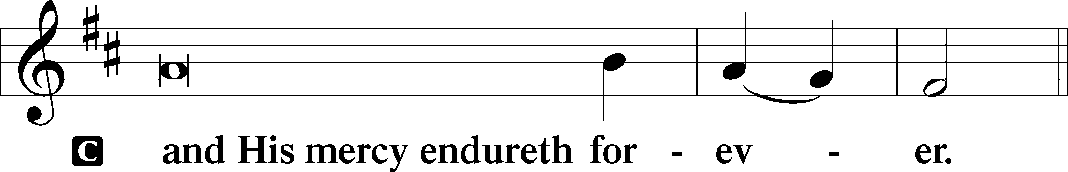

Post-Communion Collect
P Let us pray.
We give thanks to You, almighty God, that You have refreshed us through this salutary gift, and we implore You that of Your mercy You would strengthen us through the same in faith toward You and in fervent love toward one another; through Jesus Christ, Your Son, our Lord, who lives and reigns with You and the Holy Spirit, one God, now and forever.
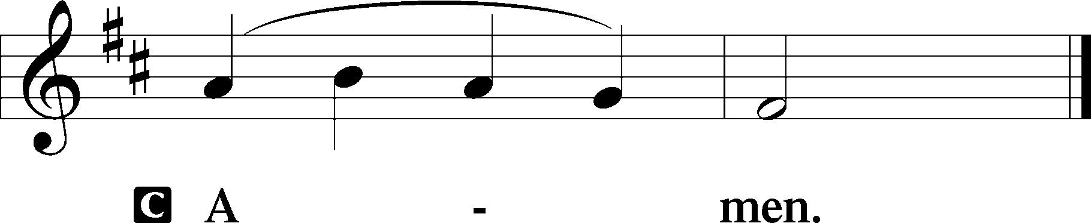

Salutation 2 Timothy 4:22
P The Lord be with you.
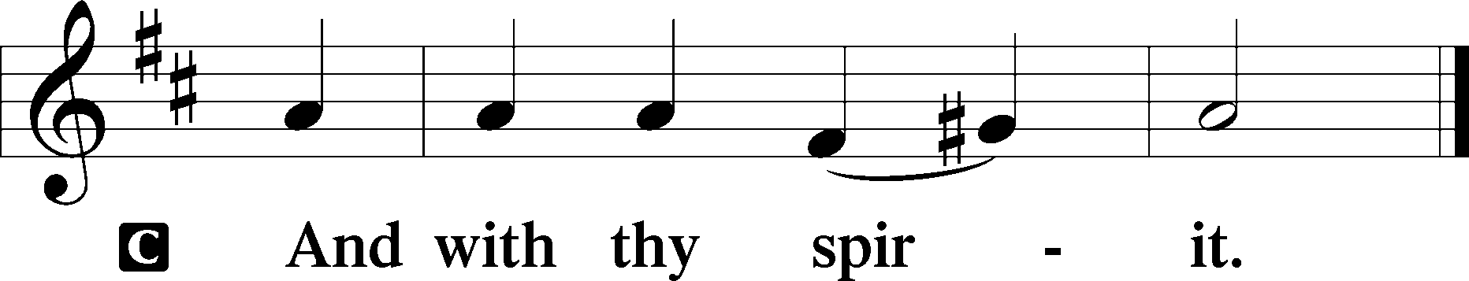

Benedicamus Psalm 103:1
P Bless we the Lord.
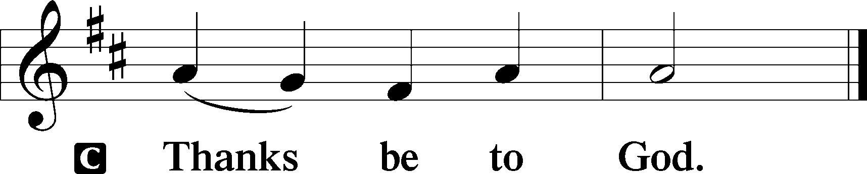

Benediction Numbers 6:24–26
P The Lord bless you and keep you.
The Lord make His face shine upon you and be gracious unto you.
The Lord lift up His countenance upon you and T give you peace.
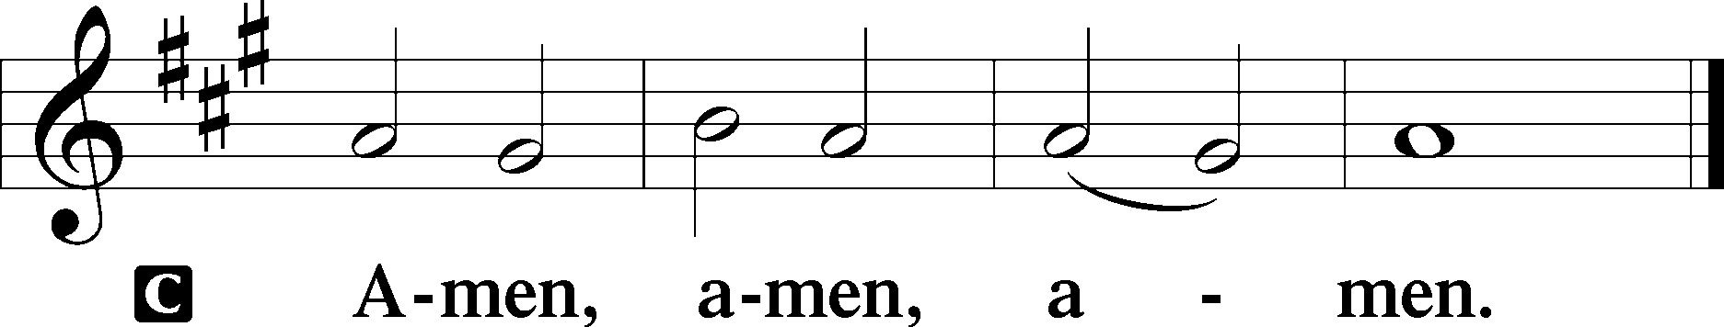

Closing Hymn: LSB #685 “Let Us Ever Walk with Jesus”

Silent prayer after worship: Heavenly Father, stay with me as I go forth from this worship service. Lead me to be in Your Word and to pray with bold faith, trusting in Your mercy through Jesus Christ who died and rose for all people.
fffffffffffffffffffffffffffffffffff
Acknowledgments
Unless otherwise indicated, Scripture quotations are from the ESV® Bible (The Holy Bible, English Standard Version®), copyright © 2001 by Crossway, a publishing ministry of Good News Publishers. Used by permission. All rights reserved.
Created by Lutheran Service Builder © 2023 Concordia Publishing House.

SCHEDULE THROUGH SEPTEMBER 10, 2023:

:

Today, 7 pm, Fellowship Hall: AA Meeting
Tuesday, 7-9 pm, Fellowship Hall: Penn-Ohio Singers
Wednesday, 7:30 pm, Fellowship Hall: NA Meeting
Thursday, 10 am, Fellowship Hall: Women’s Bible Study
Next Sunday, 8 am, Fellowship Hall: Bible Study
9 am, Sanctuary: Divine Service
Following, Fellowship Hall: Coffee Fellowship
7 pm, Fellowship Hall: AA Meeting
fffffffffffffffffffffffffffffffffff
Attendance: Sunday, August 27, 2023: 27
fffffffffffffffffffffffffffffffffff
Our Stewardship of Treasures for the Lord:
In order to do the Lord’s work, we need $2,553.63 each week to meet our 2023 budget for general purposes and $76.92 for the SELC.
Online Figures (08/02, 08/03, 08/14, & 08/17/2023)
General Fund: $710.00
SELC: $100.00
Food Pantry: $100.00
Capital Campaign: $200.00

Figures for Sunday, August 27, 2023
General Fund: $1,556.00 Behind for the week: -$997.63
SELC: $35.00 Behind for the week: -$41.92
Quarterly Missions: $35.00
Capital Campaign: $375.00

For online giving, check out https://www.saintspeterandpaul.net/online-giving.
fffffffffffffffffffffffffffffffffff
THANK YOU FOR SERVING IN SEPTEMBER: Elder: Jonathan Baisch; Ushers: Mark Kleindienst, Jerry Krivosh, & Gordon Marquette; Altarware: (prior) Diane Riefstahl; (after) Arlene Sutton (09.10), Kati Laird (09.03, 09.17, and 09/24), and Hank Holcroft (all).
Bible Memory Verses ~ Week of September 3rd:
For Adults: He who did not spare his own Son but gave him up for us all, how will he not also with him graciously give us all things? Romans 8:32
For Children: As you did it to one of the least of these my brothers, you did it to me. Matthew 25:40
fffffffffffffffffffffffffffffffffff
Sunday Morning Bible Study has resumed. We are continuing our study of the minor prophets. All are welcome to join!
fffffffffffffffffffffffffffffffffff
Available this morning:
- Copies of the September issue of “The Rock and the Sword” newsletter (narthex and table near nursery).
- Minutes from the August 20, 2023, Voters’ Assembly
fffffffffffffffffffffffffffffffffff
Reminders!
- SCRIP orders and payments may be given to Matt Berent this morning.
- Next Sunday is “Stock the Food Pantry” Sunday. Your financial contributions will be greatly appreciated. Donations may be placed in a pew envelope and put in the offering plate.
- Join us following worship next Sunday for Coffee Fellowship! September’s sponsors are Ruth Meszaros and Joani Rice. We are still seeking sponsors for October and November. If interested, please sign the sheet in the narthex.
- The next Altar Guild meeting will be held Saturday, September 16th beginning at 1 pm. All women are welcome to join! September’s hostess will be Marie Flaugher.
fffffffffffffffffffffffffffffffffff
Secretary’s office hours for the week of September 3rd:
- Open Labor Day, Sept. 4th, 8:30 am – noon. (This is a new change.)
- Open Wednesday, Sept. 6th, 8:30 am-1 pm.
- Open Thursday, Sept. 7th, 8:30 am-10 am; 11 am-5 pm.
fffffffffffffffffffffffffffffffffff

Remember the following in Prayer…
~The Hurting and Healing: Amy, Steve Antolovich, Ellen Baron^{CA}, Amy Blomenberg, Lois Bortner^{CA}, Sara Brubaker, Dee Bullock, Bev & Joe Chlpka, Susan Davies, Loretta Deal, Tim Dudash, Judith & Eddy Furey, Griffin, Austin Hamilton, Pastor Charles Henrickson, Joan, Keith Jozwiakowski, Darla Krajci, Barbara Kreske, Pastor Ed Kucera, Jess Lavoie, Elizabeth Loughan, Paul Lucas^{CA}, Sandy Marshall, Gene Moore, Frank Niemeyer^{CA}, Juanita Rentschler, Richard Reuning^{CA}, Nancy Robertson^{CA}, Landon Sargent, Kriss Svidro^{CA}, Joel & Peggy Wasson, Angela Weser^{CA}, and Ruth Wolf.
~The Homebound: Anna Mae Daris, Millie Elavsky, Rudy & Jean Tomko, Betty Wolf, and Ed & Millie Zachar.
~Celebrating this Week: Birthdays: Christine Hamilton (09.04), Michael A. Petro (09.05), Max Jelinek (09.07), Linda Tomko (09.08), Susan Daris (09.09), and Ruth Meszaros (09.09).
~Serving in the Military: Alex (Sasha) Carr, Curtis Sinewe, and Joshua Solyan.
~Community & World Needs: Those suffering from or affected by the coronavirus; those suffering due to the conflict between Ukraine and Russia; those suffering from loss and dislocation because weather disasters; those suffering from addiction and their families; Local, State, and National Government Leaders; safety for all Police Officers, Firefighters, & First Responders; the unemployed; our Third Quarter Local Mission: Luther Classical College.
*CA represents cancer.
fffffffffffffffffffffffffffffffffff
Our prayer list has been updated. If you would like someone’s name added or deleted from our Prayer List, please put a note in the secretary’s mail slot or email the church office. Thank you!
fffffffffffffffffffffffffffffffffff
Women’s Bible Study will be meeting this Thursday morning at 10 am. We will be beginning our study of the book of Romans. All are welcome to join!
fffffffffffffffffffffffffffffffffff

Here to Serve
Pastor………………………………………………...……………Rev. Jacob Deal
E-mail …………………………….……pastordeal@saintspeterandpaul.net
Phone Number……………………..…………………724-347-3620 (Option 2)
Church Office………………………..…………………724-347-3620 (Option 3)
Website …………………………………………www.saintspeterandpaul.net
Secretary…………………………………………………………Diane Riefstahl
E-mail ………………………………………church@saintspeterandpaul.net
Website …………………………………………www.saintspeterandpaul.net
Food Pantry (email): ……………foodpantry@saintspeterandpaul.net
Congregation President………………………………….…Jonathan Baisch
Church Elder …………………………………………...……. Jonathan Baisch
Organist………………………………………………..….…Rebecca Marquette
Choir Director…………………………………………………….…Chris Nelson
AA Contact: Steve………………………………………………...…724-813-2358
NA Contact: Larry……………………………………..…………..724-977-8733
fffffffffffffffffffffffffffffffffff
If needing to get into the church building during the week, please phone first to make certain someone is here to let you in.

