Sts. Peter & Paul
Evangelical Lutheran Church
Lutheran Church-Missouri Synod
Founded-1917

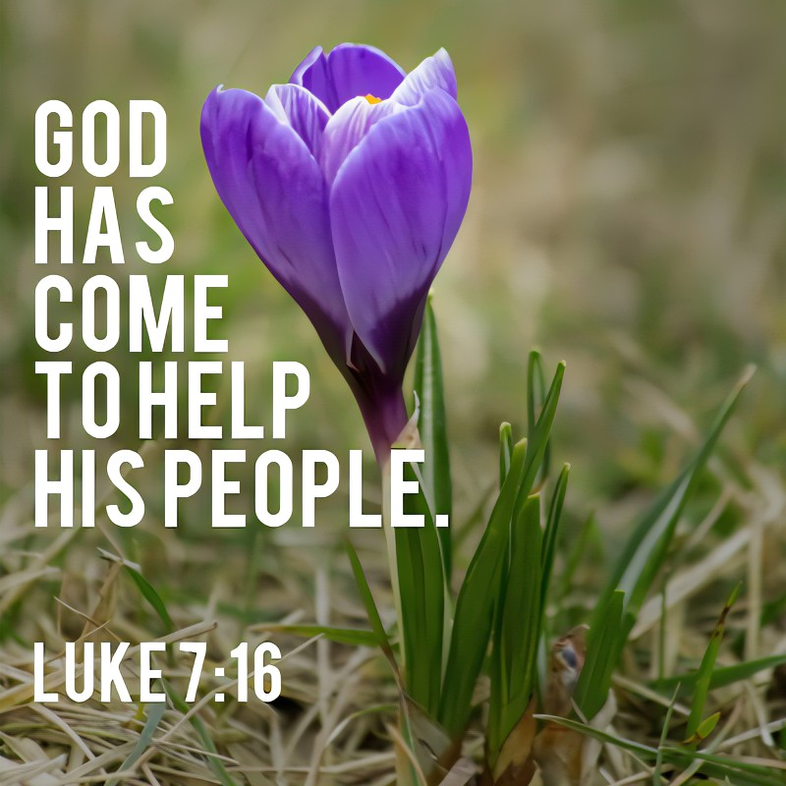

September 24, 2023

699 Stambaugh Ave.
Sharon, Pennsylvania 16146

“I was glad when they said to me,
Let us go to the house of the LORD!”
Psalm 122:1
Sts. Peter & Paul Evangelical Lutheran Church, LC-MS
THE SIXTEENTH SUNDAY AFTER TRINITY
September 24, 2023
A special welcome to our guests this day! If you would like more information about The Lutheran Church - Missouri Synod, or this congregation, please speak with Pastor Deal or an Elder after the service.
Members & Guests: Don’t be embarrassed if your children make noise during the worship service, all children do. We encourage families to worship together but, if you feel the need, there are pews in the rear of the Church which are reserved for young families on both sides of the sanctuary. There is also a quiet room available to you, located next to the sanctuary (formerly the Pastor’s office), where you would be able to follow along with the service.

Today’s service includes the Sacrament of Holy Communion. If during this past year, you have not worshipped with us and been communed, we respectfully ask that you do not partake of this sacrament this day before first speaking with Pastor Deal.
If visiting from a sister congregation of the LC-MS and are in good standing, please inform Pastor Deal of your desire to commune prior to the service.
If wishing to receive a blessing during communion, please approach with your arms crossed.

CONTACT INFORMATION
Pastor Deal: pastordeal@saintspeterandpaul.net or 724-347-3620 (opt. 2)
Church Office: church@saintspeterandpaul.net or 724-347-3620 (opt. 3)
Secretary’s Office: The office will be open Mon. & Thurs (8:30 am-4:30 pm).

Silent prayer before worship: Heavenly Father, cause my faith to grow by the power of Your Word so that I can come to You without fear, and trust in Your Son Jesus Christ for my salvation. In His name. Amen.

Confession and Absolution

Opening Hymn: LSB #544 “O Love, How Deep”

The sign of the cross may be made by all in remembrance of their Baptism.

Invocation
P In the name of the Father and of the T Son and of the Holy Spirit.
C Amen.

Exhortation Hebrews 10:22; Psalm 124:8; Psalm 32:5
P Beloved in the Lord! Let us draw near with a true heart and confess our sins unto God our Father, beseeching Him in the name of our Lord Jesus Christ to grant us forgiveness.

P Our help is in the name of the Lord,
C who made heaven and earth.
P I said, I will confess my transgressions unto the Lord,
C and You forgave the iniquity of my sin.

Silence for reflection on God’s Word and for self-examination.

Confession of Sins
P O almighty God, merciful Father,
C I, a poor, miserable sinner, confess unto You all my sins and iniquities with which I have ever offended You and justly deserved Your temporal and eternal punishment. But I am heartily sorry for them and sincerely repent of them, and I pray You of Your boundless mercy and for the sake of the holy, innocent, bitter sufferings and death of Your beloved Son, Jesus Christ, to be gracious and merciful to me, a poor, sinful being.

Absolution [John 20:19–23]
P Upon this your confession, I, by virtue of my office, as a called and ordained servant of the Word, announce the grace of God unto all of you, and in the stead and by the command of my Lord Jesus Christ I forgive you all your sins in the name of the Father and of the T Son and of the Holy Spirit.
C Amen.
Service of the Word

Introit Psalm 86:1, 7, 12–13; antiphon: vv. 3, 5
Be gracious to me, | O Lord,*
for to you do I cry | all the day.
For you, O Lord, are good and for- | giving,*
abounding in steadfast love to all who call up- | on you.
Incline your ear, O Lord, and | answer me,*
for I am poor and | needy.
In the day of my trouble I call up- | on you,*
for you | answer me.
I give thanks to you, O Lord my God, with | my whole heart,*
and I will glorify your name for- | ever.
For great is your steadfast | love toward me;*
you have delivered my soul from the depths | of Sheol.
Be gracious to me, | O Lord,*
for to you do I cry | all the day.
For you, O Lord, are good and for- | giving,*
abounding in steadfast love to all who call up- | on you.

Gloria Patri
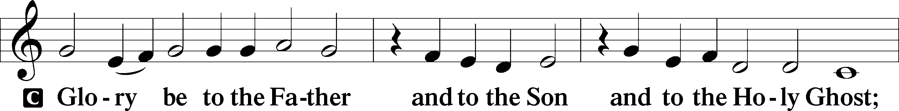
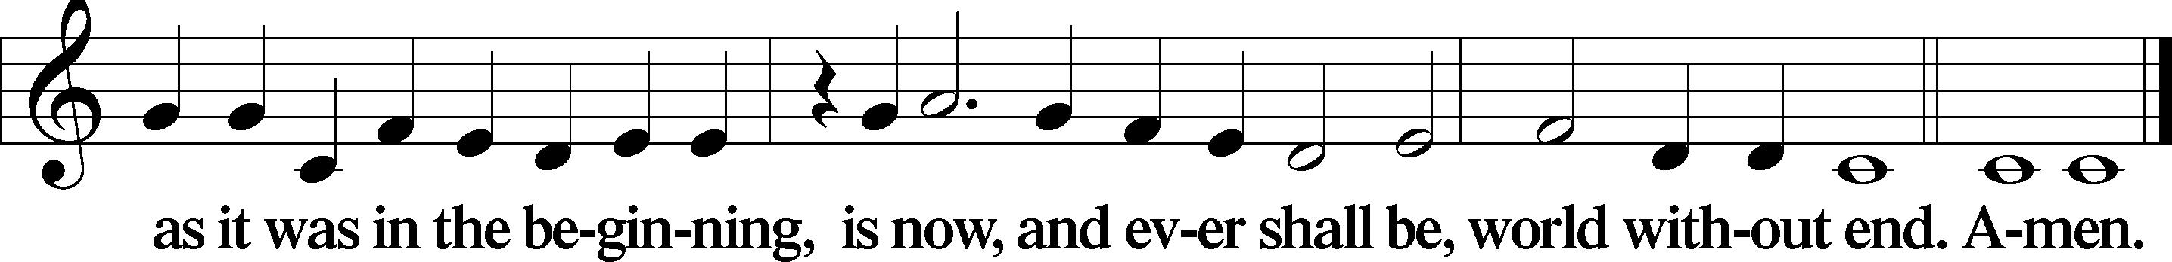
Kyrie Mark 10:47
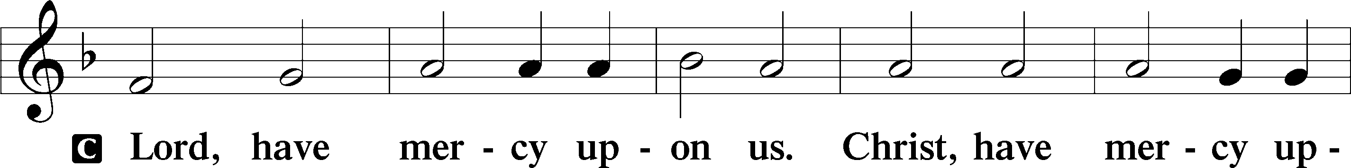
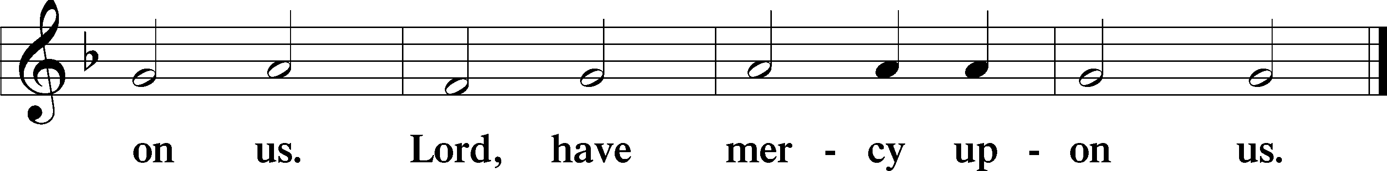

Gloria in Excelsis Luke 2:14; John 1:29
P Glory be to God on high:
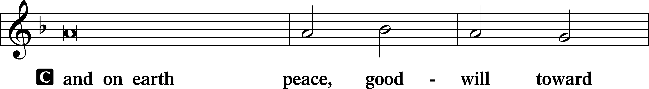
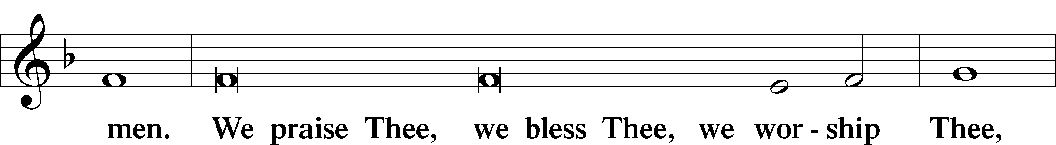
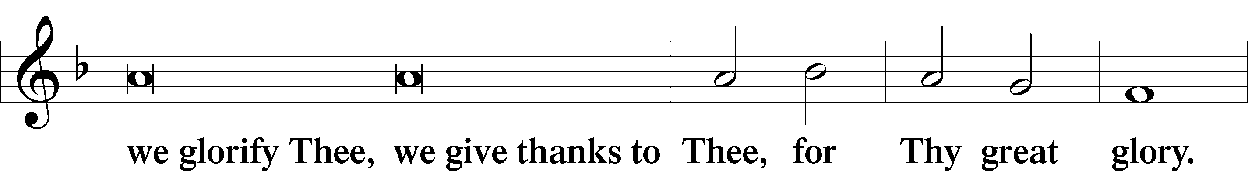
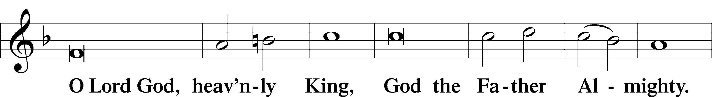
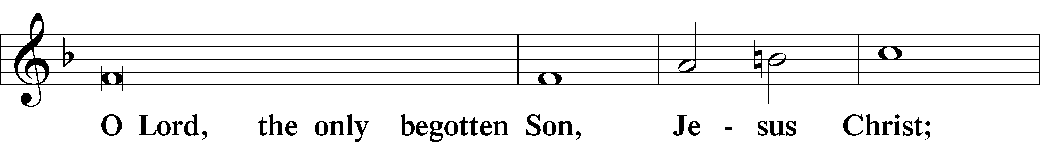
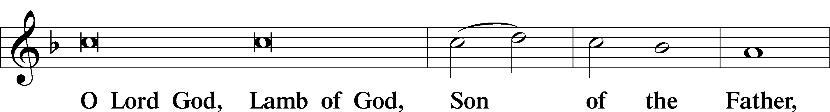
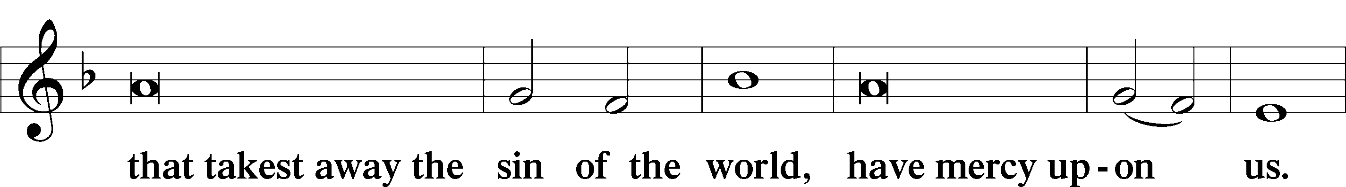
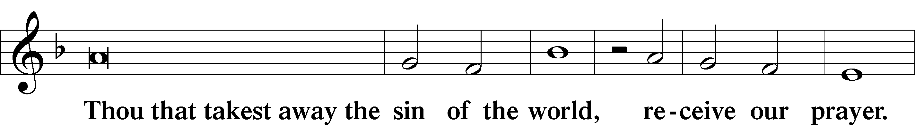
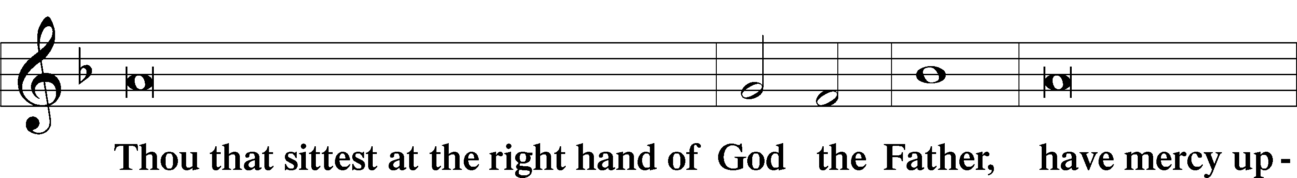
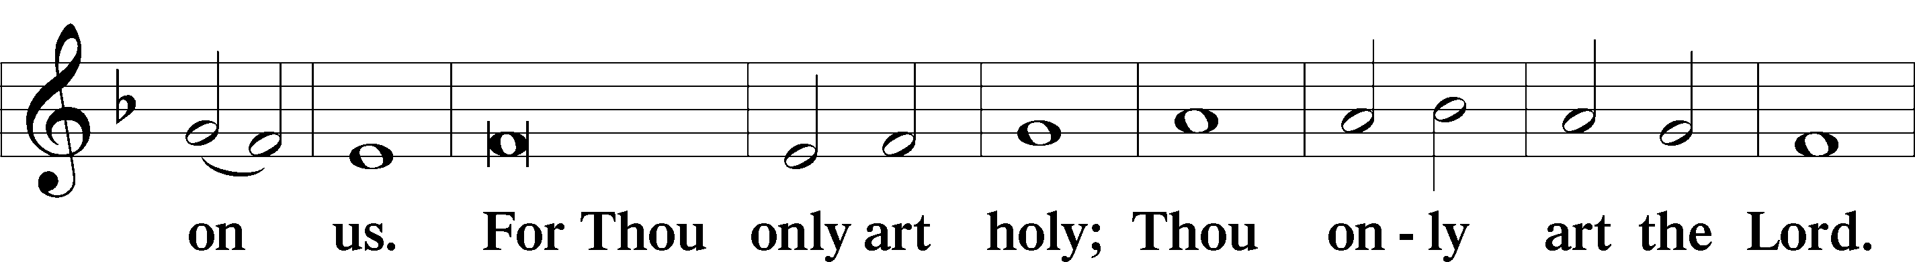
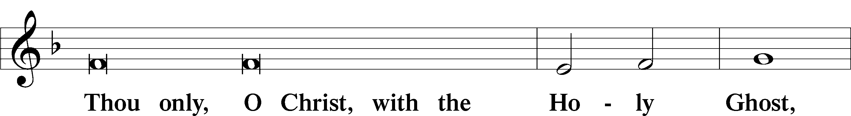
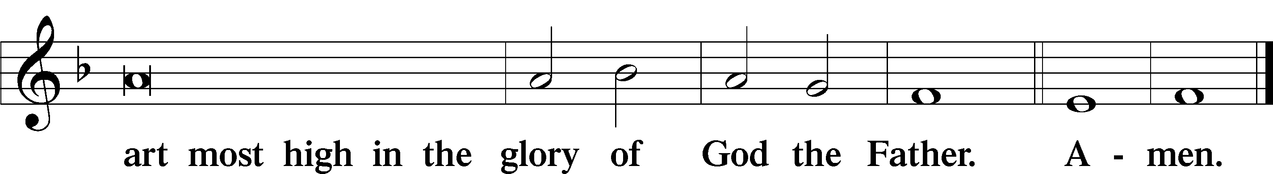

Salutation and Collect of the Day: Trinity 16
P The Lord be with you.
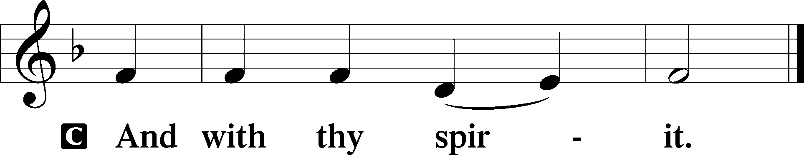

P Let us pray.
O Lord, we pray that Your grace may always go before and follow after us, that we may continually be given to all good works; through Jesus Christ, Your Son, our Lord, who lives and reigns with You and the Holy Spirit, one God, now and forever.
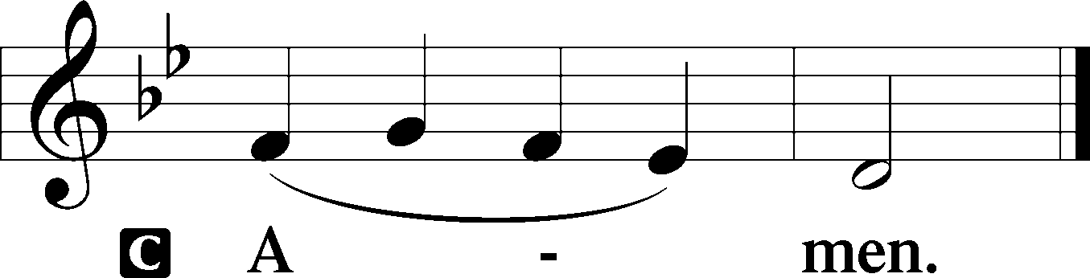
Sit

Prophecy: 1 Kings 17:17–24 (NKJV)
In those days: The son of the woman who owned the house became sick. And his sickness was so serious that there was no breath left in him. So she said to Elijah, “What have I to do with you, O man of God? Have you come to me to bring my sin to remembrance, and to kill my son?” And he said to her, “Give me your son.” So he took him out of her arms and carried him to the upper room where he was staying, and laid him on his own bed. Then he cried out to the Lord and said, “O Lord my God, have You also brought tragedy on the widow with whom I lodge, by killing her son?” And he stretched himself out on the child three times, and cried out to the Lord and said, “O Lord my God, I pray, let this child’s soul come back to him.” Then the Lord heard the voice of Elijah; and the soul of the child came back to him, and he revived. And Elijah took the child and brought him down from the upper room into the house, and gave him to his mother. And Elijah said, “See, your son lives!” Then the woman said to Elijah, “Now by this I know that you are a man of God, and that the word of the Lord in your mouth is the truth.”

P This is the Word of the Lord.
C Thanks be to God.

Gradual Psalm 102:15–16
Nations will fear the name | of the Lord,*
and all the kings of the earth will fear your | glory.
For the Lord builds up | Zion;*
he appears in his | glory.

Epistle: Ephesians 3:13–21 (NKJV)
Brethren: I ask that you do not lose heart at my tribulations for you, which is your glory. For this reason I bow my knees to the Father of our Lord Jesus Christ, from whom the whole family in heaven and earth is named, that He would grant you, according to the riches of His glory, to be strengthened with might through His Spirit in the inner man, that Christ may dwell in your hearts through faith; that you, being rooted and grounded in love, may be able to comprehend with all the saints what is the width and length and depth and height—to know the love of Christ which passes knowledge; that you may be filled with all the fullness of God. Now to Him who is able to do exceedingly abundantly above all that we ask or think, according to the power that works in us, to Him be glory in the church by Christ Jesus to all generations, forever and ever. Amen.

P This is the Word of the Lord.
C Thanks be to God.

Stand

Verse Psalm 115:11
Alleluia. You who fear the Lord, trust in the Lord! He is their help and their shield. Alleluia.

Alleluia
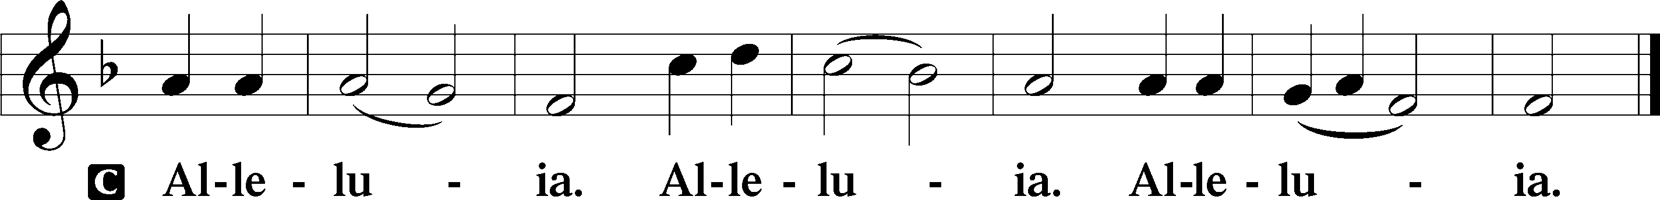

Holy Gospel: Luke 7:11–16 (NKJV)
P The Holy Gospel according to St. Luke, the seventh chapter.
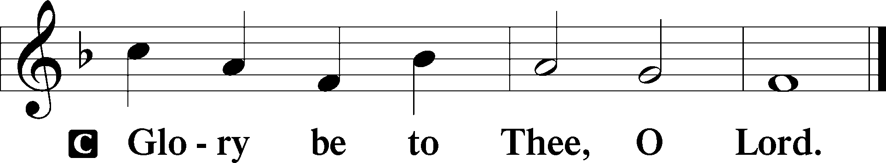

At that time: Jesus went into a city called Nain; and many of His disciples went with Him, and a large crowd. And when He came near the gate of the city, behold, a dead man was being carried out, the only son of his mother; and she was a widow. And a large crowd from the city was with her. When the Lord saw her, He had compassion on her and said to her, “Do not weep.” Then He came and touched the open coffin, and those who carried him stood still. And He said, “Young man, I say to you, arise.” So he who was dead sat up and began to speak. And He presented him to his mother. Then fear came upon all, and they glorified God, saying, “A great prophet has risen up among us”; and, “God has visited His people.”

P This is the Gospel of the Lord.
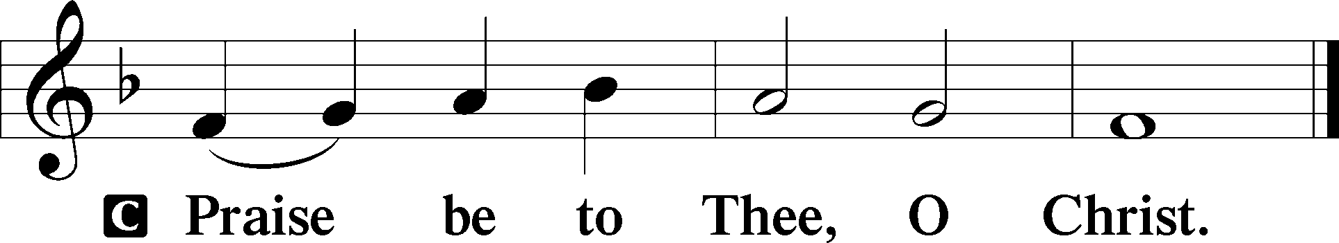

Nicene Creed
C I believe in one God,
the Father Almighty,
maker of heaven and earth
and of all things visible and invisible.

And in one Lord Jesus Christ,
the only-begotten Son of God,
begotten of His Father before all worlds,
God of God, Light of Light,
very God of very God,
begotten, not made,
being of one substance with the Father,
by whom all things were made;
who for us men and for our salvation came down from heaven
and was incarnate by the Holy Spirit of the virgin Mary
and was made man;
and was crucified also for us under Pontius Pilate.
He suffered and was buried.
And the third day He rose again according to the Scriptures
and ascended into heaven
and sits at the right hand of the Father.
And He will come again with glory to judge both the living and the dead,
whose kingdom will have no end.

And I believe in the Holy Spirit,
the Lord and giver of life,
who proceeds from the Father and the Son,
who with the Father and the Son together is worshiped and glorified,
who spoke by the prophets.
And I believe in one holy Christian and apostolic Church,
I acknowledge one Baptism for the remission of sins,
and I look for the resurrection of the dead
and the life T of the world to come. Amen.
Sit

Hymn of the Day: LSB #758 “The Will of God Is Always Best”

Sermon

Stand

Offertory Psalm 51:10–12
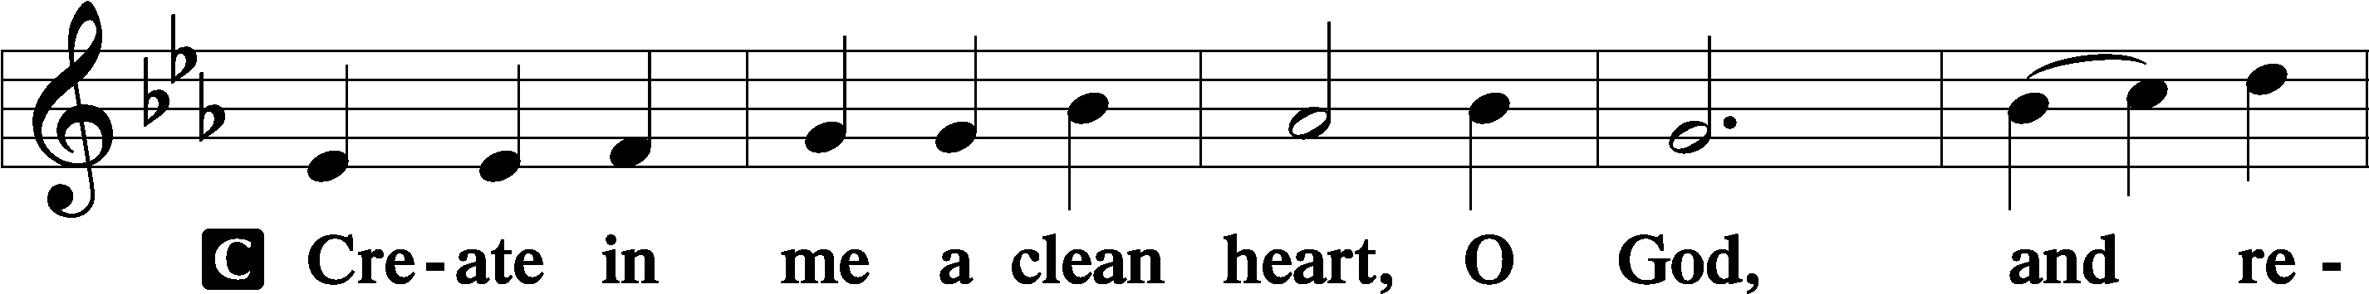
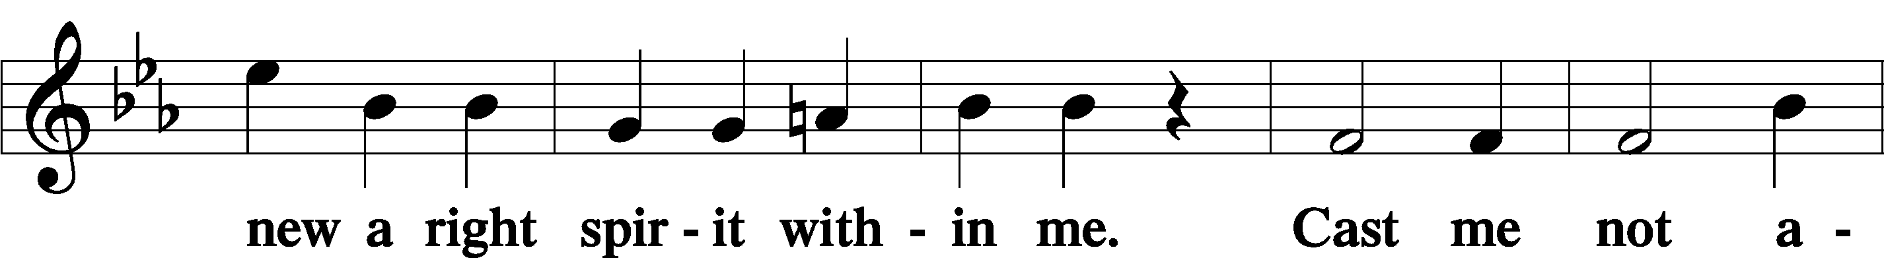
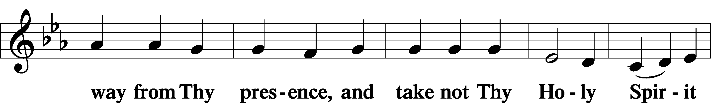
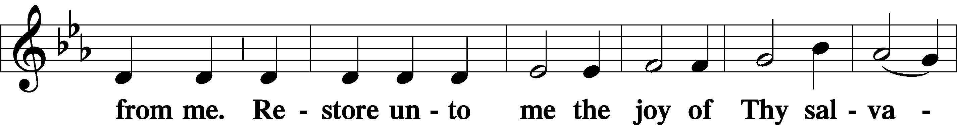
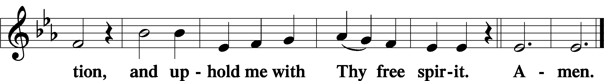

Prayer of the Church

Sit

Preparatory Hymn: LSB #755 “In the Very Midst of Life”

Stand
Service of the Sacrament

Preface 2 Timothy 4:22; Colossians 3:1 Psalm 136
P The Lord be with you.
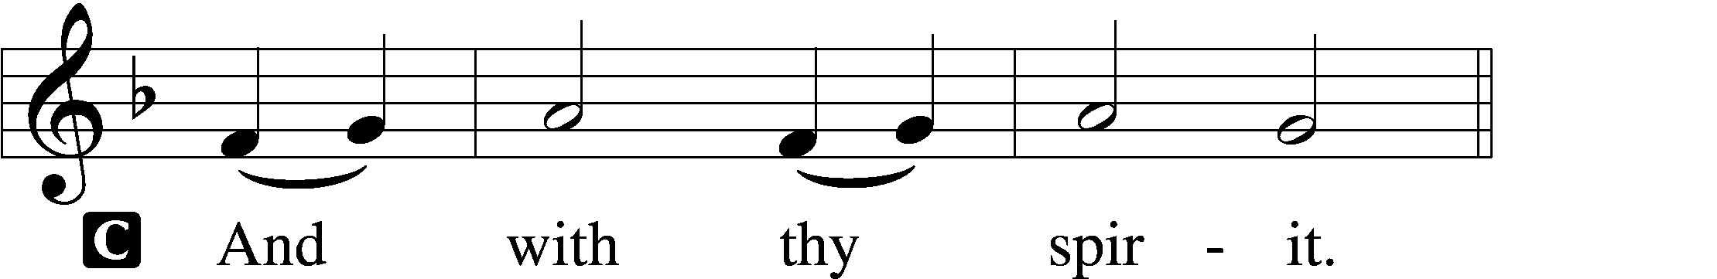

P Lift up your hearts.
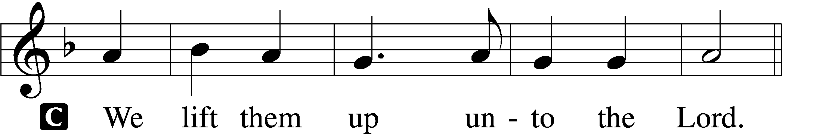

P Let us give thanks unto the Lord, our God.
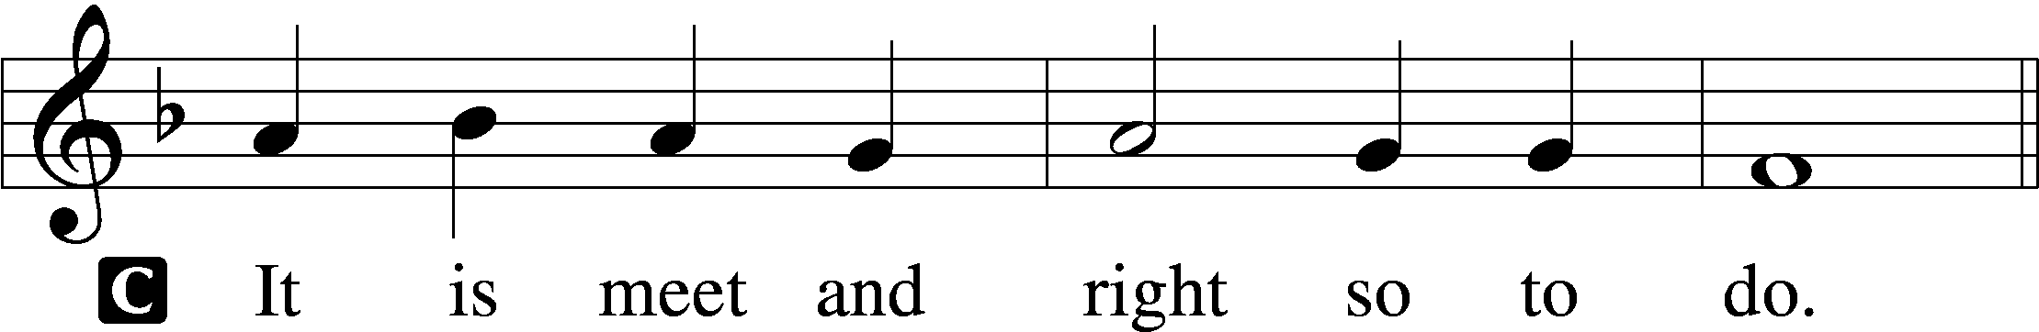

Proper Preface (Abbreviated) LSB 194
P It is truly meet, right, and salutary . . . evermore praising You and saying:

Sanctus Isaiah 6:3; Matthew 21:9
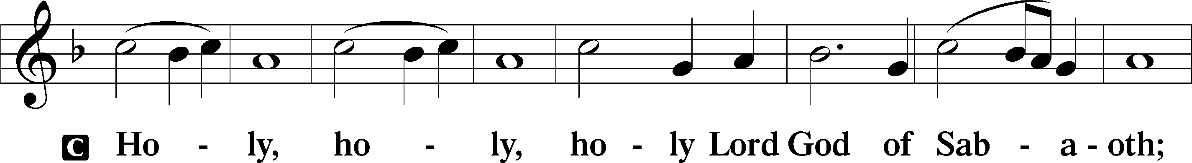
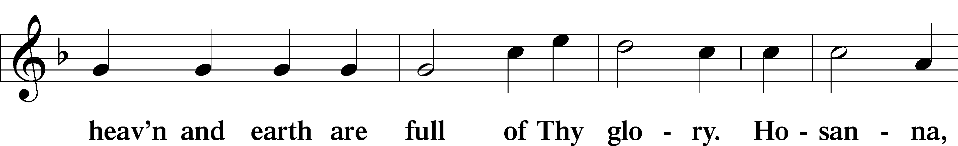
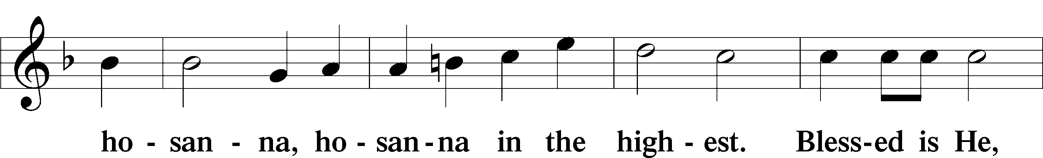
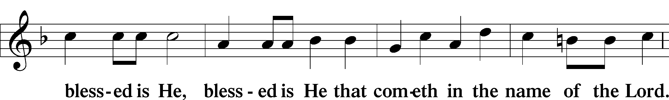
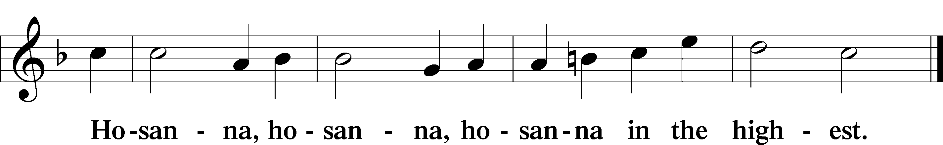

Lord’s Prayer Matthew 6:9–13
C Our Father who art in heaven,
hallowed be Thy name,
Thy kingdom come,
Thy will be done on earth as it is in heaven;
give us this day our daily bread;
and forgive us our trespasses as we forgive those who trespass against us;
and lead us not into temptation,
but deliver us from evil.
For Thine is the kingdom and the power and the glory forever and ever. Amen.

The Words of Our Lord Matthew 26:26–28; Mark 14:22–24; Luke 22:19–20; 1 Corinthians 11:23–25
P Our Lord Jesus Christ, on the night when He was betrayed, took bread, and when He had given thanks, He broke it and gave it to the disciples and said: “Take, eat; this is My T body, which is given for you. This do in remembrance of Me.”

In the same way also He took the cup after supper, and when He had given thanks, He gave it to them, saying: “Drink of it, all of you; this cup is the new testament in My T blood, which is shed for you for the forgiveness of sins. This do, as often as you drink it, in remembrance of Me.”

Pax Domini John 20:19
P The peace of the Lord be with you always.
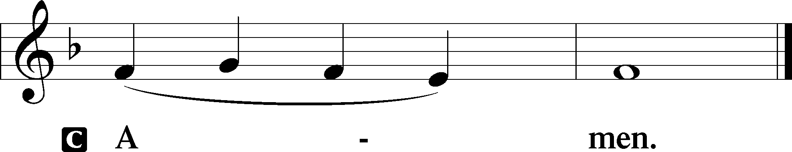

Agnus Dei John 1:29
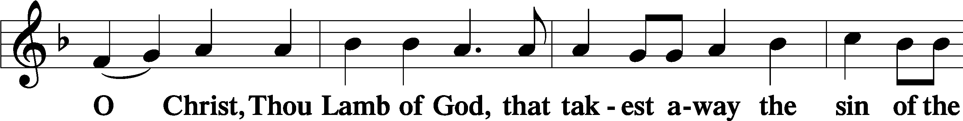
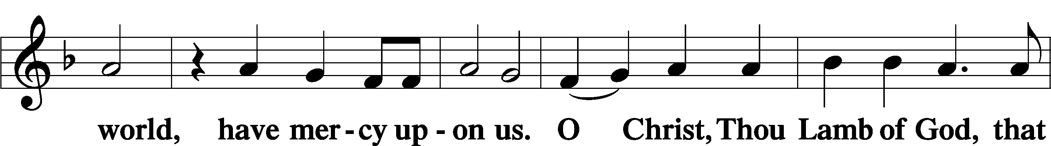
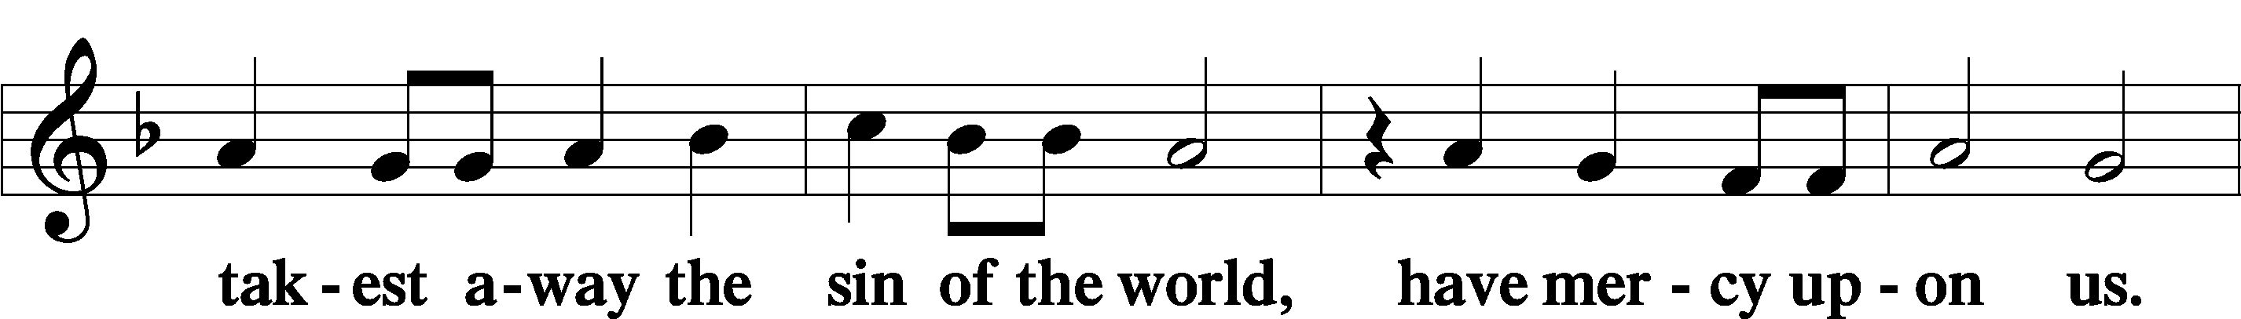
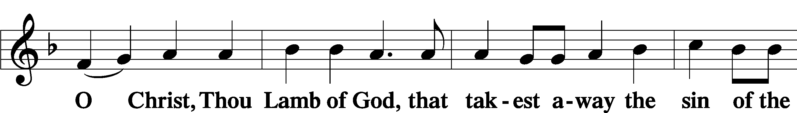
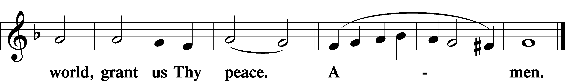
Sit

Distribution
The pastor and those who assist him receive the body and blood of Christ first and then distribute them to those who come to receive, saying:
Take, eat; this is the true body of our Lord and Savior Jesus Christ, given into death for your sins.
Amen.

Take, drink; this is the true blood of our Lord and Savior Jesus Christ, shed for the forgiveness of your sins.
Amen.

In dismissing the communicants, the following is said:
The Dismissal
P The body and blood of our Lord Jesus Christ strengthen and preserve you in body and soul to life everlasting. Depart T in peace.
C Amen.

Distribution Hymn: LSB #642 “O Living Bread from Heaven”

Distribution Hymn: LSB #742 “For Me to Live Is Jesus”

Distribution Hymn: LSB #548 “Thanks to Thee, O Christ, Victorious”

Stand

Nunc Dimittis Luke 2:29–32
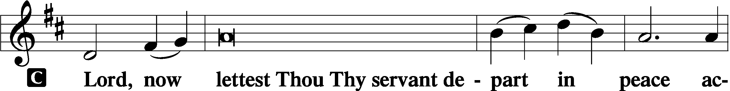
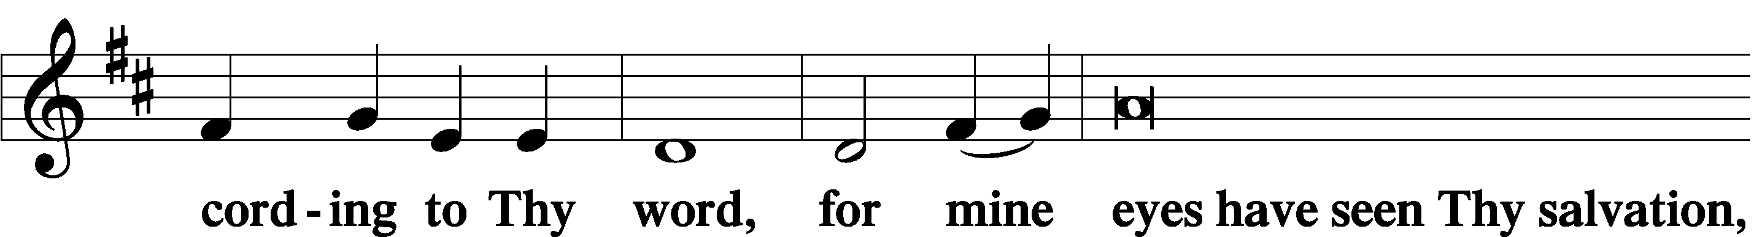
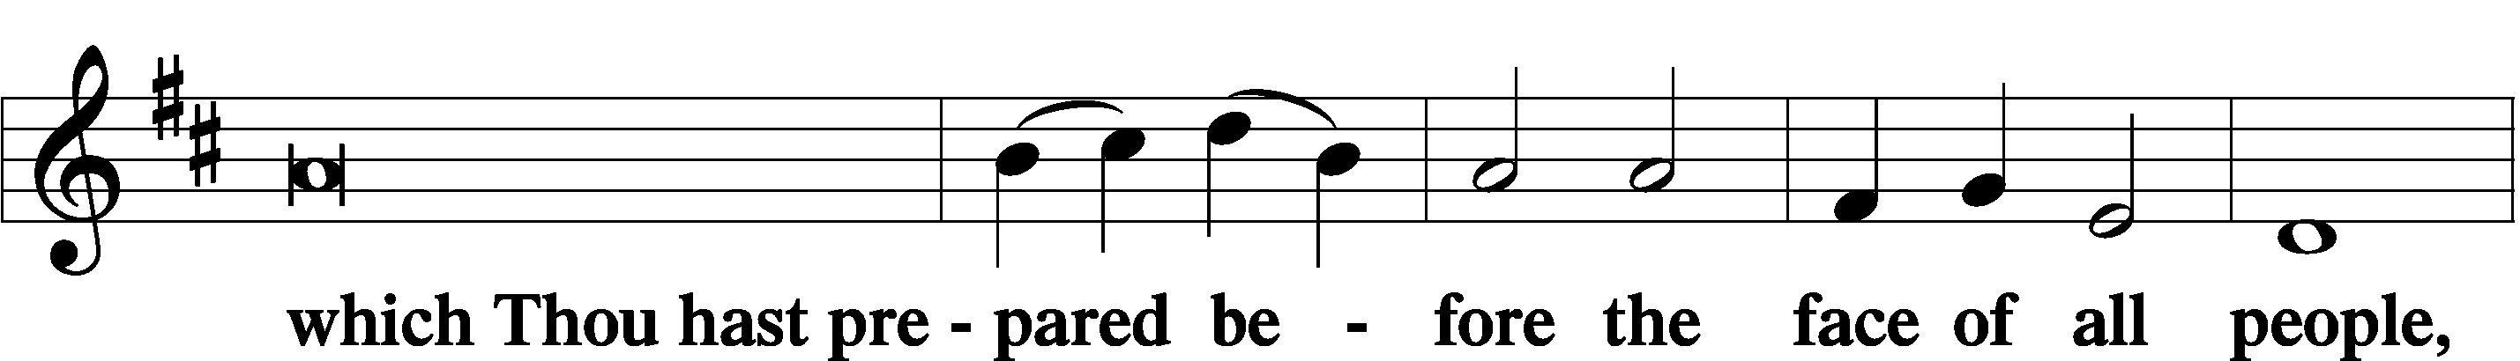
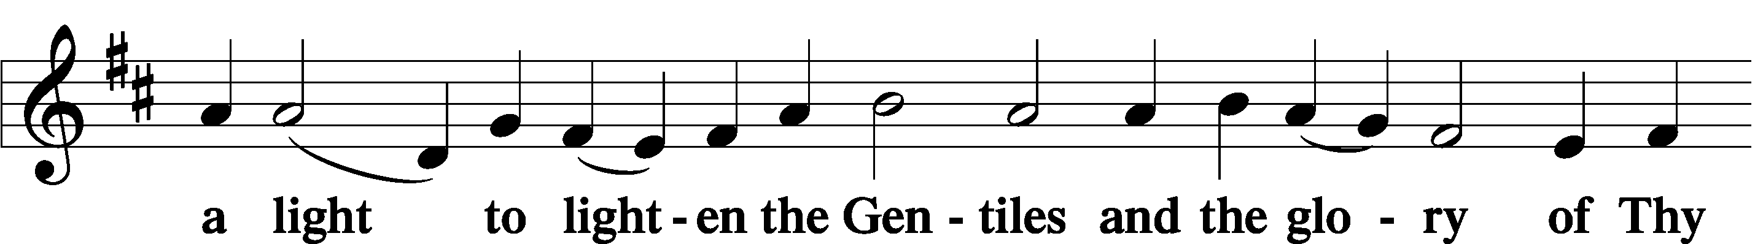
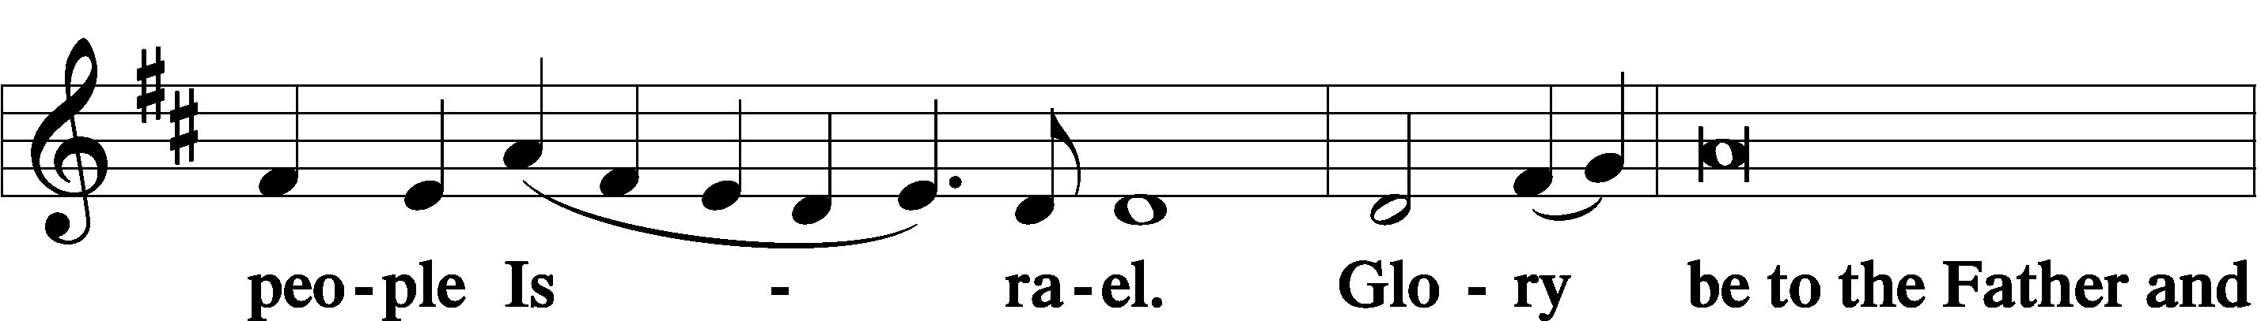
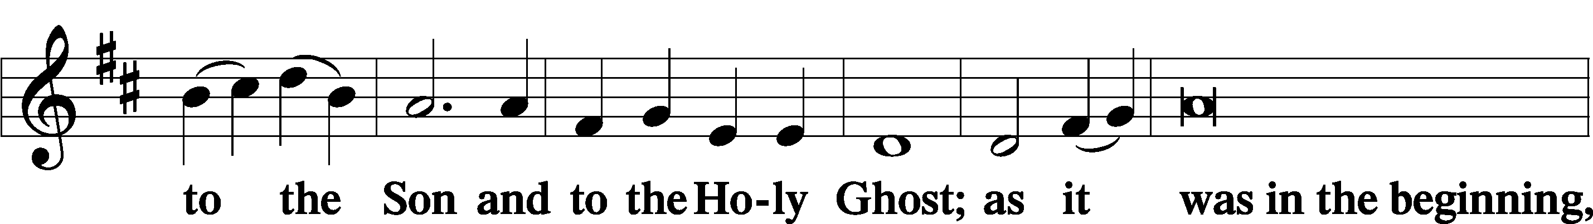
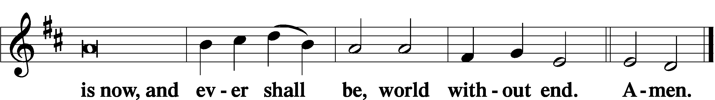

Thanksgiving Psalm 107:1
P O give thanks unto the Lord, for He is good,
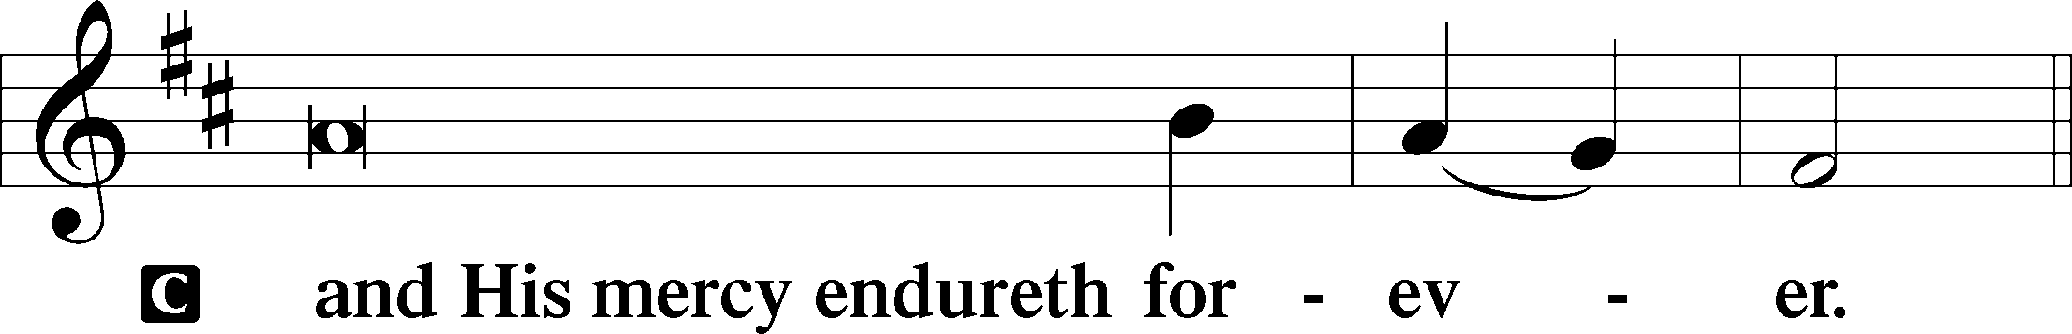

Post-Communion Collect
P Let us pray.
We give thanks to You, almighty God, that You have refreshed us through this salutary gift, and we implore You that of Your mercy You would strengthen us through the same in faith toward You and in fervent love toward one another; through Jesus Christ, Your Son, our Lord, who lives and reigns with You and the Holy Spirit, one God, now and forever.
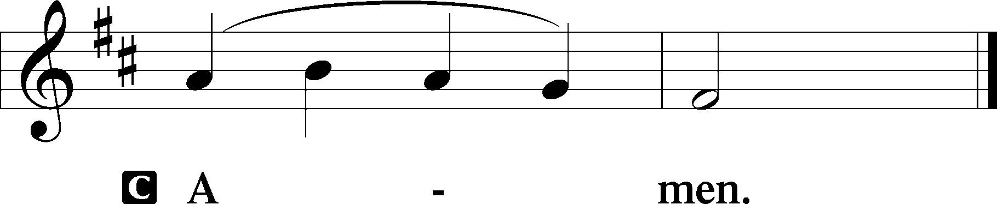

Salutation 2 Timothy 4:22
P The Lord be with you.
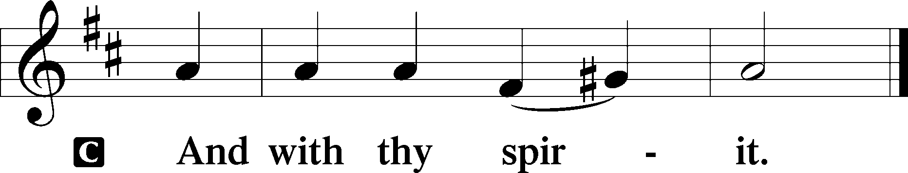

Benedicamus Psalm 103:1
P Bless we the Lord.
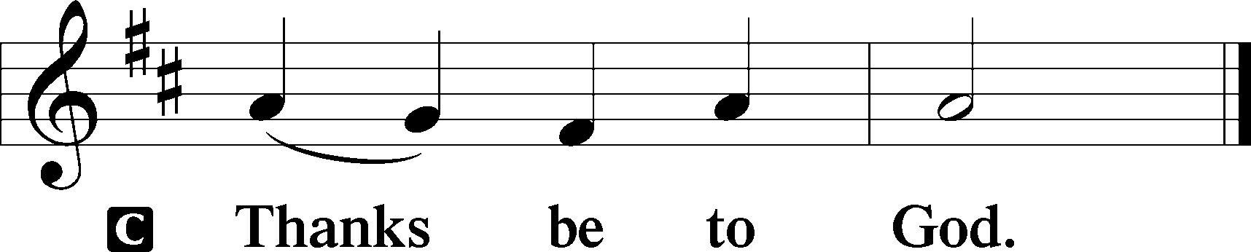

Benediction Numbers 6:24–26
P The Lord bless you and keep you.
The Lord make His face shine upon you and be gracious unto you.
The Lord lift up His countenance upon you and T give you peace.
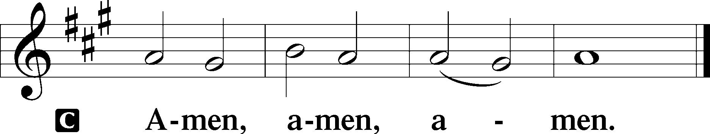

Closing Hymn: LSB #490 “Jesus Lives! The Victory’s Won”

Silent prayer after worship: Dear Jesus, You demonstrated Your great love for all humankind by dying on the cross. Lead me to daily live in Your love by trusting in You and by sharing Your love with others. Amen.
fffffffffffffffffffffffffffffffffff
Acknowledgments
Unless otherwise indicated, Scripture quotations are from the ESV® Bible (The Holy Bible, English Standard Version®), copyright © 2001 by Crossway, a publishing ministry of Good News Publishers. Used by permission. All rights reserved.
Created by Lutheran Service Builder © 2023 Concordia Publishing House.
fffffffffffffffffffffffffffffffffff

SCHEDULE THROUGH OCTOBER 1, 2023:

:

Today, 7 pm, Fellowship Hall: AA Meeting
Tuesday, 7-9 pm, Fellowship Hall: Penn-Ohio Singers
Wednesday, 7:30 pm, Fellowship Hall: NA Meeting
Thursday, 9 am, Downstairs: Food Pantry
Friday, 7 pm, Sanctuary: Divine Service ~ Festival of St. Michael and All Angels
Next Sunday, 8 am, Fellowship Hall: Bible Study
9 am, Sanctuary: Divine Service
7 pm, Fellowship Hall: AA Meeting
fffffffffffffffffffffffffffffffffff
Attendance: Sunday, September 17, 2023: 42
fffffffffffffffffffffffffffffffffff
THANK YOU FOR SERVING IN SEPTEMBER: Elder: Jonathan Baisch; Ushers: Mark Kleindienst, Jerry Krivosh, & Gordon Marquette; Altarware: (prior) Diane Riefstahl; (following) Kati Laird and Hank Holcroft.
fffffffffffffffffffffffffffffffffff
Our Stewardship of Treasures for the Lord:
In order to do the Lord’s work, we need $2,553.63 each week to meet our 2023 budget for general purposes and $76.92 for the SELC.

On-line Figures (September 14 & 17, 2023)
General Fund: $630.00
SELC: $100.00
Capital Campaign: $200.00

Figures for Sunday, September 17, 2023
General Fund: $2,198.00 Ahead for the week: +$274.37
SELC: $18.00 Ahead for the week: +$41.08
Capital Campaign: $1,276.00
Other: $12.00

For online giving, check out https://www.saintspeterandpaul.net/online-giving.
fffffffffffffffffffffffffffffffffff
Bible Memory Verses ~ Week of September 24th:
For Adults: In the world you will have tribulation. But take heart; I have overcome the world. John 16:33

For Children: Our Savior Christ Jesus…abolished death and brought life and immortality to light. 2 Timothy 1:10
fffffffffffffffffffffffffffffffffff
THANK YOU FOR SERVING IN OCTOBER: Elder: Jonathan Baisch; Ushers: Matt Berent, Mark Gabriel, Michael Laird, & Jerome Thomas; Altarware: (prior) Diane Riefstahl; (after) Oct. 29th~Elizabeth Haenftling; other~Cheryl Fedele & Clara Krivosh.
fffffffffffffffffffffffffffffffffff
Reminder!
- There will be a special Divine Service held this Friday, September 29th at 7 pm celebrating the Feast of Saint Michael and All Angels.
fffffffffffffffffffffffffffffffffff
Copies of Jonathan Baisch’s indepth report on the LC-MS Convention which he attended are available on the table in the narthex.
Remember the following in Prayer…
~The Hurting and Healing: Amy, Steve Antolovich, Ellen Baron^{CA}, Amy Blomenberg, Lois Bortner^{CA}, Sara Brubaker, Dee Bullock, Bev & Joe Chlpka, Susan Davies, Loretta Deal, Tim Dudash, Judith & Eddy Furey, Griffin, Peter Haenftling, Austin Hamilton, Pastor Charles Henrickson, Joan, Keith Jozwiakowski, Darla Krajci, Barbara Kreske, Jess Lavoie, Elizabeth Loughan, Paul Lucas^{CA}, Sandy Marshall, Frank Niemeyer^{CA}, Juanita Rentschler, Richard Reuning^{CA}, Nancy Robertson^{CA}, Kriss Svidro^{CA}, Joel & Peggy Wasson, Angela Weser^{CA}, and Ruth Wolf.
~The Homebound: Anna Mae Daris, Millie Elavsky, Rudy & Jean Tomko, Betty Wolf, and Ed & Millie Zachar.
~Celebrating this Week: Birthdays: Karen Psznick (09.24) and Gordon Marquette (09.26). Anniversary: Shawn & Staci Taylor (09.28).
~Serving in the Military: Alex (Sasha) Carr, Duncan Vaupel (grandson of Rev. Arthur & Evelyn Baisch), Curtis Sinewe, and Joshua Solyan.
~Community & World Needs: Those suffering due to the conflict between Ukraine and Russia; those suffering from loss and dislocation because weather disasters; those suffering from addiction and their families; Local, State, and National Government Leaders; safety for all Police Officers, Firefighters, & First Responders; the unemployed; our Third Quarter Local Mission: Luther Classical College.
*CA represents cancer.
fffffffffffffffffffffffffffffffffff
PASTOR & FAMILY APPRECIATION DINNER - SATURDAY, OCT. 28th, 5 PM
Come and join us for some good food and fellowship with a special dinner in appreciation of Pastor Deal and family. There will also be a birthday cake in celebration of Loretta's 5th birthday! Mark your calendars now! You don't want to miss this time with your church family.
The organizing team will be contacting everyone to make sure all are advised and to ask what you can do to help - pray for the event, set up, prepare a salad or side dish, clean up. Main entrée and dessert will be provided! If you have any questions, you can call Bess Kleindienst at 973-768-8874.
If planning to attend, please sign either the sheet located in the narthex or by the parking lot entrance so plans can be made. We look forward to sharing in this time together and pray God's blessings on us all!

Pastor Deal will be in St. Louis attending the SELC Church Workers’ Conference this Wednesday through Friday morning. He will return for Friday evening’s Divine Service.
Please contact Elder Jonathan Baisch (724-816-6866) if in need of care during this time.
fffffffffffffffffffffffffffffffffff
The October issue of “The Rock and the Sword” newsletter is available on tables in the narthex and by the parking lot entrance. Please also remember to pick up your copy of “Portals of Prayer” for October, November, and December. Note: If you had previously picked up a large print version which had been damaged by rain, there are now new, undamaged copies available.
fffffffffffffffffffffffffffffffffff
The following is the new address for Alex (Sasha) Carr:
PVT Alexander Carr
7009 Quartermaster Rd.
F Co 16th OD BN 4th PLT
Fort Gregg-Adams, VA 23801
fffffffffffffffffffffffffffffffffff

Here to Serve
Pastor………………………………………………...……………Rev. Jacob Deal
E-mail …………………………….……pastordeal@saintspeterandpaul.net
Phone Number……………………..…………………724-347-3620 (Option 2)
Church Office………………………..…………………724-347-3620 (Option 3)
Website …………………………………………www.saintspeterandpaul.net
Secretary…………………………………………………………Diane Riefstahl
E-mail ………………………………………church@saintspeterandpaul.net
Website …………………………………………www.saintspeterandpaul.net
Food Pantry (email): ……………foodpantry@saintspeterandpaul.net
Congregation President………………………………….…Jonathan Baisch
Church Elder …………………………………………...……. Jonathan Baisch
Organist………………………………………………..….…Rebecca Marquette
Choir Director…………………………………………………….…Chris Nelson
AA Contact: Steve………………………………………………...…724-813-2358
NA Contact: Larry……………………………………..…………..724-977-8733
fffffffffffffffffffffffffffffffffff
If needing to get into the church building during the week, please phone first to make certain someone is here to let you in.

