Sts. Peter & Paul
Evangelical Lutheran Church
Lutheran Church-Missouri Synod
Founded-1917
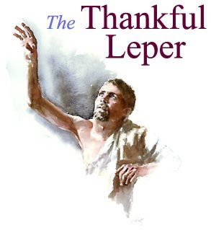
SEPTEMBER 22, 2019

699 Stambaugh Avenue
Sharon, Pennsylvania 16146

“I was glad when they said to me,
Let us go to the house of the LORD!”
Psalm 122:1

VISITOR’S BULLETIN
Sts. Peter & Paul Evangelical Lutheran Church, LC-MS

FOURTEENTH SUNDAY AFTER TRINITY
September 22, 2019

Silent prayer before worship: Heavenly Father, cause Your Holy Spirit to work through Your Word so that I may know and believe that salvation comes through no one else but Your Son, Jesus. In Jesus’ name. Amen.

CONFESSION AND ABSOLUTION
Opening Hymn: LSB #790 “Praise to the Lord, the Almighty”
Stand

The sign of the cross may be made by all in remembrance of their Baptism.

P In the name of the Father and of the T Son and of the Holy Spirit.
C Amen. Matthew 28: 19b; (18:20)
P Beloved in the Lord! Let us draw near with a true heart and confess our sins unto God our Father, beseeching Him in the name of our Lord Jesus Christ to grant us forgiveness. [Hebrews 10:22]

P Our help is in the name of the Lord,
C who made heaven and earth. Psalm 124: 8
P I said, I will confess my transgressions unto the Lord,
C and You forgave the iniquity of my sin. Psalm 32: 5

Silence for reflection on God's Word and for self-examination.

P O almighty God, merciful Father,
C I, a poor, miserable sinner, confess unto You all my sins and iniquities with which I have ever offended You and justly deserved Your temporal and eternal punishment. But I am heartily sorry for them and sincerely repent of them, and I pray You of Your boundless mercy and for the sake of the holy, innocent, bitter sufferings and death of Your beloved Son, Jesus Christ, to be gracious and merciful to me, a poor, sinful being.
P Upon this your confession, I, by virtue of my office, as a called and ordained servant of the Word, announce the grace of God unto all of you, and in the stead and by the command of my Lord Jesus Christ I forgive you all your sins in the name of the Father and of the T Son and of the Holy Spirit. [John 20: 19-23]
C Amen.

Passing of the Peace.
SERVICE OF THE WORD
Introit: Ps. 84:1–2a, 4, 10b, 11b; antiphon: Ps. 84:9–10a
Behold our shield, | O God;*
look on the face of your a- | nointed!
For a day | in your courts*
is better than a thousand | elsewhere.
How lovely is your dwelling place, O | Lord of hosts!*
My soul longs, yes, faints for the courts | of the Lord.
Blessèd are those who dwell | in your house,*
ever sing- | ing your praise!
I would rather be a doorkeeper in the house | of my God*
than dwell in the tents of | wickedness.
The Lord bestows favor and | honor.*
No good thing does he withhold from those who walk up- | rightly.

Gloria Patri
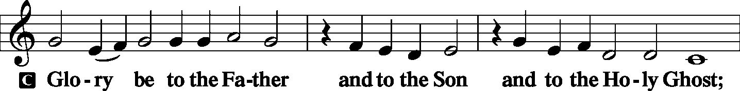
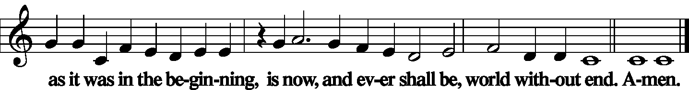

Kyrie
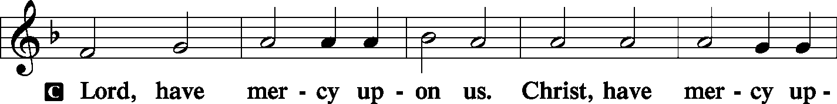
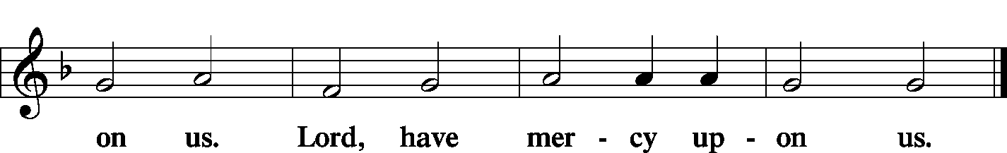

Gloria in Excelsis Luke 2: 14; John 1: 29
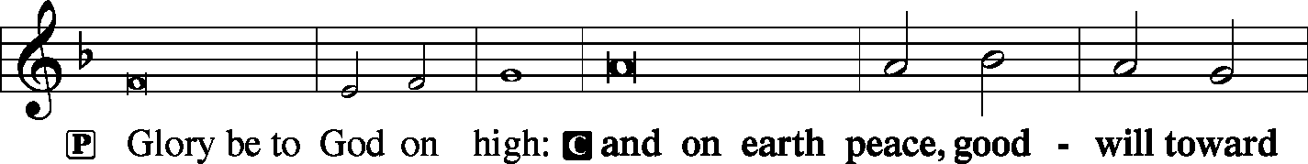
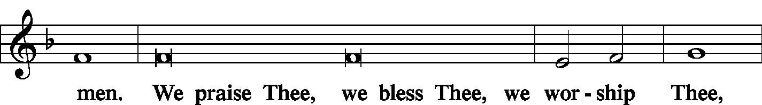
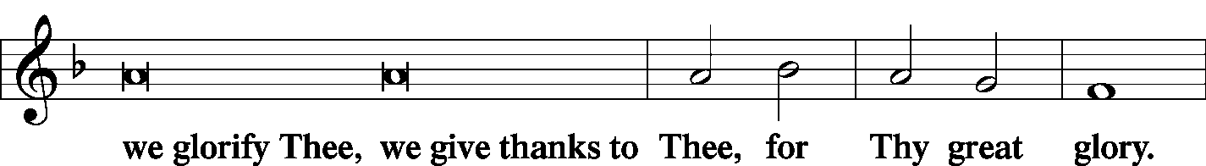
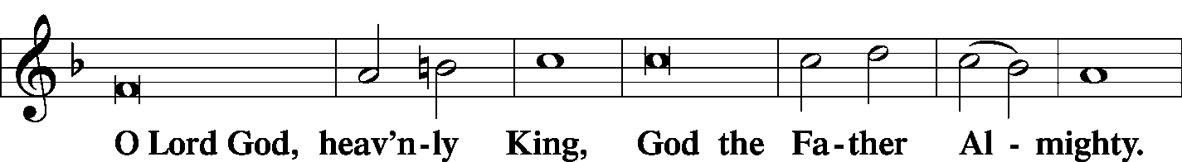
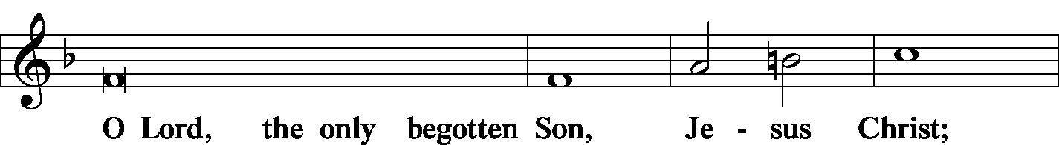
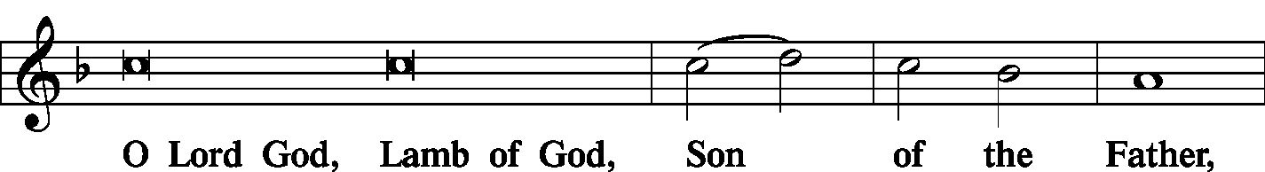
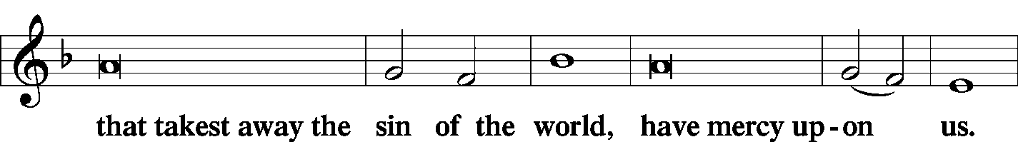
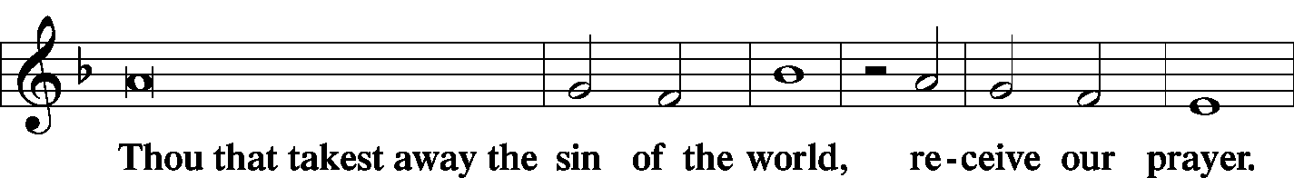
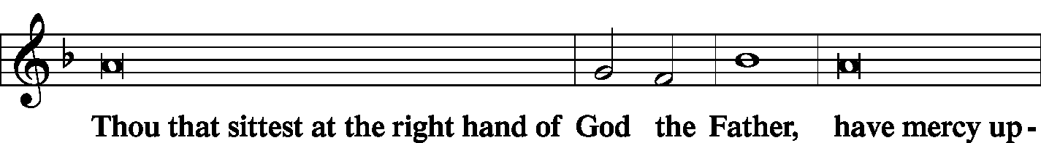
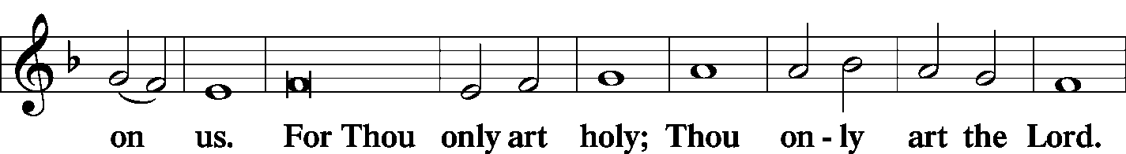
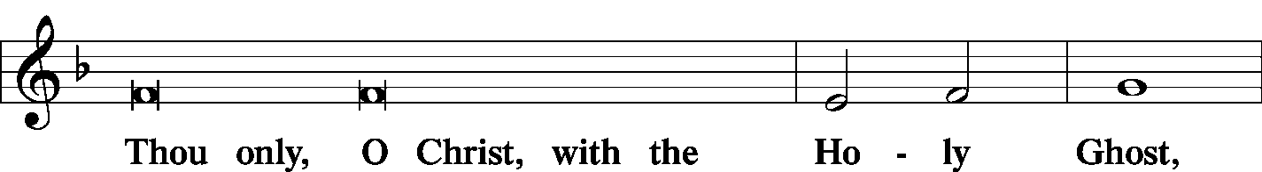
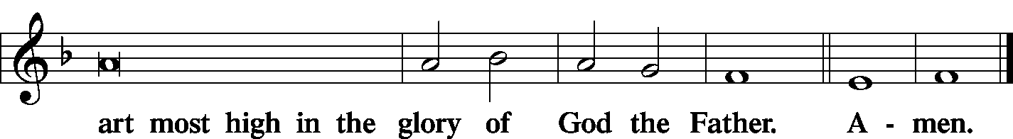

Salutation and Collect of the Day
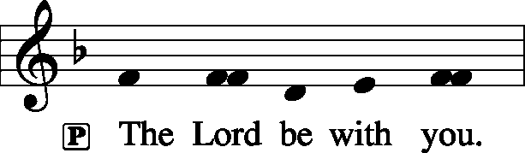 2 Timothy 4: 22
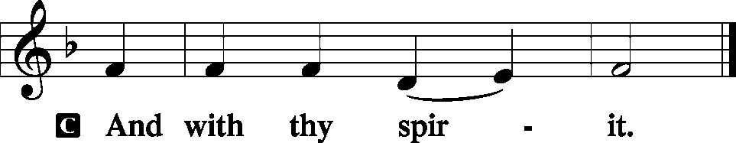

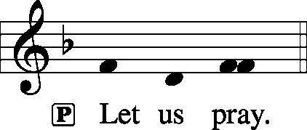

P O Lord, keep Your Church with Your perpetual mercy; and because of our frailty we cannot but fall, keep us ever by Your help from all things hurtful and lead us to all things profitable to our salvation; through Jesus Christ, Your Son, our Lord, who lives and reigns with You and the Holy Spirit, one God, now and forever.

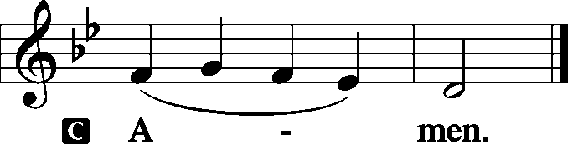

Sit
Old Testament Reading: Proverbs 4:10–23
Hear, my son, and accept my words,
that the years of your life may be many.
I have taught you the way of wisdom;
I have led you in the paths of uprightness.
When you walk, your step will not be hampered,
and if you run, you will not stumble.
Keep hold of instruction; do not let go;
guard her, for she is your life.
Do not enter the path of the wicked,
and do not walk in the way of the evil.
Avoid it; do not go on it;
turn away from it and pass on.
For they cannot sleep unless they have done wrong;
they are robbed of sleep unless they have made someone stumble.
For they eat the bread of wickedness
and drink the wine of violence.
But the path of the righteous is like the light of dawn,
which shines brighter and brighter until full day.
The way of the wicked is like deep darkness;
they do not know over what they stumble.
My son, be attentive to my words;
incline your ear to my sayings.
Let them not escape from your sight;
keep them within your heart.
For they are life to those who find them,
and healing to all their flesh.
Keep your heart with all vigilance,
for from it flow the springs of life.
P This is the Word of the Lord.
C Thanks be to God.

C Gradual: Ps. 92:1–2
It is good to give thanks to the Lord,
to sing praises to your name, O Most High;
to declare your steadfast love in the morning,
and your faithfulness by night.

Epistle: Galatians 5:16–24
But I say, walk by the Spirit, and you will not gratify the desires of the flesh. For the desires of the flesh are against the Spirit, and the desires of the Spirit are against the flesh, for these are opposed to each other, to keep you from doing the things you want to do. But if you are led by the Spirit, you are not under the law. Now the works of the flesh are evident: sexual immorality, impurity, sensuality, idolatry, sorcery, enmity, strife, jealousy, fits of anger, rivalries, dissensions, divisions, envy, drunkenness, orgies, and things like these. I warn you, as I warned you before, that those who do such things will not inherit the kingdom of God. But the fruit of the Spirit is love, joy, peace, patience, kindness, goodness, faithfulness, gentleness, self-control; against such things there is no law. And those who belong to Christ Jesus have crucified the flesh with its passions and desires.

P This is the Word of the Lord.
C Thanks be to God.

Stand
Alleluia Verse and Alleluia
P Alleluia. Praise is due to you, O God, in Zion, and to you shall vows be performed. Alleluia.

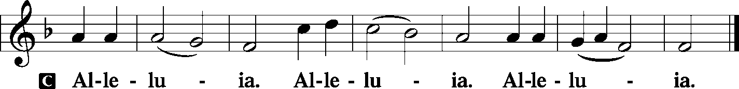

Holy Gospel: Luke 17:11–19
P The Holy Gospel according to St. Luke, the seventeenth chapter.

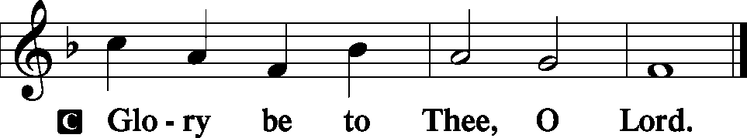
On the way to Jerusalem [Jesus] was passing along between Samaria and Galilee.
And as he entered a village, he was met by ten lepers, who stood at a distance and lifted up their voices, saying, “Jesus, Master, have mercy on us.” When he saw them he said to them, “Go and show yourselves to the priests.” And as they went they were cleansed. Then one of them, when he saw that he was healed, turned back, praising God with a loud voice; and he fell on his face at Jesus’ feet, giving him thanks. Now he was a Samaritan. Then Jesus answered, “Were not ten cleansed? Where are the nine? Was no one found to return and give praise to God except this foreigner?” And he said to him, “Rise and go your way; your faith has made you well.”

P This is the Gospel of the Lord.

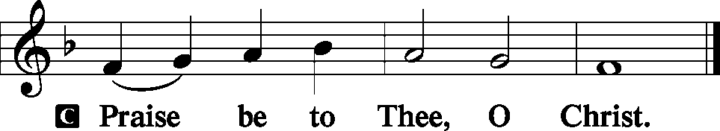

Nicene Creed
C I believe in one God,
the Father Almighty,
maker of heaven and earth
and of all things visible and invisible.
And in one Lord Jesus Christ,
the only-begotten Son of God,
begotten of His Father before all worlds,
God of God, Light of Light,
very God of very God,
begotten, not made,
being of one substance with the Father,
by whom all things were made;
who for us men and for our salvation came down from heaven
and was incarnate by the Holy Spirit of the virgin Mary
and was made man;
and was crucified also for us under Pontius Pilate.
He suffered and was buried.
And the third day He rose again according to the Scriptures
and ascended into heaven
and sits at the right hand of the Father.
And He will come again with glory to judge both the living and the dead,
whose kingdom will have no end.
And I believe in the Holy Spirit,
the Lord and giver of life,
who proceeds from the Father and the Son,
who with the Father and the Son together is worshiped and glorified,
who spoke by the prophets.
And I believe in one holy Christian and apostolic Church,
I acknowledge one Baptism for the remission of sins,
and I look for the resurrection of the dead
and the life T of the world to come. Amen.

Hymn of the Day: LSB #713 “From God Can Nothing Move Me”

Sermon

Stand

Reception of Members by Transfer or Profession of Faith
P Beloved in the Lord, our Lord Jesus Christ said to His apostles: "Whoever confesses Me before men, I will also confess before My Father who is in heaven. But whoever denies Me before men, I will also deny before My Father who is in heaven." Lift up your hearts, therefore, to the God of all grace and joyfully give answer to what I now ask you in the name of the Lord.

P Do you this day in the presence of God and of this congregation acknowledge the gifts that God gave you in your Baptism?
R Yes, I do.

P Do you renounce the devil and all his works and all his ways?
R Yes, I renounce them.

P Do you believe in God, the Father Almighty, in Jesus Christ, His only Son our Lord, and in the Holy Spirit?
R Yes, I believe in God the Father, Son, and Holy Spirit.

P Do you hold all the prophetic and apostolic Scriptures to be the inspired Word of God and the doctrine of the Evangelical Lutheran Church, drawn from them and confessed in the Small Catechism, to be faithful and true?
R I do.

P Do you intend to hear the Word of God and receive the Lord's Supper faithfully?
R I do, by the grace of God.

P Do you intend to live according to the Word of God, and in faith, word, and deed to remain true to God, Father, Son, and Holy Spirit, even to death?
R I do, by the grace of God.

P Do you desire to become a member of this congregation?
R I do.

P Will you support the work our gracious Lord has given this congregation with your prayers and the gifts God has given you?
R I will, with the help of God.

P Upon this your confession of faith, I acknowledge publicly that you are [a member/members] of the Evangelical Lutheran Church and of this congregation. Receive the Lord's Supper and participate with us in all the blessings of salvation that our Lord has given to His Church, in the name of the Father and of the T Son and of the Holy Spirit.
C Amen.

Stand

P Let us pray.
Lord God, heavenly Father, we thank and praise You for Your great goodness in bringing these Your sons and daughters to the knowledge of Your Son, our Savior, Jesus Christ, and enabling them both with the heart to believe and with the mouth to confess His saving name. Grant that by Your Word and Spirit they may continue steadfast in the one true faith in the fellowship of this congregation as together we await the day when all who have fought the good fight of faith shall receive the crown of righteousness; through Jesus Christ, Your Son, our Lord, who lives and reigns with You and the Holy Spirit, one God, now and forever.
C Amen.

P The grace of our T Lord Jesus Christ be with you.
C Amen.

Prayer of the Church

Sit

Offertory Psalm 51: 10-12
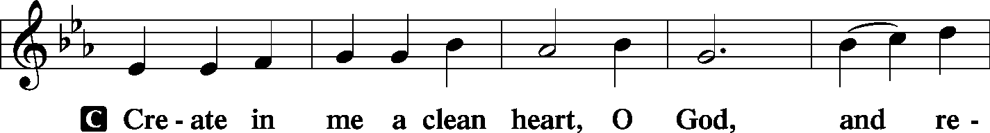
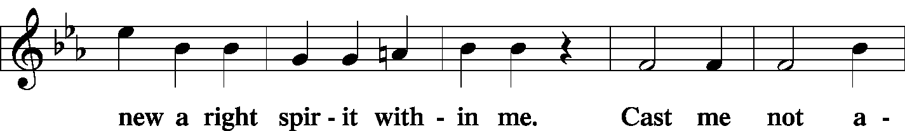
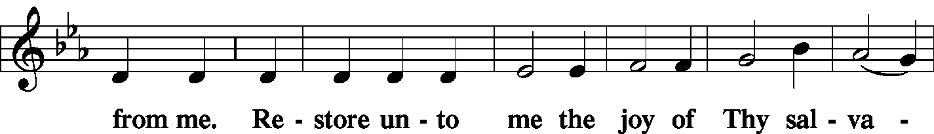
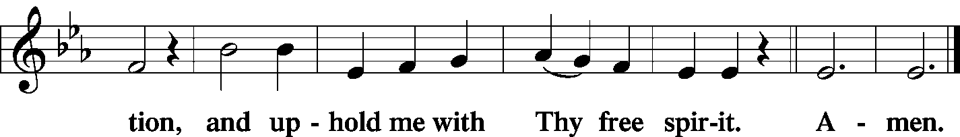

Offering/Offering Hymn: LSB #815 “All Praise to Thee, for Thou, O King Divine”

Stand
SERVICE OF THE SACRAMENT
Preface
2 Timothy 4: 22
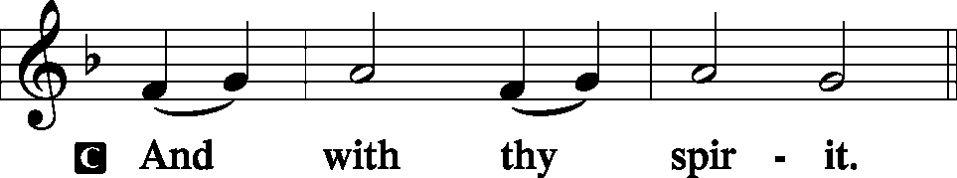
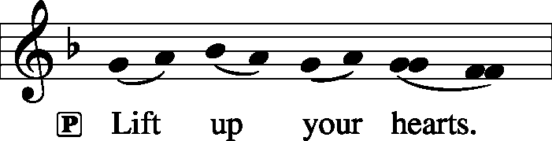 [Colossians 3:1]
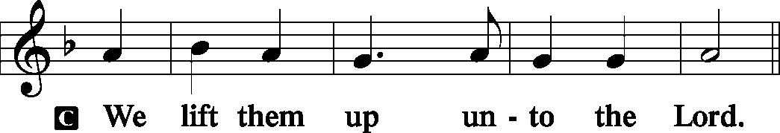

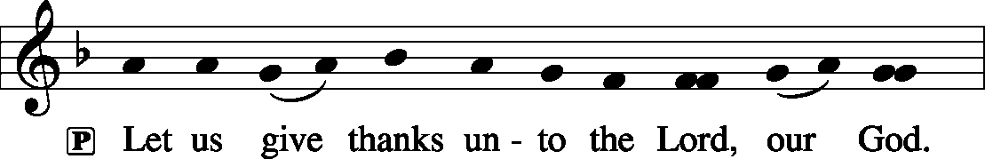 [Psalm 136]

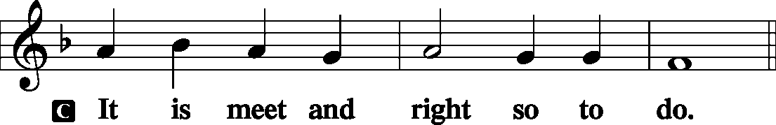

P It is truly good, right, and salutary . . . evermore praising You and saying:

Sanctus Isaiah 6: 3; Matthew 21: 9
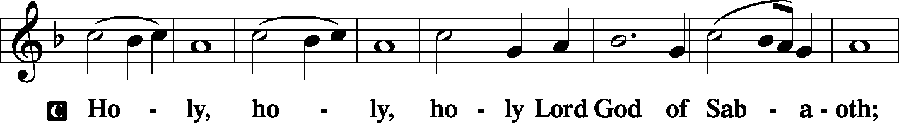
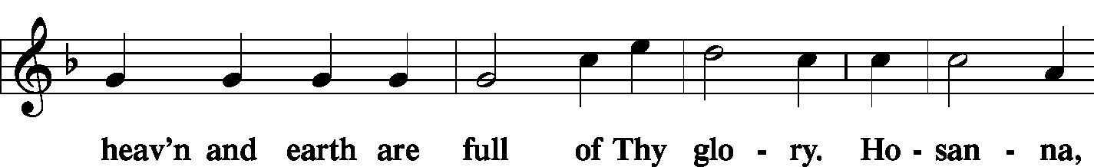
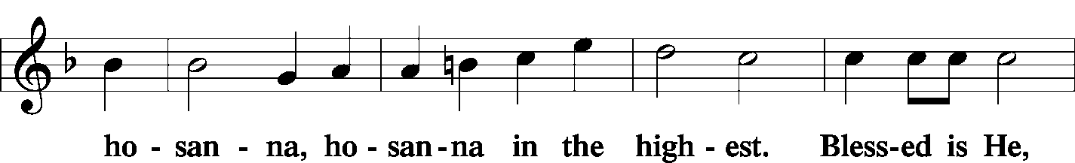
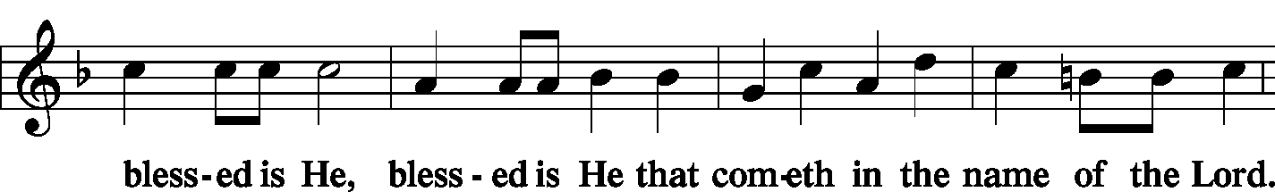
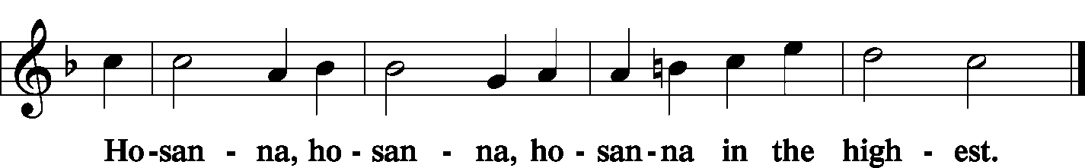

Lord's Prayer Matthew 6: 9-13
P Lord, remember us in Your kingdom and teach us to pray:
C Our Father who art in heaven,
hallowed be Thy name,
Thy kingdom come,
Thy will be done on earth as it is in heaven;
give us this day our daily bread;
and forgive us our trespasses as we forgive those who trespass against us;
and lead us not into temptation,
but deliver us from evil.
For Thine is the kingdom and the power and the glory forever and ever. Amen.

The Words of Our Lord Matthew 26: 26-28; Mark 14: 22-24
Luke 22: 19-20; 1 Corinthians 11: 23-25
P Our Lord Jesus Christ, on the night when He was betrayed, took bread, and when He had given thanks, He broke it and gave it to the disciples and said: “Take, eat; this is My T body, which is given for you. This do in remembrance of Me.”

P In the same way also He took the cup after supper, and when He had given thanks, He gave it to them, saying: “Drink of it, all of you; this cup is the new testament in My T blood, which is shed for you for the forgiveness of sins. This do, as often as you drink it, in remembrance of Me.”

Pax Domini John 20: 19
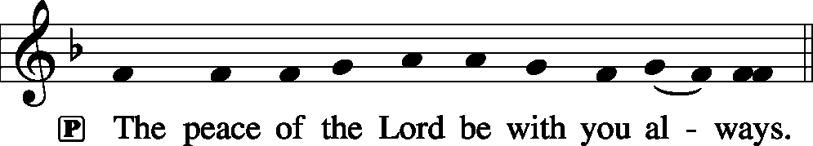

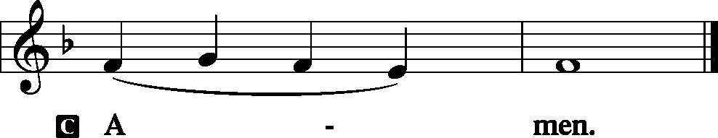

Agnus Dei John 1: 29
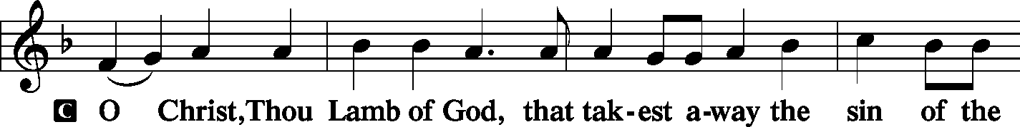
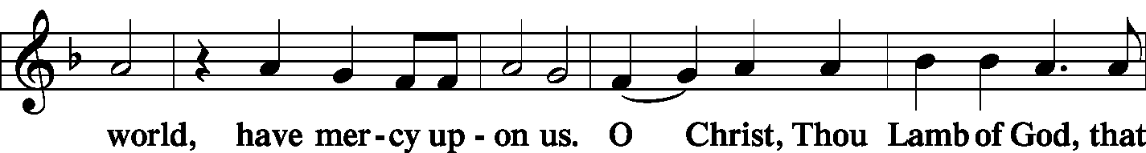
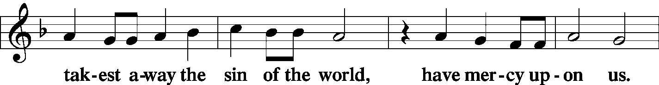
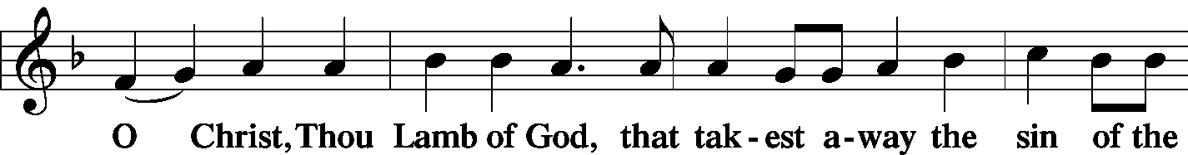
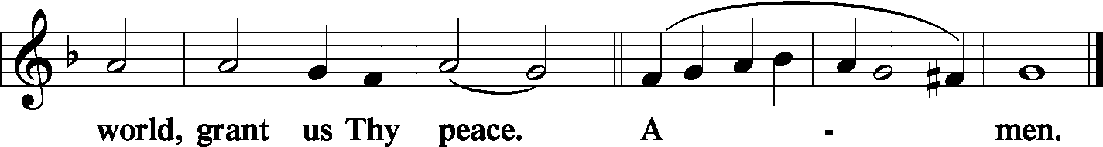
Sit

Distribution
The pastor and those who assist him receive the body and blood of Christ first and then distribute them to those who come to receive, saying:

Take, eat; this is the true body of our Lord and Savior Jesus Christ, given into death for your sins.
Amen.
Take, drink; this is the true blood of our Lord and Savior Jesus Christ, shed for the forgiveness of your sins.
Amen.

In dismissing the communicants, the following is said:
P The body and blood of our Lord Jesus Christ strengthen and preserve you in body and soul to life everlasting. Depart T in peace.
C Amen.

Distribution Hymn: LSB #434 “Lamb of God, Pure and Holy”
Distribution Hymn: LSB #633 “At the Lamb's High Feast We Sing”
Stand
Post-Communion Canticle: Nunc Dimittis Luke 2: 29-32
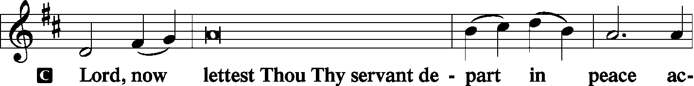
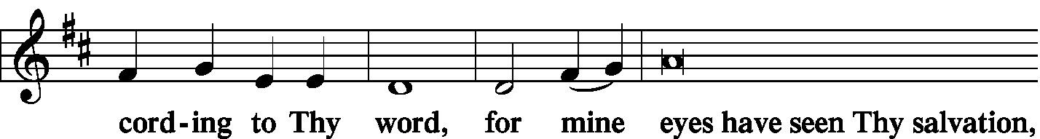
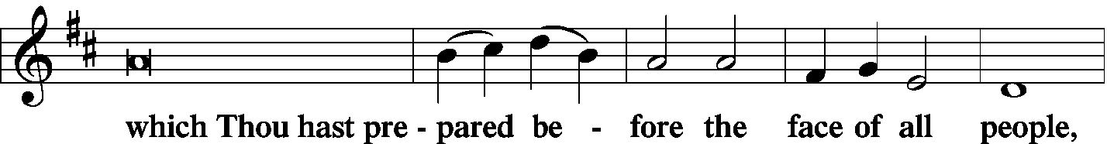
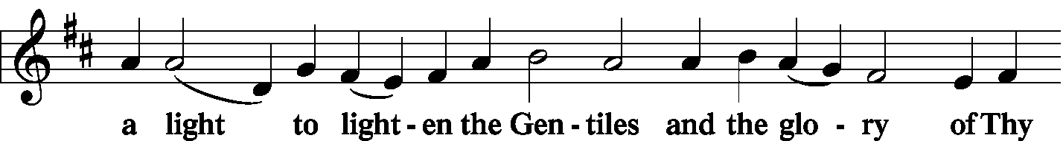
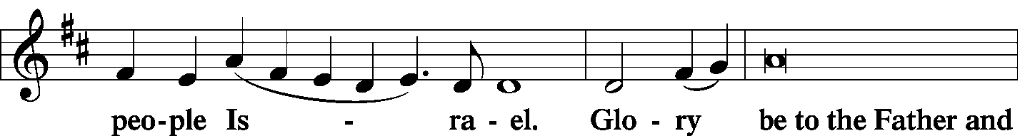
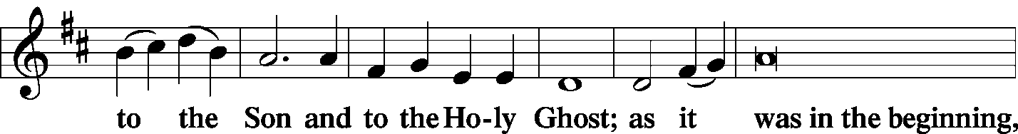
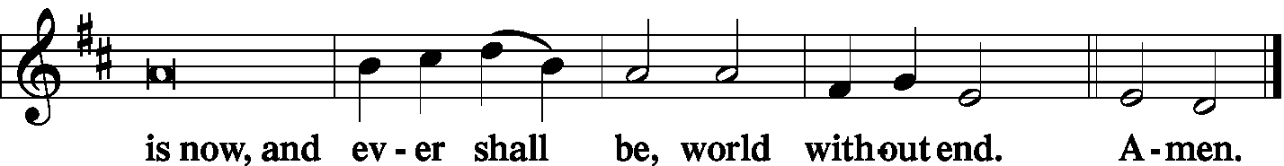

Thanksgiving Psalm 107: 1
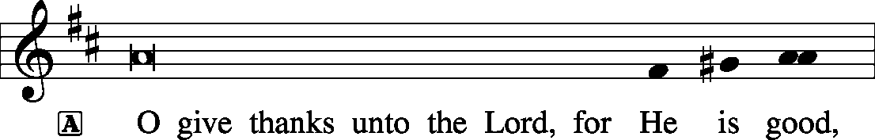
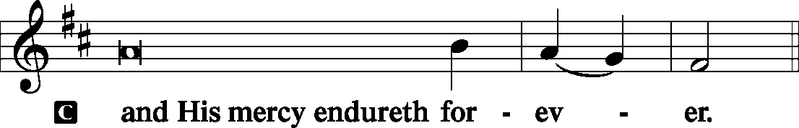

P Let us pray.
…through Jesus Christ, Your Son, our Lord, who lives and reigns with You and the Holy Spirit, one God, now and forever.

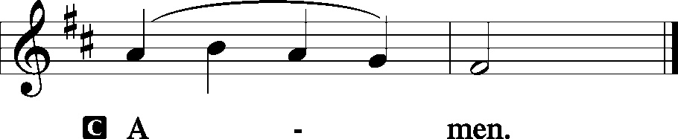

Salutation and Benedicamus
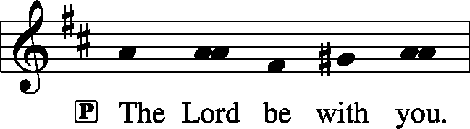 2 Timothy 4: 22
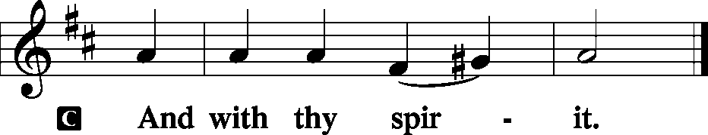
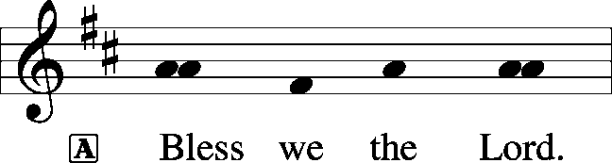 [Psalm 103: 1]
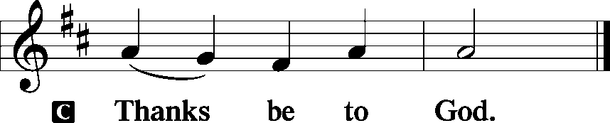

Benediction Numbers 6: 24-26
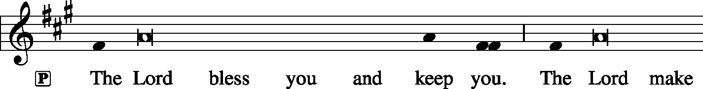
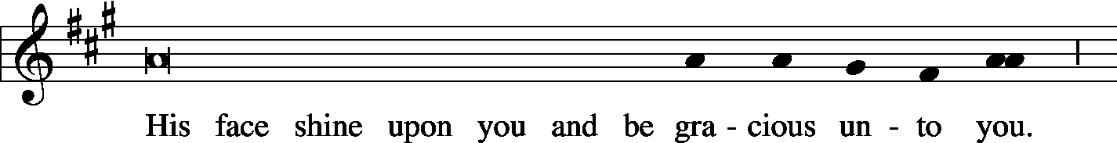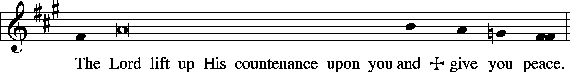

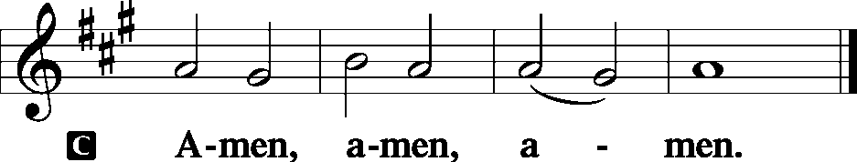

Closing Hymn: LSB #895 “Now Thank We All Our God”
Silent prayer after worship: Heavenly Father, grant that I may be in Your Word and in prayer daily, so that through Your Word I may be certain of my salvation and may also share that hope with others. In Jesus’ name. Amen.

Acknowledgments: Divine Service, Setting Three from Lutheran Service Book Unless otherwise indicated, all scripture quotations are from The Holy Bible, English Standard Version, copyright © 2001 by Crossway Bibles, a division of Good News Publishers. Used by permission. All rights reserved. Created by Lutheran Service Builder © 2006 Concordia Publishing House. CCLI License #3029-446

Bible Memory Verse: For the week of September 22th: For Adults: Humble yourselves, therefore, under the mighty hand of God so that at the proper time he may exalt you, 1 Pet. 5:6
For Children: Bless the Lord, O my soul, and forget not all his benefits.
Ps. 103:2

Attendance: Saturday, Sept. 14, 2019, and Sunday, Sept. 15: 56

In Loving Memory of Donald Voytik: Jeff & Stacy Brandes (Missions), Dolores Fee, Mark Gabriel (Major Repair), Anson & Hank Holcroft, Clara Krivosh (Major Repair), Ernie & Ruth Meszaros (Major Repair), Diane Riefstahl, Viola Sakony, Mr. & Mrs. Robert Sulek,
In Loving Memory of Joanne Wolfe: Diane Riefstahl (Preschool).

The Altar Flowers this morning are given by Anne Colt in Loving Memory of All Loved Ones. We sincerely appreciate this generous gift!

SCHEDULE FOR TODAY THROUGH SEPT. 29nd:

:

Today, 7 pm, Downstairs…………………………………………..…………………......…AA Meeting
Monday, 12:30 pm, Offices…………………………………………………Preschool Board Meeting
Thursday, 9 am, ………………………………………………………….........................…Food Pantry
Saturday, 5 pm, Chapel……………………………………….……………………..…….Divine Service
Next Sunday, 8:45 am, Downstairs……………………………………………..…………Bible Study
10 am, Sanctuary…...........................................................................Divine Service
7 pm, Downstairs…………………..…………………………………………………AA Meeting

Thank You for Serving in September:
Today’s Greeters: Gary & Eileen Burns. Assisting Elders: John Dyll & Bob Sulek. Ushers: Bob Sulek, Hugh Owen, Cheryl Fedele, Jesse Riffle, & Ralph Dorman (alternate). Altarware: Vi Sakony & Patty Parker.
September Greeters: 29 ~ Cheryl Fedele & Clara Krivosh.

We welcome this day into our membership the following: April Bosnjak, Alex Carr, Catherine Carr, and Michael Laird! May the Lord continue to bless each as they grow in faith to His word.
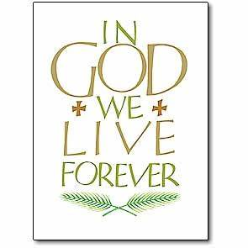
Sincere sympathy is expressed to the friends and family of Don Voytik who passed away September 10, 2019 and was laid to rest September 16, 2019. May all who mourn his passing take comfort in our Lord.

Remember the following in Prayer…
~The Hurting and Healing: The Friends and Family of Don Voytik who passed away September 10, 2019; Tony⁴, Lois Bortner^{CA}, Richard Brandes³, Eileen Burns³, Beverly Chlpka⁴, Kim⁴, Tim Dudash⁴, John Dyll³, Jennifer Hilliard³, Anson Holcroft³, Betty Knauff^{CA}, Regis Knauff⁴, Clara Krivosh¹, Jess Lavoie², Paul Lucas^{CA}, Rhonda Moats^{CA}, Barry Nelson⁴, David Nelson¹,Tom Mulligan^{CA}, Iona Oltman^{CA}, Rudy Pinal^{CA}, Angela Weser^{CA}, and Ken White^{CA}.
~Our Homebound: Helen Bender, Dan Davis, Edna Krajci, Mary Ann Krajci, Marion Roberts, and Barbara Vasconi .
~Celebrating: Birthdays: Matt Berent (09.22), Briana Matijevic (09.23), and Karen Psznick (09.24). Anniversary: Shawn & Staci Taylor (09.28).
~Serving in the Military: Clayton Drnek, Curtis Sinewe, and Joshua Solyan.
~Community & World Needs: Victims of violence and terrorism; those suffering from loss and dislocation because weather disasters; those suffering from addiction and their families; Local, State, and National Government Leaders; Safety for all Police Officers, Firefighters, & First Responders; the unemployed; our Third Quarter Local Mission: MERP (Medical Equipment Recycling Program).
*CA represents cancer; number after other names represents weeks on the prayer list. After 4 weeks names may be resubmitted. This helps us to remember people’s specific needs and reminds us that God is providing healing as people get better and no longer need our prayers. Please submit prayer requests in writing to the church office.

If anyone has any used, workable medical equipment which they would like donated to our 3rd Quarter Local Mission, MERP, please bring it into the church. Jeff Brandes will deliver it for you.

We are in need of volunteers for the Building Use Committee. Please sign the sheet in the narthex.
Our Stewardship of Treasures for the Lord:
In order to do the Lord’s work, we need $2,882.02* each week to meet our 2019 budget for general purposes and $38.46 for missions.
Saturday, September 14, 2019 & Sunday, September 15, 2019:
General Offering: $1,750.00 Behind this week*: -$1,082.02
SELC Missions: $70.00 Ahead this week: +$31.54
Local Missions: $0.00
Preschool Tuition: $50.00
Other Offerings: $175.00 *Includes preschool tuition.

Here to Serve You…

Pastor………………………………………………….………..…Rev. Jacob Deal
E-mail ……….…………………….…..pastordeal@saintspeterandpaul.net
Phone Number…………..……………………………724-347-3620 (Option 2)
Church Office………………………………….………724-347-3620 (Option 3)
Website ……….………………….……...…….www.saintspeterandpaul.net
Secretary………………………………………………….……. Diane Riefstahl
E-mail ……….…………………….…….…church@saintspeterandpaul.net
Food Pantry: John Dyll…………….……………………..…..…724-347-1779
Little People Preschool…………….……………….724-347-3620 (Option 4)
Teacher: Paula Ostheimer………….………………….…….....724-981-5846
Email ……….………….…………………….paula@saintspeterandpaul.net
AA Contact: Steve……………………….…………..……...……. 724-813-2358
Organist……………………………………………………..…Carrie Yasnowski
Choir Director……………..…………….…………..….….………Chris Nelson
Congregation President…………………………………………Jeff Brandes
 In general, the secretary’s office is open Monday and Thursdays from 8:30 am -4:30 pm. Pastor Deal is here throughout the week, except Fridays or when ministering offsite. If you need to enter the Church, please call ahead to be sure someone is here to let you in. Thank you.

