Sts. Peter & Paul
Evangelical Lutheran Church
Lutheran Church-Missouri Synod
Founded-1917

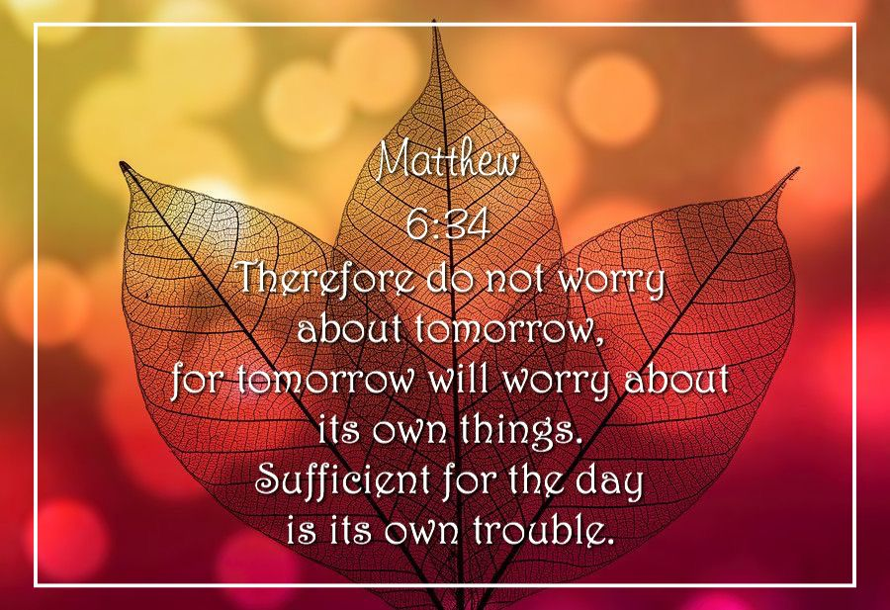

September 17, 2023

699 Stambaugh Ave.
Sharon, Pennsylvania 16146

“I was glad when they said to me,
Let us go to the house of the LORD!”
Psalm 122:1
Sts. Peter & Paul Evangelical Lutheran Church, LC-MS
THE FIFTEENTH SUNDAY AFTER TRINITY
September 17, 2023
A special welcome to our guests this day! If you would like more information about The Lutheran Church - Missouri Synod, or this congregation, please speak with Pastor Deal or an Elder after the service.
Members & Guests: Don’t be embarrassed if your children make noise during the worship service, all children do. We encourage families to worship together but, if you feel the need, there are pews in the rear of the Church which are reserved for young families on both sides of the sanctuary. There is also a quiet room available to you, located next to the sanctuary (formerly the Pastor’s office), where you would be able to follow along with the service.

Today’s service includes the Sacrament of Holy Communion. If during this past year, you have not worshipped with us and been communed, we respectfully ask that you do not partake of this sacrament this day before first speaking with Pastor Deal.
If visiting from a sister congregation of the LC-MS and are in good standing, please inform Pastor Deal of your desire to commune prior to the service.
If wishing to receive a blessing during communion, please approach with your arms crossed.

CONTACT INFORMATION
Pastor Deal: pastordeal@saintspeterandpaul.net or 724-347-3620 (opt. 2)
Church Office: church@saintspeterandpaul.net or 724-347-3620 (opt. 3)
Secretary’s Office: The office will be open Mon. (8:30 am-5 pm) & Thurs (8:30 am-10; 11-5pm).

Silent prayer before worship Heavenly Father, through Your Son Jesus You offer forgiveness and everlasting life to all who believe. Make me keenly aware of Your great love that I might worship You with a joyful and thankful heart. In Jesus’ name. Amen.
Confession and Absolution

Opening Hymn: LSB #726 “Evening and Morning”

Stand

The sign of the cross may be made by all in remembrance of their Baptism.

Invocation
P In the name of the Father and of the T Son and of the Holy Spirit.
C Amen.

Exhortation Hebrews 10:22; Psalm 124:8; Psalm 32:5
P Beloved in the Lord! Let us draw near with a true heart and confess our sins unto God our Father, beseeching Him in the name of our Lord Jesus Christ to grant us forgiveness.

P Our help is in the name of the Lord,
C who made heaven and earth.
P I said, I will confess my transgressions unto the Lord,
C and You forgave the iniquity of my sin.

Silence for reflection on God’s Word and for self-examination.

Confession of Sins
P O almighty God, merciful Father,
C I, a poor, miserable sinner, confess unto You all my sins and iniquities with which I have ever offended You and justly deserved Your temporal and eternal punishment. But I am heartily sorry for them and sincerely repent of them, and I pray You of Your boundless mercy and for the sake of the holy, innocent, bitter sufferings and death of Your beloved Son, Jesus Christ, to be gracious and merciful to me, a poor, sinful being.

Absolution [John 20:19–23]
P Upon this your confession, I, by virtue of my office, as a called and ordained servant of the Word, announce the grace of God unto all of you, and in the stead and by the command of my Lord Jesus Christ I forgive you all your sins in the name of the Father and of the T Son and of the Holy Spirit.
C Amen.

Service of the Word

Introit Psalm 86:4, 6, 15a, 16; antiphon: vv. 1a, 2b, 3
Incline your ear, O Lord, and | answer me,*
save your servant, who trusts in you—you | are my God.
Be gracious to me, | O Lord,*
for to you do I cry | all the day.
Gladden the soul of your | servant,*
for to you, O Lord, do I lift | up my soul.
Give ear, O Lord, | to my prayer;*
listen to my | plea for grace.
But you, O Lord, are a God merciful and | gracious;*
turn to me and be gra- | cious to me;
give your strength to your | servant,*
and save the son of your maid- | servant.
Incline your ear, O Lord, and | answer me,*
save your servant, who trusts in you—you | are my God.
Be gracious to me, | O Lord,*
for to you do I cry | all the day.

Gloria Patri
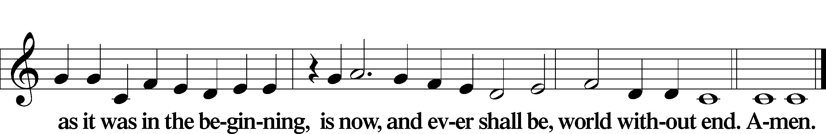

Kyrie Mark 10:47
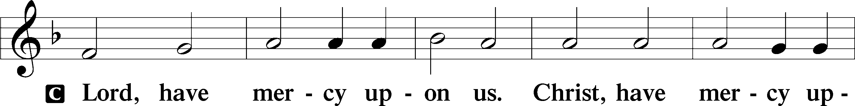
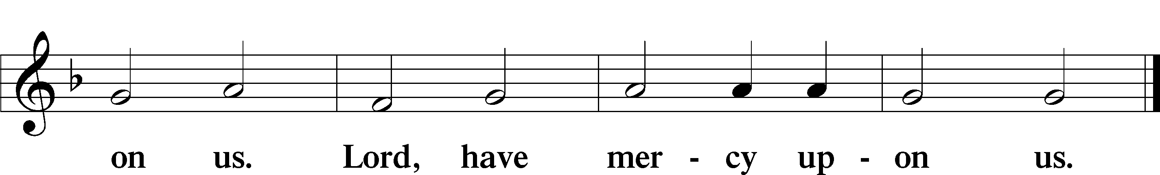

Gloria in Excelsis Luke 2:14; John 1:29
P Glory be to God on high:
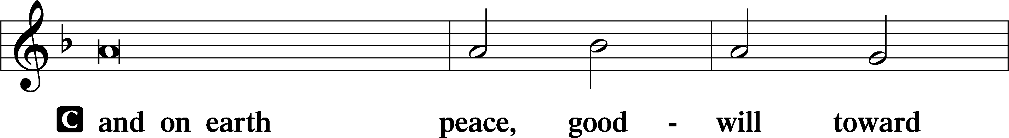
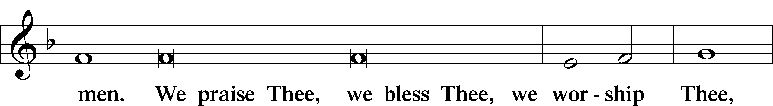
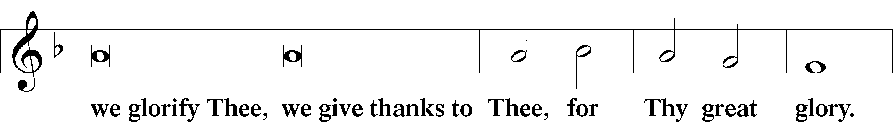
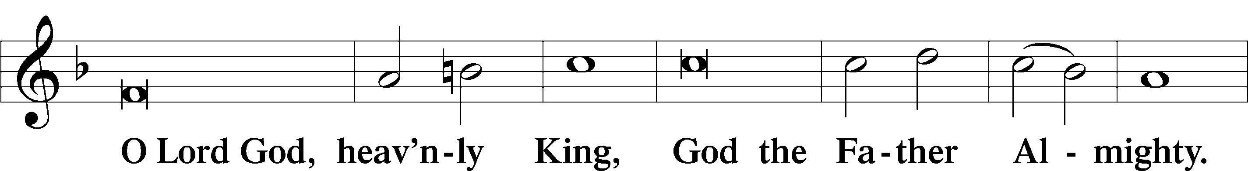
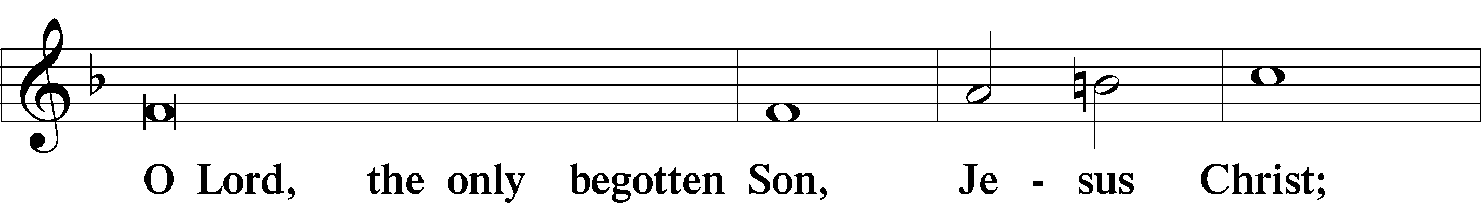
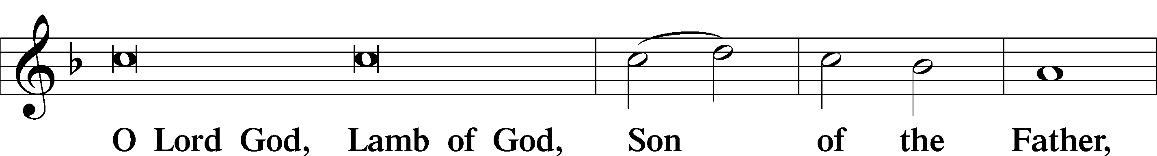
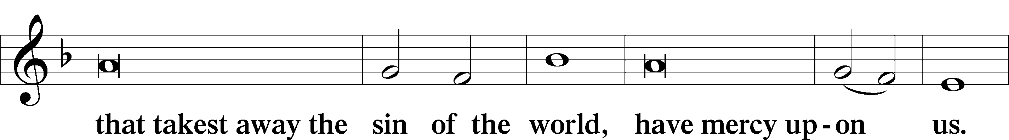
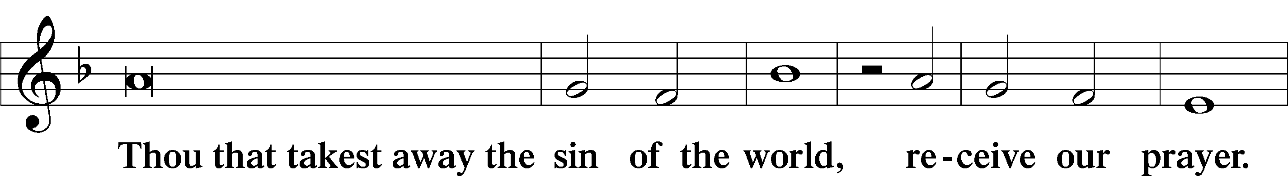
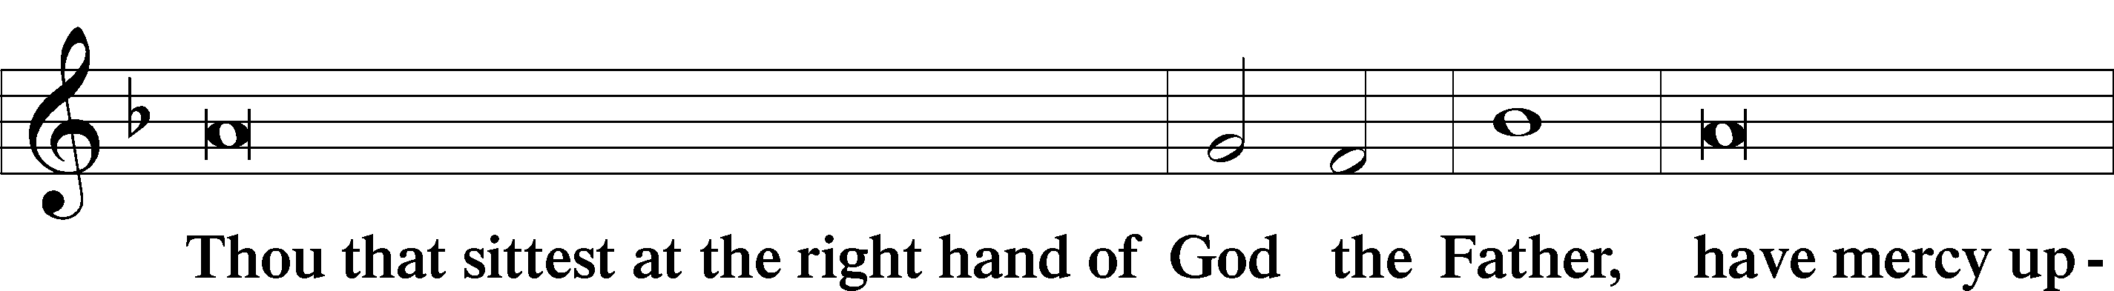
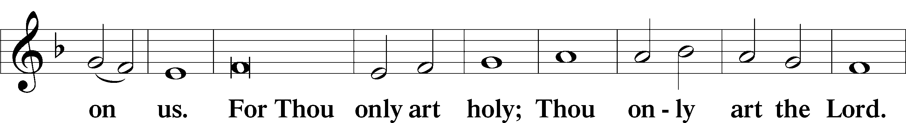
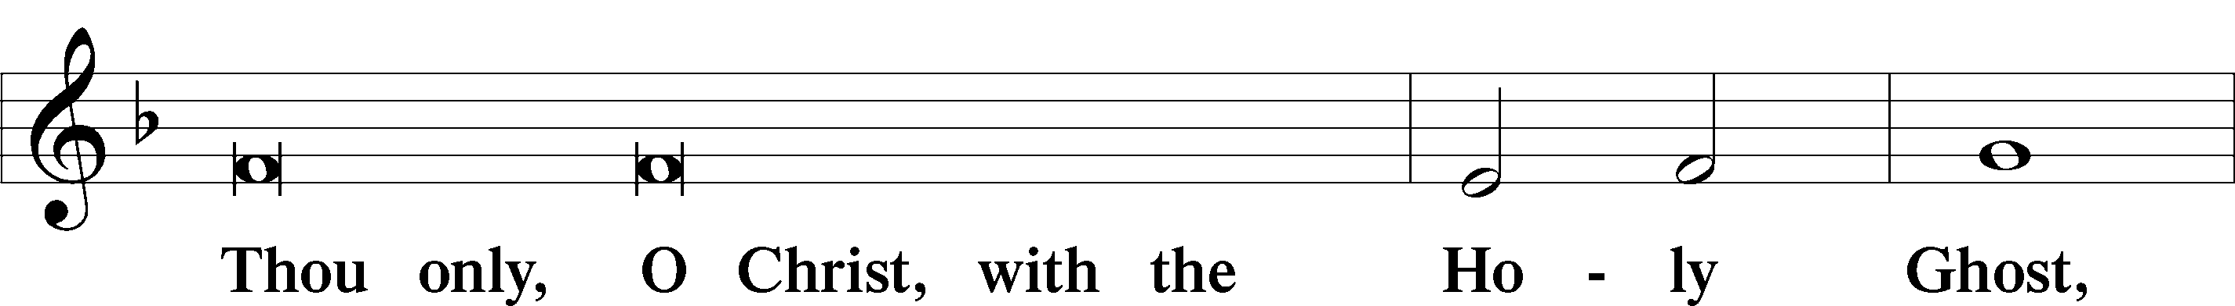
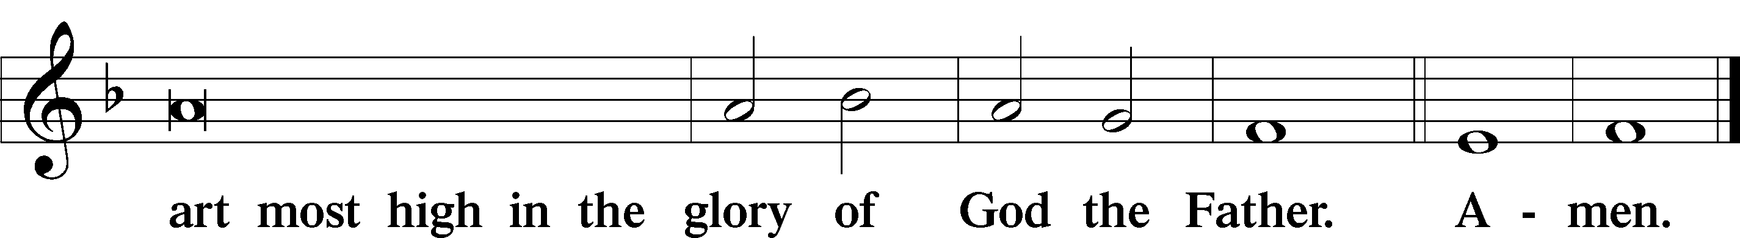

Salutation and Collect of the Day: Trinity 15
P The Lord be with you.
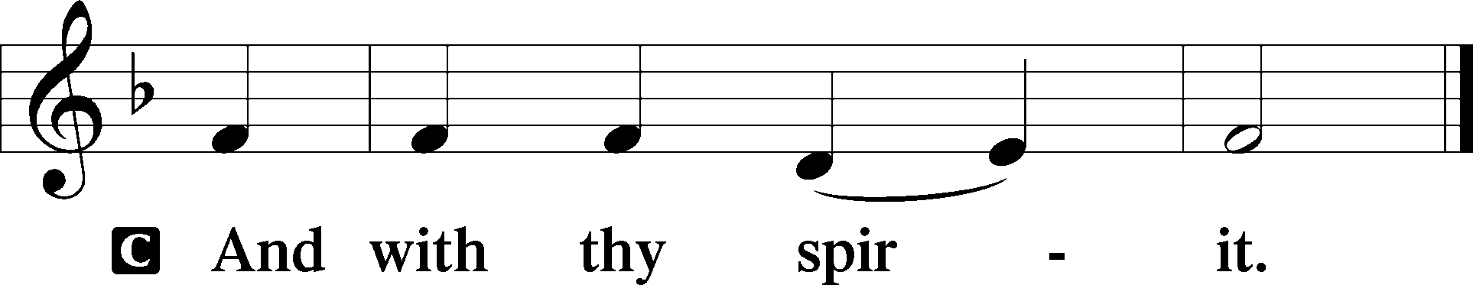

P Let us pray.
O Lord, we implore You, let Your continual pity cleanse and defend Your Church; and because she cannot continue in safety without Your aid, preserve her evermore by Your help and goodness; through Jesus Christ, Your Son, our Lord, who lives and reigns with You and the Holy Spirit, one God, now and forever.
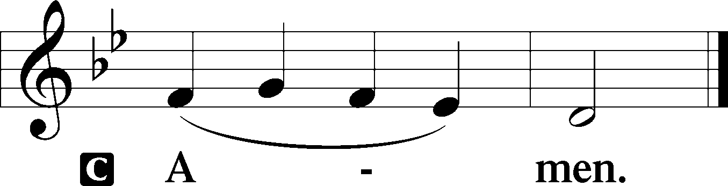
Sit

Prophecy: 1 Kings 17:8–16 (NKJV)
In those days: The word of the Lord came to Elijah, saying, “Arise, go to Zarephath, which belongs to Sidon, and dwell there. See, I have commanded a widow there to provide for you.” So he arose and went to Zarephath. And when he came to the gate of the city, indeed a widow was there gathering sticks. And he called to her and said, “Please bring me a little water in a cup, that I may drink.” And as she was going to get it, he called to her and said, “Please bring me a morsel of bread in your hand.” So she said, “As the Lord your God lives, I do not have bread, only a handful of flour in a bin, and a little oil in a jar; and see, I am gathering a couple of sticks that I may go in and prepare it for myself and my son, that we may eat it, and die.” And Elijah said to her, “Do not fear; go and do as you have said, but make me a small cake from it first, and bring it to me; and afterward make some for yourself and your son. For thus says the Lord God of Israel: ‘The bin of flour shall not be used up, nor shall the jar of oil run dry, until the day the Lord sends rain on the earth.’ ” So she went away and did according to the word of Elijah; and she and he and her household ate for many days. The bin of flour was not used up, nor did the jar of oil run dry, according to the word of the Lord which He spoke by Elijah.

P This is the Word of the Lord.
C Thanks be to God.

Gradual Psalm 118:8–9
It is better to take refuge | in the Lord*
than to | trust in man.
It is better to take refuge | in the Lord*
than to trust in | princes.
Epistle: Galatians 5:25—6:10 (NKJV)
Brethren: If we live in the Spirit, let us also walk in the Spirit. Let us not become conceited, provoking one another, envying one another. Brethren, if a man is overtaken in any trespass, you who are spiritual restore such a one in a spirit of gentleness, considering yourself lest you also be tempted. Bear one another’s burdens, and so fulfill the law of Christ. For if anyone thinks himself to be something, when he is nothing, he deceives himself. But let each one examine his own work, and then he will have rejoicing in himself alone, and not in another. For each one shall bear his own load. Let him who is taught the word share in all good things with him who teaches. Do not be deceived, God is not mocked; for whatever a man sows, that he will also reap. For he who sows to his flesh will of the flesh reap corruption, but he who sows to the Spirit will of the Spirit reap everlasting life. And let us not grow weary while doing good, for in due season we shall reap if we do not lose heart. Therefore, as we have opportunity, let us do good to all, especially to those who are of the household of faith.

P This is the Word of the Lord.
C Thanks be to God.

Stand

Verse Psalm 95:1
Alleluia. Oh come, let us sing to the Lord; let us make a joyful noise to the rock of our salvation! Alleluia.

Alleluia
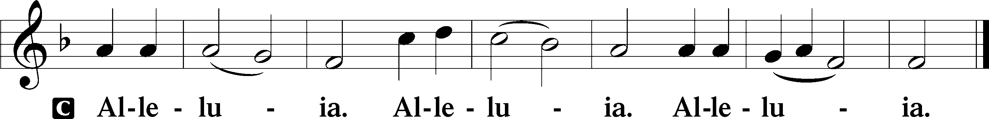

Holy Gospel: Matthew 6:24–34 (NKJV)
P The Holy Gospel according to St. Matthew, the sixth chapter.
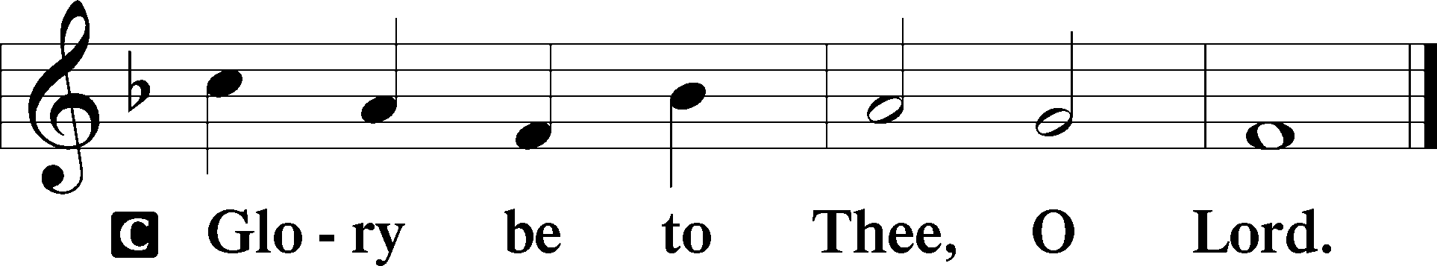

At that time Jesus said to His disciples: “No one can serve two masters; for either he will hate the one and love the other, or else he will be loyal to the one and despise the other. You cannot serve God and mammon. Therefore I say to you, do not worry about your life, what you will eat or what you will drink; nor about your body, what you will put on. Is not life more than food and the body more than clothing? Look at the birds of the air, for they neither sow nor reap nor gather into barns; yet your heavenly Father feeds them. Are you not of more value than they? Which of you by worrying can add one cubit to his stature? So why do you worry about clothing? Consider the lilies of the field, how they grow: they neither toil nor spin; and yet I say to you that even Solomon in all his glory was not arrayed like one of these. Now if God so clothes the grass of the field, which today is, and tomorrow is thrown into the oven, will He not much more clothe you, O you of little faith? Therefore do not worry, saying, ‘What shall we eat?’ or ‘What shall we drink?’ or ‘What shall we wear?’ For after all these things the Gentiles seek. For your heavenly Father knows that you need all these things. But seek first the kingdom of God and His righteousness, and all these things shall be added to you. Therefore do not worry about tomorrow, for tomorrow will worry about its own things. Sufficient for the day is its own trouble.”

P This is the Gospel of the Lord.
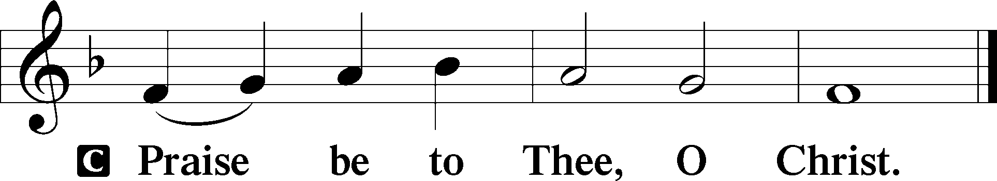

Nicene Creed
C I believe in one God,
the Father Almighty,
maker of heaven and earth
and of all things visible and invisible.

And in one Lord Jesus Christ,
the only-begotten Son of God,
begotten of His Father before all worlds,
God of God, Light of Light,
very God of very God,
begotten, not made,
being of one substance with the Father,
by whom all things were made;
who for us men and for our salvation came down from heaven
and was incarnate by the Holy Spirit of the virgin Mary
and was made man;
and was crucified also for us under Pontius Pilate.
He suffered and was buried.
And the third day He rose again according to the Scriptures
and ascended into heaven
and sits at the right hand of the Father.
And He will come again with glory to judge both the living and the dead,
whose kingdom will have no end.

And I believe in the Holy Spirit,
the Lord and giver of life,
who proceeds from the Father and the Son,
who with the Father and the Son together is worshiped and glorified,
who spoke by the prophets.
And I believe in one holy Christian and apostolic Church,
I acknowledge one Baptism for the remission of sins,
and I look for the resurrection of the dead
and the life T of the world to come. Amen.
Sit

Hymn of the Day: LSB #760 “What God Ordains Is Always Good”

Sermon

Stand

Offertory Psalm 51:10–12
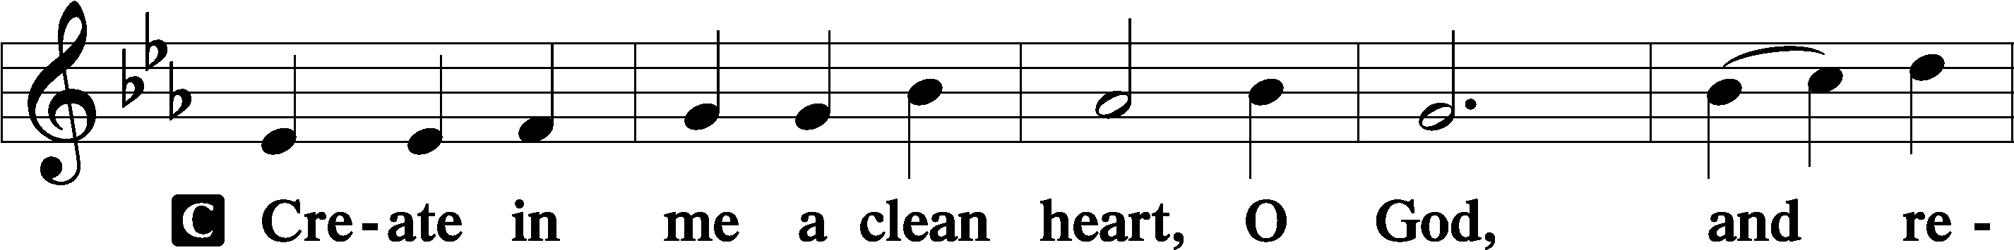
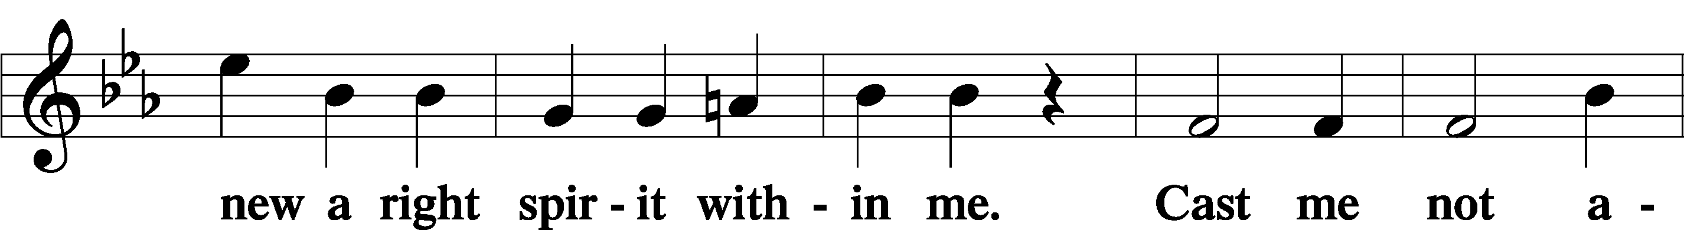
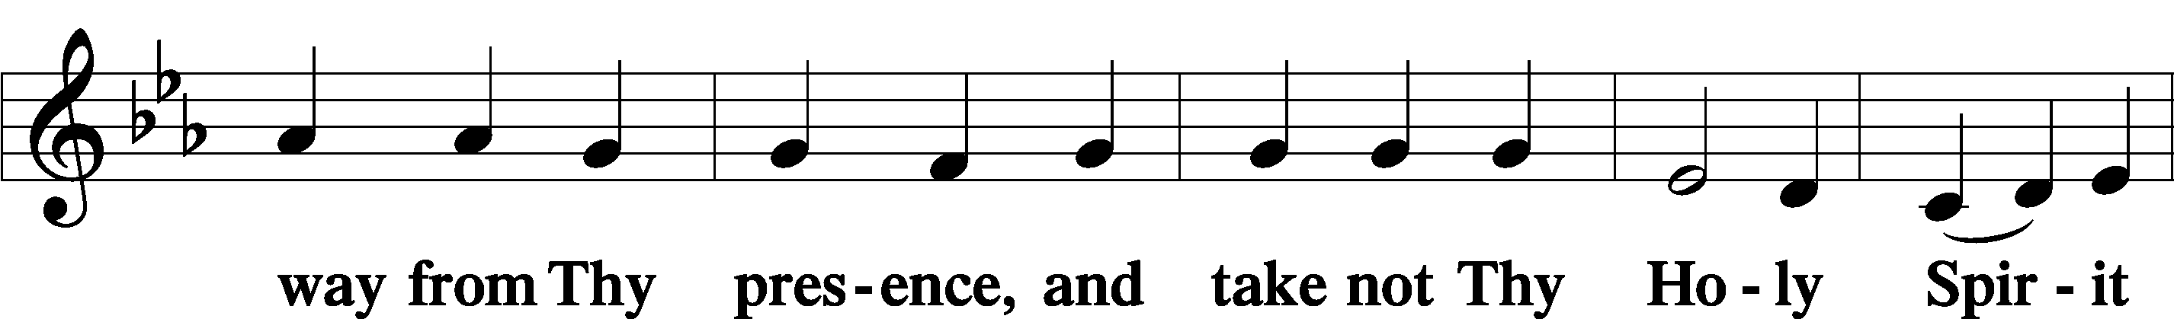
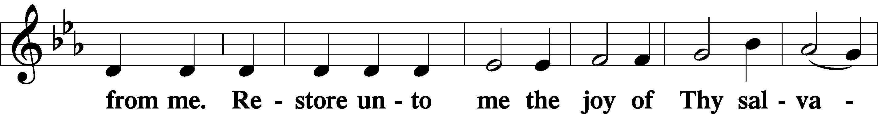
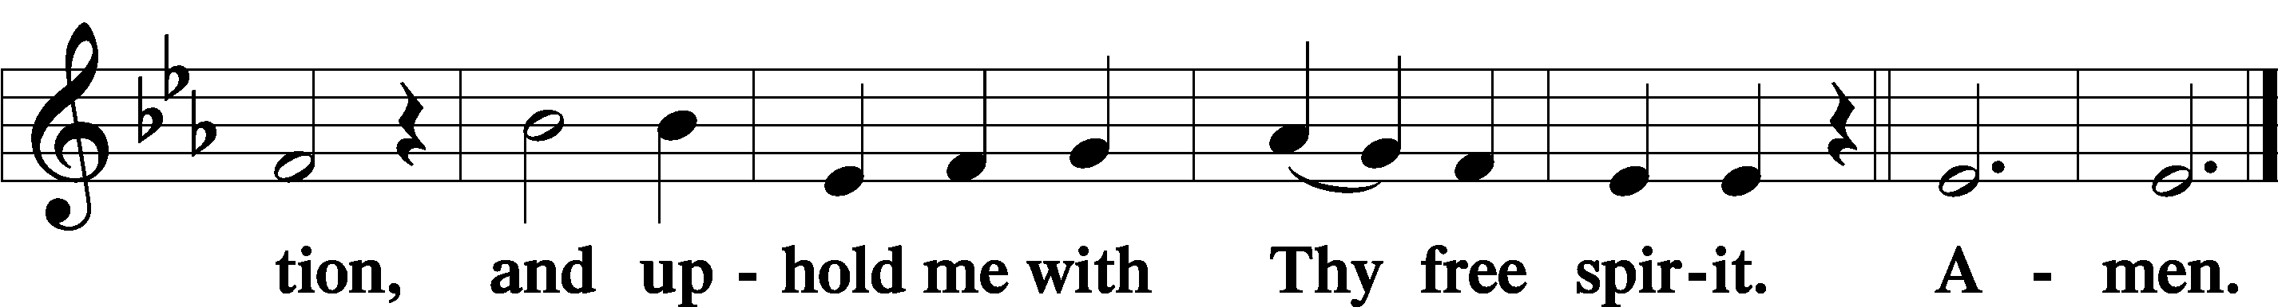

Prayer of the Church

Sit

Preparatory Hymn: LSB #756 “Why Should Cross and Trial Grieve Me”

Stand
Service of the Sacrament

Preface 2 Timothy 4:22; Colossians 3:1 Psalm 136
P The Lord be with you.

P Lift up your hearts.
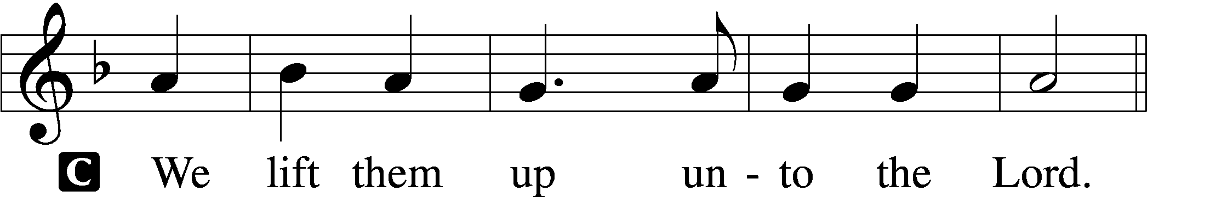

P Let us give thanks unto the Lord, our God.
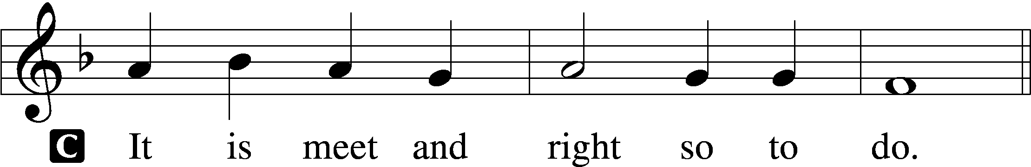

Proper Preface (Abbreviated) LSB 194
P It is truly meet, right, and salutary . . . evermore praising You and saying:

Sanctus Isaiah 6:3; Matthew 21:9
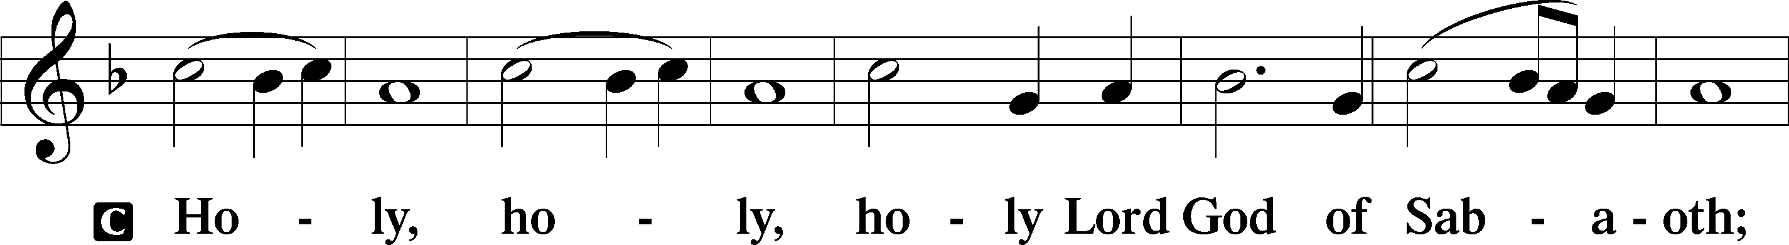
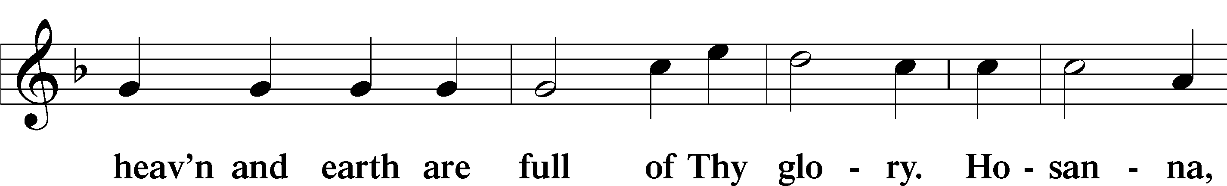
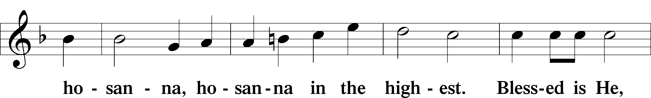
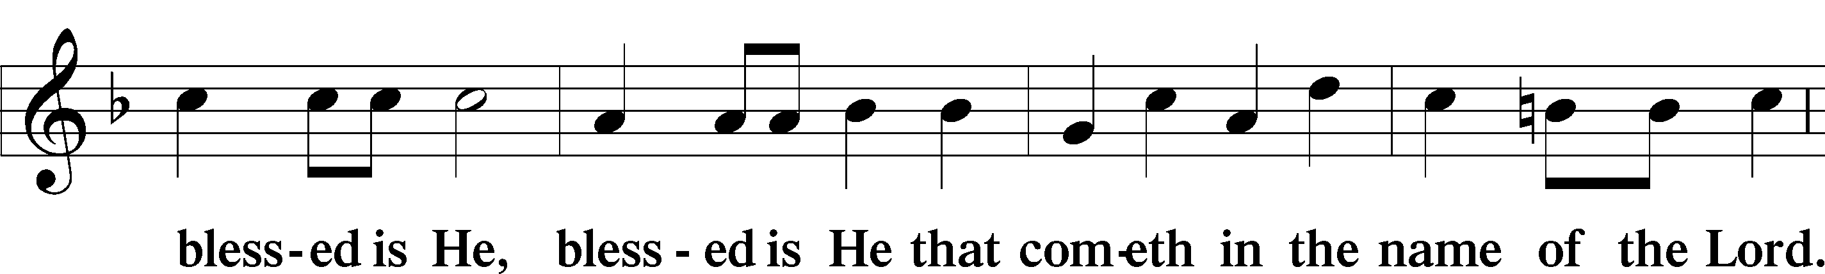
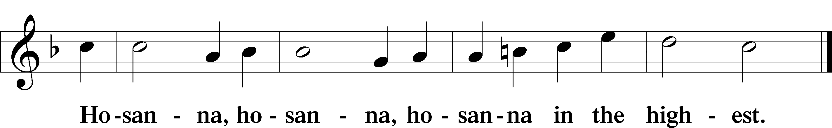

Lord’s Prayer Matthew 6:9–13
C Our Father who art in heaven,
hallowed be Thy name,
Thy kingdom come,
Thy will be done on earth as it is in heaven;
give us this day our daily bread;
and forgive us our trespasses as we forgive those who trespass against us;
and lead us not into temptation,
but deliver us from evil.
For Thine is the kingdom and the power and the glory forever and ever. Amen.

The Words of Our Lord Matthew 26:26–28; Mark 14:22–24; Luke 22:19–20; 1 Corinthians 11:23–25
P Our Lord Jesus Christ, on the night when He was betrayed, took bread, and when He had given thanks, He broke it and gave it to the disciples and said: “Take, eat; this is My T body, which is given for you. This do in remembrance of Me.”

In the same way also He took the cup after supper, and when He had given thanks, He gave it to them, saying: “Drink of it, all of you; this cup is the new testament in My T blood, which is shed for you for the forgiveness of sins. This do, as often as you drink it, in remembrance of Me.”

Pax Domini John 20:19
P The peace of the Lord be with you always.
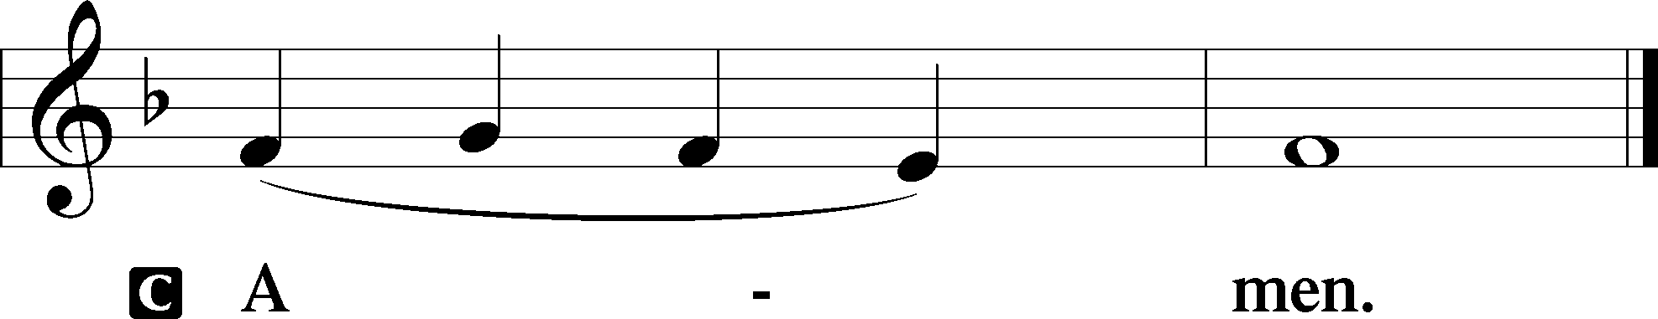

Agnus Dei John 1:29
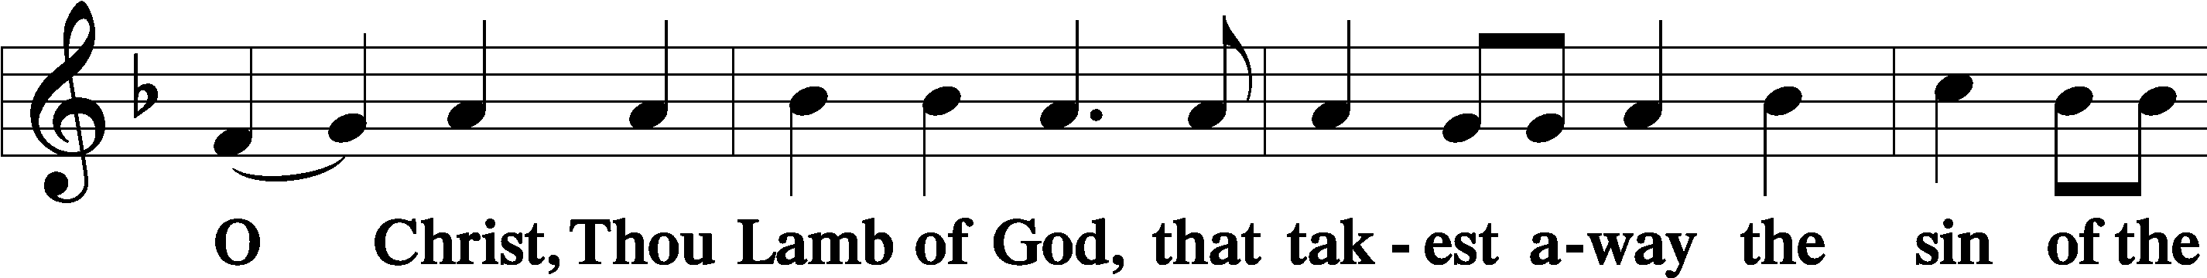
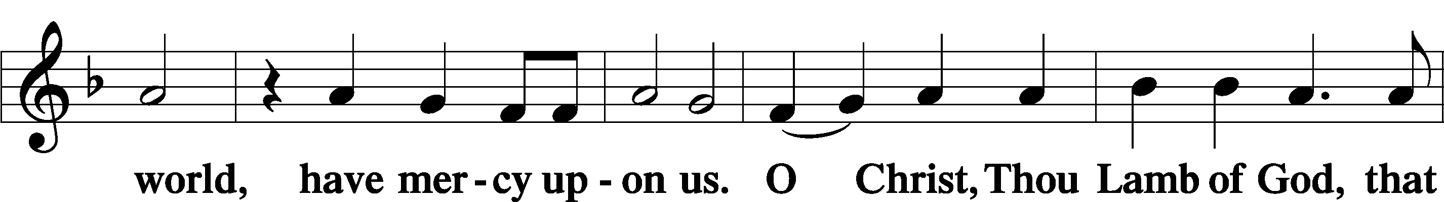
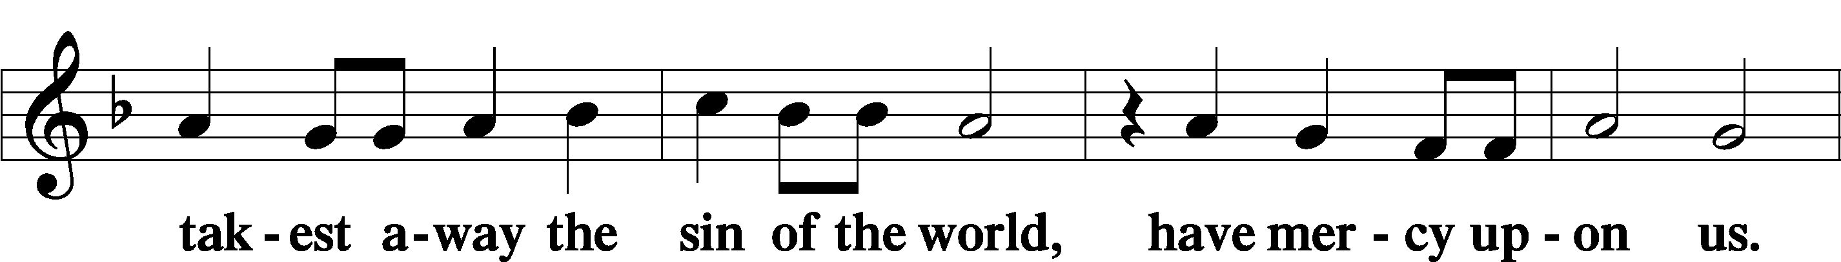
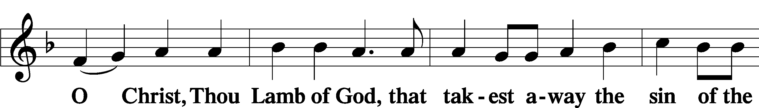
Sit

Distribution
The pastor and those who assist him receive the body and blood of Christ first and then distribute them to those who come to receive, saying:
Take, eat; this is the true body of our Lord and Savior Jesus Christ, given into death for your sins.
Amen.

Take, drink; this is the true blood of our Lord and Savior Jesus Christ, shed for the forgiveness of your sins.
Amen.

In dismissing the communicants, the following is said:
The Dismissal
P The body and blood of our Lord Jesus Christ strengthen and preserve you in body and soul to life everlasting. Depart T in peace.
C Amen.

Distribution Hymn: LSB #468 “I Am Content! My Jesus Ever Lives”

Distribution Hymn: LSB #719 “I Leave All Things to God’s Direction”

Distribution Hymn: LSB #700 “Love Divine, All Loves Excelling”

Stand

Nunc Dimittis Luke 2:29–32
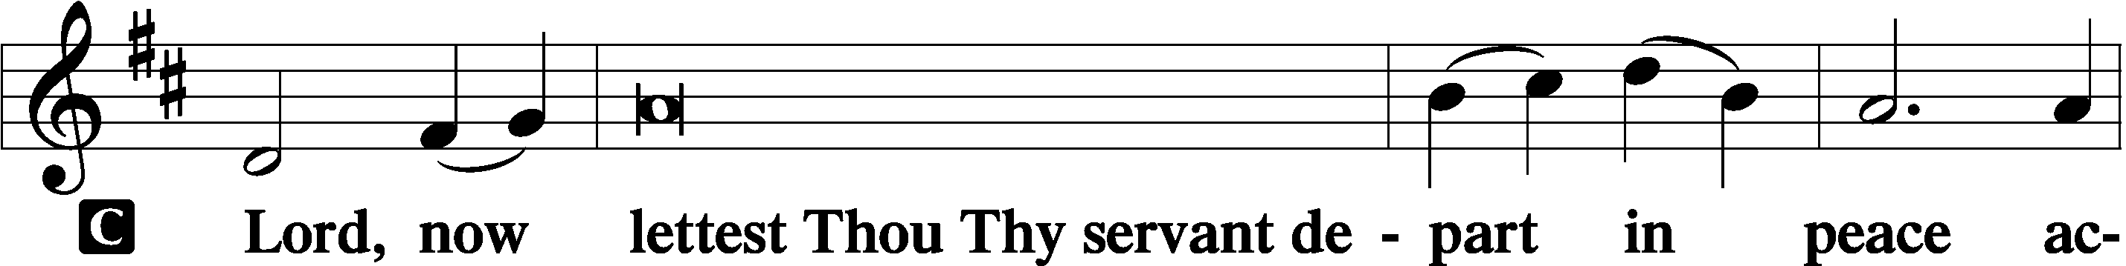
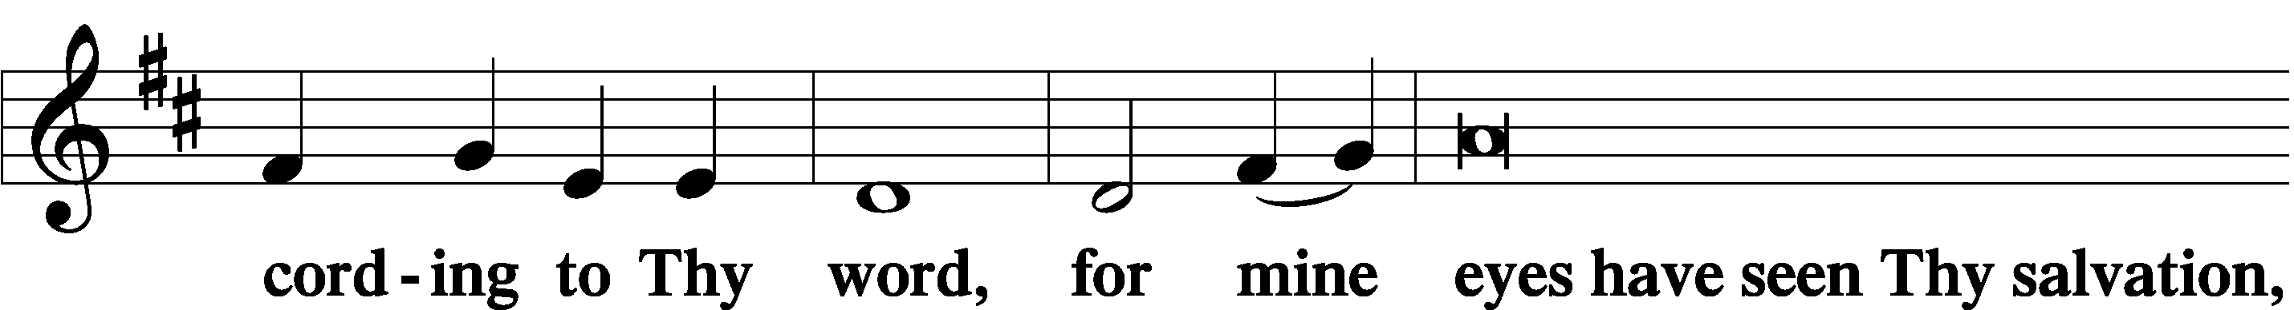
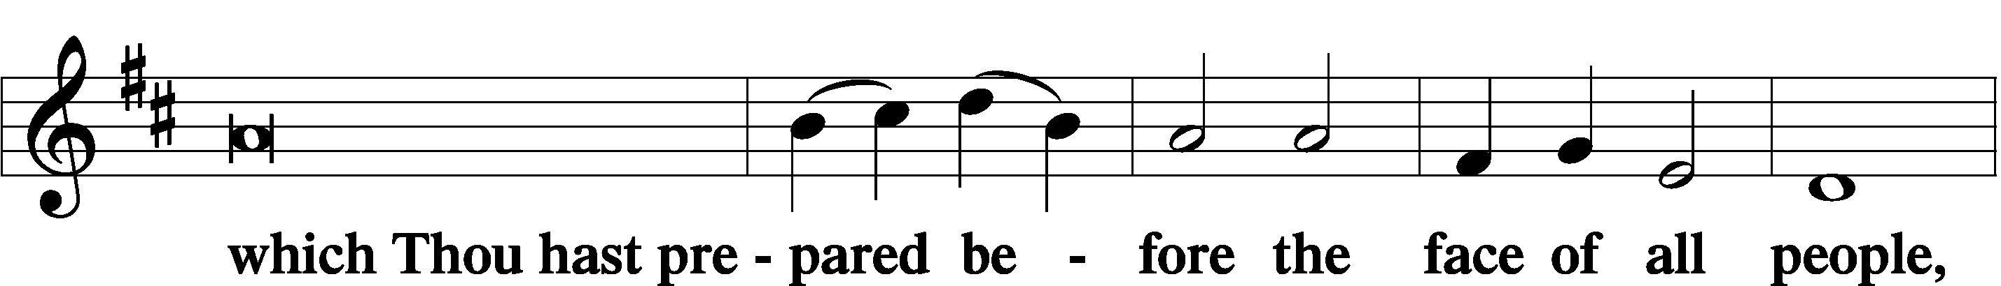
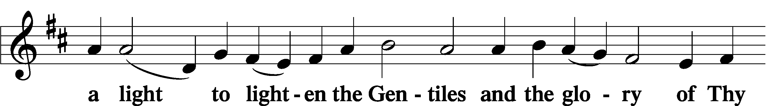
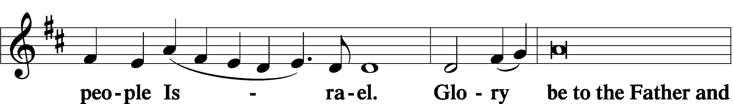
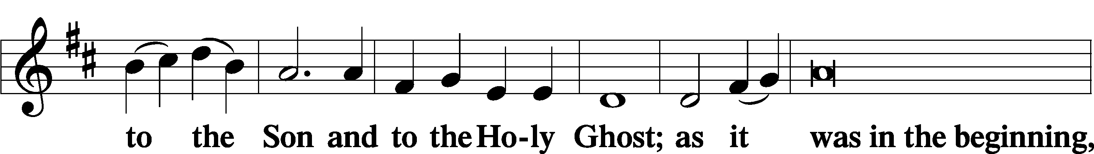
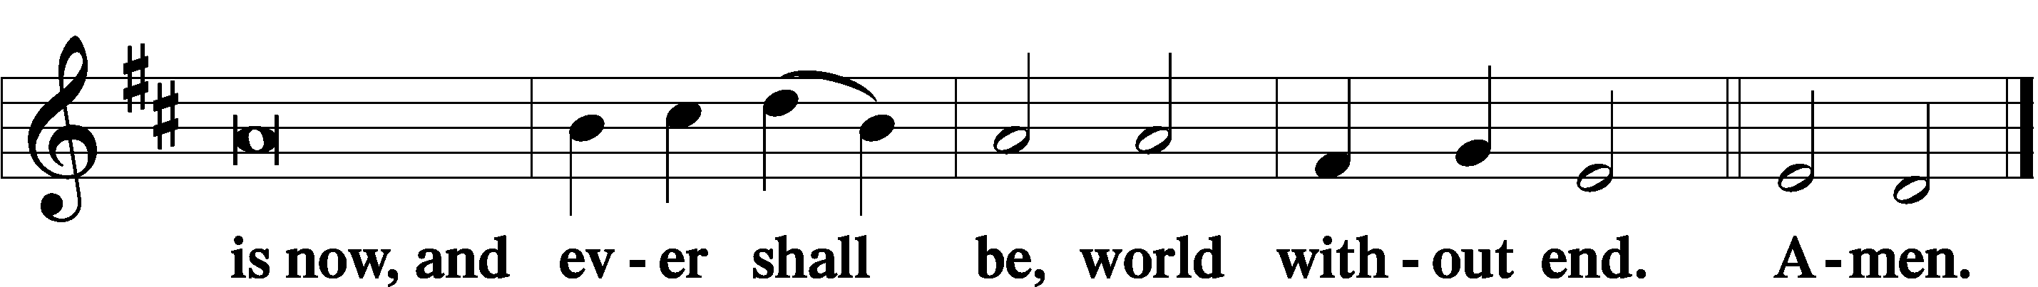

Thanksgiving Psalm 107:1
P O give thanks unto the Lord, for He is good,
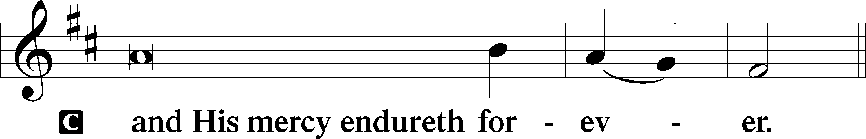

Post-Communion Collect
P Let us pray.
We give thanks to You, almighty God, that You have refreshed us through this salutary gift, and we implore You that of Your mercy You would strengthen us through the same in faith toward You and in fervent love toward one another; through Jesus Christ, Your Son, our Lord, who lives and reigns with You and the Holy Spirit, one God, now and forever.
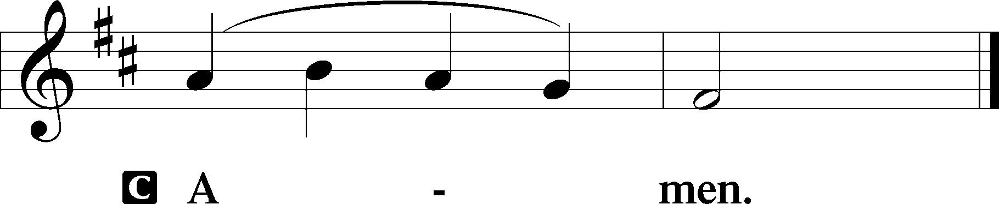

Salutation 2 Timothy 4:22
P The Lord be with you.
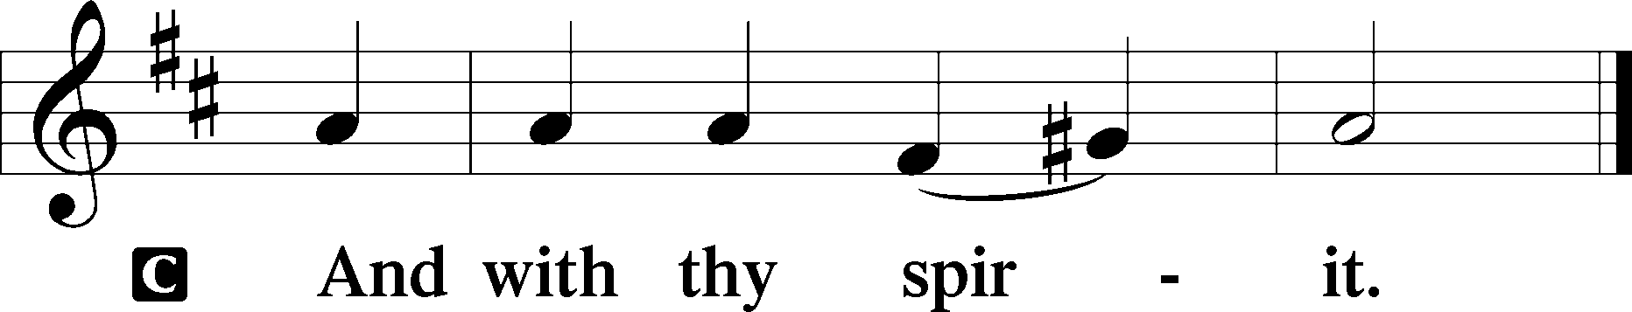

Benedicamus Psalm 103:1
P Bless we the Lord.
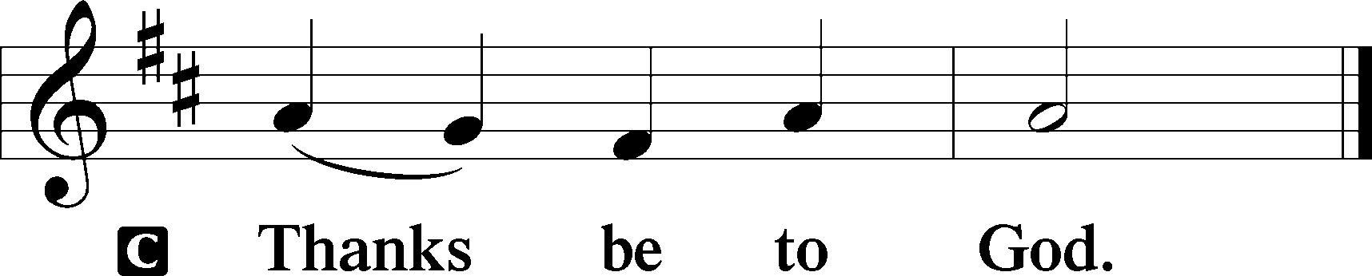

Benediction Numbers 6:24–26
P The Lord bless you and keep you.
The Lord make His face shine upon you and be gracious unto you.
The Lord lift up His countenance upon you and T give you peace.
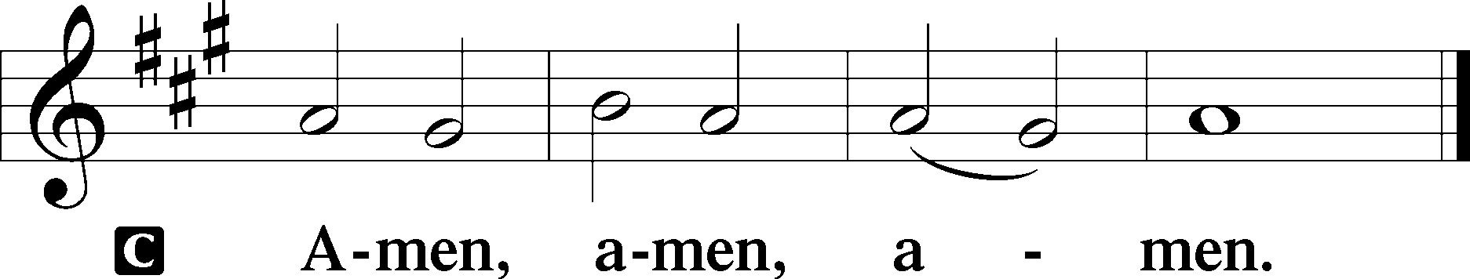

Closing Hymn: LSB #732 “All Depends on Our Possessing”

Silent prayer after worship: Dear Lord, forgive me when I wander from You and go my own way. By the power of Your word, enable me to faithfully and humbly follow You. In Jesus’ name. Amen.
fffffffffffffffffffffffffffffffffff
Acknowledgments
Unless otherwise indicated, Scripture quotations are from the ESV® Bible (The Holy Bible, English Standard Version®), copyright © 2001 by Crossway, a publishing ministry of Good News Publishers. Used by permission. All rights reserved.
Created by Lutheran Service Builder © 2023 Concordia Publishing House.

fffffffffffffffffffffffffffffffffff
In Loving Memory of Barry Nelson: Ed & Millie Zachar.
In Loving Memory of Mother, Mary Fee: Dolores Fee (Capital Campaign).
fffffffffffffffffffffffffffffffffff

SCHEDULE THROUGH SEPTEMBER 24, 2023:

:

Today, following Worship, Library: Monthly Audit
7 pm, Fellowship Hall: AA Meeting
Tuesday, 7-9 pm, Fellowship Hall: Penn-Ohio Singers
Wednesday, 7:30 pm, Fellowship Hall: NA Meeting
Thursday, 10 am, Fellowship Hall: Women’s Bible Study
Next Sunday, 8 am, Fellowship Hall: Bible Study
9 am, Sanctuary: Divine Service
7 pm, Fellowship Hall: AA Meeting
fffffffffffffffffffffffffffffffffff
Attendance: Sunday, September 10, 2023: 38
fffffffffffffffffffffffffffffffffff
Our Stewardship of Treasures for the Lord:
In order to do the Lord’s work, we need $2,553.63 each week to meet our 2023 budget for general purposes and $76.92 for the SELC.

Figures for Sunday, September 10, 2023
General Fund: $1,850.00 Behind for the week: -$703.63
SELC: $50.00 Behind for the week: -$16.92
Food Pantry: $55.00
Quarterly Missions: $75.00
Capital Campaign: $55.00
Other: $960.00

For online giving, check out https://www.saintspeterandpaul.net/online-giving.
fffffffffffffffffffffffffffffffffff
THANK YOU FOR SERVING IN SEPTEMBER: Elder: Jonathan Baisch; Ushers: Mark Kleindienst, Jerry Krivosh, & Gordon Marquette; Altarware: (prior) Diane Riefstahl; Kati Laird and Hank Holcroft.
fffffffffffffffffffffffffffffffffff
Bible Memory Verses ~ Week of September 17th:
For Adults: For it has been granted to you that for the sake of Christ you should not only believe in him but also suffer for his sake. Philippians 1:29

For Children: Cast all your anxieties on him, because he cares for you. 1 Peter 5:7
fffffffffffffffffffffffffffffffffff
Sunday Morning Bible Study has resumed. We are continuing our study of the minor prophets. All are welcome to join!
fffffffffffffffffffffffffffffffffff
Reminders!
- Auditors will meet following worship in the library for a monthly audit of deposits.
- Items for the October calendar and newsletter are due to the secretary by noon tomorrow, September 18th.
- There will be a special Divine Service held Friday, September 29th at 7 pm celebrating the Feast of Saint Michael and All Angels.
fffffffffffffffffffffffffffffffffff
Copies of Jonathan Baisch’s indepth report on the LC-MS Convention which he attended are available on the table in the narthex.
fffffffffffffffffffffffffffffffffff
At the conclusion of this morning’s worship, a freewill offering supporting the New Missions Development work by the Pittsburgh Area Lutheran Ministries (PALM) will be taken. Your support of this effort is greatly appreciated.
fffffffffffffffffffffffffffffffffff
The following is the new address for Alex (Sasha) Carr:
PVT Alexander Carr
7009 Quartermaster Rd.
F Co 16th OD BN 4th PLT
Fort Gregg-Adams, VA 23801
Remember the following in Prayer…
~The Hurting and Healing: Amy, Steve Antolovich, Ellen Baron^{CA}, Amy Blomenberg, Lois Bortner^{CA}, Sara Brubaker, Dee Bullock, Bev & Joe Chlpka, Susan Davies, Loretta Deal, Tim Dudash, Judith & Eddy Furey, Griffin, Peter Haenftling, Austin Hamilton, Pastor Charles Henrickson, Joan, Keith Jozwiakowski, Darla Krajci, Barbara Kreske, Jess Lavoie, Elizabeth Loughan, Paul Lucas^{CA}, Sandy Marshall, Gene Moore, Frank Niemeyer^{CA}, Juanita Rentschler, Richard Reuning^{CA}, Nancy Robertson^{CA}, Landon Sargent, Kriss Svidro^{CA}, Joel & Peggy Wasson, Angela Weser^{CA}, and Ruth Wolf.
~The Homebound: Anna Mae Daris, Millie Elavsky, Rudy & Jean Tomko, Betty Wolf, and Ed & Millie Zachar.
~Celebrating this Week: Birthdays: Austin Hamilton (09.20), Cathy Smith (09.20), and Matt Berent (09.22).
~Serving in the Military: Alex (Sasha) Carr, Curtis Sinewe, and Joshua Solyan.
~Community & World Needs: Those suffering due to the conflict between Ukraine and Russia; those suffering from loss and dislocation because weather disasters; those suffering from addiction and their families; Local, State, and National Government Leaders; safety for all Police Officers, Firefighters, & First Responders; the unemployed; our Third Quarter Local Mission: Luther Classical College.
*CA represents cancer.
fffffffffffffffffffffffffffffffffff
PASTOR & FAMILY APPRECIATION DINNER - SATURDAY, OCT. 28th, 5 PM
Come and join us for some good food and fellowship with a special dinner in appreciation of Pastor Deal and family. There will also be a birthday cake in celebration of Loretta's 5th birthday! Mark your calendars now! You don't want to miss this time with our church family.
The organizing team will be contacting everyone to make sure all are advised and to ask what you can do to help - pray for the event, set up, prepare a salad or side dish, clean up. Main entrée and dessert will be provided! If you have any questions, you can call Bess Kleindienst at 973-768-8874.
We look forward to sharing in this time together and pray God's blessings on us all!

Here to Serve
Pastor………………………………………………...……………Rev. Jacob Deal
E-mail …………………………….……pastordeal@saintspeterandpaul.net
Phone Number……………………..…………………724-347-3620 (Option 2)
Church Office………………………..…………………724-347-3620 (Option 3)
Website …………………………………………www.saintspeterandpaul.net
Secretary…………………………………………………………Diane Riefstahl
E-mail ………………………………………church@saintspeterandpaul.net
Website …………………………………………www.saintspeterandpaul.net
Food Pantry (email): ……………foodpantry@saintspeterandpaul.net
Congregation President………………………………….…Jonathan Baisch
Church Elder …………………………………………...……. Jonathan Baisch
Organist………………………………………………..….…Rebecca Marquette
Choir Director…………………………………………………….…Chris Nelson
AA Contact: Steve………………………………………………...…724-813-2358
NA Contact: Larry……………………………………..…………..724-977-8733
fffffffffffffffffffffffffffffffffff
If needing to get into the church building during the week, please phone first to make certain someone is here to let you in.

