Sts. Peter & Paul
Evangelical Lutheran Church
Lutheran Church-Missouri Synod
Founded-1917
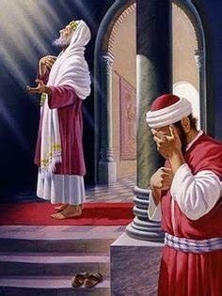

SEPTEMBER 1, 2019

699 Stambaugh Avenue
Sharon, Pennsylvania 16146

“I was glad when they said to me,
Let us go to the house of the LORD!”
Psalm 122:1

Sts. Peter & Paul Evangelical Lutheran Church, LC-MS

ELEVENTH SUNDAY AFTER TRINITY
September 1, 2019

Silent prayer before worship: Almighty God, open my eyes that I may see wonderful things in Your Word. Open my ears and my heart to hear Your voice through Holy Scriptures. Cause the light of Your love to shine forth from me so others may know You. In Jesus’ name. Amen.
CONFESSION AND ABSOLUTION
Opening Hymn: LSB #559 “Oh, How Great Is Your Compassion”
Stand

The sign of the cross may be made by all in remembrance of their Baptism.

P In the name of the Father and of the T Son and of the Holy Spirit.
C Amen. Matthew 28: 19b; (18:20)
P Beloved in the Lord! Let us draw near with a true heart and confess our sins unto God our Father, beseeching Him in the name of our Lord Jesus Christ to grant us forgiveness. [Hebrews 10:22]

P Our help is in the name of the Lord,
C who made heaven and earth. Psalm 124: 8
P I said, I will confess my transgressions unto the Lord,
C and You forgave the iniquity of my sin. Psalm 32: 5

Silence for reflection on God's Word and for self-examination.

P O almighty God, merciful Father,
C I, a poor, miserable sinner, confess unto You all my sins and iniquities with which I have ever offended You and justly deserved Your temporal and eternal punishment. But I am heartily sorry for them and sincerely repent of them, and I pray You of Your boundless mercy and for the sake of the holy, innocent, bitter sufferings and death of Your beloved Son, Jesus Christ, to be gracious and merciful to me, a poor, sinful being.
P Upon this your confession, I, by virtue of my office, as a called and ordained servant of the Word, announce the grace of God unto all of you, and in the stead and by the command of my Lord Jesus Christ I forgive you all your sins in the name of the Father and of the T Son and of the Holy Spirit. [John 20: 19-23]
C Amen.
SERVICE OF THE WORD
Introit: Ps. 68:1, 3, 7a, 10b, 19; antiphon: Ps. 68:5b, 6a, 35b
God is in his holy habi- | tation;*
[he] settles the solitary | in a home.
The God of Israel—he | is the one*
who gives power and strength to his | people.
God shall arise, his enemies shall be | scattered;*
and those who hate him shall flee be- | fore him!
But the righteous shall be glad; they shall exult be- | fore God;*
they shall be jubilant | with joy!
O God, when you went out before your | people,*
in your goodness, O God, you provided for the | needy.
Blessèd be the Lord, who daily | bears us up;*
God is our sal- | vation.

Gloria Patri
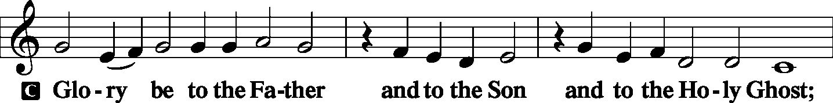
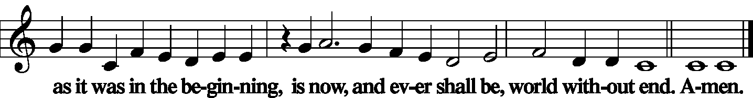

Kyrie
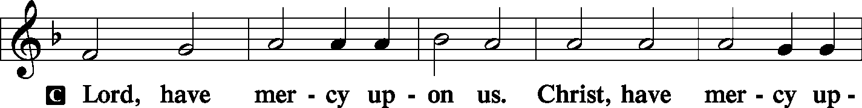
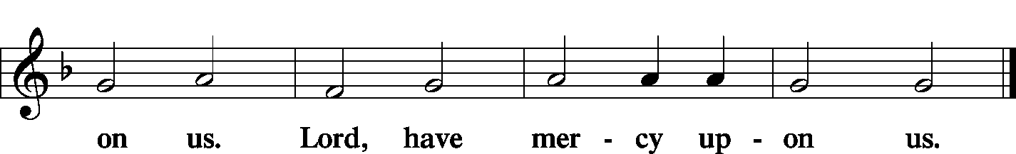

Gloria in Excelsis Luke 2: 14; John 1: 29
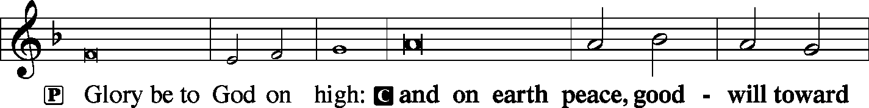
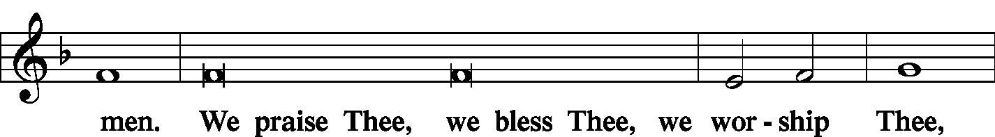
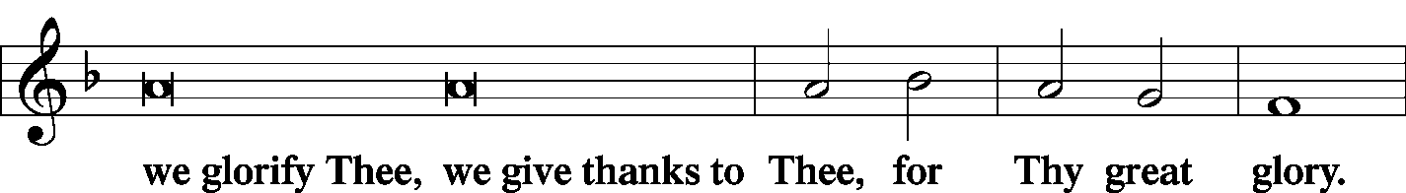
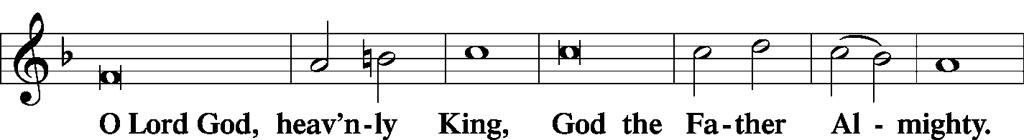
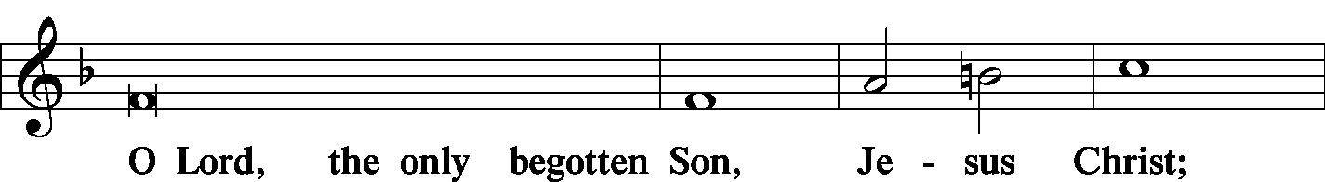
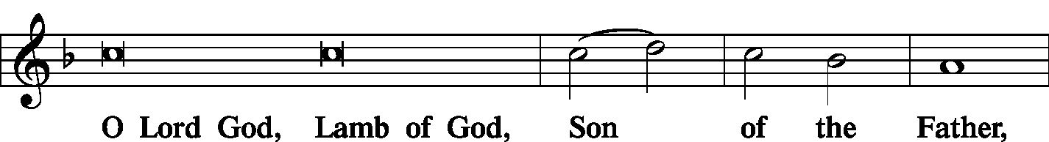
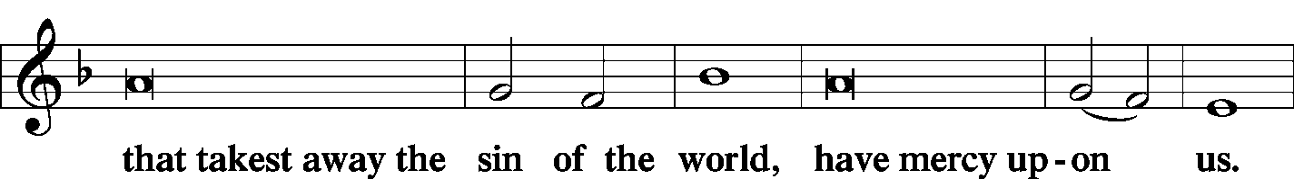
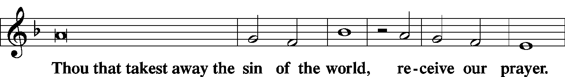
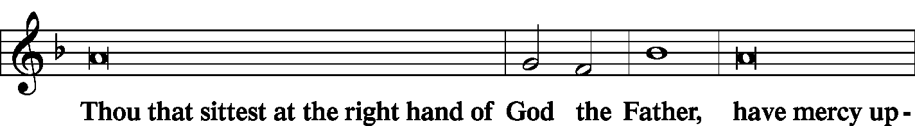
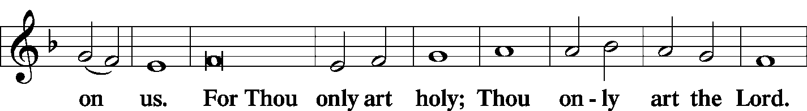
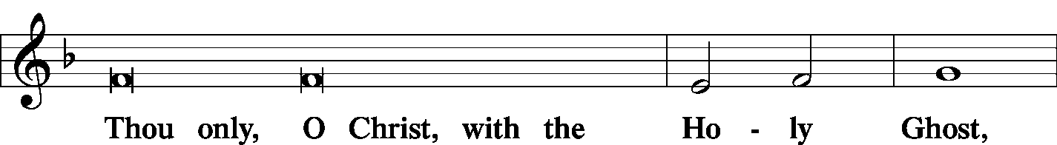
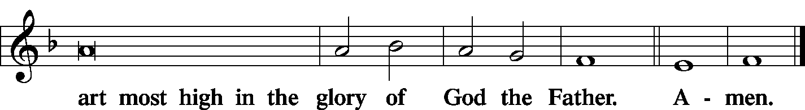

Salutation and Collect of the Day
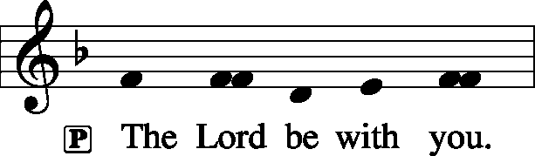 2 Timothy 4: 22
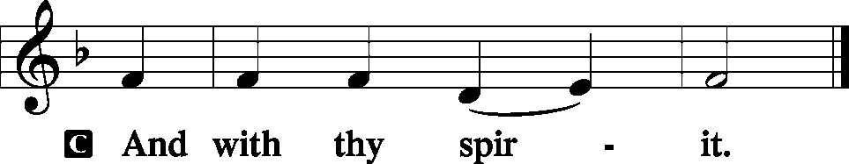

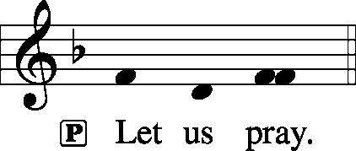

P Almighty and everlasting God, always more ready to hear than we to pray and to give more than we either desire or deserve, pour down upon us the abundance of Your mercy, forgiving those things of which our conscience is afraid and giving us those good things that we are not worthy to ask, except through the merits and mediation of Christ, our Lord, who lives and reigns with You and the Holy Spirit, one God, now and forever.

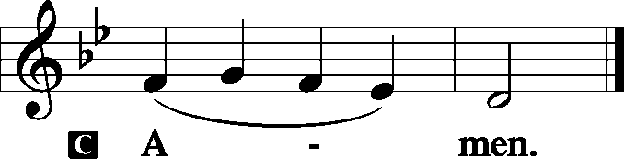

Sit

Old Testament Reading: Genesis 4:1–15
Now Adam knew Eve his wife, and she conceived and bore Cain, saying, “I have gotten a man with the help of the Lord.” And again, she bore his brother Abel. Now Abel was a keeper of sheep, and Cain a worker of the ground. In the course of time Cain brought to the Lord an offering of the fruit of the ground, and Abel also brought of the firstborn of his flock and of their fat portions. And the Lord had regard for Abel and his offering, but for Cain and his offering he had no regard. So Cain was very angry, and his face fell. The Lord said to Cain, “Why are you angry, and why has your face fallen? If you do well, will you not be accepted? And if you do not do well, sin is crouching at the door. Its desire is for you, but you must rule over it.”
Cain spoke to Abel his brother. And when they were in the field, Cain rose up against his brother Abel and killed him. Then the Lord said to Cain, “Where is Abel your brother?” He said, “I do not know; am I my brother’s keeper?” And the Lord said, “What have you done? The voice of your brother’s blood is crying to me from the ground. And now you are cursed from the ground, which has opened its mouth to receive your brother’s blood from your hand. When you work the ground, it shall no longer yield to you its strength. You shall be a fugitive and a wanderer on the earth.” Cain said to the Lord, “My punishment is greater than I can bear. Behold, you have driven me today away from the ground, and from your face I shall be hidden. I shall be a fugitive and a wanderer on the earth, and whoever finds me will kill me.” Then the Lord said to him, “Not so! If anyone kills Cain, vengeance shall be taken on him sevenfold.” And the Lord put a mark on Cain, lest any who found him should attack him.

P This is the Word of the Lord.
C Thanks be to God.

C Gradual: Ps. 28:7b, 1a, 2a
In [God] my heart trusts, and I am helped;
my heart exults, and with my song I give thanks to him.
To you, O Lord, I call; my rock, be not deaf to me,
hear the voice of my pleas for mercy, when I cry to you for help.

Epistle: Ephesians 2:1–10
And you were dead in the trespasses and sins in which you once walked, following the course of this world, following the prince of the power of the air, the spirit that is now at work in the sons of disobedience— among whom we all once lived in the passions of our flesh, carrying out the desires of the body and the mind, and were by nature children of wrath, like the rest of mankind. But God, being rich in mercy, because of the great love with which he loved us, even when we were dead in our trespasses, made us alive together with Christ—by grace you have been saved— and raised us up with him and seated us with him in the heavenly places in Christ Jesus, so that in the coming ages he might show the immeasurable riches of his grace in kindness toward us in Christ Jesus. For by grace you have been saved through faith. And this is not your own doing; it is the gift of God, not a result of works, so that no one may boast. For we are his workmanship, created in Christ Jesus for good works, which God prepared beforehand, that we should walk in them.

P This is the Word of the Lord.
C Thanks be to God.

Stand
Alleluia Verse and Alleluia
P Alleluia. Lord, you have been our dwelling place in all generations. Alleluia.

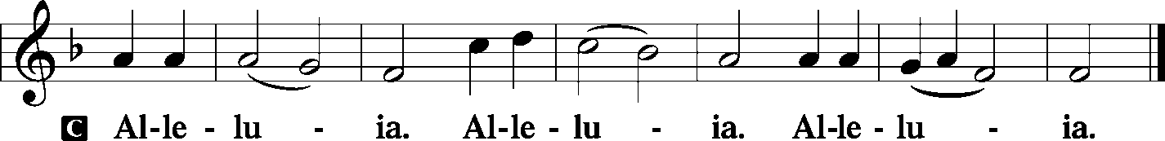

Holy Gospel: Luke 18:9–14
P The Holy Gospel according to St. Luke, the eighteenth chapter.
C Glory be to Thee, O Lord.

[Jesus] also told this parable to some who trusted in themselves that they were righteous, and treated others with contempt:
“Two men went up into the temple to pray, one a Pharisee and the other a tax collector.
The Pharisee, standing by himself, prayed thus: ‘God, I thank you that I am not like other men, extortioners, unjust, adulterers, or even like this tax collector. I fast twice a week; I give tithes of all that I get.’ But the tax collector, standing far off, would not even lift up his eyes to heaven, but beat his breast, saying, ‘God, be merciful to me, a sinner!’ I tell you, this man went down to his house justified, rather than the other. For everyone who exalts himself will be humbled, but the one who humbles himself will be exalted.”

P This is the Gospel of the Lord.
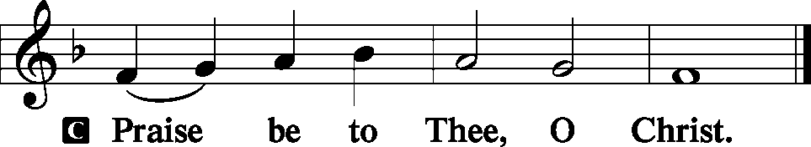

Nicene Creed
C I believe in one God,
the Father Almighty,
maker of heaven and earth
and of all things visible and invisible.
And in one Lord Jesus Christ,
the only-begotten Son of God,
begotten of His Father before all worlds,
God of God, Light of Light,
very God of very God,
begotten, not made,
being of one substance with the Father,
by whom all things were made;
who for us men and for our salvation came down from heaven
and was incarnate by the Holy Spirit of the virgin Mary
and was made man;
and was crucified also for us under Pontius Pilate.
He suffered and was buried.

And the third day He rose again according to the Scriptures
and ascended into heaven
and sits at the right hand of the Father.
And He will come again with glory to judge both the living and the dead,
whose kingdom will have no end.
And I believe in the Holy Spirit,
the Lord and giver of life,
who proceeds from the Father and the Son,
who with the Father and the Son together is worshiped and glorified,
who spoke by the prophets.
And I believe in one holy Christian and apostolic Church,
I acknowledge one Baptism for the remission of sins,
and I look for the resurrection of the dead
and the life T of the world to come. Amen.

Hymn of the Day: LSB #614 "’As Surely as I Live,’ God Said”

Sermon

Stand

Prayer of the Church

Sit

Offertory Psalm 51: 10-12
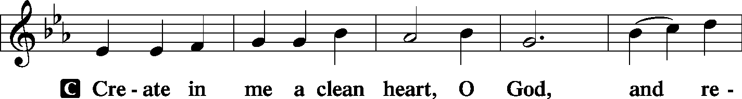
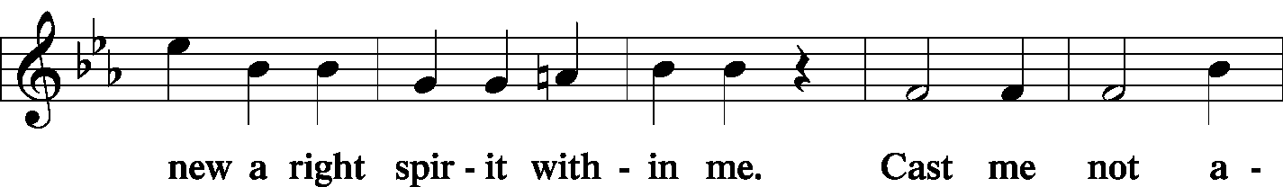
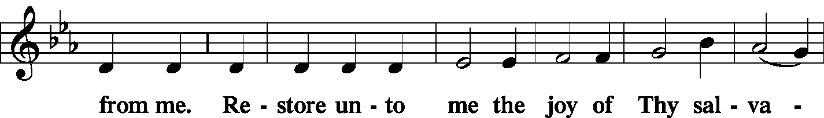
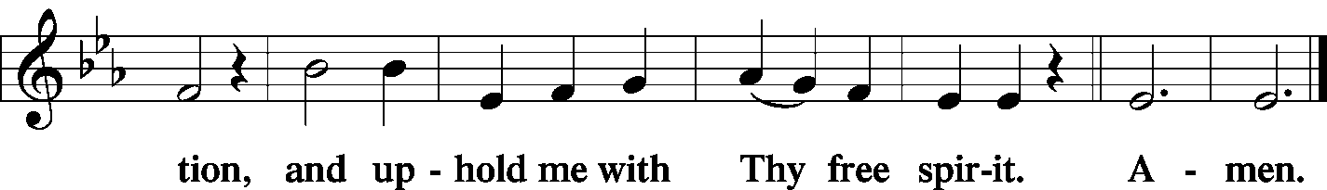

Offering/Offering Hymn: LSB #815 “All Praise to Thee, for Thou, O King Divine”

Stand
SERVICE OF THE SACRAMENT
Preface
2 Timothy 4: 22
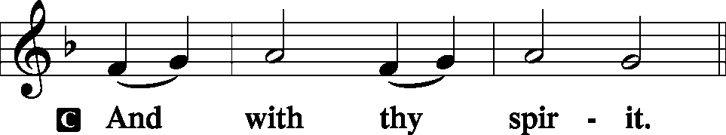
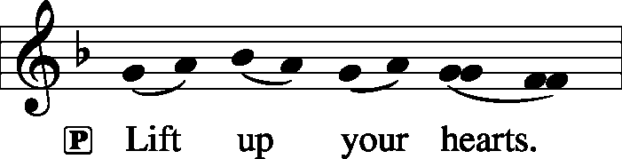 [Colossians 3:1]
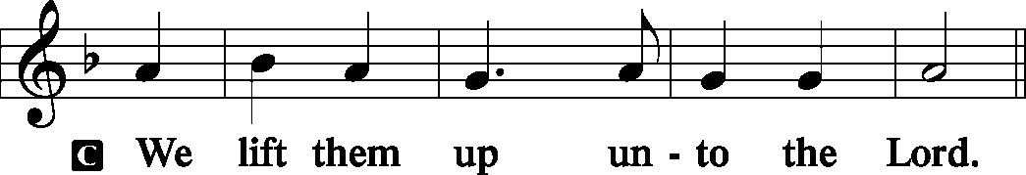

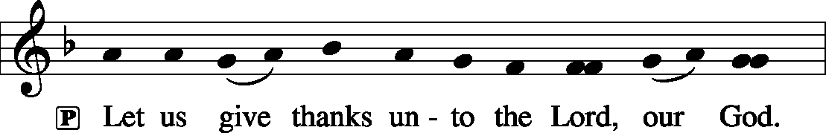 [Psalm 136]

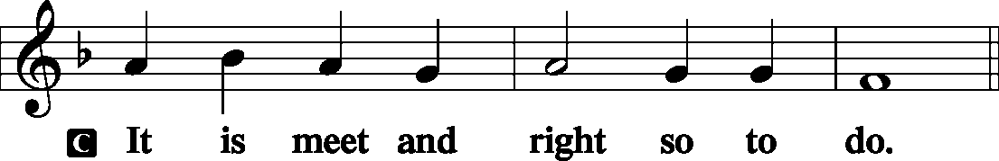

P It is truly good, right, and salutary . . . evermore praising You and saying:
Sanctus Isaiah 6: 3; Matthew 21: 9
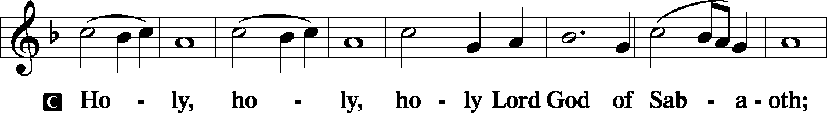
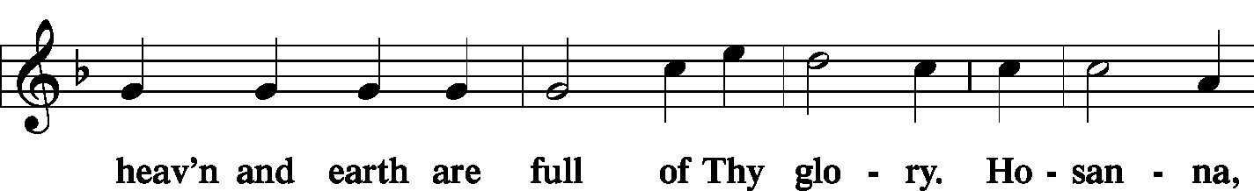
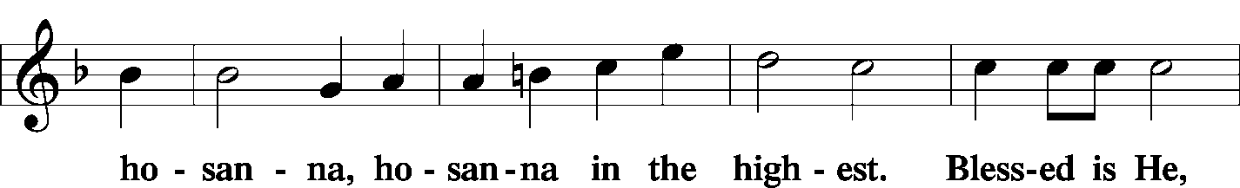
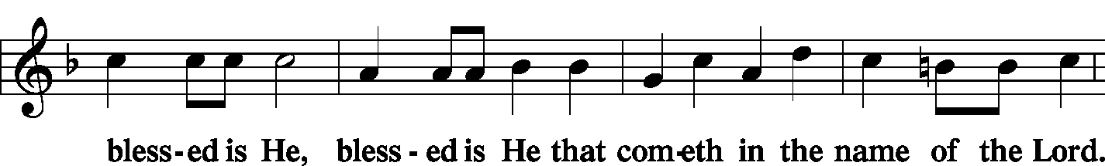
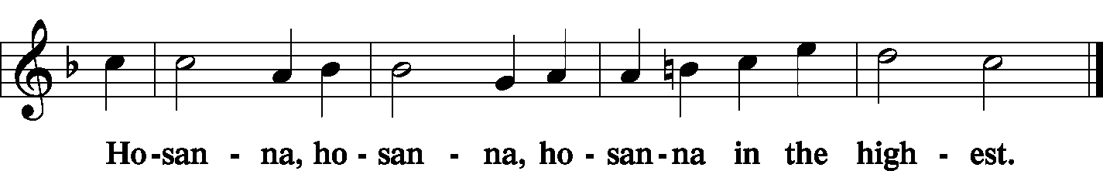

Lord's Prayer Matthew 6: 9-13
P Lord, remember us in Your kingdom and teach us to pray:
C Our Father who art in heaven,
hallowed be Thy name,
Thy kingdom come,
Thy will be done on earth as it is in heaven;
give us this day our daily bread;
and forgive us our trespasses as we forgive those who trespass against us;
and lead us not into temptation,
but deliver us from evil.
For Thine is the kingdom and the power and the glory forever and ever. Amen.

The Words of Our Lord Matthew 26: 26-28; Mark 14: 22-24
Luke 22: 19-20; 1 Corinthians 11: 23-25
P Our Lord Jesus Christ, on the night when He was betrayed, took bread, and when He had given thanks, He broke it and gave it to the disciples and said: “Take, eat; this is My T body, which is given for you. This do in remembrance of Me.”

P In the same way also He took the cup after supper, and when He had given thanks, He gave it to them, saying: “Drink of it, all of you; this cup is the new testament in My T blood, which is shed for you for the forgiveness of sins. This do, as often as you drink it, in remembrance of Me.”

Pax Domini John 20: 19
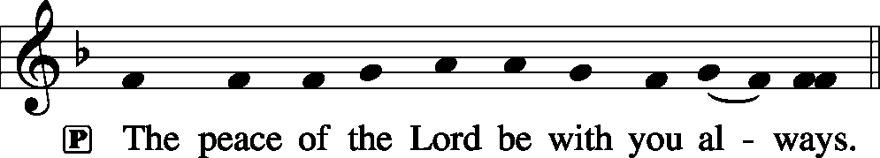

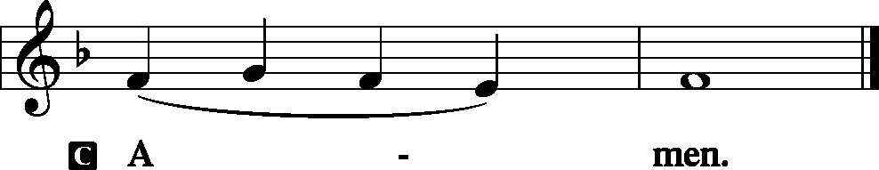

Agnus Dei John 1: 29
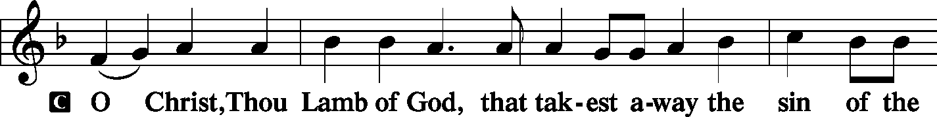
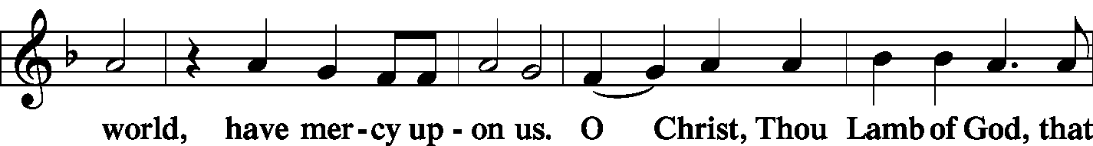
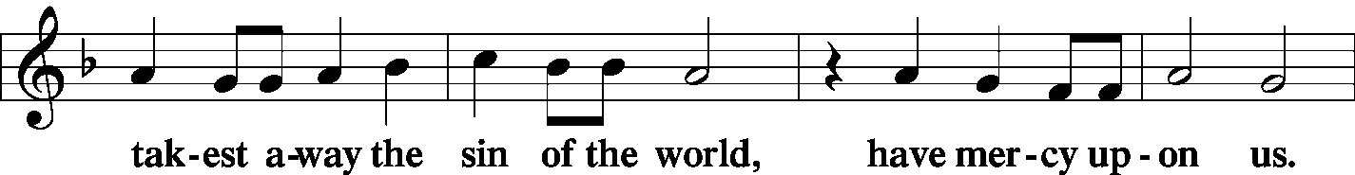
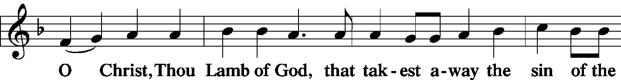
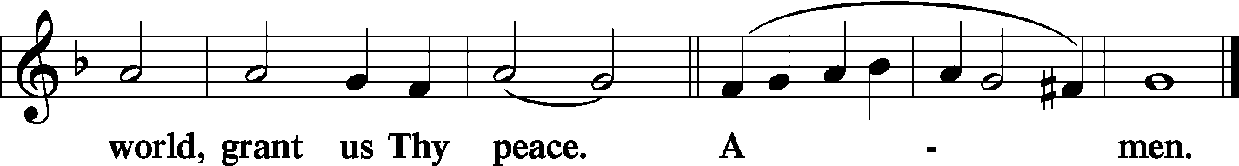
Sit

Distribution
The pastor and those who assist him receive the body and blood of Christ first and then distribute them to those who come to receive, saying:

Take, eat; this is the true body of our Lord and Savior Jesus Christ, given into death for your sins.
Amen.
Take, drink; this is the true blood of our Lord and Savior Jesus Christ, shed for the forgiveness of your sins.
Amen.

In dismissing the communicants, the following is said:
P The body and blood of our Lord Jesus Christ strengthen and preserve you in body and soul to life everlasting. Depart T in peace.
C Amen.

Distribution Hymn: LSB #611 “Chief of Sinners Though I Be”
Stand
Post-Communion Canticle: Nunc Dimittis Luke 2: 29-32
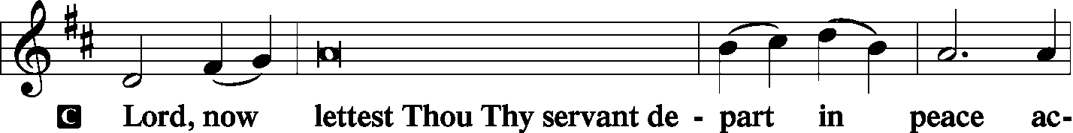
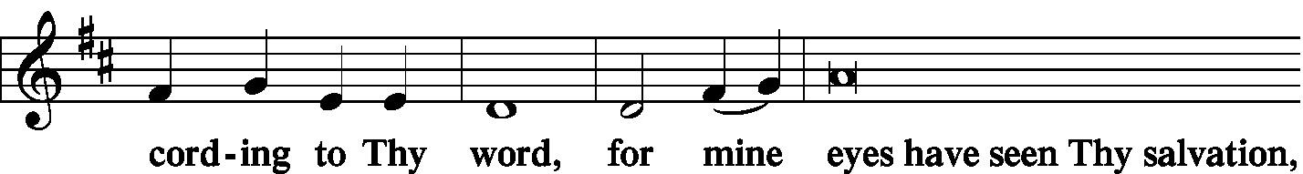
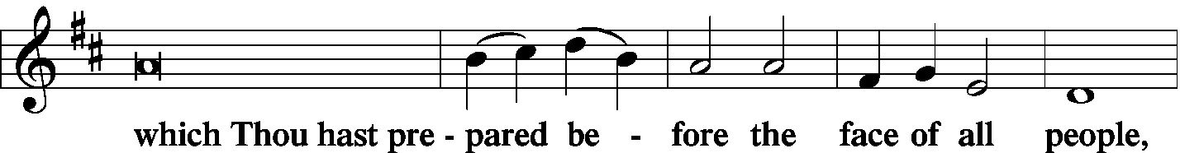
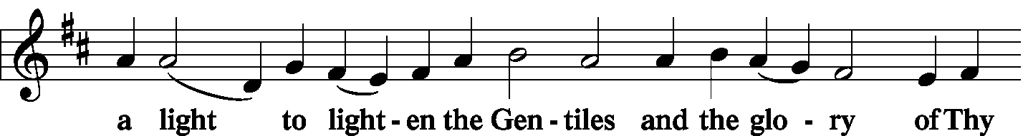
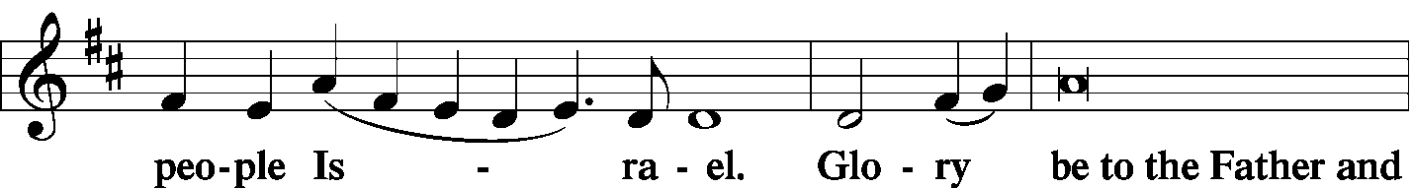
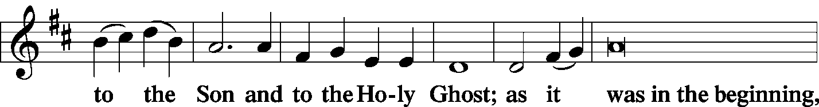
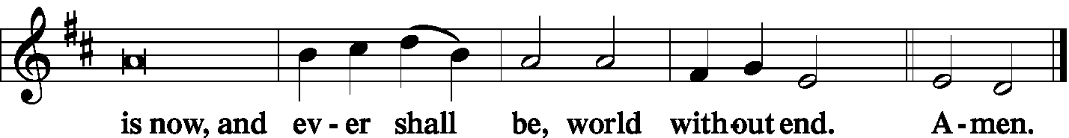

Thanksgiving Psalm 107: 1
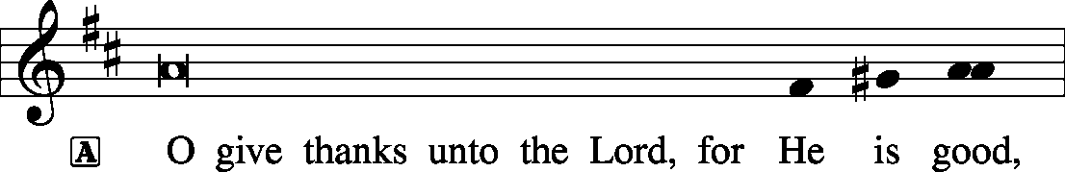
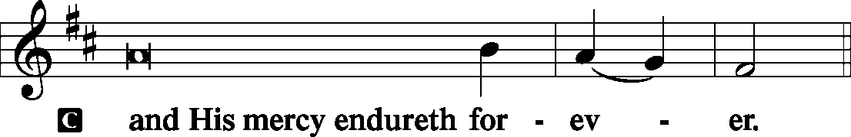

P Let us pray.
We give thanks to You, almighty God, that You have refreshed us through this salutary gift, and we implore You that of Your mercy You would strengthen us through the same in faith toward You and fervent love toward one another; through Jesus Christ, Your Son, our Lord, who lives and reigns with You and the Holy Spirit, one God, now and forever.

Salutation and Benedicamus
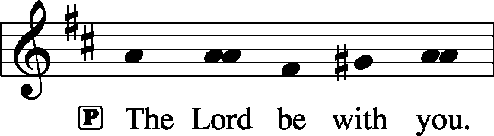 2 Timothy 4: 22
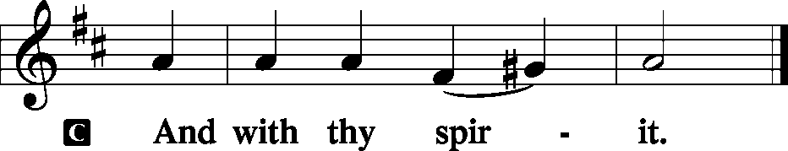
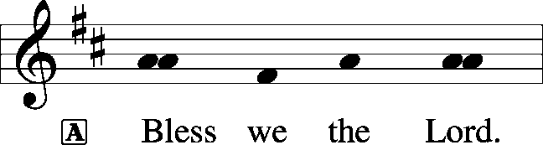 [Psalm 103: 1]
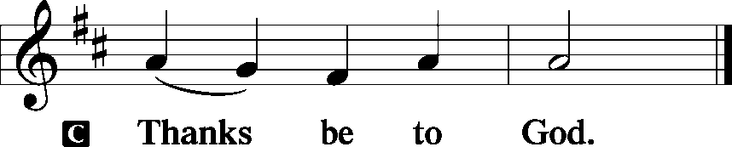

Benediction Numbers 6: 24-26
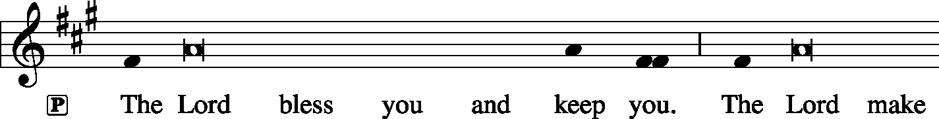
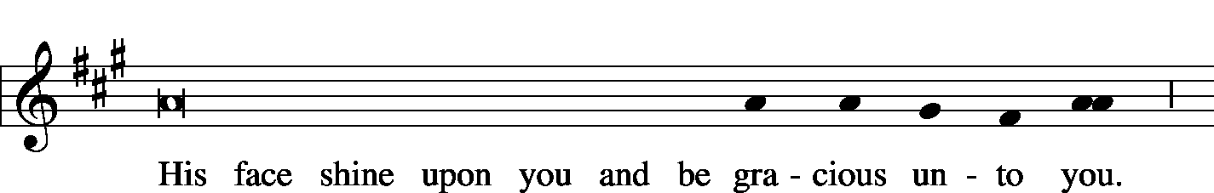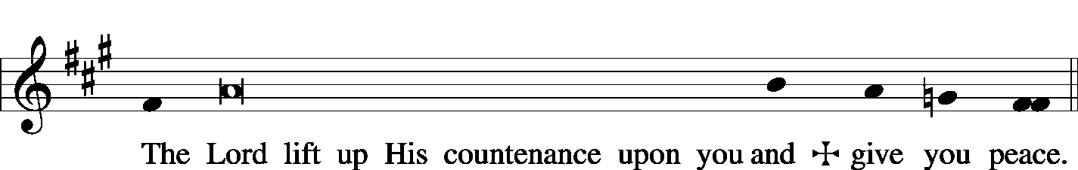

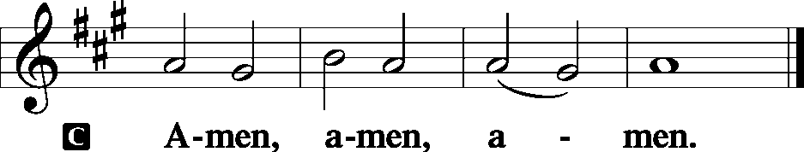

Closing Hymn: LSB #655 “Lord, Keep Us Steadfast in Your Word”
Silent prayer after worship: Heavenly Father, by the light of Your word, lead me around all spiritual dangers and temptations. Grant me Your strength and comfort, and remind me that You will never leave me nor forsake me. In Jesus’ name. Amen.

In Honor of the 59th Wedding Anniversary of Ruth & Ernie Meszaros, September 3rd: Joan Rice

The Altar Flowers this morning are given by Joan Rice in Loving Memory of Husband, Bob Rice and by Ruth Meszaros in Remembrance of her 59th Wedding Anniversary. We sincerely appreciate this generous gift!

Attendance: Wednesday, Aug. 21, 2019, and Sunday, Aug.25, 2019: 62

SCHEDULE FOR TODAY THROUGH SEPT. 8th:
:

:

Today, following Worship, Library…………………………………………Brief Audit Meeting
1 pm, Church & Buhl Park……………………………………….…..Set-up for Buhl Day
7 pm, Downstairs…………………………………………..…………………......…AA Meeting
Monday, All Day, Church & Buhl Park…………………………….……Buhl Day Fundraiser
Tuesday………………………………………………………………………..……Church Offices Closed
Thursday, 8 pm………………………………………………………….……Young Adult Bible Study
Saturday, 9 am, Downstairs………………………………………..…Fellowship Hall Work Day
5 pm, Chapel…………………………………………………………………..…….Divine Service
Next Sunday, 8:45 am, Downstairs……………………………………………..…………Bible Study
10 am, Sanctuary…...........................................................................Divine Service
Following Worship, Downstairs………………………Coffee & Donuts Fellowship

Please save and bring in “pop” tabs! Marie Flaugher will be coordinating an effort to collect “pop” tabs which will benefit Ronald McDonald Houses. A container will be placed in the narthex in which you may drop off your tabs.
Our Stewardship of Treasures for the Lord:
In order to do the Lord’s work, we need $2,882.02* each week to meet our 2019 budget for general purposes and $38.46 for missions.
Wednesday, August 21, 2019 & Sunday, August 25, 2019:
General Offering: $1,790.00
Behind this week*: -$1,092.02
SELC Missions: $75.00
Ahead this week: +$36.54
Local Missions: $10.00
Preschool Tuition: $50.00
Other Offerings: $115.00 *Includes preschool tuition.

Remember the following in Prayer…
~The Hurting and Healing: Tony², Lois Bortner^{CA}, Richard Brandes¹, Eileen Burns¹, Beverly Chlpka², Kim², Tim Dudash², John Dyll¹, Jennifer Hilliard¹, Anson Holcroft¹, Betty Knauff^{CA}, Regis Knauff², Clara Krivosh³, Jess Lavoie⁴, Paul Lucas^{CA}, Rhonda Moats^{CA}, Barry Nelson², David Nelson³,Tom Mulligan^{CA}, Iona Oltman^{CA}, Rudy Pinal^{CA}, Don Voytik¹, Angela Weser^{CA}, and Ken White^{CA}.
~Our Homebound: Helen Bender, Dan Davis, Edna Krajci, Mary Ann Krajci, Marion Roberts, Barbara Vasconi, and Joanne Wolfe.
~Celebrating: Birthdays: Christine Hamilton (09.04), Michael A. Petro (09.05), and Max Jelinek (09.07). Anniversary: Ernest & Ruth Meszaros (09.03).
~Serving in the Military: Clayton Drnek, Curtis Sinewe, and Joshua Solyan.
~Community & World Needs: Victims of violence and terrorism; those suffering from loss and dislocation because weather disasters; those suffering from addiction and their families; Local, State, and National Government Leaders; Safety for all Police Officers, Firefighters, & First Responders; the unemployed; our Third Quarter Local Mission: MERP (Medical Equipment Recycling Program).
*CA represents cancer; number after other names represents weeks on the prayer list. After 4 weeks names may be resubmitted. This helps us to remember people’s specific needs and reminds us that God is providing healing as people get better and no longer need our prayers. Please submit prayer requests in writing to the church office.

Members of the Audit Committee are reminded of the brief meeting today in the library following worship.
Thank You for Serving in September:
Today’s Greeters: Ralph Dorman & Diane Riefstahl. Assisting Elders: John Dyll & Bob Sulek. Ushers: Bob Sulek, Hugh Owen, Cheryl Fedele, Jesse Riffle, & Ralph Dorman (alternate). Altarware: Vi Sakony & Patty Parker.

September Greeters:
8 ~ John Dyll & Mark Gabriel
15 ~ Rev. Ed & Irene Kucera
22 ~ Gary & Eileen Burns
29 ~ Cheryl Fedele & Clara Krivosh.

Bible Memory Verses: For the week of September 1st:
For Children: God opposes the proud but gives grace to the humble.
1 Pet. 5:5
For Adults: Do not fear those who kill the body but cannot kill the soul. Rather fear him who can destroy both soul and body in hell. Matt. 10:28

Available in the Narthex:
- August 19th Preschool Board Minutes
- August 25th Voters’ Assembly Meeting Minutes
- September issue of “The Rock and the Sword” newsletter.

Your help is needed! Volunteers are desperately needed this Saturday morning, September 7th, beginning at 9 am, to help “spruce up” our Fellowship Hall. This will involve painting, washing walls, and other similar tasks. Please bring necessary painting / cleaning items as well as step ladders.
We are especially in need of those with tiling experience. Please speak directly with Pastor Deal concerning this.
It is hoped that, along with donated dehumidifiers and an air purifier, we will be able provide a healthier environment for all who use the fellowship hall.
Following discussion at the recent Voters’ Assembly Meeting, it was decided to form a committee to recommend guidelines to the trustees and elders for use of the fellowship hall. If interested in serving on this committee, please sign the list in the narthex. Speak with Jeff Brandes if you have any concerns or questions.

Beginning this month, we will no longer be using the Friendship Books which had been found at the middle aisle side of each pew. This is due to the inconsistency of use and the cost factor of replacement pads.
Instead, members are asked to check off their names upon entering the sanctuary and indicate whether they plan to use the common cup or individual cup during communion. Checklists will be found at both entrances to the sanctuary. Greeters are asked to help remind those in attendance to use the form.

Bulletin formats:
To guide you during your worship, we will be offering three different service bulletin formats:
- The Visitor’s Bulletin will follow the recent service bulletin format with the entire Divine Service written out.
- A Large Print Bulletin will be available for those who might find the print in the hymnal to be challenging. This bulletin will be the same as the Visitor’s Bulletin with the addition of including all hymns printed for the service.
- The Weekly Bulletin will contain an outline of the Divine Service and is meant to be used in conjunction with the “Lutheran Service Book” hymnal.
This change will take place over the next few weeks. Your patience is appreciated.
Here to Serve You…

Pastor………………………………………………….………..…Rev. Jacob Deal
E-mail ……….…………………….…..pastordeal@saintspeterandpaul.net
Phone Number…………..……………………………724-347-3620 (Option 2)
Church Office………………………………….………724-347-3620 (Option 3)
Website ……….………………….……...…….www.saintspeterandpaul.net
Secretary………………………………………………….……. Diane Riefstahl
E-mail ……….…………………….…….…church@saintspeterandpaul.net
Food Pantry: John Dyll…………….……………………..…..…724-347-1779
Little People Preschool…………….……………….724-347-3620 (Option 4)
Teacher: Paula Ostheimer………….………………….…….....724-981-5846
Email ……….………….…………………….paula@saintspeterandpaul.net
AA Contact: Steve……………………….…………..……...……. 724-813-2358
Organist……………………………………………………..…Carrie Yasnowski
Choir Director……………..…………….…………..….….………Chris Nelson
Congregation President…………………………………………Jeff Brandes
 In general, the secretary’s office is open Monday and Thursdays from 8:30 am -4:30 pm. Pastor Deal is here throughout the week, except Fridays or when ministering offsite. If you need to enter the Church, please call ahead to be sure someone is here to let you in. Thank you.

Acknowledgments: Divine Service, Setting Three from Lutheran Service Book Unless otherwise indicated, all scripture quotations are from The Holy Bible, English Standard Version, copyright © 2001 by Crossway Bibles, a division of Good News Publishers. Used by permission. All rights reserved. Created by Lutheran Service Builder © 2006 Concordia Publishing House. CCLI License #3029-446


