Sts. Peter & Paul
Evangelical Lutheran Church
Lutheran Church-Missouri Synod
Founded-1917
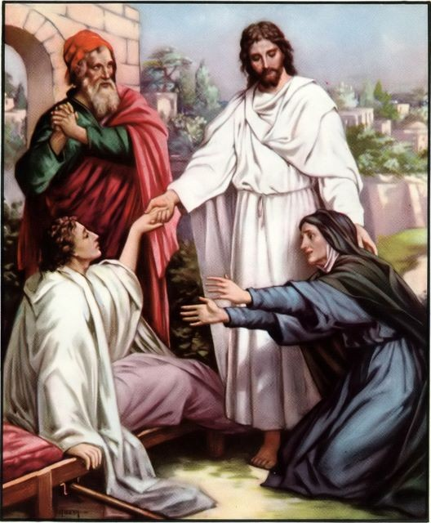
OCTOBER 6, 2019

699 Stambaugh Avenue
Sharon, Pennsylvania 16146

“I was glad when they said to me,
Let us go to the house of the LORD!”
Psalm 122:1

VISITOR’S BULLETIN
Sts. Peter & Paul Evangelical Lutheran Church, LC-MS

SIXTEENTH SUNDAY AFTER TRINITY
October 6, 2019

Silent prayer before worship: Heavenly Father, cause my faith to grow by the power of Your Word so that I can come to You without fear, and trust in Your Son Jesus Christ for my salvation. In His name. Amen.

CONFESSION AND ABSOLUTION
Opening Hymn: LSB #742 “For Me to Live Is Jesus”
Stand
The sign of the cross may be made by all in remembrance of their Baptism.

P In the name of the Father and of the T Son and of the Holy Spirit.
C Amen. Matthew 28: 19b; (18:20)
P Beloved in the Lord! Let us draw near with a true heart and confess our sins unto God our Father, beseeching Him in the name of our Lord Jesus Christ to grant us forgiveness. [Hebrews 10:22]

P Our help is in the name of the Lord,
C who made heaven and earth. Psalm 124: 8
P I said, I will confess my transgressions unto the Lord,
C and You forgave the iniquity of my sin. Psalm 32: 5

Silence for reflection on God's Word and for self-examination.

P O almighty God, merciful Father,
C I, a poor, miserable sinner, confess unto You all my sins and iniquities with which I have ever offended You and justly deserved Your temporal and eternal punishment. But I am heartily sorry for them and sincerely repent of them, and I pray You of Your boundless mercy and for the sake of the holy, innocent, bitter sufferings and death of Your beloved Son, Jesus Christ, to be gracious and merciful to me, a poor, sinful being.
P Upon this your confession, I, by virtue of my office, as a called and ordained servant of the Word, announce the grace of God unto all of you, and in the stead and by the command of my Lord Jesus Christ I forgive you all your sins in the name of the Father and of the T Son and of the Holy Spirit. [John 20: 19-23]
C Amen.

Passing of the Peace.
SERVICE OF THE WORD
Introit: Ps. 86:1, 7, 12–13; antiphon: Ps. 86:3, 5
Be gracious to me, | O Lord,*
for to you do I cry | all the day.
For you, O Lord, are good and for- | giving,*
abounding in steadfast love to all who call up- | on you.
Incline your ear, O Lord, and | answer me,*
for I am poor and | needy.
In the day of my trouble I call up- | on you,*
for you | answer me.
I give thanks to you, O Lord my God, with | my whole heart,*
and I will glorify your name for- | ever.
For great is your steadfast | love toward me;*
you have delivered my soul from the depths | of Sheol.

Gloria Patri
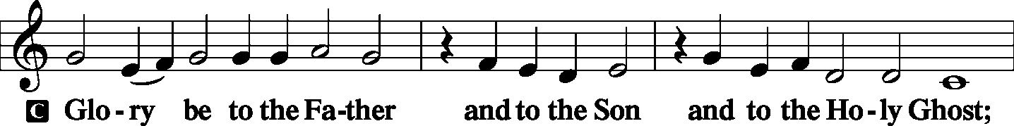
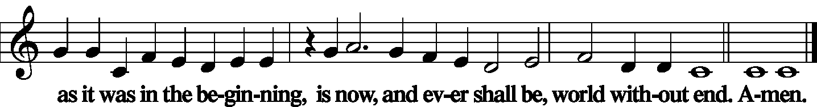

Kyrie Mark 10:47
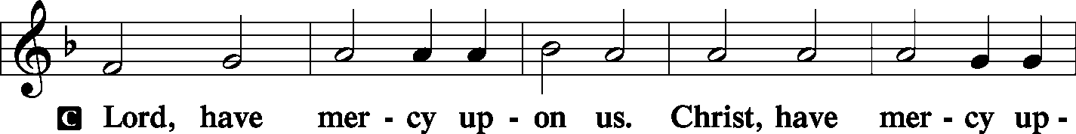
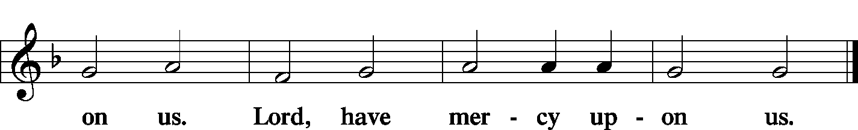

Gloria in Excelsis Luke 2: 14; John 1: 29
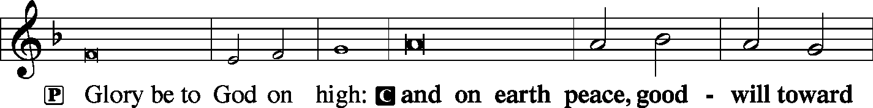
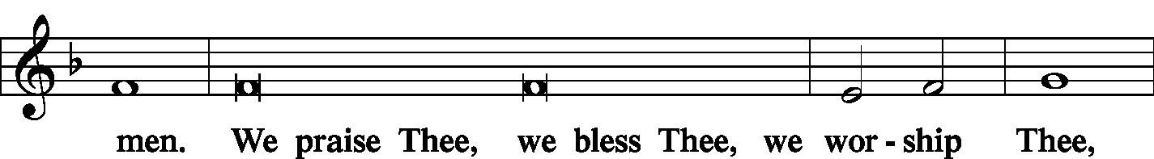
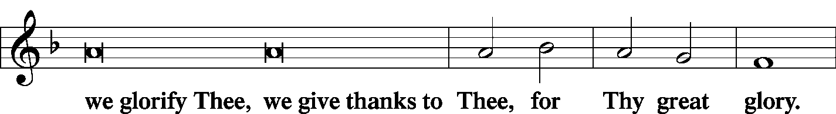
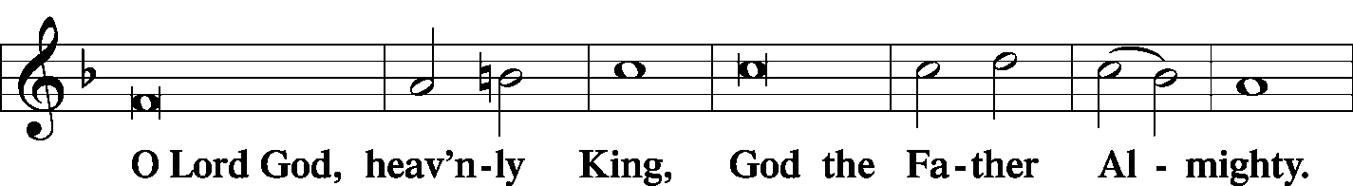
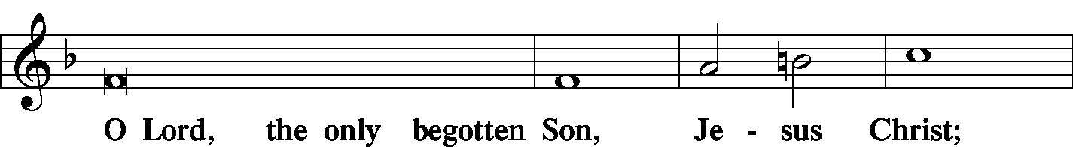
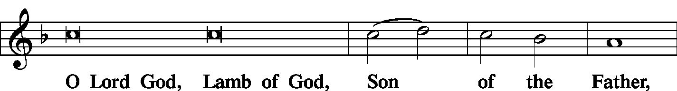
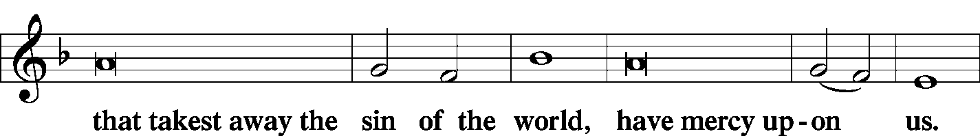
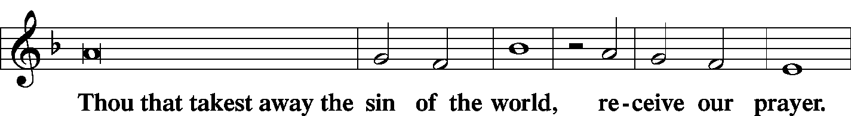
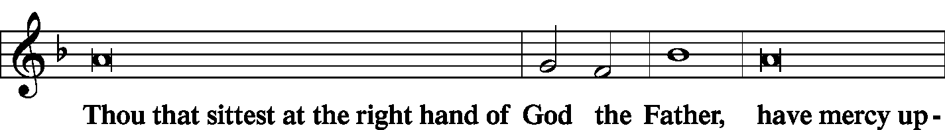
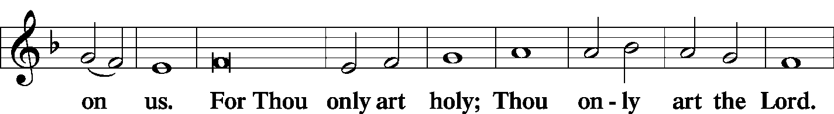
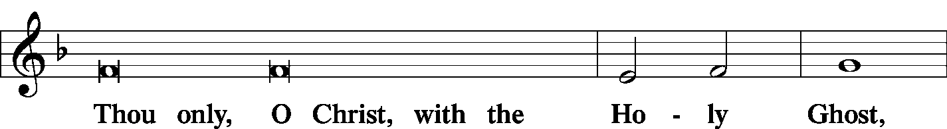
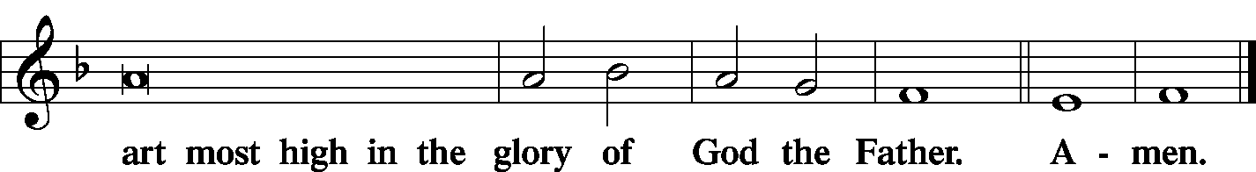

Salutation and Collect of the Day
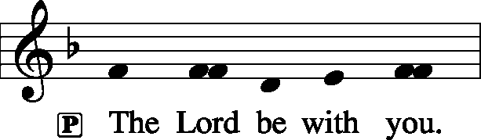 2 Timothy:22 2 Timothy 4: 22
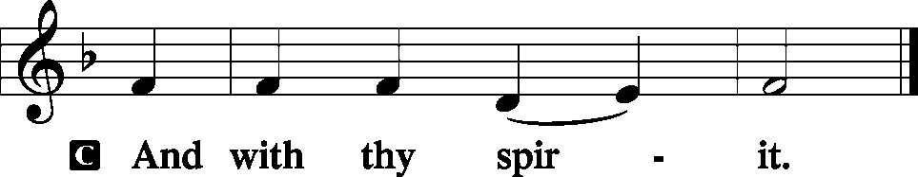

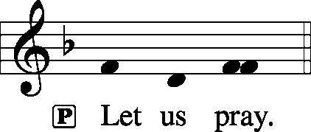

P O Lord, we pray that Your grace may always go before and follow after us, that we may continually be given to all good works; through Jesus Christ, Your Son, our Lord, who lives and reigns with You and the Holy Spirit, one God, now and forever.

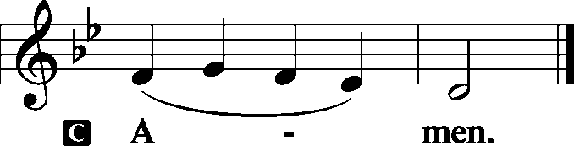

Sit

Old Testament Reading: 1 Kings 17:17–24
After this the son of the woman, the mistress of the house, became ill. And his illness was so severe that there was no breath left in him. And she said to Elijah, “What have you against me, O man of God? You have come to me to bring my sin to remembrance and to cause the death of my son!” And he said to her, “Give me your son.” And he took him from her arms and carried him up into the upper chamber where he lodged, and laid him on his own bed. And he cried to the Lord, “O Lord my God, have you brought calamity even upon the widow with whom I sojourn, by killing her son?” Then he stretched himself upon the child three times and cried to the Lord, “O Lord my God, let this child’s life come into him again.” And the Lord listened to the voice of Elijah. And the life of the child came into him again, and he revived. And Elijah took the child and brought him down from the upper chamber into the house and delivered him to his mother. And Elijah said, “See, your son lives.” And the woman said to Elijah, “Now I know that you are a man of God, and that the word of the Lord in your mouth is truth.”

P This is the Word of the Lord.
C Thanks be to God.

C Gradual: Ps. 102:15–16
Nations will fear the name of the Lord,
and all the kings of the earth will fear your glory.
For the Lord builds up Zion;
he appears in his glory.

Epistle: Ephesians 3:13–21
So I ask you not to lose heart over what I am suffering for you, which is your glory.
For this reason I bow my knees before the Father, from whom every family in heaven and on earth is named, that according to the riches of his glory he may grant you to be strengthened with power through his Spirit in your inner being, so that Christ may dwell in your hearts through faith—that you, being rooted and grounded in love, may have strength to comprehend with all the saints what is the breadth and length and height and depth, and to know the love of Christ that surpasses knowledge, that you may be filled with all the fullness of God.
Now to him who is able to do far more abundantly than all that we ask or think, according to the power at work within us, to him be glory in the church and in Christ Jesus throughout all generations, forever and ever. Amen.

P This is the Word of the Lord.
C Thanks be to God.

Stand
Alleluia Verse and Alleluia
P Alleluia. You who fear the Lord, trust in the Lord! He is their help and their shield. Alleluia.

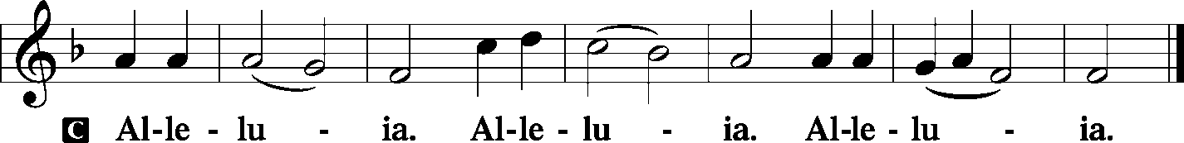

Holy Gospel: Luke 7:11–17
P The Holy Gospel according to St. Luke, the seventh chapter.

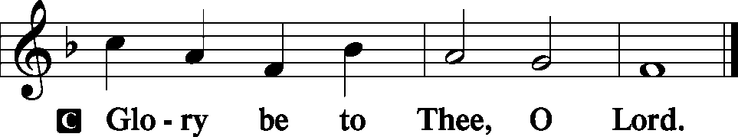

Soon afterward [Jesus] went to a town called Nain, and his disciples and a great crowd went with him.
As he drew near to the gate of the town, behold, a man who had died was being carried out, the only son of his mother, and she was a widow, and a considerable crowd from the town was with her. And when the Lord saw her, he had compassion on her and said to her, “Do not weep.” Then he came up and touched the bier, and the bearers stood still. And he said, “Young man, I say to you, arise.” And the dead man sat up and began to speak, and Jesus gave him to his mother. Fear seized them all, and they glorified God, saying, “A great prophet has arisen among us!” and “God has visited his people!” And this report about him spread through the whole of Judea and all the surrounding country.

P This is the Gospel of the Lord.

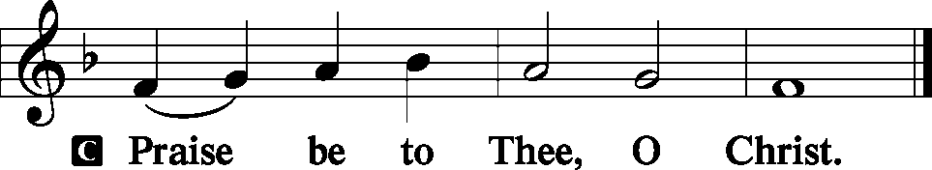

Nicene Creed
C I believe in one God,
the Father Almighty,
maker of heaven and earth
and of all things visible and invisible.
And in one Lord Jesus Christ,
the only-begotten Son of God,
begotten of His Father before all worlds,
God of God, Light of Light,
very God of very God,
begotten, not made,
being of one substance with the Father,
by whom all things were made;
who for us men and for our salvation came down from heaven
and was incarnate by the Holy Spirit of the virgin Mary
and was made man;
and was crucified also for us under Pontius Pilate.
He suffered and was buried.
And the third day He rose again according to the Scriptures
and ascended into heaven
and sits at the right hand of the Father.
And He will come again with glory to judge both the living and the dead,
whose kingdom will have no end.
And I believe in the Holy Spirit,
the Lord and giver of life,
who proceeds from the Father and the Son,
who with the Father and the Son together is worshiped and glorified,
who spoke by the prophets.
And I believe in one holy Christian and apostolic Church,
I acknowledge one Baptism for the remission of sins,
and I look for the resurrection of the dead
and the life T of the world to come. Amen.

Hymn of the Day: LSB #758 “The Will of God Is Always Best”

Sermon

Stand

Prayer of the Church [1 Timothy 2:1-4]

Sit

Offertory Psalm 51:10-12
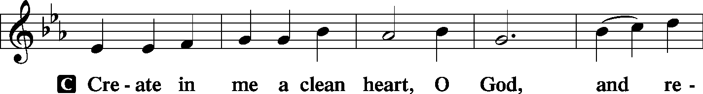
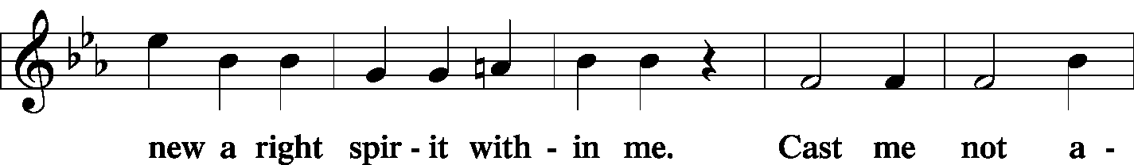
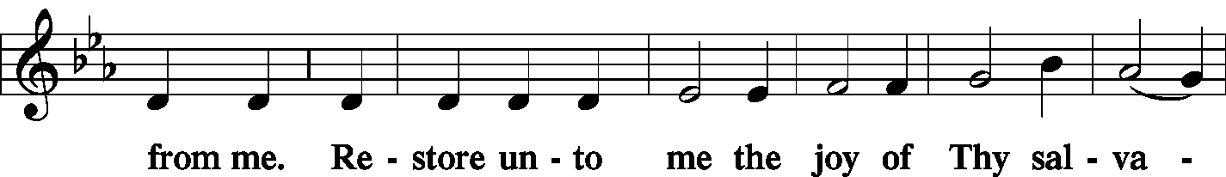
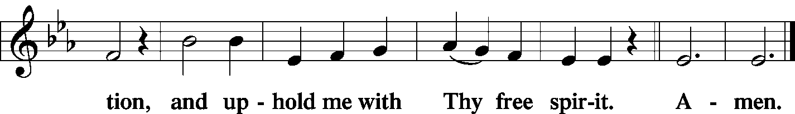

Offering/Offering Hymn: LSB #754 “Entrust Your Days and Burdens”

Stand
SERVICE OF THE SACRAMENT
Preface
2 Timothy 4: 22
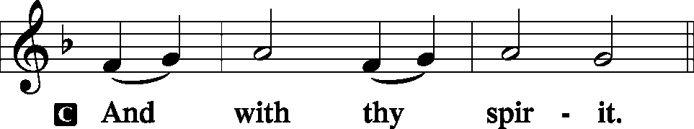
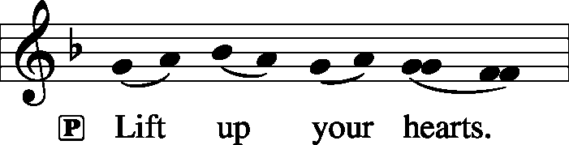 [Colossians 3:1]
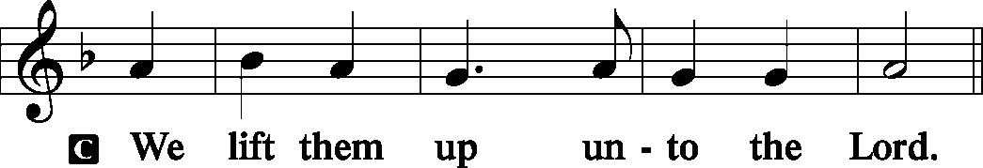

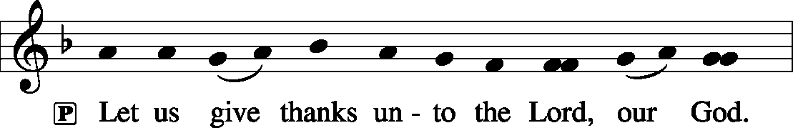 [Psalm 136]

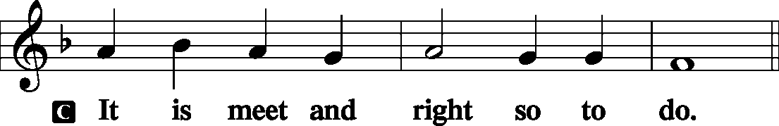

P It is truly good, right, and salutary . . . evermore praising You and saying:
Sanctus Isaiah 6: 3; Matthew 21: 9
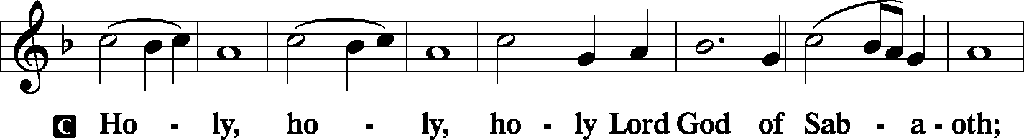
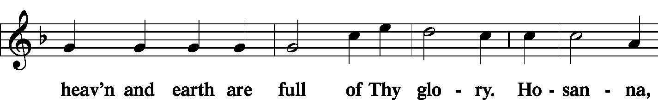
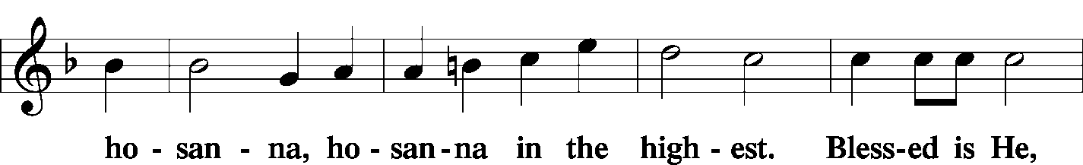
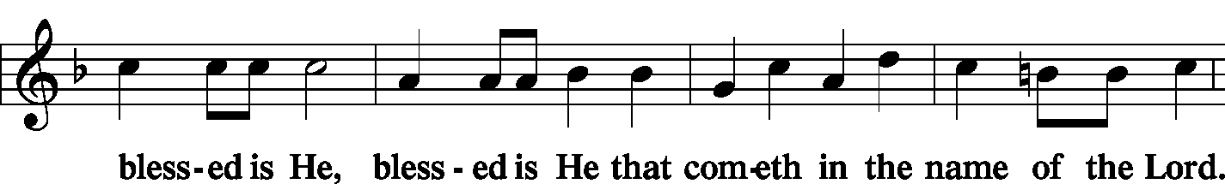
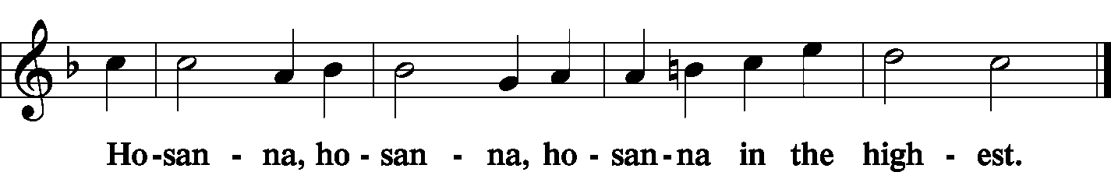

Lord's Prayer Matthew 6: 9-13
P Lord, remember us in Your kingdom and teach us to pray:
C Our Father who art in heaven,
hallowed be Thy name,
Thy kingdom come,
Thy will be done on earth as it is in heaven;
give us this day our daily bread;
and forgive us our trespasses as we forgive those who trespass against us;
and lead us not into temptation,
but deliver us from evil.
For Thine is the kingdom and the power and the glory forever and ever. Amen.

The Words of Our Lord Matthew 26: 26-28; Mark 14: 22-24
Luke 22: 19-20; 1 Corinthians 11: 23-25
P Our Lord Jesus Christ, on the night when He was betrayed, took bread, and when He had given thanks, He broke it and gave it to the disciples and said: “Take, eat; this is My T body, which is given for you. This do in remembrance of Me.”

P In the same way also He took the cup after supper, and when He had given thanks, He gave it to them, saying: “Drink of it, all of you; this cup is the new testament in My T blood, which is shed for you for the forgiveness of sins. This do, as often as you drink it, in remembrance of Me.”

Pax Domini John 20: 19
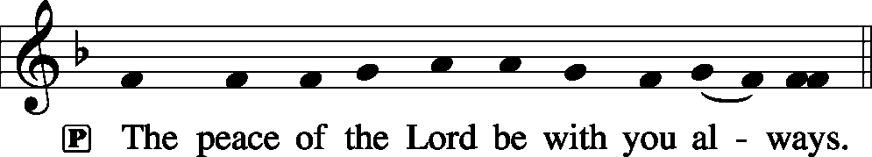

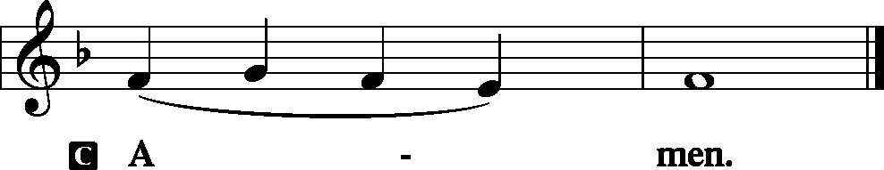

Agnus Dei John 1: 29
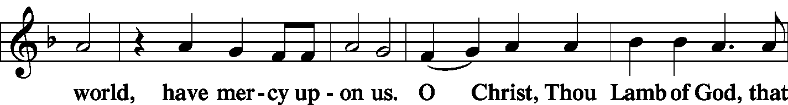
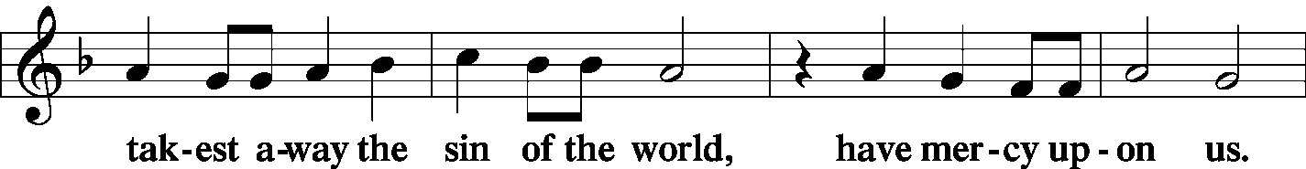
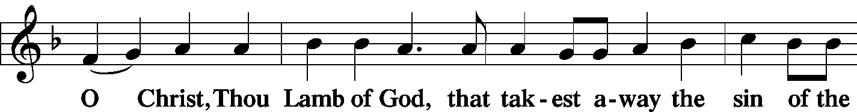
Sit

Distribution
The pastor and those who assist him receive the body and blood of Christ first and then distribute them to those who come to receive, saying:

Take, eat; this is the true body of our Lord and Savior Jesus Christ, given into death for your sins.
Amen.
Take, drink; this is the true blood of our Lord and Savior Jesus Christ, shed for the forgiveness of your sins.
Amen.

In dismissing the communicants, the following is said:
P The body and blood of our Lord Jesus Christ strengthen and preserve you in body and soul to life everlasting. Depart T in peace.
C Amen.

Distribution Hymn: LSB #642 “O Living Bread from Heaven”
Distribution Hymn: LSB #427 “In the Cross of Christ I Glory”
Stand
Post-Communion Canticle: Nunc Dimittis Luke 2: 29-32
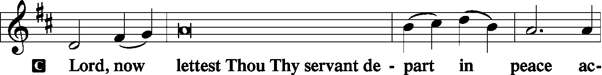
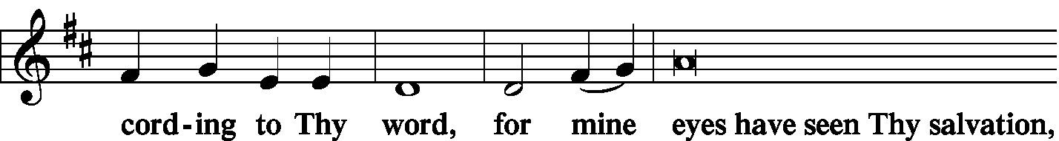
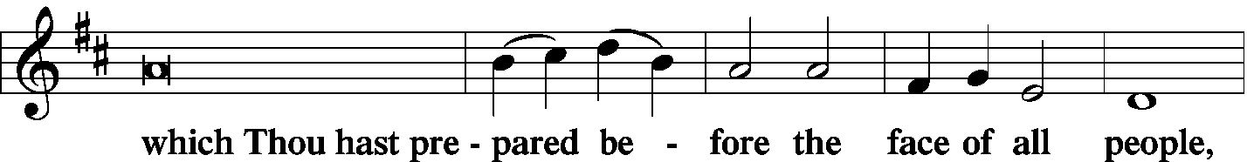
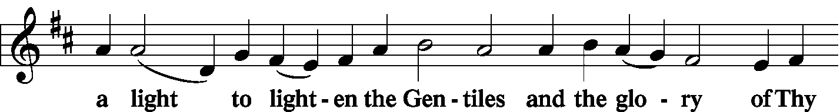
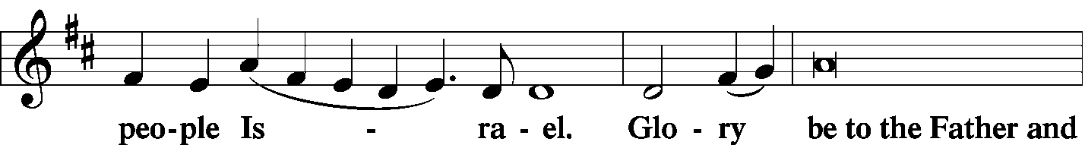
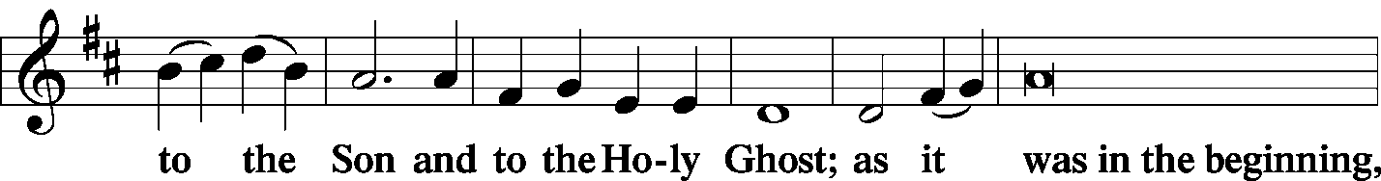
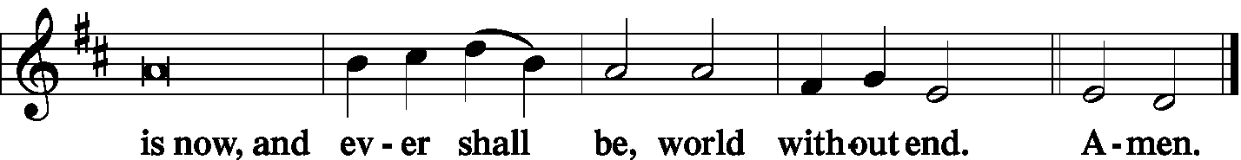

Thanksgiving Psalm 107: 1
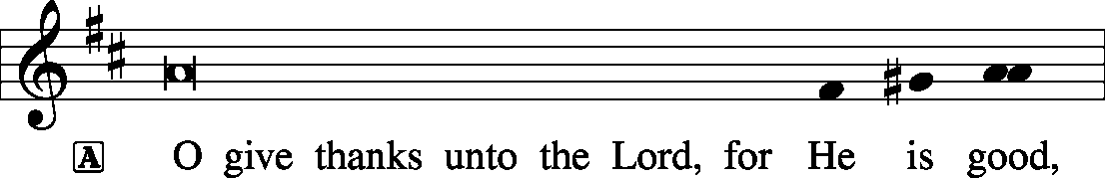
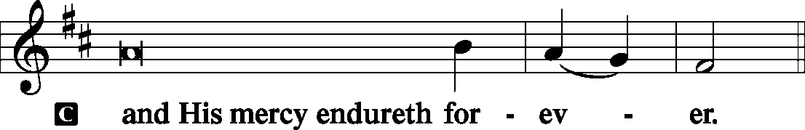

P Let us pray.
…through Jesus Christ, Your Son, our Lord, who lives and reigns with You and the Holy Spirit, one God, now and forever.

Salutation and Benedicamus
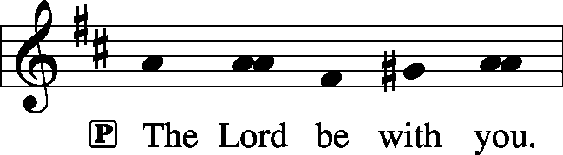 2 Timothy 4: 22
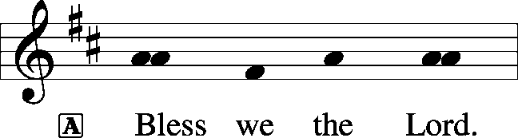 [Psalm 103: 1]
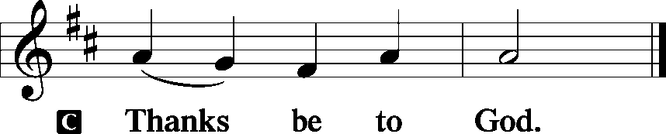

Farewell and Godspeed to Patty Petro Parker

P Beloved in the Lord, in Holy Baptism you became a member of the holy Christian Church, and our Lord's Word and Sacraments have nourished you in this congregation for sixty-seven years. As we bid you farewell and Godspeed, hear the words of the apostle Paul:

I thank my God in all my remembrance of you, always in every prayer of mine for you all making my prayer with joy, because of your partnership in the gospel from the first day until now. And I am sure of this, that he who began a good work in you will bring it to completion at the day of our Lord Jesus Christ.

P The Lord be with you.
C And also with you.

P Let us pray.
Lord God, heavenly Father, we give thanks that You have so faithfully nourished our sister with us in the communion of this congregation. Bless, protect, and defend her as she now departs from us. Preserve her in the confession of Your name and in loving service to others. Keep us in fellowship with all Your saints, and bring us at last to the joys of Your heavenly kingdom; through Jesus Christ, Your Son, our Lord, who lives and reigns with You and the Holy Spirit, one God, now and forever.
C Amen.

P Go in peace and joy. The grace of our T Lord Jesus Christ be with you.
C Amen.

Benediction Numbers 6: 24-26
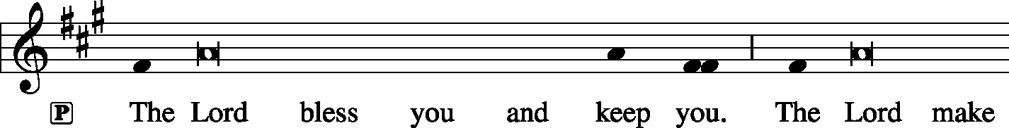
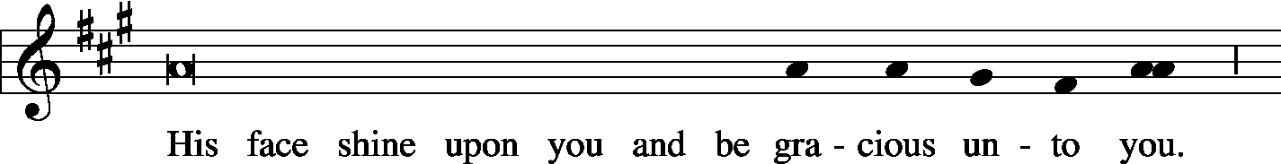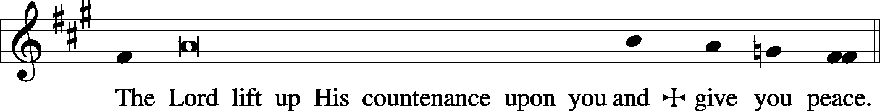

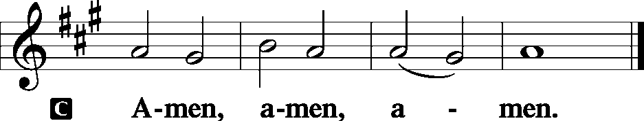

Closing Hymn: LSB #490 “Jesus Lives! The Victory's Won”
Silent prayer after worship: Dear Jesus, You demonstrated Your great love for all humankind by dying on the cross. Lead me to daily live in Your love by trusting in You and by sharing Your love with others. Amen.


In Loving Memory of Donald Voytik: Gerald & Susan Bostocky, Lew & Nancy Kachulis, Christine Martuccio & Sam Mowrey, Patricia L. Voytik, and John Zachar (Food Pantry).
In Loving Memory of Grandmother, Mary Petro: Patty Parker.

The Altar Flowers this morning are given in Loving Memory of Father, Andrew Sulek by Mr. & Mrs. Robert Sulek. We sincerely appreciate this generous gift!

Bible Memory Verse: For the week of October 6th:
For Adults: In the world you will have tribulation. But take heart; I have overcome the world. John 16:33
For Children: Our Savior Christ Jesus…abolished death and brought life and immortality to light. 2 Tim. 1:10
SCHEDULE FOR TODAY THROUGH OCT. 13th:

:

Today, following Worship, Library…………………….…..Brief Audit Committee Meeting
7 pm, Downstairs…………………………………………..………………….......…AA Meeting
Thursday, 9 am, Downstairs………………………………………………………….……..Food Pantry
5:30 pm, Sanctuary…………….…………………………………………...……Choir Rehearsal
Saturday, 10 am, Library………………………………………………………………….Elders’ Meeting
5 pm, Chapel……………………………………….……………………..……..….Divine Service
Next Sunday, 8:45 am, Downstairs……………………………………………..…………Bible Study
10 am, Sanctuary…...........................................................................Divine Service
Following Worship, Downstairs………………………Coffee & Donuts Fellowship
7 pm, Downstairs…………………..…………………………………………………AA Meeting

Remember the following in Prayer…
~The Hurting and Healing: The Sophers (friends of Jonathan and Bekah Baisch) who are mourning the loss of their child; also, Tony², Lois Bortner^{CA}, Richard Brandes¹, Eileen Burns¹, Beverly Chlpka², Kim², Tim Dudash², John Dyll¹, Jennifer Hilliard¹, Anson Holcroft¹, Betty Knauff^{CA}, Regis Knauff², Clara Krivosh³, Jess Lavoie⁴, Paul Lucas^{CA}, Rhonda Moats^{CA}, David Nelson³, Sandy Marshall (Stacy Brandes’ mother), Tom Mulligan^{CA}, Iona Oltman^{CA}, Rudy Pinal^{CA}, Angela Weser^{CA}, and Ken White^{CA}.
~Our Homebound: Helen Bender, Dan Davis, Edna Krajci, Mary Ann Krajci, Marion Roberts, and Barbara Vasconi .
~Celebrating: Birthdays: Mildred Zachar (10.07), Staci Taylor (10.09), and Kelsey Zurawsky (10.10).
~Serving in the Military: Clayton Drnek, Curtis Sinewe, and Joshua Solyan.
~Community & World Needs: Victims of violence and terrorism; those suffering from loss and dislocation because weather disasters; those suffering from addiction and their families; Local, State, and National Government Leaders; Safety for all Police Officers, Firefighters, & First Responders; the unemployed; our Fourth Quarter Local Mission: Beds for Little Heads.
*CA represents cancer; number after other names represents weeks on the prayer list. After 4 weeks names may be resubmitted. This helps us to remember people’s specific needs and reminds us that God is providing healing as people get better and no longer need our prayers. Please submit prayer requests in writing to the church office.

Available in the Narthex:
- Minutes from the September 23rd Preschool Board meeting.
- October issues of “The Rock and the Sword” newsletter and “The Lutheran Beacon”
- Fourth Quarter issue of “Portals of Prayer”
- Copies of the LCMS proposed “2019 Constitutional Amendment regarding individual membership and advisory representation” which will be voted on at our next Voters’ Assembly Meeting.

Our Stewardship of Treasures for the Lord:
In order to do the Lord’s work, we need $2,882.02* each week to meet our 2019 budget for general purposes and $38.46 for missions.
Saturday, September 28, 2019 & Sunday, September 29, 2019:
General Offering: $1,897.05 Behind this week*: -$814.97
SELC Missions: $5.00 Behind this week: -$33.46
Local Missions: $10.00
Preschool Tuition: $170.00
Other Offerings: $241.00 *Includes preschool tuition.

Audit Committee members are reminded of the brief, monthly audit meetings held the first Sunday of each month in the library. Speak with Diane if you have any questions.

Attendance: Saturday, Sept. 28, 2019, and Sunday, Sept. 29: 60

Sincere thanks are extended to Todd & Robin Deal for their generous donation to our church to help offset the cost of mold remediation in our Fellowship Hall. Their thoughtfulness is greatly appreciated.

Choir Members are reminded of Thursday evening rehearsals from 5:30-6:30 pm beginning this week. New members are always welcomed!
New LCMS Congregation!
This afternoon, the solemn rite of “Receiving a Congregation into Membership of the Synod” will be held at St. John’s Evangelical Lutheran Church of Clarksburg, WV. This is the first new LCMS congregation in the Pittsburgh area in the last forty or so years and only the fifth LCMS congregation in West Virginia. Plans are to call a pastor to the church in the next year.
To assist this new congregation in its mission to spread the word of God in its area, a freewill collection will be taken at the end of this morning’s service. Please consider making a donation.

Join us next Sunday, October 13th, at Coffee & Donuts Fellowship, for a Funeral Workshop led by Pastor Deal. At this half-hour session, materials for pre-planning a funeral service will be distributed and questions answered.
If you took part in the “Death & Dying” workshop held in 2018 and have yet to return your completed materials, you are encouraged to do so.
It’s a great gift to your family to help them through a difficult time.

Please save and bring in “pop” tabs! Marie Flaugher is coordinating an effort to collect “pop” tabs which will benefit Ronald McDonald Houses. Containers have been placed in the narthex, main hallway, and Fellowship Hall in which you may drop off your tabs. Acceptable tabs include those on soup and pet food cans as well as cans of soda.

The time of year has come to begin preparing our annual budget. All organizations are asked to pick up their budget worksheet from their mailbox and return it by October 21st. If you have any concerns or questions please talk to Jonathan Baisch.

Thank You for Serving in October:
Today’s Greeters: Matt & Cathy Berent. Assisting Elders: Hugh Owen and Ralph Dorman. Ushers: John Dyll, Barry Nelson, Jerome Thomas, Gary Burns, and Bob Sulek (alternate). Altarware: Joani Rice & Anne Colt.
October Greeters: 13 ~ Anson & Henrietta Holcroft; 20 ~ Dolores Fee & Diane Riefstahl; 27 ~ Barry & Chris Nelson

Sts. Peter & Paul Little People Preschool will be sponsoring its first annual “Trunk or Treat” Saturday, October 26th from 3-5 PM in our parking lot.
The event, which is free to all children age 12 and under, is a community outreach mission with the purpose of providing a fun, safe daytime trick or treat experience for all. Children are encouraged to dress in costume.
Those who would like to participate are asked to reserve a parking space and bring your car with its trunk decorated for the event and “loaded” with candy to give out. Decorations are asked to be appropriate for children and in good taste. Prizes will be awarded for the three best-decorated trunks!
Have a classic car? No need to decorate it! Just bring it to show off!
If you cannot participate, but still wish to help, donations of candy to be handed out will be gladly accepted. There will be a drop off box located in the main hallway of the church and in the preschool for donations.
Hot dogs and chips will be served to those in attendance.
To participate or volunteer to help, phone Marie Flaugher (724-301-8278). Deadline to sign up to participate is Friday, October 18th.

Contact Information:
Pastor Deal: pastordeal@saintspeterandpaul.net or 724-347-3620 (opt. 2)
Church Office: church@saintspeterandpaul.net or 724-347-3620 (opt. 3)
AA (Steve): 724-813-2358
Food Pantry (John): 724-347-1779

Acknowledgments: Divine Service, Setting Three from Lutheran Service Book Unless otherwise indicated, all scripture quotations are from The Holy Bible, English Standard Version, copyright © 2001 by Crossway Bibles, a division of Good News Publishers. Used by permission. All rights reserved. Created by Lutheran Service Builder © 2006 Concordia Publishing House. CCLI License #3029-446

