Sts. Peter & Paul
Evangelical Lutheran Church
Lutheran Church-Missouri Synod
Founded-1917

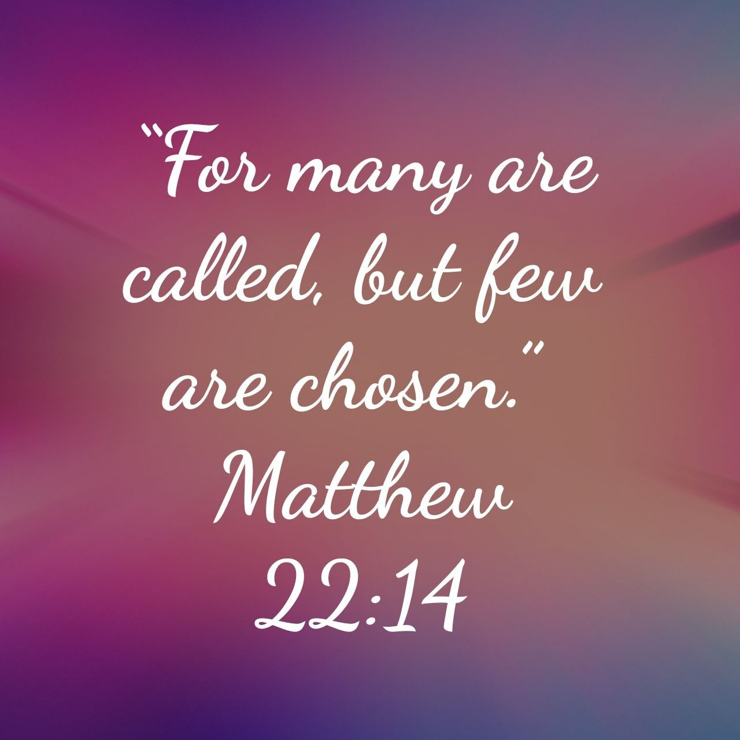

October 22, 2023

699 Stambaugh Ave.
Sharon, Pennsylvania 16146

“I was glad when they said to me,
Let us go to the house of the LORD!”
Psalm 122:1
Sts. Peter & Paul Evangelical Lutheran Church, LC-MS
THE TWENTIETH SUNDAY AFTER TRINITY
October 22, 2023
A special welcome to our guests this day! If you would like more information about The Lutheran Church - Missouri Synod, or this congregation, please speak with Pastor Deal or an Elder after the service.
Members & Guests: Don’t be embarrassed if your children make noise during the worship service, all children do. We encourage families to worship together but, if you feel the need, there are pews in the rear of the Church which are reserved for young families on both sides of the sanctuary. There is also a quiet room available to you, located next to the sanctuary (formerly the Pastor’s office), where you would be able to follow along with the service.

Today’s service includes the Sacrament of Holy Communion. If during this past year, you have not worshipped with us and been communed, we respectfully ask that you do not partake of this sacrament this day before first speaking with Pastor Deal.
If visiting from a sister congregation of the LC-MS and are in good standing, please inform Pastor Deal of your desire to commune prior to the service.
If wishing to receive a blessing during communion, please approach with your arms crossed.

CONTACT INFORMATION
Pastor Deal: pastordeal@saintspeterandpaul.net or 724-347-3620 (opt. 2)
Church Office: church@saintspeterandpaul.net or 724-347-3620 (opt. 3)
Secretary’s Office: The office will be open Thurs. & Fri. (8:30 am-4:30 pm).

Silent prayer before worship: Dear Lord, open my ears and my heart to Your holy Word, so that I can grow in faith and knowledge of You, and may remain sure of my salvation through Jesus Christ alone. Amen.

Acknowledgments: Unless otherwise indicated, Scripture quotations are from the ESV® Bible (The Holy Bible, English Standard Version®), copyright © 2001 by Crossway, a publishing ministry of Good News Publishers. Used by permission. All rights reserved.
Created by Lutheran Service Builder © 2023 Concordia Publishing House.
Confession and Absolution

Opening Hymn: LSB#644 “The Church’s One Foundation”

Stand

The sign of the cross may be made by all in remembrance of their Baptism.

Invocation
P In the name of the Father and of the T Son and of the Holy Spirit.
C Amen.

Exhortation Hebrews 10:22; Psalm 124:8; Psalm 32:5
P Beloved in the Lord! Let us draw near with a true heart and confess our sins unto God our Father, beseeching Him in the name of our Lord Jesus Christ to grant us forgiveness.

P Our help is in the name of the Lord,
C who made heaven and earth.
P I said, I will confess my transgressions unto the Lord,
C and You forgave the iniquity of my sin.

Silence for reflection on God’s Word and for self-examination.

Confession of Sins
P O almighty God, merciful Father,
C I, a poor, miserable sinner, confess unto You all my sins and iniquities with which I have ever offended You and justly deserved Your temporal and eternal punishment. But I am heartily sorry for them and sincerely repent of them, and I pray You of Your boundless mercy and for the sake of the holy, innocent, bitter sufferings and death of Your beloved Son, Jesus Christ, to be gracious and merciful to me, a poor, sinful being.

Absolution [John 20:19–23]
P Upon this your confession, I, by virtue of my office, as a called and ordained servant of the Word, announce the grace of God unto all of you, and in the stead and by the command of my Lord Jesus Christ I forgive you all your sins in the name of the Father and of the T Son and of the Holy Spirit.
C Amen.

Service of the Word

Introit Psalm 48:1, 9–11; antiphon: Liturgical Text
The Lord is righteous in all he has | done to us,*
for we have not obeyed his com- | mandments.
Glorify your name, | O Lord;*
and deal with us according to your great | mercy.
Great is the Lord and greatly | to be praised*
in the city of our God, his holy | mountain.
We have thought on your steadfast love, | O God,*
in the midst of your | temple.
As your name, O God, so your praise reaches to the ends | of the earth.*
Your right hand is filled with | righteousness.
Let Mount Zion | be glad!*
Let the daughters of Judah rejoice because of your | judgments!
The Lord is righteous in all he has | done to us,*
for we have not obeyed his com- | mandments.
Glorify your name, | O Lord;*
and deal with us according to your great | mercy.

Gloria Patri
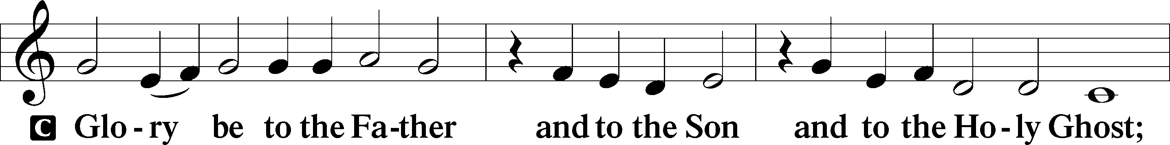
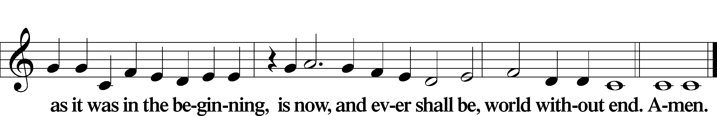

Kyrie Mark 10:47
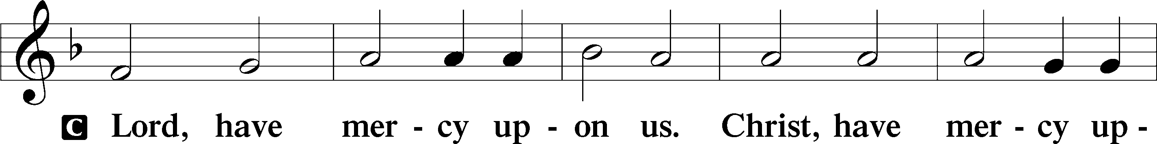
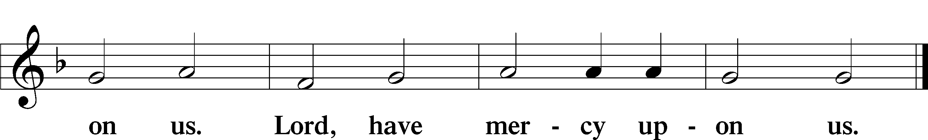

Gloria in Excelsis Luke 2:14; John 1:29
P Glory be to God on high:
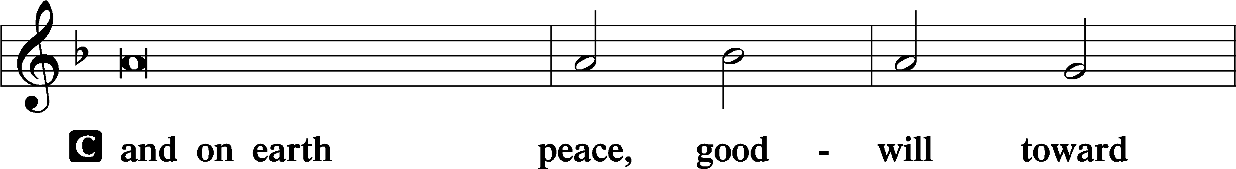
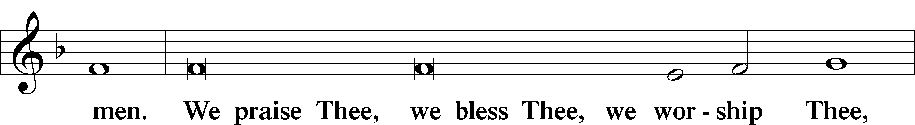
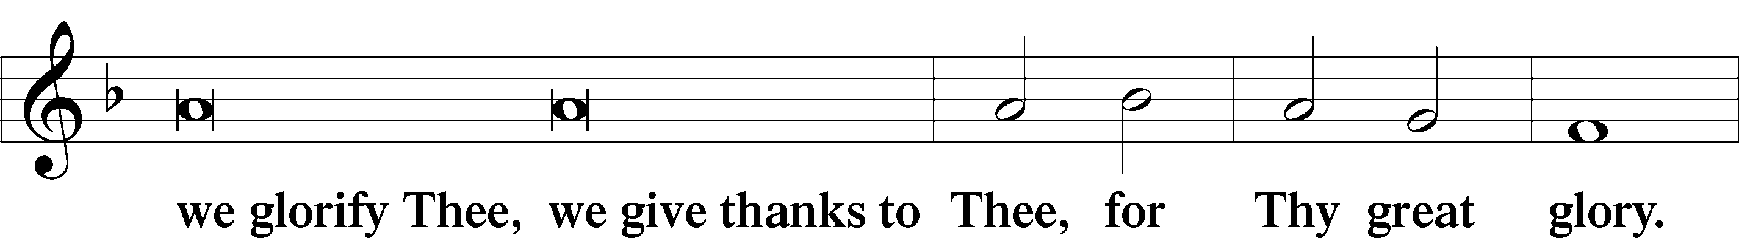
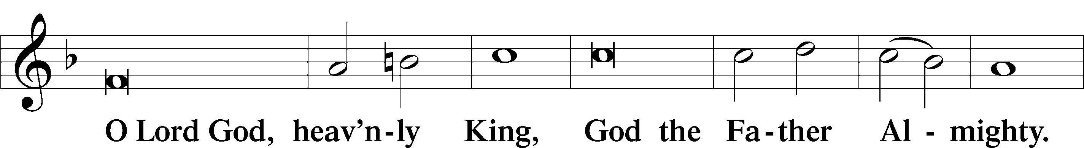
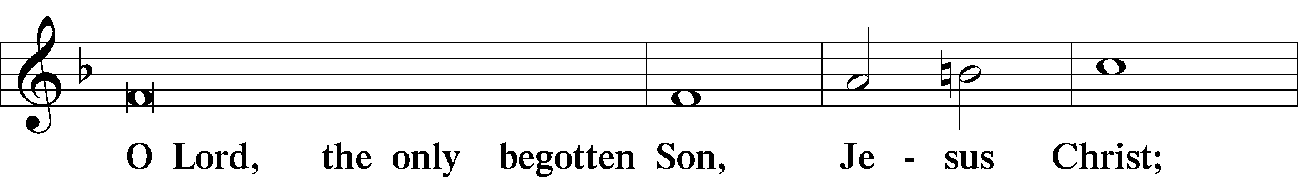
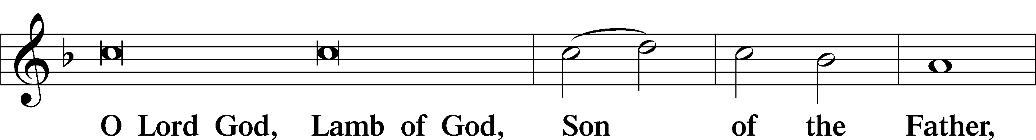
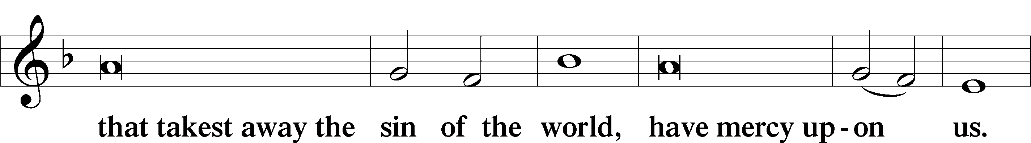
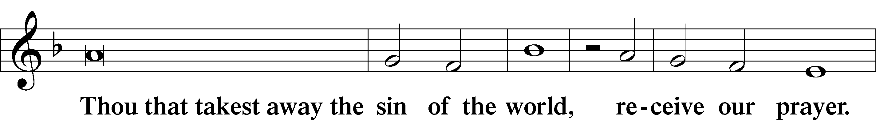
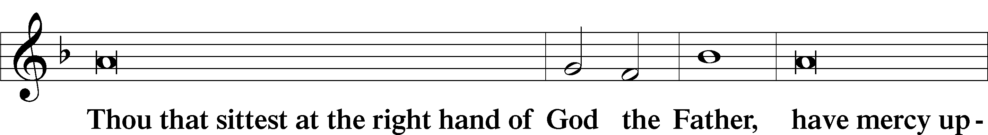
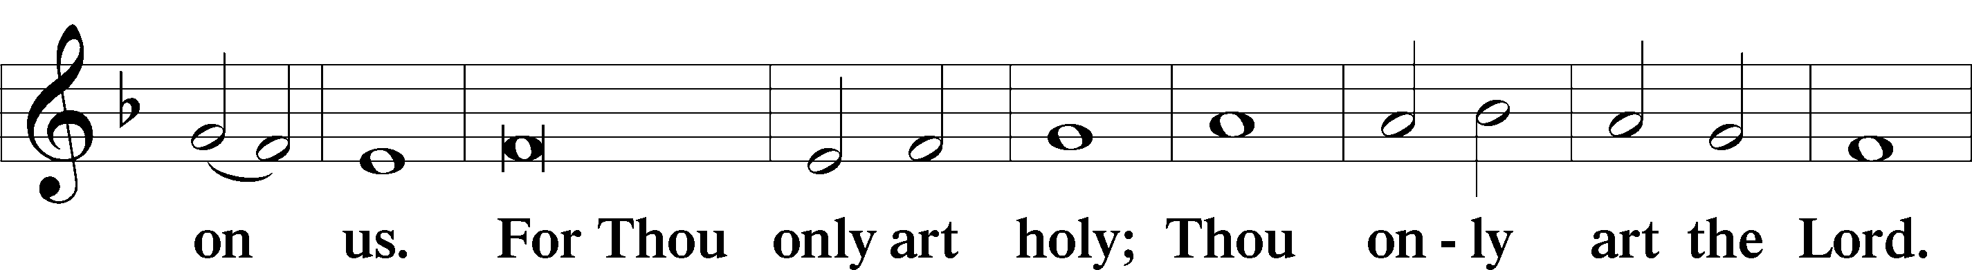
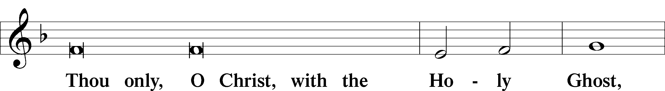
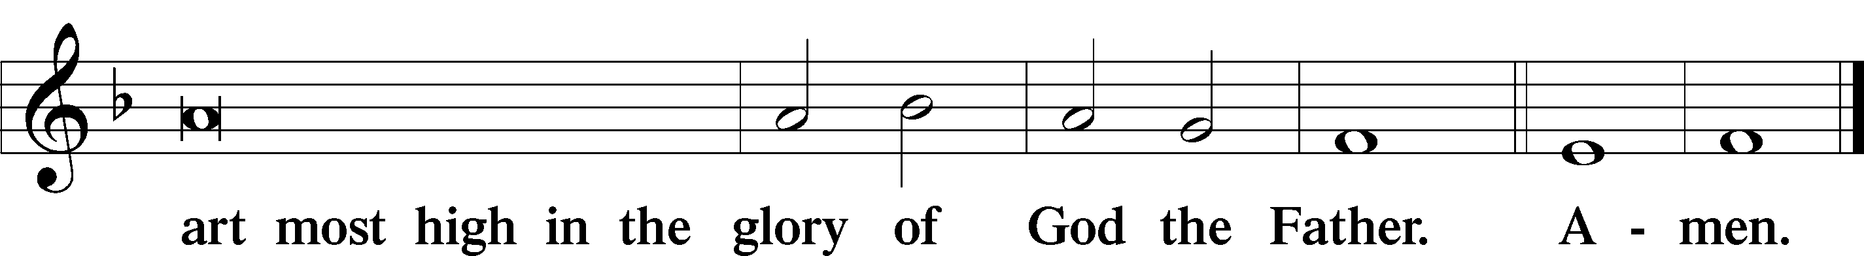

Salutation and Collect of the Day: Trinity 20
P The Lord be with you.
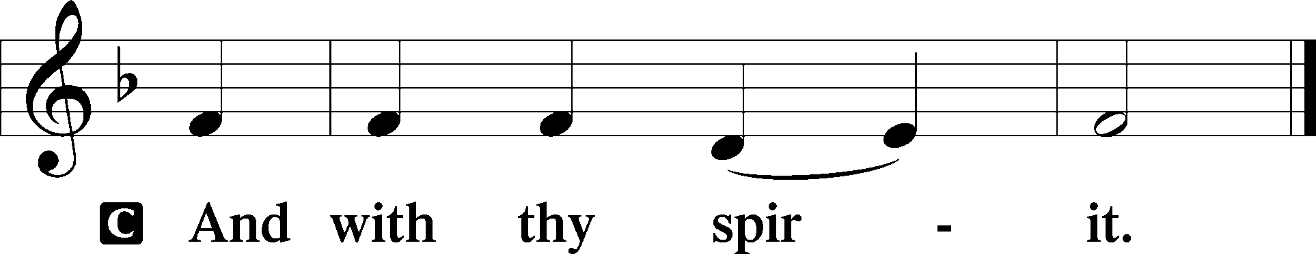

P Let us pray.
O Lord, grant to Your faithful people pardon and peace that they may be cleansed from all their sins and serve You with a quiet mind; through Jesus Christ, Your Son, our Lord, who lives and reigns with You and the Holy Spirit, one God, now and forever.
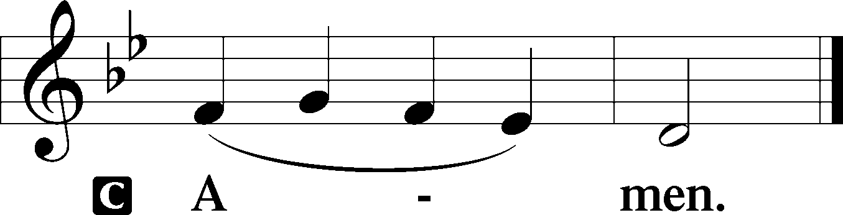
Sit

Prophecy: Isaiah 54:17b—55:11 (NKJV)
“This is the heritage of the servants of the Lord, and their righteousness is from Me,” says the Lord. “Ho! Everyone who thirsts, come to the waters; and you who have no money, come, buy and eat. Yes, come, buy wine and milk without money and without price. Why do you spend money for what is not bread, and your wages for what does not satisfy? Listen carefully to Me, and eat what is good, and let your soul delight itself in abundance. Incline your ear, and come to Me. Hear, and your soul shall live; and I will make an everlasting covenant with you—the sure mercies of David. Indeed I have given him as a witness to the people, a leader and commander for the people. Surely you shall call a nation you do not know, and nations who do not know you shall run to you, because of the Lord your God, and the Holy One of Israel; for He has glorified you.” Seek the Lord while He may be found, call upon Him while He is near. Let the wicked forsake his way, and the unrighteous man his thoughts; let him return to the Lord, and He will have mercy on him; and to our God, for He will abundantly pardon. “For My thoughts are not your thoughts, nor are your ways My ways,” says the Lord. “For as the heavens are higher than the earth, so are My ways higher than your ways, and My thoughts than your thoughts. For as the rain comes down, and the snow from heaven, and do not return there, but water the earth, and make it bring forth and bud, that it may give seed to the sower and bread to the eater, so shall My word be that goes forth from My mouth; it shall not return to Me void, but it shall accomplish what I please, and it shall prosper in the thing for which I sent it,” says the Lord Almighty.

P This is the Word of the Lord.
C Thanks be to God.

Gradual Psalm 145:15–16
The eyes of all | look to you,*
and you give them their food in due | season.
You open | your hand;*
you satisfy the desire of every | living thing.

Epistle: Ephesians 5:15–21 (NKJV)
Brethren: See that you walk circumspectly, not as fools but as wise, redeeming the time, because the days are evil. Therefore do not be unwise, but understand what the will of the Lord is. And do not be drunk with wine, in which is dissipation; but be filled with the Spirit, speaking to one another in psalms and hymns and spiritual songs, singing and making melody in your heart to the Lord, giving thanks always for all things to God the Father in the name of our Lord Jesus Christ, submitting to one another in the fear of God.

P This is the Word of the Lord.
C Thanks be to God.

Stand

Verse Psalm 130:1–2a
Alleluia. Out of the depths I cry to you, O Lord! O Lord, hear my voice! Alleluia.

Alleluia
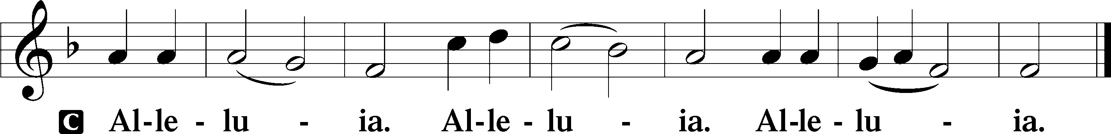

Holy Gospel: Matthew 22:1–14 (NKJV)
P The Holy Gospel according to St. Matthew, the twenty-second chapter.
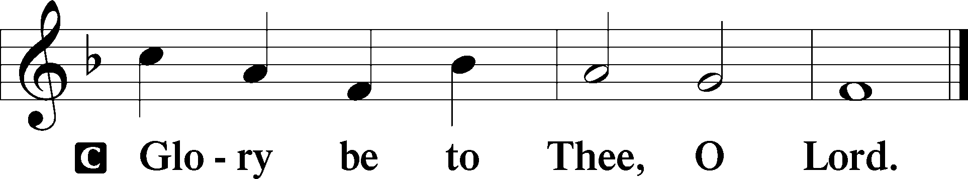

At that time: Jesus spoke to the chief priests and Pharisees by parables and said: “The kingdom of heaven is like a certain king who arranged a marriage for his son, and sent out his servants to call those who were invited to the wedding; and they were not willing to come. Again, he sent out other servants, saying, ‘Tell those who are invited, “See, I have prepared my dinner; my oxen and fatted cattle are killed, and all things are ready. Come to the wedding.” ’ But they made light of it and went their ways, one to his own farm, another to his business. And the rest seized his servants, treated them spitefully, and killed them. But when the king heard about it, he was furious. And he sent out his armies, destroyed those murderers, and burned up their city. Then he said to his servants, ‘The wedding is ready, but those who were invited were not worthy. Therefore go into the highways, and as many as you find, invite to the wedding.’ So those servants went out into the highways and gathered together all whom they found, both bad and good. And the wedding hall was filled with guests. But when the king came in to see the guests, he saw a man there who did not have on a wedding garment. So he said to him, ‘Friend, how did you come in here without a wedding garment?’ And he was speechless. Then the king said to the servants, ‘Bind him hand and foot, take him away, and cast him into outer darkness; there will be weeping and gnashing of teeth.’ For many are called, but few are chosen.”

P This is the Gospel of the Lord.
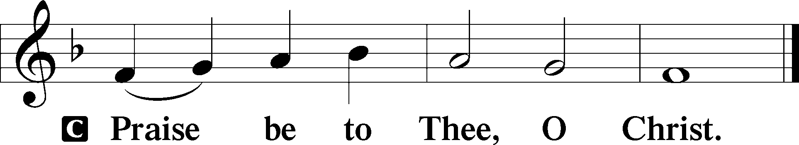

Nicene Creed
C I believe in one God,
the Father Almighty,
maker of heaven and earth
and of all things visible and invisible.

And in one Lord Jesus Christ,
the only-begotten Son of God,
begotten of His Father before all worlds,
God of God, Light of Light,
very God of very God,
begotten, not made,
being of one substance with the Father,
by whom all things were made;
who for us men and for our salvation came down from heaven
and was incarnate by the Holy Spirit of the virgin Mary
and was made man;
and was crucified also for us under Pontius Pilate.
He suffered and was buried.
And the third day He rose again according to the Scriptures
and ascended into heaven
and sits at the right hand of the Father.
And He will come again with glory to judge both the living and the dead,
whose kingdom will have no end.

And I believe in the Holy Spirit,
the Lord and giver of life,
who proceeds from the Father and the Son,
who with the Father and the Son together is worshiped and glorified,
who spoke by the prophets.
And I believe in one holy Christian and apostolic Church,
I acknowledge one Baptism for the remission of sins,
and I look for the resurrection of the dead
and the life T of the world to come. Amen.
Sit

Hymn of the Day: LSB #828 “We Are Called to Stand Together”

Sermon

Stand

Offertory Psalm 51:10–12
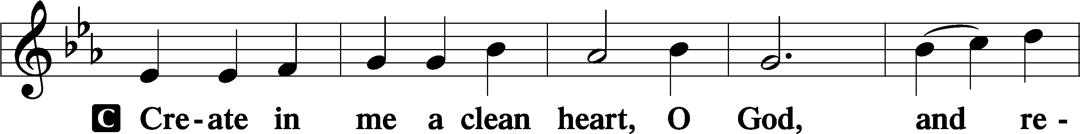
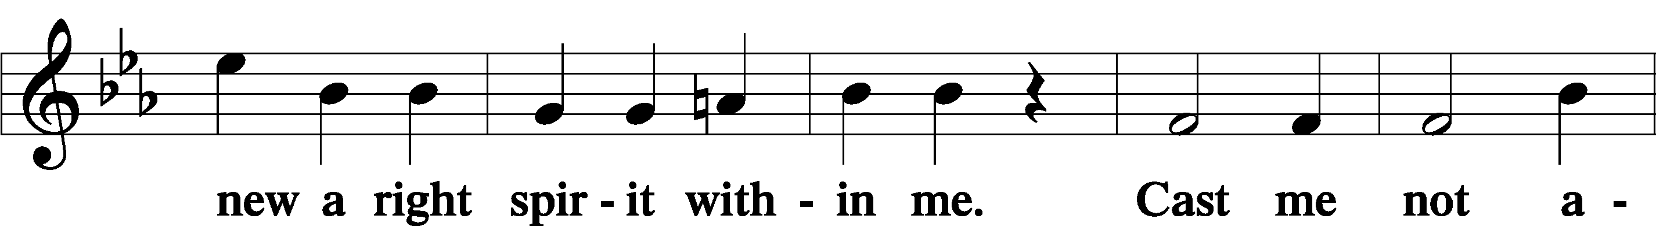
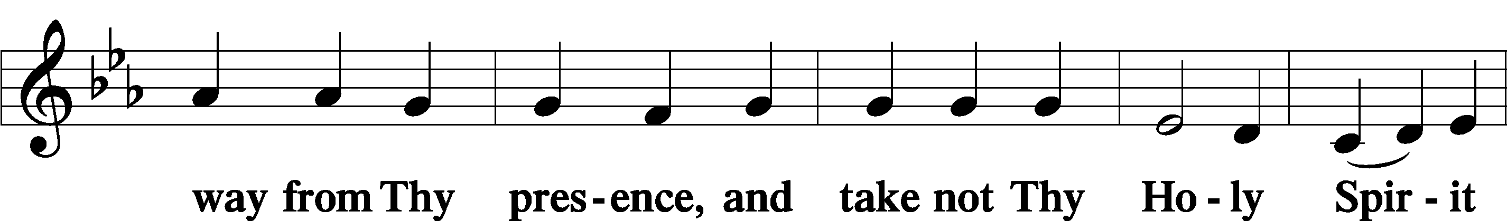
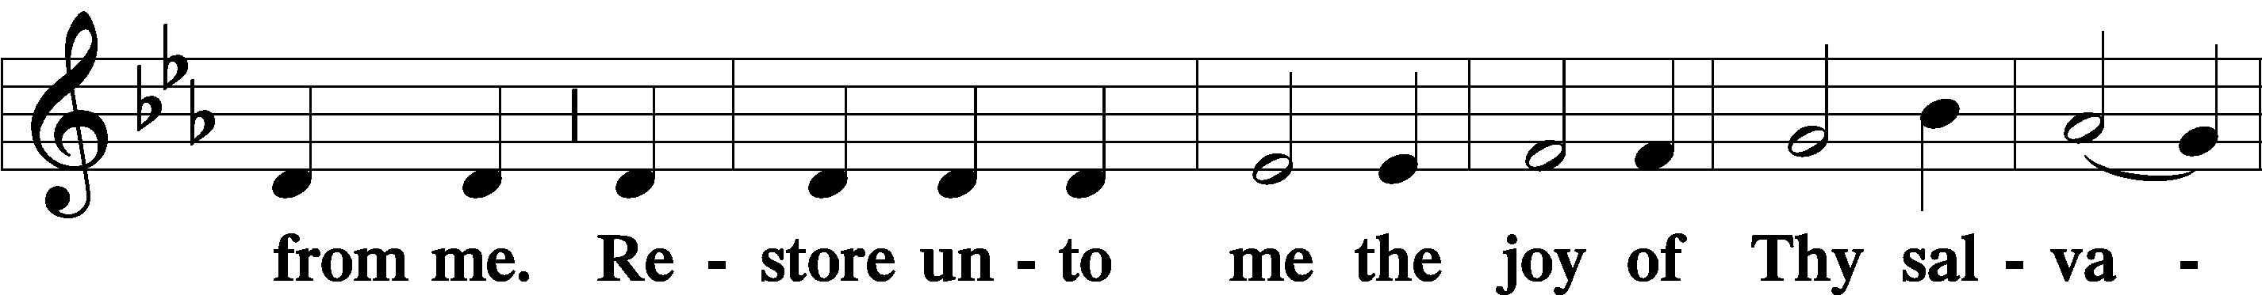
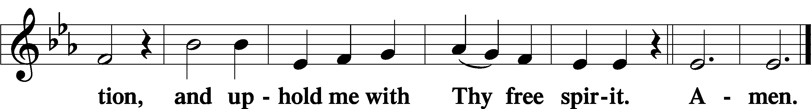

Prayer of the Church

Sit

Preparatory Hymn: LSB #430 “My Song Is Love Unknown”

Stand

Service of the Sacrament

Preface 2 Timothy 4:22; Colossians 3:1 Psalm 136
P The Lord be with you.
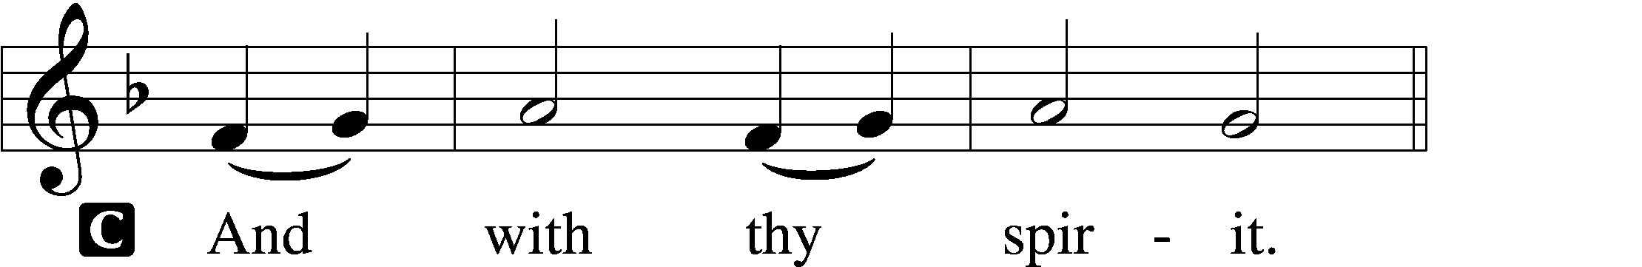
P Lift up your hearts.
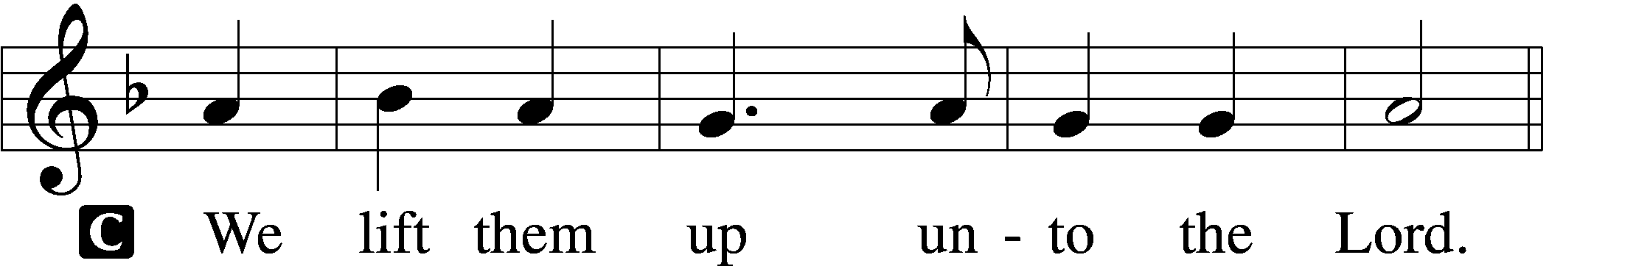

P Let us give thanks unto the Lord, our God.
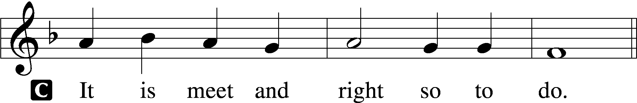

Proper Preface (Abbreviated) LSB 194
P It is truly meet, right, and salutary . . . evermore praising You and saying:

Sanctus Isaiah 6:3; Matthew 21:9
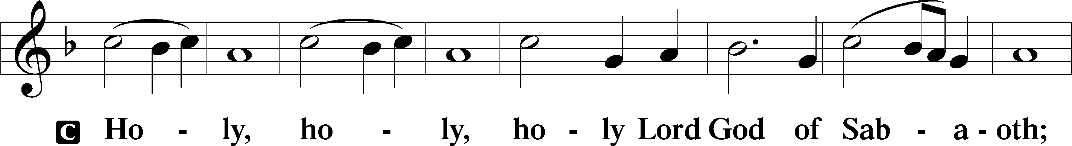
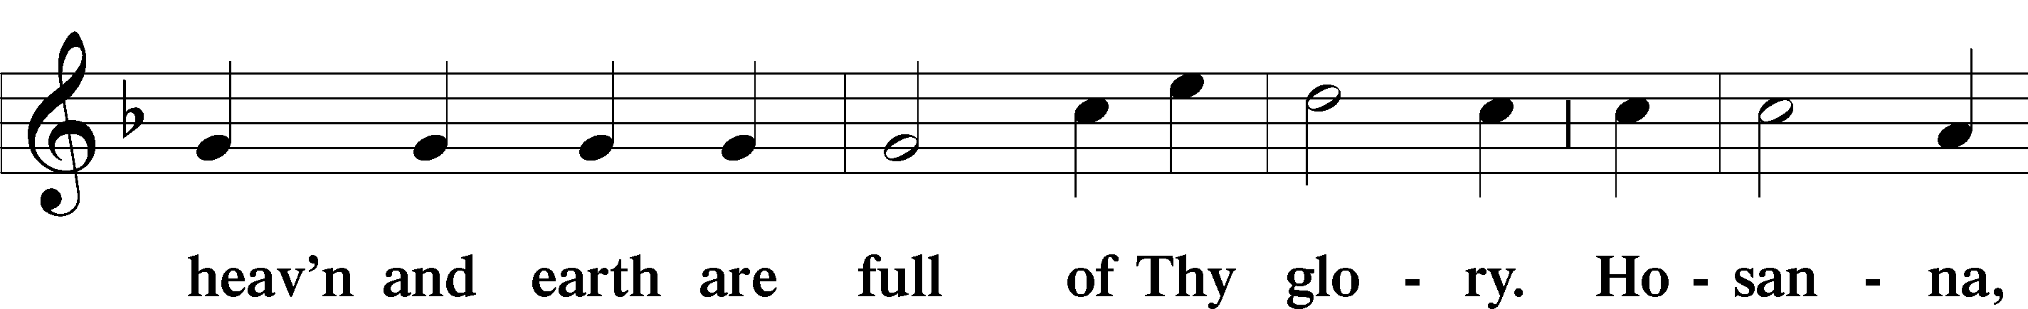
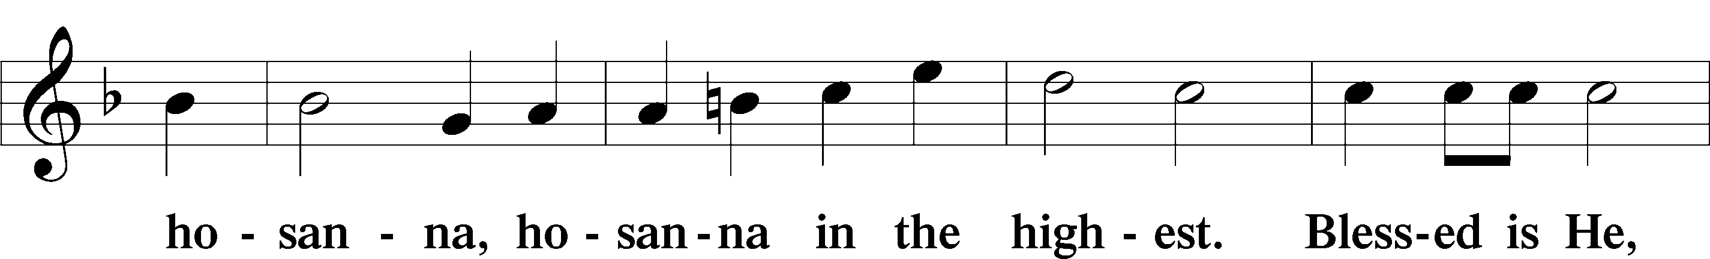
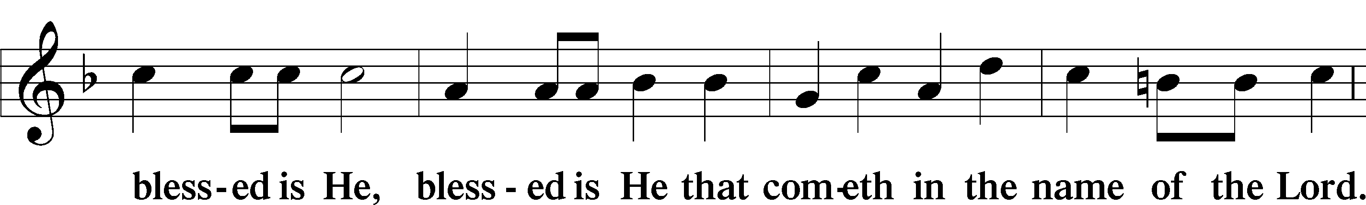
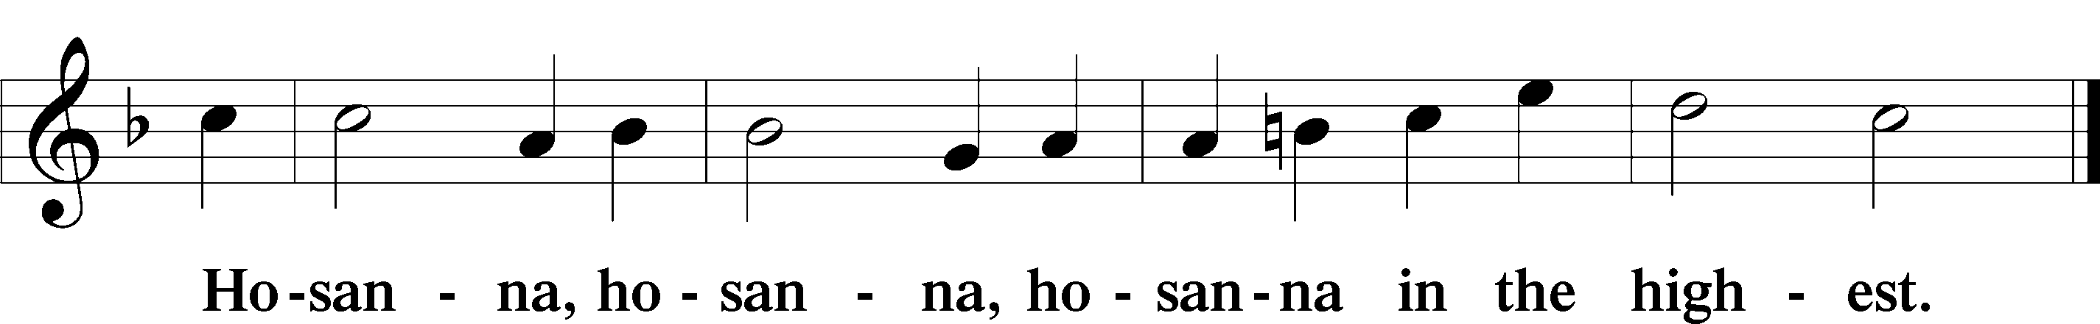

Lord’s Prayer The congregation is encouraged to silently pray the Lord’s Prayer as it is chanted. Matthew 6:9–13
P Our Father who art in heaven,
hallowed be Thy name,
Thy kingdom come,
Thy will be done on earth as it is in heaven;
give us this day our daily bread;
and forgive us our trespasses as we forgive those who trespass against us;
and lead us not into temptation,
but deliver us from evil.
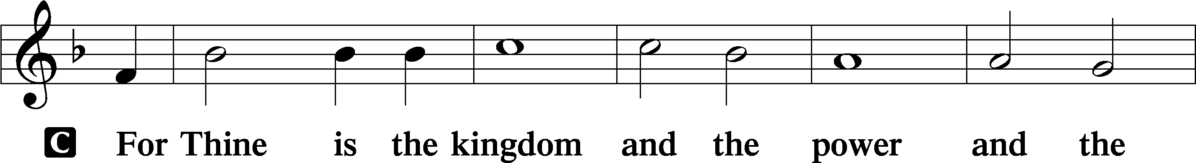
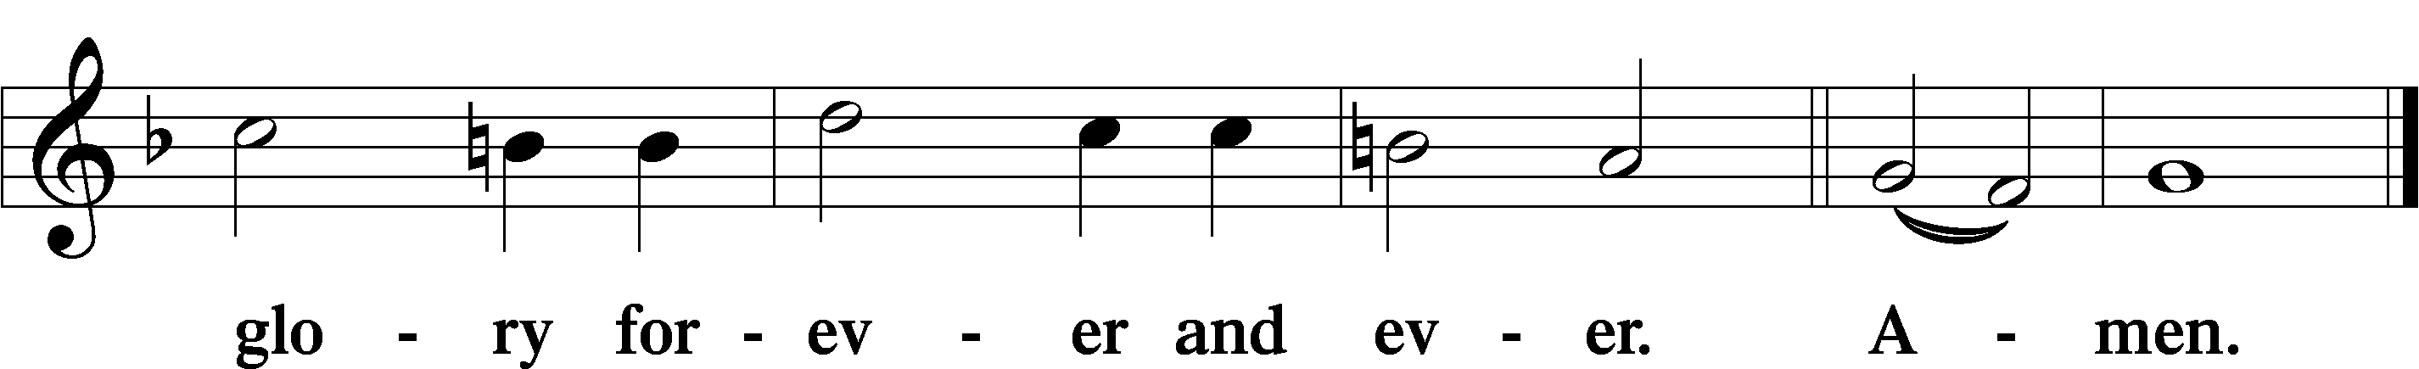

The Words of Our Lord Matthew 26:26–28; Mark 14:22–24; Luke 22:19–20; 1 Corinthians 11:23–25
P Our Lord Jesus Christ, on the night when He was betrayed, took bread, and when He had given thanks, He broke it and gave it to the disciples and said: “Take, eat; this is My T body, which is given for you. This do in remembrance of Me.”

In the same way also He took the cup after supper, and when He had given thanks, He gave it to them, saying: “Drink of it, all of you; this cup is the new testament in My T blood, which is shed for you for the forgiveness of sins. This do, as often as you drink it, in remembrance of Me.”

Pax Domini John 20:19
P The peace of the Lord be with you always.
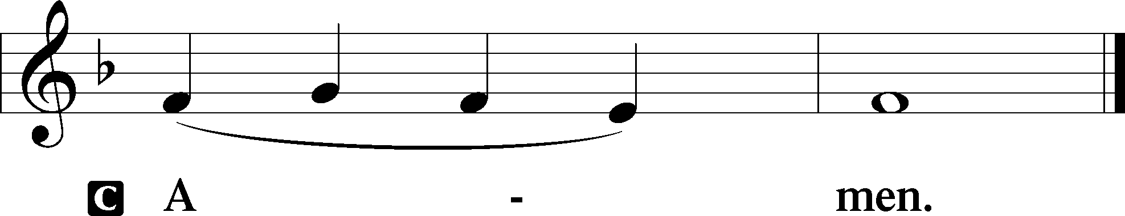
Agnus Dei John 1:29
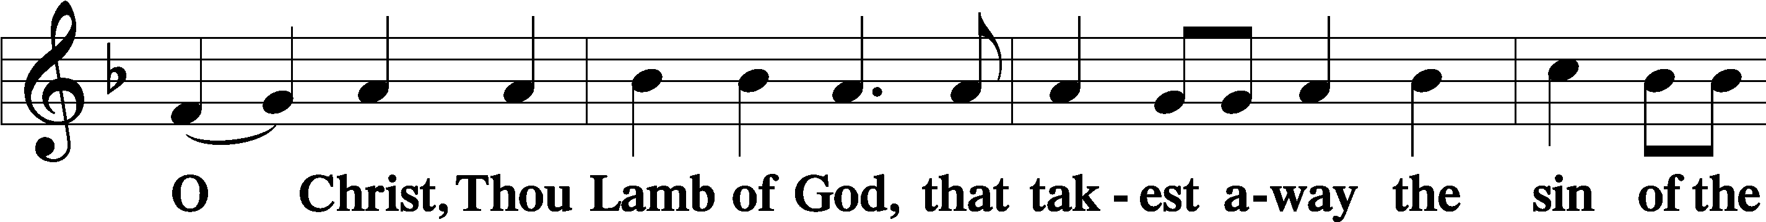
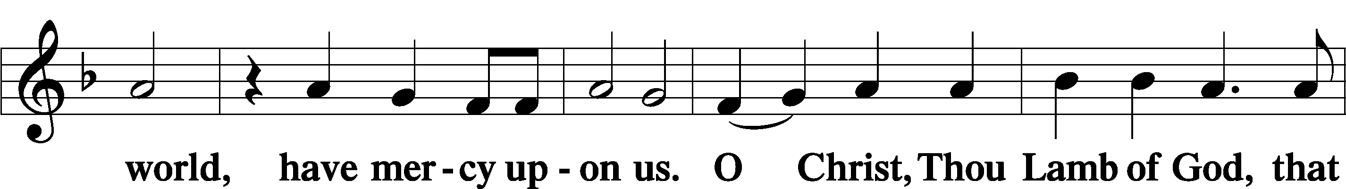
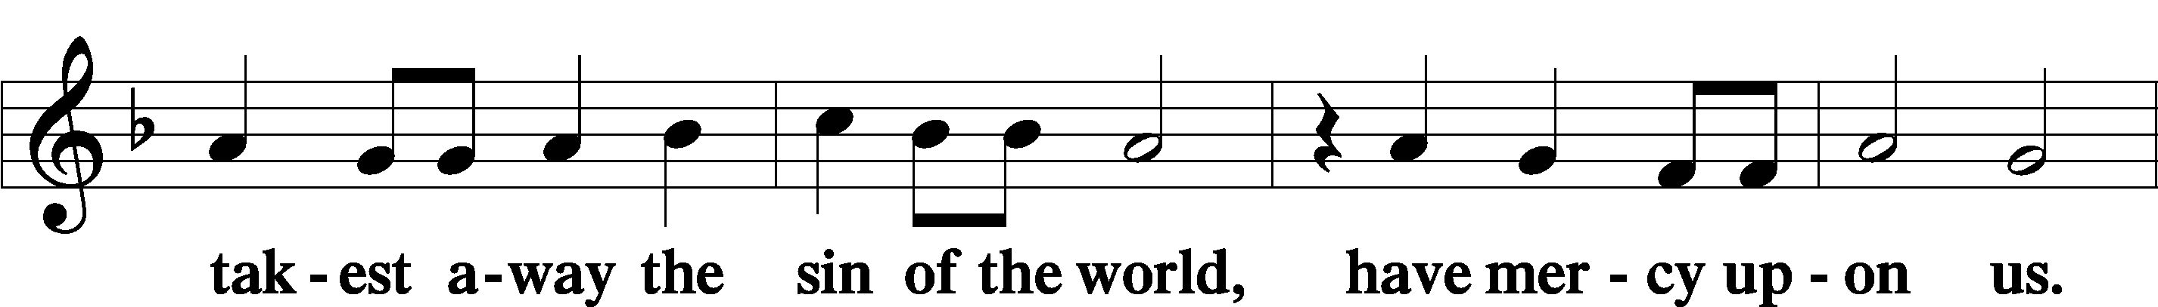
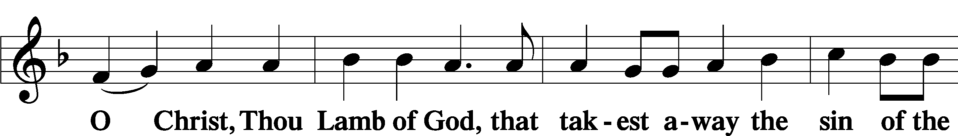
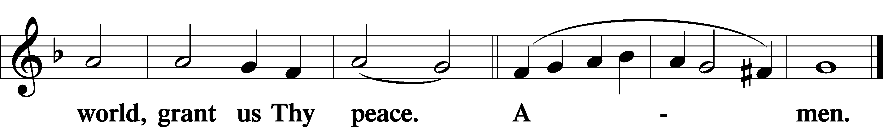
Sit

Distribution
The pastor and those who assist him receive the body and blood of Christ first and then distribute them to those who come to receive, saying:
Take, eat; this is the true body of our Lord and Savior Jesus Christ, given into death for your sins.
Amen.

Take, drink; this is the true blood of our Lord and Savior Jesus Christ, shed for the forgiveness of your sins.
Amen.

In dismissing the communicants, the following is said:
The Dismissal
P The body and blood of our Lord Jesus Christ strengthen and preserve you in body and soul to life everlasting. Depart T in peace.
C Amen.
Distribution Hymn: LSB #648 “Glorious Things of You Are Spoken”

Distribution Hymn: LSB #563 “Jesus, Thy Blood and Righteousness”

Distribution Hymn: LSB #514 “The Bridegroom Soon Will Call Us”

Stand

Nunc Dimittis Luke 2:29–32
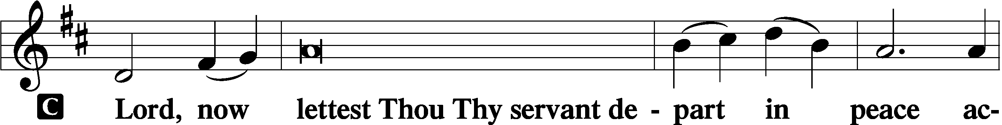
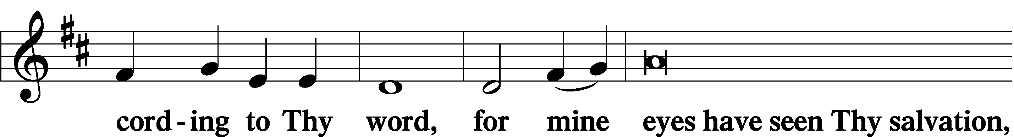
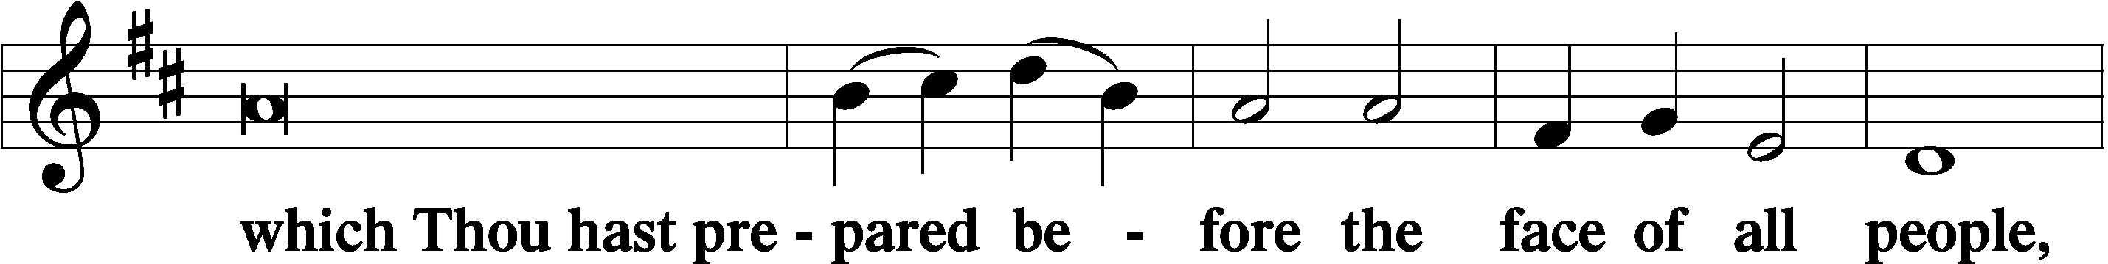
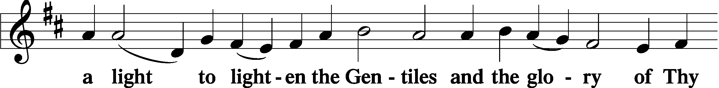
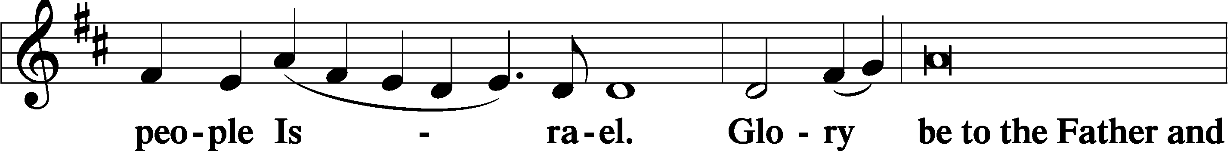
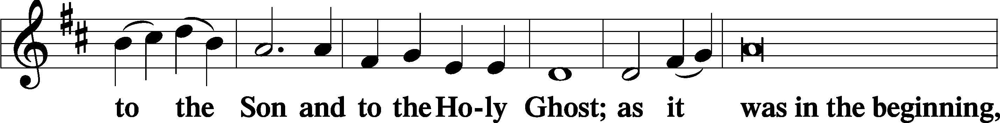
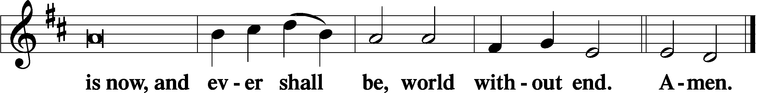

Thanksgiving Psalm 107:1
P O give thanks unto the Lord, for He is good,
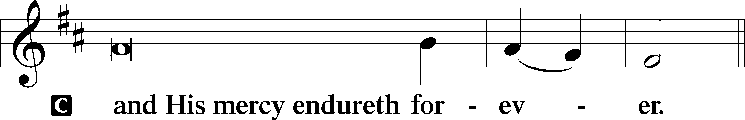

Post-Communion Collect
P Let us pray.
We give thanks to You, almighty God, … through Jesus Christ, Your Son, our Lord, who lives and reigns with You and the Holy Spirit, one God, now and forever.
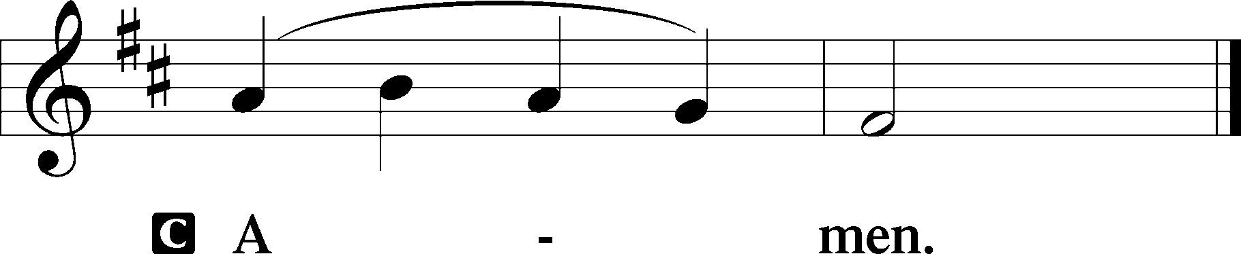

Salutation 2 Timothy 4:22
P The Lord be with you.
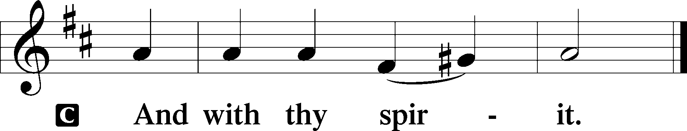

Benedicamus Psalm 103:1
P Bless we the Lord.
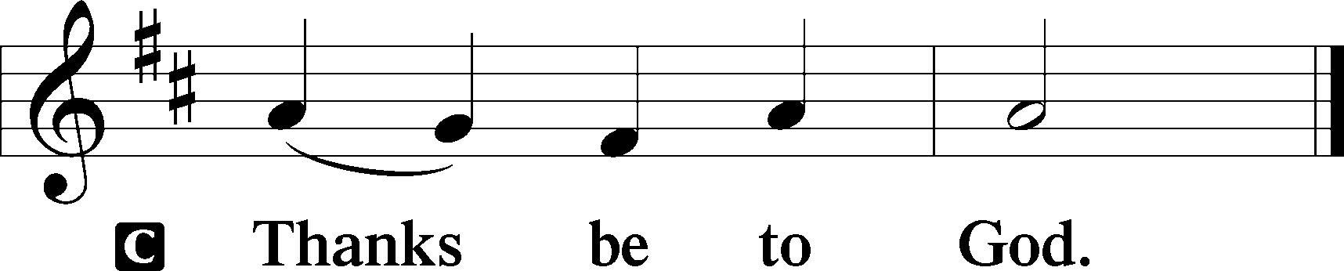

Benediction Numbers 6:24–26
P The Lord bless you and keep you.
The Lord make His face shine upon you and be gracious unto you.
The Lord lift up His countenance upon you and T give you peace.
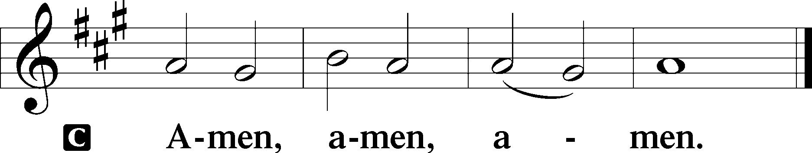

Closing Hymn: LSB #647 “Lord Jesus Christ, the Church’s Head”
fffffffffffffffffffffffffffffffffff
Silent prayer after worship: Heavenly Father, lead me to read Your Word and pray daily so that I will not drift from the true Gospel into disbelief or despair, but may trust only in Christ for forgiveness and eternal life. Amen.
fffffffffffffffffffffffffffffffffff

SCHEDULE THROUGH OCTOBER 29, 2023:

:

Today, following Worship, Library: 3rd Quarter Audit & Monthly Audit of Deposits
7 pm, Fellowship Hall: AA Meeting
Tuesday, 7-9 pm, Fellowship Hall: Penn-Ohio Singers
Wednesday, 7:30 pm, Fellowship Hall: NA Meeting
Thursday, 9 am, Downstairs: Food Pantry
Saturday, 5 pm, Fellowship Hall: Appreciation Dinner
Next Sunday, 8 am, Fellowship Hall: Bible Study
9 am, Sanctuary: Divine Service
3 pm, First Trinity Lutheran Church, Pgh, PA: Reformation Service
7 pm, Fellowship Hall: AA Meeting
fffffffffffffffffffffffffffffffffff
Attendance: Sunday, October 15, 2023: 35
Wednesday, October 18, 2023: 12
fffffffffffffffffffffffffffffffffff
Our Stewardship of Treasures for the Lord:
In order to do the Lord’s work, we need $2,553.63 each week to meet our 2023 budget for general purposes and $76.92 for the SELC.

Online Figures (10.12, 10.13, and 10.16.2023)
General Fund: $430.00
SELC: $100.00
Capital Campaign: $200.00
Figures for Sunday, October 15, 2023
General Fund: $2,125.00 Ahead for the week: +$1.37
SELC: $50.00 Ahead for the week: +$73.08
Quarterly Missions: $575.00
Capital Campaign: $395.00
Other: $122.00

For online giving, check out https://www.saintspeterandpaul.net/online-giving.
fffffffffffffffffffffffffffffffffff

THANK YOU FOR SERVING IN OCTOBER: Elder: Jonathan Baisch; Ushers: Matt Berent, Mark Gabriel, Michael Laird, & Jerome Thomas; Altarware ~ Sundays: (prior) Diane Riefstahl; (after) Oct. 29th~Elizabeth Haenftling; other~Cheryl Fedele & Clara Krivosh; Special Divine Services: Oct. 23rd & 31st ~ Elizabeth Haenftling.
fffffffffffffffffffffffffffffffffff
Bible Memory Verses ~ Week of October 22nd:
For Adults: Let each person lead the life that the Lord has assigned to him, and to which God has called him. 1 Corinthians 7:17

For Children: “The Lord knows those who are his,” and, “Let everyone who names the name of the Lord depart from iniquity.” 2 Timothy 2:19
fffffffffffffffffffffffffffffffffff
It’s time to renew subscriptions for the “Lutheran Witness” magazine for 2024. The price has increased to $19.25. If wishing to renew, place a check made out to Sts. Peter & Paul’s in a pew envelope and label the envelope with your name and that it is for the LW. Please make sure to note any change in address with your renewal. Renewals are due on or before Sunday, November 19, 2023.

fffffffffffffffffffffffffffffffffff
Up-Coming Special Divine Services (all at 7 pm):
- This Monday, October 23: Festival of Saint James of Jerusalem, Brother of Jesus and Martyr
- Tuesday, October 31: Reformation Day
- Wednesday, November 1: All Saints Day ~ Remembering those members of our congregation who passed into the arms of our Lord this past year (Kenneth Stephenson~All Saints, January 7, 2023; Anson Holcroft, February 22, 2023; Viola Sakony, March 25, 2023; Barry Nelson, April 25, 2023 and those whom we hold dear in our hearts.)
fffffffffffffffffffffffffffffffffff
Items for the November calendar and newsletter are due to the secretary by 9 am, Thursday, October 26th.
fffffffffffffffffffffffffffffffffff
The Church office will be open from 8:30 am–4:30 pm Thurs. and Fri, only, this week.
Remember the following in Prayer…
~The Hurting and Healing: Amy, Steve Antolovich, Ellen Baron^{CA}, Amy Blomenberg, Lois Bortner^{CA}, Sara Brubaker, Dee Bullock, Bev & Joe Chlpka, Susan Davies, Loretta Deal, Tim Dudash, Judith & Eddy Furey, Griffin, Peter Haenftling, Austin Hamilton, Pastor Charles Henrickson, Joan, Keith Jozwiakowski, Darla Krajci, Barbara Kreske, Jess Lavoie, Paul Lucas^{CA}, Sandy Marshall, Frank Niemeyer^{CA}, Juanita Rentschler, Richard Reuning^{CA}, Nancy Robertson^{CA}, Kriss Svidro^{CA}, Joel & Peggy Wasson, Angela Weser^{CA}, Betty Wolf (hospitalized), and Ruth Wolf.
~The Homebound: Anna Mae Daris, Millie Elavsky, Rudy & Jean Tomko, and Ed & Millie Zachar.
~Celebrating this Week: Anniversary: Jonathan & Bekah Baisch (10.15~belated!) and Gordon & Rebecca Marquette (10.24).
~Serving in the Military: Alex (Sasha) Carr, Duncan Vaupel, Curtis Sinewe, and Joshua Solyan.
~Community & World Needs: Those suffering due to the conflicts in the Middle East and between Ukraine and Russia; those suffering from loss and dislocation because weather disasters; those suffering from addiction and their families; Local, State, and National Government Leaders; safety for all Police Officers, Firefighters, & First Responders; the unemployed; our Fourth Quarter Local Mission: Willow Women’s Center.
*CA represents cancer.
fffffffffffffffffffffffffffffffffff
Church Council members are reminded that the meeting originally scheduled for October 23rd has been moved to November 6 at 7 pm.
fffffffffffffffffffffffffffffffffff
PASTOR & FAMILY APPRECIATION DINNER – THIS SAT., OCT. 28th, 5 PM
Doors will open this Saturday for the Appreciation Dinner at 4:30 pm! We are looking forward to sharing food and fellowship with one another.
A special “thanks” goes out to the planning committee for organizing this event .
fffffffffffffffffffffffffffffffffff
All are invited to attend a special Reformation Service Sunday, October 29th at 3 pm at Trinity Lutheran Church, 531 N. Neville St., Pittsburgh, PA.
Here to Serve
Pastor………………………………………………...……………Rev. Jacob Deal
E-mail …………………………….……pastordeal@saintspeterandpaul.net
Phone Number……………………..…………………724-347-3620 (Option 2)
Church Office………………………..…………………724-347-3620 (Option 3)
Website …………………………………………www.saintspeterandpaul.net
Secretary…………………………………………………………Diane Riefstahl
E-mail ………………………………………church@saintspeterandpaul.net
Website …………………………………………www.saintspeterandpaul.net
Food Pantry (email): ……………foodpantry@saintspeterandpaul.net
Congregation President………………………………….…Jonathan Baisch
Church Elder …………………………………………...……. Jonathan Baisch
Organist………………………………………………..….…Rebecca Marquette
Choir Director…………………………………………………….…Chris Nelson
AA Contact: Steve………………………………………………...…724-813-2358
NA Contact: Larry……………………………………..…………..724-977-8733
fffffffffffffffffffffffffffffffffff
If needing to get into the church building during the week, please phone first to make certain someone is here to let you in.

