Sts. Peter & Paul
Evangelical Lutheran Church
Lutheran Church-Missouri Synod
Founded-1917

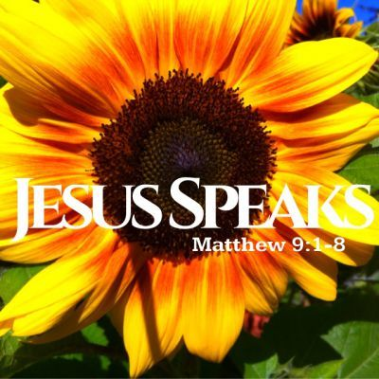

October 15, 2023

699 Stambaugh Ave.
Sharon, Pennsylvania 16146

“I was glad when they said to me,
Let us go to the house of the LORD!”
Psalm 122:1
Sts. Peter & Paul Evangelical Lutheran Church, LC-MS
THE NINETEENTH SUNDAY AFTER TRINITY
October 15, 2023
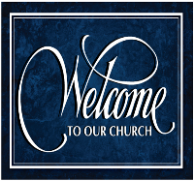
A special welcome to our guests this day! If you would like more information about The Lutheran Church - Missouri Synod, or this congregation, please speak with Pastor Deal or an Elder after the service.
Members & Guests: Don’t be embarrassed if your children make noise during the worship service, all children do. We encourage families to worship together but, if you feel the need, there are pews in the rear of the Church which are reserved for young families on both sides of the sanctuary. There is also a quiet room available to you, located next to the sanctuary (formerly the Pastor’s office), where you would be able to follow along with the service.

Today’s service includes the Sacrament of Holy Communion. If during this past year, you have not worshipped with us and been communed, we respectfully ask that you do not partake of this sacrament this day before first speaking with Pastor Deal.
If visiting from a sister congregation of the LC-MS and are in good standing, please inform Pastor Deal of your desire to commune prior to the service.
If wishing to receive a blessing during communion, please approach with your arms crossed.

CONTACT INFORMATION
Pastor Deal: pastordeal@saintspeterandpaul.net or 724-347-3620 (opt. 2)
Church Office: church@saintspeterandpaul.net or 724-347-3620 (opt. 3)
Secretary’s Office: The office will be open Mon. (8:30 am-5 pm) & Thurs (8:30 am-10 am; 11 am-5 pm).

Silent prayer before worship: Lord Jesus, You are true God, yet You lowered Yourself to live among us and to suffer and die that we might have eternal life. As I worship You today, lead me to lift You up in praise with my heart and my lips. Amen.
Confession and Absolution

Opening Hymn: LSB #814 “O Bless the Lord, My Soul”

Stand

The sign of the cross may be made by all in remembrance of their Baptism.

Invocation
P In the name of the Father and of the T Son and of the Holy Spirit.
C Amen.

Exhortation Hebrews 10:22; Psalm 124:8; Psalm 32:5
P Beloved in the Lord! Let us draw near with a true heart and confess our sins unto God our Father, beseeching Him in the name of our Lord Jesus Christ to grant us forgiveness.

P Our help is in the name of the Lord,
C who made heaven and earth.
P I said, I will confess my transgressions unto the Lord,
C and You forgave the iniquity of my sin.

Silence for reflection on God’s Word and for self-examination.

Confession of Sins
P O almighty God, merciful Father,
C I, a poor, miserable sinner, confess unto You all my sins and iniquities with which I have ever offended You and justly deserved Your temporal and eternal punishment. But I am heartily sorry for them and sincerely repent of them, and I pray You of Your boundless mercy and for the sake of the holy, innocent, bitter sufferings and death of Your beloved Son, Jesus Christ, to be gracious and merciful to me, a poor, sinful being.

Absolution [John 20:19–23]
P Upon this your confession, I, by virtue of my office, as a called and ordained servant of the Word, announce the grace of God unto all of you, and in the stead and by the command of my Lord Jesus Christ I forgive you all your sins in the name of the Father and of the T Son and of the Holy Spirit.
C Amen.

Service of the Word

Introit Psalm 78:1–3, 4b; antiphon: Psalm 35:3b; 34:17a, 6b; 48:14a
Say to my soul, “I am your sal- | vation!”*
When the righteous cry for help, the | Lord hears.
[The Lord] saved him out of all his | troubles;*
this is God, our God forever and | ever.
Give ear, O my people, to my | teaching;*
incline your ears to the words | of my mouth!
I will open my mouth in a | parable;*
I will utter dark sayings | from of old,
things that we have | heard and known,*
that our fathers have | told us.
We will tell the coming generation the glorious deeds of the Lord, | and his might,*
and the wonders that | he has done.
Say to my soul, “I am your sal- | vation!”*
When the righteous cry for help, the | Lord hears.
[The Lord] saved him out of all his | troubles;*
this is God, our God forever and | ever.

Gloria Patri
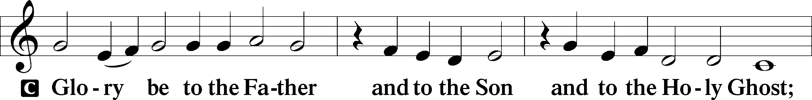
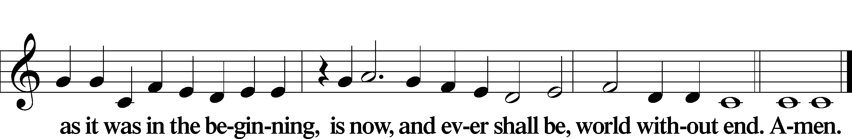

Kyrie Mark 10:47
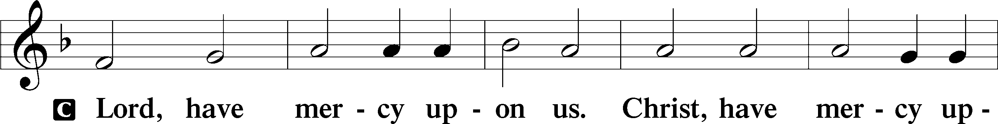
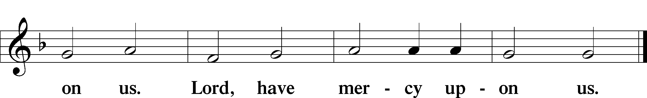

Gloria in Excelsis Luke 2:14; John 1:29
P Glory be to God on high:
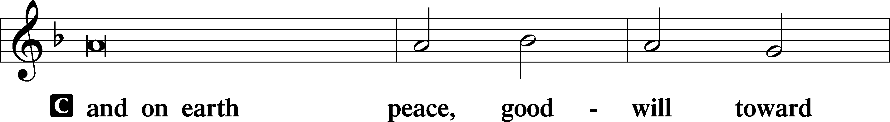
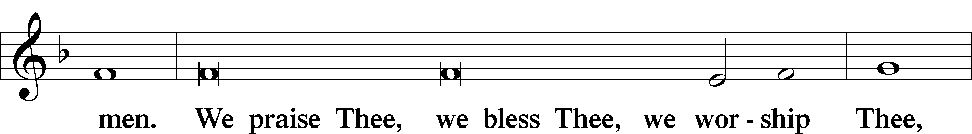
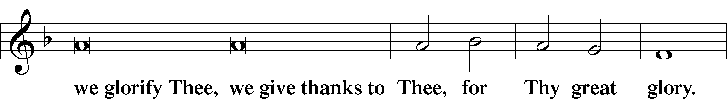
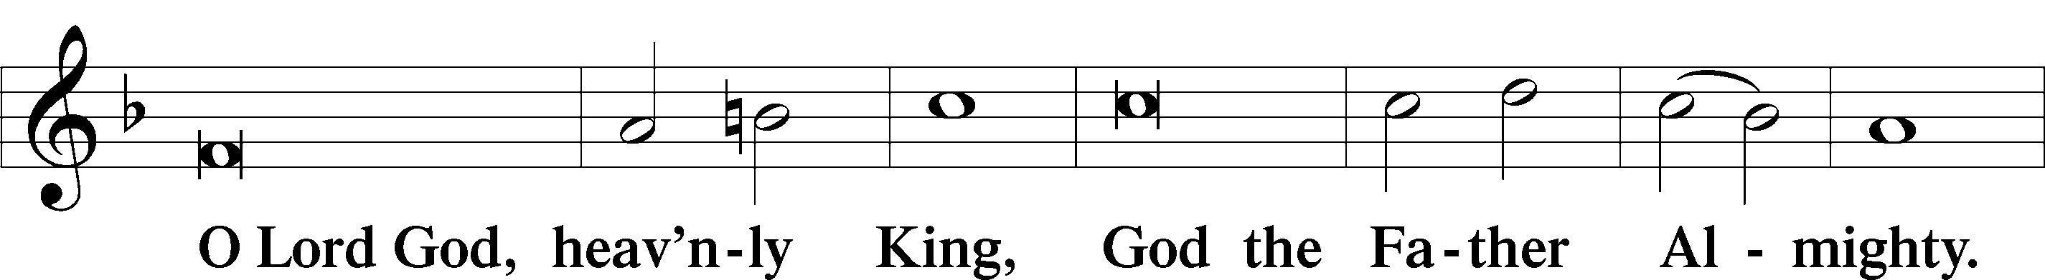
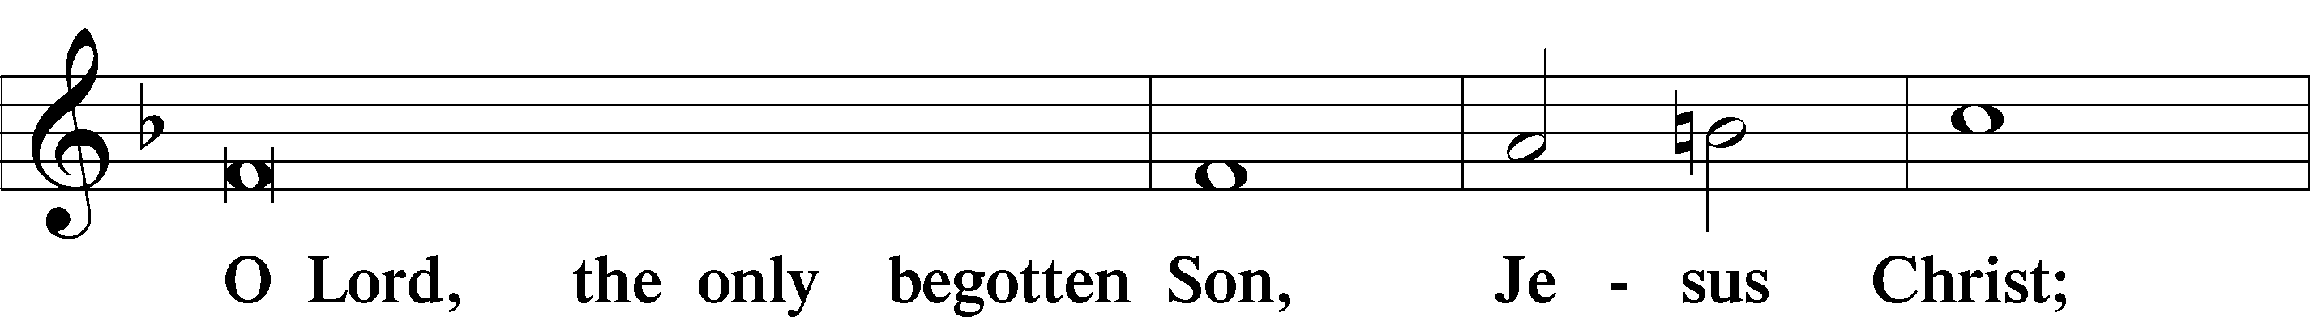
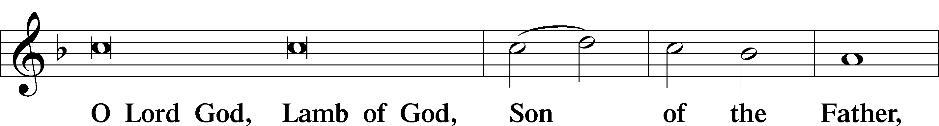
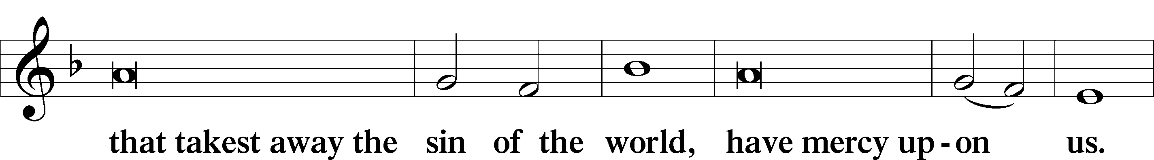
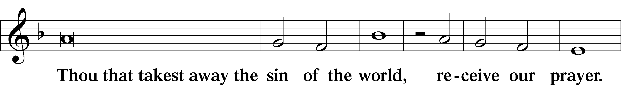
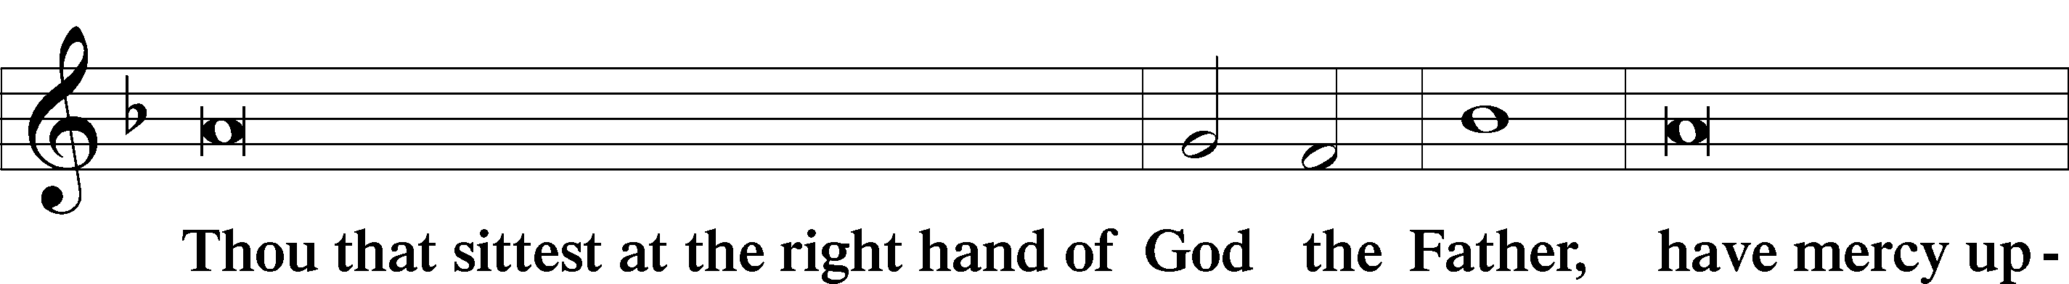
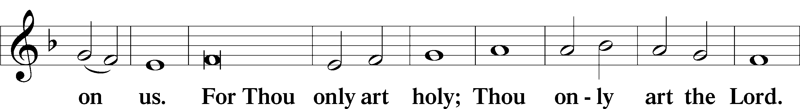
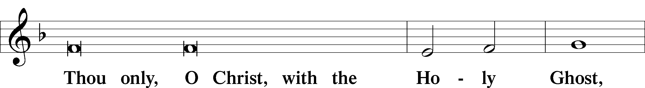
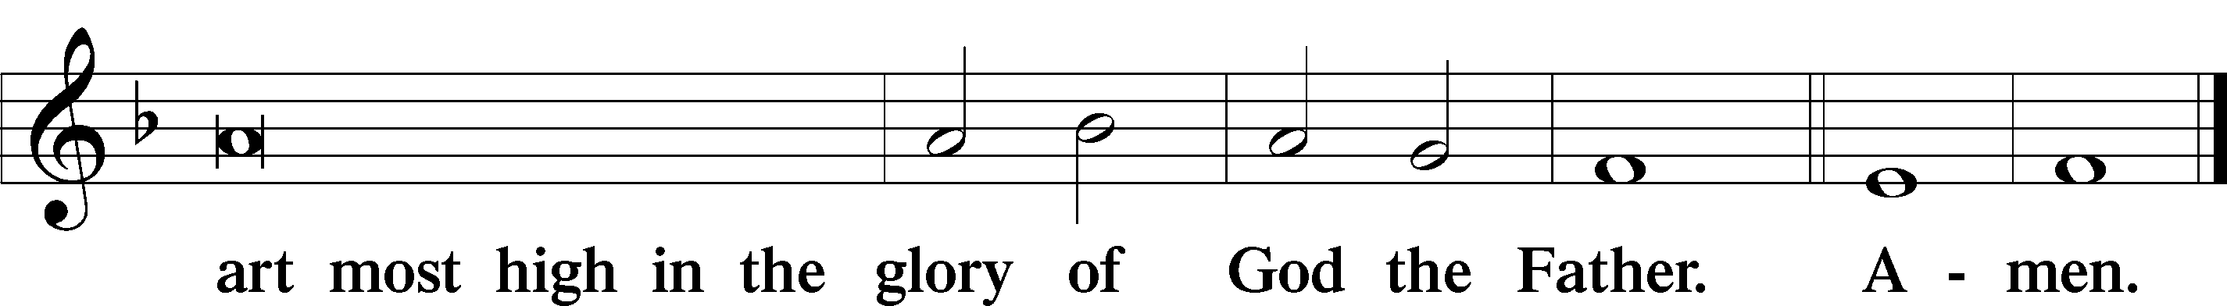

Salutation and Collect of the Day: Trinity 19
P The Lord be with you.
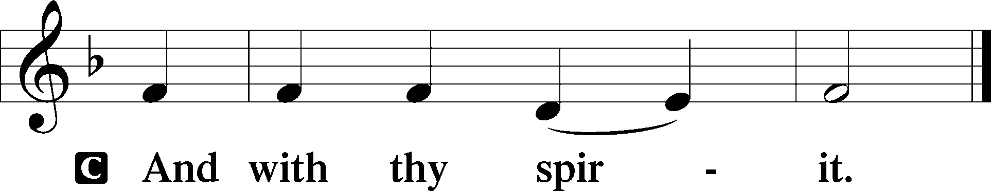

P Let us pray.
Almighty and merciful God, of Your bountiful goodness keep from us all things that may hurt us that we, being ready in both body and soul, may cheerfully accomplish whatever You would have us do; through Jesus Christ, Your Son, our Lord, who lives and reigns with You and the Holy Spirit, one God, now and forever.
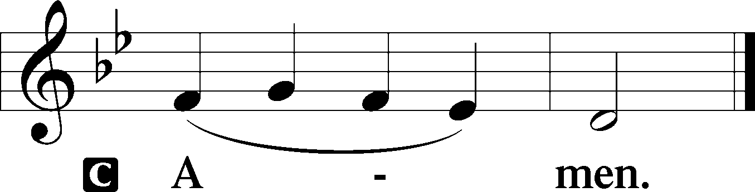

Sit

Prophecy: Isaiah 44: 21-23 (NKJV)
Thus says the Lord God: “Remember this, O Jacob, and Israel, for you are My servant; I have formed you, you are My servant; O Israel, you will not be forgotten by Me! I have blotted out, like a thick cloud, your transgressions, and like a cloud, your sins. Return to Me, for I have redeemed you.” Sing, O heavens, for the Lord has done it! Shout, you lower parts of the earth; break forth into singing, you mountains, O forest, and every tree in it! For the Lord has redeemed Jacob, and glorified Himself in Israel.

P This is the Word of the Lord.
C Thanks be to God.

Gradual Psalm 141:1–2
O Lord, I call upon you; hasten | to me!*
Give ear to my voice when I | call to you!
Let my prayer be counted as incense be- | fore you,*
and the lifting up of my hands as the evening | sacrifice!

Epistle: Ephesians 4:22–28
Brethren: Put off, concerning your former conduct, the old man which grows corrupt according to the deceitful lusts, and be renewed in the spirit of your mind, and put on the new man which was created according to God, in true righteousness and holiness. Therefore, putting away lying, “Let each one of you speak truth with his neighbor,” for we are members of one another. “Be angry, and do not sin”: do not let the sun go down on your wrath, nor give place to the devil. Let him who stole steal no longer, but rather let him labor, working with his hands what is good, that he may have something to give him who has need.

P This is the Word of the Lord.
C Thanks be to God.

Stand

Verse Psalm 98:1a
Alleluia. Sing to the Lord a new song, for he has done marvelous things! Alleluia.

Alleluia
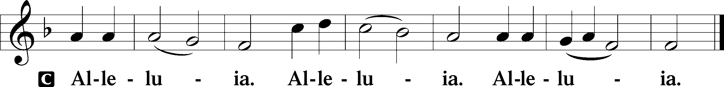

Holy Gospel: Matthew 9:1–8 (NKJV)
P The Holy Gospel according to St. Matthew, the ninth chapter.
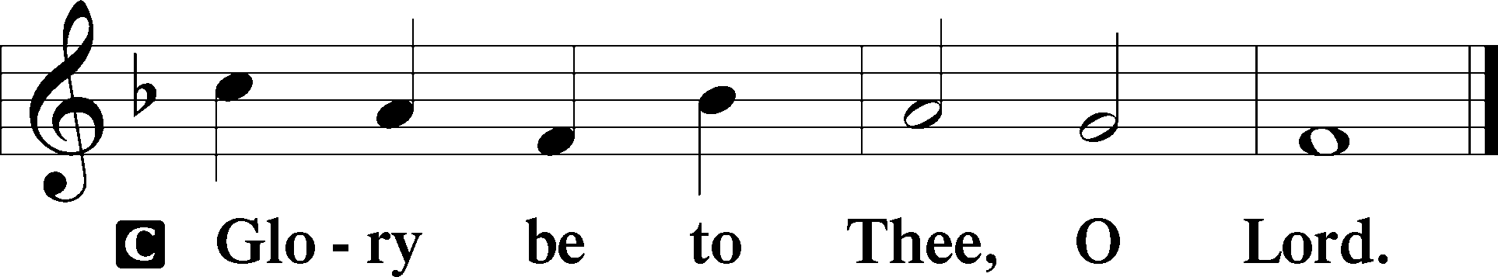

At that time: Jesus got into a boat, crossed over, and came to His own city. Then behold, they brought to Him a paralytic lying on a bed. When Jesus saw their faith, He said to the paralytic, “Son, be of good cheer; your sins are forgiven you.” And at once some of the scribes said within themselves, “This Man blasphemes!” But Jesus, knowing their thoughts, said, “Why do you think evil in your hearts? For which is easier, to say, ‘Your sins are forgiven you,’ or to say, ‘Arise and walk’? But that you may know that the Son of Man has power on earth to forgive sins”—then He said to the paralytic, “Arise, take up your bed, and go to your house.” And he arose and departed to his house. Now when the multitudes saw it, they marveled and glorified God, who had given such power to men.

P This is the Gospel of the Lord.
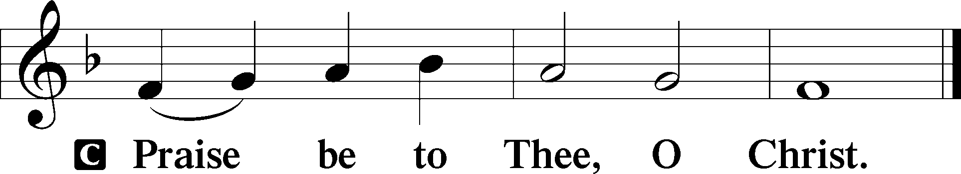

Nicene Creed
C I believe in one God,
the Father Almighty,
maker of heaven and earth
and of all things visible and invisible.

And in one Lord Jesus Christ,
the only-begotten Son of God,
begotten of His Father before all worlds,
God of God, Light of Light,
very God of very God,
begotten, not made,
being of one substance with the Father,
by whom all things were made;
who for us men and for our salvation came down from heaven
and was incarnate by the Holy Spirit of the virgin Mary
and was made man;
and was crucified also for us under Pontius Pilate.
He suffered and was buried.
And the third day He rose again according to the Scriptures
and ascended into heaven
and sits at the right hand of the Father.
And He will come again with glory to judge both the living and the dead,
whose kingdom will have no end.

And I believe in the Holy Spirit,
the Lord and giver of life,
who proceeds from the Father and the Son,
who with the Father and the Son together is worshiped and glorified,
who spoke by the prophets.
And I believe in one holy Christian and apostolic Church,
I acknowledge one Baptism for the remission of sins,
and I look for the resurrection of the dead
and the life T of the world to come. Amen.
Sit

Hymn of the Day: LSB #708 “Lord, Thee I Love with All My Heart”

Sermon

Stand

Offertory Psalm 51:10–12
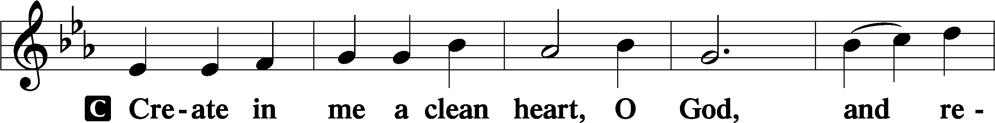
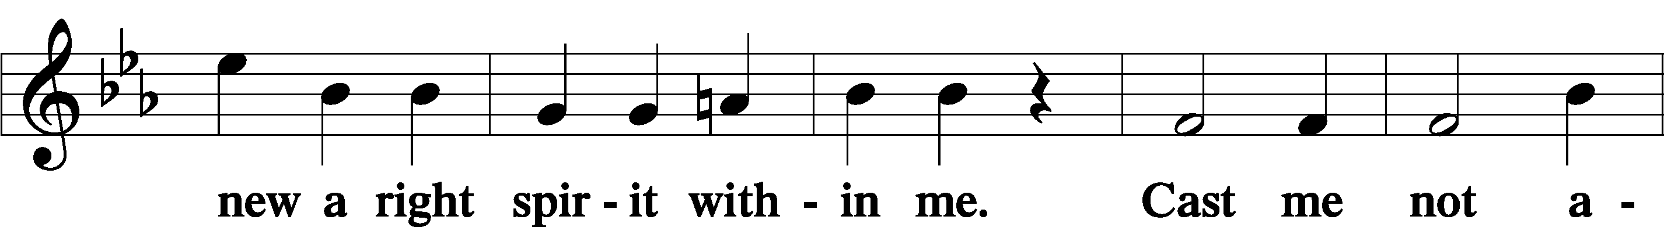
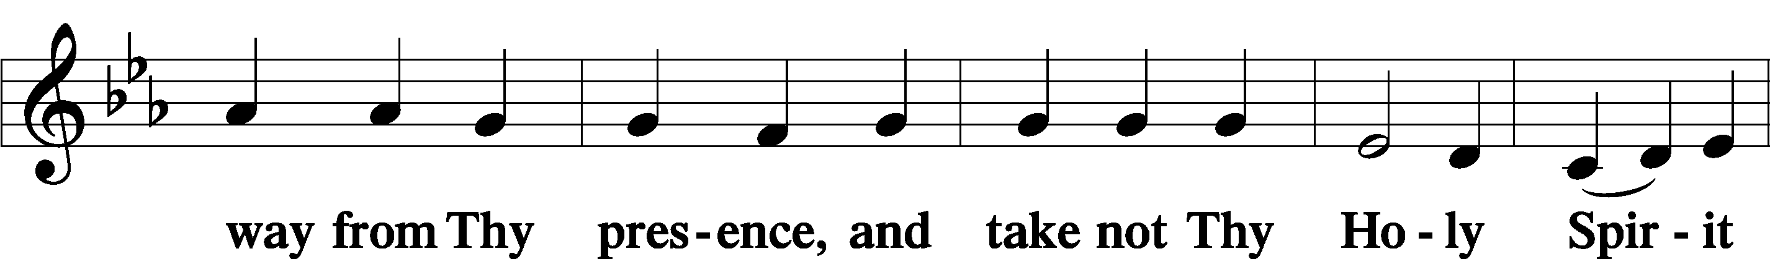
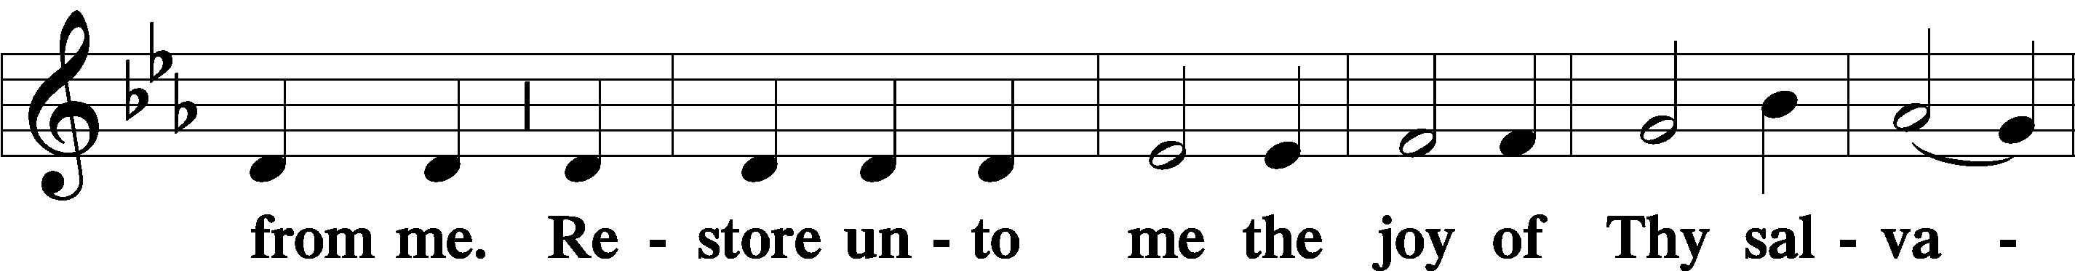
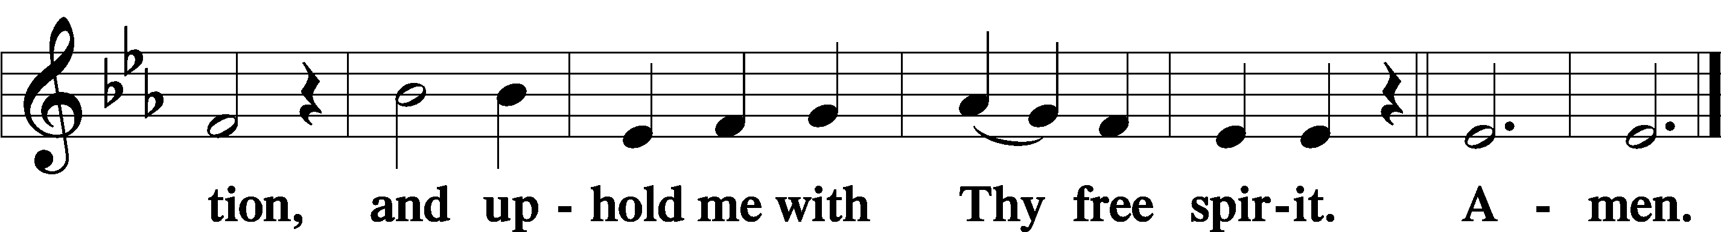

Prayer of the Church

Sit

Preparatory Hymn: LSB #609 “Jesus Sinners Doth Receive”

Stand

Service of the Sacrament

Preface 2 Timothy 4:22; Colossians 3:1 Psalm 136
P The Lord be with you.
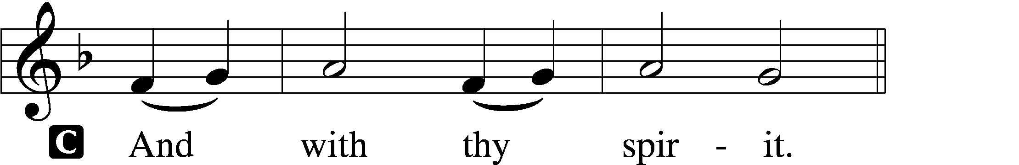

P Lift up your hearts.
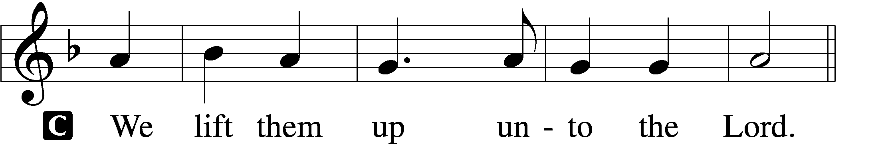

P Let us give thanks unto the Lord, our God.
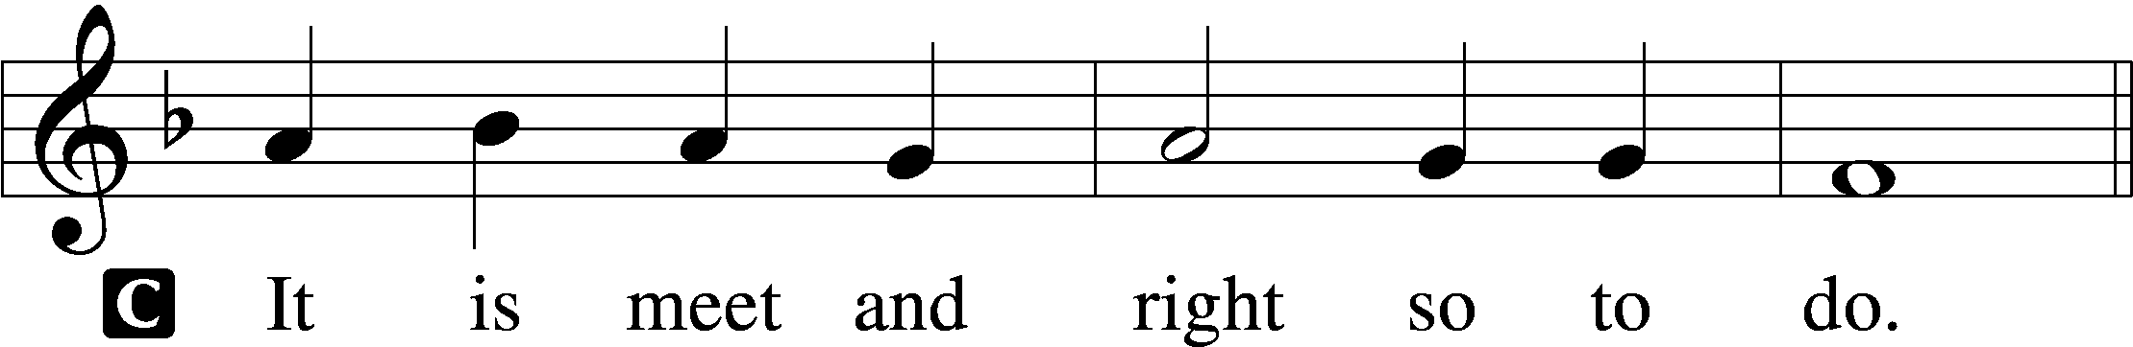

Proper Preface (Abbreviated) LSB 194
P It is truly meet, right, and salutary . . . evermore praising You and saying:

Sanctus Isaiah 6:3; Matthew 21:9
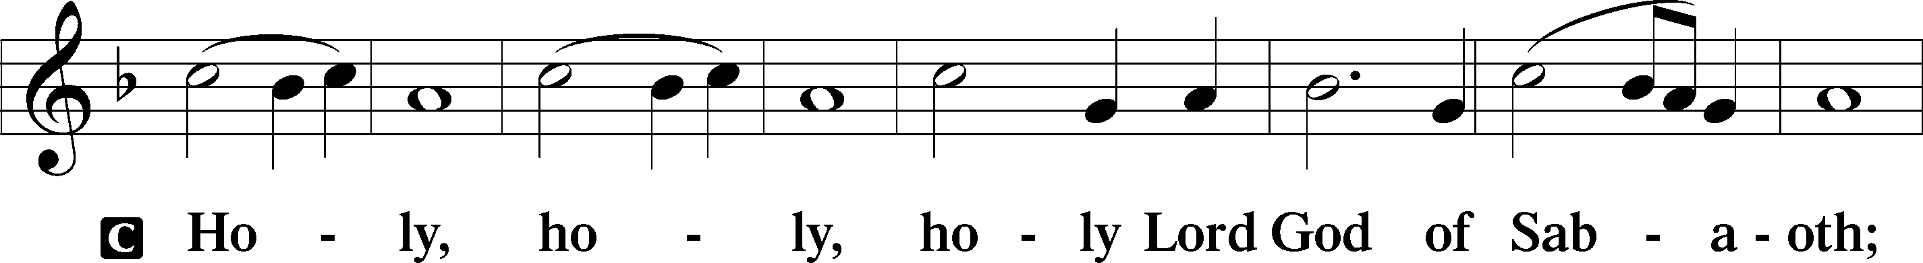
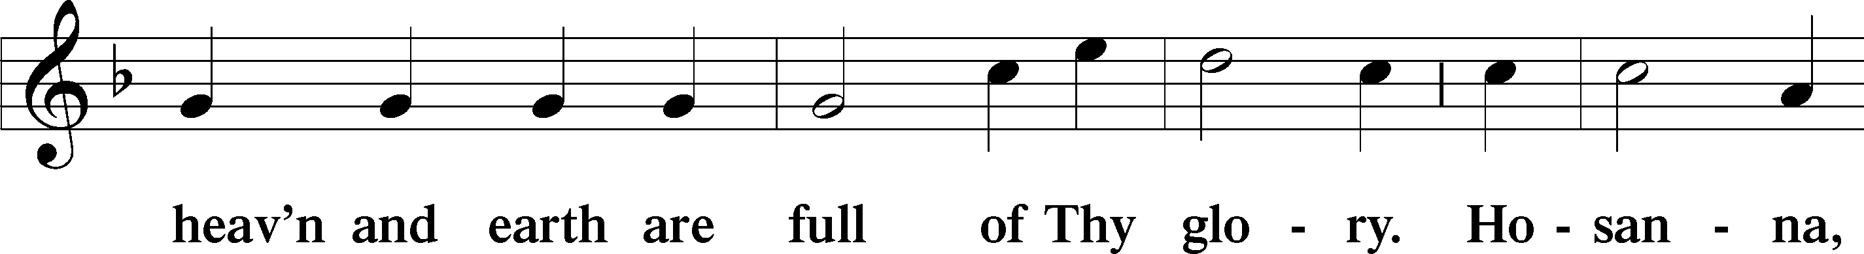
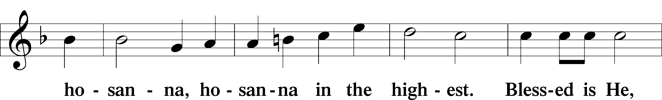
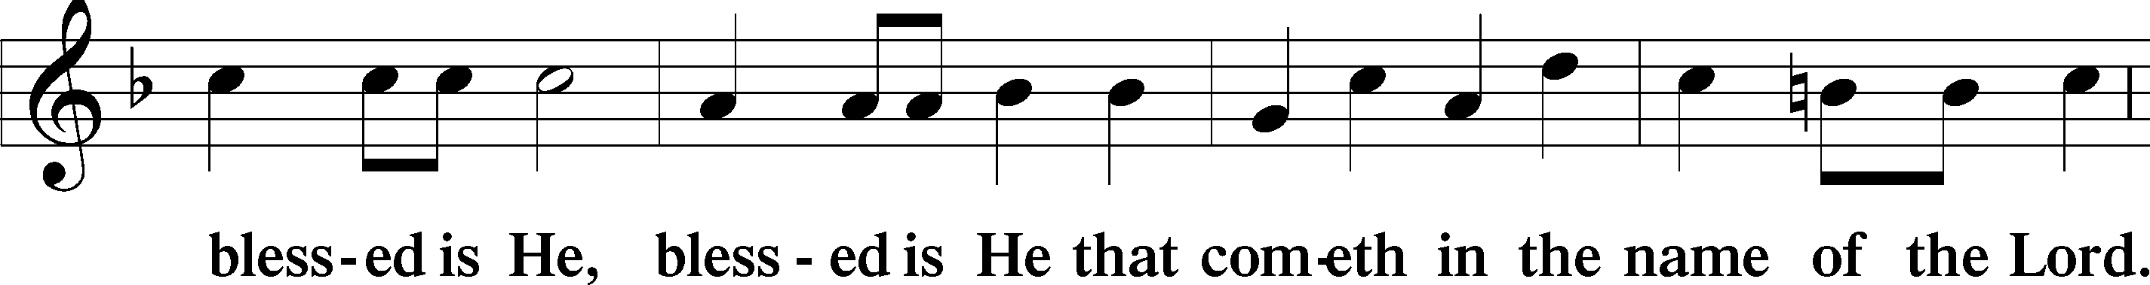
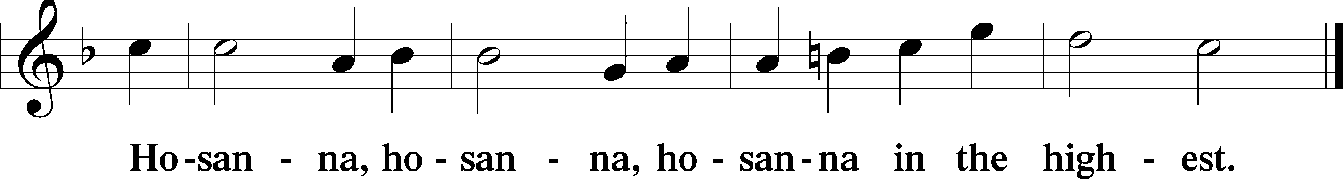

Lord’s Prayer The congregation is encouraged to silently pray the Lord’s Prayer as it is chanted. Matthew 6:9–13
P Our Father who art in heaven,
hallowed be Thy name,
Thy kingdom come,
Thy will be done on earth as it is in heaven;
give us this day our daily bread;
and forgive us our trespasses as we forgive those who trespass against us;
and lead us not into temptation,
but deliver us from evil.
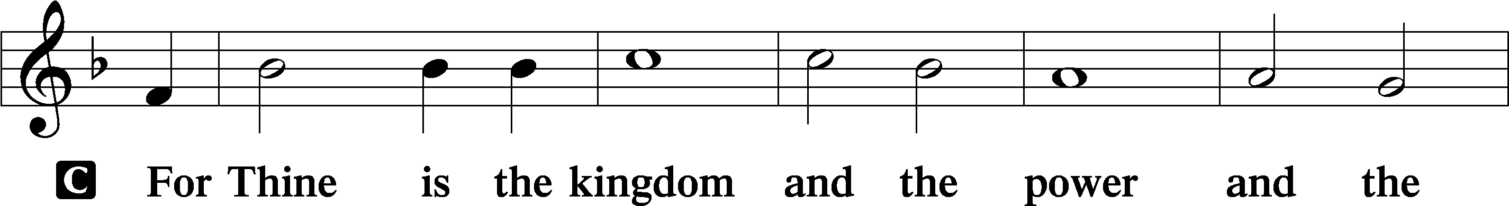
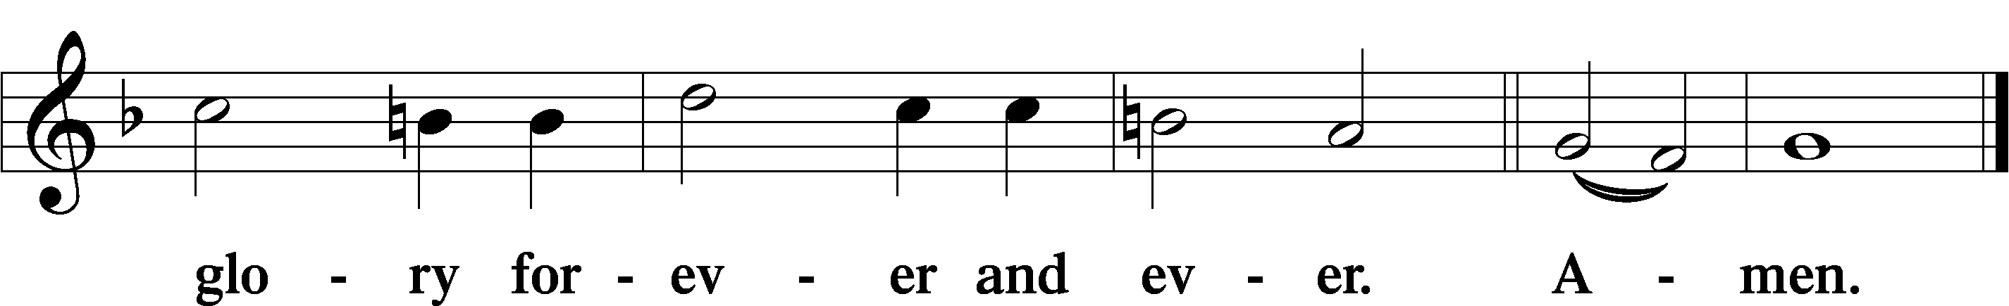

The Words of Our Lord Matthew 26:26–28; Mark 14:22–24; Luke 22:19–20; 1 Corinthians 11:23–25
P Our Lord Jesus Christ, on the night when He was betrayed, took bread, and when He had given thanks, He broke it and gave it to the disciples and said: “Take, eat; this is My T body, which is given for you. This do in remembrance of Me.”

In the same way also He took the cup after supper, and when He had given thanks, He gave it to them, saying: “Drink of it, all of you; this cup is the new testament in My T blood, which is shed for you for the forgiveness of sins. This do, as often as you drink it, in remembrance of Me.”

Pax Domini John 20:19
P The peace of the Lord be with you always.
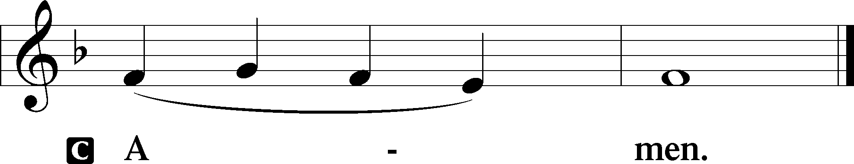

Agnus Dei John 1:29
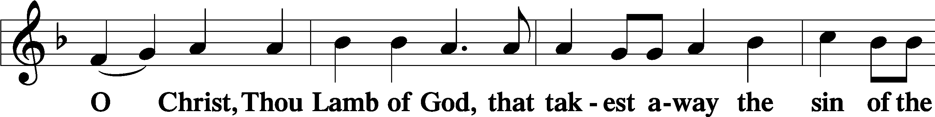
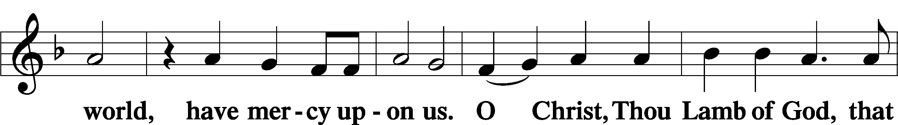
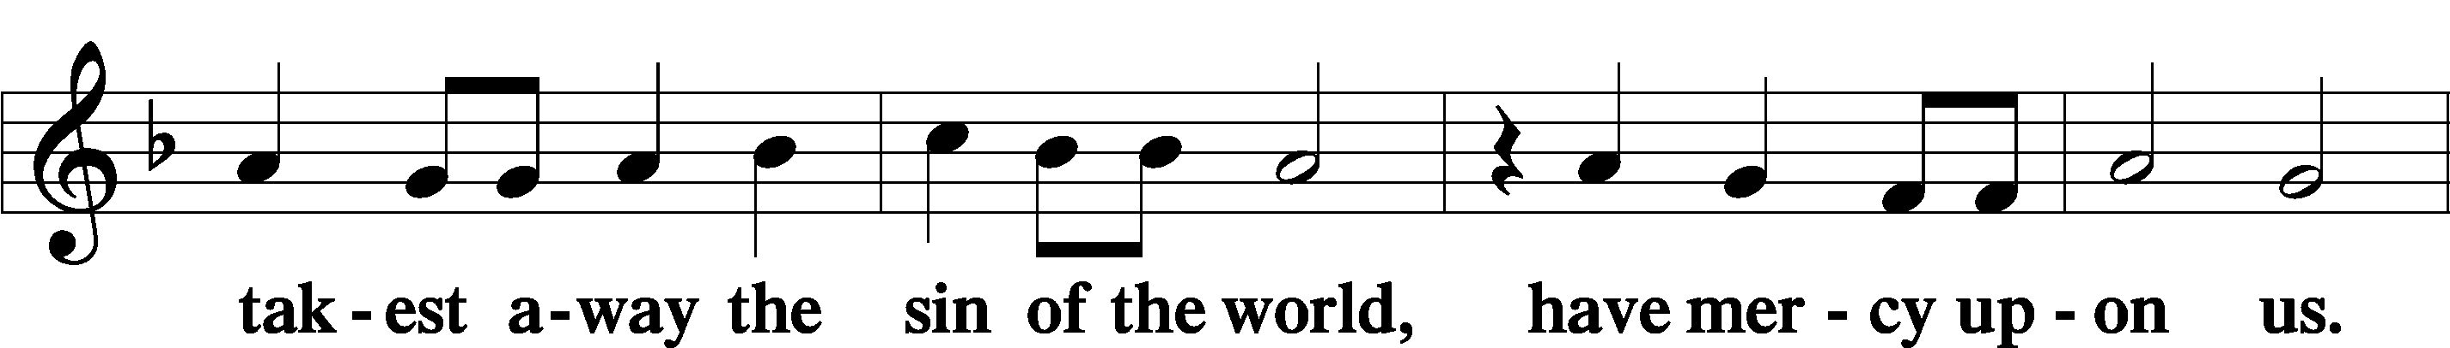
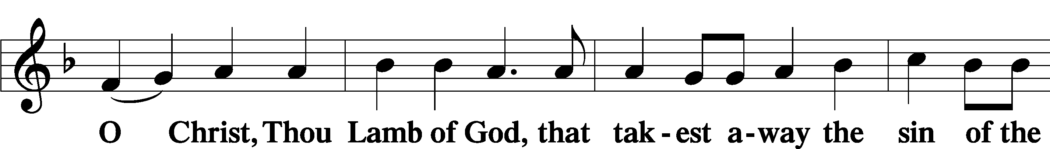
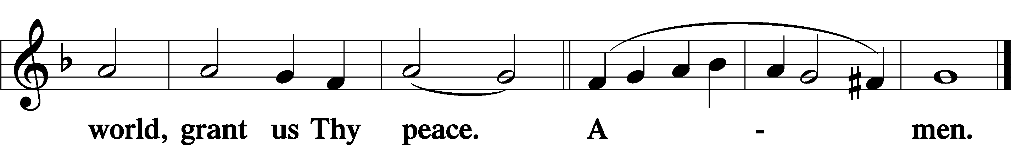
Sit

Distribution
The pastor and those who assist him receive the body and blood of Christ first and then distribute them to those who come to receive, saying:
Take, eat; this is the true body of our Lord and Savior Jesus Christ, given into death for your sins.
Amen.

Take, drink; this is the true blood of our Lord and Savior Jesus Christ, shed for the forgiveness of your sins.
Amen.

In dismissing the communicants, the following is said:
The Dismissal
P The body and blood of our Lord Jesus Christ strengthen and preserve you in body and soul to life everlasting. Depart T in peace.
C Amen.

Distribution Hymn: LSB #716 “I Walk in Danger All the Way”

Distribution Hymn: LSB #907 “God Himself Is Present”

Distribution Hymn: LSB #916 “Only-Begotten, Word of God Eternal”

Nunc Dimittis Luke 2:29–32
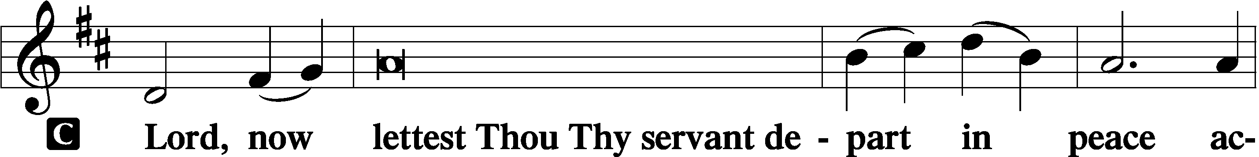
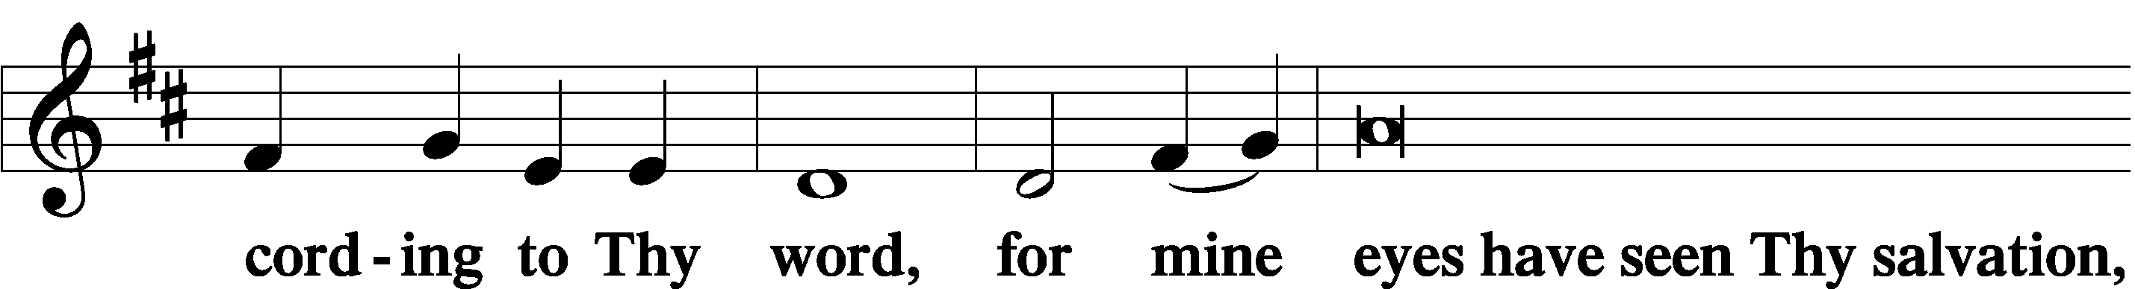
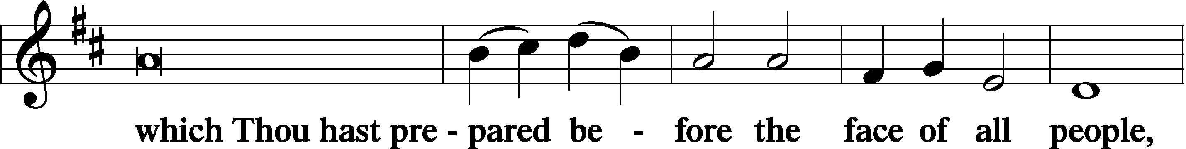
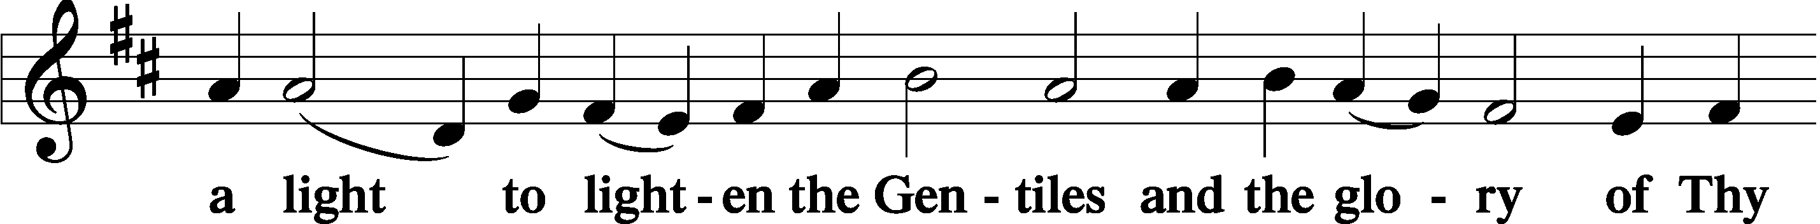
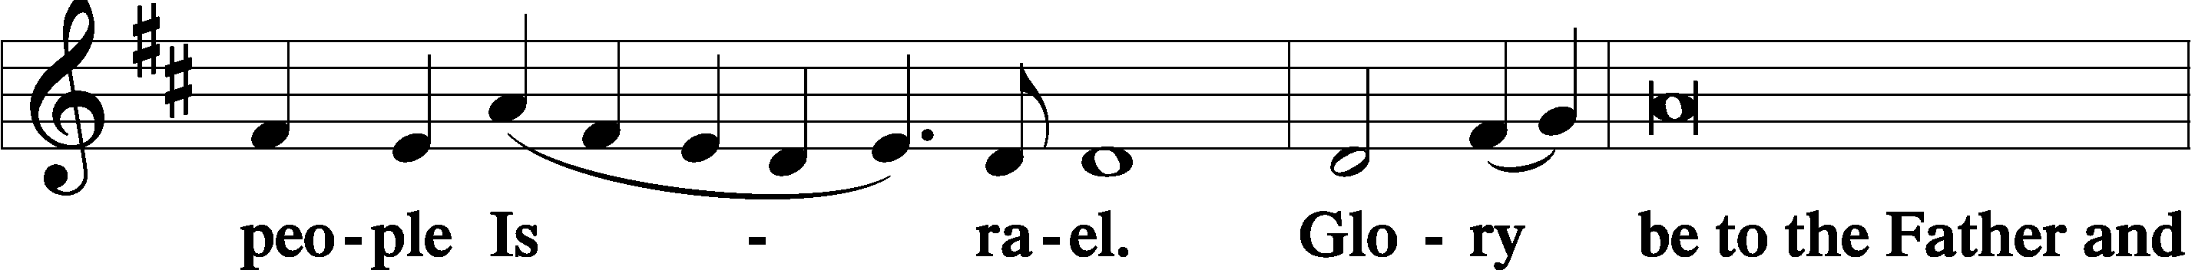
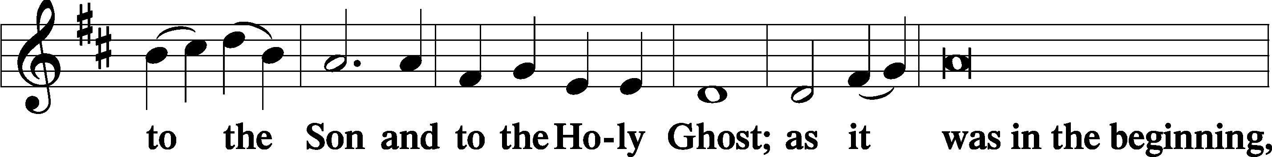
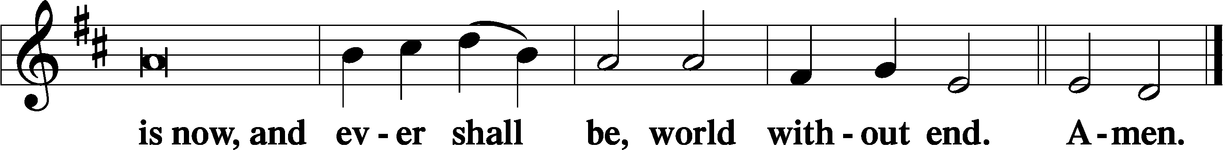

Thanksgiving Psalm 107:1
P O give thanks unto the Lord, for He is good,
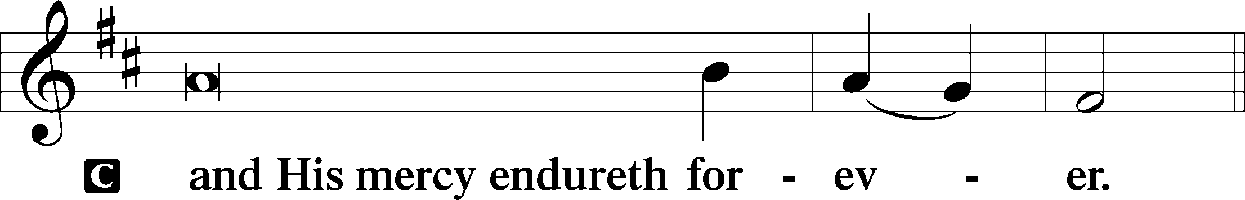

Post-Communion Collect
P Let us pray.
We give thanks to You, almighty God, … through Jesus Christ, Your Son, our Lord, who lives and reigns with You and the Holy Spirit, one God, now and forever.
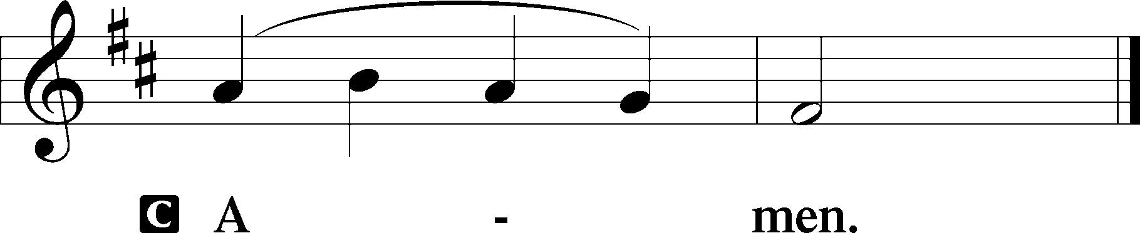

Salutation 2 Timothy 4:22
P The Lord be with you.
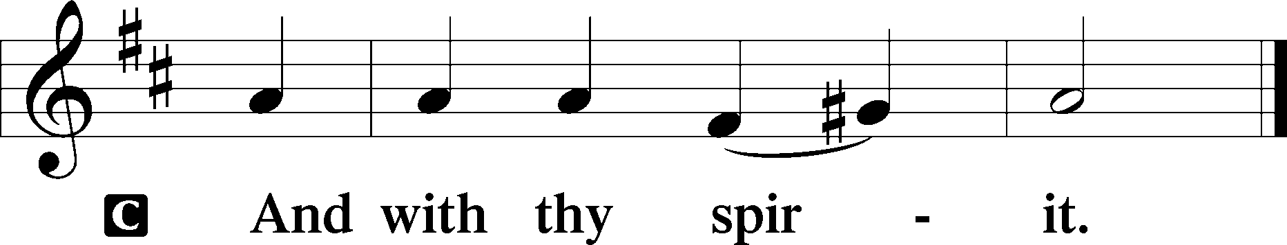

Benedicamus Psalm 103:1
P Bless we the Lord.
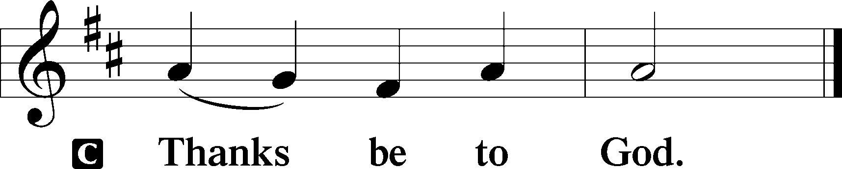

Benediction Numbers 6:24–26
P The Lord bless you and keep you.
The Lord make His face shine upon you and be gracious unto you.
The Lord lift up His countenance upon you and T give you peace.
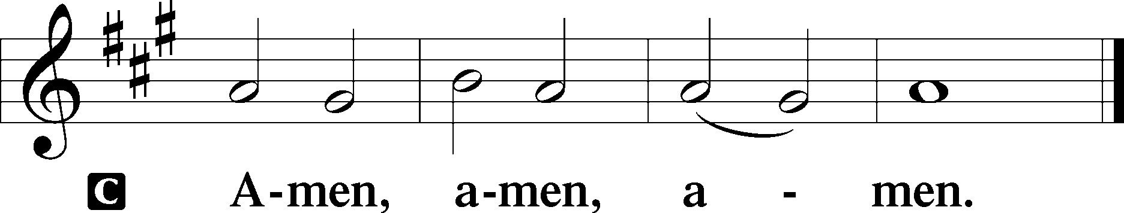

Closing Hymn: LSB #977 “I Will Sing My Maker’s Praises”
fffffffffffffffffffffffffffffffffff
Silent prayer after worship: Heavenly Father, never allow me to forget that by the power of the Gospel I am Your dear child in Jesus Christ. Lead me to boldly share Your Gospel and to honor and serve You in all I do and say. In Jesus’ name. Amen.
fffffffffffffffffffffffffffffffffff
Acknowledgments
Unless otherwise indicated, Scripture quotations are from the ESV® Bible (The Holy Bible, English Standard Version®), copyright © 2001 by Crossway, a publishing ministry of Good News Publishers. Used by permission. All rights reserved.
Created by Lutheran Service Builder © 2023 Concordia Publishing House.
fffffffffffffffffffffffffffffffffff

SCHEDULE THROUGH OCTOBER 22, 2023:

:

Today, 7 pm, Fellowship Hall: AA Meeting
Tuesday, 6 pm, Library: Constitution/Bylaws Meeting
7-9 pm, Fellowship Hall: Penn-Ohio Singers
Wednesday, 7 pm, Sanctuary: Divine Service
7:30 pm, Fellowship Hall: NA Meeting
Thursday, 10 am, Fellowship Hall: Women’s Bible Study
Following, Library: Altar Guild Polishing
Saturday, 4 pm, Fellowship Hall: Men’s Bible Study
Next Sunday, 8 am, Fellowship Hall: Bible Study
9 am, Sanctuary: Divine Service
Following Worship: 3rd Quarter Audit and Monthly Audit of Deposits
7 pm, Fellowship Hall: AA Meeting
fffffffffffffffffffffffffffffffffff
Attendance: Sunday, October 8, 2023: 39
fffffffffffffffffffffffffffffffffff

Our Stewardship of Treasures for the Lord:
In order to do the Lord’s work, we need $2,553.63 each week to meet our 2023 budget for general purposes and $76.92 for the SELC.

Figures for Sunday, October 8, 2023
General Fund: $1,069.00 Behind for the week: -$1,484.63
SELC: $28.00 Behind for the week: -$48.92
Food Pantry: $55.00
Capital Campaign: $0.00
Other: $720.00

For online giving, check out https://www.saintspeterandpaul.net/online-giving.
fffffffffffffffffffffffffffffffffff
THANK YOU FOR SERVING IN OCTOBER: Elder: Jonathan Baisch; Ushers: Matt Berent, Mark Gabriel, Michael Laird, & Jerome Thomas; Altarware ~ Sundays: (prior) Diane Riefstahl; (after) Oct. 29th~Elizabeth Haenftling; other~Cheryl Fedele & Clara Krivosh; Special Divine Services: Oct. 18th ~ Diane Riefstahl; Oct. 23rd & 31st ~ Elizabeth Haenftling.
fffffffffffffffffffffffffffffffffff
Bible Memory Verses ~ Week of October 15th:
For Adults: You will be hated by all for my name's sake. But the one who endures to the end will be saved. Matthew 10:22

For Children: Know that the Son of Man has authority on earth to forgive sins. Matthew 9:6
fffffffffffffffffffffffffffffffffff
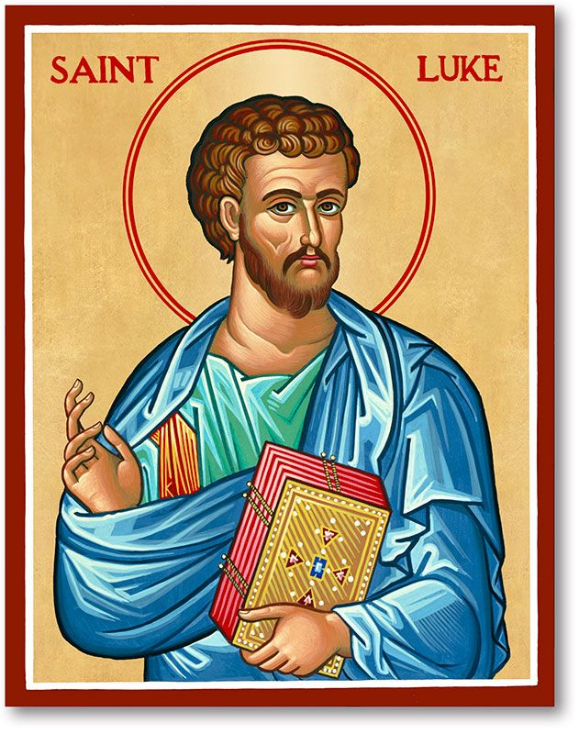
Join us Wednesday, October 18, 2023, at
7 pm for a Divine Service celebrating the
Festival of Saint Luke, Evangelist.

fffffffffffffffffffffffffffffffffff
There are some ceramic coffee cups and assorted dishware items on a table in the Fellowship Hall which are looking for “new homes”. Please, help yourself!
fffffffffffffffffffffffffffffffffff
Remember the following in Prayer…
~The Hurting and Healing: Amy, Steve Antolovich, Ellen Baron^{CA}, Amy Blomenberg, Lois Bortner^{CA}, Sara Brubaker, Dee Bullock, Bev & Joe Chlpka, Susan Davies, Loretta Deal, Tim Dudash, Judith & Eddy Furey, Griffin, Peter Haenftling, Austin Hamilton, Pastor Charles Henrickson, Joan, Keith Jozwiakowski, Darla Krajci, Barbara Kreske, Jess Lavoie, Elizabeth Loughan, Paul Lucas^{CA}, Sandy Marshall, Frank Niemeyer^{CA}, Juanita Rentschler, Richard Reuning^{CA}, Nancy Robertson^{CA}, Kriss Svidro^{CA}, Joel & Peggy Wasson, Angela Weser^{CA}, Betty Wolf (hospitalized), and Ruth Wolf.
~The Homebound: Anna Mae Daris, Millie Elavsky, Rudy & Jean Tomko, and Ed & Millie Zachar.
~Celebrating this Week: Birthdays: Loretta Deal (10.18) and Irene Kucera (10.19). Anniversaries: Jeff & Arlene Sutton (10.17), Jeff & Rachel Myers (10.20), and Mark & Bess Kleindienst (10.21).
~Serving in the Military: Alex (Sasha) Carr, Duncan Vaupel, Curtis Sinewe, and Joshua Solyan.
~Community & World Needs: Those suffering due to the conflicts in the Middle East and between Ukraine and Russia; those suffering from loss and dislocation because weather disasters; those suffering from addiction and their families; Local, State, and National Government Leaders; safety for all Police Officers, Firefighters, & First Responders; the unemployed; our Fourth Quarter Local Mission: Willow Women’s Center.
*CA represents cancer.
fffffffffffffffffffffffffffffffffff
Church Council members are reminded that the meeting originally scheduled for October 23rd has been moved to November 6 at 7 pm.
fffffffffffffffffffffffffffffffffff
Items for the November calendar and newsletter are due to the secretary by noon, Wednesday, October 25th.
fffffffffffffffffffffffffffffffffff
Bible Study Opportunities This Week:
- Thursday, October 19 at 10 am: Women’s Bible Study
- Saturday, October 21 at 4 pm: Men’s Bible Study
- Sunday, October 22 at 8 am: Sunday Morning Bible Study (open to all)
PASTOR & FAMILY APPRECIATION DINNER - SATURDAY, OCT. 28th, 5 PM
Come and join us for some good food and fellowship with a special dinner in appreciation of Pastor Deal and family. There will also be a birthday cake in celebration of Loretta's 5th birthday! Mark your calendars now! You don't want to miss this time with your church family.
Main entrée and dessert will be provided! If you have any questions, you can call Bess Kleindienst at 973-768-8874.
If planning to attend, please sign either the sheet located in the narthex or by the parking lot entrance so plans can be made. We look forward to sharing in this time together and pray God's blessings on us all!
fffffffffffffffffffffffffffffffffff
Up-Coming Meetings:
- Tuesday, October 16 at 6 pm ~ Constitution & Bylaws Committee
- Sunday, October 22 following Worship ~ Quarterly & Monthly Audit
fffffffffffffffffffffffffffffffffff
Up-Coming Special Divine Services (all at 7 pm):
- Wednesday, October 18: Festival of Saint Luke, Evangelist
- Monday, October 23: Festival of Saint James of Jerusalem, Brother of Jesus and Martyr
- Tuesday, October 31: Reformation Day
- Wednesday, November 1: All Saints Day ~ Remembering those members of our congregation who passed into the arms of our Lord this past year (Kenneth Stephenson~All Saints, January 7, 2023; Anson Holcroft, February 22, 2023; Viola Sakony, March 25, 2023; Barry Nelson, April 25, 2023) and those whom we hold dear in our hearts.)
fffffffffffffffffffffffffffffffffff
All are invited to attend the special SELC Reformation Service Sunday, October 29th at 3 pm at Trinity Lutheran Church, Pittsburgh, PA.
fffffffffffffffffffffffffffffffffff
It’s time to renew subscriptions for the “Lutheran Witness” magazine for 2024. The price has increased to $19.25. If wishing to renew, place a check made out to Sts. Peter & Paul’s in a pew envelope and label the envelope with your name and that it is for the LW. Please make sure to note any change in address with your renewal. Renewals are due on or before Sunday, November 19, 2023.
Here to Serve
Pastor………………………………………………...……………Rev. Jacob Deal
E-mail …………………………….……pastordeal@saintspeterandpaul.net
Phone Number……………………..…………………724-347-3620 (Option 2)
Church Office………………………..…………………724-347-3620 (Option 3)
Website …………………………………………www.saintspeterandpaul.net
Secretary…………………………………………………………Diane Riefstahl
E-mail ………………………………………church@saintspeterandpaul.net
Website …………………………………………www.saintspeterandpaul.net
Food Pantry (email): ……………foodpantry@saintspeterandpaul.net
Congregation President………………………………….…Jonathan Baisch
Church Elder …………………………………………...……. Jonathan Baisch
Organist………………………………………………..….…Rebecca Marquette
Choir Director…………………………………………………….…Chris Nelson
AA Contact: Steve………………………………………………...…724-813-2358
NA Contact: Larry……………………………………..…………..724-977-8733
fffffffffffffffffffffffffffffffffff
If needing to get into the church building during the week, please phone first to make certain someone is here to let you in.

