Sts. Peter & Paul
Evangelical Lutheran Church
Lutheran Church-Missouri Synod
Founded-1917

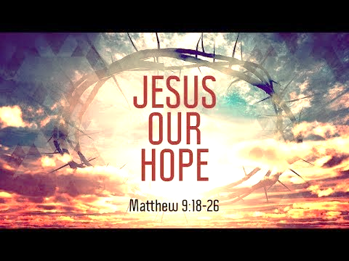

November 19, 2023

699 Stambaugh Ave.
Sharon, Pennsylvania 16146

“I was glad when they said to me,
Let us go to the house of the LORD!”
Psalm 122:1
Sts. Peter & Paul Evangelical Lutheran Church, LC-MS
THE TWENTY-FOURTH SUNDAY
AFTER TRINITY
November 19, 2023

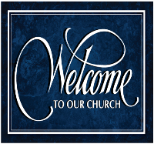
A special welcome to our guests this day! If you would like more information about The Lutheran Church - Missouri Synod, or this congregation, please speak with Pastor Deal or an Elder after the service.
Members & Guests: Don’t be embarrassed if your children make noise during the worship service, all children do. We encourage families to worship together but, if you feel the need, there are pews in the rear of the Church which are reserved for young families on both sides of the sanctuary. There is also a quiet room available to you, located next to the sanctuary (formerly the Pastor’s office), where you would be able to follow along with the service.

Today’s service includes the Sacrament of Holy Communion. If during this past year, you have not worshipped with us and been communed, we respectfully ask that you do not partake of this sacrament this day before first speaking with Pastor Deal.
If visiting from a sister congregation of the LC-MS and are in good standing, please inform Pastor Deal of your desire to commune prior to the service.
If wishing to receive a blessing during communion, please approach with your arms crossed.

CONTACT INFORMATION
Pastor Deal: pastordeal@saintspeterandpaul.net or 724-347-3620 (opt. 2)
Church Office: church@saintspeterandpaul.net or 724-347-3620 (opt. 3)
Secretary’s Office: The office will be open Monday & Wednesday (8:30 am–4:30 pm).

Silent prayer before worship: Dear Jesus, my Lord and my God, You have invited me to worship in Your house. Help me to worship You with all of my heart and soul, and to keep in mind that one day You will invite me to worship forever at Your side in heaven. Amen.
Confession and Absolution

Opening Hymn: LSB #872 “Come, Thou Bright and Morning Star”

Stand

The sign of the cross may be made by all in remembrance of their Baptism.

Invocation
P In the name of the Father and of the T Son and of the Holy Spirit.
C Amen.

Exhortation Hebrews 10:22; Psalm 124:8; Psalm 32:5
P Beloved in the Lord! Let us draw near with a true heart and confess our sins unto God our Father, beseeching Him in the name of our Lord Jesus Christ to grant us forgiveness.

P Our help is in the name of the Lord,
C who made heaven and earth.
P I said, I will confess my transgressions unto the Lord,
C and You forgave the iniquity of my sin.

Silence for reflection on God’s Word and for self-examination.

Confession of Sins
P O almighty God, merciful Father,
C I, a poor, miserable sinner, confess unto You all my sins and iniquities with which I have ever offended You and justly deserved Your temporal and eternal punishment. But I am heartily sorry for them and sincerely repent of them, and I pray You of Your boundless mercy and for the sake of the holy, innocent, bitter sufferings and death of Your beloved Son, Jesus Christ, to be gracious and merciful to me, a poor, sinful being.

Absolution [John 20:19–23]
P Upon this your confession, I, by virtue of my office, as a called and ordained servant of the Word, announce the grace of God unto all of you, and in the stead and by the command of my Lord Jesus Christ I forgive you all your sins in the name of the Father and of the T Son and of the Holy Spirit.
C Amen.
Service of the Word

Introit Psalm 95:1–4; antiphon: vv. 6–7a
Oh come, let us worship and | bow down;*
let us kneel before the Lord, our | Maker!
For he | is our God,*
and we are the people of his pasture, and the sheep | of his hand.
Oh come, let us sing | to the Lord;*
let us make a joyful noise to the rock of our sal- | vation!
Let us come into his presence with thanks- | giving;*
let us make a joyful noise to him with | songs of praise!
For the Lord is a | great God,*
and a great King a- | bove all gods.
In his hand are the depths | of the earth;*
the heights of the mountains are his | also.
Oh come, let us worship and | bow down;*
let us kneel before the Lord, our | Maker!
For he | is our God,*
and we are the people of his pasture, and the sheep | of his hand.

Gloria Patri
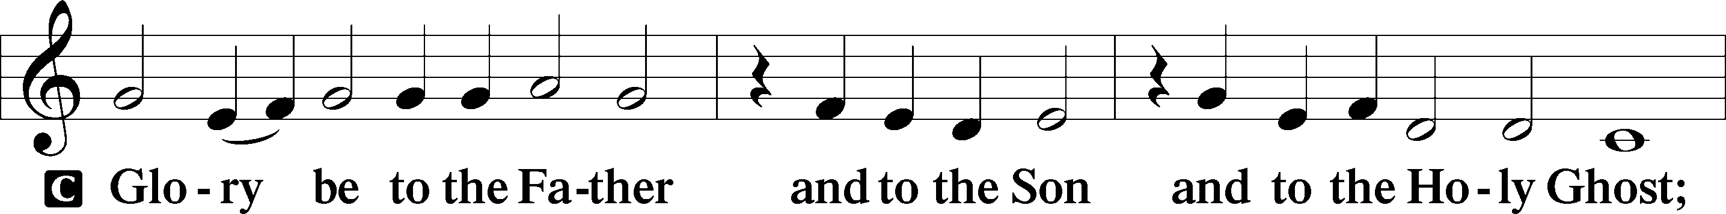
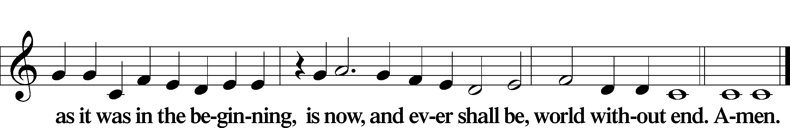

Kyrie Mark 10:47
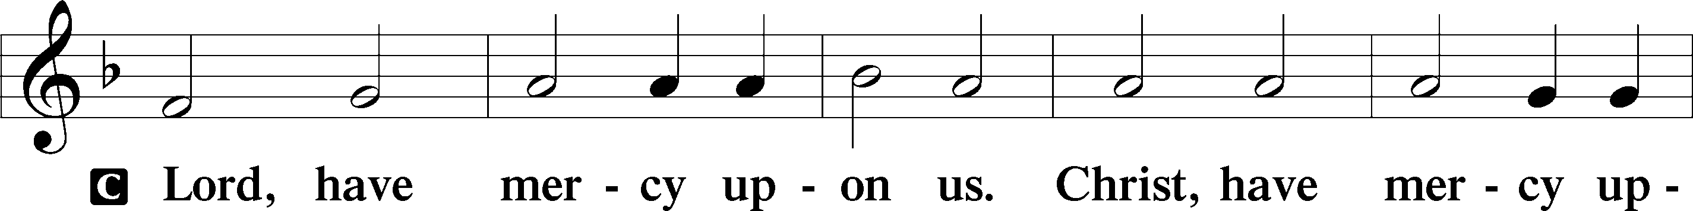
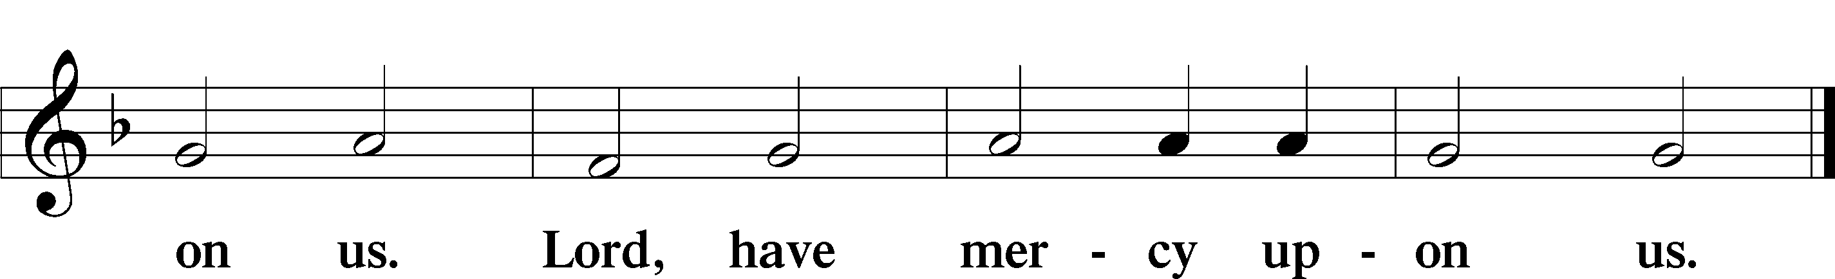

Gloria in Excelsis Luke 2:14; John 1:29
P Glory be to God on high:
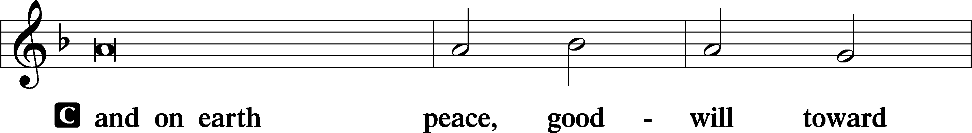
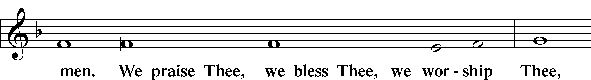
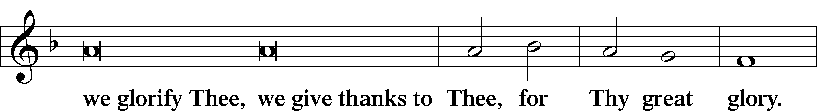
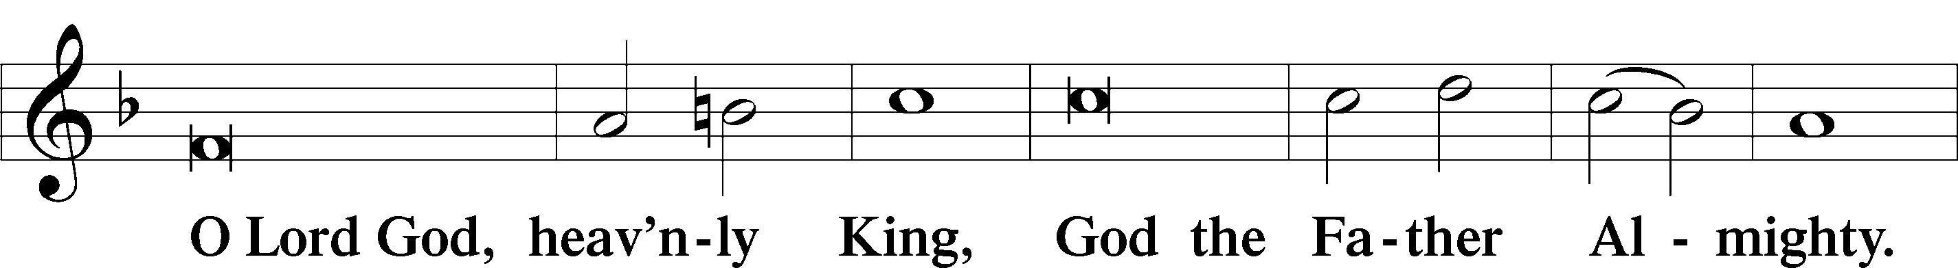
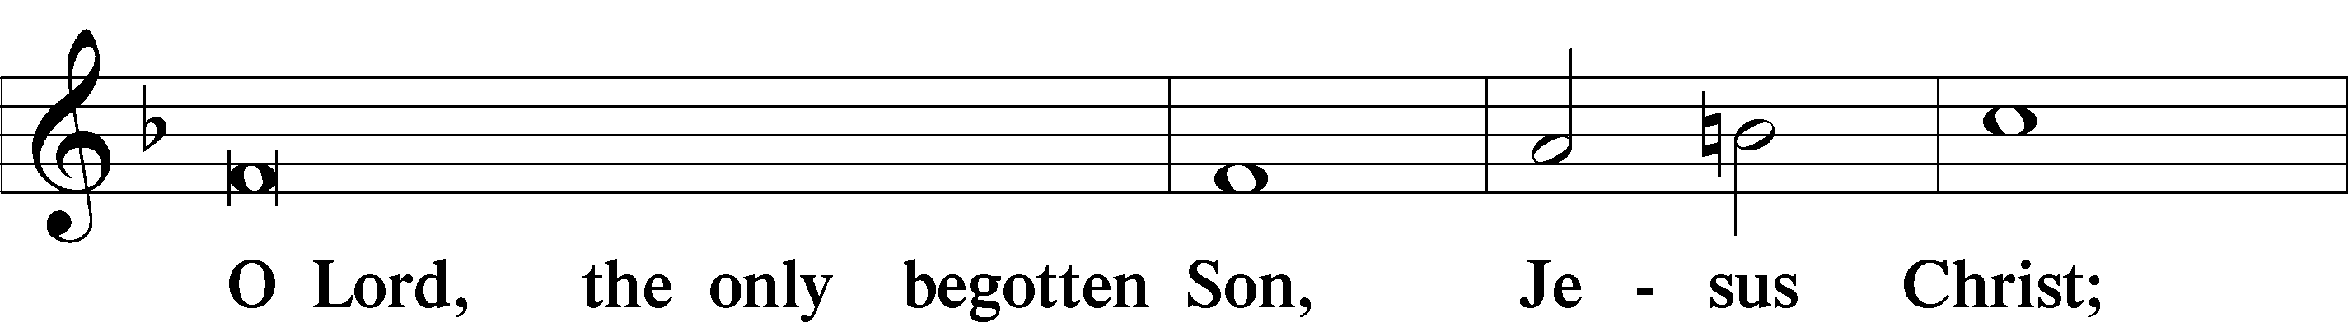
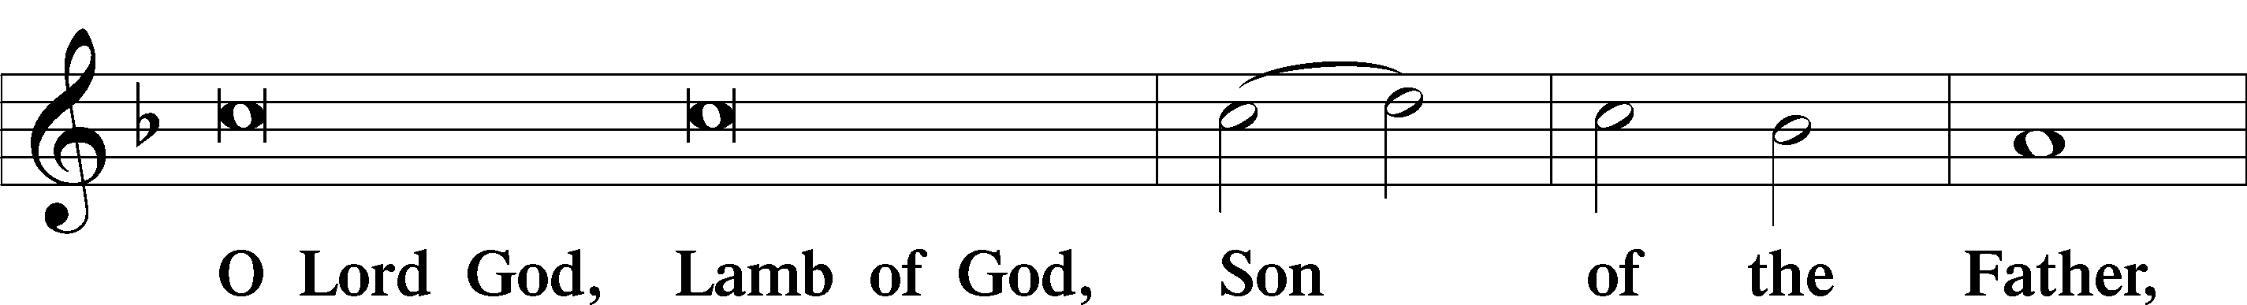
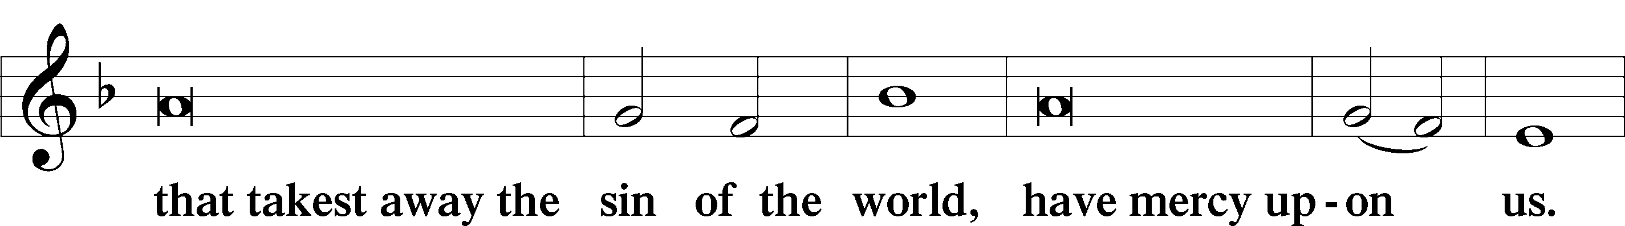
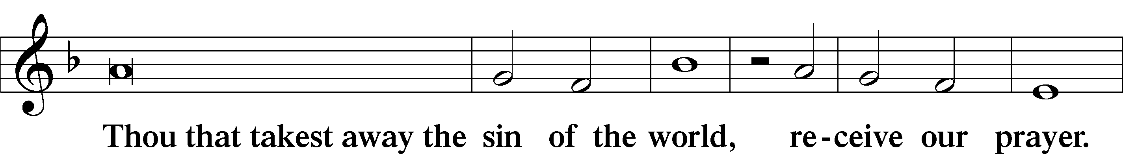
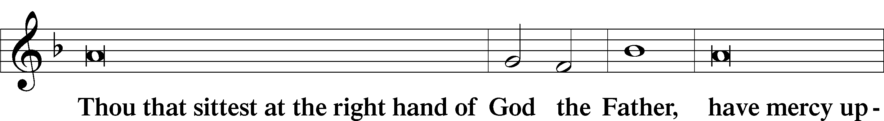
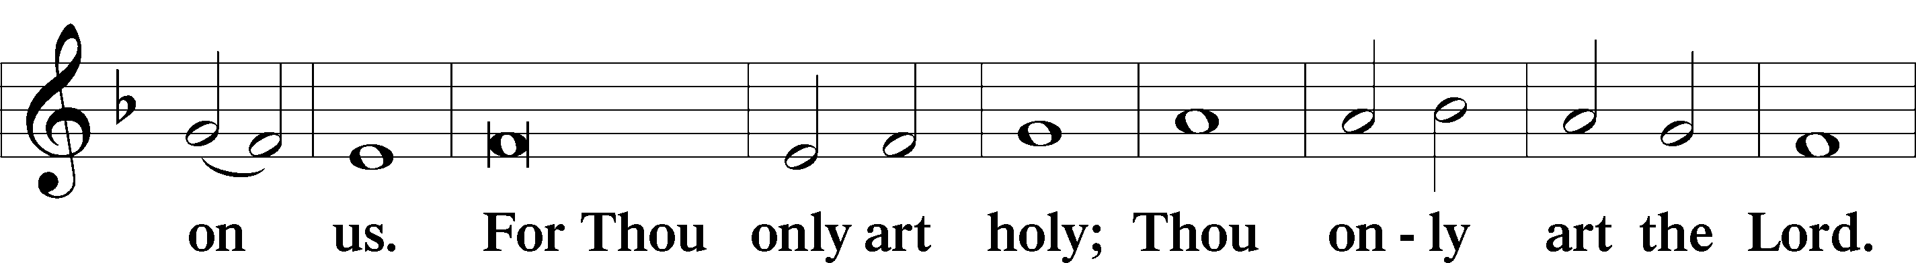
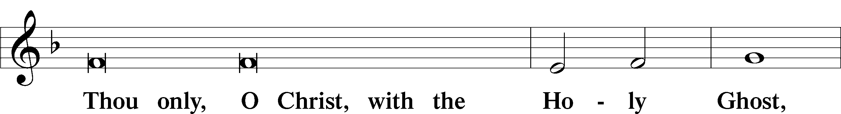
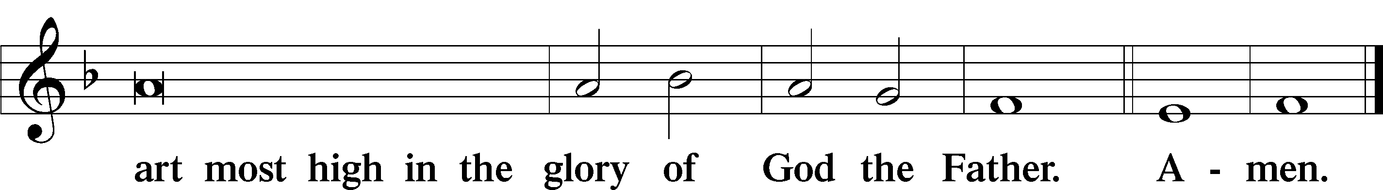

Salutation and Collect of the Day: Trinity 24
P The Lord be with you.
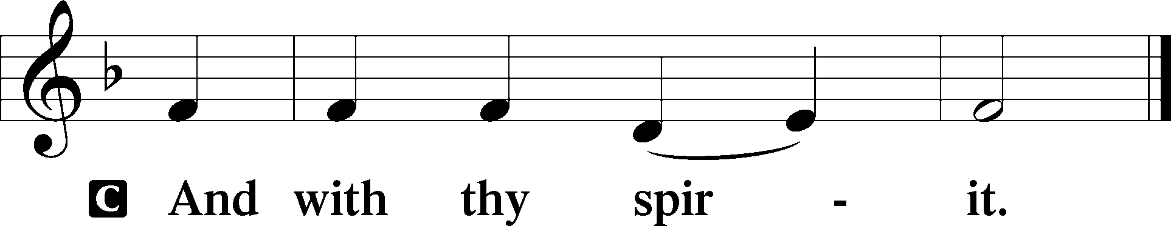

P Let us pray.
Stir up, O Lord, the wills of Your faithful people that they, plenteously bringing forth the fruit of good works, may by You be plenteously rewarded; through Jesus Christ, Your Son, our Lord, who lives and reigns with You and the Holy Spirit, one God, now and forever.
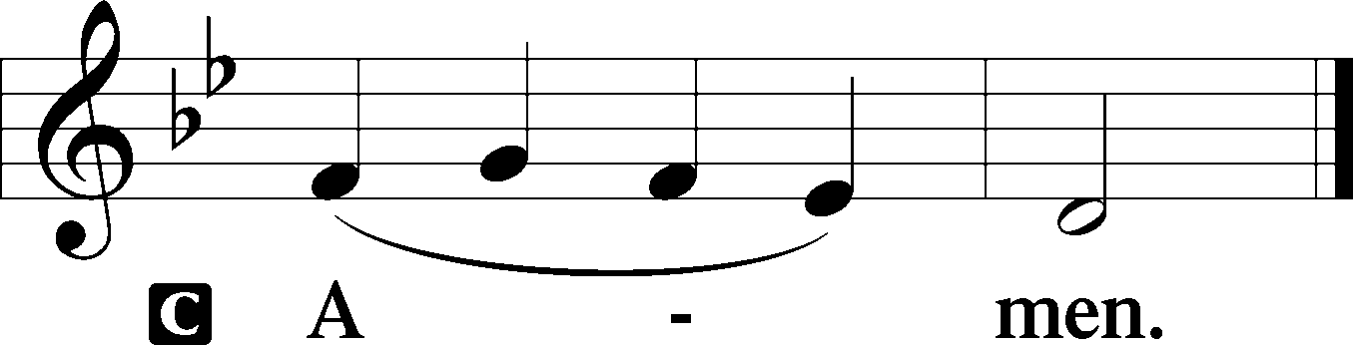
Sit

Prophecy: Isaiah 51:9–16 (NKJV)
In those days the prophet Isaiah spoke, saying: “Awake, awake, put on strength, O arm of the Lord! Awake as in the ancient days, in the generations of old. Are You not the arm that cut Rahab apart, and wounded the serpent? Are You not the One who dried up the sea, the waters of the great deep; that made the depths of the sea a road for the redeemed to cross over? So the ransomed of the Lord shall return, and come to Zion with singing, with everlasting joy on their heads. They shall obtain joy and gladness; sorrow and sighing shall flee away. I, even I, am He who comforts you. Who are you that you should be afraid of a man who will die, and of the son of a man who will be made like grass? And you forget the Lord your Maker, who stretched out the heavens and laid the foundations of the earth; you have feared continually every day because of the fury of the oppressor, when he has prepared to destroy. And where is the fury of the oppressor? The captive exile hastens, that he may be loosed, that he should not die in the pit, and that his bread should not fail. But I am the Lord your God, who divided the sea whose waves roared—the Lord of hosts is His name. And I have put My words in your mouth; I have covered you with the shadow of My hand, that I may plant the heavens, lay the foundations of the earth, and say to Zion, ‘You are My people.’ ”

P This is the Word of the Lord.
C Thanks be to God.

Gradual Psalm 116:8, 1
You have delivered my | soul from death,*
my eyes from tears, my feet from | stumbling.
I love the Lord, because | he has heard*
my voice and my pleas for | mercy.
Epistle: Colossians 1:9b–14 (NKJV)
Brethren: We do not cease to pray for you, and to ask that you may be filled with the knowledge of His will in all wisdom and spiritual understanding; that you may walk worthy of the Lord, fully pleasing Him, being fruitful in every good work and increasing in the knowledge of God; strengthened with all might, according to His glorious power, for all patience and longsuffering with joy; giving thanks to the Father who has qualified us to be partakers of the inheritance of the saints in the light. He has delivered us from the power of darkness and conveyed us into the kingdom of the Son of His love, in whom we have redemption through His blood, the forgiveness of sins, through Jesus Christ our Lord.

P This is the Word of the Lord.
C Thanks be to God.

Stand

Verse Psalm 36:9
Alleluia. With you is the fountain of life; in your light do we see light. Alleluia.

Alleluia
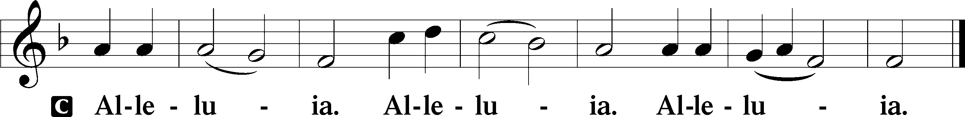

Holy Gospel: Matthew 9:18–26 (NKJV)
P The Holy Gospel according to St. Matthew, the ninth chapter.
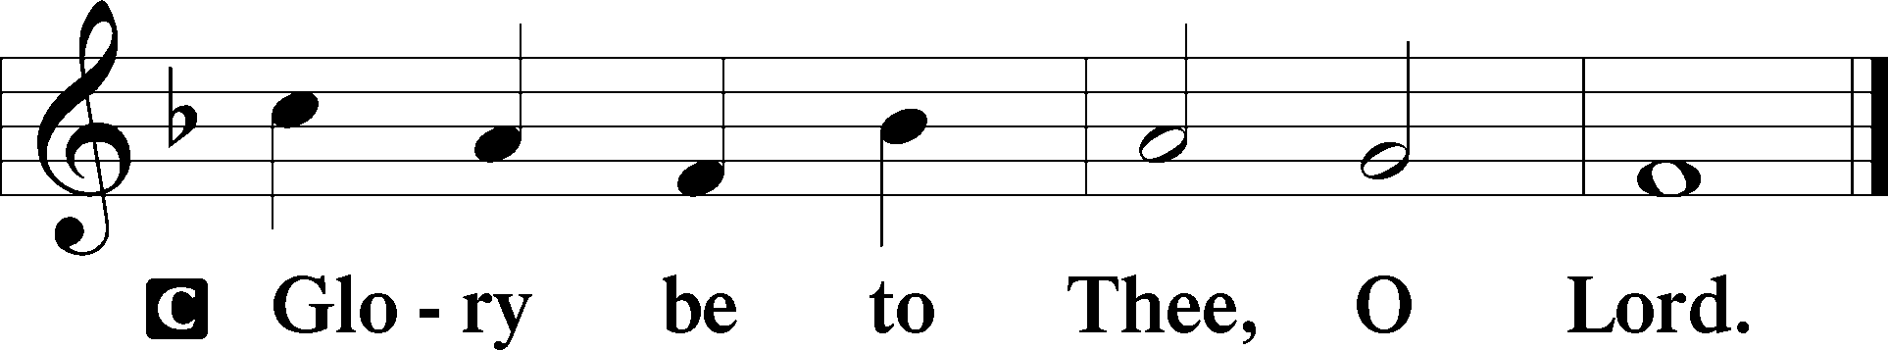

At that time: While Jesus was still speaking to the multitudes, behold, a ruler came and worshiped Him, saying, “My daughter has just died, but come and lay Your hand on her and she will live.” So Jesus arose and followed him, and so did His disciples. And suddenly, a woman who had a flow of blood for twelve years came from behind and touched the hem of His garment. For she said to herself, “If only I may touch His garment, I shall be made well.” But Jesus turned around, and when He saw her He said, “Be of good cheer, daughter; your faith has saved you.” And the woman was made well from that hour. When Jesus came into the ruler’s house, and saw the flute players and the noisy crowd wailing, He said to them, “Make room, for the girl is not dead, but sleeping.” And they ridiculed Him. But when the crowd was put outside, He went in and took her by the hand, and the girl arose. And the report of this went out into all that land.

P This is the Gospel of the Lord.
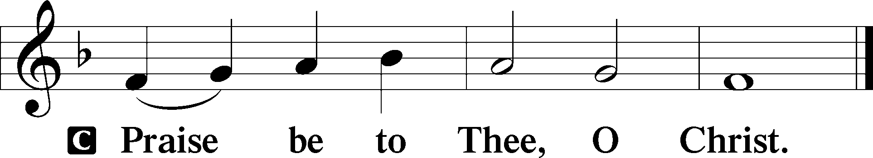

Nicene Creed
C I believe in one God,
the Father Almighty,
maker of heaven and earth
and of all things visible and invisible.

And in one Lord Jesus Christ,
the only-begotten Son of God,
begotten of His Father before all worlds,
God of God, Light of Light,
very God of very God,
begotten, not made,
being of one substance with the Father,
by whom all things were made;
who for us men and for our salvation came down from heaven
and was incarnate by the Holy Spirit of the virgin Mary
and was made man;
and was crucified also for us under Pontius Pilate.
He suffered and was buried.
And the third day He rose again according to the Scriptures
and ascended into heaven
and sits at the right hand of the Father.
And He will come again with glory to judge both the living and the dead,
whose kingdom will have no end.
And I believe in the Holy Spirit,
the Lord and giver of life,
who proceeds from the Father and the Son,
who with the Father and the Son together is worshiped and glorified,
who spoke by the prophets.
And I believe in one holy Christian and apostolic Church,
I acknowledge one Baptism for the remission of sins,
and I look for the resurrection of the dead
and the life T of the world to come. Amen.
Sit

Hymn of the Day: LSB #508 “The Day Is Surely Drawing Near”

Sermon

Stand

Offertory Psalm 51:10–12
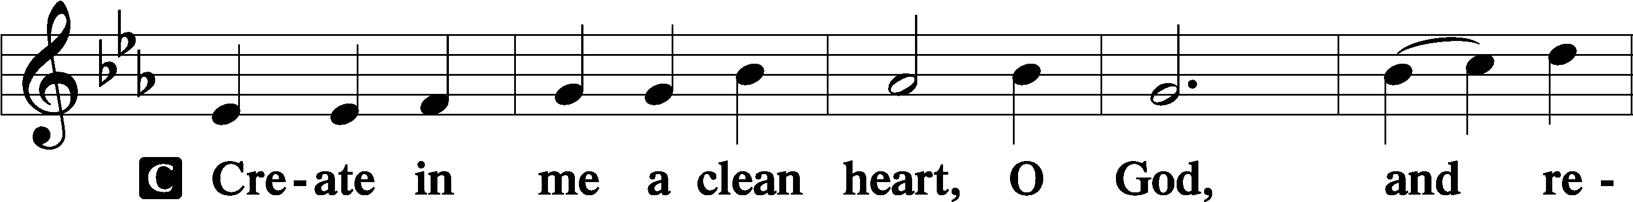
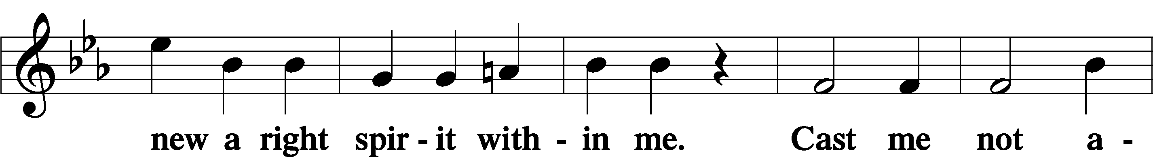
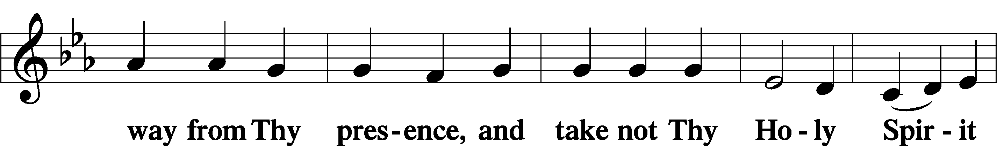
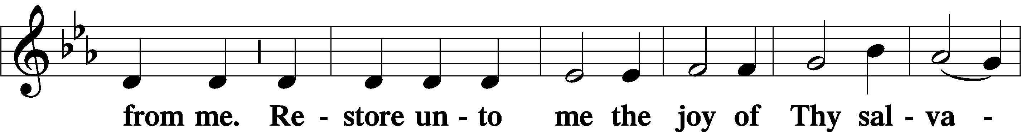
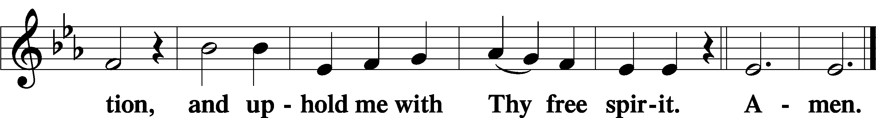

Prayer of the Church

Sit

Preparatory Hymn: LSB #637 “Draw Near and Take the Body of the Lord”

Stand
Service of the Sacrament

Preface 2 Timothy 4:22; Colossians 3:1 Psalm 136
P The Lord be with you.
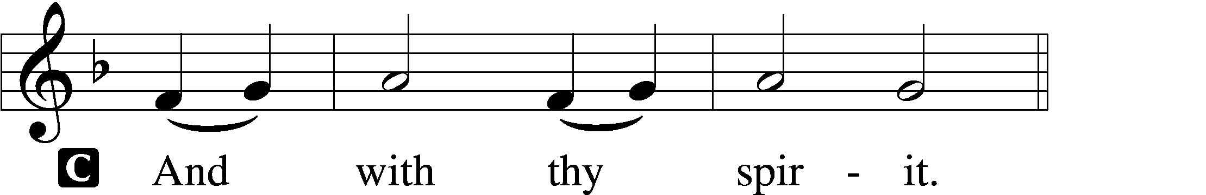

P Lift up your hearts.
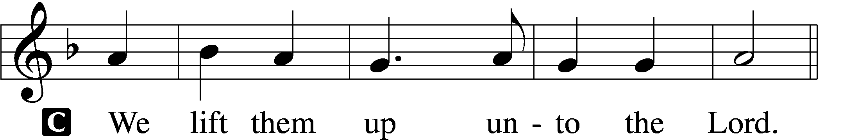

P Let us give thanks unto the Lord, our God.
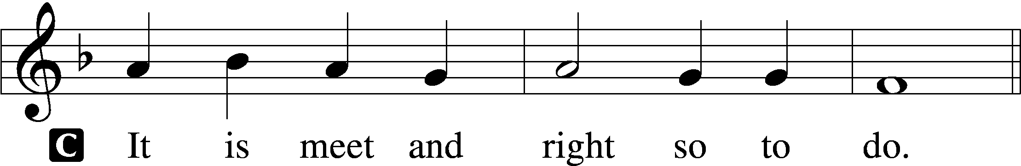

Proper Preface (Abbreviated) LSB 194
P It is truly meet, right, and salutary . . . evermore praising You and saying:

Sanctus Isaiah 6:3; Matthew 21:9
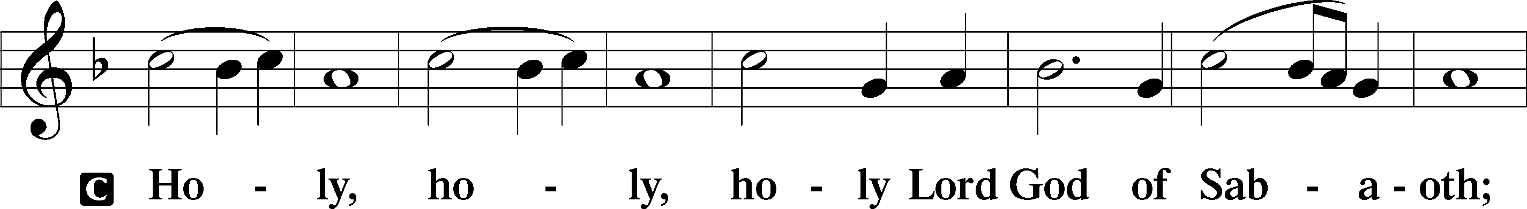
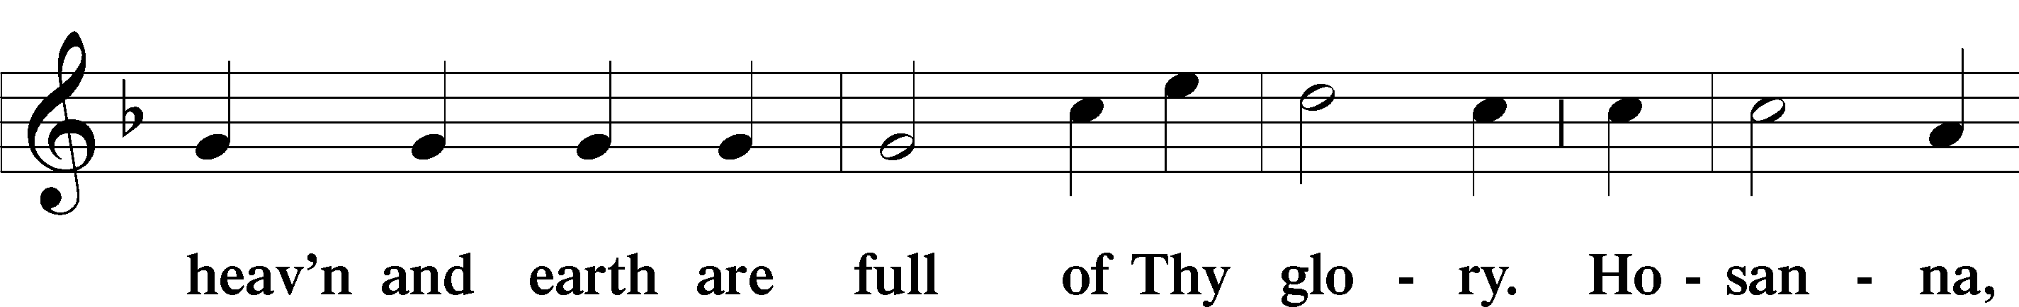
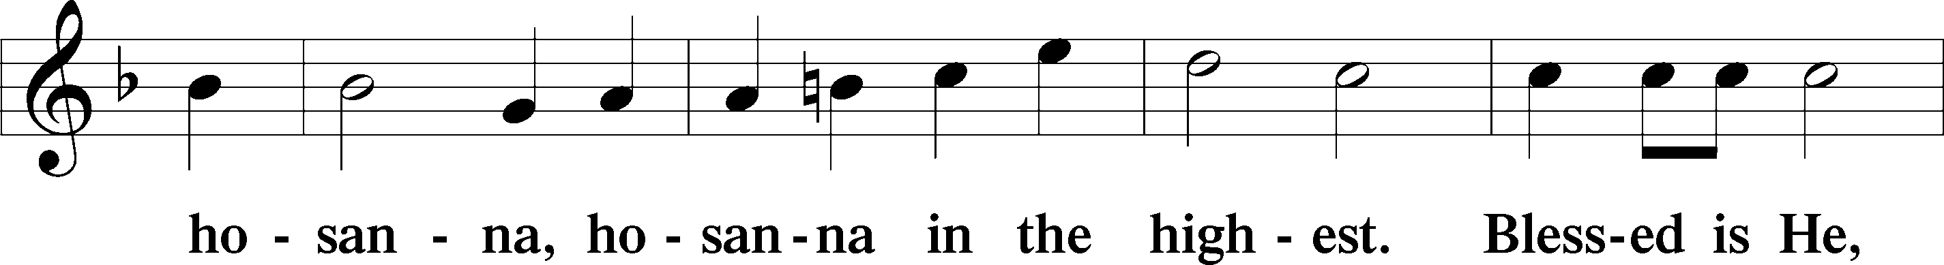
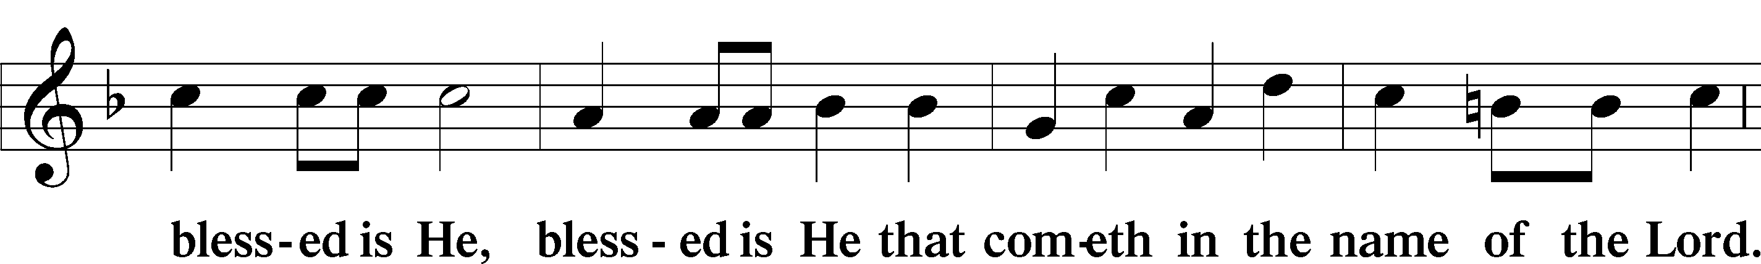
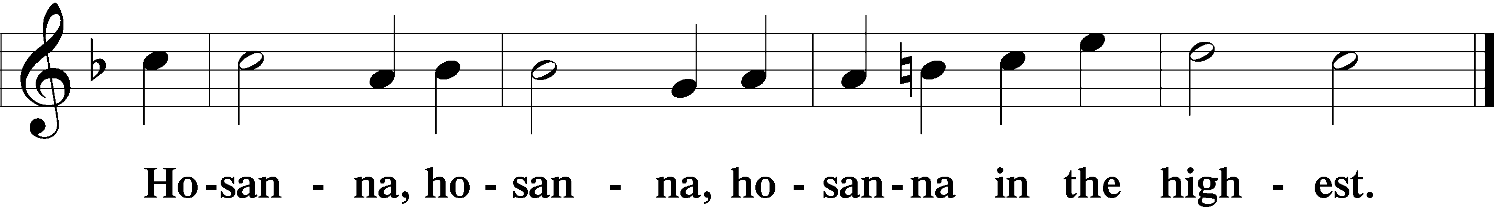

Lord’s Prayer The congregation is encouraged to silently pray the Lord’s Prayer as it is chanted. Matthew 6:9–13
P Our Father who art in heaven,
hallowed be Thy name,
Thy kingdom come,
Thy will be done on earth as it is in heaven;
give us this day our daily bread;
and forgive us our trespasses as we forgive those who trespass against us;
and lead us not into temptation,
but deliver us from evil.
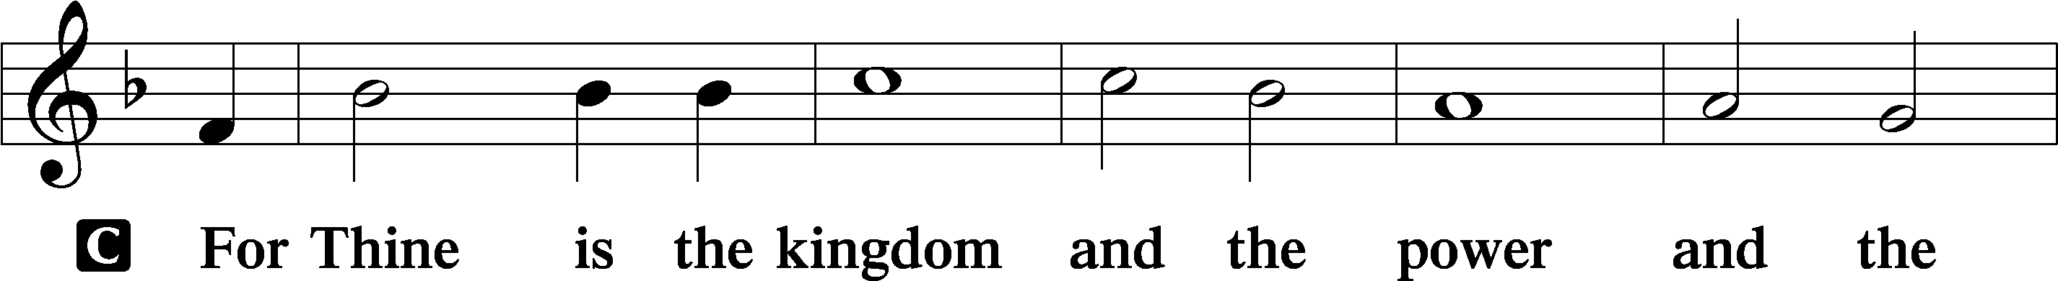
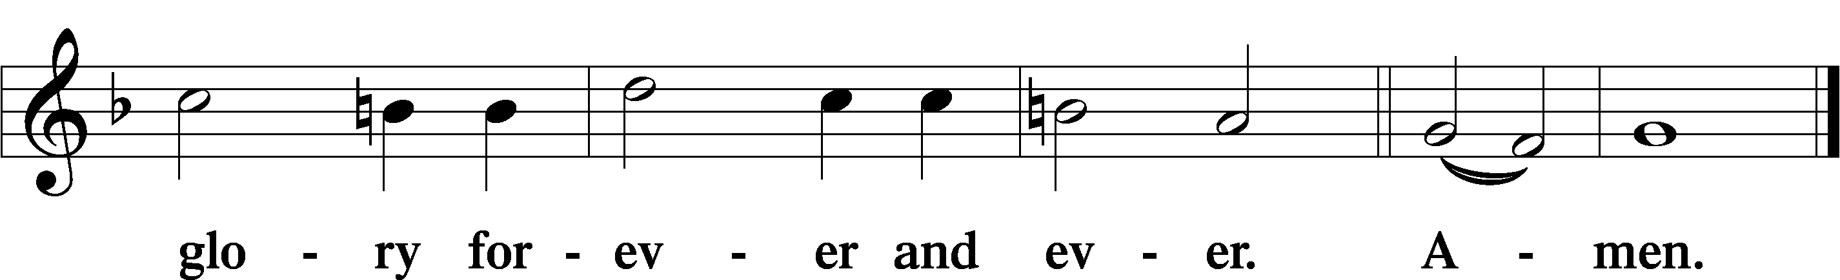

The Words of Our Lord Matthew 26:26–28; Mark 14:22–24; Luke 22:19–20; 1 Corinthians 11:23–25
P Our Lord Jesus Christ, on the night when He was betrayed, took bread, and when He had given thanks, He broke it and gave it to the disciples and said: “Take, eat; this is My T body, which is given for you. This do in remembrance of Me.”

In the same way also He took the cup after supper, and when He had given thanks, He gave it to them, saying: “Drink of it, all of you; this cup is the new testament in My T blood, which is shed for you for the forgiveness of sins. This do, as often as you drink it, in remembrance of Me.”

Pax Domini John 20:19
P The peace of the Lord be with you always.
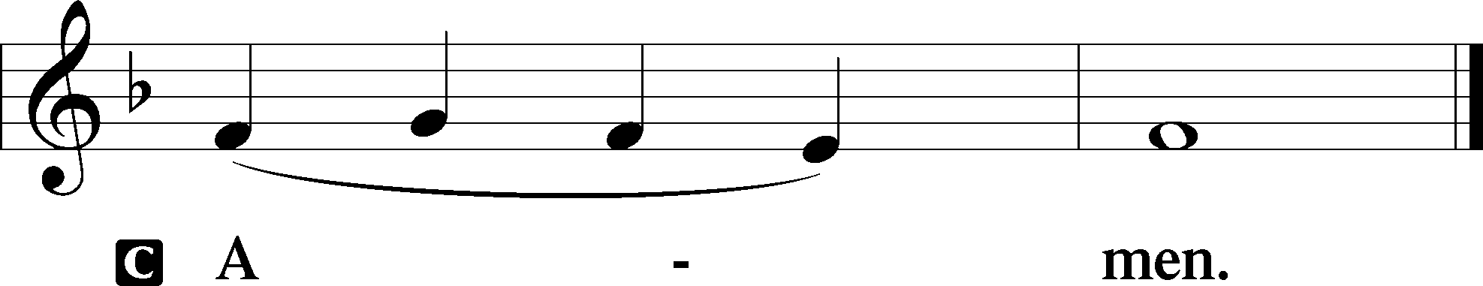

Agnus Dei John 1:29
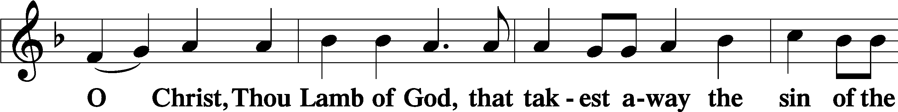
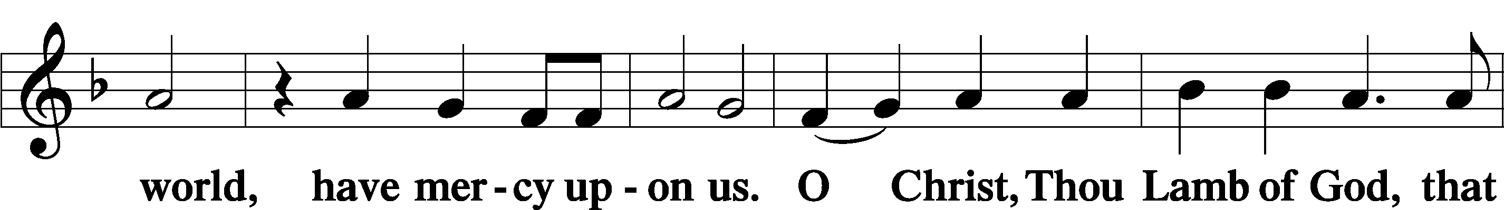
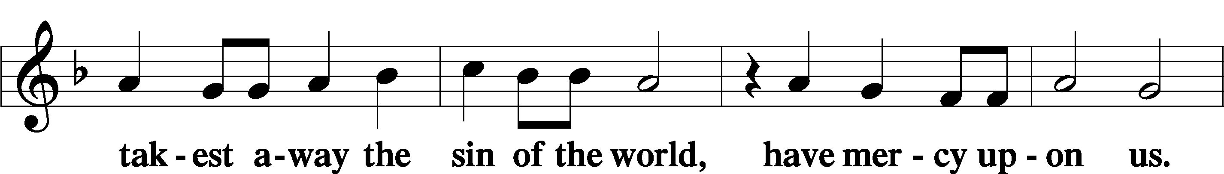
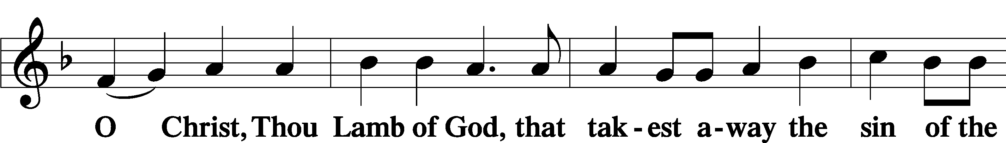
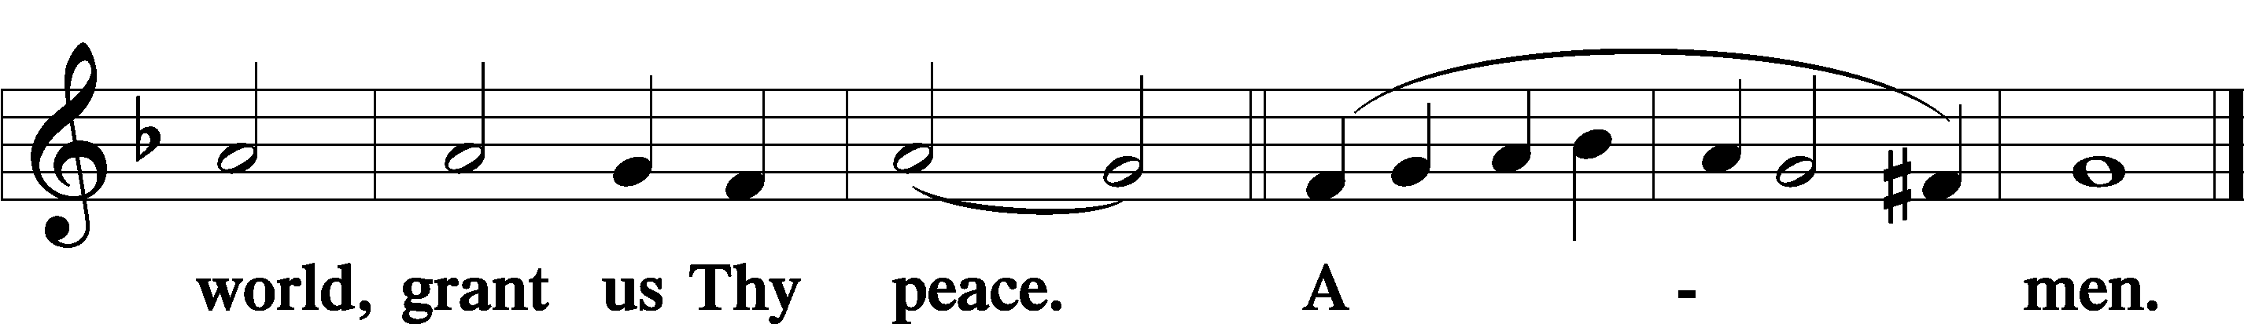
Sit
Distribution
The pastor and those who assist him receive the body and blood of Christ first and then distribute them to those who come to receive, saying:
Take, eat; this is the true body of our Lord and Savior Jesus Christ, given into death for your sins.
Amen.

Take, drink; this is the true blood of our Lord and Savior Jesus Christ, shed for the forgiveness of your sins.
Amen.

In dismissing the communicants, the following is said:
The Dismissal
P The body and blood of our Lord Jesus Christ strengthen and preserve you in body and soul to life everlasting. Depart T in peace.
C Amen.

Distribution Hymn: LSB #719 “I Leave All Things to God’s Direction”

Distribution Hymn: LSB #823 “May God Bestow on Us His Grace”

Distribution Hymn: LSB #332 “Savior of the Nations, Come”

Nunc Dimittis Luke 2:29–32
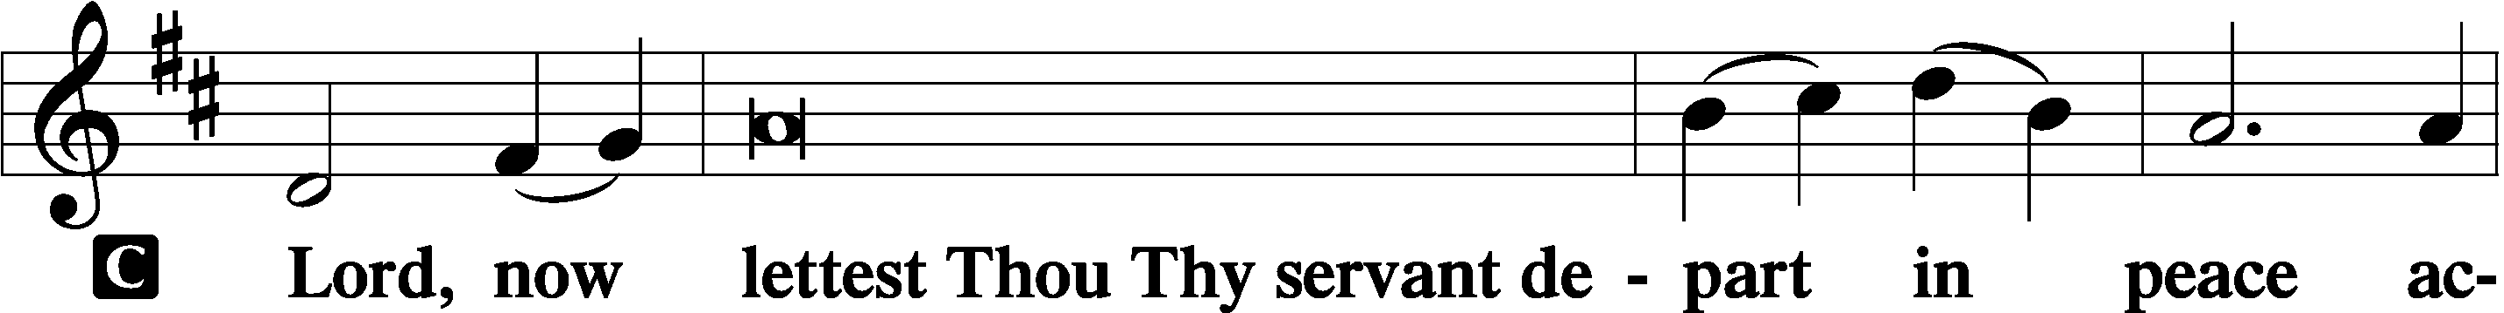
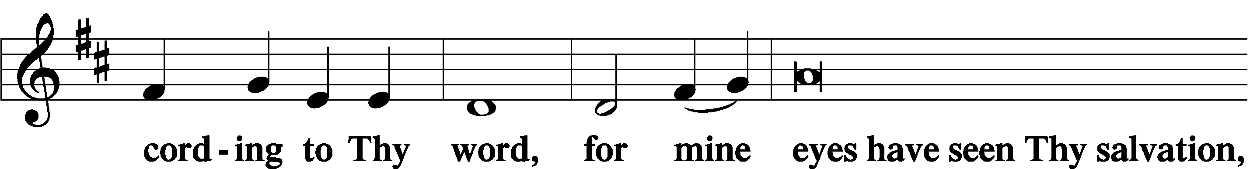
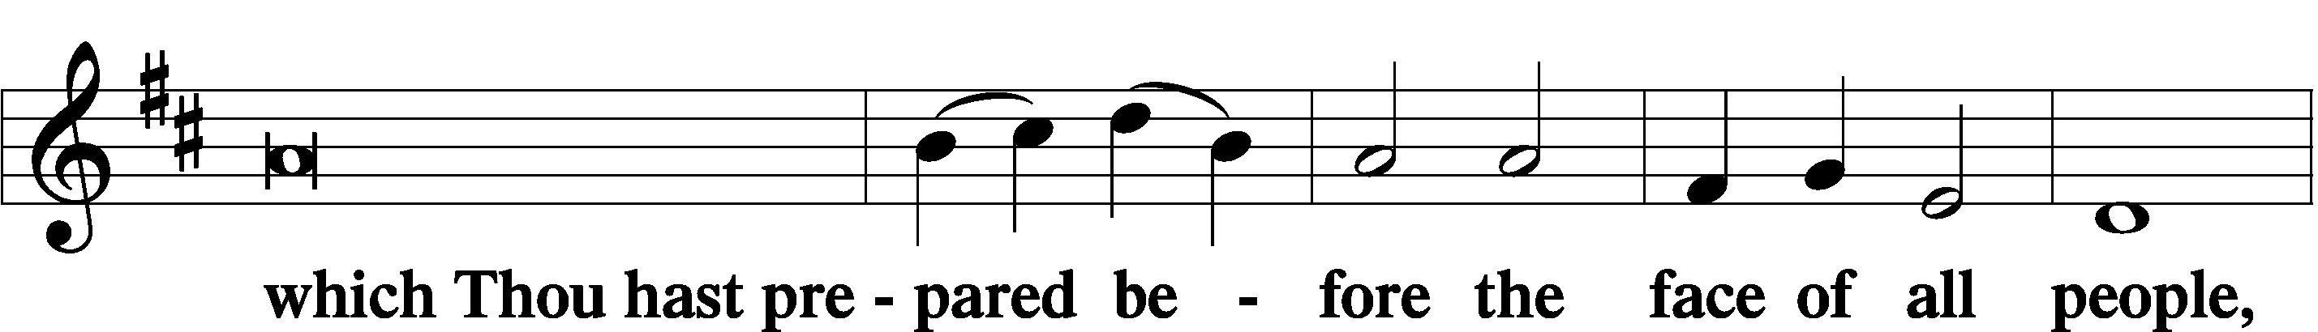
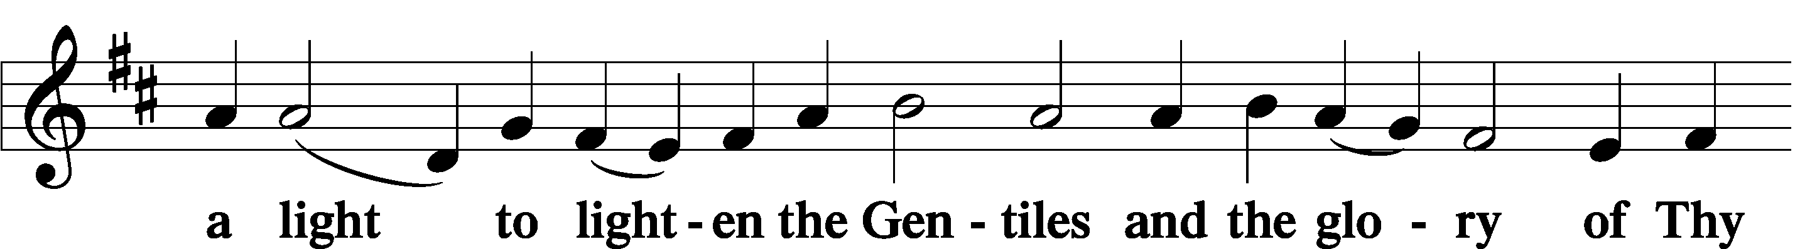
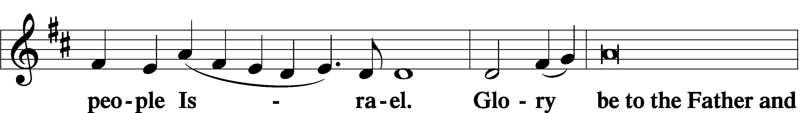
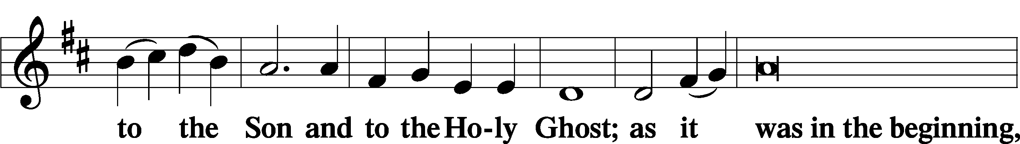
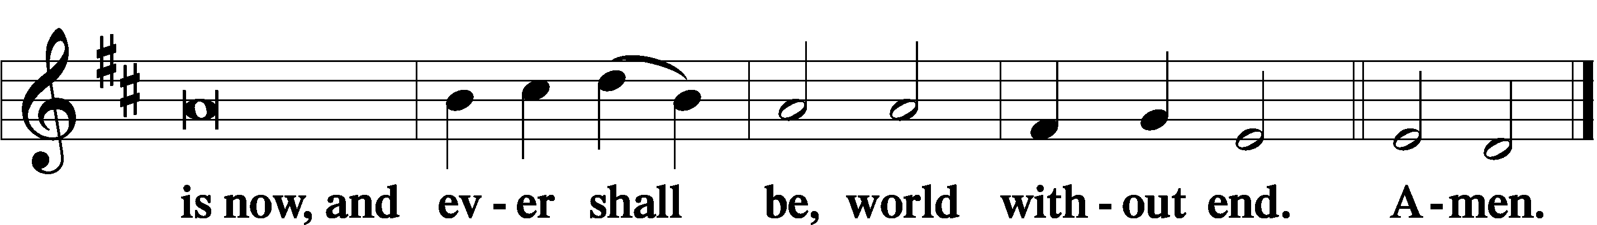

Thanksgiving Psalm 107:1
P O give thanks unto the Lord, for He is good,
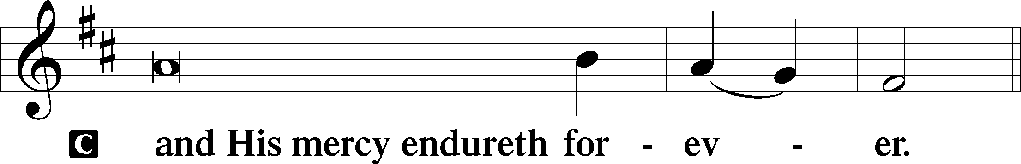

Post-Communion Collect
P Let us pray.
We give thanks to You, almighty God, that You have refreshed us through this salutary gift, and we implore You that of Your mercy You would strengthen us through the same in faith toward You and in fervent love toward one another; through Jesus Christ, Your Son, our Lord, who lives and reigns with You and the Holy Spirit, one God, now and forever.
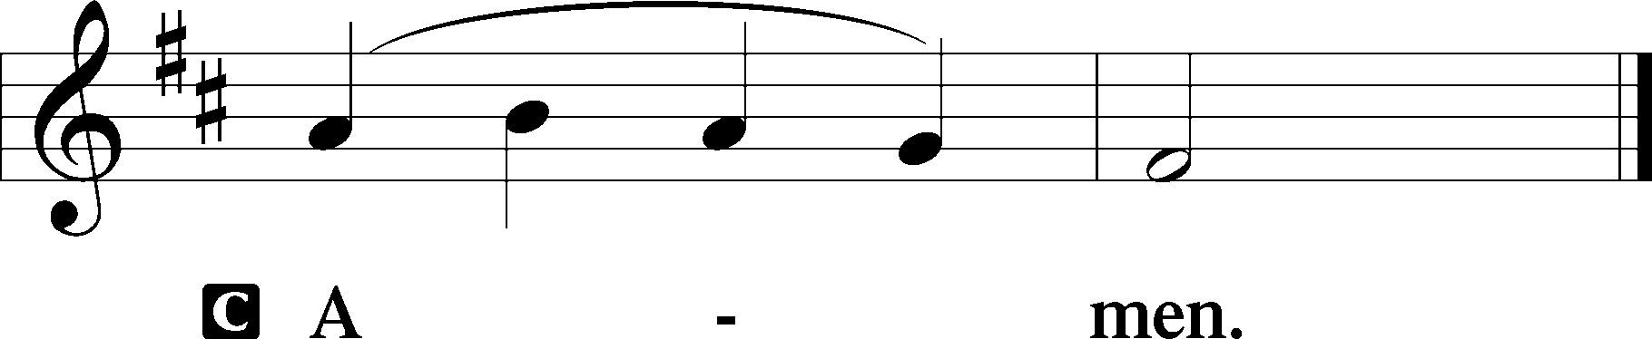

Salutation 2 Timothy 4:22
P The Lord be with you.
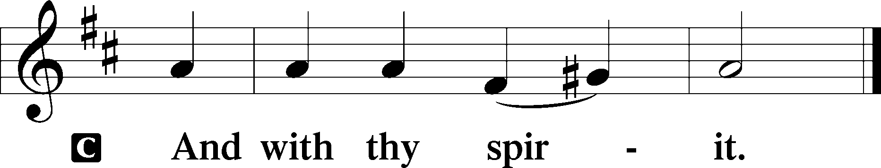

Benedicamus Psalm 103:1
P Bless we the Lord.
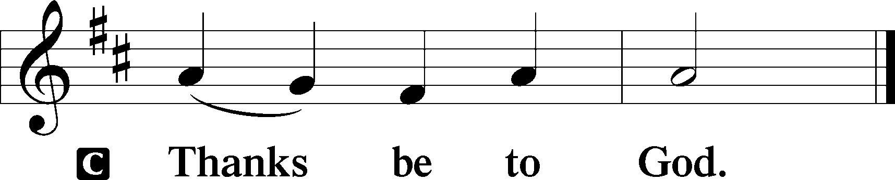

Benediction Numbers 6:24–26
P The Lord bless you and keep you.
The Lord make His face shine upon you and be gracious unto you.
The Lord lift up His countenance upon you and T give you peace.
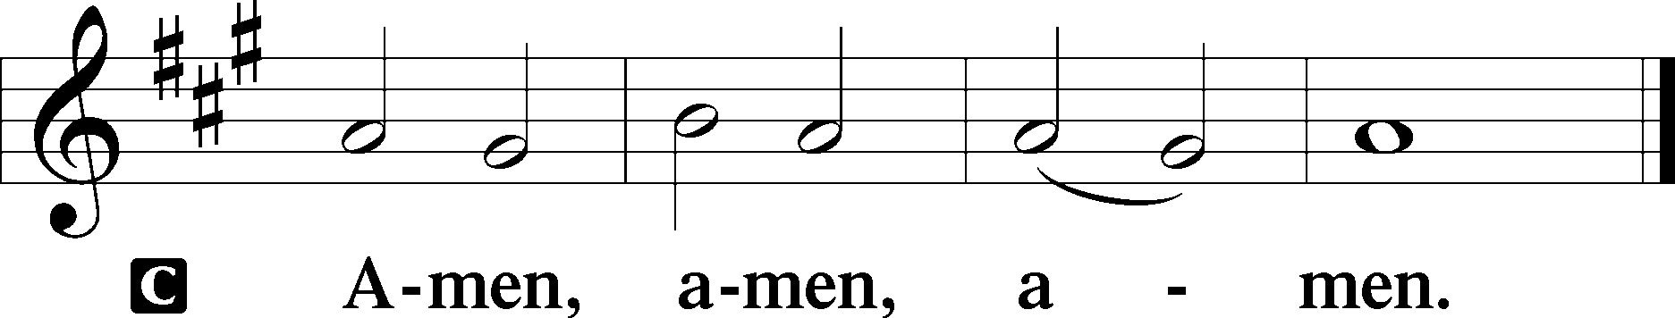

Closing Hymn: LSB #355 “O Savior, Rend the Heavens Wide”
fffffffffffffffffffffffffffffffffff
Silent prayer after worship: Holy Lord Jesus, be with me every hour. Cause me to be keenly aware of Your presence in all I do. By Your Spirit, keep me ready at all times for Your coming as King and Judge. Amen.
fffffffffffffffffffffffffffffffffff
Acknowledgments
Unless otherwise indicated, Scripture quotations are from the ESV® Bible (The Holy Bible, English Standard Version®), copyright © 2001 by Crossway, a publishing ministry of Good News Publishers. Used by permission. All rights reserved.
Created by Lutheran Service Builder © 2023 Concordia Publishing House.
fffffffffffffffffffffffffffffffffff
Attendance: Sunday, November 12, 2023: 38
fffffffffffffffffffffffffffffffffff
THANK YOU FOR SERVING IN NOVEMBER: Elder: Jonathan Baisch; Ushers: Mark Kleindienst, Jerry Krivosh, & Gordon Marquette; Altarware ~ Sundays: Diane Riefstahl; (after) Evelyn Baisch & Arlene Sutton; Special Divine Service: Nov. 30th ~ Elizabeth Haenftling.
fffffffffffffffffffffffffffffffffff
Poinsettia order forms are available on the tables in the narthex and next to the nursery. Forms and payment are due to the secretary’s office no later than Sunday, December 3rd.

SCHEDULE THROUGH NOVEMBER 26, 2023:

:

Today, following Worship, Fellowship Hall: Finance Committee Meeting
7 pm, Fellowship Hall: AA Meeting
Tuesday, 7-9 pm, Fellowship Hall: Penn-Ohio Singers
Wednesday, 9 am, Downstairs: Food Pantry
7 pm, Sanctuary: Thanksgiving Eve Vespers Service
7:30 pm, Fellowship Hall: NA Meeting
Next Sunday, 8 am, Fellowship Hall: Bible Study
9 am, Sanctuary: Divine Service
Following Worship, Library: Monthly Audit of Deposits
7 pm, Fellowship Hall: AA Meeting
fffffffffffffffffffffffffffffffffff
Our Stewardship of Treasures for the Lord:
In order to do the Lord’s work, we need $2,553.63 each week to meet our 2023 budget for general purposes and $76.92 for the SELC.

On-Line Figures (November 8, 9, & 13, 2023)
General Fund: $430.00
SELC: $100.00
Capital Campaign: $200.00
Figures for Sunday, November 5, 2023
General Fund: $1,390.00
SELC: $67.00
Food Pantry: $93.00
Quarterly Missions: $0.00
Capital Campaign: $360.00
Other: $1230.00

For online giving, check out https://www.saintspeterandpaul.net/online-giving.
fffffffffffffffffffffffffffffffffff
All are welcome this Wednesday evening at 7 pm for a special Thanksgiving Eve Vespers Service with Rev. Arthur Baisch. Please invite family and friends to join us as we give thanks to God for His bountiful blessings.
Bible Memory Verses ~ Week of November 19th:
For Adults: And it will be said in that day, "Behold, this is our God for whom we have waited that He might save us This is the LORD for whom we have waited; Let us rejoice and be glad in His salvation." Isaiah 25:9

For Children: Give thanks to the Father, who has qualified you to share in the inheritance of the saints in light. Colossians 1:2
fffffffffffffffffffffffffffffffffff
It’s time to renew subscriptions for the “Lutheran Witness” magazine for 2024. The price has increased to $19.25. If wishing to renew, place a check made out to Sts. Peter & Paul’s in a pew envelope and label the envelope with your name and that it is for the LW. Please make sure to note any change in address with your renewal. Renewals are due TODAY Sunday, November 19, 2023.

fffffffffffffffffffffffffffffffffff
Alex (Sasha) Carr wishes to thank everyone for their prayers and cards. He will be finishing this phase of his training with the U.S. Army over the next few weeks and wants everyone to know how much he appreciates their good wishes.
fffffffffffffffffffffffffffffffffff
Items for the December calendar and newsletter are due to the secretary’s office by noon tomorrow, November 20th. Thank you!
fffffffffffffffffffffffffffffffffff
Advent Midweek Services will begin Wednesday, December 6th. Two services will be offered this year: a 10 am Matins Service and a 7 pm Vesper Service. This year’s theme will focus on Christ in the Old Testament, “The Seen Yahweh”.
fffffffffffffffffffffffffffffffffff
Important: The Voters’ Assembly previously scheduled for today has been moved to December 3rd. Finance Committee members will meet following worship this morning in the Fellowship Hall.
fffffffffffffffffffffffffffffffffff
Due to the Thanksgiving holiday, church offices will be closed Thursday. The secretary’s office will be open Monday and Wednesday this week.
fffffffffffffffffffffffffffffffffff

Remember the following in Prayer…
~The Hurting and Healing: Amy, Steve Antolovich, Ellen Baron^{CA}, Amy Blomenberg, Lois Bortner^{CA}, Sara Brubaker, Dee Bullock, Bev & Joe Chlpka, Susan Davies, Loretta Deal, Tim Dudash, Judith & Eddy Furey, Griffin, Austin Hamilton, Pastor Charles Henrickson, Joan, Keith Jozwiakowski, Darla Krajci, Barbara Kreske, Jess Lavoie, Paul Lucas^{CA}, Sandy Marshall, Frank Niemeyer^{CA}, Juanita Rentschler, Richard Reuning^{CA}, Nancy Robertson^{CA}, Kriss Svidro^{CA}, Rudy Tomko, Joel & Peggy Wasson, Angela Weser^{CA}, Betty Wolf, and Ruth Wolf.
~The Homebound: Anna Mae Daris, Millie Elavsky, Jean Tomko, and Ed & Millie Zachar.
~Celebrating this Week: Birthday: Ed Zachar (11.25).
~Serving in the Military: Alex (Sasha) Carr, Duncan Vaupel, Curtis Sinewe, and Joshua Solyan.
~Community & World Needs: Those suffering due to the conflicts in the Middle East and between Ukraine and Russia; those suffering from loss and dislocation because weather disasters; those suffering from addiction and their families; Local, State, and National Government Leaders; safety for all Police Officers, Firefighters, & First Responders; the unemployed; our Fourth Quarter Local Mission: Willow Women’s Center.
*CA represents cancer.
fffffffffffffffffffffffffffffffffff
Altar Guild members are encouraged to sign up on the cookie donation sheet which is available on the table in the narthex for bringing 1-2 dozen cookies (no more, please) to the Coffee Fellowship, Sunday, December 10th.
Also available on the table are the 2024 “How May I Serve” sheets. If you haven’t already done so, please return yours to Marie Flaugher ASAP.
fffffffffffffffffffffffffffffffffff

Here to Serve
Pastor………………………………………………...……………Rev. Jacob Deal
E-mail …………………………….……pastordeal@saintspeterandpaul.net
Phone Number……………………..…………………724-347-3620 (Option 2)
Church Office………………………..…………………724-347-3620 (Option 3)
Website …………………………………………www.saintspeterandpaul.net
Secretary…………………………………………………………Diane Riefstahl
E-mail ………………………………………church@saintspeterandpaul.net
Website …………………………………………www.saintspeterandpaul.net
Food Pantry (email): ……………foodpantry@saintspeterandpaul.net
Congregation President………………………………….…Jonathan Baisch
Church Elder …………………………………………...……. Jonathan Baisch
Organist………………………………………………..….…Rebecca Marquette
AA Contact: Steve………………………………………………...…724-813-2358
NA Contact: Larry……………………………………..…………..724-977-8733
fffffffffffffffffffffffffffffffffff
If needing to get into the church building during the week, please phone first to make certain someone is here to let you in.

