Sts. Peter & Paul
Evangelical Lutheran Church
Lutheran Church-Missouri Synod
Founded-1917

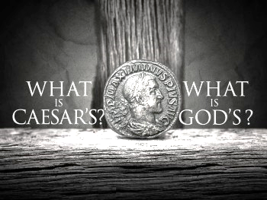

November 12, 2023

699 Stambaugh Ave.
Sharon, Pennsylvania 16146

“I was glad when they said to me,
Let us go to the house of the LORD!”
Psalm 122:1
Sts. Peter & Paul Evangelical Lutheran Church, LC-MS
THE TWENTY-THIRD SUNDAY
AFTER TRINITY
November 12, 2023

A special welcome to our guests this day! If you would like more information about The Lutheran Church - Missouri Synod, or this congregation, please speak with Pastor Deal or an Elder after the service.
Members & Guests: Don’t be embarrassed if your children make noise during the worship service, all children do. We encourage families to worship together but, if you feel the need, there are pews in the rear of the Church which are reserved for young families on both sides of the sanctuary. There is also a quiet room available to you, located next to the sanctuary (formerly the Pastor’s office), where you would be able to follow along with the service.

Today’s service includes the Sacrament of Holy Communion. If during this past year, you have not worshipped with us and been communed, we respectfully ask that you do not partake of this sacrament this day before first speaking with Pastor Deal.
If visiting from a sister congregation of the LC-MS and are in good standing, please inform Pastor Deal of your desire to commune prior to the service.
If wishing to receive a blessing during communion, please approach with your arms crossed.

CONTACT INFORMATION
Pastor Deal: pastordeal@saintspeterandpaul.net or 724-347-3620 (opt. 2)
Church Office: church@saintspeterandpaul.net or 724-347-3620 (opt. 3)
Secretary’s Office: The office will be open Mon. (8:30 am–5 pm) & Thurs. (8:30 am-10 am; 11 am-5 pm).

Silent prayer before worship: Lord Jesus, help me to always remember that nothing can take me away from You. Enable me to stand firm in my faith so I will never fall away but will always be sure of my salvation through You alone. Amen.
Confession and Absolution

Opening Hymn: LSB #755 “In the Very Midst of Life”

Stand

The sign of the cross may be made by all in remembrance of their Baptism.

Invocation
P In the name of the Father and of the T Son and of the Holy Spirit.
C Amen.

Exhortation Hebrews 10:22; Psalm 124:8; Psalm 32:5
P Beloved in the Lord! Let us draw near with a true heart and confess our sins unto God our Father, beseeching Him in the name of our Lord Jesus Christ to grant us forgiveness.

P Our help is in the name of the Lord,
C who made heaven and earth.
P I said, I will confess my transgressions unto the Lord,
C and You forgave the iniquity of my sin.

Silence for reflection on God’s Word and for self-examination.

Confession of Sins
P O almighty God, merciful Father,
C I, a poor, miserable sinner, confess unto You all my sins and iniquities with which I have ever offended You and justly deserved Your temporal and eternal punishment. But I am heartily sorry for them and sincerely repent of them, and I pray You of Your boundless mercy and for the sake of the holy, innocent, bitter sufferings and death of Your beloved Son, Jesus Christ, to be gracious and merciful to me, a poor, sinful being.

Absolution [John 20:19–23]
P Upon this your confession, I, by virtue of my office, as a called and ordained servant of the Word, announce the grace of God unto all of you, and in the stead and by the command of my Lord Jesus Christ I forgive you all your sins in the name of the Father and of the T Son and of the Holy Spirit.
C Amen.
Service of the Word

Introit Psalm 85:1, 7, 9, 11; antiphon: Jeremiah 29:11a, 12
I know the plans I have for you, de- | clares the Lord,*
plans for wholeness and not for | evil.
Then you will call upon me and come and | pray to me,*
and I will | hear you.
Lord, you were favorable | to your land;*
you restored the fortunes of | Jacob.
Show us your steadfast love, | O Lord,*
and grant us your sal- | vation.
Surely his salvation is near to those who | fear him,*
that glory may dwell | in our land.
Faithfulness springs up | from the ground,*
and righteousness looks down | from the sky.
I know the plans I have for you, de- | clares the Lord,*
plans for wholeness and not for | evil.
Then you will call upon me and come and | pray to me,*
and I will | hear you.

Gloria Patri
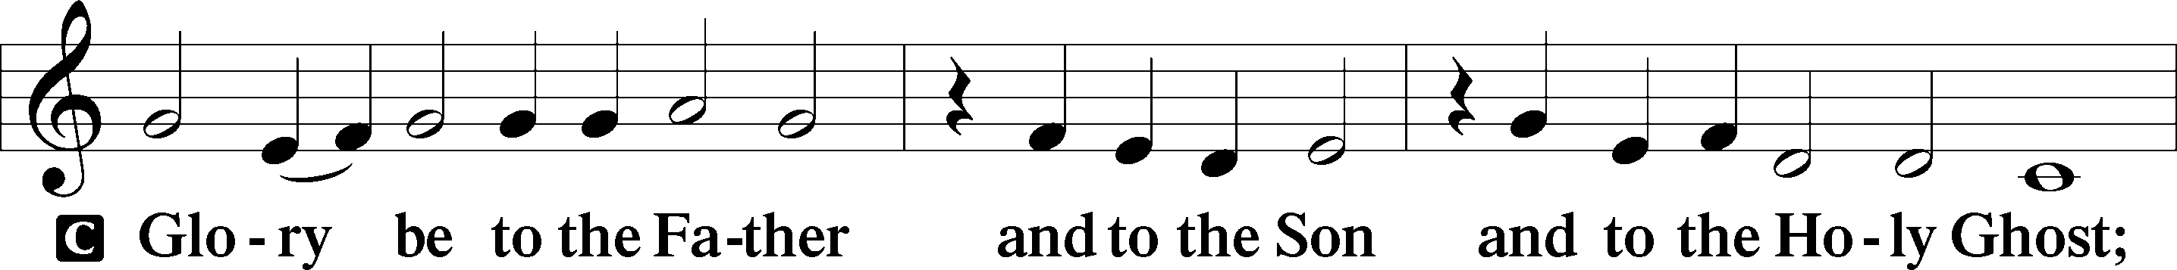
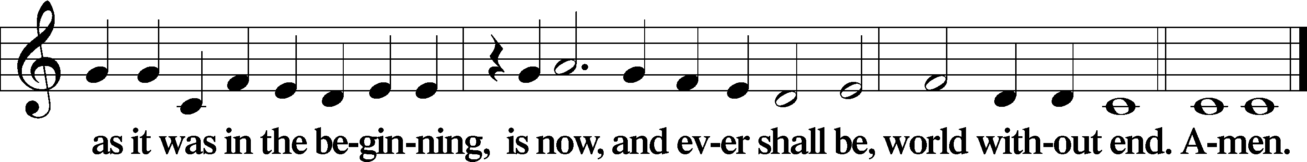

Kyrie Mark 10:47
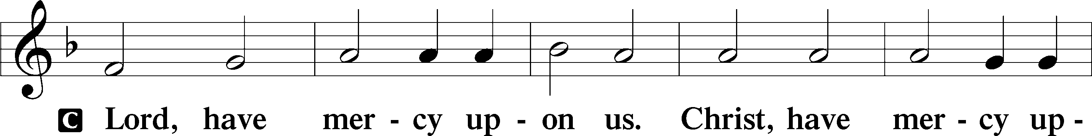
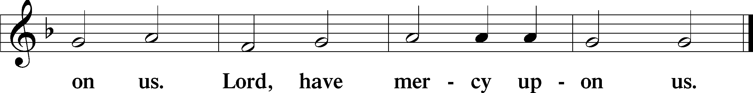

Gloria in Excelsis Luke 2:14; John 1:29
P Glory be to God on high:
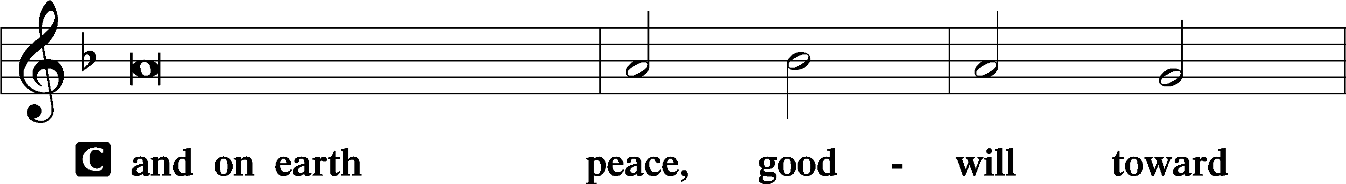
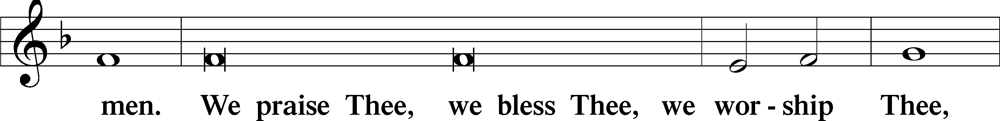
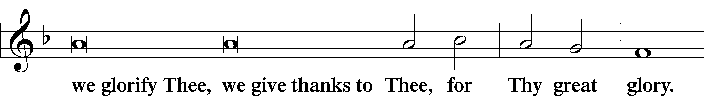
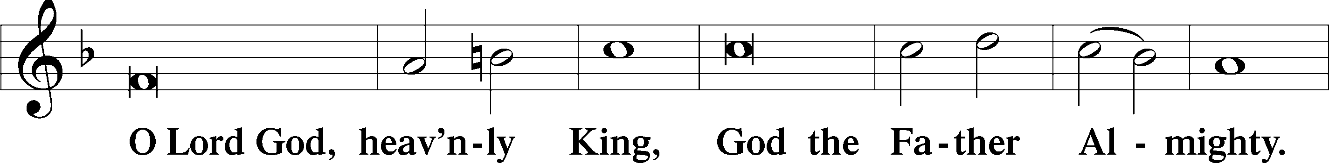
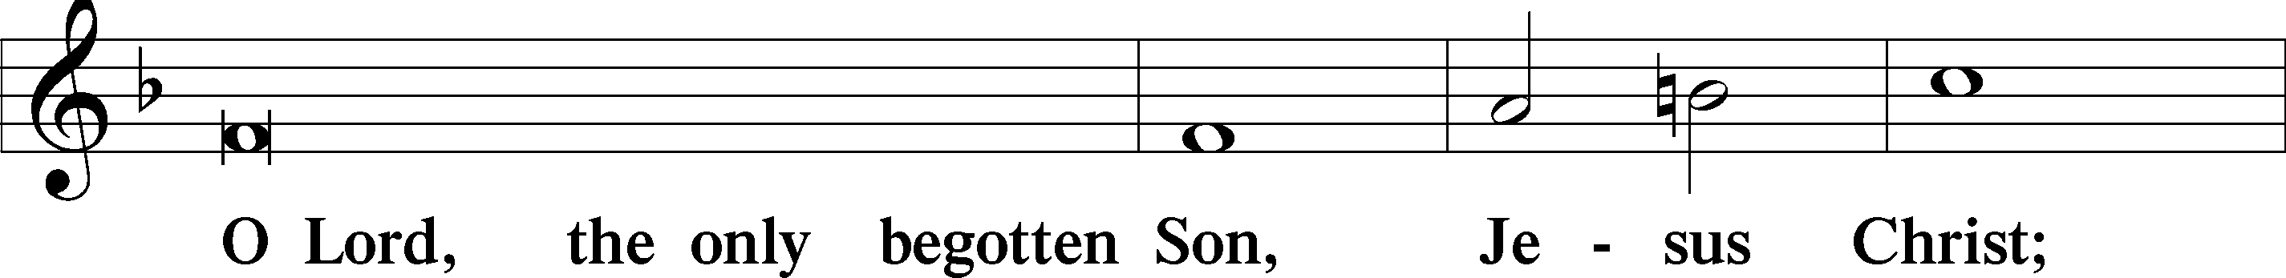
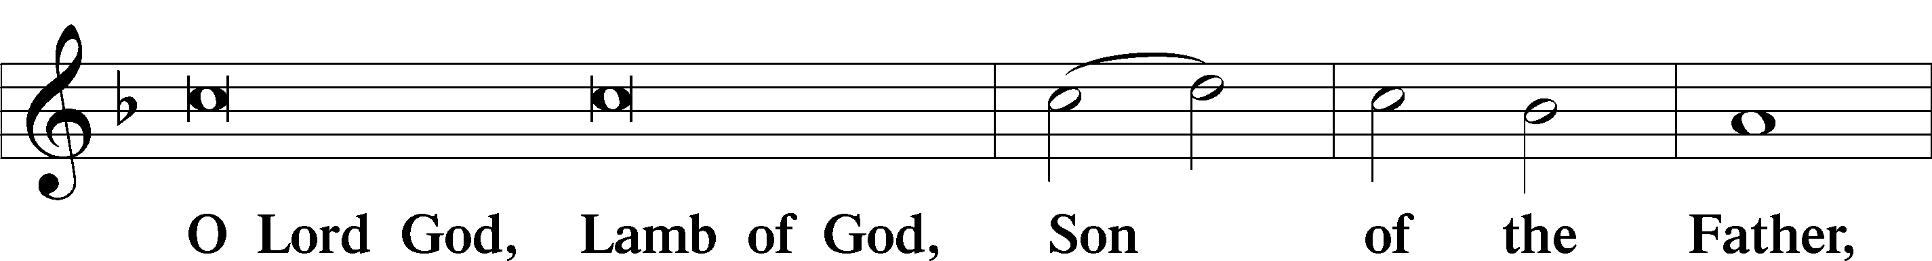
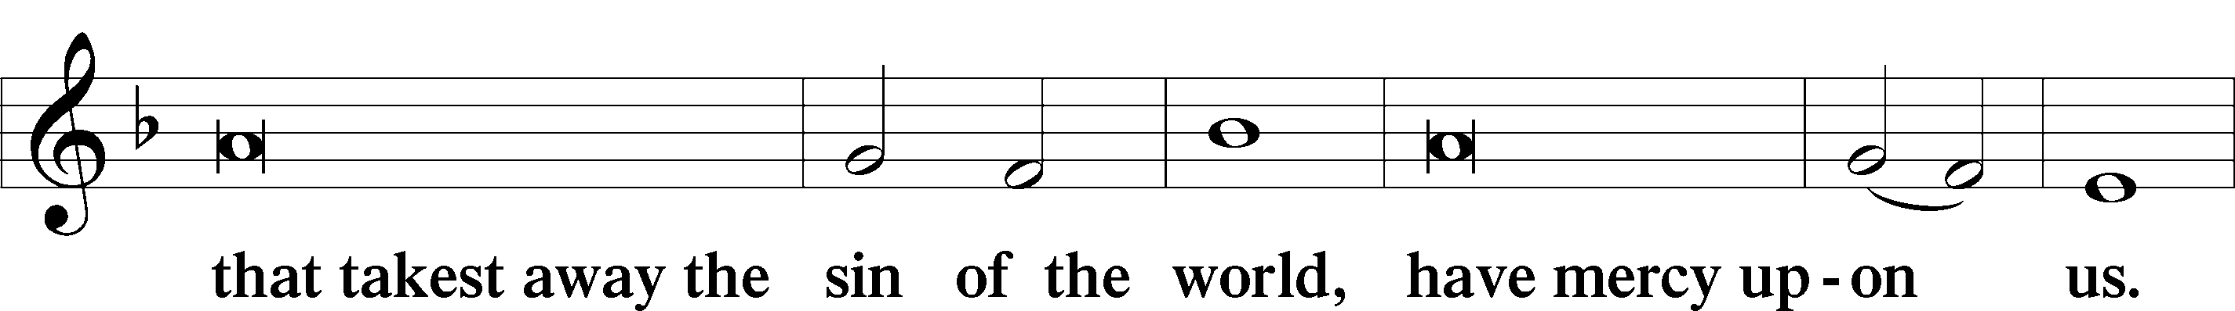
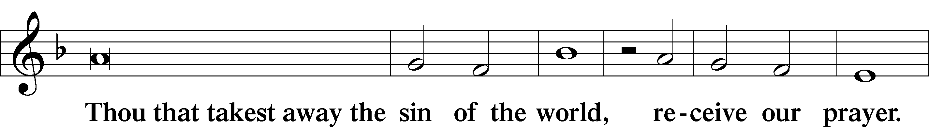
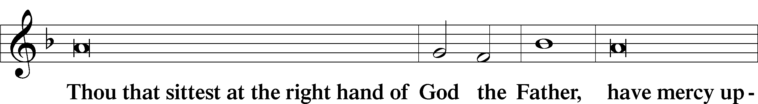
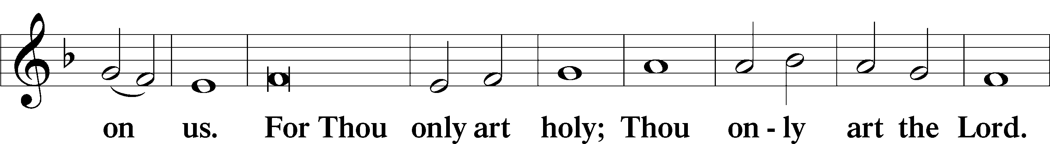
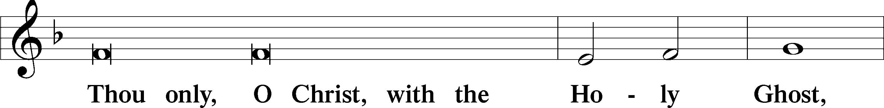
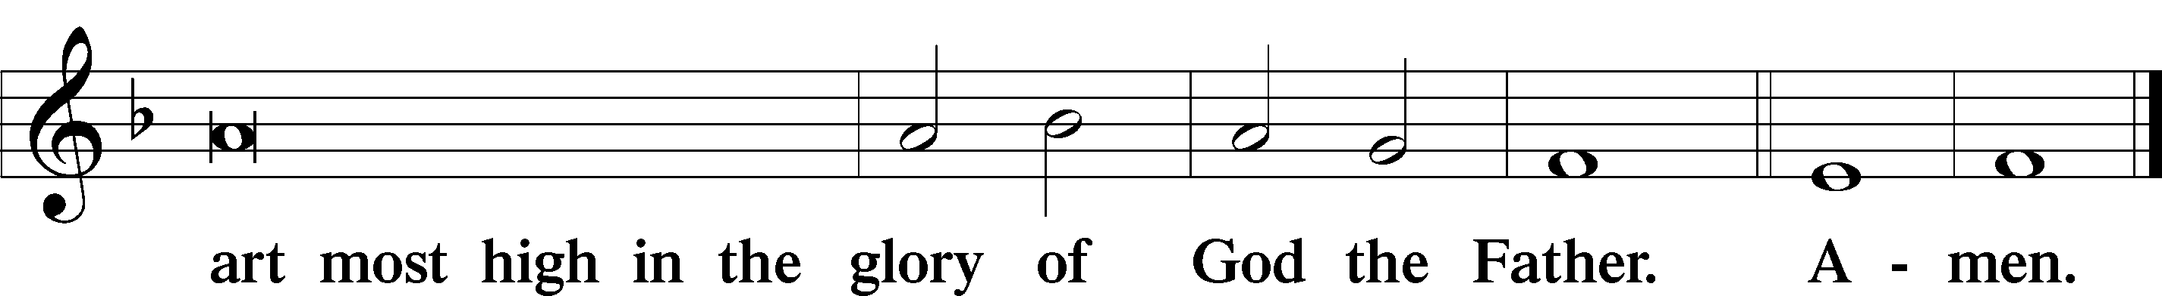

Salutation and Collect of the Day: Trinity 23
P The Lord be with you.
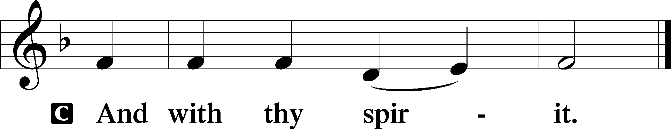

P Let us pray.
O Lord, absolve Your people from their offenses that from the bonds of our sins, which by reason of our frailty we have brought upon ourselves, we may be delivered by Your bountiful goodness; through Jesus Christ, Your Son, our Lord, who lives and reigns with You and the Holy Spirit, one God, now and forever.
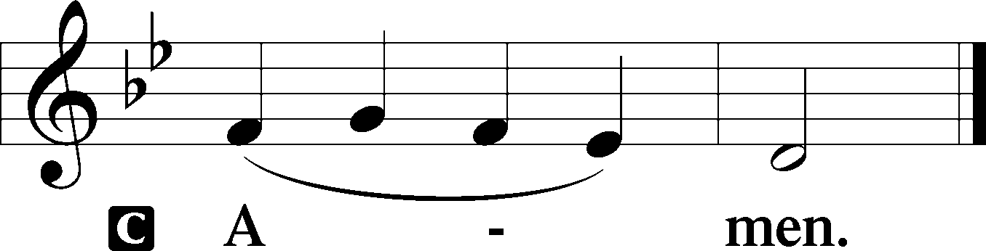
Sit

Prophecy: Proverbs 8:11–22 (NKJV)
“Wisdom is better than rubies, and all the things one may desire cannot be compared with her. I, wisdom, dwell with prudence, and find out knowledge and discretion. The fear of the Lord is to hate evil; pride and arrogance and the evil way and the perverse mouth I hate. Counsel is mine, and sound wisdom; I am understanding, I have strength. By me kings reign, and rulers decree justice. By me princes rule, and nobles, all the judges of the earth. I love those who love me, and those who seek me diligently will find me. Riches and honor are with me, enduring riches and righteousness. My fruit is better than gold, yes, than fine gold, and my revenue than choice silver. I traverse the way of righteousness, in the midst of the paths of justice, that I may cause those who love me to inherit wealth, that I may fill their treasuries. The Lord possessed me at the beginning of His way, before His works of old.”
“The Lord possessed me at the beginning of his work,
the first of his acts of old.”

P This is the Word of the Lord.
C Thanks be to God.

Gradual Psalm 44:7–8
You have saved us | from our foes*
and have put to shame those who | hate us.
In God we have boasted con- | tinually,*
and we will give thanks to your name for- | ever.

Epistle: Philippians 3:17–21 (NKJV)
Brethren, join in following my example, and note those who so walk, as you have us for a pattern. For many walk, of whom I have told you often, and now tell you even weeping, that they are the enemies of the cross of Christ: whose end is destruction, whose god is their belly, and whose glory is in their shame—who set their mind on earthly things. For our citizenship is in heaven, from which we also eagerly wait for the Savior, the Lord Jesus Christ, who will transform our lowly body that it may be conformed to His glorious body, according to the working by which He is able even to subdue all things to Himself, Jesus Christ our Lord.

P This is the Word of the Lord.
C Thanks be to God.

Stand

Verse Psalm 115:11
Alleluia. You who fear the Lord, trust in the Lord! He is their help and their shield. Alleluia.

Alleluia
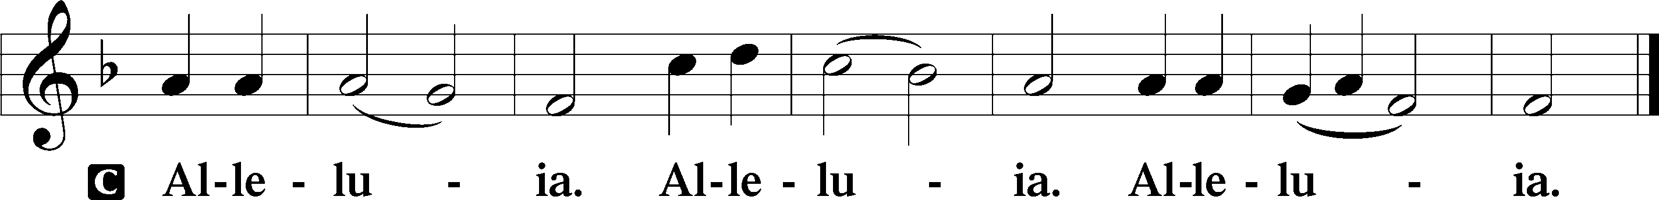

Holy Gospel: Matthew 22:15–21 (NKJV)
P The Holy Gospel according to St. Matthew, the twenty-second chapter.
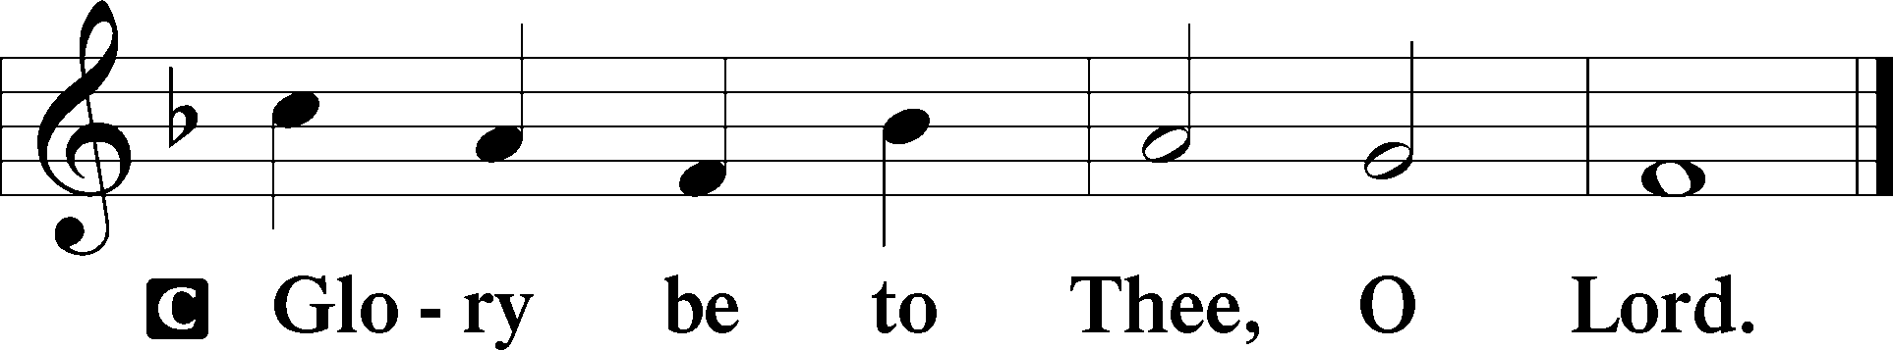

At that time: The Pharisees went and plotted how they might entangle Jesus in His talk. And they sent to Him their disciples with the Herodians, saying, “Teacher, we know that You are true, and teach the way of God in truth; nor do You care about anyone, for You do not regard the person of men. Tell us, therefore, what do You think? Is it lawful to pay taxes to Caesar, or not?” But Jesus perceived their wickedness, and said, “Why do you test Me, you hypocrites? Show Me the tax money.” So they brought Him a denarius. And He said to them, “Whose image and inscription is this?” They said to Him, “Caesar’s.” And He said to them, “Render therefore to Caesar the things that are Caesar’s, and to God the things that are God’s.”

P This is the Gospel of the Lord.
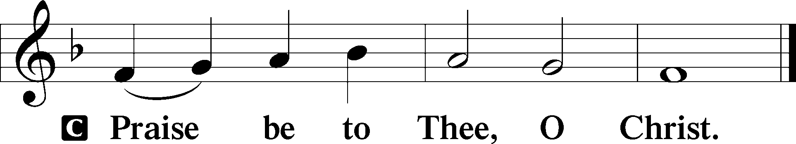

Nicene Creed
C I believe in one God,
the Father Almighty,
maker of heaven and earth
and of all things visible and invisible.

And in one Lord Jesus Christ,
the only-begotten Son of God,
begotten of His Father before all worlds,
God of God, Light of Light,
very God of very God,
begotten, not made,
being of one substance with the Father,
by whom all things were made;
who for us men and for our salvation came down from heaven
and was incarnate by the Holy Spirit of the virgin Mary
and was made man;
and was crucified also for us under Pontius Pilate.
He suffered and was buried.
And the third day He rose again according to the Scriptures
and ascended into heaven
and sits at the right hand of the Father.
And He will come again with glory to judge both the living and the dead,
whose kingdom will have no end.

And I believe in the Holy Spirit,
the Lord and giver of life,
who proceeds from the Father and the Son,
who with the Father and the Son together is worshiped and glorified,
who spoke by the prophets.
And I believe in one holy Christian and apostolic Church,
I acknowledge one Baptism for the remission of sins,
and I look for the resurrection of the dead
and the life T of the world to come. Amen.
Sit

Hymn of the Day: TLH #407 “Farewell I Gladly Bid Thee”
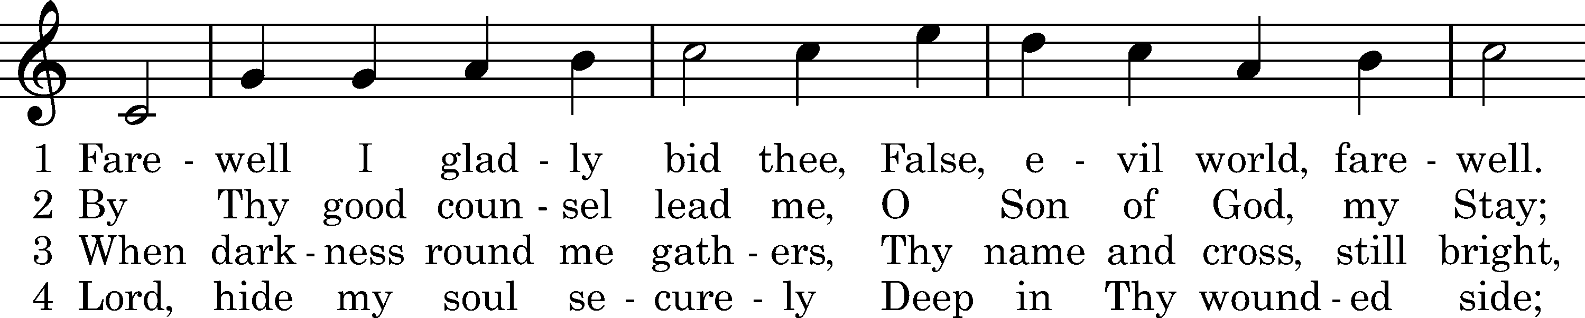
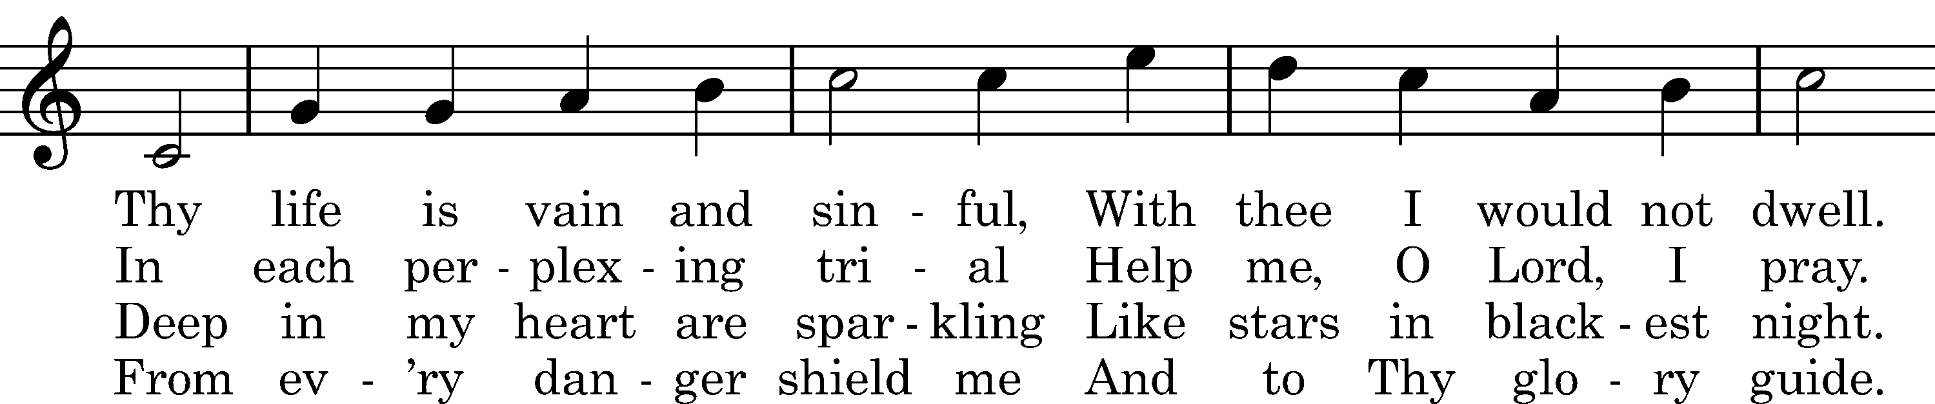
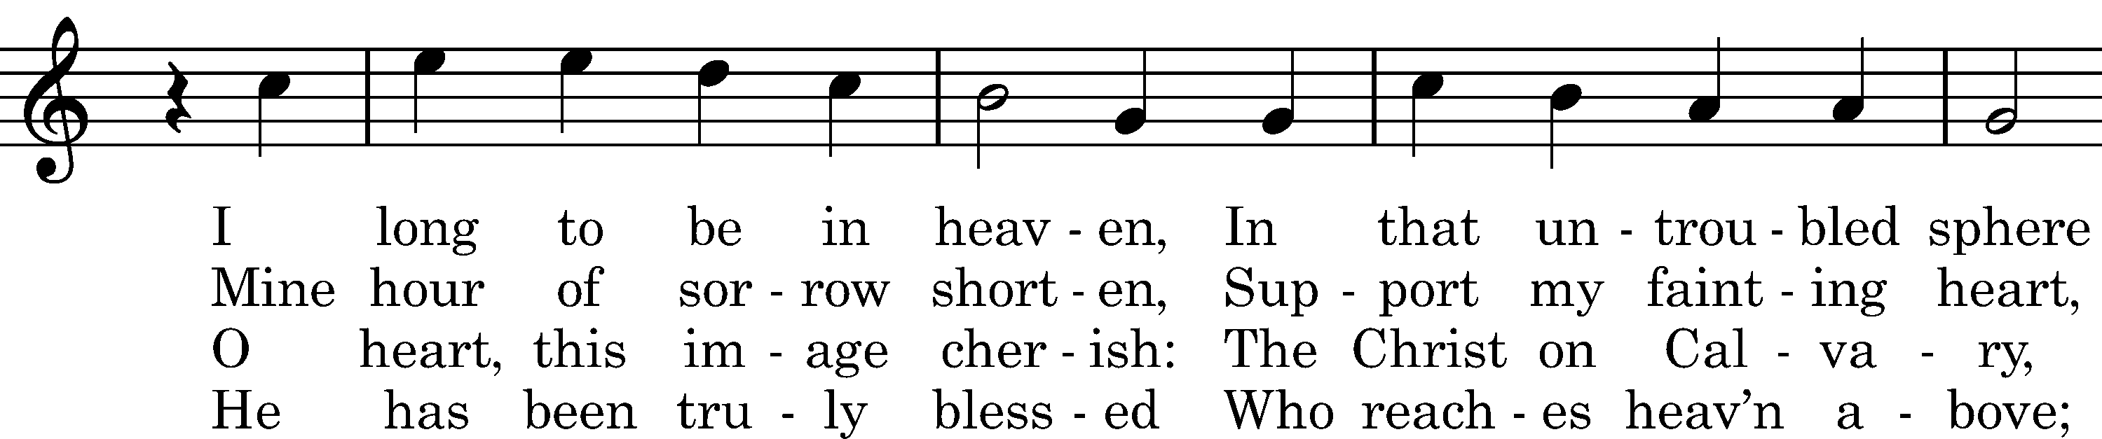
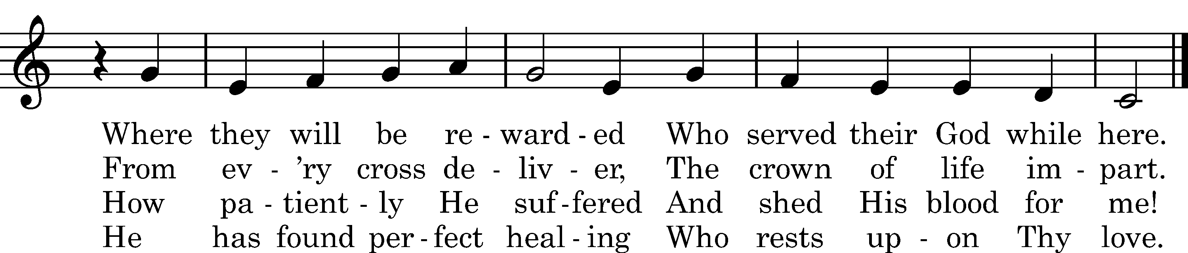

5 Lord, write my name, I pray Thee,
Now in the Book of Life
And with all true believers
Take me where joys are rife.
There let me bloom and flourish,
Thy perfect freedom prove,
And tell, as I adore Thee,
How faithful was Thy love.

Text: tr. Catherine Winkworth, 1863, alt.; Valerius Herberger, 1613 Tune: Melchior Teschner, 1613Text and tune: Public domain

Sermon

Stand

Offertory Psalm 51:10–12
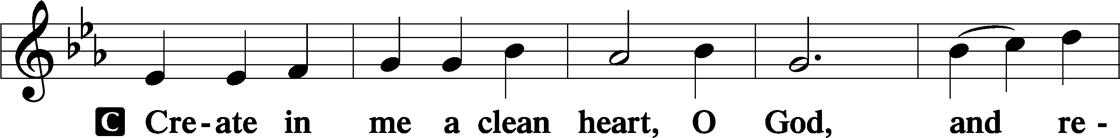
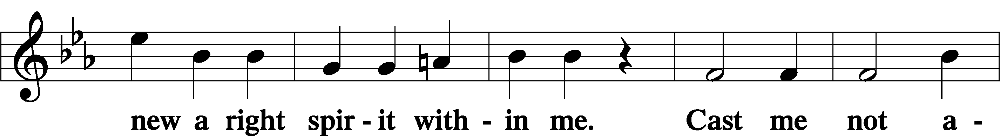
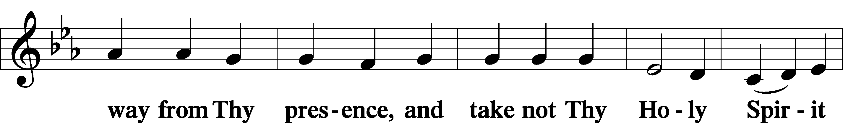
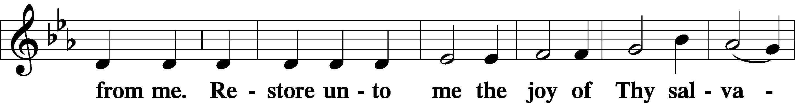
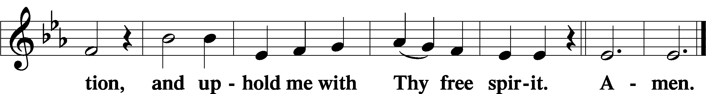

Prayer of the Church

Sit

Preparatory Hymn: LSB #622 “Lord Jesus Christ, You Have Prepared”

Stand
Service of the Sacrament

Preface 2 Timothy 4:22; Colossians 3:1 Psalm 136
P The Lord be with you.
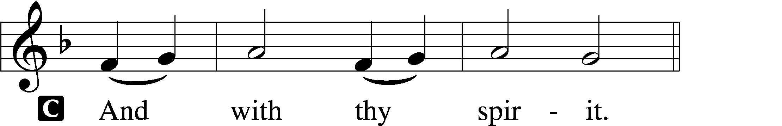

P Lift up your hearts.
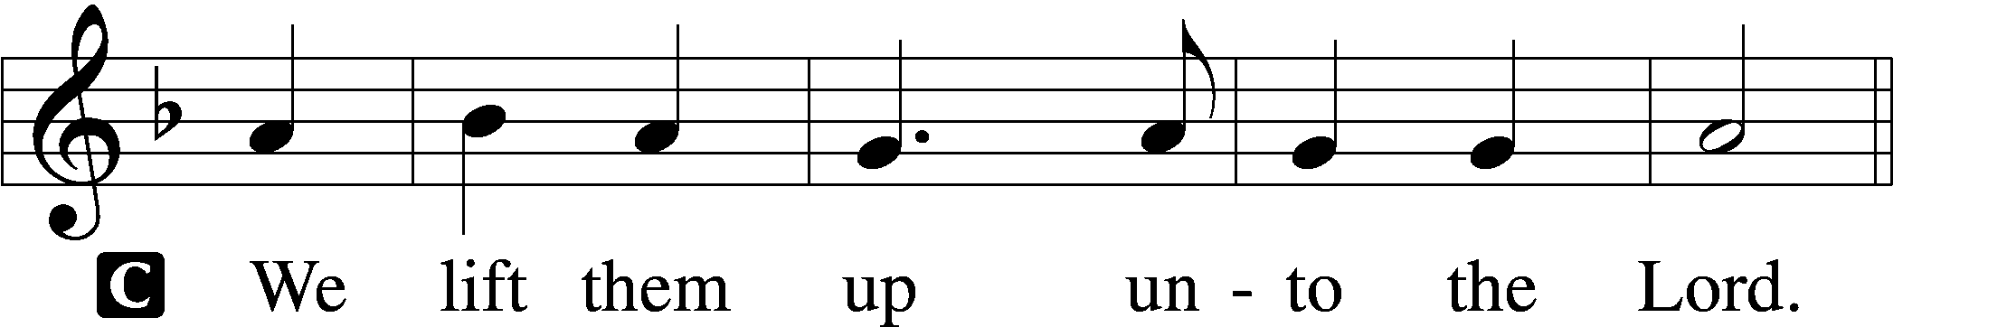

P Let us give thanks unto the Lord, our God.
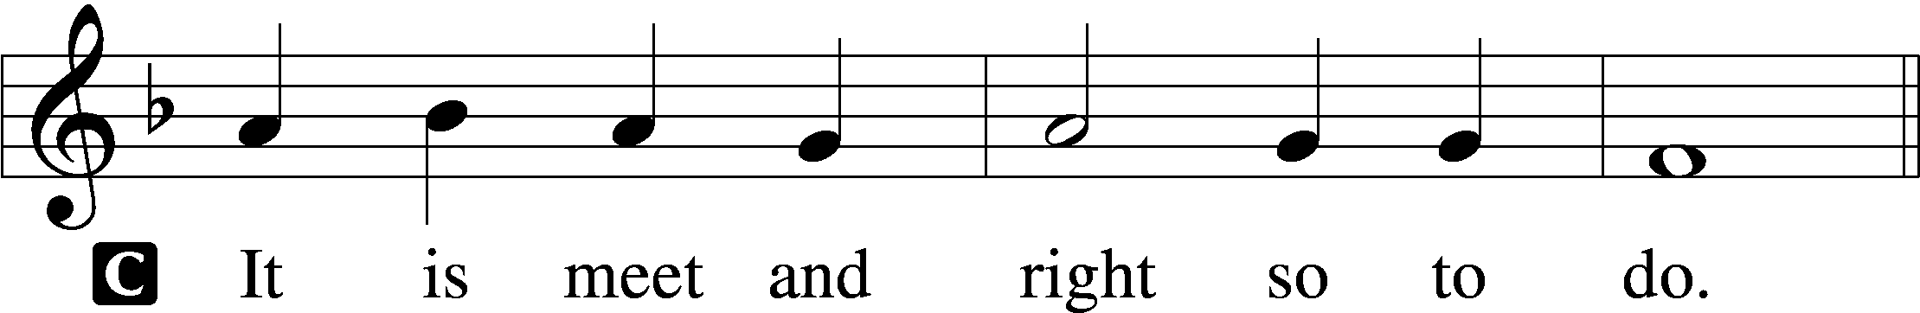

Proper Preface (Abbreviated) LSB 194
P It is truly meet, right, and salutary . . . evermore praising You and saying:

Sanctus Isaiah 6:3; Matthew 21:9
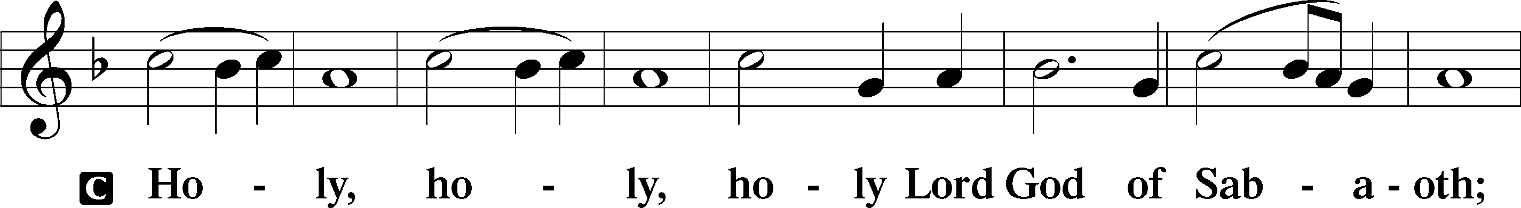
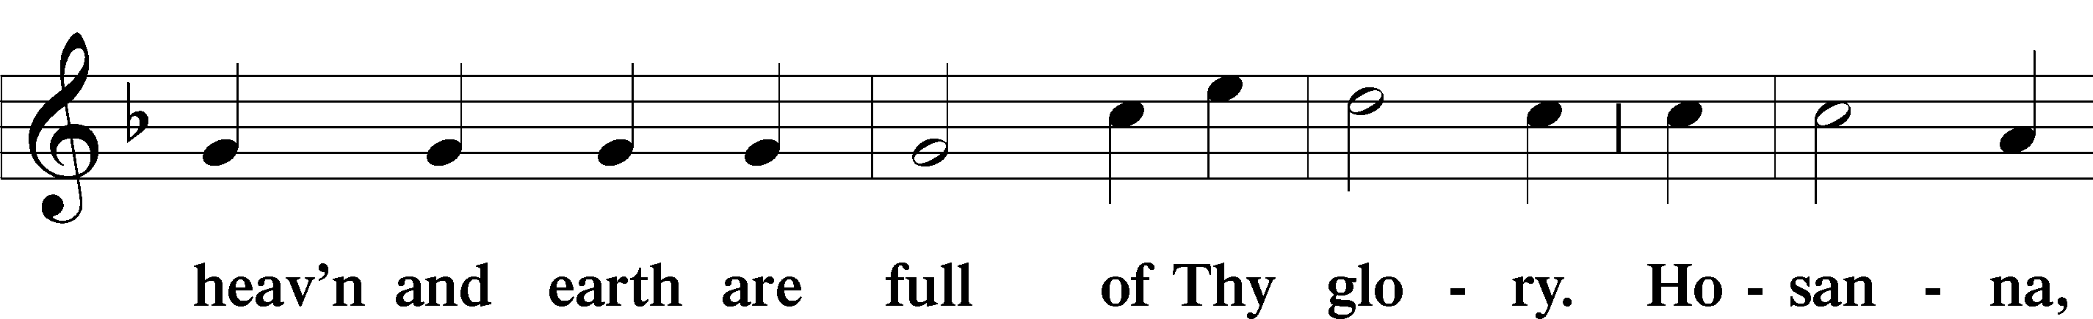
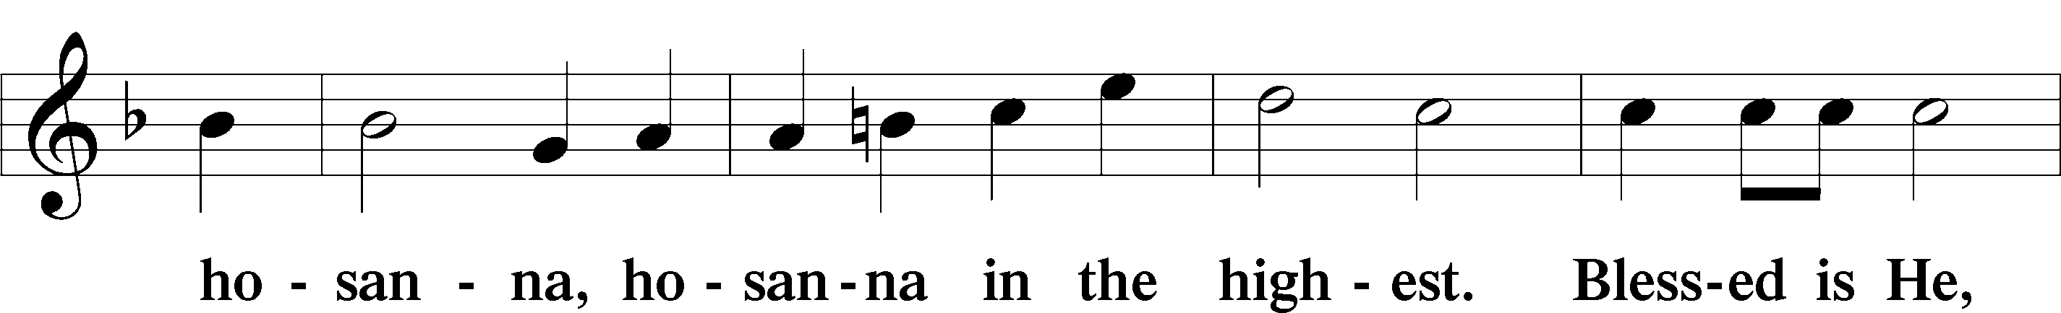
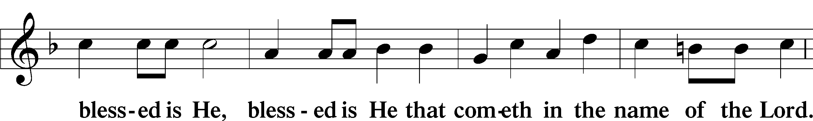
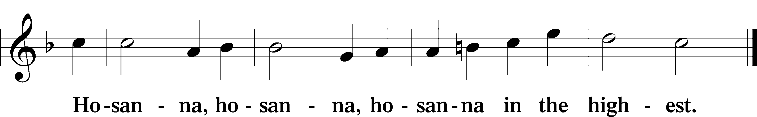

Lord’s Prayer The congregation is encouraged to silently pray the Lord’s Prayer as it is chanted. Matthew 6:9–13
P Our Father who art in heaven,
hallowed be Thy name,
Thy kingdom come,
Thy will be done on earth as it is in heaven;
give us this day our daily bread;
and forgive us our trespasses as we forgive those who trespass against us;
and lead us not into temptation,
but deliver us from evil.
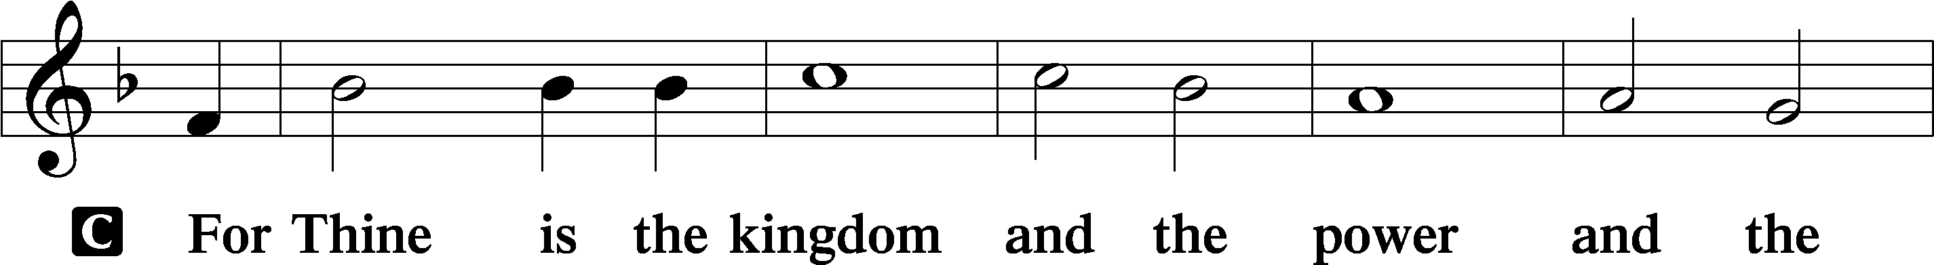
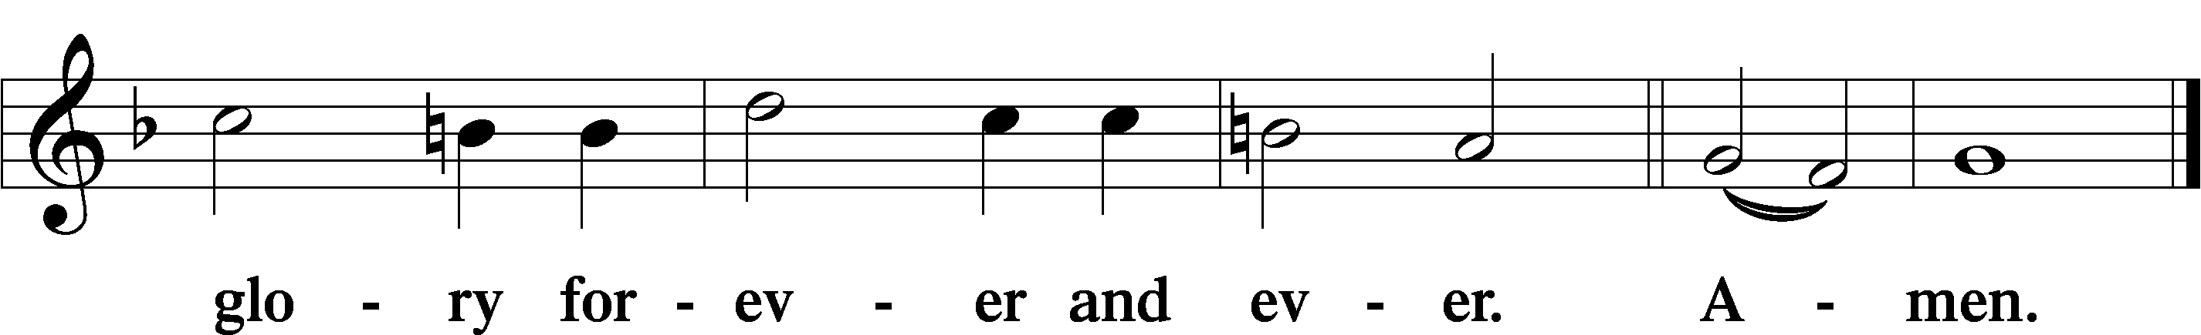

The Words of Our Lord Matthew 26:26–28; Mark 14:22–24; Luke 22:19–20; 1 Corinthians 11:23–25
P Our Lord Jesus Christ, on the night when He was betrayed, took bread, and when He had given thanks, He broke it and gave it to the disciples and said: “Take, eat; this is My T body, which is given for you. This do in remembrance of Me.”

In the same way also He took the cup after supper, and when He had given thanks, He gave it to them, saying: “Drink of it, all of you; this cup is the new testament in My T blood, which is shed for you for the forgiveness of sins. This do, as often as you drink it, in remembrance of Me.”

Pax Domini John 20:19
P The peace of the Lord be with you always.
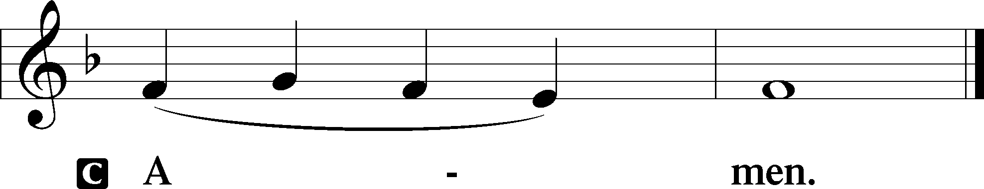

Agnus Dei John 1:29
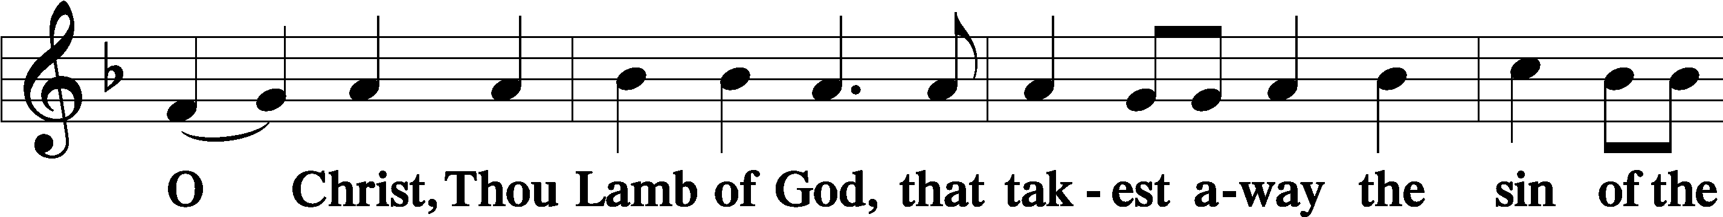
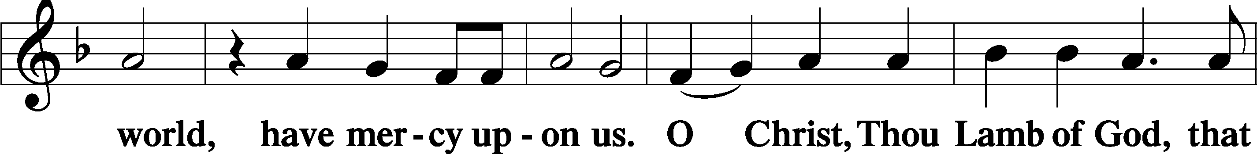
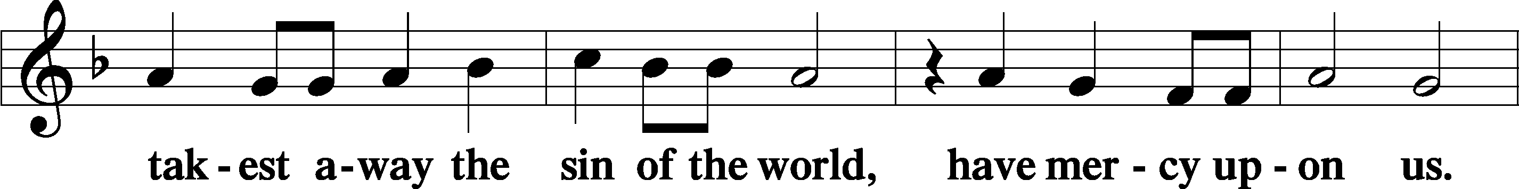
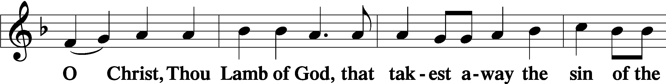
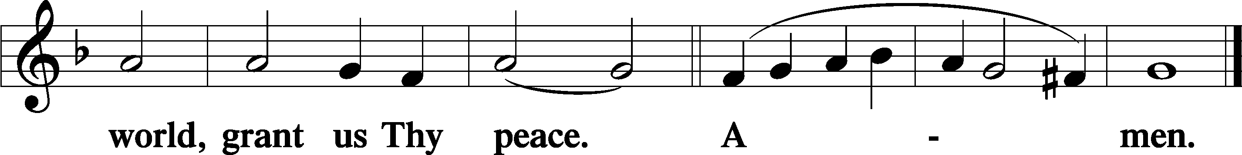
Sit

Distribution
The pastor and those who assist him receive the body and blood of Christ first and then distribute them to those who come to receive, saying:
Take, eat; this is the true body of our Lord and Savior Jesus Christ, given into death for your sins.
Amen.

Take, drink; this is the true blood of our Lord and Savior Jesus Christ, shed for the forgiveness of your sins.
Amen.

In dismissing the communicants, the following is said:
The Dismissal
P The body and blood of our Lord Jesus Christ strengthen and preserve you in body and soul to life everlasting. Depart T in peace.
C Amen.

Distribution Hymn: LSB #642 “O Living Bread from Heaven”

Distribution Hymn: LSB #336 “Lo! He Comes with Clouds Descending”

Distribution Hymn: LSB #756 “Why Should Cross and Trial Grieve Me”

Stand
Nunc Dimittis Luke 2:29–32
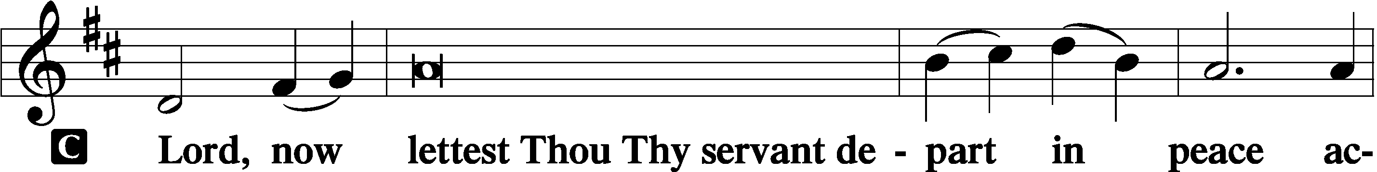
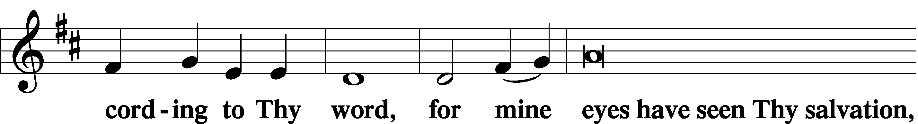
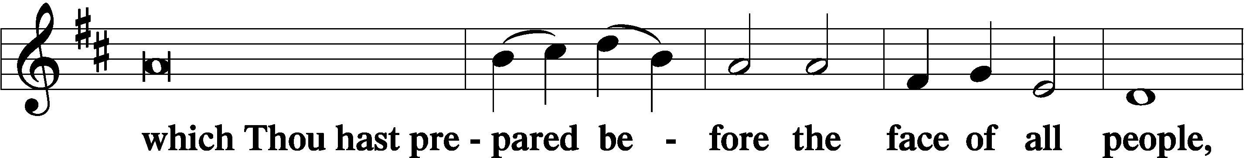
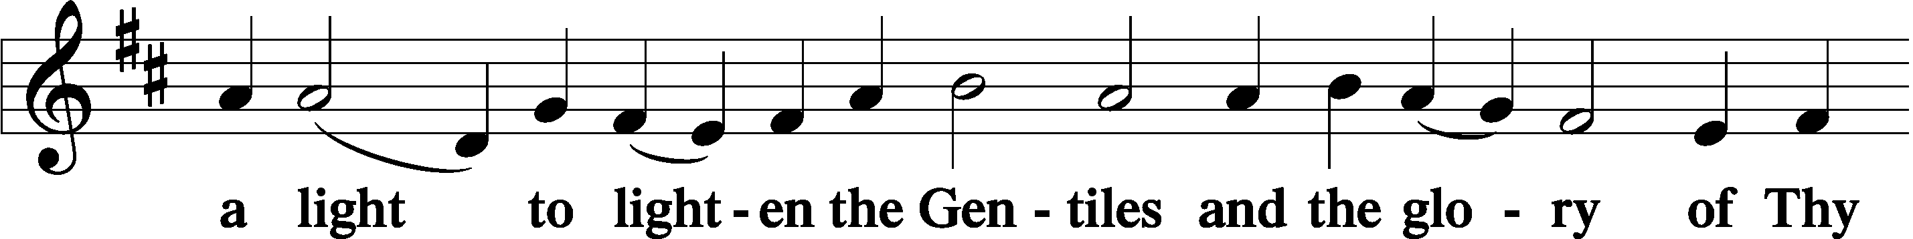
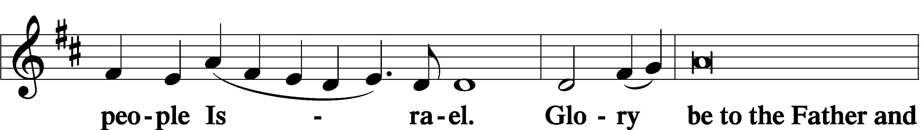
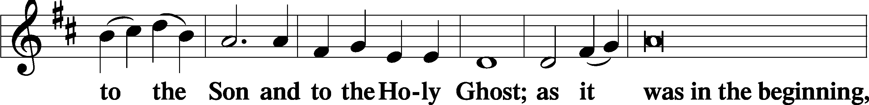
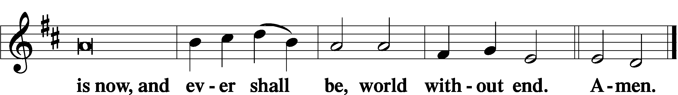

Thanksgiving Psalm 107:1
P O give thanks unto the Lord, for He is good,
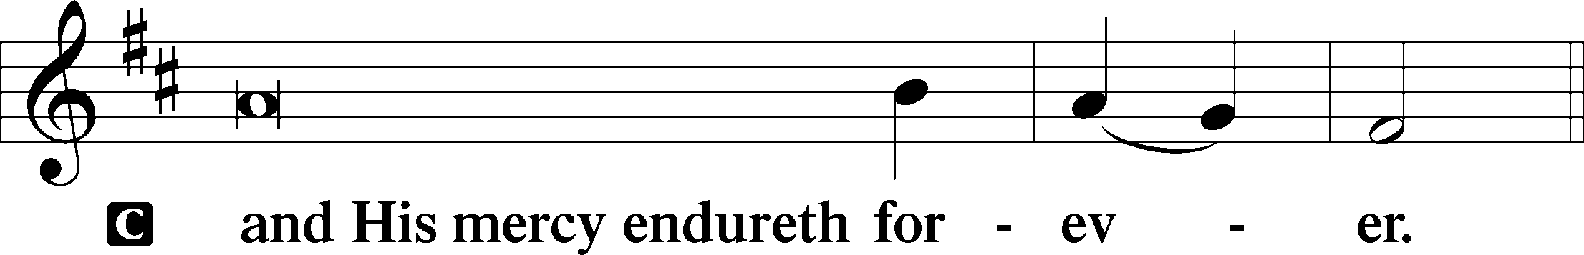

Post-Communion Collect
P Let us pray.
We give thanks to You, almighty God, that You have refreshed us through this salutary gift, and we implore You that of Your mercy You would strengthen us through the same in faith toward You and in fervent love toward one another; through Jesus Christ, Your Son, our Lord, who lives and reigns with You and the Holy Spirit, one God, now and forever.
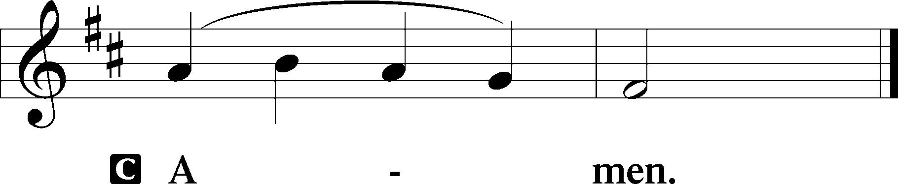

Salutation 2 Timothy 4:22
P The Lord be with you.
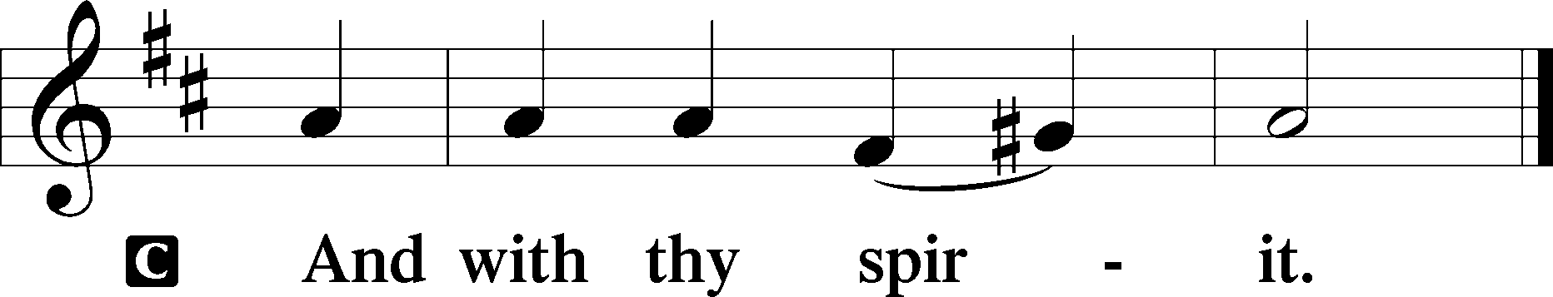

Benedicamus Psalm 103:1
P Bless we the Lord.
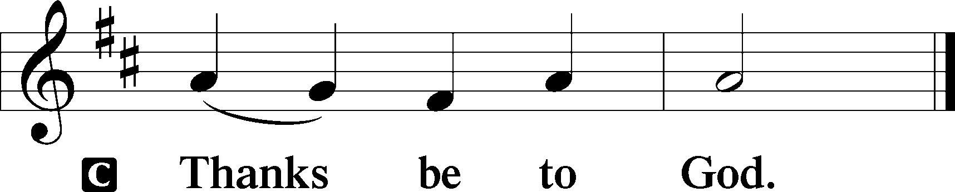

Benediction Numbers 6:24–26
P The Lord bless you and keep you.
The Lord make His face shine upon you and be gracious unto you.
The Lord lift up His countenance upon you and T give you peace.
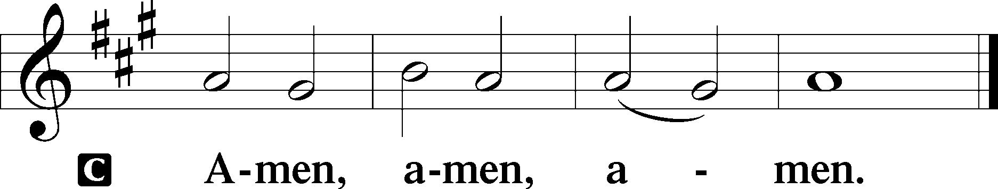

Closing Hymn: LSB #639 “Wide Open Stand the Gates”
fffffffffffffffffffffffffffffffffff
Silent prayer after worship: God of mercy and grace, lead me to be in Your Word and in prayer daily so that my faith will remain strong and I will have the confidence to share the Gospel with others. In Jesus’ name. Amen.
fffffffffffffffffffffffffffffffffff
Acknowledgments
Unless otherwise indicated, Scripture quotations are from the ESV® Bible (The Holy Bible, English Standard Version®), copyright © 2001 by Crossway, a publishing ministry of Good News Publishers. Used by permission. All rights reserved.
Created by Lutheran Service Builder © 2023 Concordia Publishing House.
fffffffffffffffffffffffffffffffffff
fffffffffffffffffffffffffffffffffff
In Loving Memory of my Husband, Robert Sulek on All Saints’ Day: Edeltraud Sulek (Capital Campaign).
In Loving Memory of Viola Sakony: Mr. & Mrs. Edward Zachar.

SCHEDULE THROUGH NOVEMBER 19, 2023:

:

Today, following Worship, Fellowship Hall: Coffee Fellowship
7 pm, Fellowship Hall: AA Meeting
Tuesday, 7-9 pm, Fellowship Hall: Penn-Ohio Singers
Wednesday, 7:30 pm, Fellowship Hall: NA Meeting
Thursday, 10 am, Fellowship Hall: Women’s Bible Study
Next Sunday, 8 am, Fellowship Hall: Bible Study
9 am, Sanctuary: Divine Service
Following Worship, Fellowship Hall: Finance Committee Meeting (New!)
7 pm, Fellowship Hall: AA Meeting
fffffffffffffffffffffffffffffffffff
Our Stewardship of Treasures for the Lord:
In order to do the Lord’s work, we need $2,553.63 each week to meet our 2023 budget for general purposes and $76.92 for the SELC.

Figures for Wednesday, November 1, 2023
General Fund: $700.00
SELC: $70.00
Quarterly Missions: $35.00
Figures for Sunday, November 5, 2023
General Fund: $1,949.00
SELC: $90.00
Quarterly Missions: $0.00
Capital Campaign: $285.00

For online giving, check out https://www.saintspeterandpaul.net/online-giving.
fffffffffffffffffffffffffffffffffff
THANK YOU FOR SERVING IN NOVEMBER: Elder: Jonathan Baisch; Ushers: Mark Kleindienst, Jerry Krivosh, & Gordon Marquette; Altarware ~ Sundays: (prior) Marie Flaugher (11.12) & Diane Riefstahl; (after) Evelyn Baisch & Arlene Sutton; Special Divine Services: Nov. 30th ~ Elizabeth Haenftling.
fffffffffffffffffffffffffffffffffff
Attendance: Sunday, November 5, 2023: 37
fffffffffffffffffffffffffffffffffff
Bible Memory Verses ~ Week of November 12th:
For Adults: But our citizenship is in heaven, and from it we await a Savior, the Lord Jesus Christ, who will transform our lowly body to be like his glorious body, by the power that enables him even to subject all things to himself.
Philippians 3:20-21
For Children: The King of kings and Lord of lords, who alone has immortality, to him be honor and eternal dominion. 1 Timothy 6:15-16
fffffffffffffffffffffffffffffffffff
It’s time to renew subscriptions for the “Lutheran Witness” magazine for 2024. The price has increased to $19.25. If wishing to renew, place a check made out to Sts. Peter & Paul’s in a pew envelope and label the envelope with your name and that it is for the LW. Please make sure to note any change in address with your renewal. Renewals are due on or before Sunday, November 19, 2023.

fffffffffffffffffffffffffffffffffff
Please join us in the Fellowship Hall following worship this morning for Coffee Fellowship! This month’s sponsors are Gordon & Rebecca Marquette. The 2024 Coffee Fellowship sheet has been posted in the narthex. If interested in being a sponsor, please bring 2-1/2—3 dozen “treats” to the Fellowship Hall kitchen prior to the worship service on the date selected along with a quart of juice. Coffee and coffee supplies will be provided along with set-up and clean-up.
fffffffffffffffffffffffffffffffffff
This morning is “Stock the Food Pantry” Sunday! Your financial contributions are greatly appreciated.
We would like to recognize and thank our Food Pantry team for all their work to keep this outreach program up and running! Congregation volunteers include April Bosnjak, Ana Deal (program director), Mike Flaugher, Jerry Krivosh, and Arlene Sutton. Also, special “thanks” to Pastor Deal, Vicar Wessel, and other volunteers for their help with the Food Pantry breakfast this past Thursday.
fffffffffffffffffffffffffffffffffff
Alex (Sasha) Carr wishes to thank everyone for their prayers and cards. He will be finishing this phase of his training with the U.S. Army over the next few weeks and wants everyone to know how much he appreciates their good wishes.
Remember the following in Prayer…
~The Hurting and Healing: Amy, Steve Antolovich, Ellen Baron^{CA}, Amy Blomenberg, Lois Bortner^{CA}, Sara Brubaker, Dee Bullock, Bev & Joe Chlpka, Susan Davies, Loretta Deal, Tim Dudash, Judith & Eddy Furey, Griffin, Austin Hamilton, Pastor Charles Henrickson, Joan, Keith Jozwiakowski, Darla Krajci, Barbara Kreske, Jess Lavoie, Paul Lucas^{CA}, Sandy Marshall, Frank Niemeyer^{CA}, Juanita Rentschler, Richard Reuning^{CA}, Nancy Robertson^{CA}, Kriss Svidro^{CA}, Rudy Tomko, Joel & Peggy Wasson, Angela Weser^{CA}, Betty Wolf, and Ruth Wolf.
~The Homebound: Anna Mae Daris, Millie Elavsky, Jean Tomko, and Ed & Millie Zachar.
~Celebrating this Week: Birthday: Jeff Sutton (11.12).
~Serving in the Military: Alex (Sasha) Carr, Duncan Vaupel, Curtis Sinewe, and Joshua Solyan.
~Community & World Needs: Those suffering due to the conflicts in the Middle East and between Ukraine and Russia; those suffering from loss and dislocation because weather disasters; those suffering from addiction and their families; Local, State, and National Government Leaders; safety for all Police Officers, Firefighters, & First Responders; the unemployed; our Fourth Quarter Local Mission: Willow Women’s Center.
*CA represents cancer.
fffffffffffffffffffffffffffffffffff
Important: The Voters’ Assembly previously scheduled for next Sunday (November 19th) has been moved to December 3rd. The Finance Committee will meet next Sunday following worship in the Fellowship Hall.
fffffffffffffffffffffffffffffffffff
Please note that there will be a Thanksgiving Eve Vesper Service Wednesday, November 22nd at 7 pm. Pastor Baisch will be leading this service.
fffffffffffffffffffffffffffffffffff
Items for the December calendar and newsletter are due to the secretary’s office by noon Monday, November 20th. Thank you!
fffffffffffffffffffffffffffffffffff
Advent Midweek Services will begin Wednesday, December 6th. Two services will be offered this year: a 10 am Matins Service and a 7 pm Vesper Service. This year’s theme will focus on Christ in the Old Testament, “The Seen Yahweh”.
Here to Serve
Pastor………………………………………………...……………Rev. Jacob Deal
E-mail …………………………….……pastordeal@saintspeterandpaul.net
Phone Number……………………..…………………724-347-3620 (Option 2)
Church Office………………………..…………………724-347-3620 (Option 3)
Website …………………………………………www.saintspeterandpaul.net
Secretary…………………………………………………………Diane Riefstahl
E-mail ………………………………………church@saintspeterandpaul.net
Website …………………………………………www.saintspeterandpaul.net
Food Pantry (email): ……………foodpantry@saintspeterandpaul.net
Congregation President………………………………….…Jonathan Baisch
Church Elder …………………………………………...……. Jonathan Baisch
Organist………………………………………………..….…Rebecca Marquette
AA Contact: Steve………………………………………………...…724-813-2358
NA Contact: Larry……………………………………..…………..724-977-8733
fffffffffffffffffffffffffffffffffff
If needing to get into the church building during the week, please phone first to make certain someone is here to let you in.

