Sts. Peter & Paul
Evangelical Lutheran Church
Lutheran Church-Missouri Synod
Founded-1917
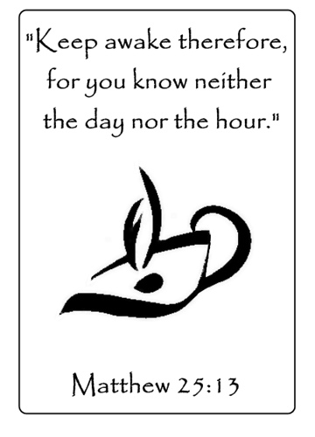
NOVEMBER 25, 2018

699 Stambaugh Avenue
Sharon, Pennsylvania 16146

“I was glad when they said to me,
Let us go to the house of the LORD!”
Psalm 122:1
Sts. Peter & Paul Evangelical Lutheran Church, LC-MS

LAST SUNDAY OF THE CHURCH YEAR
NOVEMBER 25, 2018

Silent prayer before worship: O King of kings and Lord of lords, strengthen my faith through Your Word and Sacrament. Lead me to worship You now without seeing You, so that I may later worship You as I see You in heaven. Through Jesus Christ. Amen.

CONFESSION AND ABSOLUTION
Opening Hymn: LSB #516 “Wake, Awake, for Night Is Flying”
Stand

The sign of the cross may be made by all in remembrance of their Baptism.

P In the name of the Father and of the T Son and of the Holy Spirit.
C Amen.

P Beloved in the Lord! Let us draw near with a true heart and confess our sins unto God our Father, beseeching Him in the name of our Lord Jesus Christ to grant us forgiveness.

P Our help is in the name of the Lord,
C who made heaven and earth.
P I said, I will confess my transgressions unto the Lord,
C and You forgave the iniquity of my sin.

Silence for reflection on God's Word and for self-examination.

P O almighty God, merciful Father,
C I, a poor, miserable sinner, confess unto You all my sins and iniquities with which I have ever offended You and justly deserved Your temporal and eternal punishment. But I am heartily sorry for them and sincerely repent of them, and I pray You of Your boundless mercy and for the sake of the holy, innocent, bitter sufferings and death of Your beloved Son, Jesus Christ, to be gracious and merciful to me, a poor, sinful being.

P Upon this your confession, I, by virtue of my office, as a called and ordained servant of the Word, announce the grace of God unto all of you, and in the stead and by the command of my Lord Jesus Christ I forgive you all your sins in the name of the Father and of the T Son and of the Holy Spirit.
C Amen.

Passing of the Peace.
SERVICE OF THE WORD
Introit: Ps. 39:4–5, 7– 8; antiphon: Is. 35:10
The ransomed of the Lord shall return and come to Zion with | singing;*
everlasting joy shall be up- | on their heads.
They shall obtain glad- | ness and joy,*
and sorrow and sighing shall | flee away.
O Lord, make me know my end and what is the measure | of my days;*
let me know how fleeting | I am!
Behold, you have made my days a few handbreadths, and my lifetime is as nothing be- | fore you.*
Surely all mankind stands as a | mere breath!
And now, O Lord, for what | do I wait?*
My hope | is in you.
Deliver me from all my trans- | gressions.*
Do not make me the scorn | of the fool!
Gloria Patri
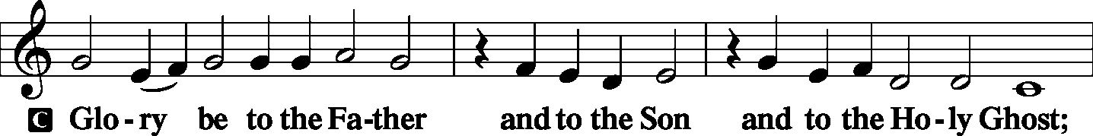
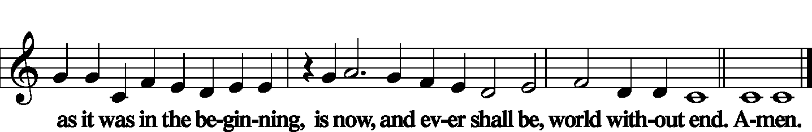

Kyrie
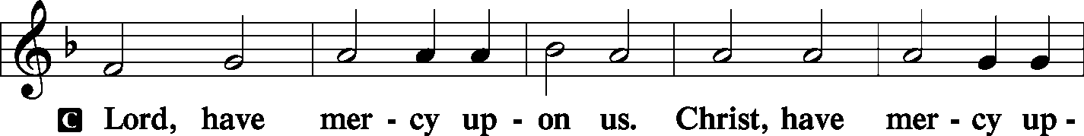
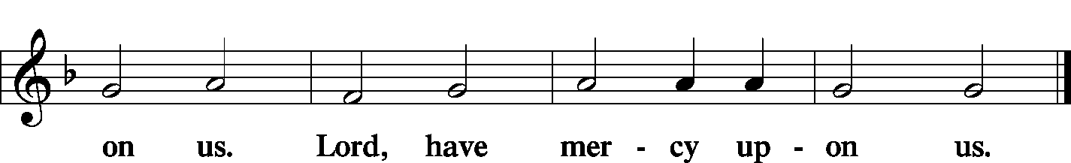

Gloria in Excelsis
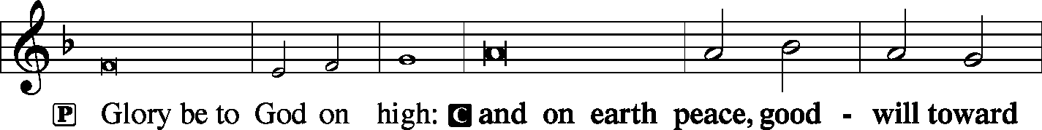
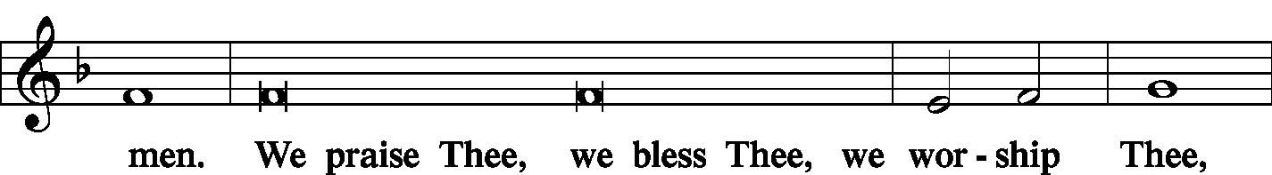
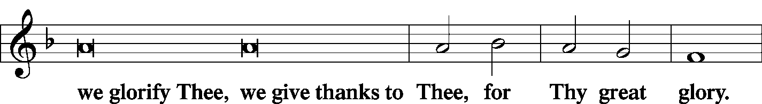
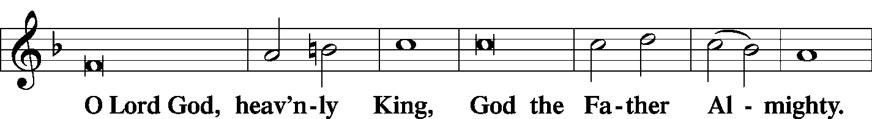
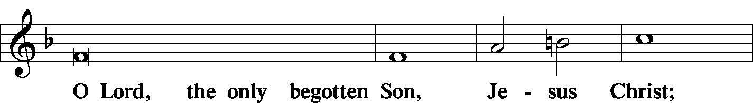
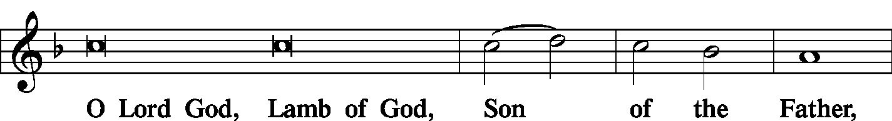
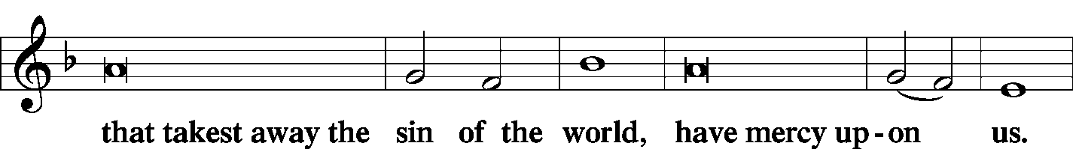
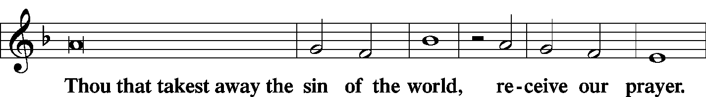
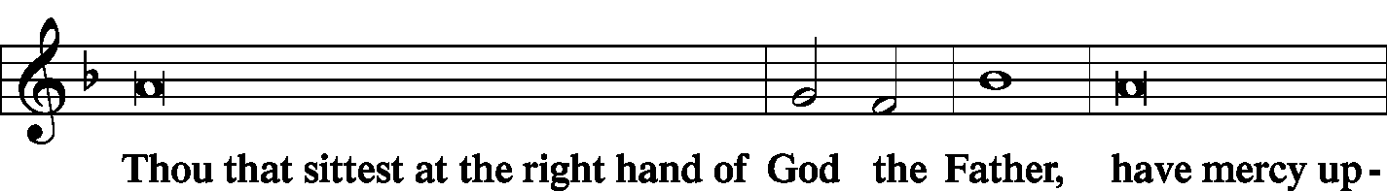
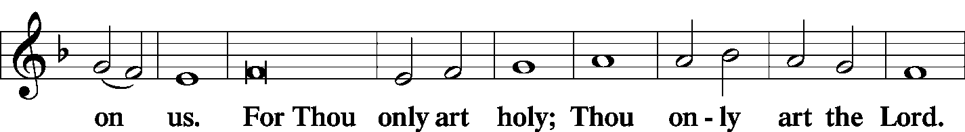
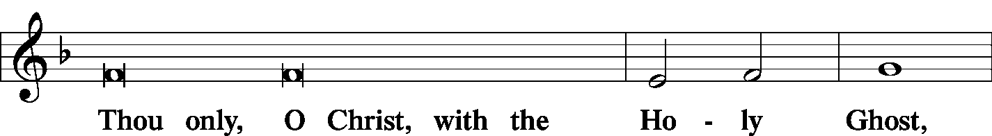
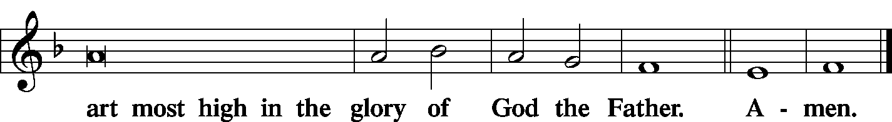

Salutation and Collect of the Day
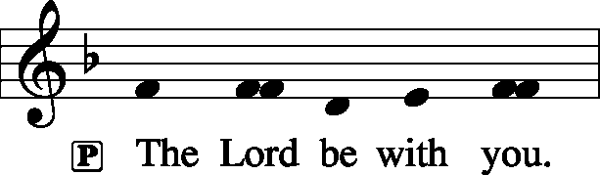
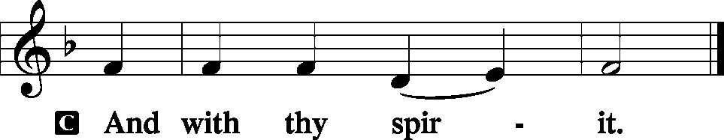

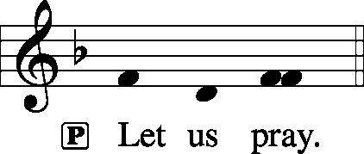

P O Lord, absolve Your people from their offenses that, from the bonds of our sins which by reason of our frailty we have brought upon ourselves, we may be delivered by Your bountiful goodness; through Jesus Christ, Your Son, our Lord, who lives and reigns with You and the Holy Spirit, one God, now and forever.
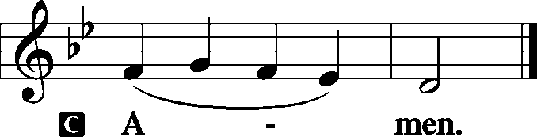

Sit

Old Testament Reading: Isaiah 65:17–25
“For behold, I create new heavens
and a new earth,
and the former things shall not be remembered
or come into mind.
But be glad and rejoice forever
in that which I create;
for behold, I create Jerusalem to be a joy,
and her people to be a gladness.
I will rejoice in Jerusalem
and be glad in my people;
no more shall be heard in it the sound of weeping
and the cry of distress.
No more shall there be in it
an infant who lives but a few days,
or an old man who does not fill out his days,
for the young man shall die a hundred years old,
and the sinner a hundred years old shall be accursed.
They shall build houses and inhabit them;
they shall plant vineyards and eat their fruit.
They shall not build and another inhabit;
they shall not plant and another eat;
for like the days of a tree shall the days of my people be,
and my chosen shall long enjoy the work of their hands.
They shall not labor in vain
or bear children for calamity,
for they shall be the offspring of the blessed of the Lord,
and their descendants with them.
Before they call I will answer;
while they are yet speaking I will hear.
The wolf and the lamb shall graze together;
the lion shall eat straw like the ox,
and dust shall be the serpent’s food.
They shall not hurt or destroy
in all my holy mountain,”
says the Lord.
P This is the Word of the Lord.
C Thanks be to God.

Gradual: Ps. 45:14–15
In many-colored robes [the king’s daughter] is led to the king,
with her virgin companions following behind her.
With joy and gladness they are led along
as they enter the palace of the king.

Epistle: 1 Thessalonians 5:1–11
Now concerning the times and the seasons, brothers, you have no need to have anything written to you. For you yourselves are fully aware that the day of the Lord will come like a thief in the night. While people are saying, “There is peace and security,” then sudden destruction will come upon them as labor pains come upon a pregnant woman, and they will not escape. But you are not in darkness, brothers, for that day to surprise you like a thief. For you are all children of light, children of the day. We are not of the night or of the darkness. So then let us not sleep, as others do, but let us keep awake and be sober. For those who sleep, sleep at night, and those who get drunk, are drunk at night. But since we belong to the day, let us be sober, having put on the breastplate of faith and love, and for a helmet the hope of salvation. For God has not destined us for wrath, but to obtain salvation through our Lord Jesus Christ, who died for us so that whether we are awake or asleep we might live with him. Therefore encourage one another and build one another up, just as you are doing.
P This is the Word of the Lord.
C Thanks be to God.

Stand
Alleluia Verse and Alleluia
P Alleluia. I saw the holy city, new Jerusalem, coming down out of heaven from God, prepared as a bride adorned for her husband. Alleluia.

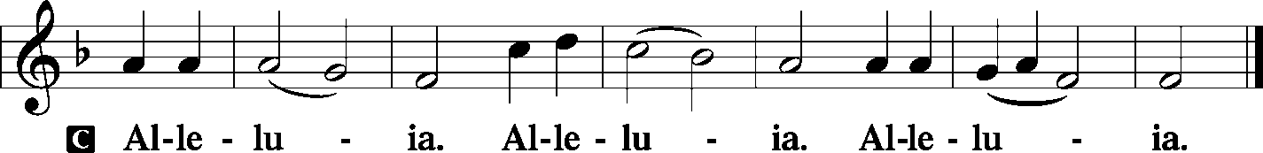

Holy Gospel: Matthew 25:1–13
P The Holy Gospel according to St. Matthew, the twenty-fifth chapter.

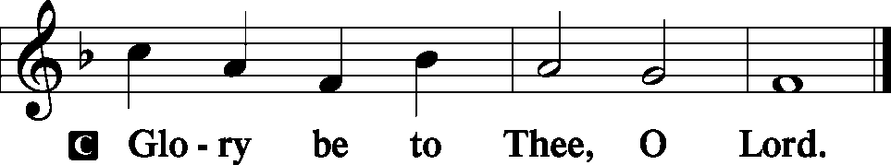

“Then the kingdom of heaven will be like ten virgins who took their lamps and went to meet the bridegroom. Five of them were foolish, and five were wise. For when the foolish took their lamps, they took no oil with them, but the wise took flasks of oil with their lamps. As the bridegroom was delayed, they all became drowsy and slept. But at midnight there was a cry, ‘Here is the bridegroom! Come out to meet him.’ Then all those virgins rose and trimmed their lamps. And the foolish said to the wise, ‘Give us some of your oil, for our lamps are going out.’ But the wise answered, saying, ‘Since there will not be enough for us and for you, go rather to the dealers and buy for yourselves.’ And while they were going to buy, the bridegroom came, and those who were ready went in with him to the marriage feast, and the door was shut. Afterward the other virgins came also, saying, ‘Lord, lord, open to us.’ But he answered, ‘Truly, I say to you, I do not know you.’ Watch therefore, for you know neither the day nor the hour.

P This is the Gospel of the Lord.
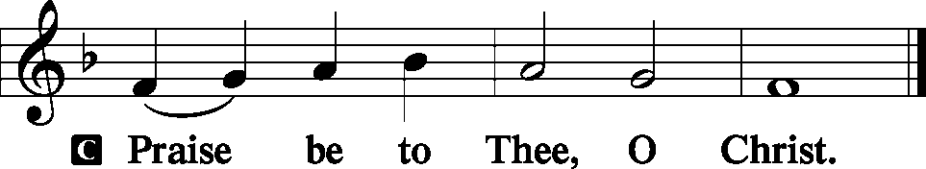

Nicene Creed
C I believe in one God,
the Father Almighty,
maker of heaven and earth
and of all things visible and invisible.
And in one Lord Jesus Christ,
the only-begotten Son of God,
begotten of His Father before all worlds,
God of God, Light of Light,
very God of very God,
begotten, not made,
being of one substance with the Father,
by whom all things were made;
who for us men and for our salvation came down from heaven
and was incarnate by the Holy Spirit of the virgin Mary
and was made man;
and was crucified also for us under Pontius Pilate.
He suffered and was buried.
And the third day He rose again according to the Scriptures
and ascended into heaven
and sits at the right hand of the Father.
And He will come again with glory to judge both the living and the dead,
whose kingdom will have no end.

And I believe in the Holy Spirit,
the Lord and giver of life,
who proceeds from the Father and the Son,
who with the Father and the Son together is worshiped and glorified,
who spoke by the prophets.
And I believe in one holy Christian and apostolic Church,
I acknowledge one Baptism for the remission of sins,
and I look for the resurrection of the dead
and the life T of the world to come. Amen.
Sit

Hymn of the Day: “Lo, He Comes on Clouds Descending” (sung to the tune of LSB #621)
Lo, he comes with clouds descending,
Once for ev’ry sinner slain;
Thousand thousand saints attending
Swell the triumph of his train:
Alleluia, alleluia!
Christ the Lord returns to reign.

Ev’ry eye shall now behold him
Robed in glorious majesty;
Those who set at nought and sold him,
Pierced and nailed him to the tree,
Deeply wailing, deeply wailing,
Shall their true Messiah see.

Those dear tokens of his Passion
Still his dazzling body bears,
Cause of endless exultation
To his ransomed worshipers.
With what rapture, with what rapture
Gaze we on those glorious scars!

Yea, amen, let all adore thee,
High on thine eternal throne;
Savior, take the pow’r and glory,
Claim the kingdom for thine own.
Alleluia, alleluia!
Thou shalt reign, and thou alone!

Sermon
Stand

P The peace of God, which passes all understanding, keep your hearts and minds in Christ Jesus.
C Amen.

Prayer of the Church
Sit

Offertory
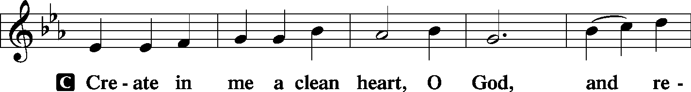
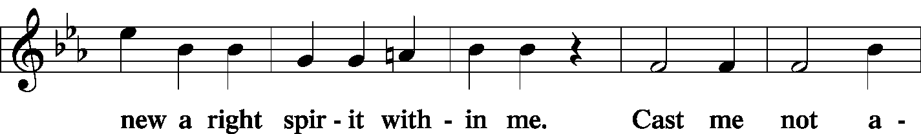
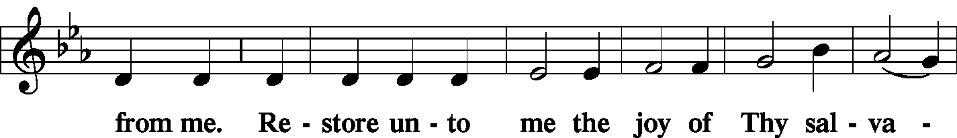
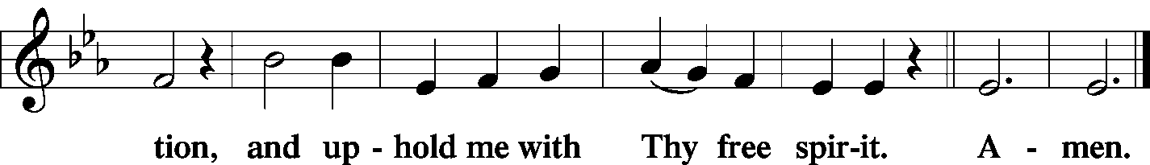

Offering/Offering Hymn: LSB #602 “The Gifts Christ Freely Gives”
Stand
SERVICE OF THE SACRAMENT
Preface
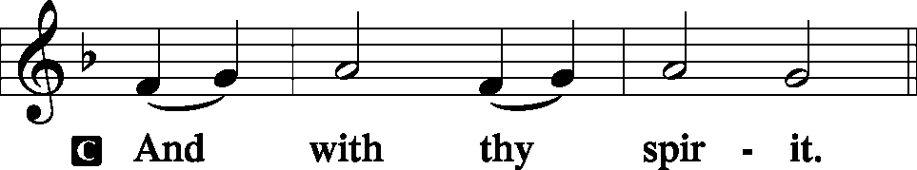
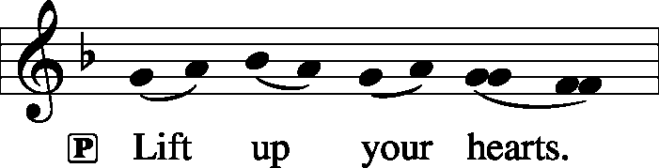

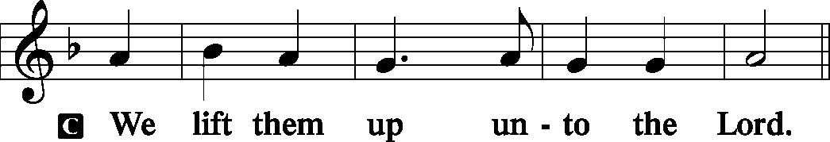

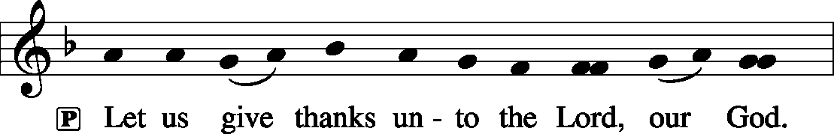

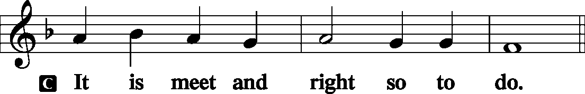

P It is truly meet, right, and salutary . . . evermore praising You and saying:
Sanctus
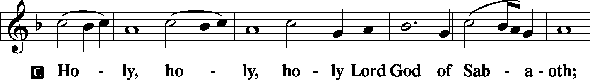
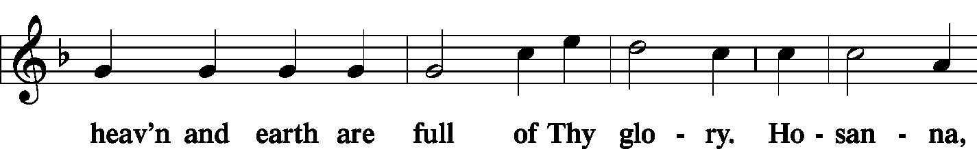
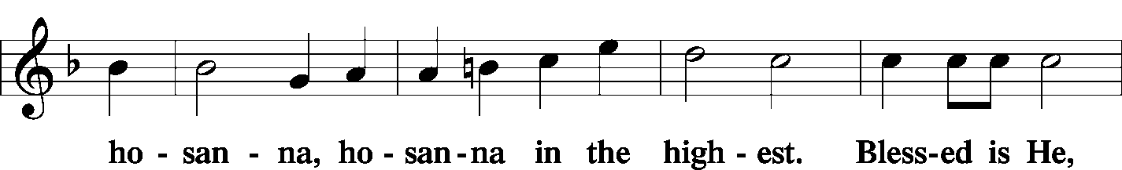
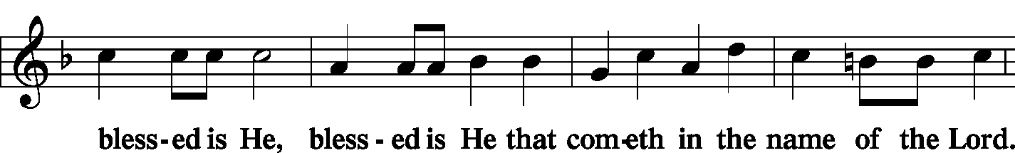
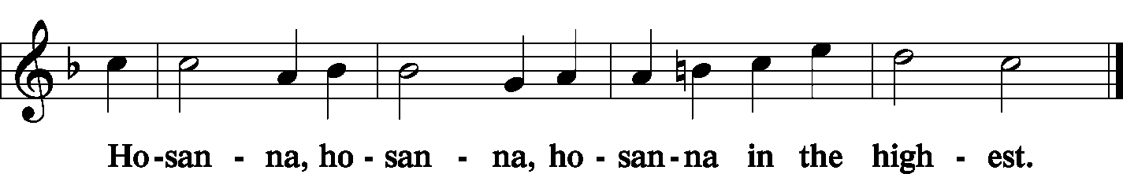

Lord's Prayer
P Lord, remember us in Your kingdom and teach us to pray:
C Our Father who art in heaven,
hallowed be Thy name,
Thy kingdom come,
Thy will be done on earth as it is in heaven;
give us this day our daily bread;
and forgive us our trespasses as we forgive those who trespass against us;
and lead us not into temptation,
but deliver us from evil.
For Thine is the kingdom and the power and the glory forever and ever. Amen.

The Words of Our Lord
P Our Lord Jesus Christ, on the night when He was betrayed, took bread, and when He had given thanks, He broke it and gave it to the disciples and said: “Take, eat; this is My T body, which is given for you. This do in remembrance of Me.”

P In the same way also He took the cup after supper, and when He had given thanks, He gave it to them, saying: “Drink of it, all of you; this cup is the new testament in My T blood, which is shed for you for the forgiveness of sins. This do, as often as you drink it, in remembrance of Me.”
Pax Domini
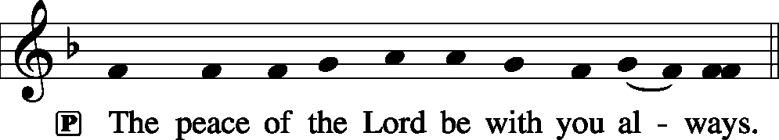

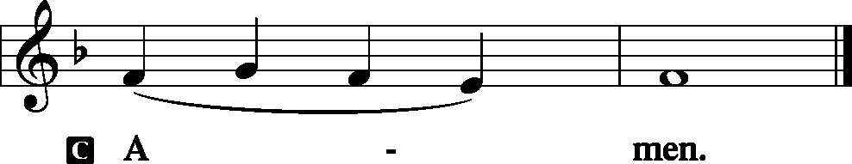
Agnus Dei
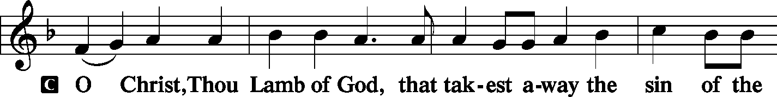
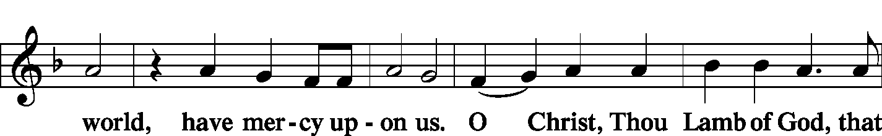
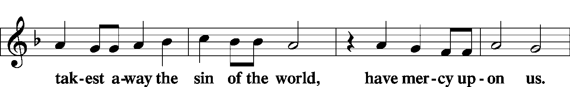
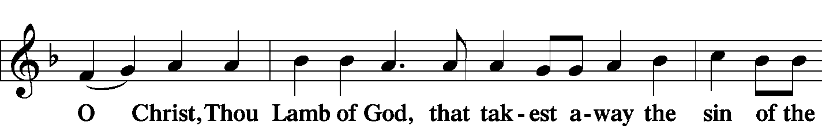
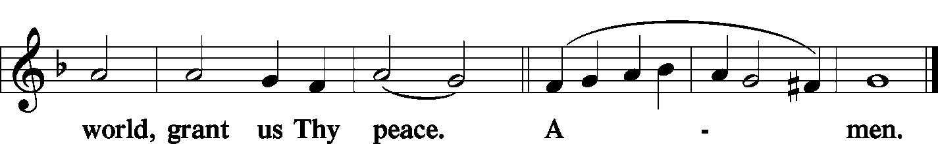
Sit

Distribution
The pastor and those who assist him receive the body and blood of Christ first and then distribute them to those who come to receive, saying:

Take, eat; this is the true body of our Lord and Savior Jesus Christ, given into death for your sins.
Amen.

Take, drink; this is the true blood of our Lord and Savior Jesus Christ, shed for the forgiveness of your sins.
Amen.

In dismissing the communicants, the following is said:

P The body and blood of our Lord Jesus Christ strengthen and preserve you in body and soul to life everlasting. Depart T in peace.
C Amen.

Distribution Hymn: LSB #617 “O Lord, We Praise Thee”
Stand

Post-Communion Canticle: Nunc Dimittis
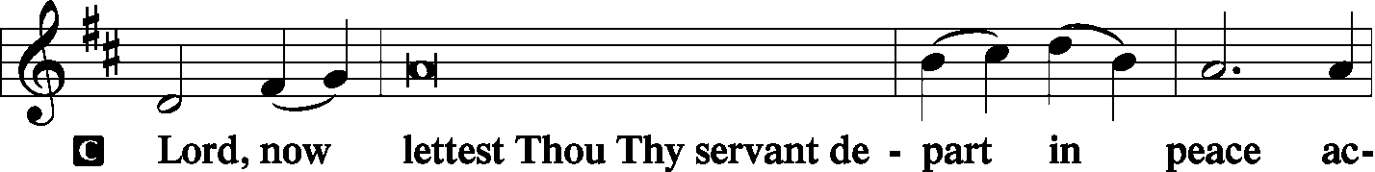
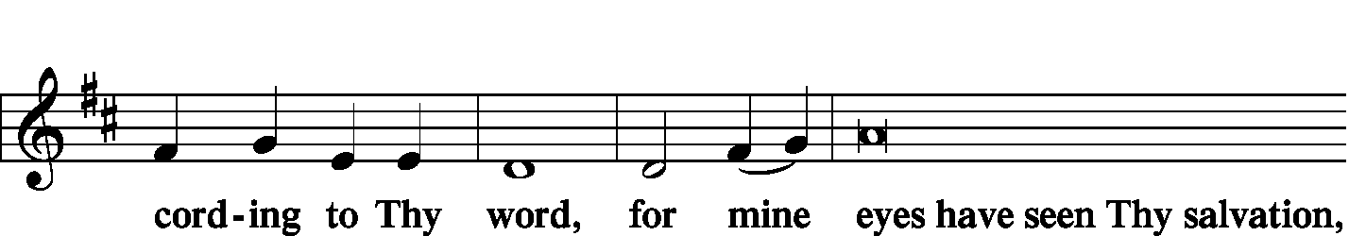
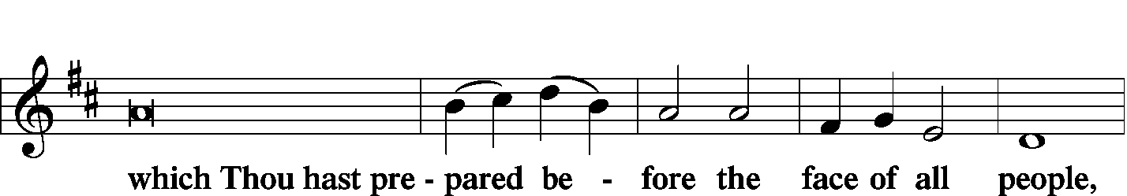
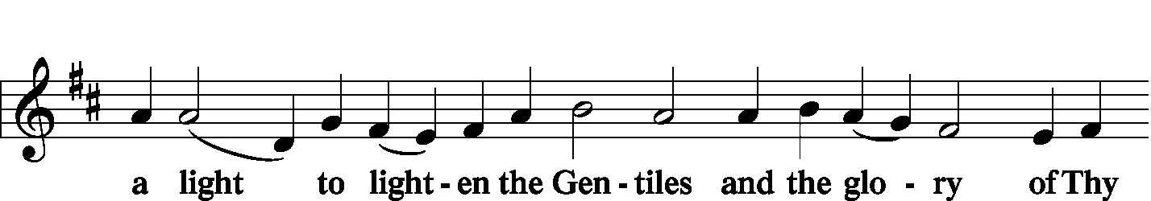
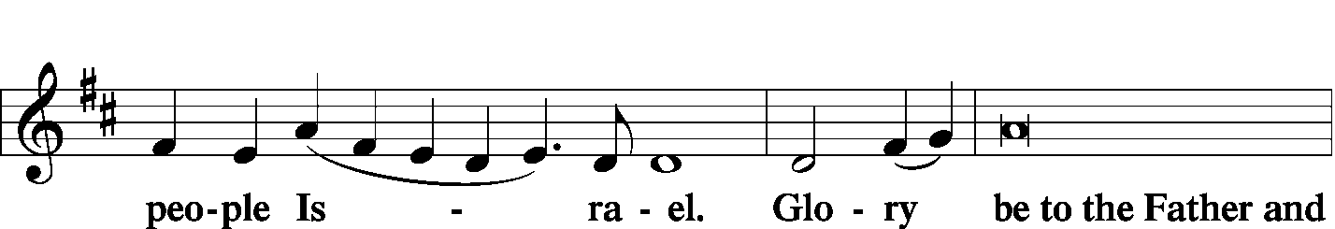
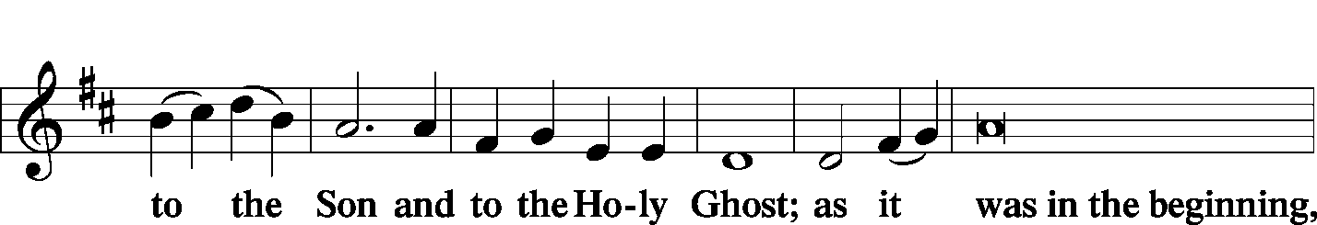
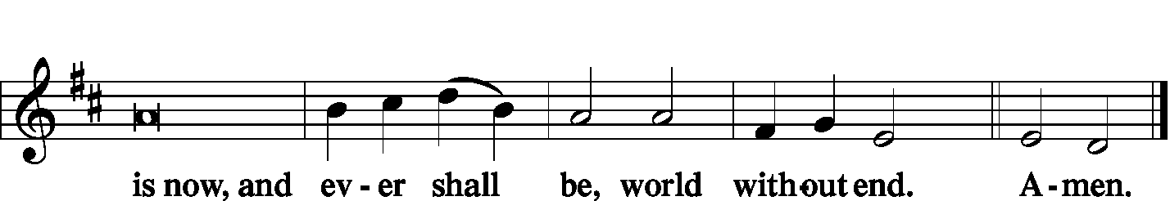

Thanksgiving
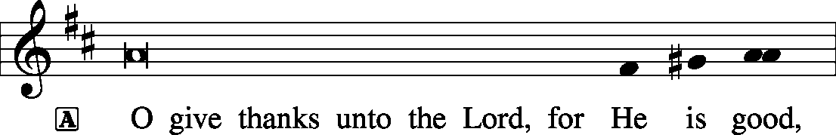
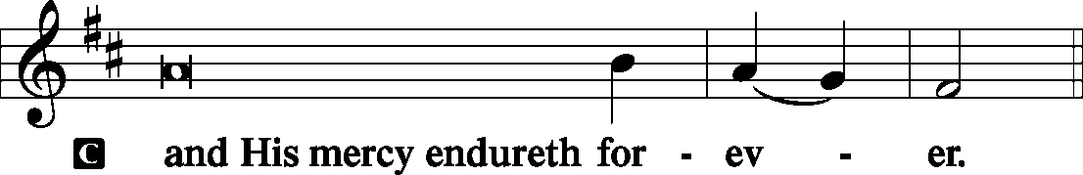

P Let us pray.
We give thanks to You, almighty God, that You have refreshed us through this salutary gift, and we implore You that of Your mercy You would strengthen us through the same in faith toward You and fervent love toward one another; through Jesus Christ, Your Son, our Lord, who lives and reigns with You and the Holy Spirit, one God, now and forever.
Salutation and Benedicamus
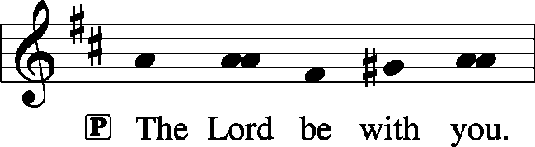

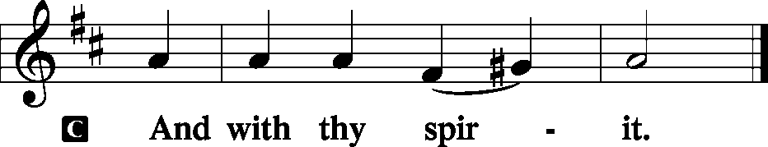
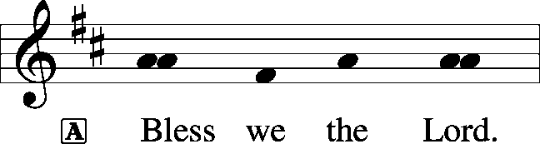

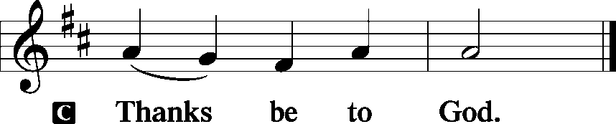

Benediction
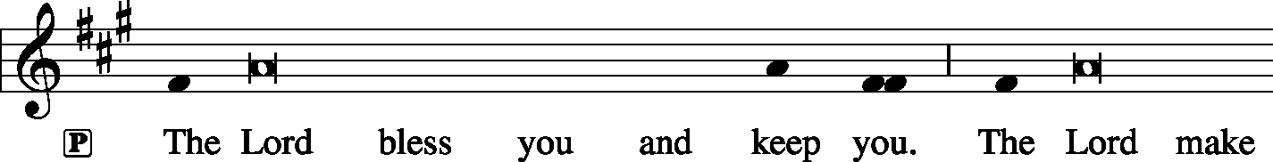
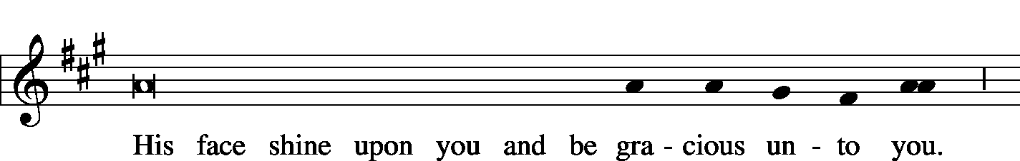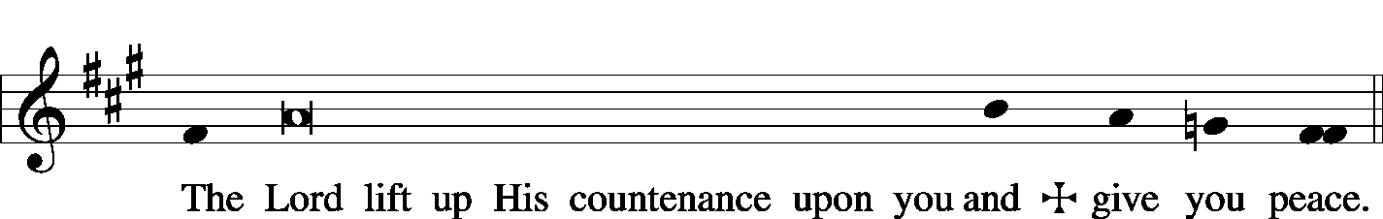

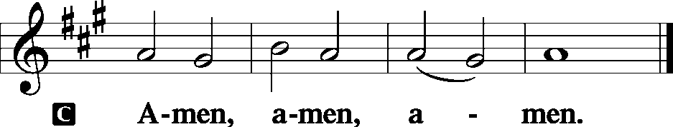

Closing Hymn: LSB #395 “O Morning Star, How Fair and Bright”
Silent prayer after worship: Lord Jesus, cause me to worship You in all I do and say. Lead me to focus my heart on You now, so I may focus my eyes on You when You return to carry me home to heaven. Amen.

Acknowledgments: Divine Service, Setting Three from Lutheran Service Book Unless otherwise indicated, all scripture quotations are from The Holy Bible, English Standard Version, copyright © 2001 by Crossway Bibles, a division of Good News Publishers. Used by permission. All rights reserved. Created by Lutheran Service Builder © 2006 Concordia Publishing House. CCLI License #3029-446


In Loving Memory of Mother, Betty Petro: Patty Parker

The Altar Flowers this morning are given anonymously to the Glory of God! We sincerely appreciate this generous gift!

Attendance:
Sunday, November 18, 2018………………………………………………………44
Wednesday, November 14, 2018.…………………………………………..…….37

SCHEDULE FOR TODAY THROUGH DEC. 2nd:
:

:

Today, 7 pm, Downstairs….…………………..….……………………………..…..……AA Meeting
Wednesday, 7 pm, Chapel…………………………………………..………..…..……Divine Service
Thursday, 5:30 pm, Sanctuary……………………………………………………….…Choir Practice
Next Sunday, 8:45 am, Downstairs………………………….…………….…………….Bible Study
10 am, Sanctuary…......................................................................Divine Service
Following Worship, Downstairs……………………….Voters’ Meeting Assembly
7 pm, Downstairs………………………………………………………..…....……AA Meeting

Thank You for Serving in November:
Today’s Greeters: Barry & Chris Nelson. Assisting Elders: John Dyll & Bob Sulek. Ushers: Bob Sulek, Gerald Arthur, Anson Holcroft, Cheryl Fedele, & Tom Zachar. Altarware: Viola Sakony & Anne Colt.

Thank You for Serving in December:
Assisting Elders: Ralph Dorman & John Dyll. Ushers: John Dyll, Ed Zachar, Barry Nelson, Jerome Thomas, Gary Burns. Altarware: Cheryl Fedele & Traudi Sulek.
Greeters: 2~Rev. Ed & Irene Kucera; 9~Anna Mae Daris & Millie Elavsky; 16~Cheryl Fedele & Clara Krivosh; 23~Matt & Cathy Berent; 24~Anson & Henrietta Holcroft; 25~Dolores Fee & Diane Riefstahl; 30~Jeff & Stacy Brandes; 31~Gary & Eileen Burns.

Bible Memory Verses:
For Children: Stay dressed for action and keep your lamps burning.
Luke 12:35
For Adults: But since we belong to the day, let us be sober, having put on the breastplate of faith and love, and for a helmet the hope of salvation.
1 Thessalonians 5:8

Remember the following in Prayer…
~The Hurting and Healing: Tony⁴, Lois Bortner^{CA}, Jeff Brandes³, Richard Brandes³, Eileen Burns³, Ed Colt², Ana Deal³, John Dyll³, Norma Ferringer¹, Anson Holcroft⁴, Betty Knauff^{CA}, Regis Knauff¹, Jess Lavoie³, Paul Lucas^{CA}, Barry Nelson¹, David Nelson¹,Tom Mulligan^{CA}, Iona Oltman^{CA}, Rudy Pinal^{CA}, Richard Reuning^{CA}, Viola Sakony², Scott^{CA}, and Angela Weser^{CA}.
~Our Homebound: Helen Bender, Dan Davis, Edna Krajci, Mary Ann Krajci, Sophie Mihm, Marion & Gene Roberts, Barbara Vasconi, and Joanne Wolfe.
~Those Celebrating: Birthday~Ed Zachar (11.25), Elizabeth Shreffler (11.26), Paul Andolina (11.29), and Barb Vasconi (12.02).
~Serving in the Military: Clayton Drnek, Curtis Sinewe, and Joshua Solyan.
~Community & World Needs: Victims of violence and terrorism; those suffering from loss and dislocation because weather disasters; those suffering from addiction and their families; safety for teachers, staff, and students; Local, State, and National Government Leaders; Safety for all Police Officers, Firefighters, & First Responders; the unemployed; our Fourth Quarter Local Mission: Willow Women’s Center.
*CA represents cancer; number after other names represents weeks on the prayer list. After 4 weeks names may be resubmitted. This helps us to remember people’s specific needs and reminds us that God is providing healing as people get better and no longer need our prayers. Please submit prayer requests in writing to the church office.
Please keep those listed above in your prayers.

Our Stewardship of Treasures for the Lord:
In order to do the Lord’s work, we need $2,843.00* each week to meet our 2018 budget for general purposes and $99.00 for missions.
Sunday, November 18 and Wednesday, November 14, 2018:
General Offering:…..…..………..................................................$1,529.90
Ahead this week*: +$701.90 *Includes Preschool.
SELC Missions:……….………..…..…..............................................$100.00
Ahead this week: +$1.00
Preschool Tuition Payments……………...…..............................…$2,015.00
Other Offerings:………….…….…........................……………...…$119.00
Here to Serve You…

Pastor………………………………………………….………..…Rev. Jacob Deal
E-mail ……….…………………….…..pastordeal@saintspeterandpaul.net
Phone Number…………..……………………………724-347-3620 (Option 2)
Church Office………………………………….………724-347-3620 (Option 3)
Website ……….………………….……...…….www.saintspeterandpaul.net
Secretary………………………………………………….……. Diane Riefstahl
E-mail ……….…………………….…….…church@saintspeterandpaul.net
Food Pantry: John Dyll…………….……………………..…..…724-347-1779
Little People Preschool…………….……………….724-347-3620 (Option 4)
Teacher: Paula Ostheimer………….………………….…….....724-981-5846
Email ……….………….…………………….paula@saintspeterandpaul.net
AA Contact: Steve……………………….…………..……...……. 724-813-2358
Organist……………………………………………………..…Carrie Yasnowski
Choir Director……………..…………….…………..….….………Chris Nelson
Congregational President……………………..…..….…………Jeff Brandes

During Advent, the Secretary’s office hours will be open Monday and Wednesday (8:30-5:00) and Fridays, as needed. Pastor Deal will be in the office Monday through Thursday unless ministering off-site. If you need to enter the Church, please call ahead to be sure someone is here to let you in. Thank you.

