Sts. Peter & Paul
Evangelical Lutheran Church
Lutheran Church-Missouri Synod
Founded-1917

NOVEMBER 18, 2018

699 Stambaugh Avenue
Sharon, Pennsylvania 16146

“I was glad when they said to me,
Let us go to the house of the LORD!”
Psalm 122:1
Sts. Peter & Paul Evangelical Lutheran Church, LC-MS

SECOND LAST SUNDAY OF THE CHURCH YEAR
NOVEMBER 18, 2018

Silent prayer before worship: Lord Jesus, help me to always remember that nothing can take me away from You. Enable me to stand firm in my faith so I will never fall away but will always be sure of my salvation through You alone. Amen.

CONFESSION AND ABSOLUTION
Opening Hymn: LSB #607 “From Depths of Woe I Cry to Thee”
Stand

The sign of the cross may be made by all in remembrance of their Baptism.

P In the name of the Father and of the T Son and of the Holy Spirit.
C Amen.

P Beloved in the Lord! Let us draw near with a true heart and confess our sins unto God our Father, beseeching Him in the name of our Lord Jesus Christ to grant us forgiveness.

P Our help is in the name of the Lord,
C who made heaven and earth.
P I said, I will confess my transgressions unto the Lord,
C and You forgave the iniquity of my sin.

Silence for reflection on God's Word and for self-examination.

P O almighty God, merciful Father,
C I, a poor, miserable sinner, confess unto You all my sins and iniquities with which I have ever offended You and justly deserved Your temporal and eternal punishment. But I am heartily sorry for them and sincerely repent of them, and I pray You of Your boundless mercy and for the sake of the holy, innocent, bitter sufferings and death of Your beloved Son, Jesus Christ, to be gracious and merciful to me, a poor, sinful being.

P Upon this your confession, I, by virtue of my office, as a called and ordained servant of the Word, announce the grace of God unto all of you, and in the stead and by the command of my Lord Jesus Christ I forgive you all your sins in the name of the Father and of the T Son and of the Holy Spirit.
C Amen.

Passing of the Peace.
SERVICE OF THE WORD
Introit: Ps. 54: 3-5, 7; antiphon: Ps. 54: 1-2
O God, save me, | by your name,*
and vindicate me | by your might.
O God, | hear my prayer;*
give ear to the words | of my mouth.
For strangers have risen a-| gainst me;*
they do not set God be- | fore themselves.
Behold, God is my | helper;*
the Lord is the upholder | of my life.
He will return the evil to my | enemies;*
in your faithfulness put an | end to them.
For he has delivered me from every | trouble,*
and my eye has looked in triumph on my | enemies.
Gloria Patri
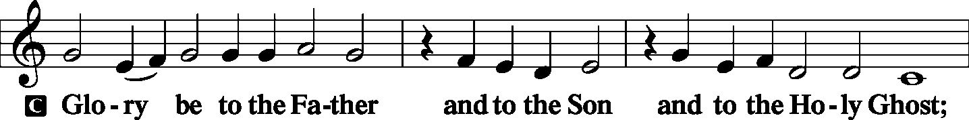
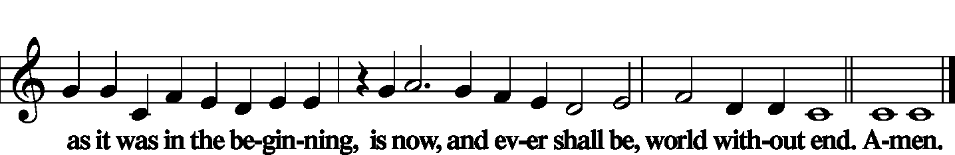

Kyrie
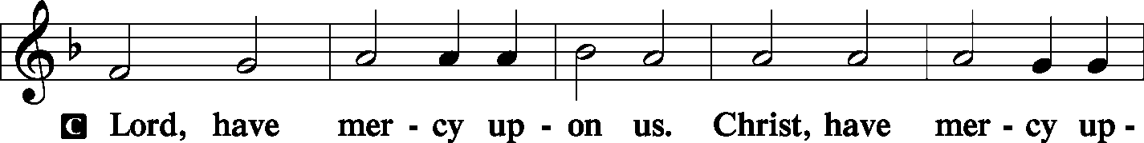
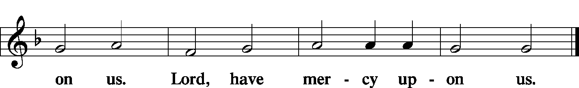

Gloria in Excelsis
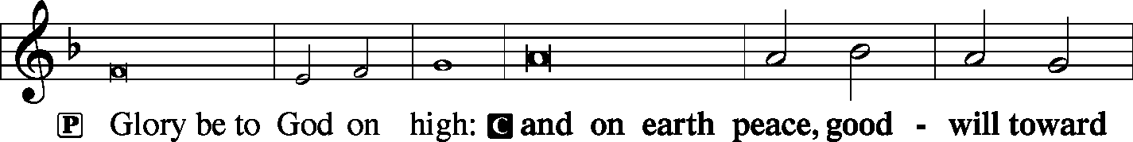
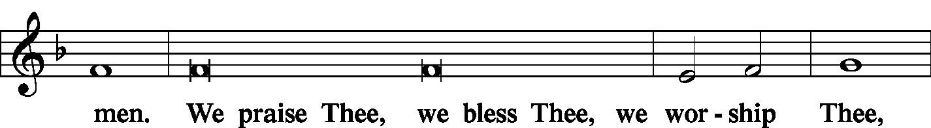
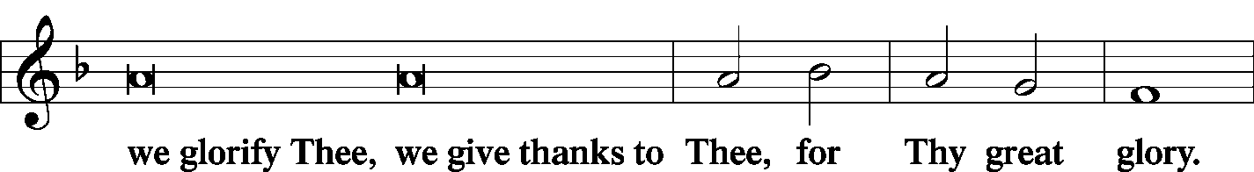
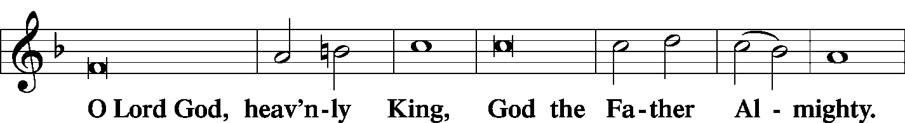
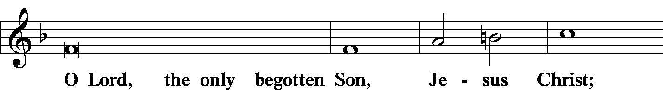
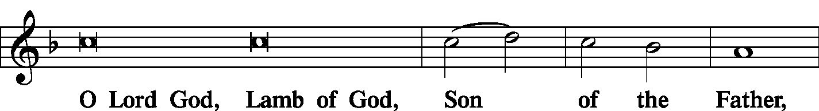
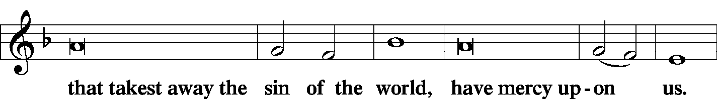
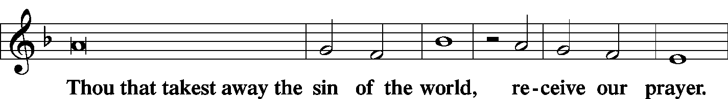
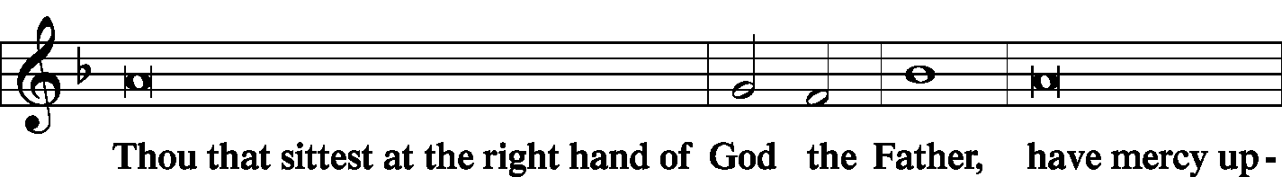
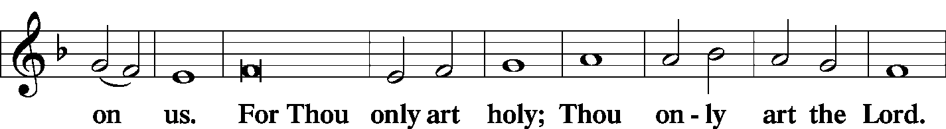
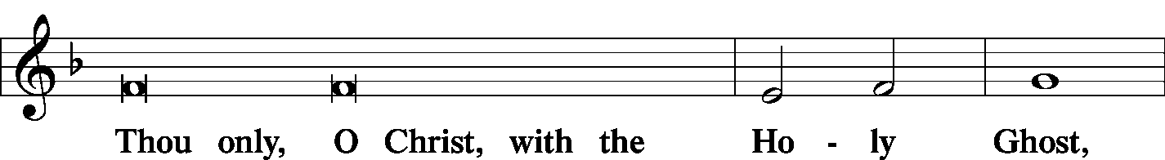
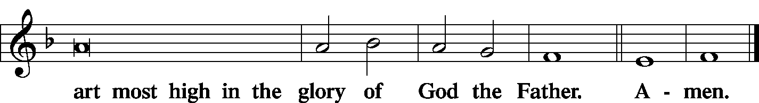

Salutation and Collect of the Day
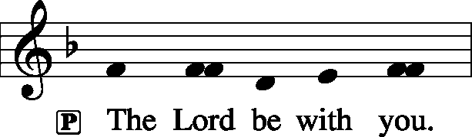
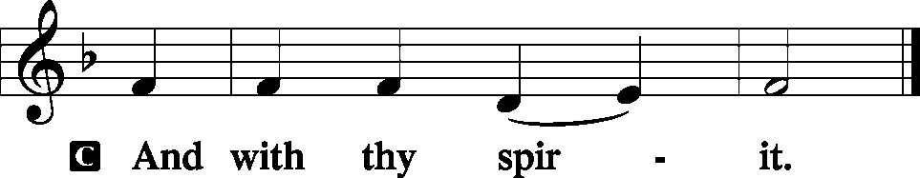

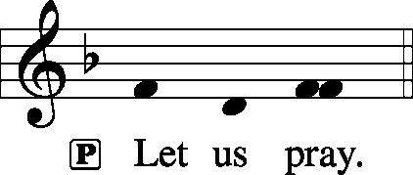

P Almighty God, we implore You, show Your mercy to Your humble servants that we, who put no trust in our own merits, may not be dealt with after the severity of Your judgment but according to Your mercy; through Jesus Christ, Your Son, our Lord, who lives and reigns with You and the Holy Spirit, one God, now and forever.
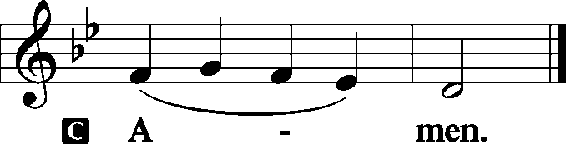

Sit

Old Testament Reading: Daniel 7: 9-14
“As I looked,
thrones were placed,
and the Ancient of Days took his seat;
his clothing was white as snow,
and the hair of his head like pure wool;
his throne was fiery flames;
its wheels were burning fire.
A stream of fire issued
and came out from before him;
a thousand thousands served him,
and ten thousand times ten thousand stood before him;
the court sat in judgment,
and the books were opened.
“I looked then because of the sound of the great words that the horn was speaking. And as I looked, the beast was killed, and its body destroyed and given over to be burned with fire. As for the rest of the beasts, their dominion was taken away, but their lives were prolonged for a season and a time.
“I saw in the night visions,
and behold, with the clouds of heaven
there came one like a son of man,
and he came to the Ancient of Days
and was presented before him.
And to him was given dominion
and glory and a kingdom,
that all peoples, nations, and languages
should serve him;
his dominion is an everlasting dominion,
which shall not pass away,
and his kingdom one
that shall not be destroyed.

A This is the Word of the Lord.
C Thanks be to God.

Gradual: Ps. 50: 4,6
He calls to the heavens above
and to the earth, that he may judge his people.
The heavens declare his righteousness,
for God himself is judge!

Epistle: 2 Peter 3: 3-14
…knowing this first of all, that scoffers will come in the last days with scoffing, following their own sinful desires. They will say, “Where is the promise of his coming? For ever since the fathers fell asleep, all things are continuing as they were from the beginning of creation.” For they deliberately overlook this fact, that the heavens existed long ago, and the earth was formed out of water and through water by the word of God, and that by means of these the world that then existed was deluged with water and perished. But by the same word the heavens and earth that now exist are stored up for fire, being kept until the day of judgment and destruction of the ungodly.
But do not overlook this one fact, beloved, that with the Lord one day is as a thousand years, and a thousand years as one day. The Lord is not slow to fulfill his promise as some count slowness, but is patient toward you, not wishing that any should perish, but that all should reach repentance. But the day of the Lord will come like a thief, and then the heavens will pass away with a roar, and the heavenly bodies will be burned up and dissolved, and the earth and the works that are done on it will be exposed.
Since all these things are thus to be dissolved, what sort of people ought you to be in lives of holiness and godliness, waiting for and hastening the coming of the day of God, because of which the heavens will be set on fire and dissolved, and the heavenly bodies will melt as they burn! But according to his promise we are waiting for new heavens and a new earth in which righteousness dwells.
Therefore, beloved, since you are waiting for these, be diligent to be found by him without spot or blemish, and at peace.

A This is the Word of the Lord.
C Thanks be to God.

Stand
Alleluia Verse and Alleluia
P Alleluia. The ransomed of the Lord shall return and come to Zion with singing; everlasting joy shall be upon their heads; they shall obtain gladness and joy. Alleluia.

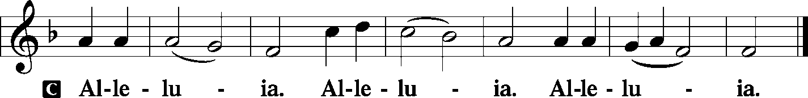

Holy Gospel: Matthew 25: 31-46
P The Holy Gospel according to St. Matthew, the twenty-fourth chapter.

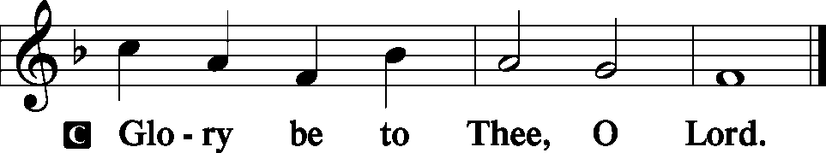

“When the Son of Man comes in his glory, and all the angels with him, then he will sit on his glorious throne. Before him will be gathered all the nations, and he will separate people one from another as a shepherd separates the sheep from the goats. And he will place the sheep on his right, but the goats on the left. Then the King will say to those on his right, ‘Come, you who are blessed by my Father, inherit the kingdom prepared for you from the foundation of the world. For I was hungry and you gave me food, I was thirsty and you gave me drink, I was a stranger and you welcomed me, I was naked and you clothed me, I was sick and you visited me, I was in prison and you came to me.’ Then the righteous will answer him, saying, ‘Lord, when did we see you hungry and feed you, or thirsty and give you drink? And when did we see you a stranger and welcome you, or naked and clothe you? And when did we see you sick or in prison and visit you?’ And the King will answer them, ‘Truly, I say to you, as you did it to one of the least of these my brothers, you did it to me.’
“Then he will say to those on his left, ‘Depart from me, you cursed, into the eternal fire prepared for the devil and his angels. For I was hungry and you gave me no food, I was thirsty and you gave me no drink, I was a stranger and you did not welcome me, naked and you did not clothe me, sick and in prison and you did not visit me.’ Then they also will answer, saying, ‘Lord, when did we see you hungry or thirsty or a stranger or naked or sick or in prison, and did not minister to you?’ Then he will answer them, saying, ‘Truly, I say to you, as you did not do it to one of the least of these, you did not do it to me.’ And these will go away into eternal punishment, but the righteous into eternal life.”

P This is the Gospel of the Lord.

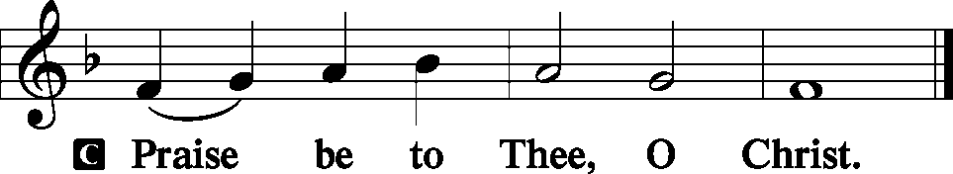

Nicene Creed
C I believe in one God,
the Father Almighty,
maker of heaven and earth
and of all things visible and invisible.
And in one Lord Jesus Christ,
the only-begotten Son of God,
begotten of His Father before all worlds,
God of God, Light of Light,
very God of very God,
begotten, not made,
being of one substance with the Father,
by whom all things were made;
who for us men and for our salvation came down from heaven
and was incarnate by the Holy Spirit of the virgin Mary
and was made man;
and was crucified also for us under Pontius Pilate.
He suffered and was buried.
And the third day He rose again according to the Scriptures
and ascended into heaven
and sits at the right hand of the Father.
And He will come again with glory to judge both the living and the dead,
whose kingdom will have no end.

And I believe in the Holy Spirit,
the Lord and giver of life,
who proceeds from the Father and the Son,
who with the Father and the Son together is worshiped and glorified,
who spoke by the prophets.
And I believe in one holy Christian and apostolic Church,
I acknowledge one Baptism for the remission of sins,
and I look for the resurrection of the dead
and the life T of the world to come. Amen.
Sit

Hymn of the Day: LSB #508 “The Day Is Surely Drawing Near”
Sermon
Stand

P The peace of God, which passes all understanding, keep your hearts and minds in Christ Jesus.
C Amen.

Prayer of the Church
Sit

Offertory
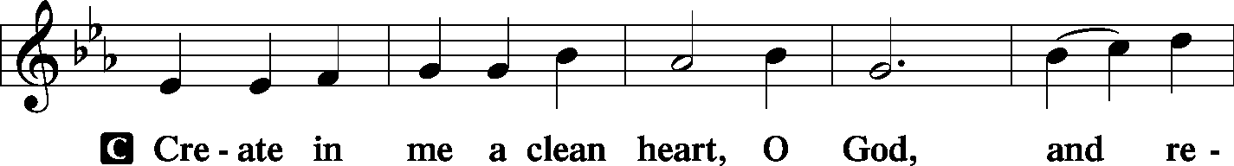
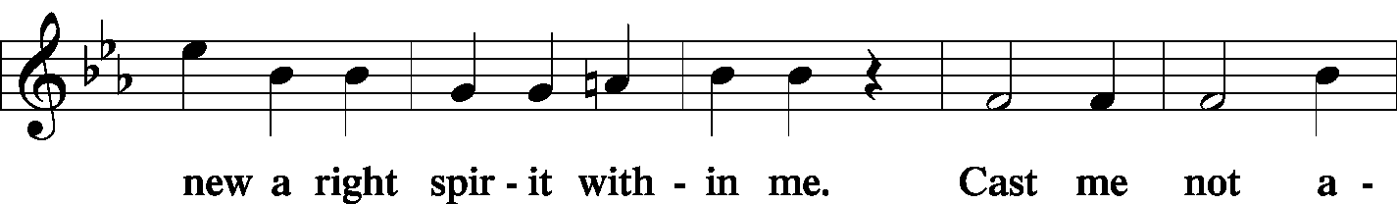
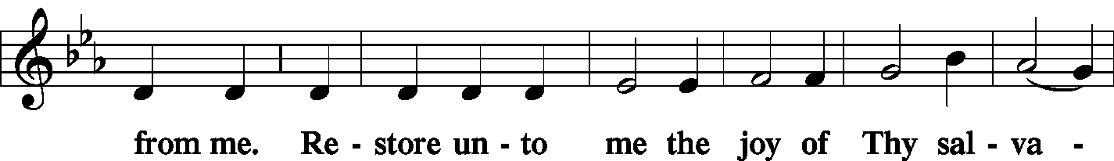
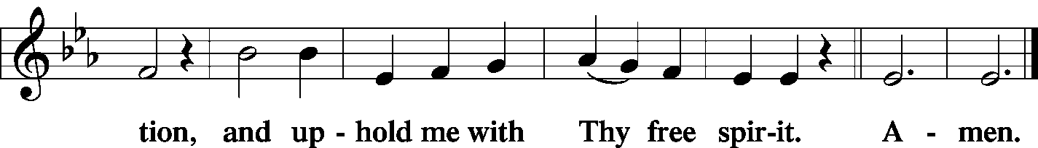

Offering/Offering Hymn: LSB #602 “The Gifts Christ Freely Gives”

Stand
SERVICE OF THE SACRAMENT
Preface
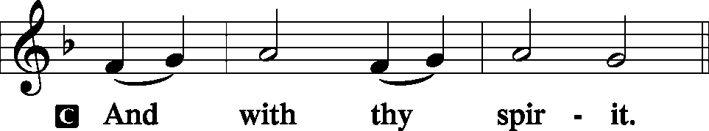
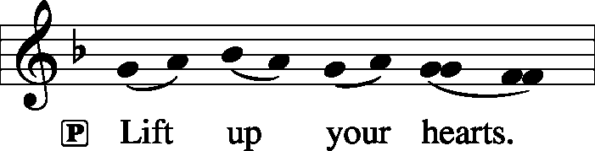

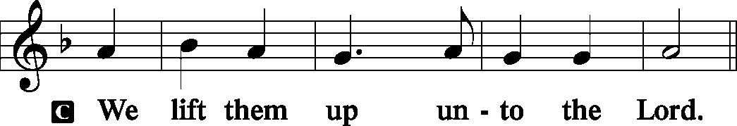

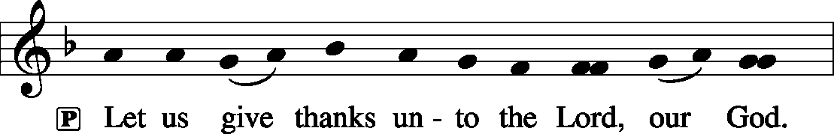

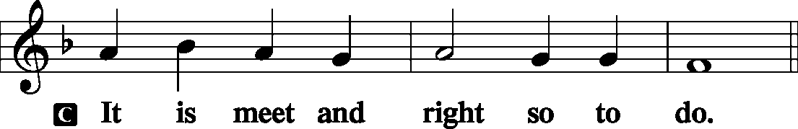

P It is truly meet, right, and salutary . . . evermore praising You and saying:
Sanctus
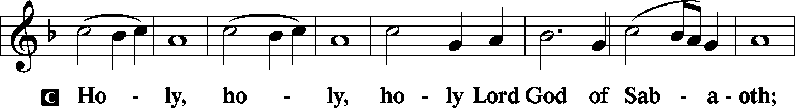
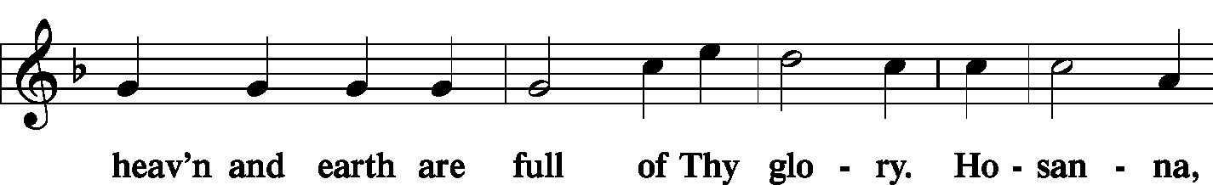
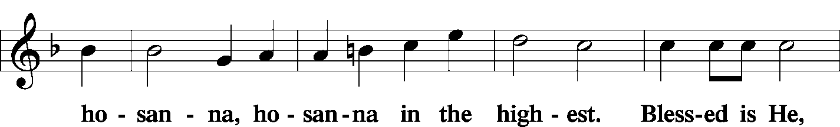
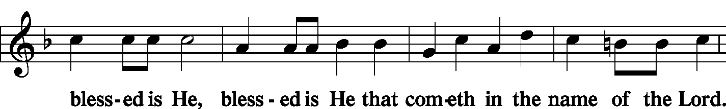
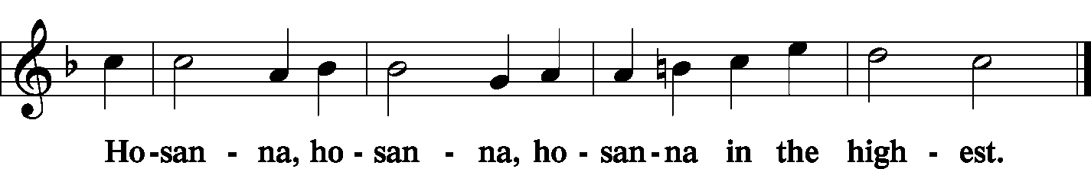

Lord's Prayer
P Lord, remember us in Your kingdom and teach us to pray:
C Our Father who art in heaven,
hallowed be Thy name,
Thy kingdom come,
Thy will be done on earth as it is in heaven;
give us this day our daily bread;
and forgive us our trespasses as we forgive those who trespass against us;
and lead us not into temptation,
but deliver us from evil.
For Thine is the kingdom and the power and the glory forever and ever. Amen.

The Words of Our Lord
P Our Lord Jesus Christ, on the night when He was betrayed, took bread, and when He had given thanks, He broke it and gave it to the disciples and said: “Take, eat; this is My T body, which is given for you. This do in remembrance of Me.”

P In the same way also He took the cup after supper, and when He had given thanks, He gave it to them, saying: “Drink of it, all of you; this cup is the new testament in My T blood, which is shed for you for the forgiveness of sins. This do, as often as you drink it, in remembrance of Me.”
Pax Domini
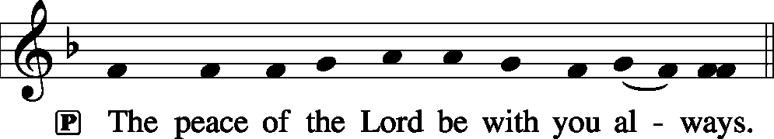

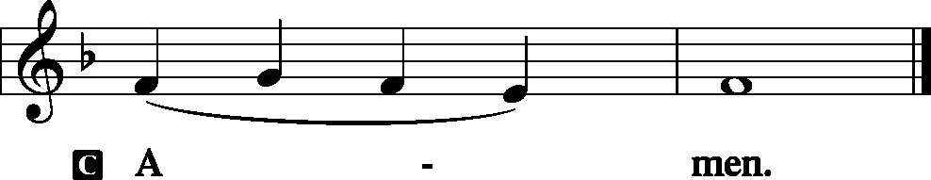
Agnus Dei
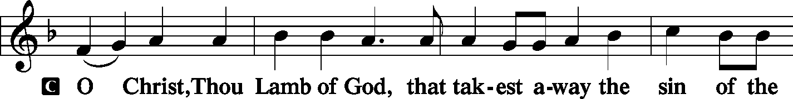
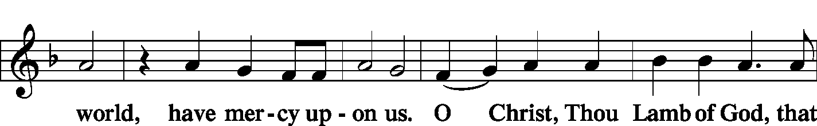
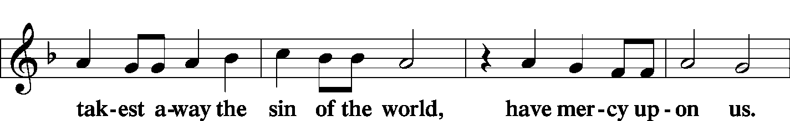
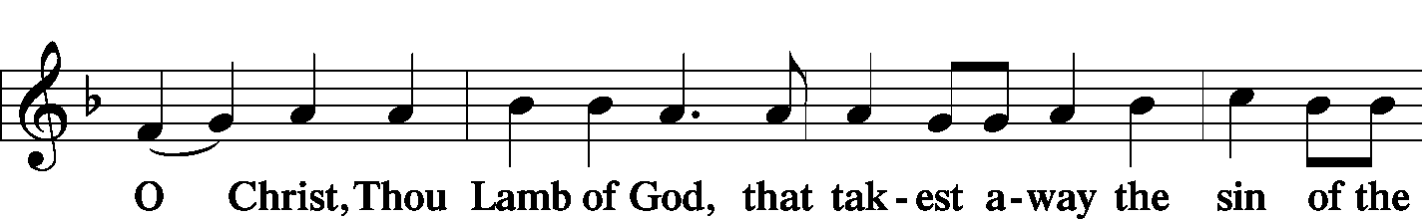
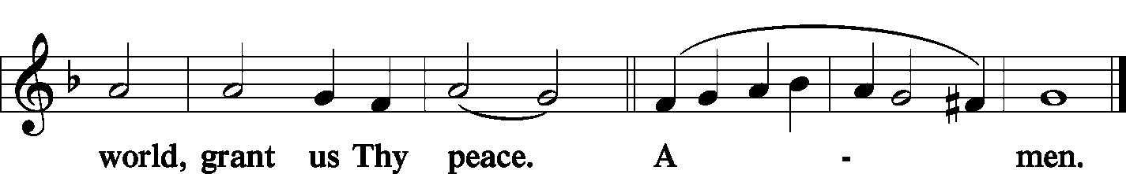
Sit

Distribution
The pastor and those who assist him receive the body and blood of Christ first and then distribute them to those who come to receive, saying:

Take, eat; this is the true body of our Lord and Savior Jesus Christ, given into death for your sins.
Amen.

Take, drink; this is the true blood of our Lord and Savior Jesus Christ, shed for the forgiveness of your sins.
Amen.

In dismissing the communicants, the following is said:

P The body and blood of our Lord Jesus Christ strengthen and preserve you in body and soul to life everlasting. Depart T in peace.
C Amen.

Distribution Hymn: LSB #511 “Herald, Sound the Note of Judgment”
Stand

Post-Communion Canticle: Nunc Dimittis
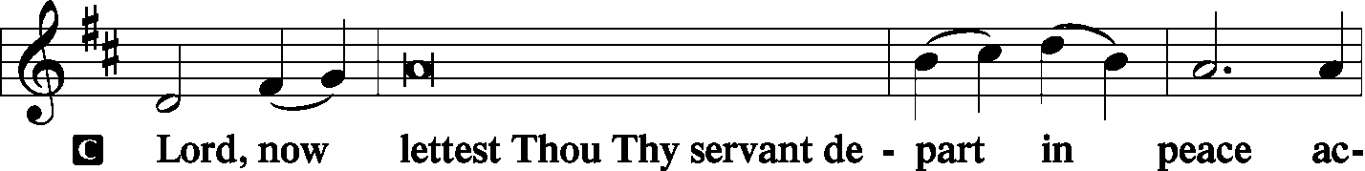
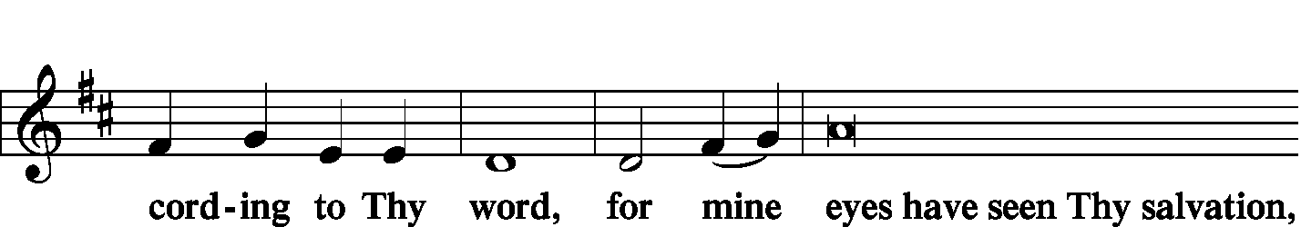
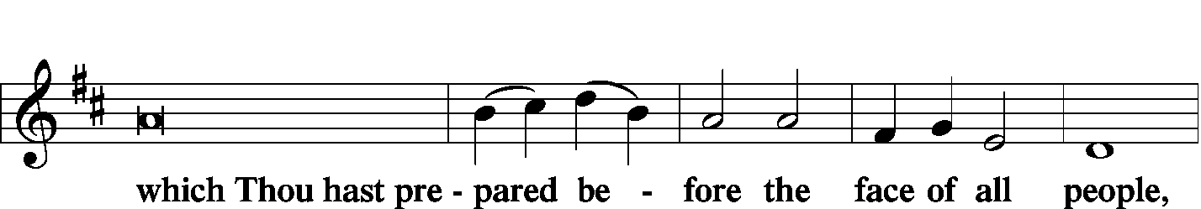
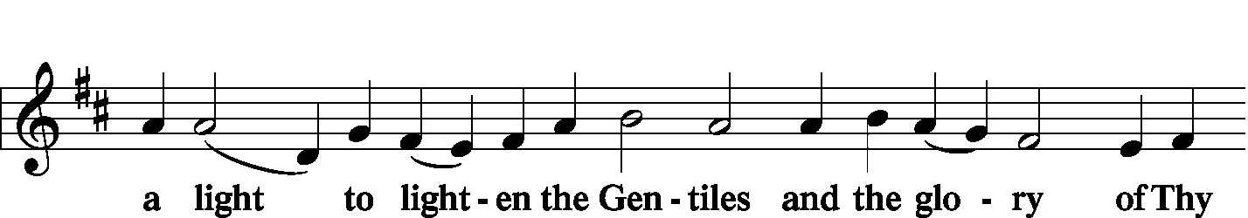
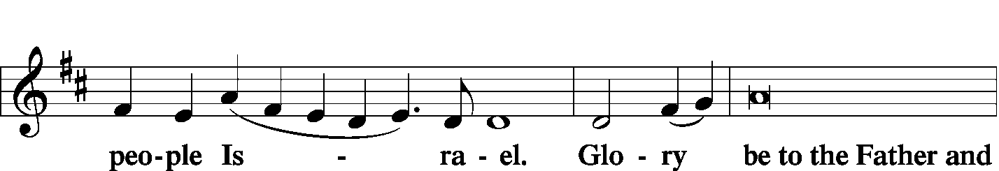
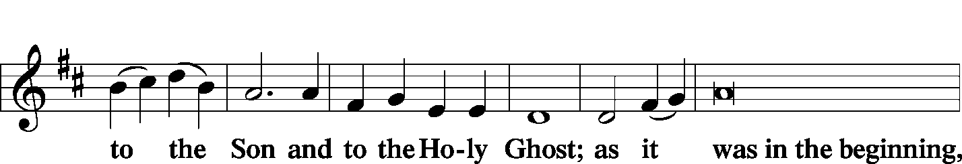
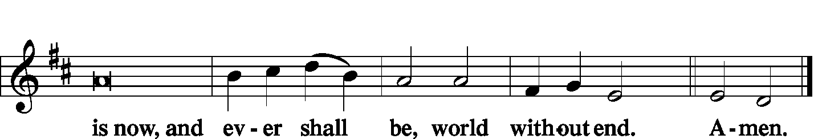

Thanksgiving
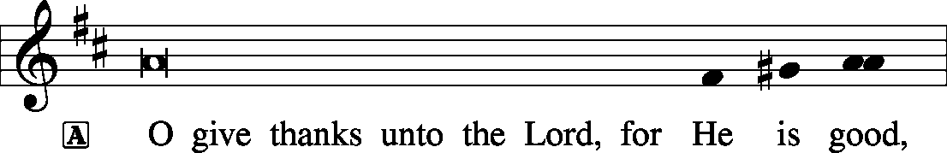
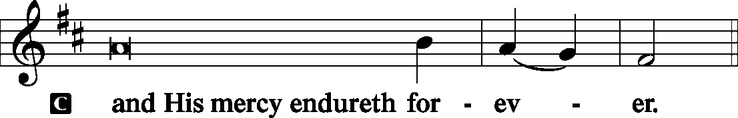

A Let us pray.
We give thanks to You, almighty God, that You have refreshed us through this salutary gift, and we implore You that of Your mercy You would strengthen us through the same in faith toward You and fervent love toward one another; through Jesus Christ, Your Son, our Lord, who lives and reigns with You and the Holy Spirit, one God, now and forever.
Salutation and Benedicamus
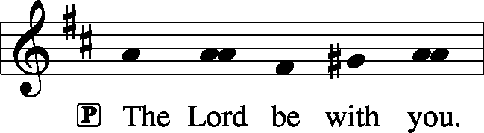

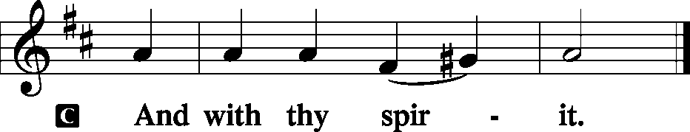
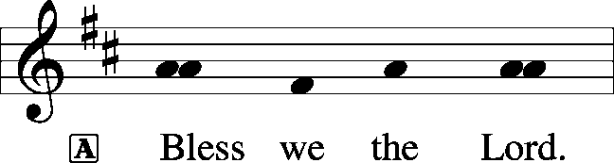

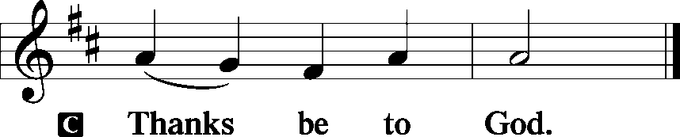

Benediction
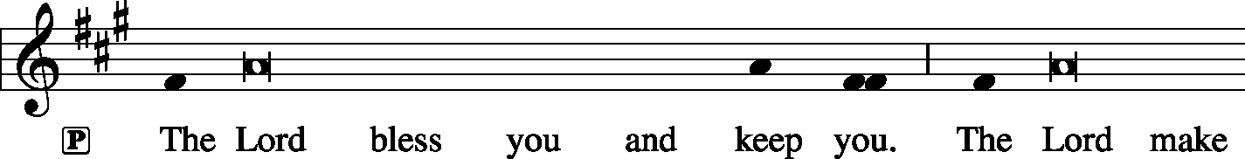
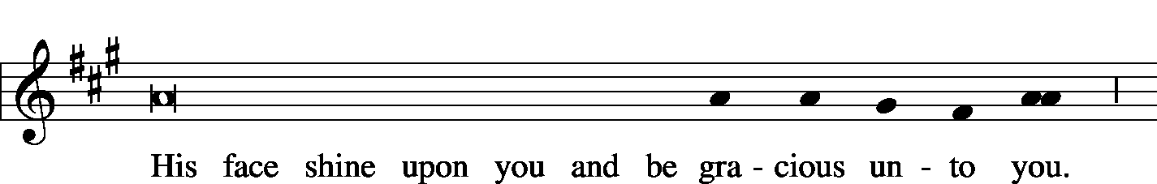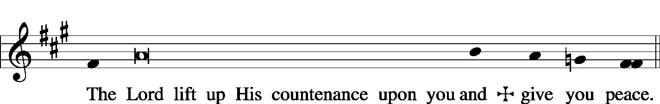

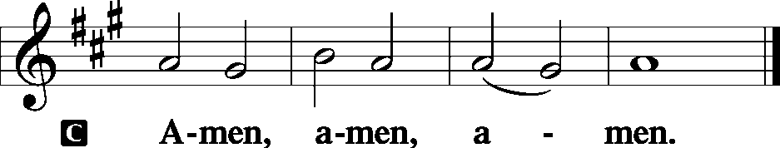

Closing Hymn: TLH #448 “Brief Life Is Here Our Portion” (sung to the tune of LSB #672)
Silent prayer after worship: God of mercy and grace, lead me to be in Your Word and in prayer daily so that my faith will remain strong and I will have the confidence to share the Gospel with others. In Jesus’ name. Amen

Acknowledgments: Divine Service, Setting Three from Lutheran Service Book Unless otherwise indicated, all scripture quotations are from The Holy Bible, English Standard Version, copyright © 2001 by Crossway Bibles, a division of Good News Publishers. Used by permission. All rights reserved. Created by Lutheran Service Builder © 2006 Concordia Publishing House. CCLI License #3029-446

Word of Hope: 1-888-217-8679
The only 24/7 CONFIDENTIAL Hotline that is distinctly Lutheran, bringing healing found in Christ, to those whose hearts have been broken by abortion.

The Altar Flowers this morning are given anonymously to the Glory of God! We sincerely appreciate this generous gift!

Attendance:
Sunday, November 11, 2018 and Wednesday, November 14, 2018.…………...48


In Loving Memory of Betty Petro: Viola Sakony (Food Pantry)

SCHEDULE FOR TODAY THROUGH NOV. 25th:
:

:

Today, 7 pm, Downstairs….…………………..….……………………………..…..……AA Meeting
Wednesday, 9 am, Downstairs……………………………………..…………………….Food Pantry
7 pm, Sanctuary……………..…..……Thanksgiving Eve Divine Worship Service
Next Sunday, 8:45 am, Downstairs………………………….………………………….Bible Study
10 am, Sanctuary….....................................................Divine Worship Service
7 pm, Downstairs…………………………………………………………....……AA Meeting

Thank You for Serving in November:
Today’s Greeters: Gary & Eileen Burns. Assisting Elders: John Dyll & Bob Sulek. Ushers: Bob Sulek, Gerald Arthur, Anson Holcroft, Cheryl Fedele, & Tom Zachar. Altarware: Viola Sakony & Anne Colt.
November Greeters: 25 ~ Barry & Chris Nelson

Bible Memory Verses:
For Children: The one who endures to the end will be saved. Matt. 24:13
For Adults: For since we believe that Jesus died and rose again, even so, through Jesus, God will bring with him those who have fallen asleep. 1 Thessalonians 4:14

Sincere “thanks” are extended to Pastor & Ana Deal and family for providing the lunch last Sunday in honor of Loretta’s birth and baptism. Many thanks, also, to those who helped set up or clean up afterwards!

Remember the following in Prayer…
~The Hurting and Healing: Tony³, Lois Bortner^{CA}, Jeff Brandes², Richard Brandes², Eileen Burns², Ed Colt¹, Ana Deal², John Dyll², Norma Ferringer⁴, Anson Holcroft³, Betty Knauff^{CA}, Regis Knauff⁴, Jess Lavoie², Paul Lucas^{CA}, Barry Nelson⁴, David Nelson⁴,Tom Mulligan^{CA}, Iona Oltman^{CA}, Rudy Pinal^{CA}, Richard Reuning^{CA}, Viola Sakony¹, Scott^{CA}, and Angela Weser^{CA}.
~Our Homebound: Helen Bender, Dan Davis, Edna Krajci, Mary Ann Krajci, Sophie Mihm, Marion & Gene Roberts, Barbara Vasconi, and Joanne Wolfe.
~Those Celebrating: Birthday~Patricia Voytik (11.23).
~Serving in the Military: Clayton Drnek, Curtis Sinewe, and Joshua Solyan.
~Community & World Needs: Victims of violence and terrorism; those suffering from loss and dislocation because weather disasters; those suffering from addiction and their families; safety for teachers, staff, and students; Local, State, and National Government Leaders; Safety for all Police Officers, Firefighters, & First Responders; the unemployed; our Fourth Quarter Local Mission: Willow Women’s Center.
*CA represents cancer; number after other names represents weeks on the prayer list. After 4 weeks names may be resubmitted. This helps us to remember people’s specific needs and reminds us that God is providing healing as people get better and no longer need our prayers. Please submit prayer requests in writing to the church office.
Please keep those listed above in your prayers.

Our Stewardship of Treasures for the Lord:
In order to do the Lord’s work, we need $2,843.00* each week to meet our 2018 budget for general purposes and $99.00 for missions.
Sunday, November 11 and Wednesday, November 7, 2018:
General Offering:…..…..………..................................................$1,290.20
Behind this week*: -$1,312.80
SELC Missions:……….………..…..…............................................$10.00
Behind this week: -$89.00
Preschool Tuition Payments……………...…..............................…$240.00
Other Offerings:………….…….…........................……………...…$150.00
*Includes Preschool.

We hope you join us this Wednesday evening at 7 pm in the sanctuary for a Thanksgiving Eve Worship Service. Please note that Holy Communion will not be celebrated.

Best wishes to you and your family for a wonderful Thanksgiving.

Here to Serve You…

Pastor………………………………………………….………..…Rev. Jacob Deal
E-mail ……….…………………….…..pastordeal@saintspeterandpaul.net
Phone Number…………..……………………………724-347-3620 (Option 2)
Church Office………………………………….………724-347-3620 (Option 3)
Website ……….………………….……...…….www.saintspeterandpaul.net
Secretary………………………………………………….……. Diane Riefstahl
E-mail ……….…………………….…….…church@saintspeterandpaul.net
Food Pantry: John Dyll…………….……………………..…..…724-347-1779
Little People Preschool…………….……………….724-347-3620 (Option 4)
Teacher: Paula Ostheimer………….………………….…….....724-981-5846
Email ……….………….…………………….paula@saintspeterandpaul.net
AA Contact: Steve……………………….…………..……...……. 724-813-2358
Organist……………………………………………………..…Carrie Yasnowski
Choir Director……………..…………….…………..….….………Chris Nelson
Congregational President……………………..…..….…………Jeff Brandes

This week, the Secretary’s office hours will be open Monday and Tuesday (8:30-4:30). The church office will be closed Thursday. Pastor Deal will be in the office Monday through Wednesday unless ministering off-site. If you need to enter the Church, please call ahead to be sure someone is here to let you in. Thank you.

