Sts. Peter & Paul
Evangelical Lutheran Church
Lutheran Church-Missouri Synod
Founded-1917

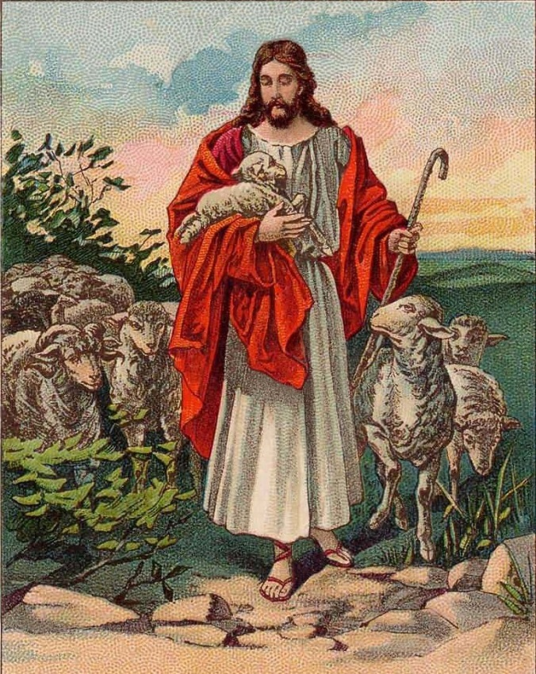

MAY 5, 2019

699 Stambaugh Avenue
Sharon, Pennsylvania 16146

“I was glad when they said to me,
Let us go to the house of the LORD!”
Psalm 122:1
Sts. Peter & Paul Evangelical Lutheran Church, LC-MS

MISERICORDIAS DOMINI
May 5, 2019

Silent prayer before worship: Heavenly Father send Your Holy Spirit through Your Word to open my mind as I listen to Your Word. Lead me to firmly trust that Jesus died for all, and that He now lives and reigns with You forever. In Jesus’ name. Amen.

Please read Communion Statement found inside the Friendship Booklet prior to taking part in Holy Communion.
CONFESSION AND ABSOLUTION
Opening Hymn: LSB #666 “O Little Flock, Fear Not the Foe”
Stand
The sign of the cross may be made by all in remembrance of their Baptism.

P In the name of the Father and of the T Son and of the Holy Spirit.
C Amen. Matthew 28: 19b; [18:20]

P If we say we have no sin, we deceive ourselves, and the truth is not in us.
C But if we confess our sins, God, who is faithful and just, will forgive our sins and cleanse us from all unrighteousness.

Silence for reflection on God's Word and for self-examination.

P Let us then confess our sins to God our Father.
C Most merciful God, we confess that we are by nature sinful and unclean. We have sinned against You in thought, word, and deed, by what we have done and by what we have left undone. We have not loved You with our whole heart; we have not loved our neighbors as ourselves. We justly deserve Your present and eternal punishment. For the sake of Your Son, Jesus Christ, have mercy on us. Forgive us, renew us, and lead us, so that we may delight in Your will and walk in Your ways to the glory of Your holy name. Amen.
P Almighty God in His mercy has given His Son to die for you and for His sake forgives you all your sins. As a called and ordained servant of Christ, and by His authority, I therefore forgive you all your sins in the name of the Father and of the T Son and of the Holy Spirit. [John 20: 19-23]
C Amen.

Passing of the Peace.
SERVICE OF THE WORD
Introit: Ps. 33:1, 18–20; antiphon: Ps. 33:5b, 6a
The earth is full of the steadfast love of the Lord. Alle- | luia.*
By the word of the Lord the heavens were made. Alle- | luia.
Shout for joy in the Lord, O you | righteous!*
Praise befits the | upright.
Behold, the eye of the Lord is on those who | fear him,*
on those who hope in his | steadfast love,
that he may deliver their | soul from death*
and keep them alive in | famine.
Our soul waits | for the Lord;*
he is our help | and our shield.
Glory be to the Father and | to the Son*
and to the Holy | Spirit;
as it was in the be- | ginning,*
is now, and will be forever. | Amen.
The earth is full of the steadfast love of the Lord. Alle- | luia.*
By the word of the Lord the heavens were made. Alle- | luia.

Kyrie Mark 10:47
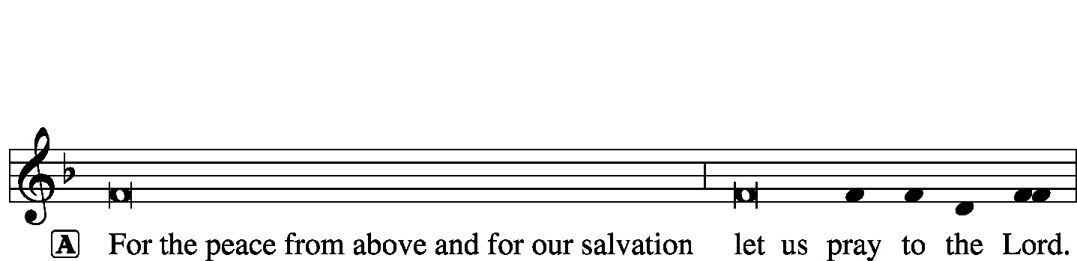
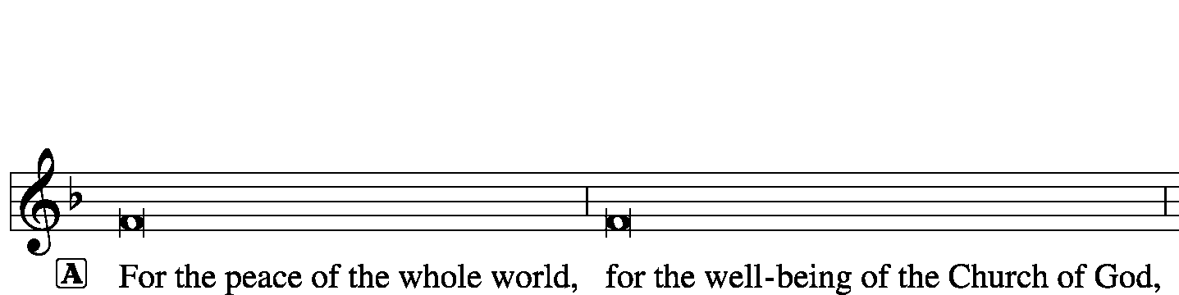
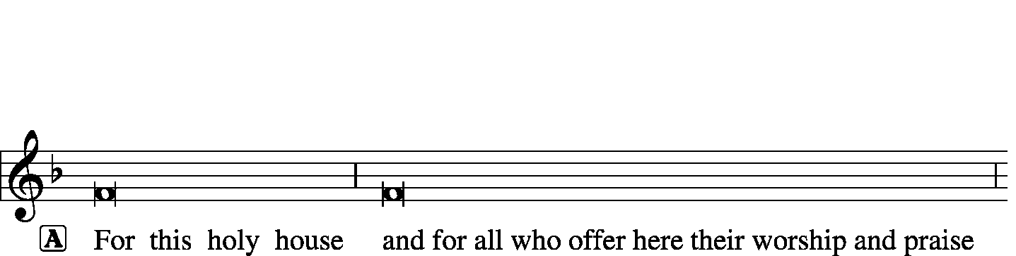
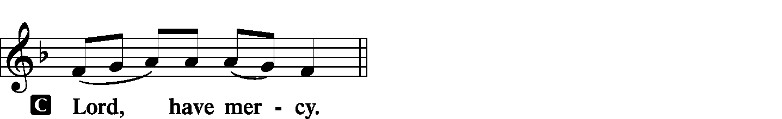
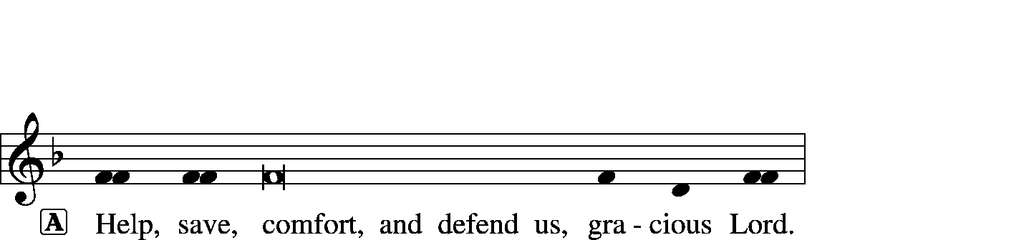

Gloria in Excelsis Luke 2: 14; John 1: 29
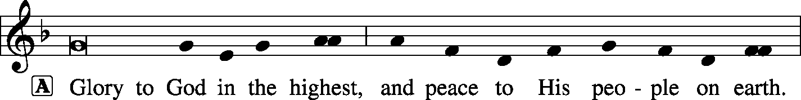
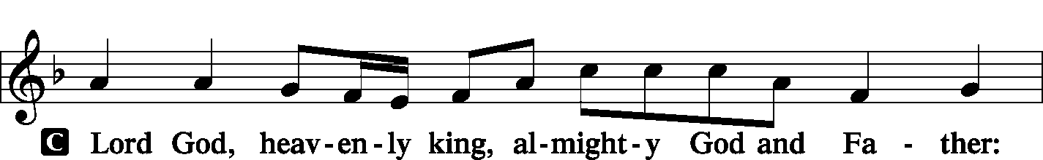
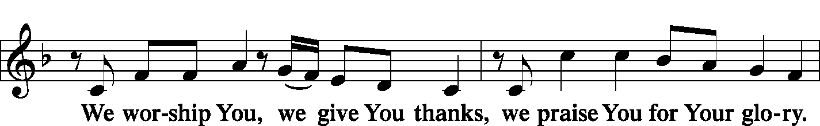
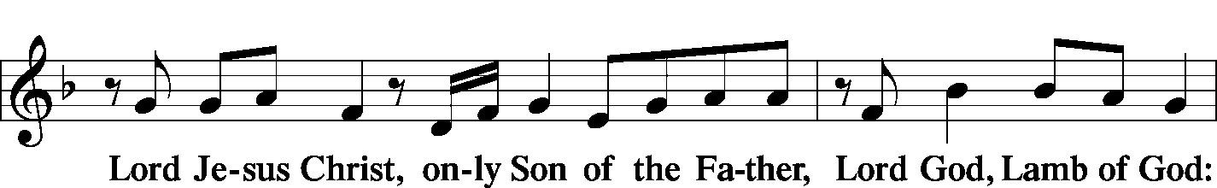
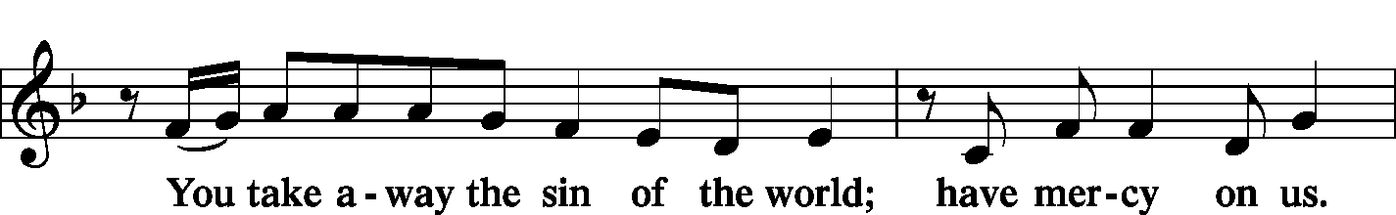
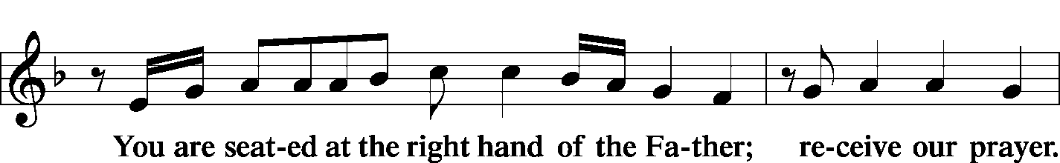
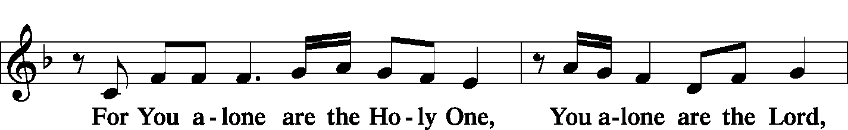
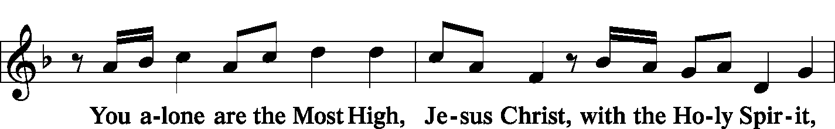
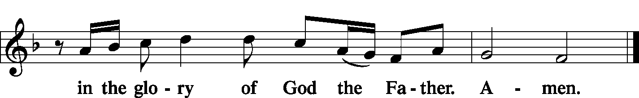

Salutation and Collect of the Day 2 Timothy 4: 22
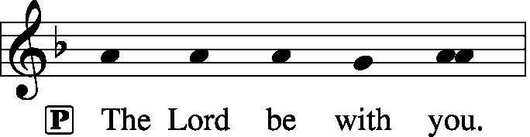
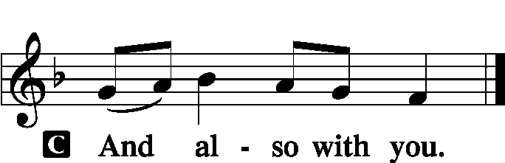

P Let us pray.
O God, through the humiliation of Your Son You raised up the fallen world. Grant to Your faithful people, rescued from the peril of everlasting death, perpetual gladness and eternal joys; through Jesus Christ, our Lord, who lives and reigns with You and the Holy Spirit, one God, now and forever.
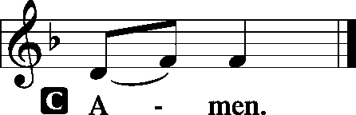

Sit

Old Testament Reading: Ezekiel 34:11–16
“For thus says the Lord God: Behold, I, I myself will search for my sheep and will seek them out. As a shepherd seeks out his flock when he is among his sheep that have been scattered, so will I seek out my sheep, and I will rescue them from all places where they have been scattered on a day of clouds and thick darkness. And I will bring them out from the peoples and gather them from the countries, and will bring them into their own land. And I will feed them on the mountains of Israel, by the ravines, and in all the inhabited places of the country. I will feed them with good pasture, and on the mountain heights of Israel shall be their grazing land. There they shall lie down in good grazing land, and on rich pasture they shall feed on the mountains of Israel. I myself will be the shepherd of my sheep, and I myself will make them lie down, declares the Lord God.
I will seek the lost, and I will bring back the strayed, and I will bind up the injured, and I will strengthen the weak, and the fat and the strong I will destroy. I will feed them in justice.”

P This is the Word of the Lord.
C Thanks be to God.

Gradual: Rom. 10:15b, 18b; Is. 52:7b, alt.
How beautiful are the feet of those who preach the good news,
who publish peace and bring good news of salvation.
Their voice has gone out to all the earth,
and their words to the ends of the world.

Epistle: 1 Peter 2:21–25
For to this you have been called, because Christ also suffered for you, leaving you an example, so that you might follow in his steps. He committed no sin, neither was deceit found in his mouth. When he was reviled, he did not revile in return; when he suffered, he did not threaten, but continued entrusting himself to him who judges justly. He himself bore our sins in his body on the tree, that we might die to sin and live to righteousness. By his wounds you have been healed. For you were straying like sheep, but have now returned to the Shepherd and Overseer of your souls.

P This is the Word of the Lord.
C Thanks be to God.

Stand
Verse of the Day: Luke 24:35b; John 10:14
Alleluia. [The Lord] was known to them in the breaking of the bread. Alleluia. I am the good shepherd. I know my own and my own know me. Alleluia.

Common Alleluia
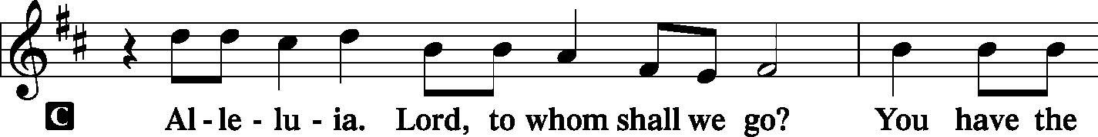
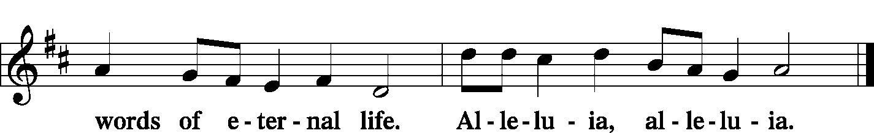

Holy Gospel: John 10:11–16
P The Holy Gospel according to St. John, the tenth chapter.

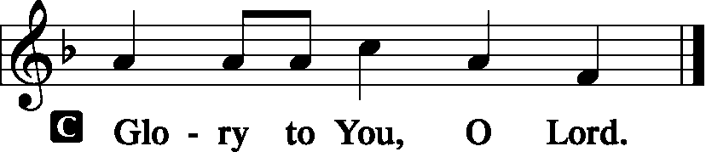

I am the good shepherd. The good shepherd lays down his life for the sheep. He who is a hired hand and not a shepherd, who does not own the sheep, sees the wolf coming and leaves the sheep and flees, and the wolf snatches them and scatters them. He flees because he is a hired hand and cares nothing for the sheep. I am the good shepherd. I know my own and my own know me, just as the Father knows me and I know the Father; and I lay down my life for the sheep. And I have other sheep that are not of this fold. I must bring them also, and they will listen to my voice. So there will be one flock, one shepherd.

P This is the Gospel of the Lord.
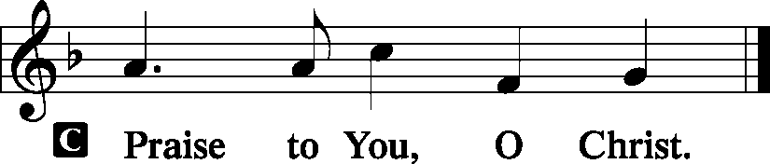

Nicene Creed
C I believe in one God,
the Father Almighty,
maker of heaven and earth
and of all things visible and invisible.
And in one Lord Jesus Christ,
the only-begotten Son of God,
begotten of His Father before all worlds,
God of God, Light of Light,
very God of very God,
begotten, not made,
being of one substance with the Father,
by whom all things were made;
who for us men and for our salvation came down from heaven
and was incarnate by the Holy Spirit of the virgin Mary
and was made man;
and was crucified also for us under Pontius Pilate.
He suffered and was buried.
And the third day He rose again according to the Scriptures
and ascended into heaven
and sits at the right hand of the Father.
And He will come again with glory to judge both the living and the dead,
whose kingdom will have no end.
And I believe in the Holy Spirit,
the Lord and giver of life,
who proceeds from the Father and the Son,
who with the Father and the Son together is worshiped and glorified,
who spoke by the prophets.
And I believe in one holy Christian and apostolic Church,
I acknowledge one Baptism for the remission of sins,
and I look for the resurrection of the dead
and the life T of the world to come. Amen.
Sit

Hymn of the Day: LSB #709 “The King of Love My Shepherd Is”

Sermon
Stand

Prayer of the Church [Timothy 2: 1-4]

Sit

Offertory Psalm 116: 12-13, 17-19
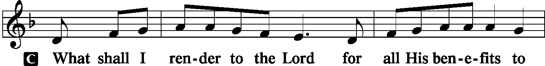
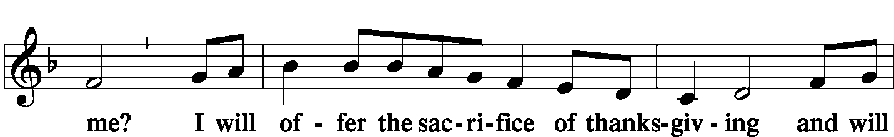
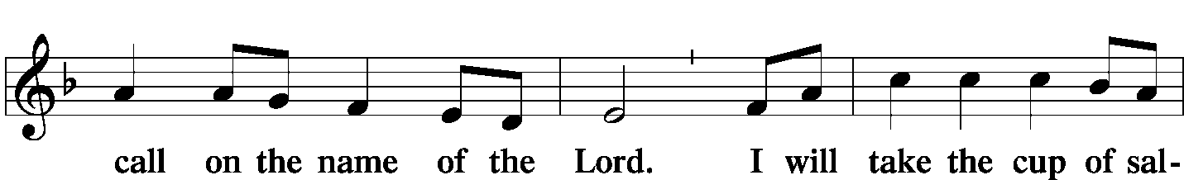
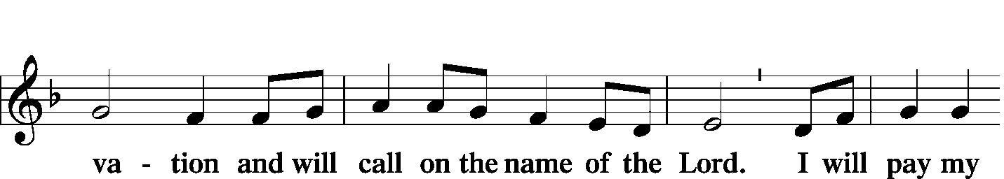
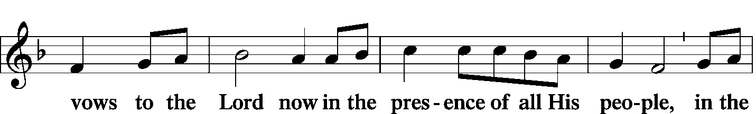
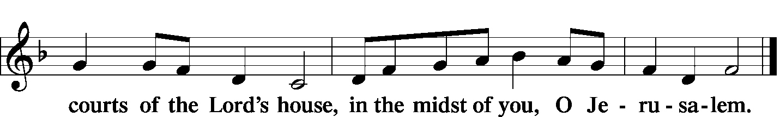

Offering/Offering Hymn: LSB #710 “The Lord’s My Shepherd, I’ll Not Want”

Stand
SERVICE OF THE SACRAMENT
Preface
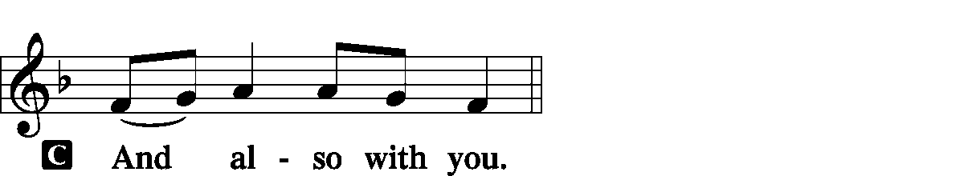
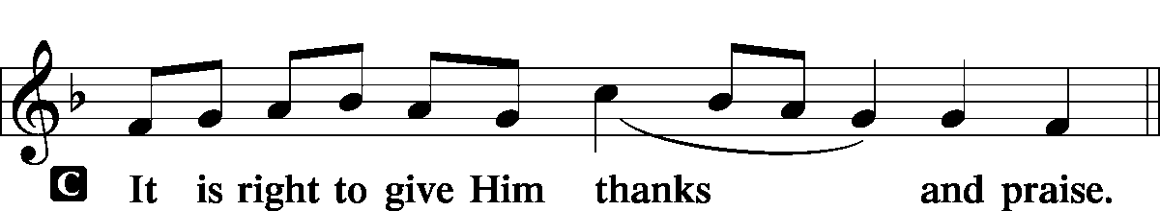

P It is truly meet, right, and salutary … evermore praising You and saying:

Sanctus
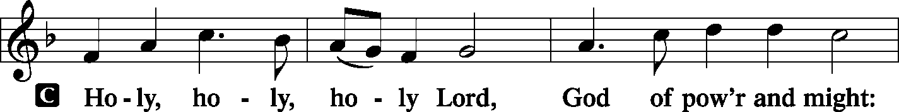
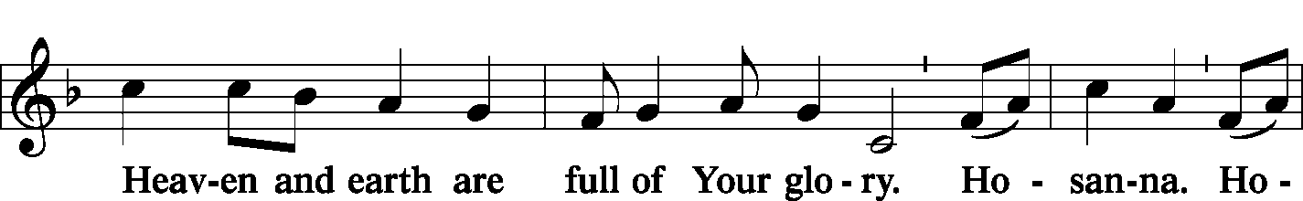
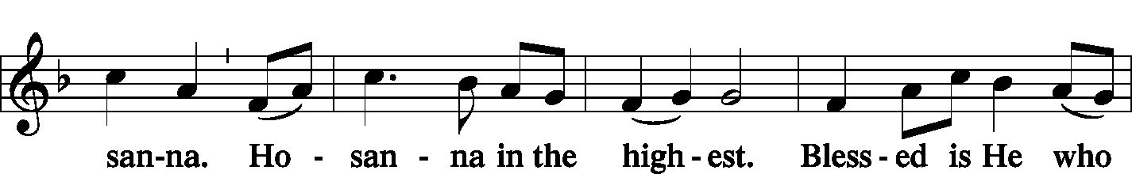
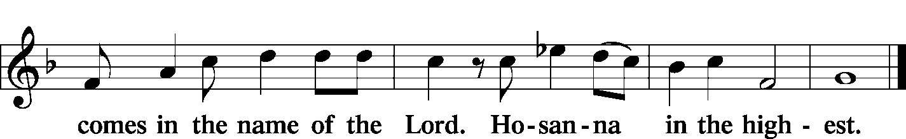

Lord's Prayer Matthew 6: 9-13
P Lord, remember us in Your kingdom and teach us to pray:
C Our Father who art in heaven,
hallowed be Thy name,
Thy kingdom come,
Thy will be done on earth as it is in heaven;
give us this day our daily bread;
and forgive us our trespasses as we forgive those who trespass against us;
and lead us not into temptation,
but deliver us from evil.
For Thine is the kingdom and the power and the glory forever and ever. Amen.

The Words of Our Lord Matthew 26: 26-28; Mark 14: 22-24
Luke 22: 19-20; 1 Corinthians 11: 23-25
P Our Lord Jesus Christ, on the night when He was betrayed, took bread, and when He had given thanks, He broke it and gave it to the disciples and said: “Take, eat; this is My T body, which is given for you. This do in remembrance of Me.”

P In the same way also He took the cup after supper, and when He had given thanks, He gave it to them, saying: “Drink of it, all of you; this cup is the new testament in My T blood, which is shed for you for the forgiveness of sins. This do, as often as you drink it, in remembrance of Me.”

Pax Domini John 20: 19
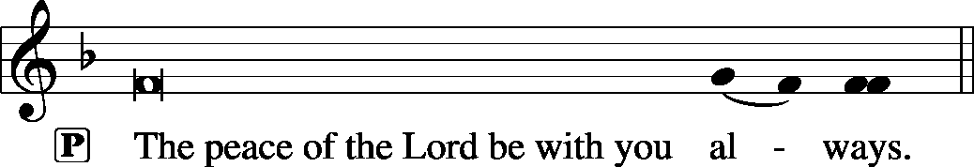

Agnus Dei John 1: 29
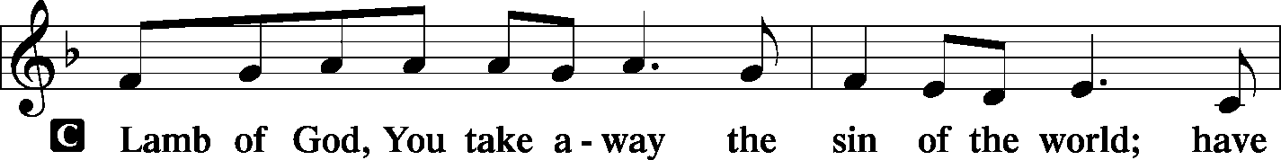
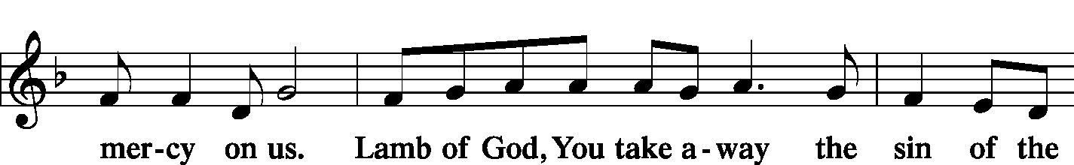
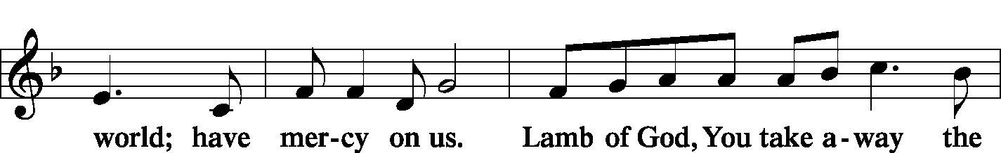
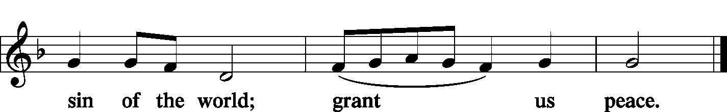

Sit

Distribution
The pastor and those who assist him receive the body and blood of Christ first and then distribute them to those who come to receive, saying:

Take, eat; this is the true body of our Lord and Savior Jesus Christ, given into death for your sins.
Amen.

Take, drink; this is the true blood of our Lord and Savior Jesus Christ, shed for the forgiveness of your sins.
Amen.
In dismissing the communicants, the following is said:
P The body and blood of our Lord Jesus Christ strengthen and preserve you in body and soul to life everlasting. Depart T in peace.
C Amen.

Distribution Hymn: LSB p. 155 “This Is the Feast”
Distribution Hymn: LSB #740 “I Am Jesus' Little Lamb”
Stand

Nunc Dimittis Luke 2: 29-32
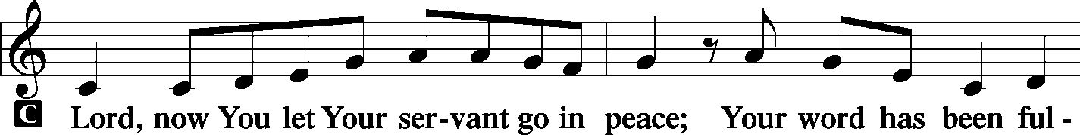
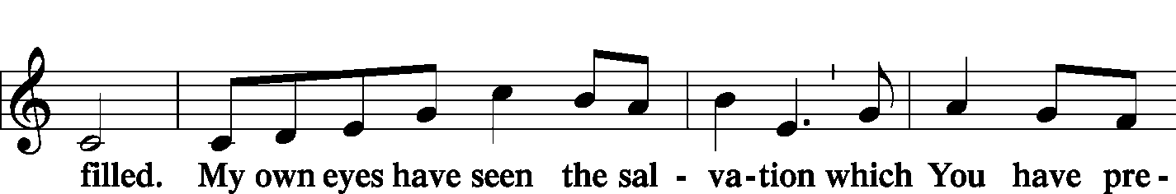
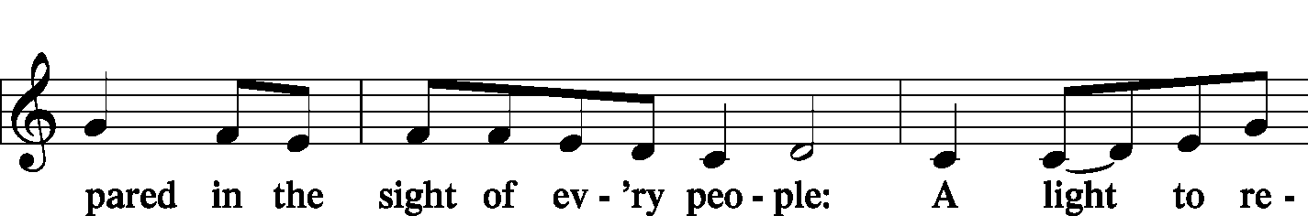
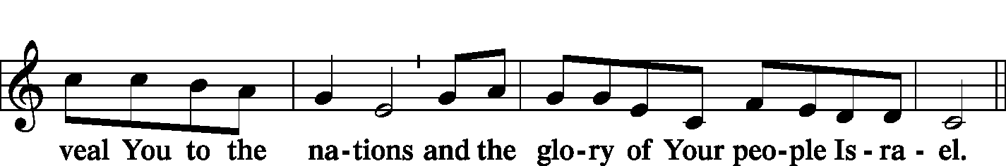
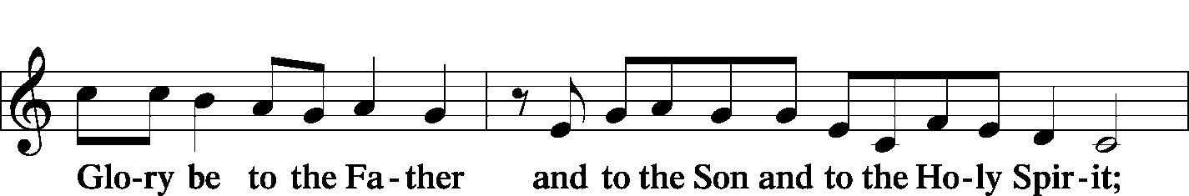
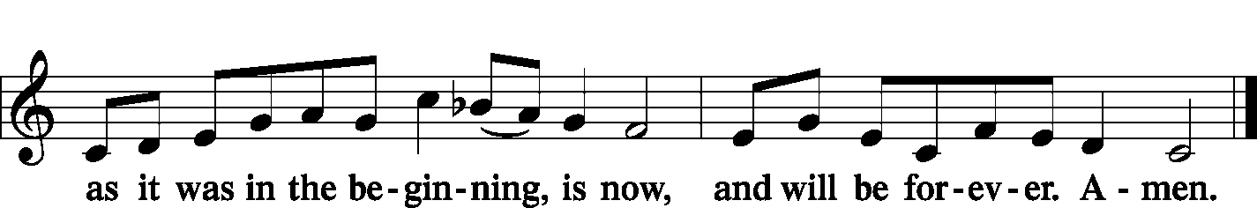

Post-Communion Collect Let us pray.
P We give thanks to You, almighty God, that You have refreshed us through this salutary gift, and we implore You that of Your mercy You would strengthen us through the same in faith toward You and fervent love toward one another; through Jesus Christ, Your Son, our Lord, who lives and reigns with You and the Holy Spirit, one God, now and forever.
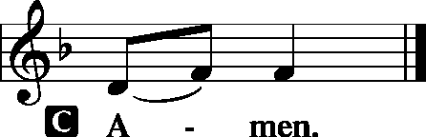

Benediction Numbers 6: 24-26

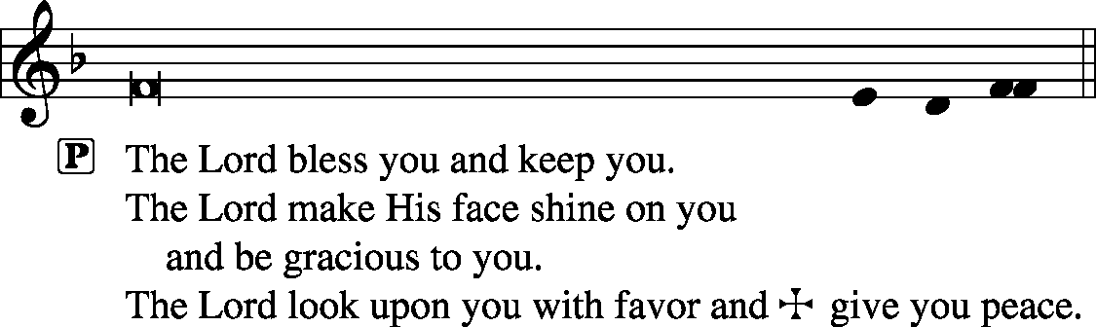

Closing Hymn: LSB #461 “I Know That My Redeemer Lives”
Silent prayer after worship: Dear Jesus, as I leave Your house today, walk with me wherever I go this week. Keep me in Your Word and open my heart that I may be constantly aware of Your presence. Amen.

Acknowledgments: Divine Service, Setting One from Lutheran Service Book Unless otherwise indicated, all scripture quotations are from The Holy Bible, English Standard Version, copyright © 2001 by Crossway Bibles, a division of Good News Publishers. Used by permission. All rights reserved. Created by Lutheran Service Builder © 2006 Concordia Publishing House. CCLI License #3029-446

Word of Hope: 1-888-217-8679
The only 24/7 CONFIDENTIAL Hotline that is distinctly Lutheran, bringing healing found in Christ, to those whose hearts have been broken by abortion.


SCHEDULE FOR TODAY THROUGH MAY 12th:
:

:

Today, following Worship, Downstairs……………….……Finance Committee Meeting
7 pm, Downstairs….…………….…………………..…………..…………..……AA Meeting
Thursday, 9 am, Downstairs………..……………………………………………………Food Pantry
Friday, noon, Downstairs……………………….……….Preschool Mother’s Day Luncheon
Saturday, 10 am…………………………………………………….….……………Trustees Walk-thru
5 pm, Chapel………………………………………………….....…Saturday Divine Service
Next Sunday, 8:45 am, Downstairs……………………………………………..………Bible Study
10 am, Sanctuary….....................................................................Divine Service
7 pm, Downstairs…………………………………………..……………..…....…AA Meeting

The Altar Flowers this morning are given by Mark Gabriel in Loving Memory of the wedding anniversary of his parents, Peter & Anne Gabriel, May 1st 1943. We sincerely appreciate this generous gift!
Thank You for Serving in May:
Today’s Greeters: Matt & Cathy Berent. Assisting Elders: Hugh Owen & Ralph Dorman. Ushers: Ralph Dorman, Jonathan Baisch, Matt Berent, Mark Gabriel, and John Dyll (alternate). Altarware: Hank Holcroft & Cheryl Fedele.
May Greeters:
12 ~ Anson & Henrietta Holcroft; 19 ~ Dolores Fee & Diane Riefstahl; 26 ~ Jeff & Stacy Brandes

Available in the Narthex:
- May issue of “The Rock & the Sword” newsletter.
- May issue of “The Lutheran Beacon”.

Several have inquired as to Hugh Owen’s address in order to send him cards as he recuperates from his surgery. It is 3776 Pothour Wheeler Rd., Hubbard, OH 44425.

Our Stewardship of Treasures for the Lord:
In order to do the Lord’s work, we need $2,882.02* each week to meet our 2019 budget for general purposes and $38.46 for missions.
Sunday, April 28, 2019:
General Offering:…..…..………............................................................$1,442.00
Behind this week*: -$1,440.02
SELC Missions:……….………..…..……........................................................$5.00 Behind this week#: -$33.46
Other Offerings:………….…….…….....................………..……..……........$31.00
*Includes preschool tuition.

Bible Memory Verses: For the week of May 5th:
For Children: I am the Good Shepherd…My sheep hear my voice, and I know them, and they follow me. I give them eternal life. John 10:11, 27-28
For Adults: And there is salvation in no one else, for there is no other name under heaven given among men by which we must be saved. Acts 4:12 

NOTE: The Preschool Board meeting has been changed to Mon., May 13th at 12:30 pm.


In Loving Memory of Caroline Swartzbeck: Dolores Fee.
In Memory of Loved Ones: Audrey Infante.
In Honor of the Petro and Balash Families: Mildred P. Balash (major repair)

Attendance:
Sunday, April 28, 2019………………...……………………………………………38

Remember the following in Prayer…
~The Hurting and Healing: The friends and family of Susan Dudash (friend of John Zachar) who passed away 04.30.19; Tony², Lois Bortner^{CA}, Patricia Brandes¹, Richard Brandes¹, Eileen Burns¹, Beverly Chlpka², Anne Colt³, Kim² (Tiffany Bale’s mother), Tim Dudash², John Dyll¹, Norma Ferringer¹, Anson Holcroft², Betty Knauff^{CA}, Regis Knauff², Jess Lavoie⁴, Paul Lucas^{CA}, Barry Nelson², David Nelson³,Tom Mulligan^{CA}, Iona Oltman^{CA}, Hugh Owen², Rudy Pinal^{CA}, Katie Sass³, and Angela Weser^{CA}.
~Our Homebound: Helen Bender, Dan Davis, Edna Krajci, Mary Ann Krajci, Sophie Mihm, Marion & Gene Roberts, Barbara Vasconi, and Joanne Wolfe.
~Celebrating: Birthday: Evan Reichard (05-07); Anniversary: Jim & Kathy McGowan (05-04).
~Serving in the Military: Clayton Drnek, Curtis Sinewe, and Joshua Solyan.
~Community & World Needs: Victims of violence and terrorism; those suffering from loss and dislocation because weather disasters; those suffering from addiction and their families; safety for teachers, staff, and students; Local, State, and National Government Leaders; Safety for all Police Officers, Firefighters, & First Responders; the unemployed; our Second Quarter Local Mission: Sts. Peter & Paul’s Third Annual Community Day.
*CA represents cancer; number after other names represents weeks on the prayer list. After 4 weeks names may be resubmitted. This helps us to remember people’s specific needs and reminds us that God is providing healing as people get better and no longer need our prayers. Please submit prayer requests in writing to the church office.
Please keep those listed above in your prayers.

NOTE:
- The Saturday Divine Service in the Chapel will begin at 5 pm, not 4 pm as previously announced.
- May Coffee & Donuts Fellowship will take place prior to the next Voters’ Assembly meeting May 19th.

The following is taken from the “Hymn of the Day Studies” found on LCMS.org.
LSB#709 “The King of Love My Shepherd Is”

Exploring the Hymn Text
- Stanza 1 quickly reveals that “trust” is not an abstract feeling. It is grounded on a firm foundation. “I am His / And He is mine forever.” What specific actions has Jesus taken toward us that we may have the confident trust to sing, “I am His / And He is mine”?
- In stanza 2, the text proclaims, “Where streams of living water flow, / My ransomed soul He leadeth.” In what ways is the phrase “streams of living water” an allusion to Holy Baptism? To the Holy Spirit? From what you have learned about Holy Baptism from the Small Catechism, how does our Good Shepherd “lead us” by this Sacrament?
- This second stanza closes with the words, “With food celestial feedeth.” This image is tied together with the “transport of delight” flowing “From Thy pure chalice” in stanza 5. Can this be an allusion to the Lord’s Supper? Why or why not? Explain what it means that by the bread and cup of the Sacrament, “I am [Christ’s] / And He is mine.” In what ways does the participation in Christ’s body and blood nourish our trust in Him?
- The poet, Henry Baker, had the words of stanza 3 on his lips as he died in 1877. In this he echoed Martin Luther’s dying words, “We are beggars; this is true.” Regardless of our condition, “in love” Christ seeks us. Stanza 4 goes on to show the full extent of Christ’s love. Find phrases throughout the hymn text that show that Christ’s love is an active love. What is the height of Christ’s love? What action of His love is alluded to in stanza 4? In the mystery of the crucifixion, Jesus Himself cries out, “Why have you forsaken me?” (Matt. 27:46). What effect does this cry have on our trust in Christ? What effect does it have on our trust in God’s goodness and mercy?
- The closing two stanzas sing of a life of trust that flows from Christ’s cross in the new life that is revealed in His resurrection. Do you read any allusions to Easter in this hymn text? If so, what words suggest this? It is the resurrection of Jesus that reveals the basis of our trust in singing, “Thy goodness faileth never” (st. 6). In what ways is our trust in Christ tested and strengthened when the promise of Easter is hidden under the experiences of Christ’s cross that we share?
Here to Serve…

Pastor………………………………………………….………..…Rev. Jacob Deal
E-mail ……….…………………….…..pastordeal@saintspeterandpaul.net
Phone Number…………..……………………………724-347-3620 (Option 2)
Church Office………………………………….………724-347-3620 (Option 3)
Website ……….………………….……...…….www.saintspeterandpaul.net
Secretary………………………………………………….……. Diane Riefstahl
E-mail ……….…………………….…….…church@saintspeterandpaul.net
Food Pantry: John Dyll…………….……………………..…..…724-347-1779
Little People Preschool…………….……………….724-347-3620 (Option 4)
Teacher: Paula Ostheimer………….………………….…….....724-981-5846
Email ……….………….…………………….paula@saintspeterandpaul.net
AA Contact: Steve……………………….…………..……...……. 724-813-2358
Organist……………………………………………………..…Carrie Yasnowski
Choir Director……………..…………….…………..….….………Chris Nelson
Congregation President…………………………………………Jeff Brandes

The secretary’s office hours are Mondays and Thursdays (8:30-4:30). Pastor Deal will be in the office Monday through Thursday unless ministering off-site. If you need to enter the Church, please call ahead to be sure someone is here to let you in. Thank you.


