Sts. Peter & Paul
Evangelical Lutheran Church
Lutheran Church-Missouri Synod
Founded-1917

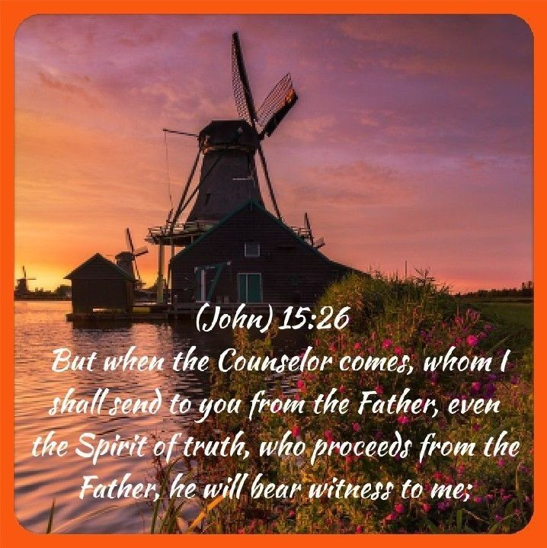

May 21, 2023

699 Stambaugh Ave.
Sharon, Pennsylvania 16146

“I was glad when they said to me,
Let us go to the house of the LORD!”
Psalm 122:1
Sts. Peter & Paul Evangelical Lutheran Church, LC-MS
EXAUDI
May 21, 2023

A special welcome to our guests this day! If you would like more information about The Lutheran Church - Missouri Synod, or this congregation, please speak with Pastor Deal or an Elder after the service.
Members & Guests: Don’t be embarrassed if your children make noise during the worship service, all children do. We encourage families to worship together but, if you feel the need, there are pews in the rear of the Church which are reserved for young families on both sides of the sanctuary. There is also a quiet room available to you during our service which is located down the hallway past the offices on the right side of the church as well as a children’s area in the Fellowship Hall where you are able to follow along with the service.

Today’s service includes the Sacrament of Holy Communion. If during this past year, you have not worshipped with us and been communed, we respectfully ask that you do not partake of this sacrament this day before first speaking with Pastor Deal.
If visiting from a sister congregation of the LC-MS and are in good standing, please inform Pastor Deal of your desire to commune prior to the service.
If wishing to receive a blessing during communion, please approach with your arms crossed.

CONTACT INFORMATION
Pastor Deal: pastordeal@saintspeterandpaul.net or 724-347-3620 (opt. 2)
Church Office: church@saintspeterandpaul.net or 724-347-3620 (opt. 3)
Secretary’s Office will be open Monday and Thursday this week from 8:30 – 4:30.

Silent prayer before worship: Heavenly Father, by grace through faith You have brought me into a relationship with You in Jesus Christ. Accept my praise and hear my prayers according to Your gracious will. And lead me to witness to other of Your love. In Jesus name. Amen.
Confession and Absolution

Opening Hymn: TLH #217 “Oh, Sing with Exultation”
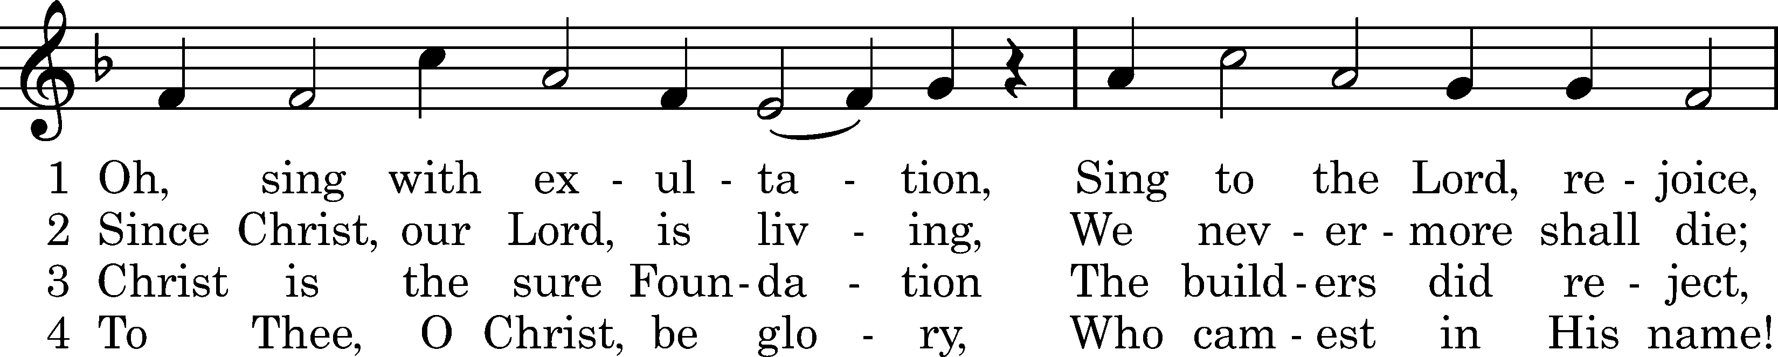
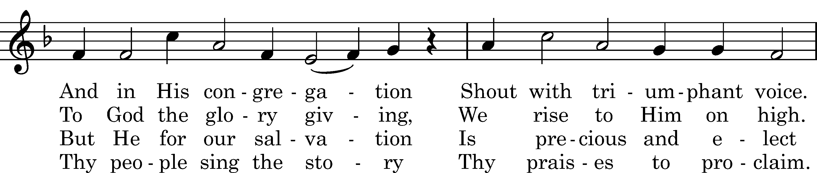
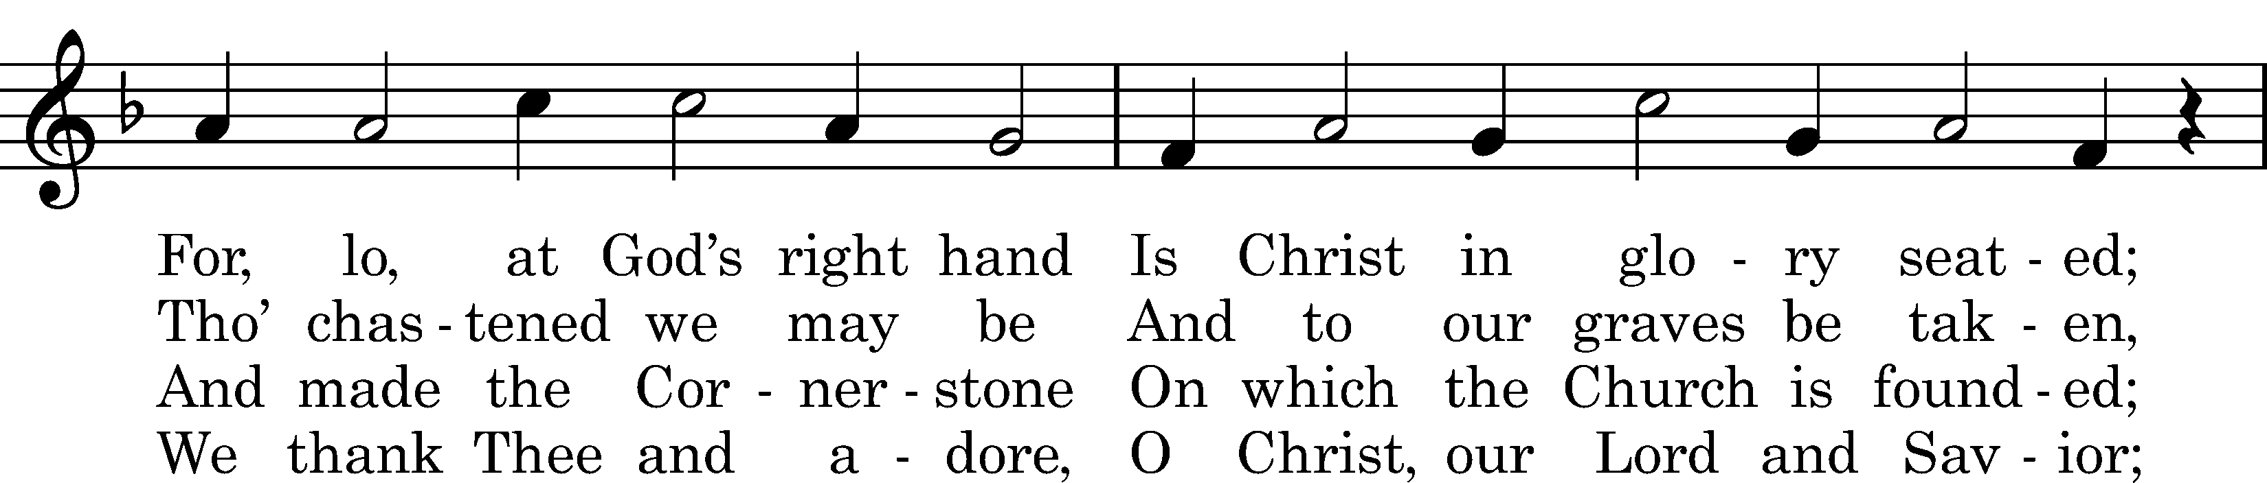
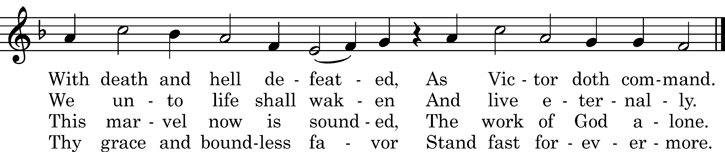

Text: tr. Carl Doving, 1907; Anders C. Arrebo, 1623, cento Tune: Neu Catechismus-Gesangbuechlein, Hamburg, 1598 Text and tune: Public domain

Stand

The sign of the cross may be made by all in remembrance of their Baptism.

Invocation
P In the name of the Father and of the T Son and of the Holy Spirit.
C Amen.

Exhortation Hebrews 10:22; Psalm 124:8; Psalm 32:5
P Beloved in the Lord! Let us draw near with a true heart and confess our sins unto God our Father, beseeching Him in the name of our Lord Jesus Christ to grant us forgiveness.

P Our help is in the name of the Lord,
C who made heaven and earth.
P I said, I will confess my transgressions unto the Lord,
C and You forgave the iniquity of my sin.

Silence for reflection on God’s Word and for self-examination.

Confession of Sins
P O almighty God, merciful Father,
C I, a poor, miserable sinner, confess unto You all my sins and iniquities with which I have ever offended You and justly deserved Your temporal and eternal punishment. But I am heartily sorry for them and sincerely repent of them, and I pray You of Your boundless mercy and for the sake of the holy, innocent, bitter sufferings and death of Your beloved Son, Jesus Christ, to be gracious and merciful to me, a poor, sinful being.

Absolution [John 20:19–23]
P Upon this your confession, I, by virtue of my office, as a called and ordained servant of the Word, announce the grace of God unto all of you, and in the stead and by the command of my Lord Jesus Christ I forgive you all your sins in the name of the Father and of the T Son and of the Holy Spirit.
C Amen.
Service of the Word
Introit Psalm 27:1, 11a, 12; antiphon: vv. 7a, 8b, 9a
Hear, O Lord, when I cry aloud. Alle- | luia.*
Your face, Lord, do I seek; hide not your face from me. Alle- | luia.
The Lord is my light and my salvation; whom | shall I fear?*
The Lord is the stronghold of my life; of whom shall I | be afraid?
Teach me your way, | O Lord;*
give me not up to the will of my adver- | saries;
for false witnesses have risen a- | gainst me,*
and they breathe out | violence.
Hear, O Lord, when I cry aloud. Alle- | luia.*
Your face, Lord, do I seek; hide not your face from me. Alle- | luia.

Gloria Patri
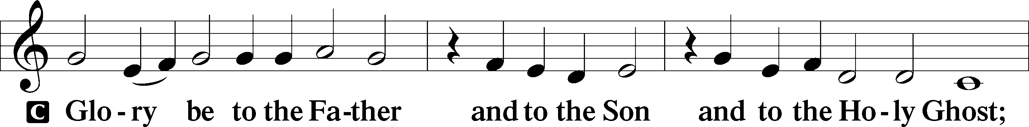
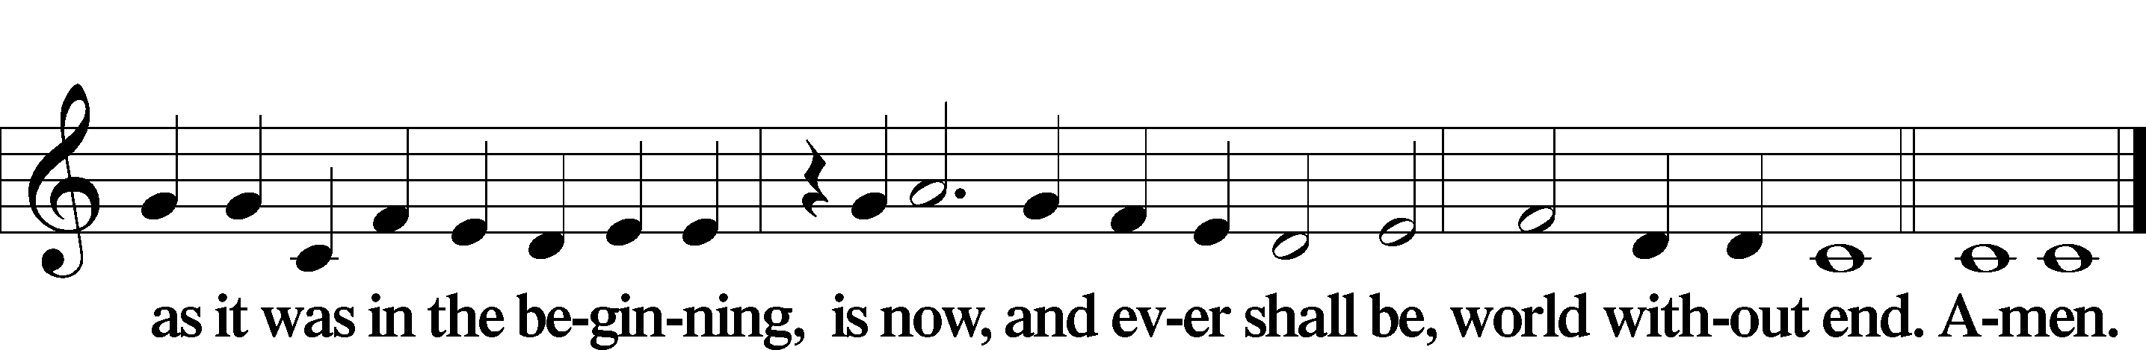

Kyrie Mark 10:47
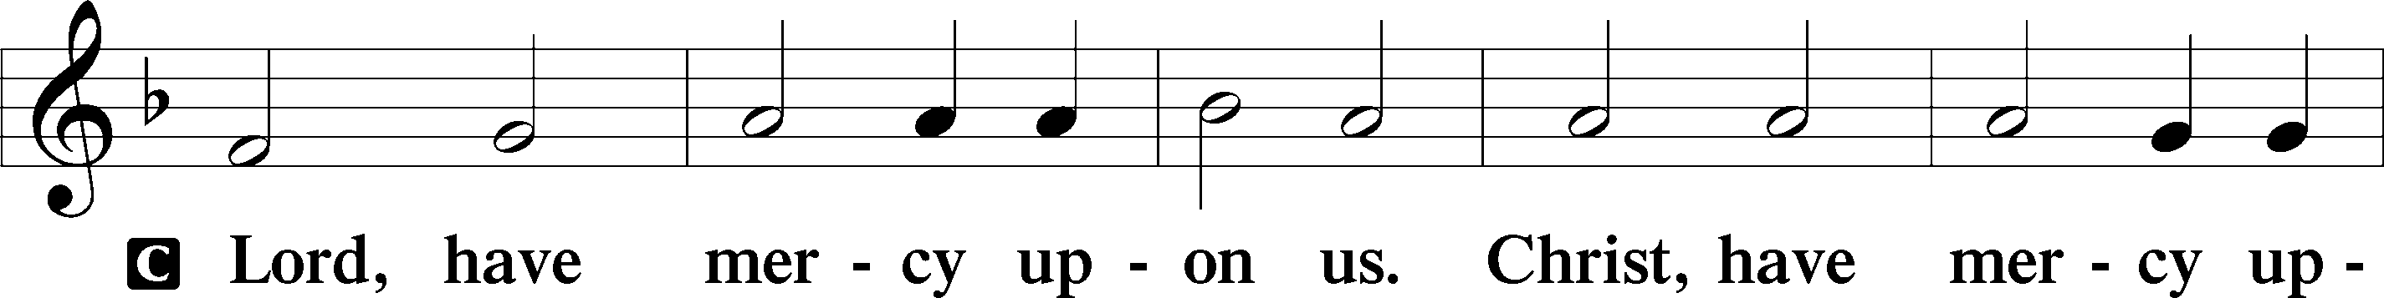
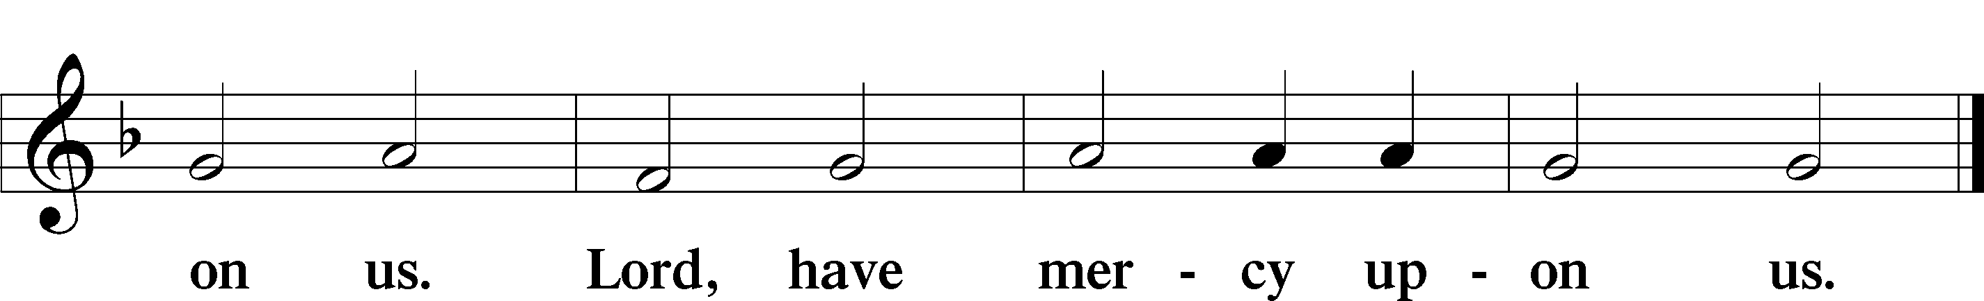

Gloria in Excelsis Luke 2:14; John 1:29
P Glory be to God on high:
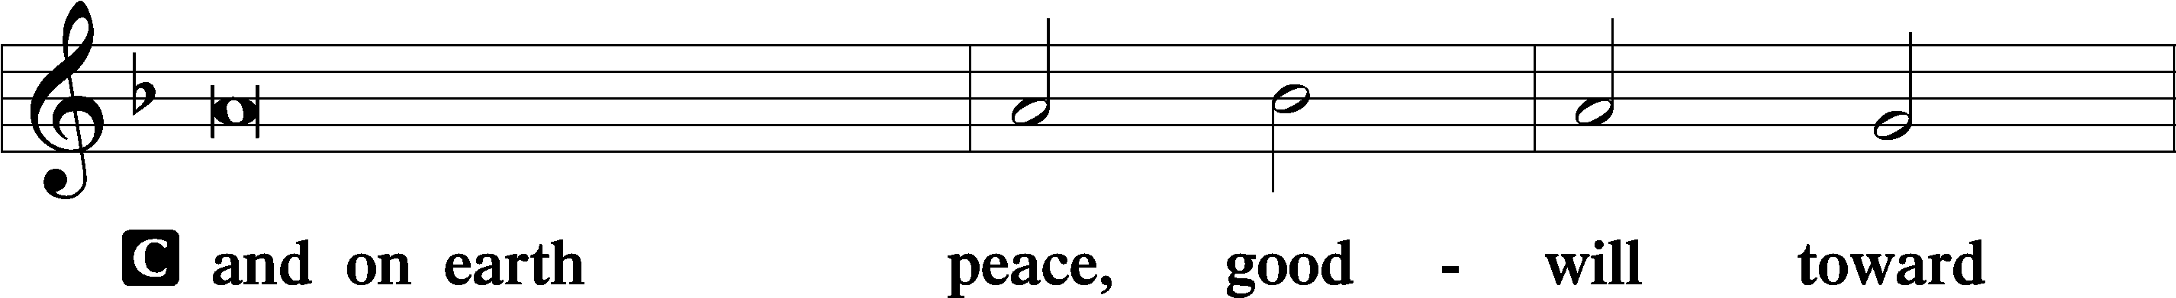
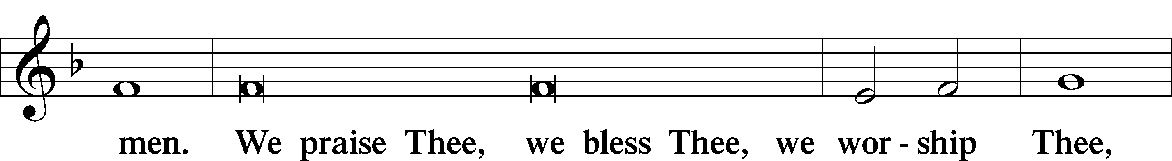
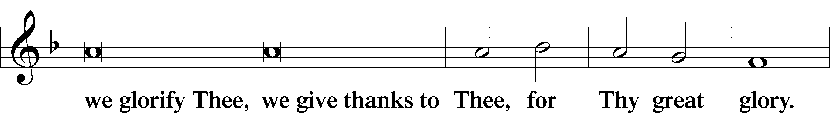
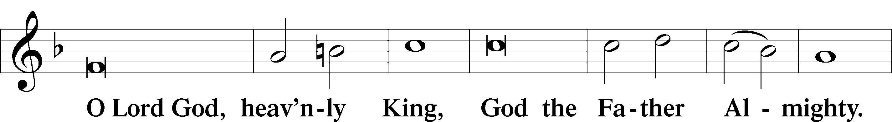
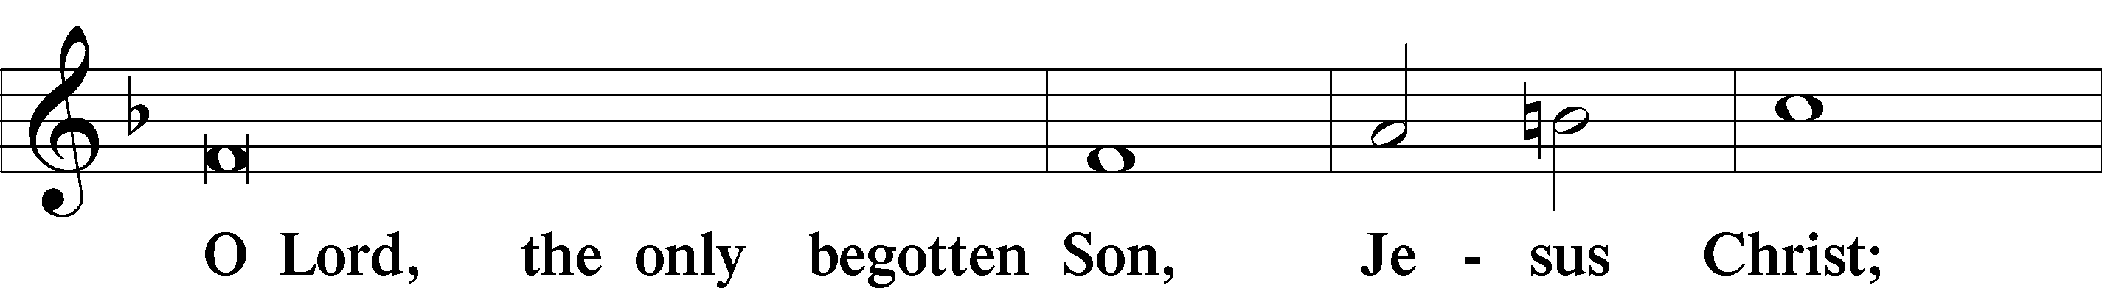
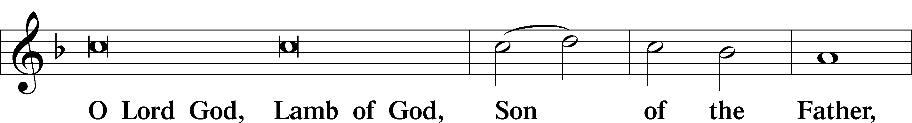
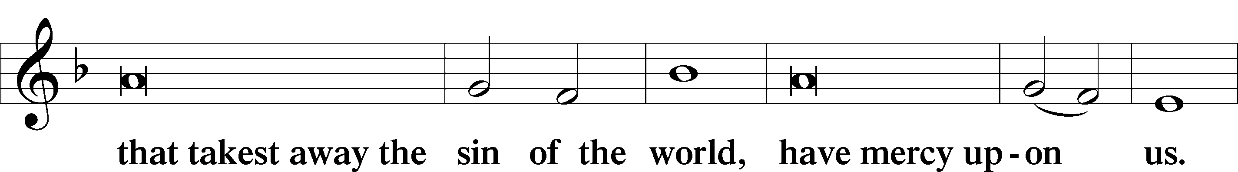
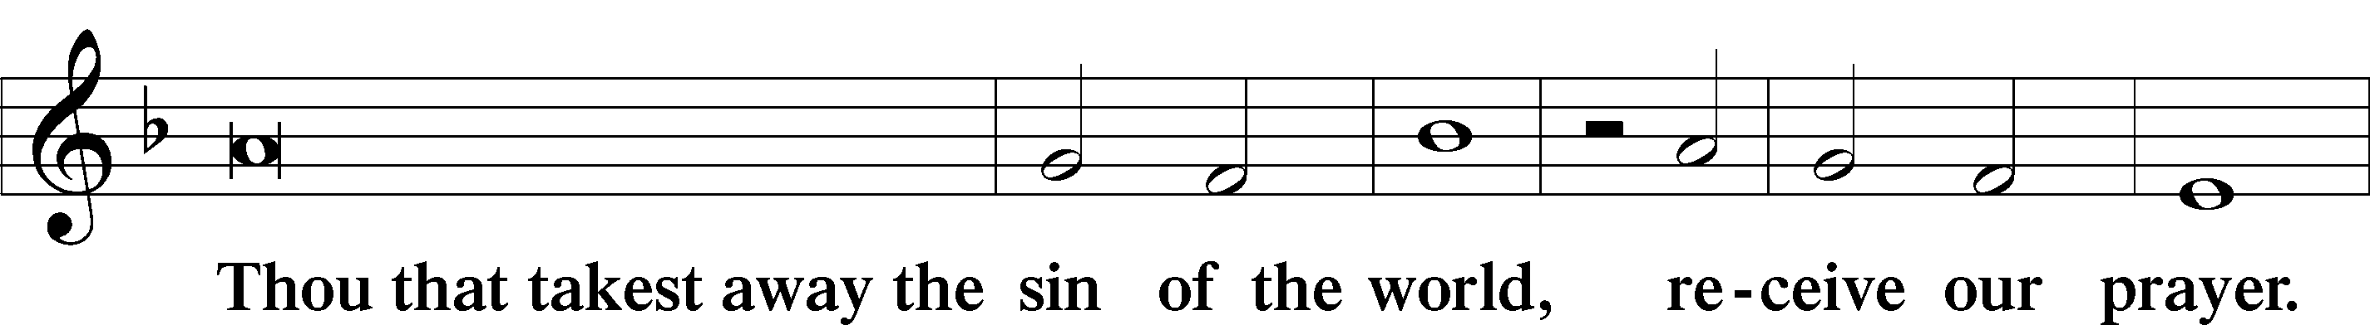
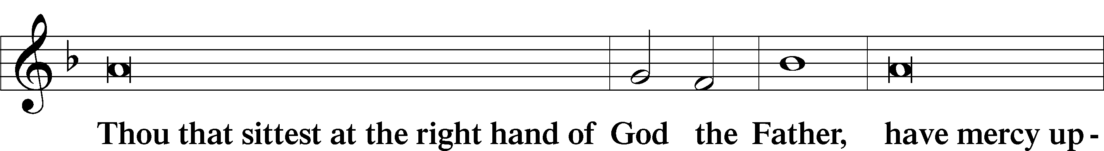
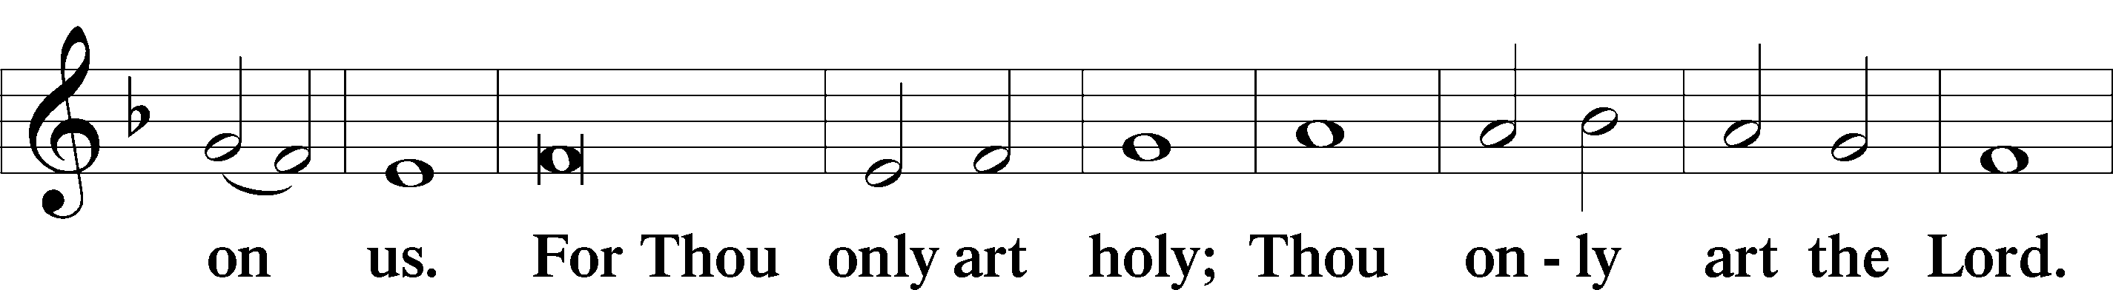
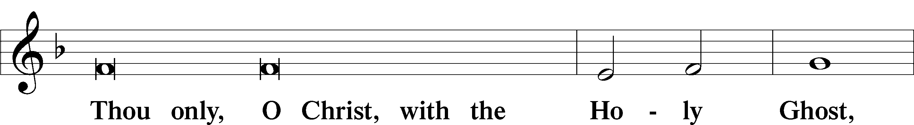
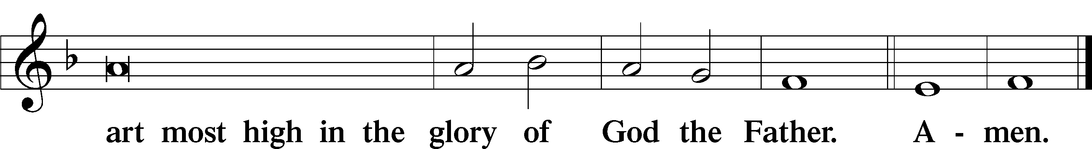

Salutation and Collect of the Day: Exaudi
P The Lord be with you.
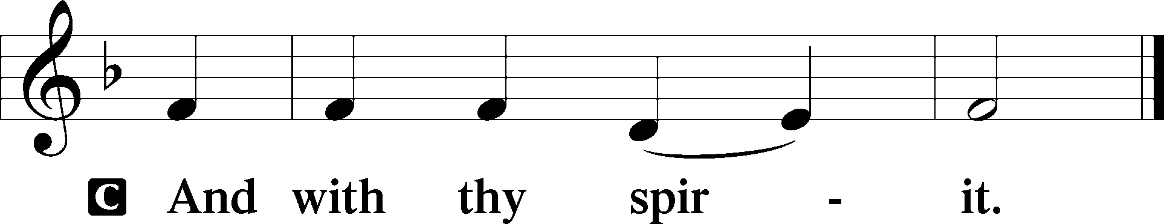

P Let us pray.
O King of glory, Lord of hosts, uplifted in triumph far above all heavens, leave us not without consolation but send us the Spirit of truth whom You promised from the Father; for You live and reign with Him and the Holy Spirit, one God, now and forever.
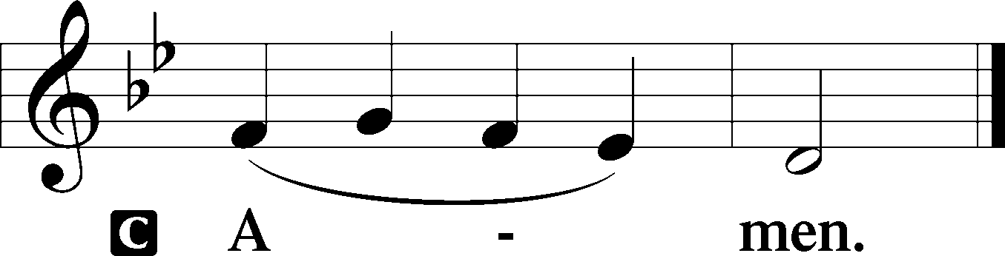
Sit

Prophecy: Ezekiel 36:23a, 23c–28 (NKJV)
Thus says the Lord God: “I will sanctify My great name, and the nations shall know that I am the Lord, when I am hallowed in you before their eyes. For I will take you from among the nations, gather you out of all countries, and bring you into your own land. Then I will sprinkle clean water on you, and you shall be clean; I will cleanse you from all your filthiness and from all your idols. I will give you a new heart and put a new spirit within you; I will take the heart of stone out of your flesh and give you a heart of flesh. I will put My Spirit within you and cause you to walk in My statutes, and you will keep My judgments and do them. Then you shall dwell in the land that I gave to your fathers; you shall be My people, and I will be your God,” says the Lord Almighty.

P This is the Word of the Lord.
C Thanks be to God.

Psalm: Psalm 51:1–12
Have mercy on me, O God,
according to your steadfast love;
according to your abundant mercy
blot out my transgressions.
Wash me thoroughly from my iniquity,
and cleanse me from my sin!
For I know my transgressions,
and my sin is ever before me.
Against you, you only, have I sinned
and done what is evil in your sight,
so that you may be justified in your words
and blameless in your judgment.
Behold, I was brought forth in iniquity,
and in sin did my mother conceive me.
Behold, you delight in truth in the inward being,
and you teach me wisdom in the secret heart.
Purge me with hyssop, and I shall be clean;
wash me, and I shall be whiter than snow.
Let me hear joy and gladness;
let the bones that you have broken rejoice.
Hide your face from my sins,
and blot out all my iniquities.
Create in me a clean heart, O God,
and renew a right spirit within me.
Cast me not away from your presence,
and take not your Holy Spirit from me.
Restore to me the joy of your salvation,
and uphold me with a willing spirit.

Epistle: 1 Peter 4:7b–11 (NKJV)
Dearly Beloved: Be serious and watchful in your prayers. And above all things have fervent love for one another, for “love will cover a multitude of sins.” Be hospitable to one another without grumbling. As each one has received a gift, minister it to one another, as good stewards of the manifold grace of God. If anyone speaks, let him speak as the oracles of God. If anyone ministers, let him do it as with the ability which God supplies, that in all things God may be glorified through Jesus Christ, to whom belong the glory and the dominion forever and ever. Amen.

P This is the Word of the Lord.
C Thanks be to God.

Stand

Verse Psalm 47:8; John 14:18a, 28; 16:22b
Alleluia. God reigns over the nations; God sits on his holy throne. Alleluia. I will not leave you as orphans; I am going away, and I will come to you, and your hearts will rejoice. Alleluia.

Alleluia
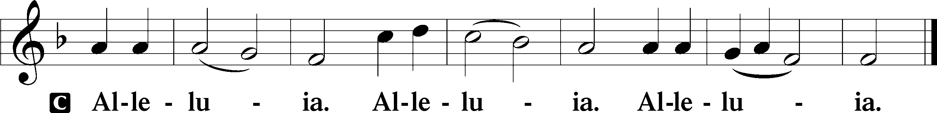

Holy Gospel: John 15:26—16:4a (NKJV)
P The Holy Gospel according to St. John, the fifteenth chapter.
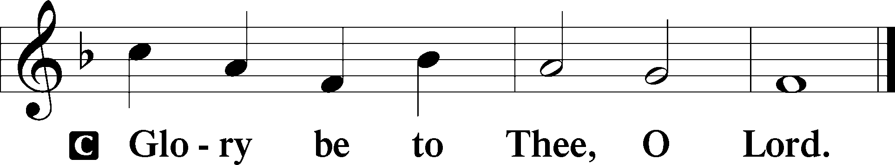

At that time Jesus said to His disciples: “When the Helper comes, whom I shall send to you from the Father, the Spirit of truth who proceeds from the Father, He will testify of Me. And you also will bear witness, because you have been with Me from the beginning. These things I have spoken to you, that you should not be made to stumble. They will put you out of the synagogues; yes, the time is coming that whoever kills you will think that he offers God service. And these things they will do to you because they have not known the Father nor Me. But these things I have told you, that when the time comes, you may remember that I told you of them.”

P This is the Gospel of the Lord.
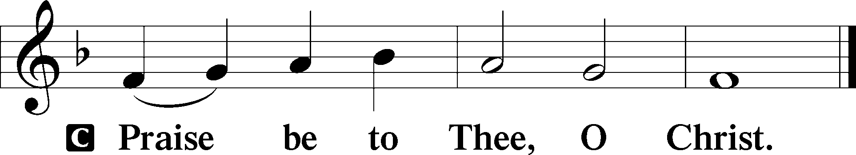

Nicene Creed
C I believe in one God,
the Father Almighty,
maker of heaven and earth
and of all things visible and invisible.

And in one Lord Jesus Christ,
the only-begotten Son of God,
begotten of His Father before all worlds,
God of God, Light of Light,
very God of very God,
begotten, not made,
being of one substance with the Father,
by whom all things were made;
who for us men and for our salvation came down from heaven
and was incarnate by the Holy Spirit of the virgin Mary
and was made man;
and was crucified also for us under Pontius Pilate.
He suffered and was buried.
And the third day He rose again according to the Scriptures
and ascended into heaven
and sits at the right hand of the Father.
And He will come again with glory to judge both the living and the dead,
whose kingdom will have no end.

And I believe in the Holy Spirit,
the Lord and giver of life,
who proceeds from the Father and the Son,
who with the Father and the Son together is worshiped and glorified,
who spoke by the prophets.
And I believe in one holy Christian and apostolic Church,
I acknowledge one Baptism for the remission of sins,
and I look for the resurrection of the dead
and the life T of the world to come. Amen.
Sit

Hymn of the Day: TLH #223 “We Thank Thee, Jesus, Dearest Friend”
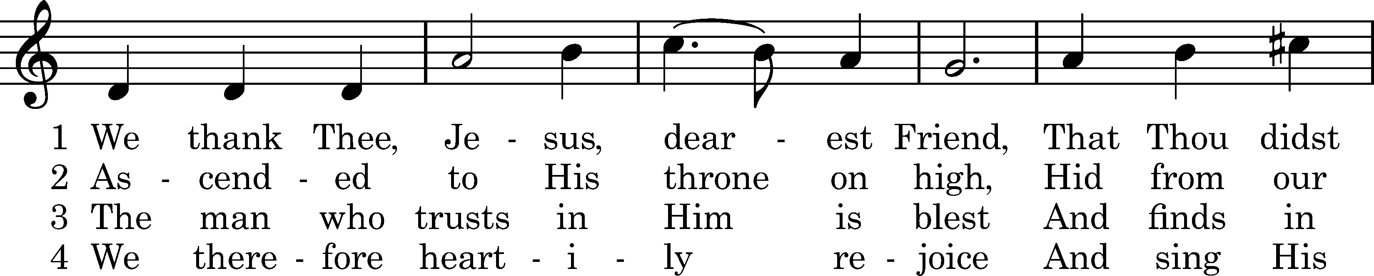
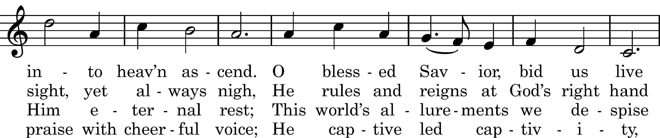
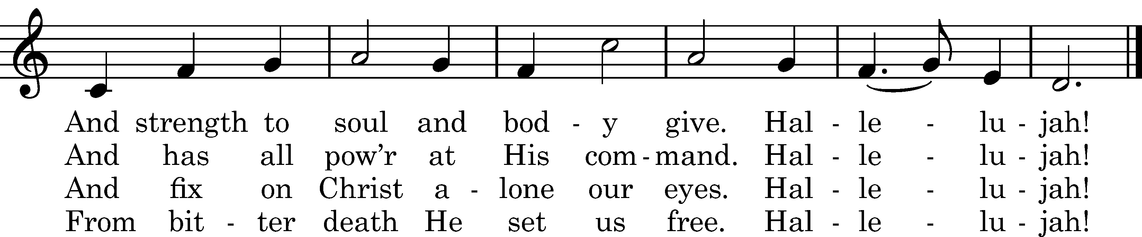

5 Thro' Him we heirs of heav'n are made;
O Brother, Christ, extend Thine aid
That we may firmly trust in Thee
And thro' Thee live eternally.
Hallelujah!

Text: tr. Matthias Loy, 1880, alt.; author unknown, 1607, cento Tune: Nikolaus Herman, 1560 Text and tune: Public domain

Sermon

Stand

Prayer of the Church

Offertory Psalm 51:10–12
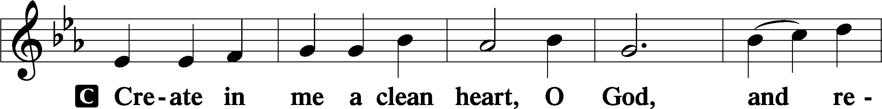
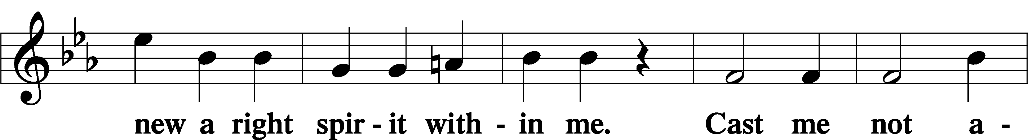
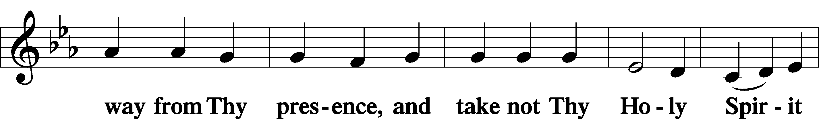
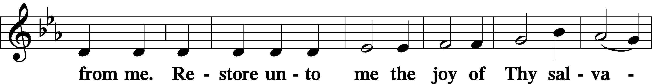
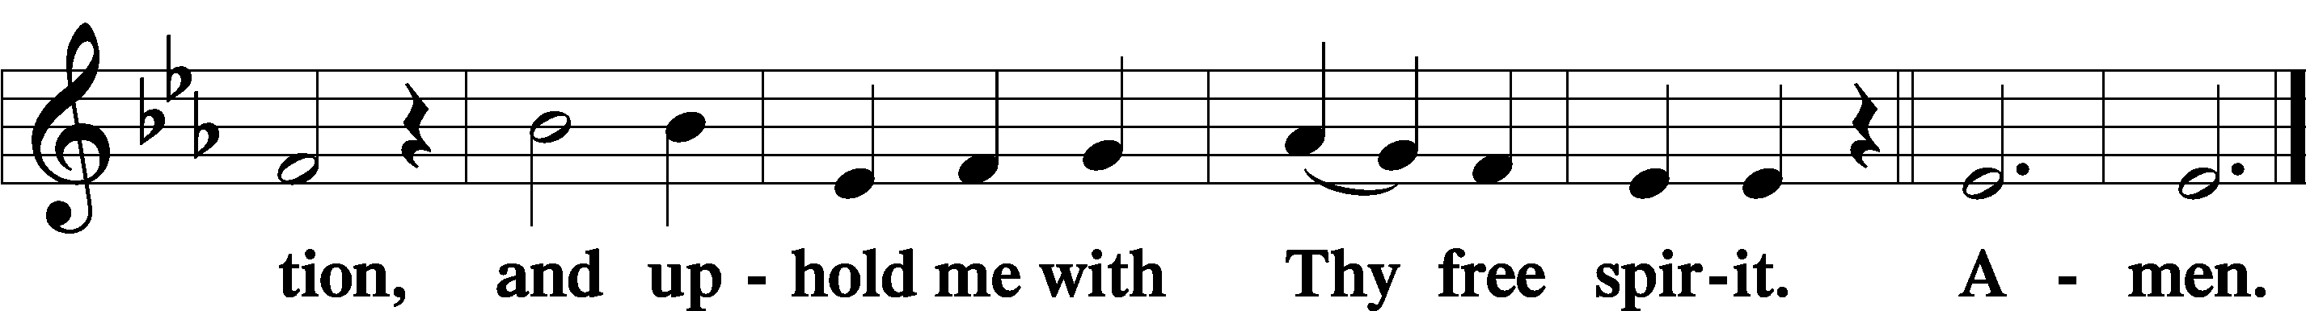
Sit

Preparatory Hymn: LSB #622 “Lord Jesus Christ, You Have Prepared”

Stand

Service of the Sacrament

Preface 2 Timothy 4:22; Colossians 3:1 Psalm 136
P The Lord be with you.

P Lift up your hearts.
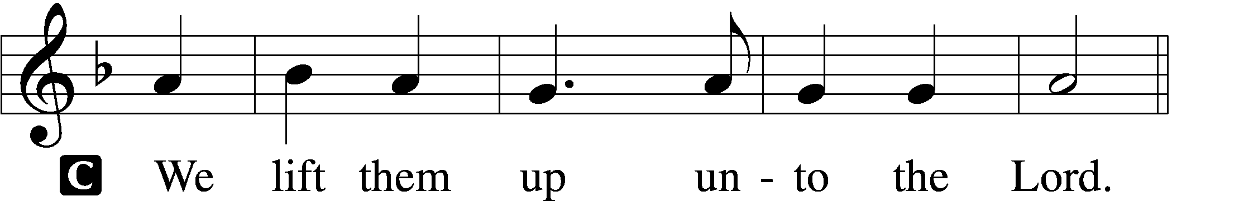

P Let us give thanks unto the Lord, our God.
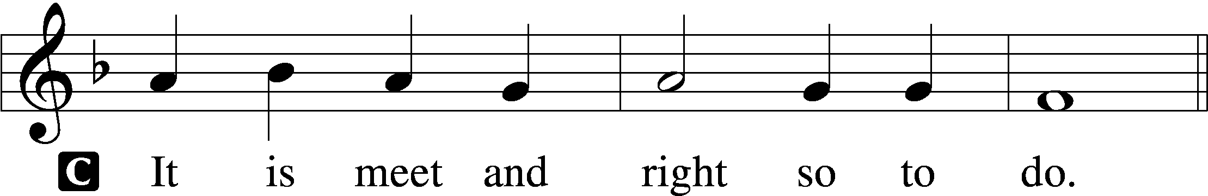

Proper Preface (Abbreviated) LSB 194
P It is truly meet, right, and salutary . . . evermore praising You and saying:

Sanctus Isaiah 6:3; Matthew 21:9
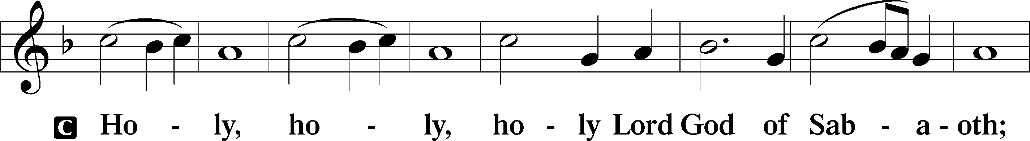
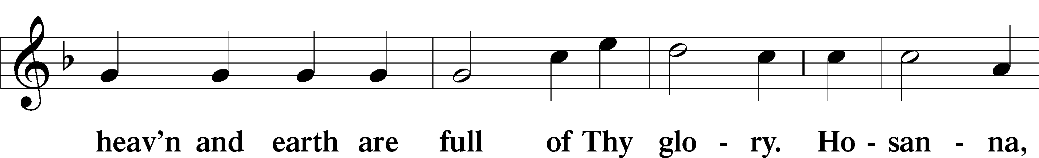
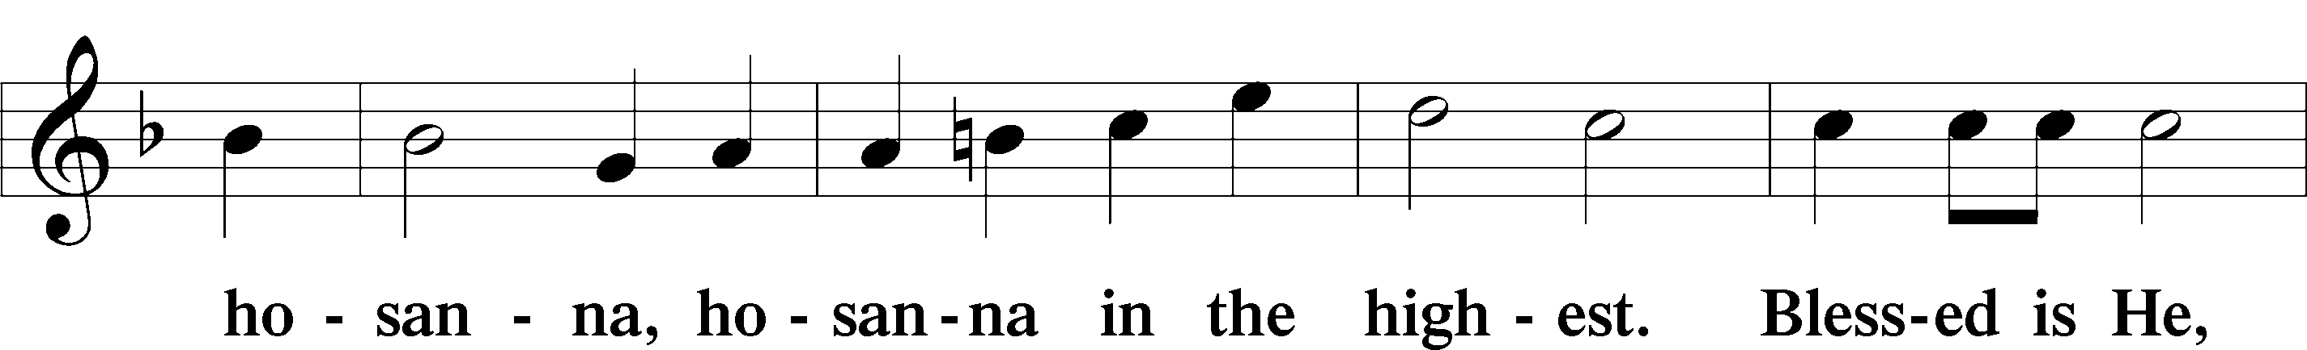
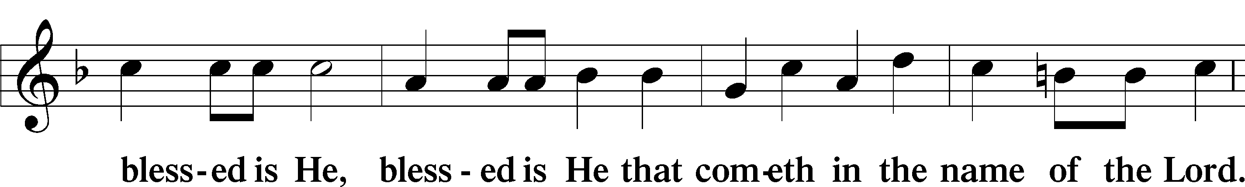
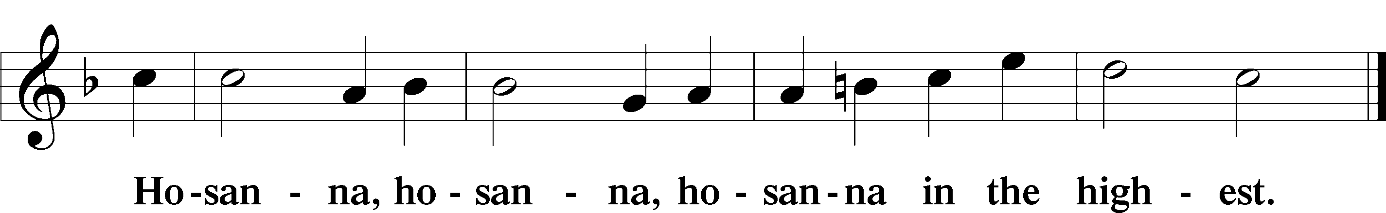

Lord’s Prayer Matthew 6:9–13
C Our Father who art in heaven,
hallowed be Thy name,
Thy kingdom come,
Thy will be done on earth as it is in heaven;
give us this day our daily bread;
and forgive us our trespasses as we forgive those who trespass against us;
and lead us not into temptation,
but deliver us from evil.
For Thine is the kingdom and the power and the glory forever and ever. Amen.

The Words of Our Lord Matthew 26:26–28; Mark 14:22–24; Luke 22:19–20; 1 Corinthians 11:23–25
P Our Lord Jesus Christ, on the night when He was betrayed, took bread, and when He had given thanks, He broke it and gave it to the disciples and said: “Take, eat; this is My T body, which is given for you. This do in remembrance of Me.”

In the same way also He took the cup after supper, and when He had given thanks, He gave it to them, saying: “Drink of it, all of you; this cup is the new testament in My T blood, which is shed for you for the forgiveness of sins. This do, as often as you drink it, in remembrance of Me.”

Pax Domini John 20:19
P The peace of the Lord be with you always.
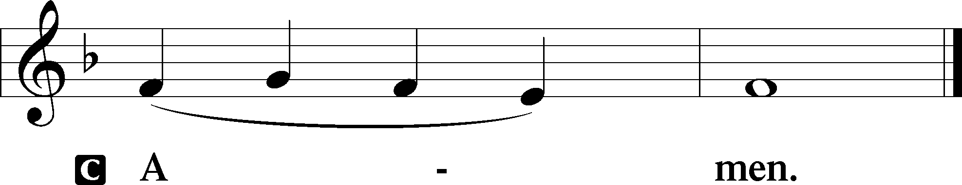

Agnus Dei John 1:29
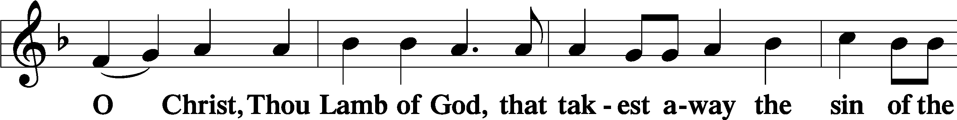
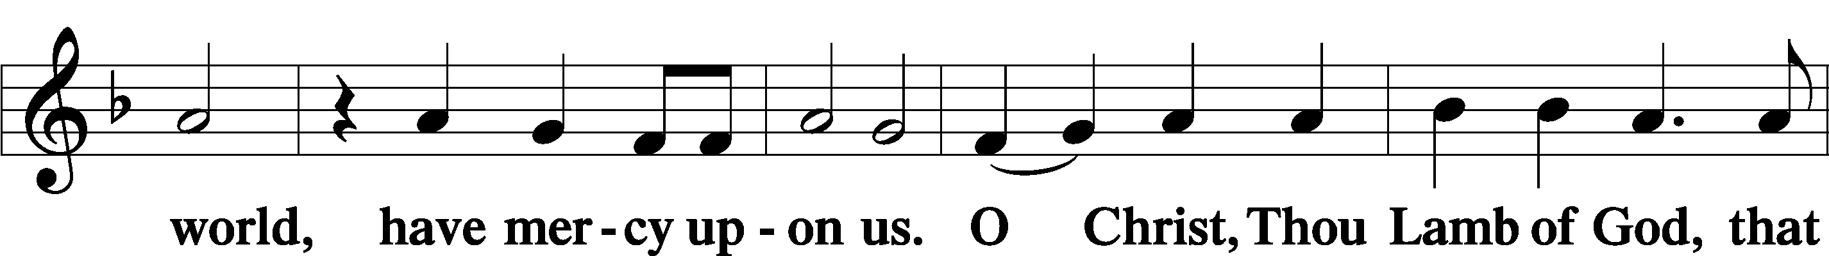
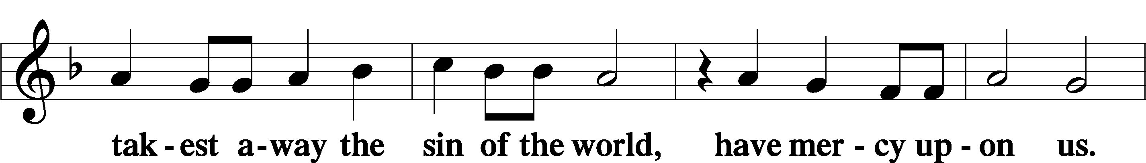
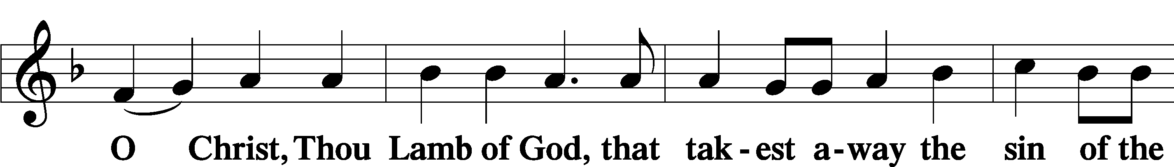
Sit

Distribution
The pastor and those who assist him receive the body and blood of Christ first and then distribute them to those who come to receive, saying:
Take, eat; this is the true body of our Lord and Savior Jesus Christ, given into death for your sins.
Amen.

Take, drink; this is the true blood of our Lord and Savior Jesus Christ, shed for the forgiveness of your sins.
Amen.

In dismissing the communicants, the following is said:
The Dismissal
P The body and blood of our Lord Jesus Christ strengthen and preserve you in body and soul to life everlasting. Depart T in peace.
C Amen.

Distribution Hymn: LSB #494 “See, the Lord Ascends in Triumph”

Distribution Hymn: LSB #818 “In Thee Is Gladness”

Distribution Hymn: LSB #713 “From God Can Nothing Move Me”

Nunc Dimittis Luke 2:29–32
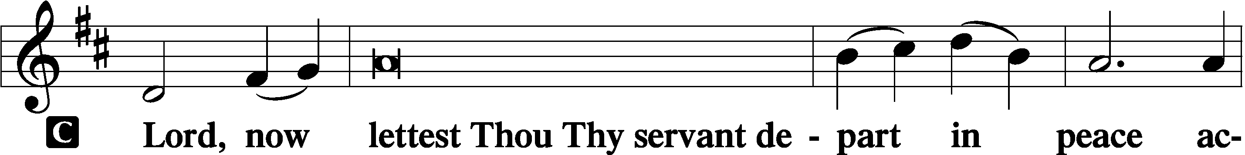
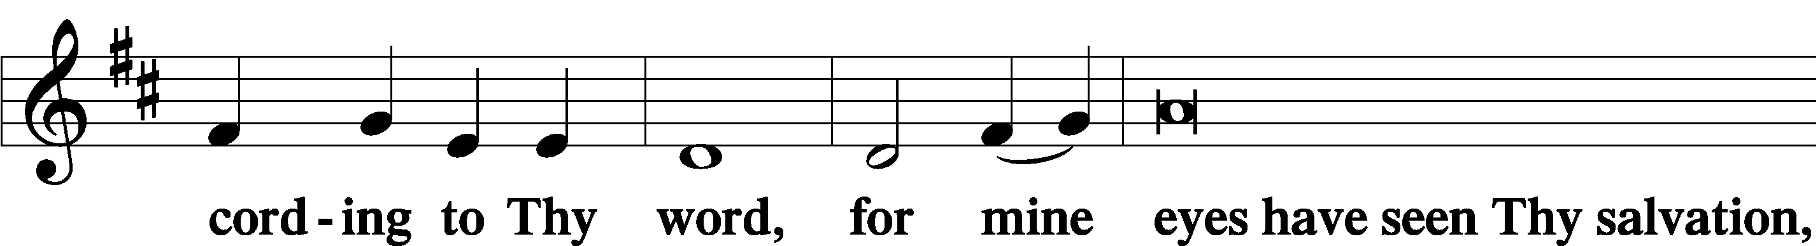
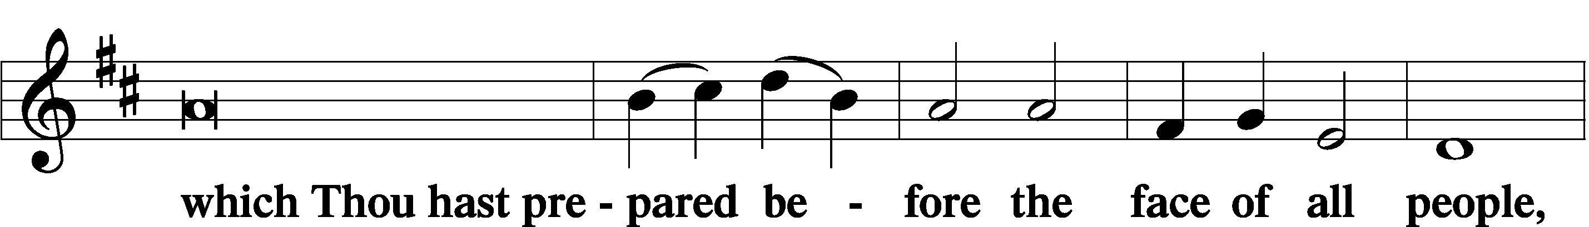
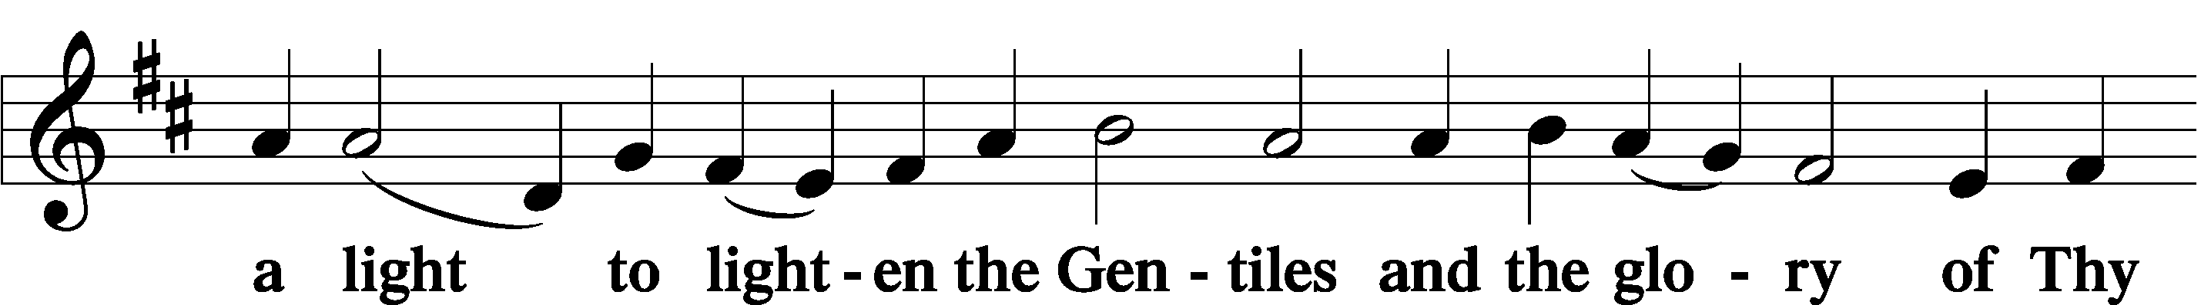
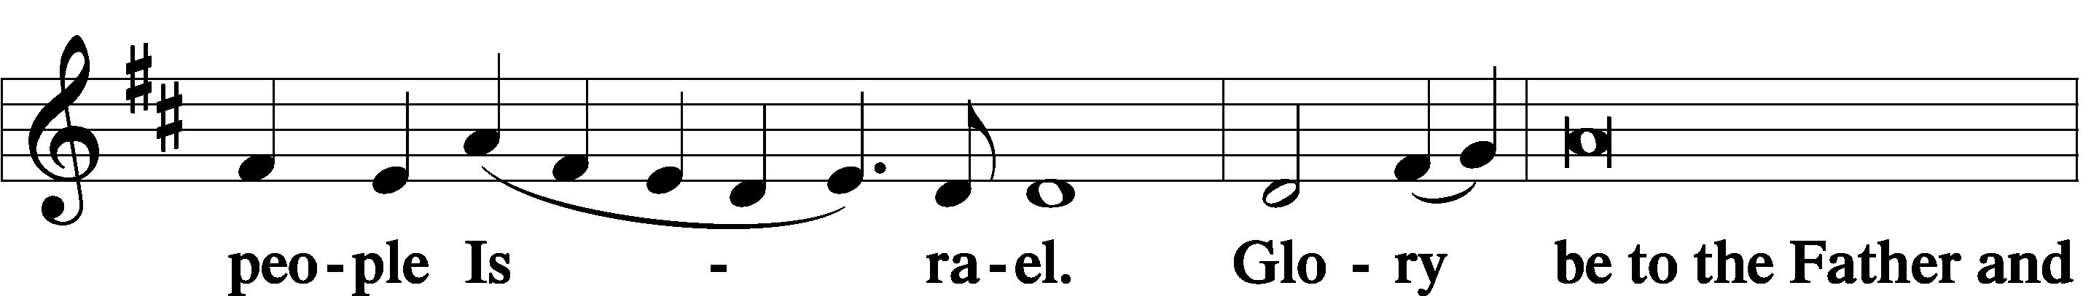
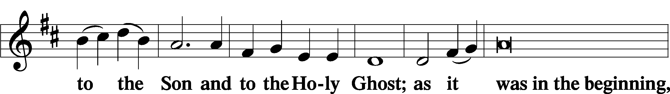
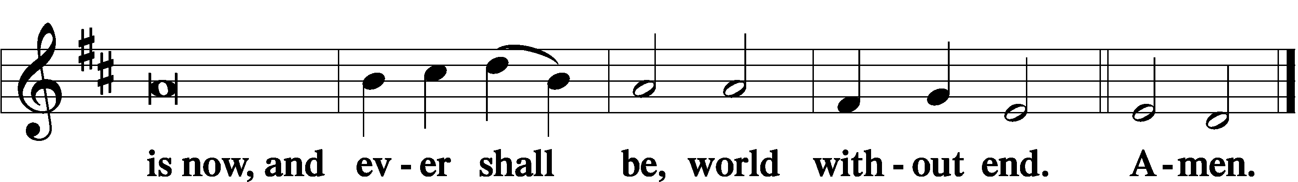

Thanksgiving Psalm 107:1
P O give thanks unto the Lord, for He is good,
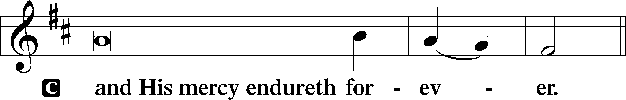

Post-Communion Collect
P Let us pray.
We give thanks to You, almighty God, that You have refreshed us through this salutary gift, and we implore You that of Your mercy You would strengthen us through the same in faith toward You and in fervent love toward one another; through Jesus Christ, Your Son, our Lord, who lives and reigns with You and the Holy Spirit, one God, now and forever.
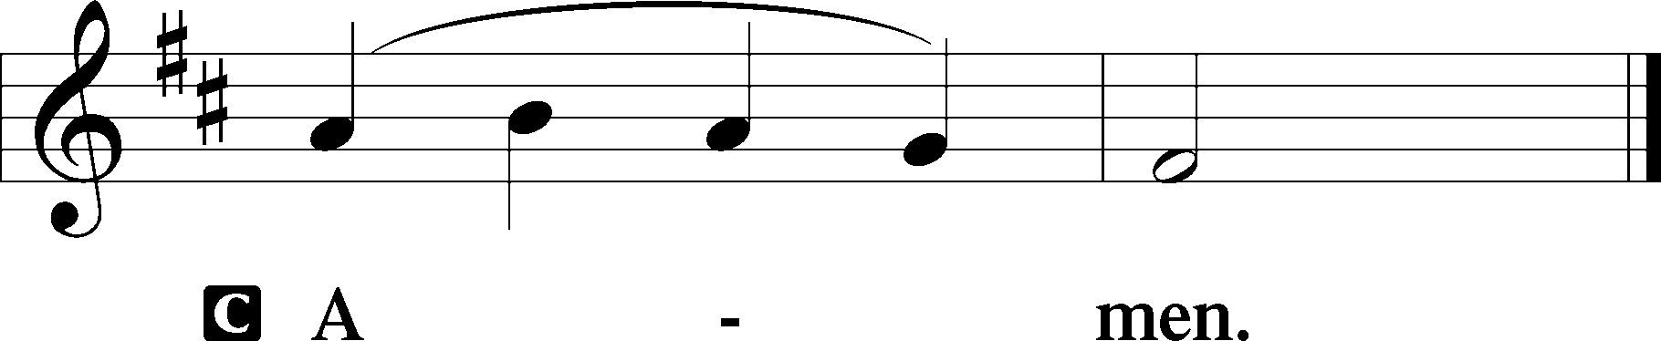

Salutation 2 Timothy 4:22
P The Lord be with you.
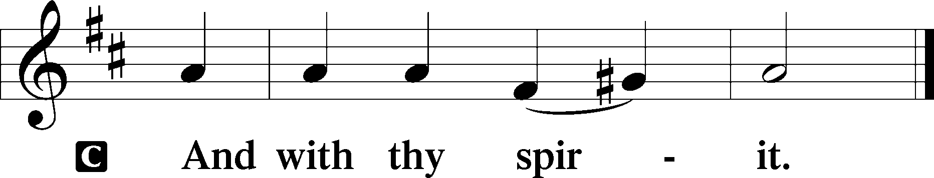

Benedicamus Psalm 103:1
P Bless we the Lord.
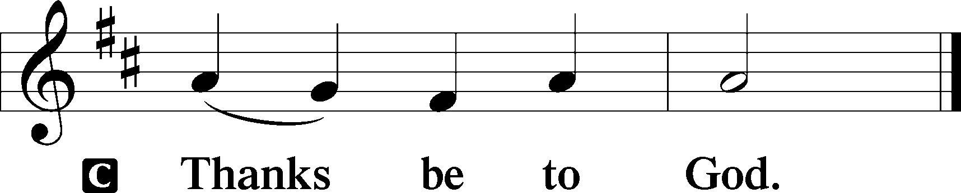

Benediction Numbers 6:24–26
P The Lord bless you and keep you.
The Lord make His face shine upon you and be gracious unto you.
The Lord lift up His countenance upon you and T give you peace.
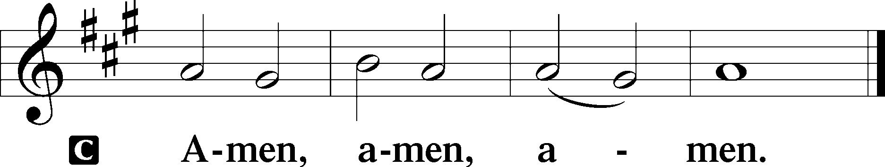

Closing Hymn: LSB #672 “Jerusalem the Golden”

Silent prayer after worship: O Lord, through Holy Baptism You have claimed me as Your own dear child. Help me to remember that my eternal life in Christ has already begun and will continue forever in heaven. Lead me to live my life to Your glory. In Jesus’ name. Amen.
fffffffffffffffffffffffffffffffffff
Acknowledgments: Unless otherwise indicated, Scripture quotations are from the ESV® Bible (The Holy Bible, English Standard Version®), copyright © 2001 by Crossway, a publishing ministry of Good News Publishers. Used by permission. All rights reserved. Created by Lutheran Service Builder © 2023 Concordia Publishing House.
fffffffffffffffffffffffffffffffffff
In Loving Memory of Mother, Eva Dorfi: Edeltraud Sulek (Capital Campaign).
In Loving Memory of Barry Nelson: Rev. Dona & Joe Cummings (Food Pantry), Lisa & Max Jelinek (Food Pantry), Michael & Kati Laird (Food Pantry), Janice & David Langdon (Food Pantry), Mercer Elementary School Teachers & Staff (Food Pantry), James Popa (Food Pantry), Juanita Rynd (Food Pantry), Sandra Shuttleworth (Food Pantry), Skip & Patty Wachter (Food Pantry), Steven & Judith Zachar (Food Pantry)
fffffffffffffffffffffffffffffffffff
The Altar Flowers today are given in appreciation of God’s great mercy and healing powers from an anonymous donor. We are very appreciative of this generous gift.
fffffffffffffffffffffffffffffffffff
SCHEDULE THROUGH MAY 28, 2023:

:

Today, following Worship, Library: Audit of Deposits
7 pm, Fellowship Hall: AA Meeting
Tuesday, 7-9 pm, Fellowship Hall: Penn-Ohio Singers
Wednesday, 7:30 pm, Fellowship Hall: NA Meeting
Thursday, 9 am, Downstairs: Food Pantry
Next Sunday, 8 am, Fellowship Hall: Bible Study
9 am, Sanctuary: Divine Service
Following Worship, Fellowship Hall: Financial Committee Meeting
7 pm, Fellowship Hall: AA Meeting
fffffffffffffffffffffffffffffffffff
Items for the June calendar and newsletter are due to Diane no later than noon tomorrow, May 22nd.
fffffffffffffffffffffffffffffffffff
Available in the narthex: Minutes from the May 15, 2023, Church Council mtg. and tentative June 4, 2023, Voters’ Assembly agendas.
fffffffffffffffffffffffffffffffffff
Attendance: Sunday, May 14, 2023: 41
Our Stewardship of Treasures for the Lord:
In order to do the Lord’s work, we need $2,553.63 each week to meet our 2023 budget for general purposes and $76.92 for the SELC. Online Figures (05.11 & 05.15.2023)
General Fund: $230.00
Capital Campaign: $200.00
Figures for Sunday, May 14, 2023
General Fund: $1,320.00 Behind for the week*: -$1,003.63
SELC: $63.00 Behind for the week*: -$13.92
Food Pantry: $995.00 *Includes above figures.
Quarterly Missions: $15.00
Capital Campaign: $40.00
Other: $25.00

For online giving, check out https://www.saintspeterandpaul.net/online-giving.
fffffffffffffffffffffffffffffffffff
THANK YOU FOR SERVING IN MAY: Elder: Jonathan Baisch; Ushers: Matt Berent, Mark Gabriel, Michael Laird, & Jerome Thomas; Altarware: (prior) Diane Riefstahl & Marie Flaugher (05/14); (after) Evelyn Baisch (05/07 & 05/14), Hank Holcroft (05/21), Ruth Meszaros (05/28) & Arlene Sutton.
fffffffffffffffffffffffffffffffffff
All are invited to celebrate Alex (Sasha) Carr’s Graduation and Army Reception at an Open House, Sunday, June 4 from 2-5 pm in the Fellowship Hall. Join us as we give thanks for Alex’s service to our church and wish him success in his future.
fffffffffffffffffffffffffffffffffff
Bible Memory Verses ~ Week of May 21st:
For Adults: This is my commandment, that you love one another as I have loved you. John 15:12

For Children: I will pour out a spirit of grace and pleas for mercy.
Zechariah 12:10
fffffffffffffffffffffffffffffffffff
Auditors will meet today in the library for a monthly audit of deposits.
Remember the following in Prayer…
~The Hurting and Healing: Amy, Gerald Arthur, Ellen Baron^{CA}, Lois Bortner^{CA}, John Burdette, Bev & Joe Chlpka, Kathleen Coughenour, Kim, Anna Mae Daris, Susan Davies, Tim Dudash, Millie Elavsky, Joseph Fleet, Judith & Eddy Furey, Tim Haenftling, Austin Hamilton, Joan, Darla Krajci, Barbara Kreske, Donna Kennedy, Jess Lavoie, Joanne Lozier, Paul Lucas^{CA}, Sandy Marshall, Frank Niemeyer^{CA}, Linda Parkany, Juanita Rentschler, Richard Reuning^{CA}, Nancy Robertson^{CA}, Marty Scott, Kara, Fred Tonty, Joel & Peggy Wasson, Angela Weser^{CA}, and Ruth Wolf.
~The Homebound: Rudy & Jean Tomko, Betty Wolf, and Ed & Millie Zachar.
~Celebrating this Week: Birthdays: Catherine Carr (05.21), Ralph Dorman (05.21), and Joe Chlpka (05.21). Anniversary: Michael & Kati Laird (05.21).
~Serving in the Military: Curtis Sinewe and Joshua Solyan.
~Community & World Needs: Those suffering from or affected by the coronavirus; those suffering due to the conflict between Ukraine and Russia; those suffering from loss and dislocation because weather disasters; those suffering from addiction and their families; Local, State, and National Government Leaders; safety for all Police Officers, Firefighters, & First Responders; the unemployed; our Second Quarter Local Mission: The Support of a Concordia, Fort Wayne Seminarian.
*CA represents cancer.
fffffffffffffffffffffffffffffffffff
If needing to get into the church building during the week, please phone first to make certain someone is here to let you in.
fffffffffffffffffffffffffffffffffff
Nominations are being sought for a Missionary/Mission to support as our 3rd Quarter Mission project. Please submit nominations and supporting materials to Jonathan Baisch no later than next Sunday, May 28th, if possible.
fffffffffffffffffffffffffffffffffff
Church Website: www.saintspeterandpaul.net
Church Email: church@saintspeterandpaul.net
AA Contact (Steve): 724-813-2358
NA Contact (Larry): 724-977-8733

