“Spiritual Contemplation of Christ’s Suffering”
2024 LENTEN MIDWEEK MATINS SERVICE

OPENING HYMN:
February 21: LSB #562 “All Mankind Fell in Adam’s Fall”
February 28: LSB #439:1-8 “O Dearest Jesus, What Law Hast Thou Broken”
March 6: LSB #440 “Jesus, I Will Ponder Now”
March 13: LSB #430 “My Song Is Love Unknown”
March 20: LSB #756 “Why Should Cross and Tral Grieve Me”

Stand
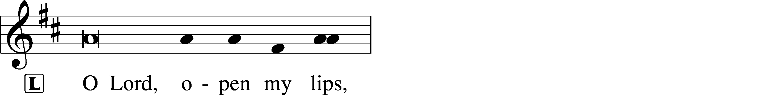
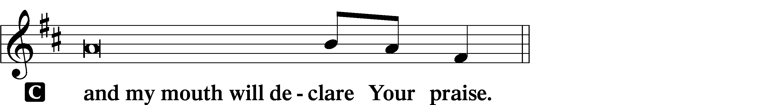

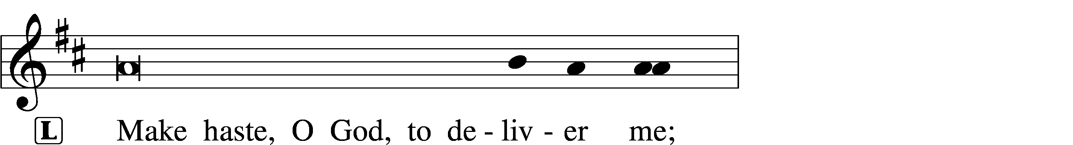
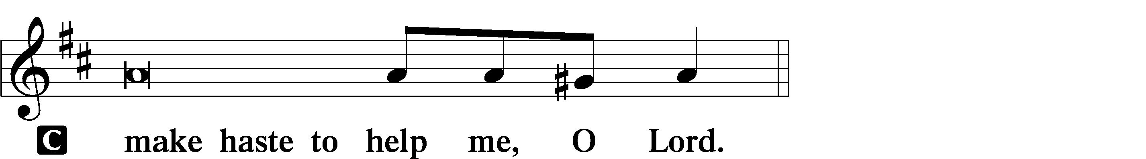

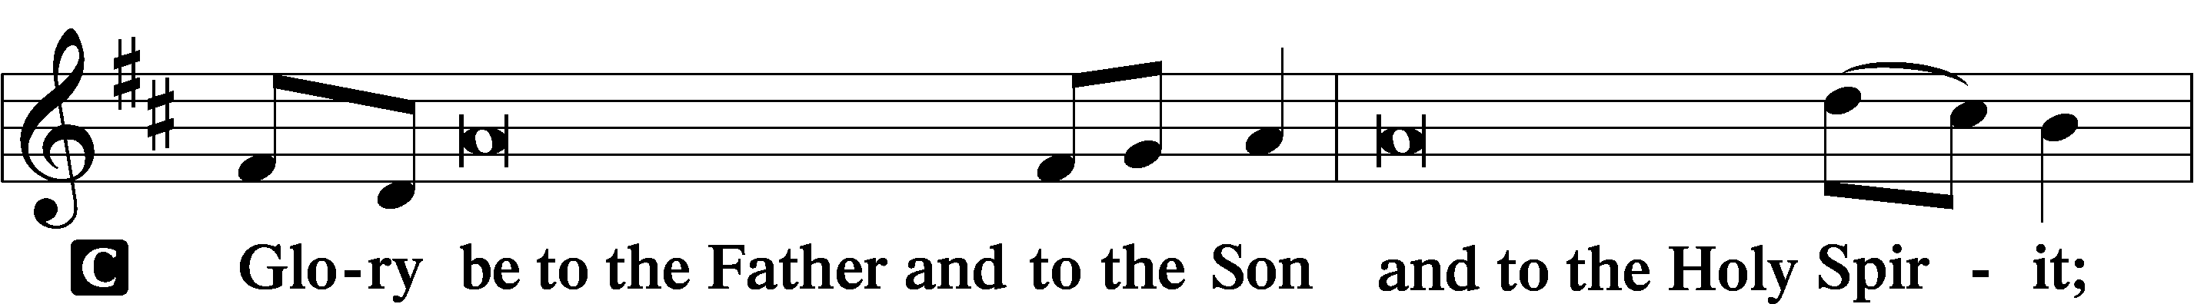
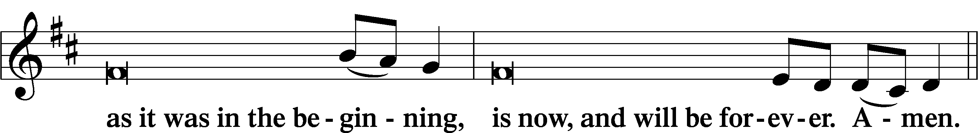
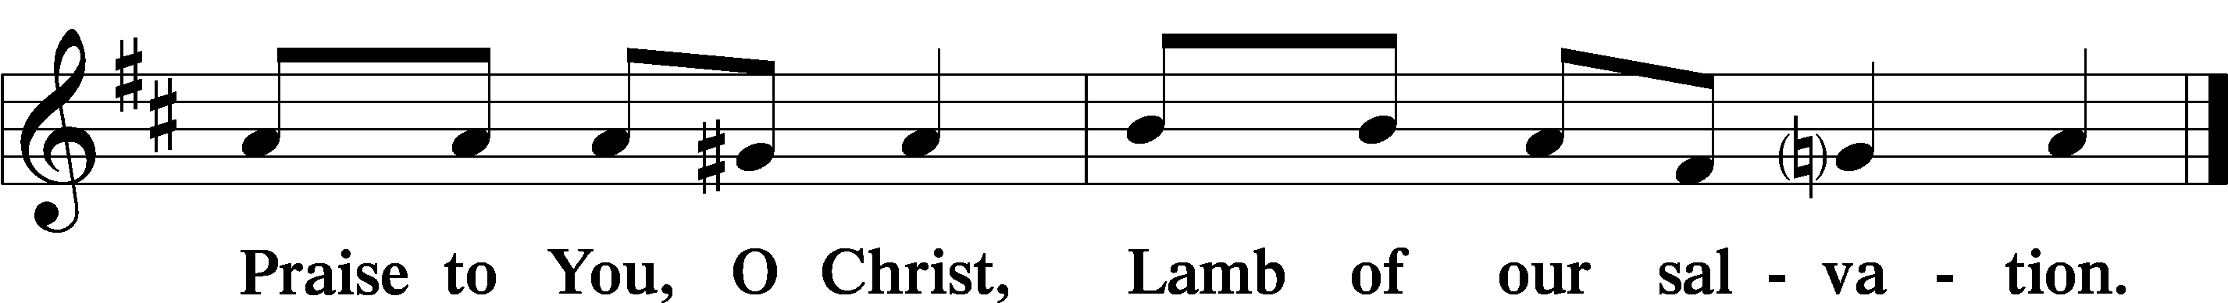

Psalmody

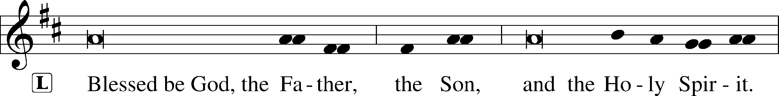
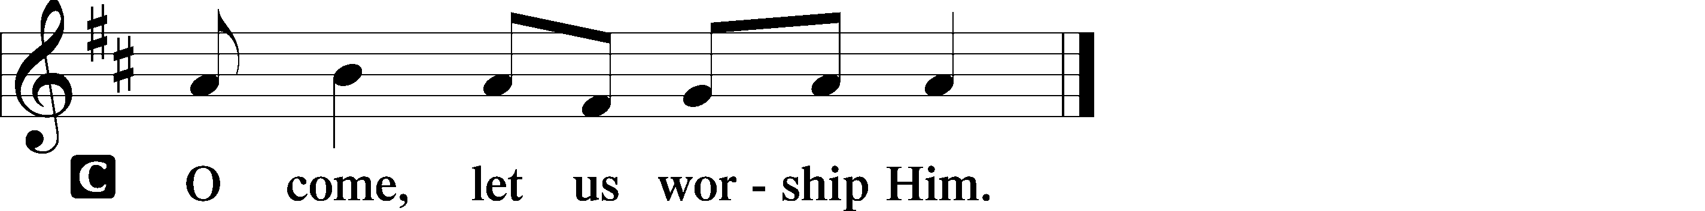

VENITE LSB 220
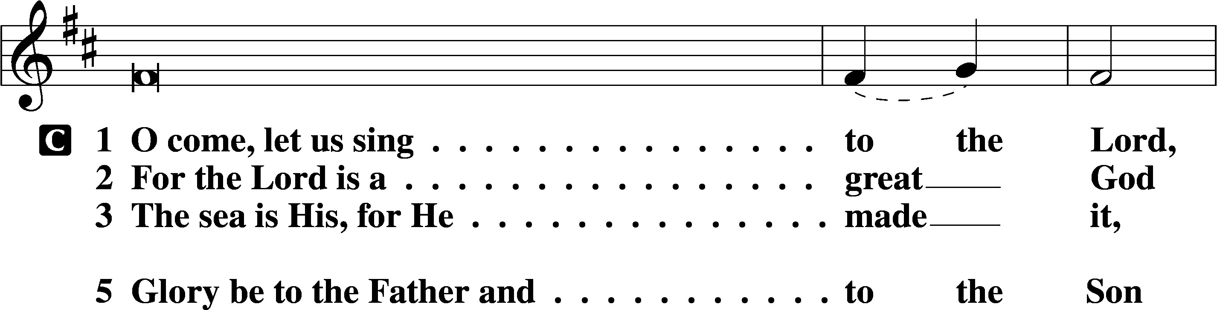
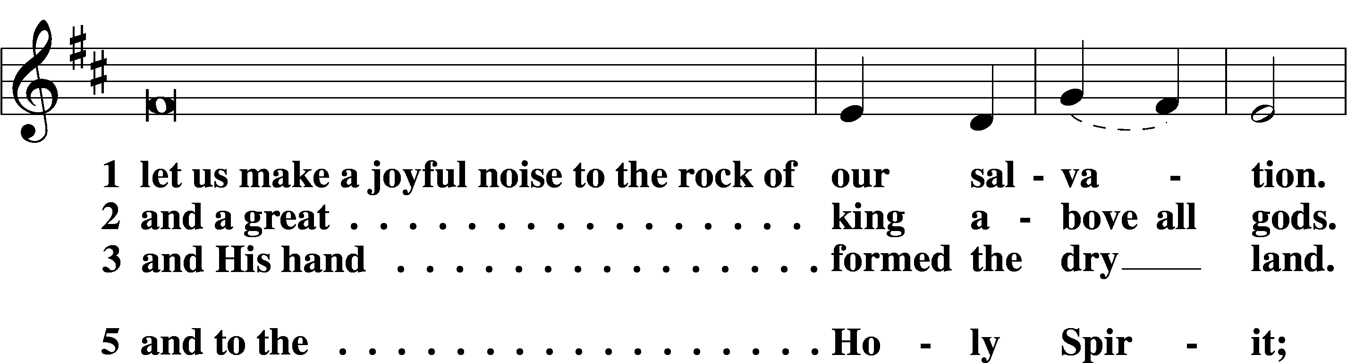
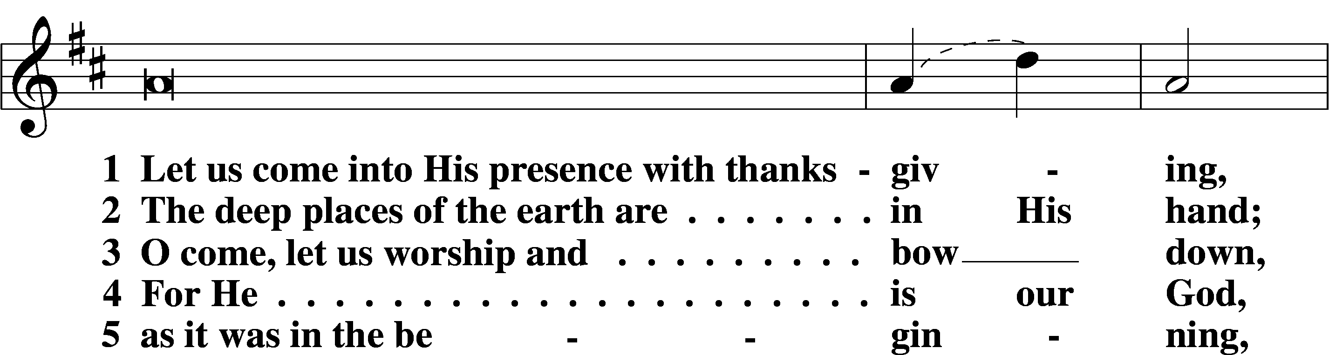
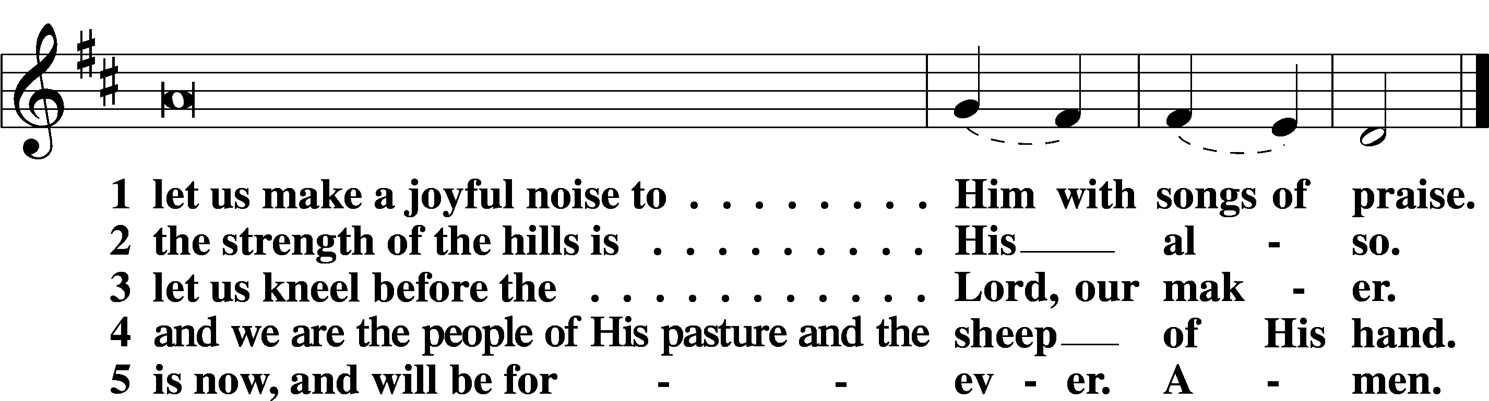

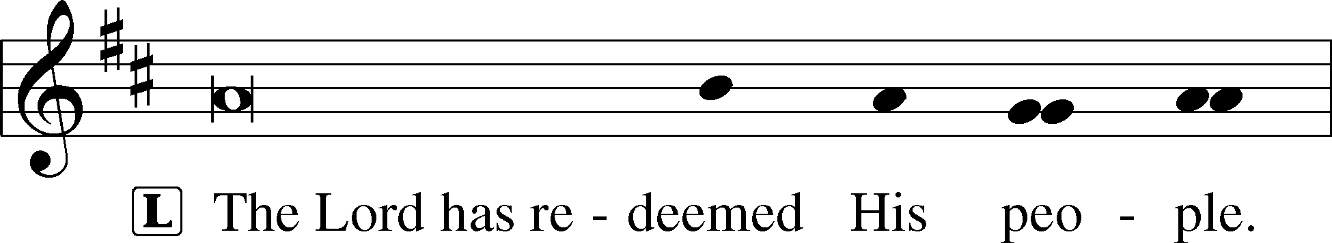
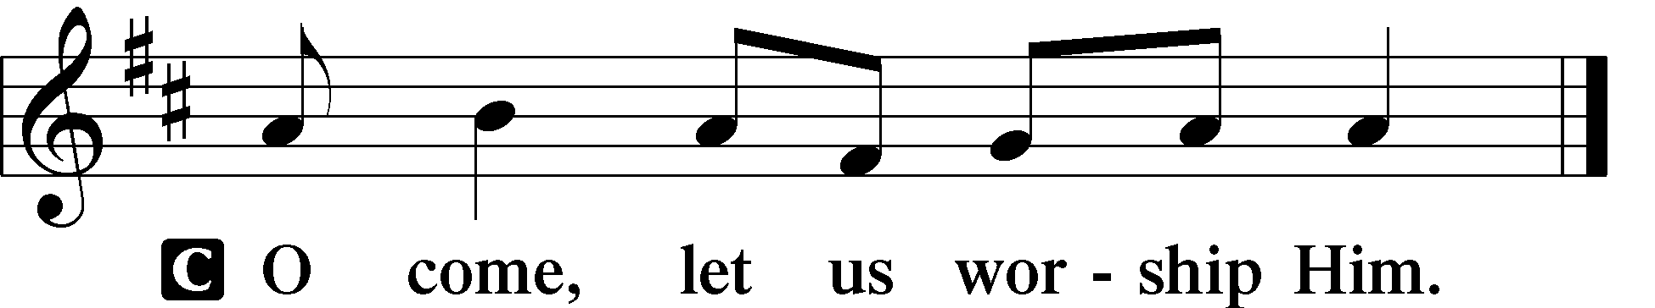

PSALMS:
February 21: Psalm 16 March 13: Psalm 85
February 28: Psalm 103 March 20: Psalm 119:65-72
March 6: Psalm 22
Sit

HYMN OF THE DAY:
February 21: LSB #438 “A Lamb Goes Uncomplaining Forth”
February 28: LSB #568 “If Your Beloved Son, O God”
March 6: LSB #438 “A Lamb Goes Uncomplaining Forth”
March 13: LSB #571 “God Loved the World So That He Gave”
March 20: LSB #685 “Let Us Ever Walk with Jesus”
Readings
PROPHECY:
February 21: Isaiah 50:5-10 March 13: Hosea 14:1-9
February 28: Isaiah 52:13—53:12 March 20: Job 1:6-22
March 6: Zechariah 13:1-9

Reading Response:
P O Lord, have mercy on us.
C Thanks be to God.

EPISTLE:
February 21: Romans 5:1-21 March 13: 1 John 4:7-21
February 28: Galatians 3:10-14 March 20: 1 Peter 4:12-19
March 6: Acts 4:23-31

Reading Response:
P O Lord, have mercy on us.
C Thanks be to God.

GOSPEL:
February 21: John 6:35-40 March 13: John 15:1-17
February 28: John 3:13-21 March 20: John 15:18—16:4
March 6: Mark 14:26-50

Reading Response:
P O Lord, have mercy on us.
C Thanks be to God.

Responsory (Lent) LSB 222
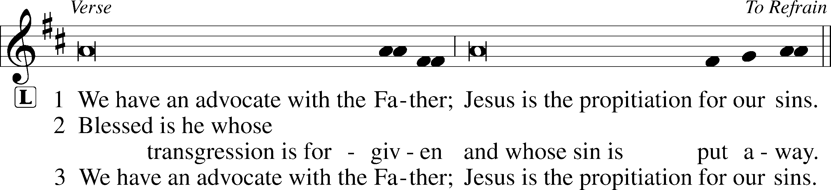
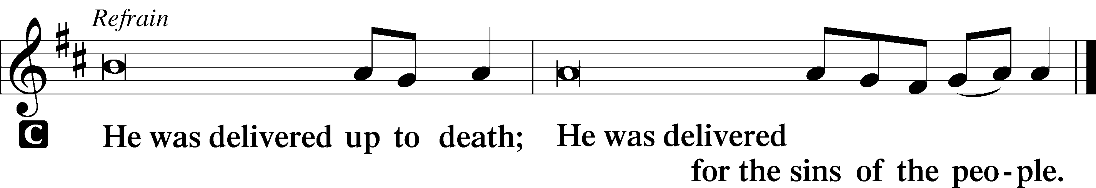

Sermon
Canticle
Stand
Te Deum LSB 223
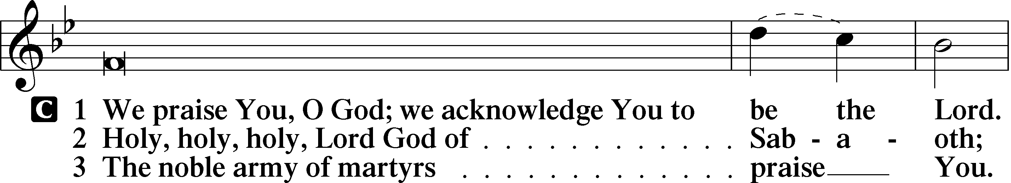
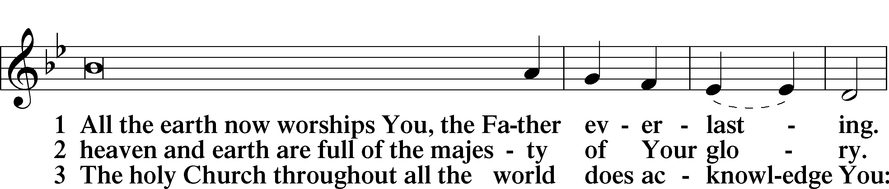
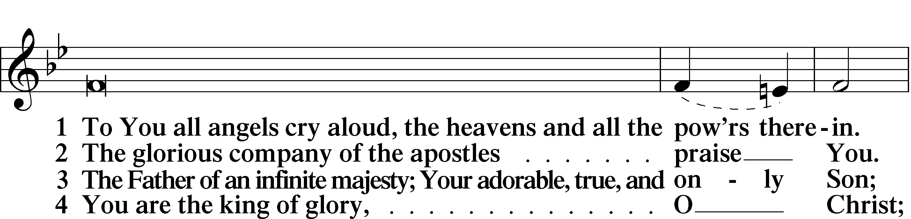
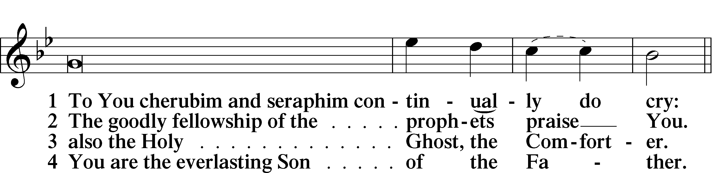
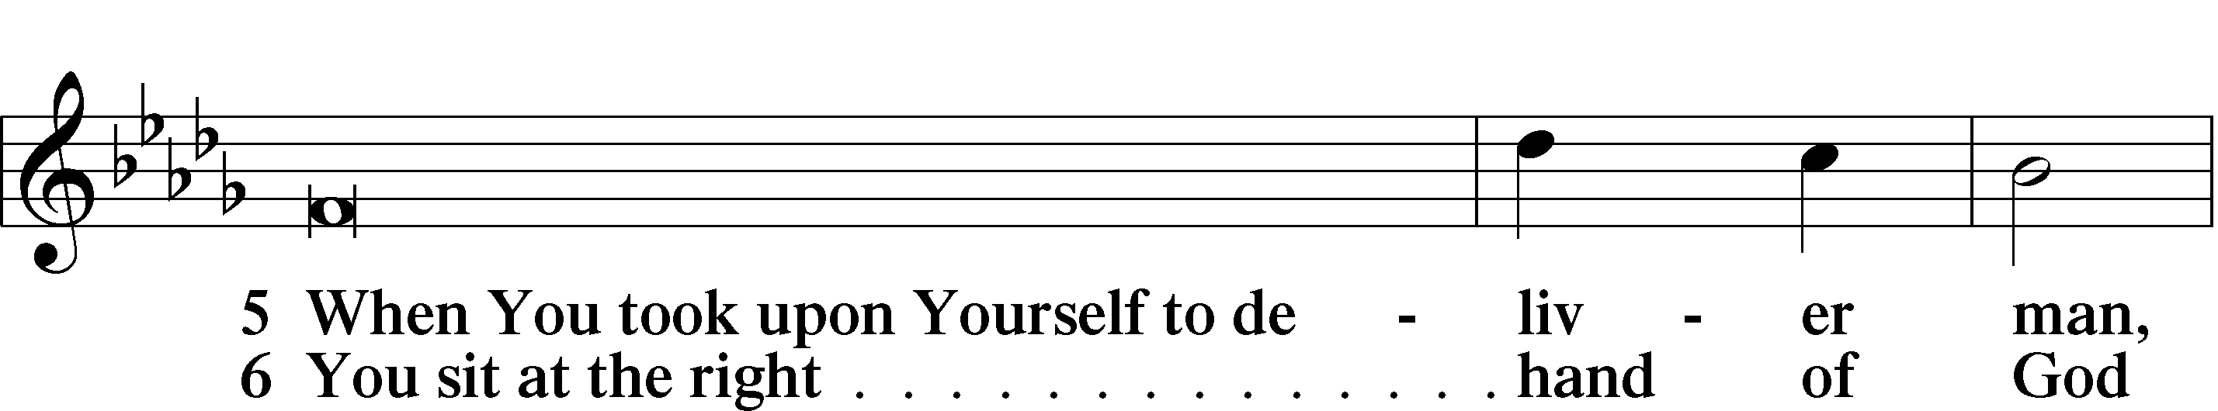
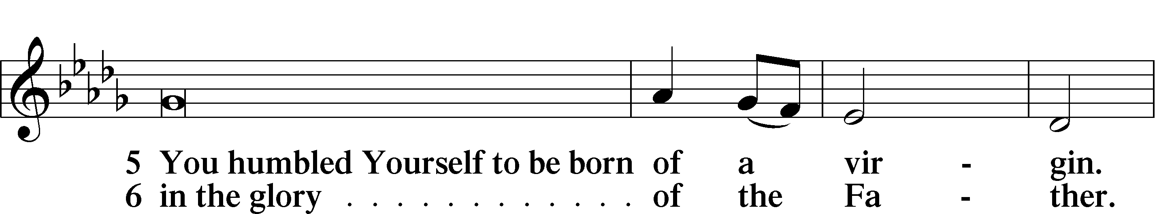
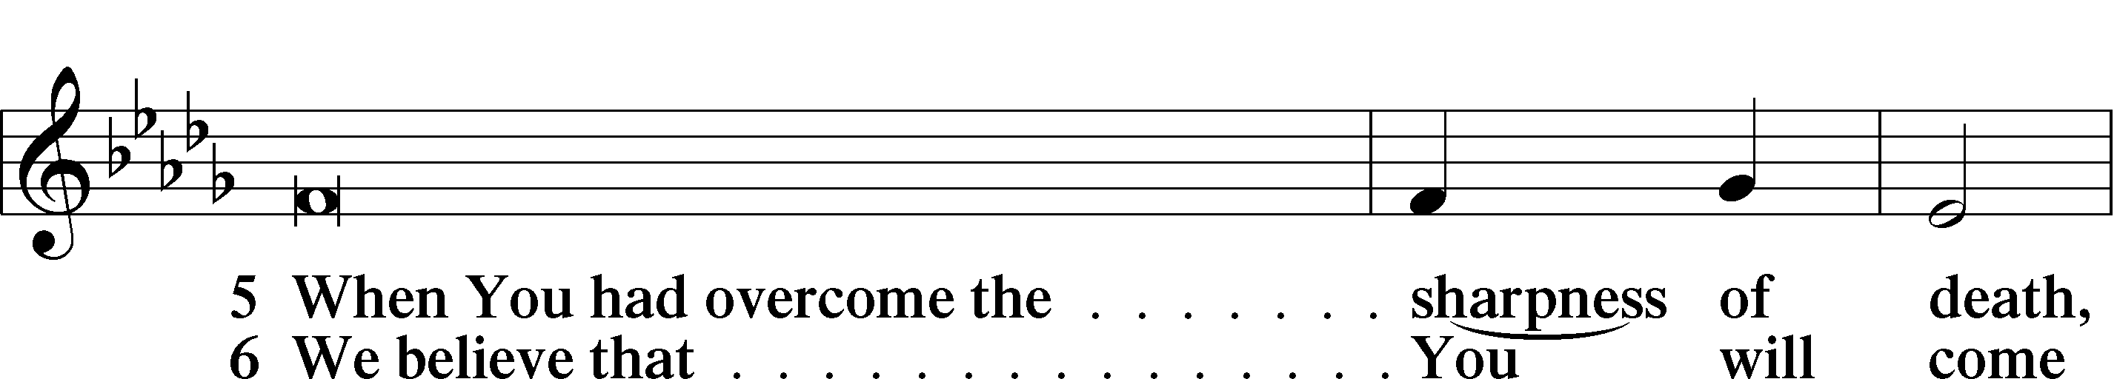
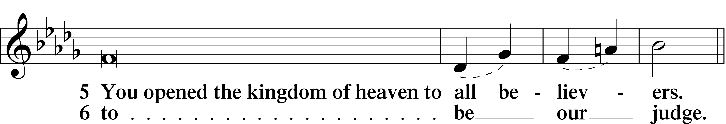

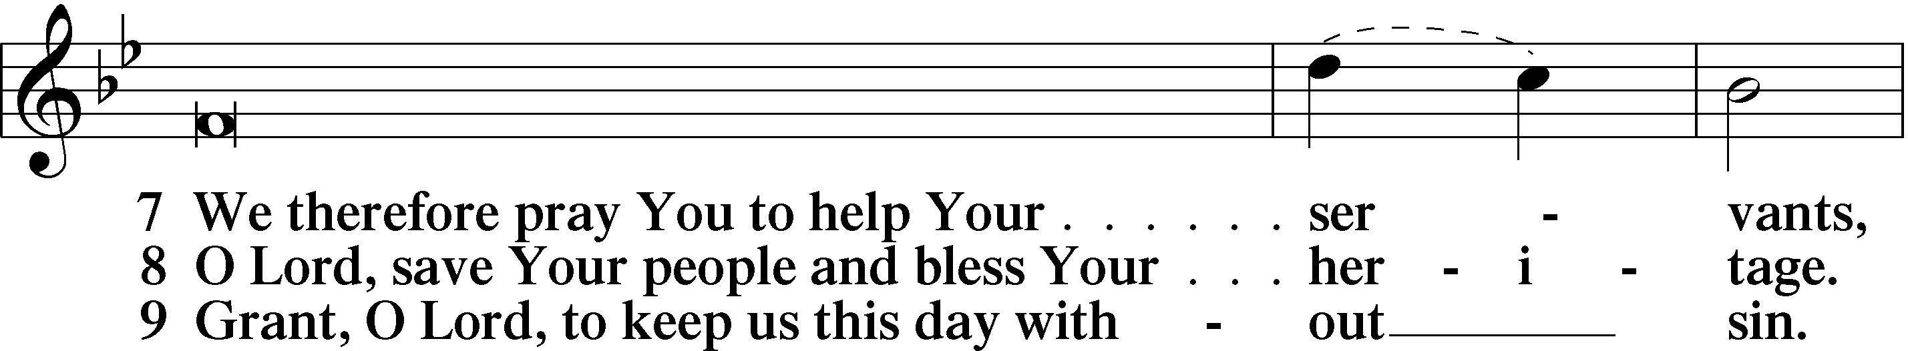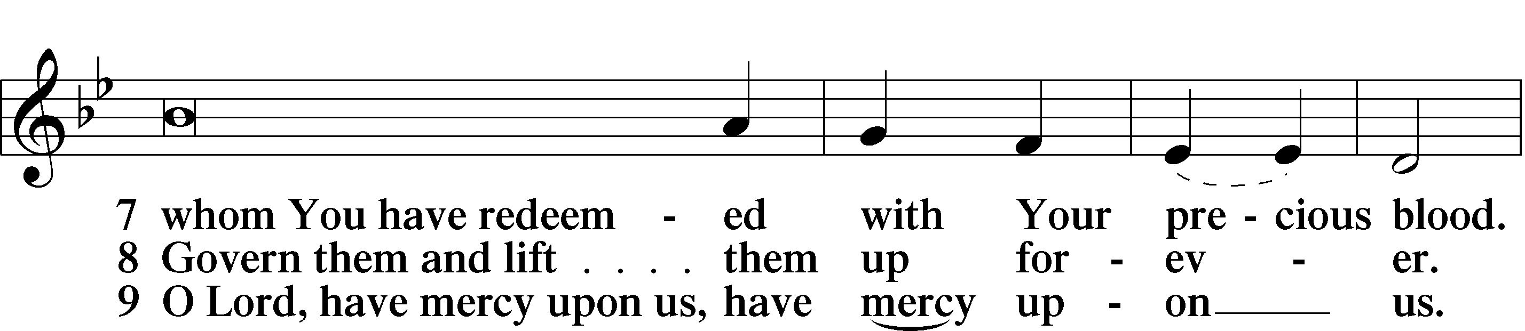
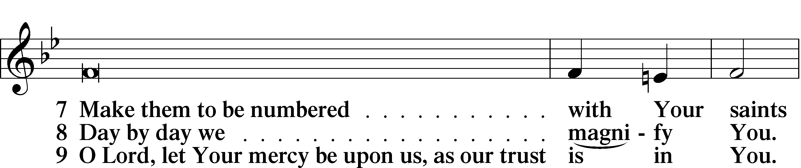
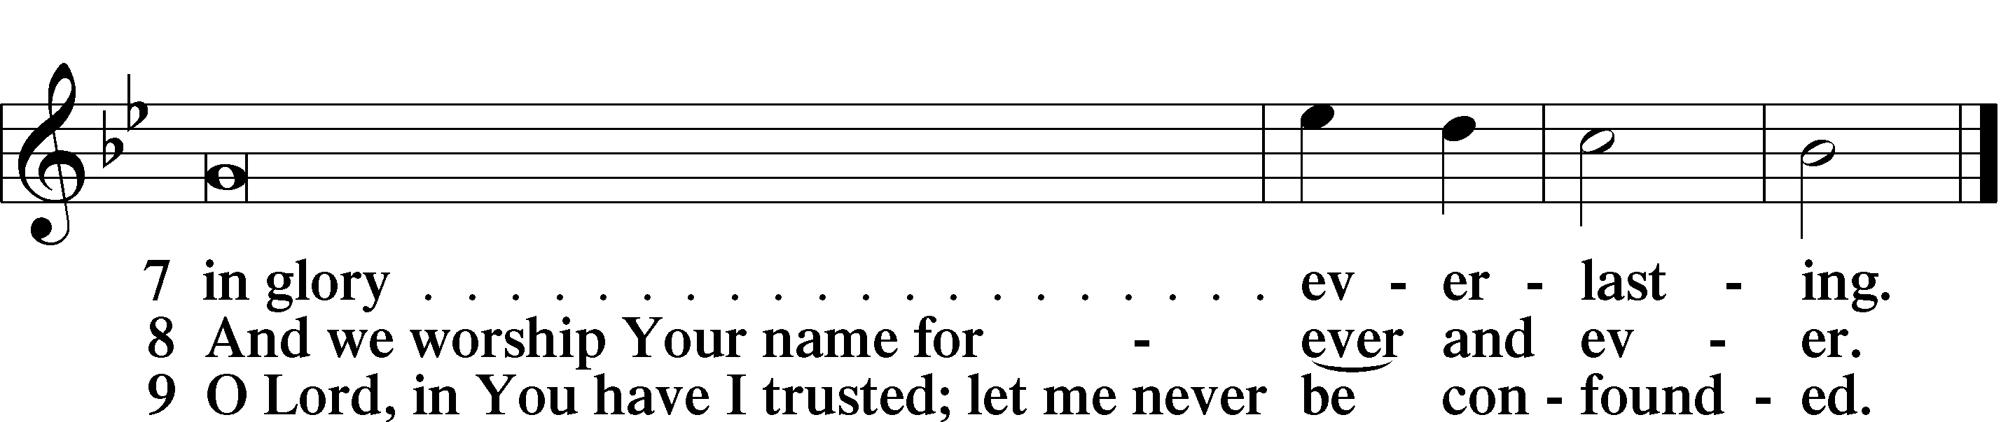

Prayer

Kyrie LSB 227
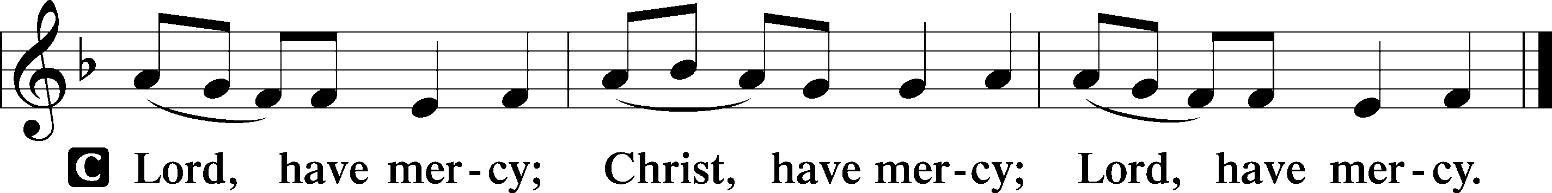

The Lord’s Prayer: LSB #957 “Our Father Who Art in Heaven” LSB 957
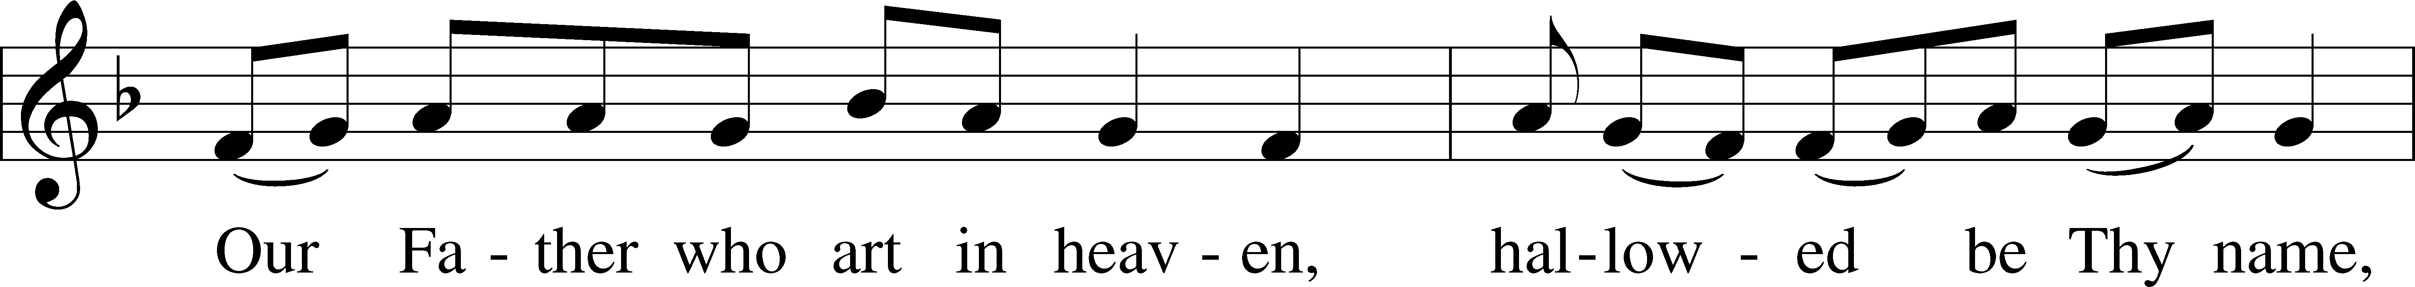
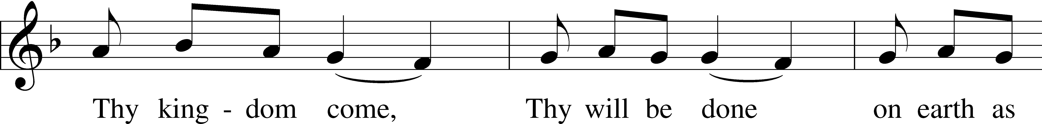
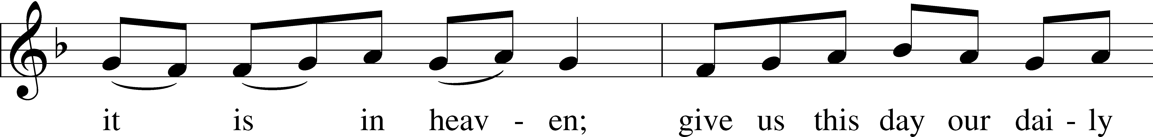
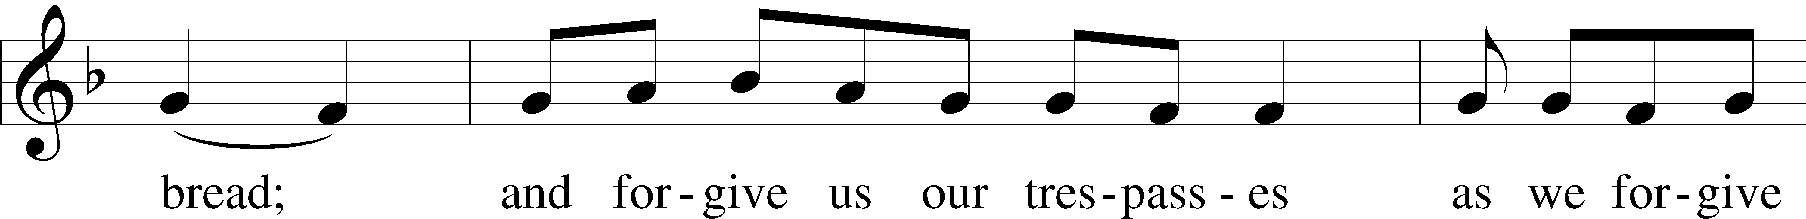
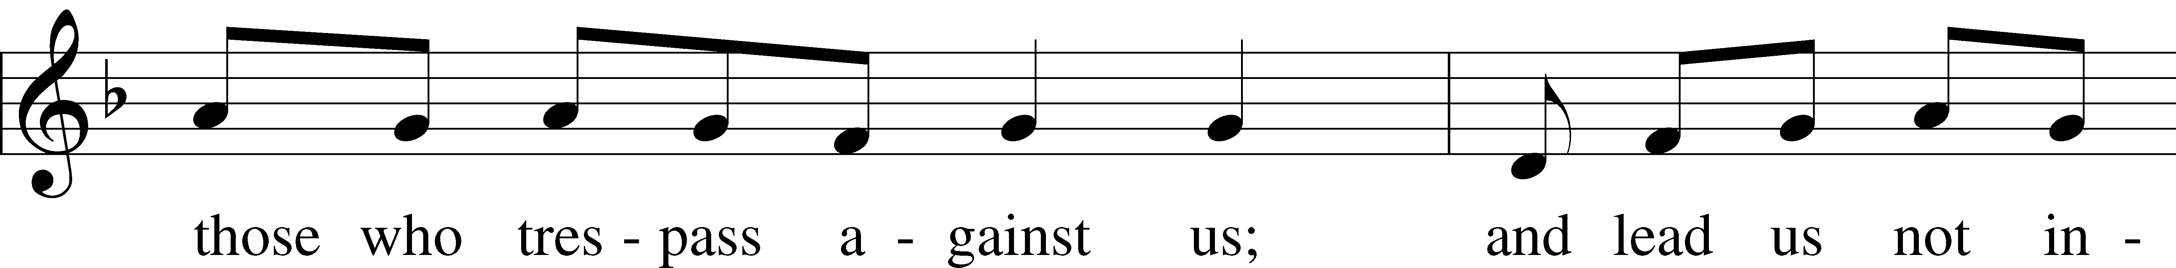
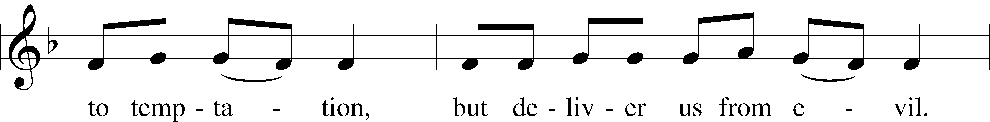
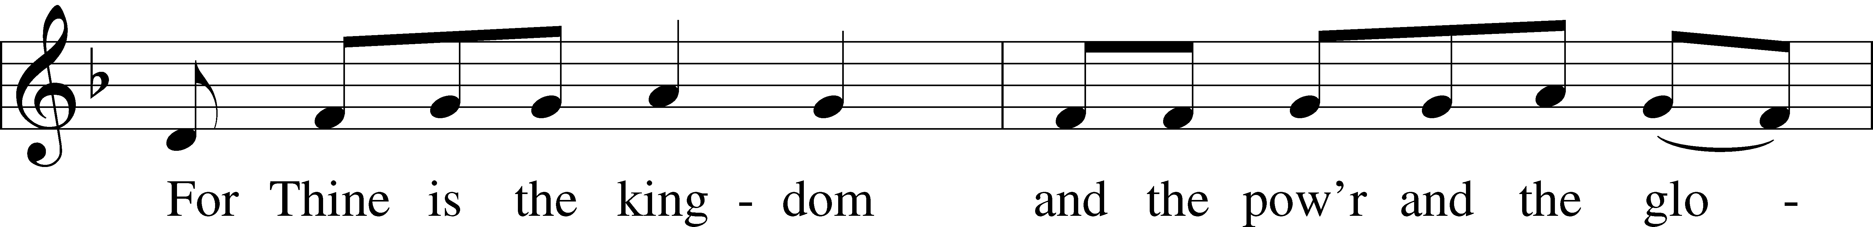
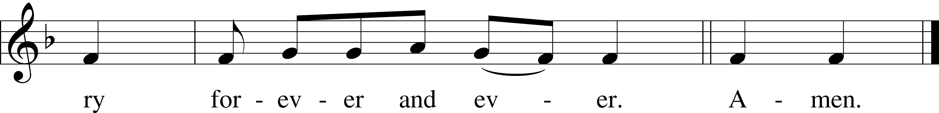

Text: Traditional Tune: Plainsong, mode VII Text and tune: Public domain

Collects
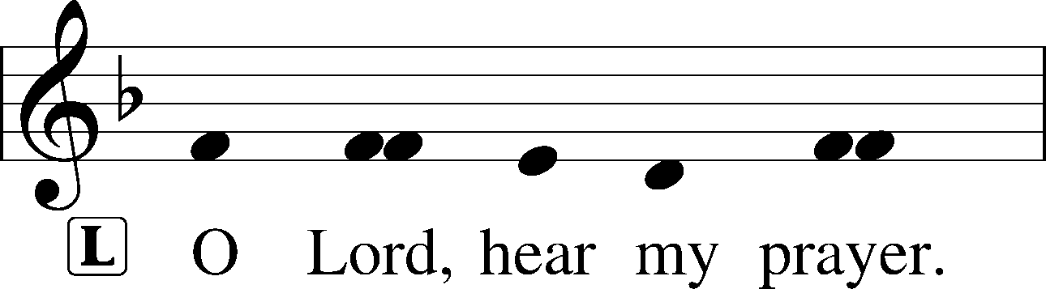
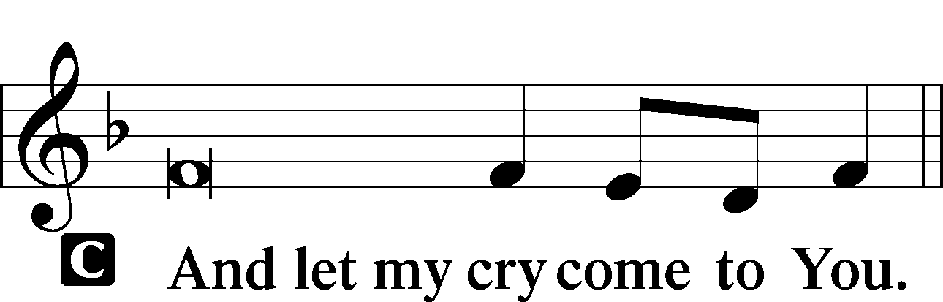

Collect of the Day
P … through Jesus Christ, Your Son, our Lord, who lives and reigns with You and the Holy Spirit, one God, now and forever.
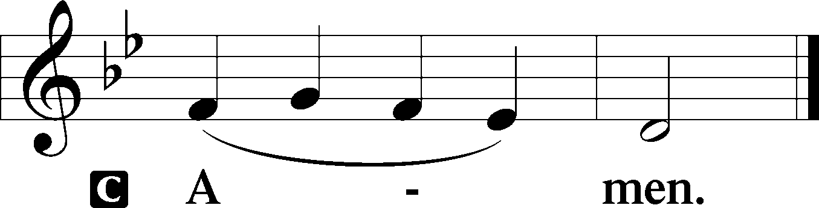

Collect for Grace
P O Lord, our heavenly Father, almighty and everlasting God, You have safely brought us to the beginning of this day. Defend us in the same with Your mighty power and grant that this day we fall into no sin, neither run into any kind of danger, but that all our doings, being ordered by Your governance, may be righteous in Your sight; through Jesus Christ, Your Son, our Lord, who lives and reigns with You and the Holy Spirit, one God, now and forever.
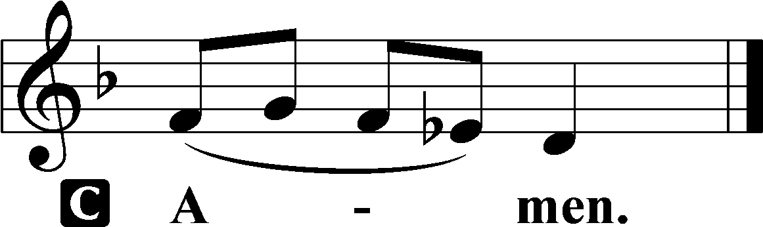

Benedicamus LSB 228
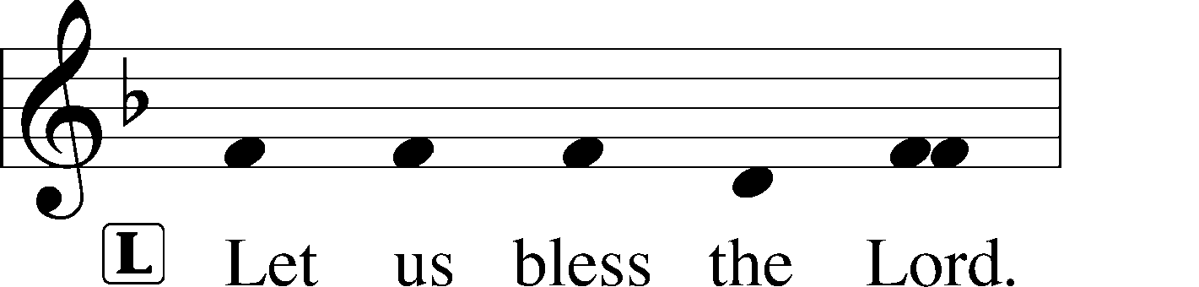
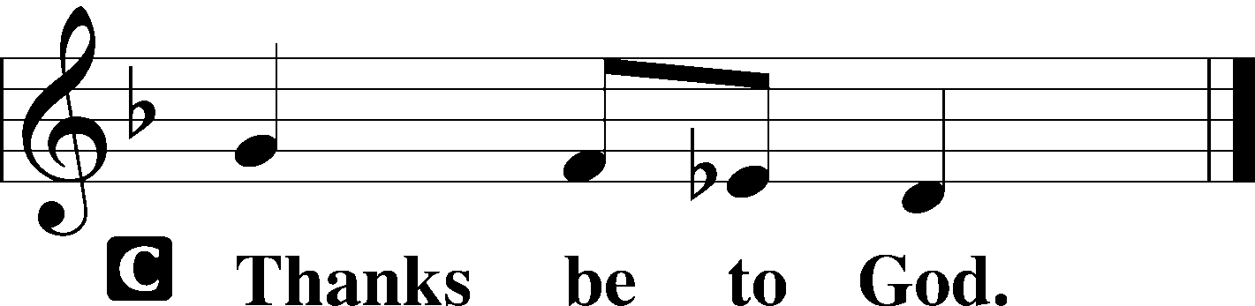

Benediction LSB 228
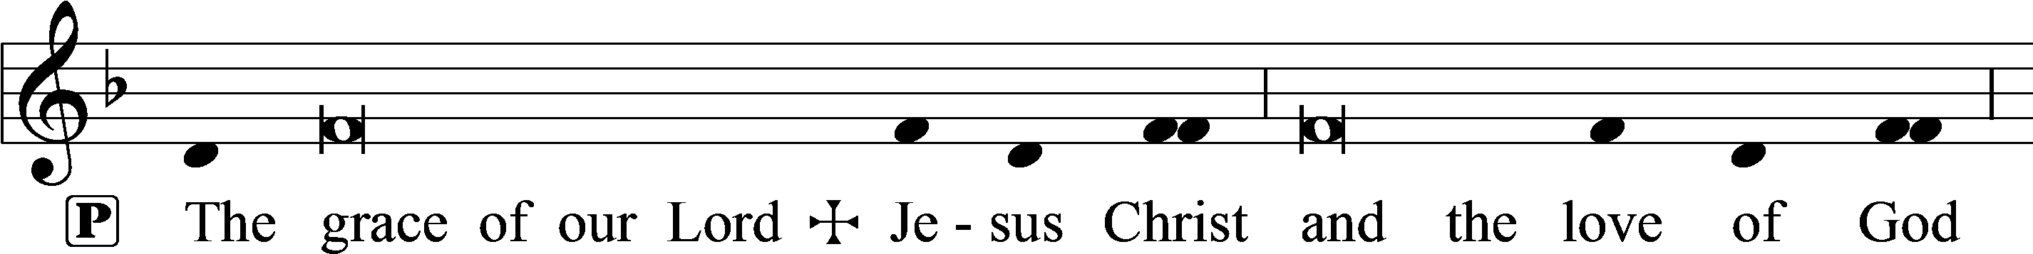
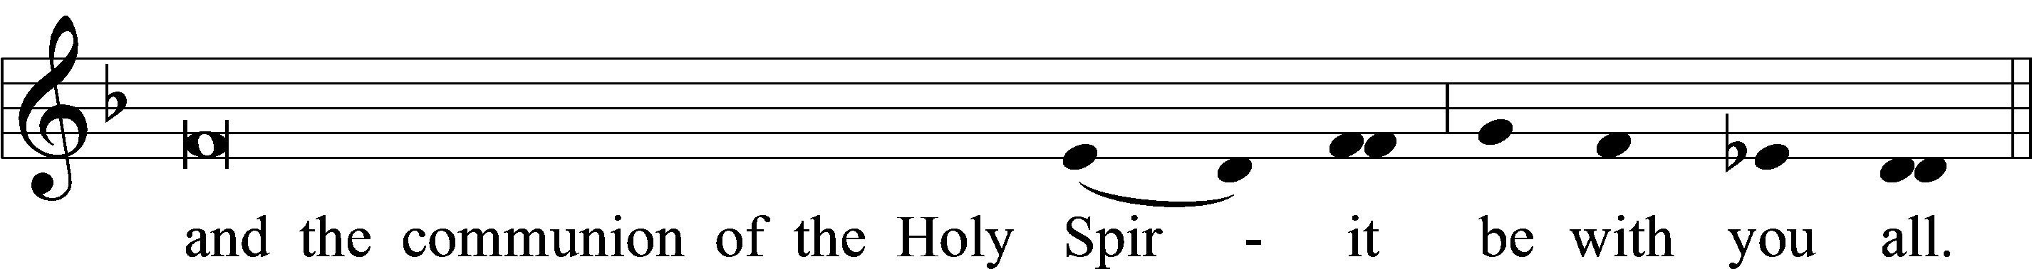

Closing Hymn:
February 21: LSB #556 “Dear Christians, One and All, Rejoice”
February 28: LSB #439: 9-15 “O Dearest Jesus, What Law Hast Thou Broken”
March 6: LSB #555 “Salvation unto Us Is Come”
March 13: LSB #746 “Through Jesus’ Blood and Merit”
March 20: LSB #724 “If God Himself Be for Me”

Acknowledgments: Matins from Lutheran Service Book. Unless otherwise indicated, Scripture quotations are from the ESV® Bible (The Holy Bible, English Standard Version®), copyright © 2001 by Crossway, a publishing ministry of Good News Publishers. Used by permission. All rights reserved. Created by Lutheran Service Builder © 2023 Concordia Publishing House.

