Sts. Peter & Paul
Evangelical Lutheran Church
Lutheran Church-Missouri Synod
Founded-1917

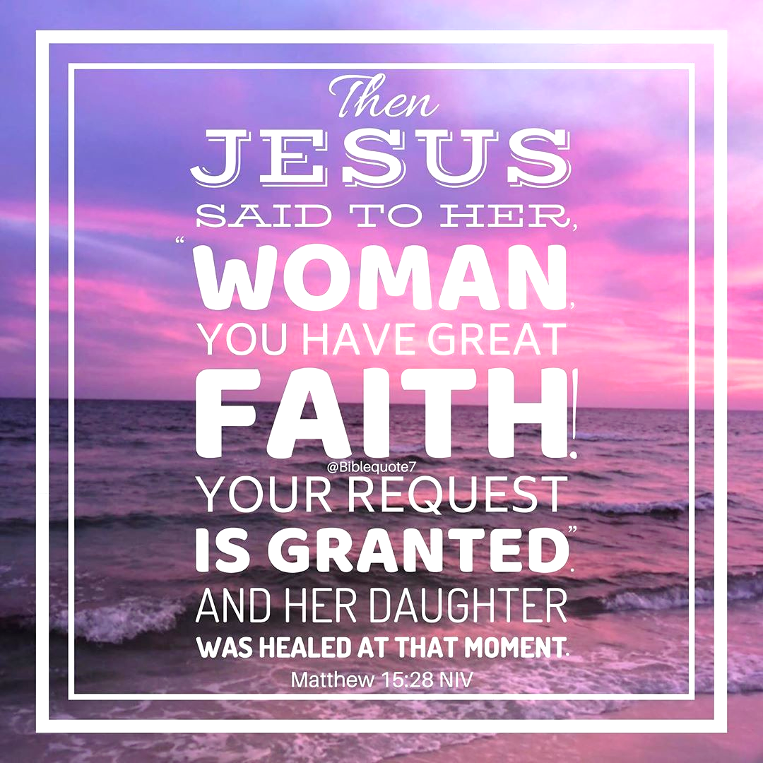

March 5, 2023

699 Stambaugh Avenue
Sharon, Pennsylvania 16146

“I was glad when they said to me,
Let us go to the house of the LORD!”
Psalm 122:1
Sts. Peter & Paul Evangelical Lutheran Church, LC-MS
REMINISCERE
March 5, 2023

A special welcome to our guests this day! If you would like more information about The Lutheran Church - Missouri Synod, or this congregation, please speak with Pastor Deal or an Elder after the service.
Members & Guests: Don’t be embarrassed if your children make noise during the worship service, all children do. We encourage families to worship together but, if you feel the need, there are pews in the rear of the Church which are reserved for young families on both sides of the sanctuary. There is also a quiet room available to you during our service which is located down the hallway past the offices on the right side of the church as well as a children’s area in the Fellowship Hall where you are able to follow along with the service.

Today’s service includes the Sacrament of Holy Communion. If during this past year, you have not worshipped with us and been communed, we respectfully ask that you do not partake of this sacrament this day before first speaking with Pastor Deal.
If visiting from a sister congregation of the LC-MS and are in good standing, please inform Pastor Deal of your desire to commune prior to the service.
If wishing to receive a blessing during communion, please approach with your arms crossed.

CONTACT INFORMATION
Pastor Deal: pastordeal@saintspeterandpaul.net or 724-347-3620 (opt. 2)
Church Office: church@saintspeterandpaul.net or 724-347-3620 (opt. 3)

Silent prayer before worship: Lord Jesus, by the power of the Holy Spirit through Your Word, fill my heart with faith, hope, joy and peace that come with the new life You have given me in Holy Baptism. Amen.

Confession and Absolution

Opening Hymn: LSB #605 “Father Welcomes”

Stand

The sign of the cross may be made by all in remembrance of their Baptism.

Invocation
P In the name of the Father and of the T Son and of the Holy Spirit.
C Amen.

Exhortation Hebrews 10:22; Psalm 124:8; Psalm 32:5
P Beloved in the Lord! Let us draw near with a true heart and confess our sins unto God our Father, beseeching Him in the name of our Lord Jesus Christ to grant us forgiveness.

P Our help is in the name of the Lord,
C who made heaven and earth.
P I said, I will confess my transgressions unto the Lord,
C and You forgave the iniquity of my sin.

Silence for reflection on God’s Word and for self-examination.

Confession of Sins
P O almighty God, merciful Father,
C I, a poor, miserable sinner, confess unto You all my sins and iniquities with which I have ever offended You and justly deserved Your temporal and eternal punishment. But I am heartily sorry for them and sincerely repent of them, and I pray You of Your boundless mercy and for the sake of the holy, innocent, bitter sufferings and death of Your beloved Son, Jesus Christ, to be gracious and merciful to me, a poor, sinful being.

Absolution [John 20:19–23]
P Upon this your confession, I, by virtue of my office, as a called and ordained servant of the Word, announce the grace of God unto all of you, and in the stead and by the command of my Lord Jesus Christ I forgive you all your sins in the name of the Father and of the T Son and of the Holy Spirit.
C Amen.

Service of the Word

Introit Psalm 25:1–2a, 7–8, 11; antiphon: vv. 6, 2b, 22
Remember your mercy, O Lord, and your | steadfast love,*
for they have been | from of old.
Let not my enemies exult | over me.*
Redeem Israel, O God, out of all his | troubles.
To you, O Lord, I lift | up my soul.*
O my God, in you I trust; let me not be | put to shame.
Remember not the sins of my youth or my trans- | gressions;*
according to your steadfast love remember me, for the sake of your goodness, | O Lord!
Good and upright | is the Lord;*
therefore he instructs sinners | in the way.
For your name’s sake, | O Lord,*
pardon my guilt, for | it is great.
Glory be to the Father and | to the Son*
and to the Holy | Spirit;
as it was in the be- | ginning,*
is now, and will be forever. | Amen.

Kyrie Mark 10:47
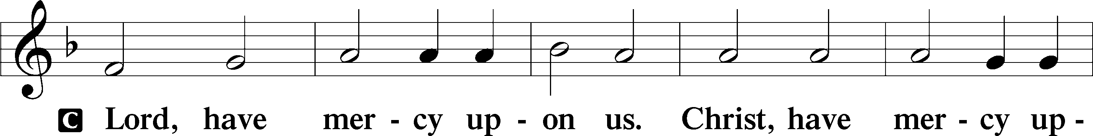
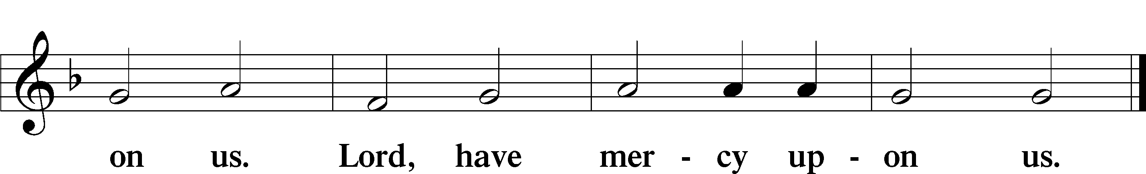

Salutation and Collect of the Day: Reminiscere
P The Lord be with you.
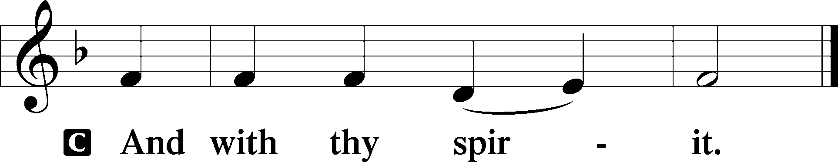

P Let us pray.
O God, You see that of ourselves we have no strength. By Your mighty power defend us from all adversities that may happen to the body and from all evil thoughts that may assault and hurt the soul; through Jesus Christ, Your Son, our Lord, who lives and reigns with You and the Holy Spirit, one God, now and forever.
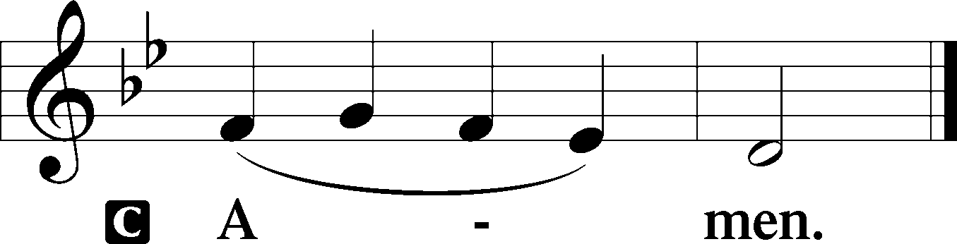
Sit

Prophecy: Genesis 32:22–32
In those days: Jacob arose at night and took his two wives, his two female servants, and his eleven sons, and crossed over the ford of Jabbok. He took them, sent them over the brook, and sent over what he had. Then Jacob was left alone; and a Man wrestled with him until the breaking of day. Now when He saw that He did not prevail against him, He touched the socket of his hip; and the socket of Jacob’s hip was out of joint as He wrestled with him. And He said, “Let Me go, for the day breaks.” But he said, “I will not let You go unless You bless me!” So He said to him, “What is your name?” He said, “Jacob.” And He said, “Your name shall no longer be called Jacob, but Israel; for you have struggled with God and with men, and have prevailed.” Then Jacob asked, saying, “Tell me Your name, I pray.” And He said, “Why is it that you ask about My name?” And He blessed him there. So Jacob called the name of the place Peniel: “For I have seen God face to face, and my life is preserved.”

P This is the Word of the Lord.
C Thanks be to God.

Gradual Psalm 25:17–18
The troubles of my heart | are enlarged;*
bring me out of my dis- | tresses.
Consider my affliction and my | trouble,*
and forgive | all my sins.

Epistle: 1 Thessalonians 4:1–7
Brethren: We urge and exhort in the Lord Jesus that you should abound more and more, just as you received from us how you ought to walk and to please God; for you know what commandments we gave you through the Lord Jesus. For this is the will of God, your sanctification: that you should abstain from sexual immorality; that each of you should know how to possess his own vessel in sanctification and honor, not in passion of lust, like the Gentiles who do not know God; that no one should take advantage of and defraud his brother in this matter, because the Lord is the avenger of all such, as we also forewarned you and testified. For God did not call us to uncleanness, but in holiness, in Christ Jesus our Lord.

P This is the Word of the Lord.
C Thanks be to God.

Stand

Holy Gospel: Matthew 15:21–28
P The Holy Gospel according to St. Matthew, the fifteenth chapter.
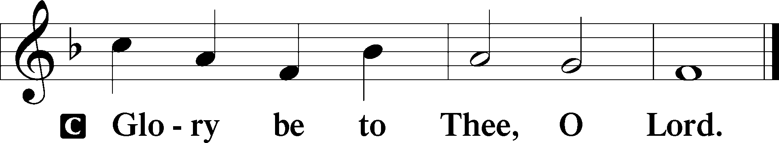

At that time: Jesus departed to the region of Tyre and Sidon. And behold, a woman of Canaan came from that region and cried out to Him, saying, “Have mercy on me, O Lord, Son of David! My daughter is severely demon-possessed.” But He answered her not a word. And His disciples came and urged Him, saying, “Send her away, for she cries out after us.” But He answered and said, “I was not sent except to the lost sheep of the house of Israel.” Then she came and worshiped Him, saying, “Lord, help me!” But He answered and said, “It is not good to take the children’s bread and throw it to the little dogs.” And she said, “Yes, Lord, yet even the little dogs eat the crumbs which fall from their masters’ table.” Then Jesus answered and said to her, “O woman, great is your faith! Let it be to you as you desire.” And her daughter was healed from that very hour.

P This is the Gospel of the Lord.
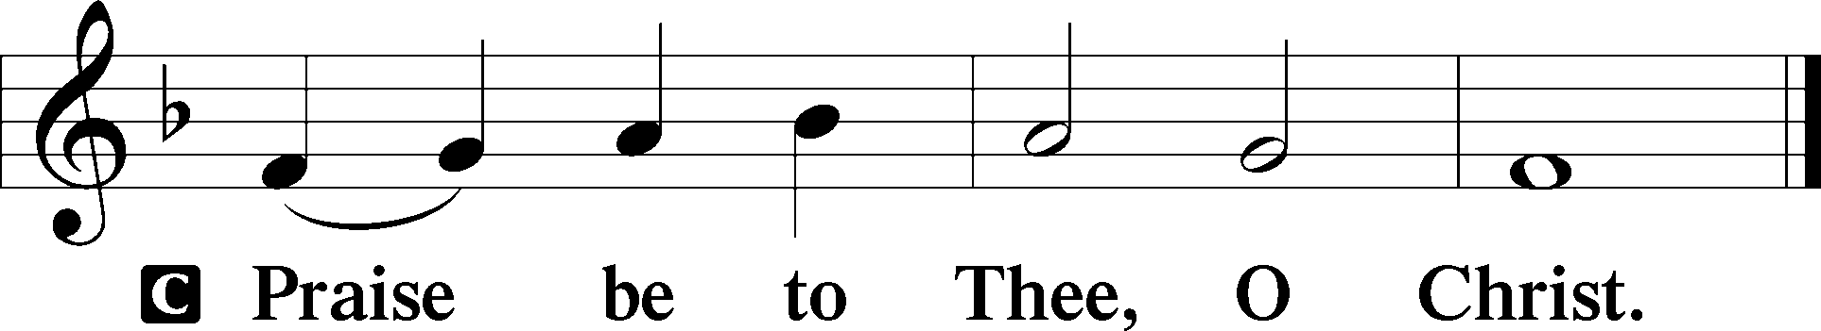

Nicene Creed
C I believe in one God,
the Father Almighty,
maker of heaven and earth
and of all things visible and invisible.

And in one Lord Jesus Christ,
the only-begotten Son of God,
begotten of His Father before all worlds,
God of God, Light of Light,
very God of very God,
begotten, not made,
being of one substance with the Father,
by whom all things were made;
who for us men and for our salvation came down from heaven
and was incarnate by the Holy Spirit of the virgin Mary
and was made man;
and was crucified also for us under Pontius Pilate.
He suffered and was buried.
And the third day He rose again according to the Scriptures
and ascended into heaven
and sits at the right hand of the Father.
And He will come again with glory to judge both the living and the dead,
whose kingdom will have no end.

And I believe in the Holy Spirit,
the Lord and giver of life,
who proceeds from the Father and the Son,
who with the Father and the Son together is worshiped and glorified,
who spoke by the prophets.
And I believe in one holy Christian and apostolic Church,
I acknowledge one Baptism for the remission of sins,
and I look for the resurrection of the dead
and the life T of the world to come. Amen.
Sit

Hymn of the Day: LSB #734 “I Trust, O Lord, Your Holy Name”

Sermon

Stand

Prayer of the Church

Offertory Psalm 51:10–12
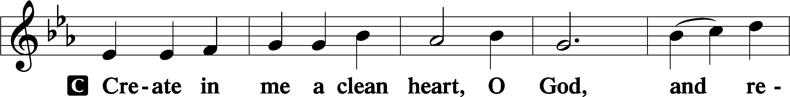
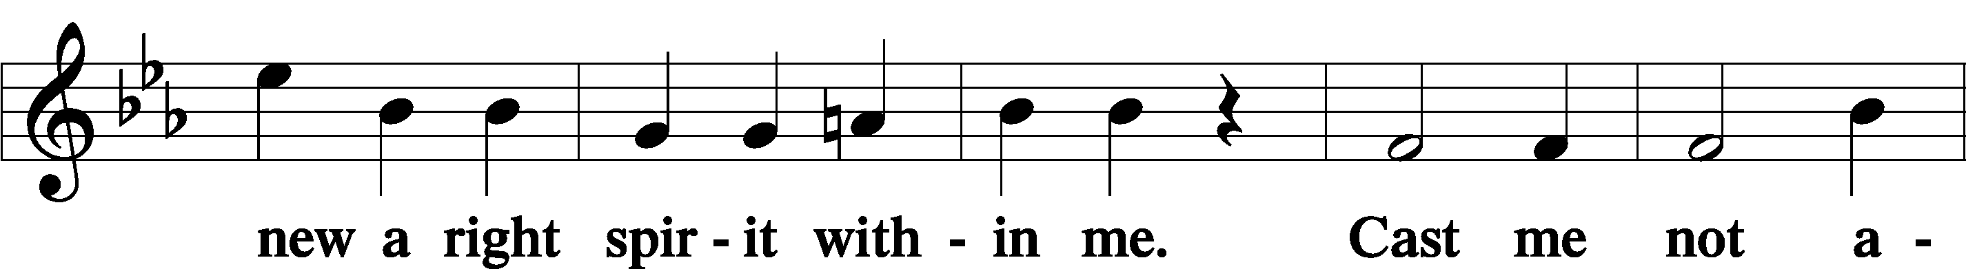
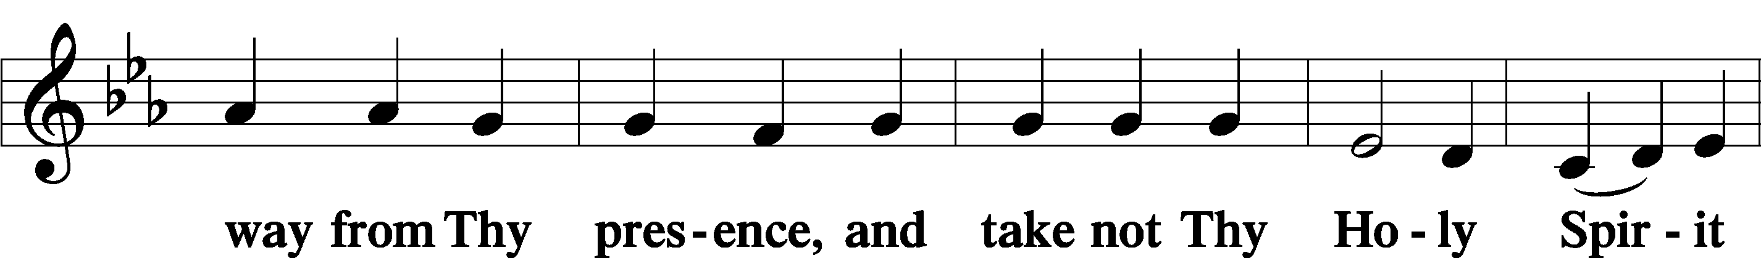
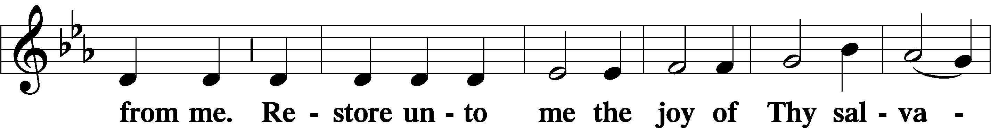
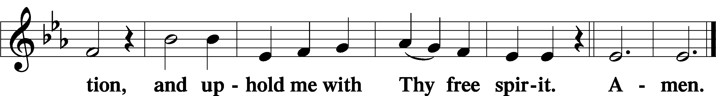
Sit

Preparatory Hymn: LSB #440 “Jesus, I Will Ponder Now”

Stand

Service of the Sacrament

Preface 2 Timothy 4:22; Colossians 3:1 Psalm 136
P The Lord be with you.
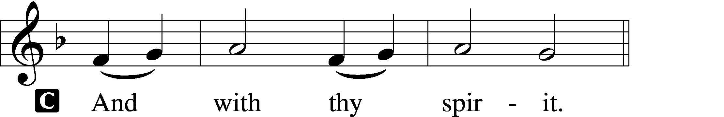

P Lift up your hearts.
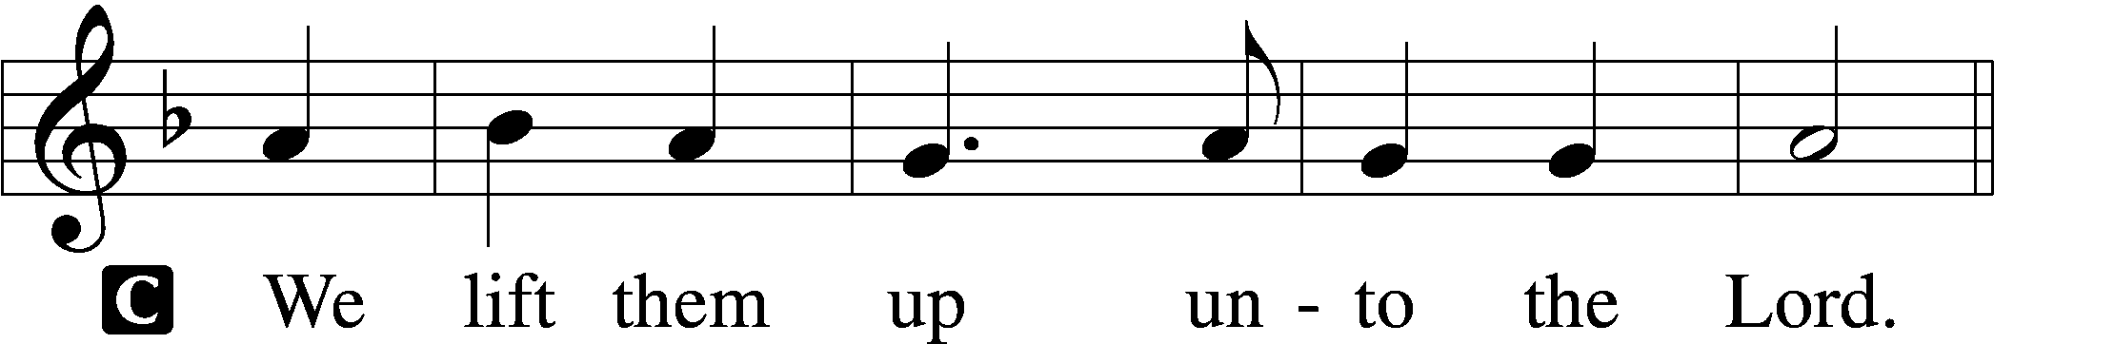

P Let us give thanks unto the Lord, our God.
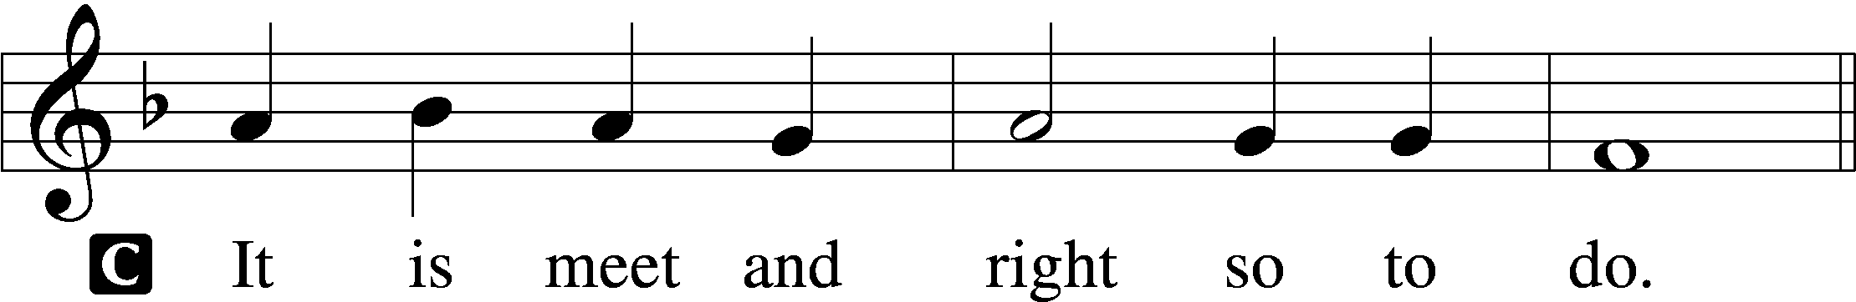

Proper Preface (Abbreviated) LSB 194
P It is truly meet, right, and salutary . . . evermore praising You and saying:

Sanctus Isaiah 6:3; Matthew 21:9
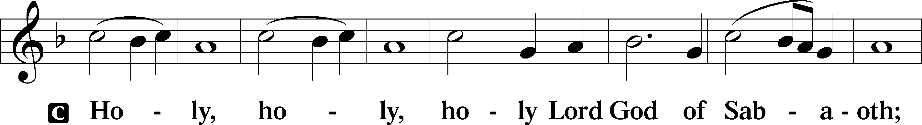
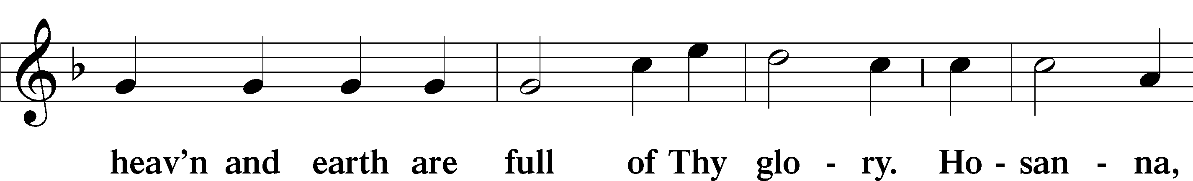
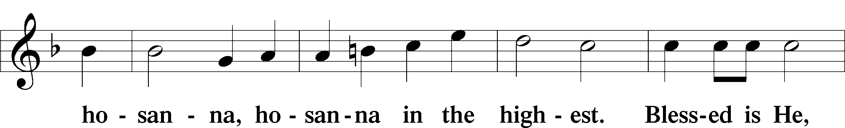
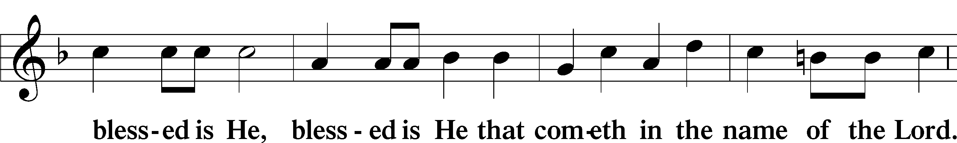
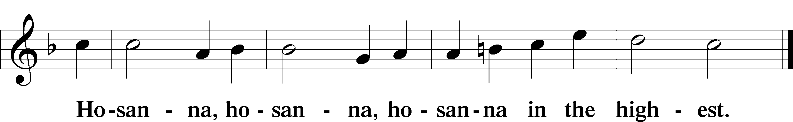

Lord’s Prayer Matthew 6:9–13
C Our Father who art in heaven,
hallowed be Thy name,
Thy kingdom come,
Thy will be done on earth as it is in heaven;
give us this day our daily bread;
and forgive us our trespasses as we forgive those who trespass against us;
and lead us not into temptation,
but deliver us from evil.
For Thine is the kingdom and the power and the glory forever and ever. Amen.

The Words of Our Lord Matthew 26:26–28; Mark 14:22–24; Luke 22:19–20; 1 Corinthians 11:23–25
P Our Lord Jesus Christ, on the night when He was betrayed, took bread, and when He had given thanks, He broke it and gave it to the disciples and said: “Take, eat; this is My T body, which is given for you. This do in remembrance of Me.”

In the same way also He took the cup after supper, and when He had given thanks, He gave it to them, saying: “Drink of it, all of you; this cup is the new testament in My T blood, which is shed for you for the forgiveness of sins. This do, as often as you drink it, in remembrance of Me.”

Pax Domini John 20:19
P The peace of the Lord be with you always.
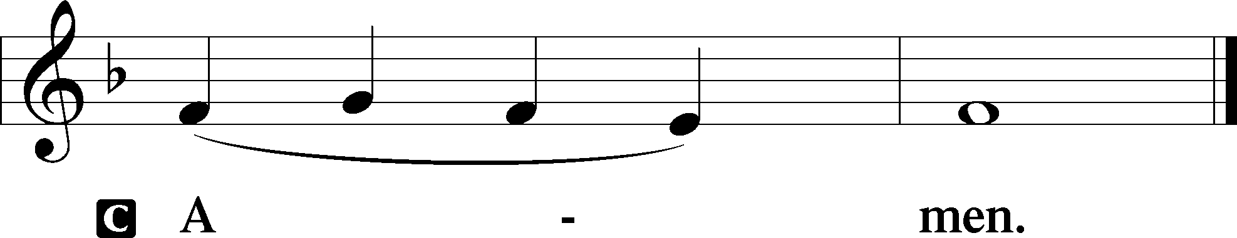

Agnus Dei John 1:29
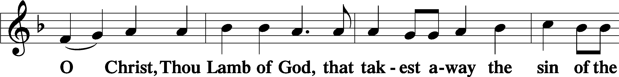
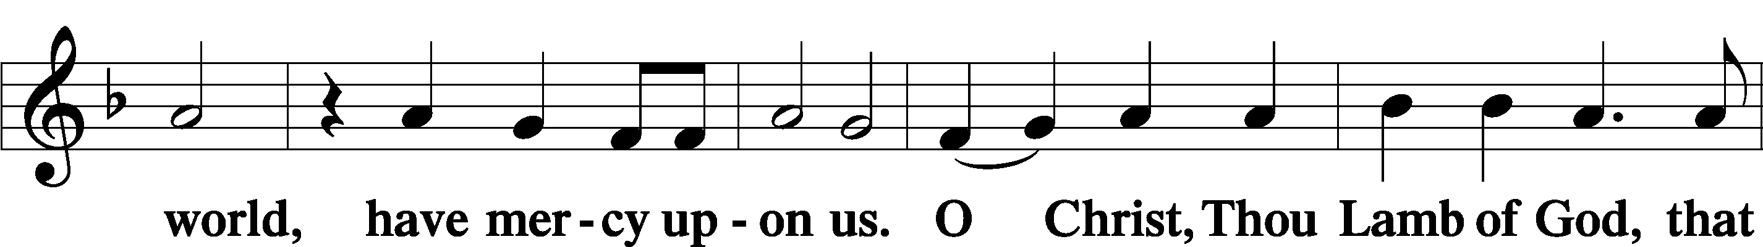
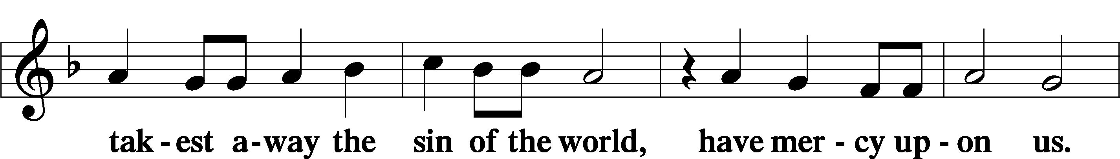
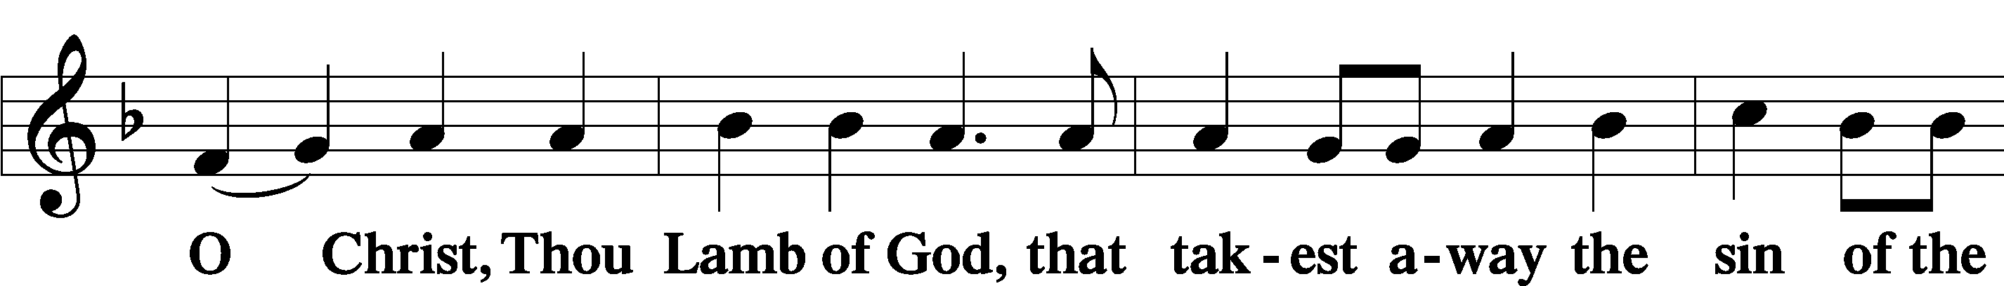
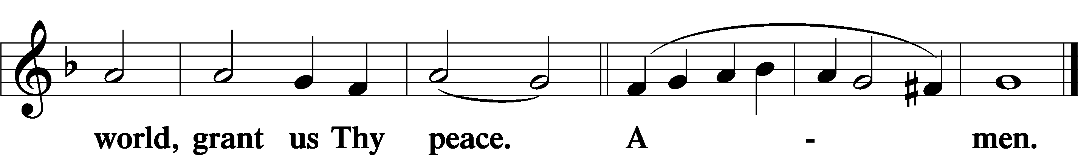
Sit

Distribution
The pastor and those who assist him receive the body and blood of Christ first and then distribute them to those who come to receive, saying:
Take, eat; this is the true body of our Lord and Savior Jesus Christ, given into death for your sins.
Amen.

Take, drink; this is the true blood of our Lord and Savior Jesus Christ, shed for the forgiveness of your sins.
Amen.

In dismissing the communicants, the following is said:
The Dismissal
P The body and blood of our Lord Jesus Christ strengthen and preserve you in body and soul to life everlasting. Depart T in peace.
C Amen.

Distribution Hymn: TLH #157 “There Is a Fountain Filled with Blood”
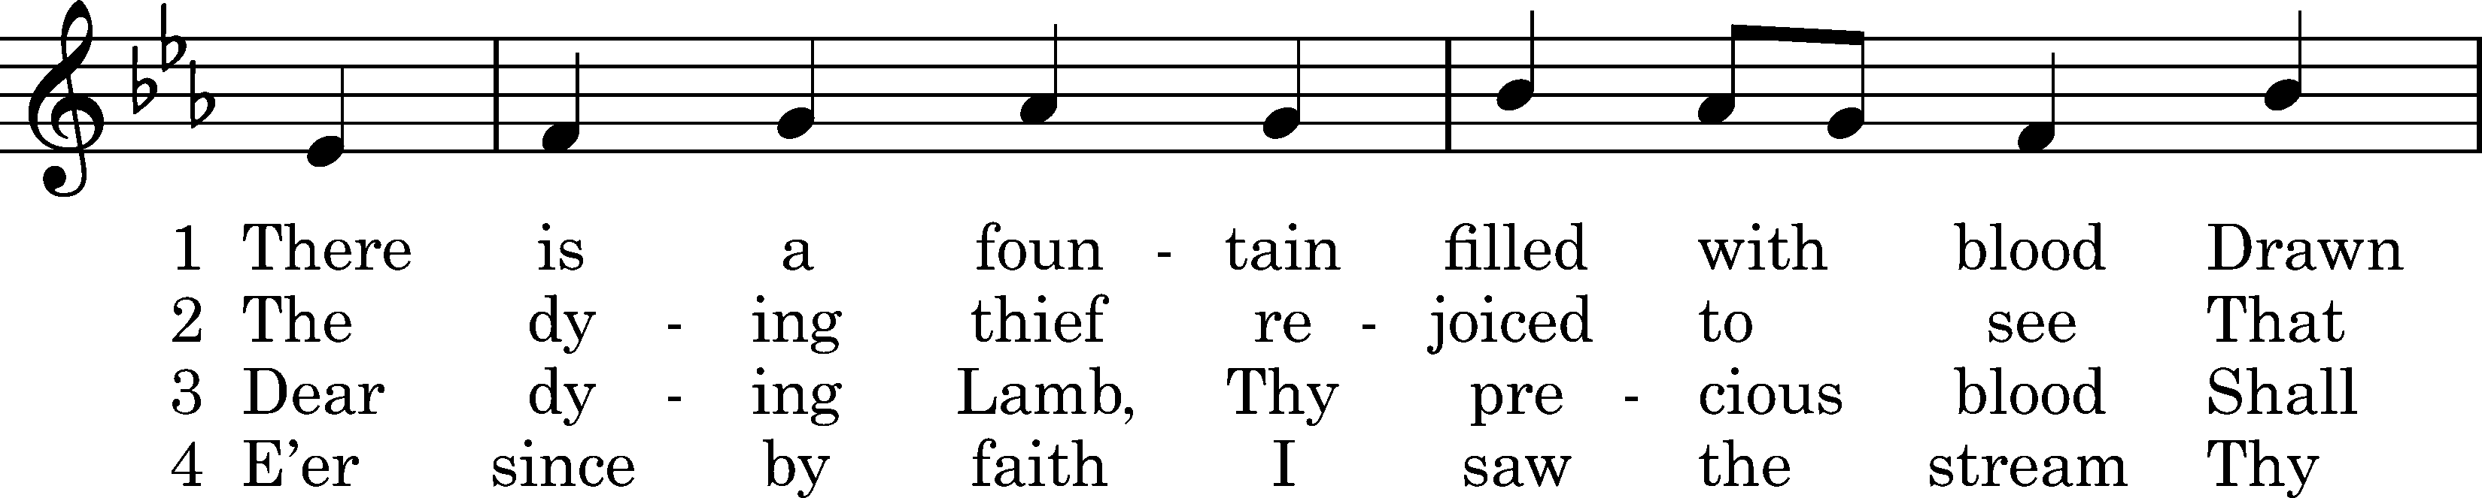
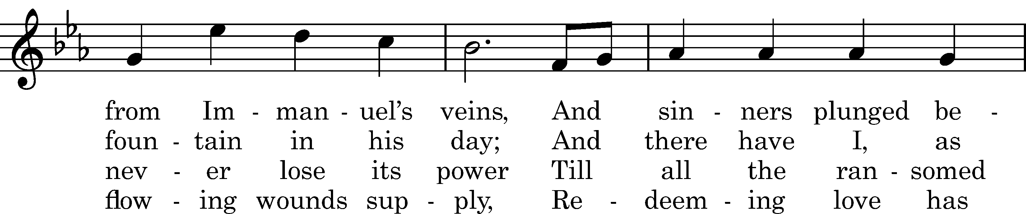
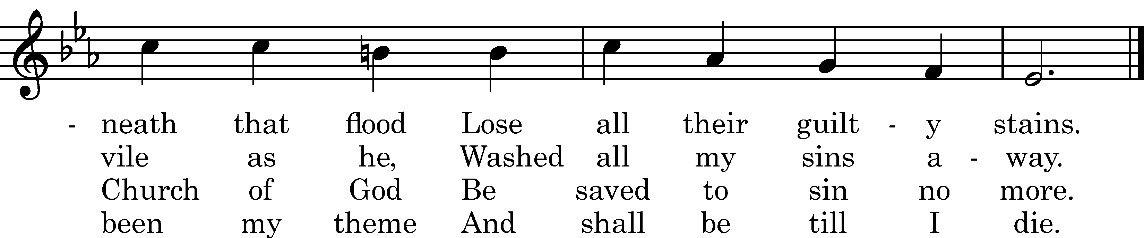

5 When this poor lisping, stamm'ring tongue
Lies silent in the grave,
Then in a nobler, sweeter song
I'll sing Thy pow'r to save.
Text: William Cowper, 1771, cento
Tune: William Horsley, 1844
Text and tune: Public domain

Distribution Hymn: LSB #714 “Who Trusts in God a Strong Abode”

Distribution Hymn: LSB #422 “On My Heart Imprint Your Image”

Stand

Nunc Dimittis Luke 2:29–32
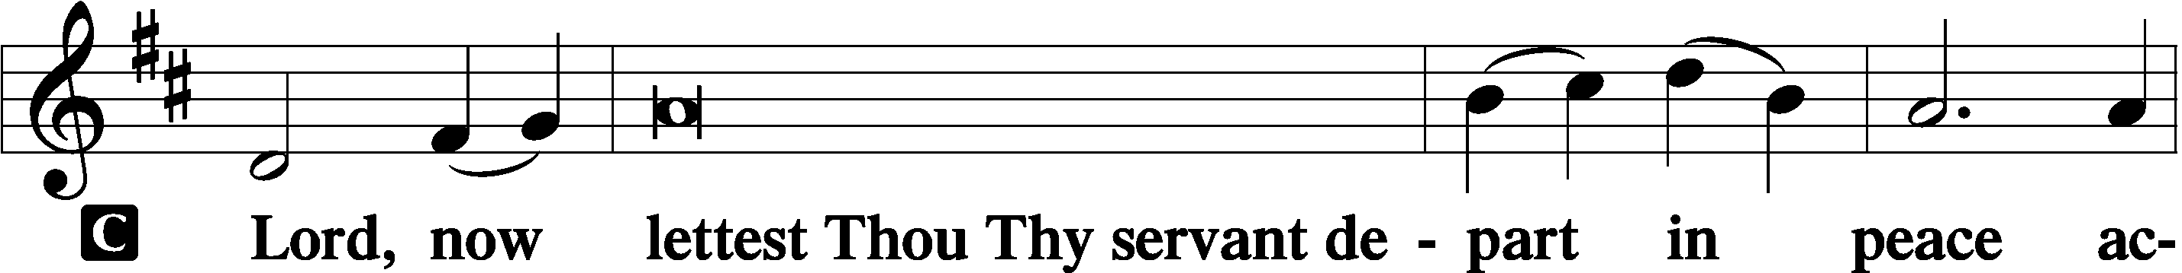
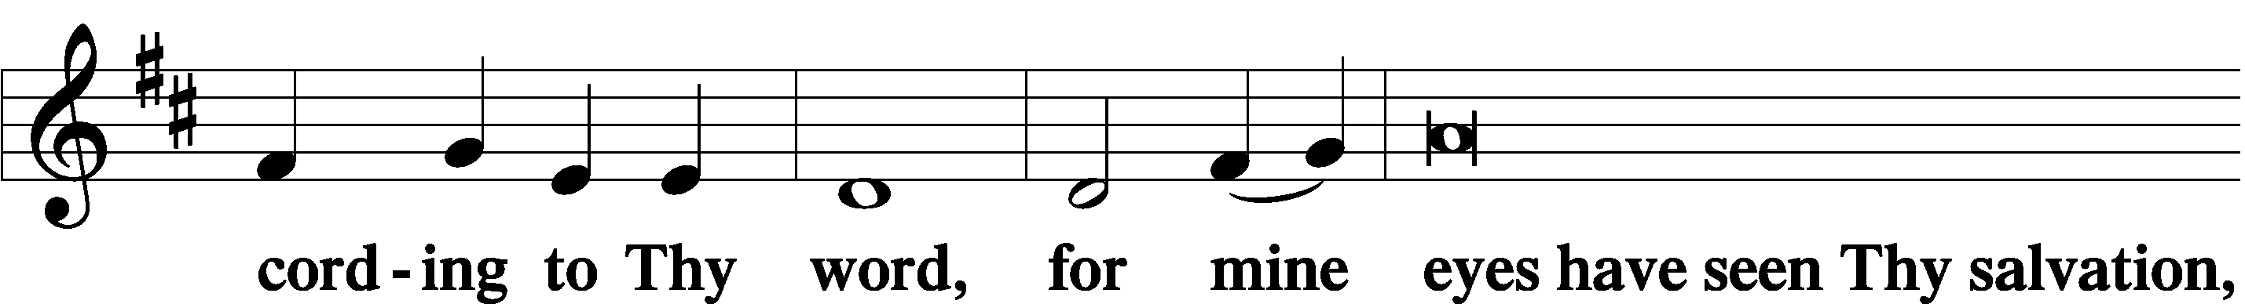
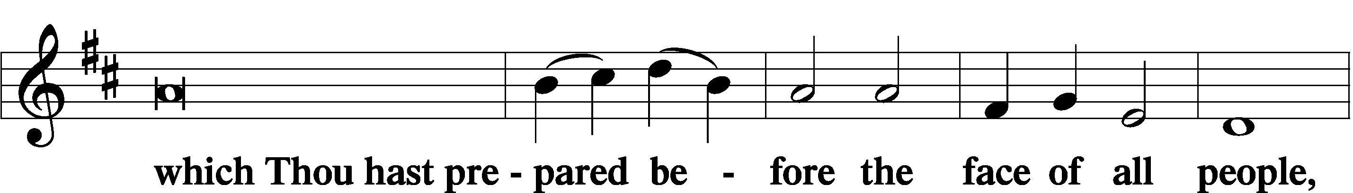
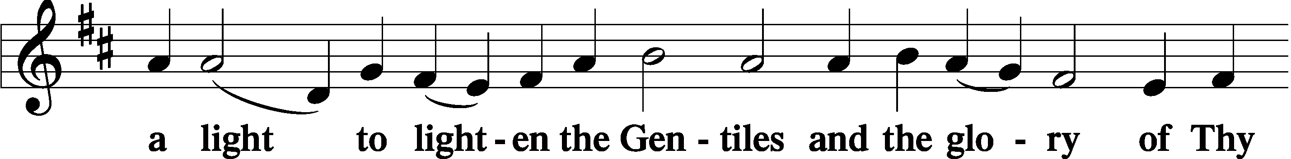
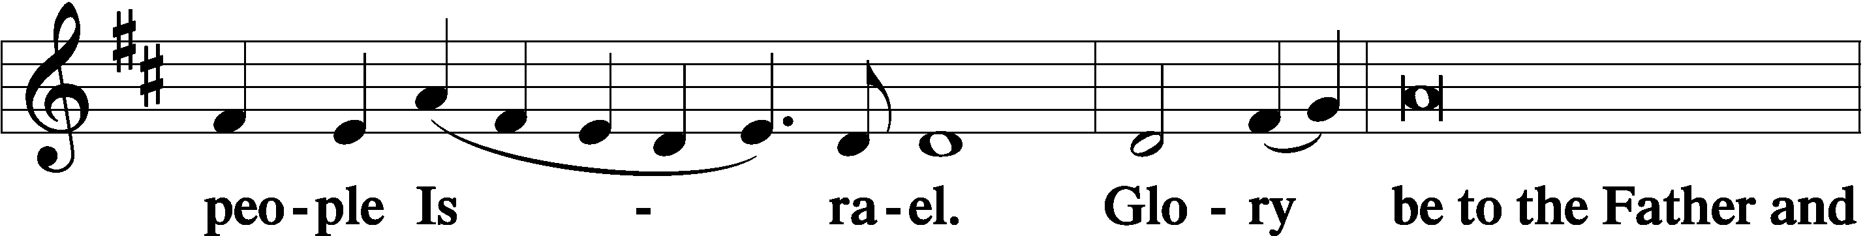
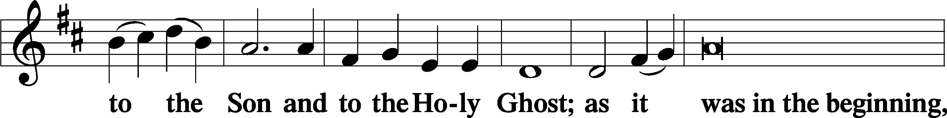
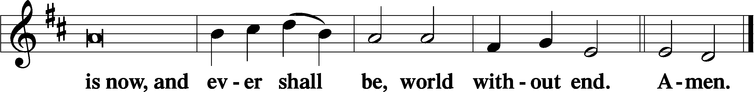

Thanksgiving Psalm 107:1
P O give thanks unto the Lord, for He is good,
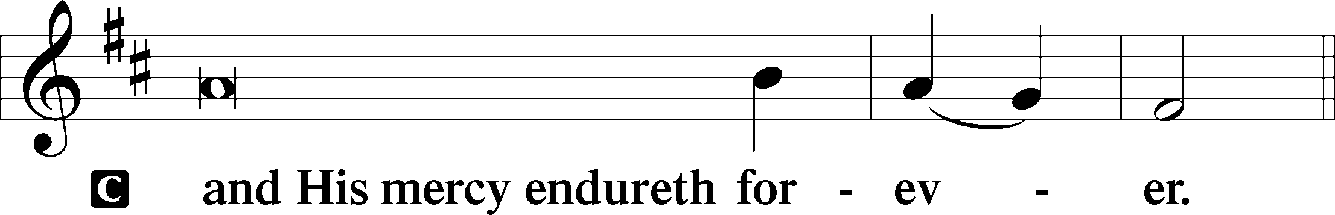

Post-Communion Collect
P Let us pray.
We give thanks to You, almighty God, that You have refreshed us through this salutary gift, and we implore You that of Your mercy You would strengthen us through the same in faith toward You and in fervent love toward one another; through Jesus Christ, Your Son, our Lord, who lives and reigns with You and the Holy Spirit, one God, now and forever.
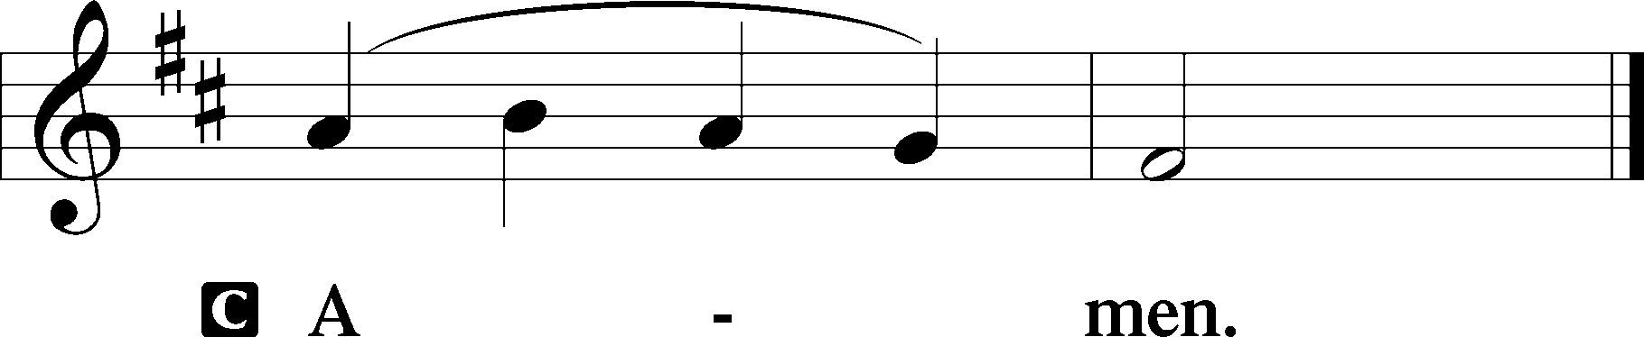

Salutation 2 Timothy 4:22
P The Lord be with you.
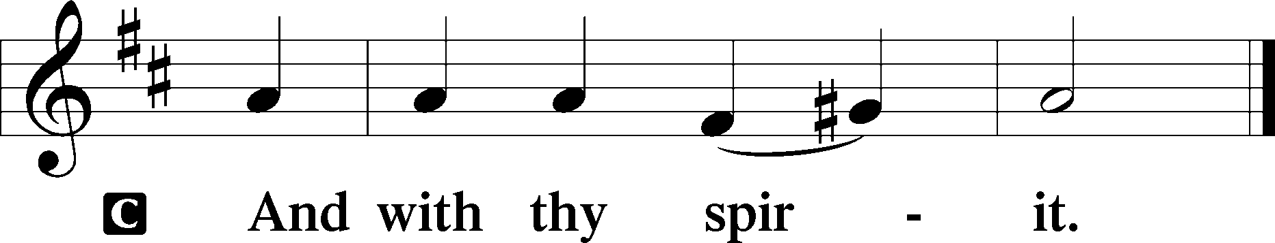

Benedicamus Psalm 103:1
P Bless we the Lord.
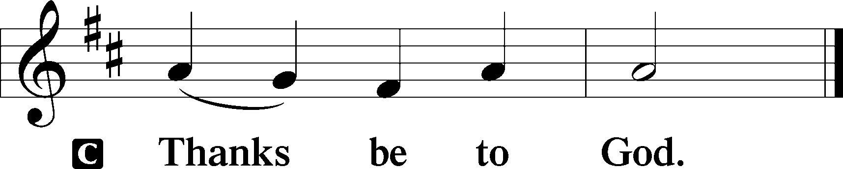

Benediction Numbers 6:24–26
P The Lord bless you and keep you.
The Lord make His face shine upon you and be gracious unto you.
The Lord lift up His countenance upon you and T give you peace.
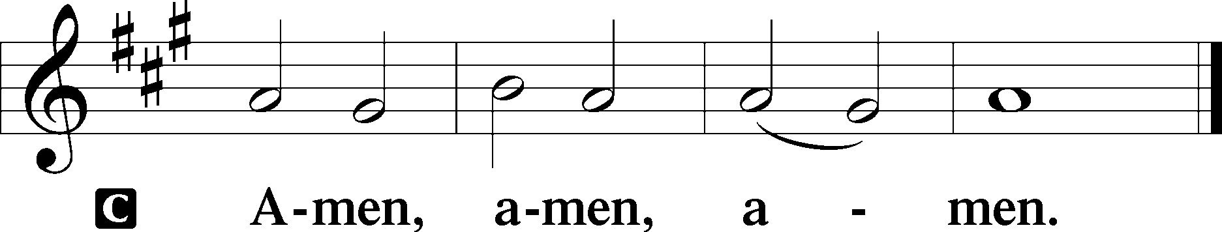

Closing Hymn: TLH #148 “Lord Jesus Christ, My Life, My Light”
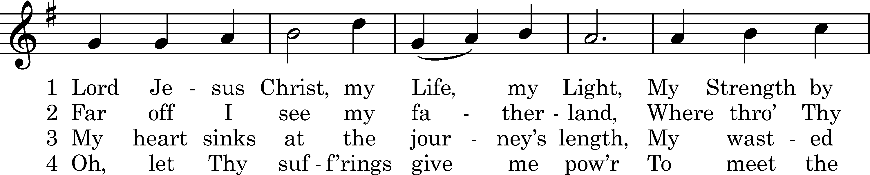
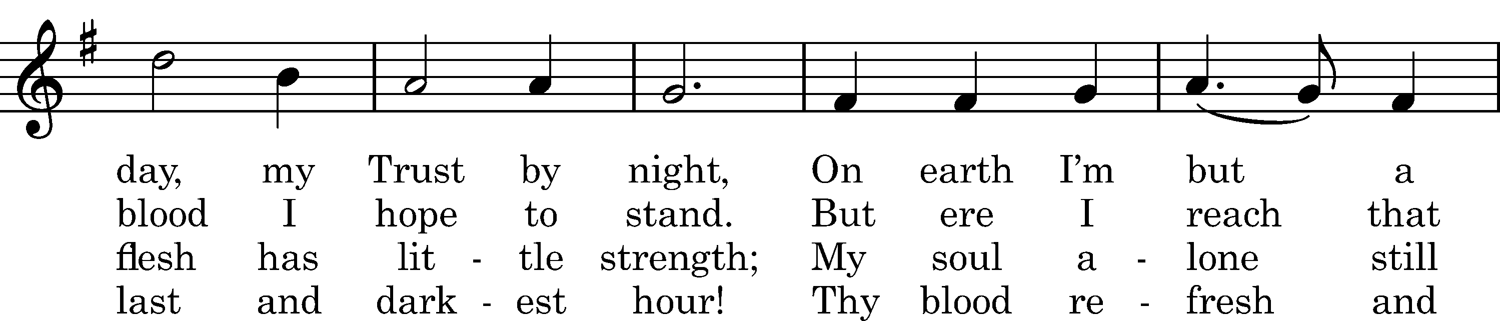
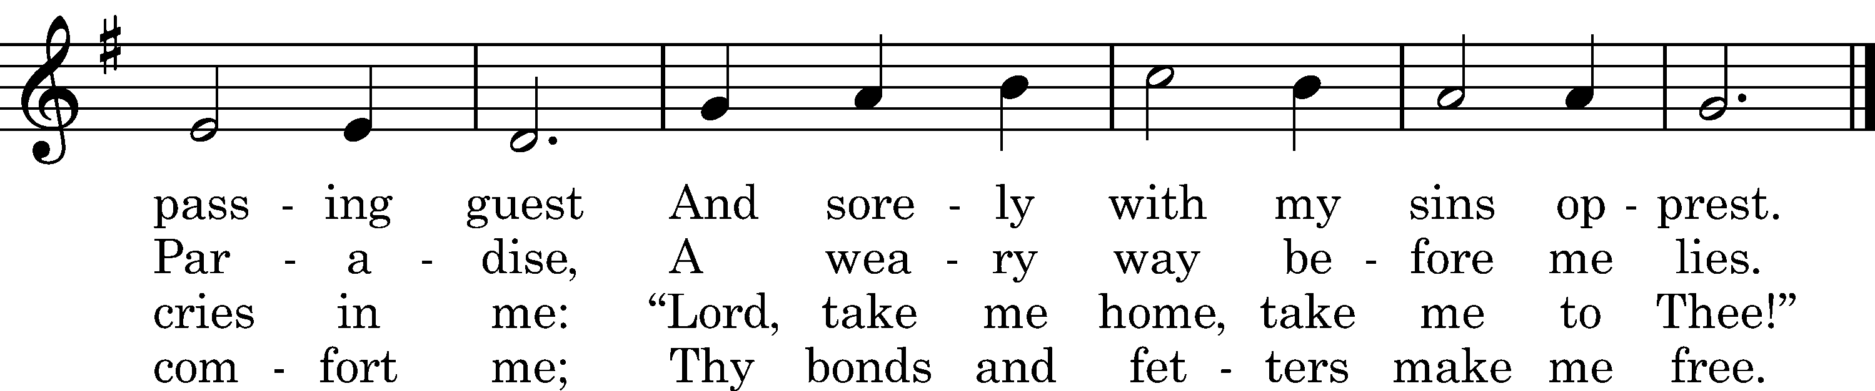

5 Oh, let Thy holy wounds for me
Clefts in the rock forever be
Where as a dove my soul can hide
And safe from Satan's rage abide.

6 And when my spirit flies away,
Thy dying words shall be my stay.
Thy cross shall be my staff in life,
Thy holy grave my rest from strife.

7 Lord, in Thy nail-prints let me read
That Thou to save me hast decreed
And grant that in Thine opened side
My troubled soul may ever hide.

8 Since Thou hast died, the Pure, the Just.
I take my homeward way in trust.
The gates of heav'n, Lord, open wide
When here I may no more abide.

9 And when the last Great Day shall come
And Thou, our Judge, shalt speak the doom,
Let me with joy behold the light
And set me then upon Thy right.

10 Renew this wasted flesh of mine
That like the sun it there may shine
Among the angels pure and bright,
Yea, like Thyself in glorious light.

11 Ah, then I'll have my heart's desire,
When, singing with the angels' choir,
Among the ransomed of Thy grace,
Forever I'll behold Thy face!
Text: tr. Catherine Winkworth, 1863, alt.; Martin Behm, 1610, cento
Tune: Nuernbergisches Gesangbuch, 1676
Text and tune: Public domain

Silent prayer after worship: Heavenly Father, thank You for claiming me as Your own dear child through the rebirth of Holy Baptism. Lead me to daily live in my Baptism by faith, and to share Your love and hope with others. In Jesus’ name. Amen.
fffffffffffffffffffffffffffffffffff
fffffffffffffffffffffffffffffffffff
In Loving Memory of Anson Holcroft: Sue Bender (Major Repair), Mr. & Mrs. Joseph Chlpka, Diane Riefstahl, and Traudi Sulek & Family (Food Pantry & Capital Campaign).
In Loving Memory of Brother-in-Law, Ernest L. Meszaros: Joani Rice (Food Pantry & Major Repair).
fffffffffffffffffffffffffffffffffff
SCHEDULE THROUGH MARCH 12, 2023:

:

Today, Following Worship, Fellowship Hall: Voters’ Assembly
7 pm, Fellowship Hall: AA Meeting
Tuesday, 7 pm, All Saints~Slippery Rock: Lenten Midweek Vespers Service
7-9 pm, Fellowship Hall: Penn-Ohio Singers
Wednesday, Noon, Sanctuary: Lenten Midweek Matins Service
7 pm, Sanctuary: Lenten Midweek Vespers Service
7:30 pm, Fellowship Hall: NA Meeting
Thursday, 9 am, Downstairs: Food Pantry
Saturday, 9 am, All Saints~Slippery Rock: Catechism Class
Next Sunday, 8 am, Fellowship Hall: Bible Study
9 am, Sanctuary: Divine Service
Following, Fellowship Hall: Coffee Fellowship
7 pm, Fellowship Hall: AA Meeting
fffffffffffffffffffffffffffffffffff
Attendance: Wednesday, February 22, 2023: 30
Sunday, February 26, 2023: 41
Wednesday, March 1: (noon) : (7pm)
fffffffffffffffffffffffffffffffffff
THANK YOU FOR SERVING IN MARCH: Elder: Jonathan Baisch; Ushers: Cheryl Fedele, Mike Flaugher, and Jesse Riffle; Altarware: (prior) Diane Riefstahl & Marie Flaugher (03/12); (after) Elizabeth Haenftling & Traudi Sulek.
fffffffffffffffffffffffffffffffffff
Bible Memory Verses ~ Week of March 5th:
For Adults: Finally, brothers, whatever is true, whatever is honorable, whatever is just, whatever is pure, whatever is lovely, whatever is commendable, if there is any excellence, if there is anything worthy of praise, think about these things.
Philippians 4:8
For Children: The Lord God has opened my ear, and I was not rebellious; I turned not backward. Isaiah 50:4-5
fffffffffffffffffffffffffffffffffff
Our Stewardship of Treasures for the Lord:
In order to do the Lord’s work, we need $2,553.63 each week to meet our 2023 budget for general purposes and $76.92 for the SELC.
Online Figures (01.19.23; 02.02.23; 02.16.23; 02.27.23)
General Fund: $2,240.00
SELC: $100.00
Food Pantry: $100.00
Capital Campaign: $200.00
Figures for Wednesday, February 22, 2023
General Fund: $1,085.00
SELC: $40.00
Food Pantry: $25.00
Other: $35.00
Figures for Sunday, February 26, 2023
General Fund: $1,438.00 Ahead for the week*: +$2,209.37
SELC: $10.00 Ahead for the week*: +$73.08
Food Pantry: $100.00
Capital Campaign: $726.00 *Includes above figures.
Other: $100.00

For online giving, check out https://www.saintspeterandpaul.net/online-giving.
fffffffffffffffffffffffffffffffffff
There will be a VOTERS’ ASSEMBLY in the Fellowship Hall ten minutes following the end of worship this morning. Your attendance will be greatly appreciated.
fffffffffffffffffffffffffffffffffff
Choir members are reminded that there will NOT be practice this Wednesday.

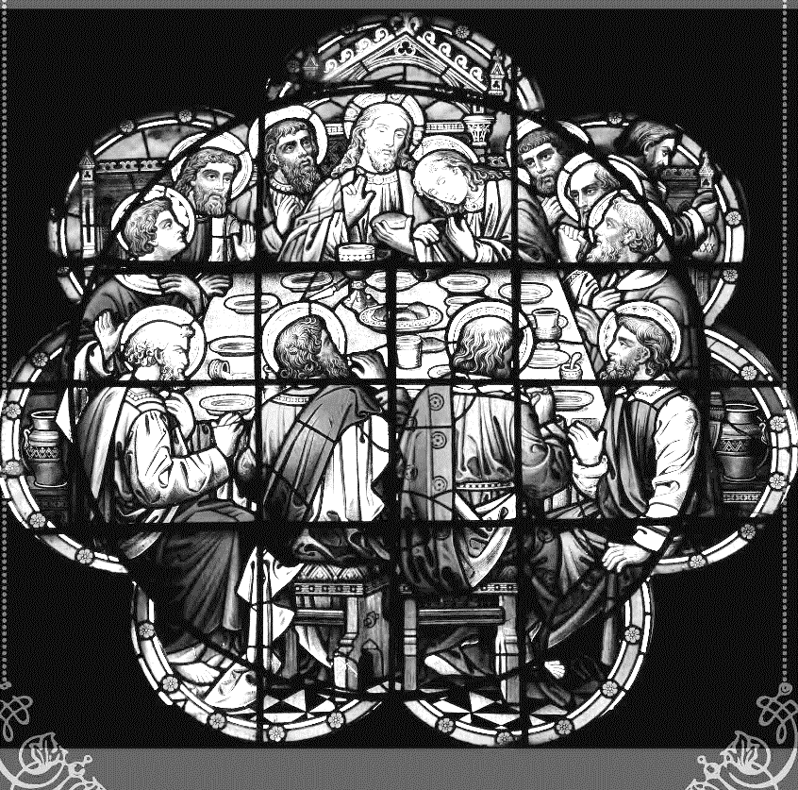
Join us this Lenten season as we focus on the Lord’s Supper with the following Wednesday midweek services:
March 1-29
Matins Service at Noon
Vespers Service at 7 pm

fffffffffffffffffffffffffffffffffff
The March issue of “The Rock and the Sword” newsletter is available on the tables in the narthex and the sign-in table next to Pastor Deal’s office. Also available in the narthex is the 2022 Annual Report.
fffffffffffffffffffffffffffffffffff
Remember the following in Prayer…
~The Hurting and Healing: The family and friends of Anson Holcroft, who passed away Wednesday, February 22, 2023; Amy, Gerald Arthur, Evelyn Baisch, Ellen Baron^{CA}, Lois Bortner^{CA}, John Burdette, Bev & Joe Chlpka, Kathleen Coughenour, Kim, Anna Mae Daris, Susan Davies, Tim Dudash, Millie Elavsky, Joseph Fleet, Judith & Eddy Furey, Tim Haenftling, Austin Hamilton, Neil Huston, Joan, Darla Krajci, Barbara Kreske, Donna Kennedy, Jess Lavoie, Paul Lucas^{CA}, Sandy Marshall, David Nelson, Linda Parkany, Juanita Rentschler, Richard Reuning^{CA}, Diane Riefstahl, Nancy Robertson^{CA}, Viola Sakony, Marty Scott, Kara, Fred Tonty, Angela Weser^{CA}, and Ruth Wolf.
~The Homebound: Rudy & Jean Tomko, Betty Wolf, and Ed & Millie Zachar.
~Serving in the Military: Curtis Sinewe and Joshua Solyan.
~Community & World Needs: Those suffering from or affected by the coronavirus; those suffering due to the conflict between Ukraine and Russia; those suffering from loss and dislocation because weather disasters; those suffering from addiction and their families; Local, State, and National Government Leaders; safety for all Police Officers, Firefighters, & First Responders; the unemployed; our First Quarter Local Mission: Sts. Peter & Paul’s Community Day 2023. *CA represents cancer.
fffffffffffffffffffffffffffffffffff
Heartfelt sympathy is extended to the family and friends of Anson Holcroft who was called home to his Lord, Wednesday, February 22, 2023. Anson was a faithful servant to this church and, although he will be greatly missed, we are comforted in the knowledge that he is with our Lord, and Savior.
Here to Serve
Pastor………………………………………………...……………Rev. Jacob Deal
E-mail …………………………….……pastordeal@saintspeterandpaul.net
Phone Number……………………..…………………724-347-3620 (Option 2)
Church Office………………………..…………………724-347-3620 (Option 3)
Website …………………………………………www.saintspeterandpaul.net
Secretary…………………………………………………………Diane Riefstahl
E-mail ………………………………………church@saintspeterandpaul.net
Website …………………………………………www.saintspeterandpaul.net
Food Pantry: Please leave message……………724-347-3620 (Option 3)
AA Contact: Steve………………………………………………..…724-813-2358
NA Contact: Larry………………………………………………..724-977-8733
Choir Director………………………………………………………Chris Nelson
Congregation President……………………………………Jonathan Baisch
Church Elder …………………………………………...…… Jonathan Baisch
fffffffffffffffffffffffffffffffffff
If needing to get into the church building during the week, please phone first to make certain someone is here to let you in.
Acknowledgments: Unless otherwise indicated, Scripture quotations are from the ESV® Bible (The Holy Bible, English Standard Version®), copyright © 2001 by Crossway, a publishing ministry of Good News Publishers. Used by permission. All rights reserved. Created by Lutheran Service Builder © 2021 Concordia Publishing House.

