Sts. Peter & Paul
Evangelical Lutheran Church
Lutheran Church-Missouri Synod
Founded-1917

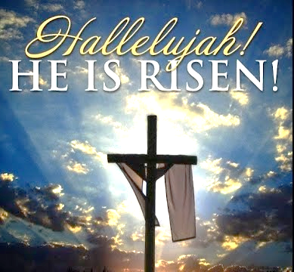

March 31, 2024

699 Stambaugh Ave.
Sharon, Pennsylvania 16146

“I was glad when they said to me,
Let us go to the house of the LORD!”
Psalm 122:1
Sts. Peter & Paul Evangelical Lutheran Church, LC-MS
THE RESURRECTION OF OUR LORD
March 31, 2024

A special welcome to our guests this day! If you would like more information about The Lutheran Church - Missouri Synod, or this congregation, please speak with Pastor Deal or an Elder after the service.
Members & Guests: Don’t be embarrassed if your children make noise during the worship service, all children do. We encourage families to worship together but, if you feel the need, there are pews in the rear of the Church which are reserved for young families on both sides of the sanctuary. There is also a quiet room available to you during our service which is located down the hallway past the offices on the right side of the church as well as a children’s area in the Fellowship Hall where you are able to follow along with the service.

Today’s service includes the Sacrament of Holy Communion. If during this past year, you have not worshipped with us and been communed, we respectfully ask that you do not partake of this sacrament this day before first speaking with Pastor Deal.
If visiting from a sister congregation of the LC-MS and are in good standing, please inform Pastor Deal of your desire to commune prior to the service.
If wishing to receive a blessing during communion, please approach with your arms crossed.

CONTACT INFORMATION
Pastor Deal: pastordeal@saintspeterandpaul.net or 724-347-3620 (opt. 2)
Church Office: church@saintspeterandpaul.net or 724-347-3620 (opt. 3)
Office Hours: The church office will be open Monday and Thursday (8:30 am-4:30 pm).

Silent prayer before worship Heavenly Father, give me confidence to trust that through our living Savior Jesus I have a new and eternal life. Fill my heart with a joyful desire to share the wonderful news that Christ is risen. Amen.
Confession and Absolution

Choir: “Hallelujah!”

Opening Hymn: TLH #207 “Like the Golden Sun Ascending”

3. Though I be by sin o’ertaken,
Though I lie in helplessness,

Though I be by friends forsaken
And must suffer sore distress,
Though I be despised, contemned,
And by all the world condemned,
Though the dark grave yawn before me,
Yet the light of hope shines o’er me.

4. Thou hast died for my transgression,
All my sins on Thee were laid;
Thou hast won for me salvation,
On the cross my debt was paid.
From the grave I shall arise
And shall meet Thee in the skies.
Death itself is transitory;
I shall lift my head in glory.

5. Grant me grace, O blessed Savior,
And Thy Holy Spirit send
That my walk and my behavior
May be pleasing to the end;
That I may not fall again
Into Death’s grim pit and pain,
Whence by grace Thou hast retrieved me
And from which Thou hast relieved me.

6. For the joy Thy advent gave me,
For Thy holy, precious Word;
For Thy Baptism, which doth save me,
For Thy blest Communion board;
For Thy death, the bitter scorn,
For Thy resurrection morn,
Lord, I thank Thee and extol Thee,
And in heaven I shall behold Thee.

Stand

The sign of the cross may be made by all in remembrance of their Baptism.

Invocation
P In the name of the Father and of the T Son and of the Holy Spirit.
C Amen.

Exhortation Hebrews 10:22; Psalm 124:8; Psalm 32:5
P Beloved in the Lord! Let us draw near with a true heart and confess our sins unto God our Father, beseeching Him in the name of our Lord Jesus Christ to grant us forgiveness.

P Our help is in the name of the Lord,
C who made heaven and earth.
P I said, I will confess my transgressions unto the Lord,
C and You forgave the iniquity of my sin.

Silence for reflection on God’s Word and for self-examination.

Confession of Sins
P O almighty God, merciful Father,
C I, a poor, miserable sinner, confess unto You all my sins and iniquities with which I have ever offended You and justly deserved Your temporal and eternal punishment. But I am heartily sorry for them and sincerely repent of them, and I pray You of Your boundless mercy and for the sake of the holy, innocent, bitter sufferings and death of Your beloved Son, Jesus Christ, to be gracious and merciful to me, a poor, sinful being.

Absolution [John 20:19–23]
P Upon this your confession, I, by virtue of my office, as a called and ordained servant of the Word, announce the grace of God unto all of you, and in the stead and by the command of my Lord Jesus Christ I forgive you all your sins in the name of the Father and of the T Son and of the Holy Spirit.
C Amen.
Service of the Word

Introit Psalm 8:1, 5–6, 9; antiphon: Luke 24:5b–6b
He is risen! Alle- | luia!*
Why do you seek the living among the dead? Alle- | luia!
Remember how he told you, Alle- | luia,*
that the Son of Man must be crucified and on the third day rise. Alle- | luia!
O Lord, our Lord, how majestic is your name in | all the earth!*
You have set your glory above the | heavens.
Yet you have made him a little lower than the heavenly | beings*
and crowned him with glory and | honor.
You have given him dominion over the works | of your hands;*
you have put all things under | his feet.
O | Lord, our Lord,*
how majestic is your name in | all the earth!
He is risen! Alle- | luia!*
Why do you seek the living among the dead? Alle- | luia!
Remember how he told you, Alle- | luia,*
that the Son of Man must be crucified and on the third day rise. Alle- | luia!

Gloria Patri
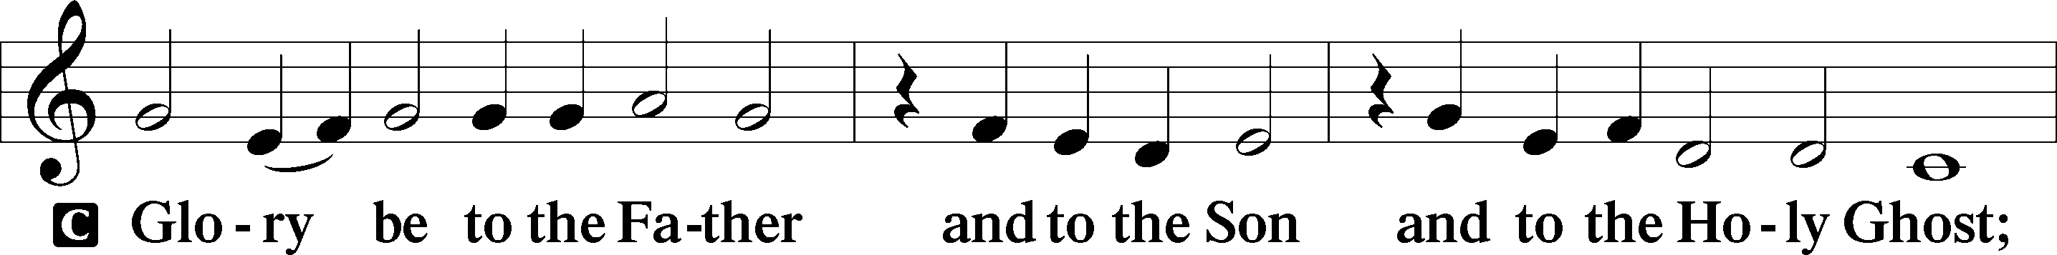
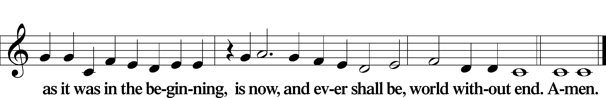

Kyrie Mark 10:47
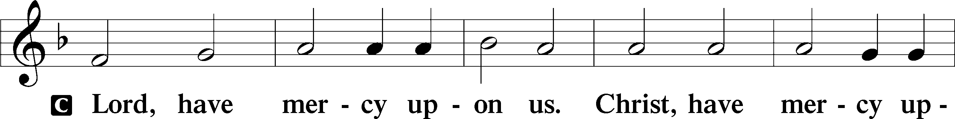
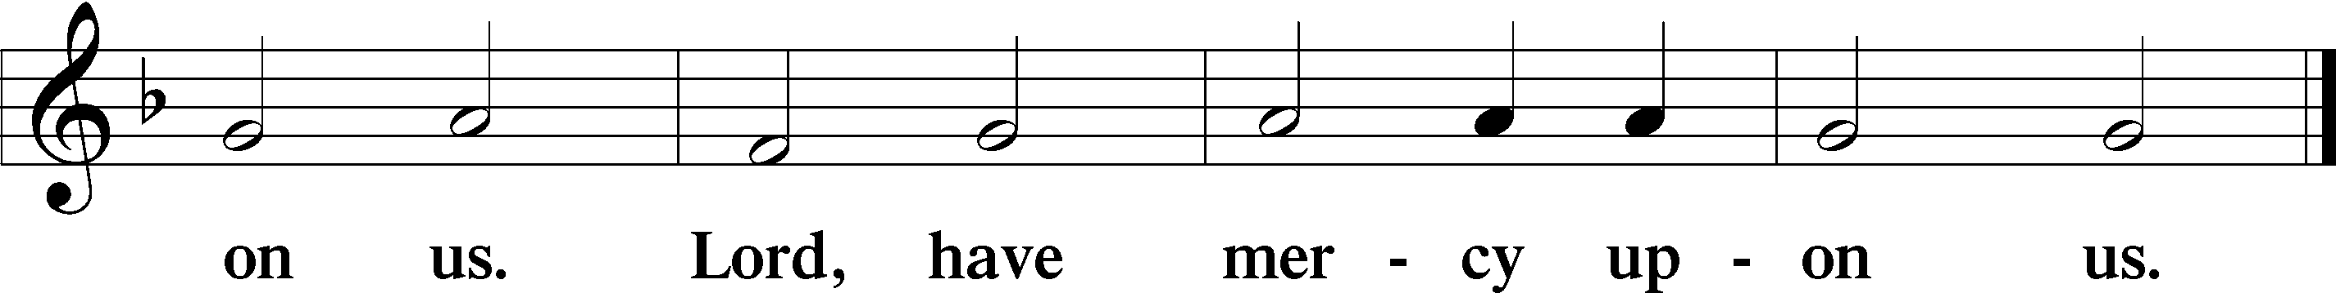

Gloria in Excelsis Luke 2:14; John 1:29
P Glory be to God on high:
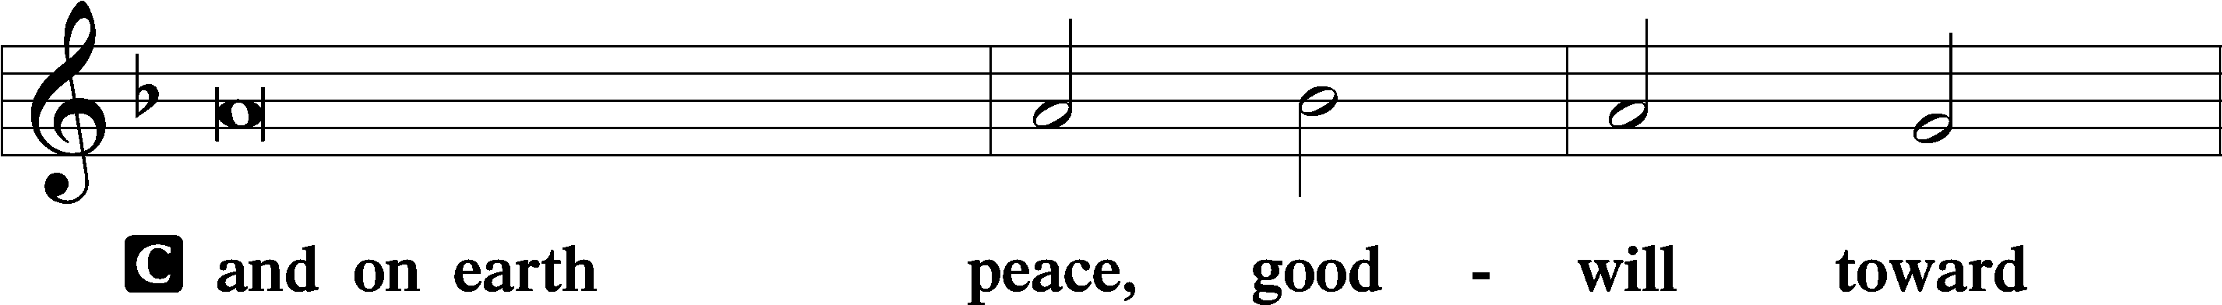
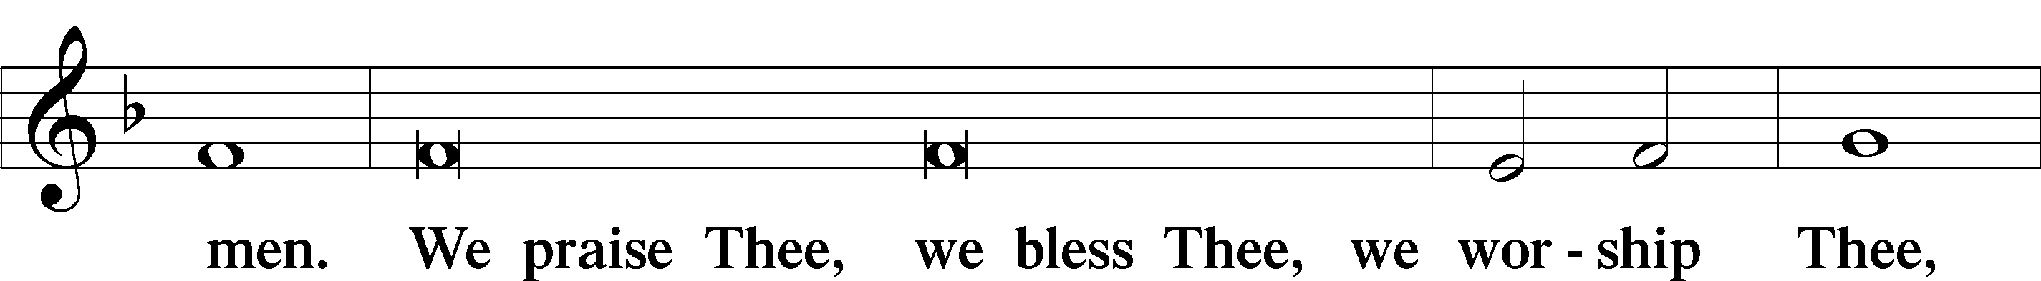
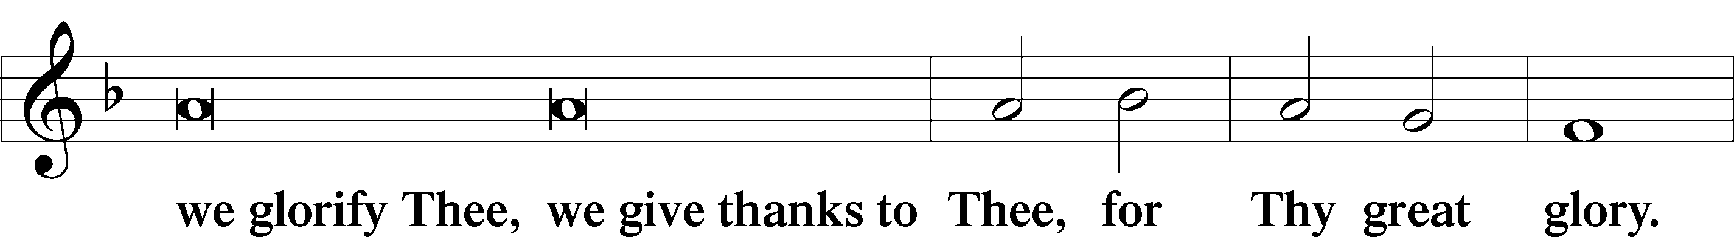
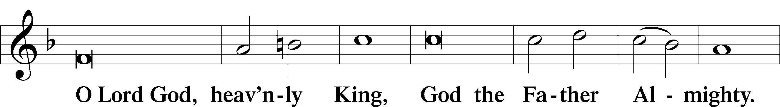
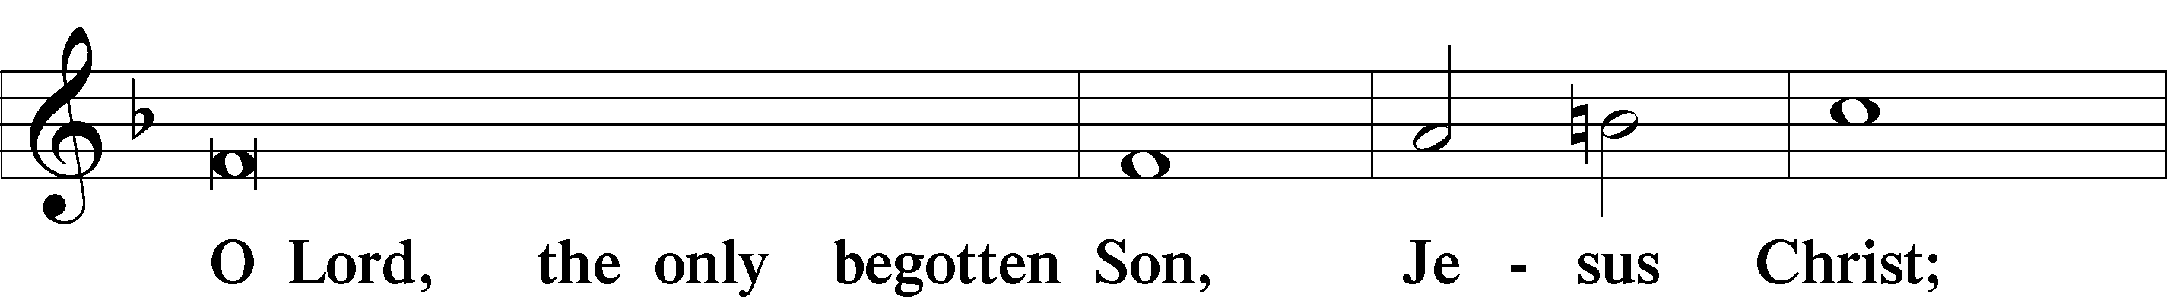
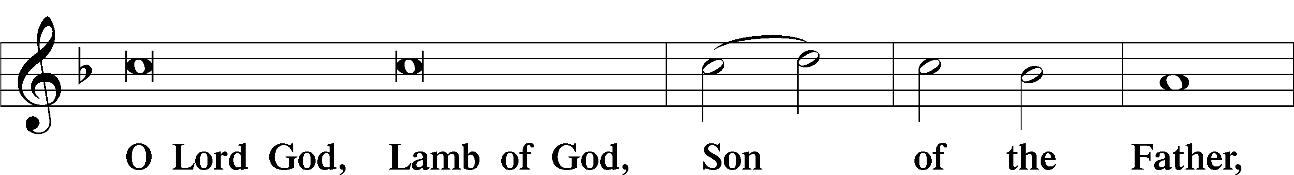
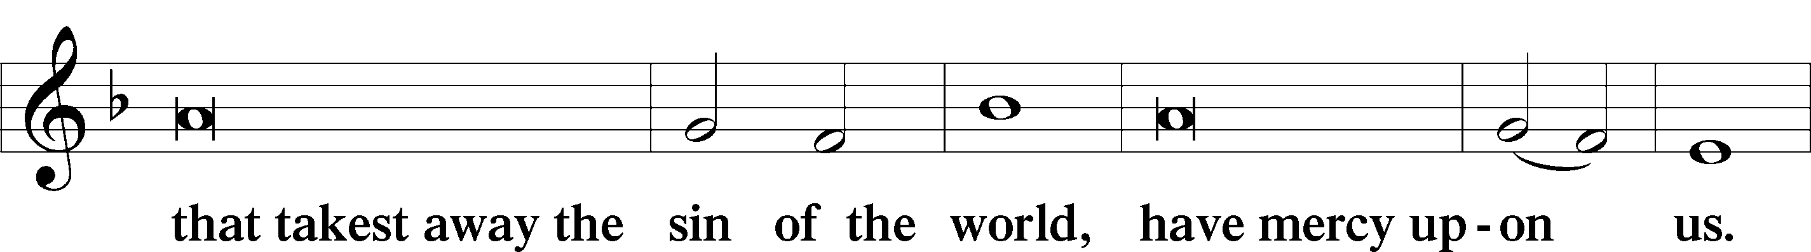
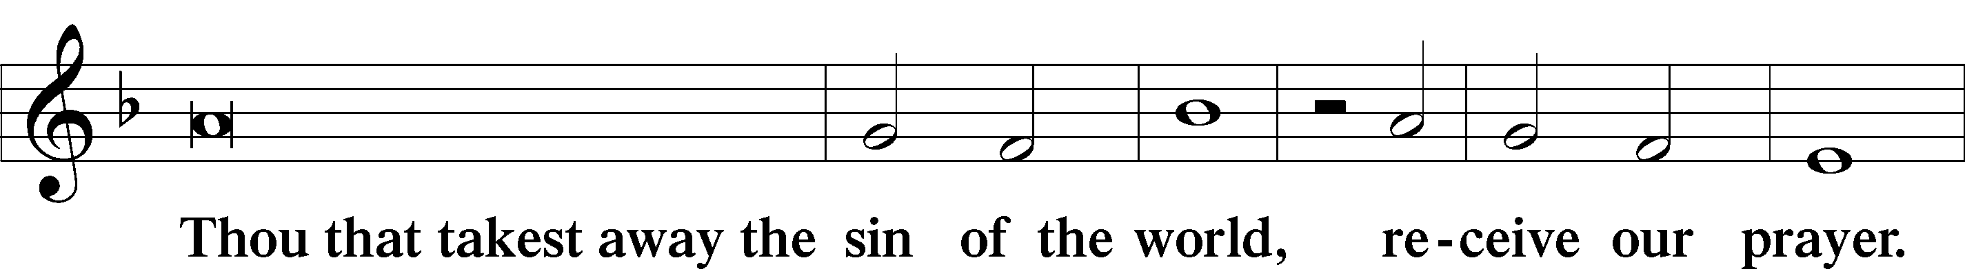
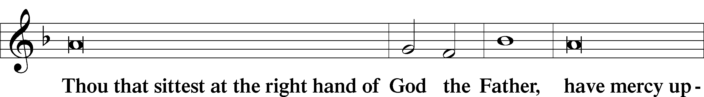
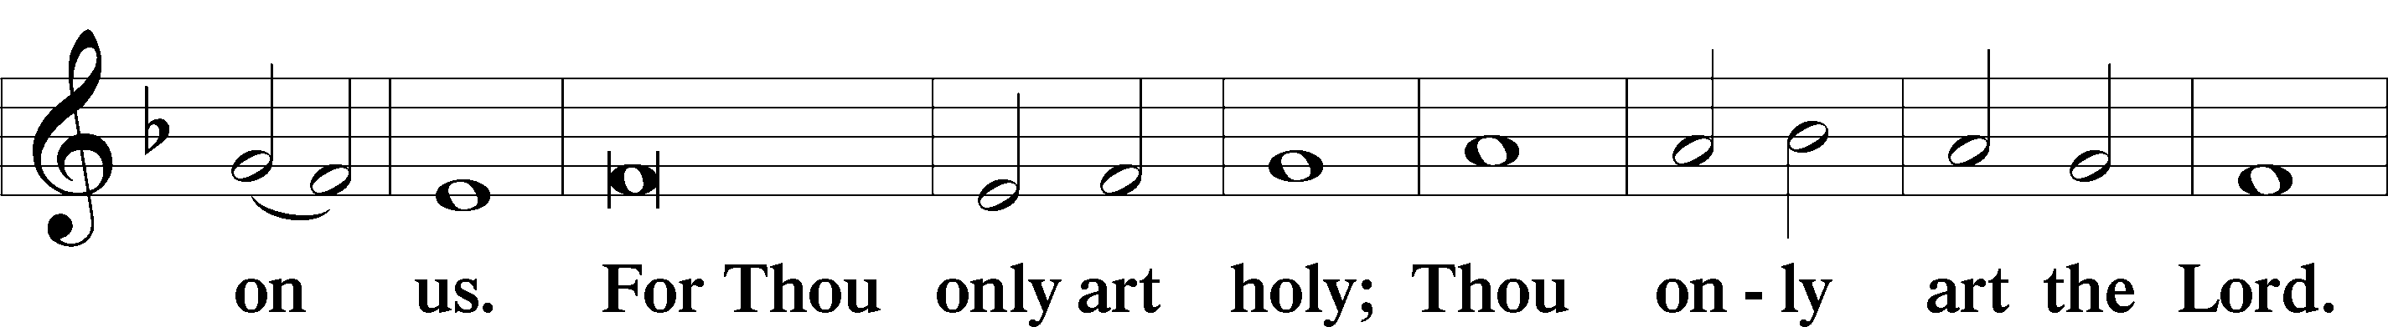
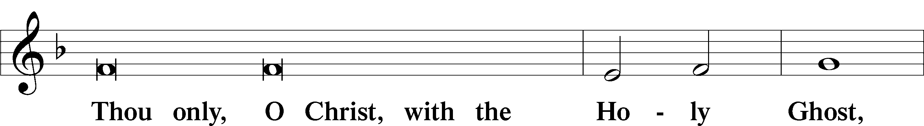
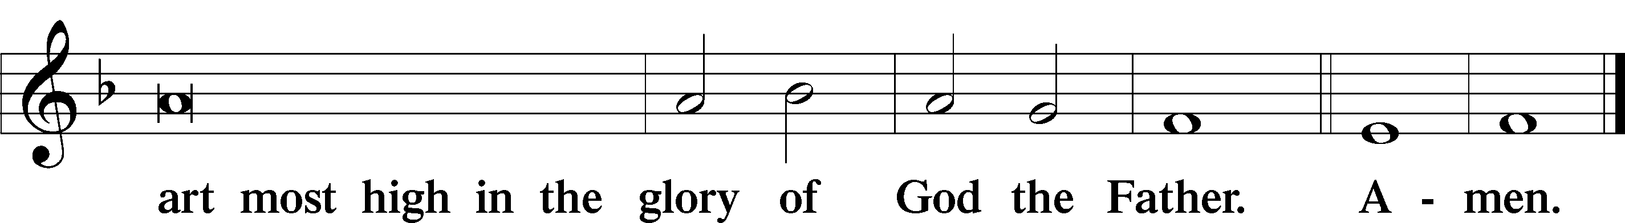

Salutation and Collect of the Day: Easter
P The Lord be with you.
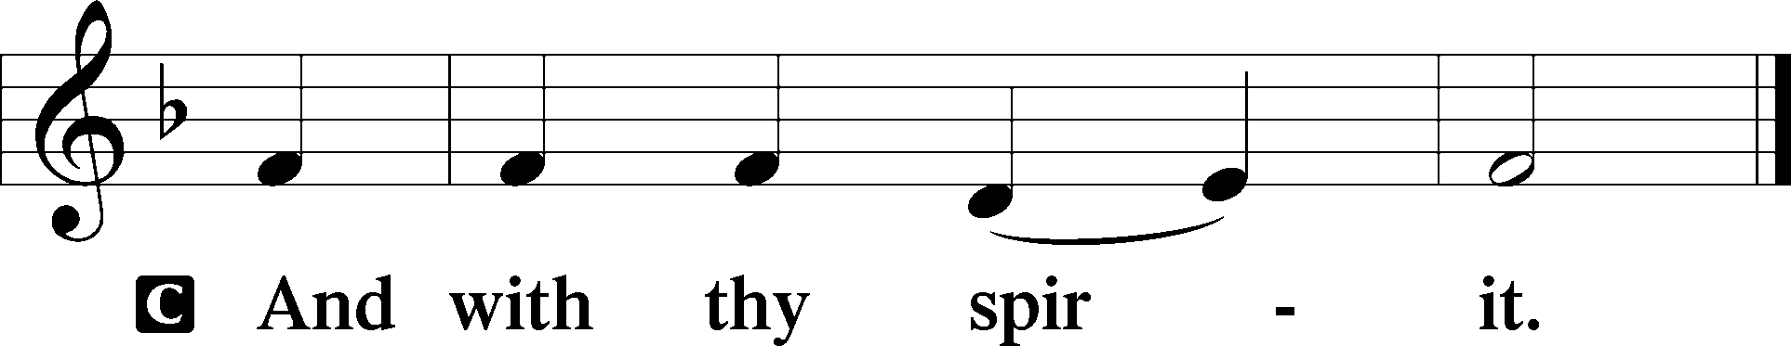

P Let us pray.
Almighty God the Father, through Your only-begotten Son, Jesus Christ, You have overcome death and opened the gate of everlasting life to us. Grant that we, who celebrate with joy the day of our Lord’s resurrection, may be raised from the death of sin by Your life-giving Spirit; through Jesus Christ, our Lord, who lives and reigns with You and the Holy Spirit, one God, now and forever.
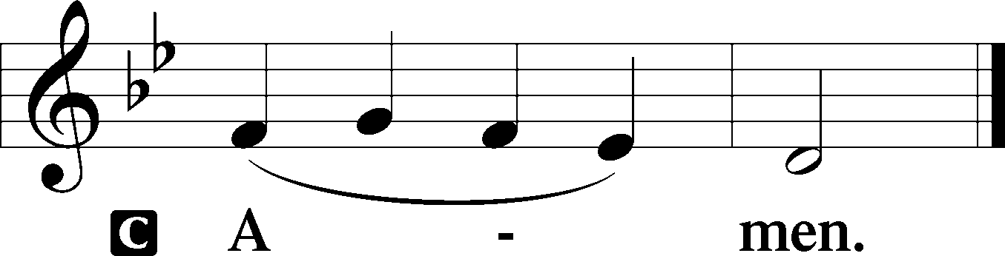
Sit

Prophecy: Job 19:23–27 (NKJV)
In those days the prophet Job spoke, saying: “Oh, that my words were written! Oh, that they were inscribed in a book! That they were engraved on a rock with an iron pen and lead, forever! For I know that my Redeemer lives, and He shall stand at last on the earth; and after my skin is destroyed, this I know, that in my flesh I shall see God, whom I shall see for myself, and my eyes shall behold, and not another. How my heart yearns within me!”

P This is the Word of the Lord.
C Thanks be to God.

Gradual Psalm 118:24, 1
This is the day that the | Lord has made;*
let us rejoice and be | glad in it.
Oh give thanks to the Lord, for | he is good;*
for his steadfast love endures for- | ever!

Epistle: 1 Corinthians 5:7–8 (NKJV)
Brethren: Purge out the old leaven, that you may be a new lump, since you truly are unleavened. For indeed Christ, our Passover, was sacrificed for us. Therefore let us keep the feast, not with old leaven, nor with the leaven of malice and wickedness, but with the unleavened bread of sincerity and truth.

P This is the Word of the Lord.
C Thanks be to God.
Stand

Verse 1 Corinthians 5:7b–8a, c
Alleluia. Christ, our Passover lamb, has been sacrificed. Let us therefore celebrate the festival with the unleavened bread of sincerity and truth. Alleluia.

Alleluia
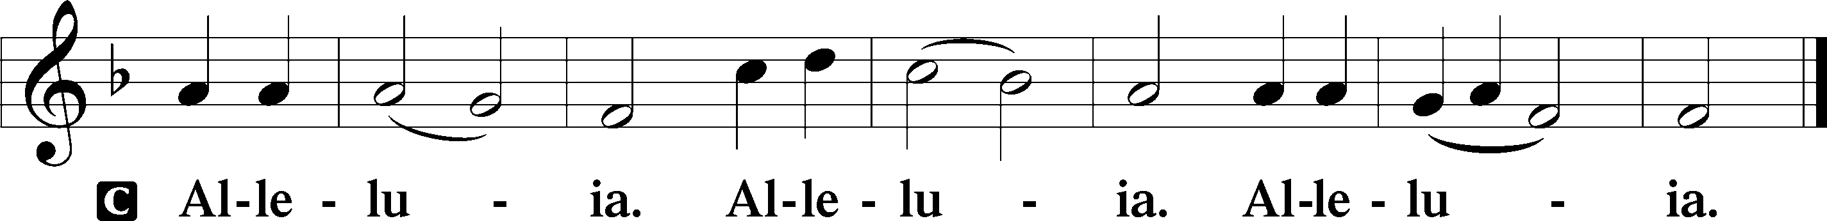
Holy Gospel: Mark 16:1–8 (NKJV)
P The Holy Gospel according to St. Mark, the sixteenth chapter.
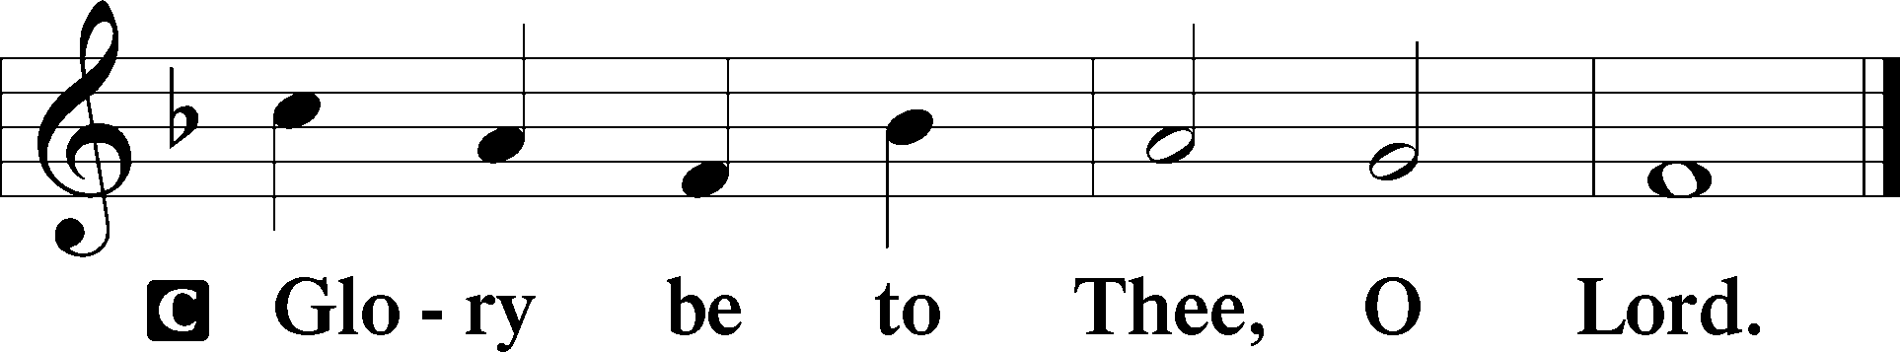

At that time: Mary Magdalene, Mary the mother of James, and Salome bought spices, that they might come and anoint Jesus. Very early in the morning, on the first day of the week, they came to the tomb when the sun had risen. And they said among themselves, “Who will roll away the stone from the door of the tomb for us?” But when they looked up, they saw that the stone had been rolled away—for it was very large. And entering the tomb, they saw a young man clothed in a long white robe sitting on the right side; and they were alarmed. But he said to them, “Do not be alarmed. You seek Jesus of Nazareth, who was crucified. He is risen! He is not here. See the place where they laid Him. But go, tell His disciples—and Peter—that He is going before you into Galilee; there you will see Him, as He said to you.” So they went out quickly and fled from the tomb, for they trembled and were amazed. And they said nothing to anyone, for they were afraid.

P This is the Gospel of the Lord.
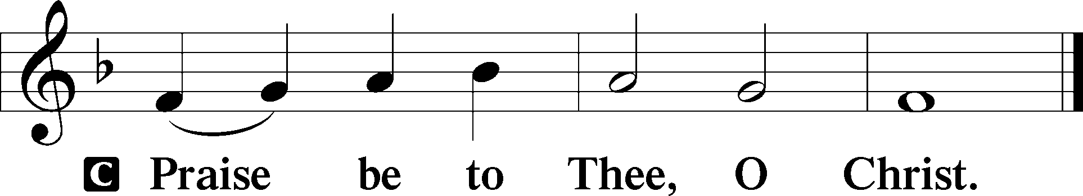

Nicene Creed
C I believe in one God,
the Father Almighty,
maker of heaven and earth
and of all things visible and invisible.

And in one Lord Jesus Christ,
the only-begotten Son of God,
begotten of His Father before all worlds,
God of God, Light of Light,
very God of very God,
begotten, not made,
being of one substance with the Father,
by whom all things were made;
who for us men and for our salvation came down from heaven
and was incarnate by the Holy Spirit of the virgin Mary
and was made man;
and was crucified also for us under Pontius Pilate.
He suffered and was buried.
And the third day He rose again according to the Scriptures
and ascended into heaven
and sits at the right hand of the Father.
And He will come again with glory to judge both the living and the dead,
whose kingdom will have no end.

And I believe in the Holy Spirit,
the Lord and giver of life,
who proceeds from the Father and the Son,
who with the Father and the Son together is worshiped and glorified,
who spoke by the prophets.
And I believe in one holy Christian and apostolic Church,
I acknowledge one Baptism for the remission of sins,
and I look for the resurrection of the dead
and the life T of the world to come. Amen.
Sit

Hymn of the Day: LSB #458 “Christ Jesus Lay in Death’s Strong Bands”

Sermon

Stand

Offertory Psalm 51:10–12
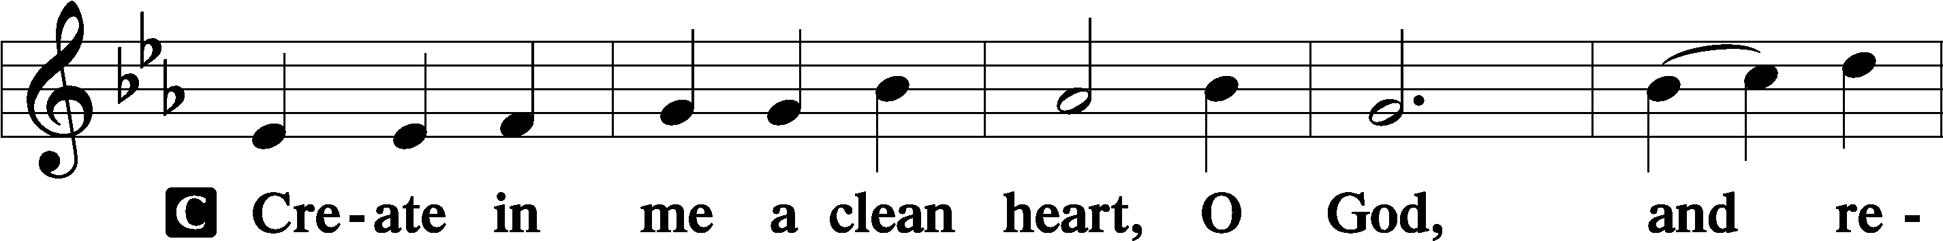
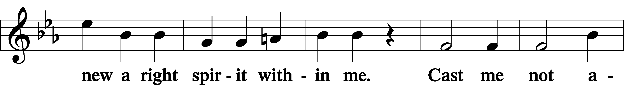
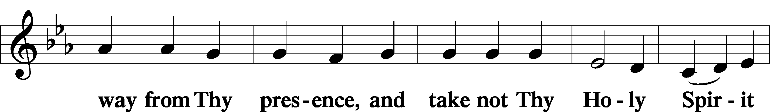
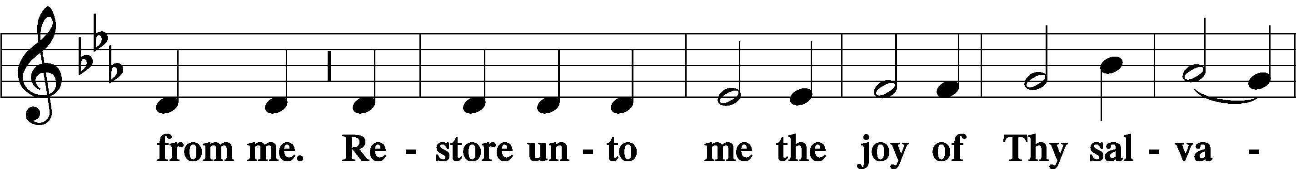
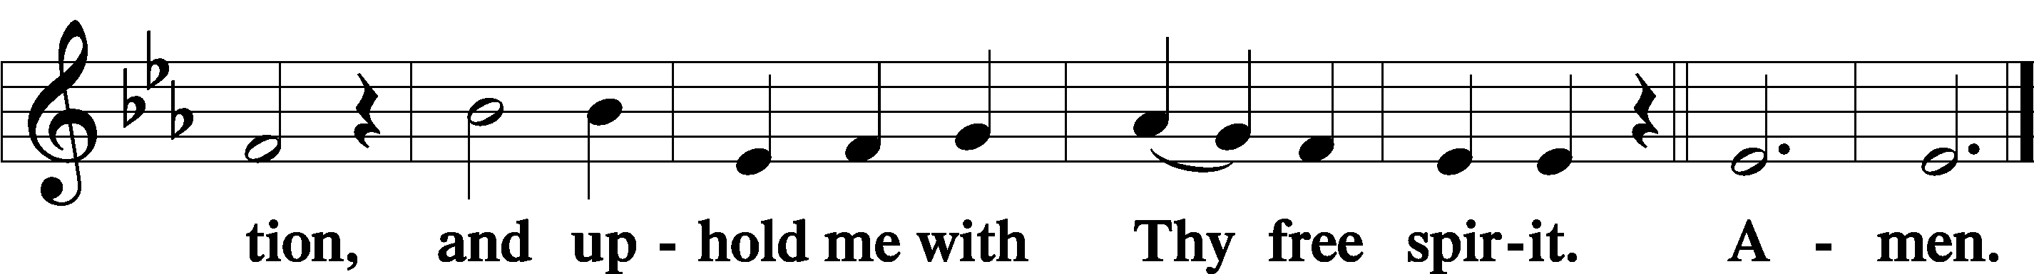

Offering: Please leave your offering in the plate upon entering.

Prayer of the Church

Sit

Preparatory Hymn: LSB #461 “I Know That My Redeemer Lives”

Stand
Service of the Sacrament

Preface 2 Timothy 4:22; Colossians 3:1 Psalm 136
P The Lord be with you.

P Lift up your hearts.
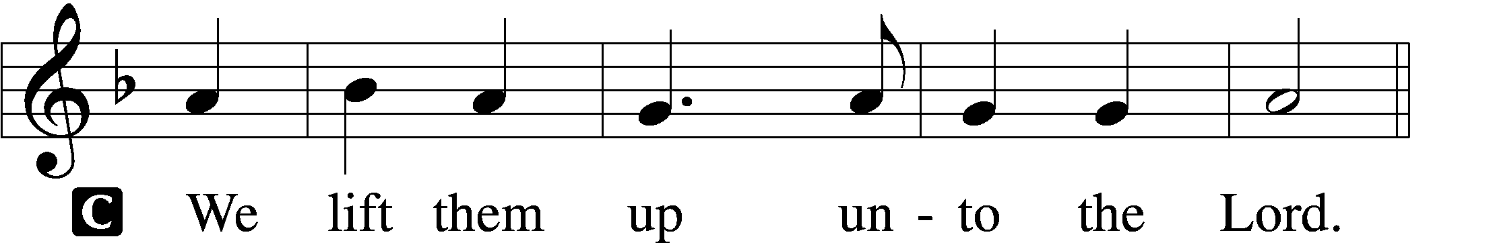

P Let us give thanks unto the Lord, our God.
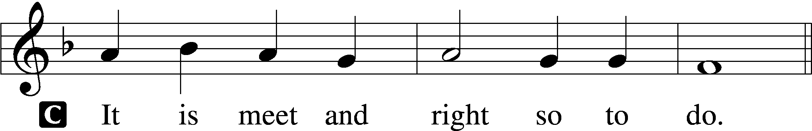

Proper Preface (Abbreviated) LSB 194
P It is truly meet, right, and salutary . . . evermore praising You and saying:

Sanctus Isaiah 6:3; Matthew 21:9
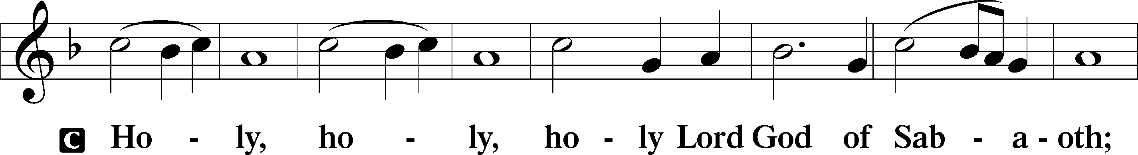
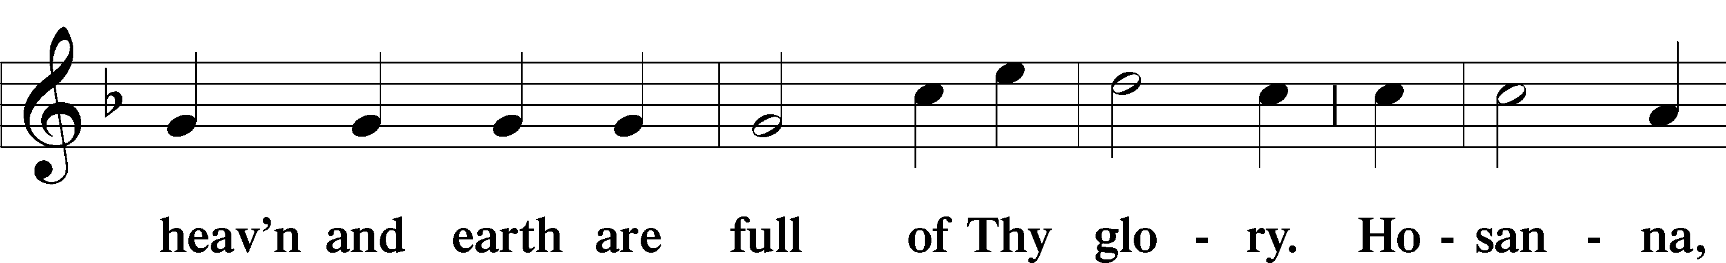
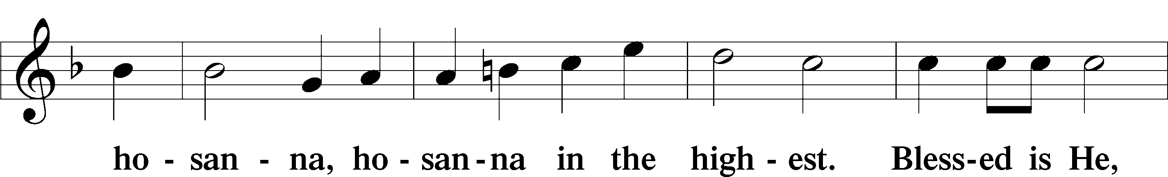
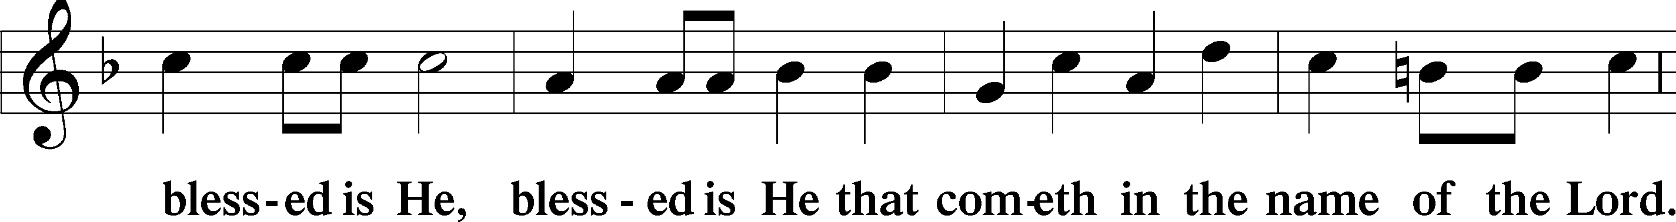
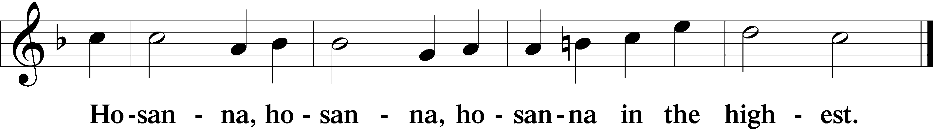

Lord’s Prayer The congregation is encouraged to silently pray the Lord’s Prayer as it is chanted. Matthew 6:9–13
P Our Father who art in heaven,
hallowed be Thy name,
Thy kingdom come,
Thy will be done on earth as it is in heaven;
give us this day our daily bread;
and forgive us our trespasses as we forgive those who trespass against us;
and lead us not into temptation,
but deliver us from evil.
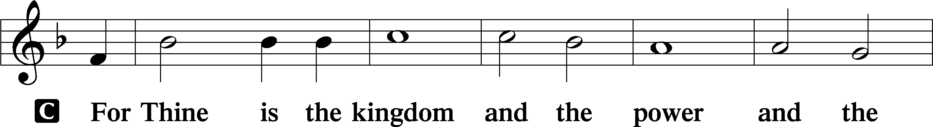
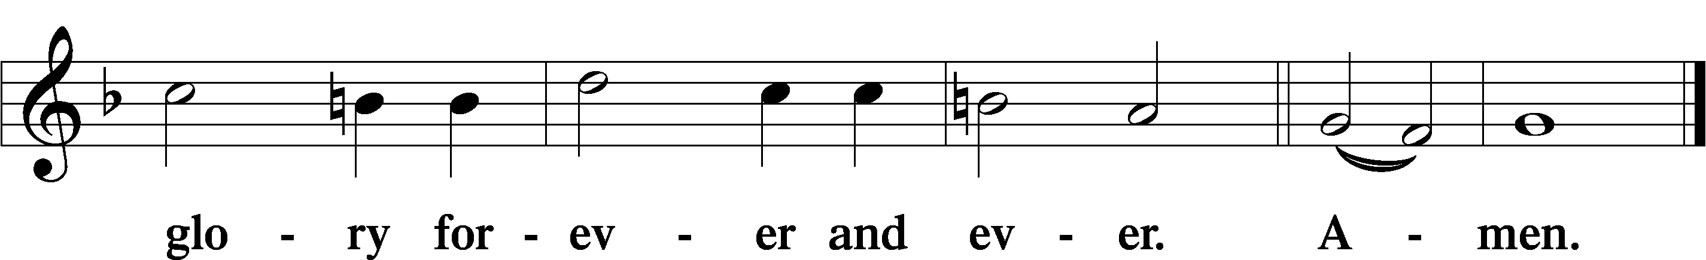

The Words of Our Lord Matthew 26:26–28; Mark 14:22–24; Luke 22:19–20; 1 Corinthians 11:23–25
P Our Lord Jesus Christ, on the night when He was betrayed, took bread, and when He had given thanks, He broke it and gave it to the disciples and said: “Take, eat; this is My T body, which is given for you. This do in remembrance of Me.”

In the same way also He took the cup after supper, and when He had given thanks, He gave it to them, saying: “Drink of it, all of you; this cup is the new testament in My T blood, which is shed for you for the forgiveness of sins. This do, as often as you drink it, in remembrance of Me.”

Pax Domini John 20:19
P The peace of the Lord be with you always.
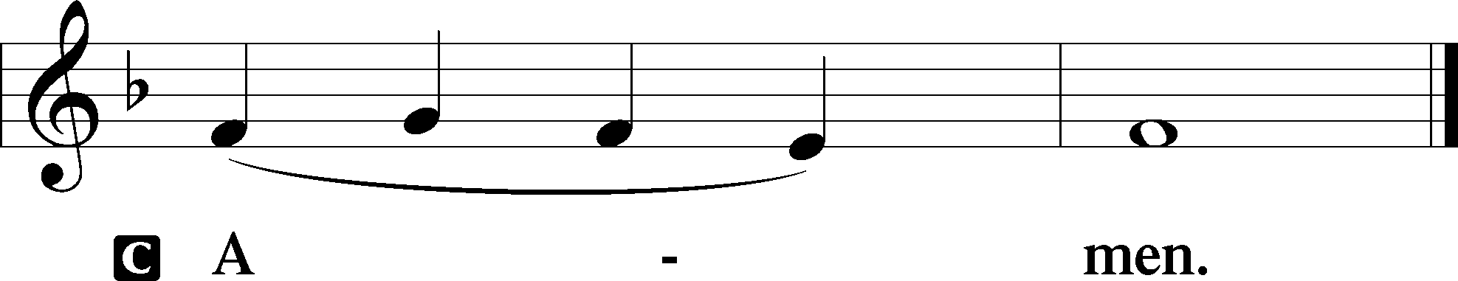

Agnus Dei John 1:29
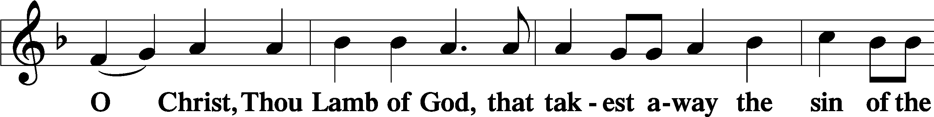
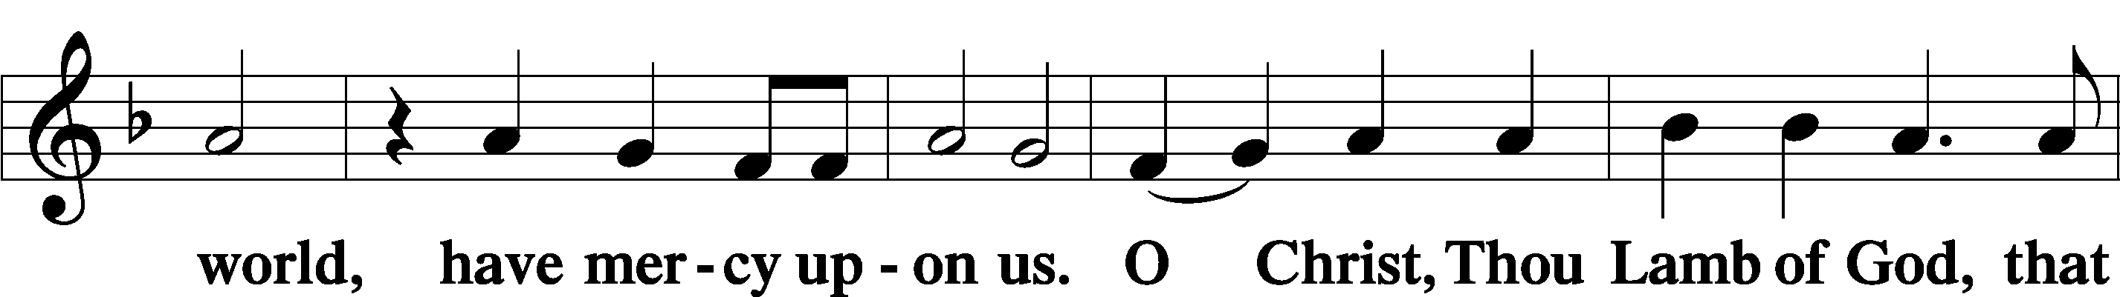
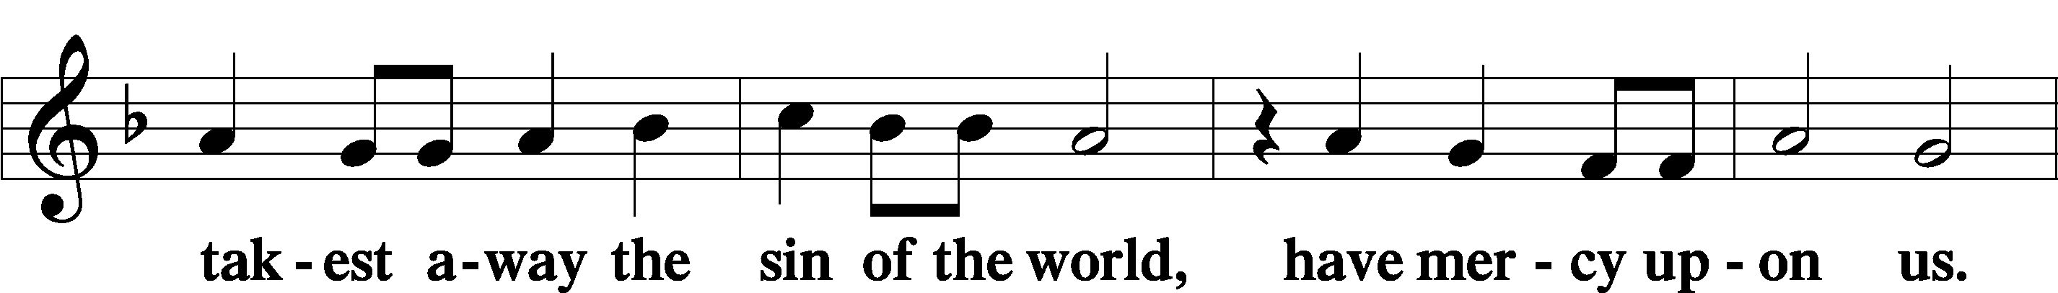
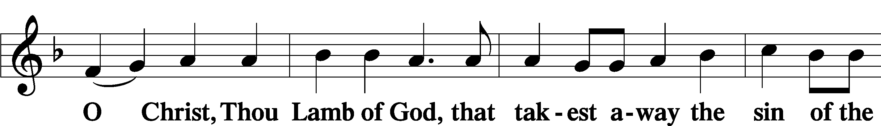
Sit

Distribution
The pastor and those who assist him receive the body and blood of Christ first and then distribute them to those who come to receive, saying:
Take, eat; this is the true body of our Lord and Savior Jesus Christ, given into death for your sins.
Amen.

Take, drink; this is the true blood of our Lord and Savior Jesus Christ, shed for the forgiveness of your sins.
Amen.

In dismissing the communicants, the following is said:
The Dismissal
P The body and blood of our Lord Jesus Christ strengthen and preserve you in body and soul to life everlasting. Depart T in peace.
C Amen.

Distribution Hymn: LSB p. 155 “This Is the Feast”

Distribution Hymn: LSB #463 “Christ the Lord Is Risen Today; Alleluia”

Distribution Hymn: LSB #457 “Jesus Christ Is Risen Today”

Nunc Dimittis Luke 2:29–32
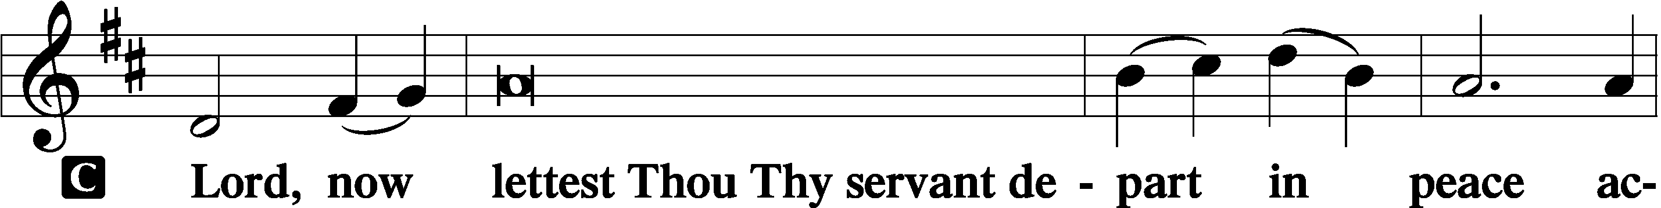
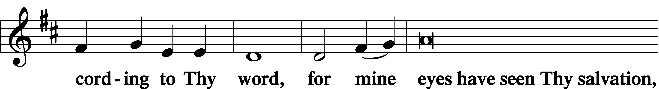
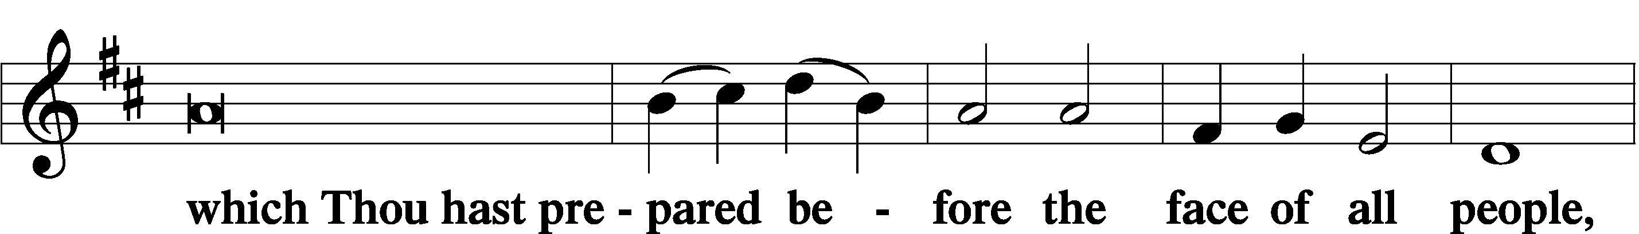
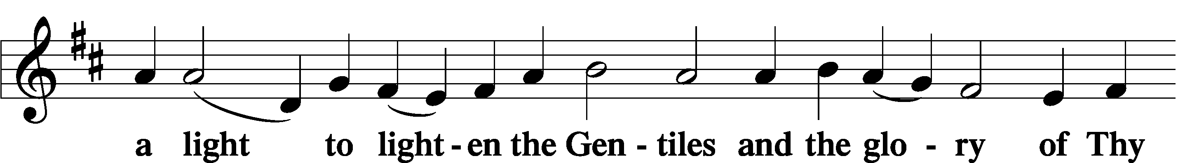
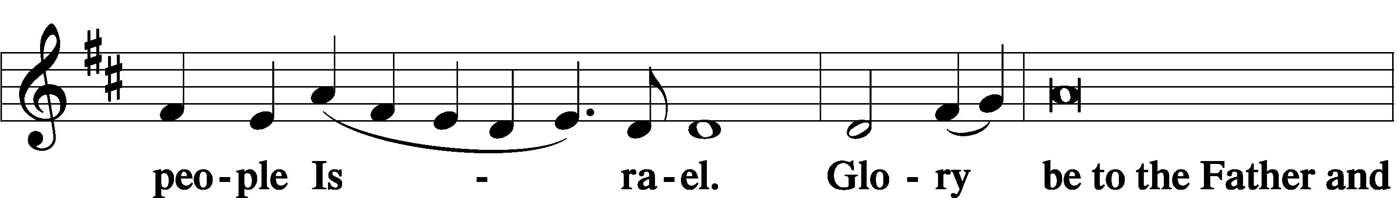
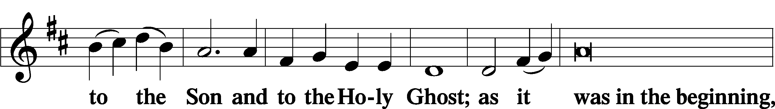
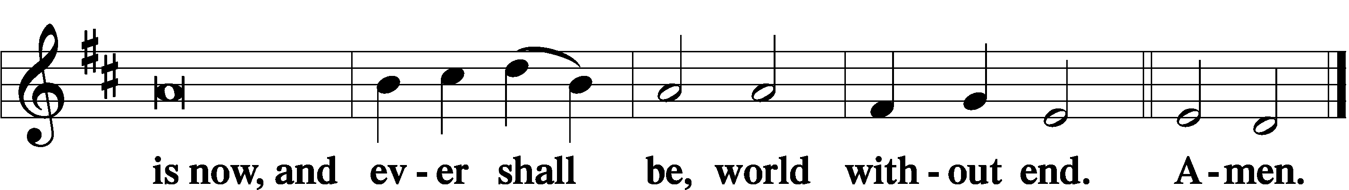

Thanksgiving Psalm 107:1
P O give thanks unto the Lord, for He is good,
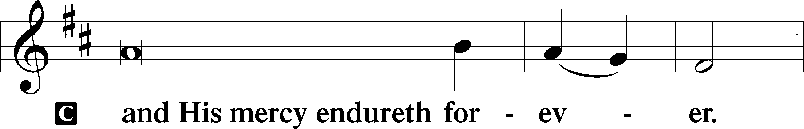

Post-Communion Collect
P Let us pray.
… through Jesus Christ, Your Son, our Lord, who lives and reigns with You and the Holy Spirit, one God, now and forever.
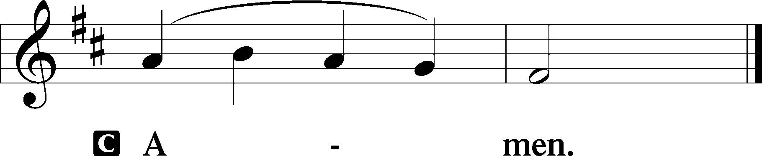

Salutation 2 Timothy 4:22
P The Lord be with you.
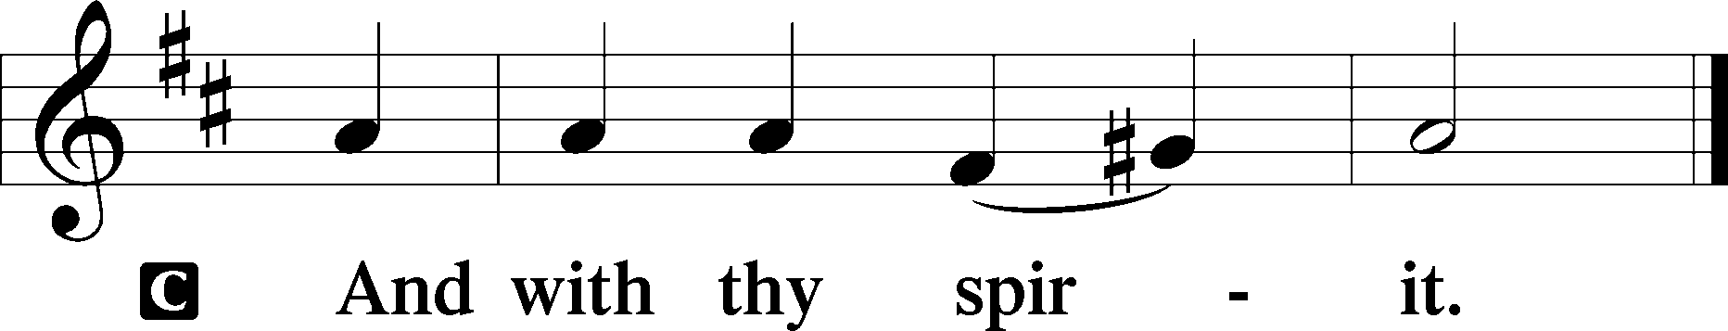

Benedicamus Psalm 103:1
P Bless we the Lord.
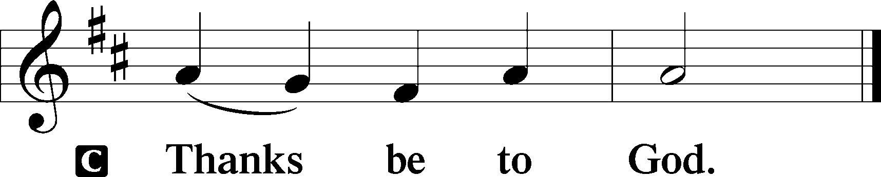

Benediction Numbers 6:24–26
P The Lord bless you and keep you.
The Lord make His face shine upon you and be gracious unto you.
The Lord lift up His countenance upon you and T give you peace.
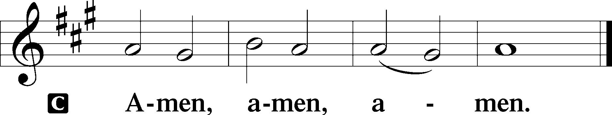

Closing Hymn: LSB #465 “Now All the Vault of Heaven Resounds”

Silent prayer after worship: Lord Jesus, grant me the enduring comfort that You are with me every day and in all circumstances. Fill me with Your Holy Spirit so that I can live joyfully in Your love and share that love with others. Amen.

Acknowledgments
Unless otherwise indicated, Scripture quotations are from the ESV® Bible (The Holy Bible, English Standard Version®), copyright © 2001 by Crossway, a publishing ministry of Good News Publishers. Used by permission. All rights reserved.Created by Lutheran Service Builder © 2024 Concordia Publishing House.

fffffffffffffffffffffffffffffffffff
In Memory of Carolee Grexa’s Birthday, March 31: Dolores Fee (Capital Campaign).
fffffffffffffffffffffffffffffffffff
The Flowering Plants which adorn the Sanctuary this blessed day were generously donated by the following:
Catherine Carr In Loving Memory of Rev. Timothy Carr and In Honor of my
Children and Grandchildren: Eric, Nora, Edven, Ronan, Alex,
Michael, Allie, Levi, & Noel Carr and Pastor, Ana, Isaiah, Titus,
& Loretta Deal (1 Easter lily & 1 daffodil)
Marie Flaugher In Honor of All Who Help with the Church (2 daffodils)
Bonnie Fleissner To the Glory of Our Risen Lord! (1 Easter lily)
Mark Gabriel In Loving Memory of Denny Gabriel and Pete & Anne Gabriel
(1 daffodil)
Judith Furey In Loving Memory of Judith E. Boal, Dorothy Shoenberger, &
Viola Sakony (3 daffodils)
Henrietta Holcroft In Loving Memory of Anson (1 Easter lily)
Elizabeth Loughan In Loving Memory of Bill Loughan and James & Iris Reigelman
(2 Altar Easter lilies)
Chris Nelson In Memory of my Beloved Husband, Barry Nelson; my Parents,
John and Mary Ann Krajci; his Parents, Bill and Marge Nelson;
and All Loved Ones (1 Easter lily)
Diane Riefstahl In Loving Memory of Parents, Donald & Lucile Riefstahl; and
Brother, Donnie (1 daffodil)
Edeltraud Sulek In Loving Memory of Husband, Robert Sulek (1 Easter lily)
Linda Tomko In Loving Memory of Parents, Paul & Lillian Tomko and All
Loved Ones (2 daffodils)
Plants may be taken at the conclusion of this morning’s service.
fffffffffffffffffffffffffffffffffff
THANK YOU FOR SERVING IN MARCH: Elder: Jonathan Baisch; Ushers: Mark Kleindienst, Jerry Krivosh, & Gordon Marquette; Altarware ~ (prior) Marie Flaugher; (after) Cheryl Fedele & Clara Krivosh.
SCHEDULE THROUGH APRIL 7, 2024:

:

Today, 7 pm, Fellowship Hall: AA Meeting
Tuesday, 5:30 pm, All Saints (Slippery Rock): Catechesis
7-9 pm, Fellowship Hall: Penn-Ohio Singers
Wednesday, 10 am, Sanctuary: Matins Service
7 pm, Fellowship Hall: NA Meeting
Thursday, 10 am, Fellowship Hall: Bible Study
Saturday, 11 am - 4 pm, Texas Roadhouse, Niles, OH: Church Fundraiser
Next Sunday, 8 am, Fellowship Hall: Bible Study
9 am, Sanctuary: Divine Service
Following, Fellowship Hall: Finance Committee Meeting
7 pm, Fellowship Hall: AA Meeting
fffffffffffffffffffffffffffffffffff
Bible Memory Verses ~ Week of March 31st:
For Adults: I am the resurrection and the life. Whoever believes in me, though he die, yet shall he live, and everyone who lives and believes in me shall never die.
John 11:25-26a

For Children: I am the living one. I died, and behold I am alive forevermore, and I have the keys of Death and Hades. Revelation 1:18
fffffffffffffffffffffffffffffffffff
Our Stewardship of Treasures for the Lord:
Figure for Wednesday, March 20, 2024
General Fund: $103.00
Figures for Sunday, March 24, 2024
General Fund: $951.00
SELC: $0.00
Capital Campaign: $235.00
YTD Giving/Budget (as of March 17, 2024)
General Fund: $24,847.00 / $29,837.72
SELC: $656.00 / $846.12

For online giving, check out https://www.saintspeterandpaul.net/online-giving.
Remember the following in Prayer…
~The Hurting and Healing: Amy, Ralph, Steve, Mary Jane Anderson, Steve Antolovich, Ellen Baron^{CA}, Don Baxter^{CA}, Amy Blomenberg, Lois Bortner^{CA}, Sara Brubaker and her son, Canaan; Dee Bullock, Bev & Joe Chlpka, Susan Davies, Tim Dudash, Mike Flaugher, Judith & Eddy Furey, Griffin, Pastor Charles Henrickson, Joan, Keith Jozwiakowski, Bob Kozar, Darla Krajci, Barbara Kreske, Jess Lavoie, Paul Lucas^{CA}, Sandy Marshall, Drew Martz, Augusta Mennell, Lynn Price, Juanita Rentschler, Richard Reuning^{CA}, Nancy Robertson^{CA}, Kriss Svidro^{CA}, Rudy Tomko, Bob Usnarski, Joel & Peggy Wasson, Angela Weser^{CA}, and Ruth Wolf.
~The Homebound: Anna Mae Daris, Millie Elavsky, Jean Tomko, Betty Wolf, and Ed & Millie Zachar.
~Celebrating: Birthdays: Dillon Hamilton (04.02) & Patty Parker (04.03).
~Serving in the Military: Alex (Sasha) Carr, Duncan Vaupel, Curtis Sinewe, and Joshua Solyan.
~Community & World Needs: Those suffering due to the conflicts in the Middle East and between Ukraine and Russia; those suffering from loss and dislocation because weather disasters; those suffering from addiction and their families; Local, State, and National Government Leaders; safety for all Police Officers, Firefighters, & First Responders; the unemployed; our First Quarter Local Mission: Community Outreach. *CA represents cancer.
fffffffffffffffffffffffffffffffffff
Attendance: Sun., March 24, 2024: 35
Mon., March 25, 2024: 6 Tues., March 26, 2024: 3
Wed., March 27, 2024: 4 Thurs., March 28, 2024: 24
Fri., March, 29, 2024 (Stations of the Cross): 4; Fri., March 29, 2024 (Tre Ore): 16
Fri., March 29, 2024 (Tenebrae Service): 15
fffffffffffffffffffffffffffffffffff
THANK YOU FOR SERVING IN APRIL: Elder: Jonathan Baisch; Ushers: Cheryl Fedele, Mike Flaugher, & Jesse Riffle. Altarware ~ (prior) Elizabeth Haenftling (04.07), Marie Flaugher (04.14), & Diane Riefstahl (04.21 & 04.28); (after) Evelyn Baisch & Traudi Sulek.
fffffffffffffffffffffffffffffffffff

