Sts. Peter & Paul
Evangelical Lutheran Church
Lutheran Church-Missouri Synod
Founded-1917
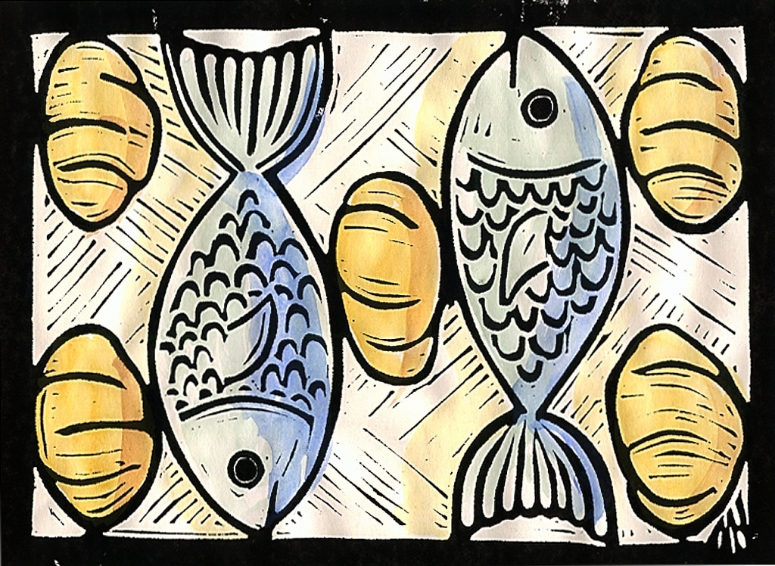

MARCH 31, 2019

699 Stambaugh Avenue
Sharon, Pennsylvania 16146

“I was glad when they said to me,
Let us go to the house of the LORD!”
Psalm 122:1
Sts. Peter & Paul Evangelical Lutheran Church, LC-MS

LAETARE: THE FOURTH SUNDAY IN LENT
March 31, 2019

Silent prayer before worship: Gracious God, send Your Holy Spirit to work through Your word within my heart to give me new life and to grant me the assurance of forgiveness, life and salvation through Jesus Christ. Amen.

Please read Communion Statement found in pews prior to taking part in Holy Communion.
CONFESSION AND ABSOLUTION
Opening Hymn: LSB #897 “O Rejoice, Ye Christians, Loudly”
Stand
The sign of the cross may be made by all in remembrance of their Baptism.

P In the name of the Father and of the T Son and of the Holy Spirit.
C Amen. Matthew 28: 19b; [18:20]

P If we say we have no sin, we deceive ourselves, and the truth is not in us.
C But if we confess our sins, God, who is faithful and just, will forgive our sins and cleanse us from all unrighteousness.

Silence for reflection on God's Word and for self-examination.

P Let us then confess our sins to God our Father.
C Most merciful God, we confess that we are by nature sinful and unclean. We have sinned against You in thought, word, and deed, by what we have done and by what we have left undone. We have not loved You with our whole heart; we have not loved our neighbors as ourselves. We justly deserve Your present and eternal punishment. For the sake of Your Son, Jesus Christ, have mercy on us. Forgive us, renew us, and lead us, so that we may delight in Your will and walk in Your ways to the glory of Your holy name. Amen.
P Almighty God in His mercy has given His Son to die for you and for His sake forgives you all your sins. As a called and ordained servant of Christ, and by His authority, I therefore forgive you all your sins in the name of the Father and of the T Son and of the Holy Spirit. [John 20: 19-23]
C Amen.

Passing of the Peace.
SERVICE OF THE WORD
Introit: Ps. 122:1–2, 6, 8; antiphon: Is. 66:10a, 11a
P Rejoice with Jerusalem, and be | glad for her,*
all you who | love her;
that you may nurse and be | satisfied*
from her con- | soling breast.
I was glad when they | said to me,*
“Let us go to the house | of the Lord!”
Our feet have been | standing*
within your gates, O Je- | rusalem!
Pray for the peace of Je- | rusalem!*
May they be secure who | love you!
For my brothers and com- | panions’ sake*
I will say, “Peace be with- | in you!”
C Glory be to the Father and | to the Son*
and to the Holy | Spirit;
as it was in the be- | ginning,*
is now, and will be forever. | Amen.
Rejoice with Jerusalem, and be | glad for her,*
all you who | love her;
that you may nurse and be | satisfied*
from her con- | soling breast.

Kyrie Mark 10:47
P In peace let us pray to the Lord.
C Lord, have mercy.
P For the peace from above and for our salvation let us pray to the Lord.
C Lord, have mercy.
P For the peace of the whole world, for the well-being of the Church of God, and for the unity of all let us pray to the Lord.
C Lord, have mercy.
P For this holy house and for all who offer here their worship and praise let us pray to the Lord.
C Lord, have mercy.
P Help, save, comfort, and defend us, gracious Lord.
C Amen.

Salutation and Collect of the Day
P The Lord be with you. 2 Timothy 4: 22
C And also with you.

P Let us pray.
Almighty God, our heavenly Father, Your mercies are new every morning; and though we deserve only punishment, You receive us as Your children and provide for all our needs of body and soul. Grant that we may heartily acknowledge Your merciful goodness, give thanks for all Your benefits, and serve You in willing obedience; through Jesus Christ, Your Son, our Lord, who lives and reigns with You and the Holy Spirit, one God, now and forever.

C Amen.

Sit

Old Testament Reading: Exodus 16:2–21
And the whole congregation of the people of Israel grumbled against Moses and Aaron in the wilderness, and the people of Israel said to them, “Would that we had died by the hand of the Lord in the land of Egypt, when we sat by the meat pots and ate bread to the full, for you have brought us out into this wilderness to kill this whole assembly with hunger.”
Then the Lord said to Moses, “Behold, I am about to rain bread from heaven for you, and the people shall go out and gather a day’s portion every day, that I may test them, whether they will walk in my law or not. On the sixth day, when they prepare what they bring in, it will be twice as much as they gather daily.” So Moses and Aaron said to all the people of Israel, “At evening you shall know that it was the Lord who brought you out of the land of Egypt, and in the morning you shall see the glory of the Lord, because he has heard your grumbling against the Lord. For what are we, that you grumble against us?” And Moses said, “When the Lord gives you in the evening meat to eat and in the morning bread to the full, because the Lord has heard your grumbling that you grumble against him—what are we? Your grumbling is not against us but against the Lord.”
Then Moses said to Aaron, “Say to the whole congregation of the people of Israel, ‘Come near before the Lord, for he has heard your grumbling.’” And as soon as Aaron spoke to the whole congregation of the people of Israel, they looked toward the wilderness, and behold, the glory of the Lord appeared in the cloud. And the Lord said to Moses, “I have heard the grumbling of the people of Israel. Say to them, ‘At twilight you shall eat meat, and in the morning you shall be filled with bread. Then you shall know that I am the Lord your God.’”
In the evening quail came up and covered the camp, and in the morning dew lay around the camp. And when the dew had gone up, there was on the face of the wilderness a fine, flake-like thing, fine as frost on the ground. When the people of Israel saw it, they said to one another, “What is it?” For they did not know what it was. And Moses said to them, “It is the bread that the Lord has given you to eat. This is what the Lord has commanded: ‘Gather of it, each one of you, as much as he can eat. You shall each take an omer, according to the number of the persons that each of you has in his tent.’” And the people of Israel did so. They gathered, some more, some less. But when they measured it with an omer, whoever gathered much had nothing left over, and whoever gathered little had no lack. Each of them gathered as much as he could eat. And Moses said to them, “Let no one leave any of it over till the morning.” But they did not listen to Moses. Some left part of it till the morning, and it bred worms and stank. And Moses was angry with them. Morning by morning they gathered it, each as much as he could eat; but when the sun grew hot, it melted.

P This is the Word of the Lord.
C Thanks be to God.

Gradual: Ps. 122:1, 7
I was glad when they said to me,
“Let us go to the house of the Lord!”
Peace be within your walls
and security within your towers!

Epistle: Galatians 4:21–31
Tell me, you who desire to be under the law, do you not listen to the law? For it is written that Abraham had two sons, one by a slave woman and one by a free woman. But the son of the slave was born according to the flesh, while the son of the free woman was born through promise. Now this may be interpreted allegorically: these women are two covenants. One is from Mount Sinai, bearing children for slavery; she is Hagar. Now Hagar is Mount Sinai in Arabia; she corresponds to the present Jerusalem, for she is in slavery with her children. But the Jerusalem above is free, and she is our mother. For it is written,
“Rejoice, O barren one who does not bear;
break forth and cry aloud, you who are not in labor!
For the children of the desolate one will be more
than those of the one who has a husband.”
Now you, brothers, like Isaac, are children of promise. But just as at that time he who was born according to the flesh persecuted him who was born according to the Spirit, so also it is now. But what does the Scripture say? “Cast out the slave woman and her son, for the son of the slave woman shall not inherit with the son of the free woman.” So, brothers, we are not children of the slave but of the free woman.

P This is the Word of the Lord.
C Thanks be to God.

Choir: “Amazing Love”

Tract: Ps. 125:1–2, 5b
Those who trust in the Lord are like Mount Zion,
which cannot be moved, but abides forever.
As the mountains surround Jerusalem, so the Lord surrounds his people,
from this time forth and forevermore. Peace be upon Israel!

Stand
Holy Gospel: John 6:1–15
P The Holy Gospel according to St. John, the sixth chapter.
C Glory to You, O Lord.

After this Jesus went away to the other side of the Sea of Galilee, which is the Sea of Tiberias. And a large crowd was following him, because they saw the signs that he was doing on the sick. Jesus went up on the mountain, and there he sat down with his disciples. Now the Passover, the feast of the Jews, was at hand. Lifting up his eyes, then, and seeing that a large crowd was coming toward him, Jesus said to Philip, “Where are we to buy bread, so that these people may eat?” He said this to test him, for he himself knew what he would do. Philip answered him, “Two hundred denarii would not buy enough bread for each of them to get a little.” One of his disciples, Andrew, Simon Peter’s brother, said to him, “There is a boy here who has five barley loaves and two fish, but what are they for so many?” Jesus said, “Have the people sit down.” Now there was much grass in the place. So the men sat down, about five thousand in number. Jesus then took the loaves, and when he had given thanks, he distributed them to those who were seated. So also the fish, as much as they wanted. And when they had eaten their fill, he told his disciples, “Gather up the leftover fragments, that nothing may be lost.” So they gathered them up and filled twelve baskets with fragments from the five barley loaves, left by those who had eaten. When the people saw the sign that he had done, they said, “This is indeed the Prophet who is to come into the world!”
Perceiving then that they were about to come and take him by force to make him king, Jesus withdrew again to the mountain by himself.

P This is the Gospel of the Lord.
C Praise to You, O Christ.

Nicene Creed
C I believe in one God,
the Father Almighty,
maker of heaven and earth
and of all things visible and invisible.
And in one Lord Jesus Christ,
the only-begotten Son of God,
begotten of His Father before all worlds,
God of God, Light of Light,
very God of very God,
begotten, not made,
being of one substance with the Father,
by whom all things were made;
who for us men and for our salvation came down from heaven
and was incarnate by the Holy Spirit of the virgin Mary
and was made man;
and was crucified also for us under Pontius Pilate.
He suffered and was buried.
And the third day He rose again according to the Scriptures
and ascended into heaven
and sits at the right hand of the Father.
And He will come again with glory to judge both the living and the dead,
whose kingdom will have no end.
And I believe in the Holy Spirit,
the Lord and giver of life,
who proceeds from the Father and the Son,
who with the Father and the Son together is worshiped and glorified,
who spoke by the prophets.
And I believe in one holy Christian and apostolic Church,
I acknowledge one Baptism for the remission of sins,
and I look for the resurrection of the dead
and the life T of the world to come. Amen.
Sit

Hymn of the Day: LSB #743 “Jesus, Priceless Treasure”

Sermon
Stand

Prayer of the Church [Timothy 2: 1-4]

Sit

Offertory Psalm 116: 12-13, 17-19
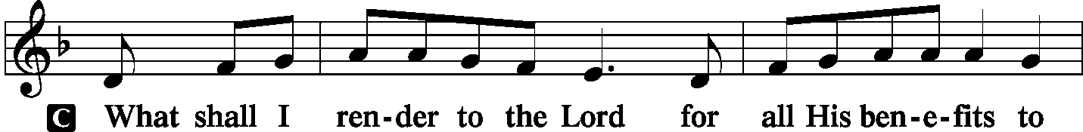
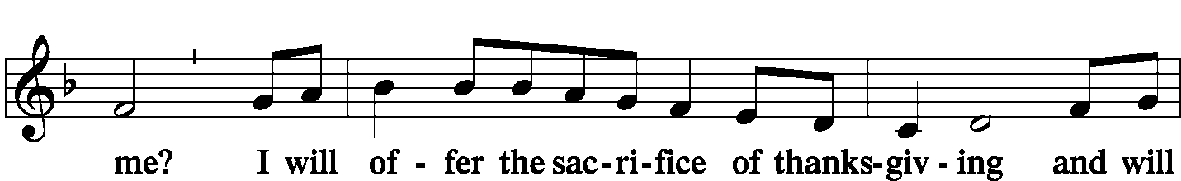
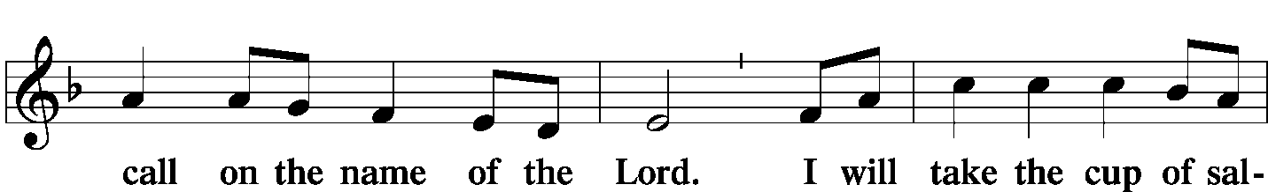
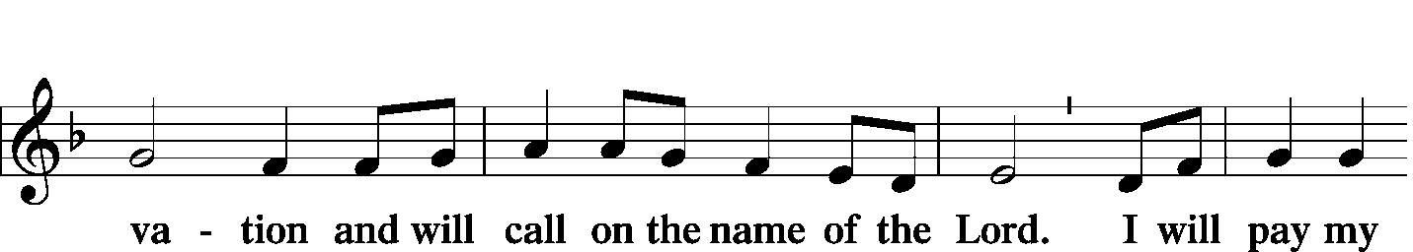
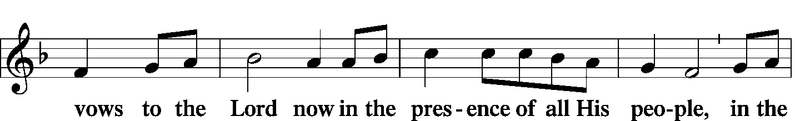
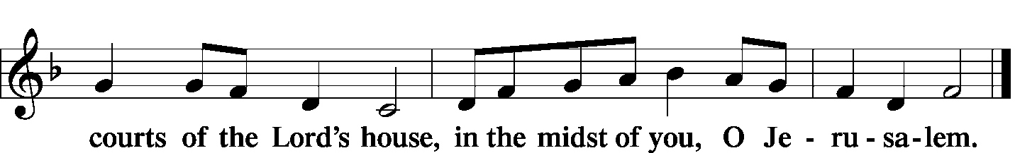

Offering
Stand
SERVICE OF THE SACRAMENT
Preface
P The Lord be with you. 2 Timothy 4: 22
C And also with you.
P Lift up your hearts. [Colossians 3: 1]
C We lift them to the Lord.
P Let us give thanks to the Lord our God. [Psalm 136]
C It is right to give Him thanks and praise.

P It is truly meet, right, and salutary … evermore praising You and saying:

Sanctus Isaiah 6: 3; Matthew 21: 9
C Holy, holy, holy Lord, God of pow'r and might:
Heaven and earth are full of your glory.
Hosanna. Hosanna.
Hosanna in the highest.
Blessed is He who comes in the name of the Lord.
Hosanna in the highest.

Lord's Prayer Matthew 6: 9-13
P Lord, remember us in Your kingdom and teach us to pray:
C Our Father who art in heaven,
hallowed be Thy name,
Thy kingdom come,
Thy will be done on earth as it is in heaven;
give us this day our daily bread;
and forgive us our trespasses as we forgive those who trespass against us;
and lead us not into temptation,
but deliver us from evil.
For Thine is the kingdom and the power and the glory forever and ever. Amen.

The Words of Our Lord Matthew 26: 26-28; Mark 14: 22-24
Luke 22: 19-20; 1 Corinthians 11: 23-25
P Our Lord Jesus Christ, on the night when He was betrayed, took bread, and when He had given thanks, He broke it and gave it to the disciples and said: “Take, eat; this is My T body, which is given for you. This do in remembrance of Me.”

P In the same way also He took the cup after supper, and when He had given thanks, He gave it to them, saying: “Drink of it, all of you; this cup is the new testament in My T blood, which is shed for you for the forgiveness of sins. This do, as often as you drink it, in remembrance of Me.”

Pax Domini John 20: 19
P The peace of the Lord be with you always.
C Amen.

Agnus Dei John 1: 29
C Lamb of God, You take away the sin of the world; have mercy on us.
Lamb of God, You take away the sin of the world; have mercy on us.
Lamb of God, You take away the sin of the world; grant us peace.

Sit

Distribution
The pastor and those who assist him receive the body and blood of Christ first and then distribute them to those who come to receive, saying:

Take, eat; this is the true body of our Lord and Savior Jesus Christ, given into death for your sins.
Amen.

Take, drink; this is the true blood of our Lord and Savior Jesus Christ, shed for the forgiveness of your sins.
Amen.
In dismissing the communicants, the following is said:
P The body and blood of our Lord Jesus Christ strengthen and preserve you in body and soul to life everlasting. Depart T in peace.
C Amen.

Distribution Hymn: LSB #556 “Dear Christians, One and All, Rejoice” vv. 1, 3–5, 7–8
Stand

Nunc Dimitti
C Lord, now You let Your servant go in peace; Your word has been fulfilled.
My own eyes have seen the salvation which You have prepared in the sight of ev'ry people:
A light to reveal You to the nations and the glory of Your people Israel.
Glory be to the Father and to the Son and to the Holy Spirit;
as it was in the beginning, is now, and will be forever. Amen.

Post-Communion Collect Let us pray.
P We give thanks to You, almighty God, that You have refreshed us through this salutary gift, and we implore You that of Your mercy You would strengthen us through the same in faith toward You and fervent love toward one another; through Jesus Christ, Your Son, our Lord, who lives and reigns with You and the Holy Spirit, one God, now and forever.
C Amen.

Benediction Numbers 6: 24-26

P The Lord bless you and keep you.
The Lord make His face shine on you
and be gracious to you.
The Lord look upon you with favor and T give you peace.
C Amen.

Closing Hymn: LSB #737 “Rejoice, My Heart, Be Glad and Sing”

Silent prayer after worship: O Heavenly Father, You have entrusted me with a priceless inheritance: the Gospel of Christ. Give me faith to believe the Gospel and boldness to share it with others. In Jesus’ name. Amen.

Acknowledgments: Divine Service, Setting One from Lutheran Service Book Unless otherwise indicated, all scripture quotations are from The Holy Bible, English Standard Version, copyright © 2001 by Crossway Bibles, a division of Good News Publishers. Used by permission. All rights reserved. Created by Lutheran Service Builder © 2006 Concordia Publishing House. CCLI License #3029-446

The Altar Flowers this morning are given anonymously to the Glory of God. We sincerely appreciate this generous gift.

Attendance:
Sunday, March 24, 2019………………...……………………………………………45
Wednesday, March 27, 2019 (evening, only)………………………………………19

Spring Flowering Plants order forms and payments for Easter Sunday are due to Diane next Sunday, April 7th.

Members and guests are asked to sign the “Friendship” books found at the inside aisle of your pews. Ushers will collect signed sheets after the offering.

SCHEDULE FOR TODAY THROUGH APR. 7th:
:

:

Today, 7 pm, Downstairs….…………….…………………..…………..…………..……AA Meeting
Wednesday, noon & 7 pm, Sanctuary…….………………………..Midweek Lenten Service
5:30 pm, Sanctuary…………………….………………………………………...Choir Practice
Thursday, 8 pm, TBD………………………………….………………..Young Adult Bible Study
Next Sunday, 8:45 am, Downstairs…………………..………………………………….Bible Study
10 am, Sanctuary…......................................................................Divine Service
7 pm, Downstairs………………………………………………………..…....……AA Meeting

Our Stewardship of Treasures for the Lord:
In order to do the Lord’s work, we need $2,882.02* each week to meet our 2019 budget for general purposes and $38.46 for missions.
Sunday, March 24, 2018:
General Offering:…..…..……….............................................................$1,175.00
Behind this week*#: -$1,512.02
SELC Missions:……….………..…..…….......................................................$10.00 Behind this week#: -$23.46
Quarterly Local Mission:……………………………………………………...…..$0.00
Preschool Tuition Payments:...…………………...................................…......$0.00
Other Offerings:………….…….…….....................………..……..…………....$1.00
Wednesday, March 20, 2018:
General Offering:…..…..………................................................................$195.00
SELC Missions:……….………..…..…….........................................................$5.00
Quarterly Local Mission:………………………………………………………..…$0.00
Preschool Tuition Payments:...………………….................................…….....$0.00
Other Offerings:………….…….…….....................………..……..……..…..$770.00
*Includes preschool tuition; #Includes Wednesday’s figures.

Available in the narthex:
- Greeters’ schedules for April, May, and June.
- Portals of Prayer for April, May, and June.
- Minutes from the March 24th Community Day organizational meeting.
- The April issues of “The Rock and the Sword” newsletter and “The Lutheran Beacon”.
Remember the following in Prayer…
~The Hurting and Healing: Tony¹, Lois Bortner^{CA}, Richard Brandes⁴, Eileen Burns⁴, Mark Chirdon¹, Loretta Deal¹, Norma Ferringer⁴, Anson Holcroft¹, Betty Knauff^{CA}, Regis Knauff¹, Jess Lavoie³, Paul Lucas^{CA}, Barry Nelson¹, David Nelson²,Tom Mulligan^{CA}, Iona Oltman^{CA}, Rudy Pinal^{CA}, Richard Reuning^{CA}, Katie Sass ², and Angela Weser^{CA}.
~Celebrating: Birthdays: Dillon Hamilton (04.02), Patricia Parker (04.03).
~Our Homebound: Helen Bender, Dan Davis, Edna Krajci, Mary Ann Krajci, Sophie Mihm, Marion & Gene Roberts, Barbara Vasconi, and Joanne Wolfe.
~Serving in the Military: Clayton Drnek, Curtis Sinewe, and Joshua Solyan.
~Community & World Needs: Victims of violence and terrorism; those suffering from loss and dislocation because weather disasters; those suffering from addiction and their families; safety for teachers, staff, and students; Local, State, and National Government Leaders; Safety for all Police Officers, Firefighters, & First Responders; the unemployed; our First Quarter Local Mission: Shenango Valley Meals on Wheels.
*CA represents cancer; number after other names represents weeks on the prayer list. After 4 weeks names may be resubmitted. This helps us to remember people’s specific needs and reminds us that God is providing healing as people get better and no longer need our prayers. Please submit prayer requests in writing to the church office.
Please keep those listed above in your prayers.

Bible Memory Verses: For the week of March 31st:
For Children: Unless a grain of wheat falls into the earth and dies, it remains alone; but if it dies, it bears much fruit. John 12:24
For Adults: My son, keep your father's commandment, and forsake not your mother's teaching. Listen to your father who gave you life, and do not despise your mother when she is old. Proverbs 6:20; 23:22

Thank You for Serving in March:
Today’s Greeters: Anna Mae Daris & Millie Elavsky. Assisting Elders: Bob Sulek & Barry Nelson. Ushers: Bob Sulek, Hugh Owen, Cheryl Fedele, Jesse Riffle, & Ralph Dorman (alternate). Altarware: Hank Holcroft & Kati Laird.

Thank You for Serving in April:
Assisting Elders: John Dyll & Bob Sulek. Ushers: John Dyll, Barry Nelson, Jerome Thomas, Gary Burns, & Bob Sulek (alternate). Altarware: Anne Colt & Joani Rice. April Greeters: 7~John Dyll & Mark Gabriel; 14 ~ Rev. Ed & Irene Kucera; 20 ~ (Sat., 7 pm) Dolores Fee & Diane Riefstahl; 21 ~ Anna Mae Daris & Millie Elavsky; 28 ~ Cheryl Fedele & Clara Krivosh.
Here to Serve…

Pastor………………………………………………….………..…Rev. Jacob Deal
E-mail ……….…………………….…..pastordeal@saintspeterandpaul.net
Phone Number…………..……………………………724-347-3620 (Option 2)
Church Office………………………………….………724-347-3620 (Option 3)
Website ……….………………….……...…….www.saintspeterandpaul.net
Secretary………………………………………………….……. Diane Riefstahl
E-mail ……….…………………….…….…church@saintspeterandpaul.net
Food Pantry: John Dyll…………….……………………..…..…724-347-1779
Little People Preschool…………….……………….724-347-3620 (Option 4)
Teacher: Paula Ostheimer………….………………….…….....724-981-5846
Email ……….………….…………………….paula@saintspeterandpaul.net
AA Contact: Steve……………………….…………..……...……. 724-813-2358
Organist……………………………………………………..…Carrie Yasnowski
Choir Director……………..…………….…………..….….………Chris Nelson
Congregation President…………………………………………Jeff Brandes

The secretary’s office hours will be Mondays (8:30-4:30) and Wednesdays (8:30-5:30). Pastor Deal will be in the office Monday through Thursday unless ministering off-site. If you need to enter the Church, please call ahead to be sure someone is here to let you in. Thank you.


