Sts. Peter & Paul
Evangelical Lutheran Church
Lutheran Church-Missouri Synod
Founded-1917
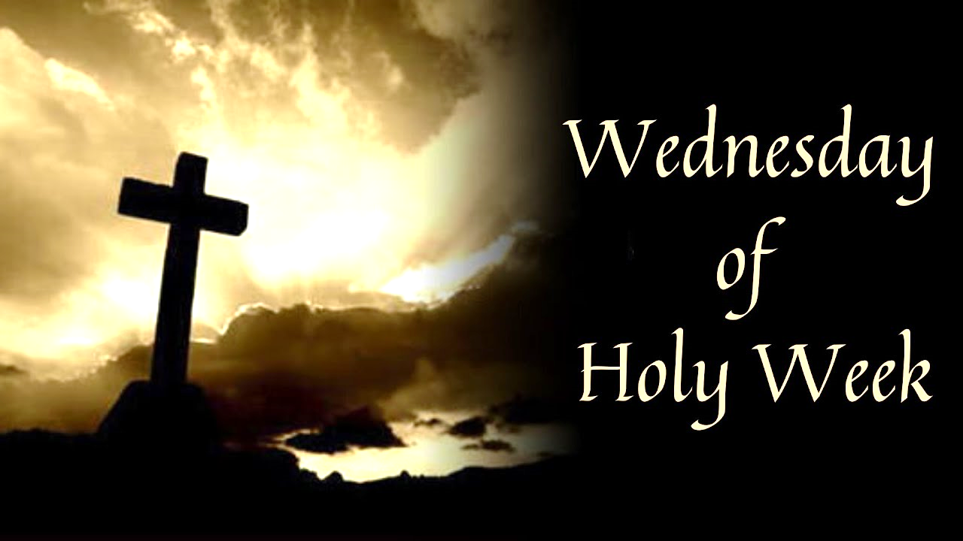

699 Stambaugh Avenue
Sharon, Pennsylvania 16146

HOLY WEDNESDAY
March 27, 2024

“I was glad when they said to me,
Let us go to the house of the LORD!”
Psalm 122:1
Sts. Peter & Paul Evangelical Lutheran Church, LC-MS
HOLY WEDNESDAY
March 27, 2024

Stand

Psalmody

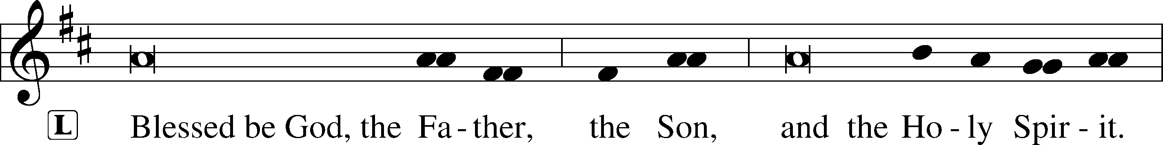

Venite LSB 220
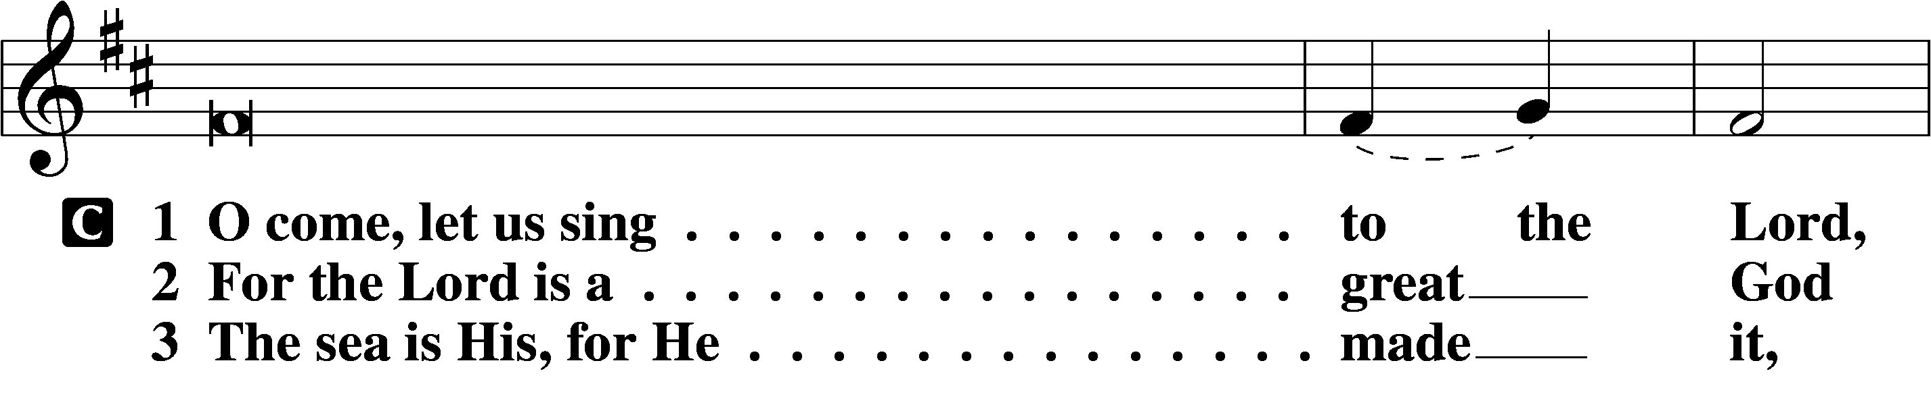
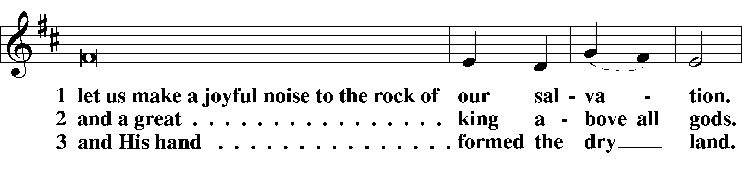
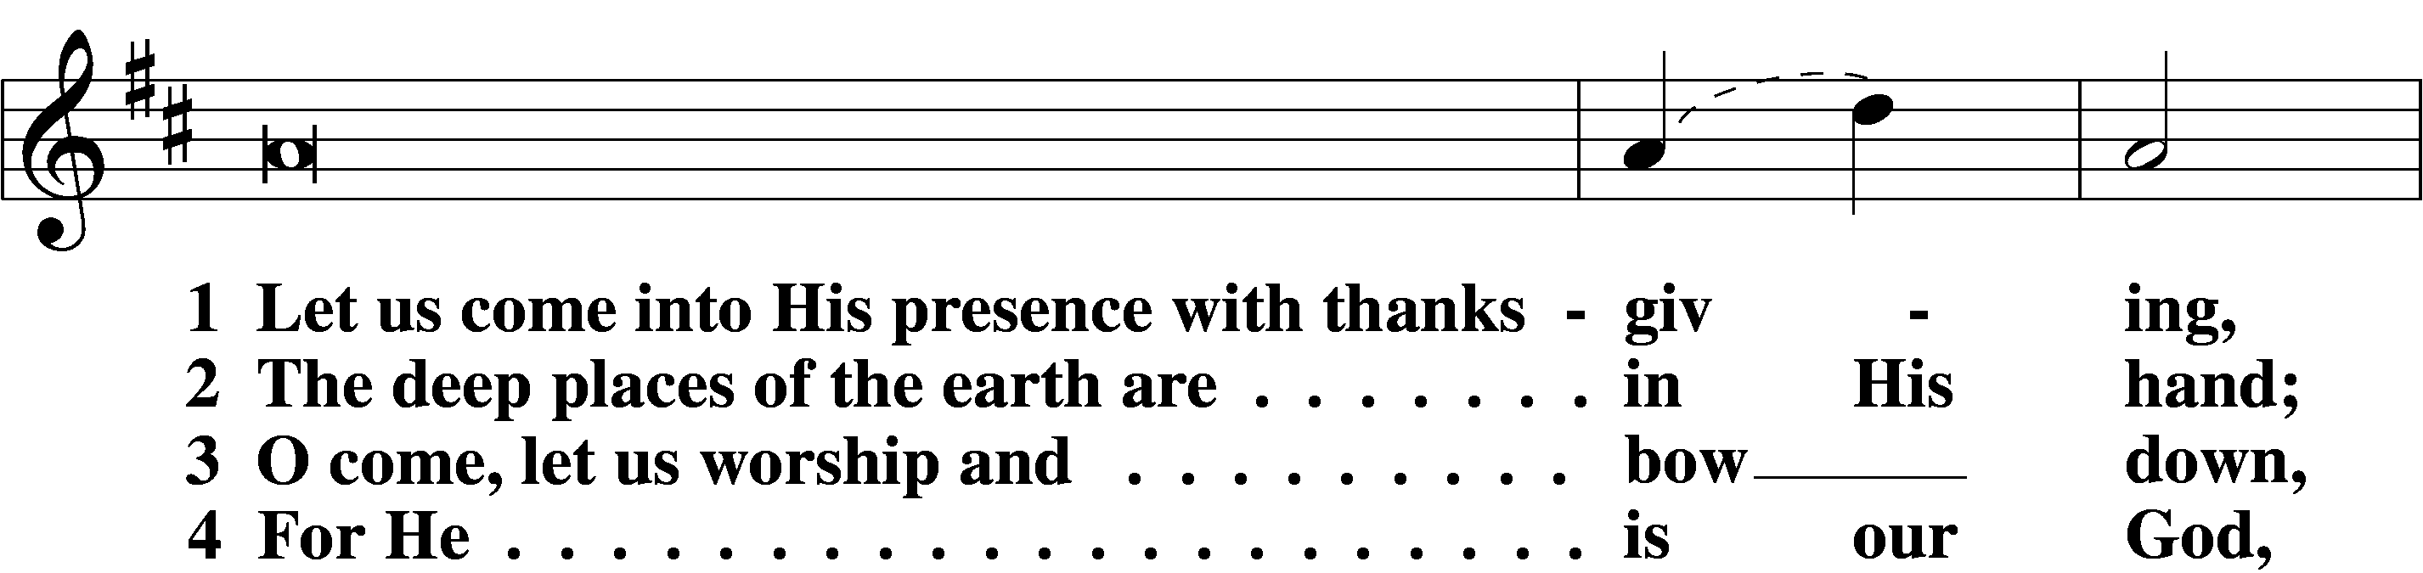
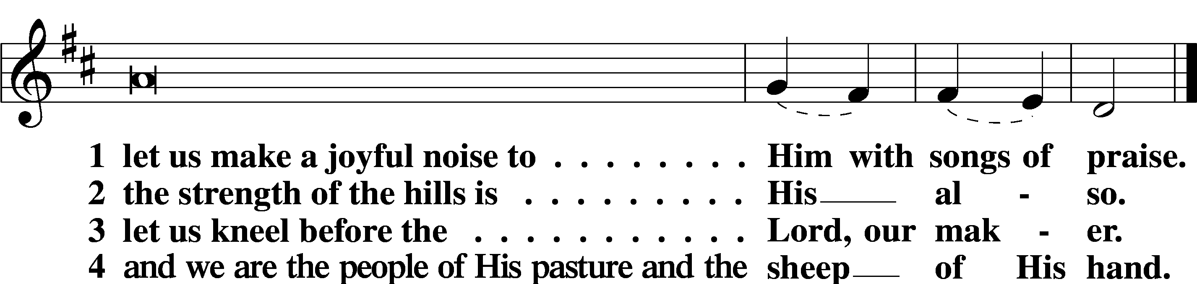

Psalm: Psalm 70; antiphon: v. 5
Make haste, O God, to deliver me!
O Lord, make haste to help me!
Let them be put to shame and confusion
who seek my life!
Let them be turned back and brought to dishonor
who desire my hurt!
Let them turn back because of their shame
who say, “Aha, Aha!”
May all who seek you
rejoice and be glad in you!
May those who love your salvation
say evermore, “God is great!”
But I am poor and needy;
hasten to me, O God!
You are my help and my deliverer;
O Lord, do not delay!
Sit

Office Hymn: LSB #451 “Stricken, Smitten, and Afflicted”
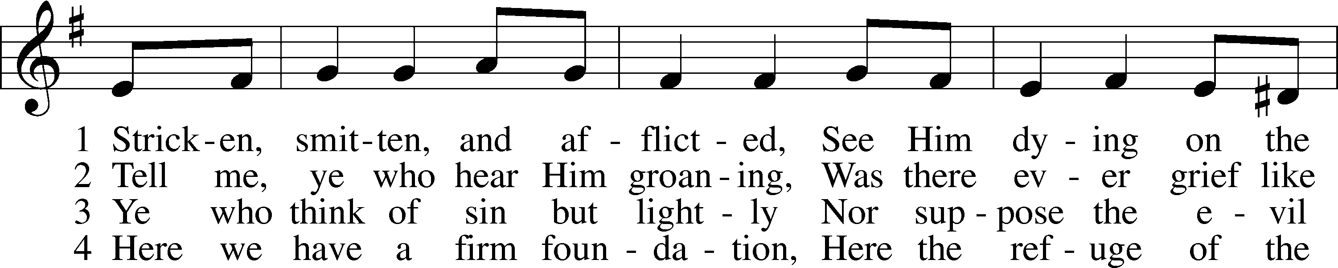
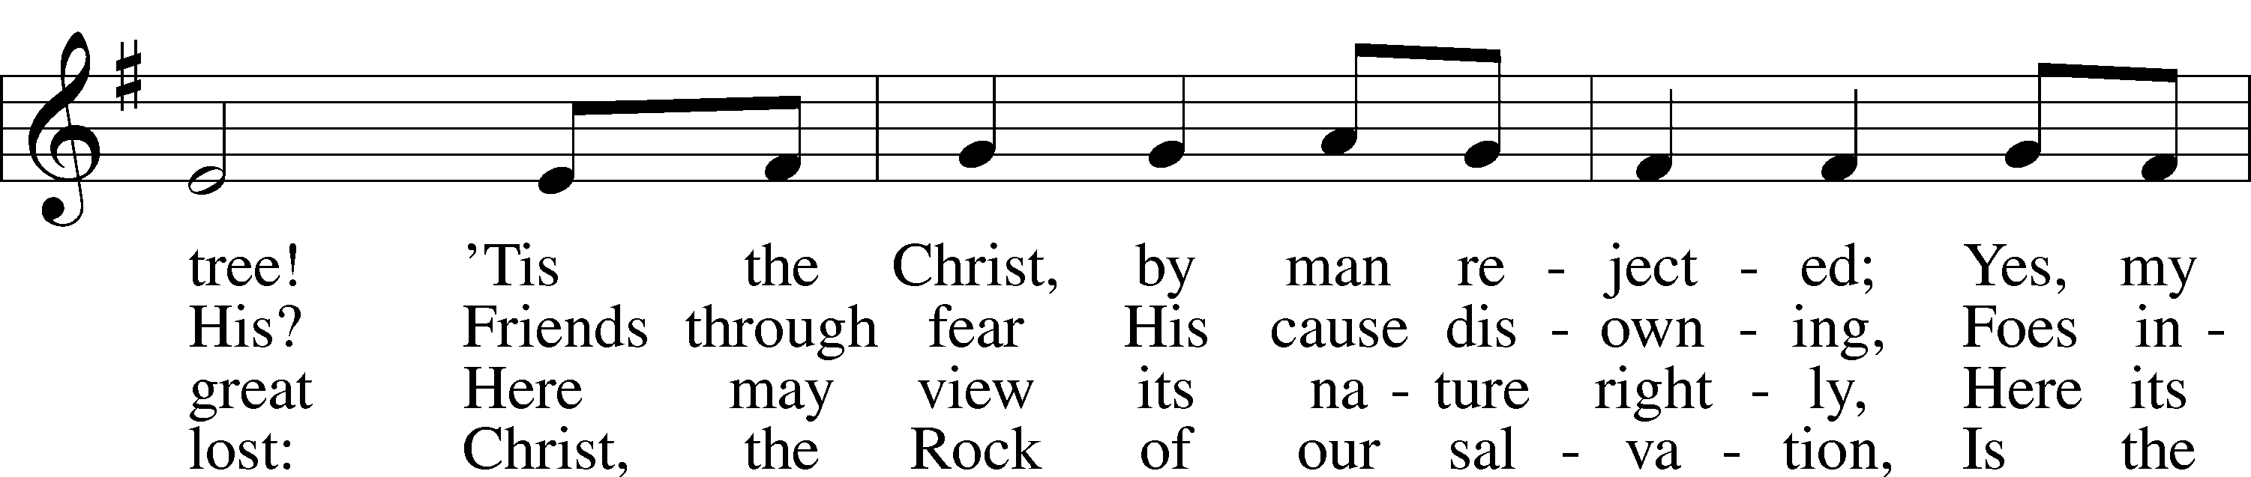
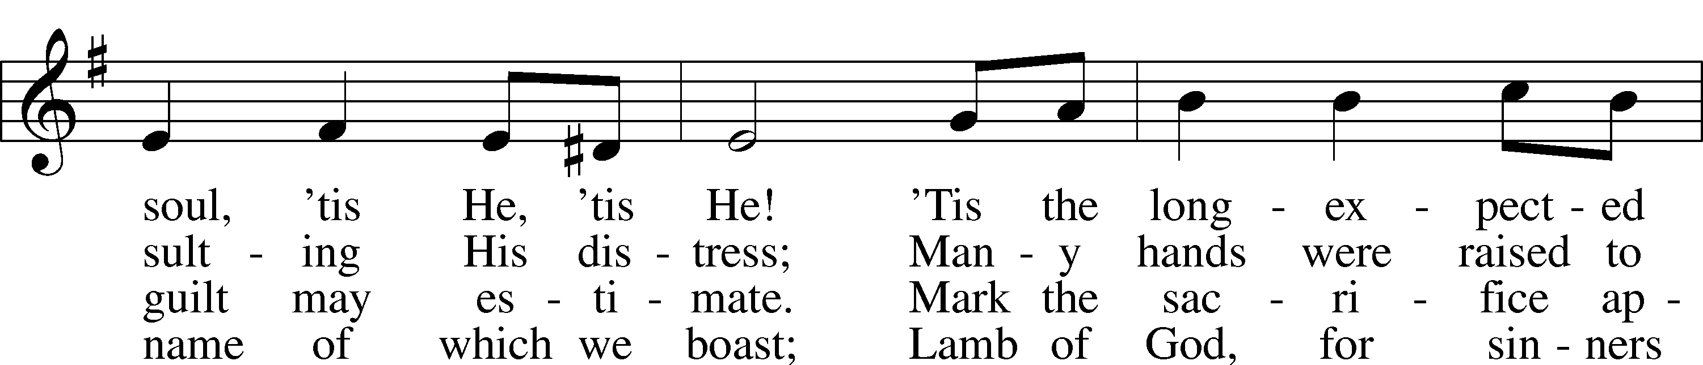
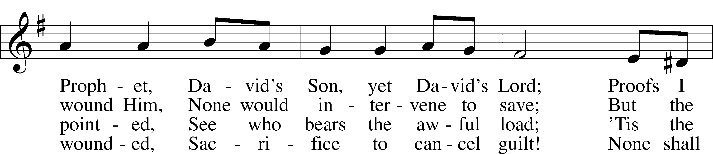
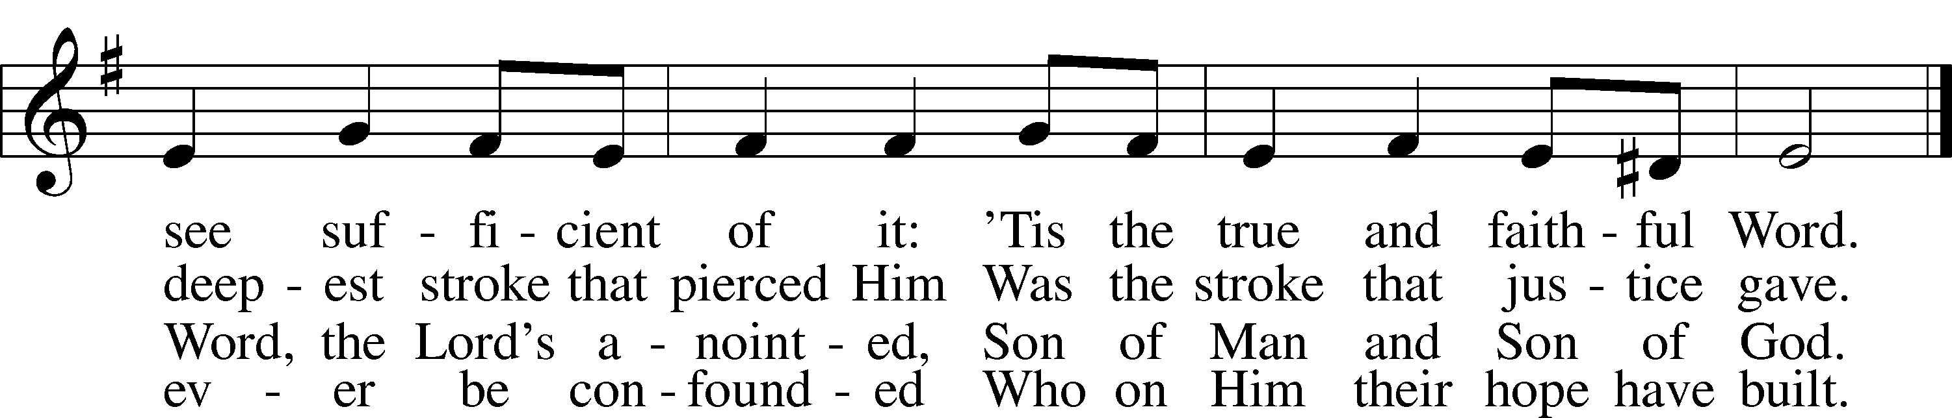

Text: Thomas Kelly, 1769–1855, alt. Tune: Geistliche Volkslieder, 1850, Paderborn Text and tune: Public domain

Readings

Prophecy: Isaiah 62:11b; 63:1-5, 7a (NKJV)
Thus says the Lord God: “Say to the daughter of Zion, ‘Surely your salvation is coming; behold, His reward is with Him, and His work before Him.’ ” Who is this who comes from Edom, with dyed garments from Bozrah, this One who is glorious in His apparel, traveling in the greatness of His strength?—“I who speak in righteousness, mighty to save.” Why is Your apparel red, and Your garments like one who treads in the winepress? “I have trodden the winepress alone, and from the peoples no one was with Me. For I have trodden them in My anger, and trampled them in My fury; their blood is sprinkled upon My garments, and I have stained all My robes. For the day of vengeance is in My heart, and the year of My redeemed has come. I looked, but there was no one to help, and I wondered that there was no one to uphold; therefore My own arm brought salvation for Me; and My own fury, it sustained Me.” I will mention the lovingkindnesses of the Lord and the praises of the Lord, according to all that He has bestowed on us, even the Lord our God.

P O Lord, have mercy on us.
C Thanks be to God.

Epistle: Isaiah 53:1-12 (NKJV)
In those days the prophet Isaiah spoke, saying: O Lord, who has believed our report? And to whom has the arm of the Lord been revealed? For He shall grow up before Him as a tender plant, and as a root out of dry ground. He has no form or comeliness; and when we see Him, there is no beauty that we should desire Him. He is despised and rejected by men, a Man of sorrows and acquainted with grief. And we hid, as it were, our faces from Him; He was despised, and we did not esteem Him. Surely He has borne our griefs and carried our sorrows; yet we esteemed Him stricken, smitten by God, and afflicted. But He was wounded for our transgressions, He was bruised for our iniquities; the chastisement for our peace was upon Him, and by His stripes we are healed. All we like sheep have gone astray; we have turned, every one, to his own way; and the Lord has laid on Him the iniquity of us all. He was oppressed and He was afflicted, yet He opened not His mouth; He was led as a lamb to the slaughter, and as a sheep before its shearers is silent, so He opened not His mouth. He was taken from prison and from judgment, and who will declare His generation? For He was cut off from the land of the living; for the transgressions of My people He was stricken. And they made His grave with the wicked—but with the rich at His death, because He had done no violence, nor was any deceit in His mouth. Yet it pleased the Lord to bruise Him; He has put Him to grief. When You make His soul an offering for sin, He shall see His seed, He shall prolong His days, and the pleasure of the Lord shall prosper in His hand. He shall see the labor of His soul, and be satisfied. By His knowledge My righteous Servant shall justify many, for He shall bear their iniquities. Therefore I will divide Him a portion with the great, and He shall divide the spoil with the strong, because He poured out His soul unto death, and He was numbered with the transgressors, and He bore the sin of many, and made intercession for the transgressors, that they would not perish, says the Lord Almighty.
P O Lord, have mercy on us.
C Thanks be to God.

Gospel: Luke 22:1—23:53 (NKJV)
At that time: The Feast of Unleavened Bread drew near, which is called Passover. And the chief priests and the scribes sought how they might kill Him, for they feared the people. Then Satan entered Judas, surnamed Iscariot, who was numbered among the twelve. So he went his way and conferred with the chief priests and captains, how he might betray Him to them. And they were glad, and agreed to give him money. So he promised and sought opportunity to betray Him to them in the absence of the multitude. Then came the Day of Unleavened Bread, when the Passover must be killed. And He sent Peter and John, saying, “Go and prepare the Passover for us, that we may eat.” So they said to Him, “Where do You want us to prepare?” And He said to them, “Behold, when you have entered the city, a man will meet you carrying a pitcher of water; follow him into the house which he enters. Then you shall say to the master of the house, ‘The Teacher says to you, “Where is the guest room where I may eat the Passover with My disciples?” ’ Then he will show you a large, furnished upper room; there make ready.” So they went and found it just as He had said to them, and they prepared the Passover. When the hour had come, He sat down, and the twelve apostles with Him. Then He said to them, “With fervent desire I have desired to eat this Passover with you before I suffer; for I say to you, I will no longer eat of it until it is fulfilled in the kingdom of God.” Then He took the cup, and gave thanks, and said, “Take this and divide it among yourselves; for I say to you, I will not drink of the fruit of the vine until the kingdom of God comes.” And He took bread, gave thanks and broke it, and gave it to them, saying, “This is My body which is given for you; do this in remembrance of Me.” Likewise He also took the cup after supper, saying, “This cup is the new covenant in My blood, which is shed for you. But behold, the hand of My betrayer is with Me on the table. And truly the Son of Man goes as it has been determined, but woe to that man by whom He is betrayed!” Then they began to question among themselves, which of them it was who would do this thing. Now there was also a dispute among them, as to which of them should be considered the greatest. And He said to them, “The kings of the Gentiles exercise lordship over them, and those who exercise authority over them are called ‘benefactors.’ But not so among you; on the contrary, he who is greatest among you, let him be as the younger, and he who governs as he who serves. For who is greater, he who sits at the table, or he who serves? Is it not he who sits at the table? Yet I am among you as the One who serves. But you are those who have continued with Me in My trials. And I bestow upon you a kingdom, just as My Father bestowed one upon Me, that you may eat and drink at My table in My kingdom, and sit on thrones judging the twelve tribes of Israel.” And the Lord said, “Simon, Simon! Indeed, Satan has asked for you, that he may sift you as wheat. But I have prayed for you, that your faith should not fail; and when you have returned to Me, strengthen your brethren.” But he said to Him, “Lord, I am ready to go with You, both to prison and to death.” Then He said, “I tell you, Peter, the rooster shall not crow this day before you will deny three times that you know Me.” And He said to them, “When I sent you without money bag, knapsack, and sandals, did you lack anything?” So they said, “Nothing.” Then He said to them, “But now, he who has a money bag, let him take it, and likewise a knapsack; and he who has no sword, let him sell his garment and buy one. For I say to you that this which is written must still be accomplished in Me: ‘And He was numbered with the transgressors.’ For the things concerning Me have an end.” So they said, “Lord, look, here are two swords.” And He said to them, “It is enough.” Coming out, He went to the Mount of Olives, as He was accustomed, and His disciples also followed Him. When He came to the place, He said to them, “Pray that you may not enter into temptation.” And He was withdrawn from them about a stone’s throw, and He knelt down and prayed, saying, “Father, if it is Your will, take this cup away from Me; nevertheless not My will, but Yours, be done.” Then an angel appeared to Him from heaven, strengthening Him. And being in agony, He prayed more earnestly. Then His sweat became like great drops of blood falling down to the ground. When He rose up from prayer, and had come to His disciples, He found them sleeping from sorrow. Then He said to them, “Why do you sleep? Rise and pray, lest you enter into temptation.” And while He was still speaking, behold, a multitude; and he who was called Judas, one of the twelve, went before them and drew near to Jesus to kiss Him. But Jesus said to him, “Judas, are you betraying the Son of Man with a kiss?” When those around Him saw what was going to happen, they said to Him, “Lord, shall we strike with the sword?” And one of them struck the servant of the high priest and cut off his right ear. But Jesus answered and said, “Permit even this.” And He touched his ear and healed him. Then Jesus said to the chief priests, captains of the temple, and the elders who had come to Him, “Have you come out, as against a robber, with swords and clubs? When I was with you daily in the temple, you did not try to seize Me. But this is your hour, and the power of darkness.” Having arrested Him, they led Him and brought Him into the high priest’s house. But Peter followed at a distance. Now when they had kindled a fire in the midst of the courtyard and sat down together, Peter sat among them. And a certain servant girl, seeing him as he sat by the fire, looked intently at him and said, “This man was also with Him.” But he denied Him, saying, “Woman, I do not know Him.” And after a little while another saw him and said, “You also are of them.” But Peter said, “Man, I am not!” Then after about an hour had passed, another confidently affirmed, saying, “Surely this fellow also was with Him, for he is a Galilean.” But Peter said, “Man, I do not know what you are saying!” Immediately, while he was still speaking, the rooster crowed. And the Lord turned and looked at Peter. Then Peter remembered the word of the Lord, how He had said to him, “Before the rooster crows, you will deny Me three times.” So Peter went out and wept bitterly. Now the men who held Jesus mocked Him and beat Him. And having blindfolded Him, they struck Him on the face and asked Him, saying, “Prophesy! Who is the one who struck You?” And many other things they blasphemously spoke against Him. As soon as it was day, the elders of the people, both chief priests and scribes, came together and led Him into their council, saying, “If You are the Christ, tell us.” But He said to them, “If I tell you, you will by no means believe. And if I also ask you, you will by no means answer Me or let Me go. Hereafter the Son of Man will sit on the right hand of the power of God.” Then they all said, “Are You then the Son of God?” So He said to them, “You rightly say that I am.” And they said, “What further testimony do we need? For we have heard it ourselves from His own mouth.” Then the whole multitude of them arose and led Him to Pilate. And they began to accuse Him, saying, “We found this fellow perverting the nation, and forbidding to pay taxes to Caesar, saying that He Himself is Christ, a King.” Then Pilate asked Him, saying, “Are You the King of the Jews?” He answered him and said, “It is as you say.” So Pilate said to the chief priests and the crowd, “I find no fault in this Man.” But they were the more fierce, saying, “He stirs up the people, teaching throughout all Judea, beginning from Galilee to this place.” When Pilate heard of Galilee, he asked if the Man were a Galilean. And as soon as he knew that He belonged to Herod’s jurisdiction, he sent Him to Herod, who was also in Jerusalem at that time. Now when Herod saw Jesus, he was exceedingly glad; for he had desired for a long time to see Him, because he had heard many things about Him, and he hoped to see some miracle done by Him. Then he questioned Him with many words, but He answered him nothing. And the chief priests and scribes stood and vehemently accused Him. Then Herod, with his men of war, treated Him with contempt and mocked Him, arrayed Him in a gorgeous robe, and sent Him back to Pilate. That very day Pilate and Herod became friends with each other, for previously they had been at enmity with each other. Then Pilate, when he had called together the chief priests, the rulers, and the people, said to them, “You have brought this Man to me, as one who misleads the people. And indeed, having examined Him in your presence, I have found no fault in this Man concerning those things of which you accuse Him; no, neither did Herod, for I sent you back to him; and indeed nothing deserving of death has been done by Him. I will therefore chastise Him and release Him” (for it was necessary for him to release one to them at the feast). And they all cried out at once, saying, “Away with this Man, and release to us Barabbas”—who had been thrown into prison for a certain rebellion made in the city, and for murder. Pilate, therefore, wishing to release Jesus, again called out to them. But they shouted, saying, “Crucify Him, crucify Him!” Then he said to them the third time, “Why, what evil has He done? I have found no reason for death in Him. I will therefore chastise Him and let Him go.” But they were insistent, demanding with loud voices that He be crucified. And the voices of these men and of the chief priests prevailed. So Pilate gave sentence that it should be as they requested. And he released to them the one they requested, who for rebellion and murder had been thrown into prison; but he delivered Jesus to their will. Now as they led Him away, they laid hold of a certain man, Simon a Cyrenian, who was coming from the country, and on him they laid the cross that he might bear it after Jesus. And a great multitude of the people followed Him, and women who also mourned and lamented Him. But Jesus, turning to them, said, “Daughters of Jerusalem, do not weep for Me, but weep for yourselves and for your children. For indeed the days are coming in which they will say, ‘Blessed are the barren, wombs that never bore, and breasts which never nursed!’ Then they will begin ‘to say to the mountains, “Fall on us!” and to the hills, “Cover us!” ’ For if they do these things in the green wood, what will be done in the dry?” There were also two others, criminals, led with Him to be put to death. And when they had come to the place called Calvary, there they crucified Him, and the criminals, one on the right hand and the other on the left. Then Jesus said, “Father, forgive them, for they do not know what they do.” And they divided His garments and cast lots. And the people stood looking on. But even the rulers with them sneered, saying, “He saved others; let Him save Himself if He is the Christ, the chosen of God.” The soldiers also mocked Him, coming and offering Him sour wine, and saying, “If You are the King of the Jews, save Yourself.” And an inscription also was written over Him in letters of Greek, Latin, and Hebrew: THIS IS THE KING OF THE JEWS. Then one of the criminals who were hanged blasphemed Him, saying, “If You are the Christ, save Yourself and us.” But the other, answering, rebuked him, saying, “Do you not even fear God, seeing you are under the same condemnation? And we indeed justly, for we receive the due reward of our deeds; but this Man has done nothing wrong.” Then he said to Jesus, “Lord, remember me when You come into Your kingdom.” And Jesus said to him, “Assuredly, I say to you, today you will be with Me in Paradise.” Now it was about the sixth hour, and there was darkness over all the earth until the ninth hour. Then the sun was darkened, and the veil of the temple was torn in two. And when Jesus had cried out with a loud voice, He said, “Father, ‘into Your hands I commit My spirit.’ ” Having said this, He breathed His last. So when the centurion saw what had happened, he glorified God, saying, “Certainly this was a righteous Man!” And the whole crowd who came together to that sight, seeing what had been done, beat their breasts and returned. But all His acquaintances, and the women who followed Him from Galilee, stood at a distance, watching these things. Now behold, there was a man named Joseph, a council member, a good and just man. He had not consented to their decision and deed. He was from Arimathea, a city of the Jews, who himself was also waiting for the kingdom of God. This man went to Pilate and asked for the body of Jesus. Then he took it down, wrapped it in linen, and laid it in a tomb that was hewn out of the rock, where no one had ever lain before.

P O Lord, have mercy on us.
C Thanks be to God.

Responsory (Lent) LSB 222
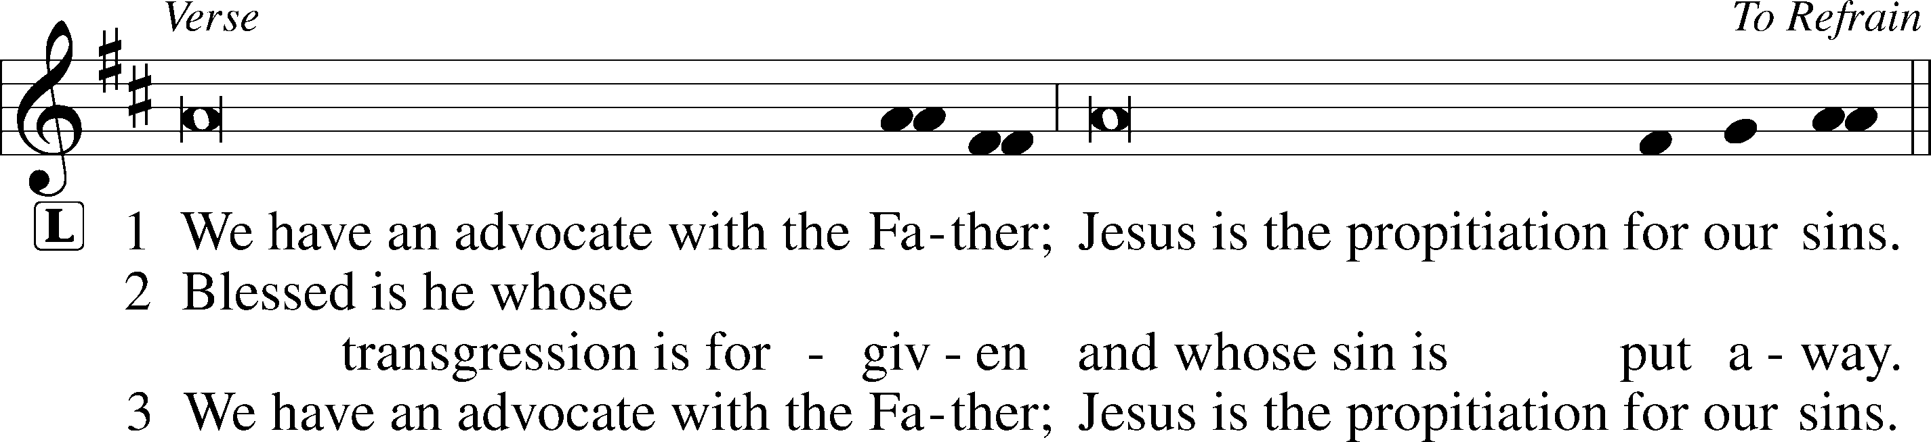
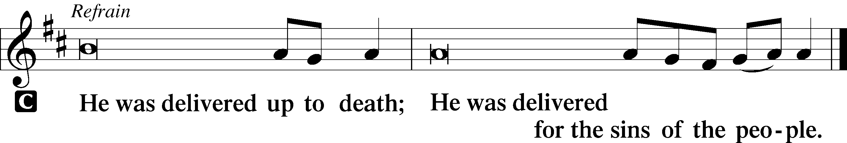

Sermon
Canticle
Stand

Magnificat LSB 231
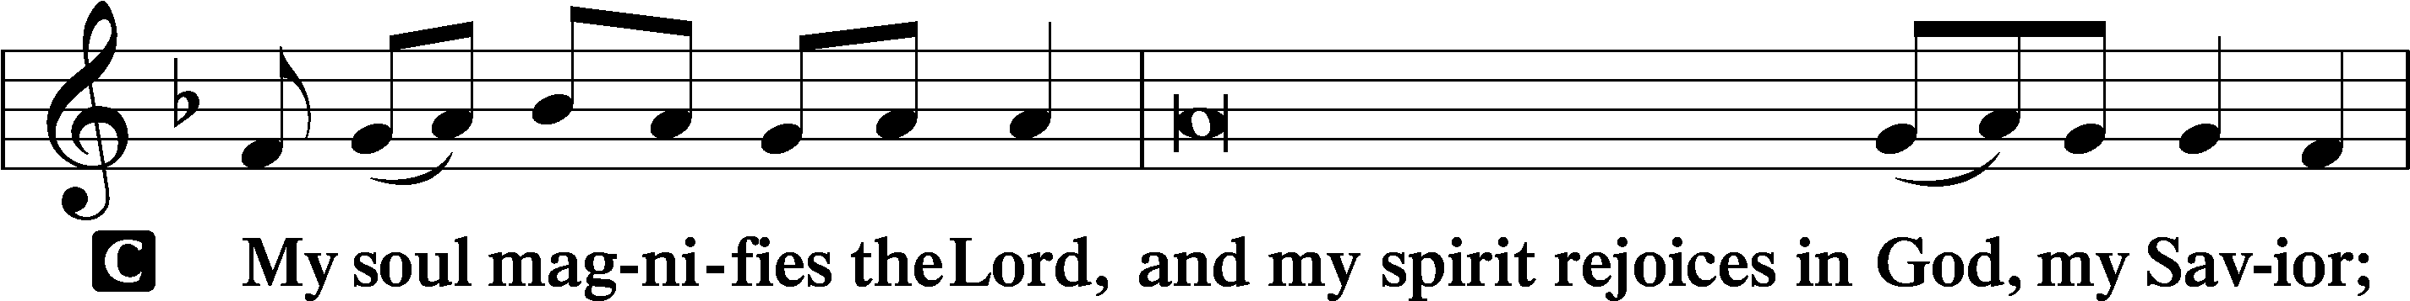
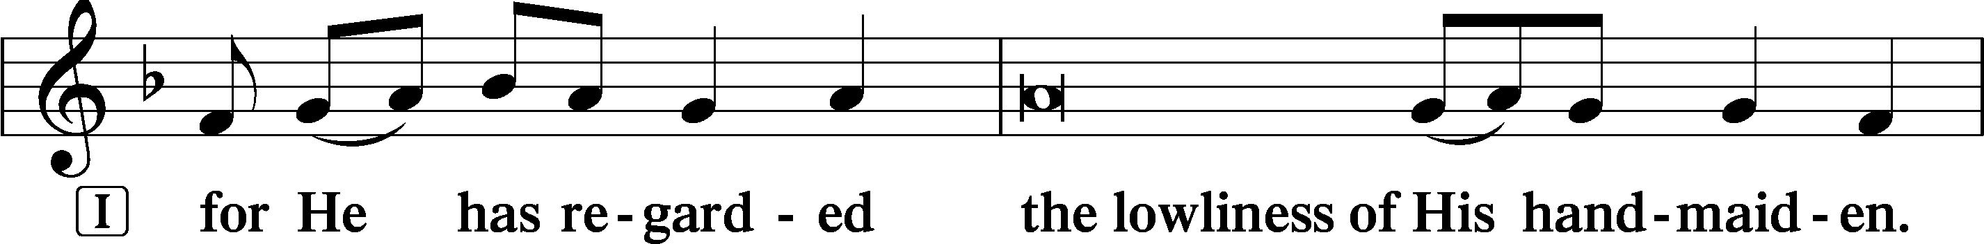
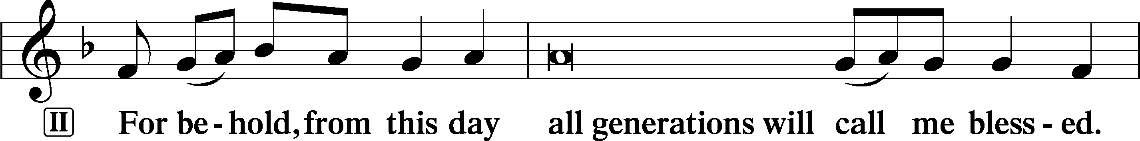
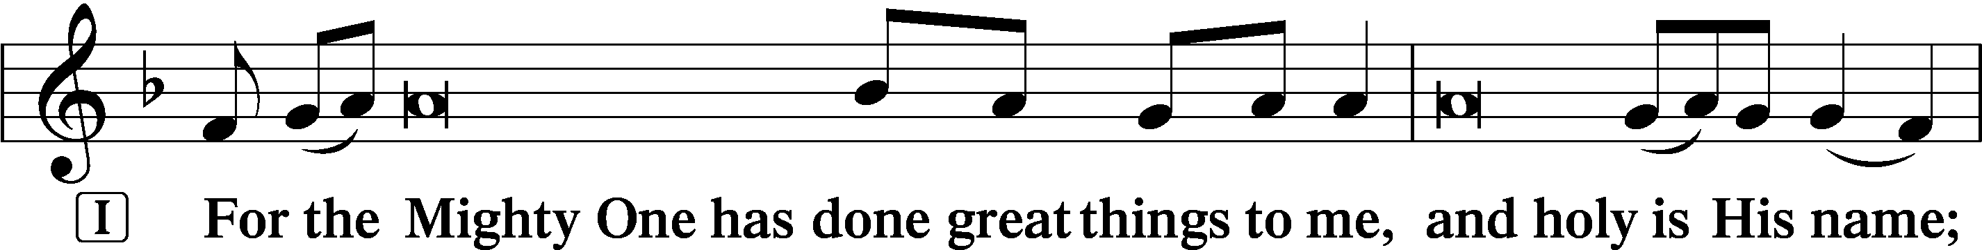
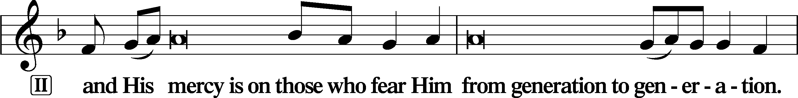
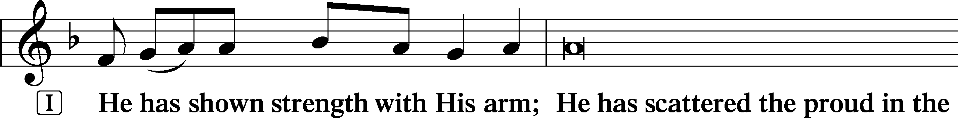
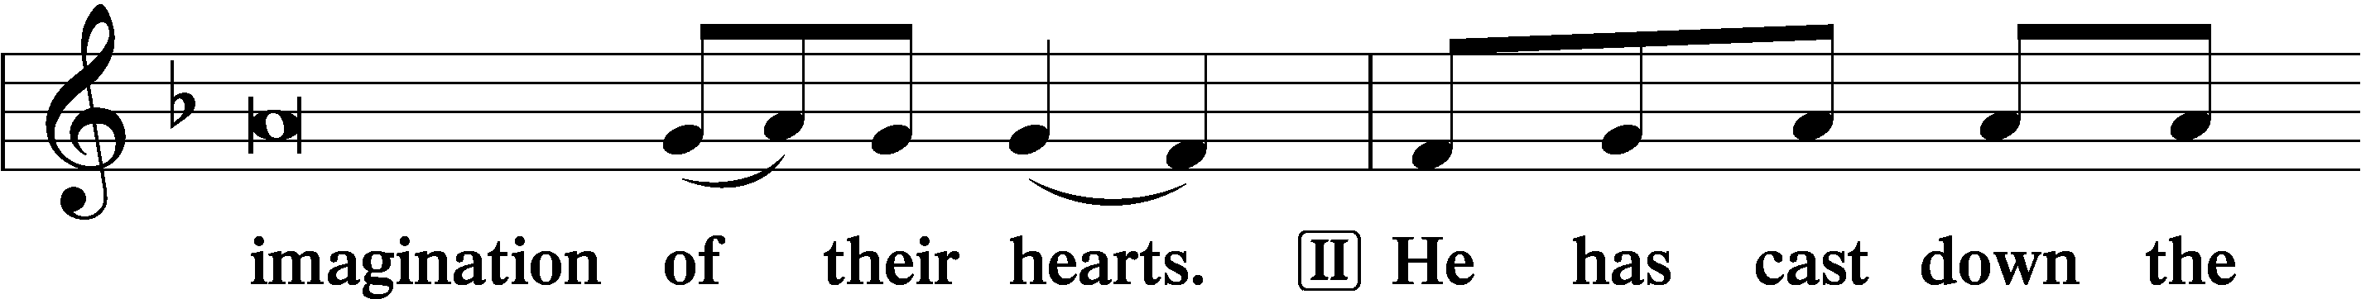
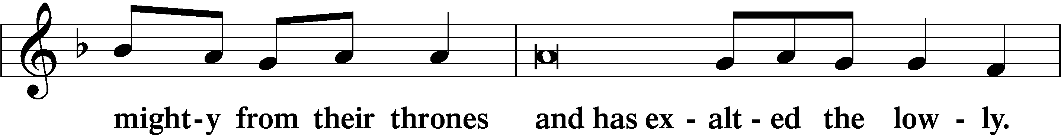
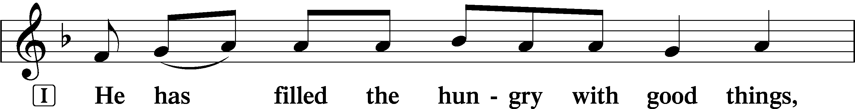
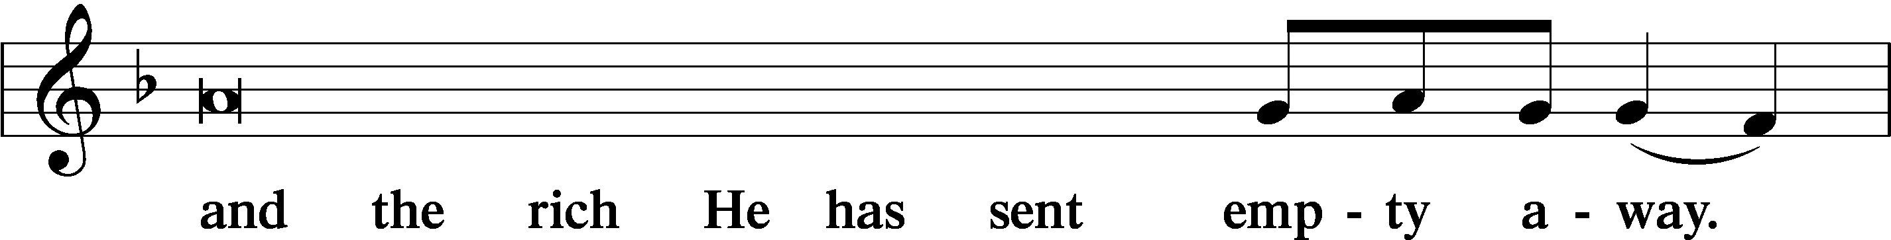
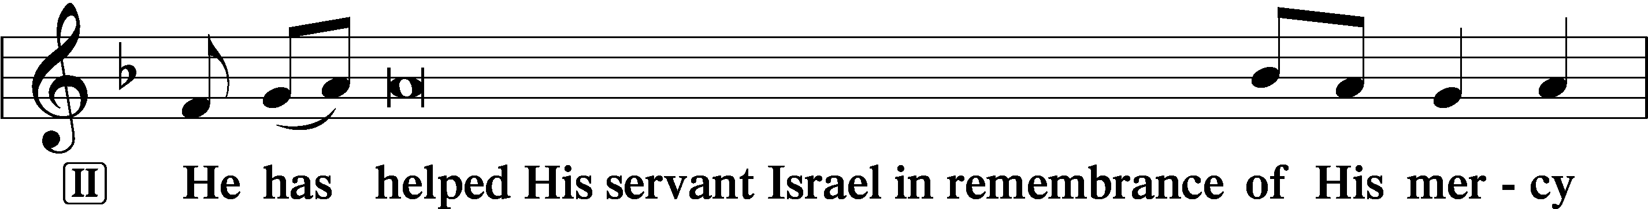
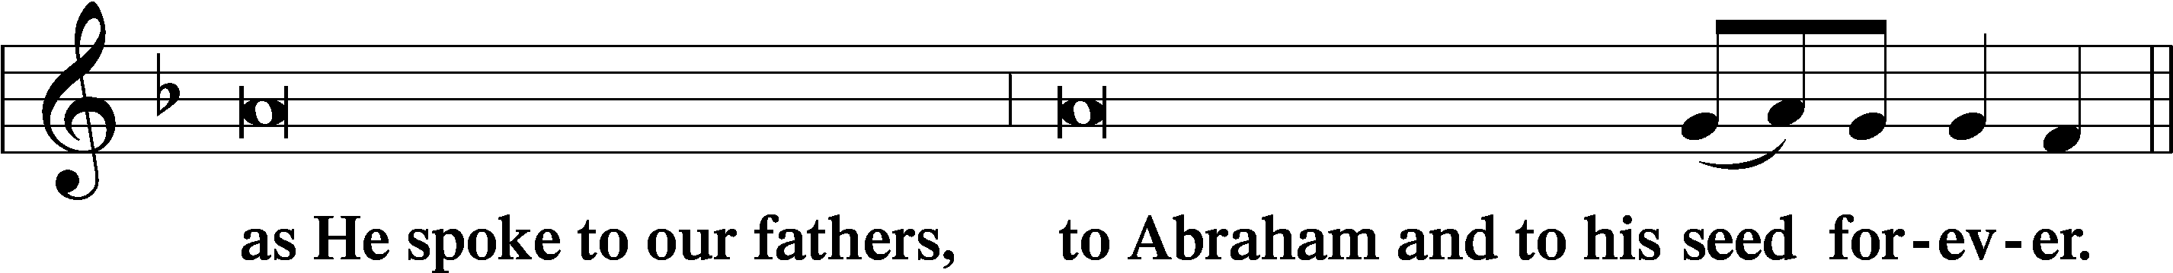
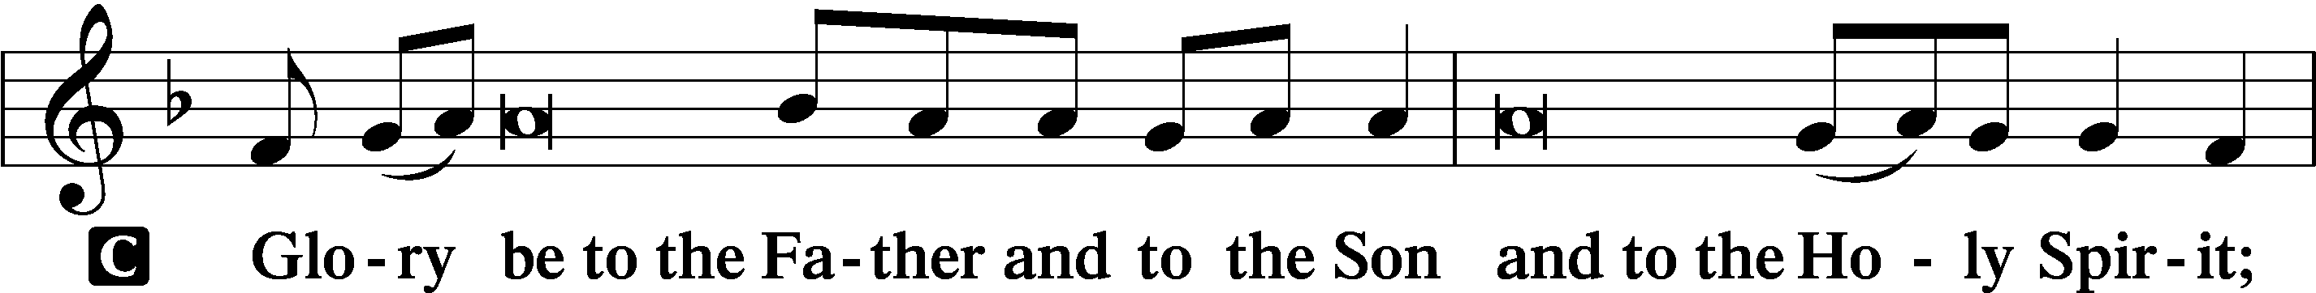
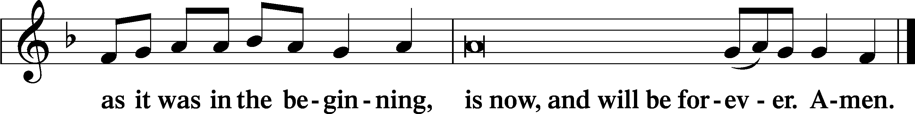

Offering: Please leave your offering in the plate upon entering.

Prayer
Kyrie LSB 227
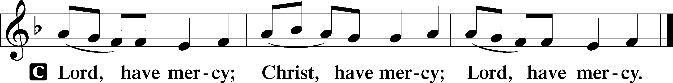

The Lord’s Prayer: LSB #957 “Our Father Who Art in Heaven” LSB 957
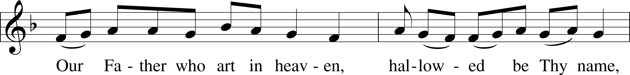
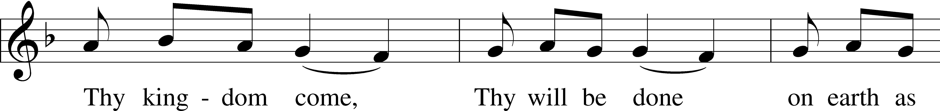
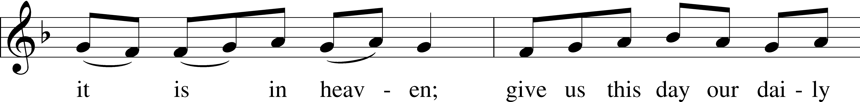
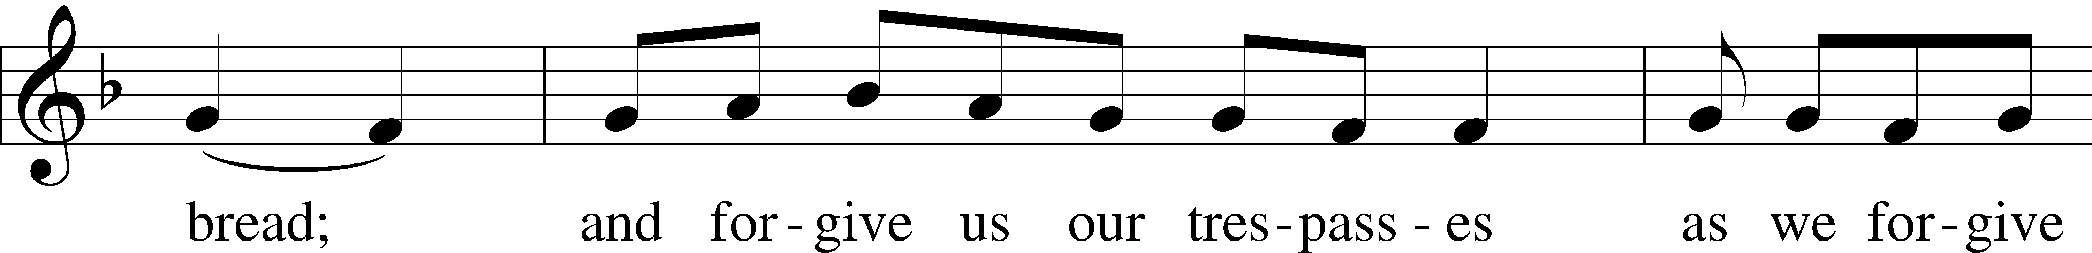
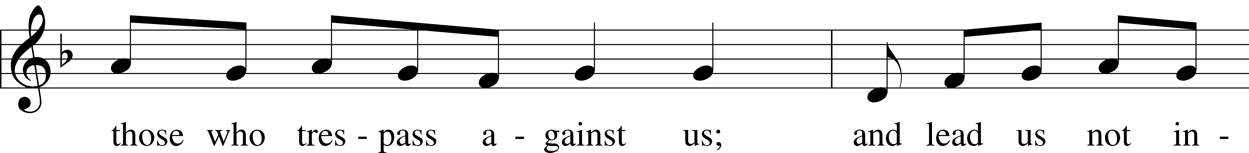
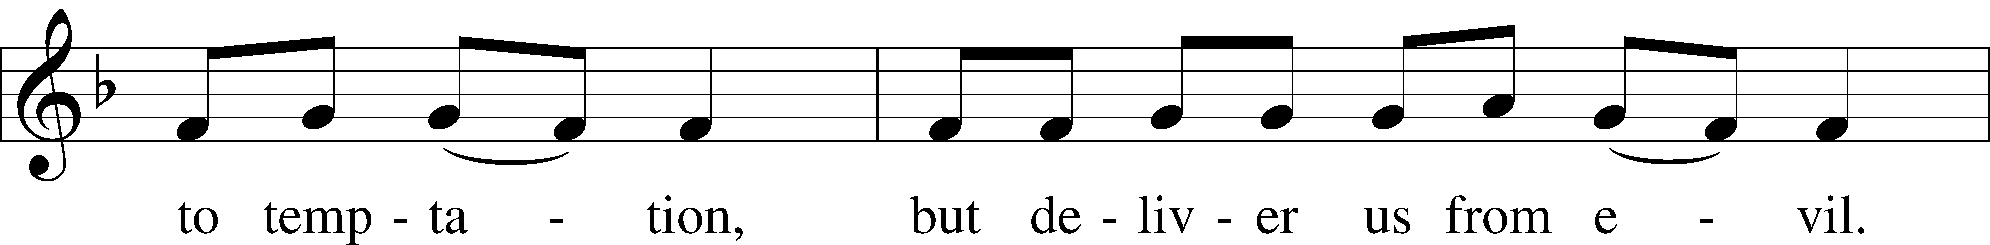
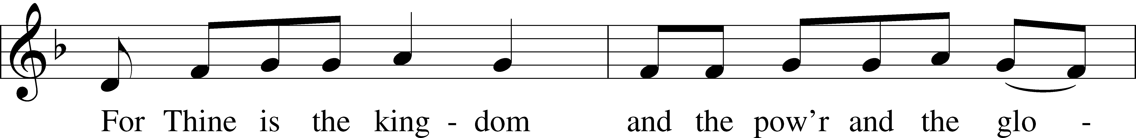
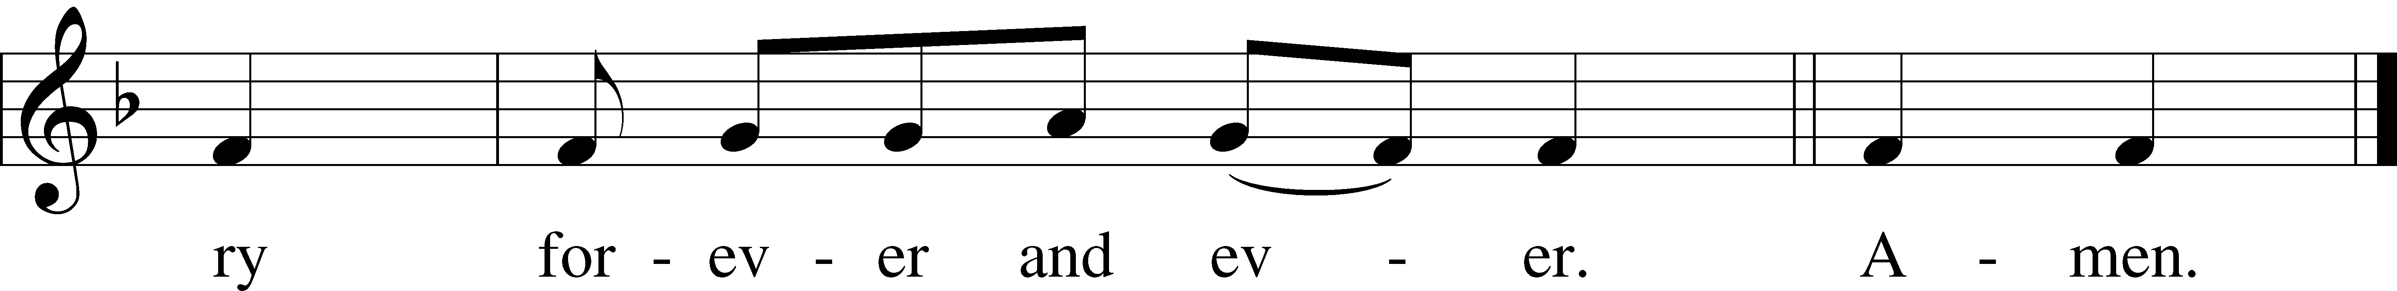

Text: Traditional Tune: Plainsong, mode VII Text and tune: Public domain

Collects
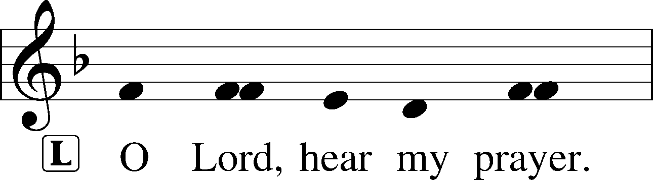
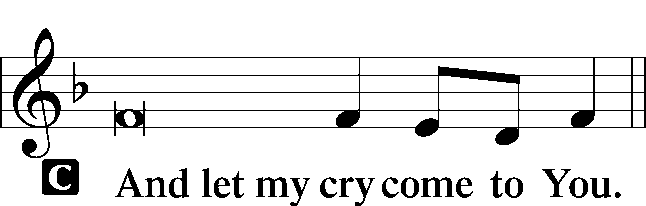

Collect of the Day
P Merciful and everlasting God, You did not spare Your only Son but delivered Him up for us all to bear our sins on the cross. Grant that our hearts may be so fixed with steadfast faith in Him that we fear not the power of sin, death, and the devil; through the same Jesus Christ, our Lord, who lives and reigns with You and the Holy Spirit, one God, now and forever. Amen.
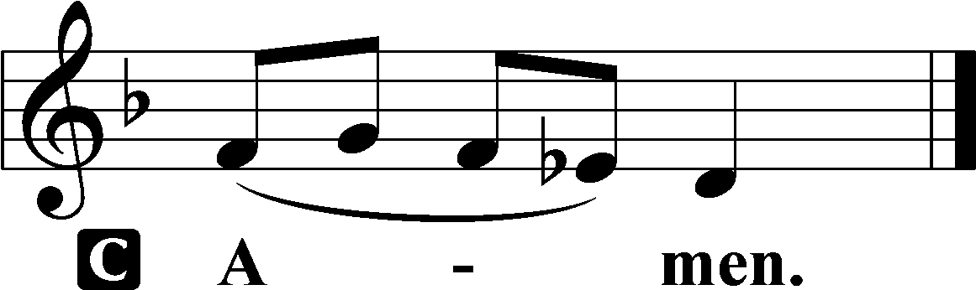

Collect for Grace
P O Lord, our heavenly Father, almighty and everlasting God, You have safely brought us to the beginning of this day. Defend us in the same with Your mighty power and grant that this day we fall into no sin, neither run into any kind of danger, but that all our doings, being ordered by Your governance, may be righteous in Your sight; through Jesus Christ, Your Son, our Lord, who lives and reigns with You and the Holy Spirit, one God, now and forever.

Benedicamus LSB 228
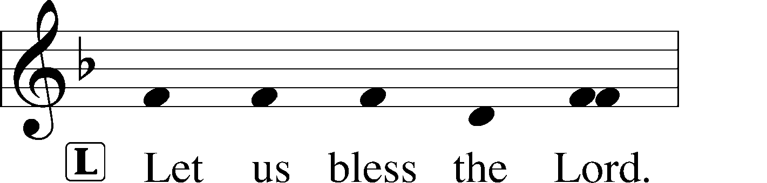
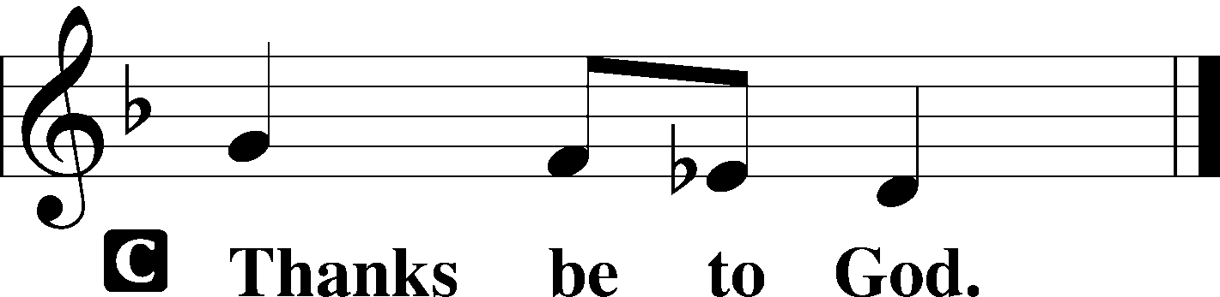

Benediction LSB 228
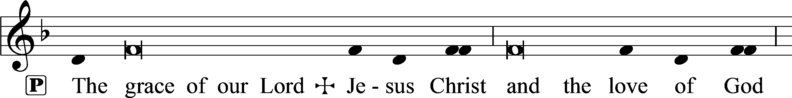
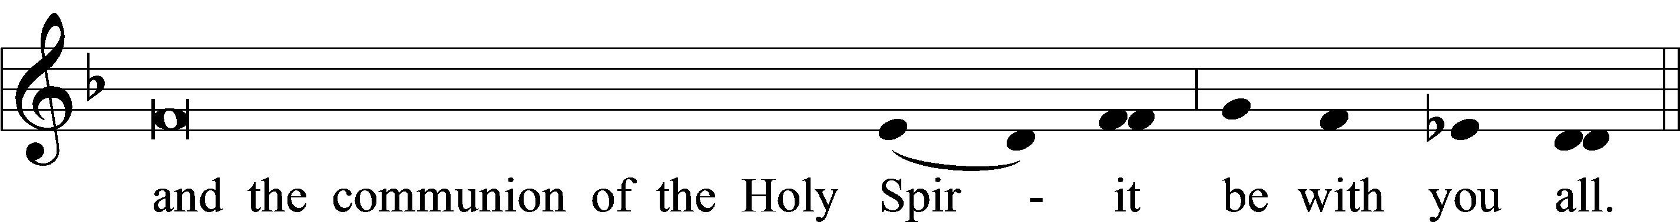

Acknowledgments
Matins from Lutheran Service Book
Unless otherwise indicated, Scripture quotations are from the ESV® Bible (The Holy Bible, English Standard Version®), copyright © 2001 by Crossway, a publishing ministry of Good News Publishers. Used by permission. All rights reserved.
Created by Lutheran Service Builder © 2024 Concordia Publishing House.

