Sts. Peter & Paul
Evangelical Lutheran Church
Lutheran Church-Missouri Synod
Founded-1917

699 Stambaugh Avenue
Sharon, Pennsylvania 16146

HOLY TUESDAY
March 26, 2024

“I was glad when they said to me,
Let us go to the house of the LORD!”
Psalm 122:1
Sts. Peter & Paul Evangelical Lutheran Church, LC-MS
HOLY TUESDAY
March 26, 2024

Stand

Psalmody

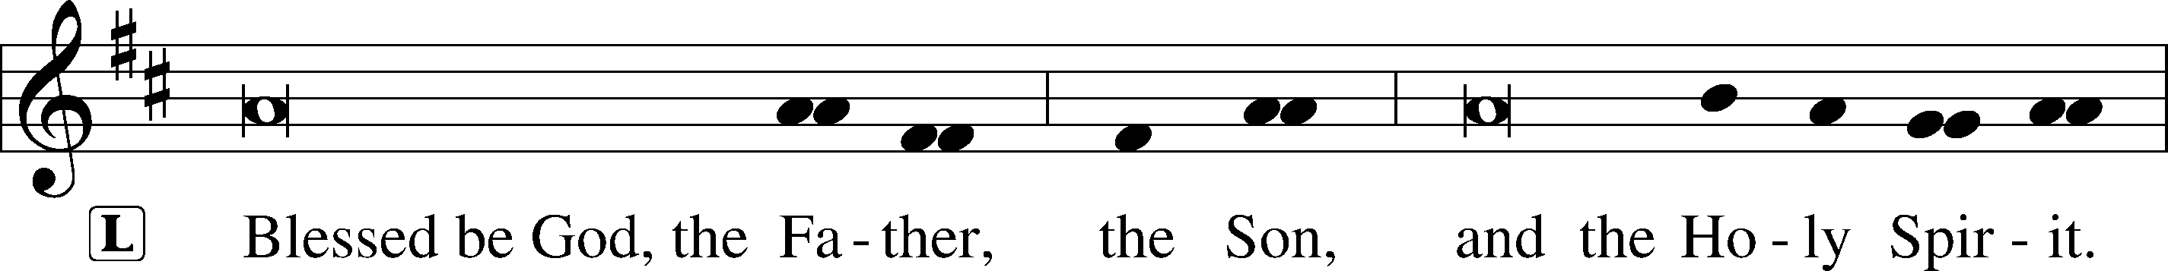

Venite LSB 220
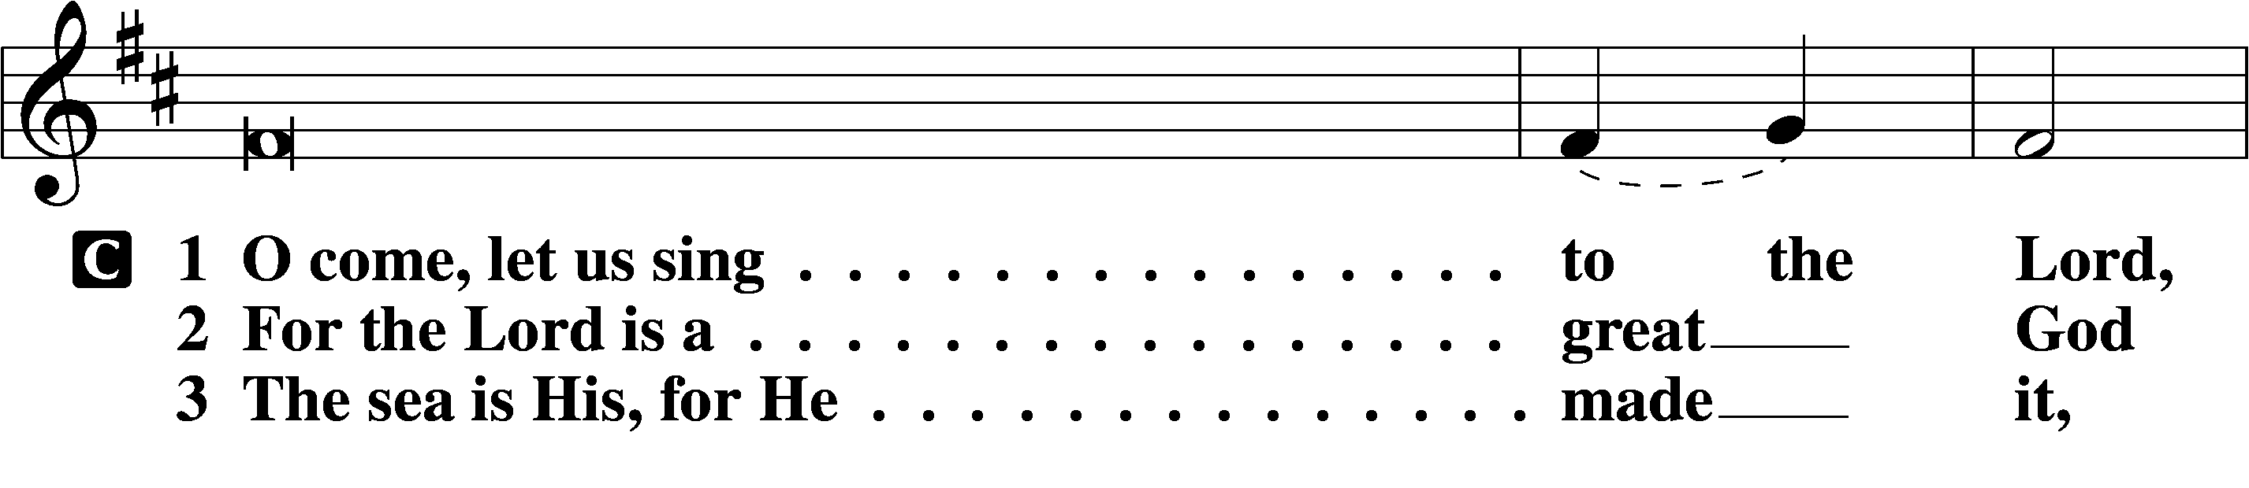
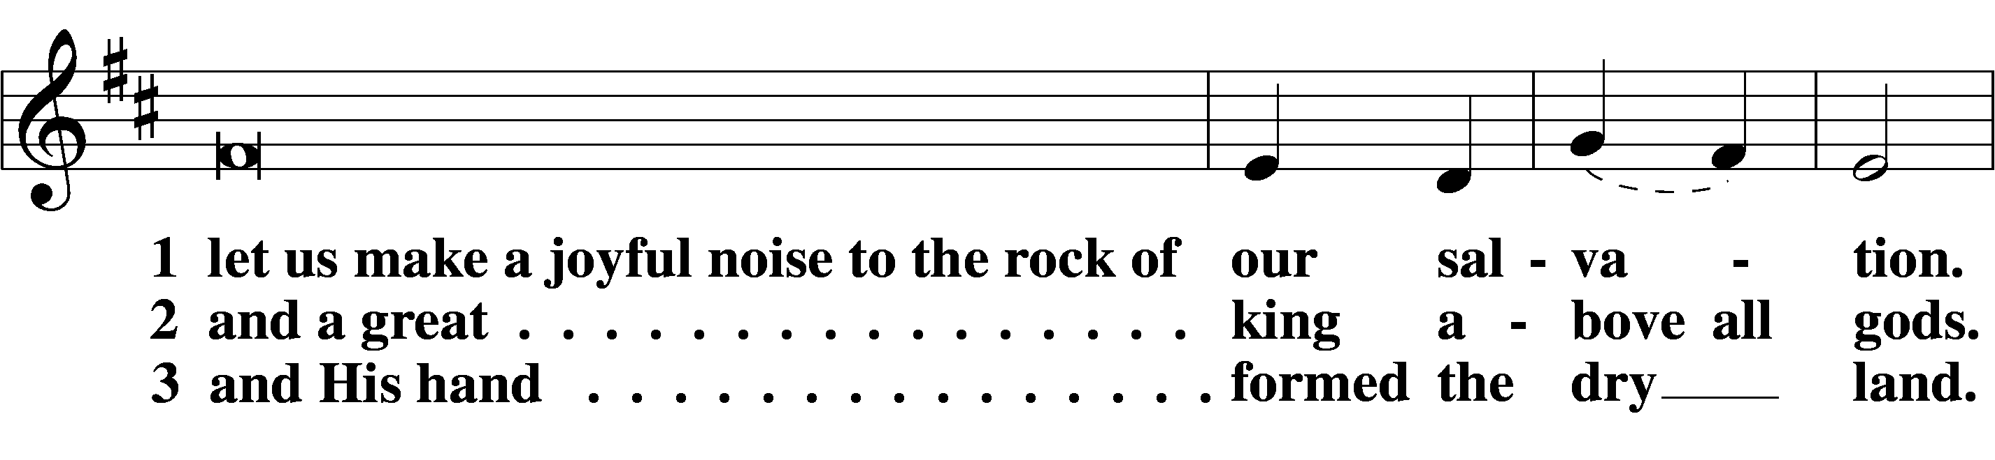
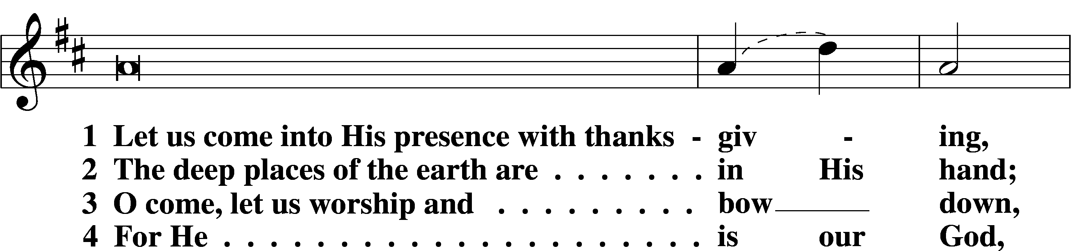
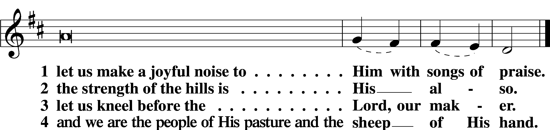

Psalm: Psalm 54; antiphon: v. 4
O God, save me, by your name,
and vindicate me by your might.
O God, hear my prayer;
give ear to the words of my mouth.
For strangers have risen against me;
ruthless men seek my life;
they do not set God before themselves.
Behold, God is my helper;
the Lord is the upholder of my life.
He will return the evil to my enemies;
in your faithfulness put an end to them.
With a freewill offering I will sacrifice to you;
I will give thanks to your name, O Lord, for it is good.
For he has delivered me from every trouble,
and my eye has looked in triumph on my enemies.
Sit

Office Hymn: LSB #453 “Upon the Cross Extended”
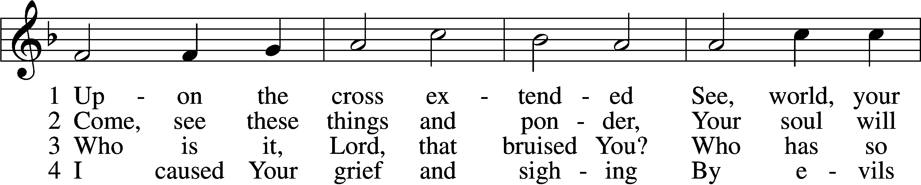
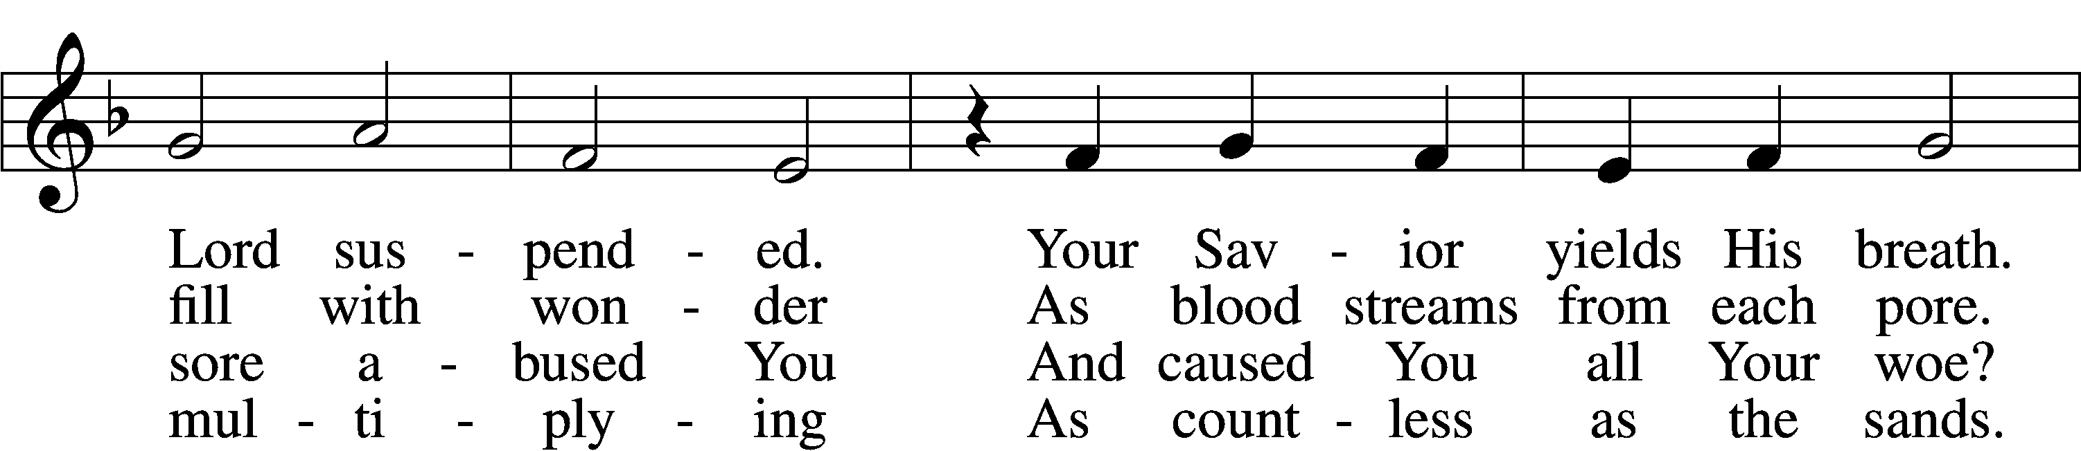
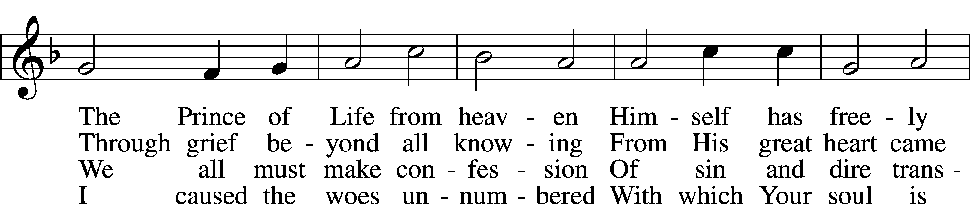
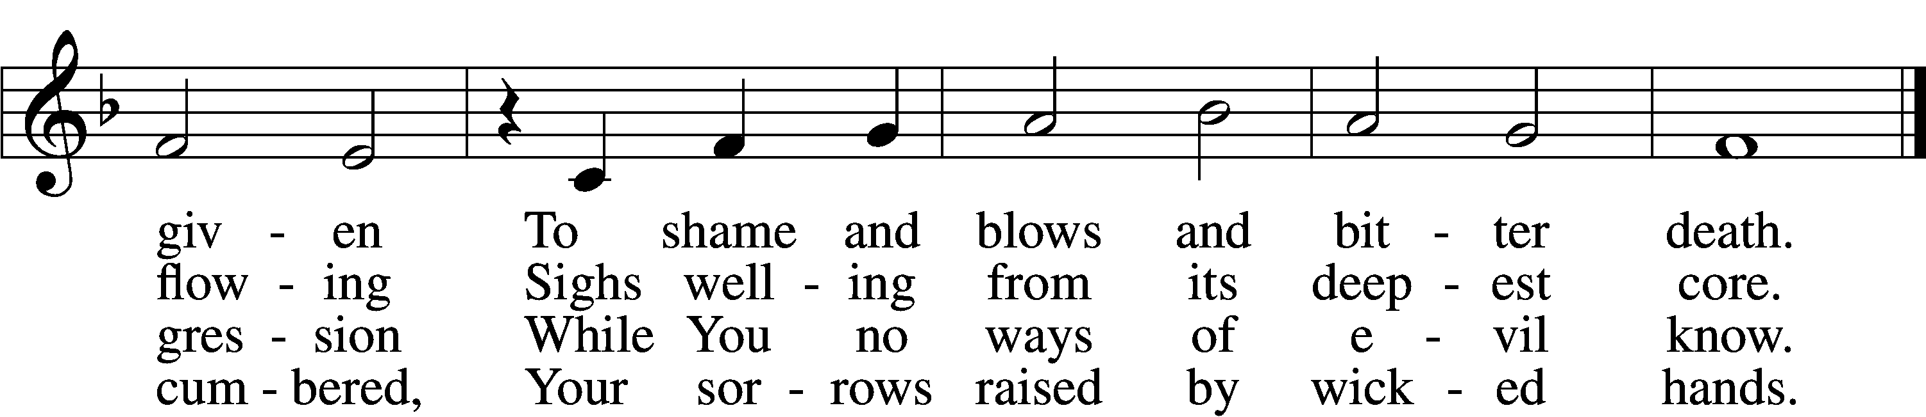
5 Your soul in griefs unbounded,
Your head with thorns surrounded,
You died to ransom me.
The cross for me enduring,
The crown for me securing,
You healed my wounds and set me free.

6 Your cords of love, my Savior,
Bind me to You forever,
I am no longer mine.
To You I gladly tender
All that my life can render
And all I have to You resign.

7 Your cross I place before me;
Its saving pow’r restore me,
Sustain me in the test.
It will, when life is ending,
Be guiding and attending
My way to Your eternal rest.

Text: Paul Gerhardt, 1607–76; tr. John Kelly, 1833–90, alt. Tune: Heinrich Isaac, c. 1450–1517 Text and tune: Public domain

Readings

Prophecy: Jeremiah 11:18–20 (NKJV)
In those days the prophet Jeremiah spoke, saying: The Lord gave me knowledge, and I know; for You showed me their doings. But I was like a docile lamb brought to the slaughter; and I did not know that they had devised schemes against me, saying, “Let us destroy the tree with its fruit, and let us cut him off from the land of the living, that his name may be remembered no more.” But, O Lord of hosts, You who judge righteously, testing the mind and the heart, let me see Your vengeance on them, for to You I have revealed my cause, O Lord my God.

P O Lord, have mercy on us.
C Thanks be to God.
Epistle: Wisdom 2:12-22 (NKJV)
In those days the wicked Jews said among themselves: “Let us lie in wait for the righteous Man, because He is inconvenient to us and opposes our actions; He reproaches us for sins against the law and accuses us of sins against our training. He professes to have knowledge of God and calls Himself a Child of the Lord. He became to us a reproof of our thoughts; the very sight of Him is a burden to us, because His manner of life is unlike that of others and His ways are strange. We are considered by Him as something base, and He avoids our ways as unclean; He calls the last end of the righteous happy and boasts that God is his Father. Let us see if His words are true, and let us test what will happen at the end of His life; for if the righteous Man is God’s Son, God will help Him and will deliver Him from the hand of His adversaries. Let us test Him with insult and torture, that we may find out how gentle He is and make trial of His forbearance. Let us condemn Him to a shameful death for, according to what He says, He will be protected.” Thus they reasoned, but they were led astray, for their wickedness blinded them, and they did not know the secret purposes of God or hope for the wages of holiness or discern the prize for blameless souls.

P O Lord, have mercy on us.
C Thanks be to God.

Gospel: John 12:1-36 (NKJV)
At that time: Six days before the Passover, Jesus came to Bethany, where Lazarus was who had been dead, whom He had raised from the dead. There they made Him a supper; and Martha served, but Lazarus was one of those who sat at the table with Him. Then Mary took a pound of very costly oil of spikenard, anointed the feet of Jesus, and wiped His feet with her hair. And the house was filled with the fragrance of the oil. But one of His disciples, Judas Iscariot, Simon’s son, who would betray Him, said, “Why was this fragrant oil not sold for three hundred denarii and given to the poor?” This he said, not that he cared for the poor, but because he was a thief, and had the money box; and he used to take what was put in it. But Jesus said, “Let her alone; she has kept this for the day of My burial. For the poor you have with you always, but Me you do not have always.” Now a great many of the Jews knew that He was there; and they came, not for Jesus’ sake only, but that they might also see Lazarus, whom He had raised from the dead. But the chief priests plotted to put Lazarus to death also, because on account of him many of the Jews went away and believed in Jesus. The next day a great multitude that had come to the feast, when they heard that Jesus was coming to Jerusalem, took branches of palm trees and went out to meet Him, and cried out: “Hosanna! ‘Blessed is He who comes in the name of the Lord!’ The King of Israel!” Then Jesus, when He had found a young donkey, sat on it; as it is written: “Fear not, daughter of Zion; behold, your King is coming, sitting on a donkey’s colt.” His disciples did not understand these things at first; but when Jesus was glorified, then they remembered that these things were written about Him and that they had done these things to Him. Therefore the people, who were with Him when He called Lazarus out of his tomb and raised him from the dead, bore witness. For this reason the people also met Him, because they heard that He had done this sign. The Pharisees therefore said among themselves, “You see that you are accomplishing nothing. Look, the world has gone after Him!” Now there were certain Greeks among those who came up to worship at the feast. Then they came to Philip, who was from Bethsaida of Galilee, and asked him, saying, “Sir, we wish to see Jesus.” Philip came and told Andrew, and in turn Andrew and Philip told Jesus. But Jesus answered them, saying, “The hour has come that the Son of Man should be glorified. Most assuredly, I say to you, unless a grain of wheat falls into the ground and dies, it remains alone; but if it dies, it produces much grain. He who loves his life will lose it, and he who hates his life in this world will keep it for eternal life. If anyone serves Me, let him follow Me; and where I am, there My servant will be also. If anyone serves Me, him My Father will honor. Now My soul is troubled, and what shall I say? ‘Father, save Me from this hour’? But for this purpose I came to this hour. Father, glorify Your name.” Then a voice came from heaven, saying, “I have both glorified it and will glorify it again.” Therefore the people who stood by and heard it said that it had thundered. Others said, “An angel has spoken to Him.” Jesus answered and said, “This voice did not come because of Me, but for your sake. Now is the judgment of this world; now the ruler of this world will be cast out. And I, if I am lifted up from the earth, will draw all peoples to Myself.” This He said, signifying by what death He would die. The people answered Him, “We have heard from the law that the Christ remains forever; and how can You say, ‘The Son of Man must be lifted up’? Who is this Son of Man?” Then Jesus said to them, “A little while longer the light is with you. Walk while you have the light, lest darkness overtake you; he who walks in darkness does not know where he is going. While you have the light, believe in the light, that you may become sons of light.” These things Jesus spoke, and departed, and was hidden from them.

P O Lord, have mercy on us.
C Thanks be to God.

Responsory (Lent) LSB 222
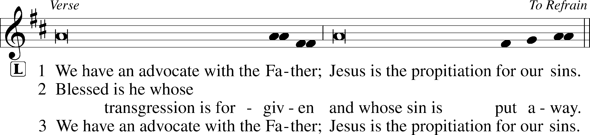
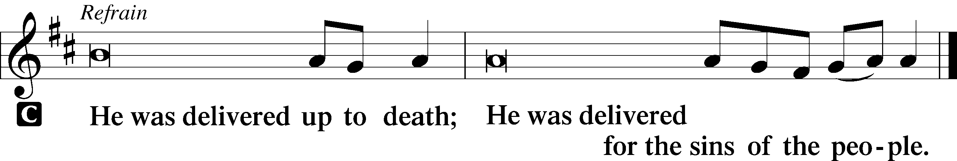

Sermon
Canticle
Stand
Magnificat 231
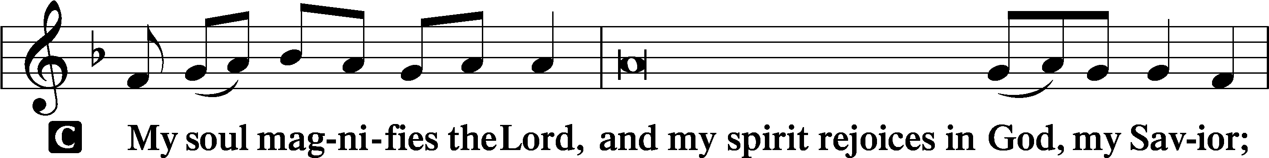
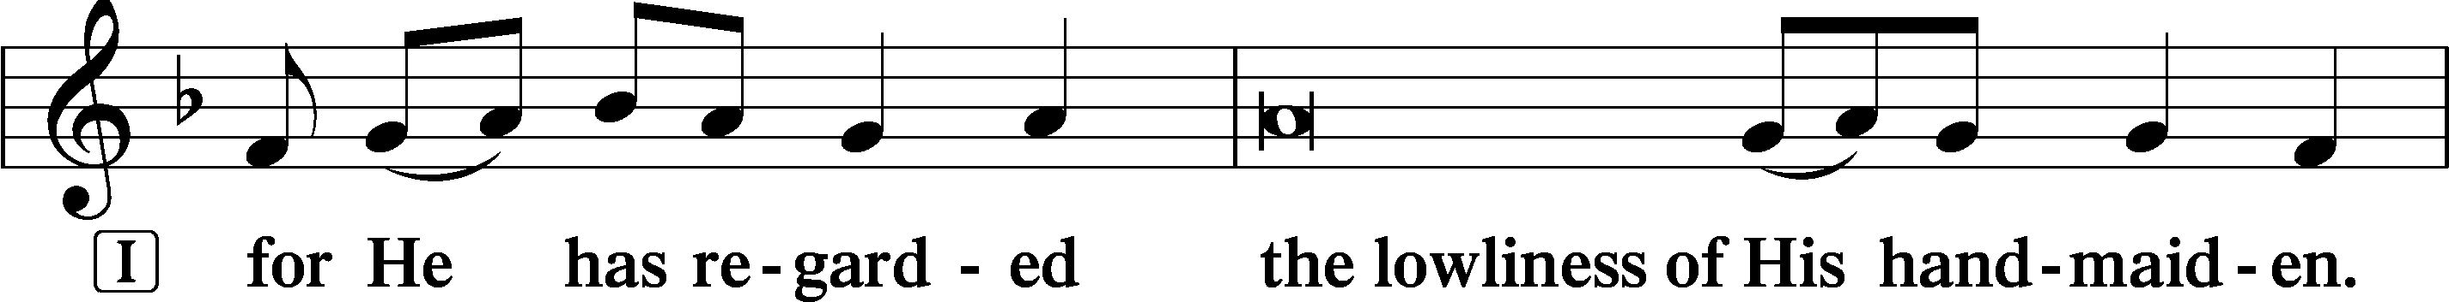
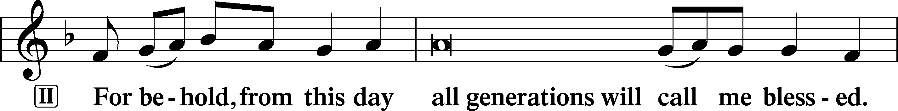
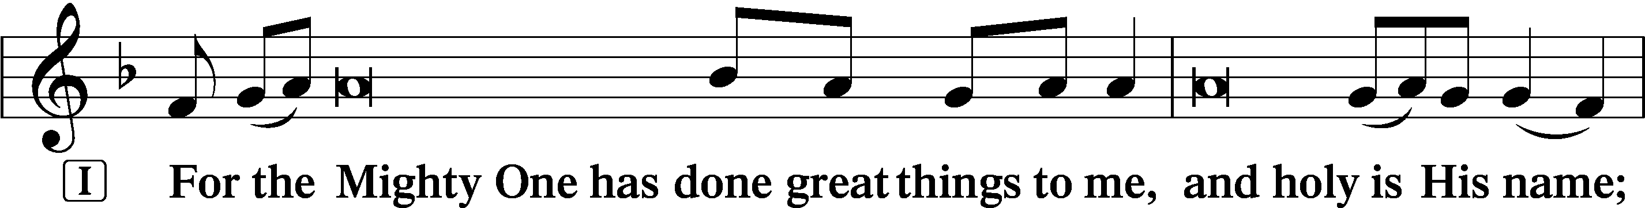
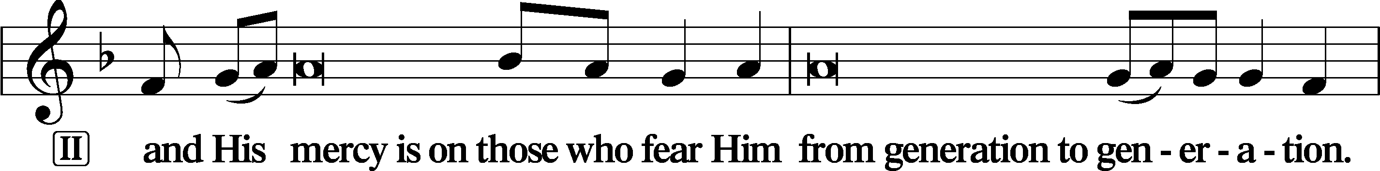
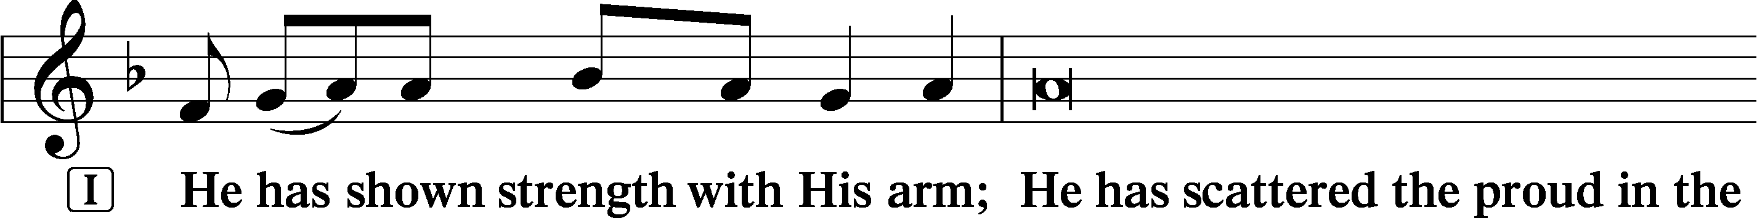
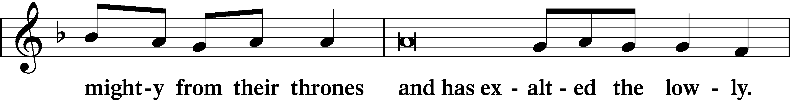
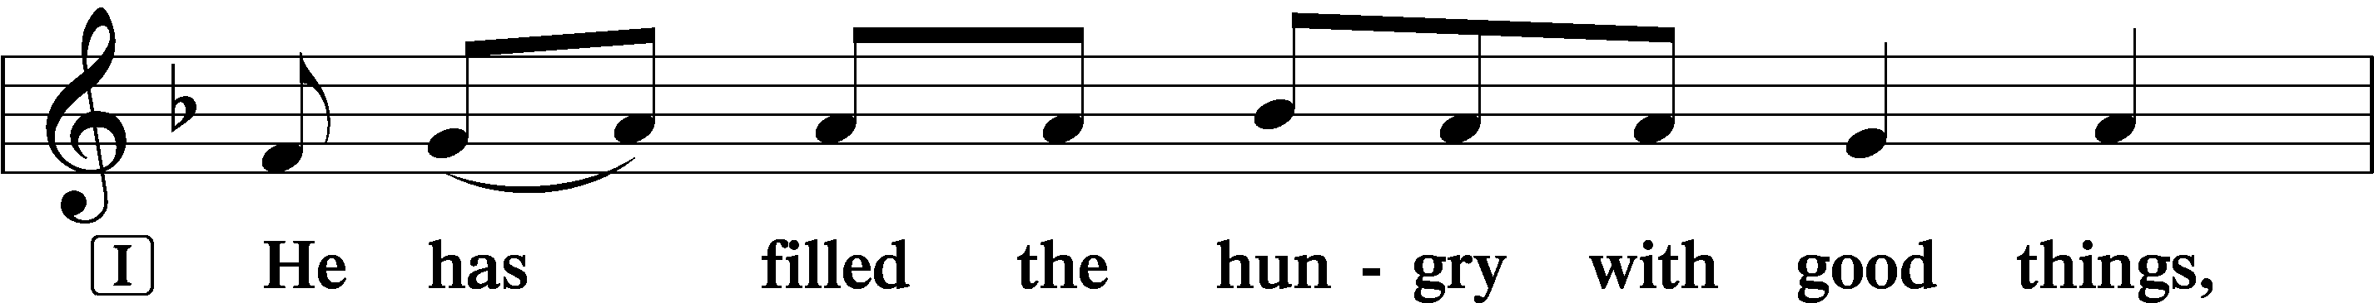
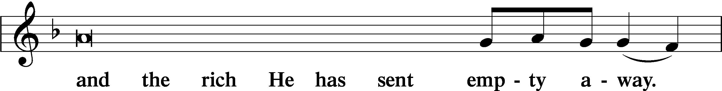
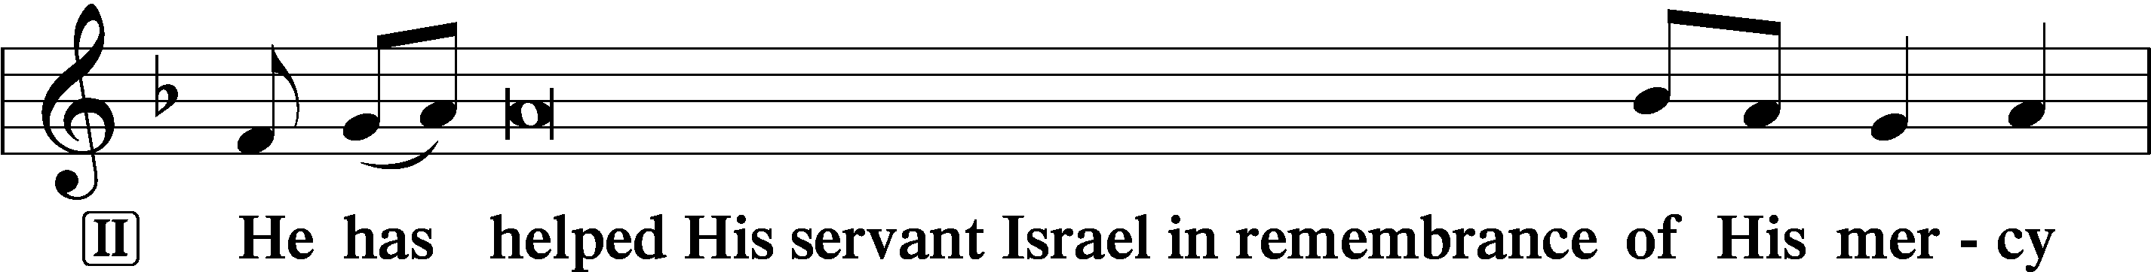
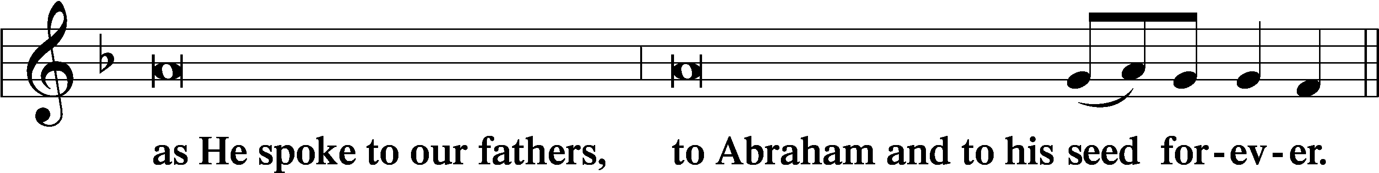

Offering: Please leave your offering in the plate upon entering.

Prayer
Kyrie LSB 227

The Lord’s Prayer: LSB #957 “Our Father Who Art in Heaven” LSB 957
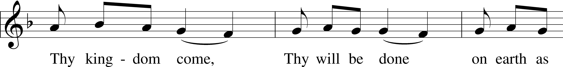
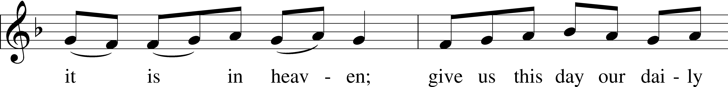
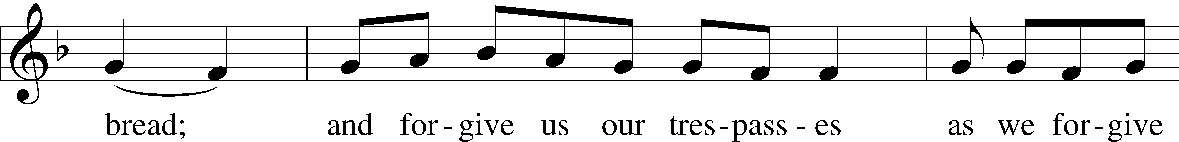
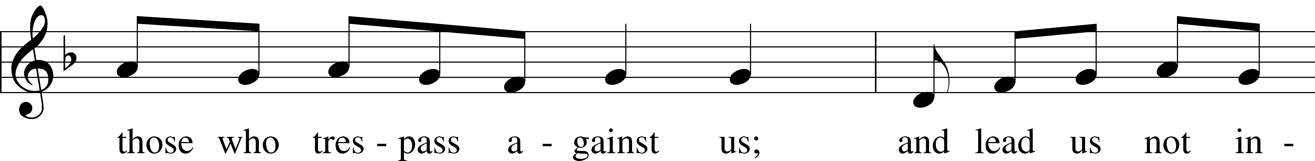
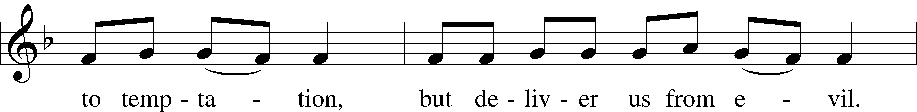
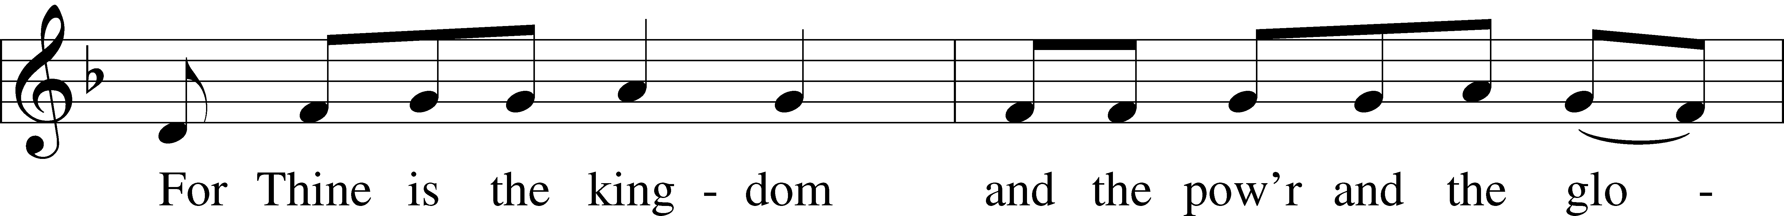
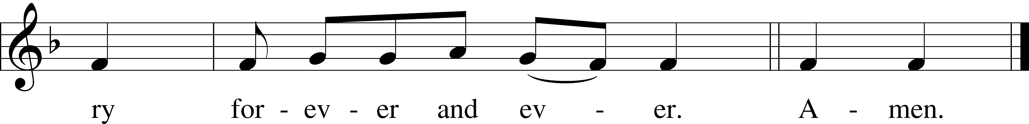

Text: Traditional Tune: Plainsong, mode VII Text and tune: Public domain

Collects
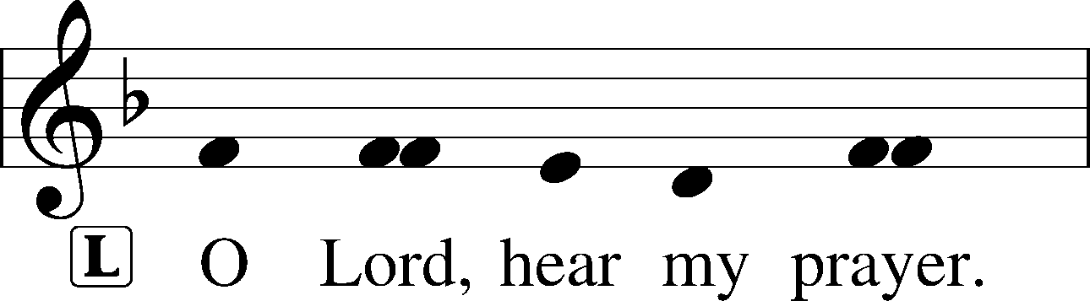
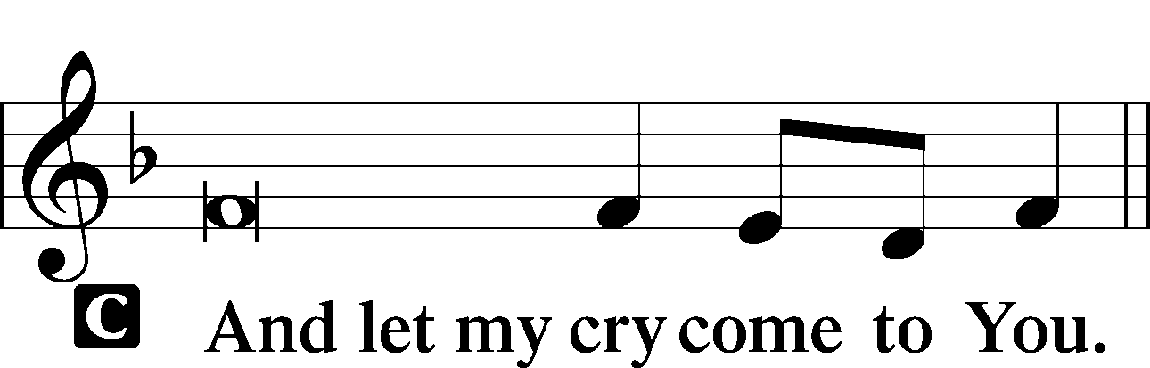

Collect of the Day
P Almighty and everlasting God, grant us by Your grace so to pass through this holy time of our Lord's passion that we may obtain the forgiveness of our sins; through Jesus Christ, Your Son, our Lord, who lives and reigns with You and the Holy Spirit, one God, now and forever.
Collect for Grace
P O Lord, our heavenly Father, almighty and everlasting God, You have safely brought us to the beginning of this day. Defend us in the same with Your mighty power and grant that this day we fall into no sin, neither run into any kind of danger, but that all our doings, being ordered by Your governance, may be righteous in Your sight; through Jesus Christ, Your Son, our Lord, who lives and reigns with You and the Holy Spirit, one God, now and forever.

Benedicamus LSB 228
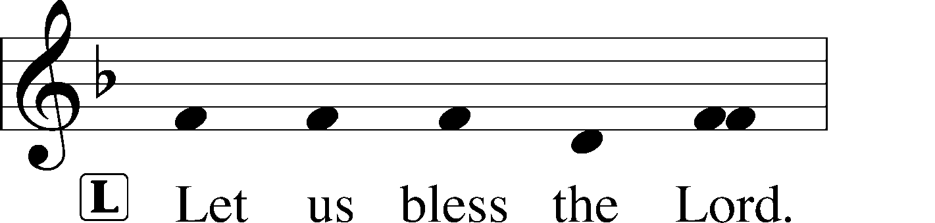
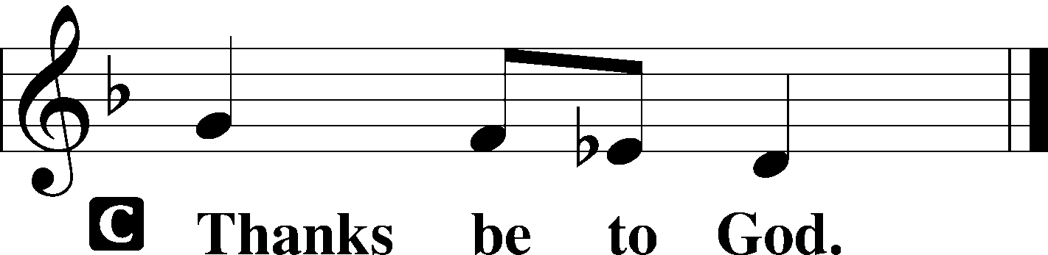

Benediction LSB 228
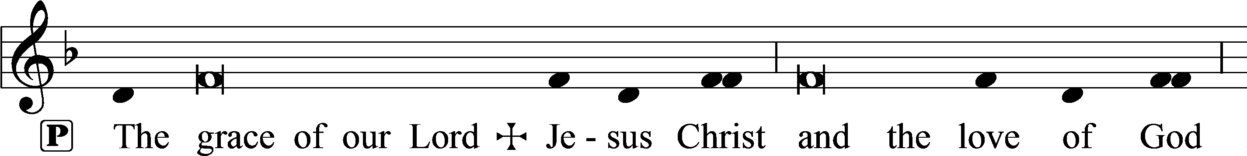
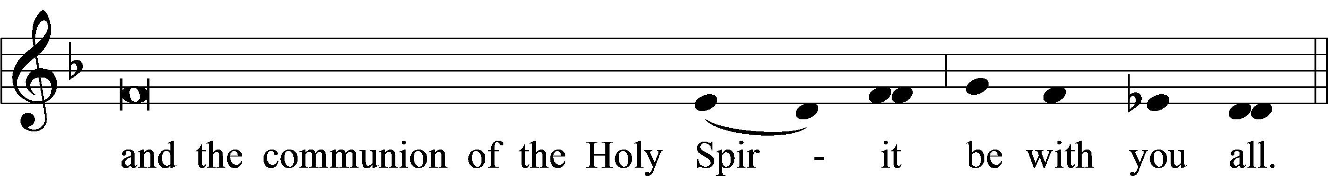

Acknowledgments
Matins from Lutheran Service Book
Unless otherwise indicated, Scripture quotations are from the ESV® Bible (The Holy Bible, English Standard Version®), copyright © 2001 by Crossway, a publishing ministry of Good News Publishers. Used by permission. All rights reserved.
Created by Lutheran Service Builder © 2024 Concordia Publishing House.

