Sts. Peter & Paul
Evangelical Lutheran Church
Lutheran Church-Missouri Synod
Founded-1917

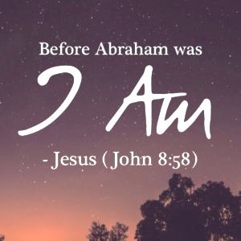

March 26, 2023

699 Stambaugh Ave.
Sharon, Pennsylvania 16146

“I was glad when they said to me,
Let us go to the house of the LORD!”
Psalm 122:1
Sts. Peter & Paul Evangelical Lutheran Church, LC-MS
JUDICA
March 26, 2023

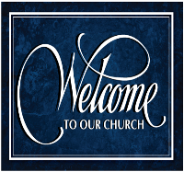
A special welcome to our guests this day! If you would like more information about The Lutheran Church - Missouri Synod, or this congregation, please speak with Pastor Deal or an Elder after the service.
Members & Guests: Don’t be embarrassed if your children make noise during the worship service, all children do. We encourage families to worship together but, if you feel the need, there are pews in the rear of the Church which are reserved for young families on both sides of the sanctuary. There is also a quiet room available to you during our service which is located down the hallway past the offices on the right side of the church as well as a children’s area in the Fellowship Hall where you are able to follow along with the service.

Today’s service includes the Sacrament of Holy Communion. If during this past year, you have not worshipped with us and been communed, we respectfully ask that you do not partake of this sacrament this day before first speaking with Pastor Deal.
If visiting from a sister congregation of the LC-MS and are in good standing, please inform Pastor Deal of your desire to commune prior to the service.
If wishing to receive a blessing during communion, please approach with your arms crossed.

CONTACT INFORMATION
Pastor Deal: pastordeal@saintspeterandpaul.net or 724-347-3620 (opt. 2)
Church Office: church@saintspeterandpaul.net or 724-347-3620 (opt. 3)

Silent prayer before worship: Heavenly Father, through Your Son Jesus I have freedom from sin and death. Cause Your Word to work in my heart that I may trust in Your grace alone through Christ to save me from sin and death. Amen.

Confession and Absolution

Opening Hymn: LSB #798 “The God of Abr’ham Praise”

The sign of the cross may be made by all in remembrance of their Baptism.

Invocation
P In the name of the Father and of the T Son and of the Holy Spirit.
C Amen.

Exhortation Hebrews 10:22; Psalm 124:8; Psalm 32:5
P Beloved in the Lord! Let us draw near with a true heart and confess our sins unto God our Father, beseeching Him in the name of our Lord Jesus Christ to grant us forgiveness.

P Our help is in the name of the Lord,
C who made heaven and earth.
P I said, I will confess my transgressions unto the Lord,
C and You forgave the iniquity of my sin.

Silence for reflection on God’s Word and for self-examination.

Confession of Sins
P O almighty God, merciful Father,
C I, a poor, miserable sinner, confess unto You all my sins and iniquities with which I have ever offended You and justly deserved Your temporal and eternal punishment. But I am heartily sorry for them and sincerely repent of them, and I pray You of Your boundless mercy and for the sake of the holy, innocent, bitter sufferings and death of Your beloved Son, Jesus Christ, to be gracious and merciful to me, a poor, sinful being.

Absolution [John 20:19–23]
P Upon this your confession, I, by virtue of my office, as a called and ordained servant of the Word, announce the grace of God unto all of you, and in the stead and by the command of my Lord Jesus Christ I forgive you all your sins in the name of the Father and of the T Son and of the Holy Spirit.
C Amen.
Service of the Word

Introit Psalm 43:3–5; antiphon: vv. 1–2a
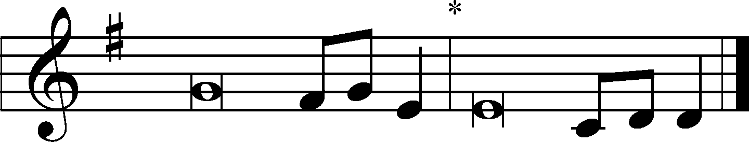
Vindicate me, | O God,*
and defend my cause against an ungodly | people,
from the deceitful and unjust man de- | liver me!*
For you are the God in whom I take | refuge.
Send out your light and your truth; let them | lead me;*
let them bring me to your holy hill and to your | dwelling!
Then I will go to the altar of God, to God my ex- | ceeding joy,*
and I will praise you with the lyre, O | God, my God.
Why are you cast down, O my soul, and why are you in turmoil with- | in me?*
Hope in God; for I shall again praise him, my salvation | and my God.

Kyrie Mark 10:47
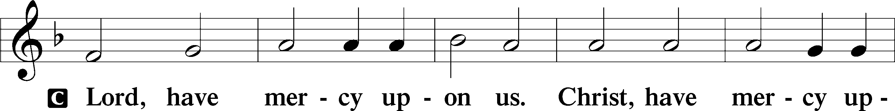
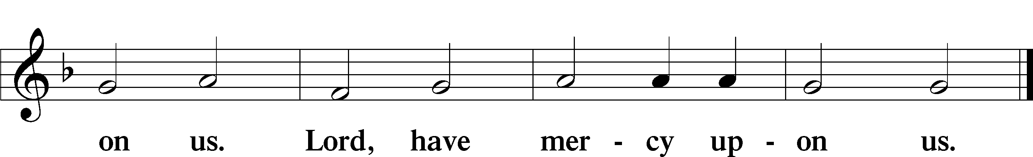

Salutation and Collect of the Day: Judica
P The Lord be with you.
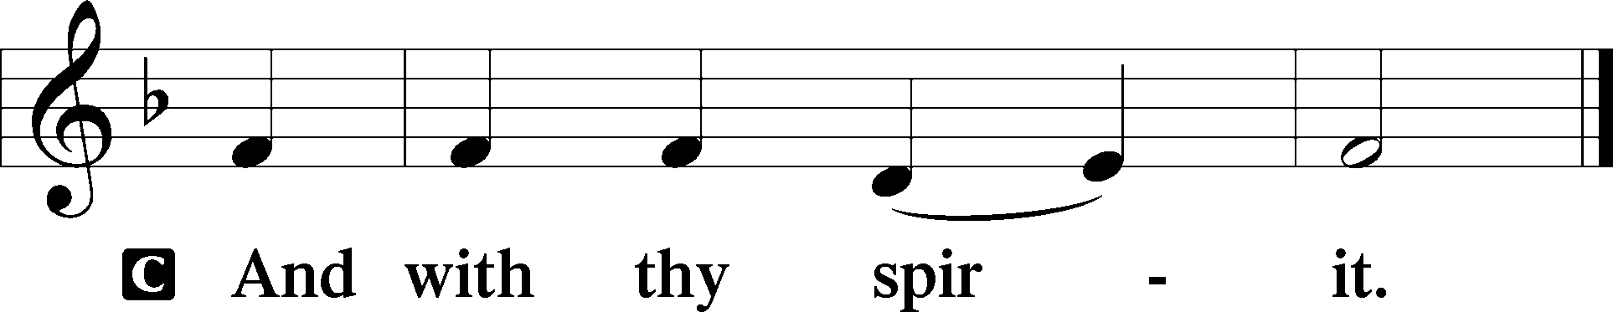

P Let us pray.
Almighty God, by Your great goodness mercifully look upon Your people that we may be governed and preserved evermore in body and soul; through Jesus Christ, Your Son, our Lord, who lives and reigns with You and the Holy Spirit, one God, now and forever.
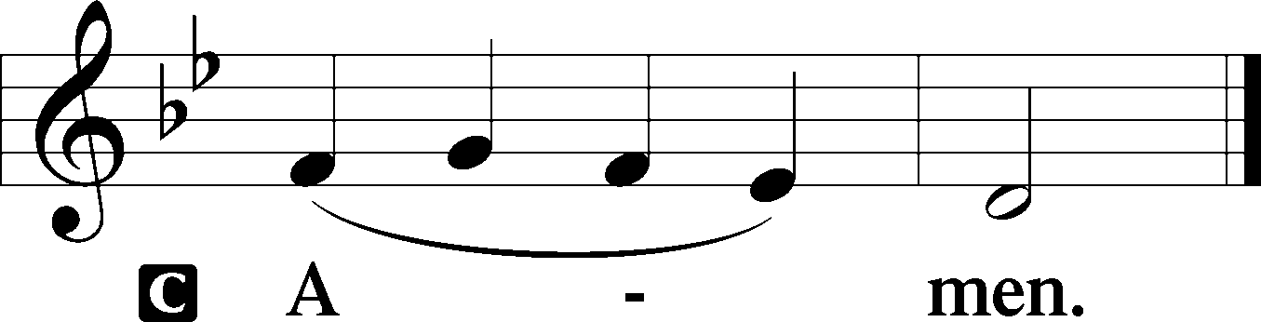
Sit

Prophecy: Genesis 22:1–19 (NKJV)
God tested Abraham, and said to him, “Abraham!” And he said, “Here I am.” Then He said, “Take now your son, your only son Isaac, whom you love, and go to the land of Moriah, and offer him there as a burnt offering on one of the mountains of which I shall tell you.” So Abraham rose early in the morning and saddled his donkey, and took two of his young men with him, and Isaac his son; and he split the wood for the burnt offering, and arose and went to the place of which God had told him. Then on the third day Abraham lifted his eyes and saw the place afar off. And Abraham said to his young men, “Stay here with the donkey; the lad and I will go yonder and worship, and we will come back to you.” So Abraham took the wood of the burnt offering and laid it on Isaac his son; and he took the fire in his hand, and a knife, and the two of them went together. But Isaac spoke to Abraham his father and said, “My father!” And he said, “Here I am, my son.” Then he said, “Look, the fire and the wood, but where is the lamb for a burnt offering?” And Abraham said, “My son, God will provide for Himself the lamb for a burnt offering.” So the two of them went together. Then they came to the place of which God had told him. And Abraham built an altar there and placed the wood in order; and he bound Isaac his son and laid him on the altar, upon the wood. And Abraham stretched out his hand and took the knife to slay his son. But the Angel of the Lord called to him from heaven and said, “Abraham, Abraham!” So he said, “Here I am.” And He said, “Do not lay your hand on the lad, or do anything to him; for now I know that you fear God, since you have not withheld your son, your only son, from Me.” Then Abraham lifted his eyes and looked, and there behind him was a ram caught in a thicket by its horns. So Abraham went and took the ram, and offered it up for a burnt offering instead of his son. And Abraham called the name of the place, The-Lord-Will-Provide; as it is said to this day, “In the Mount of the Lord it shall be provided.” Then the Angel of the Lord called to Abraham a second time out of heaven, and said: “By Myself I have sworn, says the Lord, because you have done this thing, and have not withheld your son, your only son—blessing I will bless you, and multiplying I will multiply your descendants as the stars of the heaven and as the sand which is on the seashore; and your descendants shall possess the gate of their enemies. In your seed all the nations of the earth shall be blessed, because you have obeyed My voice.” So Abraham returned to his young men, and they rose and went together to Beersheba; and Abraham dwelt at Beersheba.

P This is the Word of the Lord.
C Thanks be to God.

Gradual Psalm 143:9a, 10a; 18:48a, c
Deliver me from my enemies, | O Lord!*
Teach me to do your will, for you | are my God!
[You] delivered me from my | enemies;*
you rescued me from the man of | violence.

Choir: “Create in Me”

Epistle: Hebrews 9:11–15 (NKJV)
Brethren: Christ came as High Priest of the good things to come, with the greater and more perfect tabernacle not made with hands, that is, not of this creation. Not with the blood of goats and calves, but with His own blood He entered the Most Holy Place once for all, having obtained eternal redemption. For if the blood of bulls and goats and the ashes of a heifer, sprinkling the unclean, sanctifies for the purifying of the flesh, how much more shall the blood of Christ, who through the eternal Spirit offered Himself without spot to God, cleanse your conscience from dead works to serve the living God? And for this reason He is the Mediator of the new covenant, by means of death, for the redemption of the transgressions under the first covenant, that those who are called may receive the promise of the eternal inheritance, in Christ Jesus our Lord.

P This is the Word of the Lord.
C Thanks be to God.

Stand

Holy Gospel: John 8:46–59a (NKJV)
P The Holy Gospel according to St. John, the eighth chapter.
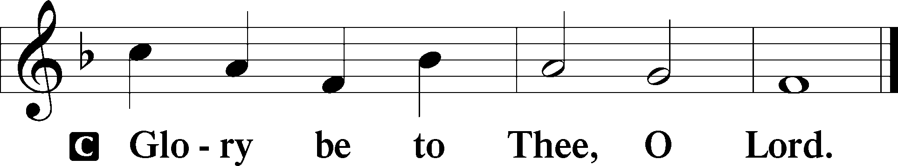

“Which one of you convicts me of sin? If I tell the truth, why do you not believe me? Whoever is of God hears the words of God. The reason why you do not hear them is that you are not of God.”
The Jews answered him, “Are we not right in saying that you are a Samaritan and have a demon?” Jesus answered, “I do not have a demon, but I honor my Father, and you dishonor me. Yet I do not seek my own glory; there is One who seeks it, and he is the judge. Truly, truly, I say to you, if anyone keeps my word, he will never see death.” The Jews said to him, “Now we know that you have a demon! Abraham died, as did the prophets, yet you say, ‘If anyone keeps my word, he will never taste death.’ Are you greater than our father Abraham, who died? And the prophets died! Who do you make yourself out to be?” Jesus answered, “If I glorify myself, my glory is nothing. It is my Father who glorifies me, of whom you say, ‘He is our God.’ But you have not known him. I know him. If I were to say that I do not know him, I would be a liar like you, but I do know him and I keep his word. Your father Abraham rejoiced that he would see my day. He saw it and was glad.” So the Jews said to him, “You are not yet fifty years old, and have you seen Abraham?” Jesus said to them, “Truly, truly, I say to you, before Abraham was, I am.” So they picked up stones to throw at him, but Jesus hid himself and went out of the temple.

P This is the Gospel of the Lord.
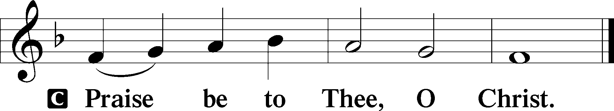

Nicene Creed
C I believe in one God,
the Father Almighty,
maker of heaven and earth
and of all things visible and invisible.

And in one Lord Jesus Christ,
the only-begotten Son of God,
begotten of His Father before all worlds,
God of God, Light of Light,
very God of very God,
begotten, not made,
being of one substance with the Father,
by whom all things were made;
who for us men and for our salvation came down from heaven
and was incarnate by the Holy Spirit of the virgin Mary
and was made man;
and was crucified also for us under Pontius Pilate.
He suffered and was buried.
And the third day He rose again according to the Scriptures
and ascended into heaven
and sits at the right hand of the Father.
And He will come again with glory to judge both the living and the dead,
whose kingdom will have no end.

And I believe in the Holy Spirit,
the Lord and giver of life,
who proceeds from the Father and the Son,
who with the Father and the Son together is worshiped and glorified,
who spoke by the prophets.
And I believe in one holy Christian and apostolic Church,
I acknowledge one Baptism for the remission of sins,
and I look for the resurrection of the dead
and the life T of the world to come. Amen.
Sit

Hymn of the Day: LSB #430 “My Song Is Love Unknown”

Sermon

Stand

Prayer of the Church

Offertory Psalm 51:10–12
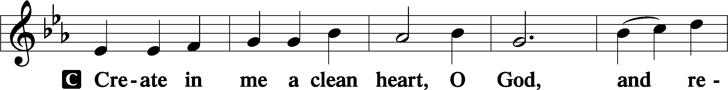
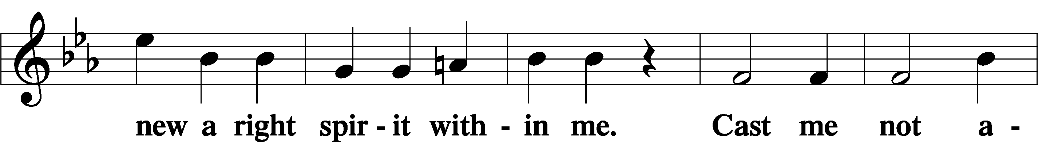
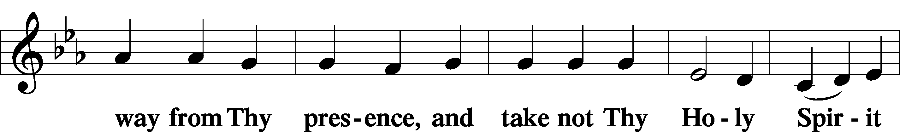
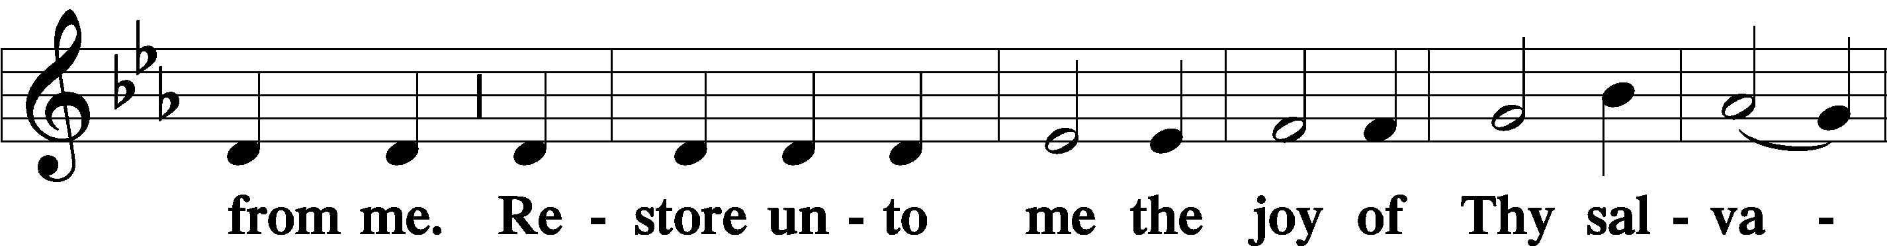
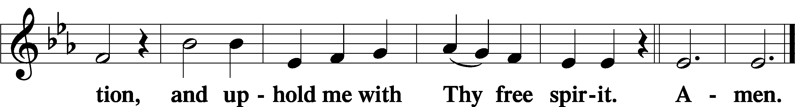
Sit

Preparatory Hymn: LSB #631 “Here, O My Lord, I See Thee Face to Face”

Stand
Service of the Sacrament

Preface 2 Timothy 4:22; Colossians 3:1 Psalm 136
P The Lord be with you.
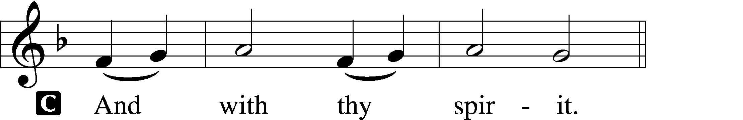

P Lift up your hearts.
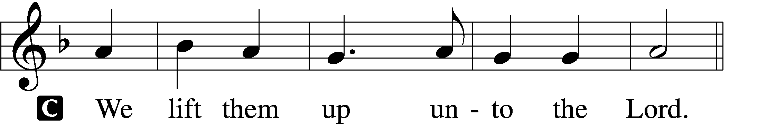

P Let us give thanks unto the Lord, our God.
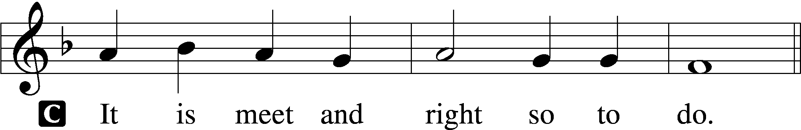

Proper Preface (Abbreviated) LSB 194
P It is truly meet, right, and salutary . . . evermore praising You and saying:

Sanctus Isaiah 6:3; Matthew 21:9
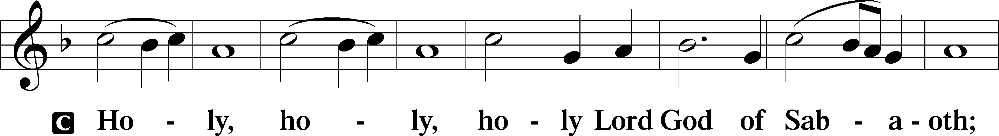
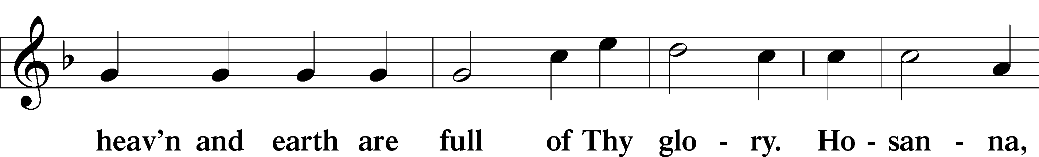
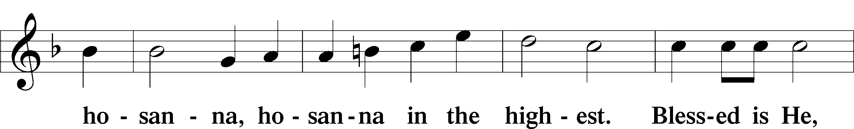
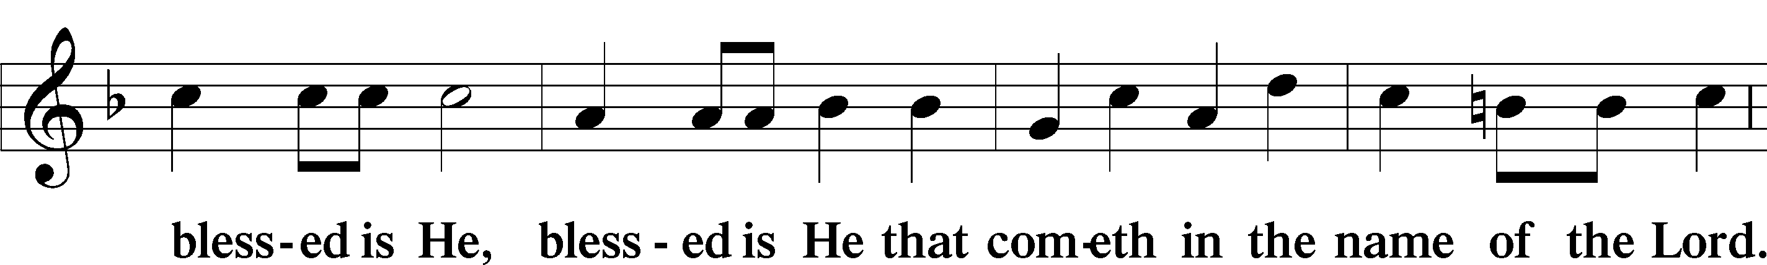
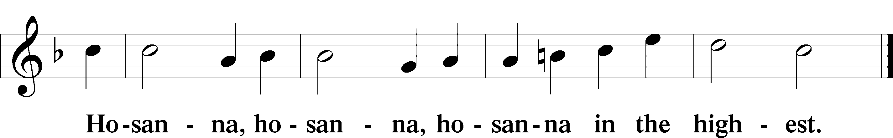

Lord’s Prayer Matthew 6:9–13
C Our Father who art in heaven,
hallowed be Thy name,
Thy kingdom come,
Thy will be done on earth as it is in heaven;
give us this day our daily bread;
and forgive us our trespasses as we forgive those who trespass against us;
and lead us not into temptation,
but deliver us from evil.
For Thine is the kingdom and the power and the glory forever and ever. Amen.

The Words of Our Lord Matthew 26:26–28; Mark 14:22–24; Luke 22:19–20; 1 Corinthians 11:23–25
P Our Lord Jesus Christ, on the night when He was betrayed, took bread, and when He had given thanks, He broke it and gave it to the disciples and said: “Take, eat; this is My T body, which is given for you. This do in remembrance of Me.”

In the same way also He took the cup after supper, and when He had given thanks, He gave it to them, saying: “Drink of it, all of you; this cup is the new testament in My T blood, which is shed for you for the forgiveness of sins. This do, as often as you drink it, in remembrance of Me.”
Pax Domini John 20:19
P The peace of the Lord be with you always.
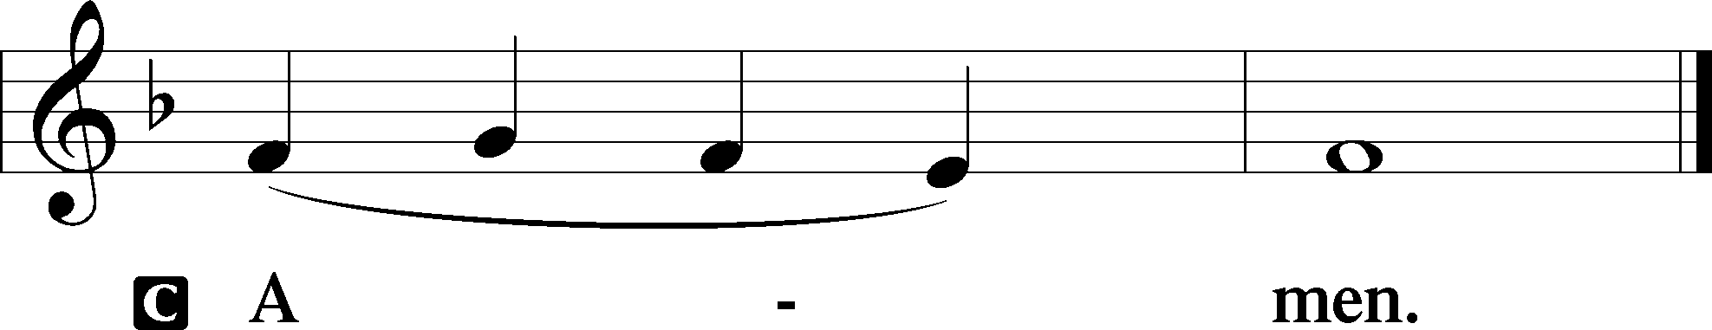

Agnus Dei John 1:29
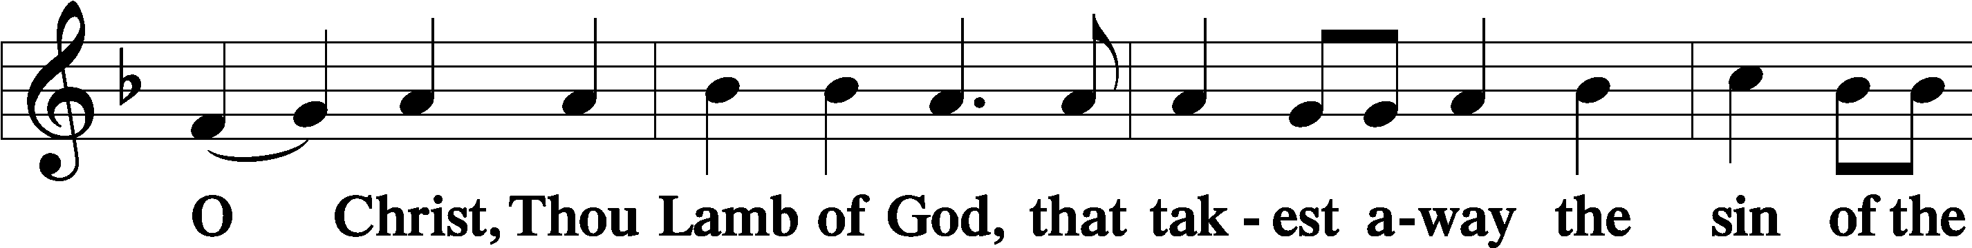
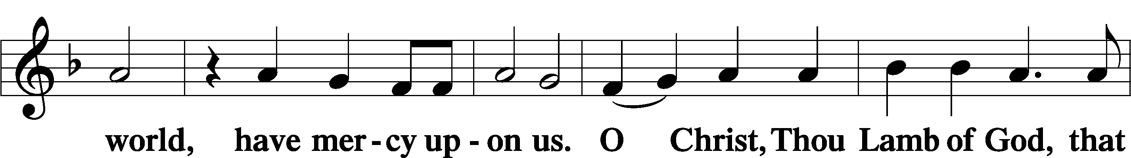
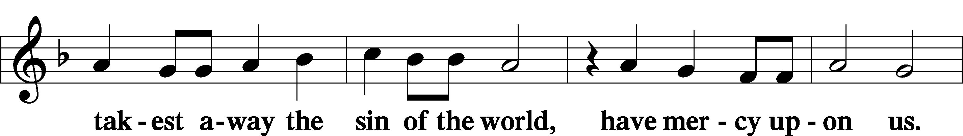
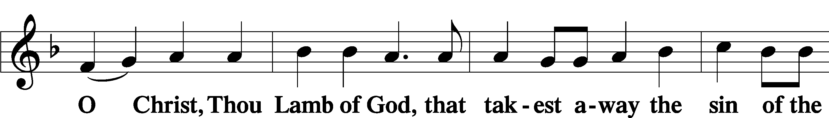
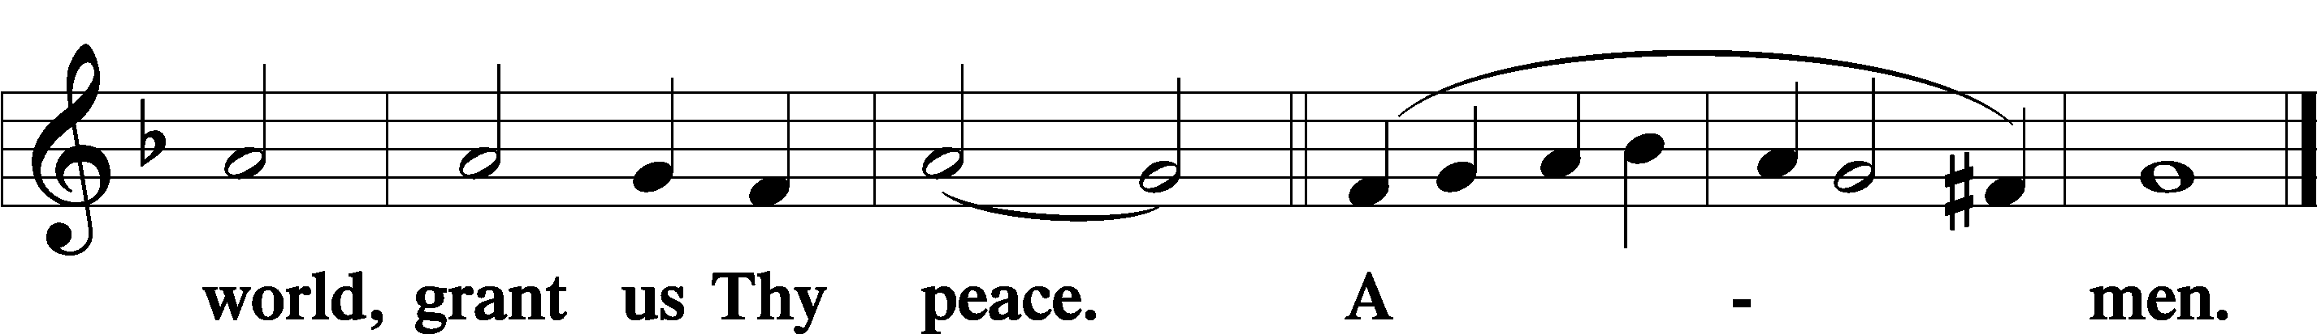
Sit

Distribution
The pastor and those who assist him receive the body and blood of Christ first and then distribute them to those who come to receive, saying:
Take, eat; this is the true body of our Lord and Savior Jesus Christ, given into death for your sins.
Amen.

Take, drink; this is the true blood of our Lord and Savior Jesus Christ, shed for the forgiveness of your sins.
Amen.

In dismissing the communicants, the following is said:
The Dismissal
P The body and blood of our Lord Jesus Christ strengthen and preserve you in body and soul to life everlasting. Depart T in peace.
C Amen.

Distribution Hymn: LSB #563 “Jesus, Thy Blood and Righteousness”

Distribution Hymn: TLH #148 “Lord Jesus Christ, My Life, My Light”
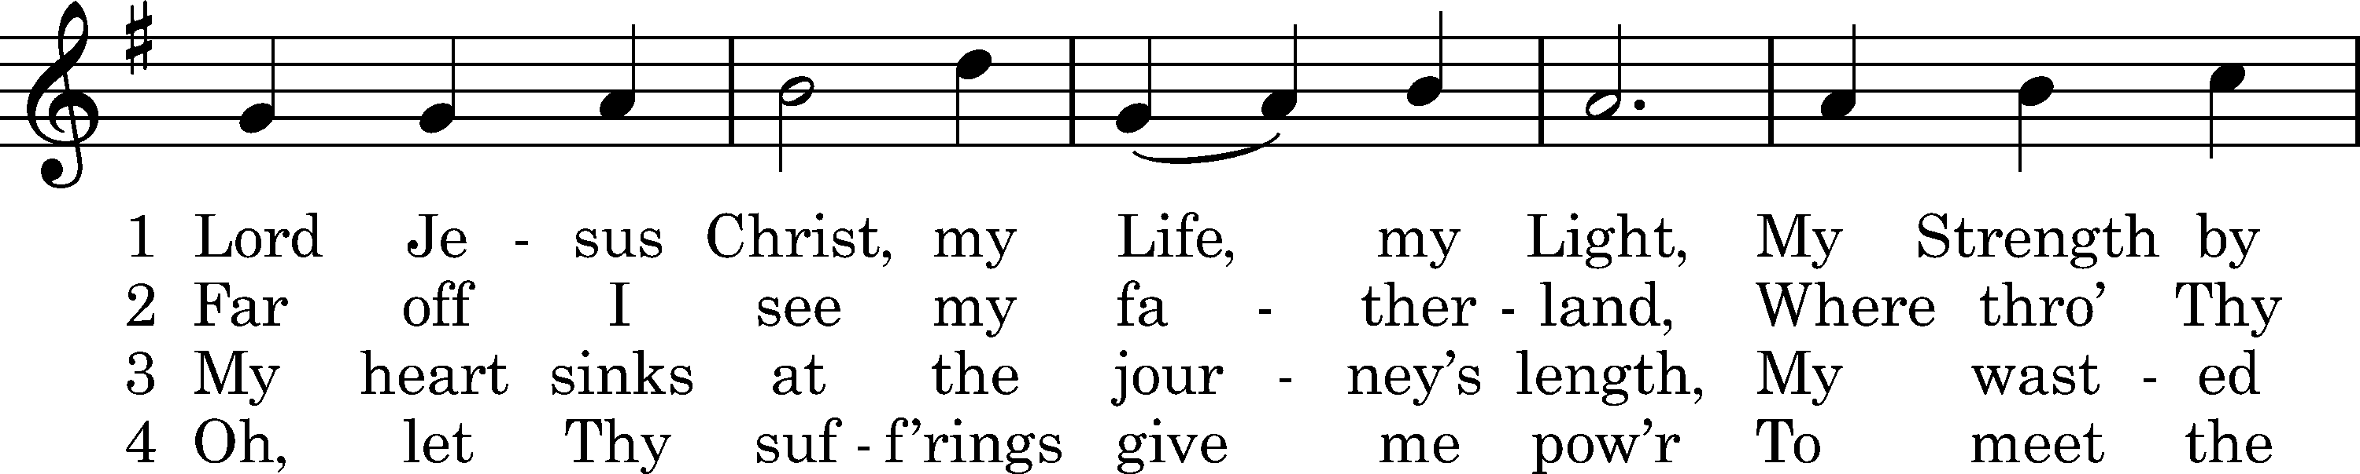
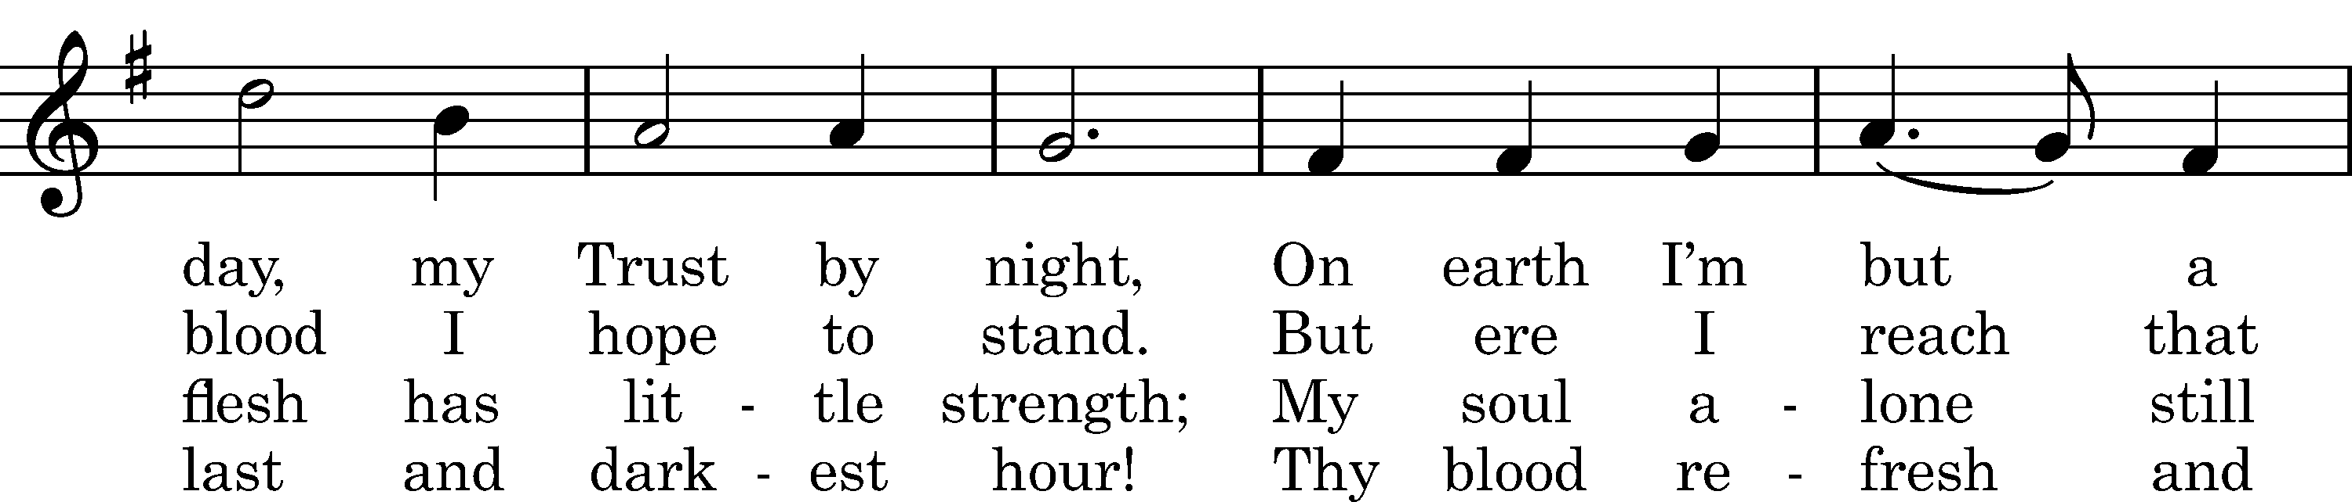
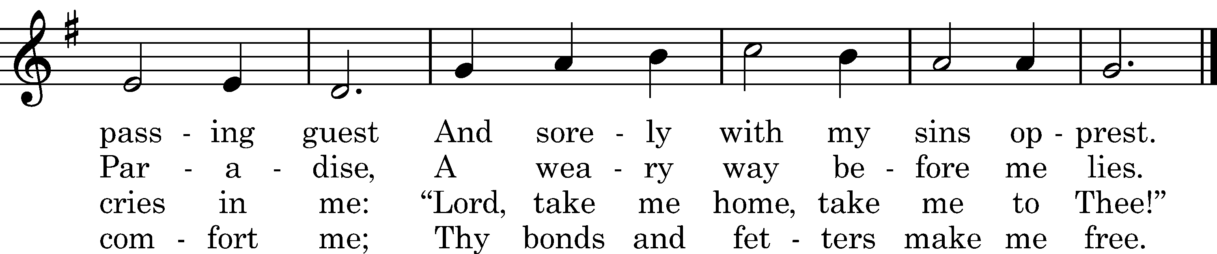

5 Oh, let Thy holy wounds for me
Clefts in the rock forever be
Where as a dove my soul can hide
And safe from Satan's rage abide.

6 And when my spirit flies away,
Thy dying words shall be my stay.
Thy cross shall be my staff in life,
Thy holy grave my rest from strife.

7 Lord, in Thy nail-prints let me read
That Thou to save me hast decreed
And grant that in Thine opened side
My troubled soul may ever hide.

8 Since Thou hast died, the Pure, the Just.
I take my homeward way in trust.
The gates of heav'n, Lord, open wide
When here I may no more abide.

9 And when the last Great Day shall come
And Thou, our Judge, shalt speak the doom,
Let me with joy behold the light
And set me then upon Thy right.

10 Renew this wasted flesh of mine
That like the sun it there may shine
Among the angels pure and bright,
Yea, like Thyself in glorious light.

11 Ah, then I'll have my heart's desire,
When, singing with the angels' choir,
Among the ransomed of Thy grace,
Forever I'll behold Thy face!
Text: tr. Catherine Winkworth, 1863, alt.; Martin Behm, 1610, cento
Tune: Nuernbergisches Gesangbuch, 1676
Text and tune: Public domain

Distribution Hymn: LSB #431 “Not All the Blood of Beasts”

Stand

The Nunc Dimittis is not included on Judica Sunday.

Thanksgiving Psalm 107:1
P O give thanks unto the Lord, for He is good,
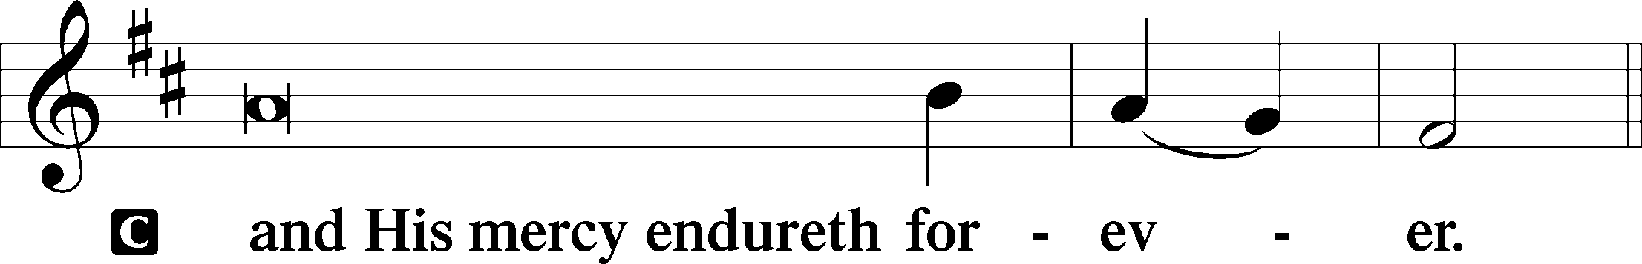

Post-Communion Collect
P Let us pray.
We give thanks to You, almighty God, that You have refreshed us through this salutary gift, and we implore You that of Your mercy You would strengthen us through the same in faith toward You and in fervent love toward one another; through Jesus Christ, Your Son, our Lord, who lives and reigns with You and the Holy Spirit, one God, now and forever.
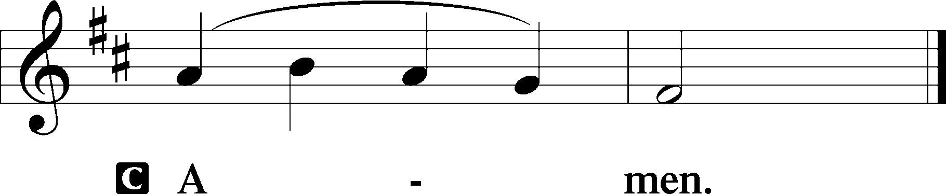

Salutation 2 Timothy 4:22
P The Lord be with you.
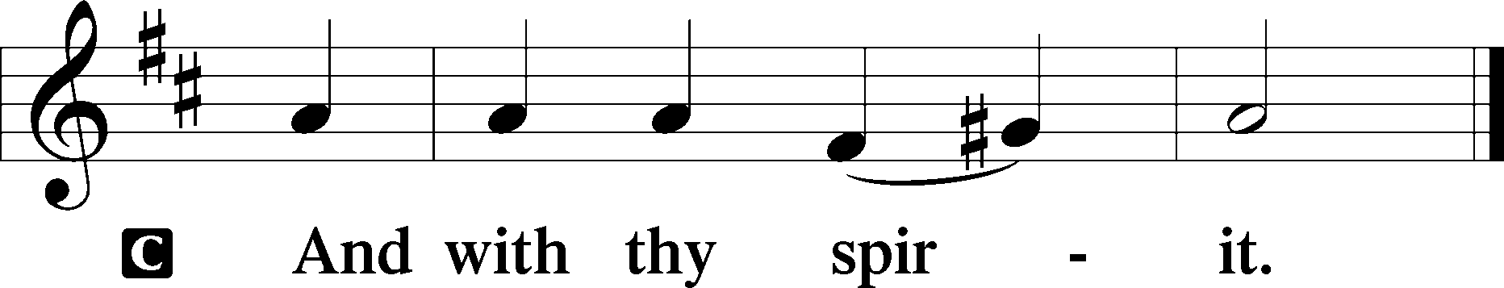

Benedicamus Psalm 103:1
P Bless we the Lord.
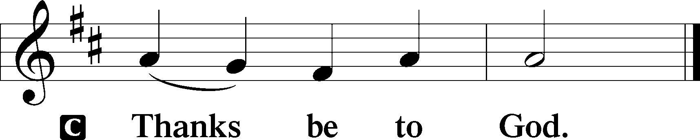

Benediction Numbers 6:24–26
P The Lord bless you and keep you.
The Lord make His face shine upon you and be gracious unto you.
The Lord lift up His countenance upon you and T give you peace.
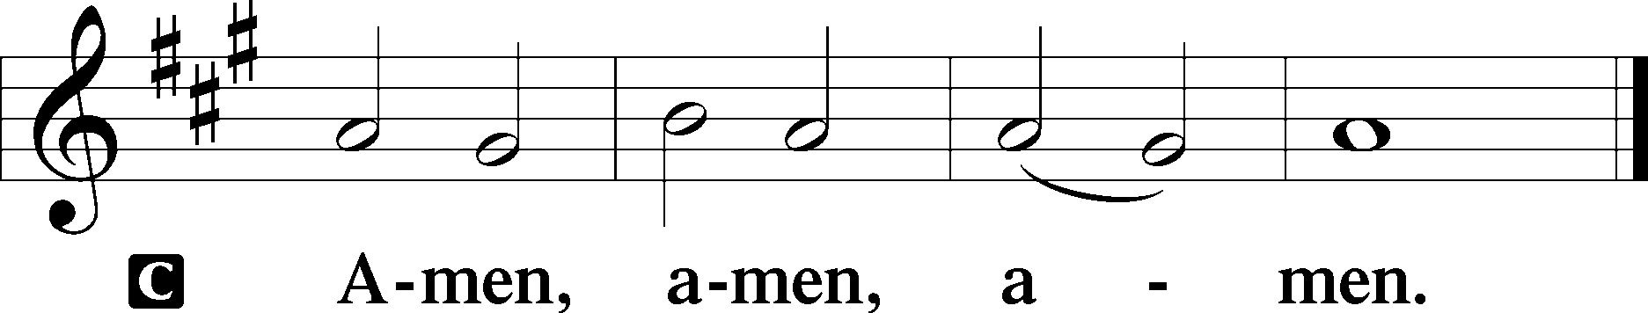

Closing Hymn: LSB #544 “O Love, How Deep”

Silent prayer after worship: Almighty God, lead me to honor You above all things, to cherish Your gift of salvation through Christ’s life, death and resurrection, and to share this gift with others. In Jesus’s name. Amen.
fffffffffffffffffffffffffffffffffff
Acknowledgments
Unless otherwise indicated, Scripture quotations are from the ESV® Bible (The Holy Bible, English Standard Version®), copyright © 2001 by Crossway, a publishing ministry of Good News Publishers. Used by permission. All rights reserved.
Created by Lutheran Service Builder © 2023 Concordia Publishing House.
fffffffffffffffffffffffffffffffffff
fffffffffffffffffffffffffffffffffff
In Loving Memory of John Daris, Husband, Father, & Grandfather: Anna Mae, Karen and Susan, Brooke and Morgan.
In Loving Memory of Anson Holcroft: Lisa & John McMath (Capital Campaign), Joani Rice (Major Repair), Viola Sakony, and Betty & Bill Wolf (Capital Campaign).
In Loving Memory of David Nelson: Dolores Fee (Food Pantry), Hank Holcroft (Food Pantry), Clara Krivosh (Food Pantry), Rev. Ed & Irene Kucera (Food Pantry), and Edeltraud Sulek (Capital Campaign).
fffffffffffffffffffffffffffffffffff
Attendance: Sunday, March 19, 2023: 36
Wednesday, March 22: 27 (11~noon; 16~7pm)
fffffffffffffffffffffffffffffffffff
THANK YOU FOR SERVING IN MARCH: Elder: Jonathan Baisch; Ushers: Cheryl Fedele, Mike Flaugher, and Jesse Riffle; Altarware: (prior) Diane Riefstahl & Marie Flaugher (3/12); (after) Elizabeth Haenftling & Traudi Sulek.
fffffffffffffffffffffffffffffffffff
THANK YOU FOR SERVING IN APRIL: Elder: Jonathan Baisch; Ushers: Jerry Krivosh, Barry Nelson, & Jeff Sutton; Altarware: (prior) Diane Riefstahl & Marie Flaugher (04/09 & 04/30); (after) Elizabeth Haenftling (04/02 & 04/16) & Marie Flaugher (04/09, 04/23, & 04/30).
fffffffffffffffffffffffffffffffffff
SCHEDULE THROUGH APRIL 2, 2023:

:

Today, 7 pm, Fellowship Hall: AA Meeting
Tuesday, 7 pm, All Saints~Slippery Rock: Lenten Midweek Vespers Service
7-9 pm, Fellowship Hall: Penn-Ohio Singers
Wednesday, Noon, Sanctuary: Lenten Midweek Matins Service
5:30 pm, Sanctuary: Choir Rehearsal
7 pm, Sanctuary: Lenten Midweek Vespers Service
7:30 pm, Fellowship Hall: NA Meeting
Saturday, 9 am, All Saints~Slippery Rock: Catechism Class
Next Sunday, 9 am, Sanctuary: Divine Service
Following, Coffee Fellowship: Fellowship Hall
7 pm, Fellowship Hall: AA Meeting
fffffffffffffffffffffffffffffffffff
Bible Memory Verses ~ Week of March 26th:
For Adults: Be angry and do not sin; do not let the sun go down on your anger, and give no opportunity to the devil. Ephesians 4:26-27
For Children: Christ says: “For their sake I consecrate myself, that they also may be sanctified in truth.” John 17:19
fffffffffffffffffffffffffffffffffff
Today is the final day to purchase Easter flowers (Easter lilies and daffodils) to adorn our sanctuary Easter Sunday. The choice of flowers this year is limited to accommodate those with allergies. Order forms may be found on the tables in the narthex and by Pastor Deal’s office. Payment is due at the time of ordering.
fffffffffffffffffffffffffffffffffff
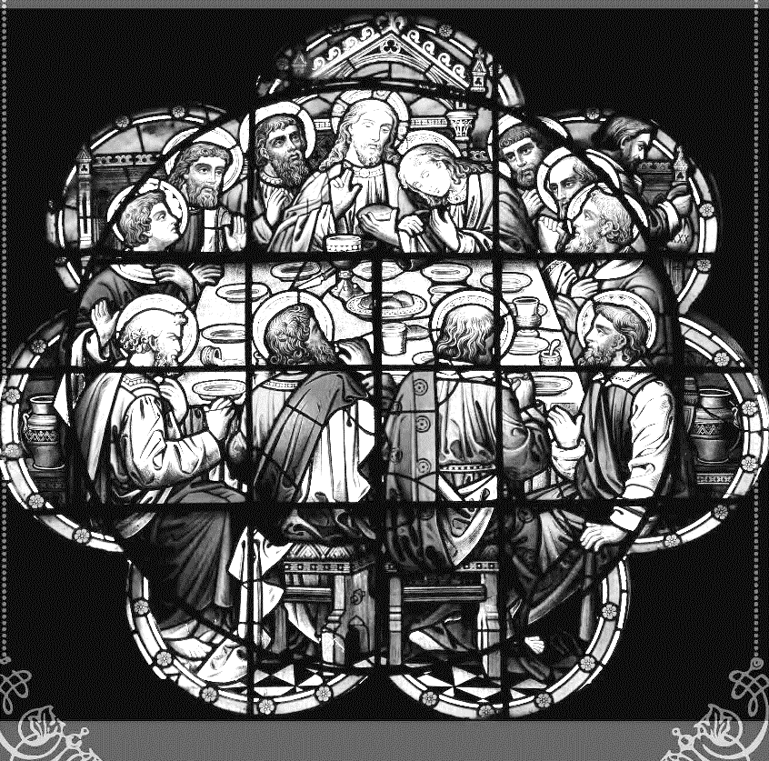
Join us this Lenten season as we focus on the Lord’s Supper with the following Wednesday midweek services through the end of March:
Matins Service at Noon
Vespers Service at 7 pm
fffffffffffffffffffffffffffffffffff
The April issue of “The Rock and the Sword” newsletter is available on the tables in the narthex and by Pastor Deal’s office.
Our Stewardship of Treasures for the Lord:
In order to do the Lord’s work, we need $2,553.63 each week to meet our 2023 budget for general purposes and $76.92 for the SELC.
Online Figures (March 2, 3, and 16, 2023)
General Fund: $1080.00
SELC: $100.00
Food Pantry: $100.00
Capital Campaign: $200.00
Figures for Wednesday, March 15, 2023
General Fund: $243.00
SELC: $25.00
Food Pantry: $20.00
Capital Campaign: $600.00
Other: $13.00
Figures for Sunday, March 19, 2023
General Fund: $5,533.00 Ahead for the week*: +$4,302.37
SELC: $325.00 Ahead for the week*: +$373.08
Food Pantry: $1,255.00
Quarterly Missions: $110.00
Capital Campaign: $476.00 *Includes above figures.
Other: $751.00

For online giving, check out https://www.saintspeterandpaul.net/online-giving.
fffffffffffffffffffffffffffffffffff
April Coffee Fellowship Date Change: Please note that the date for April’s Coffee Fellowship has been changed to April 16th. April’s sponsors, Isaiah & Titus Deal, hope that you will be able to join them that day.
If interested in sponsoring a Coffee Fellowship, please sign the sheet posted in the narthex. Sponsors are asked to drop off 2-3 dozen “treats” and 1 quart of juice in the kitchen prior to worship. Set-up (including the making of coffee) and clean-up will be done for you!
fffffffffffffffffffffffffffffffffff
Copies of the “Portals of Prayer” for April, May, and June 2023 are available in the narthex and main hallway.
Remember the following in Prayer…
~The Hurting and Healing: Amy, Gerald Arthur, Evelyn Baisch, Ellen Baron^{CA}, Lois Bortner^{CA}, John Burdette, Bev & Joe Chlpka, Kathleen Coughenour, Kim, Anna Mae Daris, Susan Davies, Tim Dudash, Millie Elavsky, Joseph Fleet, Judith & Eddy Furey, Tim Haenftling, Austin Hamilton, Neil Huston, Joan, Darla Krajci, Barbara Kreske, Donna Kennedy, Jess Lavoie, Paul Lucas^{CA}, Sandy Marshall, Frank Niemeyer^{CA}, Linda Parkany, Juanita Rentschler, Richard Reuning^{CA}, Nancy Robertson^{CA}, Viola Sakony, Marty Scott, Kara, Fred Tonty, Angela Weser^{CA}, and Ruth Wolf.
~The Homebound: Rudy & Jean Tomko, Betty Wolf, and Ed & Millie Zachar.
~Celebrating: Birthday ~ Dillon Hamilton (04.02). Anniversary ~ Brian & Liz Shreffler.
~Serving in the Military: Curtis Sinewe and Joshua Solyan.
~Community & World Needs: Those suffering from or affected by the coronavirus; those suffering due to the conflict between Ukraine and Russia; those suffering from loss and dislocation because weather disasters; those suffering from addiction and their families; Local, State, and National Government Leaders; safety for all Police Officers, Firefighters, & First Responders; the unemployed; our First Quarter Local Mission: Sts. Peter & Paul’s Community Day 2023. *CA represents cancer.
fffffffffffffffffffffffffffffffffff
Next Sunday is Palm Sunday. Weather-permitting, we will be processing into the church at the beginning of the service. (Exiting the Clover St. door, and entering the main narthex doors.) If able to join us, please meet in the main hallway by the offices at 8:55 am.
fffffffffffffffffffffffffffffffffff

Here to Serve
Pastor………………………………………………...……………Rev. Jacob Deal
E-mail …………………………….……pastordeal@saintspeterandpaul.net
Phone Number……………………..…………………724-347-3620 (Option 2)
Church Office………………………..…………………724-347-3620 (Option 3)
Website …………………………………………www.saintspeterandpaul.net
Secretary…………………………………………………………Diane Riefstahl
E-mail ………………………………………church@saintspeterandpaul.net
Website …………………………………………www.saintspeterandpaul.net
Food Pantry: Please leave message……………724-347-3620 (Option 3)
AA Contact: Steve………………………………………………..…724-813-2358
NA Contact: Larry………………………………………………..724-977-8733
Choir Director………………………………………………………Chris Nelson
Congregation President……………………………………Jonathan Baisch
Church Elder …………………………………………...…… Jonathan Baisch
fffffffffffffffffffffffffffffffffff
If needing to get into the church building during the week, please phone first to make certain someone is here to let you in.

