Sts. Peter & Paul
Evangelical Lutheran Church
Lutheran Church-Missouri Synod
Founded-1917

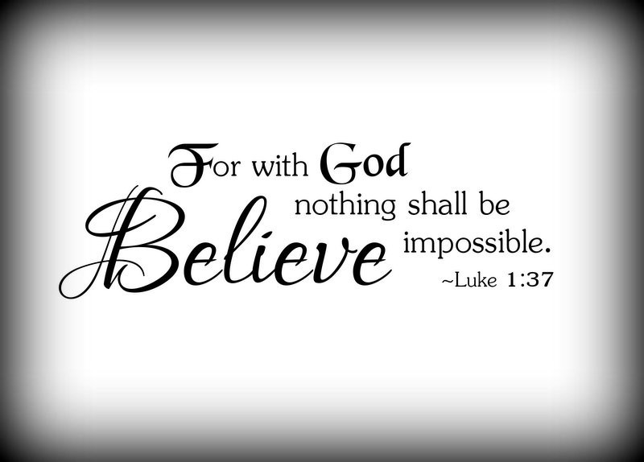

March 25, 2024

699 Stambaugh Ave.
Sharon, Pennsylvania 16146

“I was glad when they said to me,
Let us go to the house of the LORD!”
Psalm 122:1
Sts. Peter & Paul Evangelical Lutheran Church, LC-MS
THE ANNUNCIATION OF OUR LORD
March 25, 2024

Silent prayer before worship: Heavenly Father, through Your Son Jesus I have freedom from sin and death. Cause Your Word to work in my heart that I may trust in Your grace alone through Christ to save me from sin and death. Amen.

Confession and Absolution

Opening Hymn: LSB #351 “Creator of the Stars of Night”

The sign of the cross may be made by all in remembrance of their Baptism.

Invocation
P In the name of the Father and of the T Son and of the Holy Spirit.
C Amen.

Exhortation Hebrews 10:22; Psalm 124:8; Psalm 32:5
P Beloved in the Lord! Let us draw near with a true heart and confess our sins unto God our Father, beseeching Him in the name of our Lord Jesus Christ to grant us forgiveness.

P Our help is in the name of the Lord,
C who made heaven and earth.
P I said, I will confess my transgressions unto the Lord,
C and You forgave the iniquity of my sin.

Silence for reflection on God’s Word and for self-examination.

Confession of Sins
P O almighty God, merciful Father,
C I, a poor, miserable sinner, confess unto You all my sins and iniquities with which I have ever offended You and justly deserved Your temporal and eternal punishment. But I am heartily sorry for them and sincerely repent of them, and I pray You of Your boundless mercy and for the sake of the holy, innocent, bitter sufferings and death of Your beloved Son, Jesus Christ, to be gracious and merciful to me, a poor, sinful being.

Absolution [John 20:19–23]
P Upon this your confession, I, by virtue of my office, as a called and ordained servant of the Word, announce the grace of God unto all of you, and in the stead and by the command of my Lord Jesus Christ I forgive you all your sins in the name of the Father and of the T Son and of the Holy Spirit.
C Amen.
Service of the Word

Introit Psalm 34:1–3; antiphon: Isaiah 62:11b
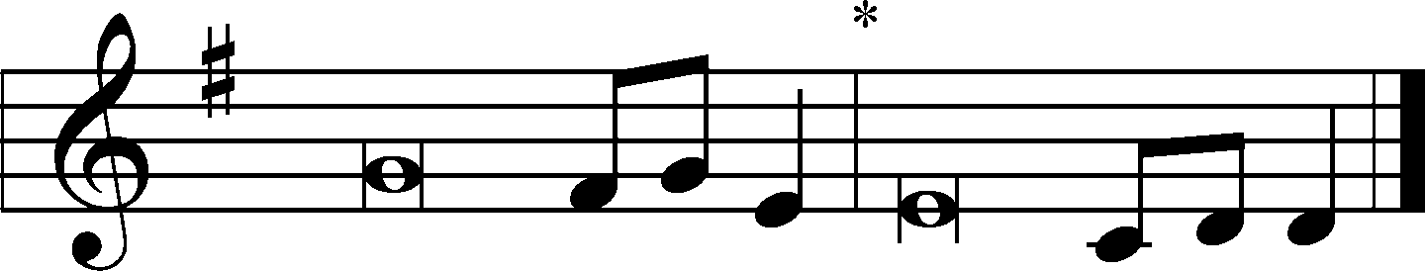
Say to the daughter of | Zion,*
“Behold, your sal- | vation comes.”
I will bless the Lord at | all times;*
his praise shall continually be | in my mouth.
My soul makes its boast | in the Lord;*
let the humble hear | and be glad.
Oh, magnify the | Lord with me,*
and let us exalt his name to- | gether!

Kyrie Mark 10:47
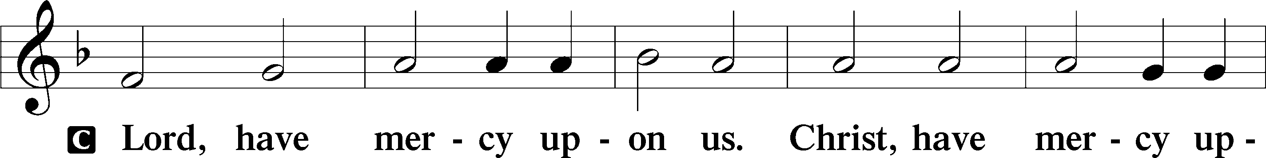
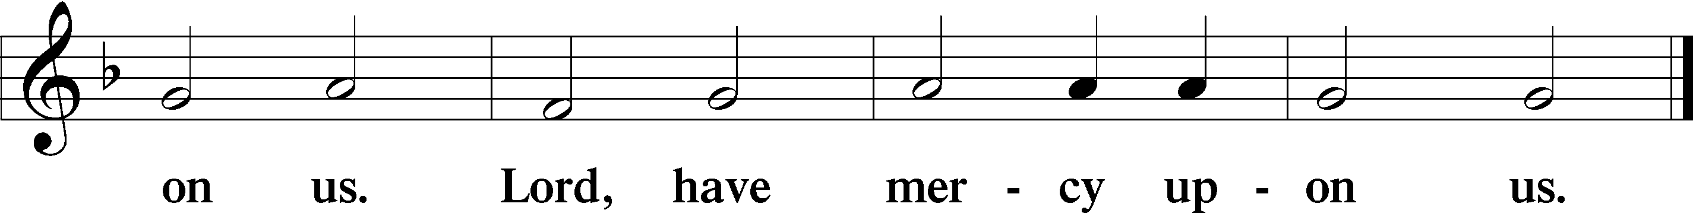
Salutation and Collect of the Day: The Annunciation of Our Lord
P The Lord be with you.
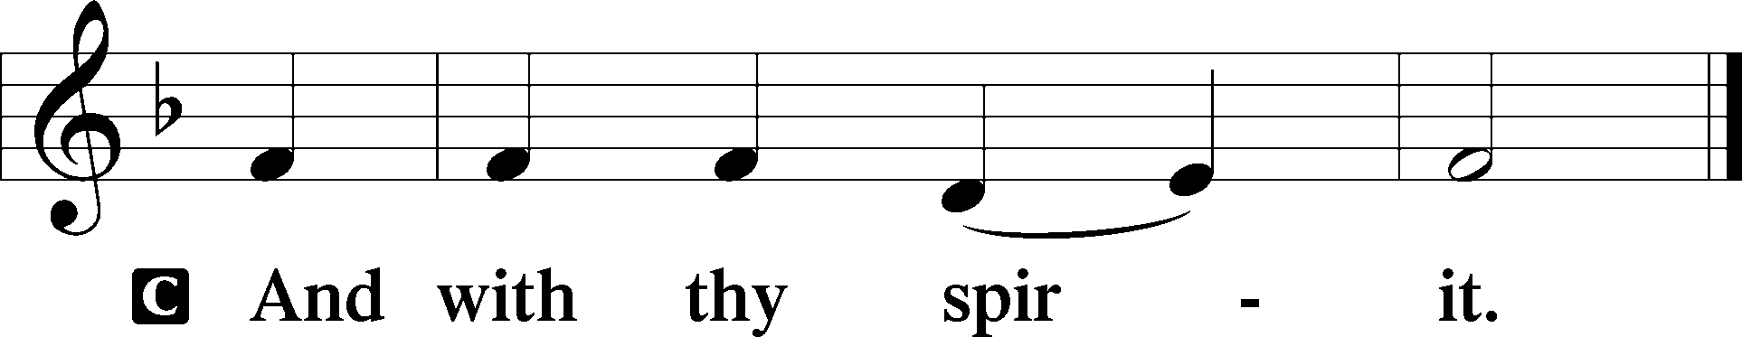

P Let us pray.
O Lord, as we have known the incarnation of Your Son, Jesus Christ, by the message of the angel to the virgin Mary, so by the message of His cross and passion bring us to the glory of His resurrection; through the same Jesus Christ, our Lord, who lives and reigns with You and the Holy Spirit, one God, now and forever.
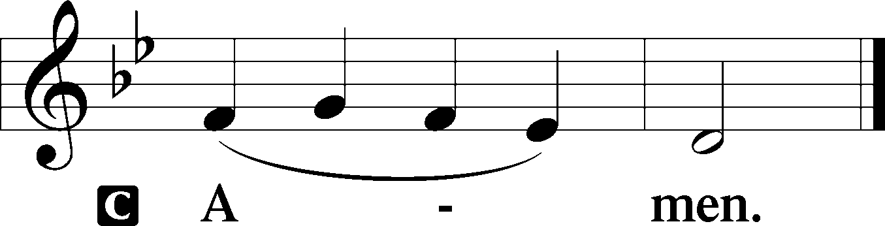
Sit

Prophecy: Isaiah 7:10–15 (NKJV)
In those days: The Lord spoke to Ahaz, saying, “Ask a sign for yourself from the Lord your God; ask it either in the depth or in the height above.” But Ahaz said, “I will not ask, nor will I test the Lord!” Then he said, “Hear now, O house of David! Is it a small thing for you to weary men, but will you weary my God also? Therefore the Lord Himself will give you a sign: Behold, the virgin shall conceive and bear a Son, and shall call His name Immanuel. Curds and honey He shall eat, that He may know to refuse the evil and choose the good.”

P This is the Word of the Lord.
C Thanks be to God.

Gradual Psalm 45:6–7b
Your throne, O God, is forever and | ever.*
The scepter of your kingdom is a scepter of up- | rightness;
you have loved righteousness and hated | wickedness.*
Therefore God, your God, has anointed you with the oil of | gladness.

Epistle: Galatians 4:1-7 (NKJV)
Brethren: The heir, as long as he is a child, does not differ at all from a slave, though he is master of all, but is under guardians and stewards until the time appointed by the father. Even so we, when we were children, were in bondage under the elements of the world. But when the fullness of the time had come, God sent forth His Son, born of a woman, born under the law, to redeem those who were under the law, that we might receive the adoption as sons. And because you are sons, God has sent forth the Spirit of His Son into your hearts, crying out, “Abba, Father!” Therefore you are no longer a slave but a son, and if a son, then an heir of God through Christ.

P This is the Word of the Lord.
C Thanks be to God.

Stand

Verse Luke 1:46b–47; 2:30–31
My soul magnifies the Lord, and my spirit rejoices in God my Savior. For my eyes have seen your salvation that you have prepared in the presence of all peoples.

Holy Gospel: Luke 1:26-38 (NKJV)
P The Holy Gospel according to St. Luke, the first chapter.
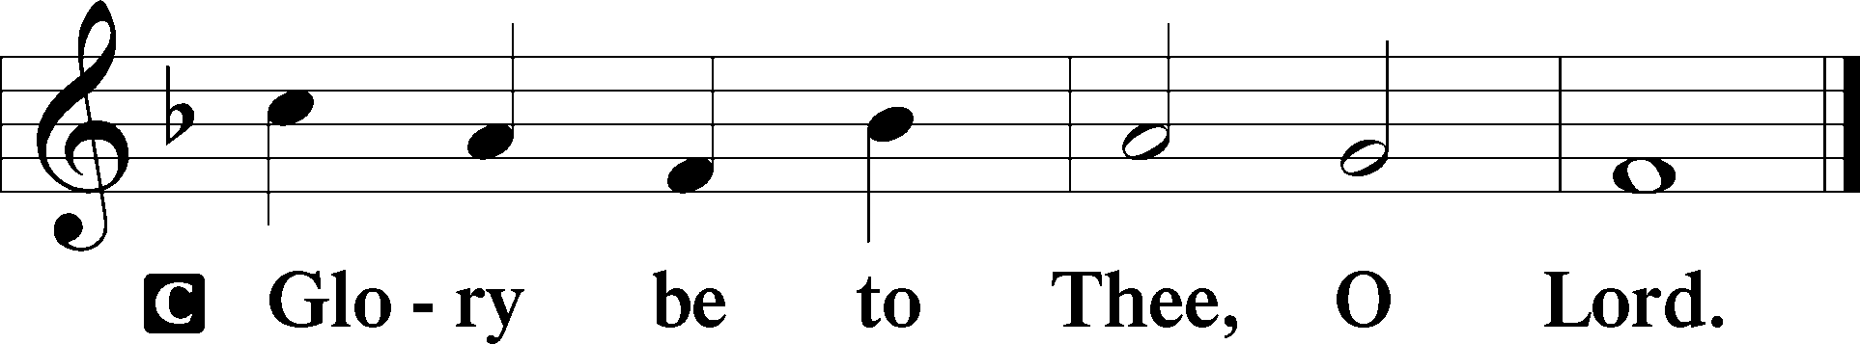
At that time: The angel Gabriel was sent by God to a city of Galilee named Nazareth, to a virgin betrothed to a man whose name was Joseph, of the house of David. The virgin’s name was Mary. And having come in, the angel said to her, “Rejoice, highly favored one, the Lord is with you; blessed are you among women!” But when she saw him, she was troubled at his saying, and considered what manner of greeting this was. Then the angel said to her, “Do not be afraid, Mary, for you have found favor with God. And behold, you will conceive in your womb and bring forth a Son, and shall call His name Jesus. He will be great, and will be called the Son of the Highest; and the Lord God will give Him the throne of His father David. And He will reign over the house of Jacob forever, and of His kingdom there will be no end.” Then Mary said to the angel, “How can this be, since I do not know a man?” And the angel answered and said to her, “The Holy Spirit will come upon you, and the power of the Highest will overshadow you; therefore, also, that Holy One who is to be born will be called the Son of God. Now indeed, Elizabeth your relative has also conceived a son in her old age; and this is now the sixth month for her who was called barren. For with God nothing will be impossible.” Then Mary said, “Behold the maidservant of the Lord! Let it be to me according to your word.”

P This is the Gospel of the Lord.
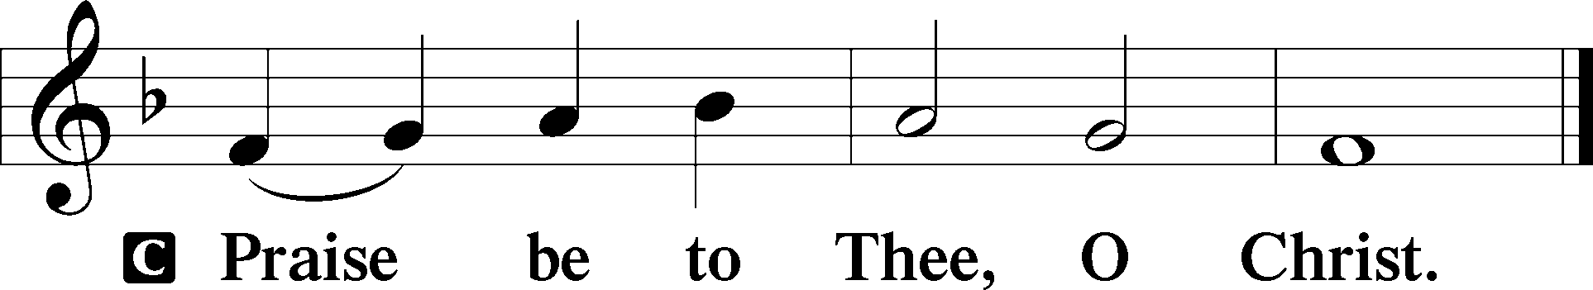

The Creed is not spoken on weekdays.
Sit

Hymn of the Day: TLH #104 “Now Praise We Christ, the Holy One”
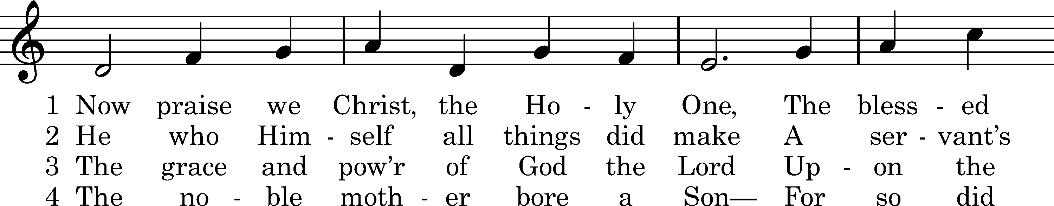
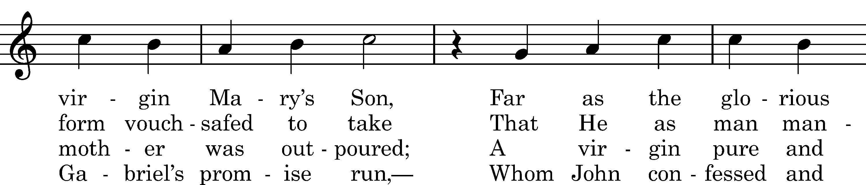
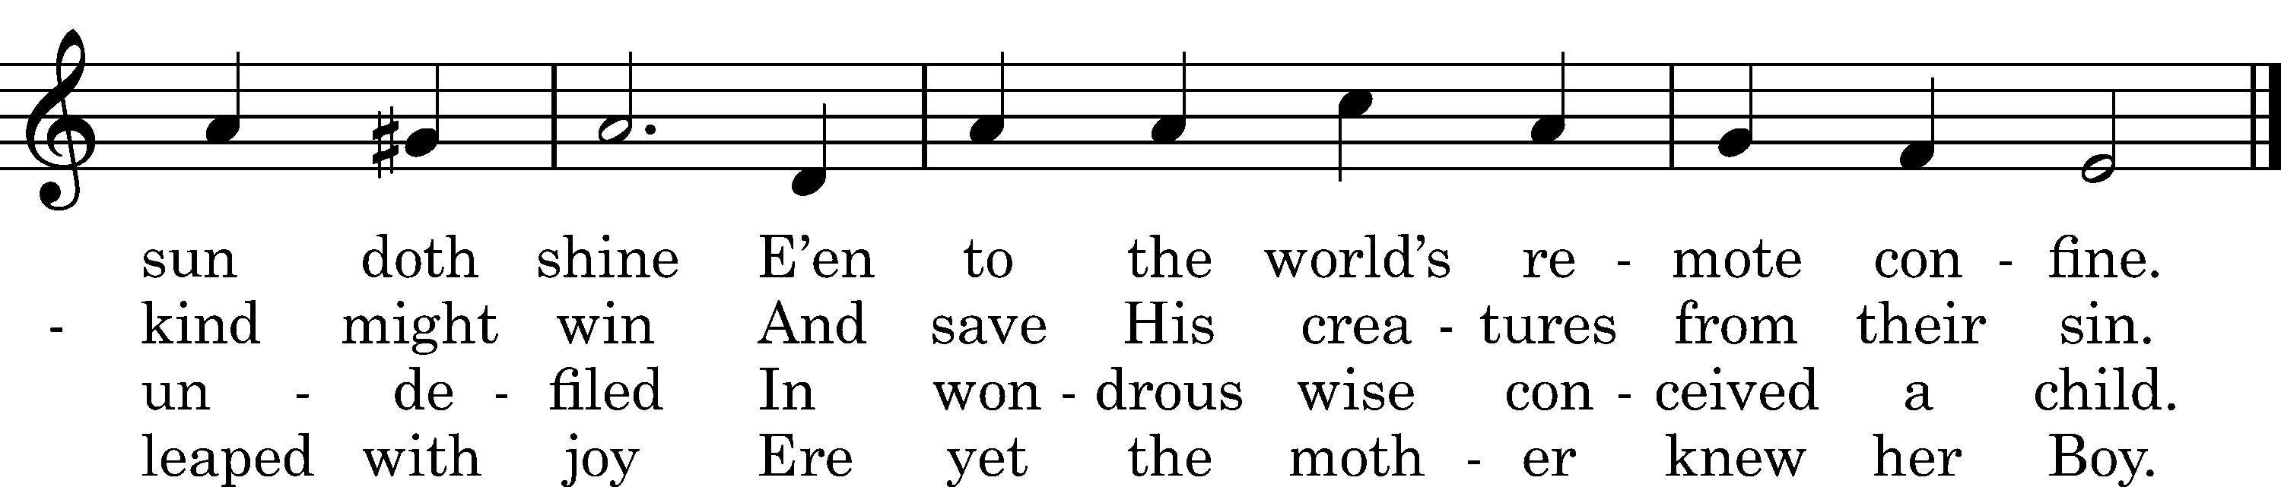

5 Upon a manger filled with hay
In poverty content He lay;
With milk was fed the Lord of all,
Who feeds the ravens when they call.

6 The heav'nly choirs rejoice and raise
Their voice to God in songs of praise.
To humble shepherds is proclaimed
The Shepherd who the world hath framed.

D 7 All honor unto Christ be paid,
Pure Offspring of the favored maid,
With Father and with Holy Ghost,
Till time in endless time be lost.

Text: tr. Richard Massie, 1854, alt.; Martin Luther, 1524, alt.; Coelius Sedulius, c. 450, alt. Tune: Enchiridion, Erfurt, 1524 Text and tune: Public domain

Sermon

Stand

Offertory Psalm 51:10–12
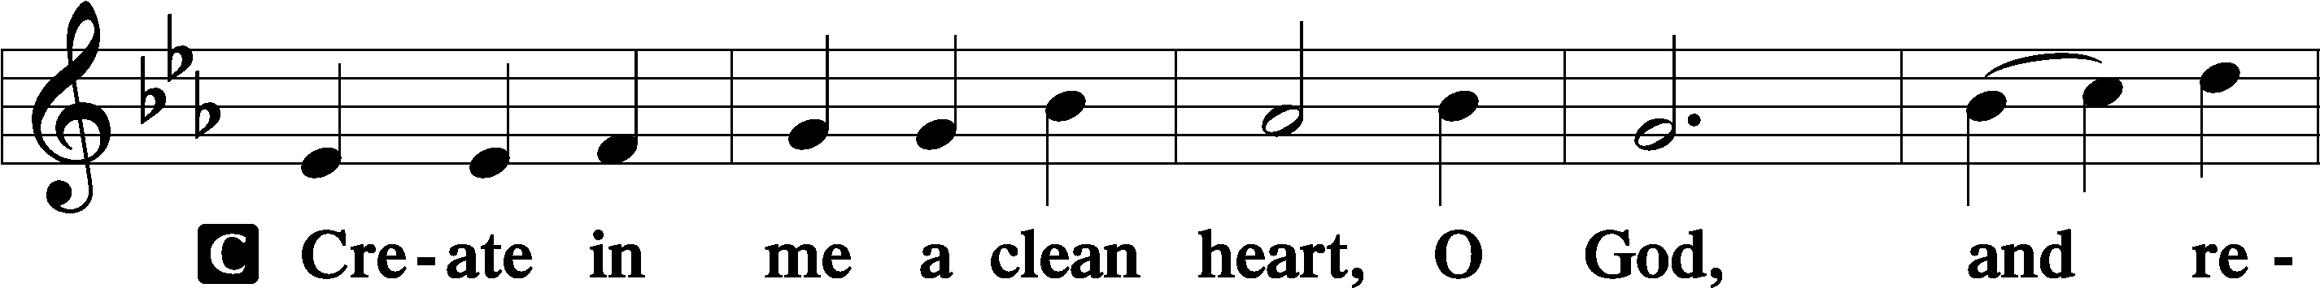
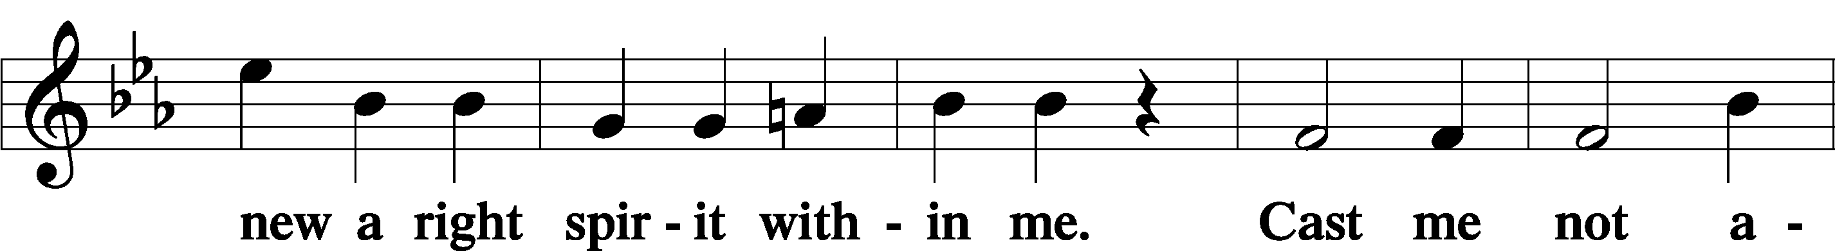
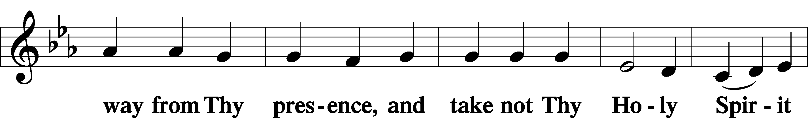
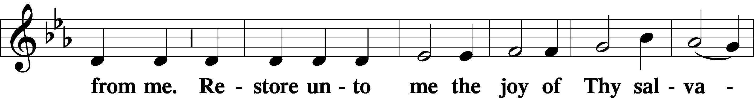
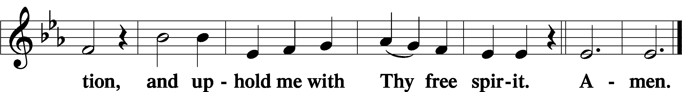

Prayer of the Church

Sit

Preparatory Hymn: LSB #624 “The Infant Priest Was Holy Born”

Stand
Service of the Sacrament

Preface 2 Timothy 4:22; Colossians 3:1 Psalm 136
P The Lord be with you.
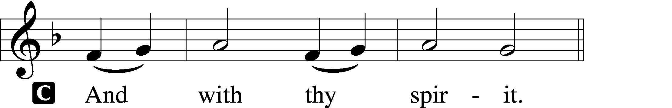

P Lift up your hearts.
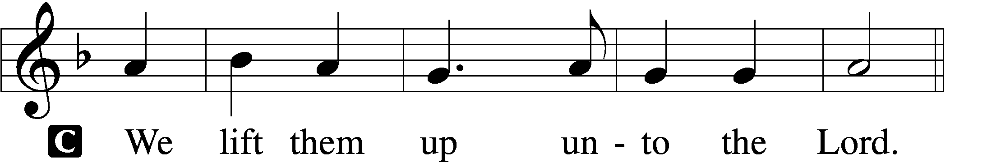

P Let us give thanks unto the Lord, our God.
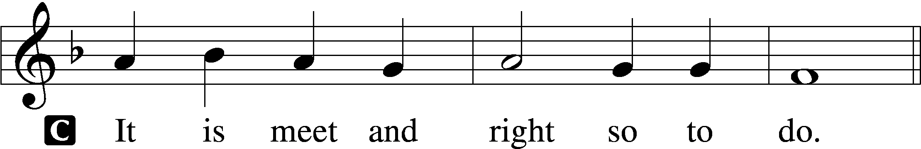

Proper Preface (Abbreviated) LSB 194
P It is truly meet, right, and salutary . . . evermore praising You and saying:
Sanctus Isaiah 6:3; Matthew 21:9
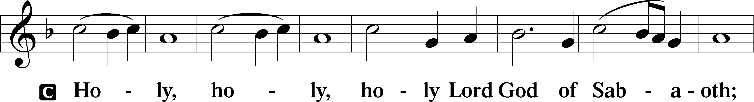
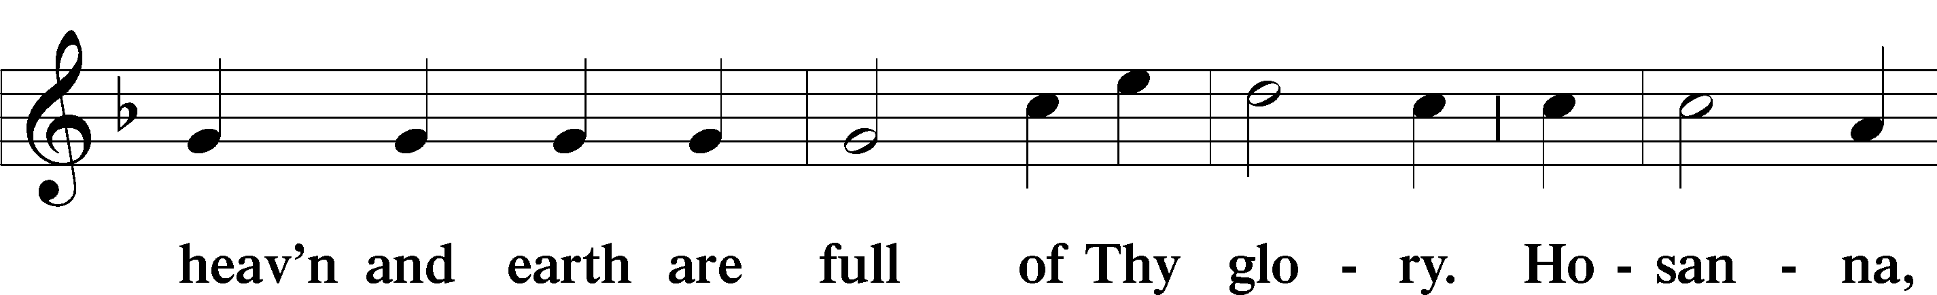
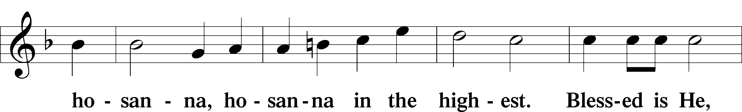
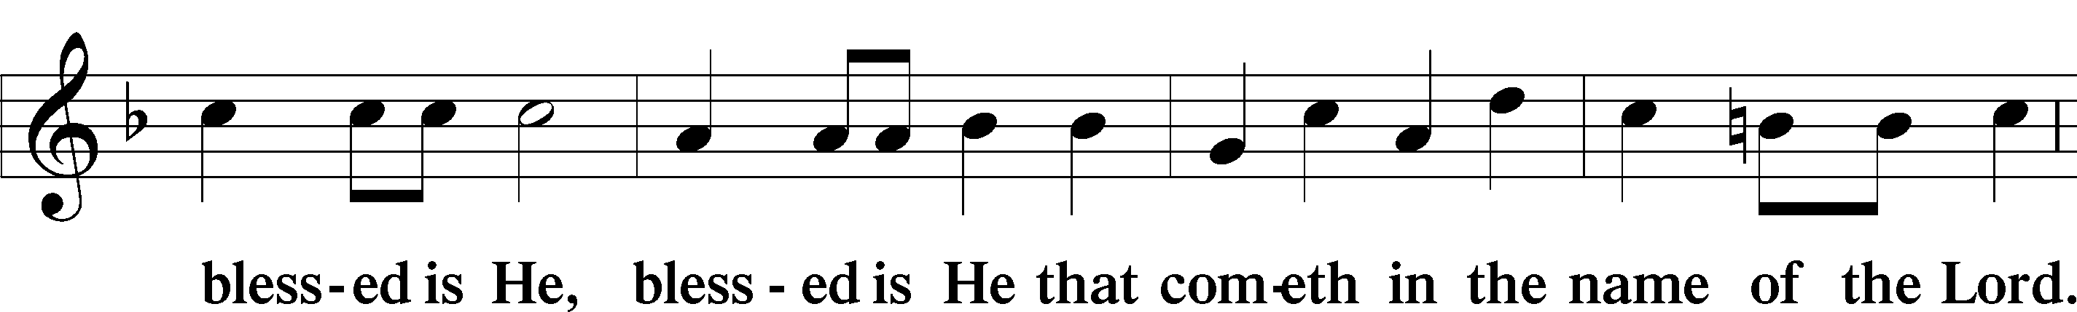
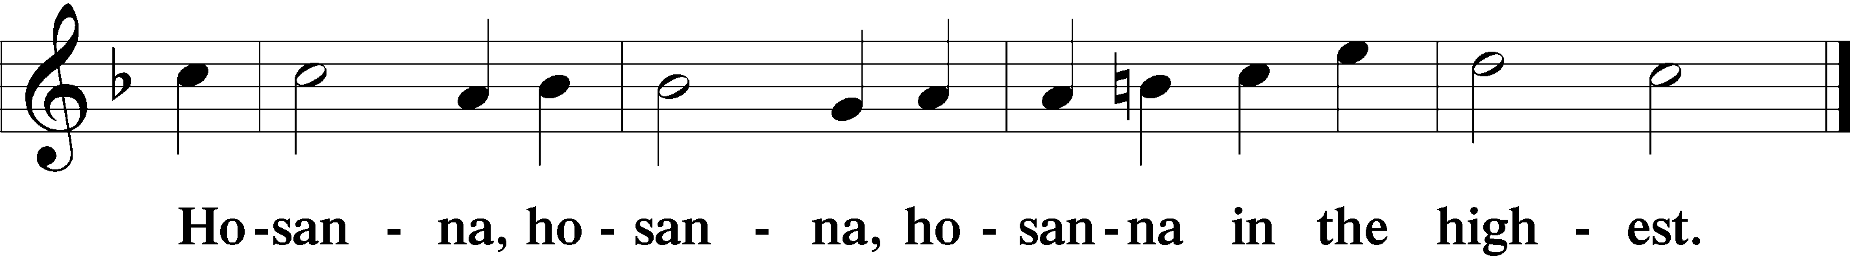

Lord’s Prayer The congregation is encouraged to silently pray the Lord’s Prayer as it is chanted. Matthew 6:9–13
P Our Father who art in heaven,
hallowed be Thy name,
Thy kingdom come,
Thy will be done on earth as it is in heaven;
give us this day our daily bread;
and forgive us our trespasses as we forgive those who trespass against us;
and lead us not into temptation,
but deliver us from evil.
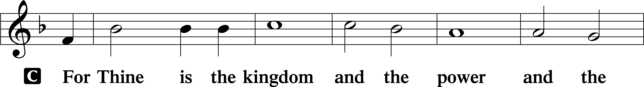
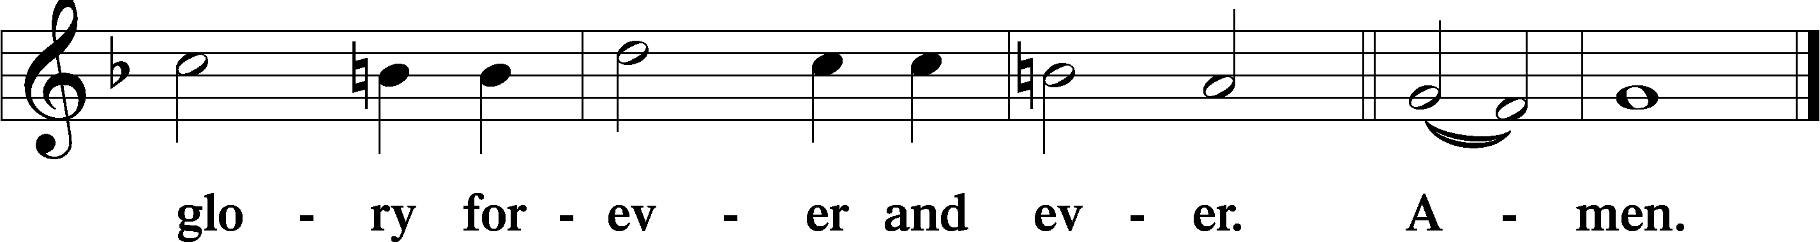
The Words of Our Lord Matthew 26:26–28; Mark 14:22–24; Luke 22:19–20; 1 Corinthians 11:23–25
P Our Lord Jesus Christ, on the night when He was betrayed, took bread, and when He had given thanks, He broke it and gave it to the disciples and said: “Take, eat; this is My T body, which is given for you. This do in remembrance of Me.”

In the same way also He took the cup after supper, and when He had given thanks, He gave it to them, saying: “Drink of it, all of you; this cup is the new testament in My T blood, which is shed for you for the forgiveness of sins. This do, as often as you drink it, in remembrance of Me.”

Pax Domini John 20:19
P The peace of the Lord be with you always.
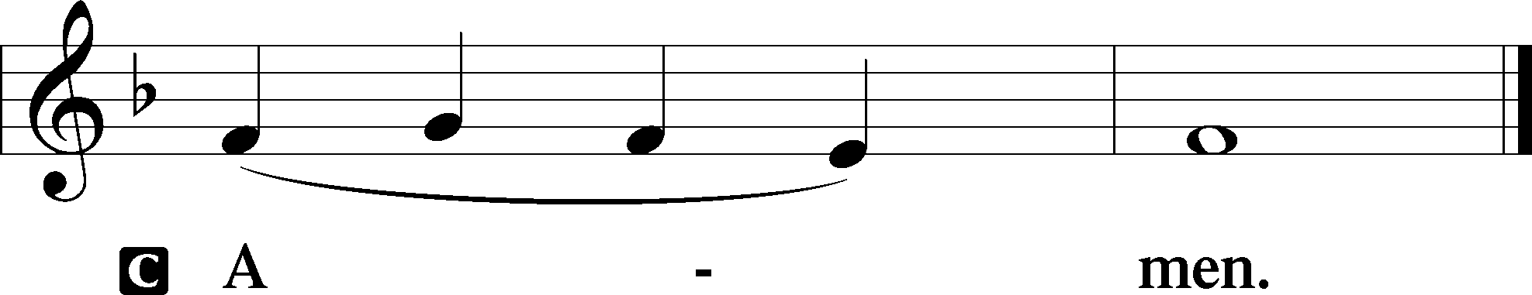

Agnus Dei John 1:29
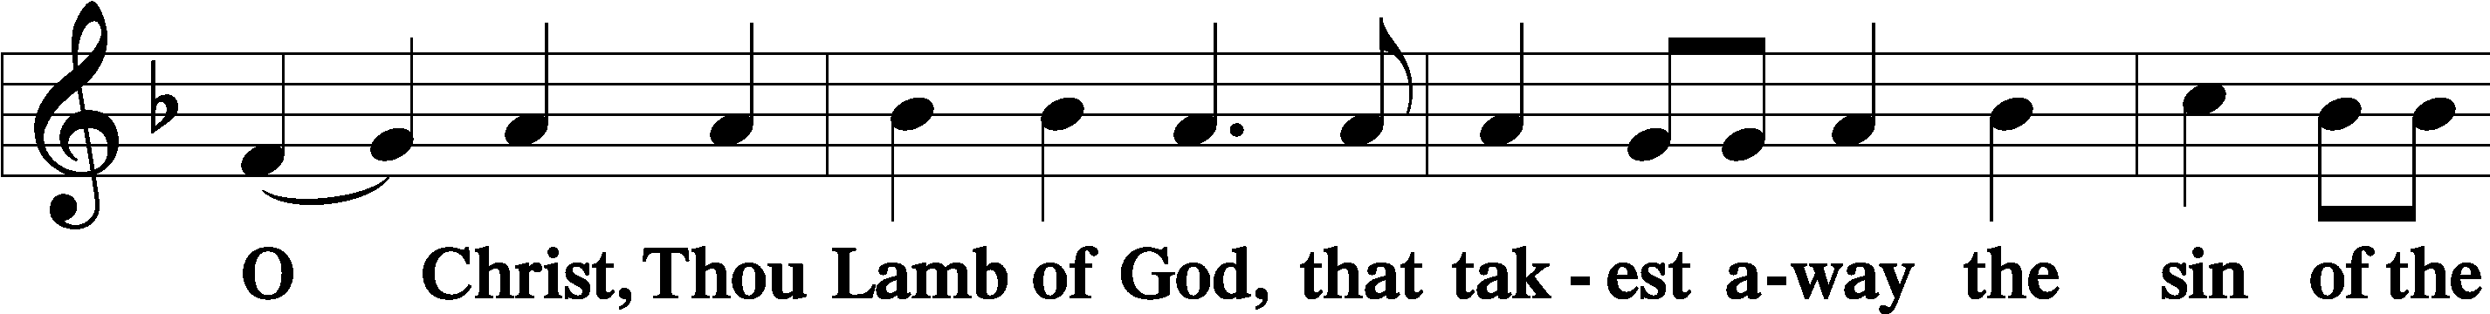
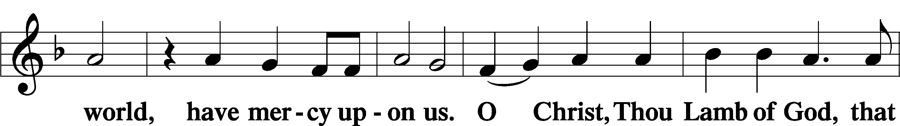
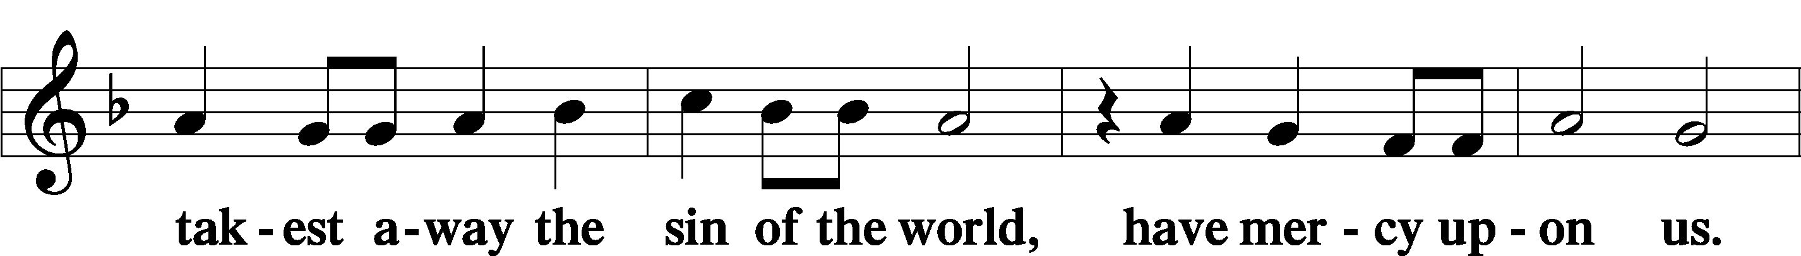
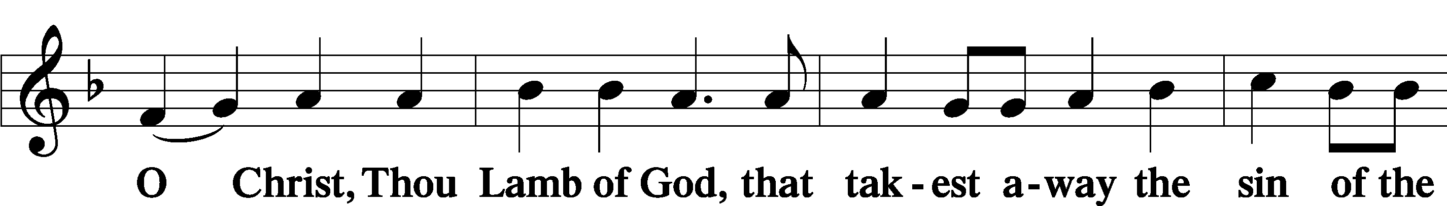
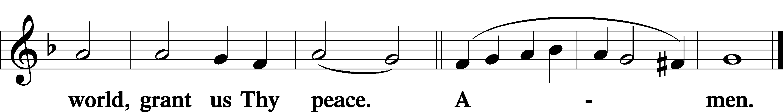
Sit
Distribution
The pastor and those who assist him receive the body and blood of Christ first and then distribute them to those who come to receive, saying:
Take, eat; this is the true body of our Lord and Savior Jesus Christ, given into death for your sins.
Amen.

Take, drink; this is the true blood of our Lord and Savior Jesus Christ, shed for the forgiveness of your sins.
Amen.

In dismissing the communicants, the following is said:
The Dismissal
P The body and blood of our Lord Jesus Christ strengthen and preserve you in body and soul to life everlasting. Depart T in peace.
C Amen.

Distribution Hymn: LSB #359 “Lo, How a Rose E’er Blooming”

Distribution Hymn: LSB #333 “Once He Came in Blessing”

Stand

The Nunc Dimittis is omitted during Passiontide.

Thanksgiving Psalm 107:1
P O give thanks unto the Lord, for He is good,
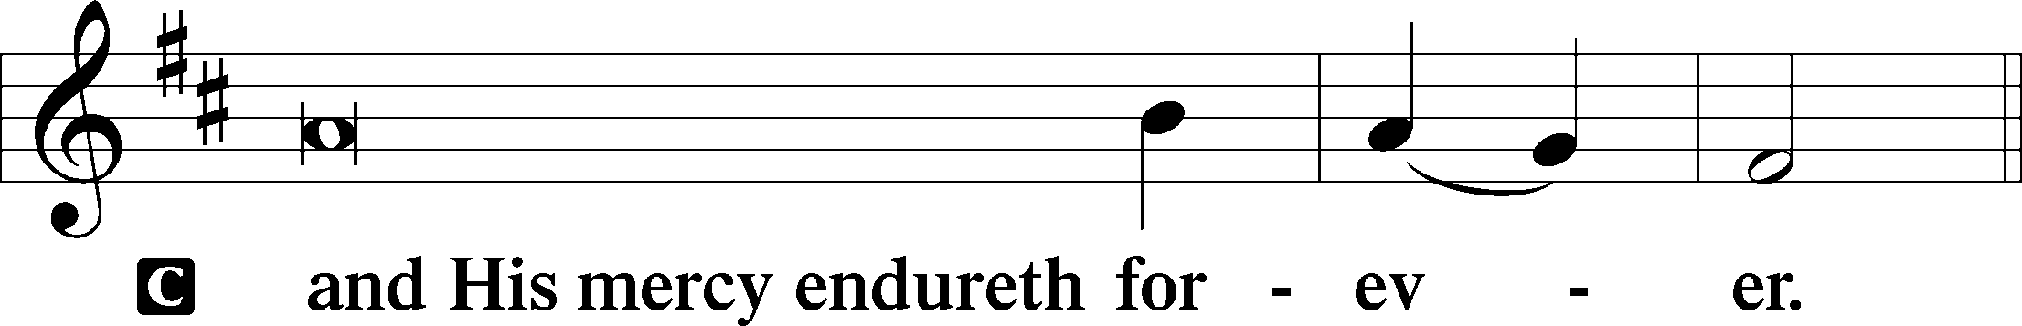

Post-Communion Collect
P Let us pray.
We give thanks to You, almighty God, that You have refreshed us through this salutary gift, and we implore You that of Your mercy You would strengthen us through the same in faith toward You and in fervent love toward one another; through Jesus Christ, Your Son, our Lord, who lives and reigns with You and the Holy Spirit, one God, now and forever.
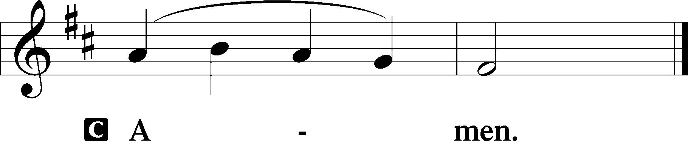

Salutation 2 Timothy 4:22
P The Lord be with you.
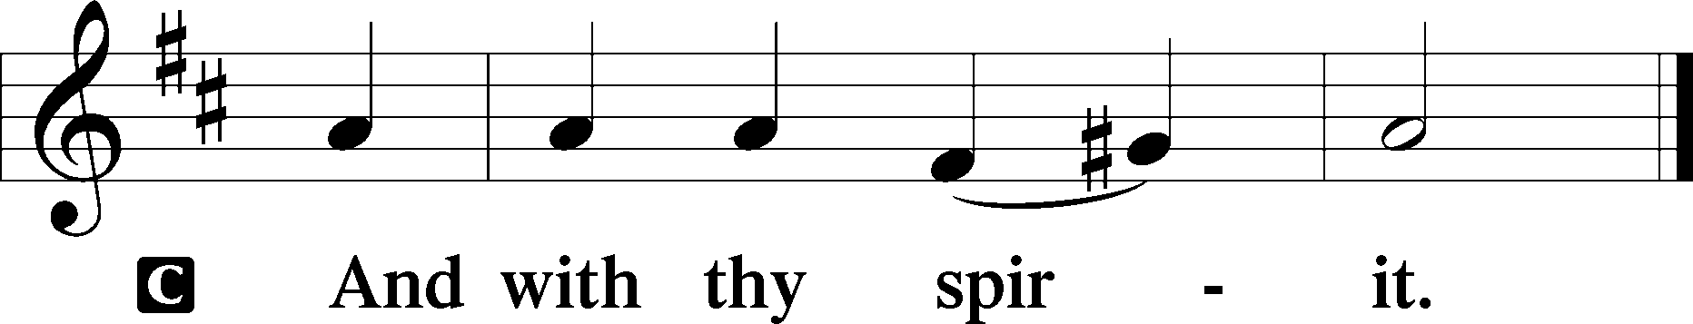

Benedicamus Psalm 103:1
P Bless we the Lord.
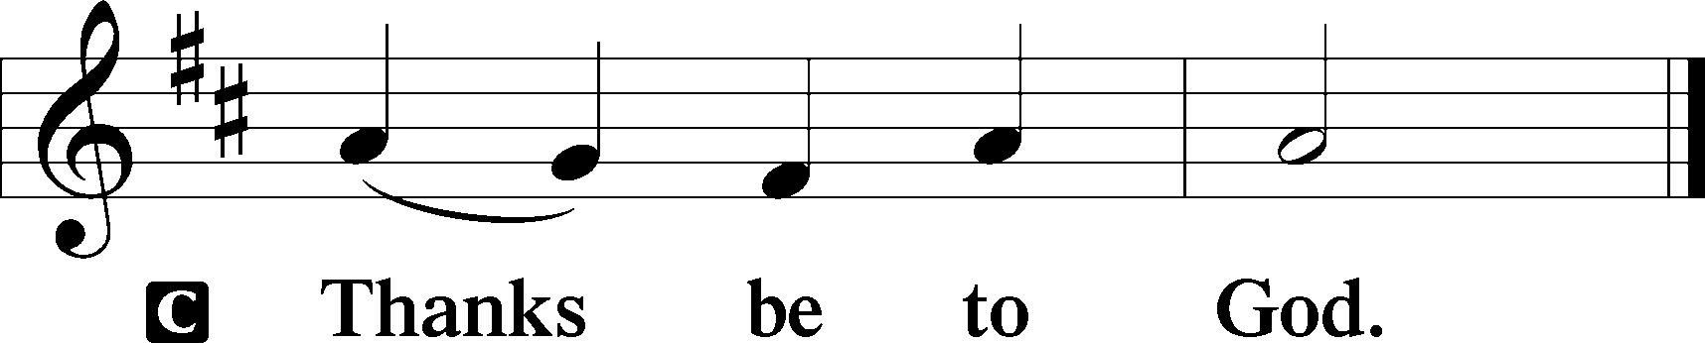

Benediction Numbers 6:24–26
P The Lord bless you and keep you.
The Lord make His face shine upon you and be gracious unto you.
The Lord lift up His countenance upon you and T give you peace.
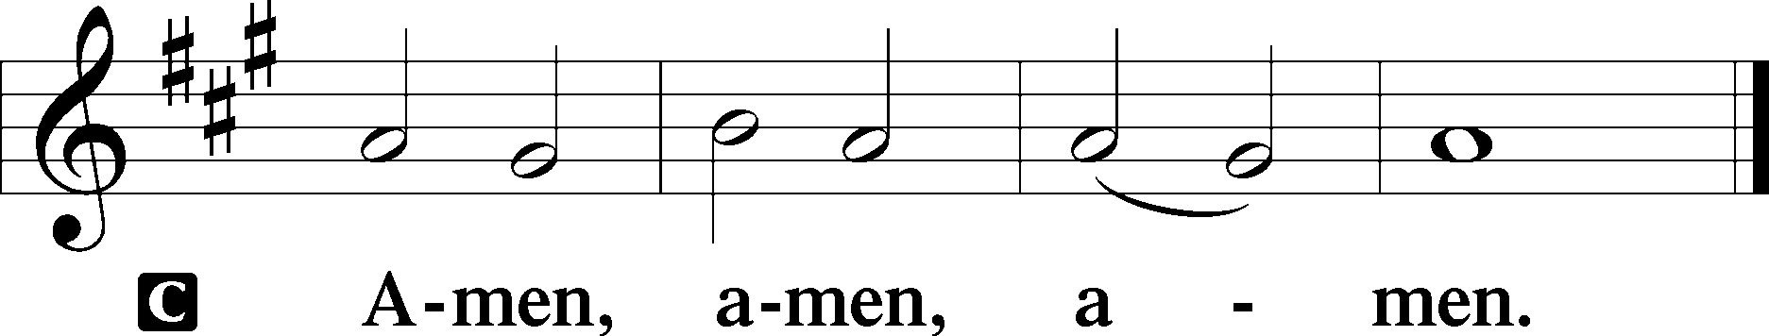

Closing Hymn: LSB #356 “The Angel Gabriel from Heaven Came”

Silent prayer after worship: Dear Jesus, help me this week to keep in mind the purpose of Your suffering, death and resurrection. Cause me to believe and proclaim the hope of salvation You won for all by Your death and resurrection. Amen.
fffffffffffffffffffffffffffffffffff
Acknowledgments: Unless otherwise indicated, Scripture quotations are from the ESV® Bible (The Holy Bible, English Standard Version®), copyright © 2001 by Crossway, a publishing ministry of Good News Publishers. Used by permission. All rights reserved. Created by Lutheran Service Builder © 2023 Concordia Publishing House.

