Sts. Peter & Paul
Evangelical Lutheran Church
Lutheran Church-Missouri Synod
Founded-1917

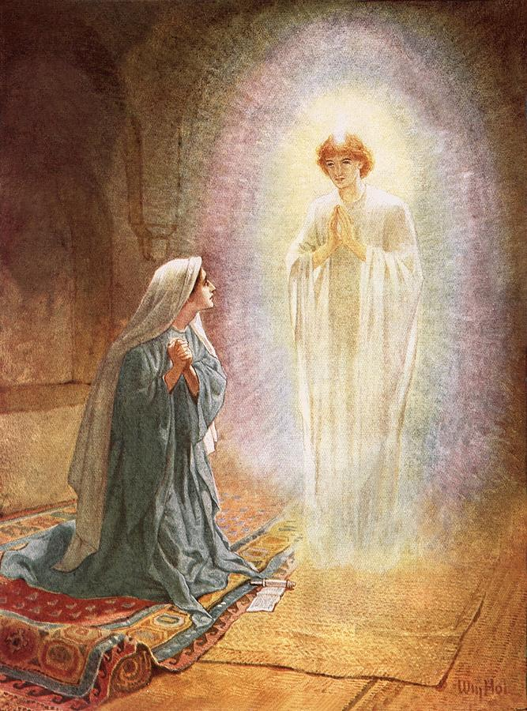

THE ANNUNCIATION OF OUR LORD

699 Stambaugh Avenue
Sharon, Pennsylvania 16146

“I was glad when they said to me,
Let us go to the house of the LORD!”
Psalm 122:1
Sts. Peter & Paul Evangelical Lutheran Church, LC-MS
THE ANNUNCIATION OF OUR LORD
Vespers Service
March 25, 2023

Opening Hymn: LSB#351 “Creator of the Stars of Night”

Stand

Lent Versicles
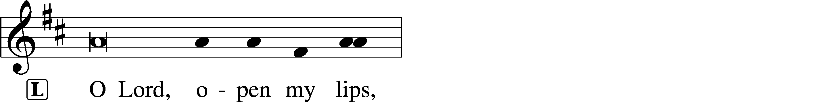
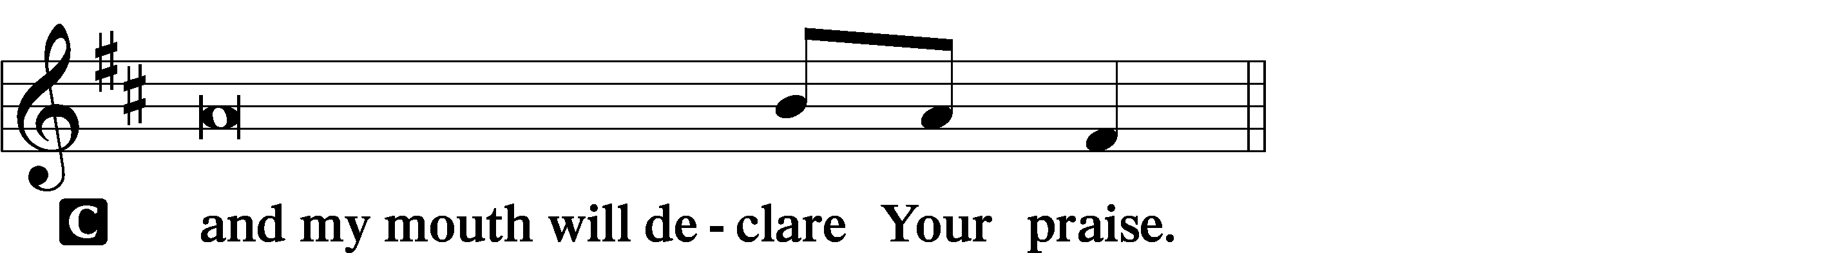

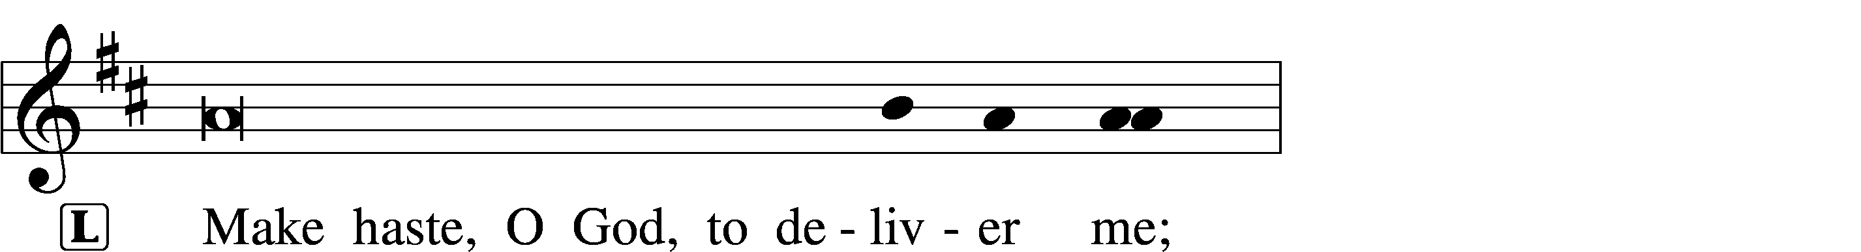
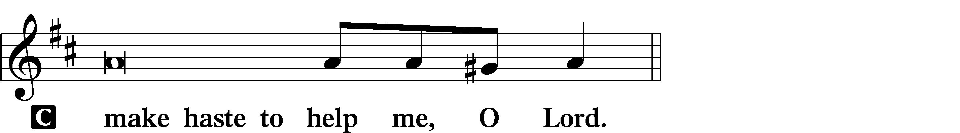

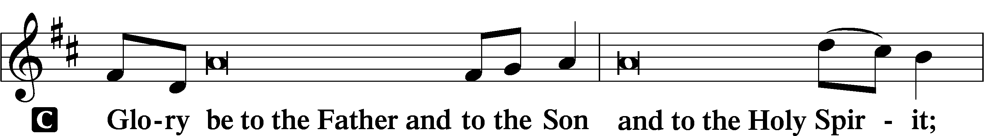
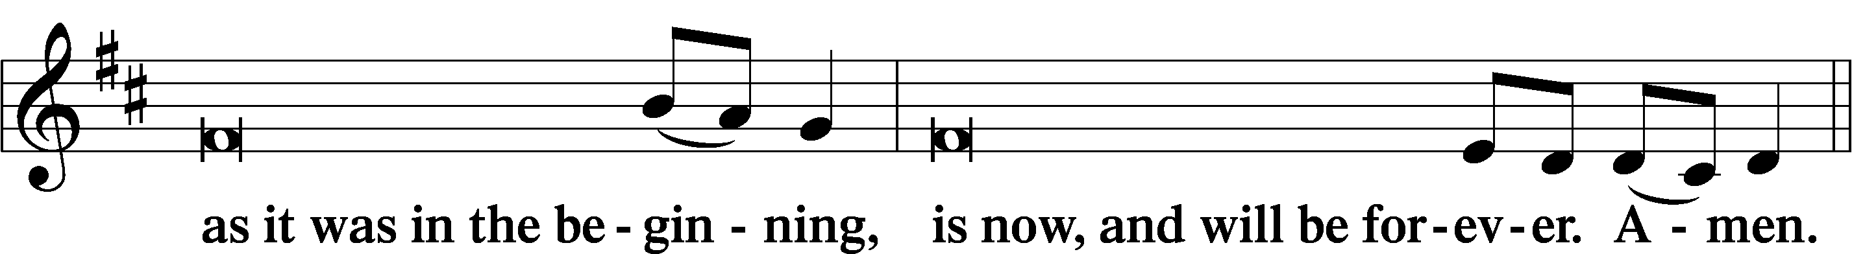
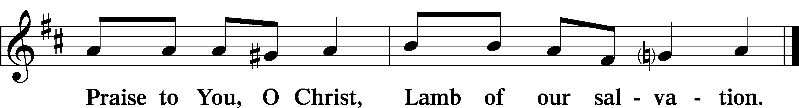
Psalmody

Psalm 45:7–17 (NKJV)
You love righteousness and hate wickedness;
Therefore God, Your God, has anointed You
With the oil of gladness more than Your companions.
All Your garments are scented with myrrh and aloes and cassia,
Out of the ivory palaces, by which they have made You glad.
Kings’ daughters are among Your honorable women;
At Your right hand stands the queen in gold from Ophir.
Listen, O daughter,
Consider and incline your ear;
Forget your own people also, and your father’s house;
So the King will greatly desire your beauty;
Because He is your Lord, worship Him.
And the daughter of Tyre will come with a gift;
The rich among the people will seek your favor.
The royal daughter is all glorious within the palace;
Her clothing is woven with gold.
She shall be brought to the King in robes of many colors;
The virgins, her companions who follow her, shall be brought to You.
With gladness and rejoicing they shall be brought;
They shall enter the King’s palace.
Instead of Your fathers shall be Your sons,
Whom You shall make princes in all the earth.
I will make Your name to be remembered in all generations;
Therefore the people shall praise You forever and ever.
Sit

Hymn of the Day: TLH #104 “Now Praise We Christ, the Holy One”
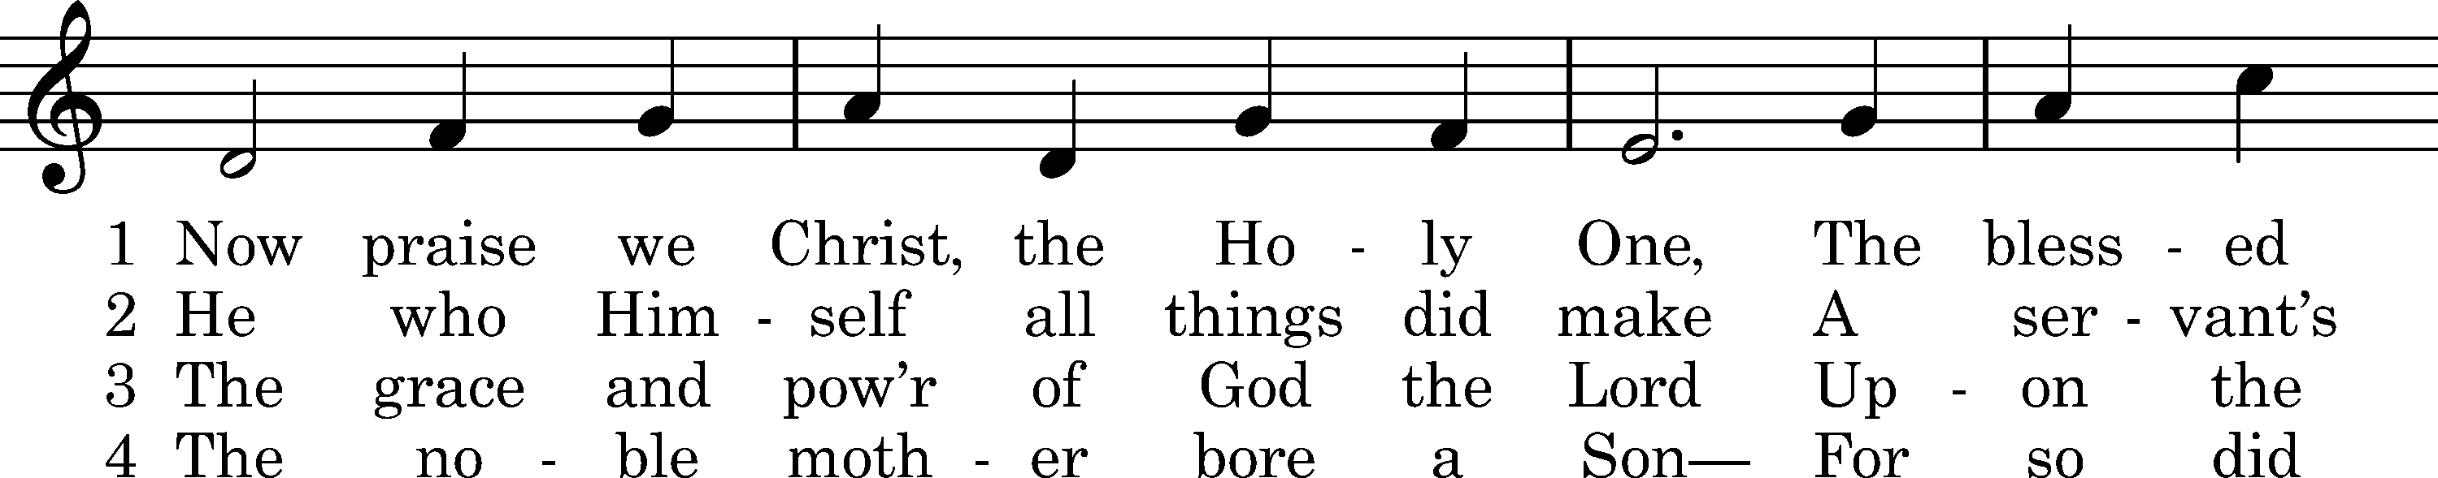
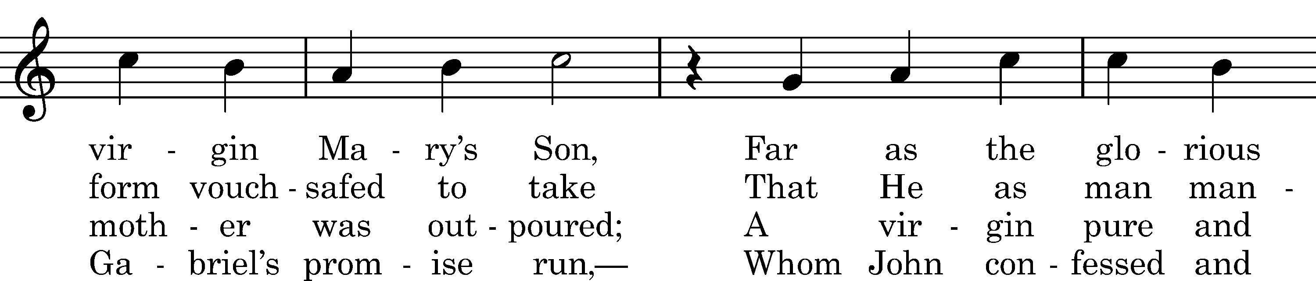
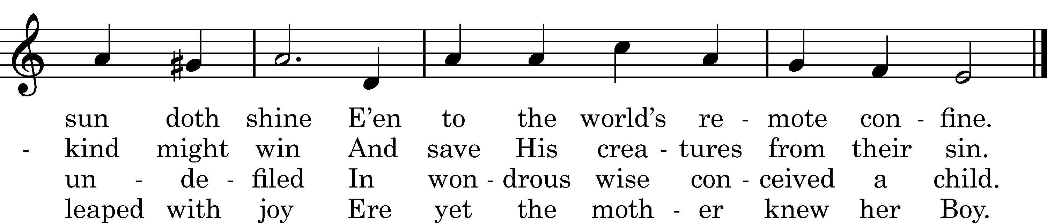

5 Upon a manger filled with hay
In poverty content He lay;
With milk was fed the Lord of all,
Who feeds the ravens when they call.

6 The heav'nly choirs rejoice and raise
Their voice to God in songs of praise.
To humble shepherds is proclaimed
The Shepherd who the world hath framed.

D 7 All honor unto Christ be paid,
Pure Offspring of the favored maid,
With Father and with Holy Ghost,
Till time in endless time be lost.
Text: tr. Richard Massie, 1854, alt.; Martin Luther, 1524, alt.; Coelius Sedulius, c. 450, alt.
Tune: Enchiridion, Erfurt, 1524
Text and tune: Public domain

Sit

Readings

Prophecy: Isaiah 7:10–14 (NKJV)
Moreover the Lord spoke again to Ahaz, saying, “Ask a sign for yourself from the Lord your God; ask it either in the depth or in the height above.”
But Ahaz said, “I will not ask, nor will I test the Lord!”
Then he said, “Hear now, O house of David! Is it a small thing for you to weary men, but will you weary my God also? Therefore the Lord Himself will give you a sign: Behold, the virgin shall conceive and bear a Son, and shall call His name Immanuel.
P This is the Word of the Lord.
C Thanks be to God.

Epistle: Hebrews 10:4–10 (NKJV)
For it is not possible that the blood of bulls and goats could take away sins.
Therefore, when He came into the world, He said:
“Sacrifice and offering You did not desire,
But a body You have prepared for Me.
In burnt offerings and sacrifices for sin
You had no pleasure.
Then I said, ‘Behold, I have come—
In the volume of the book it is written of Me—
To do Your will, O God.’ ”
Previously saying, “Sacrifice and offering, burnt offerings, and offerings for sin You did not desire, nor had pleasure in them” (which are offered according to the law), then He said, “Behold, I have come to do Your will, O God.” He takes away the first that He may establish the second. By that will we have been sanctified through the offering of the body of Jesus Christ once for all.
P O Lord, have mercy on us.
C Thanks be to God.

Gospel: Luke 1:26–38 (NKJV)
P A reading from Luke, chapter 1.

Now in the sixth month the angel Gabriel was sent by God to a city of Galilee named Nazareth, to a virgin betrothed to a man whose name was Joseph, of the house of David. The virgin’s name was Mary. And having come in, the angel said to her, “Rejoice, highly favored one, the Lord is with you; blessed are you among women!”
But when she saw him, she was troubled at his saying, and considered what manner of greeting this was. Then the angel said to her, “Do not be afraid, Mary, for you have found favor with God. And behold, you will conceive in your womb and bring forth a Son, and shall call His name Jesus. He will be great, and will be called the Son of the Highest; and the Lord God will give Him the throne of His father David. And He will reign over the house of Jacob forever, and of His kingdom there will be no end.”
Then Mary said to the angel, “How can this be, since I do not know a man?”
And the angel answered and said to her, “The Holy Spirit will come upon you, and the power of the Highest will overshadow you; therefore, also, that Holy One who is to be born will be called the Son of God. Now indeed, Elizabeth your relative has also conceived a son in her old age; and this is now the sixth month for her who was called barren. For with God nothing will be impossible.”
Then Mary said, “Behold the maidservant of the Lord! Let it be to me according to your word.” And the angel departed from her.
P O Lord, have mercy on us.
C Thanks be to God.

Responsory (Lent) LSB 231
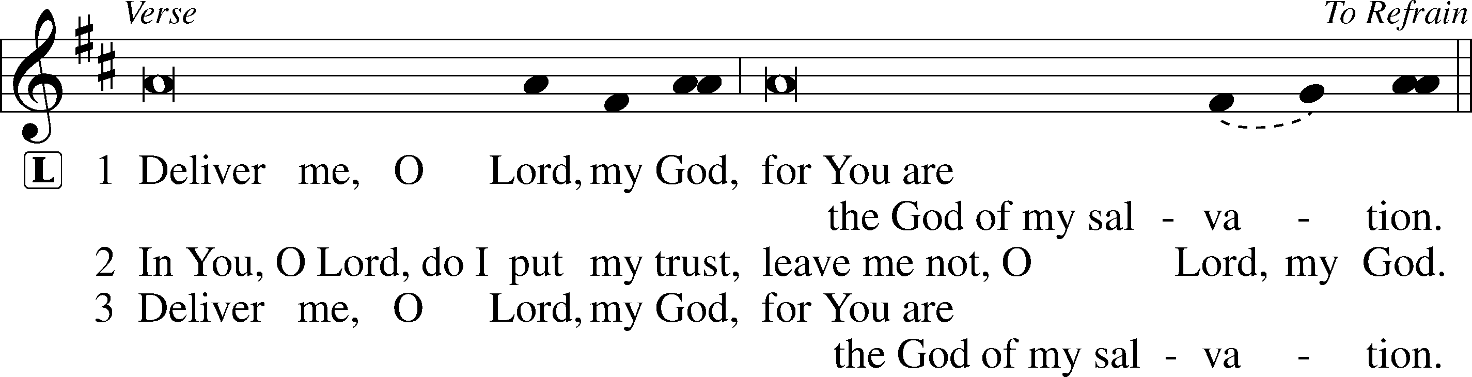
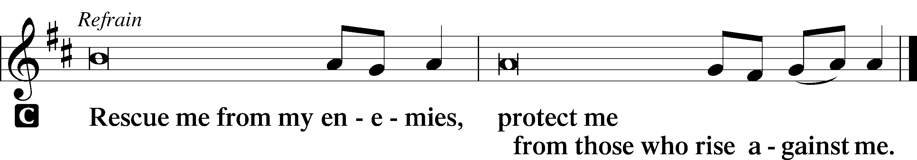

Sermon
Canticle
Stand
Antiphon (Common) 231
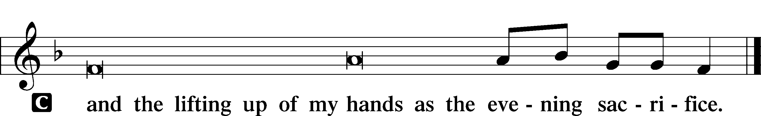

Magnificat 231
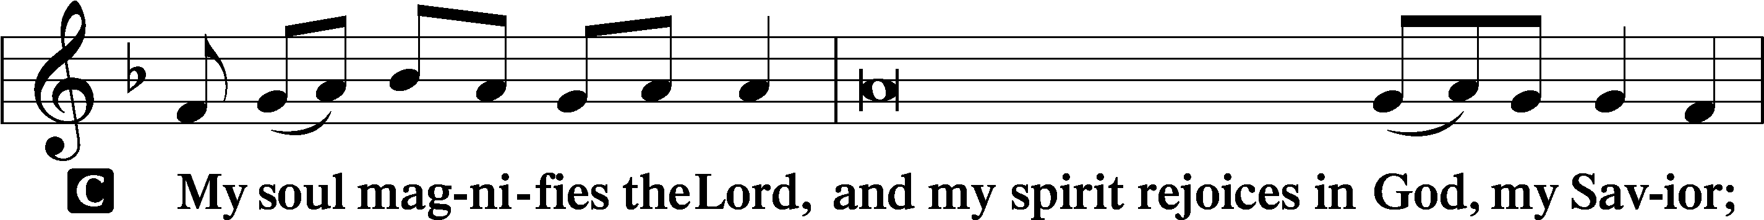
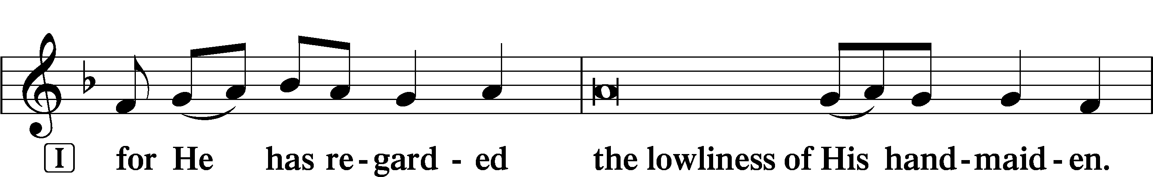
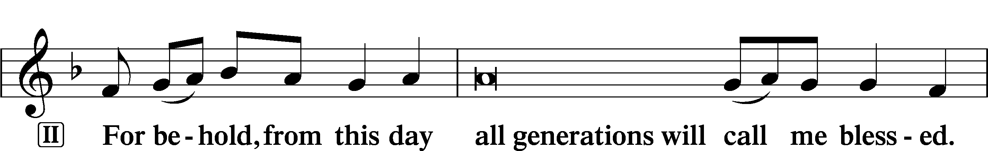
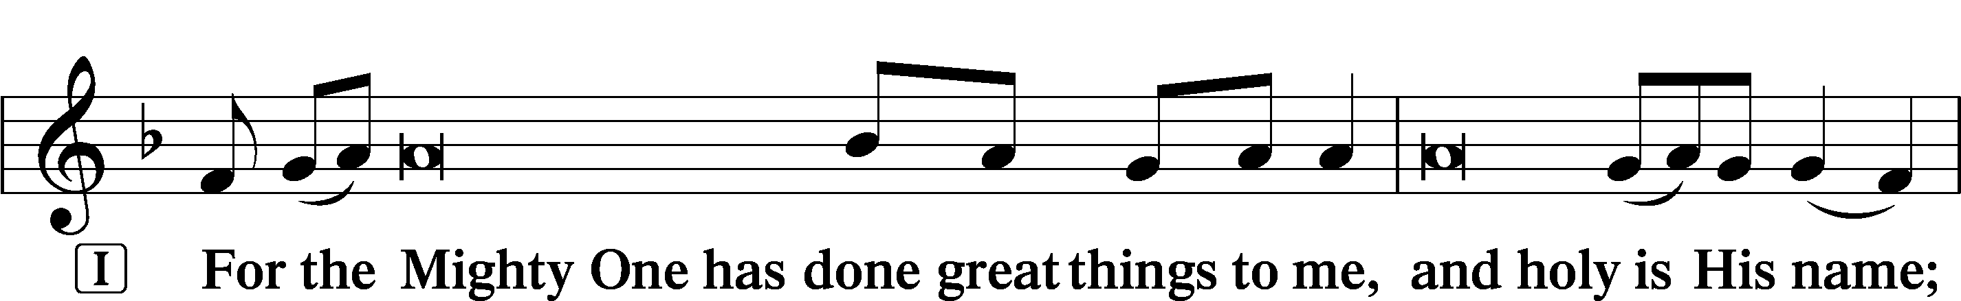
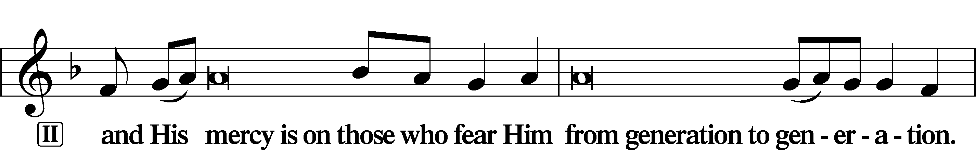
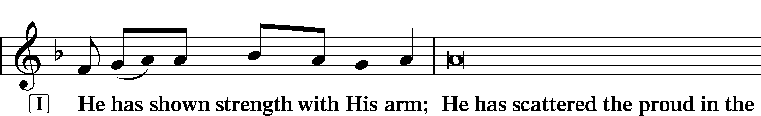
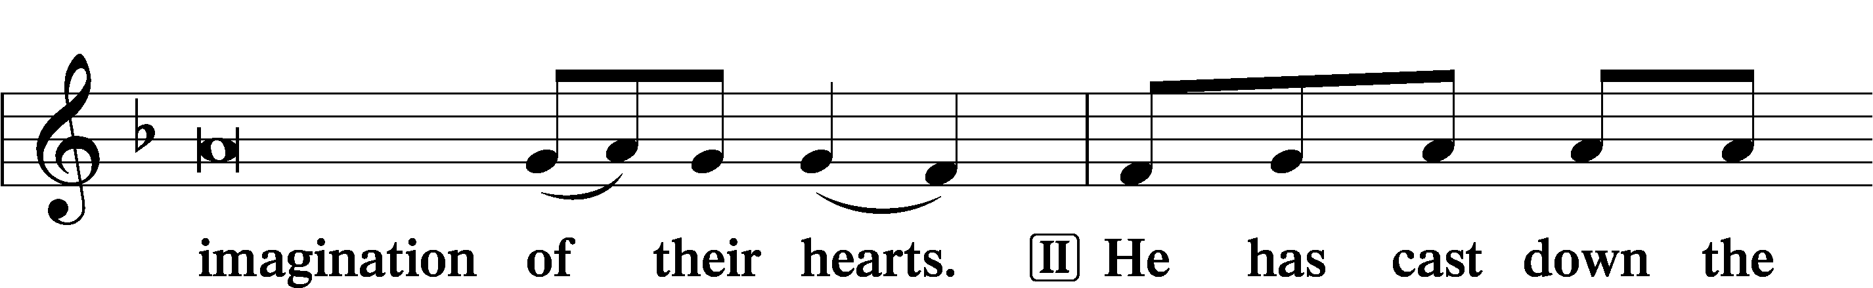
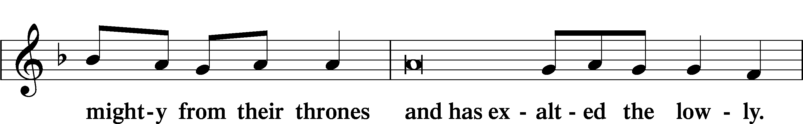
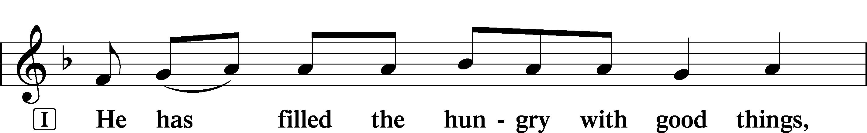
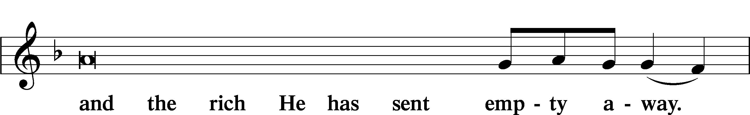
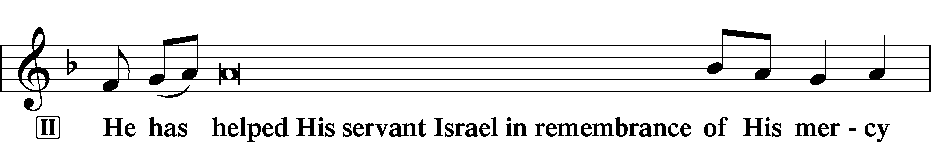
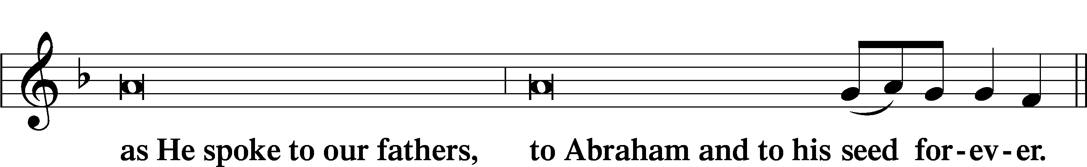
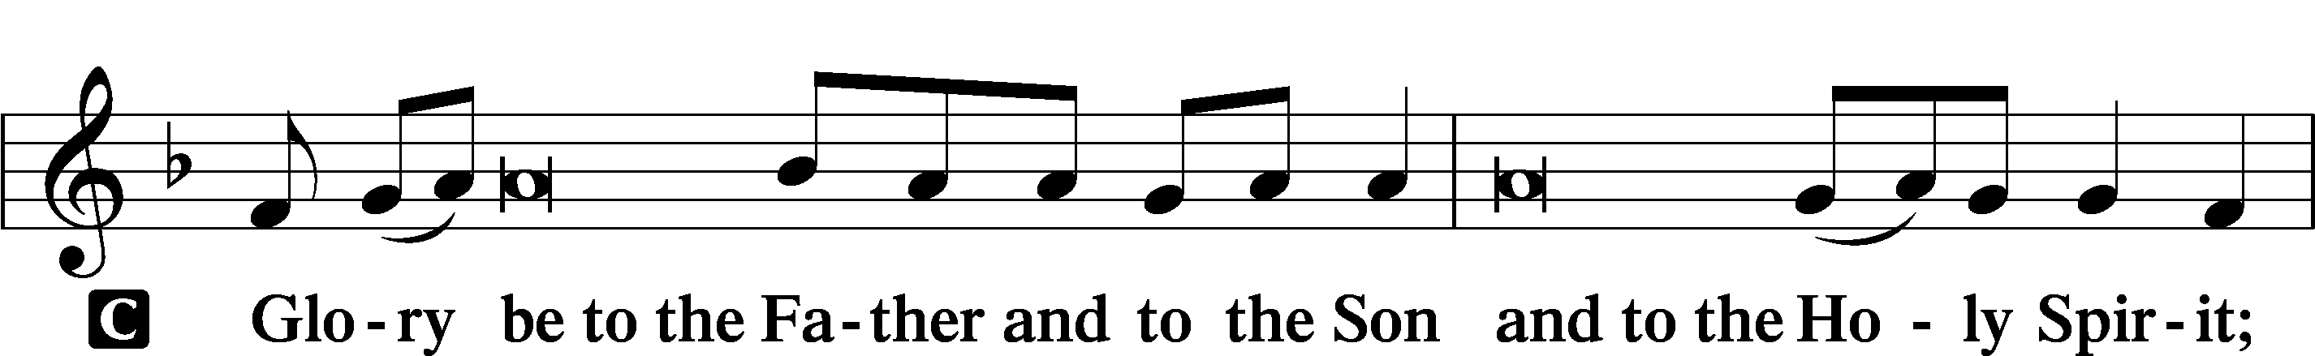
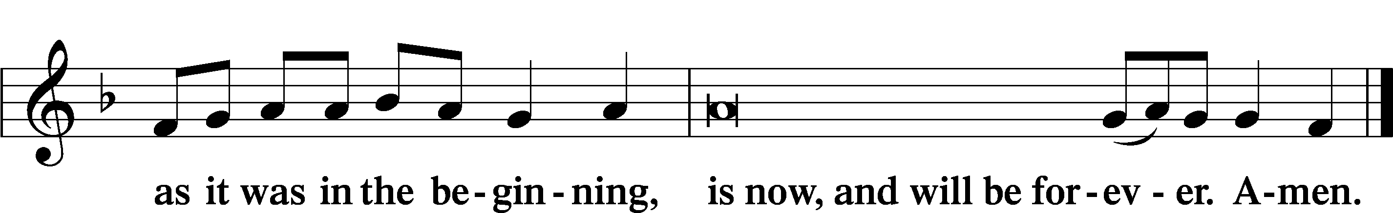

Prayer

Kyrie LSB 233
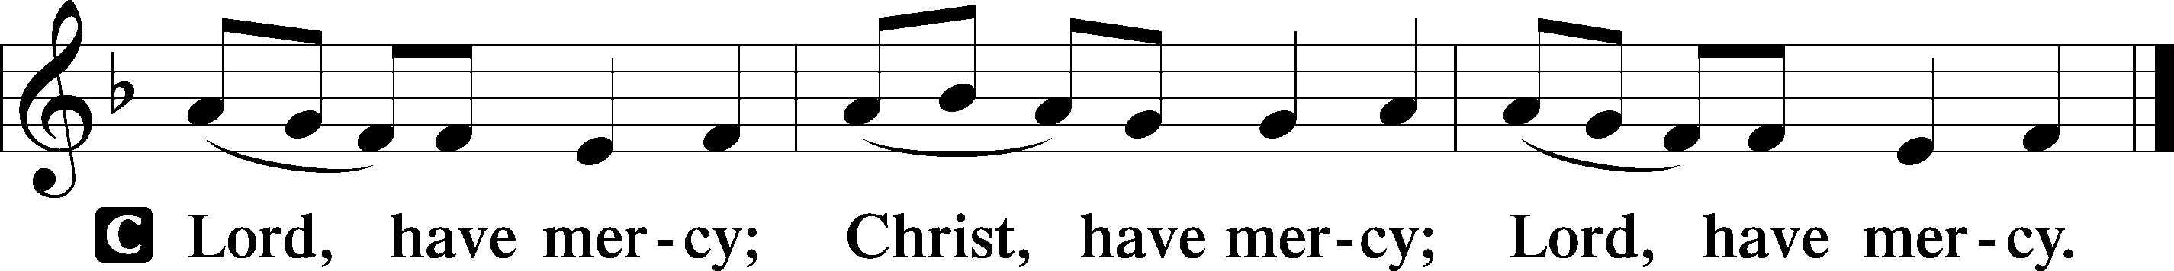

Lord’s Prayer
C Our Father who art in heaven,
hallowed be Thy name,
Thy kingdom come,
Thy will be done on earth
as it is in heaven;
give us this day our daily bread;
and forgive us our trespasses
as we forgive those
who trespass against us;
and lead us not into temptation,
but deliver us from evil.
For Thine is the kingdom
and the power and the glory
forever and ever. Amen.

Collects
Introduction to Collects LSB 233
L O Lord, hear my prayer.
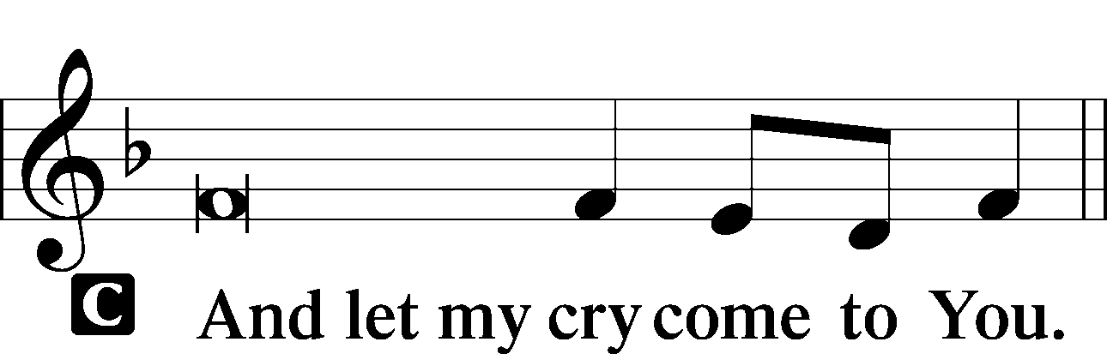

Collect of the Day: Annunciation
P O Lord, as we have known the incarnation of Your Son, Jesus Christ, by the message of the angel to the virgin Mary, so by the message of His cross and passion bring us to the glory of His resurrection; through the same Jesus Christ, our Lord, who lives and reigns with You and the Holy Spirit, one God, now and forever.
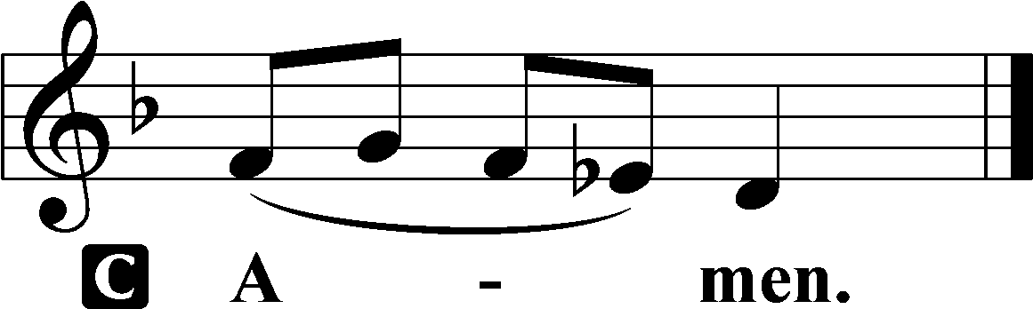

Collect for Peace
P O God, from whom come all holy desires, all good counsels, and all just works, give to us, Your servants, that peace which the world cannot give, that our hearts may be set to obey Your commandments and also that we, being defended from the fear of our enemies, may live in peace and quietness; through Jesus Christ, Your Son, our Lord, who lives and reigns with You and the Holy Spirit, one God, now and forever.

Stand

Benedicamus LSB 234
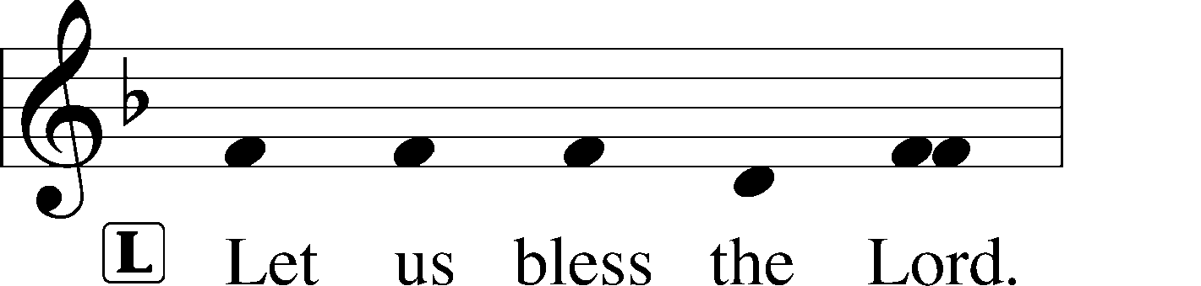
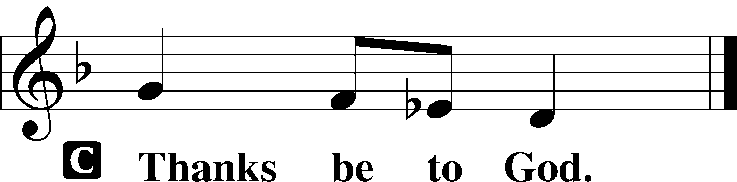

Benediction LSB 234
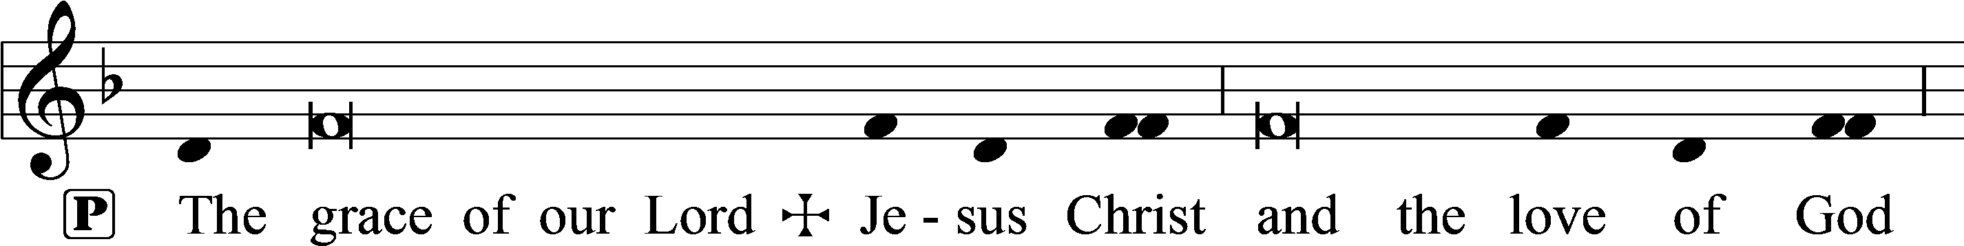
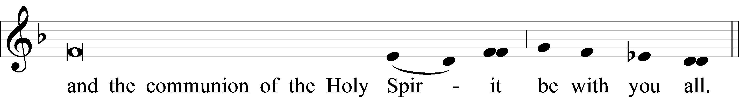

Closing Hymn: TLH #274 “Praise We the Lord This Day”
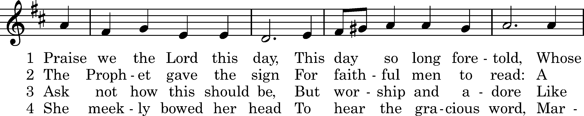
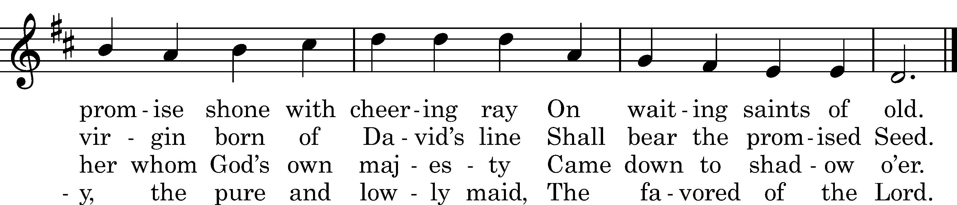

5 Blessed shall be her name
In all the Church on earth,
Through whom that wondrous mercy came,
Th'_incarnate Savior's birth.

6 Jesus, the Virgin's Son,
We praise Thee and adore,
Who art with God the Father One
And Spirit evermore.
Text: author unknown, 1846
Tune: Johann M. Spiess, 1745
Text and tune: Public domain

Acknowledgments
Unless otherwise indicated, Scripture quotations are from the ESV® Bible (The Holy Bible, English Standard Version®), copyright © 2001 by Crossway, a publishing ministry of Good News Publishers. Used by permission. All rights reserved.
Created by Lutheran Service Builder © 2023 Concordia Publishing House.

