Sts. Peter & Paul
Evangelical Lutheran Church
Lutheran Church-Missouri Synod
Founded-1917

March 24, 2024

699 Stambaugh Ave.
Sharon, Pennsylvania 16146

“I was glad when they said to me,
Let us go to the house of the LORD!”
Psalm 122:1
Sts. Peter & Paul Evangelical Lutheran Church, LC-MS
PALM SUNDAY / PASSION SUNDAY
March 24, 2024

A special welcome to our guests this day! If you would like more information about The Lutheran Church - Missouri Synod, or this congregation, please speak with Pastor Deal or an Elder after the service.
Members & Guests: Don’t be embarrassed if your children make noise during the worship service, all children do. We encourage families to worship together but, if you feel the need, there are pews in the rear of the Church which are reserved for young families on both sides of the sanctuary. There is also a quiet room available to you during our service which is located down the hallway past the offices on the right side of the church as well as a children’s area in the Fellowship Hall where you are able to follow along with the service.

Today’s service includes the Sacrament of Holy Communion. If during this past year, you have not worshipped with us and been communed, we respectfully ask that you do not partake of this sacrament this day before first speaking with Pastor Deal.
If visiting from a sister congregation of the LC-MS and are in good standing, please inform Pastor Deal of your desire to commune prior to the service.
If wishing to receive a blessing during communion, please approach with your arms crossed.

CONTACT INFORMATION
Pastor Deal: pastordeal@saintspeterandpaul.net or 724-347-3620 (opt. 2)
Church Office: church@saintspeterandpaul.net or 724-347-3620 (opt. 3)
Office Hours: The church office will be open Monday, Wednesday, and Friday* (8:30 am-4:30 pm; *unless a worship service is in progress).

Silent prayer before worship: Lord Jesus, on this day many people praised You as King and Lord. Lead me to praise You with my heart and my lips for the gift of salvation that You won for me on the cross. Amen.
The Liturgy of the Palms

If the procession begins outside the nave, the congregation gathers around the processional cross. If the congregation is already seated in the nave, it now stands and faces the processional cross at the entrance to the nave.

Collect
P Let us pray.
O God, whom to love and cherish is true righteousness: multiply in our hearts the gifts of Thy holy grace; and as Thou hast, in the death of Thine only Son, made us to hope for those things which we believe, make us by His resurrection happily to arrive whither we now take our journey; through the same Jesus Christ, Thy Son, our Lord, who liveth and reigneth with Thee and the Holy Ghost, ever one God, world without end.

Epistle: Exodus 15:27—16:10 (NKJV)
In those days: The children of Israel came to Elim, where there were twelve wells of water and seventy palm trees; so they camped there by the waters. And they journeyed from Elim, and all the congregation of the children of Israel came to the Wilderness of Sin, which is between Elim and Sinai, on the fifteenth day of the second month after they departed from the land of Egypt. Then the whole congregation of the children of Israel complained against Moses and Aaron in the wilderness. And the children of Israel said to them, “Oh, that we had died by the hand of the Lord in the land of Egypt, when we sat by the pots of meat and when we ate bread to the full! For you have brought us out into this wilderness to kill this whole assembly with hunger.” Then the Lord said to Moses, “Behold, I will rain bread from heaven for you. And the people shall go out and gather a certain quota every day, that I may test them, whether they will walk in My law or not. And it shall be on the sixth day that they shall prepare what they bring in, and it shall be twice as much as they gather daily.” Then Moses and Aaron said to all the children of Israel, “At evening you shall know that the Lord has brought you out of the land of Egypt. And in the morning you shall see the glory of the Lord; for He hears your complaints against the Lord. But what are we, that you complain against us?” Also Moses said, “This shall be seen when the Lord hears your complants which you make against Him. And what are we? Your complaints are not against us but against the Lord.”
Then Moses spoke to Aaron, “Say to all the congregation of the children of Israel, ‘Come near before the Lord, for He has heard your complaints.’” Now it came to pass, as Aaron spoke to the whole congregation of the children of Israel, that they looked toward the wilderness, and behold, the glory of the Lord appeared in the cloud.

P The Word of the Lord.
C Thanks be to God.

Responsory John 11:47-49a, 50b, 53
P Then gathered the chief priests and the Pharisees a council,
And said, What do we? For this Man doeth many miracles.
If we let Him thus alone, all men will believe on Him.
C Let not the Romans come and take away both our place and nation.
P And one of them, named Caiaphas,
Being high priest that same year, prophesied, saying:
It is expedient for you, that one Man should die for the people,
And that the whole nation perish not.
Then from that day forth they took counsel together for to put Him to death, saying:
C Let not the Romans come and take away both our place and nation.

Gospel: Luke 19:29-40 (NKJV)
P The Lord be with you.
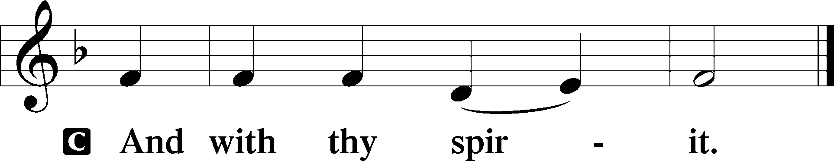

P The continuation of the T Holy Gospel T according to T Saint Luke.

At that time: When Jesus drew near to Bethphage and Bethany, at the mountain called Olivet, He sent two of His disciples, saying, “Go into the village opposite you, where as you enter you will find a colt tied, on which no one has ever sat. Loose it and bring it here. And if anyone asks you, ‘Why are you loosing it?’ thus you shall say to him, ‘Because the Lord has need of it.’ ” So those who were sent went their way and found it just as He had said to them. But as they were loosing the colt, the owners of it said to them, “Why are you loosing the colt?” And they said, “The Lord has need of him.” Then they brought him to Jesus. And they threw their own clothes on the colt, and they set Jesus on him. And as He went, many spread their clothes on the road. Then, as He was now drawing near the descent of the Mount of Olives, the whole multitude of the disciples began to rejoice and praise God with a loud voice for all the mighty works they had seen, saying: “ ‘Blessed is the King who comes in the name of the Lord!’ Peace in heaven and glory in the highest!” And some of the Pharisees called to Him from the crowd, “Teacher, rebuke Your disciples.” But He answered and said to them, “I tell you that if these should keep silent, the stones would immediately cry out.”

P The Gospel of the Lord.
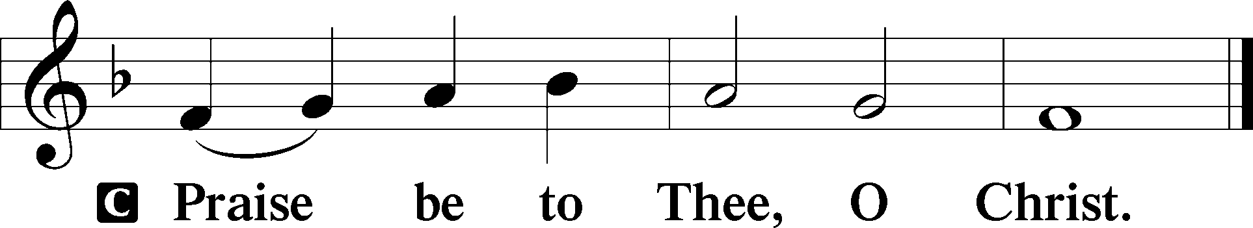

Blessing of the Palms
P Our help T is in the name of the Lord.
C Who made heaven and earth.
P Let us pray.
O God, whose Son, for the salvation of mankind, came down from heaven to earth and, when the hour of His Passion drew nigh, willed to come to Jerusalem sitting on a donkey and to be hailed as King and praised by the multitude: Be pleased to bl T ess and sanc T tify these Thy people who carry these branches: that all who carry them may be so filled with the gift of Thy blessing that they may overcome the ancient foe even in this world, and with the palm of victory and the fruit of good works appear before Thee in the world to come; through the same Jesus Christ, Thy Son, our Lord, who liveth and reigneth with Thee and the Holy Ghost, ever one God, world without end.
C Amen.

P Let us pray.
O God, who for our salvation didst send Thy Son, our Lord Jesus Christ, into this world to humble Himself to us and to call us back to Thee; before whom, as He came to Jerusalem to fulfill the Scriptures, the multitude of believers devoutly strewed His way with their garments and palms: Grant, we beseech Thee, that we may prepare before Him the way of faith, and removing every stone of stumbling and rock of offense, may flourish before Thee with the fruitful branches of righteous works, that we may follow in His steps, through the same Jesus Christ, Thy Son, our Lord.
C Amen.

P Let us pray.
Almighty and everlasting God, who restores us by the blessed Passion of Jesus Christ, Thy Son, preserve in us the works of Thy mercy, that in the celebration of this mystery we may live in perpetual devotion, through the same Jesus Christ, Thy Son, our Lord, who liveth and reigneth with Thee and the Holy Ghost, ever one God, world without end.
C Amen.

Antiphon
P When the people heard that Jesus was coming to Jerusalem, they took branches of palm trees, and went forth to meet Him; and the children cried, saying:
This is He who was to come for the salvation of the people.
This is our salvation: and the redemption of Israel
How great is He, whom thrones and dominions run to meet.
Fear not, daughter of Zion,
Behold thy King, cometh unto thee,
Sitting on an ass’s colt, as it is written.
Hail, O King, Creator of the world.
Who didst come to redeem us.
Processional Hymn: TLH #160 “All Glory, Laud, and Honor”
(Sung to the tune of LSB #442)

- All glory, laud, and honor to Thee, Redeemer, King,
To whom the lips of children made sweet hosannas ring.
Thou art the King of Israel, Thou David’s royal Son,
Who in the Lord’s name comest, the King and Blessed One.

- All glory, laud, and honor to Thee, Redeemer, King,
To whom the lips of children made sweet hosannas ring.
The company of angels are praising Thee on high,
And mortal men and all things created make reply.

- All glory, laud, and honor to Thee, Redeemer, King,
To whom the lips of children made sweet hosannas ring.
The people of the Hebrews with palms before Thee went;
Our praise and prayer and anthems before Thee we present.

- All glory, laud, and honor to Thee, Redeemer, King,
To whom the lips of children made sweet hosannas ring.
To Thee, before Thy Passion, they sang their hymns of praise;
To Thee, now high exalted, our melody we raise.

- All glory, laud, and honor To Thee, Redeemer, King,
To whom the lips of children made sweet hosannas ring.
Thou didst accept their praises; accept the prayers we bring,
Who in all good delightest, Thou good and gracious King.

Introit Psalm 22: 19, 21, 1
P Be not Thou not far from me, | O Lord:*
O my strength, haste Thee to | help me.
Save me from the | lion’s mouth:*
And deliver me from the horns of the | unicorns.
My God, my God, why hast Thou for-| saken me?*
Why art Thou so far from helping me, and from the words of my | roaring?
A time of silence may be observed to highlight the contrast between Jesus’ triumphal entry and His passion.
Kyrie Mark 10:47
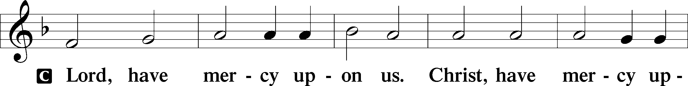
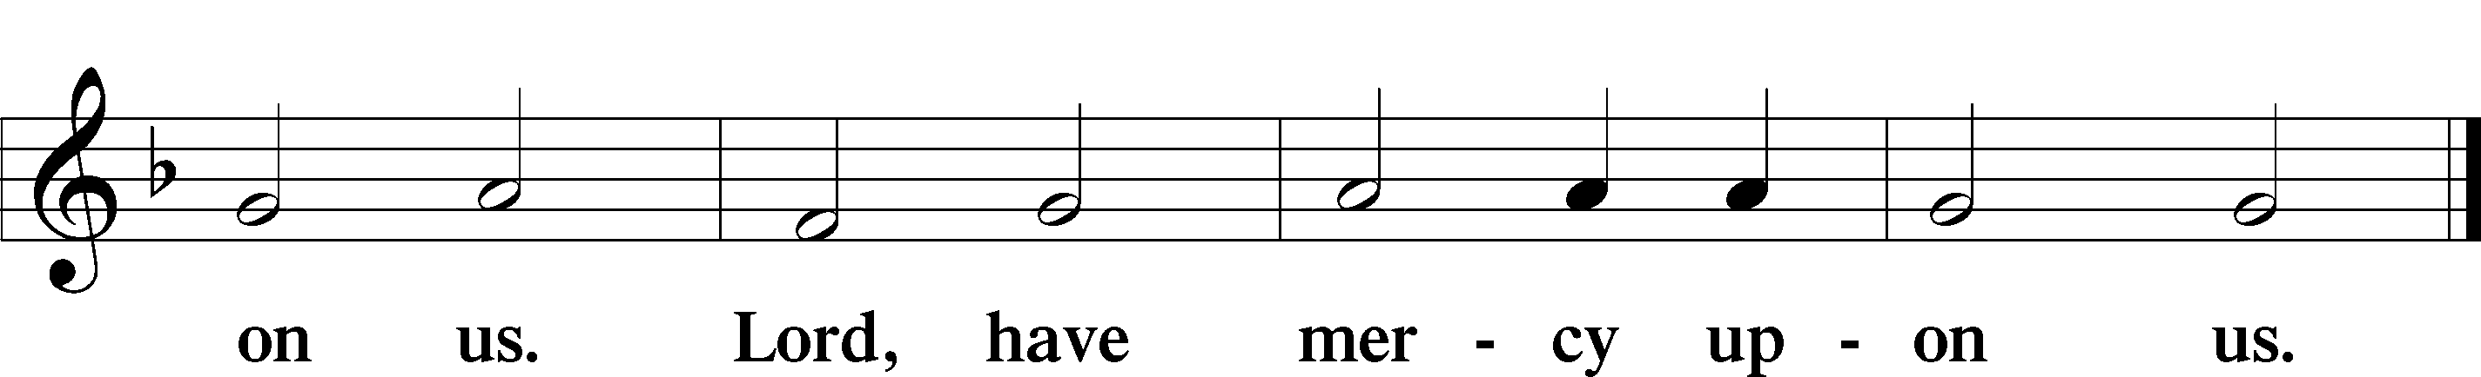

Collect
P The Lord be with you.

P Let us pray.
Almighty and everlasting God, who hast sent Thy Son, our Saviour Jesus Christ, to take upon Him our flesh and to suffer death upon the cross, that all mankind should follow the example of His great humility: mercifully grant that we may both follow the example of His patience and also be made partakers of His resurrection, through the same Jesus Christ, Thy Son, our Lord, who liveth and reigneth with Thee and the Holy Ghost, ever one God, world without end.
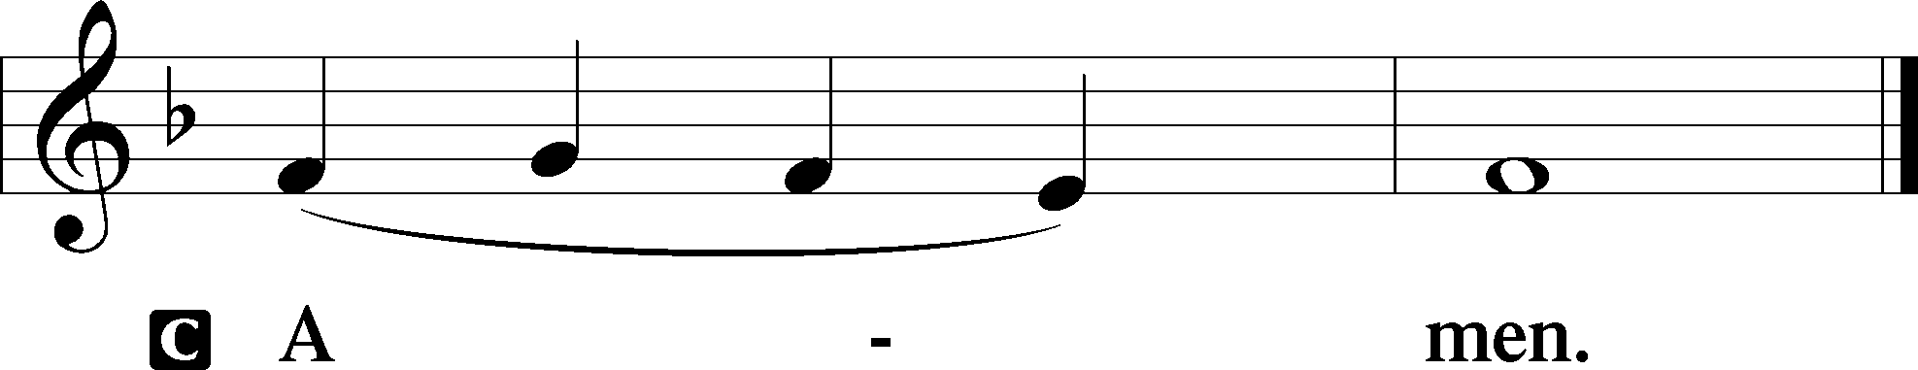

Sit

Prophecy: Zechariah 9:9–12 (NKJV)
“Rejoice greatly, O daughter of Zion!
Shout, O daughter of Jerusalem!
Behold, your King is coming to you;
He is just and having salvation,
Lowly and riding on a donkey,
A colt, the foal of a donkey.
I will cut off the chariot from Ephraim
And the horse from Jerusalem;
The battle bow shall be cut off.
He shall speak peace to the nations;
His dominion shall be ‘from sea to sea,
And from the River to the ends of the earth.’

“As for you also,
Because of the blood of your covenant,
I will set your prisoners free from the waterless pit.
Return to the stronghold,
You prisoners of hope.
Even today I declare
That I will restore double to you.

P The Word of the Lord.
C Thanks be to God.

Epistle: Philippians 2:5–11 (NKJV)
Brethren: Let this mind be in you which was also in Christ Jesus, who, being in the form of God, did not consider it robbery to be equal with God, but made Himself of no reputation, taking the form of a bondservant, and coming in the likeness of men. And being found in appearance as a man, He humbled Himself and became obedient to the point of death, even the death of the cross. Therefore God also has highly exalted Him and given Him the name which is above every name, that at the name of Jesus every knee should bow, of those in heaven, and of those on earth, and of those under the earth, and that every tongue should confess that Jesus Christ is Lord, to the glory of God the Father.

P The Word of the Lord.
C Thanks be to God.

Gradual Psalm 73:23b-24, 1-3
Thou hast holden me by my | right hand*
Thou shalt guide me with Thy counsel: and afterward receive me to | glory.
Truly, God is good to Israel,
Even to such as are of a | clean heart*
But as for me, my feet were*almost gone,
My steps had well-nigh slipped
For I was jealous on occasion of the | wicked*
When I saw the prosperity of | sinners.

Stand

Tract Psalm 22:1-8, 17b-18, 21, 23a, 30b-31
O God, my God, look up- | on me*
Why hast Thou for- | saken me?
Why art Thou so far from helping me
And from the words of my | roaring?*
O my God, I cry in the day time, but Thou | hearest not,
And in the night season, and am not | silent.*
But Thou art holy,
Thou that inhabitest the praises of | Israel.
Our fathers trusted in Thee:
They trusted, and Thou didst de- | liver them.*
They cried unto Thee, and were delivered:
Thy trusted in Thee, and were not con- | founded.
I am a worm and no man
A reproach of men and despised of the | people.*
All they that see me laugh me to scorn:
They shoot out the lip, they shake the head, | saying,
He trusted on the Lord; that He would deliver Him
Let Him deliver Him: seeing he delighted | in Him.*
They look and stare upon me; they part my garments among them:
And cast lots upon my | vesture.
Save me from the lion’s mouth:
And from the horns of the | unicorns.*
Ye that fear the Lord, praise Him:
All ye the seed of Jacob, glor- | ify Him.
There shall be declared to the Lord a genera- | tion to come*
And the heavens shall show forth His justice.
Which the Lord | hath made.

Gospel: Matthew 26:1—27:66 (NKJV)
P The Lord be with you.

You may be seated for the reading.

At that time: Jesus said to His disciples, “You know that after two days is the Passover, and the Son of Man will be delivered up to be crucified.” Then the chief priests, the scribes, and the elders of the people assembled at the palace of the high priest, who was called Caiaphas, and plotted to take Jesus by trickery and kill Him. But they said, “Not during the feast, lest there be an uproar among the people.” And when Jesus was in Bethany at the house of Simon the leper, a woman came to Him having an alabaster flask of very costly fragrant oil, and she poured it on His head as He sat at the table. But when His disciples saw it, they were indignant, saying, “Why this waste? For this fragrant oil might have been sold for much and given to the poor.” But when Jesus was aware of it, He said to them, “Why do you trouble the woman? For she has done a good work for Me. For you have the poor with you always, but Me you do not have always. For in pouring this fragrant oil on My body, she did it for My burial. Assuredly, I say to you, wherever this gospel is preached in the whole world, what this woman has done will also be told as a memorial to her.” Then one of the twelve, called Judas Iscariot, went to the chief priests and said, “What are you willing to give me if I deliver Him to you?” And they counted out to him thirty pieces of silver. So from that time he sought opportunity to betray Him. Now on the first day of the Feast of the Unleavened Bread the disciples came to Jesus, saying to Him, “Where do You want us to prepare for You to eat the Passover?” And He said, “Go into the city to a certain man, and say to him, ‘The Teacher says, “My time is at hand; I will keep the Passover at your house with My disciples.” ’ ” So the disciples did as Jesus had directed them; and they prepared the Passover. When evening had come, He sat down with the twelve. Now as they were eating, He said, “Assuredly, I say to you, one of you will betray Me.” And they were exceedingly sorrowful, and each of them began to say to Him, “Lord, is it I?” He answered and said, “He who dipped his hand with Me in the dish will betray Me. The Son of Man indeed goes just as it is written of Him, but woe to that man by whom the Son of Man is betrayed! It would have been good for that man if he had not been born.” Then Judas, who was betraying Him, answered and said, “Rabbi, is it I?” He said to him, “You have said it.” And as they were eating, Jesus took bread, blessed and broke it, and gave it to the disciples and said, “Take, eat; this is My body.” Then He took the cup, and gave thanks, and gave it to them, saying, “Drink from it, all of you. For this is My blood of the new covenant, which is shed for many for the remission of sins. But I say to you, I will not drink of this fruit of the vine from now on until that day when I drink it new with you in My Father’s kingdom.” And when they had sung a hymn, they went out to the Mount of Olives. Then Jesus said to them, “All of you will be made to stumble because of Me this night, for it is written: ‘I will strike the Shepherd, and the sheep of the flock will be scattered.’ But after I have been raised, I will go before you to Galilee.” Peter answered and said to Him, “Even if all are made to stumble because of You, I will never be made to stumble.” Jesus said to him, “Assuredly, I say to you that this night, before the rooster crows, you will deny Me three times.” Peter said to Him, “Even if I have to die with You, I will not deny You!” And so said all the disciples. Then Jesus came with them to a place called Gethsemane, and said to the disciples, “Sit here while I go and pray over there.” And He took with Him Peter and the two sons of Zebedee, and He began to be sorrowful and deeply distressed. Then He said to them, “My soul is exceedingly sorrowful, even to death. Stay here and watch with Me.” He went a little farther and fell on His face, and prayed, saying, “O My Father, if it is possible, let this cup pass from Me; nevertheless, not as I will, but as You will.” Then He came to the disciples and found them sleeping, and said to Peter, “What! Could you not watch with Me one hour? Watch and pray, lest you enter into temptation. The spirit indeed is willing, but the flesh is weak.” Again, a second time, He went away and prayed, saying, “O My Father, if this cup cannot pass away from Me unless I drink it, Your will be done.” And He came and found them asleep again, for their eyes were heavy. So He left them, went away again, and prayed the third time, saying the same words. Then He came to His disciples and said to them, “Are you still sleeping and resting? Behold, the hour is at hand, and the Son of Man is being betrayed into the hands of sinners. Rise, let us be going. See, My betrayer is at hand.” And while He was still speaking, behold, Judas, one of the twelve, with a great multitude with swords and clubs, came from the chief priests and elders of the people. Now His betrayer had given them a sign, saying, “Whomever I kiss, He is the One; seize Him.” Immediately he went up to Jesus and said, “Greetings, Rabbi!” and kissed Him. But Jesus said to him, “Friend, why have you come?” Then they came and laid hands on Jesus and took Him. And suddenly, one of those who were with Jesus stretched out his hand and drew his sword, struck the servant of the high priest, and cut off his ear. But Jesus said to him, “Put your sword in its place, for all who take the sword will perish by the sword. Or do you think that I cannot now pray to My Father, and He will provide Me with more than twelve legions of angels? How then could the Scriptures be fulfilled, that it must happen thus?” In that hour Jesus said to the multitudes, “Have you come out, as against a robber, with swords and clubs to take Me? I sat daily with you, teaching in the temple, and you did not seize Me. But all this was done that the Scriptures of the prophets might be fulfilled.” Then all the disciples forsook Him and fled. And those who had laid hold of Jesus led Him away to Caiaphas the high priest, where the scribes and the elders were assembled. But Peter followed Him at a distance to the high priest’s courtyard. And he went in and sat with the servants to see the end. Now the chief priests, the elders, and all the council sought false testimony against Jesus to put Him to death, but found none. Even though many false witnesses came forward, they found none. But at last two false witnesses came forward and said, “This fellow said, ‘I am able to destroy the temple of God and to build it in three days.’ ” And the high priest arose and said to Him, “Do You answer nothing? What is it these men testify against You?” But Jesus kept silent. And the high priest answered and said to Him, “I put You under oath by the living God: Tell us if You are the Christ, the Son of God!” Jesus said to him, “It is as you said. Nevertheless, I say to you, hereafter you will see the Son of Man sitting at the right hand of the Power, and coming on the clouds of heaven.” Then the high priest tore his clothes, saying, “He has spoken blasphemy! What further need do we have of witnesses? Look, now you have heard His blasphemy! What do you think?” They answered and said, “He is deserving of death.” Then they spat in His face and beat Him; and others struck Him with the palms of their hands, saying, “Prophesy to us, Christ! Who is the one who struck You?” Now Peter sat outside in the courtyard. And a servant girl came to him, saying, “You also were with Jesus of Galilee.” But he denied it before them all, saying, “I do not know what you are saying.” And when he had gone out to the gateway, another girl saw him and said to those who were there, “This fellow also was with Jesus of Nazareth.” But again he denied with an oath, “I do not know the Man!” And a little later those who stood by came up and said to Peter, “Surely you also are one of them, for your speech betrays you.” Then he began to curse and swear, saying, “I do not know the Man!” Immediately a rooster crowed. And Peter remembered the word of Jesus who had said to him, “Before the rooster crows, you will deny Me three times.” So he went out and wept bitterly. When morning came, all the chief priests and elders of the people plotted against Jesus to put Him to death. And when they had bound Him, they led Him away and delivered Him to Pontius Pilate the governor. Then Judas, His betrayer, seeing that He had been condemned, was remorseful and brought back the thirty pieces of silver to the chief priests and elders, saying, “I have sinned by betraying innocent blood.” And they said, “What is that to us? You see to it!” Then he threw down the pieces of silver in the temple and departed, and went and hanged himself. But the chief priests took the silver pieces and said, “It is not lawful to put them into the treasury, because they are the price of blood.” And they consulted together and bought with them the potter’s field, to bury strangers in. Therefore that field has been called the Field of Blood to this day. Then was fulfilled what was spoken by Jeremiah the prophet, saying, “And they took the thirty pieces of silver, the value of Him who was priced, whom they of the children of Israel priced, and gave them for the potter’s field, as the Lord directed me.” Now Jesus stood before the governor. And the governor asked Him, saying, “Are You the King of the Jews?” Jesus said to him, “It is as you say.” And while He was being accused by the chief priests and elders, He answered nothing. Then Pilate said to Him, “Do You not hear how many things they testify against You?” But He answered him not one word, so that the governor marveled greatly. Now at the feast the governor was accustomed to releasing to the multitude one prisoner whom they wished. And at that time they had a notorious prisoner called Barabbas. Therefore, when they had gathered together, Pilate said to them, “Whom do you want me to release to you? Barabbas, or Jesus who is called Christ?” For he knew that they had handed Him over because of envy. While he was sitting on the judgment seat, his wife sent to him, saying, “Have nothing to do with that just Man, for I have suffered many things today in a dream because of Him.” But the chief priests and elders persuaded the multitudes that they should ask for Barabbas and destroy Jesus. The governor answered and said to them, “Which of the two do you want me to release to you?” They said, “Barabbas!” Pilate said to them, “What then shall I do with Jesus who is called Christ?” They all said to him, “Let Him be crucified!” Then the governor said, “Why, what evil has He done?” But they cried out all the more, saying, “Let Him be crucified!” When Pilate saw that he could not prevail at all, but rather that a tumult was rising, he took water and washed his hands before the multitude, saying, “I am innocent of the blood of this just Person. You see to it.” And all the people answered and said, “His blood be on us and on our children.” Then he released Barabbas to them; and when he had scourged Jesus, he delivered Him to be crucified. Then the soldiers of the governor took Jesus into the Praetorium and gathered the whole garrison around Him. And they stripped Him and put a scarlet robe on Him. When they had twisted a crown of thorns, they put it on His head, and a reed in His right hand. And they bowed the knee before Him and mocked Him, saying, “Hail, King of the Jews!” Then they spat on Him, and took the reed and struck Him on the head. And when they had mocked Him, they took the robe off Him, put His own clothes on Him, and led Him away to be crucified. Now as they came out, they found a man of Cyrene, Simon by name. Him they compelled to bear His cross. And when they had come to a place called Golgotha, that is to say, Place of a Skull, they gave Him sour wine mingled with gall to drink. But when He had tasted it, He would not drink. Then they crucified Him, and divided His garments, casting lots, that it might be fulfilled which was spoken by the prophet: “They divided My garments among them, and for My clothing they cast lots.” Sitting down, they kept watch over Him there. And they put up over His head the accusation written against Him: THIS IS JESUS THE KING OF THE JEWS. Then two robbers were crucified with Him, one on the right and another on the left. And those who passed by blasphemed Him, wagging their heads and saying, “You who destroy the temple and build it in three days, save Yourself! If You are the Son of God, come down from the cross.” Likewise the chief priests also, mocking with the scribes and elders, said, “He saved others; Himself He cannot save. If He is the King of Israel, let Him now come down from the cross, and we will believe Him. He trusted in God; let Him deliver Him now if He will have Him; for He said, ‘I am the Son of God.’ ” Even the robbers who were crucified with Him reviled Him with the same thing. Now from the sixth hour until the ninth hour there was darkness over all the land. And about the ninth hour Jesus cried out with a loud voice, saying, “Eli, Eli, lama sabachthani?” that is, “My God, My God, why have You forsaken Me?” Some of those who stood there, when they heard that, said, “This Man is calling for Elijah!” Immediately one of them ran and took a sponge, filled it with sour wine and put it on a reed, and offered it to Him to drink. The rest said, “Let Him alone; let us see if Elijah will come to save Him.” And Jesus cried out again with a loud voice, and yielded up His spirit.

At the words “yielded up His spirit,” all will stand and silently pray the Lord’s Prayer.

Then, behold, the veil of the temple was torn in two from top to bottom; and the earth quaked, and the rocks were split, and the graves were opened; and many bodies of the saints who had fallen asleep were raised; and coming out of the graves after His resurrection, they went into the holy city and appeared to many. So when the centurion and those with him, who were guarding Jesus, saw the earthquake and the things that had happened, they feared greatly, saying, “Truly this was the Son of God!” And many women who followed Jesus from Galilee, ministering to Him, were there looking on from afar, among whom were Mary Magdalene, Mary the mother of James and Joses, and the mother of Zebedee’s sons. Now when evening had come, there came a rich man from Arimathea, named Joseph, who himself had also become a disciple of Jesus. This man went to Pilate and asked for the body of Jesus. Then Pilate commanded the body to be given to him. When Joseph had taken the body, he wrapped it in a clean linen cloth, and laid it in his new tomb which he had hewn out of the rock; and he rolled a large stone against the door of the tomb, and departed. And Mary Magdalene was there, and the other Mary, sitting opposite the tomb. On the next day, which followed the Day of Preparation, the chief priests and Pharisees gathered together to Pilate, saying, “Sir, we remember, while He was still alive, how that deceiver said, ‘After three days I will rise.’ Therefore command that the tomb be made secure until the third day, lest His disciples come by night and steal Him away, and say to the people, ‘He has risen from the dead.’ So the last deception will be worse than the first.” Pilate said to them, “You have a guard; go your way, make it as secure as you know how.” So they went and made the tomb secure, sealing the stone and setting the guard.

Nicene Creed
C I believe in one God,
the Father Almighty,
maker of heaven and earth
and of all things visible and invisible.

And in one Lord Jesus Christ,
the only-begotten Son of God,
begotten of His Father before all worlds,
God of God, Light of Light,
very God of very God,
begotten, not made,
being of one substance with the Father,
by whom all things were made;
who for us men and for our salvation came down from heaven
and was incarnate by the Holy Spirit of the virgin Mary
and was made man;
and was crucified also for us under Pontius Pilate.
He suffered and was buried.
And the third day He rose again according to the Scriptures
and ascended into heaven
and sits at the right hand of the Father.
And He will come again with glory to judge both the living and the dead,
whose kingdom will have no end.

And I believe in the Holy Spirit,
the Lord and giver of life,
who proceeds from the Father and the Son,
who with the Father and the Son together is worshiped and glorified,
who spoke by the prophets.
And I believe in one holy Christian and apostolic Church,
I acknowledge one Baptism for the remission of sins,
and I look for the resurrection of the dead
and the life T of the world to come. Amen.
Sit

Hymn of the Day: TLH #142 “A Lamb Goes Uncomplaining Forth”
(Sung to the tune of LSB #438)

- A Lamb goes uncomplaining forth,
The guilt of all men bearing;
And laden with the sins of earth,
None else the burden sharing!
Goes patient on, grows weak and faint,
To slaughter led without complaint,
That spotless life to offer;
Bears shame, and stripes, and wounds and death,
Anguish and mockery, and saith,
“Willing all this I suffer.”

- This Lamb is Christ, the soul’s great Friend,
The Lamb of God, our Savior;
Him God the Father chose to send
To gain for us His favor.
“Go forth, My Son,” the Father saith,
“And free men from the fear of death,
From guilt and condemnation.
The wrath and stripes are hard to bear,
But by Thy Passion men shall share
The fruit of Thy salvation.”

- “Yea, Father, yea, most willingly
I’ll bear what Thou commandest;
My will conforms to Thy decree,
I do what Thou demandest.”
O wondrous Love, what hast Thou done!
The Father offers up His Son!
The Son, content, descendeth!
O Love, how strong, Thou art to save!
Thou beddest Him within the grave
Whose word the mountains rendeth.

- From morn till eve my theme shall be
Thy mercy’s wondrous measure;
To sacrifice myself for Thee
Shall be my aim and pleasure.
My stream of life shall ever be
A current flowing ceaselessly,
Thy constant praise outpouring.
I’ll treasure in my memory,
O Lord, all Thou hast done for me,
Thy gracious love adoring.

- Of death I am no more afraid,
New life from Thee is flowing;
Thy cross affords me cooling shade
When noonday’s sun is glowing.
When by my grief I am opprest,
On Thee my weary soul shall rest
Serenely as on pillows.
Thou art my Anchor when by woe
My bark is driven to and fro
On trouble’s surging billows.

- And when Thy glory I shall see
And taste Thy kingdom’s pleasure,
Thy blood my royal robe shall be,
My joy beyond all measure;
When I appear before Thy throne,
Thy righteousness shall be my crown,--
With these I need not hide me.
And there, in garments richly wrought
As Thine own bride, I shall be brought
To stand in joy beside Thee.
Homily

Stand
Offertory Psalm 51:10–12
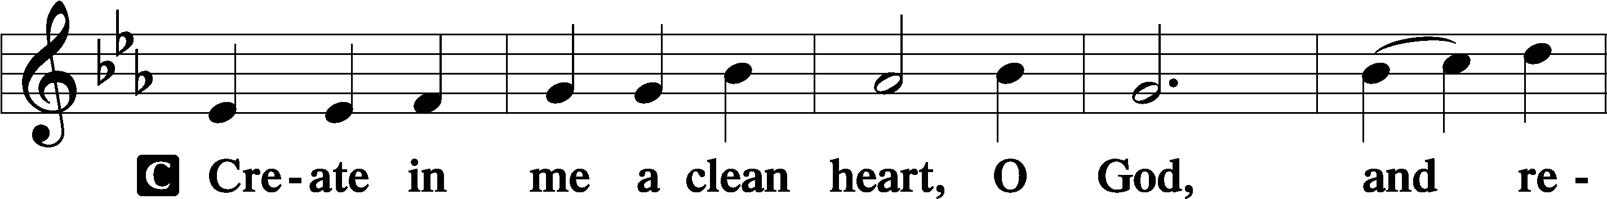
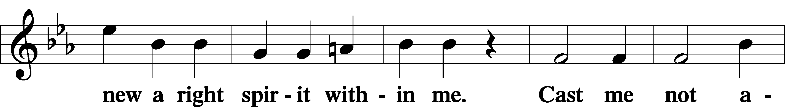
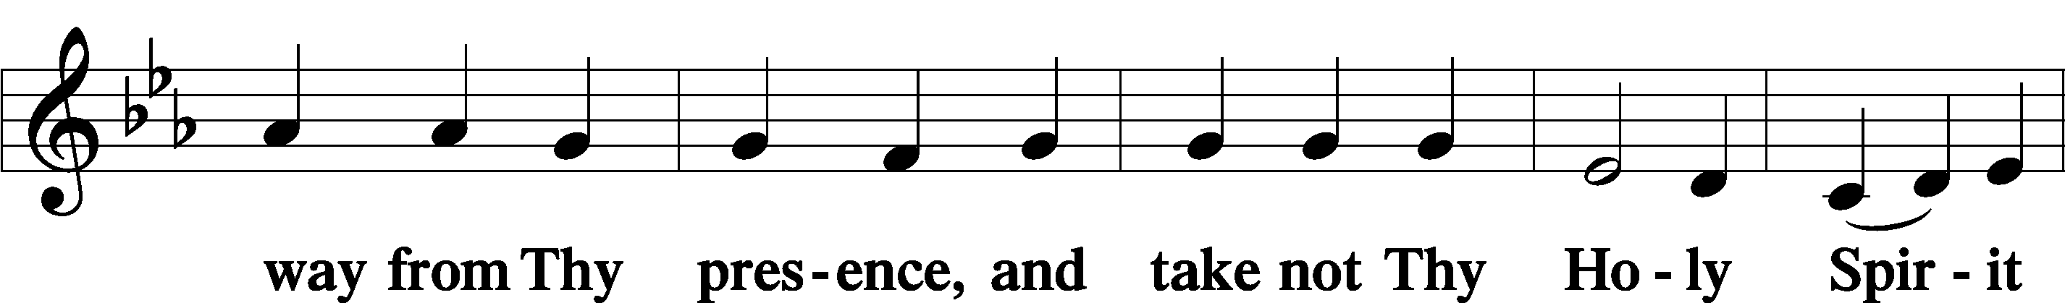
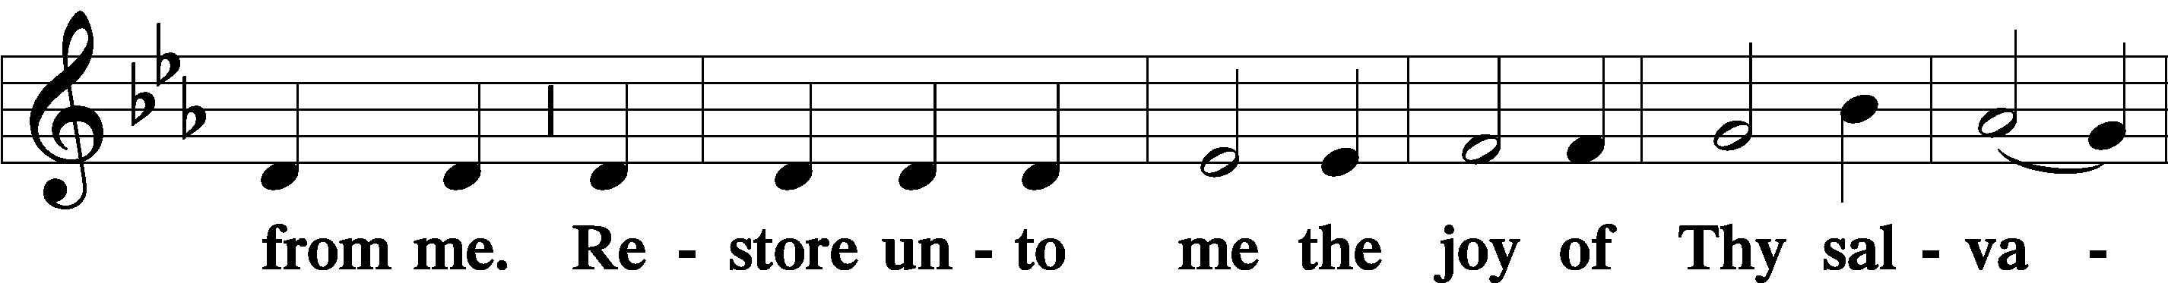
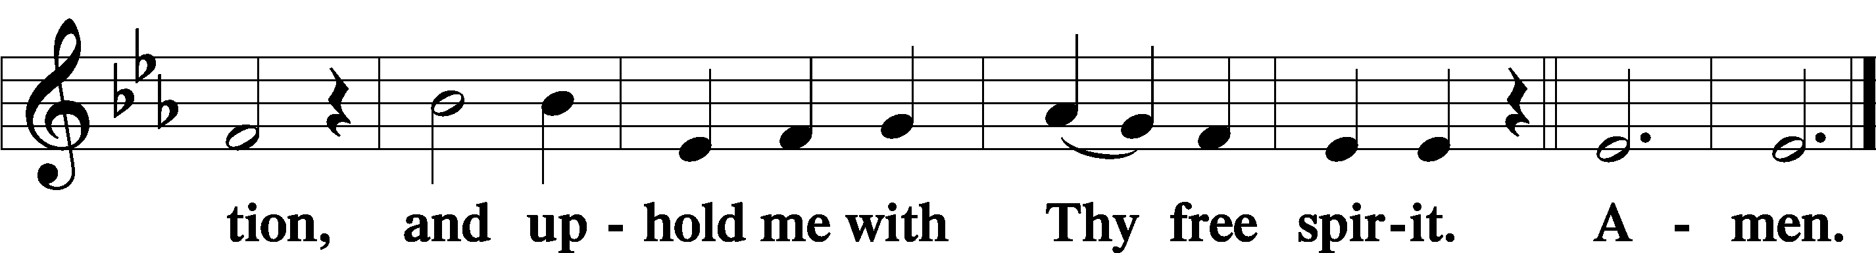

Prayer of the Church

Sit

Preparatory Hymn: LSB #630 “Now, My Tongue, the Mystery Telling”

Stand
Service of the Sacrament

Preface 2 Timothy 4:22; Colossians 3:1 Psalm 136
P The Lord be with you.

P Lift up your hearts.
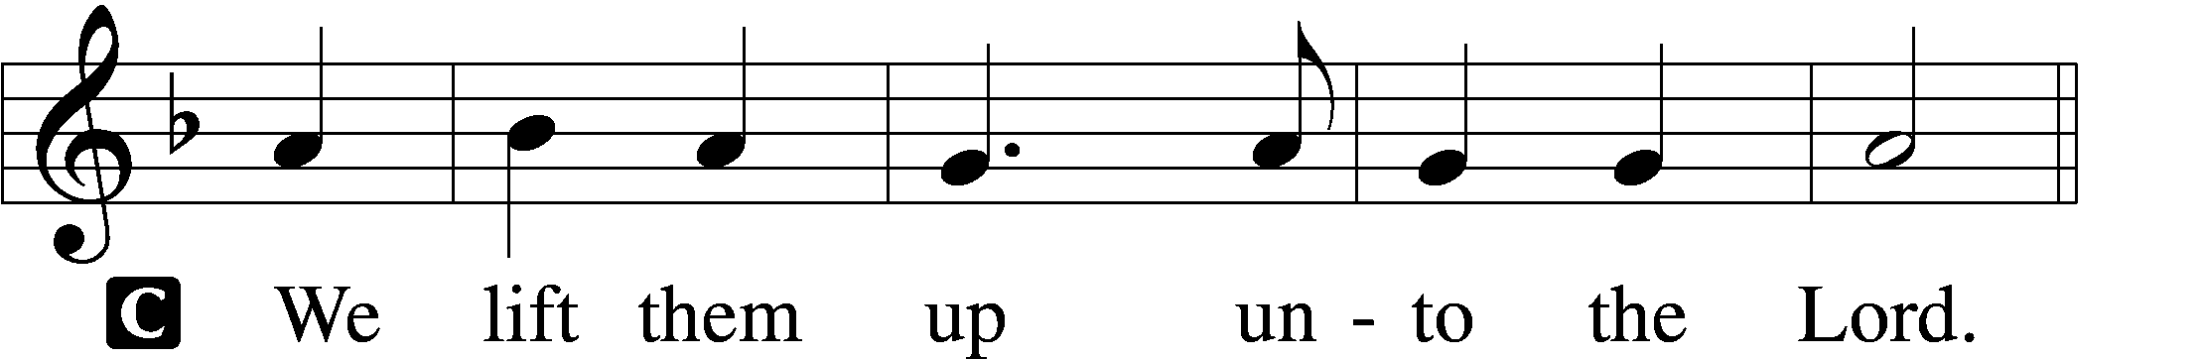
P Let us give thanks unto the Lord, our God.
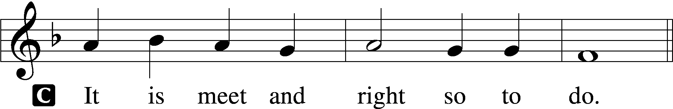

Proper Preface (Abbreviated) LSB 194
P It is truly meet, right, and salutary . . . evermore praising You and saying:

Sanctus Isaiah 6:3; Matthew 21:9
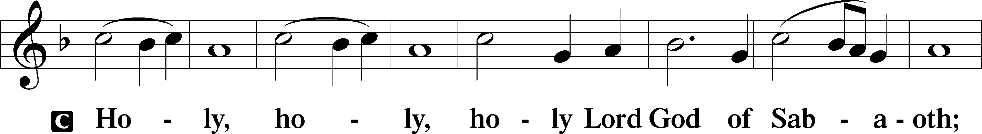
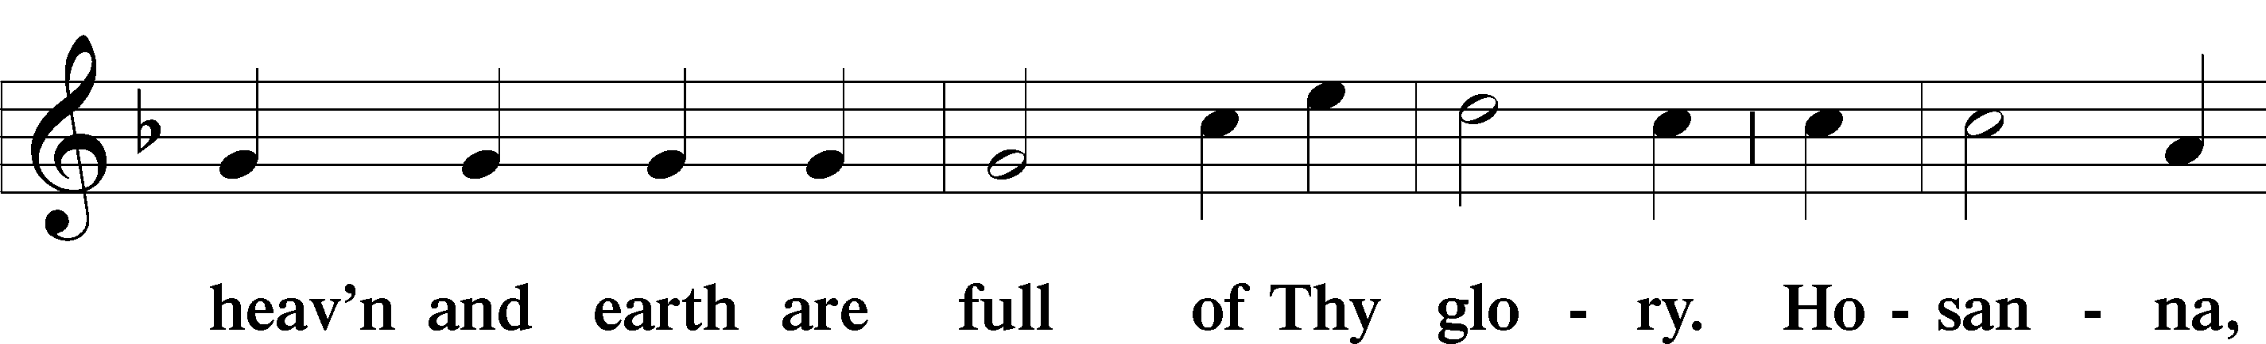
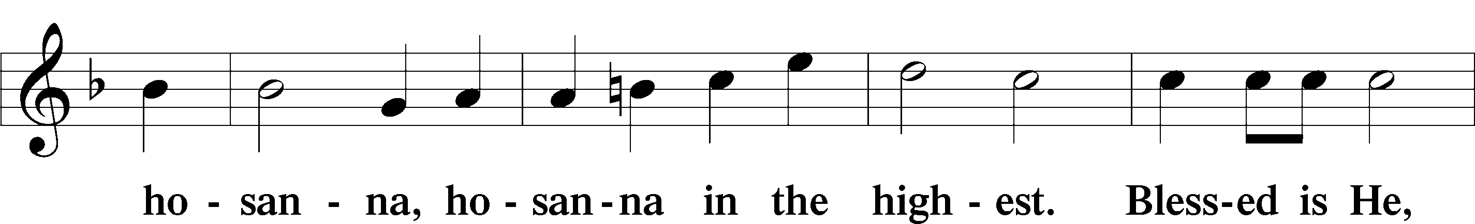
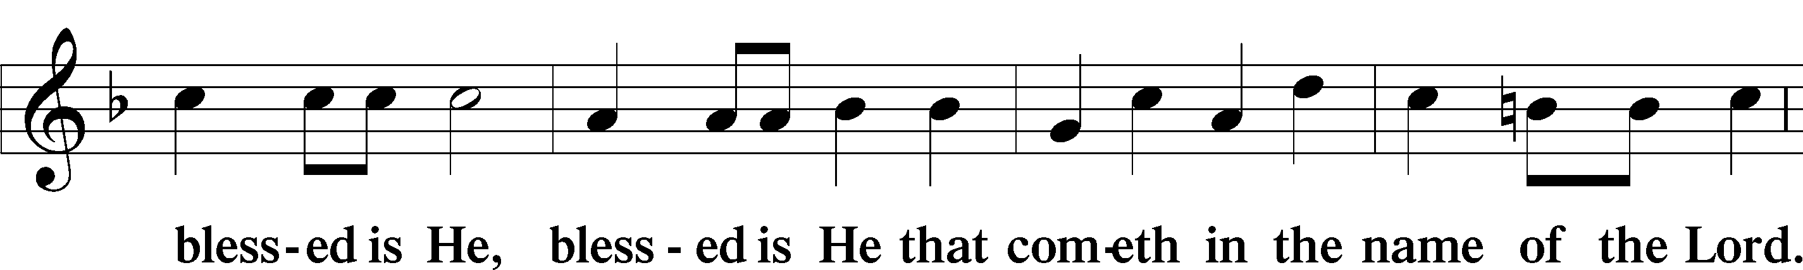
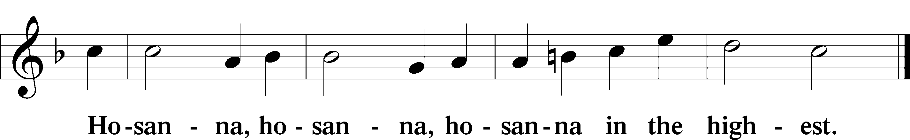

Lord’s Prayer Matthew 6:9–13
C Our Father who art in heaven,
hallowed be Thy name,
Thy kingdom come,
Thy will be done on earth as it is in heaven;
give us this day our daily bread;
and forgive us our trespasses as we forgive those who trespass against us;
and lead us not into temptation,
but deliver us from evil.
For Thine is the kingdom and the power and the glory forever and ever. Amen.

The Words of Our Lord Matthew 26:26–28; Mark 14:22–24; Luke 22:19–20; 1 Corinthians 11:23–25
P Our Lord Jesus Christ, on the night when He was betrayed, took bread, and when He had given thanks, He broke it and gave it to the disciples and said: “Take, eat; this is My T body, which is given for you. This do in remembrance of Me.”

In the same way also He took the cup after supper, and when He had given thanks, He gave it to them, saying: “Drink of it, all of you; this cup is the new testament in My T blood, which is shed for you for the forgiveness of sins. This do, as often as you drink it, in remembrance of Me.”

Pax Domini John 20:19
P The peace of the Lord be with you always.

Agnus Dei John 1:29
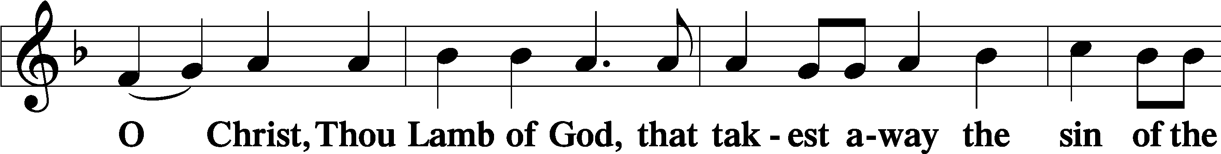
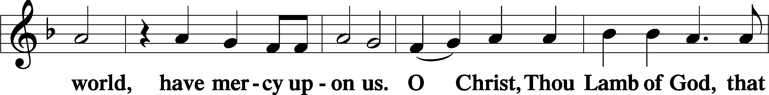
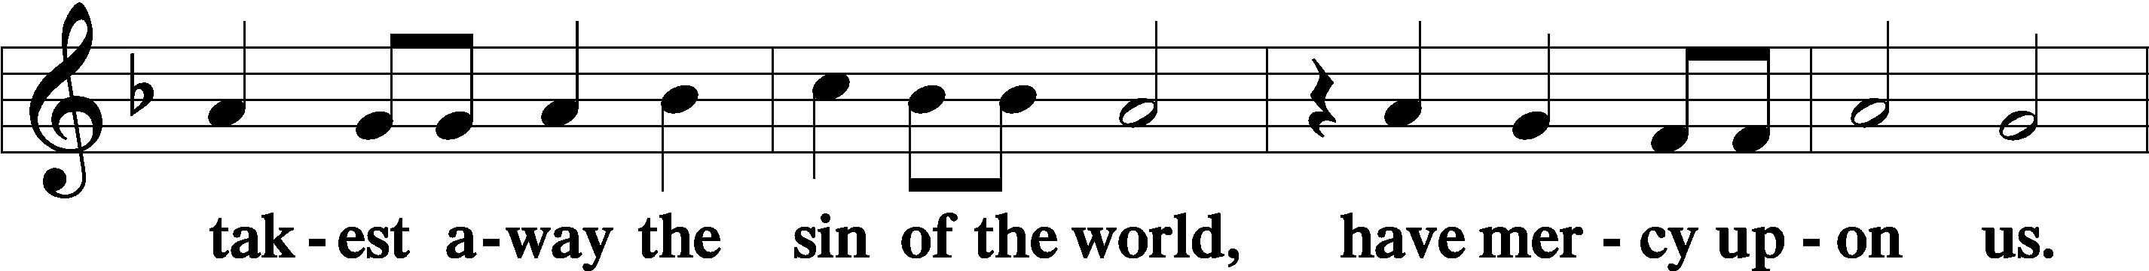
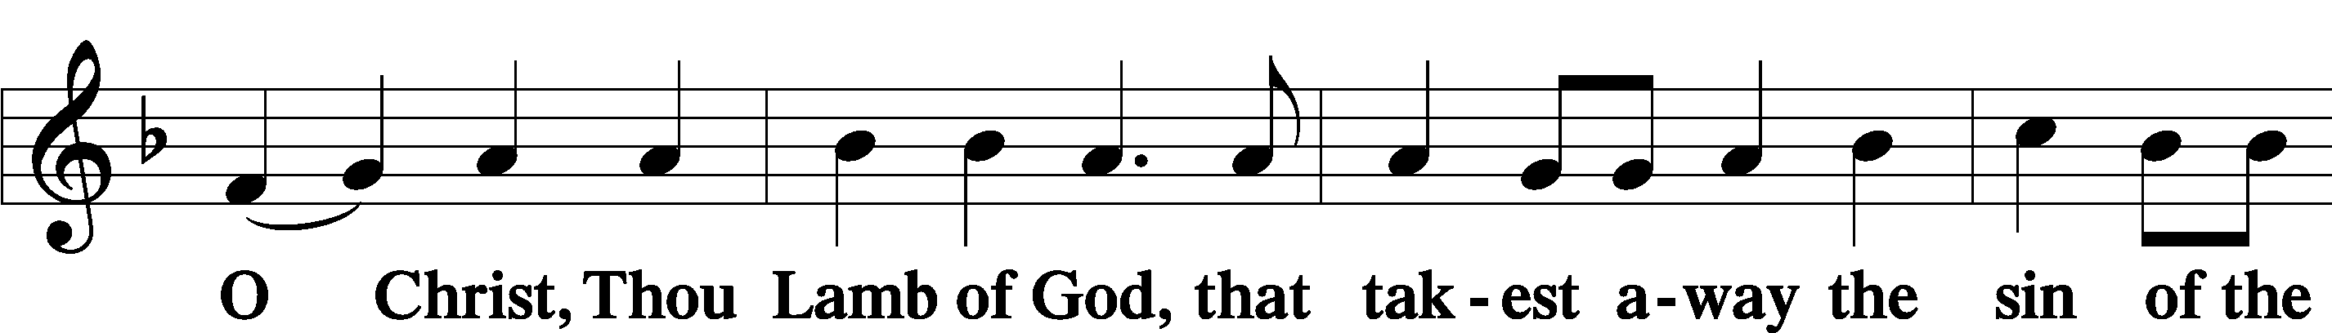
Sit

Private Prayer before Communion
Let not the partaking of Thy Body, O Lord Jesus Christ, which I, though unworthy, do presume to receive, turn to me for judgment and condemnation; but, according to Thy loving-kindness, let it be profitable to me for the forgiveness of sins, life, and salvation, who with the Father and the Holy Ghost livest and reignest, ever one God, world without end. Amen.

Private Prayer during Communion
O Lord, I am not worthy that Thou shouldest come under my roof; but speak the word only, and my soul shall be healed. Amen.

Private Prayer after Communion
Let Thy Body, O Lord, which I have received, and Thy Blood which I have drunk, cleave unto my members; and grant that no stain of sin may remain in me, whom Thou hast refreshed with this pure and holy sacrament, who with the Father and the Holy Ghost livest and reignest, ever one God, world without end. Amen.

Distribution
The pastor and those who assist him receive the body and blood of Christ first and then distribute them to those who come to receive, saying:
Take, eat; this is the true body of our Lord and Savior Jesus Christ, given into death for your sins.
Amen.
Take, drink; this is the true blood of our Lord and Savior Jesus Christ, shed for the forgiveness of your sins.
Amen.

In dismissing the communicants, the following is said:
The Dismissal
P The body and blood of our Lord Jesus Christ strengthen and preserve you in body and soul to life everlasting. Depart T in peace.
C Amen.

Distribution Hymn: LSB #421 “Jesus, Grant that Balm and Healing”

Distribution Hymn: LSB #443 “Hosanna, Loud Hosanna”

Distribution Hymn: LSB #343 “Prepare the Royal Highway”

Stand

The Nunc Dimittis continues to be omitted in Passiontide.

Thanksgiving Psalm 107:1
P O give thanks unto the Lord, for He is good,
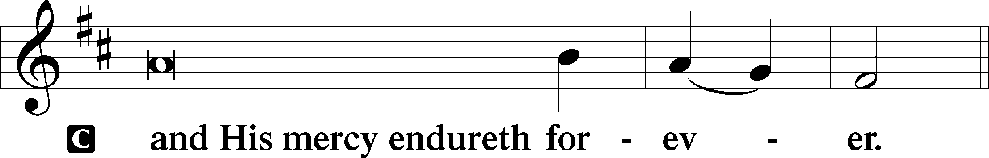

Post-Communion Collect
P Let us pray.
By the working of this mystery, O Lord, may both our vices be purged away, and just desires brought to fulfilment; through Jesus Christ, Thy Son, our Lord, who liveth and reigneth with Thee and the Holy Ghost, ever one God, world without end.
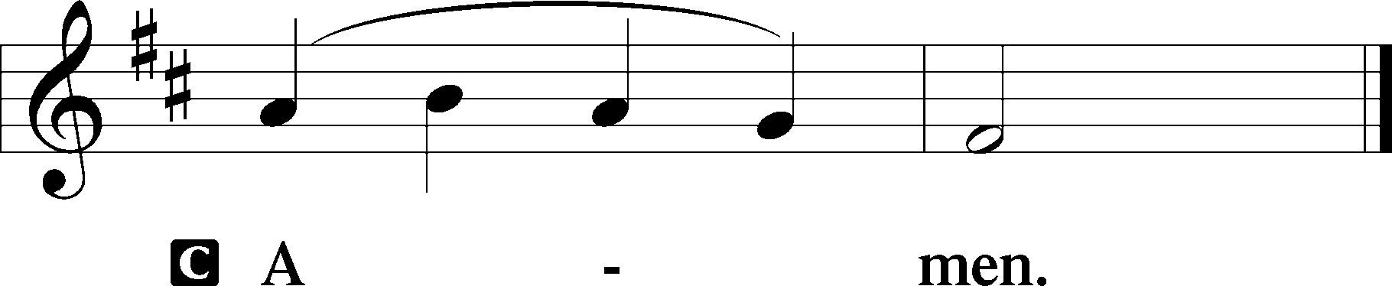

Salutation 2 Timothy 4:22
P The Lord be with you.
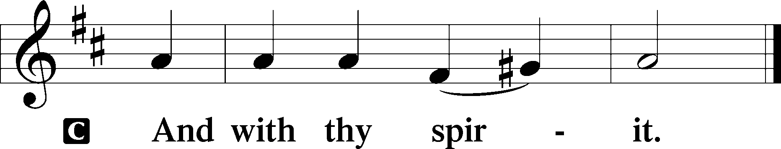
Benedicamus Psalm 103:1
P Bless we the Lord.
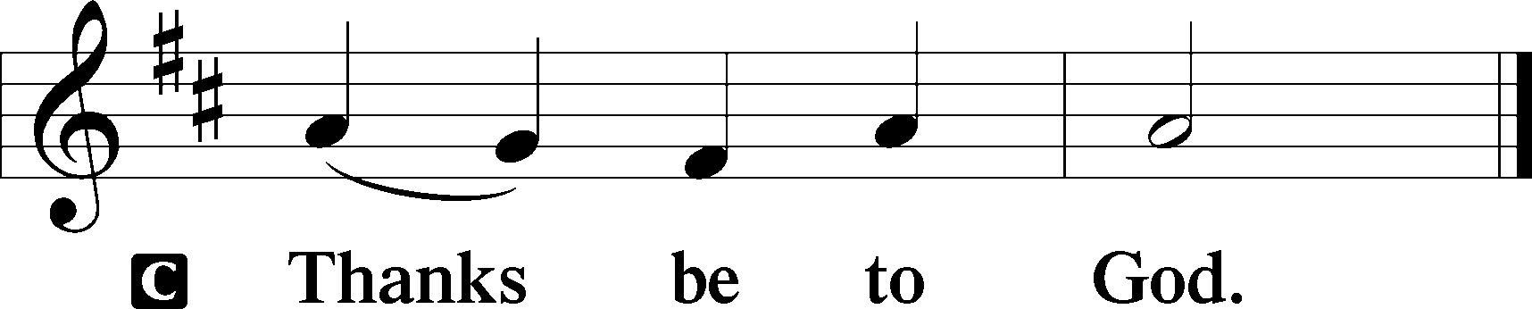

Benediction Numbers 6:24–26
P The Lord bless you and keep you.
The Lord make His face shine upon you and be gracious unto you.
The Lord lift up His countenance upon you and T give you peace.
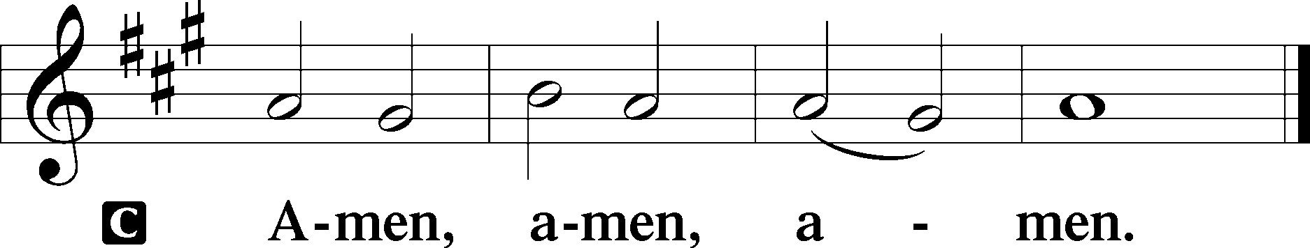

Closing Hymn: LSB #441 “Ride On, Ride On in Majesty”

Silent prayer after worship: Dear Jesus, help me this week to keep in mind the purpose of Your suffering, death and resurrection. Cause me to believe and proclaim the hope of salvation You won for all by Your death and resurrection. Amen.
fffffffffffffffffffffffffffffffffff
Acknowledgments: Unless otherwise indicated, Scripture quotations are from the ESV® Bible (The Holy Bible, English Standard Version®), copyright © 2001 by Crossway, a publishing ministry of Good News Publishers. Used by permission. All rights reserved. Created by Lutheran Service Builder © 2023 Concordia Publishing House.
fffffffffffffffffffffffffffffffffff
fffffffffffffffffffffffffffffffffff
To the Glory of God and His Great Mercy: Diane Riefstahl
fffffffffffffffffffffffffffffffffff
THANK YOU FOR SERVING IN MARCH: Elder: Jonathan Baisch; Ushers: Mark Kleindienst, Jerry Krivosh, & Gordon Marquette; Altarware ~ (prior) Marie Flaugher (03.31) & Diane Riefstahl (03.24, 03.28, 03.29, & 03.30); (after) Marie Flaugher (03.28 & 03.30), Diane Riefstahl (03.25 & 03.29), and Cheryl Fedele & Clara Krivosh (Sundays).
fffffffffffffffffffffffffffffffffff
SCHEDULE THROUGH MARCH 31, 2024:

:

Today, 6 pm, Deal Home: Sunday Evening Bible Study
7 pm, Fellowship Hall: AA Meeting
Monday, 10 am, Sanctuary: Divine Service (The Annunciation of Our Lord)
Tuesday, 10 am, Sanctuary: Matins Service (Holy Tuesday)
5:30 pm, All Saints (Slippery Rock): Catechesis
7-9 pm, Fellowship Hall: Penn-Ohio Singers
Wednesday, 10 am, Sanctuary: Matins Service (Holy Wednesday)
7 pm, Fellowship Hall: NA Meeting
Thursday, 9 am, Downstairs: Food Pantry
7 pm, Sanctuary: Maundy Thursday Divine Service
Friday, 8 am, Sanctuary: Stations of the Cross
Noon – 3 pm, Sanctuary: Tre Ore Divine Service
8 pm, Sanctuary: Tenebrae Service
Saturday, 8 pm, Sanctuary: Saturday Easter Vigil Divine Service
Next Sunday, 9 am, Sanctuary: Easter Divine Service
7 pm, Fellowship Hall: AA Meeting
fffffffffffffffffffffffffffffffffff
Bible Memory Verses ~ Week of March 24th:
For Adults: Keep your life free from love of money, and be content with what you have, for he has said, “I will never leave you nor forsake you.” Hebrews 13:5

For Children: He shall divide the spoil with the strong, because he poured out his soul to death and…bore the sin of many. Isaiah 53:12
fffffffffffffffffffffffffffffffffff
Attendance: Sunday, March 17, 2024: 38
Tuesday, March 19, 2024: 5
Wednesday, March 20, 2024: (Matins: 8; Vespers: 16)
fffffffffffffffffffffffffffffffffff
REMINDER! Submissions for the April calendar and newsletter are due to the secretary’s office tomorrow, March 25th.
fffffffffffffffffffffffffffffffffff
Our Stewardship of Treasures for the Lord:
Online Figures for March 13 & 14, 2024
General Fund: $230.00
Capital Campaign: $200.00
Figures for Wednesday, March 13, 2024
General Fund: $580.00
SELC: $50.00
Food Pantry: $70.00
Capital Campaign: $1,200.00
Figures for Sunday, March 17, 2024
General Fund: $1,526.00
SELC: $25.00
Capital Campaign: $35.00
Other: $13.00
YTD Giving/Budget (as of March 10, 2024)
General Fund: $22,511.00 / $27,125.20
SELC: $581.00 / $769.20

For online giving, check out https://www.saintspeterandpaul.net/online-giving.
fffffffffffffffffffffffffffffffffff
Unable to make it to worship services scheduled to be held here at Sts. Peter & Paul’s this Holy Week? All are welcome to join the congregation at All Saints (351 S. Main St., Slippery Rock 16057) for theirs!
Holy Week Vesper Services will be held Monday, Tuesday, and Wednesday at 7 pm. A Maundy Thursday Divine Service will be held Thursday at 10 am. Good Friday’s Stations of the Cross will be held at 8 am and a Tenebrae Service at 8 pm.
fffffffffffffffffffffffffffffffffff
Pittsburgh Area Lutheran Ministries (PALM) Lenten Update: Over this Lenten
season, you have read of PALM’s efforts in furthering missions in Gospel teaching, fellowship, and mercy. Today, PALM appeals to you for a financial gift to benefit PALM’s Small Mission Grant Fund. Thank you for your prayer support and your gifts. Please contact PALM with any questions or comments. www.palmpa.org
fffffffffffffffffffffffffffffffffff
Remember the following in Prayer…
~The Hurting and Healing: Amy, Ralph, Steve, Mary Jane Anderson, Steve Antolovich, Ellen Baron^{CA}, Don Baxter^{CA}, Amy Blomenberg, Lois Bortner^{CA}, Sara Brubaker and her son, Canaan; Dee Bullock, Bev & Joe Chlpka, Susan Davies, Tim Dudash, Mike Flaugher, Judith & Eddy Furey, Griffin, Pastor Charles Henrickson, Joan, Keith Jozwiakowski, Bob Kozar, Darla Krajci, Barbara Kreske, Jess Lavoie, Paul Lucas^{CA}, Sandy Marshall, Lynn Price, Juanita Rentschler, Richard Reuning^{CA}, Nancy Robertson^{CA}, Kriss Svidro^{CA}, Rudy Tomko, Bob Usnarski, Joel & Peggy Wasson, Angela Weser^{CA}, and Ruth Wolf.
~The Homebound: Anna Mae Daris, Millie Elavsky, Jean Tomko, Betty Wolf, and Ed & Millie Zachar.
~Celebrating: Anniversary: Brian & Liz Shreffler (03.27)
~Serving in the Military: Alex (Sasha) Carr, Duncan Vaupel, Curtis Sinewe, and Joshua Solyan.
~Community & World Needs: Those suffering due to the conflicts in the Middle East and between Ukraine and Russia; those suffering from loss and dislocation because weather disasters; those suffering from addiction and their families; Local, State, and National Government Leaders; safety for all Police Officers, Firefighters, & First Responders; the unemployed; our First Quarter Local Mission: Community Outreach. *CA represents cancer.
fffffffffffffffffffffffffffffffffff
Attention All Trustees!
A Trustees’ meeting has been scheduled for Wednesday, April 10th at 7 pm. We will meet in the library. Your attendance will be greatly appreciated!
fffffffffffffffffffffffffffffffffff

Sts Peter and Paul Spring Luncheon
Saturday April 20, 2024
11AM in the Fellowship Hall

Dear Ladies of Saints Peter and Paul –

All ladies are invited to our Ladies’ Spring Salad Luncheon hosted by the Altar Guild. This includes ALL ladies – our faithful ladies who have been with us all these years, those returning after being away for a bit, and new members to our congregation!
Spring season is a wonderful time to be together, a time to relax after all the busy holidays. We hope to give you a chance to visit with one another, enjoy good food, and celebrate the beauty of spring.
A sign-up sheet is on the clipboard in the Narthex. If you’d like to bring a friend or family member, note that also. Attendees are asked to bring a salad to share.
Please sign up by Sunday, April 14th. There is no limit to number of guests you may bring!
If you have any questions, contact Marie Flaugher, ph# 724-301-8278, or Elizabeth Haenftling, ph#570-931-0044. Feel free to leave a message!

Plan to come and eat, meet, and enjoy a fun afternoon!

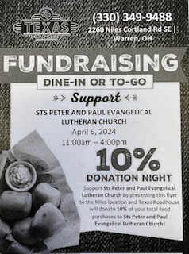
On the table near the nursery are coupons for a fundraiser
Saturday, April 6th, from 11 am until 4 pm at the
TEXAS ROADHOUSE RESTAURANT in Niles, OH.
If a coupon is presented at the time of ordering, 10% of your total food purchase will be donated back to our church. Profits will be designated
for our Major Repairs Fund.

Take coupons for friends and neighbors. Coupons cannot be passed out on the restaurant’s property!

Here to Serve
Pastor………………………………………………...……………Rev. Jacob Deal
E-mail …………………………….……pastordeal@saintspeterandpaul.net
Phone Number……………………..…………………724-347-3620 (Option 2)
Church Office………………………..…………………724-347-3620 (Option 3)
Website …………………………………………www.saintspeterandpaul.net
Secretary…………………………………………………………Diane Riefstahl
E-mail ………………………………………church@saintspeterandpaul.net
Food Pantry (phone): ……………………………….…724-347-3620 (opt. 4)
Food Pantry (email): ……………foodpantry@saintspeterandpaul.net
Congregation President………………………………….…Jonathan Baisch
Church Elder …………………………………………...……. Jonathan Baisch
Organist………………………………………………..….…Rebecca Marquette
AA Contact: Steve………………………………………………...…724-813-2358
NA Contact: Larry……………………………………..…………..724-977-8733
fffffffffffffffffffffffffffffffffff
If needing to get into the church building during the week, please phone first to make certain someone is here to let you in.

