Sts. Peter & Paul
Evangelical Lutheran Church
Lutheran Church-Missouri Synod
Founded-1917

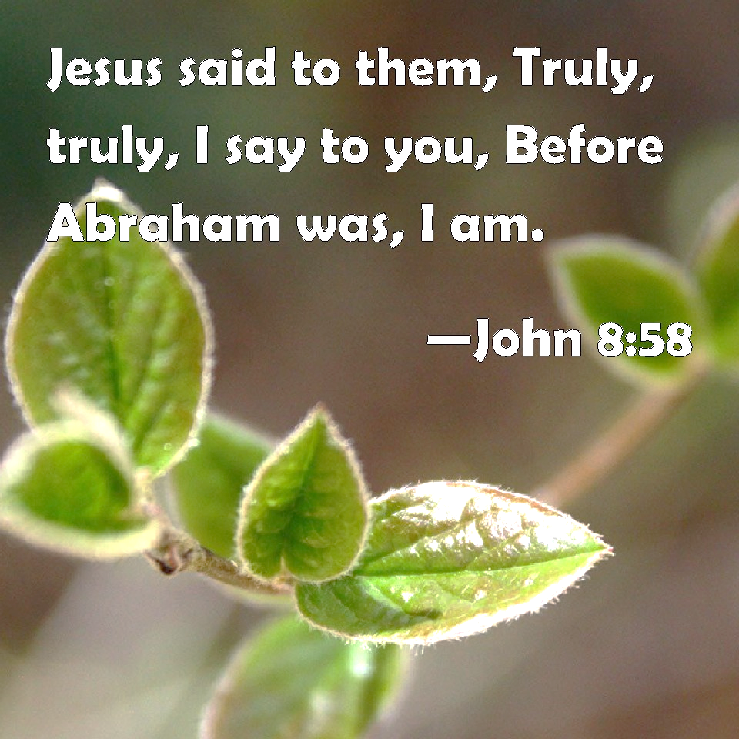

March 17, 2024

699 Stambaugh Ave.
Sharon, Pennsylvania 16146

“I was glad when they said to me,
Let us go to the house of the LORD!”
Psalm 122:1
Sts. Peter & Paul Evangelical Lutheran Church, LC-MS
JUDICA
March 17, 2024

A special welcome to our guests this day! If you would like more information about The Lutheran Church - Missouri Synod, or this congregation, please speak with Pastor Deal or an Elder after the service.
Members & Guests: Don’t be embarrassed if your children make noise during the worship service, all children do. We encourage families to worship together but, if you feel the need, there are pews in the rear of the Church which are reserved for young families on both sides of the sanctuary. There is also a quiet room available to you, located next to the sanctuary (formerly the Pastor’s office), where you would be able to follow along with the service.

Today’s service includes the Sacrament of Holy Communion. If during this past year, you have not worshipped with us and been communed, we respectfully ask that you do not partake of this sacrament this day before first speaking with Pastor Deal.
If visiting from a sister congregation of the LC-MS and are in good standing, please inform Pastor Deal of your desire to commune prior to the service.
If wishing to receive a blessing during communion, please approach with your arms crossed.

CONTACT INFORMATION
Pastor Deal: pastordeal@saintspeterandpaul.net or 724-347-3620 (opt. 2)
Church Office: church@saintspeterandpaul.net or 724-347-3620 (opt. 3)
Secretary’s Office: The office will be open Monday (8:30 am – 5 pm) & Wednesday (8:30 – 10 am; 12-4:30 pm) and Thursday/Friday, as needed.

Silent prayer before worship: Heavenly Father, through Your Son Jesus I have freedom from sin and death. Cause Your Word to work in my heart that I may trust in Your grace alone through Christ to save me from sin and death. Amen.
Confession and Absolution

Opening Hymn: LSB #430 “My Song Is Love Unknown”

Stand

The sign of the cross may be made by all in remembrance of their Baptism.

Invocation
P In the name of the Father and of the T Son and of the Holy Spirit.
C Amen.

Exhortation Hebrews 10:22; Psalm 124:8; Psalm 32:5
P Beloved in the Lord! Let us draw near with a true heart and confess our sins unto God our Father, beseeching Him in the name of our Lord Jesus Christ to grant us forgiveness.

P Our help is in the name of the Lord,
C who made heaven and earth.
P I said, I will confess my transgressions unto the Lord,
C and You forgave the iniquity of my sin.

Silence for reflection on God’s Word and for self-examination.

Confession of Sins
P O almighty God, merciful Father,
C I, a poor, miserable sinner, confess unto You all my sins and iniquities with which I have ever offended You and justly deserved Your temporal and eternal punishment. But I am heartily sorry for them and sincerely repent of them, and I pray You of Your boundless mercy and for the sake of the holy, innocent, bitter sufferings and death of Your beloved Son, Jesus Christ, to be gracious and merciful to me, a poor, sinful being.

Absolution [John 20:19–23]
P Upon this your confession, I, by virtue of my office, as a called and ordained servant of the Word, announce the grace of God unto all of you, and in the stead and by the command of my Lord Jesus Christ I forgive you all your sins in the name of the Father and of the T Son and of the Holy Spirit.
C Amen.
Service of the Word

Introit Psalm 43:3–5; antiphon: vv. 1–2a
Vindicate me, | O God,*
and defend my cause against an ungodly | people,
from the deceitful and unjust man de- | liver me!*
For you are the God in whom I take | refuge.
Send out your light and your truth; let them | lead me;*
let them bring me to your holy hill and to your | dwelling!
Then I will go to the altar of God, to God my ex- | ceeding joy,*
and I will praise you with the lyre, O | God, my God.
Why are you cast down, O my soul, and why are you in turmoil with- | in me?*
Hope in God; for I shall again praise him, my salvation | and my God.
Vindicate me, | O God,*
and defend my cause against an ungodly | people,
from the deceitful and unjust man de- | liver me!*
For you are the God in whom I take | refuge.

Kyrie Mark 10:47
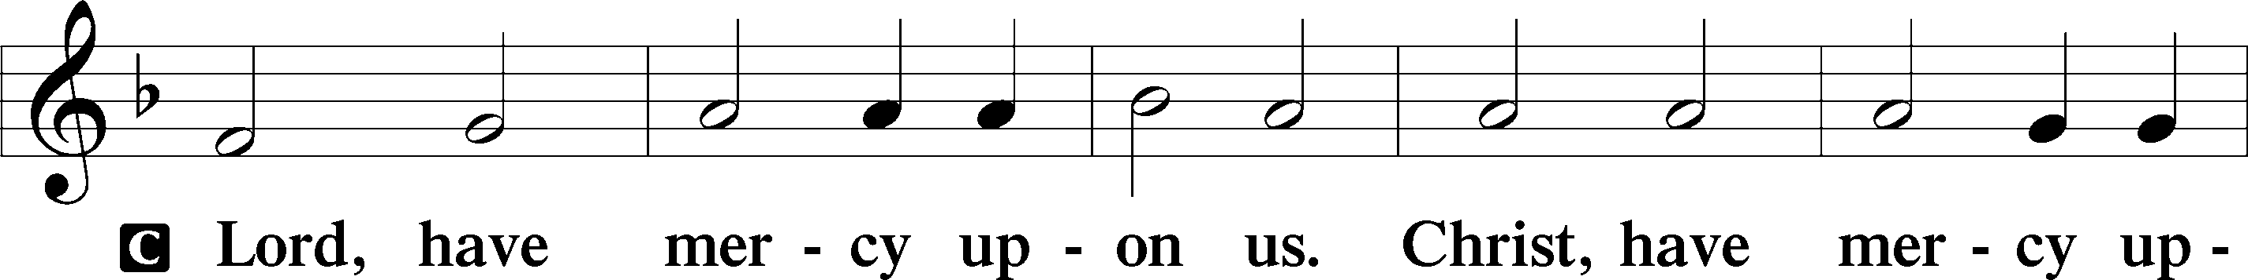
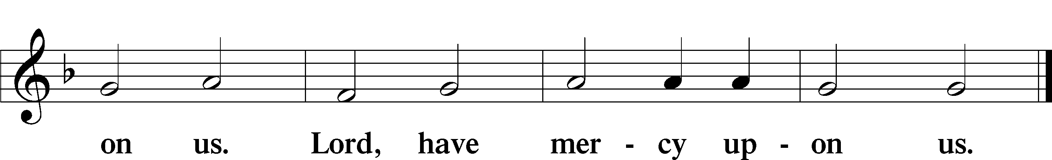

Salutation and Collect of the Day: Judica
P The Lord be with you.
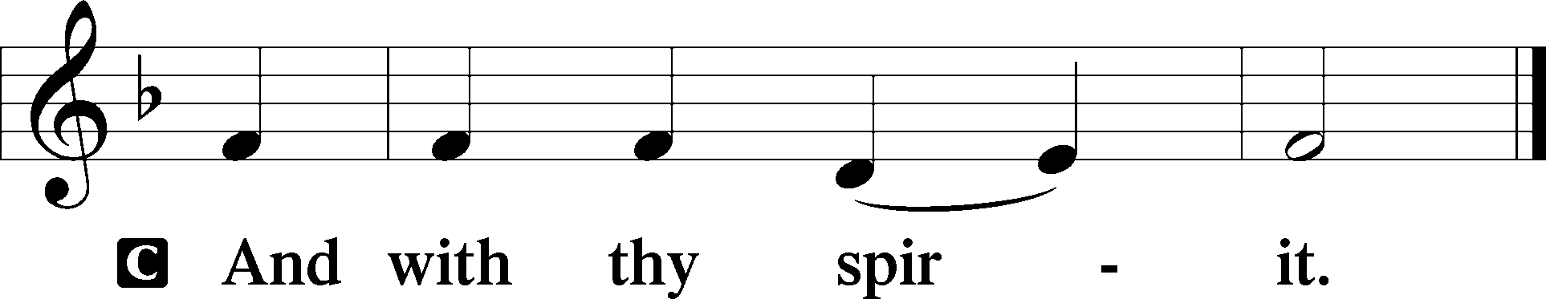

P Let us pray.
Almighty God, by Your great goodness mercifully look upon Your people that we may be governed and preserved evermore in body and soul; through Jesus Christ, Your Son, our Lord, who lives and reigns with You and the Holy Spirit, one God, now and forever.
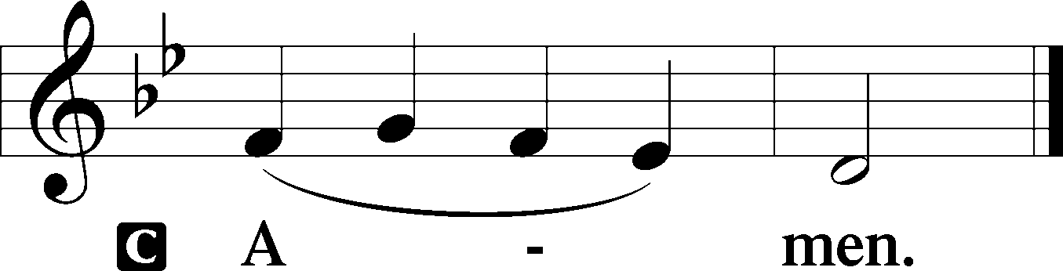
Sit

Prophecy: Genesis 22:1–19 (NKJV)
God tested Abraham, and said to him, “Abraham!” And he said, “Here I am.” Then He said, “Take now your son, your only son Isaac, whom you love, and go to the land of Moriah, and offer him there as a burnt offering on one of the mountains of which I shall tell you.” So Abraham rose early in the morning and saddled his donkey, and took two of his young men with him, and Isaac his son; and he split the wood for the burnt offering, and arose and went to the place of which God had told him. Then on the third day Abraham lifted his eyes and saw the place afar off. And Abraham said to his young men, “Stay here with the donkey; the lad and I will go yonder and worship, and we will come back to you.” So Abraham took the wood of the burnt offering and laid it on Isaac his son; and he took the fire in his hand, and a knife, and the two of them went together. But Isaac spoke to Abraham his father and said, “My father!” And he said, “Here I am, my son.” Then he said, “Look, the fire and the wood, but where is the lamb for a burnt offering?” And Abraham said, “My son, God will provide for Himself the lamb for a burnt offering.” So the two of them went together. Then they came to the place of which God had told him. And Abraham built an altar there and placed the wood in order; and he bound Isaac his son and laid him on the altar, upon the wood. And Abraham stretched out his hand and took the knife to slay his son. But the Angel of the Lord called to him from heaven and said, “Abraham, Abraham!” So he said, “Here I am.” And He said, “Do not lay your hand on the lad, or do anything to him; for now I know that you fear God, since you have not withheld your son, your only son, from Me.” Then Abraham lifted his eyes and looked, and there behind him was a ram caught in a thicket by its horns. So Abraham went and took the ram, and offered it up for a burnt offering instead of his son. And Abraham called the name of the place, The-Lord-Will-Provide; as it is said to this day, “In the Mount of the Lord it shall be provided.” Then the Angel of the Lord called to Abraham a second time out of heaven, and said: “By Myself I have sworn, says the Lord, because you have done this thing, and have not withheld your son, your only son—blessing I will bless you, and multiplying I will multiply your descendants as the stars of the heaven and as the sand which is on the seashore; and your descendants shall possess the gate of their enemies. In your seed all the nations of the earth shall be blessed, because you have obeyed My voice.” So Abraham returned to his young men, and they rose and went together to Beersheba; and Abraham dwelt at Beersheba.

P This is the Word of the Lord.
C Thanks be to God.

Gradual Psalm 143:9a, 10a; 18:48a, c
Deliver me from my enemies, | O Lord!*
Teach me to do your will, for you | are my God!
[You] delivered me from my | enemies;*
you rescued me from the man of | violence.

Epistle: Hebrews 9:11–15 (NKJV)
Brethren: Christ came as High Priest of the good things to come, with the greater and more perfect tabernacle not made with hands, that is, not of this creation. Not with the blood of goats and calves, but with His own blood He entered the Most Holy Place once for all, having obtained eternal redemption. For if the blood of bulls and goats and the ashes of a heifer, sprinkling the unclean, sanctifies for the purifying of the flesh, how much more shall the blood of Christ, who through the eternal Spirit offered Himself without spot to God, cleanse your conscience from dead works to serve the living God? And for this reason He is the Mediator of the new covenant, by means of death, for the redemption of the transgressions under the first covenant, that those who are called may receive the promise of the eternal inheritance, in Christ Jesus our Lord.

P This is the Word of the Lord.
C Thanks be to God.

Stand

Tract Psalm 129:1–4
“Greatly have they afflicted me | from my youth”—*
let Israel | now say—
“Greatly have they afflicted me | from my youth,*
yet they have not prevailed a- | gainst me.
The plowers plowed up- | on my back;*
they made long their | furrows.”
The Lord is | righteous;*
he has cut the cords of the | wicked.

Holy Gospel: John 8:46–59a (NKJV)
P The Holy Gospel according to St. John, the eighth chapter.
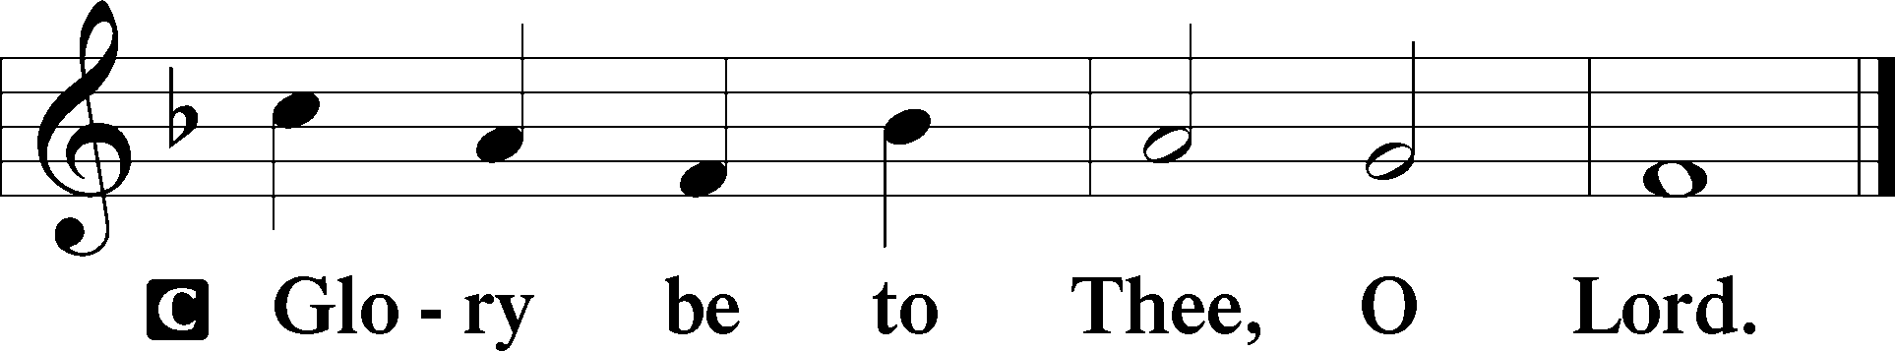

At that time Jesus said to the multitude of the Jews and the chief priests: “Which of you convicts Me of sin? And if I tell the truth, why do you not believe Me? He who is of God hears God’s words; therefore you do not hear, because you are not of God.” Then the Jews answered and said to Him, “Do we not say rightly that You are a Samaritan and have a demon?” Jesus answered, “I do not have a demon; but I honor My Father, and you dishonor Me. And I do not seek My own glory; there is One who seeks and judges. Most assuredly, I say to you, if anyone keeps My word he shall never see death.” Then the Jews said to Him, “Now we know that You have a demon! Abraham is dead, and the prophets; and You say, ‘If anyone keeps My word he shall never taste death.’ Are You greater than our father Abraham, who is dead? And the prophets are dead. Who do You make Yourself out to be?” Jesus answered, “If I honor Myself, My honor is nothing. It is My Father who honors Me, of whom you say that He is your God. Yet you have not known Him, but I know Him. And if I say, ‘I do not know Him,’ I shall be a liar like you; but I do know Him and keep His word. Your father Abraham rejoiced to see My day, and he saw it and was glad.” Then the Jews said to Him, “You are not yet fifty years old, and have You seen Abraham?” Jesus said to them, “Most assuredly, I say to you, before Abraham was, I AM.” Then they took up stones to throw at Him; but Jesus hid Himself and went out of the temple.

P This is the Gospel of the Lord.
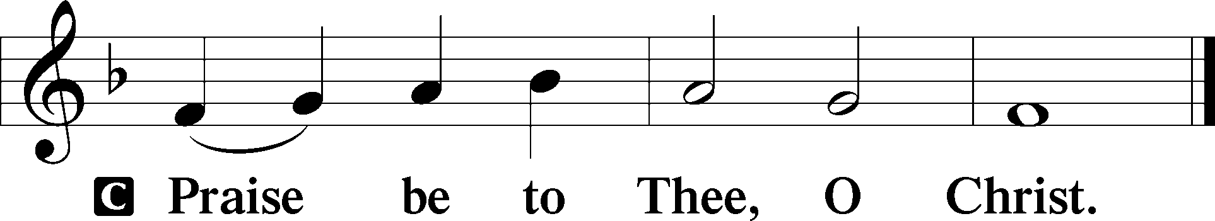

The crosses will be veiled.

Nicene Creed
C I believe in one God,
the Father Almighty,
maker of heaven and earth
and of all things visible and invisible.
And in one Lord Jesus Christ,
the only-begotten Son of God,
begotten of His Father before all worlds,
God of God, Light of Light,
very God of very God,
begotten, not made,
being of one substance with the Father,
by whom all things were made;
who for us men and for our salvation came down from heaven
and was incarnate by the Holy Spirit of the virgin Mary
and was made man;
and was crucified also for us under Pontius Pilate.
He suffered and was buried.
And the third day He rose again according to the Scriptures
and ascended into heaven
and sits at the right hand of the Father.
And He will come again with glory to judge both the living and the dead,
whose kingdom will have no end.

And I believe in the Holy Spirit,
the Lord and giver of life,
who proceeds from the Father and the Son,
who with the Father and the Son together is worshiped and glorified,
who spoke by the prophets.
And I believe in one holy Christian and apostolic Church,
I acknowledge one Baptism for the remission of sins,
and I look for the resurrection of the dead
and the life T of the world to come. Amen.
Sit

Hymn of the Day: ELH #272 “O Sinner, Come Thy Sin to Mourn”
(Tune unavailable)
- O sinner, come thy sin to mourn,
So vast and vile that it has borne
Christ to this vale of anguish;
Son of a Virgin, sweet and mild
In poverty the Holy Child,
Thy Substitute, did languish;
Behold, with faith, God’s only Son!
Come nigh and see what Love has done
To save thee from damnation;
The Father cast on Him thy guilt,
For thee His precious blood was spilt,
To bless thee with salvation.

- O meditate, how painfully
The Lamb of God, on Calvary
Has died for thy transgressions;
How dreary was that awful night
Of agony, how great the fight
Of His most wondrous Passion!
O Son of God, eternal Word,
Divine Redeemer, dearest Lord,
We marvel at Thy suff’ring;
For Thy disgrace, and pain, and shame,
We’ll ever magnify Thy name,
And praise Thy glorious off’ring.

Sermon

Stand

Offertory Psalm 51:10–12
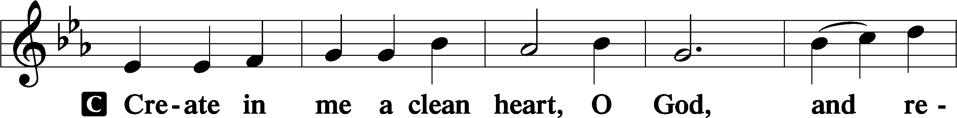
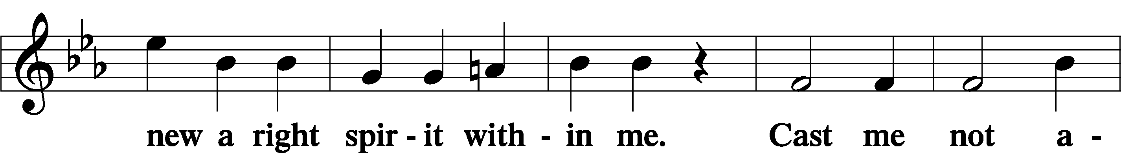
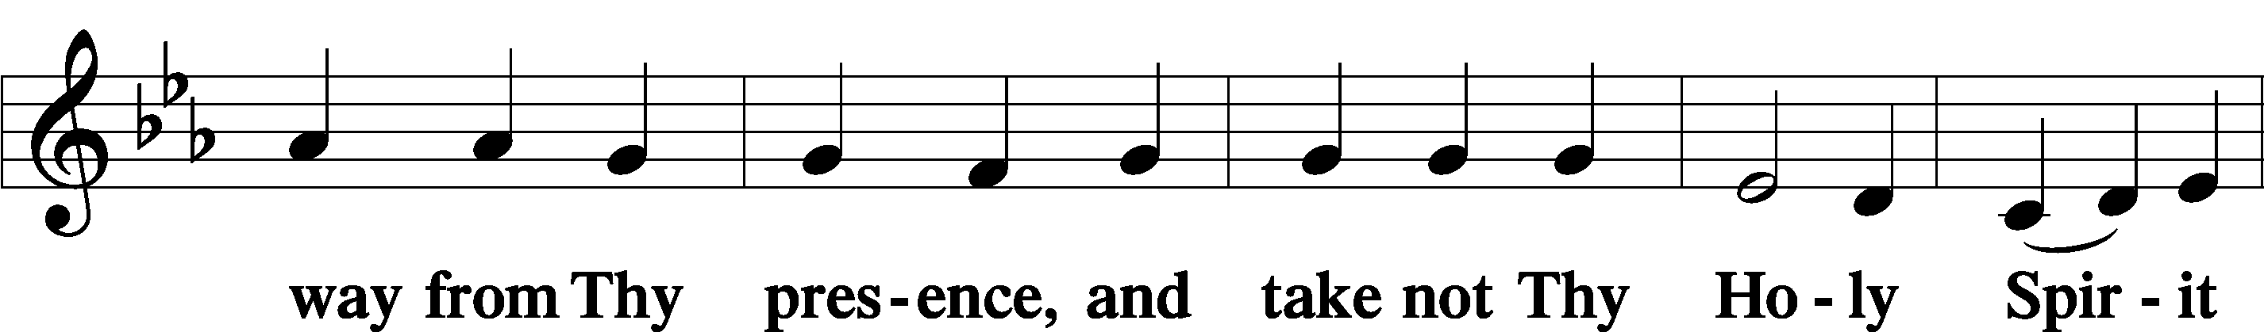
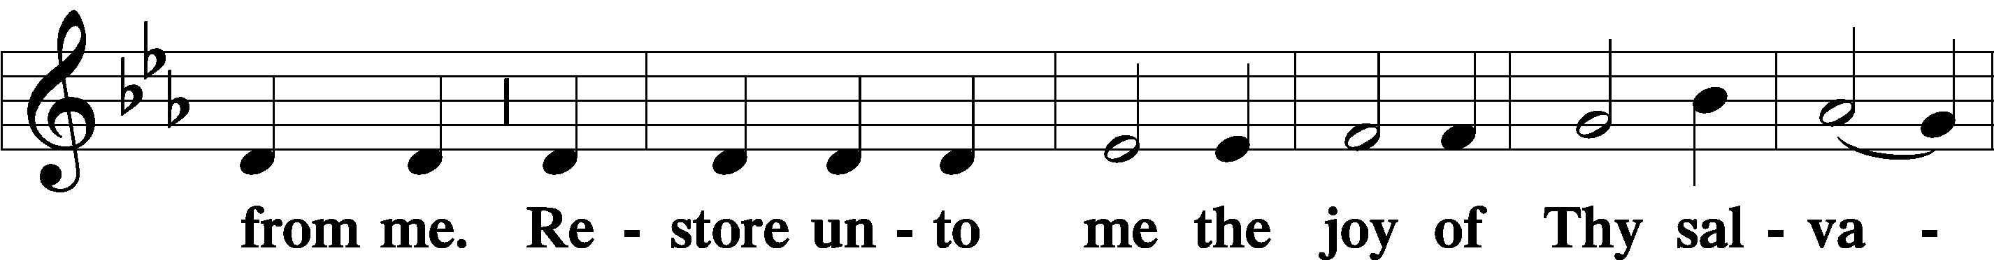
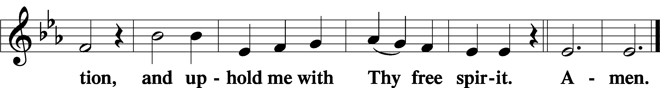

Prayer of the Church

Sit

Preparatory Hymn: LSB #631 “Here, O My Lord, I See Thee Face to Face”

Stand
Service of the Sacrament

Preface 2 Timothy 4:22; Colossians 3:1 Psalm 136
P The Lord be with you.
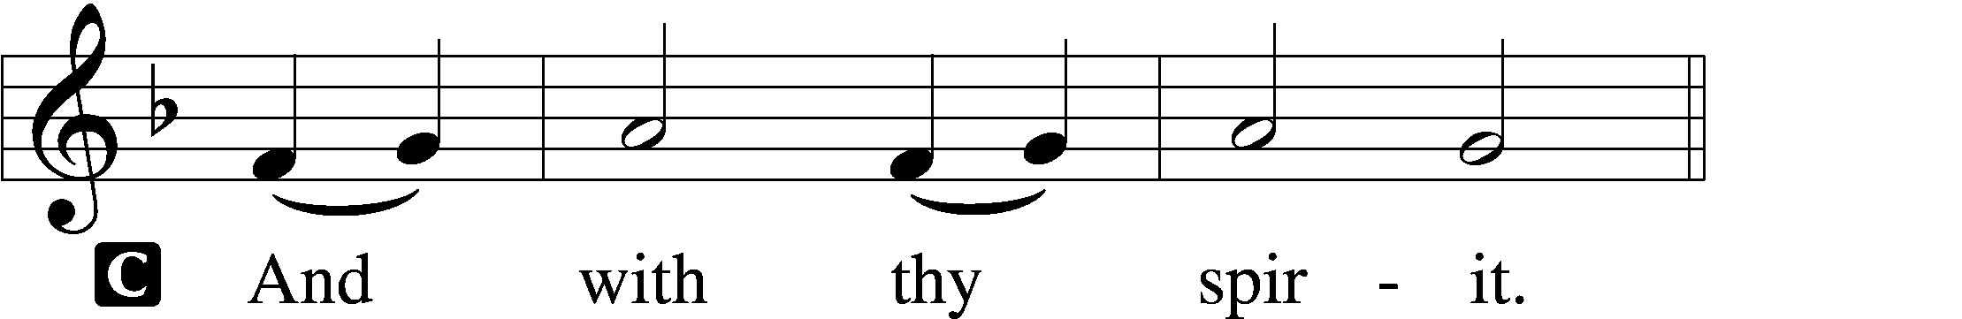

P Lift up your hearts.
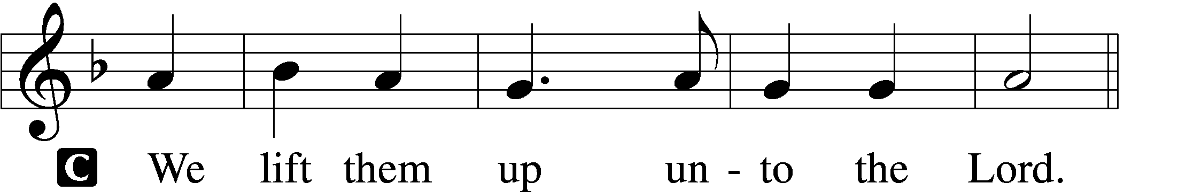
P Let us give thanks unto the Lord, our God.
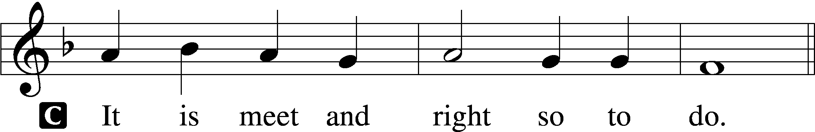

Proper Preface (Abbreviated) LSB 194
P It is truly meet, right, and salutary . . . evermore praising You and saying:

Sanctus Isaiah 6:3; Matthew 21:9
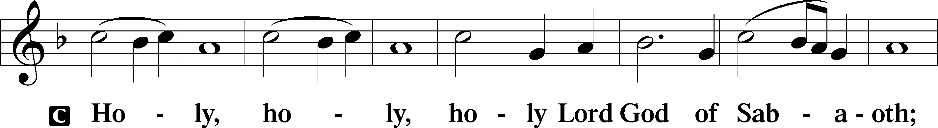
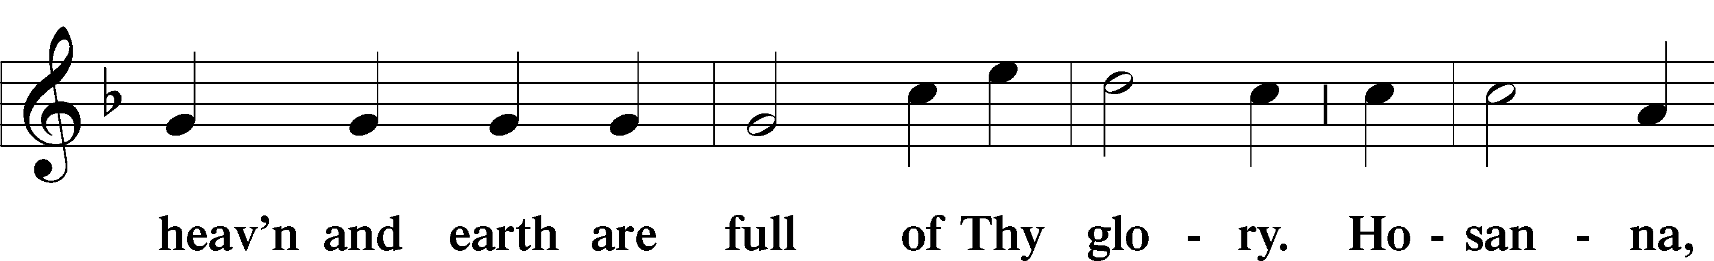
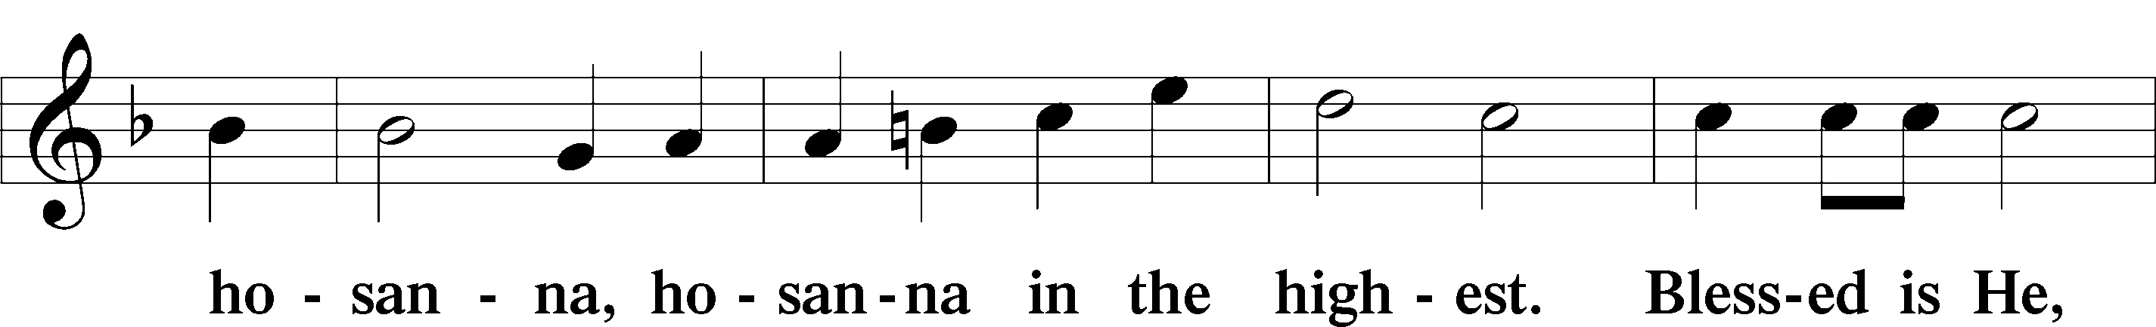
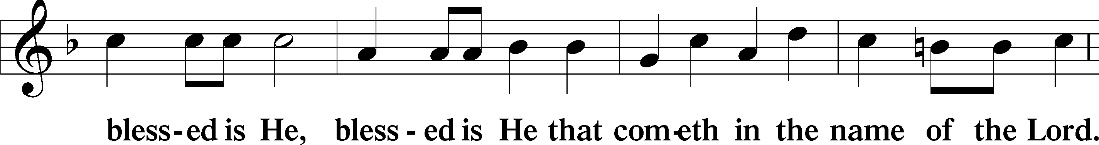
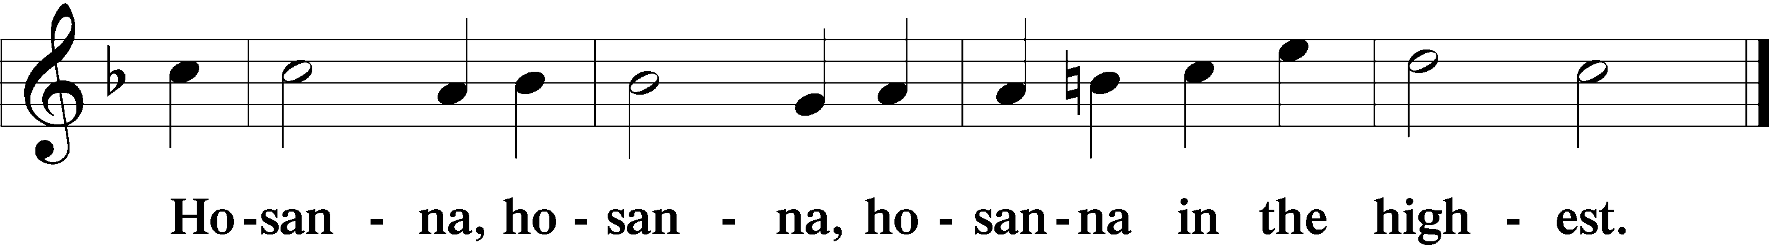

Lord’s Prayer The congregation is encouraged to silently pray the Lord’s Prayer as it is chanted. Matthew 6:9–13
P Our Father who art in heaven,
hallowed be Thy name,
Thy kingdom come,
Thy will be done on earth as it is in heaven;
give us this day our daily bread;
and forgive us our trespasses as we forgive those who trespass against us;
and lead us not into temptation,
but deliver us from evil.
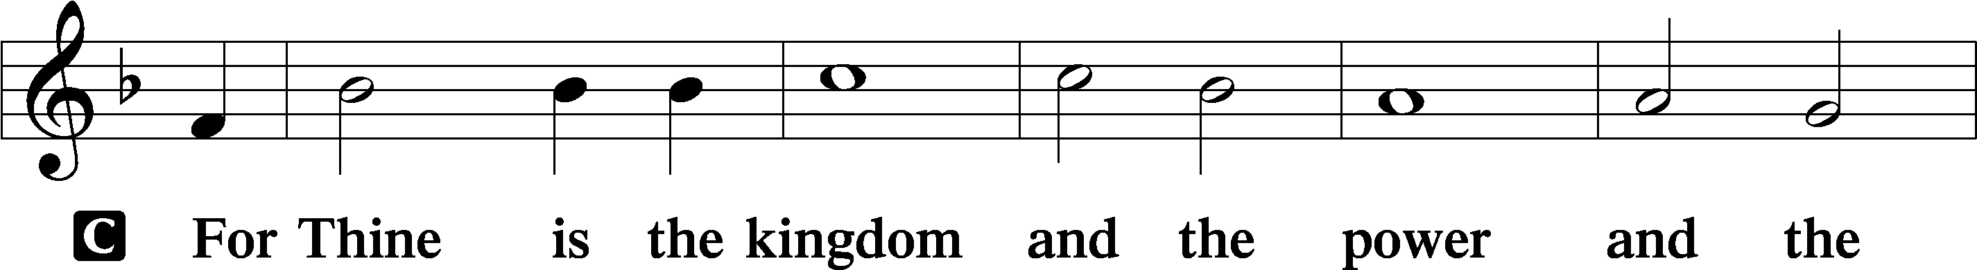
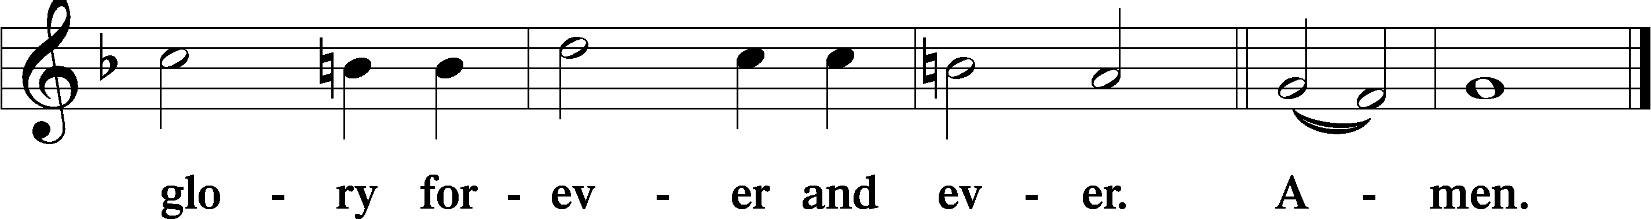

The Words of Our Lord Matthew 26:26–28; Mark 14:22–24; Luke 22:19–20; 1 Corinthians 11:23–25
P Our Lord Jesus Christ, on the night when He was betrayed, took bread, and when He had given thanks, He broke it and gave it to the disciples and said: “Take, eat; this is My T body, which is given for you. This do in remembrance of Me.”

In the same way also He took the cup after supper, and when He had given thanks, He gave it to them, saying: “Drink of it, all of you; this cup is the new testament in My T blood, which is shed for you for the forgiveness of sins. This do, as often as you drink it, in remembrance of Me.”

Pax Domini John 20:19
P The peace of the Lord be with you always.
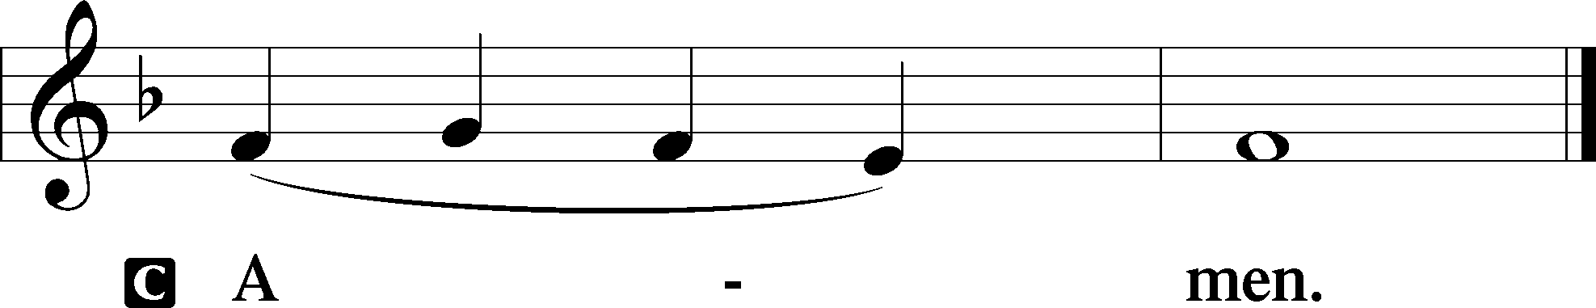

Agnus Dei John 1:29
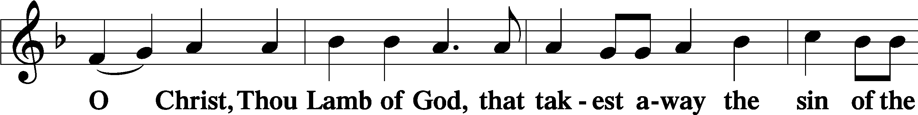
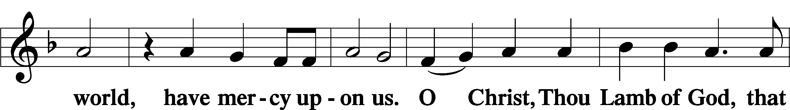
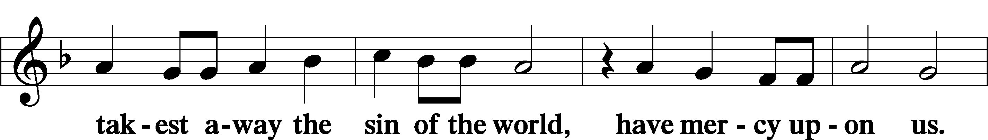
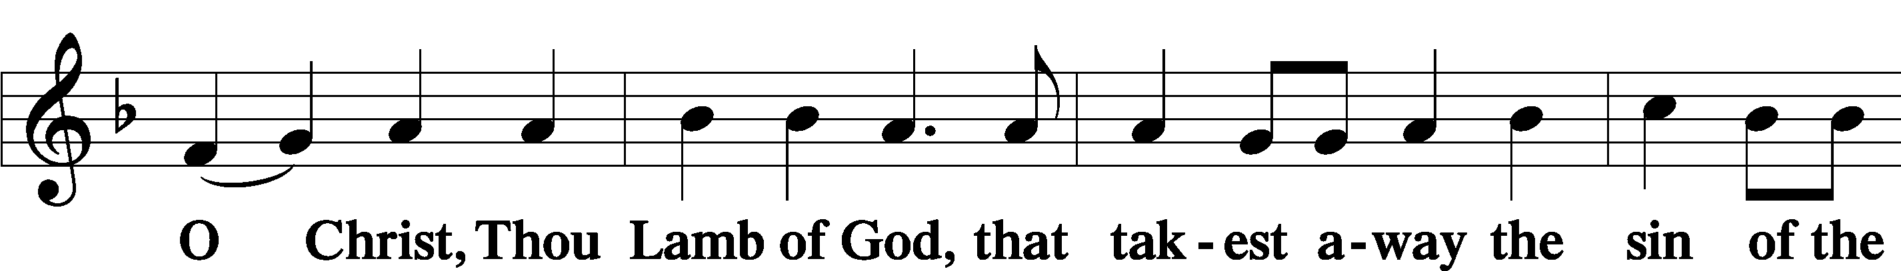
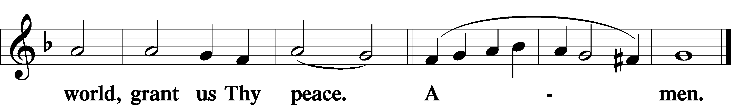
Sit
Distribution
The pastor and those who assist him receive the body and blood of Christ first and then distribute them to those who come to receive, saying:
Take, eat; this is the true body of our Lord and Savior Jesus Christ, given into death for your sins.
Amen.

Take, drink; this is the true blood of our Lord and Savior Jesus Christ, shed for the forgiveness of your sins.
Amen.

In dismissing the communicants, the following is said:
The Dismissal
P The body and blood of our Lord Jesus Christ strengthen and preserve you in body and soul to life everlasting. Depart T in peace.
C Amen.

Distribution Hymn: LSB #563 “Jesus, Thy Blood and Righteousness”

Distribution Hymn: LSB #454 “Sing, My Tongue, the Glorious Battle”

Nunc Dimittis Luke 2:29–32
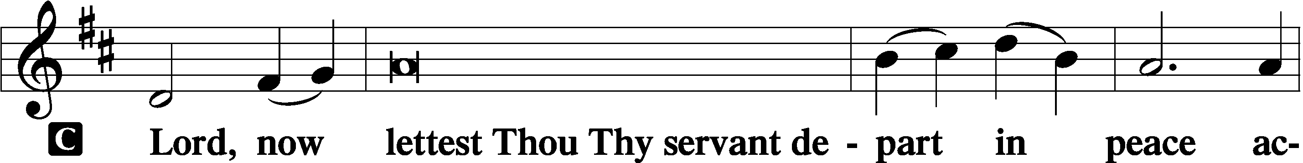
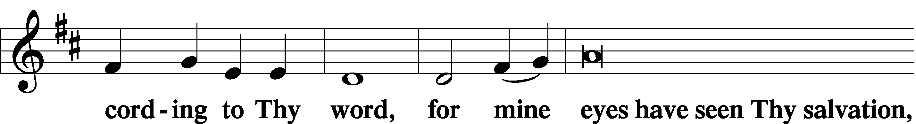
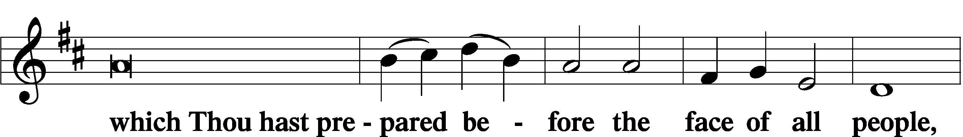
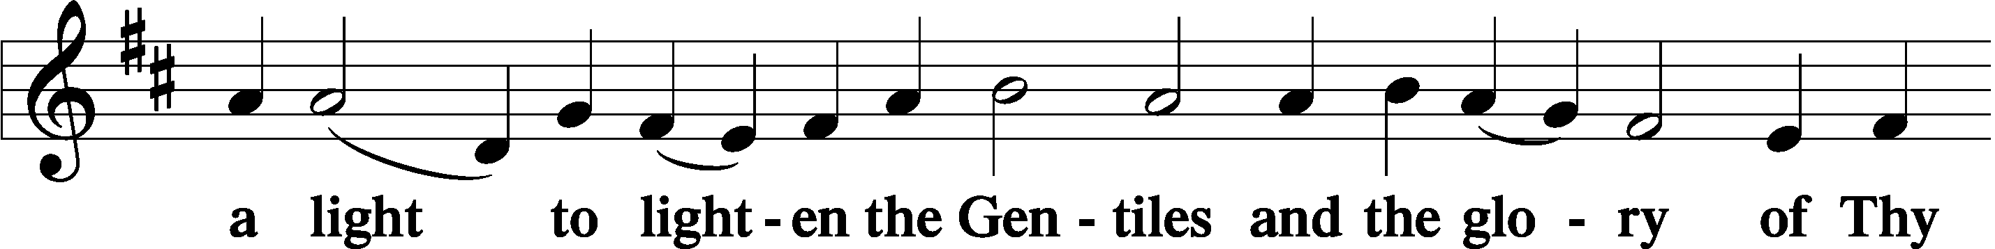
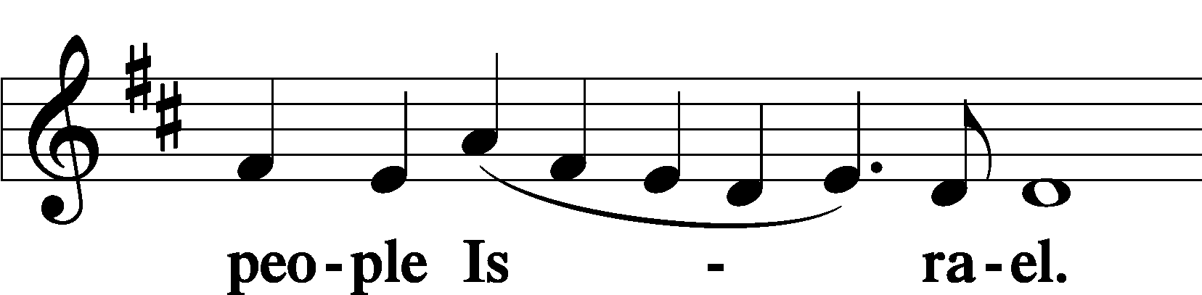

Thanksgiving Psalm 107:1
P O give thanks unto the Lord, for He is good,
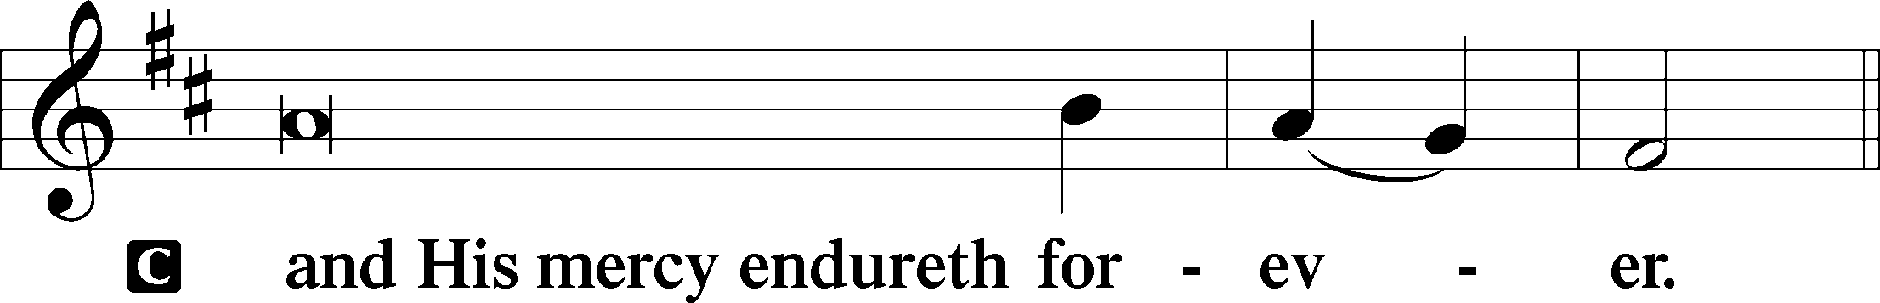

Post-Communion Collect
P Let us pray.
We give thanks to You, almighty God, that You have refreshed us through this salutary gift, and we implore You that of Your mercy You would strengthen us through the same in faith toward You and in fervent love toward one another; through Jesus Christ, Your Son, our Lord, who lives and reigns with You and the Holy Spirit, one God, now and forever.
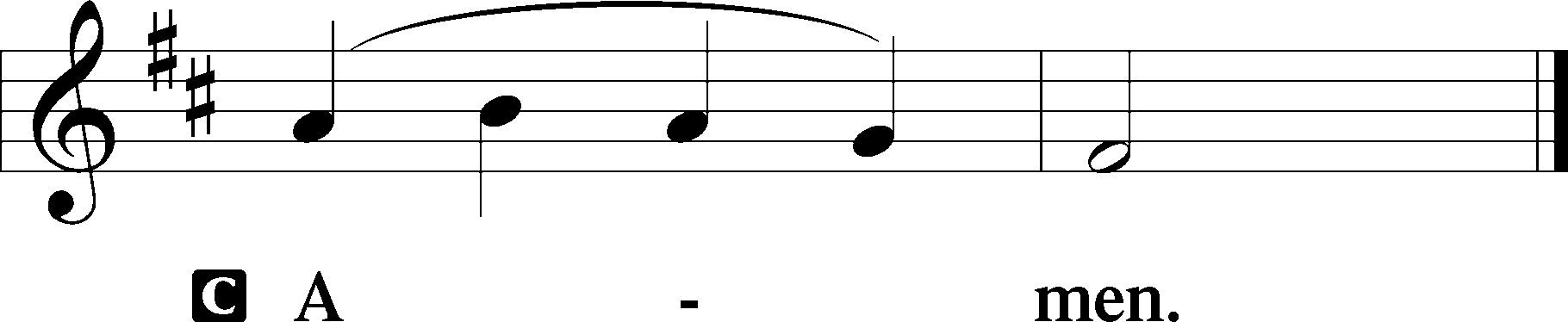

Salutation 2 Timothy 4:22
P The Lord be with you.
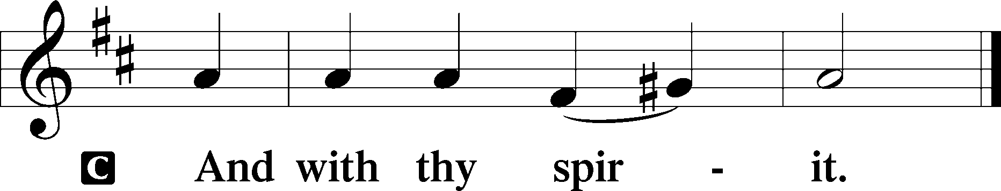

Benedicamus Psalm 103:1
P Bless we the Lord.
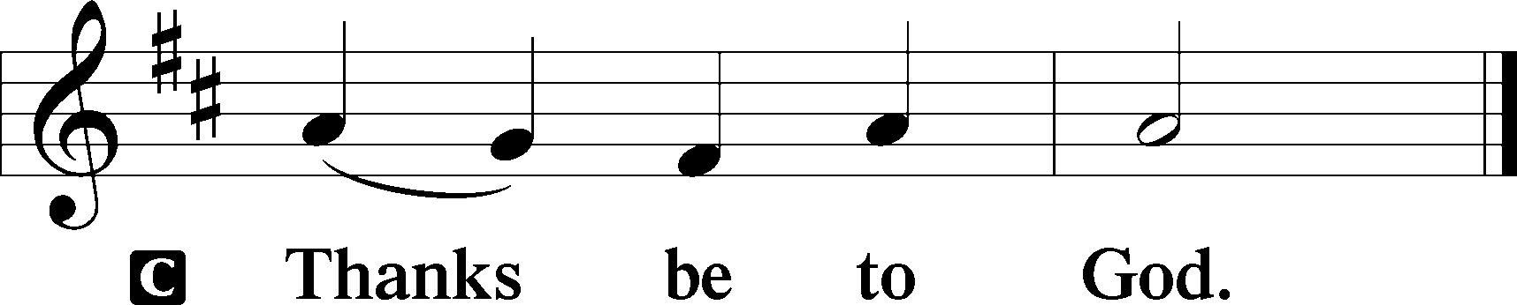

Benediction Numbers 6:24–26
P The Lord bless you and keep you.
The Lord make His face shine upon you and be gracious unto you.
The Lord lift up His countenance upon you and T give you peace.
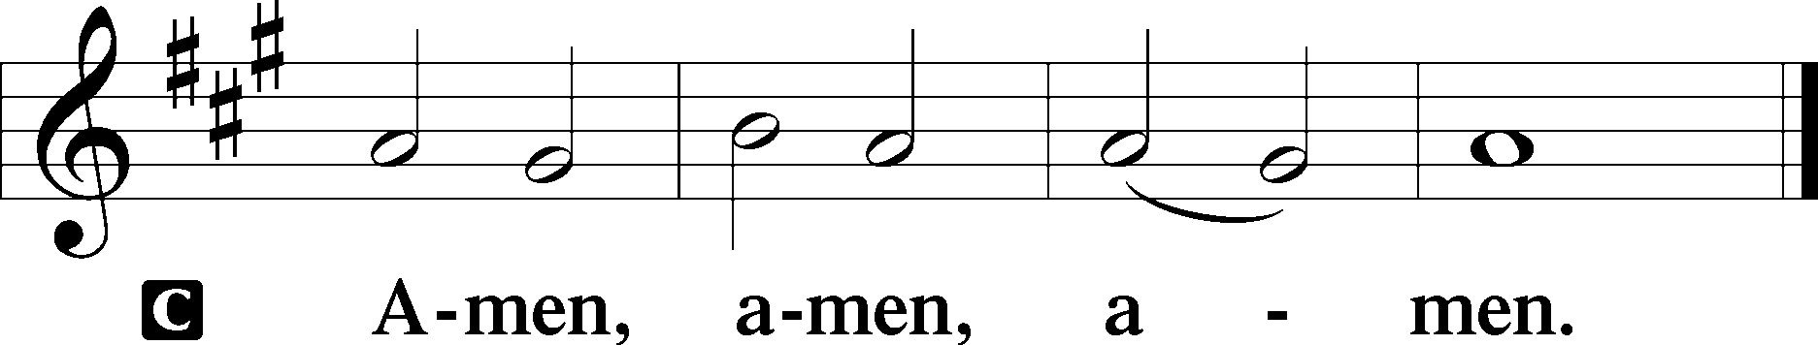

Closing Hymn: LSB #429 “We Sing the Praise of Him Who Died”

Silent prayer after worship: Almighty God, lead me to honor You above all things, to cherish Your gift of salvation through Christ’s life, death and resurrection, and to share this gift with others. In Jesus’s name. Amen.

Acknowledgments
Unless otherwise indicated, Scripture quotations are from the ESV® Bible (The Holy Bible, English Standard Version®), copyright © 2001 by Crossway, a publishing ministry of Good News Publishers. Used by permission. All rights reserved.Created by Lutheran Service Builder © 2024 Concordia Publishing House.


fffffffffffffffffffffffffffffffffff
In Loving Memory of Barry Nelson on his Birthday, March 17th: Chris Nelson and Family (Food Pantry).
fffffffffffffffffffffffffffffffffff
THANK YOU FOR SERVING IN MARCH: Elder: Jonathan Baisch; Ushers: Mark Kleindienst, Jerry Krivosh, & Gordon Marquette; Altarware ~ (prior) Marie Flaugher (03.31) & Diane Riefstahl (03.17, 03.24, 03.28, 03.29, & 03.30); (after) Marie Flaugher (03.28 & 03.30), Diane Riefstahl (03.29), and Cheryl Fedele & Clara Krivosh (Sundays).
fffffffffffffffffffffffffffffffffff
Attendance: Sunday, March 10, 2024: 33
Wednesday, March 13, 2024: (Matins: 6; Vespers: 20)
fffffffffffffffffffffffffffffffffff
SCHEDULE THROUGH MARCH 24, 2024:

:

Today, following Worship, Library: Monthly Audit
7 pm, Fellowship Hall: AA Meeting
Tuesday, 5:30 pm, All Saints (Slippery Rock): Catechesis
7 pm, Sanctuary: Vespers Service (Saint Joseph, Guardian of Jesus)
7-9 pm, Fellowship Hall: Penn-Ohio Singers
Wednesday, 10 am, Sanctuary: Lenten Midweek Matins Service
11 am, Fellowship Hall: Lenten Soup Luncheon & Bible Study
6 pm, Fellowship Hall: Lenten Soup Supper
7 pm, Sanctuary: Lenten Midweek Vespers Service
7 pm, Fellowship Hall: NA Meeting
Friday, 10 am, Fellowship Hall: Craft Fellowship
Next Sunday, 8 am, Fellowship Hall: Bible Study
9 am, Sanctuary: Divine Service
6 pm, Deal Home: Sunday Evening Bible Study
7 pm, Fellowship Hall: AA Meeting
fffffffffffffffffffffffffffffffffff
Bible Memory Verses ~ Week of March 17th:
For Adults: Be angry and do not sin; do not let the sun go down on your anger, and give no opportunity to the devil. Ephesians 4:26-27
For Children: Christ says: “For their sake I consecrate myself, that they also may be sanctified in truth.” John 17:19
fffffffffffffffffffffffffffffffffff
Our Stewardship of Treasures for the Lord:
Online Figure for February 29, 2024
General Fund: $80.00
Figures for Wednesday, March 6, 2024
General Fund: $729.50
Capital Campaign: $351.00
Figures for Sunday, March 10, 2024
General Fund: $1,183.00
SELC: $47.00
Food Pantry: $153.00
Quarterly Missions: $75.00
Altar Flowers: $177.00
Capital Campaign: $35.00
Other: $1,225.00
YTD Giving/Budget (as of March 3, 2024)
General Fund: $20,518.50 / $24,412.68
SELC: $543.00 / $692.28

For online giving, check out https://www.saintspeterandpaul.net/online-giving.
fffffffffffffffffffffffffffffffffff
Join us this Wednesday for our final Lenten Midweek Worship Services:
10 am Matins Service followed by a soup luncheon & Bible Study
6 pm Soup Supper
7 pm Vespers Service
fffffffffffffffffffffffffffffffffff
A reminder to all Crafters! We will meet to share craft fellowship this Friday at 10 am. Please enter using the Clover St. door.

Remember the following in Prayer…
~The Hurting and Healing: Amy, Ralph, Steve, Mary Jane Anderson, Steve Antolovich, Ellen Baron^{CA}, Amy Blomenberg, Lois Bortner^{CA}, Sara Brubaker and her son, Canaan; Dee Bullock, Bev & Joe Chlpka, Susan Davies, Tim Dudash, Mike Flaugher, Judith & Eddy Furey, Griffin, Pastor Charles Henrickson, Joan, Keith Jozwiakowski, Bob Kozar, Darla Krajci, Barbara Kreske, Jess Lavoie, Paul Lucas^{CA}, Sandy Marshall, Lynn Price, Juanita Rentschler, Richard Reuning^{CA}, Nancy Robertson^{CA}, Kriss Svidro^{CA}, Rudy Tomko, Bob Usnarski, Joel & Peggy Wasson, Angela Weser^{CA}, and Ruth Wolf.
~The Homebound: Anna Mae Daris, Millie Elavsky, Jean Tomko, Betty Wolf, and Ed & Millie Zachar.
~Celebrating: Birthday: Michael Laird (03.23)
~Serving in the Military: Alex (Sasha) Carr, Duncan Vaupel, Curtis Sinewe, and Joshua Solyan.
~Community & World Needs: Those suffering due to the conflicts in the Middle East and between Ukraine and Russia; those suffering from loss and dislocation because weather disasters; those suffering from addiction and their families; Local, State, and National Government Leaders; safety for all Police Officers, Firefighters, & First Responders; the unemployed; our First Quarter Local Mission: Community Outreach. *CA represents cancer.
fffffffffffffffffffffffffffffffffff
Pittsburgh Area Lutheran Ministries (PALM) Lenten Update: In addition to regular support of 11 Gospel, fellowship, and mercy missions, PALM administers small grants of up to $500 to support local LCMS mission projects. If you have in mind a ministry that could benefit from such a gift, contact PALM for an application. Please pray for PALM and its partnering missions, and please consider financially supporting the Small Mission Grant Fund this Palm Sunday during the annual PALM Sunday Appeal offering. www.palmpa.org
fffffffffffffffffffffffffffffffffff
There will be a special Vespers Service this Tuesday, March 19th, beginning at 7 pm, celebrating the Feast of Saint Joseph, Guardian of Jesus. Please join us!
fffffffffffffffffffffffffffffffffff
Minutes from the March 3rd Voters’ Assembly are available.

Here to Serve
Pastor………………………………………………...……………Rev. Jacob Deal
E-mail …………………………….……pastordeal@saintspeterandpaul.net
Phone Number……………………..…………………724-347-3620 (Option 2)
Church Office………………………..…………………724-347-3620 (Option 3)
Website …………………………………………www.saintspeterandpaul.net
Secretary…………………………………………………………Diane Riefstahl
E-mail ………………………………………church@saintspeterandpaul.net
Food Pantry (phone): ……………………………….…724-347-3620 (opt. 4)
Food Pantry (email): ……………foodpantry@saintspeterandpaul.net
Congregation President………………………………….…Jonathan Baisch
Church Elder …………………………………………...……. Jonathan Baisch
Organist………………………………………………..….…Rebecca Marquette
AA Contact: Steve………………………………………………...…724-813-2358
NA Contact: Larry……………………………………..…………..724-977-8733
fffffffffffffffffffffffffffffffffff
If needing to get into the church building during the week, please phone first to make certain someone is here to let you in.

