Sts. Peter & Paul
Evangelical Lutheran Church
Lutheran Church-Missouri Synod
Founded-1917

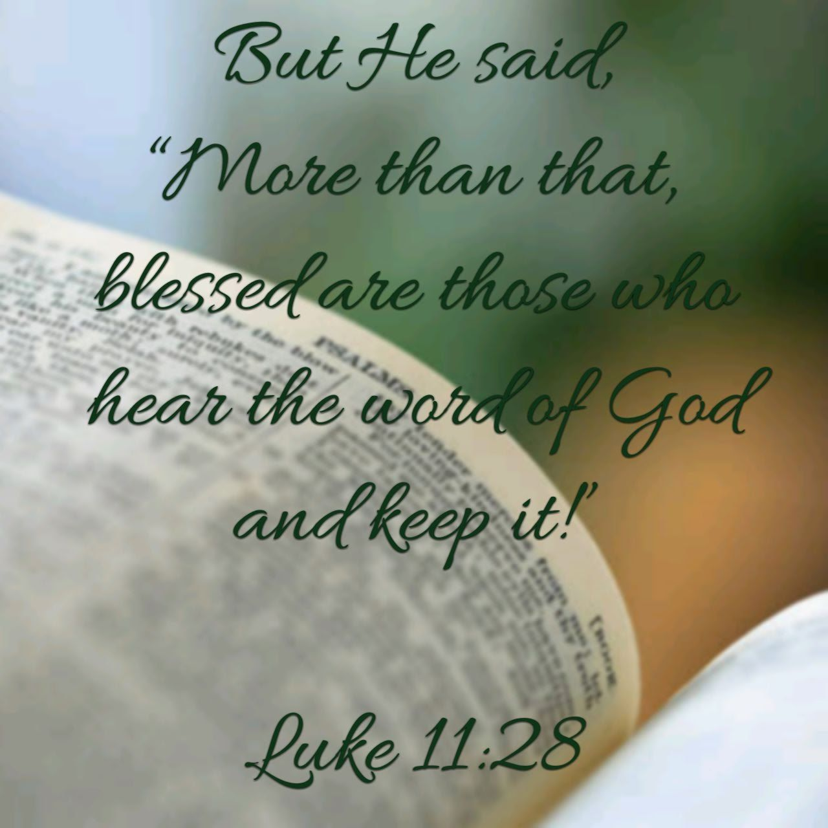

March 12, 2023

699 Stambaugh Ave.
Sharon, Pennsylvania 16146

“I was glad when they said to me,
Let us go to the house of the LORD!”
Psalm 122:1
Sts. Peter & Paul Evangelical Lutheran Church, LC-MS
OCULI
March 12, 2023

A special welcome to our guests this day! If you would like more information about The Lutheran Church - Missouri Synod, or this congregation, please speak with Pastor Deal or an Elder after the service.
Members & Guests: Don’t be embarrassed if your children make noise during the worship service, all children do. We encourage families to worship together but, if you feel the need, there are pews in the rear of the Church which are reserved for young families on both sides of the sanctuary. There is also a quiet room available to you during our service which is located down the hallway past the offices on the right side of the church as well as a children’s area in the Fellowship Hall where you are able to follow along with the service.

Today’s service includes the Sacrament of Holy Communion. If during this past year, you have not worshipped with us and been communed, we respectfully ask that you do not partake of this sacrament this day before first speaking with Pastor Deal.
If visiting from a sister congregation of the LC-MS and are in good standing, please inform Pastor Deal of your desire to commune prior to the service.
If wishing to receive a blessing during communion, please approach with your arms crossed.

CONTACT INFORMATION
Pastor Deal: pastordeal@saintspeterandpaul.net or 724-347-3620 (opt. 2)
Church Office: church@saintspeterandpaul.net or 724-347-3620 (opt. 3)

Silent prayer before worship: Heavenly Father, by sending Your Son Jesus as our Redeemer, You showed that You are faithful to Your promises. Lead me to depend on Your grace and to trust in You alone for my salvation through Christ. Amen.

Confession and Absolution

Opening Hymn: LSB #420 “Christ, the Life of All the Living”

Stand

The sign of the cross may be made by all in remembrance of their Baptism.

Invocation
P In the name of the Father and of the T Son and of the Holy Spirit.
C Amen.

Exhortation Hebrews 10:22; Psalm 124:8; Psalm 32:5
P Beloved in the Lord! Let us draw near with a true heart and confess our sins unto God our Father, beseeching Him in the name of our Lord Jesus Christ to grant us forgiveness.

P Our help is in the name of the Lord,
C who made heaven and earth.
P I said, I will confess my transgressions unto the Lord,
C and You forgave the iniquity of my sin.

Silence for reflection on God’s Word and for self-examination.

Confession of Sins
P O almighty God, merciful Father,
C I, a poor, miserable sinner, confess unto You all my sins and iniquities with which I have ever offended You and justly deserved Your temporal and eternal punishment. But I am heartily sorry for them and sincerely repent of them, and I pray You of Your boundless mercy and for the sake of the holy, innocent, bitter sufferings and death of Your beloved Son, Jesus Christ, to be gracious and merciful to me, a poor, sinful being.

Absolution [John 20:19–23]
P Upon this your confession, I, by virtue of my office, as a called and ordained servant of the Word, announce the grace of God unto all of you, and in the stead and by the command of my Lord Jesus Christ I forgive you all your sins in the name of the Father and of the T Son and of the Holy Spirit.
C Amen.
Service of the Word

Introit Psalm 25:1–2, 17–18, 20; antiphon: vv. 15–16
My eyes are ever | toward the Lord,*
for he will pluck my feet out | of the net.
Turn to me and be gra- | cious to me,*
for I am lonely and af- | flicted.
To you, | O Lord,*
I lift | up my soul.
O my God, in you I trust; let me not be | put to shame;*
let not my enemies exult | over me.
The troubles of my heart | are enlarged;*
bring me out of my dis- | tresses.
Consider my affliction and my | trouble,*
and forgive | all my sins.
Oh, guard my soul, and de- | liver me!*
Let me not be put to shame, for I take ref- | uge in you.
Glory be to the Father and | to the Son*
and to the Holy | Spirit;
as it was in the be- | ginning,*
is now, and will be forever. | Amen.

Kyrie Mark 10:47
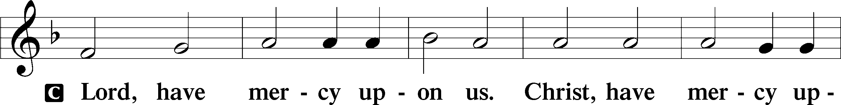
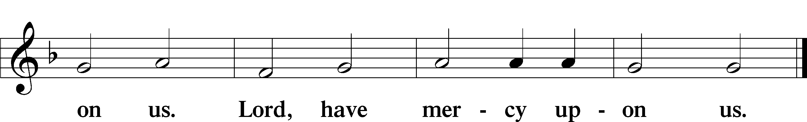

Salutation and Collect of the Day: Oculi
P The Lord be with you.
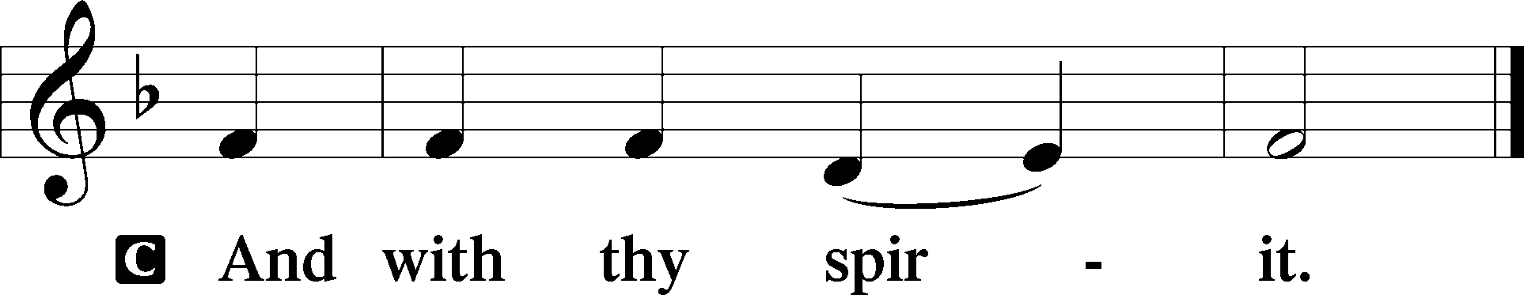

P Let us pray.
O God, whose glory it is always to have mercy, be gracious to all who have gone astray from Your ways and bring them again with penitent hearts and steadfast faith to embrace and hold fast the unchangeable truth of Your Word; through Jesus Christ, Your Son, our Lord, who lives and reigns with You and the Holy Spirit, one God, now and forever.
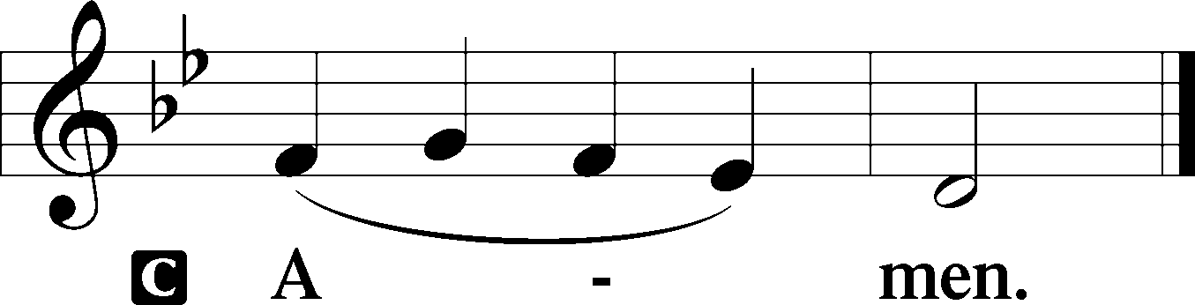
Sit

Prophecy: Exodus 8:16–24 (NKJV)
In those days: The Lord said to Moses, “Say to Aaron, ‘Stretch out your rod, and strike the dust of the land, so that it may become lice throughout all the land of Egypt.’ ” And they did so. For Aaron stretched out his hand with his rod and struck the dust of the earth, and it became lice on man and beast. All the dust of the land became lice throughout all the land of Egypt. Now the magicians so worked with their enchantments to bring forth lice, but they could not. So there were lice on man and beast. Then the magicians said to Pharaoh, “This is the finger of God.” But Pharaoh’s heart grew hard, and he did not heed them, just as the Lord had said. And the Lord said to Moses, “Rise early in the morning and stand before Pharaoh as he comes out to the water. Then say to him, ‘Thus says the Lord: “Let My people go, that they may serve Me. Or else, if you will not let My people go, behold, I will send swarms of flies on you and your servants, on your people and into your houses. The houses of the Egyptians shall be full of swarms of flies, and also the ground on which they stand. And in that day I will set apart the land of Goshen, in which My people dwell, that no swarms of flies shall be there, in order that you may know that I am the Lord in the midst of the land. I will make a difference between My people and your people. Tomorrow this sign shall be.” ’ ” And the Lord did so. Thick swarms of flies came into the house of Pharaoh, into his servants’ houses, and into all the land of Egypt. The land was corrupted because of the swarms of flies.

P This is the Word of the Lord.
C Thanks be to God.

Gradual Psalm 9:19, 3
Arise, O Lord! Let not | man prevail;*
let the nations be judged be- | fore you!
When my enemies | turn back,*
they stumble and perish before your | presence.

Epistle: Ephesians 5:1–9 (NKJV)
Brethren: Be imitators of God as dear children. And walk in love, as Christ also has loved us and given Himself for us, an offering and a sacrifice to God for a sweet-smelling aroma. But fornication and all uncleanness or covetousness, let it not even be named among you, as is fitting for saints; neither filthiness, nor foolish talking, nor coarse jesting, which are not fitting, but rather giving of thanks. For this you know, that no fornicator, unclean person, nor covetous man, who is an idolater, has any inheritance in the kingdom of Christ and God. Let no one deceive you with empty words, for because of these things the wrath of God comes upon the sons of disobedience. Therefore do not be partakers with them. For you were once darkness, but now you are light in the Lord. Walk as children of light, for the fruit of the Spirit is in all goodness, righteousness, and truth.

P This is the Word of the Lord.
C Thanks be to God.

Stand

Holy Gospel: Luke 11:14–28 (NKJV)
P The Holy Gospel according to St. Luke, the eleventh chapter.
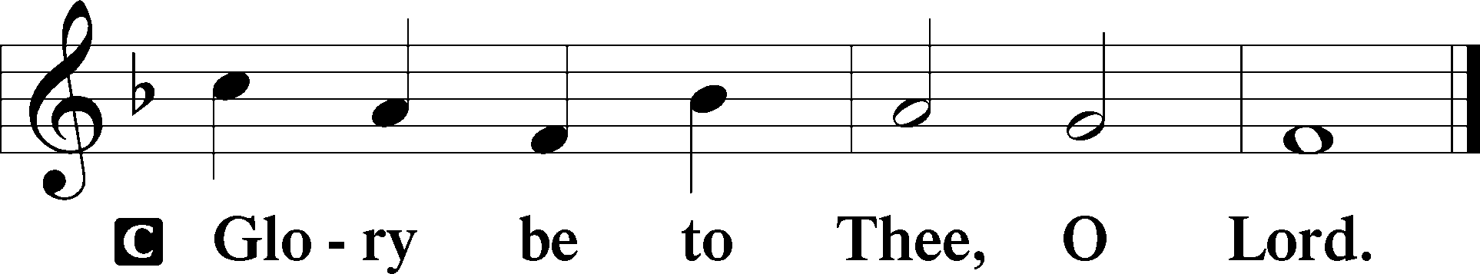

At that time: Jesus was casting out a demon, and it was mute. So it was, when the demon had gone out, that the mute spoke; and the multitudes marveled. But some of them said, “He casts out demons by Beelzebub, the ruler of the demons.” Others, testing Him, sought from Him a sign from heaven. But He, knowing their thoughts, said to them: “Every kingdom divided against itself is brought to desolation, and a house divided against a house falls. If Satan also is divided against himself, how will his kingdom stand? Because you say I cast out demons by Beelzebub. And if I cast out demons by Beelzebub, by whom do your sons cast them out? Therefore they will be your judges. But if I cast out demons with the finger of God, surely the kingdom of God has come upon you. When a strong man, fully armed, guards his own palace, his goods are in peace. But when a stronger than he comes upon him and overcomes him, he takes from him all his armor in which he trusted, and divides his spoils. He who is not with Me is against Me, and he who does not gather with Me scatters. When an unclean spirit goes out of a man, he goes through dry places, seeking rest; and finding none, he says, ‘I will return to my house from which I came.’ And when he comes, he finds it swept and put in order. Then he goes and takes with him seven other spirits more wicked than himself, and they enter and dwell there; and the last state of that man is worse than the first.” And it happened, as He spoke these things, that a certain woman from the crowd raised her voice and said to Him, “Blessed is the womb that bore You, and the breasts which nursed You!” But He said, “More than that, blessed are those who hear the word of God and keep it!”

P This is the Gospel of the Lord.
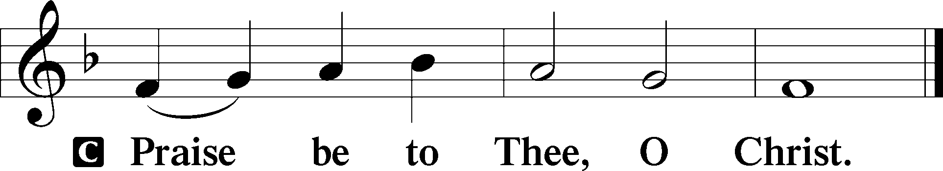

Nicene Creed
C I believe in one God,
the Father Almighty,
maker of heaven and earth
and of all things visible and invisible.

And in one Lord Jesus Christ,
the only-begotten Son of God,
begotten of His Father before all worlds,
God of God, Light of Light,
very God of very God,
begotten, not made,
being of one substance with the Father,
by whom all things were made;
who for us men and for our salvation came down from heaven
and was incarnate by the Holy Spirit of the virgin Mary
and was made man;
and was crucified also for us under Pontius Pilate.
He suffered and was buried.
And the third day He rose again according to the Scriptures
and ascended into heaven
and sits at the right hand of the Father.
And He will come again with glory to judge both the living and the dead,
whose kingdom will have no end.

And I believe in the Holy Spirit,
the Lord and giver of life,
who proceeds from the Father and the Son,
who with the Father and the Son together is worshiped and glorified,
who spoke by the prophets.
And I believe in one holy Christian and apostolic Church,
I acknowledge one Baptism for the remission of sins,
and I look for the resurrection of the dead
and the life T of the world to come. Amen.
Sit

Hymn of the Day: LSB #659 “Lord of Our Life”

Sermon

Stand

Prayer of the Church

Offertory Psalm 51:10–12
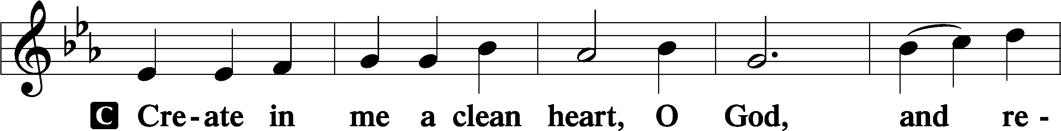
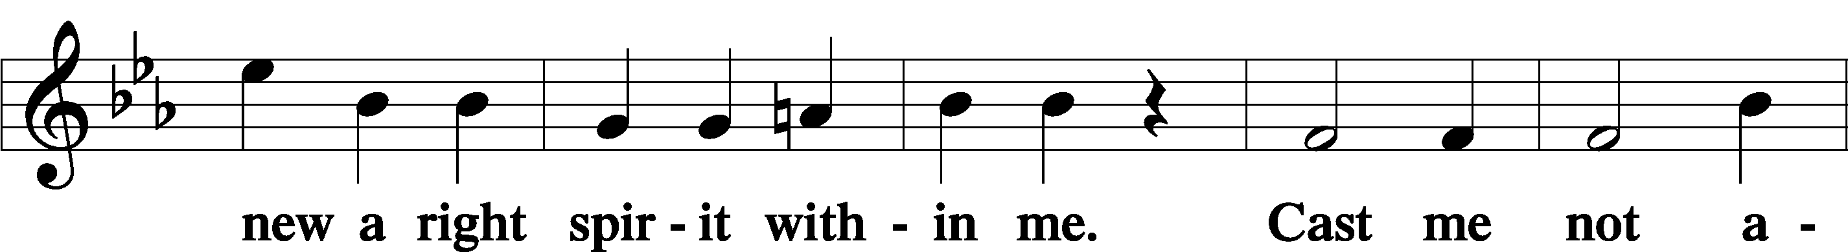
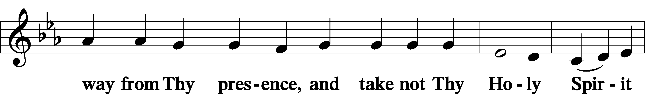
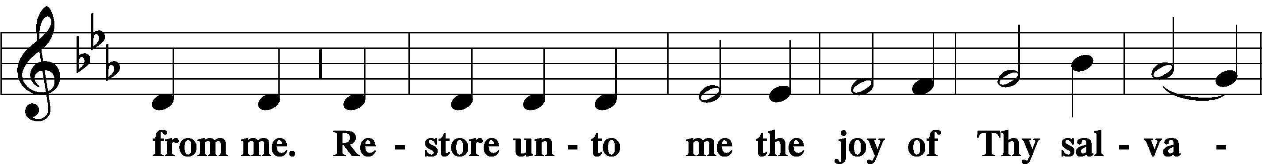
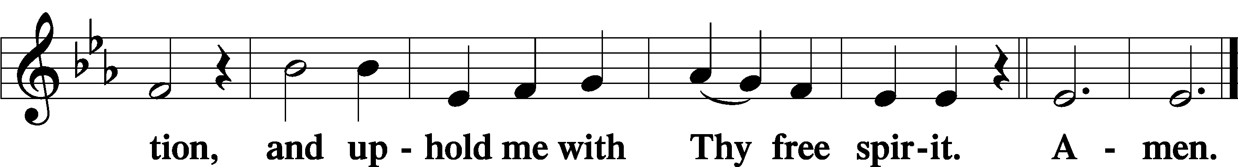
Sit

Preparatory Hymn: LSB #617 “O Lord, We Praise Thee”

Stand
Service of the Sacrament

Preface 2 Timothy 4:22; Colossians 3:1 Psalm 136
P The Lord be with you.
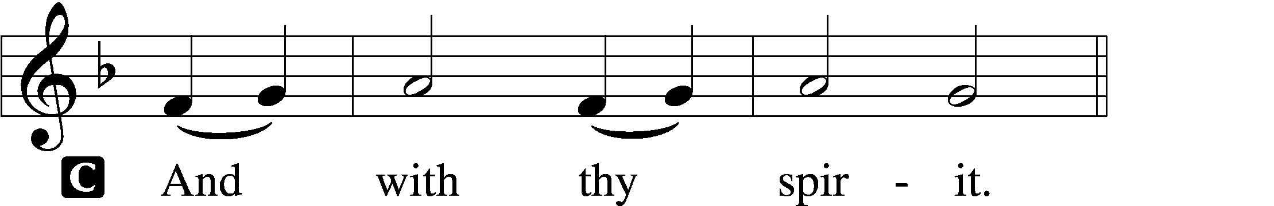

P Lift up your hearts.
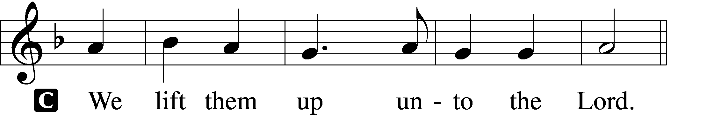

P Let us give thanks unto the Lord, our God.
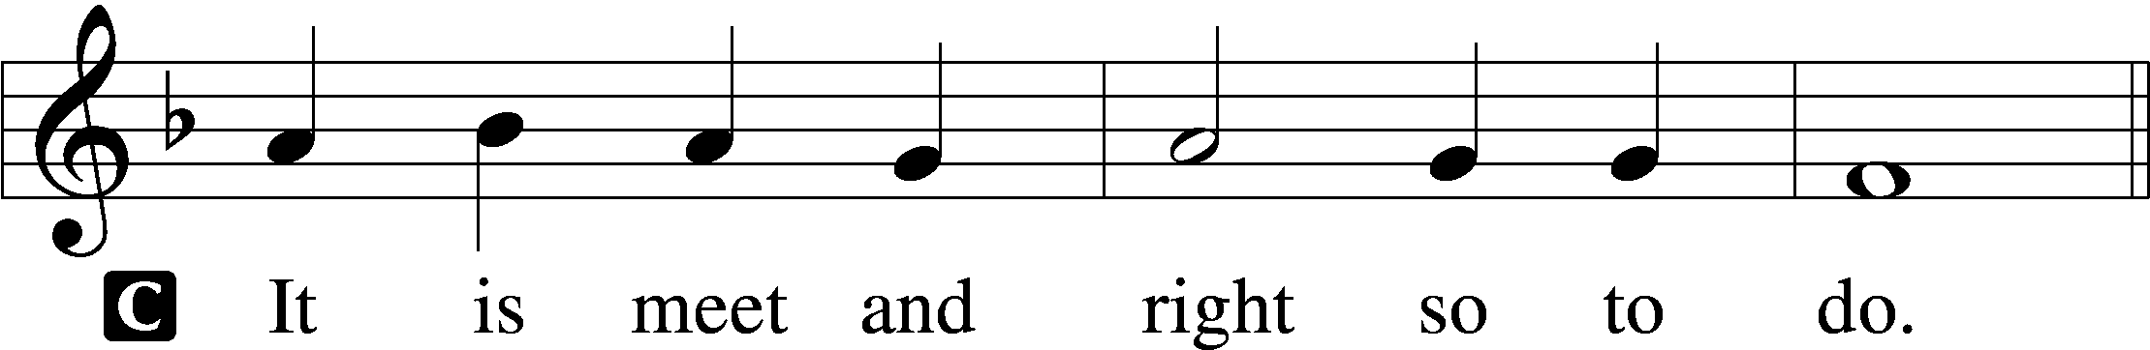

Proper Preface (Abbreviated) LSB 194
P It is truly meet, right, and salutary . . . evermore praising You and saying:

Sanctus Isaiah 6:3; Matthew 21:9
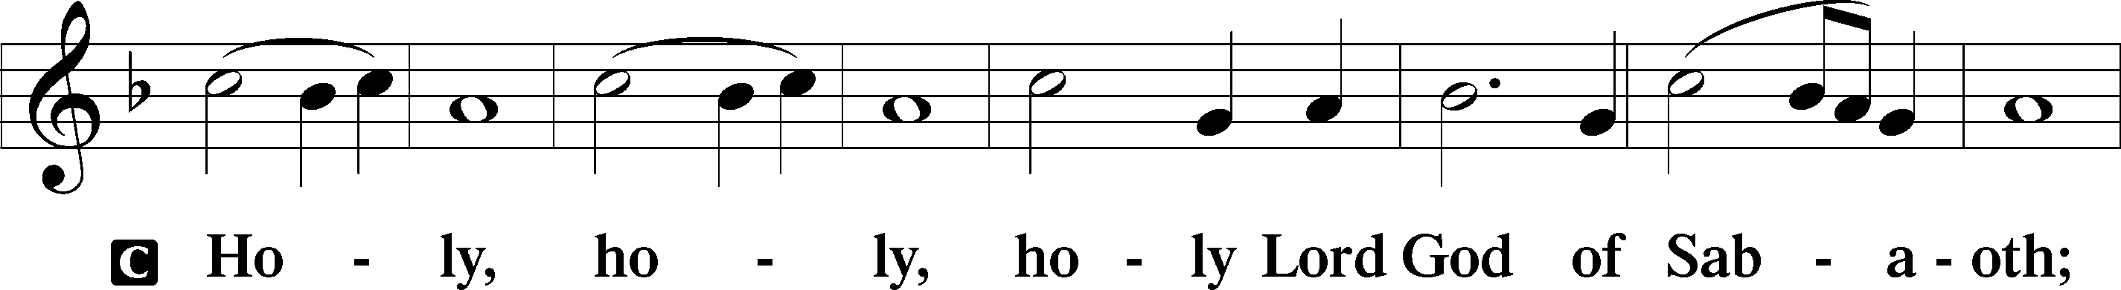
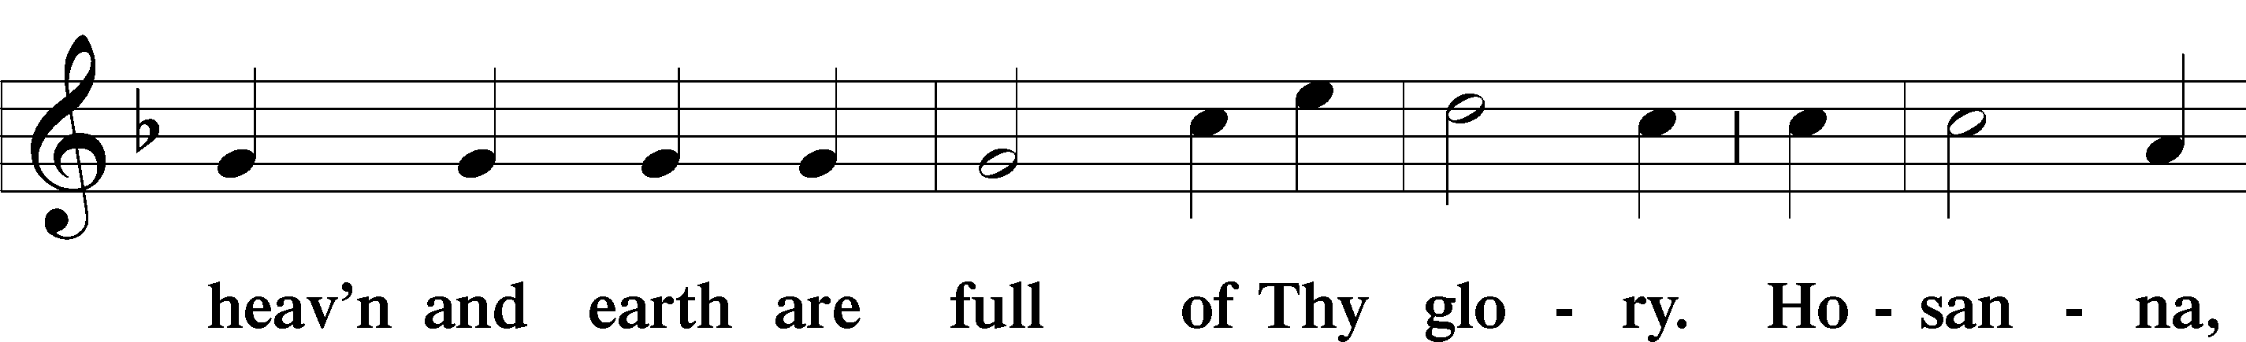
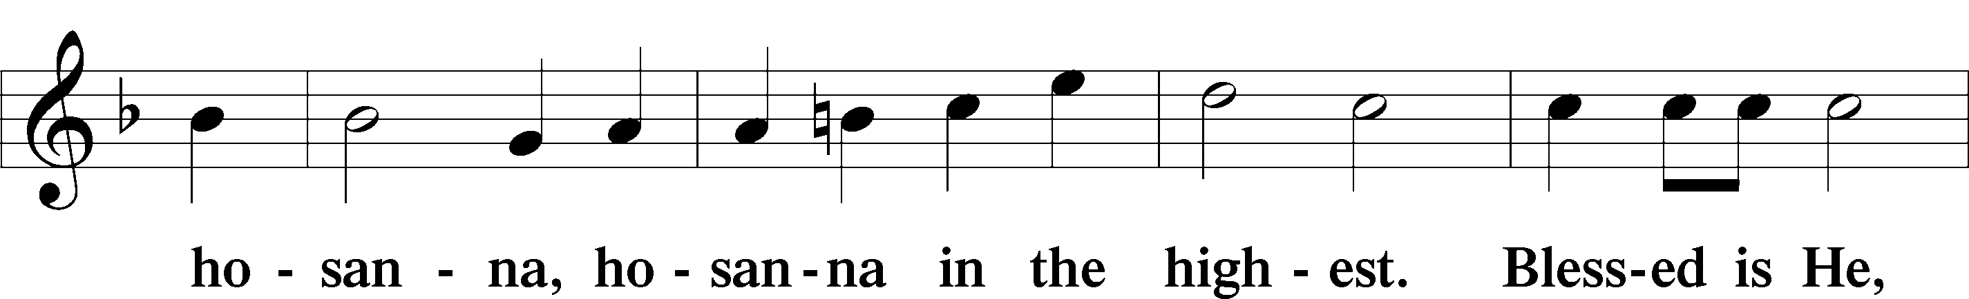
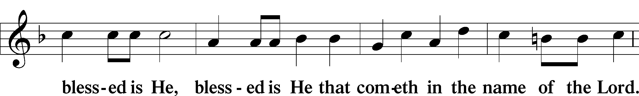
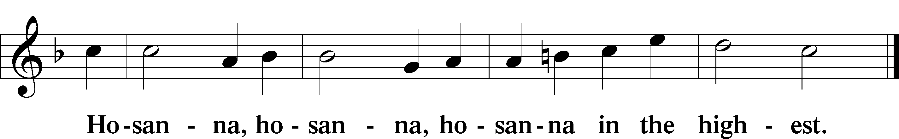

Lord’s Prayer Matthew 6:9–13
C Our Father who art in heaven,
hallowed be Thy name,
Thy kingdom come,
Thy will be done on earth as it is in heaven;
give us this day our daily bread;
and forgive us our trespasses as we forgive those who trespass against us;
and lead us not into temptation,
but deliver us from evil.
For Thine is the kingdom and the power and the glory forever and ever. Amen.

The Words of Our Lord Matthew 26:26–28; Mark 14:22–24; Luke 22:19–20; 1 Corinthians 11:23–25
P Our Lord Jesus Christ, on the night when He was betrayed, took bread, and when He had given thanks, He broke it and gave it to the disciples and said: “Take, eat; this is My T body, which is given for you. This do in remembrance of Me.”

In the same way also He took the cup after supper, and when He had given thanks, He gave it to them, saying: “Drink of it, all of you; this cup is the new testament in My T blood, which is shed for you for the forgiveness of sins. This do, as often as you drink it, in remembrance of Me.”
Pax Domini John 20:19
P The peace of the Lord be with you always.
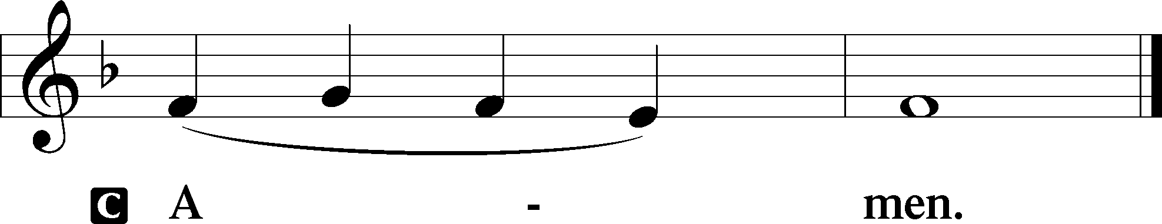

Agnus Dei John 1:29
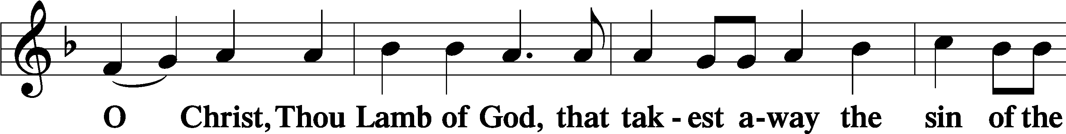
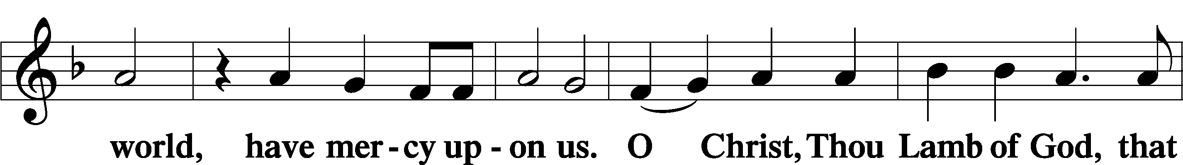
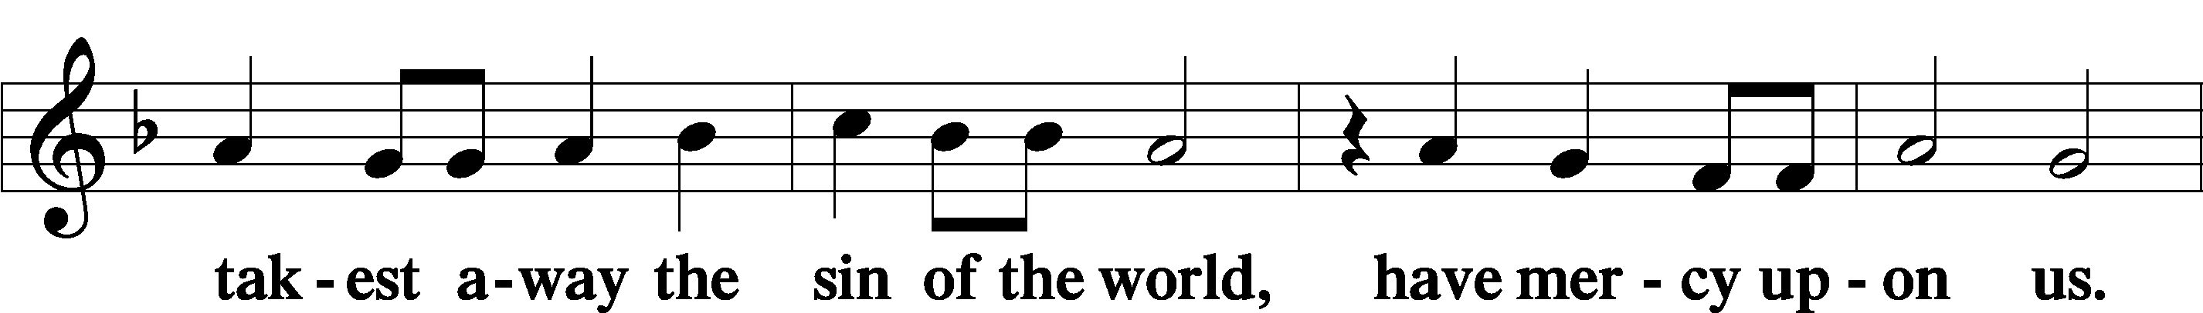
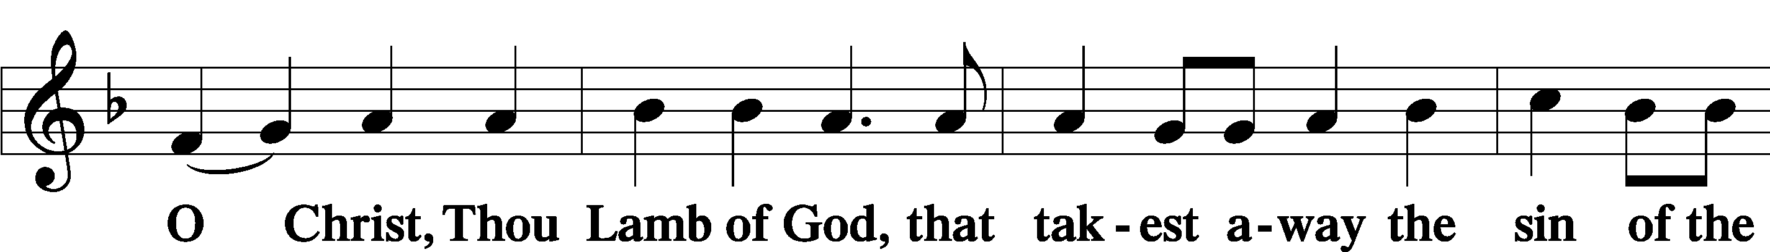
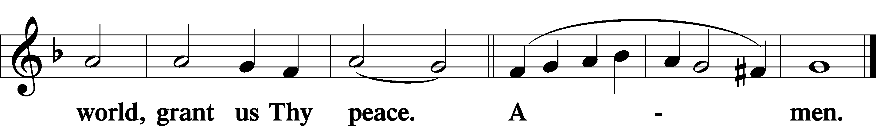
Sit

Distribution
The pastor and those who assist him receive the body and blood of Christ first and then distribute them to those who come to receive, saying:
Take, eat; this is the true body of our Lord and Savior Jesus Christ, given into death for your sins.
Amen.

Take, drink; this is the true blood of our Lord and Savior Jesus Christ, shed for the forgiveness of your sins.
Amen.

In dismissing the communicants, the following is said:
The Dismissal
P The body and blood of our Lord Jesus Christ strengthen and preserve you in body and soul to life everlasting. Depart T in peace.
C Amen.

Distribution Hymn: TLH #268 “Zion Mourns in Fear and Anguish”
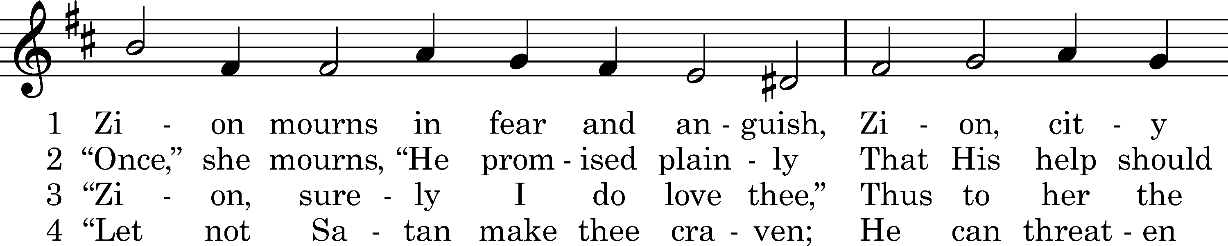
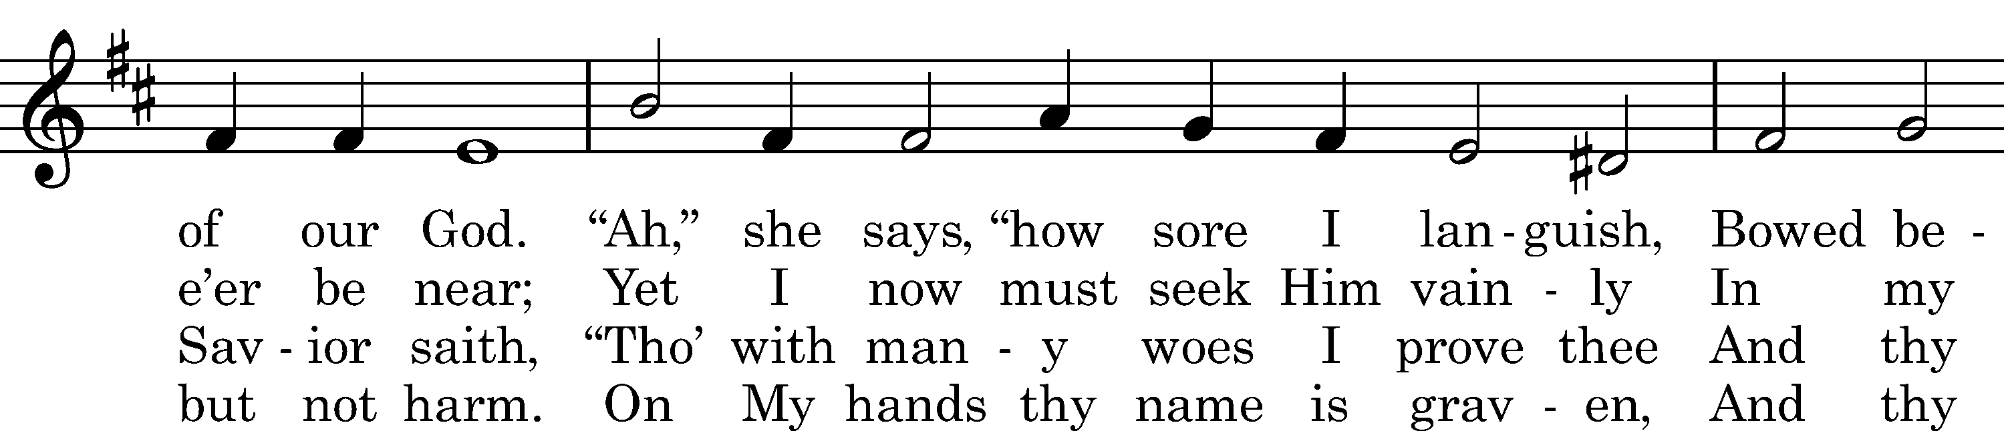
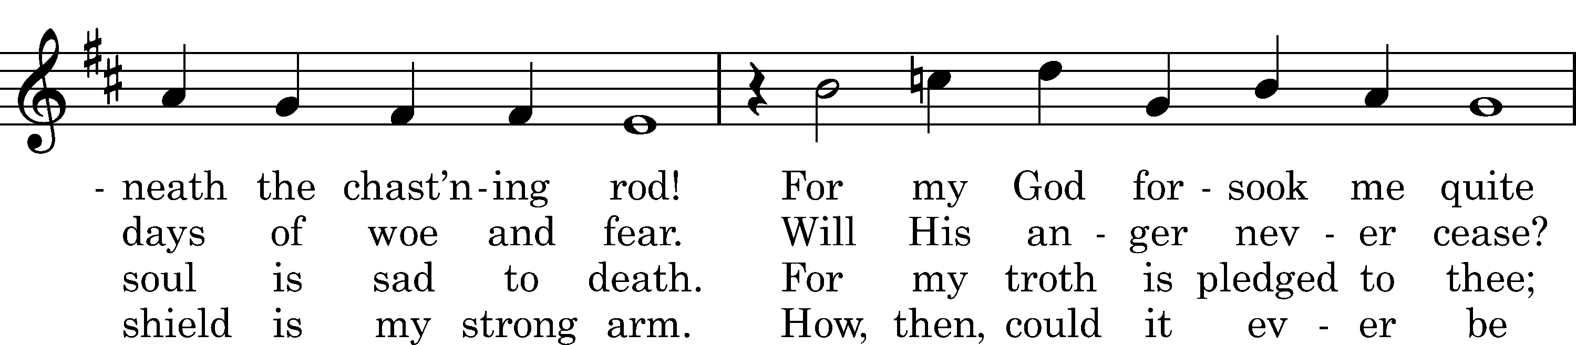
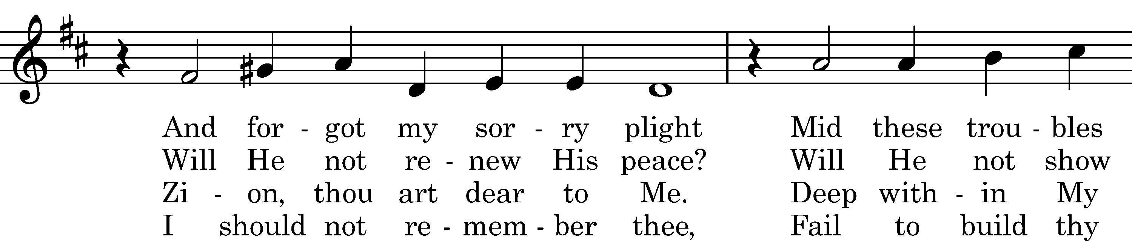
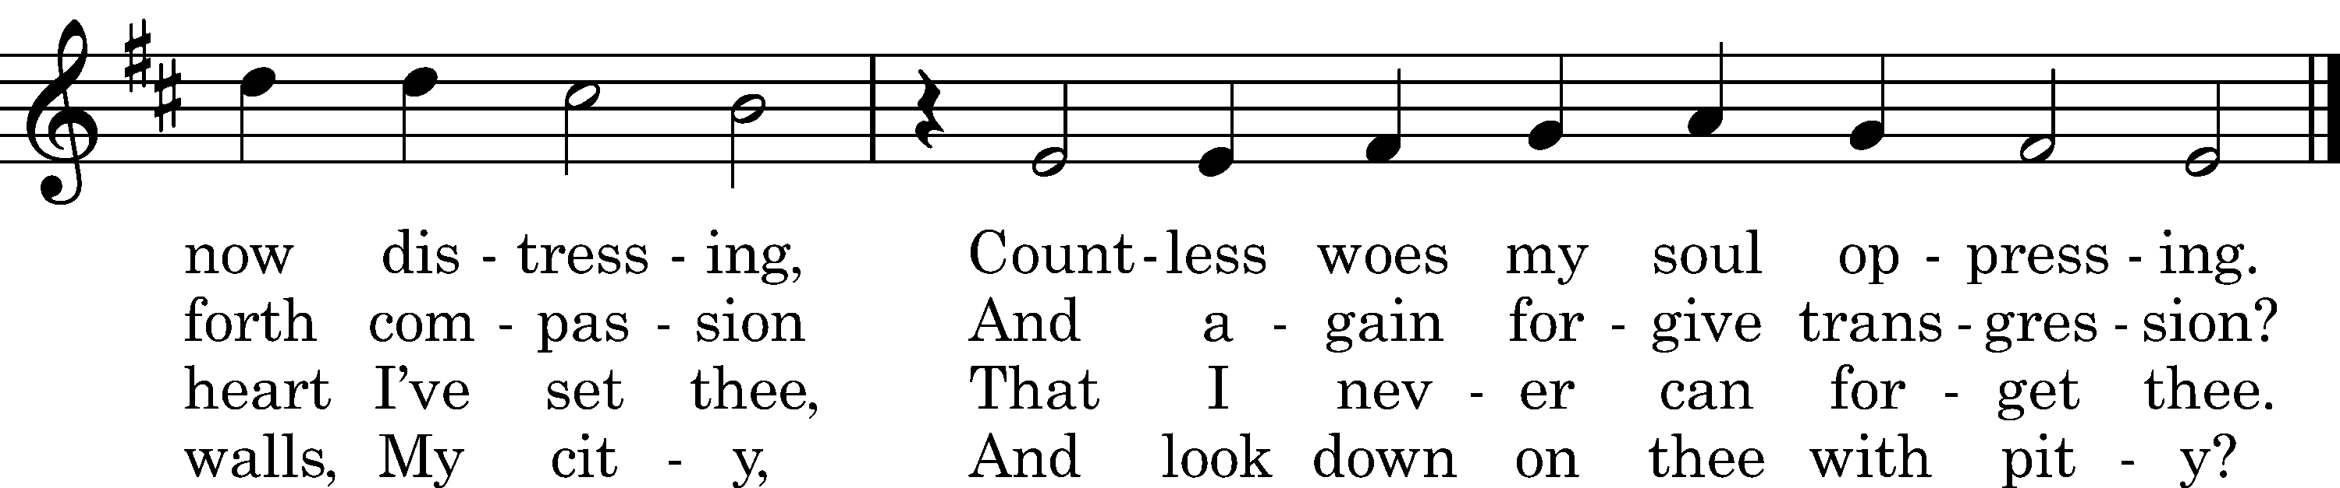

5 "Ever shall Mine eyes behold thee;
On My bosom thou art laid.
Ever shall My love enfold thee;
Never shalt thou lack Mine aid.
Neither Satan, war, nor stress
Then shall mar thy happiness:
With this blessèd consolation
Be thou firm in tribulation."
Text: tr. Catherine Winkworth, 1869, alt.; Johann Heermann, 1636, alt.
Tune: J. Hermann Schein, 1623
Text and tune: Public domain

Distribution Hymn: LSB #634 “The Death of Jesus Christ, Our Lord”

Stand

Nunc Dimittis Luke 2:29–32
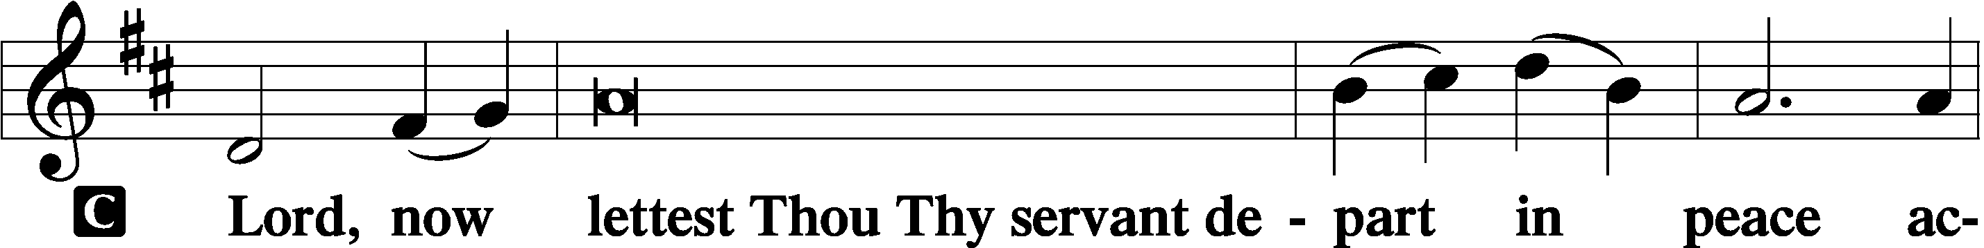
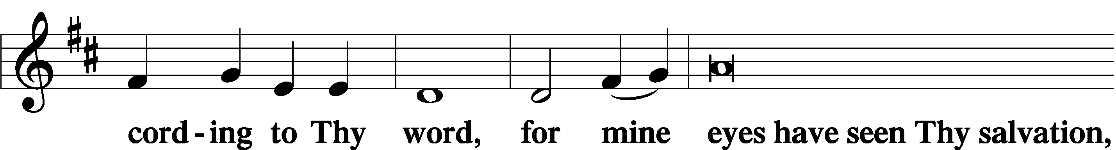
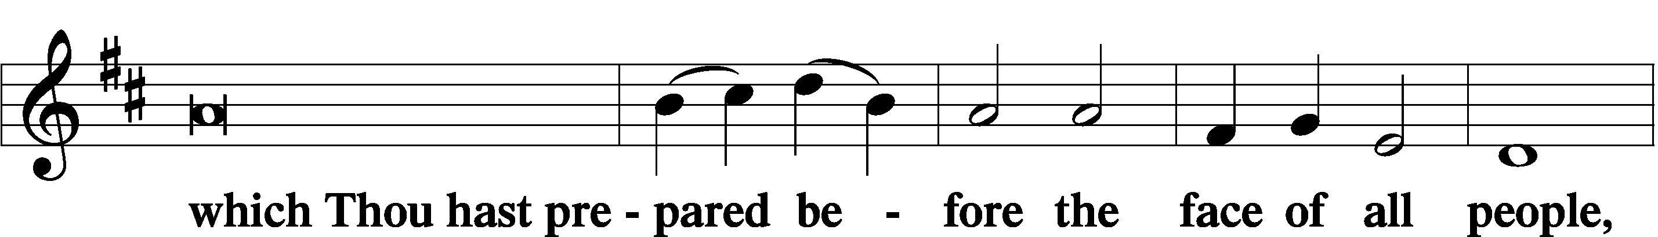
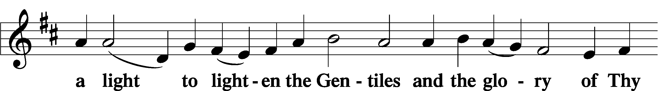
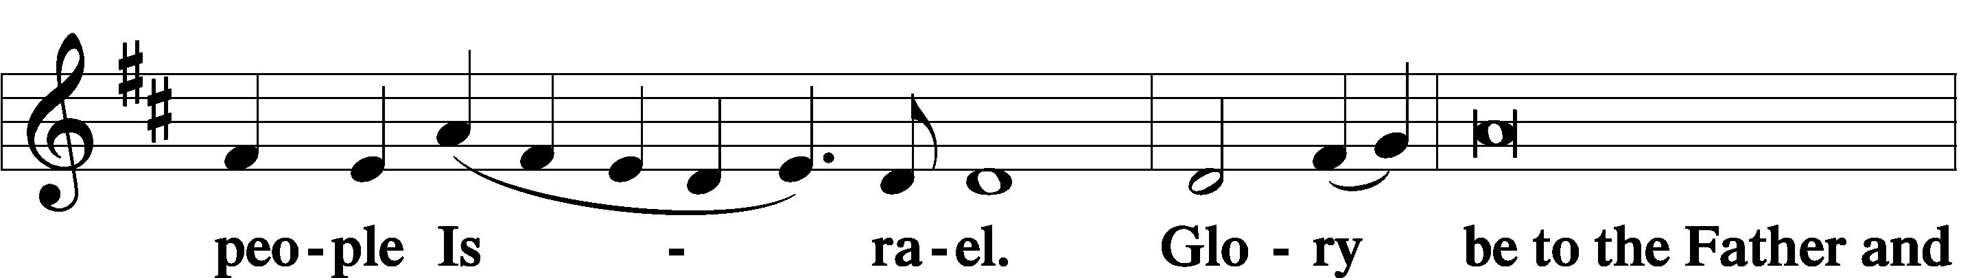
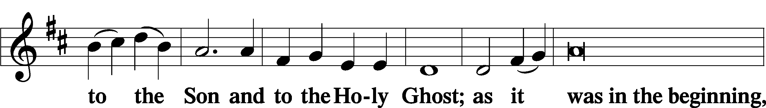
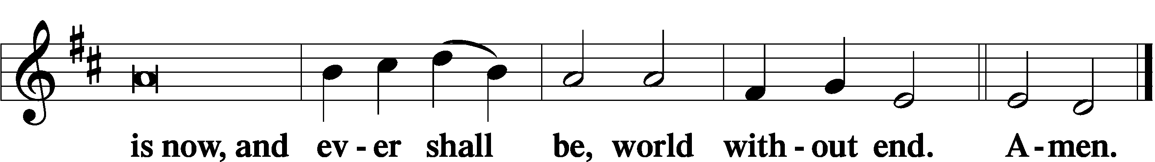
Thanksgiving Psalm 107:1
P O give thanks unto the Lord, for He is good,
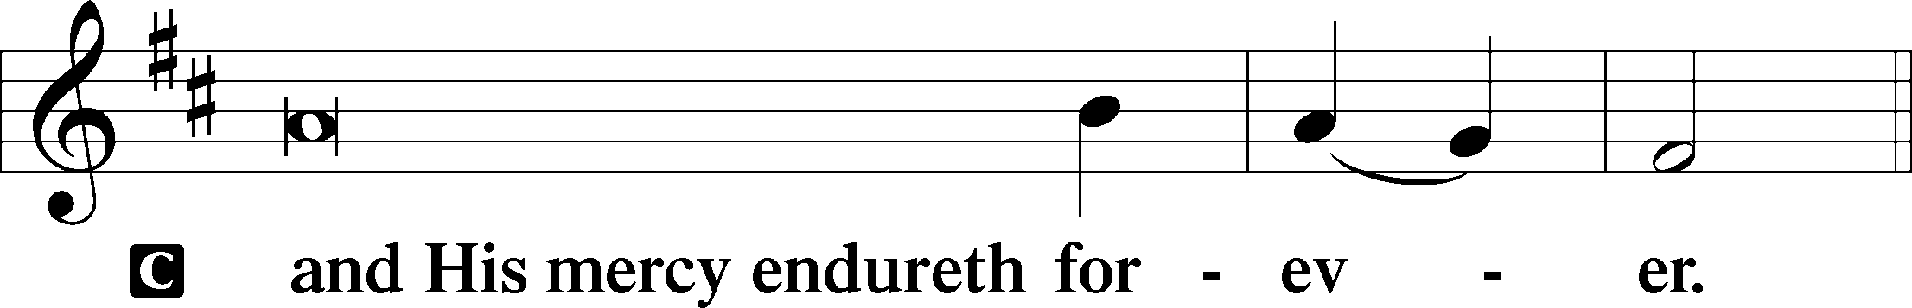

Post-Communion Collect
P Let us pray.
We give thanks to You, almighty God, that You have refreshed us through this salutary gift, and we implore You that of Your mercy You would strengthen us through the same in faith toward You and in fervent love toward one another; through Jesus Christ, Your Son, our Lord, who lives and reigns with You and the Holy Spirit, one God, now and forever.
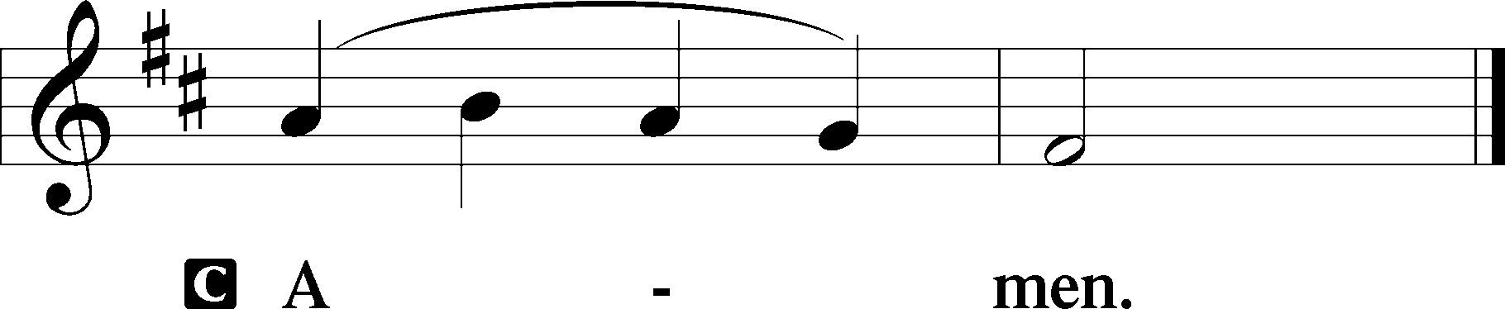

Salutation 2 Timothy 4:22
P The Lord be with you.
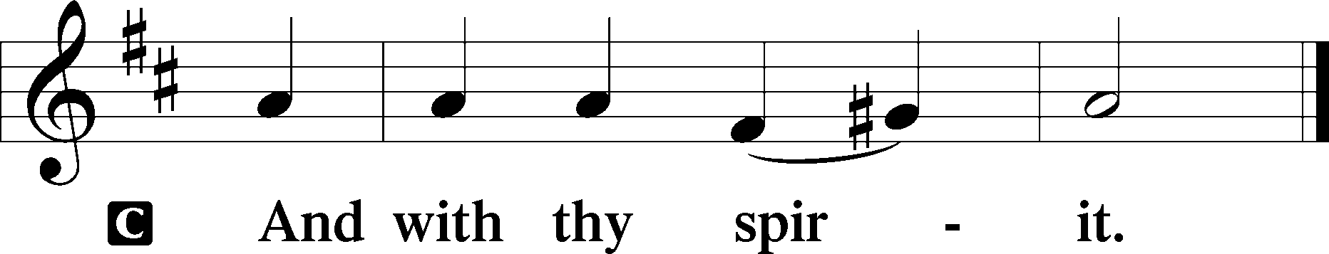

Benedicamus Psalm 103:1
P Bless we the Lord.
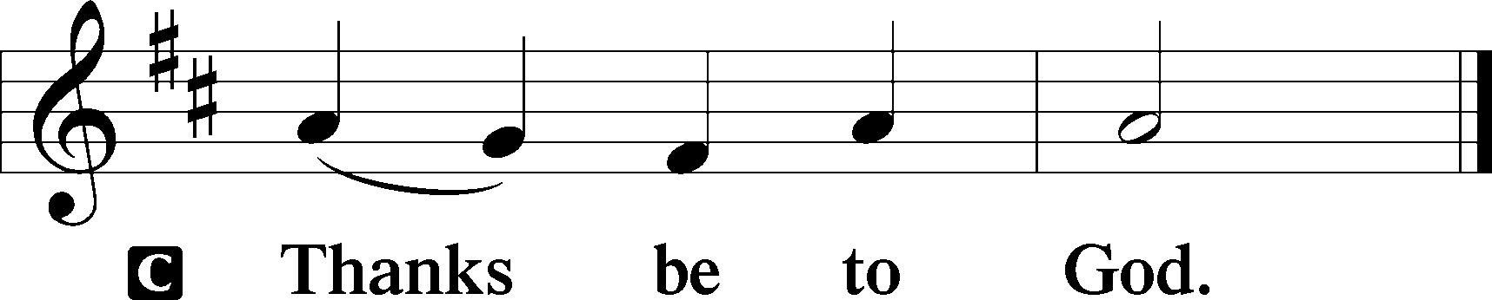

Benediction Numbers 6:24–26
P The Lord bless you and keep you.
The Lord make His face shine upon you and be gracious unto you.
The Lord lift up His countenance upon you and T give you peace.
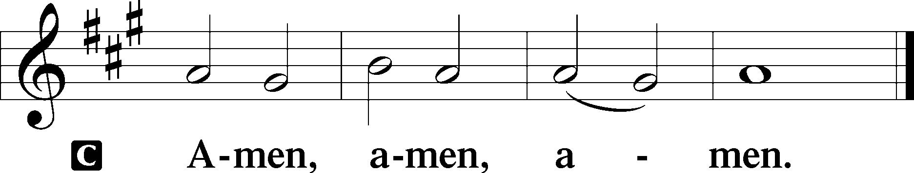

Closing Hymn: LSB #716 “I Walk in Danger All the Way”

Silent prayer after worship: Dear Lord, lead me to be in Your Word and in prayer daily, so I will always trust that You will defend me from evil, keep me strong in times of temptation, and forgive me when I fall into sin. In Jesus’ name. Amen.
fffffffffffffffffffffffffffffffffff
Acknowledgments
Unless otherwise indicated, Scripture quotations are from the ESV® Bible (The Holy Bible, English Standard Version®), copyright © 2001 by Crossway, a publishing ministry of Good News Publishers. Used by permission. All rights reserved.
Created by Lutheran Service Builder © 2023 Concordia Publishing House.
fffffffffffffffffffffffffffffffffff
fffffffffffffffffffffffffffffffffff
In Loving Memory of Anson Holcroft: Bonnie & Ralph Arcuri; Anna Mae Daris; Dolores Fee (Food Pantry); Mark Gabriel; Hank Holcroft (Food Pantry & Capital Campaign); Lisa Jelinek (Food Pantry); Clara Krivosh (Food Pantry); Rev. Ed & Irene Kucera (Food Pantry); Barbara Collins and Steve & Sherri Kuhlmann; Denise Lindsey (Major Repair); Toni & Heather Shaw (Major Repair); Jeanne Steffen; Robert & Marsha Swimm.
In Loving Memory of Ernie Meszaros: Dolores Fee (Food Pantry).
In Loving Memory of my Husband, Ernie Meszaros’s 84th Birthday: Ruth Meszaros (Food Pantry)
fffffffffffffffffffffffffffffffffff
Please join us in the Fellowship Hall following worship this morning for Coffee Fellowship. This month’s sponsors are Jonathan and Bekah Baisch.
Interested in sponsoring in the future? Sponsors are asked sign up on the sheet posted in the narthex and bring 2-3 dozen “treats” to the Fellowship Hall kitchen along with a quart of juice prior to the service on the date selected. All other items will be provided and the set-up and clean-up will be done for you!
SCHEDULE THROUGH MARCH 19, 2023:

:

Today, Following Worship, Fellowship Hall: Coffee Fellowship
7 pm, Fellowship Hall: AA Meeting
Tuesday, 7 pm, All Saints~Slippery Rock: Lenten Midweek Vespers Service
7-9 pm, Fellowship Hall: Penn-Ohio Singers
Wednesday, Noon, Sanctuary: Lenten Midweek Matins Service
5:30 pm, Sanctuary: Choir Rehearsal
7 pm, Sanctuary: Lenten Midweek Vespers Service
7:30 pm, Fellowship Hall: NA Meeting
Saturday, 9 am, All Saints~Slippery Rock: Catechism Class
1 pm, Fellowship Hall: Women’s Bible Study
2:15 pm, Fellowship Hall: Altar Guild Meeting
4 pm, Fellowship Hall: Men’s Bible Study
Next Sunday, 8 am, Fellowship Hall: Bible Study
9 am, Sanctuary: Divine Service
Following, Library: Audit of Deposits
7 pm, Fellowship Hall: AA Meeting
fffffffffffffffffffffffffffffffffff
Attendance: Sunday, March 5, 2023: 48
Wednesday, March 8: 32 (19~noon; 13~7pm)
fffffffffffffffffffffffffffffffffff
THANK YOU FOR SERVING IN MARCH: Elder: Jonathan Baisch; Ushers: Cheryl Fedele, Mike Flaugher, and Jesse Riffle; Altarware: (prior) Diane Riefstahl & Marie Flaugher (03/12); (after) Elizabeth Haenftling & Traudi Sulek.
fffffffffffffffffffffffffffffffffff
Bible Memory Verses ~ Week of March 12th:
For Adults: Do you not know that your body is a temple of the Holy Spirit within you, whom you have from God? You are not your own, for you were bought with a price. So glorify God in your body. 1 Corinthians 6:19-20
For Children: The Son of Man came not to be served but to serve, and to give his life as a ransom for many. Matthew 20:28
fffffffffffffffffffffffffffffffffff
Our Stewardship of Treasures for the Lord:
In order to do the Lord’s work, we need $2,553.63 each week to meet our 2023 budget for general purposes and $76.92 for the SELC.
Figures for Wednesday, March 1, 2023
General Fund: $75.00
SELC: $5.00
Figures for Sunday, March 5, 2023
General Fund: $3,563.25 Ahead for the week*: +$1,084.62
SELC: $155.00 Ahead for the week*: +$83.08
Food Pantry: $140.00
Quarterly Missions: $35.00
Capital Campaign: $1000.00 *Includes above figures.
Other: $210.00

For online giving, check out https://www.saintspeterandpaul.net/online-giving.
fffffffffffffffffffffffffffffffffff
Minutes from the March 5th VOTERS’ ASSEMBLY are available on the table in the narthex.
fffffffffffffffffffffffffffffffffff
Choir members are reminded that there will be practice this Wednesday.
fffffffffffffffffffffffffffffffffff
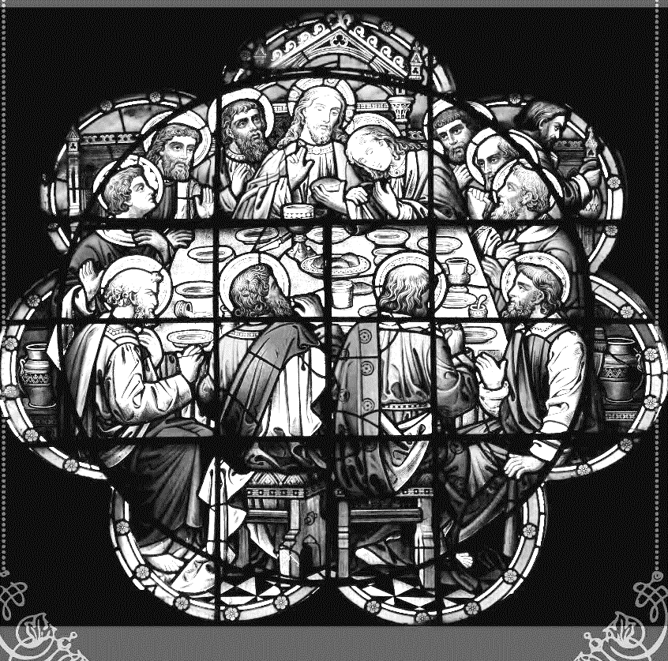
Join us this Lenten season as we focus on the Lord’s Supper with the following Wednesday midweek services through the end of March:
Matins Service at Noon
Vespers Service at 7 pm

fffffffffffffffffffffffffffffffffff
This morning is “Food Pantry Sunday”! Your financial support of this outreach mission is greatly appreciated. Donations may be placed in a pew envelope labeled with your name and envelope number. Please make certain to designate “food pantry” on the envelope.
fffffffffffffffffffffffffffffffffff

Remember the following in Prayer…
~The Hurting and Healing: The family and friends of David Nelson, brother of Barry Nelson, who passed away March 5th; Amy, Gerald Arthur, Evelyn Baisch, Ellen Baron^{CA}, Lois Bortner^{CA}, John Burdette, Bev & Joe Chlpka, Kathleen Coughenour, Kim, Anna Mae Daris, Susan Davies, Tim Dudash, Millie Elavsky, Joseph Fleet, Judith & Eddy Furey, Tim Haenftling, Austin Hamilton, Neil Huston, Joan, Darla Krajci, Barbara Kreske, Donna Kennedy, Jess Lavoie, Paul Lucas^{CA}, Sandy Marshall, Frank Niemeyer^{CA}, Linda Parkany, Juanita Rentschler, Richard Reuning^{CA}, Diane Riefstahl, Nancy Robertson^{CA}, Viola Sakony, Marty Scott, Kara, Fred Tonty, Angela Weser^{CA}, and Ruth Wolf.
~The Homebound: Rudy & Jean Tomko, Betty Wolf, and Ed & Millie Zachar.
~Celebrating: Birthday ~ Barry Nelson (03.17).
~Serving in the Military: Curtis Sinewe and Joshua Solyan.
~Community & World Needs: Those suffering from or affected by the coronavirus; those suffering due to the conflict between Ukraine and Russia; those suffering from loss and dislocation because weather disasters; those suffering from addiction and their families; Local, State, and National Government Leaders; safety for all Police Officers, Firefighters, & First Responders; the unemployed; our First Quarter Local Mission: Sts. Peter & Paul’s Community Day 2023. *CA represents cancer.
fffffffffffffffffffffffffffffffffff
BIBLE STUDY OPPORTUNITIES!
Women’s Bible Study: Saturday, March 18th at 1 pm.
Men’s Bible Study: Saturday, March 18th at 4 pm.
All are welcome to join us each Sunday morning at 8 am.
All sessions are held in the Fellowship Hall.
fffffffffffffffffffffffffffffffffff
The next Altar Guild Meeting will be held following the Women’s Bible Study session March 18th. The estimated start time is 2:15 pm. This month’s hostess is Evelyn Baisch. Please consider joining us!
fffffffffffffffffffffffffffffffffff
There is an insert in today’s bulletin for those interested in purchasing Easter flowers (Easter lilies and daffodils) to adorn our sanctuary Easter Sunday. The choice of flowers this year is limited to accommodate those with allergies.

Here to Serve
Pastor………………………………………………...……………Rev. Jacob Deal
E-mail …………………………….……pastordeal@saintspeterandpaul.net
Phone Number……………………..…………………724-347-3620 (Option 2)
Church Office………………………..…………………724-347-3620 (Option 3)
Website …………………………………………www.saintspeterandpaul.net
Secretary…………………………………………………………Diane Riefstahl
E-mail ………………………………………church@saintspeterandpaul.net
Website …………………………………………www.saintspeterandpaul.net
Food Pantry: Please leave message……………724-347-3620 (Option 3)
AA Contact: Steve………………………………………………..…724-813-2358
NA Contact: Larry………………………………………………..724-977-8733
Choir Director………………………………………………………Chris Nelson
Congregation President……………………………………Jonathan Baisch
Church Elder …………………………………………...…… Jonathan Baisch
fffffffffffffffffffffffffffffffffff
If needing to get into the church building during the week, please phone first to make certain someone is here to let you in.

