Sts. Peter & Paul
Evangelical Lutheran Church
Lutheran Church-Missouri Synod
Founded-1917

JUNE 9, 2019

699 Stambaugh Avenue
Sharon, Pennsylvania 16146

“I was glad when they said to me,
Let us go to the house of the LORD!”
Psalm 122:1
Sts. Peter & Paul Evangelical Lutheran Church, LC-MS

PENTECOST
June 9, 2019

Silent prayer before worship: O Lord, thank You for the gift of the Holy Spirit through whom I can believe and come to You in prayer. Cause me to be in Your Word daily that the Holy Spirit may strengthen my faith in You. Amen.

Please read Communion Statement found inside the Friendship Booklet prior to taking part in Holy Communion.
CONFESSION AND ABSOLUTION
Opening Hymn: LSB #913 “O Holy Spirit, Enter In”
Stand
The sign of the cross may be made by all in remembrance of their Baptism.

P In the name of the Father and of the T Son and of the Holy Spirit.
C Amen. Matthew 28: 19b; [18:20]

P If we say we have no sin, we deceive ourselves, and the truth is not in us.
C But if we confess our sins, God, who is faithful and just, will forgive our sins and cleanse us from all unrighteousness.

Silence for reflection on God's Word and for self-examination.

P Let us then confess our sins to God our Father.
C Most merciful God, we confess that we are by nature sinful and unclean. We have sinned against You in thought, word, and deed, by what we have done and by what we have left undone. We have not loved You with our whole heart; we have not loved our neighbors as ourselves. We justly deserve Your present and eternal punishment. For the sake of Your Son, Jesus Christ, have mercy on us. Forgive us, renew us, and lead us, so that we may delight in Your will and walk in Your ways to the glory of Your holy name. Amen.
P Almighty God in His mercy has given His Son to die for you and for His sake forgives you all your sins. As a called and ordained servant of Christ, and by His authority, I therefore forgive you all your sins in the name of the Father and of the T Son and of the Holy Spirit. [John 20: 19-23]
C Amen.

Passing of the Peace.

SERVICE OF THE WORD

Introit: Ps. 68:1, 4a, c, 11a, 33b, 35a; antiphon: Liturgical Text; Ps. 68:3
The Spirit of the Lord fills the world. Alle- | luia.*
The righteous | shall be glad.
They shall exult be- | fore God;*
they shall be jubilant with joy! Alle- | luia.
God shall arise, his enemies shall be | scattered;*
and those who hate him shall flee be- | fore him!
Sing to God, sing praises | to his name;*
exult be- | fore him!
The Lord | gives the word;*
behold, he sends out his voice, his | mighty voice.
Awesome is God from his sanctu- | ary;*
the God of Israel—he is the one who gives power and strength to his | people.
Glory be to the Father and | to the Son*
and to the Holy | Spirit;
as it was in the be- | ginning,*
is now, and will be forever. | Amen.

The Spirit of the Lord fills the world. Alle- | luia.*
The righteous | shall be glad.
They shall exult be- | fore God;*
they shall be jubilant with joy! Alle- | luia.

Kyrie Mark 10:47

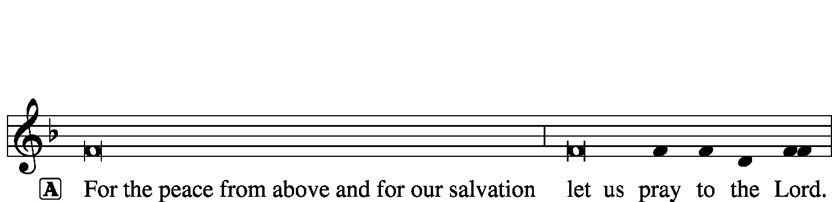
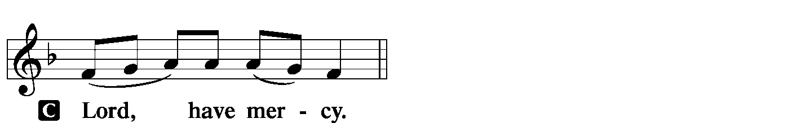
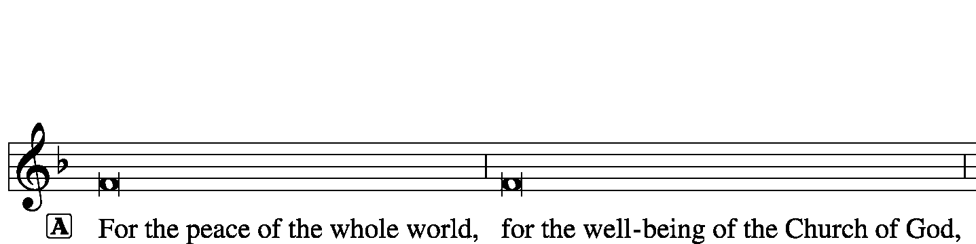
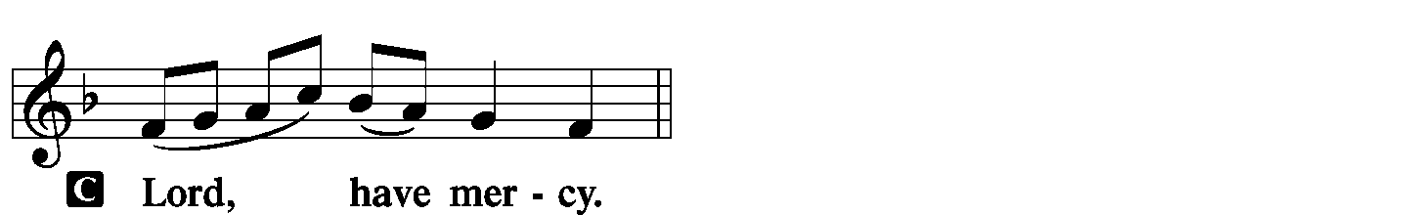
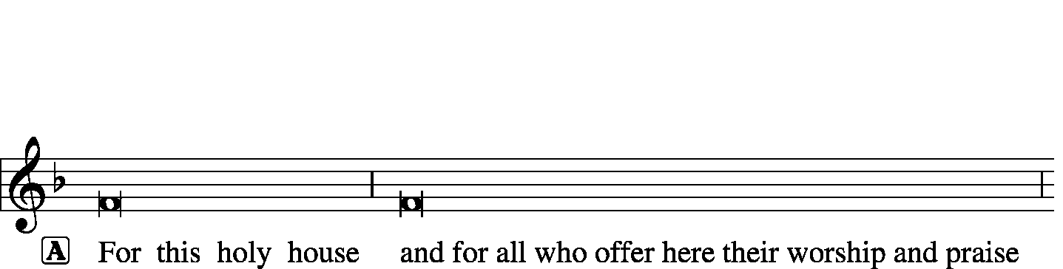
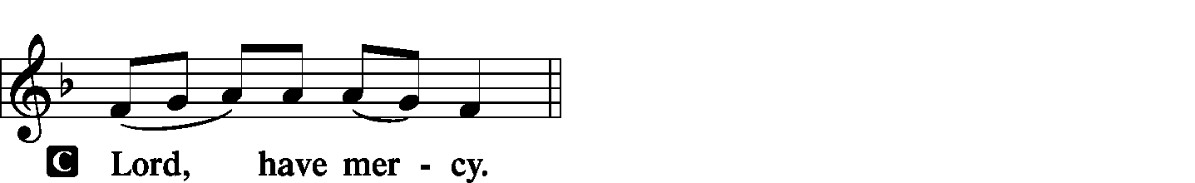
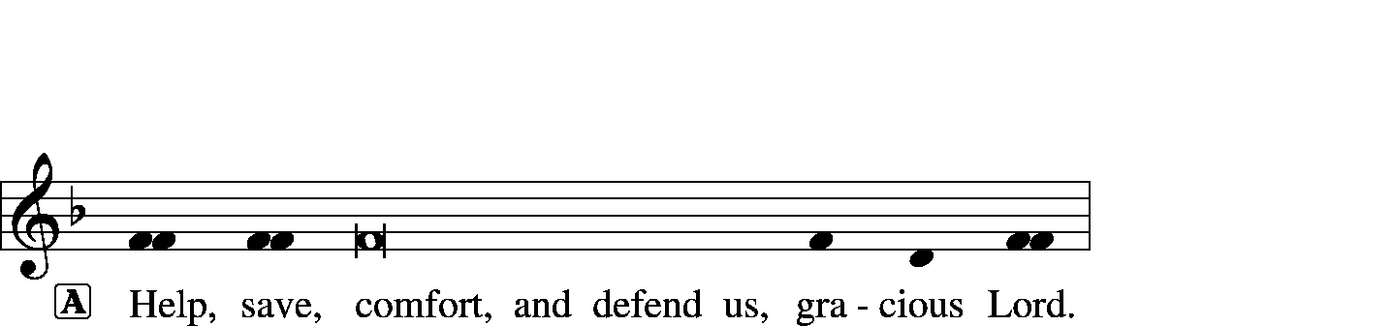

Gloria in Excelsis Luke 2: 14; John 1: 29
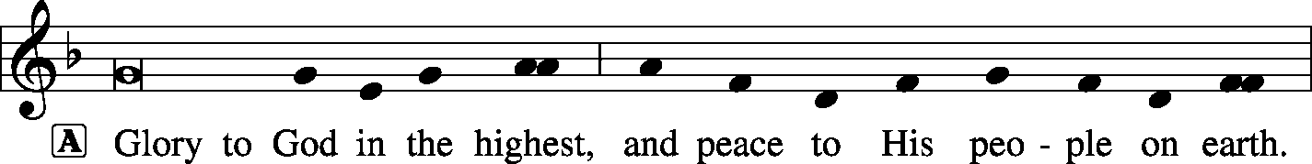
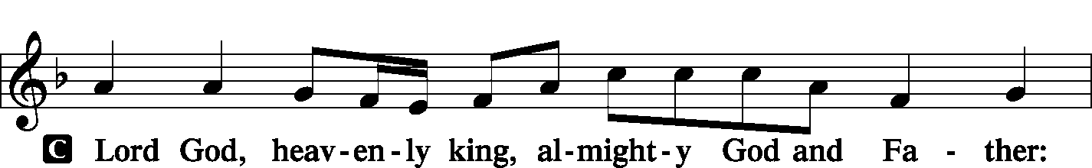
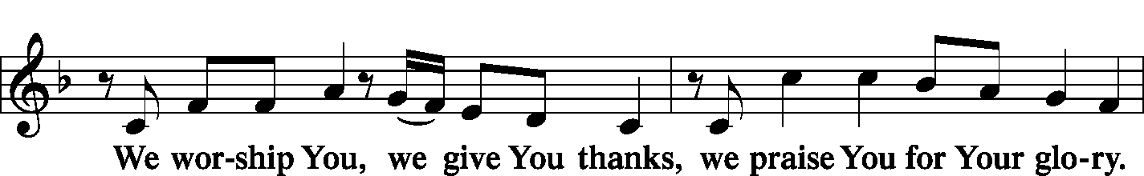
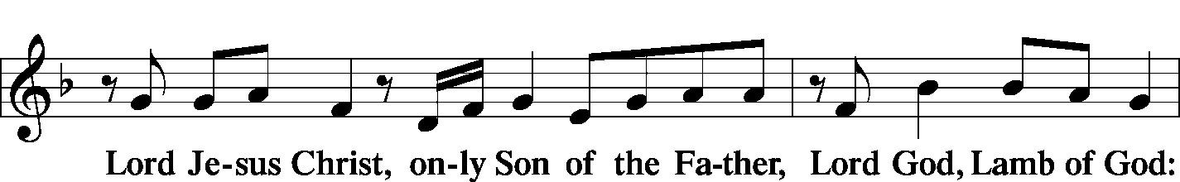
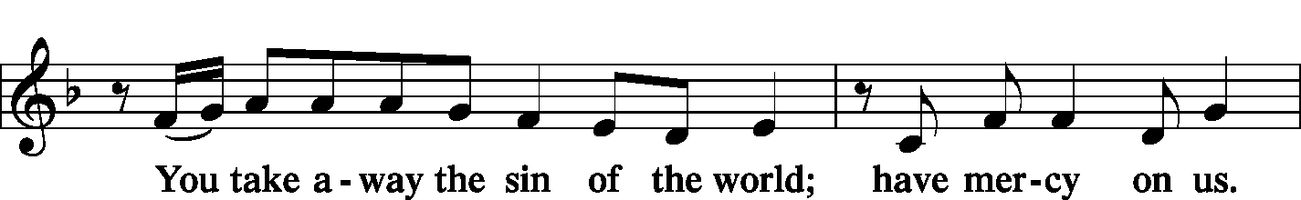
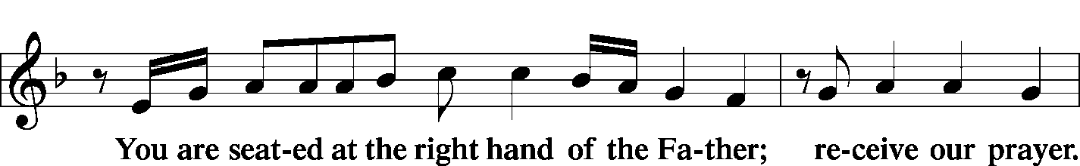
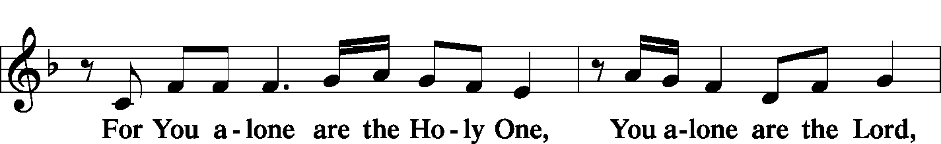
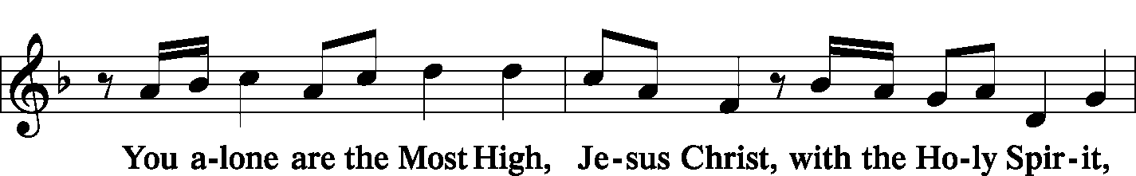
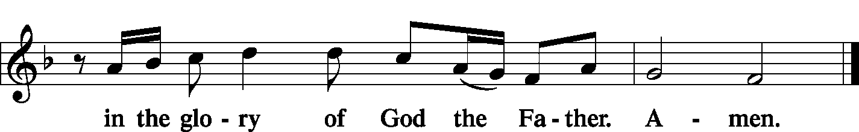

Salutation and Collect of the Day 2 Timothy 4: 22
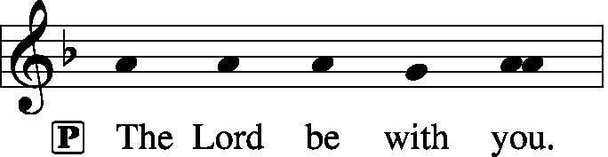
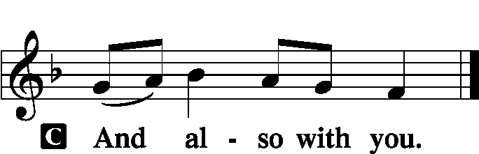

P Let us pray.
O God, on this day You once taught the hearts of Your faithful people by sending them the light of Your Holy Spirit. Grant us in our day by the same Spirit to have a right understanding in all things and evermore to rejoice in His holy consolation; through Jesus Christ, Your Son, our Lord, who lives and reigns with You and the Holy Spirit, one God, now and forever.

Sit

Old Testament Reading: Genesis 11:1–9
Now the whole earth had one language and the same words. And as people migrated from the east, they found a plain in the land of Shinar and settled there. And they said to one another, “Come, let us make bricks, and burn them thoroughly.” And they had brick for stone, and bitumen for mortar. Then they said, “Come, let us build ourselves a city and a tower with its top in the heavens, and let us make a name for ourselves, lest we be dispersed over the face of the whole earth.” And the Lord came down to see the city and the tower, which the children of man had built. And the Lord said, “Behold, they are one people, and they have all one language, and this is only the beginning of what they will do. And nothing that they propose to do will now be impossible for them. Come, let us go down and there confuse their language, so that they may not understand one another’s speech.” So the Lord dispersed them from there over the face of all the earth, and they left off building the city. Therefore its name was called Babel, because there the Lord confused the language of all the earth. And from there the Lord dispersed them over the face of all the earth.

P This is the Word of the Lord.
C Thanks be to God.

Gradual: Eph. 4:8b, 11, 12b; 2:19a, c
When he ascended on high he led a host of captives,
and he gave gifts to men.
He gave the apostles, the prophets, the evangelists, the pastors and teachers,
for building up the body of Christ.
So then you are no longer strangers and aliens,
but members of the household of God.
The Second Reading: Acts 2:1–21
When the day of Pentecost arrived, they were all together in one place. And suddenly there came from heaven a sound like a mighty rushing wind, and it filled the entire house where they were sitting. And divided tongues as of fire appeared to them and rested on each one of them. And they were all filled with the Holy Spirit and began to speak in other tongues as the Spirit gave them utterance.
Now there were dwelling in Jerusalem Jews, devout men from every nation under heaven. And at this sound the multitude came together, and they were bewildered, because each one was hearing them speak in his own language. And they were amazed and astonished, saying, “Are not all these who are speaking Galileans? And how is it that we hear, each of us in his own native language? Parthians and Medes and Elamites and residents of Mesopotamia, Judea and Cappadocia, Pontus and Asia, Phrygia and Pamphylia, Egypt and the parts of Libya belonging to Cyrene, and visitors from Rome, both Jews and proselytes, Cretans and Arabians—we hear them telling in our own tongues the mighty works of God.” And all were amazed and perplexed, saying to one another, “What does this mean?” But others mocking said, “They are filled with new wine.”
But Peter, standing with the eleven, lifted up his voice and addressed them, “Men of Judea and all who dwell in Jerusalem, let this be known to you, and give ear to my words. For these men are not drunk, as you suppose, since it is only the third hour of the day. But this is what was uttered through the prophet Joel:
“‘And in the last days it shall be, God declares,
that I will pour out my Spirit on all flesh,
and your sons and your daughters shall prophesy,
and your young men shall see visions,
and your old men shall dream dreams;
even on my male servants and female servants
in those days I will pour out my Spirit, and they shall prophesy.
And I will show wonders in the heavens above
and signs on the earth below,
blood, and fire, and vapor of smoke;
the sun shall be turned to darkness
and the moon to blood,
before the day of the Lord comes, the great and magnificent day.
And it shall come to pass that everyone who calls upon the name of the Lord shall be saved.’”
P This is the Word of the Lord.
C Thanks be to God.

Stand

Verse of the Day: Ps. 104:30; Liturgical Text
Alleluia. When you send forth your Spirit, they are created, and you renew the face of the ground. Alleluia. Come, Holy Spirit, fill the hearts of the faithful, and kindle in them the fire of your love. Alleluia.

Common Alleluia
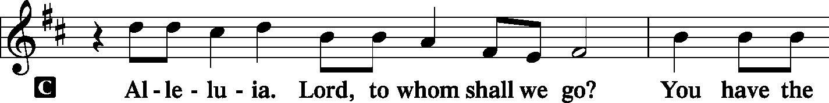
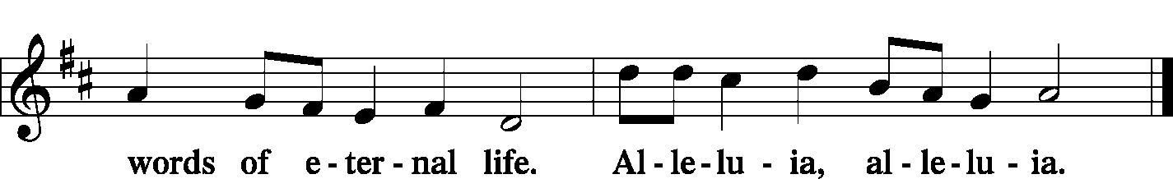

Holy Gospel: John 14:23–31
P The Holy Gospel according to St. John, the fourteenth chapter.

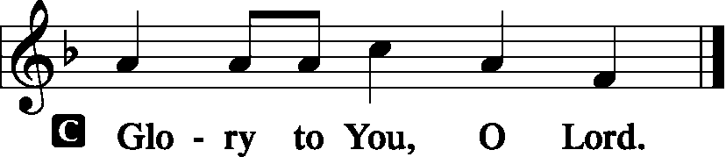

Jesus answered him, “If anyone loves me, he will keep my word, and my Father will love him, and we will come to him and make our home with him. Whoever does not love me does not keep my words. And the word that you hear is not mine but the Father’s who sent me.
“These things I have spoken to you while I am still with you. But the Helper, the Holy Spirit, whom the Father will send in my name, he will teach you all things and bring to your remembrance all that I have said to you. Peace I leave with you; my peace I give to you. Not as the world gives do I give to you. Let not your hearts be troubled, neither let them be afraid. You heard me say to you, ‘I am going away, and I will come to you.’ If you loved me, you would have rejoiced, because I am going to the Father, for the Father is greater than I. And now I have told you before it takes place, so that when it does take place you may believe. I will no longer talk much with you, for the ruler of this world is coming. He has no claim on me, but I do as the Father has commanded me, so that the world may know that I love the Father. Rise, let us go from here.

P This is the Gospel of the Lord.
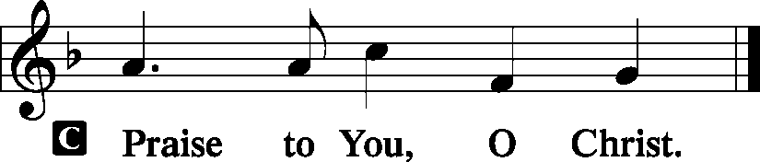

Nicene Creed
C I believe in one God,
the Father Almighty,
maker of heaven and earth
and of all things visible and invisible.
And in one Lord Jesus Christ,
the only-begotten Son of God,
begotten of His Father before all worlds,
God of God, Light of Light,
very God of very God,
begotten, not made,
being of one substance with the Father,
by whom all things were made;
who for us men and for our salvation came down from heaven
and was incarnate by the Holy Spirit of the virgin Mary
and was made man;
and was crucified also for us under Pontius Pilate.
He suffered and was buried.
And the third day He rose again according to the Scriptures
and ascended into heaven
and sits at the right hand of the Father.
And He will come again with glory to judge both the living and the dead,
whose kingdom will have no end.
And I believe in the Holy Spirit,
the Lord and giver of life,
who proceeds from the Father and the Son,
who with the Father and the Son together is worshiped and glorified,
who spoke by the prophets.
And I believe in one holy Christian and apostolic Church,
I acknowledge one Baptism for the remission of sins,
and I look for the resurrection of the dead
and the life T of the world to come. Amen.
Sit

Hymn of the Day: LSB #500 “Creator Spirit, by Whose Aid”

Sermon
Stand
Prayer of the Church [Timothy 2: 1-4]

Sit

Offertory Psalm 116: 12-13, 17-19
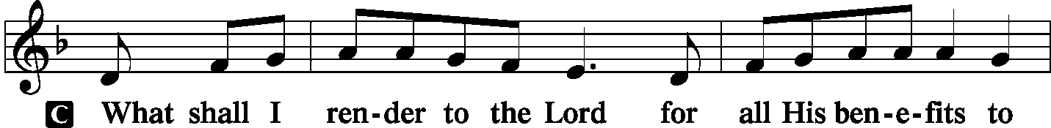
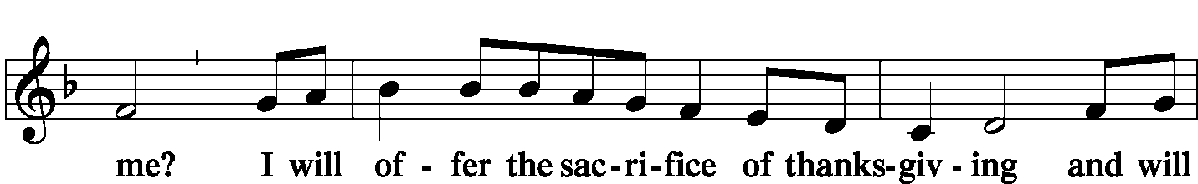
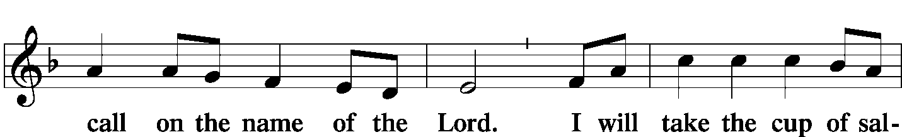
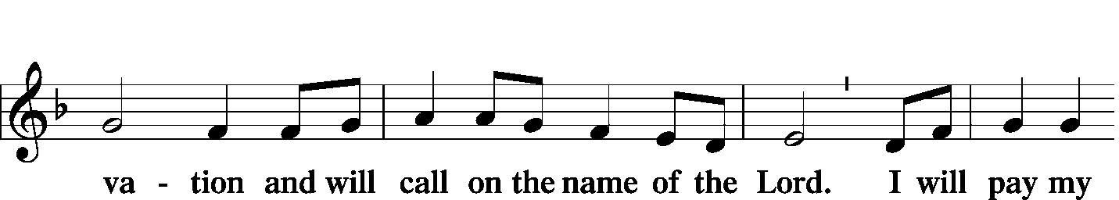
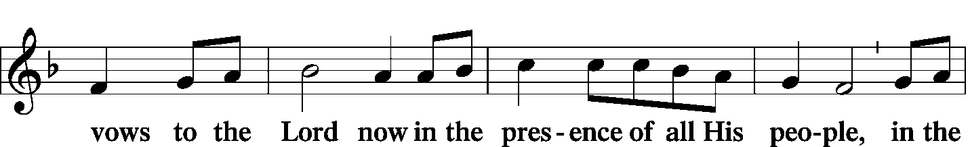
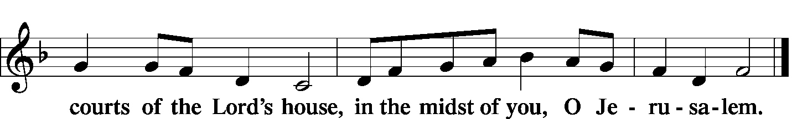

Offering/Offering Hymn: LSB #497 “Come, Holy Ghost, God and Lord”
Stand
SERVICE OF THE SACRAMENT
Preface
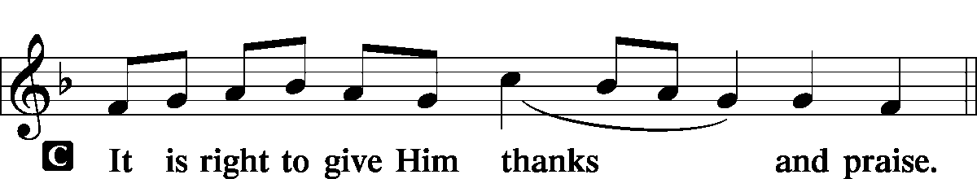

P It is truly meet, right, and salutary … evermore praising You and saying:

Sanctus
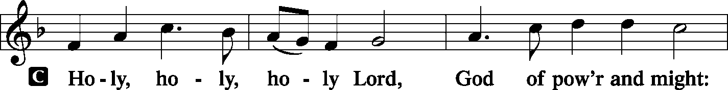
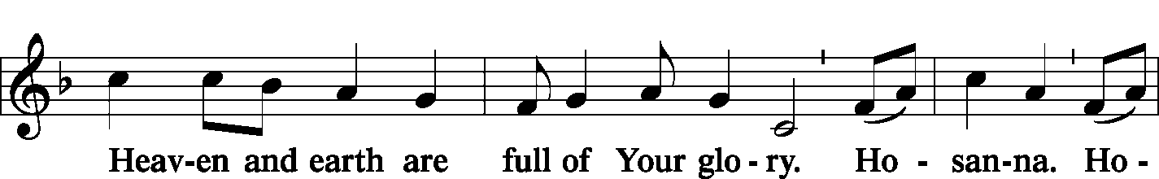
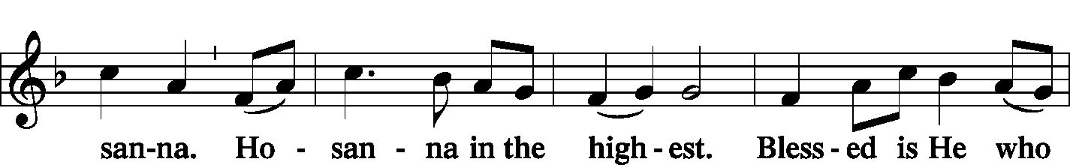
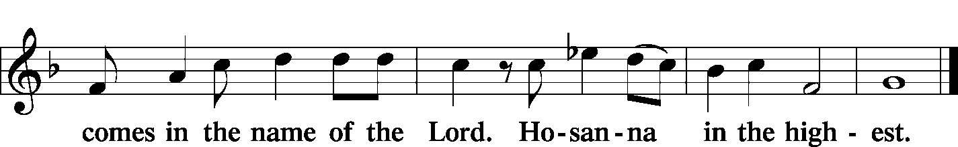

Lord's Prayer Matthew 6: 9-13
P Lord, remember us in Your kingdom and teach us to pray:
C Our Father who art in heaven,
hallowed be Thy name,
Thy kingdom come,
Thy will be done on earth as it is in heaven;
give us this day our daily bread;
and forgive us our trespasses as we forgive those who trespass against us;
and lead us not into temptation,
but deliver us from evil.
For Thine is the kingdom and the power and the glory forever and ever. Amen.

The Words of Our Lord Matthew 26: 26-28; Mark 14: 22-24
Luke 22: 19-20; 1 Corinthians 11: 23-25
P Our Lord Jesus Christ, on the night when He was betrayed, took bread, and when He had given thanks, He broke it and gave it to the disciples and said: “Take, eat; this is My T body, which is given for you. This do in remembrance of Me.”

P In the same way also He took the cup after supper, and when He had given thanks, He gave it to them, saying: “Drink of it, all of you; this cup is the new testament in My T blood, which is shed for you for the forgiveness of sins. This do, as often as you drink it, in remembrance of Me.”

Pax Domini John 20: 19
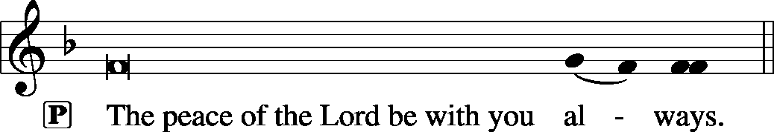

Agnus Dei John 1: 29
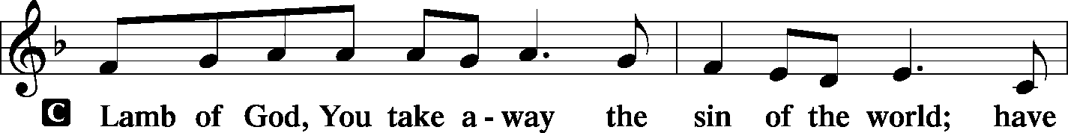
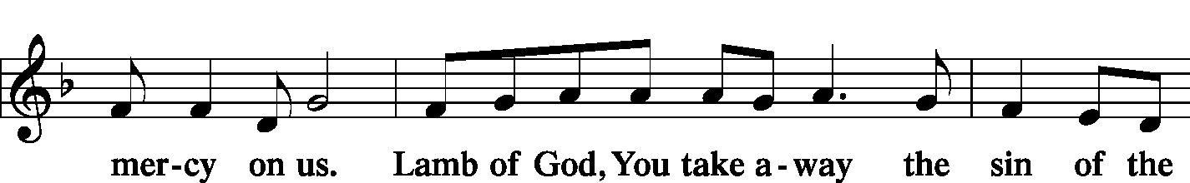
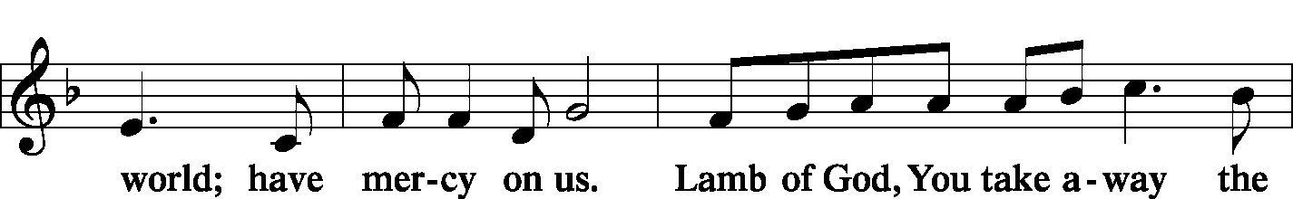
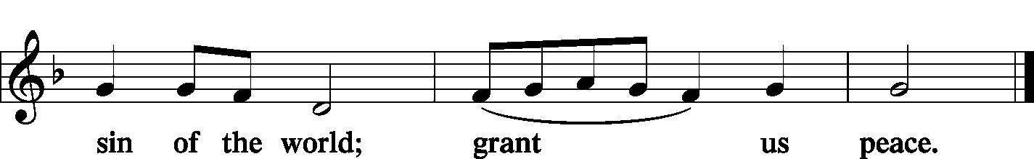

Sit

Distribution
The pastor and those who assist him receive the body and blood of Christ first and then distribute them to those who come to receive, saying:

Take, eat; this is the true body of our Lord and Savior Jesus Christ, given into death for your sins.
Amen.

Take, drink; this is the true blood of our Lord and Savior Jesus Christ, shed for the forgiveness of your sins.
Amen.
In dismissing the communicants, the following is said:
P The body and blood of our Lord Jesus Christ strengthen and preserve you in body and soul to life everlasting. Depart T in peace.
C Amen.

Distribution Hymn: LSB p. 155 “This is the Feast”
Distribution Hymn: LSB #618 ”I Come, O Savior, to Thy Table”
Stand
Nunc Dimittis Luke 2: 29-32
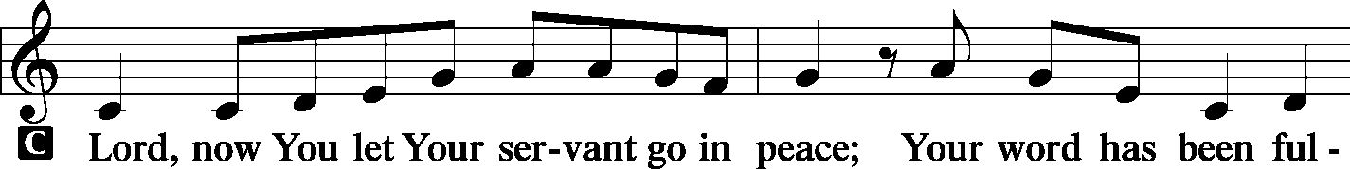
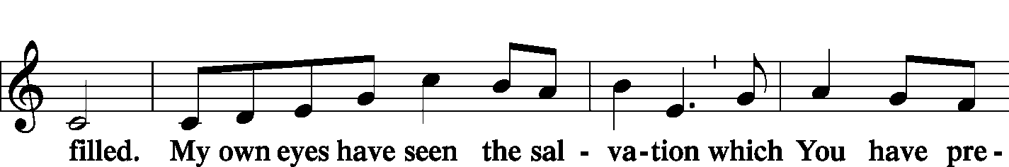
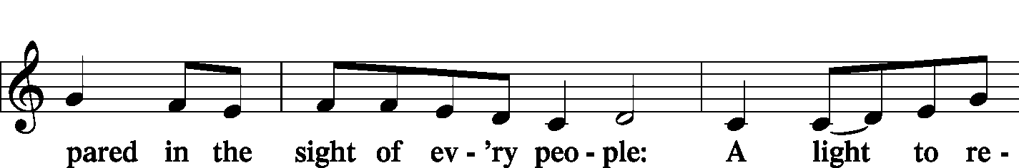
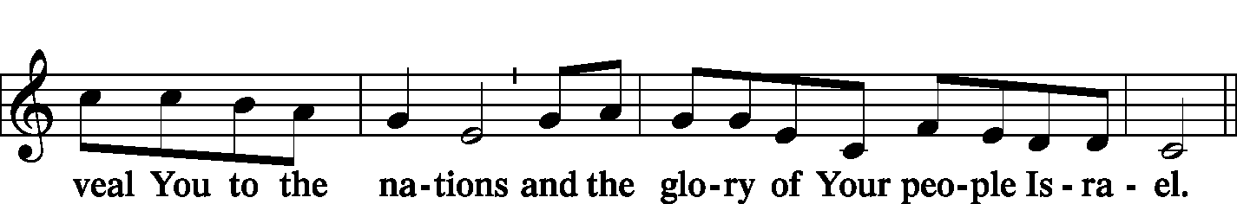
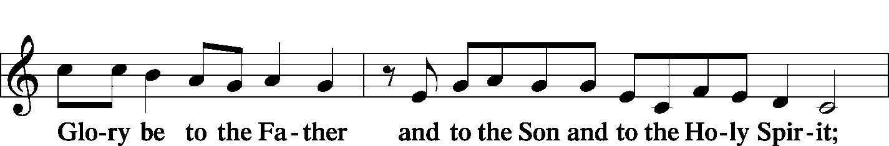
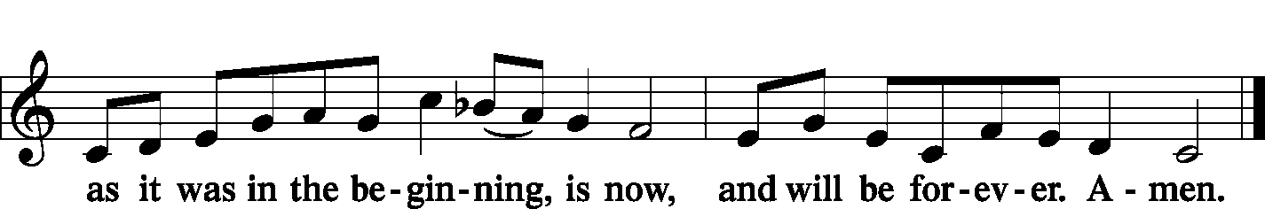

Post-Communion Collect Let us pray.
P We give thanks to You, almighty God, that You have refreshed us through this salutary gift, and we implore You that of Your mercy You would strengthen us through the same in faith toward You and fervent love toward one another; through Jesus Christ, Your Son, our Lord, who lives and reigns with You and the Holy Spirit, one God, now and forever.
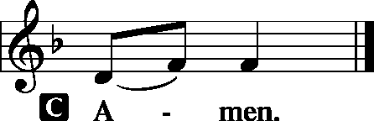

Benediction Numbers 6: 24-26

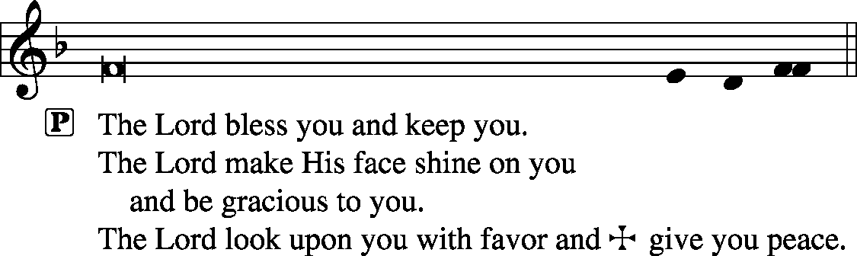

Closing Hymn: LSB #496 “Holy Spirit, Light Divine”
Silent prayer after worship: Help me, O Lord, to go forth from Your house with Your message of salvation in my heart and on my lips. Make me bold to speak to others about Your love in Christ. In Jesus’ name. Amen.

Acknowledgments: Divine Service, Setting One from Lutheran Service Book Unless otherwise indicated, all scripture quotations are from The Holy Bible, English Standard Version, copyright © 2001 by Crossway Bibles, a division of Good News Publishers. Used by permission. All rights reserved. Created by Lutheran Service Builder © 2006 Concordia Publishing House. CCLI License #3029-446

Attendance: Saturday, June 1, and Sunday, June 2, 2019………….………50
Please sign the Friendship Book and give your sheet to an usher after the offering.

Jim and Kathy McGowan would like to invite the members of Sts. Peter and Paul to Madi's graduation celebration! It will take place on Friday, June 21st from 5 to 9 at The Refuge located at 1155 Churchill-Hubbard Rd. Youngstown, Ohio 44505.

Thank You for Serving in June:
Today’s Greeters: Barry & Chris Nelson. Assisting Elders: Ralph Dorman & John Dyll. Ushers: Bob Sulek, Hugh Owen, Cheryl Fedele, Jesse Riffle, & Ralph Dorman (alternate). Altarware: Eileen Burns & Ruth Meszaros.
June Greeters: 16~Ralph Dorman & Diane Riefstahl; 23~John Dyll & Mark Gabriel; 30~Rev. Ed & Irene Kucera

Word of Hope: 1-888-217-8679
The only 24/7 CONFIDENTIAL Hotline that is distinctly Lutheran, bringing healing found in Christ, to those whose hearts have been broken by abortion.

In Loving Memory of my dear friend Cookie, who was like a sister to me: Patty Parker (Major Repair).
In Loving Memory of Patricia Brandes: Diane Riefstahl (Local Mission).
In Loving Memory of Sophia Mihm: Jeff & Stacy Brandes (Missions), Mark Gabriel, Clara Krivosh (Major Repair), Diane Riefstahl (Local Mission).
In Loving Memory of Suzie Dudash: John Zachar (Missions).
In Loving Memory of Norma Ferringer: Ruth Meszaros (Major Repair), John Zachar (Missions).
In Loving Memory of John Daris’s sister, Clara Wojtanowski: John Zachar (Food Pantry).
In Loving Memory of Viola Sakony’s sister, Caroline Swartzbeck: John Zachar (Food Pantry).
In Loving Memory of Gene Roberts: Patty Parker (Major Repair), John Zachar (Food Pantry).

SCHEDULE FOR TODAY THROUGH JUNE 16th:
:

:

Today, following Worship, Downstairs………………………Coffee & Donuts Fellowship
7 pm, Downstairs….…………….…………………..………………….……...……AA Meeting
Monday, 4:30 pm, Offices………………………………………………….…..New Members’ Class
Thursday, 9 am, Downstairs……………………………………………….……………….Food Pantry
Saturday, 5 pm, Chapel…………………….……………………….....…...Saturday Divine Service
Next Sunday, 8:45 am, Downstairs………………………………………………..………Bible Study
10 am, Sanctuary…........................................................................Divine Service
7 pm, Downstairs…………………………………………..………………….....…AA Meeting

Please join us Downstairs following worship for
Coffee & Donuts Fellowship.

As of June 1, 2019, the balance in the Major Repair Fund was $15,814.34.
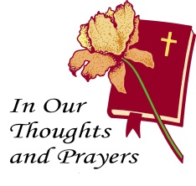
Sincere sympathy is expressed to the friends and families of Patricia Brandes (Jeff’s mother), who passed away May 29th; Gene Roberts (Marion’s husband), who passed away May 30th; and Sophia Mihm (Lisa Jelinek’s mother and Max’s grandmother), who passed away May 31st. May those who mourn their passings find comfort in the knowledge of our Lord’s promises.

Bible Memory Verses: For the week of June 9th:
For Children: Not by might, nor by power, but by my Spirit, says the Lord of hosts.
Zech. 4:6
For Adults: For this light momentary affliction is preparing for us an eternal weight of glory beyond all comparison, as we look not to the things that are seen but to the things that are unseen. For the things that are seen are transient, but the things that are unseen are eternal. 2 Corinthians 4:17-18

This morning is
“Stock the Food Pantry” Sunday.
Your contributions to this Community Outreach program are greatly appreciated. You may put financial contributions in a pew envelope and place them in the offering plate.

Our Stewardship of Treasures for the Lord:
In order to do the Lord’s work, we need $2,882.02* each week to meet our 2019 budget for general purposes and $38.46 for missions.
Saturday, June 1 and Sunday, June 2, 2019:
General Offering: $2,705.77 Behind this week*: -$176.25
SELC Missions: $90.00 Ahead this week: +$51.54
Local Missions: $100.00
Preschool Tuition: $0.00
Other Offerings: $275.00
*Includes preschool tuition.

Remember the following in Prayer…
~The Hurting and Healing: The families and friends of Patricia Brandes (Jeff’s mother), who passed away May 29th; and Gene Roberts (Marion’s husband), who passed away May 30th, and Sophia Mihm (Lisa Jelinek’s mother and Max’s grandmother). Also, Tony³, Lois Bortner^{CA}, Richard Brandes², Eileen Burns², Beverly Chlpka³, Anne Colt⁴, Kim³, Tim Dudash³, John Dyll², Jennifer Hilliard²,Anson Holcroft³, Betty Knauff^{CA}, Regis Knauff³, Jess Lavoie¹, Paul Lucas^{CA}, Barry Nelson³, David Nelson⁴,Tom Mulligan^{CA}, Iona Oltman^{CA}, Hugh Owen³, Rudy Pinal^{CA}, Ashley & Dale Weaver and their baby³, and Angela Weser^{CA}.
~Our Homebound: Helen Bender, Dan Davis, Edna Krajci, Mary Ann Krajci, Marion Roberts, Barbara Vasconi, and Joanne Wolfe.
~Celebrating: Birthdays: Jonathan Baisch (06.09), Lisa Jelinek (06.09), and Isaiah Deal (06.11). Anniversaries: Rev. Edward & Irene Kucera (06.09) and Ed & Millie Zachar (06.12).
~Serving in the Military: Clayton Drnek, Curtis Sinewe, and Joshua Solyan.
~Community & World Needs: Victims of violence and terrorism; those suffering from loss and dislocation because weather disasters; those suffering from addiction and their families; Local, State, and National Government Leaders; Safety for all Police Officers, Firefighters, & First Responders; the unemployed; our Second Quarter Local Mission: Sts. Peter & Paul’s Third Annual Community Day.
*CA represents cancer; number after other names represents weeks on the prayer list. After 4 weeks names may be resubmitted. This helps us to remember people’s specific needs and reminds us that God is providing healing as people get better and no longer need our prayers. Please submit prayer requests in writing to the church office.
Please keep those listed above in your prayers.

Here to serve:
Pastor: Rev. Jacob Deal pastordeal@saintspeterandpaul.net
Church Phone Number: 724-347-3620 Secretary: Diane Riefstahl
Pastor: Opt 2; Church Office: Opt 3; Preschool: Opt. 4
Website: www.saintspeterandpaul.net
E-mail : church@saintspeterandpaul.net
Food Pantry ~ John Dyll: 724-347-1779
AA Contact ~Steve: 724-813-2358
Organist: Carrie Yasnowski
Choir Director: Chris Nelson
Congregation President: Jeff Brandes

