Sts. Peter & Paul
Evangelical Lutheran Church
Lutheran Church-Missouri Synod
Founded-1917
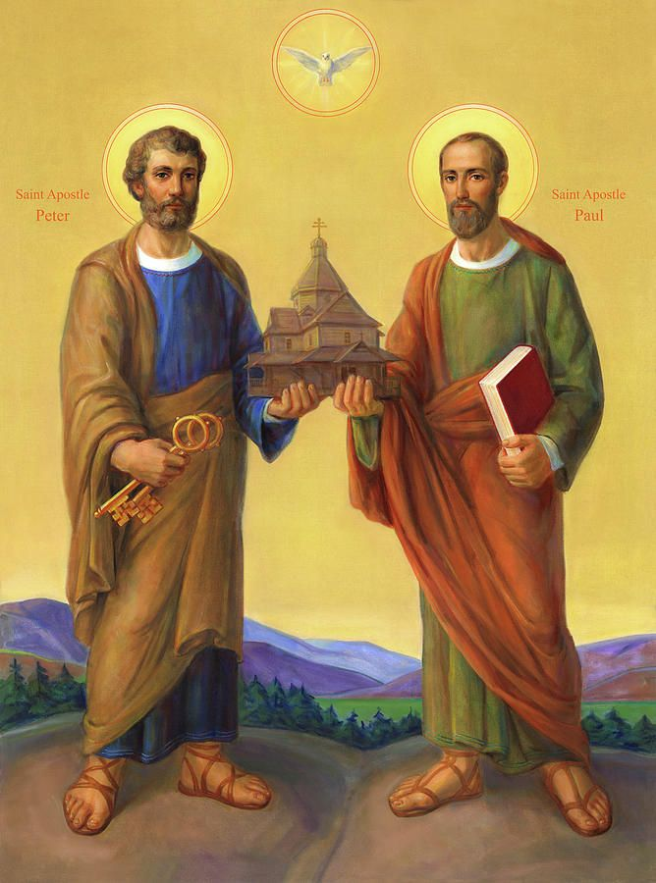

June 29, 2023

699 Stambaugh Ave.
Sharon, Pennsylvania 16146

“I was glad when they said to me,
Let us go to the house of the LORD!”
Psalm 122:1
Sts. Peter & Paul Evangelical Lutheran Church, LC-MS
FESTIVAL OF SAINT PETER & SAINT PAUL
June 29, 2023

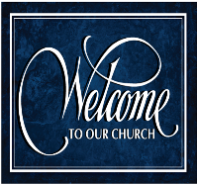
A special welcome to our guests this day! If you would like more information about The Lutheran Church - Missouri Synod, or this congregation, please speak with Pastor Deal or an Elder after the service.
Members & Guests: Don’t be embarrassed if your children make noise during the worship service, all children do. We encourage families to worship together but, if you feel the need, there are pews in the rear of the Church which are reserved for young families on both sides of the sanctuary. There is also a quiet room available to you during our service which is located down the hallway past the offices on the right side of the church as well as a children’s area in the Fellowship Hall where you are able to follow along with the service.

Today’s service includes the Sacrament of Holy Communion. If during this past year, you have not worshipped with us and been communed, we respectfully ask that you do not partake of this sacrament this day before first speaking with Pastor Deal.
If visiting from a sister congregation of the LC-MS and are in good standing, please inform Pastor Deal of your desire to commune prior to the service.
If wishing to receive a blessing during communion, please approach with your arms crossed.

CONTACT INFORMATION
Pastor Deal: pastordeal@saintspeterandpaul.net or 724-347-3620 (opt. 2)
Church Office: church@saintspeterandpaul.net or 724-347-3620 (opt. 3)
Secretary’s Office will be open Monday and Thursday (8:30-4:30) this week.

Silent prayer before worship: Almighty God, by Your mercy You made me a new creation in Christ Jesus and You claim me as Your own dear child. Cause the Holy Spirit to work in my heart so that I may live my life for You. In Jesus’ name. Amen.
Confession and Absolution

Opening Hymn: LSB #909 “Christ Is Made the Sure Foundation”

The sign of the cross may be made by all in remembrance of their Baptism.

Invocation
P In the name of the Father and of the T Son and of the Holy Spirit.
C Amen.

Exhortation Hebrews 10:22; Psalm 124:8; Psalm 32:5
P Beloved in the Lord! Let us draw near with a true heart and confess our sins unto God our Father, beseeching Him in the name of our Lord Jesus Christ to grant us forgiveness.

P Our help is in the name of the Lord,
C who made heaven and earth.
P I said, I will confess my transgressions unto the Lord,
C and You forgave the iniquity of my sin.

Silence for reflection on God’s Word and for self-examination.

Confession of Sins
P O almighty God, merciful Father,
C I, a poor, miserable sinner, confess unto You all my sins and iniquities with which I have ever offended You and justly deserved Your temporal and eternal punishment. But I am heartily sorry for them and sincerely repent of them, and I pray You of Your boundless mercy and for the sake of the holy, innocent, bitter sufferings and death of Your beloved Son, Jesus Christ, to be gracious and merciful to me, a poor, sinful being.

Absolution [John 20:19–23]
P Upon this your confession, I, by virtue of my office, as a called and ordained servant of the Word, announce the grace of God unto all of you, and in the stead and by the command of my Lord Jesus Christ I forgive you all your sins in the name of the Father and of the T Son and of the Holy Spirit.
C Amen.
Service of the Word
Introit Psalm 89:1, 5, 15–16; antiphon: Psalm 119:46
I will speak of your testimonies before kings, | [O Lord,]*
and shall not be | put to shame.
I will sing of the steadfast love of the Lord, for- | ever;*
with my mouth I will make known your faithfulness to all gener- | ations.
Let the heavens praise your wonders, | O Lord,*
your faithfulness in the assembly of the | holy ones!
Blessèd are the people who know the | festal shout,*
who walk, O Lord, in the light | of your face,
who exult in your name | all the day*
and in your righteousness are ex- | alted.
I will speak of your testimonies before kings, | [O Lord,]*
and shall not be | put to shame.

Gloria Patri
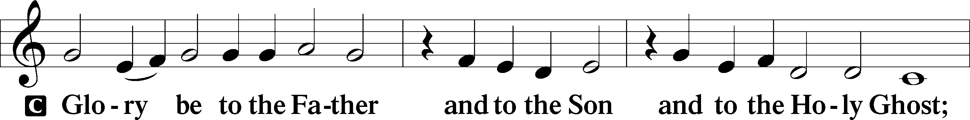
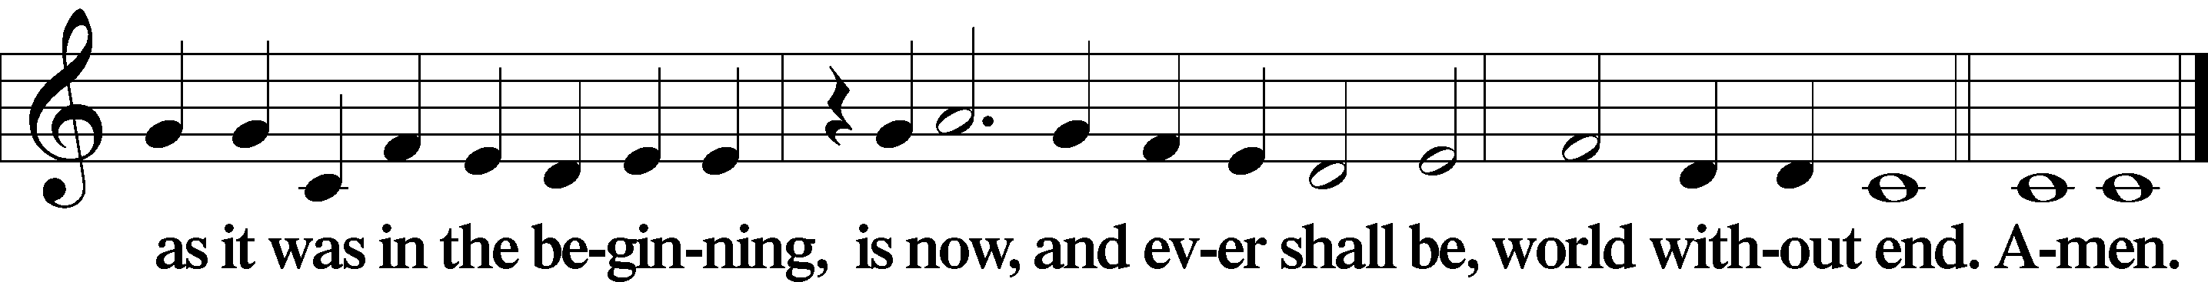

Kyrie Mark 10:47
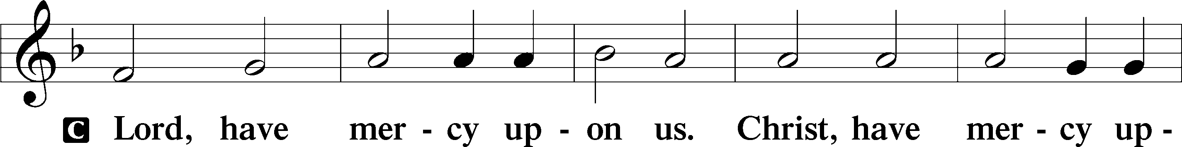
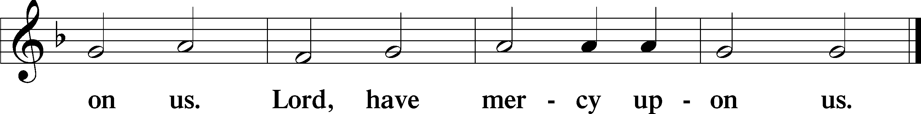

Gloria in Excelsis Luke 2:14; John 1:29
P Glory be to God on high:
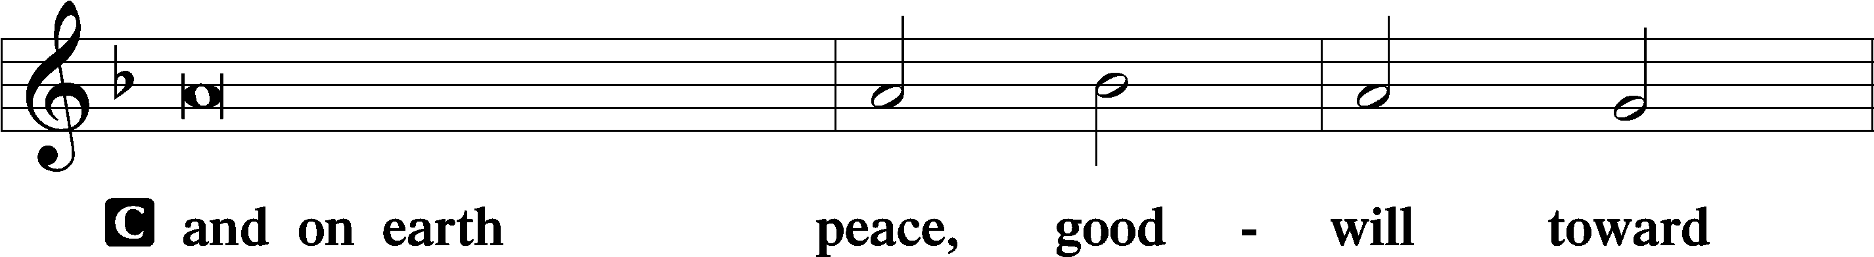
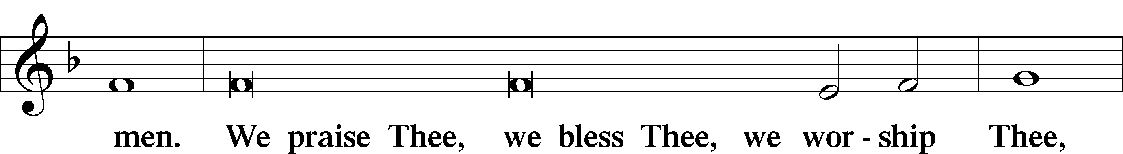
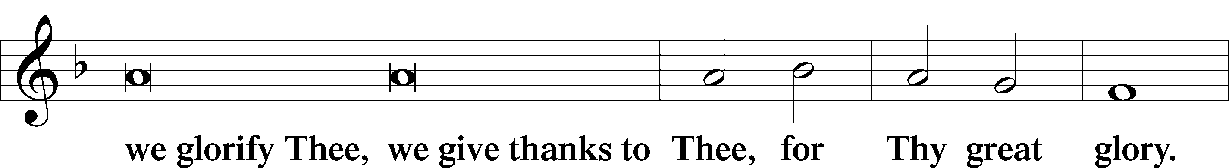
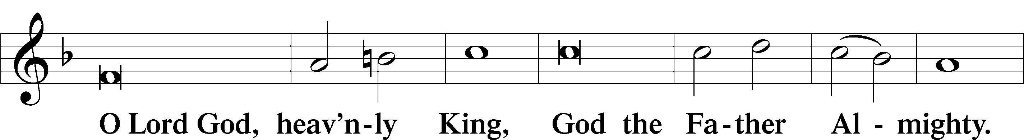
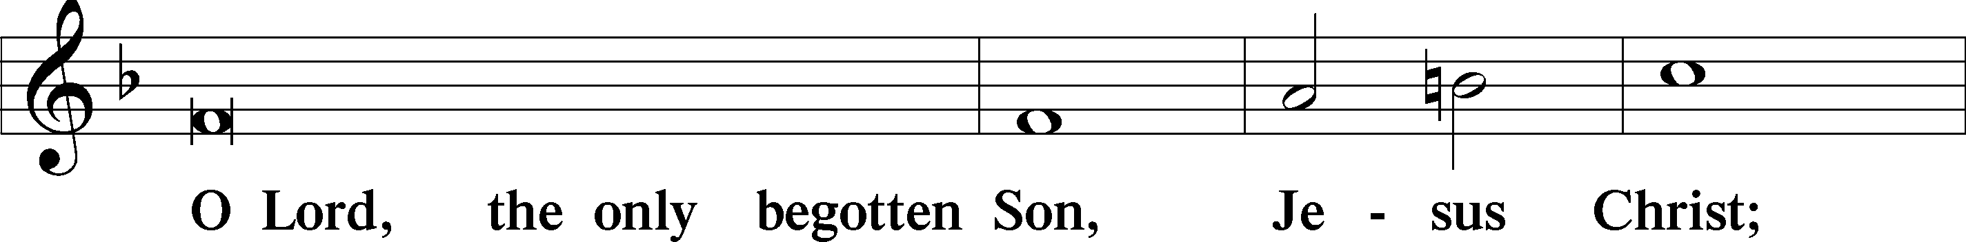
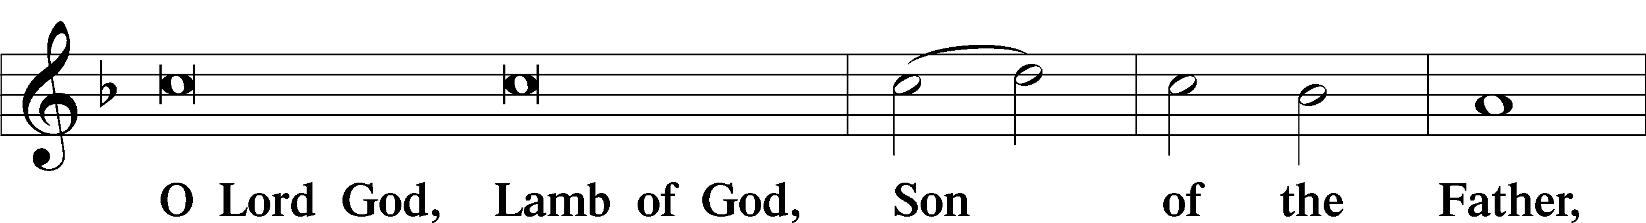
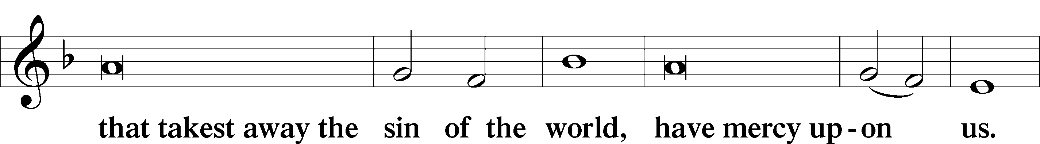
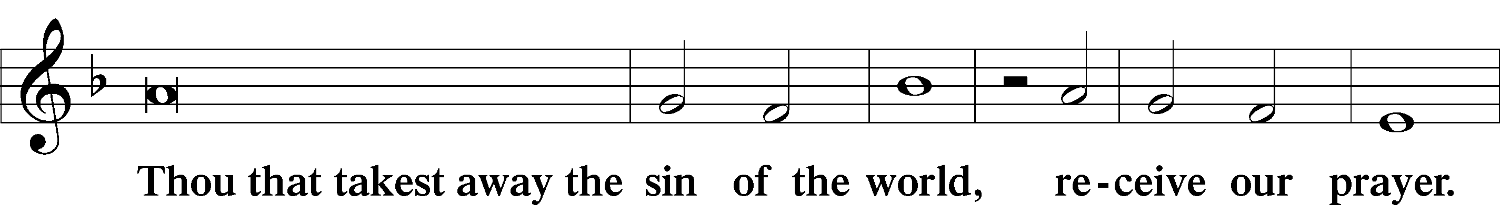
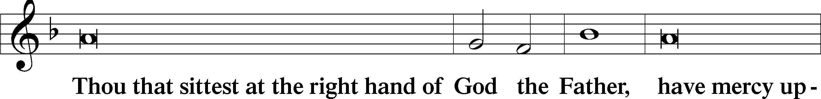
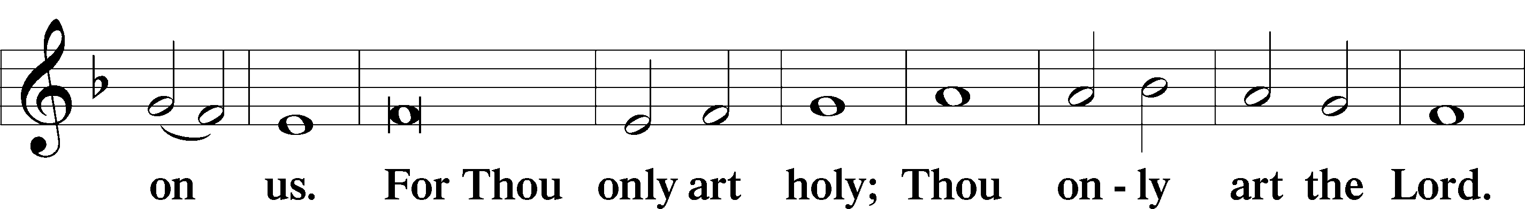
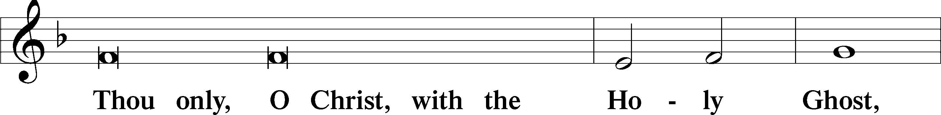
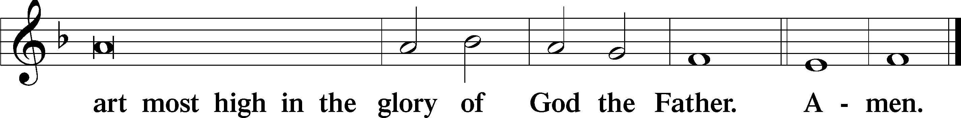

Salutation and Collect of the Day: Festival of Saint Peter and Saint Paul
P The Lord be with you.
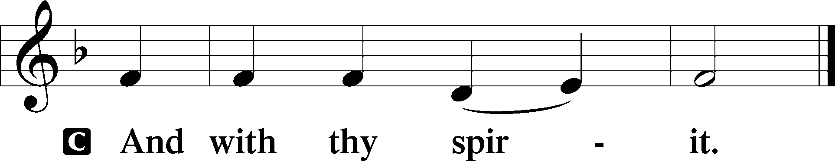

P Let us pray.
Merciful and eternal God, Your holy apostles Peter and Paul received grace and strength to lay down their lives for the sake of Your Son. Strengthen us by Your Holy Spirit that we may confess Your truth and at all times be ready to lay down our lives for Him who laid down His life for us, even Jesus Christ, our Lord, who lives and reigns with You and the Holy Spirit, one God, now and forever.
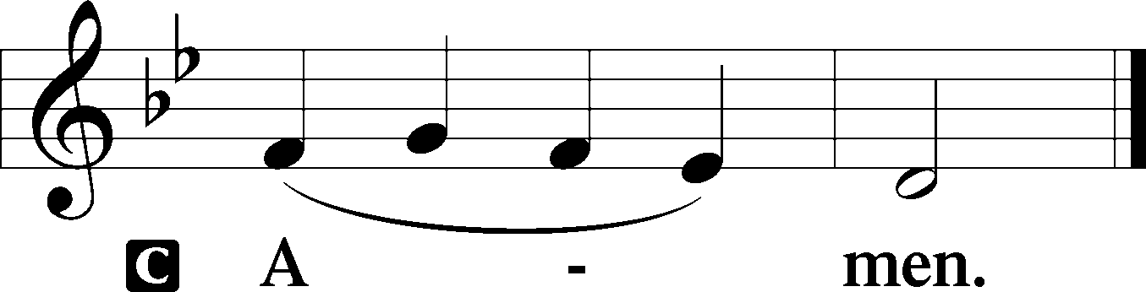
Sit

First Reading: Acts 12:1–11 (NKJV)
In those days: Herod the king stretched out his hand to harass some from the church. Then he killed James the brother of John with the sword. And because he saw that it pleased the Jews, he proceeded further to seize Peter also. Now it was during the Days of Unleavened Bread. So when he had arrested him, he put him in prison, and delivered him to four squads of soldiers to keep him, intending to bring him before the people after Passover. Peter was therefore kept in prison, but constant prayer was offered to God for him by the church. And when Herod was about to bring him out, that night Peter was sleeping, bound with two chains between two soldiers; and the guards before the door were keeping the prison. Now behold, an angel of the Lord stood by him, and a light shone in the prison; and he struck Peter on the side and raised him up, saying, “Arise quickly!” And his chains fell off his hands. Then the angel said to him, “Gird yourself and tie on your sandals”; and so he did. And he said to him, “Put on your garment and follow me.” So he went out and followed him, and did not know that what was done by the angel was real, but thought he was seeing a vision. When they were past the first and the second guard posts, they came to the iron gate that leads to the city, which opened to them of its own accord; and they went out and went down one street, and immediately the angel departed from him. And when Peter had come to himself, he said, “Now I know for certain that the Lord has sent His angel, and has delivered me from the hand of Herod and from all the expectation of the Jewish people.”

P This is the Word of the Lord.
C Thanks be to God.

Gradual Romans 10:15b, 18b; Isaiah 52:7b, alt.
How beautiful are the feet of those who preach the | good news,*
who publish peace and bring good news of sal- | vation.
Their voice has gone out to | all the earth,*
and their words to the ends | of the world.

Epistle: Galatians 2:1–10 (NKJV)
Brethren: After fourteen years I went up to Jerusalem with Barnabas, and also took Titus with me. And I went up by revelation, and communicated to them that gospel which I preach among the Gentiles, but privately to those who were of reputation, lest by any means I might run, or had run, in vain. Yet not even Titus who was with me, being a Greek, was compelled to be circumcised. And this occurred because of false brethren secretly brought in (who came in by stealth to spy out our liberty which we have in Christ Jesus, that they might bring us into bondage), to whom we did not yield submission even for an hour, that the truth of the gospel might continue with you. But from those who seemed to be something—whatever they were, it makes no difference to me; God shows personal favoritism to no man—for those who seemed to be something added nothing to me. But on the contrary, when they saw that the gospel for the uncircumcised had been committed to me, as the gospel for the circumcised was to Peter (for He who worked effectively in Peter for the apostleship to the circumcised also worked effectively in me toward the Gentiles), and when James, Cephas, and John, who seemed to be pillars, perceived the grace that had been given to me, they gave me and Barnabas the right hand of fellowship, that we should go to the Gentiles and they to the circumcised. They desired only that we should remember the poor, the very thing which I also was eager to do.

P This is the Word of the Lord.
C Thanks be to God.

Stand
Verse Matthew 16:18b
Alleluia. On this rock I will build my church, and the gates of hell shall not prevail against it. Alleluia.

Alleluia
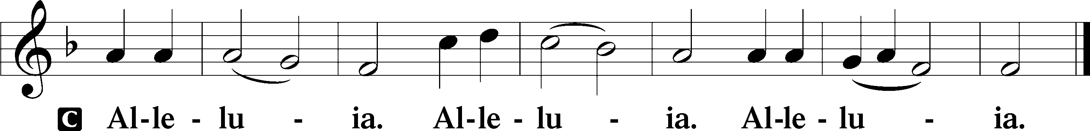

Holy Gospel: Matthew 16:13-19 (NKJV)
P The Holy Gospel according to St. Matthew, the sixteenth chapter.
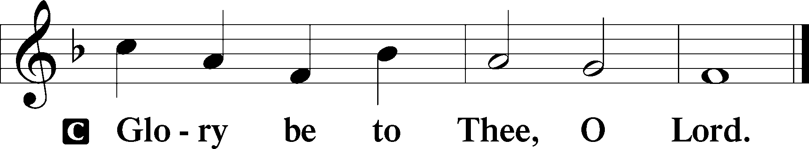
At that time: When Jesus came into the region of Caesarea Philippi, He asked His disciples, saying, “Who do men say that I, the Son of Man, am?” So they said, “Some say John the Baptist, some Elijah, and others Jeremiah or one of the prophets.” He said to them, “But who do you say that I am?” Simon Peter answered and said, “You are the Christ, the Son of the living God.” Jesus answered and said to him, “Blessed are you, Simon Bar-Jonah, for flesh and blood has not revealed this to you, but My Father who is in heaven. And I also say to you that you are Peter, and on this rock I will build My church, and the gates of Hades shall not prevail against it. And I will give you the keys of the kingdom of heaven, and whatever you bind on earth will be bound in heaven, and whatever you loose on earth will be loosed in heaven.”

P This is the Gospel of the Lord.
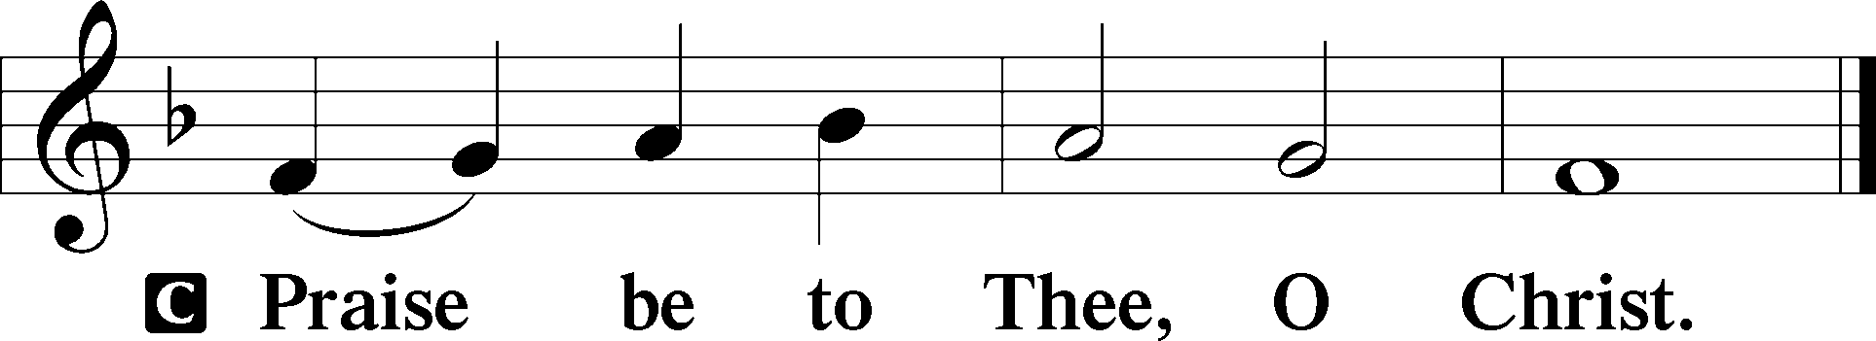

Nicene Creed
C I believe in one God,
the Father Almighty,
maker of heaven and earth
and of all things visible and invisible.

And in one Lord Jesus Christ,
the only-begotten Son of God,
begotten of His Father before all worlds,
God of God, Light of Light,
very God of very God,
begotten, not made,
being of one substance with the Father,
by whom all things were made;
who for us men and for our salvation came down from heaven
and was incarnate by the Holy Spirit of the virgin Mary
and was made man;
and was crucified also for us under Pontius Pilate.
He suffered and was buried.
And the third day He rose again according to the Scriptures
and ascended into heaven
and sits at the right hand of the Father.
And He will come again with glory to judge both the living and the dead,
whose kingdom will have no end.

And I believe in the Holy Spirit,
the Lord and giver of life,
who proceeds from the Father and the Son,
who with the Father and the Son together is worshiped and glorified,
who spoke by the prophets.
And I believe in one holy Christian and apostolic Church,
I acknowledge one Baptism for the remission of sins,
and I look for the resurrection of the dead
and the life T of the world to come. Amen.
Sit

Hymn of the Day: LSB #647 “Lord Jesus Christ, the Church’s Head”

Sermon

Stand
Prayer of the Church

Offertory Psalm 51:10–12
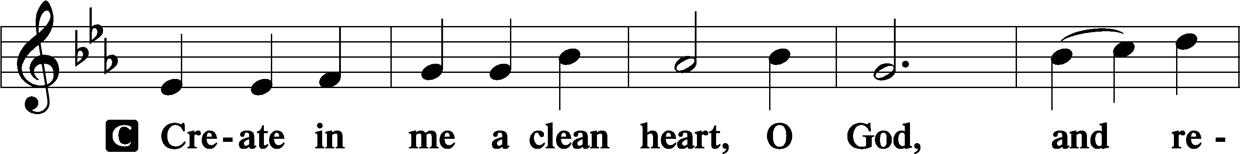
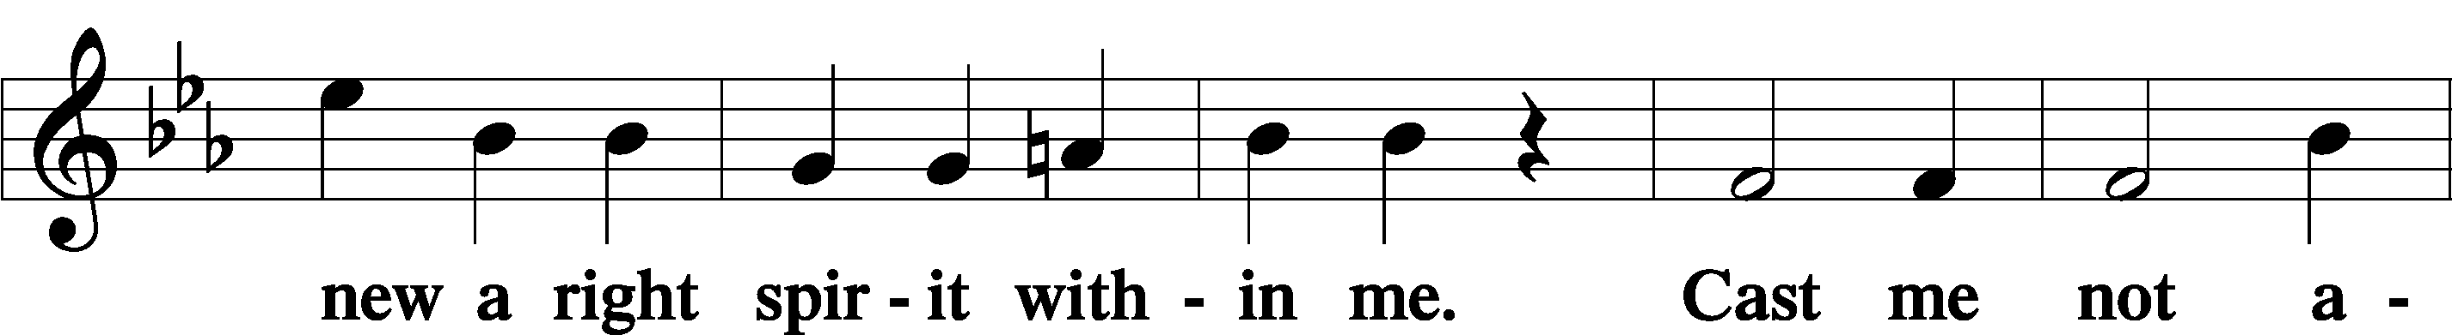
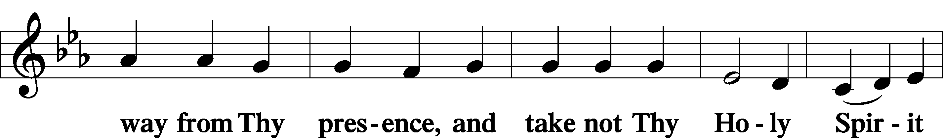
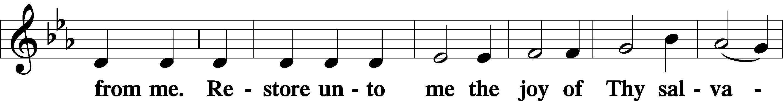
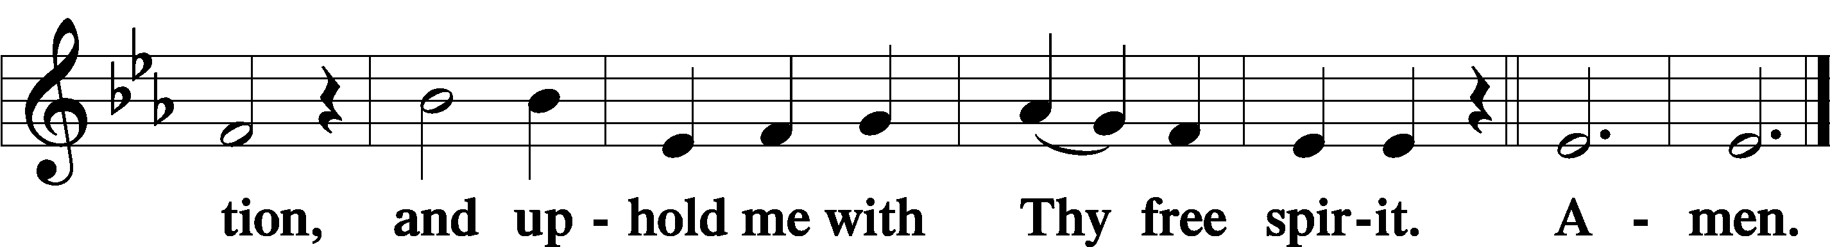
Sit

Preparatory Hymn: LSB #645 “Built on the Rock”

Stand
Service of the Sacrament

Preface 2 Timothy 4:22; Colossians 3:1 Psalm 136
P The Lord be with you.
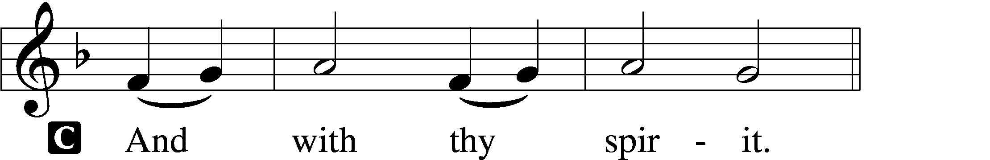

P Lift up your hearts.
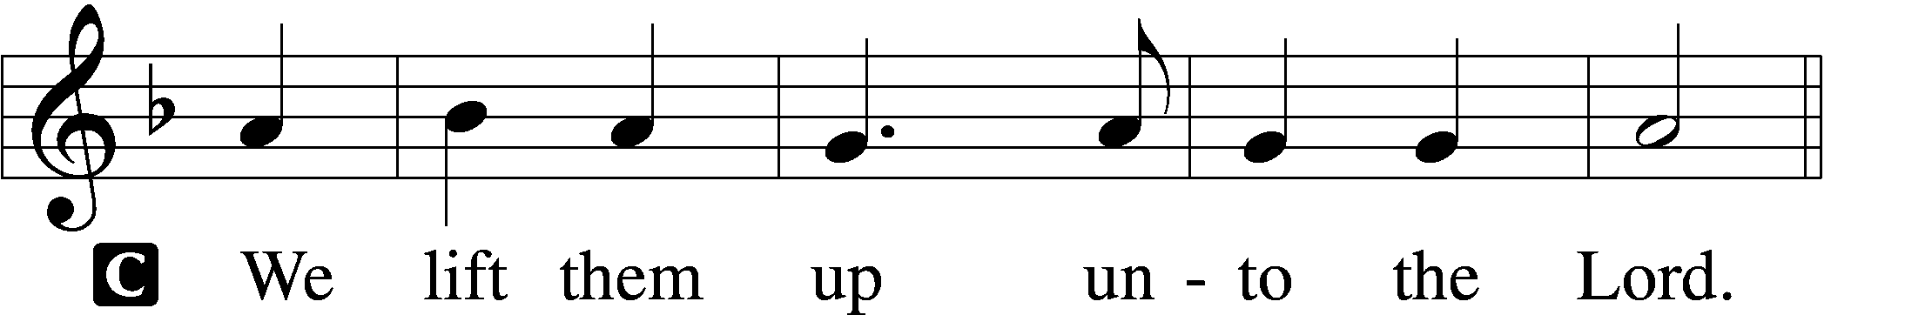
P Let us give thanks unto the Lord, our God.
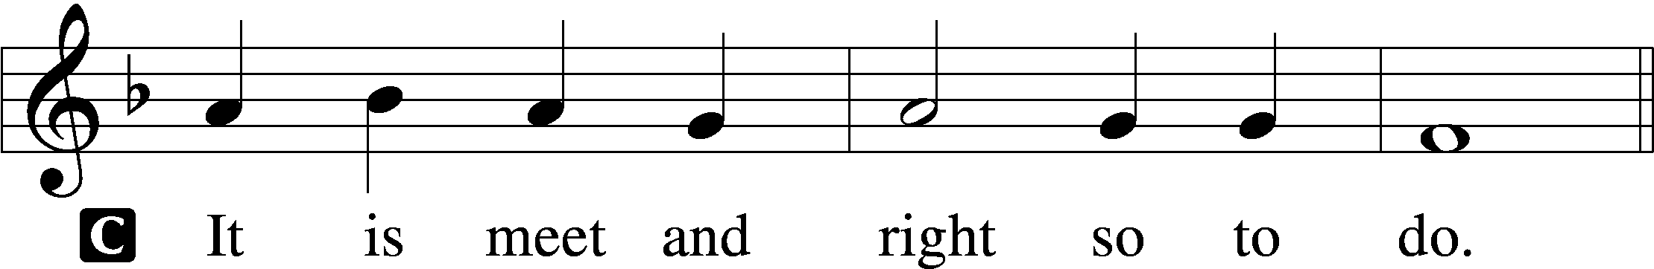

Proper Preface (Abbreviated) LSB 194
P It is truly meet, right, and salutary . . . evermore praising You and saying:

Sanctus Isaiah 6:3; Matthew 21:9
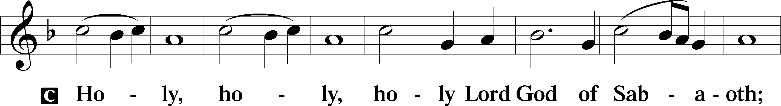
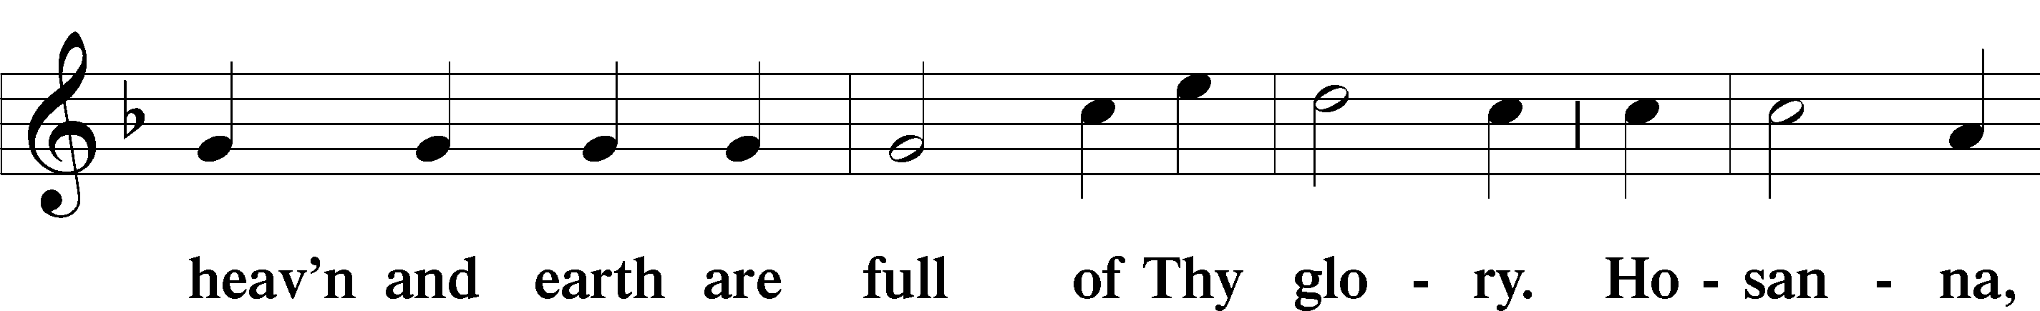
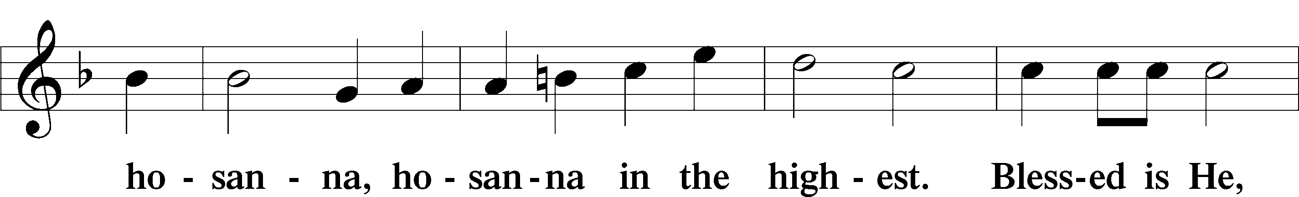
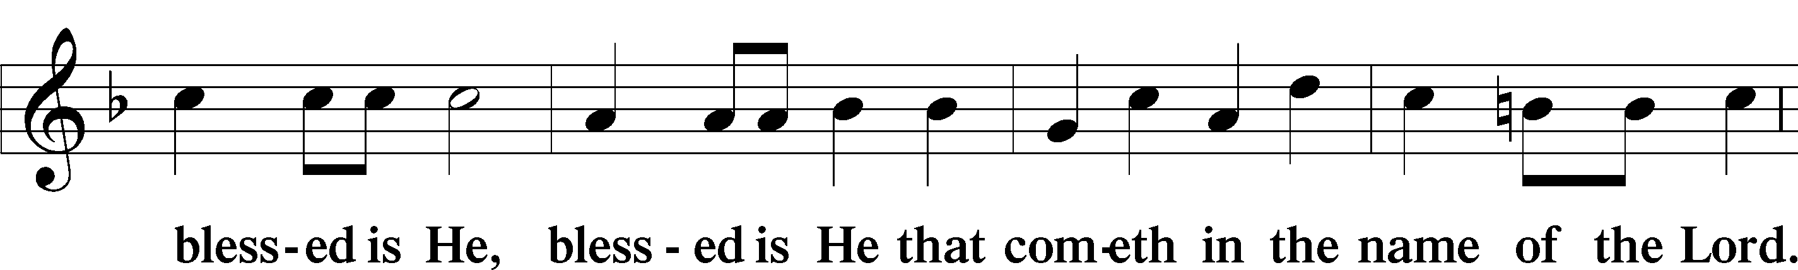
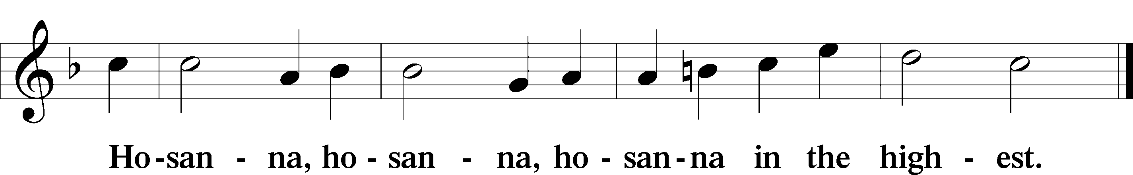

Lord’s Prayer Matthew 6:9–13
C Our Father who art in heaven,
hallowed be Thy name,
Thy kingdom come,
Thy will be done on earth as it is in heaven;
give us this day our daily bread;
and forgive us our trespasses as we forgive those who trespass against us;
and lead us not into temptation,
but deliver us from evil.
For Thine is the kingdom and the power and the glory forever and ever. Amen.

The Words of Our Lord Matthew 26:26–28; Mark 14:22–24; Luke 22:19–20; 1 Corinthians 11:23–25
P Our Lord Jesus Christ, on the night when He was betrayed, took bread, and when He had given thanks, He broke it and gave it to the disciples and said: “Take, eat; this is My T body, which is given for you. This do in remembrance of Me.”

In the same way also He took the cup after supper, and when He had given thanks, He gave it to them, saying: “Drink of it, all of you; this cup is the new testament in My T blood, which is shed for you for the forgiveness of sins. This do, as often as you drink it, in remembrance of Me.”

Pax Domini John 20:19
P The peace of the Lord be with you always.
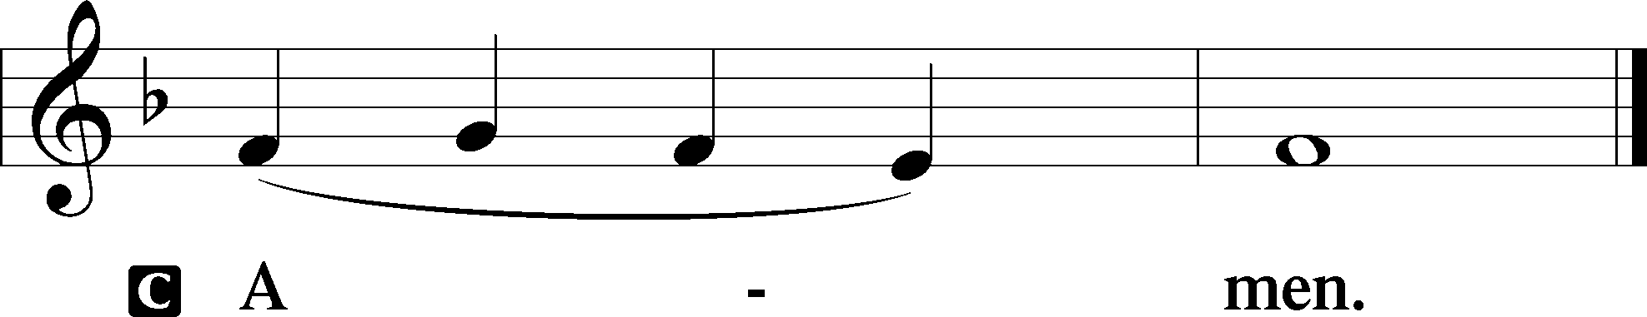

Agnus Dei John 1:29
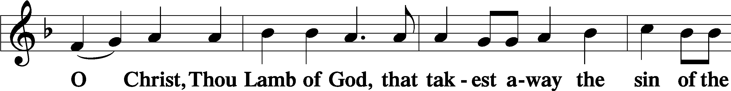
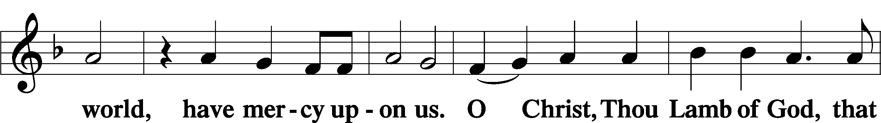
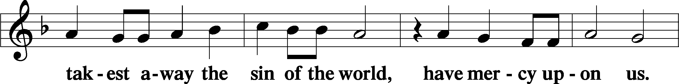
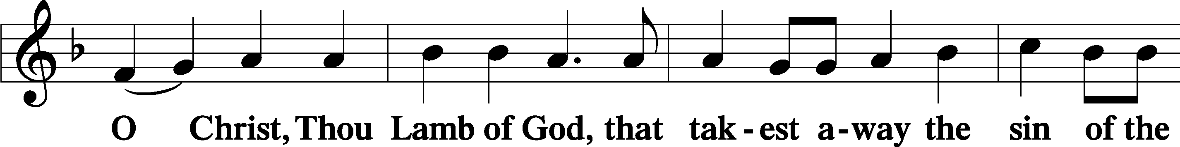
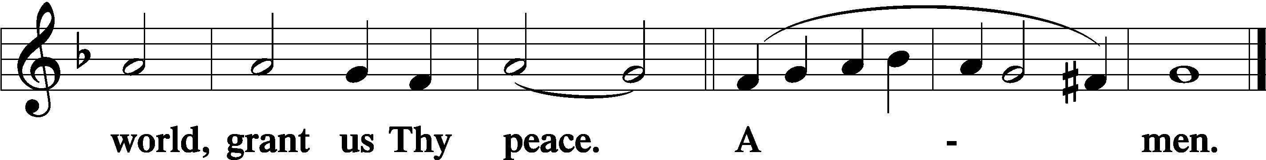
Sit
Distribution
The pastor and those who assist him receive the body and blood of Christ first and then distribute them to those who come to receive, saying:
Take, eat; this is the true body of our Lord and Savior Jesus Christ, given into death for your sins.
Amen.

Take, drink; this is the true blood of our Lord and Savior Jesus Christ, shed for the forgiveness of your sins.
Amen.

In dismissing the communicants, the following is said:
The Dismissal
P The body and blood of our Lord Jesus Christ strengthen and preserve you in body and soul to life everlasting. Depart T in peace.
C Amen.

Distribution Hymn: LSB #587 “I Know My Faith Is Founded”

Distribution Hymn: LSB #644 “The Church’s One Foundation”

Stand
Nunc Dimittis Luke 2:29–32
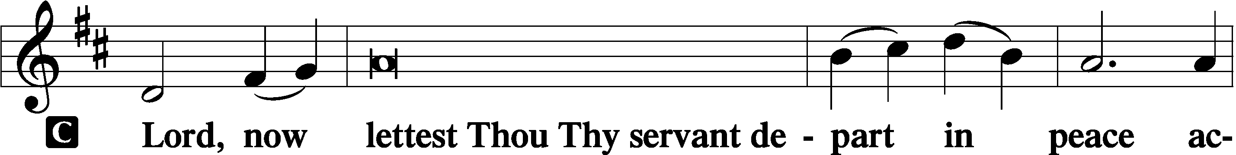
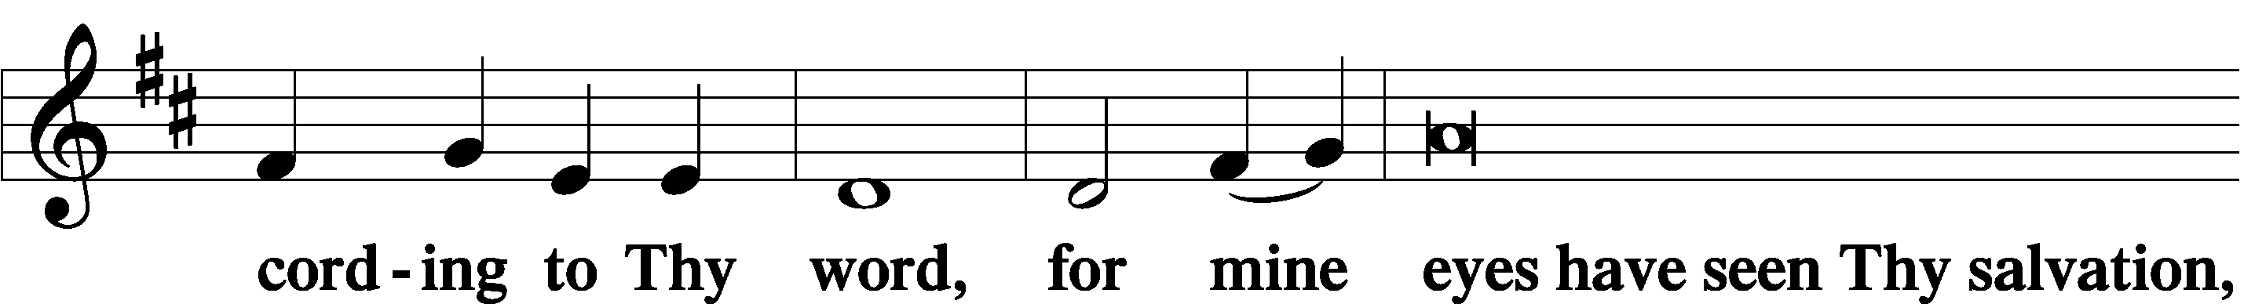
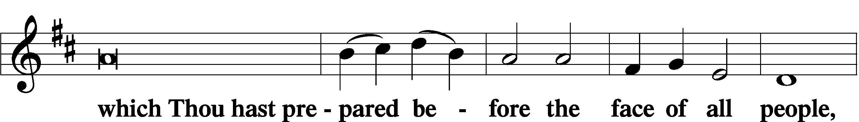
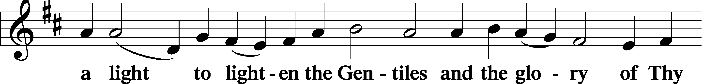
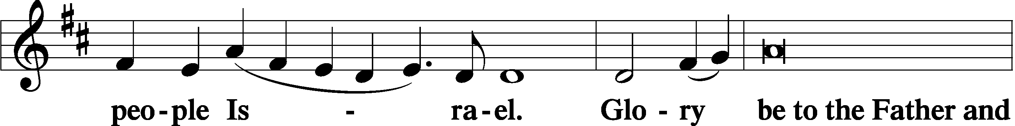
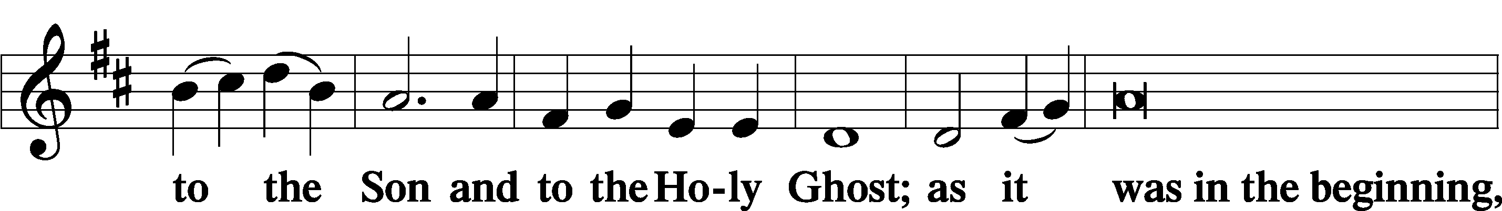
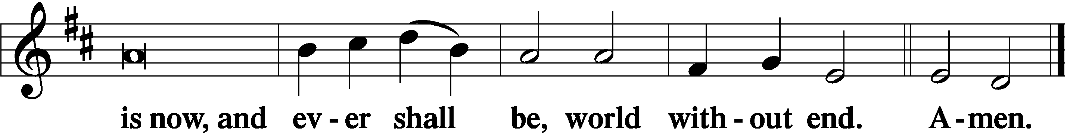

Thanksgiving Psalm 107:1
P O give thanks unto the Lord, for He is good,
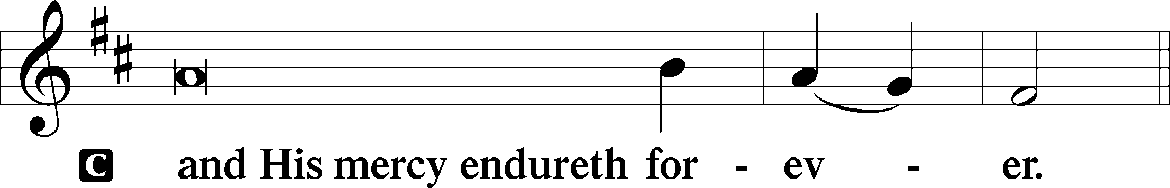

Post-Communion Collect
P Let us pray.
We give thanks to You, almighty God, that You have refreshed us through this salutary gift, and we implore You that of Your mercy You would strengthen us through the same in faith toward You and in fervent love toward one another; through Jesus Christ, Your Son, our Lord, who lives and reigns with You and the Holy Spirit, one God, now and forever.
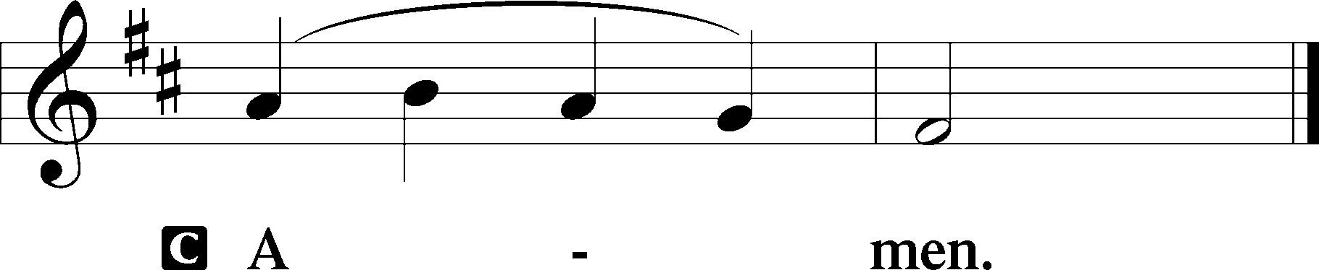

Salutation 2 Timothy 4:22
P The Lord be with you.
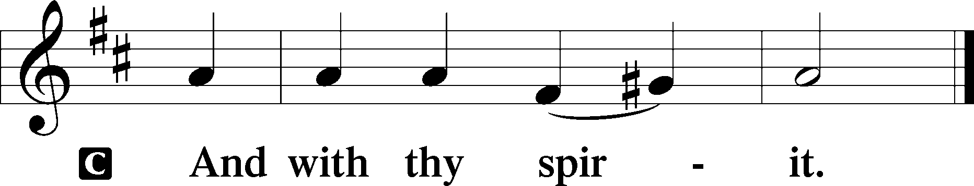

Benedicamus Psalm 103:1
P Bless we the Lord.
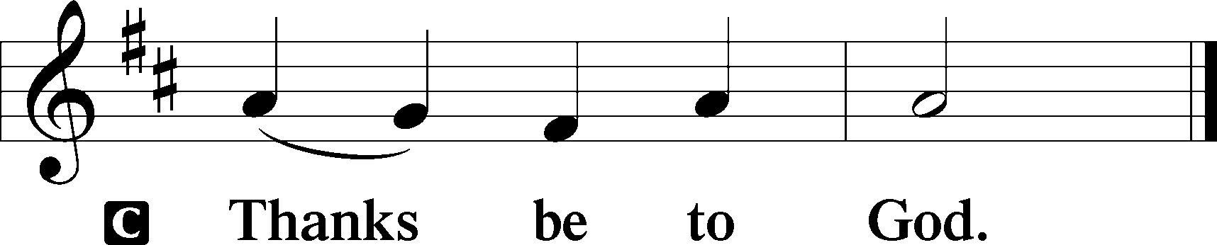

Benediction Numbers 6:24–26
P The Lord bless you and keep you.
The Lord make His face shine upon you and be gracious unto you.
The Lord lift up His countenance upon you and T give you peace.
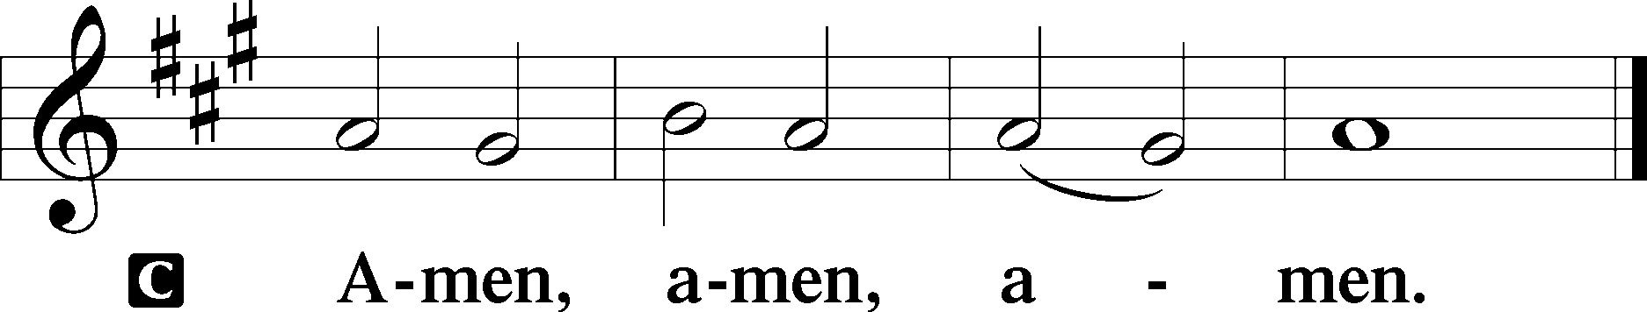

Closing Hymn: LSB #940 “Holy God, We Praise Thy Name”

Silent prayer after worship: Lord Jesus, You freely gave Your life for me, so that I might have forgiveness and eternal life. Make me constantly aware of Your love, so I will always be thankful and will want to share Your love every day. Amen.
fffffffffffffffffffffffffffffffffff
Acknowledgments
Unless otherwise indicated, Scripture quotations are from the ESV® Bible (The Holy Bible, English Standard Version®), copyright © 2001 by Crossway, a publishing ministry of Good News Publishers. Used by permission. All rights reserved.
Created by Lutheran Service Builder © 2023 Concordia Publishing House.
fffffffffffffffffffffffffffffffffff

