Sts. Peter & Paul
Evangelical Lutheran Church
Lutheran Church-Missouri Synod
Founded-1917

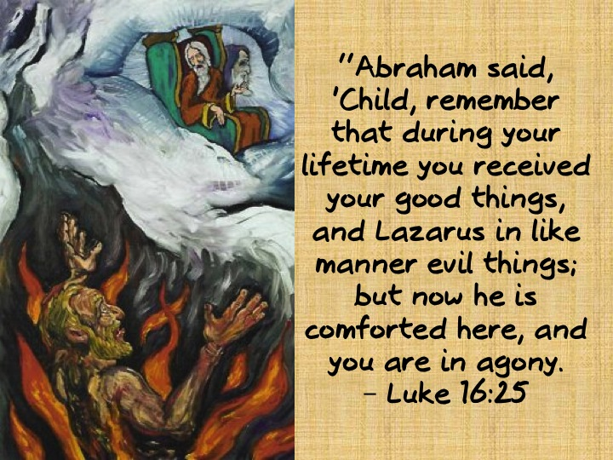

JUNE 23, 2019

699 Stambaugh Avenue
Sharon, Pennsylvania 16146

“I was glad when they said to me,
Let us go to the house of the LORD!”
Psalm 122:1

Sts. Peter & Paul Evangelical Lutheran Church, LC-MS

FIRST SUNDAY AFTER TRINITY
June 23, 2019

Silent prayer before worship: Dear God, You sent Your only begotten Son to suffer and die so that all who believe in him may heave eternal life. Lead me to worship You with a loving, joyful and thankful heart. In Jesus’ name. Amen.

Please read Communion Statement found inside the Friendship Booklet prior to taking part in Holy Communion.
CONFESSION AND ABSOLUTION
Opening Hymn: LSB #696 “O God, My Faithful God”
Stand
The sign of the cross may be made by all in remembrance of their Baptism.

P In the name of the Father and of the T Son and of the Holy Spirit.
C Amen. Matthew 28: 19b; [18:20]

P If we say we have no sin, we deceive ourselves, and the truth is not in us.
C But if we confess our sins, God, who is faithful and just, will forgive our sins and cleanse us from all unrighteousness.

Silence for reflection on God's Word and for self-examination.

P Let us then confess our sins to God our Father.
C Most merciful God, we confess that we are by nature sinful and unclean. We have sinned against You in thought, word, and deed, by what we have done and by what we have left undone. We have not loved You with our whole heart; we have not loved our neighbors as ourselves. We justly deserve Your present and eternal punishment. For the sake of Your Son, Jesus Christ, have mercy on us. Forgive us, renew us, and lead us, so that we may delight in Your will and walk in Your ways to the glory of Your holy name. Amen.
P Almighty God in His mercy has given His Son to die for you and for His sake forgives you all your sins. As a called and ordained servant of Christ, and by His authority, I therefore forgive you all your sins in the name of the Father and of the T Son and of the Holy Spirit. [John 20: 19-23]
C Amen.

Passing of the Peace.

SERVICE OF THE WORD

Introit: Ps. 13:1– 4; antiphon: Ps. 13:5–6
[O Lord,] I have trusted in your | steadfast love;*
my heart shall rejoice in your sal- | vation.
I will sing | to the Lord,*
because he has dealt bountifully | with me.
How long, O Lord? Will you forget me for- | ever?*
How long will you hide your | face from me?
How long must I take counsel in my soul and have sorrow in my heart | all the day?*
How long shall my enemy be exalted | over me?
Consider and answer me, O | Lord my God;*
light up my eyes, lest I sleep the | sleep of death,
lest my enemy say, “I have prevailed | over him,”*
lest my foes rejoice because I am | shaken.
Glory be to the Father and | to the Son*
and to the Holy | Spirit;
as it was in the be- | ginning,*
is now, and will be forever. | Amen.
[O Lord,] I have trusted in your | steadfast love;*
my heart shall rejoice in your sal- | vation.
I will sing | to the Lord,*
because he has dealt bountifully | with me.

Kyrie Mark 10:47

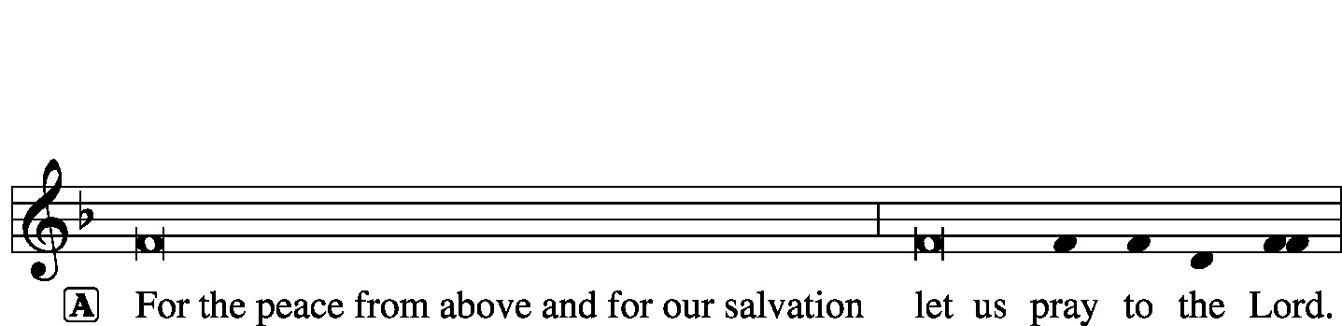
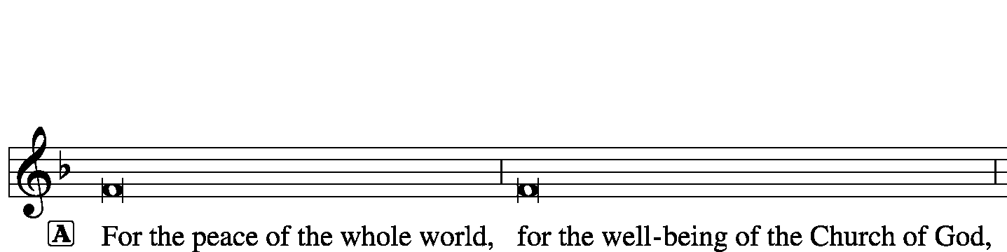
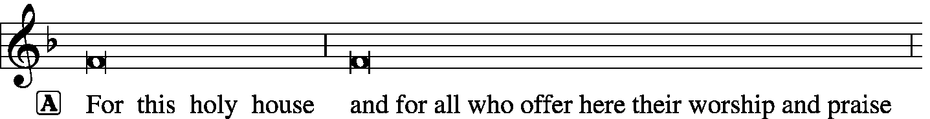
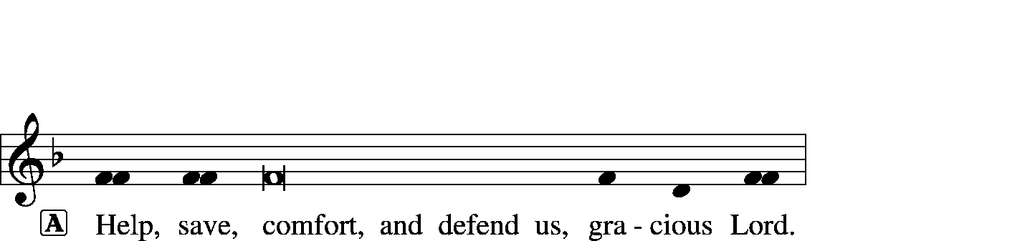

Gloria in Excelsis Luke 2: 14; John 1: 29
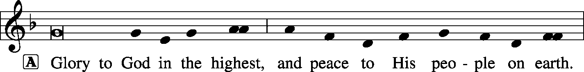
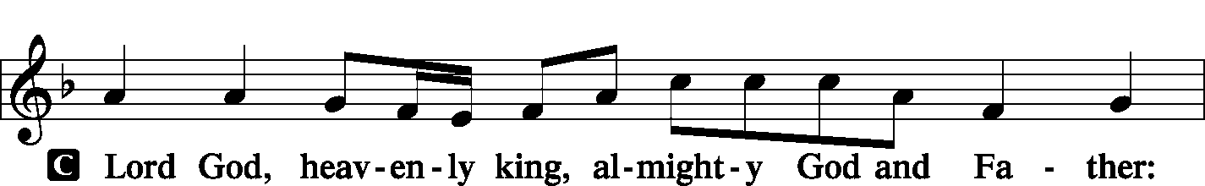
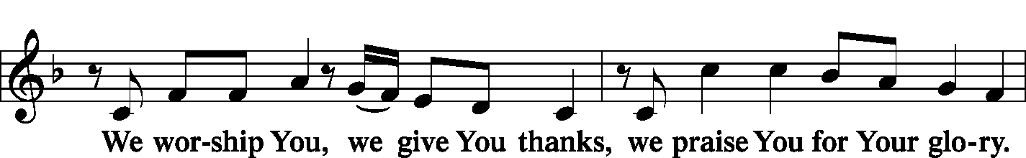
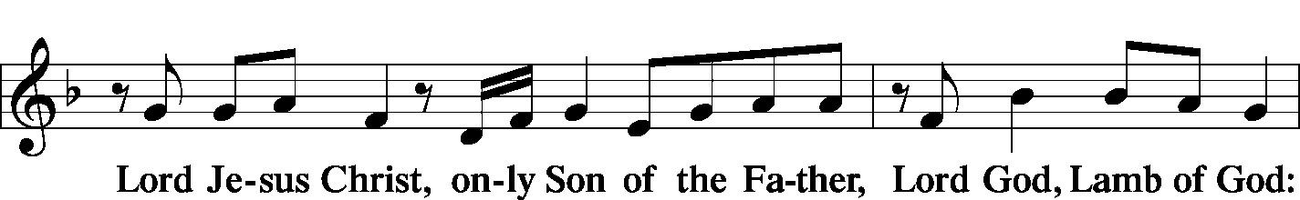
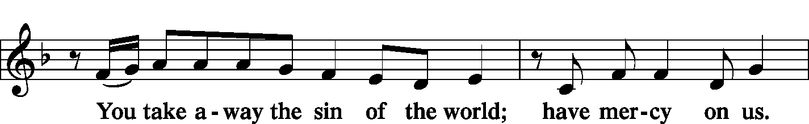
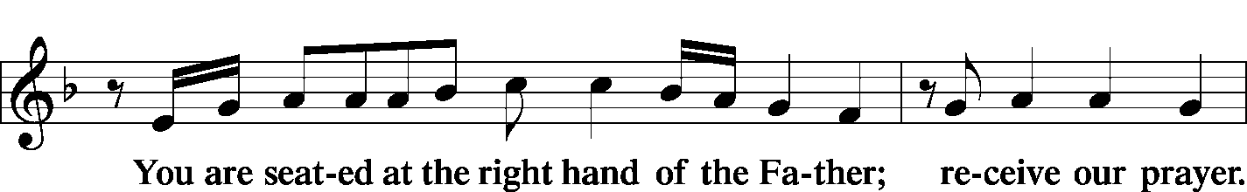
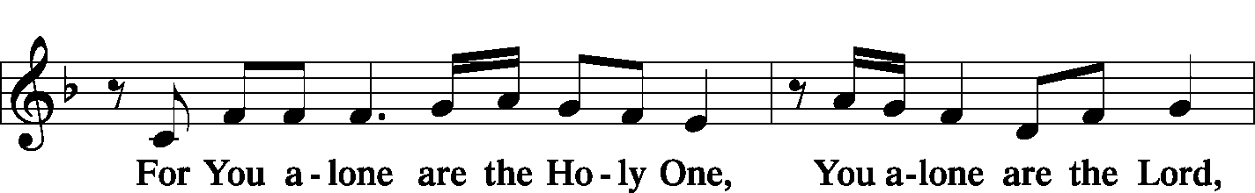
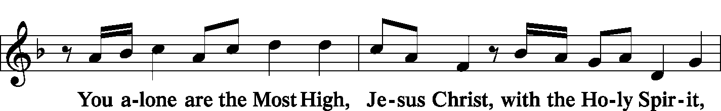
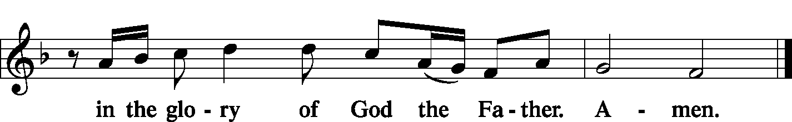

Salutation and Collect of the Day 2 Timothy 4: 22
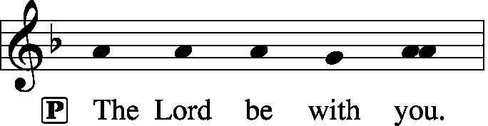
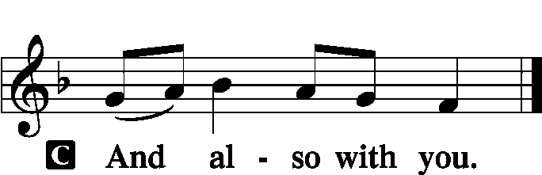

P Let us pray.
O God, the strength of all who trust in You, mercifully accept our prayers; and because through the weakness of our mortal nature we can do no good thing, grant us Your grace to keep Your commandments that we may please You in both will and deed; through Jesus Christ, our Lord, who lives and reigns with You and the Holy Spirit, one God, now and forever.

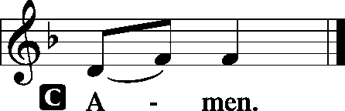

Sit

Old Testament Reading: Genesis 15:1–6
After these things the word of the Lord came to Abram in a vision: “Fear not, Abram, I am your shield; your reward shall be very great.” But Abram said, “O Lord God, what will you give me, for I continue childless, and the heir of my house is Eliezer of Damascus?” And Abram said, “Behold, you have given me no offspring, and a member of my household will be my heir.” And behold, the word of the Lord came to him: “This man shall not be your heir; your very own son shall be your heir.” And he brought him outside and said, “Look toward heaven, and number the stars, if you are able to number them.” Then he said to him, “So shall your offspring be.” And he believed the Lord, and he counted it to him as righteousness.

P This is the Word of the Lord.
C Thanks be to God.

Gradual: Ps. 41:4, 1
I said, “O Lord, be gracious to me;
heal me, for I have sinned against you!”
Blessèd is the one who considers the poor!
In the day of trouble the Lord delivers him.

Epistle: 1 John 4:16–21
So we have come to know and to believe the love that God has for us. God is love, and whoever abides in love abides in God, and God abides in him. By this is love perfected with us, so that we may have confidence for the day of judgment, because as he is so also are we in this world. There is no fear in love, but perfect love casts out fear. For fear has to do with punishment, and whoever fears has not been perfected in love. We love because he first loved us. If anyone says, “I love God,” and hates his brother, he is a liar; for he who does not love his brother whom he has seen cannot love God whom he has not seen. And this commandment we have from him: whoever loves God must also love his brother.
P This is the Word of the Lord.
C Thanks be to God.

Stand

Verse of the Day: Ps. 7: 1
Alleluia. O Lord my God, in you do I take refuge; save me from all my pursuers and deliver me. Alleluia.

Common Alleluia
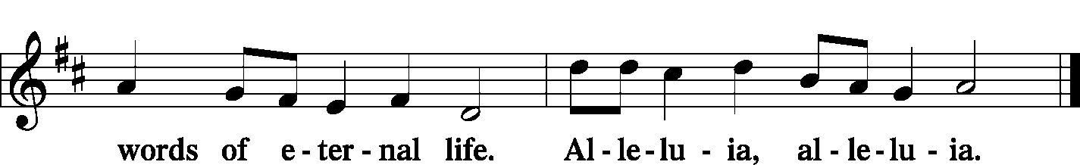

Holy Gospel: Luke 16:19–31
P The Holy Gospel according to St. Luke, the sixteenth chapter.

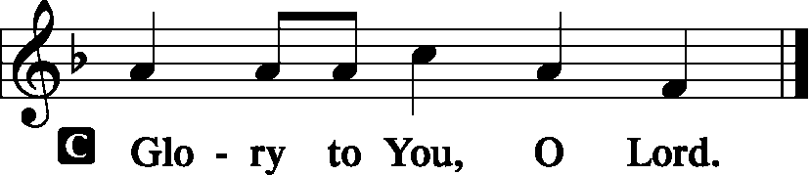

[Jesus said:] “There was a rich man who was clothed in purple and fine linen and who feasted sumptuously every day.
And at his gate was laid a poor man named Lazarus, covered with sores, who desired to be fed with what fell from the rich man’s table. Moreover, even the dogs came and licked his sores. The poor man died and was carried by the angels to Abraham’s side. The rich man also died and was buried, and in Hades, being in torment, he lifted up his eyes and saw Abraham far off and Lazarus at his side. And he called out, ‘Father Abraham, have mercy on me, and send Lazarus to dip the end of his finger in water and cool my tongue, for I am in anguish in this flame.’ But Abraham said, ‘Child, remember that you in your lifetime received your good things, and Lazarus in like manner bad things; but now he is comforted here, and you are in anguish. And besides all this, between us and you a great chasm has been fixed, in order that those who would pass from here to you may not be able, and none may cross from there to us.’ And he said, ‘Then I beg you, father, to send him to my father’s house— for I have five brothers—so that he may warn them, lest they also come into this place of torment.’ But Abraham said, ‘They have Moses and the Prophets; let them hear them.’ And he said, ‘No, father Abraham, but if someone goes to them from the dead, they will repent.’ He said to him, ‘If they do not hear Moses and the Prophets, neither will they be convinced if someone should rise from the dead.’”

P This is the Gospel of the Lord.
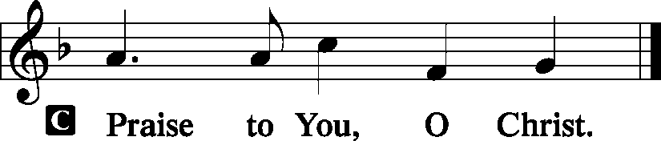

Nicene Creed
C I believe in one God,
the Father Almighty,
maker of heaven and earth
and of all things visible and invisible.
And in one Lord Jesus Christ,
the only-begotten Son of God,
begotten of His Father before all worlds,
God of God, Light of Light,
very God of very God,
begotten, not made,
being of one substance with the Father,
by whom all things were made;
who for us men and for our salvation came down from heaven
and was incarnate by the Holy Spirit of the virgin Mary
and was made man;
and was crucified also for us under Pontius Pilate.
He suffered and was buried.
And the third day He rose again according to the Scriptures
and ascended into heaven
and sits at the right hand of the Father.
And He will come again with glory to judge both the living and the dead,
whose kingdom will have no end.
And I believe in the Holy Spirit,
the Lord and giver of life,
who proceeds from the Father and the Son,
who with the Father and the Son together is worshiped and glorified,
who spoke by the prophets.
And I believe in one holy Christian and apostolic Church,
I acknowledge one Baptism for the remission of sins,
and I look for the resurrection of the dead
and the life T of the world to come. Amen.
Sit

Hymn of the Day: LSB #768 “To God the Holy Spirit Let Us Pray”

Sermon
Stand
Prayer of the Church [Timothy 2: 1-4]

Sit

Offertory Psalm 116: 12-13, 17-19
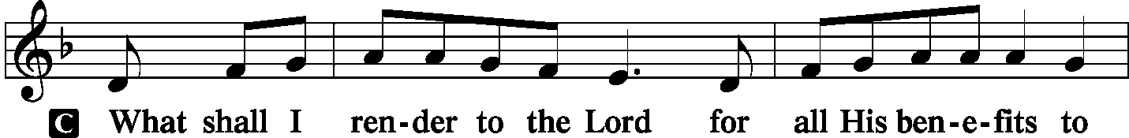
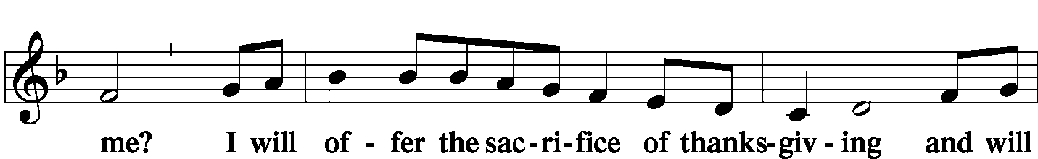
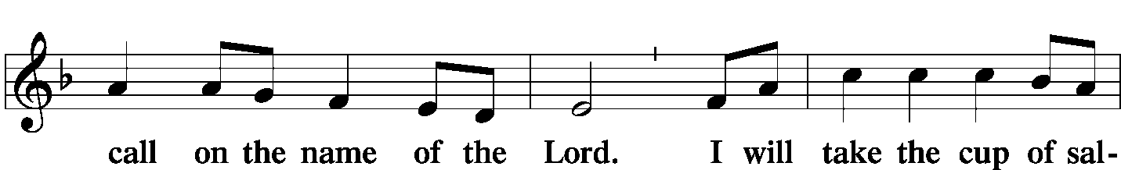
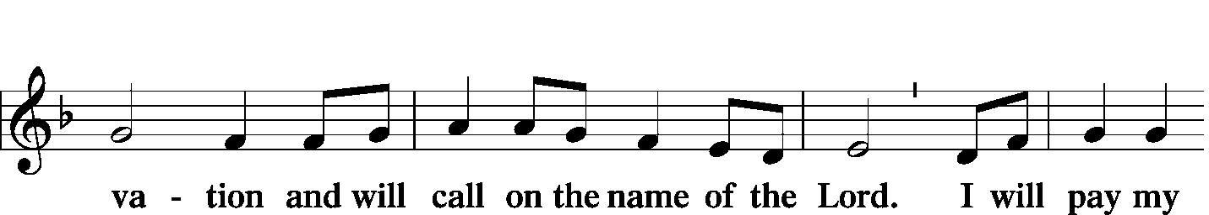
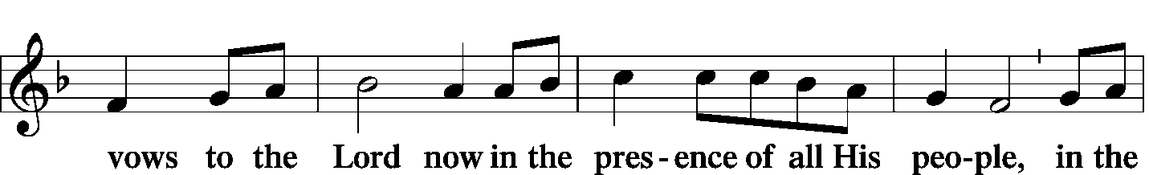
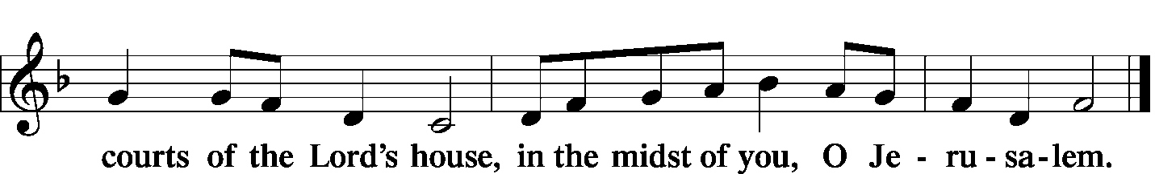

Offering/Offering Hymn: LSB #578 “Thy Strong Word”
Stand
SERVICE OF THE SACRAMENT
Preface
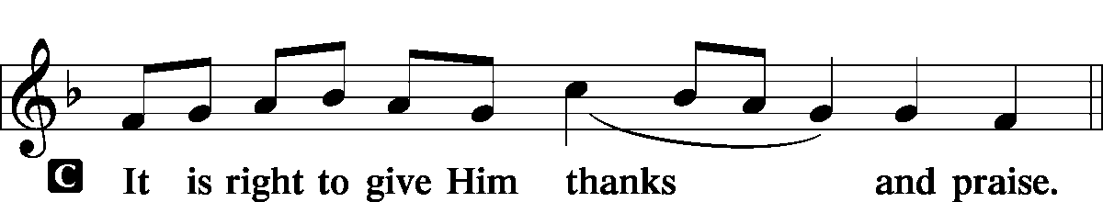

P It is truly meet, right, and salutary … evermore praising You and saying:

Sanctus
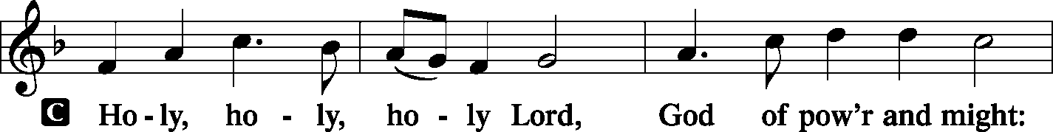
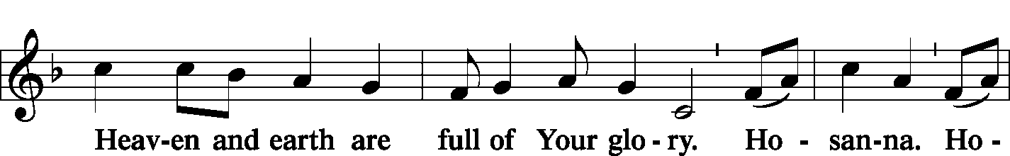
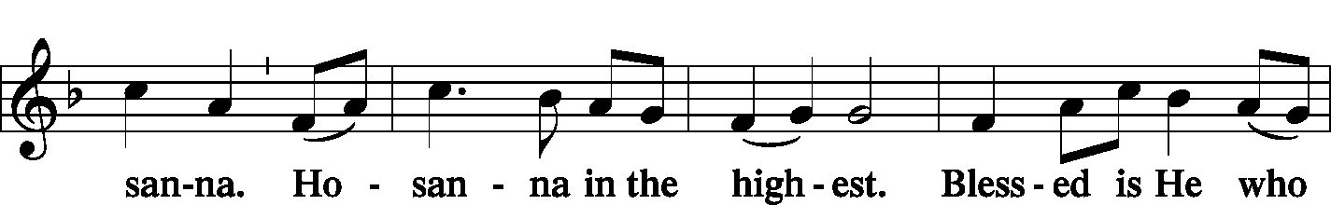
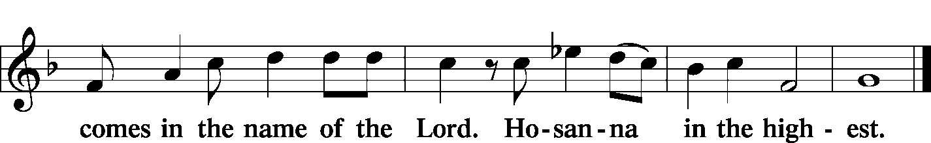

Lord's Prayer Matthew 6: 9-13
P Lord, remember us in Your kingdom and teach us to pray:
C Our Father who art in heaven,
hallowed be Thy name,
Thy kingdom come,
Thy will be done on earth as it is in heaven;
give us this day our daily bread;
and forgive us our trespasses as we forgive those who trespass against us;
and lead us not into temptation,
but deliver us from evil.
For Thine is the kingdom and the power and the glory forever and ever. Amen.

The Words of Our Lord Matthew 26: 26-28; Mark 14: 22-24
Luke 22: 19-20; 1 Corinthians 11: 23-25
P Our Lord Jesus Christ, on the night when He was betrayed, took bread, and when He had given thanks, He broke it and gave it to the disciples and said: “Take, eat; this is My T body, which is given for you. This do in remembrance of Me.”

P In the same way also He took the cup after supper, and when He had given thanks, He gave it to them, saying: “Drink of it, all of you; this cup is the new testament in My T blood, which is shed for you for the forgiveness of sins. This do, as often as you drink it, in remembrance of Me.”

Pax Domini John 20: 19
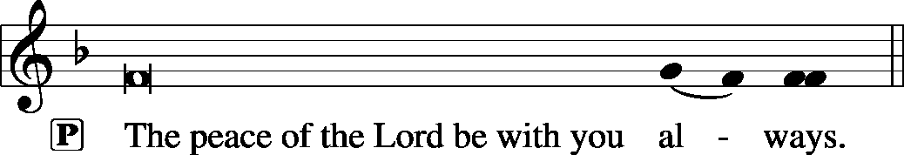

Agnus Dei John 1: 29
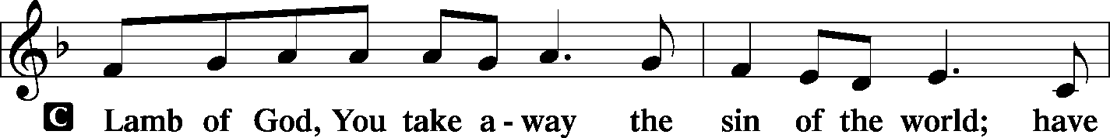
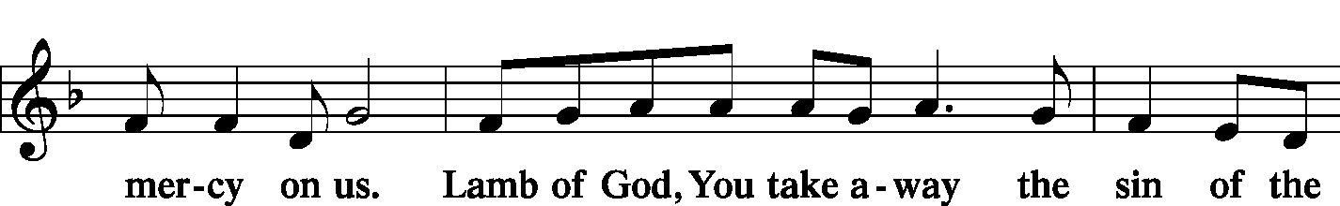
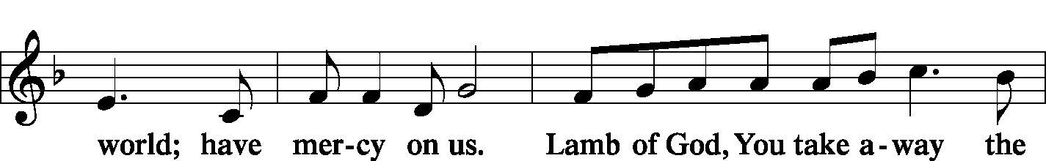
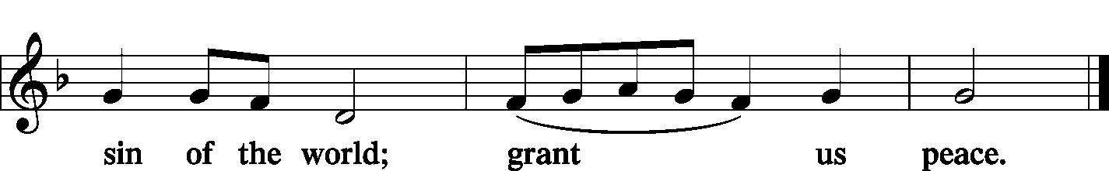

Sit

Distribution
The pastor and those who assist him receive the body and blood of Christ first and then distribute them to those who come to receive, saying:

Take, eat; this is the true body of our Lord and Savior Jesus Christ, given into death for your sins.
Amen.

Take, drink; this is the true blood of our Lord and Savior Jesus Christ, shed for the forgiveness of your sins.
Amen.
In dismissing the communicants, the following is said:
P The body and blood of our Lord Jesus Christ strengthen and preserve you in body and soul to life everlasting. Depart T in peace.
C Amen.

Distribution Hymn: LSB #629 “What Is This Bread”
Distribution Hymn: LSB #634 “The Death of Jesus Christ, Our Lord”

Stand

Nunc Dimittis Luke 2: 29-32
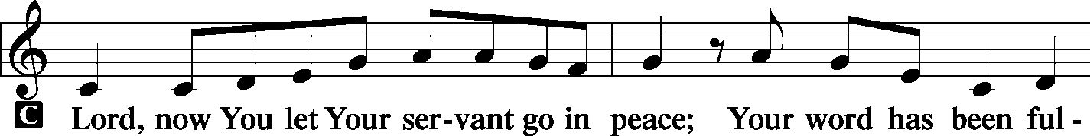
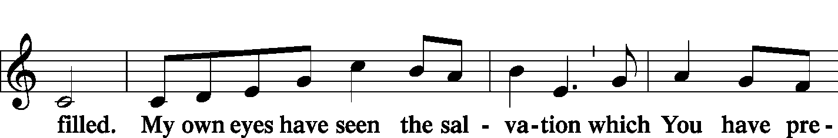
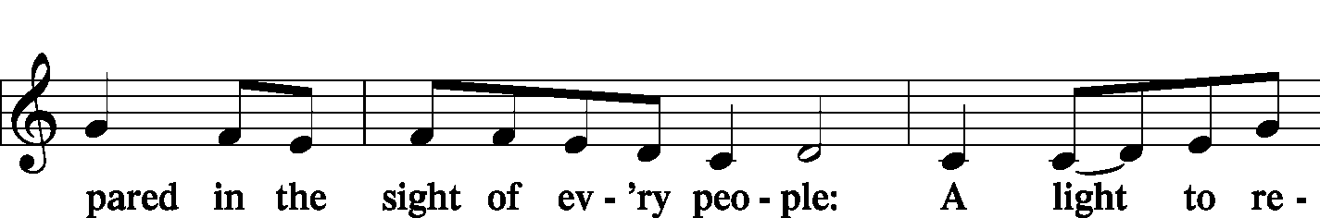
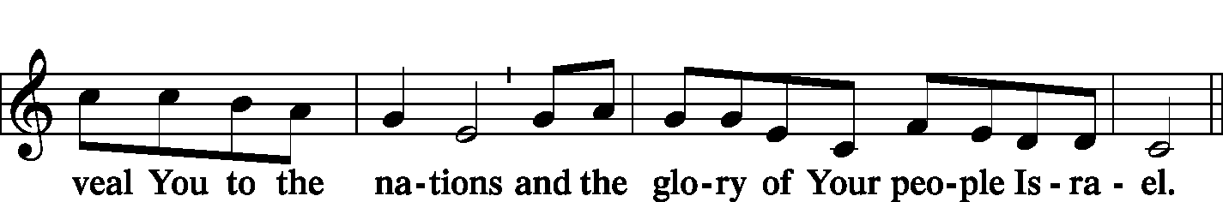
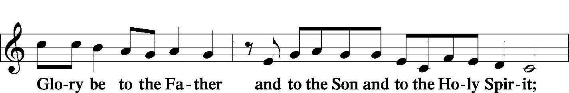
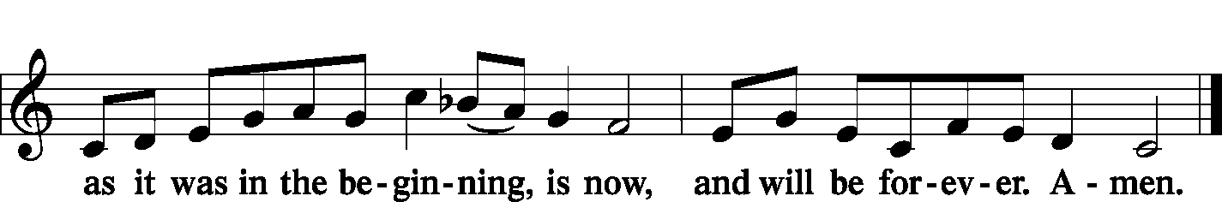

Post-Communion Collect Let us pray.

P We give thanks to You, almighty God, that You have refreshed us through this salutary gift, and we implore You that of Your mercy You would strengthen us through the same in faith toward You and fervent love toward one another; through Jesus Christ, Your Son, our Lord, who lives and reigns with You and the Holy Spirit, one God, now and forever.

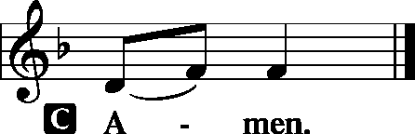
Benediction Numbers 6: 24-26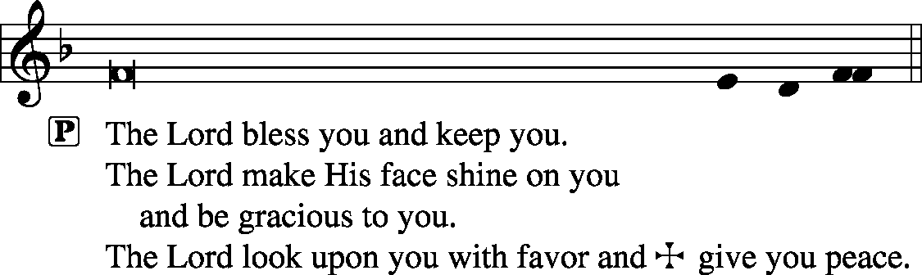

Closing Hymn: LSB #948 “All Glory Be to God Alone”
Silent prayer after worship: Dear Heavenly Father, let me never forget that I am Your special and dearly loved child in Jesus Christ. Cause me to live in Your love, to love You above all else, and to love my neighbor as myself. In Jesus’ name I pray. Amen.

Acknowledgments: Divine Service, Setting One from Lutheran Service Book Unless otherwise indicated, all scripture quotations are from The Holy Bible, English Standard Version, copyright © 2001 by Crossway Bibles, a division of Good News Publishers. Used by permission. All rights reserved. Created by Lutheran Service Builder © 2006 Concordia Publishing House. CCLI License #3029-446

Attendance: Saturday, June 15, and Sunday, June 16, 2019………….……66
Please sign the Friendship Book and give your sheet to an usher after the offering.

Thank You for Serving in June:
Today’s Greeters: John Dyll & Mark Gabriel. Assisting Elders: Ralph Dorman & John Dyll. Ushers: Bob Sulek, Hugh Owen, Cheryl Fedele, Jesse Riffle, & Ralph Dorman (alternate). Altarware: Eileen Burns & Ruth Meszaros.
June Greeters: 30~Rev. Ed & Irene Kucera

The Altar Flowers this morning are given anonymously to the Glory of God. We sincerely appreciate this generous gift!

Just a friendly reminder that, during the summer months, the cleaning staff will be cleaning the church twice monthly. It would be greatly appreciated if all would pitch in to keep our sanctuary looking neat and tidy. Thank you!


In Loving Memory of Patricia Brandes: Anne, Colt, Joani Rice, Viola Sakony (Food Pantry), Cathy Smith, and John Zachar (Food Pantry).
In Loving Memory of Aunt, Sophia Mihm: Anna Mary (Bocko) Hoovler.
In Loving Memory of Sophia Mihm: Michael & Emily Bocko, Anne Colt, Anna Mae Daris (Major Repair), Rev. & Mrs. Edward Kucera (Missions), Joani Rice (Major Repair), Bob & Traudi Sulek and Family (Missions), and John Zachar (Missions).
In Loving Memory of “Sonny” Meszaros: Joani Rice (Major Repair).
In Loving Memory of Gene Roberts: Anne Colt.
In Loving Memory of Clara Wojtanowski: Anne Colt, John & Anna Mae Daris and Family (Major Repair).
Praise be to God for taking my sister Caroline so peacefully into His loving arms: Viola Sakony (Major Repair).

SCHEDULE FOR TODAY THROUGH JUNE 30th:
:

:

Today, following Worship, Sonshine Room……………………..Community Day Meeting
7 pm, Downstairs….…………….…………………..………………….……...……AA Meeting
Monday, 4:30 pm, Offices………………………………………………………New Members’ Class
Thursday, 9 am, Downstairs..…………………………….………….……………………..Food Pantry
Saturday, 5 pm, Sanctuary……………….…….Festival of Sts. Peter & Paul Divine Service
Next Sunday, 8:45 am, Downstairs………………………………………………..………Bible Study
10 am, Sanctuary…...........................................................................Divine Service
2-6 pm, Fellowship Hall……………………………………………….……..Ostheimer party
7 pm, Downstairs…………………………………………..…………………......…AA Meeting

Sincere sympathy is expressed to the friends and family of John “Sonny” Meszaros, Ruth’s brother-in-law, who passed away June 15, 2019. May those who mourn his death find comfort in our Lord and His promises.
Our Stewardship of Treasures for the Lord:
In order to do the Lord’s work, we need $2,882.02* each week to meet our 2019 budget for general purposes and $38.46 for missions.
Saturday, June 15 and Sunday, June 16, 2019:
General Offering: $2,586.00
Behind this week*: -$296.02
SELC Missions: $165.00
Ahead this week: +$126.54
Local Missions: $10.00
Preschool Tuition: $0.00
Other Offerings: $457.00
*Includes preschool tuition.

Please note that the Fellowship Hall will be in use next Sunday afternoon (June 30th) from 2-6 pm.

Remember the following in Prayer…
~The Hurting and Healing: The Friends and Family of John “Sonny” Meszaros, Ruth’s brother-in-law, who passed away June 15th, Tony¹, Lois Bortner^{CA}, Richard Brandes⁴, Eileen Burns⁴, Beverly Chlpka¹, Anne Colt², Kim¹, Tim Dudash¹, John Dyll⁴, Jennifer Hilliard⁴, Anson Holcroft⁴, Betty Knauff^{CA}, Regis Knauff¹, Clara Krivosh², Jess Lavoie³, Paul Lucas^{CA}, Barry Nelson¹, David Nelson²,Tom Mulligan^{CA}, Iona Oltman^{CA}, Rudy Pinal^{CA}, Don Voytik¹, Ashley & Dale Weaver, and Angela Weser^{CA}.
~Our Homebound: Helen Bender, Dan Davis, Edna Krajci, Mary Ann Krajci, Marion Roberts, Barbara Vasconi, and Joanne Wolfe.
~Celebrating: Birthdays: John Dyll (06.23) and Chris Nelson (06.28).
~Serving in the Military: Clayton Drnek, Curtis Sinewe, and Joshua Solyan.
~Community & World Needs: Victims of violence and terrorism; those suffering from loss and dislocation because weather disasters; those suffering from addiction and their families; Local, State, and National Government Leaders; Safety for all Police Officers, Firefighters, & First Responders; the unemployed; our Second Quarter Local Mission: Sts. Peter & Paul’s Third Annual Community Day.
*CA represents cancer; number after other names represents weeks on the prayer list. After 4 weeks names may be resubmitted. This helps us to remember people’s specific needs and reminds us that God is providing healing as people get better and no longer need our prayers. Please submit prayer requests in writing to the church office.
Please keep those listed above in your prayers.
Word of Hope: 1-888-217-8679
The only 24/7 CONFIDENTIAL Hotline that is distinctly Lutheran, bringing healing found in Christ, to those whose hearts have been broken by abortion.

Members of the Community Day planning committee are reminded of the meeting scheduled for this morning following worship. We will meet in the Sonshine Room.

Bible Memory Verses: For the week of June 23rd:
For Children: The one who hears you hears me, and the one who rejects you rejects me, and the one who rejects me rejects him who sent me. Luke 10:16
For Adults: The Lord is good to those who wait for him, to the soul who seeks him. It is good that one should wait quietly for the salvation of the Lord. Lamentations 3:25-26

Please plan to join us Saturday, June 29th, at 5 pm in the sanctuary for the celebration of the Festival of Saints Peter and Paul.

There is a sign-up sheet on the table in the narthex for those planning to attend the potluck luncheon celebrating Pastor Kucera’s sixtieth anniversary of his ordination Sunday, July 14th. Please sign-up no later than Sunday, July 7th so that plans may be made.
We will be blessed that morning to welcome SELC District President Waldemar Vinovskis as our guest preacher during our Divine Service.

Members of the Audit Committee should plan to attend the next audit July 7th following worship.
Here to Serve You…

Pastor………………………………………………….………..…Rev. Jacob Deal
E-mail ……….…………………….…..pastordeal@saintspeterandpaul.net
Phone Number…………..……………………………724-347-3620 (Option 2)
Church Office………………………………….………724-347-3620 (Option 3)
Website ……….………………….……...…….www.saintspeterandpaul.net
Secretary………………………………………………….……. Diane Riefstahl
E-mail ……….…………………….…….…church@saintspeterandpaul.net
Food Pantry: John Dyll…………….……………………..…..…724-347-1779
Little People Preschool…………….……………….724-347-3620 (Option 4)
Teacher: Paula Ostheimer………….………………….…….....724-981-5846
Email ……….………….…………………….paula@saintspeterandpaul.net
AA Contact: Steve……………………….…………..……...……. 724-813-2358
Organist……………………………………………………..…Carrie Yasnowski
Choir Director……………..…………….…………..….….………Chris Nelson
Congregation President…………………………………………Jeff Brandes
 In general, the secretary’s office is open Monday and Thursdays from 8:30 am -4:30 pm. Pastor Deal is here throughout the week, except Fridays or when ministering offsite. If you need to enter the Church, please call ahead to be sure someone is here to let you in. Thank you.

