**From the Pastor…**

**Sts. Peter & Paul Evangelical Lutheran Church LC-MS**

Monthly Newsletter --- June 2019

699 Stambaugh Avenue, Sharon, PA 16146

Phone: 724.347.3620 Little People Pre-School: 724.347.3620 (option 4)

E-mail: church@saintspeterandpaul.net [www.saintspeterandpaul.net](http://www.saintspeterandpaul.net)

“THE ROCK and THE SWORD”

“Built upon the Rock of Christ and wielding the

Sword of the Spirit, the Word of God.”

Only God can Judge Me

Often I’ve heard it said, “Only God can judge me.” Usually, those who say this have come face to face with someone, probably a loving pastor, a relative, or even their own parent, who has shown them where the Bible says they are sinning. Of course no one likes to hear that they have sinned against God, let alone be shown it by another person.  People just like to be left alone doing whatever makes them happy, especially when they are living in darkness. There are two things which are underlying this response. The first is that people do not believe the Bible is the actual voice of God. The second is that people believe their confession of faith is only between them and God.

The Age of Enlightenment, also known as the Age of Reason, traditionally is marked as starting in the beginning of the 18th century around 1715 and ending around the turn of the 19th century around 1785. It was during these formative years that the Bible began being touted as unreliable, not wholly truthful, and subject to interpretation. When the Church proclaimed that the Bible was absolutely authoritative, philosophers and people responded by questioning the right doctrines of the church. All things were being subjected to our reason. What reason could not understand, the heart and mind would not trust. It was following this time period that the Jefferson Bible was made and when, in fact, Jefferson ripped out the passages of Scripture which were unfathomable to the human mind (visitation of angels, miracles, virgin birth, and resurrection).  John

Locke and Thomas Jefferson were among the men of this time who reduced the New Testament to moral teachings. They consigned faith to a moral code and went on a path to destroy orthodox Christianity in the wake of religious tolerance.

What did all this do for us today? It changed how people engaged the Word of God. If one hasn’t been raised in a Church that specifically and explicitly says “God’s Word is God’s Word, and not the word of man”, one is most likely to be of the mindset that the Scriptures are the words of man. Therefore, that person will not likely hold the Bible as being authoritative for right doctrine and life. Hence, the response, “Only God can judge me.”

To all those who hold to God’s Word being His voice, hear what God speaks concerning the use of Scripture:

1. “For **no prophecy was ever produced by the will of man, but men spoke from God** as they were carried along by the Holy Spirit.” 2 Peter 1:21
2. “But as for you, continue in what you have learned and have firmly believed, knowing from whom you learned it and how from childhood you have been acquainted with the sacred writings, which are able to make you wise for salvation through faith in Christ Jesus. **All Scripture is breathed out by God and profitable for teaching, for reproof, for correction, and for training in righteousness,  that the man of God may be complete, equipped for every good work.**” 2 Timothy 3:14-17
3. “Sanctify them in the truth; **your word is truth**.” John 17:17

Of course more could be quoted, but, for now, this is sufficient.

Now we go to the second point that “faith is between God and me.” How misleading this is! It sounds very nice and pious to say such a thing, but truly it is an empty platitude. There is only one faith which saves (John 11:25), and that faith is in God’s only Son, Jesus Christ, our Lord, who lived the perfect life fulfilling God’s Law (Matthew 5:17-20), who died our death for our sins( 2 Cor. 5:21), and who rose again on the third day (Matthew 28). No one comes to the Father except through that one Jesus of Nazareth (John 14:6).  Now, it is also true that one cannot believe for another (Mark 16:16). Finally, we also know that this faith is not private for Jesus says, “I tell you, everyone who confesses Me before men, the Son of Man will also confess him before the angels of God” (Luke 12:8; Matthew 10:32). Saint James also says, “Therefore put away all filthiness and rampant wickedness and receive with meekness the implanted word, which is able to save your souls. But be doers of the word, and not hearers only, deceiving yourselves. For if anyone is a hearer of the word and not a doer, he is like a man who looks intently at his natural face in a mirror.  For he looks at himself and goes away and at once forgets what he was like. But the one who looks into the perfect law, the law of liberty, and perseveres, being no hearer who forgets but a doer who acts, he will be blessed in his doing” (James 1:21-25). The faith that God gives you is always lived out in public confession before the world. The one who says otherwise, deceives only himself.

God’s Word says not to judge others over matters of opinion (read Romans 14).  Doctrine is never a matter of opinion; wickedness and evil are never matters of opinion. As we seek to love our brother in Christ, let us always follow the Word of God in reproving him. The same Law of God that applies to your brother, also applies to you. Repent first of your own sins in that matter before seeking to pull the speck from your brother’s eye (Matthew 7:5). Then go and read Matthew 18. Remember that Christ tells us to forgive our brother 70x7 (it means you shouldn’t be counting). When we reprove our brother living in sin, our hope should always be to win him back so that we share, once again, in the reconciliation in Christ (Matthew 18:15). It is better for one to be angry with us over his sins now, than to face the judgement seat of God and to suffer eternal punishment for unbelief. It is necessary that God’s Word reveal sin so that the Gospel may enter in and bring forgiveness.

In Christ,

~Pastor Jacob Deal

****

**Thank You for Serving in June:**

**Assisting Elders:** Ralph Dorman & John Dyll. **Ushers:** Bob Sulek, Hugh Owen, Cheryl Fedele, Jesse Riffle, & Ralph Dorman (alternate). **Altarware:** Eileen Burns & Ruth Meszaros.

**June Greeters:**

2 ~ Gary & Eileen Burns

9 ~ Barry & Chris Nelson

16 ~ Ralph Dorman & Diane Riefstahl

23 ~ John Dyll & Mark Gabriel

30 ~ Rev. Ed & Irene Kucera

***New Greeters are ALWAYS needed!***

***If you would like to be added to the Greeters’ schedule, please speak with Diane. Thank you!***



**“Stock the Food Pantry Sunday”**



**is June 9th!**

***Let us remember those in need!***

Please consider making a financial donation to this important function of our church. Let’s try to bring some joy into the lives of others and help them feel God’s blessings and love.

‘Truly, I say to you, as you did it to one of the least of these my brothers, you did it to me.’ Matthew 25:40



It’s so nice to see our “snowbirds” and those who had been ill this winter, along with several new individuals and families, in our pews once again!

**In Sympathy:** Sincere sympathy is extended to the friends and families of Susan Dudash (John Zachar’s friend), Norma Ferringer (Pat Voytik’s sister), and Clara Wojtanowski (Anna Mae Daris’s sister-in-law) who recently passed. May all find comfort in memories of happier days and our Lord’s mercy.





**CELEBRATING IN JUNE!**

**Birthdays:**

Gerald Krivosh Jr. 6-1

Ana Deal 6-2

June Thomas 6-2

Presley Sieg 6-4

Stacy Brandes 6-7

Jonathan Baisch 6-9

Lisa Jelinek 6-9

Isaiah Deal 6-10

Rudy Tomko 6 20

Sue Bender 6-21

John Dyll 6-23

Chris Nelson 6-28

Mark Gabriel 6-30

**Anniversaries:**

Tony & Tiffany Bale 6-2

Rev. Ed & Irene Kucera 6-9

Ed & Millie Zachar 6-12

Matt & Cathy Berent 6-23

*If birthdays or anniversaries have been omitted, please let the church office know. Thank You!





**Word of Hope: 1-888-217-8679**

The only 24/7 CONFIDENTIAL Hotline that is distinctly Lutheran bringing healing, found in Christ, to those whose hearts have been broken by abortion.



**Thrivent choice Dollars**

**We were recently notified that Thrivent Choice Dollars were directed to our church. We thank Jeffery Brandes for making us the recipient of his giving.**

**Our Home Bound Members:**

***Please keep the following people in your prayers:***

Helen Bender

920 Pleasantview Dr.

New Castle, PA 16101



Dan Davis, Avalon Springs

745 Greenville Road

Mercer, PA 16137



Edna Krajci, **Vista Center at The Ridge**  
3379 Main St   
Mineral Ridge, Ohio 44440  
330-652-9901



Mary Ann Krajci, John XXIII

2250 Shenango Valley Freeway

Hermitage, PA 16148

724-981-3200



Sophie Mihm, John XXIII

2250 Shenango Valley Freeway

Hermitage, PA 16148

724-981-3200



Marion Roberts,

906 Orchard Rd.

Mercer, PA 16137

724-946-2236



Barbara Vasconi

880 Mayfield Rd.

Sharpsville, PA 16150

724-962-7960



Joanne Wolfe

31 North Park Ave.

Meadville, PA 16335

814-332-9301



**LIKE & FOLLOW both our Church and Preschool Facebook pages.**

Remember to like, comment, and share to help us reach as many people as possible.

******

Make certain to pick-up the June-July issue of ***The Lutheran Beacon*** which is available in the narthex. You may also read the Lutheran Beacon on-line at [**www.selc.lcms.org**](http://www.selc.lcms.org/)**.**

**Bible Memory Verses**

Have you ever wondered about the origin of the beautiful words which make up our liturgy? What about the basis of our hymns found in our worship hymnal? The source is the same for both: The Holy Bible.

It is to The Bible we should turn, not only to find words of comfort, but for God’s plan as to how our lives should be led. Arm yourselves with these words, and you will see God’s plan for you!

The following are the Bible verses from the month of **May:**

**FOR CHILDREN:**

***May 5:*** *I am the Good Shepherd…My sheep hear my voice, and I know them, and they follow me. I give them eternal life. John 10:11, 27-28*

***May 12:*** *If anyone is in Christ, he is a new creation. The old has passed away; behold, the new has come. 2 Cor. 5:17*

***May 19:*** *Oh sing to the Lord a new song, for he has done marvelous things! Ps. 98:1*

***May 26:*** *I, when I am lifted up from the earth, will draw all people to myself. John 12:32*

**FOR ADULTS:**

***May 5:*** *And there is salvation in no one else, for there is no other name under heaven given among men by which we must be saved. Acts 4:12*

***May 12:*** *In the same way, let your light shine before others, so that they may see your good works and give glory to your Father who is in heaven.*

*Matthew 5:16*

***May 19:*** *Do not be conformed to this world, but be transformed by the renewal of your mind, that by testing you may discern what is the will of God, what is good and acceptable and perfect. Romans 12:2*

***May 26:*** *But godliness with contentment is great gain, for we brought nothing into the world, and we cannot take anything out of the world. But if we have food and clothing, with these we will be content. 1 Timothy 6:6-8*



******

**REMINDER:** Please let the church office know of any changes to your address, phone, cell phone or your e-mail address!

******

**BOILER UPDATE:** At the recent Voters’ Assembly meeting, voters authorized the trustees to spend up to $15,000 to replace the non-operational steam boiler, thermostats, conditioning system, and needed plumbing. It is anticipated that items will be ordered in the next few weeks to allow ample time for installation to occur before next winter.

Many thanks go out to all those who have been involved in analyzing our current situation, getting bids, and figuring out our best course of action. Additional thanks are extended to the number of individuals and families who have generously donated to this cause.



Many thanks go out to Joani Rice who has been tending to the church gardens this spring! Please know your efforts are greatly appreciated.





Be certain to check out our website: [www.saintspeterandpaul.net](http://www.saintspeterandpaul.net) which was recently up-dated. Current service bulletins and newsletters may be accessed under the Publications page and there is an audio link to Pastor Deal’s sermons.



Pastor Deal is offering several **“new members’ class”** opportunities. Interested participants can opt to attend classes or participate on-line. Please speak with Pastor if interested!

Swaddling

Clothes

**Gifts for Moms and Babies**

Ana Deal submitted to the Church Council a proposal to begin a Swaddling Clothes program here at Sts. Peter & Paul’s. The program, which already exists in various LCMS congregations, seeks to share Christ’s mercy with those in need through gifts of clothing, food, friendship, and forgiveness. The proposal to begin such a program here was accepted by the membership at the last Voters’ Assembly meeting. As a result, we will become the first “Swaddling Clothes” facility in Pennsylvania.

Project “Swaddling Clothes” will involve acquiring, organizing, and distributing food, diapers, formula, gently-used clothing, and other items needed by babies and mothers. This can include things such as car seats, cribs, and high chairs as long as items are not expired and are in good working condition. Think of this project as an outreach opportunity similar to our Food Pantry.

It will take time to get the program up and running. Fortunately, although day-to-day operations will be strictly under our control, there is a manual of operating suggestions (including liability measures) for us to consult.

Before we can begin offering this program to those in need, the following will have to occur.

1. Shopping days/times established.
2. Donations sought.



1. Advertising.
2. Shopping space set up.

This is a major undertaking which will require many volunteers to make happen. There can be many levels of involvement. Please prayerfully consider how you can help with this project. For further information, either speak with Ana or check out [www.swaddlingclothes.org](http://www.swaddlingclothes.org).

**Coupons needed!**

Coupons for diapers, wipes, baby food, etc. will be collected for our “Swaddling Clothes” operation. Coupons can be placed in the manila envelopes found in the narthex or secretary’s mail slot (office door).

Monthly Fellowship

Many thanks to the Deal family who sponsored May’s Coffee & Donuts fellowship with delicious home-made treats! We are greatly appreciative for this month’s sponsorship by Judith Furley and Elizabeth Logan following worship June 9th.

Please note that there will be no Coffee & Donuts fellowship in July due to the dinner being planned in recognition of Pastor Kucera’s 60 years in the ministry.

We do have a few remaining months of the year needing sponsorship. If interested, please sign the sheet found in the narthex. On your fellowship day, you are asked to simply drop off 2-1/2 dozen donuts/muffins (or similar items) and 1 qt. juice before Sunday worship begins. That’s all. Set-up and clean-up will be taken care of for you.

Fellowship is an important part of keeping connected with your church family. We pray that we do not lose this opportunity to catch up with one another and get to know each other better.



There are many Sundays available to purchase Flowers for the Altar. Check out the sign-up sheet in the narthex.



Plans are underway for a special 60th anniversary celebration of Pastor Kucera’s ordination as an LCMS minister July 14, 2019 during our worship service with a luncheon to follow. Stay tuned for further details!

**SCRIP PROGRAM TO BEGIN:** At the recent Voters’ Assembly meeting, Matt Berent made a presentation about a Scrip Fundraising Program which members could opt to participate in and which would financially benefit the church.

The Scrip Program basically works like this: A member can purchase one or more gift cards through the program. A percentage of the gift card amount, which does NOT lessen the value of the gift card, will be given to the church by the company sponsoring the program. So, if you purchase a $100 gift card, you still receive a $100 gift card AND the church receives a contribution as well. The percentage of the contributions varies depending on the store for which the gift card is intended. Card percentages vary from 3% to 8% of the value.

Following questions and discussion about the program, voters accepted the motion to begin such a program here at Sts. Peter & Paul’s. Matt volunteered to oversee the program and will make information for ordering cards available once the program is in place. It is anticipated that gift card orders will be placed monthly. Participants will also have the ability to purchase reloadable gift cards which they will be able to personally reload.

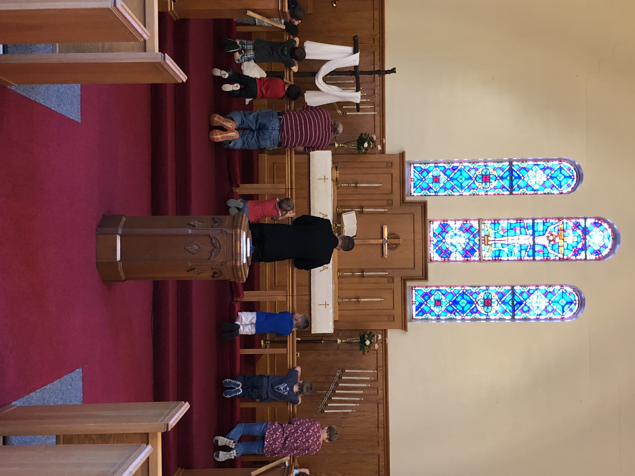



Can’t make church Sunday mornings? Consider attending the Divine Service offered Saturday evenings at 5 pm in the chapel.



**Bible Study Opportunity**

**Sunday Morning Bible Study** begins at 8:45 am and is held in the Fellowship Hall. We are studying the weekly Gospel lessons. This class is open to all ages.

The **Young Adult Bible Study** continues this month and will meet at 8 pm the first and third Thursday evenings of the month. Please speak with Pastor Deal if you would like to attend.

PRESCHOOL NEWS!

May was a busy time for our preschoolers as they wrapped up their academic year. Several field trips took place and students’ families received written reports on students’ progress this year.

A Mother’s Day luncheon took place May 10th and seven students “graduated” May 24th.

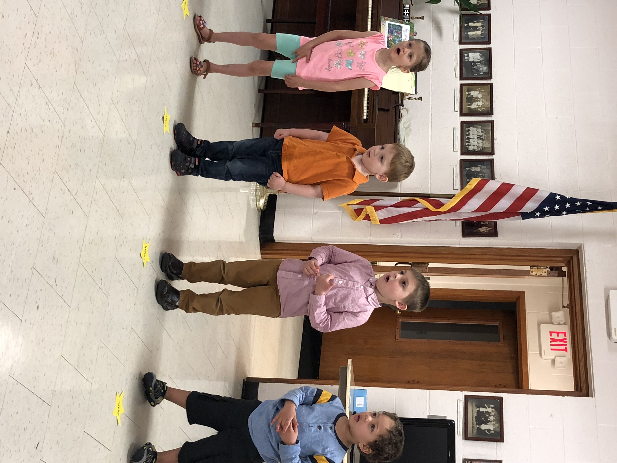

Preschool students perform for mothers and special guests at the annual Mother’s Day luncheon.

Pastor Deal and Preschool students share a prayer for those graduating this year and their families.



**Sts. Peter & Paul Little People Preschool** is now accepting registrations for the next school year. If you or someone you know are looking for a preschool that instills good Christian values and provides wonderful learning opportunities in a caring, nurturing environment, call the preschool at 724-347-3620 (Option 4) or Paula Ostheimer (724-981-5846) for more information.





**Our Second Quarter Local Mission is**

**Sts. Peter & Paul’s**

**Community Day 2019**

Scheduled for Saturday, August 3rd, this summer’s annual Community Day will shift its hours to an evening gathering.

June is the final month to donate to Community Day 2019 as your Second Quarter Local Mission. Monetary donations may be placed in pew envelopes and put in the offering plate. Please make certain to note “Local Mission” or “Community Day” on the envelope.

We are very grateful to Mike Flaugher who reached out to Thrivent and was able to get a $250.00 Action Team donation. This is about 50 % of the funds needed to finance this event.

As the event approaches, we will be counting on your man-power as well. Volunteers will be needed to solicit donations, prepare raffle baskets, set-up for the gathering, work the event, and to clean- up following its conclusion.

If interested in providing a basket for our free Chinese auction, check out the bulletin boards in the narthex and main hallway if looking for ideas for contributions or speak with Diane Riefstahl.

****

**Church Insurance Company Changed** Council Vice President Jonathan Baisch announced at the recent Voters’ Assembly Meeting that the Financial Committee has decided to switch insurance programs to Churches Mutual due to better coverage and cost. The committee also recommended going to a higher deductible based upon recent insurance history. Additionally, Jonathan reported that the Finance Committee is still pursuing the idea of a capital campaign given anticipated needs to fix or replace the roof, window insulation, doors, and add security systems.

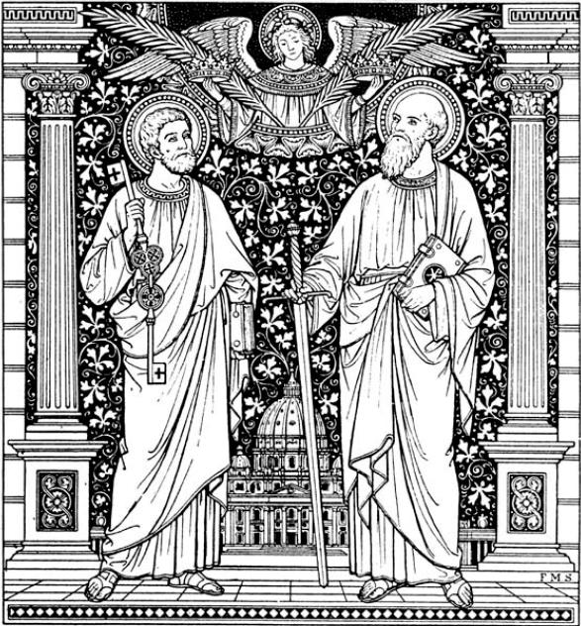

**Festival of**

**Saints Peter and Paul**

**Divine Service**

Friday, June 29, 2018

at 5 pm.

*Please join us and invite a friend!*

****

**Happy Anniversary**

**Sts. Peter & Paul’s!**

Did you know that June 3rd marks the 102nd anniversary of our congregation!

*All praise be to God!*



**Reminders**: During the summer months of June, July, & August, the cleaning staff, Ana Deal & Cheryl Fedele, will only be cleaning twice a month. Let’s all help to keep our church home looking beautiful!

Also, please submit names of high school/college graduates to Diane ASAP. Include their relationship to you and future plans. This information will be included in the July issue of “The Rock and the Sword”.