Sts. Peter & Paul
Evangelical Lutheran Church
Lutheran Church-Missouri Synod
Founded-1917

JUNE 16, 2019

699 Stambaugh Avenue
Sharon, Pennsylvania 16146

“I was glad when they said to me,
Let us go to the house of the LORD!”
Psalm 122:1
Sts. Peter & Paul Evangelical Lutheran Church, LC-MS

TRINITY SUNDAY
June 16, 2019

Silent prayer before worship: Heavenly Father, I thank You for the many blessings I enjoy each day. Jesus, I thank You for dying and rising so that I can have life now and forever. Holy Spirit, I thank You for enabling me to believe and be saved. Amen.

Please read Communion Statement found inside the Friendship Booklet prior to taking part in Holy Communion.
CONFESSION AND ABSOLUTION
Opening Hymn: LSB #947 “All Glory Be to God on High”
Stand
The sign of the cross may be made by all in remembrance of their Baptism.

P In the name of the Father and of the T Son and of the Holy Spirit.
C Amen. Matthew 28: 19b; [18:20]

P If we say we have no sin, we deceive ourselves, and the truth is not in us.
C But if we confess our sins, God, who is faithful and just, will forgive our sins and cleanse us from all unrighteousness.

Silence for reflection on God's Word and for self-examination.

P Let us then confess our sins to God our Father.
C Most merciful God, we confess that we are by nature sinful and unclean. We have sinned against You in thought, word, and deed, by what we have done and by what we have left undone. We have not loved You with our whole heart; we have not loved our neighbors as ourselves. We justly deserve Your present and eternal punishment. For the sake of Your Son, Jesus Christ, have mercy on us. Forgive us, renew us, and lead us, so that we may delight in Your will and walk in Your ways to the glory of Your holy name. Amen.
P Almighty God in His mercy has given His Son to die for you and for His sake forgives you all your sins. As a called and ordained servant of Christ, and by His authority, I therefore forgive you all your sins in the name of the Father and of the T Son and of the Holy Spirit. [John 20: 19-23]
C Amen.

Passing of the Peace.

SERVICE OF THE WORD

Introit: Ps. 8:1–2a, 3–5; antiphon: Liturgical Text
Blessèd be the Holy Trinity and the undivided | Unity.*
Let us give glory to him because he has shown his mer- | cy to us.
O | Lord, our Lord,*
how majestic is your name in | all the earth!
You have set your glory above the | heavens.*
Out of the mouth of babes and infants, you have es- | tablished strength.
When I look at your heavens, the work of your | fingers,*
the moon and the stars, which you have | set in place,
what is man that you are mind- | ful of him,*
and the son of man that you | care for him?
Yet you have made him a little lower than the heavenly | beings*
and crowned him with glory and | honor.
Glory be to the Father and | to the Son*
and to the Holy | Spirit;
as it was in the be- | ginning,*
is now, and will be forever. | Amen.
Blessèd be the Holy Trinity and the undivided | Unity.*
Let us give glory to him because he has shown his mer- | cy to us.
Kyrie Mark 10:47

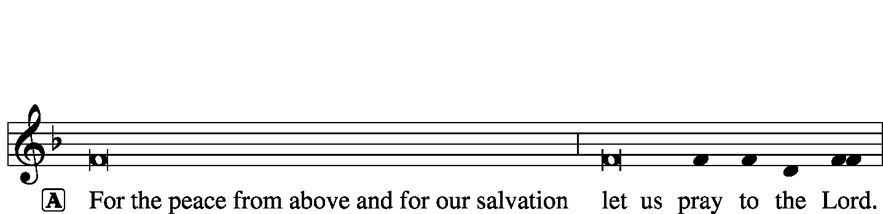
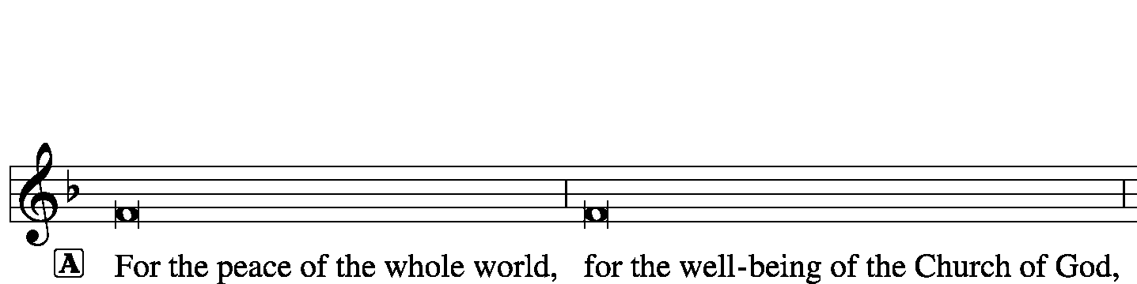
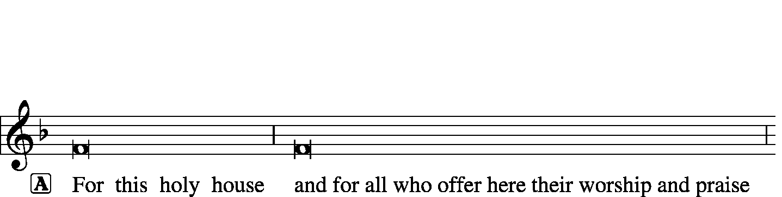
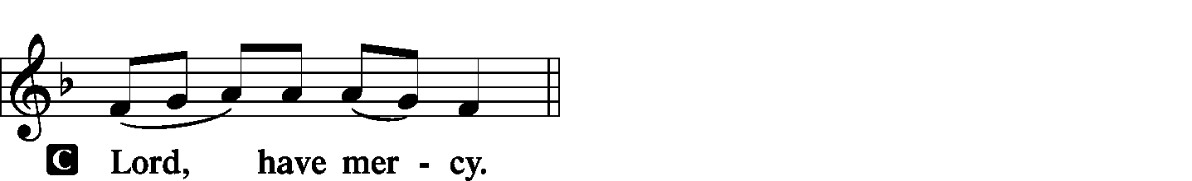
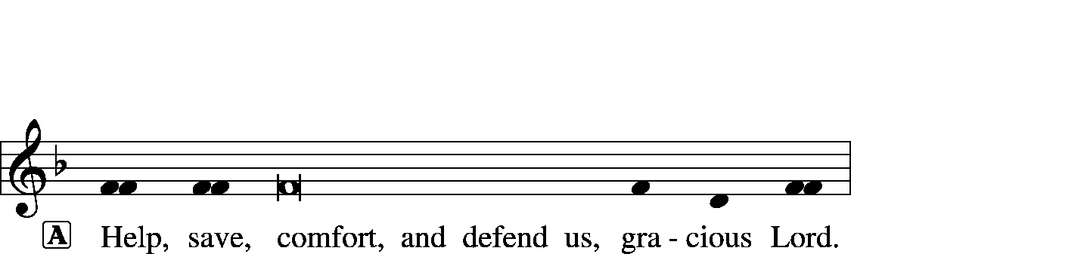

Gloria in Excelsis Luke 2: 14; John 1: 29
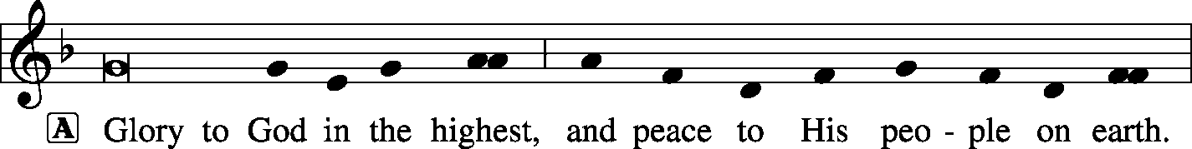
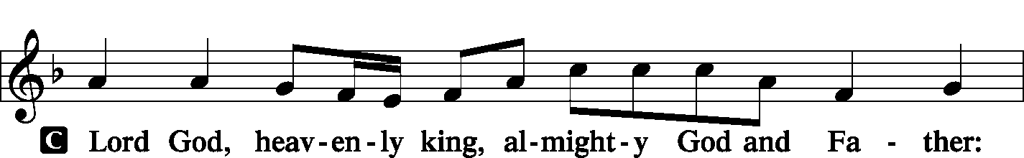
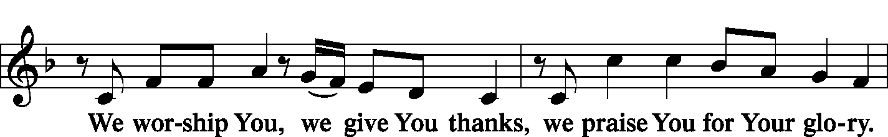
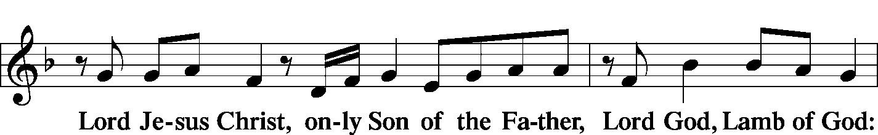
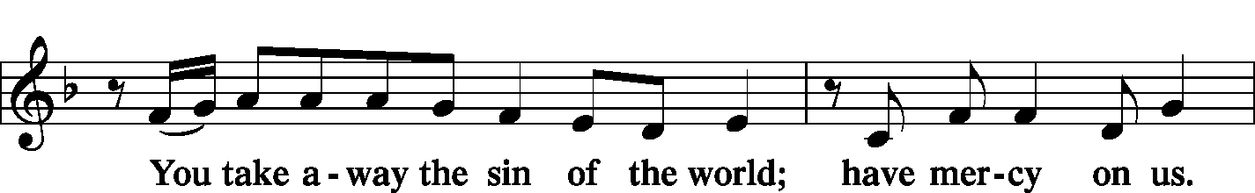
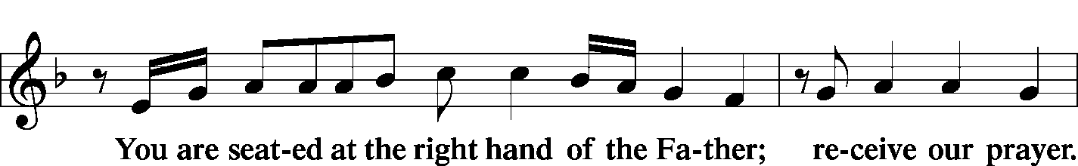
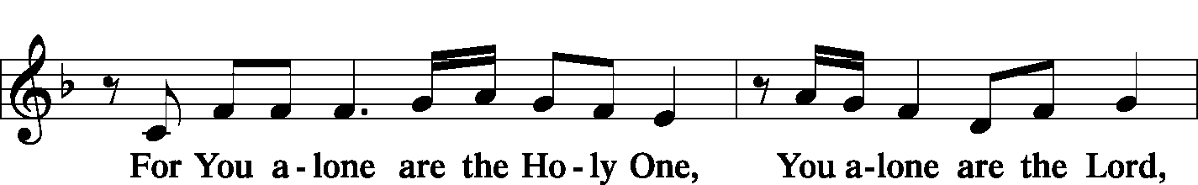
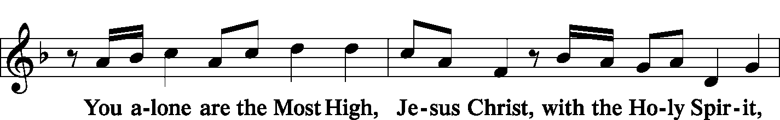
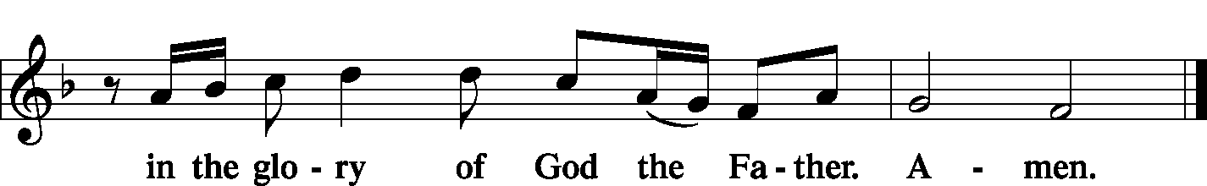

Salutation and Collect of the Day 2 Timothy 4: 22
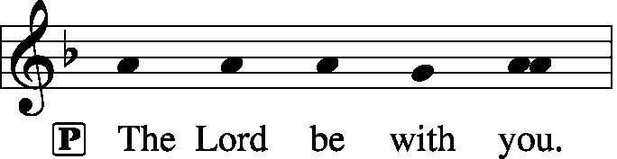
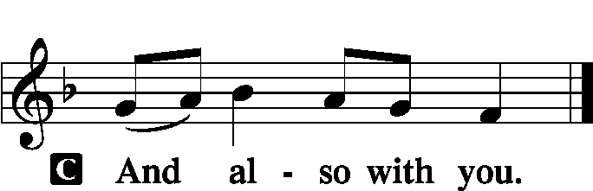

P Let us pray.
Almighty and everlasting God, You have given us grace to acknowledge the glory of the eternal Trinity by the confession of a true faith and to worship the Unity in the power of the Divine Majesty. Keep us steadfast in this faith and defend us from all adversities; for You, O Father, Son, and Holy Spirit, live and reign, one God, now and forever.

Sit

Old Testament Reading: Isaiah 6:1–7
In the year that King Uzziah died I saw the Lord sitting upon a throne, high and lifted up; and the train of his robe filled the temple. Above him stood the seraphim. Each had six wings: with two he covered his face, and with two he covered his feet, and with two he flew. And one called to another and said:
“Holy, holy, holy is the Lord of hosts;
the whole earth is full of his glory!”
And the foundations of the thresholds shook at the voice of him who called, and the house was filled with smoke. And I said: “Woe is me! For I am lost; for I am a man of unclean lips, and I dwell in the midst of a people of unclean lips; for my eyes have seen the King, the Lord of hosts!”
Then one of the seraphim flew to me, having in his hand a burning coal that he had taken with tongs from the altar. And he touched my mouth and said: “Behold, this has touched your lips; your guilt is taken away, and your sin atoned for.”

P This is the Word of the Lord.
C Thanks be to God.

Gradual: Liturgical Text
Blessèd are You, O Lord, who beholds the deep,
and who dwells between the cherubim.
Blessèd are You, O Lord, in the firmament of heaven,
and greatly to be praised forever.

Epistle: Romans 11:33–36
Oh, the depth of the riches and wisdom and knowledge of God! How unsearchable are his judgments and how inscrutable his ways!
“For who has known the mind of the Lord,
or who has been his counselor?”
“Or who has given a gift to him
that he might be repaid?”
For from him and through him and to him are all things. To him be glory forever. Amen.

P This is the Word of the Lord.
C Thanks be to God.

Stand

Verse of the Day: Liturgical Text
Alleluia. Blessed are you, O Lord God of our fathers, and greatly to be praised and glorified forever. Alleluia.

Common Alleluia
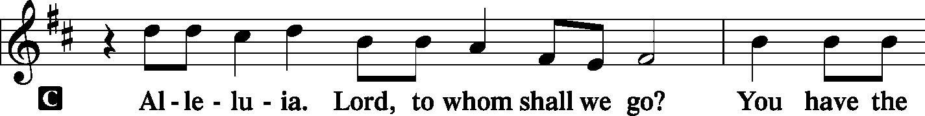
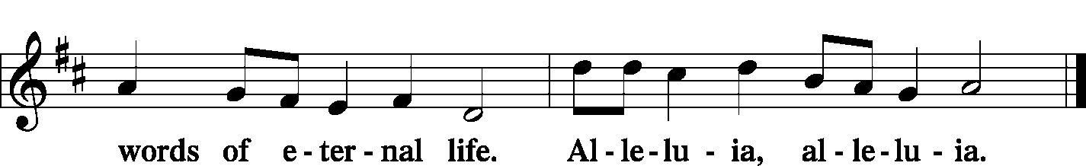

Holy Gospel: John 3:1–15
P The Holy Gospel according to St. John, the third chapter.

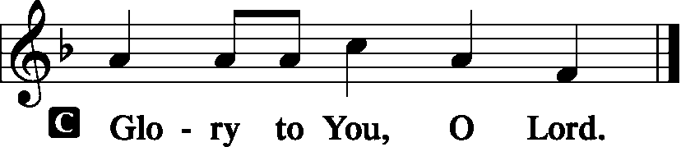

Now there was a man of the Pharisees named Nicodemus, a ruler of the Jews. This man came to Jesus by night and said to him, “Rabbi, we know that you are a teacher come from God, for no one can do these signs that you do unless God is with him.” Jesus answered him, “Truly, truly, I say to you, unless one is born again he cannot see the kingdom of God.” Nicodemus said to him, “How can a man be born when he is old? Can he enter a second time into his mother’s womb and be born?” Jesus answered, “Truly, truly, I say to you, unless one is born of water and the Spirit, he cannot enter the kingdom of God. That which is born of the flesh is flesh, and that which is born of the Spirit is spirit. Do not marvel that I said to you, ‘You must be born again.’ The wind blows where it wishes, and you hear its sound, but you do not know where it comes from or where it goes. So it is with everyone who is born of the Spirit.”
Nicodemus said to him, “How can these things be?” Jesus answered him, “Are you the teacher of Israel and yet you do not understand these things? Truly, truly, I say to you, we speak of what we know, and bear witness to what we have seen, but you do not receive our testimony. If I have told you earthly things and you do not believe, how can you believe if I tell you heavenly things? No one has ascended into heaven except he who descended from heaven, the Son of Man. And as Moses lifted up the serpent in the wilderness, so must the Son of Man be lifted up, that whoever believes in him may have eternal life.

P This is the Gospel of the Lord.
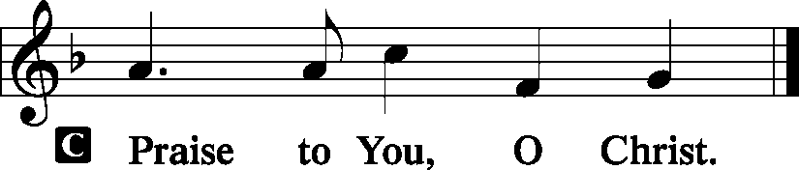

Athanasian Creed (in three parts):
C Whoever desires to be saved must, above all, hold the catholic faith.
Whoever does not keep it whole and undefiled will without doubt perish eternally.
And the catholic faith is this,
that we worship one God in Trinity and Trinity in Unity, neither confusing the persons nor dividing the substance.
For the Father is one person, the Son is another, and the Holy Spirit is another.
But the Godhead of the Father and of the Son and of the Holy Spirit is one: the glory equal, the majesty coeternal.

LSB#506 “Glory Be to God the Father”, v. 1
Glory be to God the Father, Glory be to God the Son,
Glory be to God the Spirit: Great Jehovah, Three in One!
Glory, glory While eternal ages run!

C Such as the Father is, such is the Son, and such is the Holy Spirit:
the Father uncreated, the Son uncreated, the Holy Spirit uncreated;
the Father infinite, the Son infinite, the Holy Spirit infinite;
the Father eternal, the Son eternal, the Holy Spirit eternal.
And yet there are not three Eternals, but one Eternal,
just as there are not three Uncreated or three Infinites, but one Uncreated and one Infinite.
In the same way, the Father is almighty, the Son almighty, the Holy Spirit almighty;
and yet there are not three Almighties, but one Almighty.

LSB#506 “Glory Be to God the Father”, v. 2
Glory be to Him who loved us, Washed us from each spot and stain;
Glory be to Him who bought us, Made us kings with Him to reign!
Glory, glory To the Lamb that once was slain!

C So the Father is God, the Son is God, the Holy Spirit is God;
and yet there are not three Gods, but one God.
So the Father is Lord, the Son is Lord, the Holy Spirit is Lord;
and yet there are not three Lords, but one Lord.
Just as we are compelled by the Christian truth to acknowledge each distinct person as God and Lord, so also are we prohibited by the catholic religion to say that there are three Gods or Lords.
The Father is not made nor created nor begotten by anyone.
The Son is neither made nor created, but begotten of the Father alone.
The Holy Spirit is of the Father and of the Son, neither made nor created nor begotten, but proceeding.
Thus, there is one Father, not three Fathers; one Son, not three Sons; one Holy Spirit, not three Holy Spirits.
And in this Trinity none is before or after another; none is greater or less than another;
but the whole three persons are coeternal with each other and coequal, so that in all things, as has been stated above, the Trinity in Unity and Unity in Trinity is to be worshiped.
Therefore, whoever desires to be saved must think thus about the Trinity.

LSB#506 “Glory Be to God the Father”, v. 3
Glory to the King of angels, Glory to the Church’s King,
Glory to the King of nations; Heav’n and earth, your praises bring!
Glory, glory To the King of glory sing!

C But it is also necessary for everlasting salvation that one faithfully believe the incarnation of our Lord Jesus Christ.
Therefore, it is the right faith that we believe and confess that our Lord Jesus Christ, the Son of God, is at the same time both God and man.
He is God, begotten from the substance of the Father before all ages; and He is man, born from the substance of His mother in this age:
perfect God and perfect man, composed of a rational soul and human flesh;
equal to the Father with respect to His divinity, less than the Father with respect to His humanity.
Although He is God and man, He is not two, but one Christ:
one, however, not by the conversion of the divinity into flesh, but by the assumption of the humanity into God;
one altogether, not by confusion of substance, but by unity of person.

LSB#506 “Glory Be to God the Father”, v. 4
Glory, blessing, praise eternal! Thus the choir of angels sings;
Honor, riches, pow’r, dominion! Thus its praise creation brings.
Glory, glory, Glory to the King of kings!

C For as the rational soul and flesh is one man, so God and man is one Christ,
who suffered for our salvation, descended into hell, rose again the third day from the dead,
ascended into heaven, and is seated at the right hand of the Father, God Almighty, from whence He will come to judge the living and the dead.
At His coming all people will rise again with their bodies and give an account concerning their own deeds.
And those who have done good will enter into eternal life, and those who have done evil into eternal fire.
This is the catholic faith; whoever does not believe it faithfully and firmly cannot be saved.

Sermon
Stand
Prayer of the Church [Timothy 2: 1-4]

Sit

Offertory Psalm 116: 12-13, 17-19
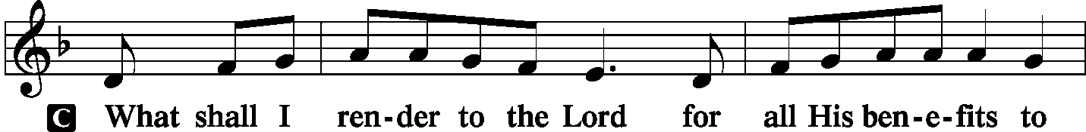
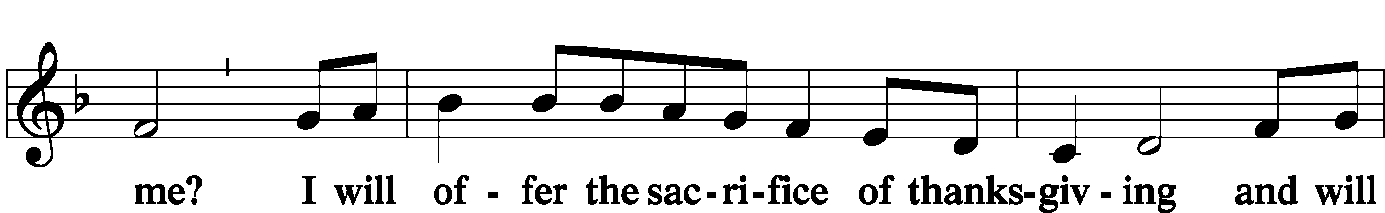
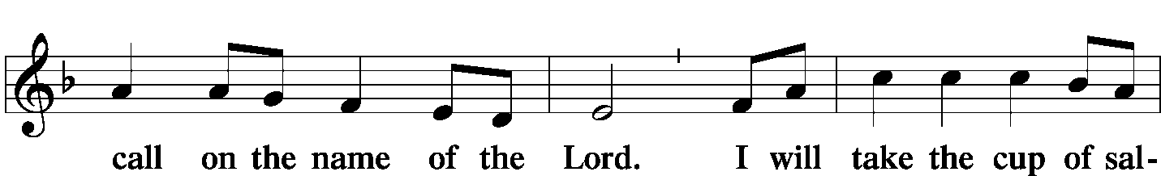
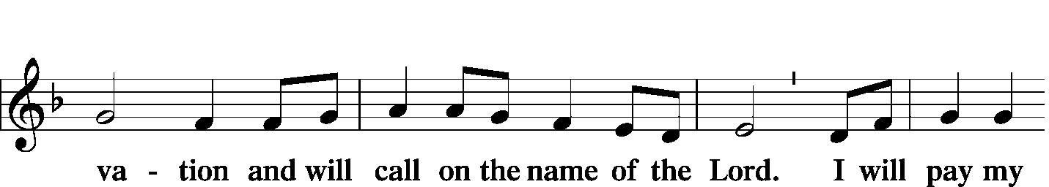
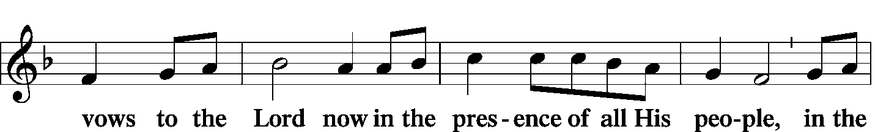
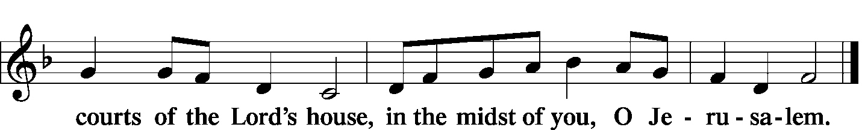

Offering/Offering Hymn: LSB p. 223 “Te Deum”
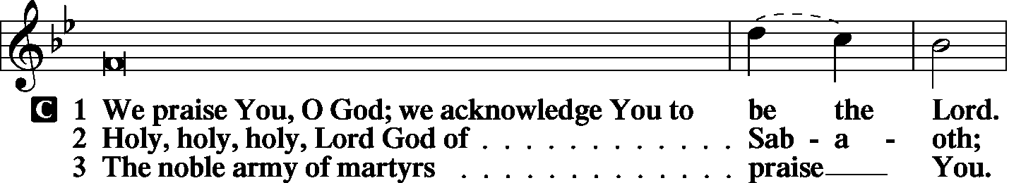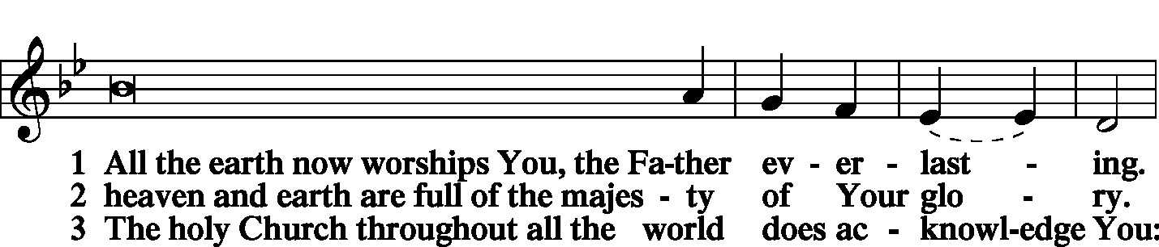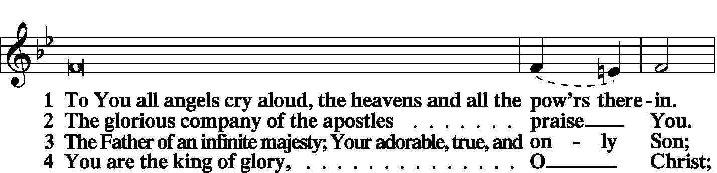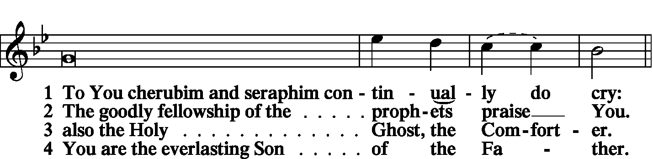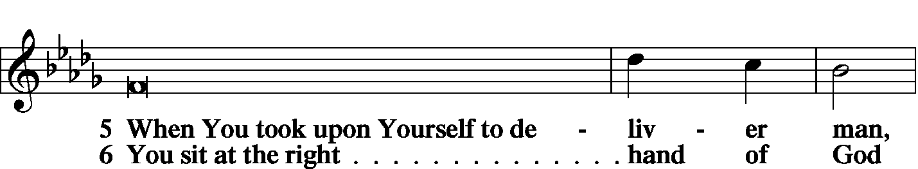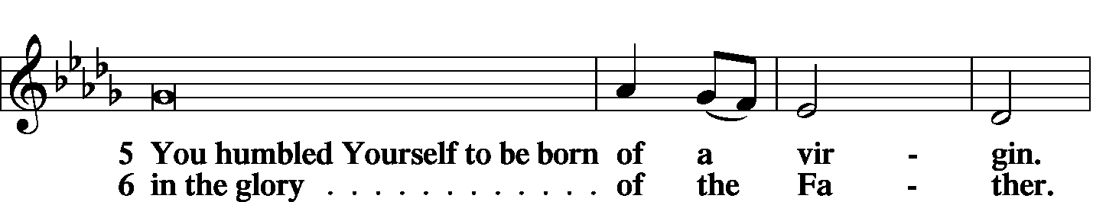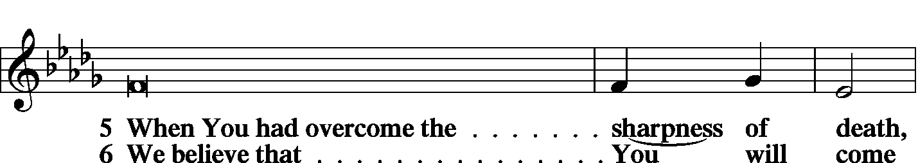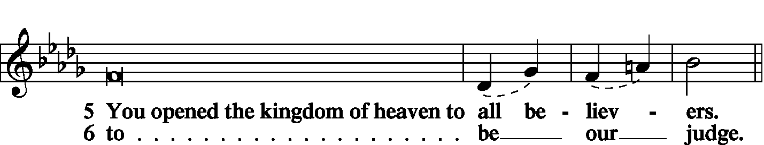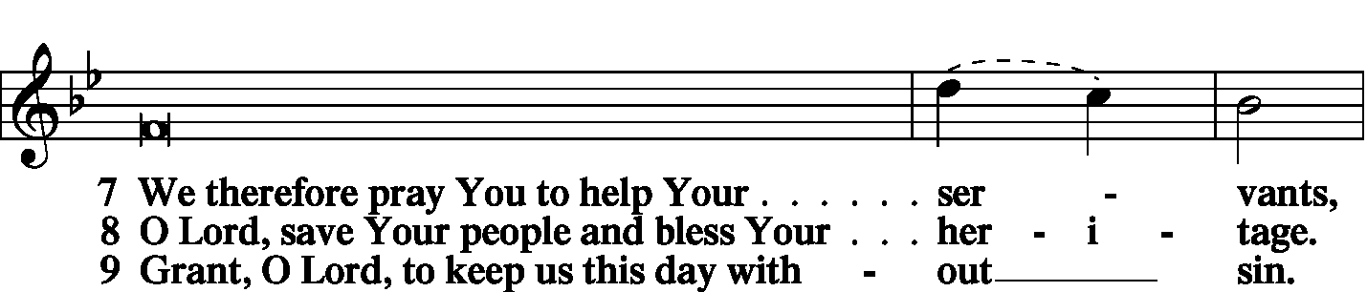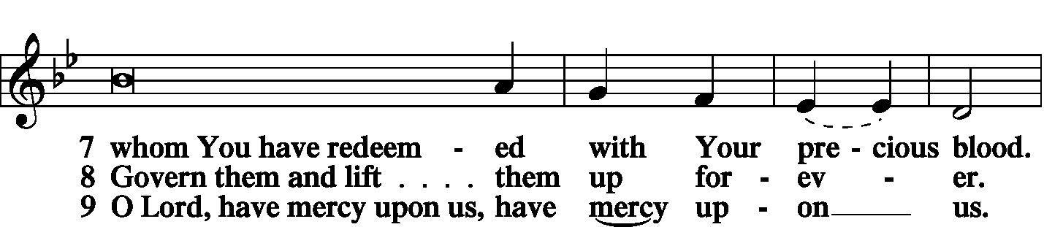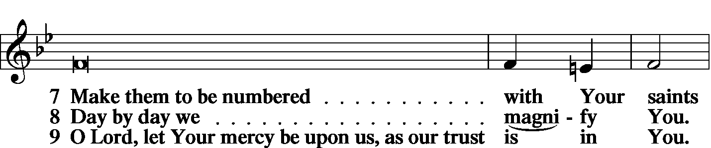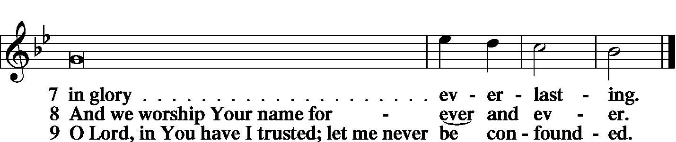

Stand
SERVICE OF THE SACRAMENT
Preface
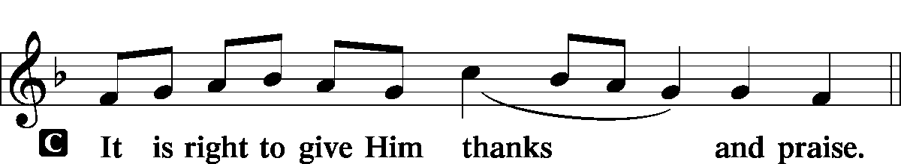

P It is truly meet, right, and salutary … evermore praising You and saying:

Sanctus
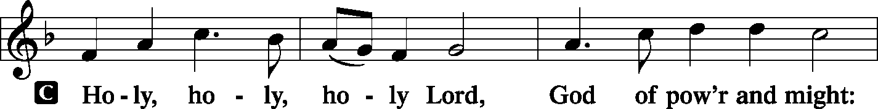
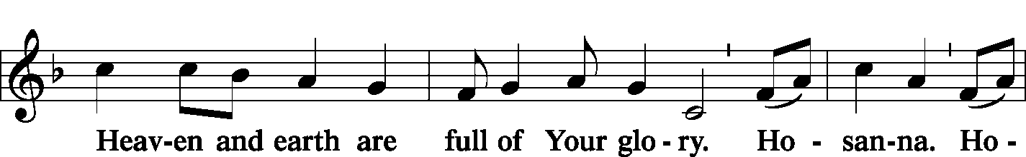
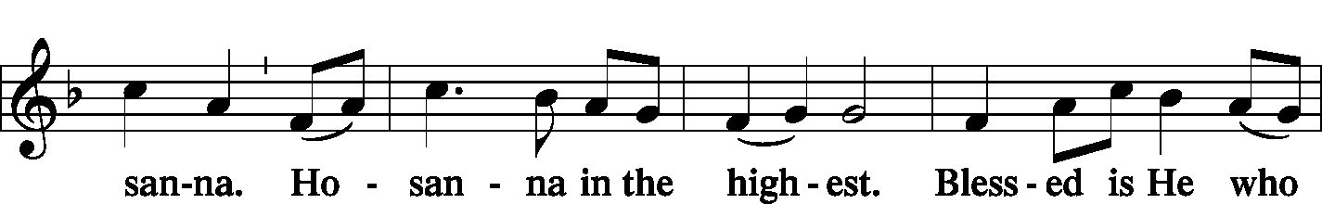
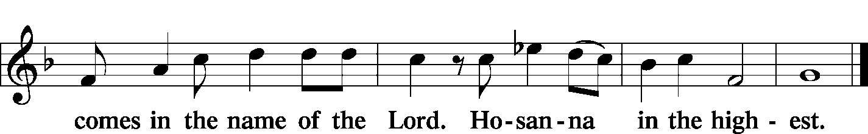

Lord's Prayer Matthew 6: 9-13
P Lord, remember us in Your kingdom and teach us to pray:
C Our Father who art in heaven,
hallowed be Thy name,
Thy kingdom come,
Thy will be done on earth as it is in heaven;
give us this day our daily bread;
and forgive us our trespasses as we forgive those who trespass against us;
and lead us not into temptation,
but deliver us from evil.
For Thine is the kingdom and the power and the glory forever and ever. Amen.

The Words of Our Lord Matthew 26: 26-28; Mark 14: 22-24
Luke 22: 19-20; 1 Corinthians 11: 23-25
P Our Lord Jesus Christ, on the night when He was betrayed, took bread, and when He had given thanks, He broke it and gave it to the disciples and said: “Take, eat; this is My T body, which is given for you. This do in remembrance of Me.”

P In the same way also He took the cup after supper, and when He had given thanks, He gave it to them, saying: “Drink of it, all of you; this cup is the new testament in My T blood, which is shed for you for the forgiveness of sins. This do, as often as you drink it, in remembrance of Me.”

Pax Domini John 20: 19
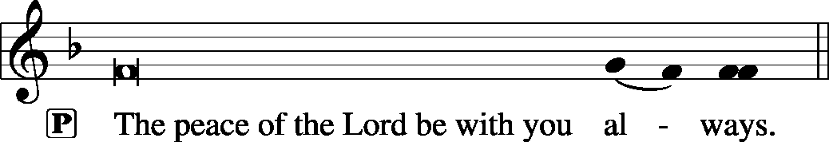

Agnus Dei John 1: 29
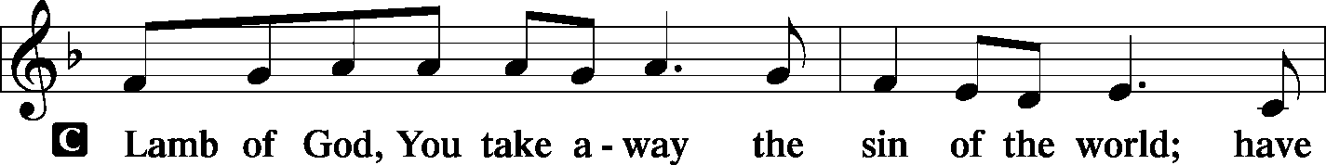
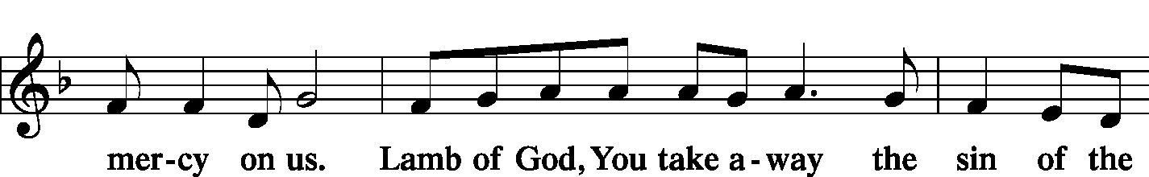
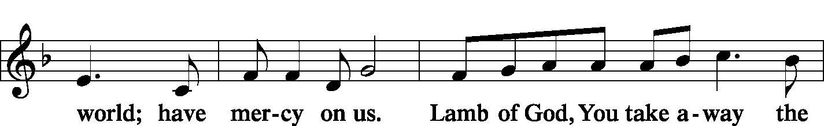
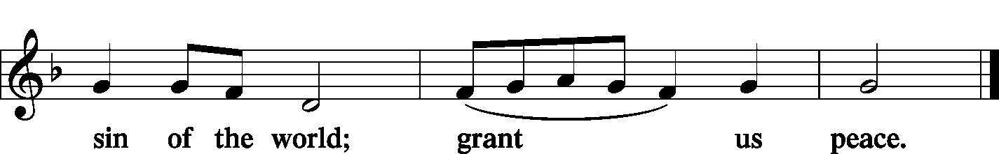

Sit

Distribution
The pastor and those who assist him receive the body and blood of Christ first and then distribute them to those who come to receive, saying:

Take, eat; this is the true body of our Lord and Savior Jesus Christ, given into death for your sins.
Amen.

Take, drink; this is the true blood of our Lord and Savior Jesus Christ, shed for the forgiveness of your sins.
Amen.
In dismissing the communicants, the following is said:
P The body and blood of our Lord Jesus Christ strengthen and preserve you in body and soul to life everlasting. Depart T in peace.
C Amen.

Distribution Hymn: LSB #507 “Holy, Holy, Holy”
Stand
Nunc Dimittis Luke 2: 29-32
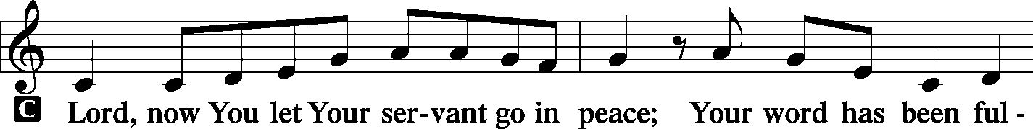
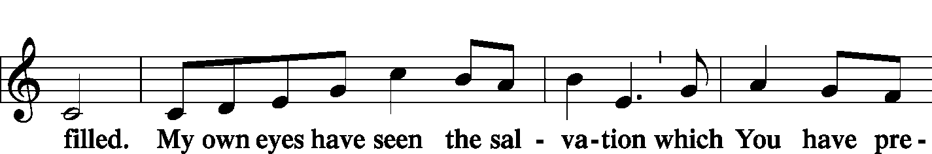
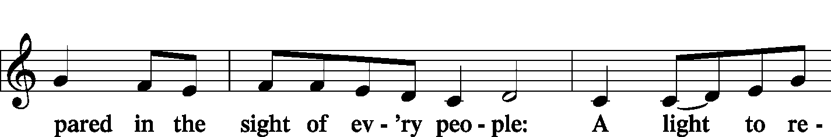
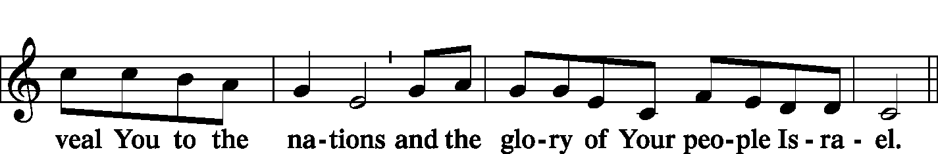
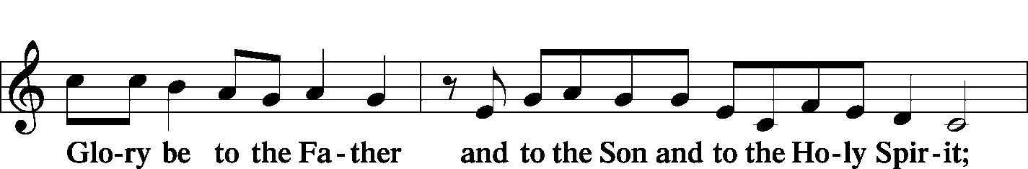
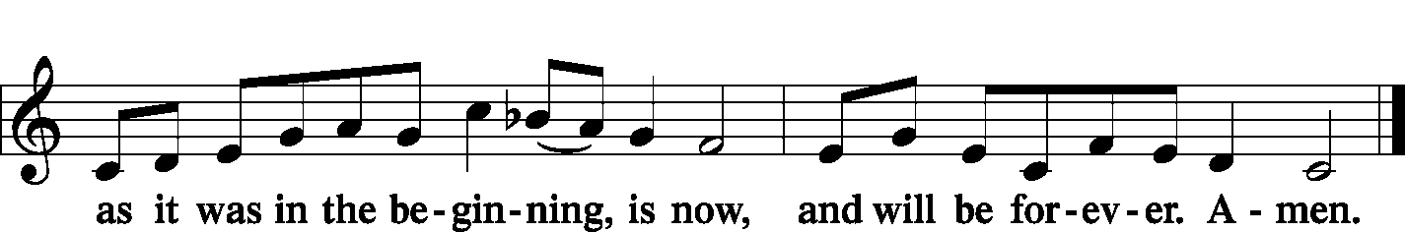

Post-Communion Collect Let us pray.

P We give thanks to You, almighty God, that You have refreshed us through this salutary gift, and we implore You that of Your mercy You would strengthen us through the same in faith toward You and fervent love toward one another; through Jesus Christ, Your Son, our Lord, who lives and reigns with You and the Holy Spirit, one God, now and forever.

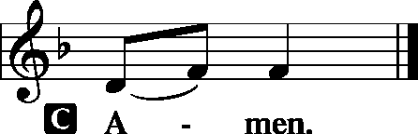

Benediction Numbers 6: 24-26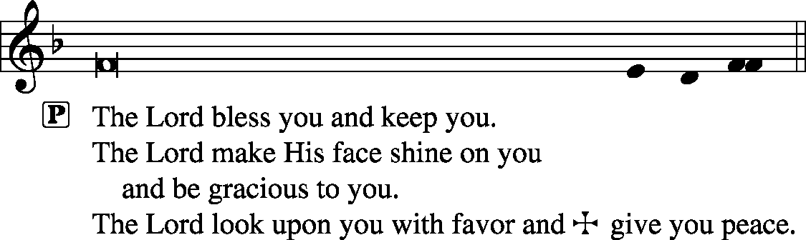

Closing Hymn: LSB #940 “Holy God, We Praise Thy Name”
Silent prayer after worship: O almighty God, Father, Son and Holy Spirit, by Your grace, enable me to believe and trust even without understanding. Lead me to be in Your Word so that I may grow in my trust in You and my love for You above all things. Amen.

Acknowledgments: Divine Service, Setting One from Lutheran Service Book Unless otherwise indicated, all scripture quotations are from The Holy Bible, English Standard Version, copyright © 2001 by Crossway Bibles, a division of Good News Publishers. Used by permission. All rights reserved. Created by Lutheran Service Builder © 2006 Concordia Publishing House. CCLI License #3029-446

Attendance: Saturday, June 8, and Sunday, June 9, 2019………….………61
Please sign the Friendship Book and give your sheet to an usher after the offering.

Jim and Kathy McGowan would like to invite the members of Sts. Peter and Paul to Madi's graduation celebration! It will take place on Friday, June 21st from 5 to 9 at The Refuge located at 1155 Churchill-Hubbard Rd. Youngstown, Ohio 44505.

Thank You for Serving in June:
Today’s Greeters: Ralph Dorman & Diane Riefstahl. Assisting Elders: Ralph Dorman & John Dyll. Ushers: Bob Sulek, Hugh Owen, Cheryl Fedele, Jesse Riffle, & Ralph Dorman (alternate). Altarware: Eileen Burns & Ruth Meszaros.
June Greeters: 23~John Dyll & Mark Gabriel; 30~Rev. Ed & Irene Kucera


Best wishes for a blessed Father’s Day to all the fathers in our congregation!


In Honor of Granddaughter Abigail Burns’ Graduation: Gary & Eileen Burns (Food Pantry).
In Loving Memory of Patricia Brandes: Gary & Eileen Burns (Food Pantry), Anson & Hank Holcroft, Max & Lisa Jelinek, and Rev. & Mrs. Ed Kucera (Missions).
In Loving Memory of Sophia Mihm: Gary & Eileen Burns (Food Pantry), Anson & Hank Holcroft, Ruth Meszaros (Major Repair), Patty Parker (Major Repair), Viola Sakony, Cathy Smith, Pat & Don Voytik (Altar Guild), Mr. & Mrs. Edward Zachar, Ladies of the Altar Guild Society, Lisa & Max’s wonderful neighbor (Food Pantry), and Max’s co-workers at John XXIII (Food Pantry).
In Loving Memory of Gene Roberts: Jeff & Stacy Brandes (Food Pantry), Viola Sakony, and Pat & Don Voytik (Major Repair).
In Loving Memory of Caroline Swartzbeck: Gary & Eileen Burns (Food Pantry).
In Loving Memory of Clara Wojtanowski: Gary & Eileen Burns (Food Pantry).

SCHEDULE FOR TODAY THROUGH JUNE 23rd:
:

:

Today, 7 pm, Downstairs….…………….…………………..………………….……...……AA Meeting
Thursday, 8 pm, ……………………………………………….………….….Young Adult Bible Study
Saturday, 5 pm, Chapel…………………….……………………….....…...Saturday Divine Service
Next Sunday, 8:45 am, Downstairs………………………………………………..………Bible Study
10 am, Sanctuary…...........................................................................Divine Service
Following Worship, Sonshine Room….……Community Day Planning Meeting
7 pm, Downstairs…………………………………………..…………………......…AA Meeting

Pastor Deal will be on jury duty this week. Please be sure to phone the church office if needing to get into the building to make certain someone is here to let you in.
Additionally, there will be NO new members’ class Monday, June 17th.

The Altar Flowers this morning are given by Hugh Owen in honor of his daughter, Liz Miller’s, birthday and Father’s Day. We sincerely appreciate this generous gift!

Bible Memory Verses: For the week of June 16th:
For Children: Holy, holy, holy is the Lord of hosts; the whole earth is full of his glory!
Isaiah 6:3
For Adults: All authority in heaven and on earth has been given to me. Go therefore and make disciples of all nations, baptizing them in the name of the Father and of the Son and of the Holy Spirit. Matthew 28:18b-19

Our Stewardship of Treasures for the Lord:
In order to do the Lord’s work, we need $2,882.02* each week to meet our 2019 budget for general purposes and $38.46 for missions.
Saturday, June 8 and Sunday, June 9, 2019:
General Offering: $1,885.00 Behind this week*: -$997.02
SELC Missions: $100.00 Ahead this week: +$61.54
Local Missions: $0.00
Preschool Tuition: $0.00
Other Offerings: $305.00 *Includes preschool tuition.

As of June 1, 2019, the balance in the Major Repair Fund was $15,814.34.

Included in your bulletin this morning is a special insert and envelope for donations to the 2019-2021 LCMS National Offering. This special collection will help set the tone for the next triennium under the theme “Joy to the World”, preparing hearts for prayerful rejoicing, gratitude and bold action.
Please consider donating to this LCMS mission.


Remember the following in Prayer…
~The Hurting and Healing: Tony⁴, Lois Bortner^{CA}, Richard Brandes³, Eileen Burns³, Beverly Chlpka⁴, Anne Colt¹, Kim⁴, Tim Dudash⁴, John Dyll³, Jennifer Hilliard³,Anson Holcroft³, Betty Knauff^{CA}, Regis Knauff⁴, Clara Krivosh, Jess Lavoie², Paul Lucas^{CA}, Barry Nelson⁴, David Nelson¹,Tom Mulligan^{CA}, Iona Oltman^{CA}, Hugh Owen⁴, Rudy Pinal^{CA}, Ashley & Dale Weaver and their baby⁴, and Angela Weser^{CA}.
~Our Homebound: Helen Bender, Dan Davis, Edna Krajci, Mary Ann Krajci, Marion Roberts, Barbara Vasconi, and Joanne Wolfe.
~Celebrating: Birthdays: Rudy Tomko (06.20) and Sue Bender (06.21).
~Serving in the Military: Clayton Drnek, Curtis Sinewe, and Joshua Solyan.
~Community & World Needs: Victims of violence and terrorism; those suffering from loss and dislocation because weather disasters; those suffering from addiction and their families; Local, State, and National Government Leaders; Safety for all Police Officers, Firefighters, & First Responders; the unemployed; our Second Quarter Local Mission: Sts. Peter & Paul’s Third Annual Community Day.
*CA represents cancer; number after other names represents weeks on the prayer list. After 4 weeks names may be resubmitted. This helps us to remember people’s specific needs and reminds us that God is providing healing as people get better and no longer need our prayers. Please submit prayer requests in writing to the church office.
Please keep those listed above in your prayers.

Word of Hope: 1-888-217-8679
The only 24/7 CONFIDENTIAL Hotline that is distinctly Lutheran, bringing healing found in Christ, to those whose hearts have been broken by abortion.

Members of the Community Day planning committee are reminded of the meeting scheduled for next Sunday, June 23rd following worship. Please be prepared to report on progress made in the area(s) for which you are responsible.

A very special “thanks” to Pastor Kucera for his participation in this morning’s service.
Here to Serve You…

Pastor………………………………………………….………..…Rev. Jacob Deal
E-mail…………………………….…..pastordeal@stspeterandpaullcms.org
Cell Number………………………………………………….……….724-977-1682
Church Office………………………………….……………………..724-347-3620
Website…………………………….………….www.stspeterandpaullcms.org
Secretaries………………………….…….StacyBrandes & Diane Riefstahl
E-mail……………………………….…secretary@stspeterandpaullcms.org
Food Pantry: John Dyll…………….……………………..…..…724-347-1779
Little People Preschool…………….……………..……….….…..724-347-5655
Teacher: Paula Ostheimer………….………………….…….....724-981-5846
AA Contact: Steve……………………….…………..……...……. 724-813-2358
Choir Director……………..…………….…………..….….………Chris Nelson
Organist……………..…………….…………….……..….…………..……Lisa Orr
Congregational President……………………..…..….…………Jeff Brandes

In general, the secretary’s office is open Monday and Thursdays from 8:30 am -4:30 pm. Pastor Deal is here throughout the week, except Fridays or when ministering offsite. If you need to enter the Church, please call ahead to be sure someone is here to let you in. Thank you.


