Sts. Peter & Paul
Evangelical Lutheran Church
Lutheran Church-Missouri Synod
Founded-1917

June 11, 2023

699 Stambaugh Ave.
Sharon, Pennsylvania 16146

“I was glad when they said to me,
Let us go to the house of the LORD!”
Psalm 122:1
Sts. Peter & Paul Evangelical Lutheran Church, LC-MS
FIRST SUNDAY AFTER TRINITY
June 11, 2023

A special welcome to our guests this day! If you would like more information about The Lutheran Church - Missouri Synod, or this congregation, please speak with Pastor Deal or an Elder after the service.
Members & Guests: Don’t be embarrassed if your children make noise during the worship service, all children do. We encourage families to worship together but, if you feel the need, there are pews in the rear of the Church which are reserved for young families on both sides of the sanctuary. There is also a quiet room available to you during our service which is located down the hallway past the offices on the right side of the church as well as a children’s area in the Fellowship Hall where you are able to follow along with the service.

Today’s service includes the Sacrament of Holy Communion. If during this past year, you have not worshipped with us and been communed, we respectfully ask that you do not partake of this sacrament this day before first speaking with Pastor Deal.
If visiting from a sister congregation of the LC-MS and are in good standing, please inform Pastor Deal of your desire to commune prior to the service.
If wishing to receive a blessing during communion, please approach with your arms crossed.

CONTACT INFORMATION
Pastor Deal: pastordeal@saintspeterandpaul.net or 724-347-3620 (opt. 2)
Church Office: church@saintspeterandpaul.net or 724-347-3620 (opt. 3)
Secretary’s Office will be open Monday (8:30-5) and Thursday (8:30-10; 11-5) this week.

Silent prayer before worship: Dear God, You sent Your only begotten Son to suffer and die so that all who believe in him may heave eternal life. Lead me to worship You with a loving, joyful and thankful heart. In Jesus’ name. Amen.
Confession and Absolution

Opening Hymn: LSB #760 “What God Ordains Is Always Good”

Stand

The sign of the cross may be made by all in remembrance of their Baptism.

Invocation
P In the name of the Father and of the T Son and of the Holy Spirit.
C Amen.

Exhortation Hebrews 10:22; Psalm 124:8; Psalm 32:5
P Beloved in the Lord! Let us draw near with a true heart and confess our sins unto God our Father, beseeching Him in the name of our Lord Jesus Christ to grant us forgiveness.

P Our help is in the name of the Lord,
C who made heaven and earth.
P I said, I will confess my transgressions unto the Lord,
C and You forgave the iniquity of my sin.

Silence for reflection on God’s Word and for self-examination.

Confession of Sins
P O almighty God, merciful Father,
C I, a poor, miserable sinner, confess unto You all my sins and iniquities with which I have ever offended You and justly deserved Your temporal and eternal punishment. But I am heartily sorry for them and sincerely repent of them, and I pray You of Your boundless mercy and for the sake of the holy, innocent, bitter sufferings and death of Your beloved Son, Jesus Christ, to be gracious and merciful to me, a poor, sinful being.

Absolution [John 20:19–23]
P Upon this your confession, I, by virtue of my office, as a called and ordained servant of the Word, announce the grace of God unto all of you, and in the stead and by the command of my Lord Jesus Christ I forgive you all your sins in the name of the Father and of the T Son and of the Holy Spirit.
C Amen.

Service of the Word

Introit Psalm 13:1–4; antiphon: vv. 5–6
[O Lord,] I have trusted in your | steadfast love;*
my heart shall rejoice in your sal- | vation.
I will sing | to the Lord,*
because he has dealt bountifully | with me.
How long, O Lord? Will you forget me for- | ever?*
How long will you hide your | face from me?
How long must I take counsel in my soul and have sorrow in my heart | all the day?*
How long shall my enemy be exalted | over me?
Consider and answer me, O | Lord my God;*
light up my eyes, lest I sleep the | sleep of death,
lest my enemy say, “I have prevailed | over him,”*
lest my foes rejoice because I am | shaken.
[O Lord,] I have trusted in your | steadfast love;*
my heart shall rejoice in your sal- | vation.
I will sing | to the Lord,*
because he has dealt bountifully | with me.

Gloria Patri
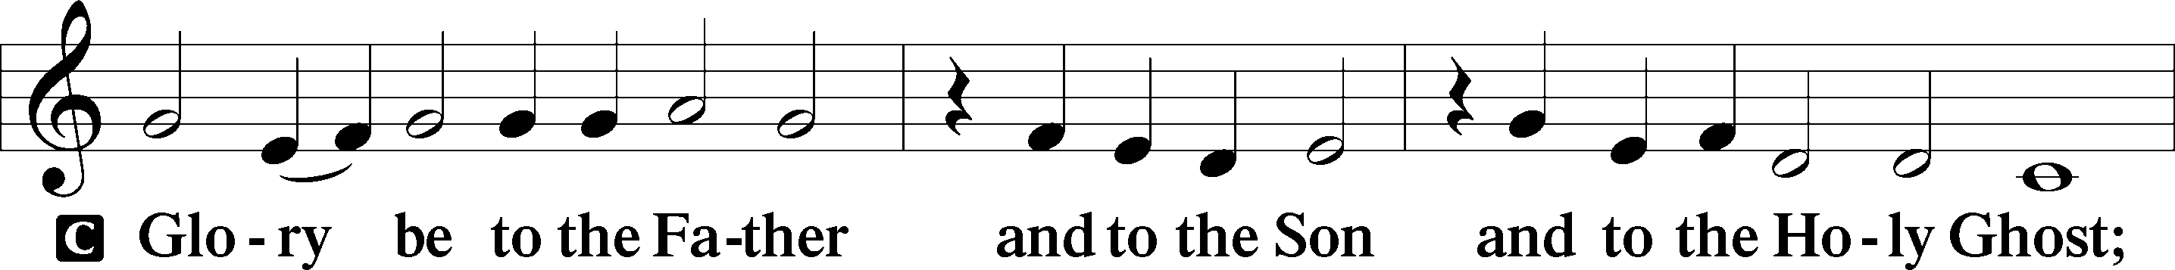
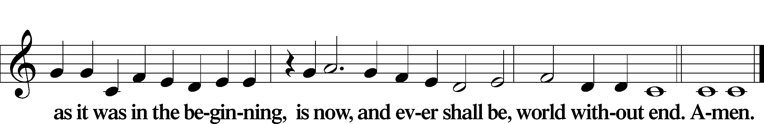

Kyrie Mark 10:47
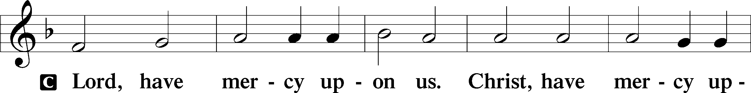
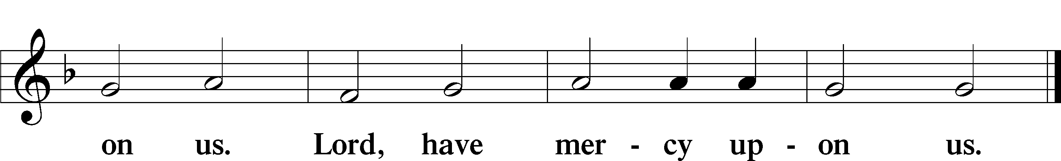

Gloria in Excelsis Luke 2:14; John 1:29
P Glory be to God on high:
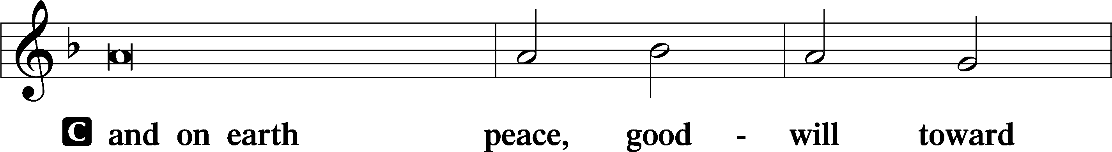
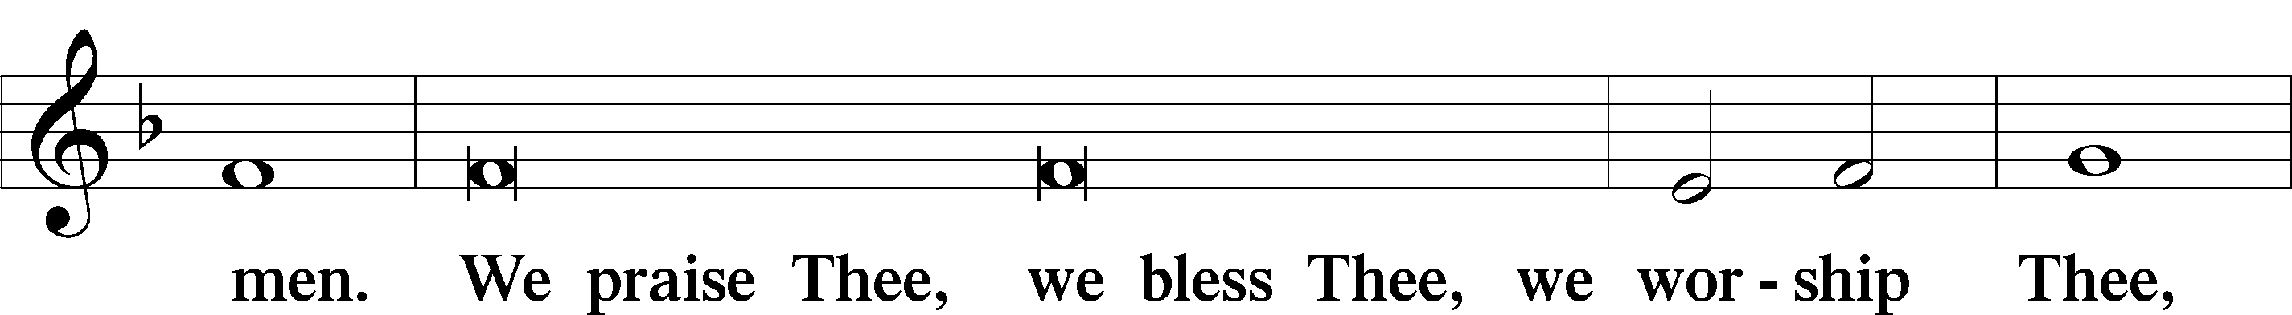
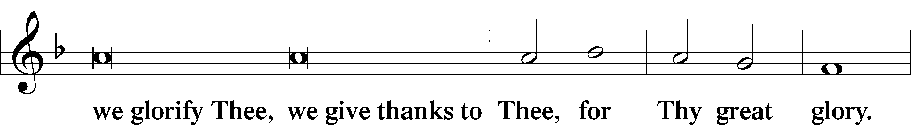
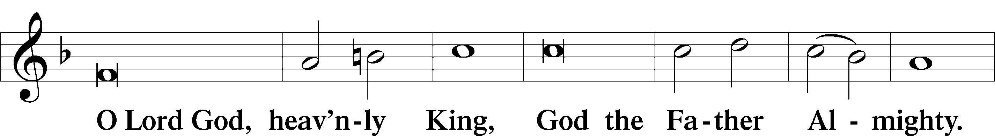
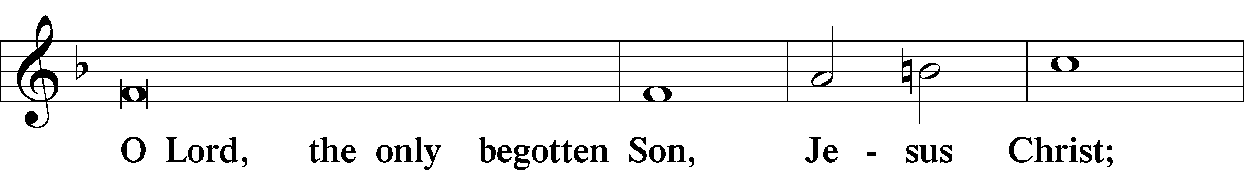
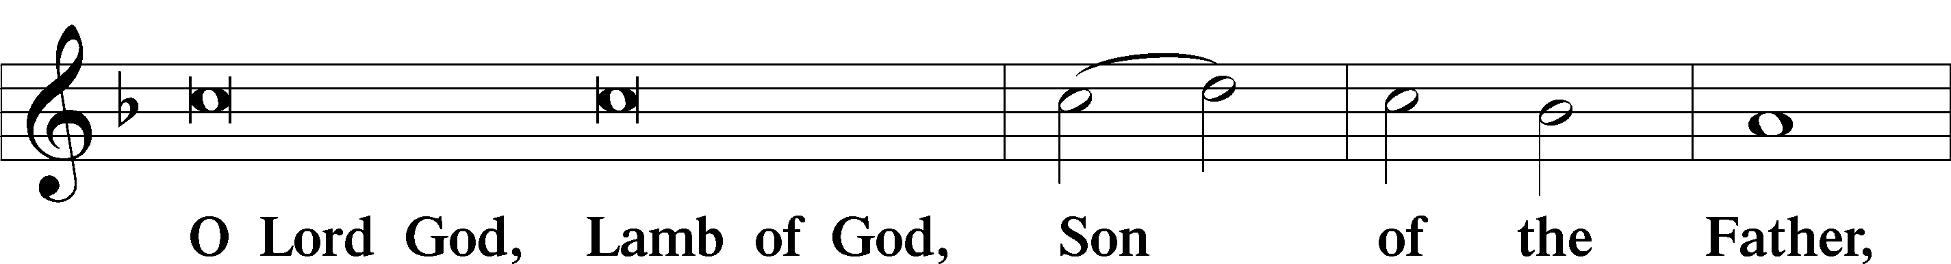
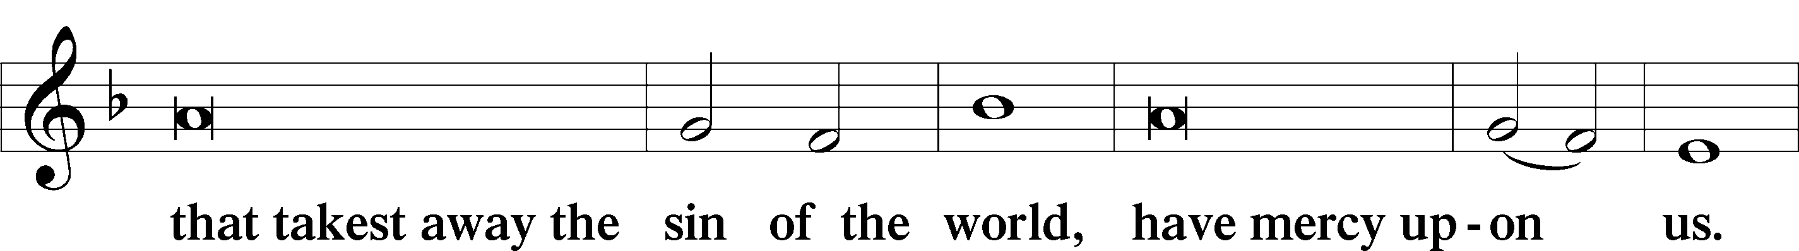
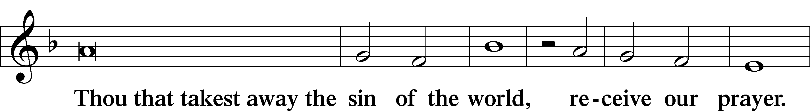
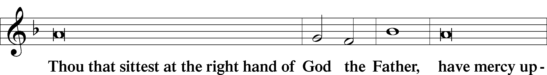
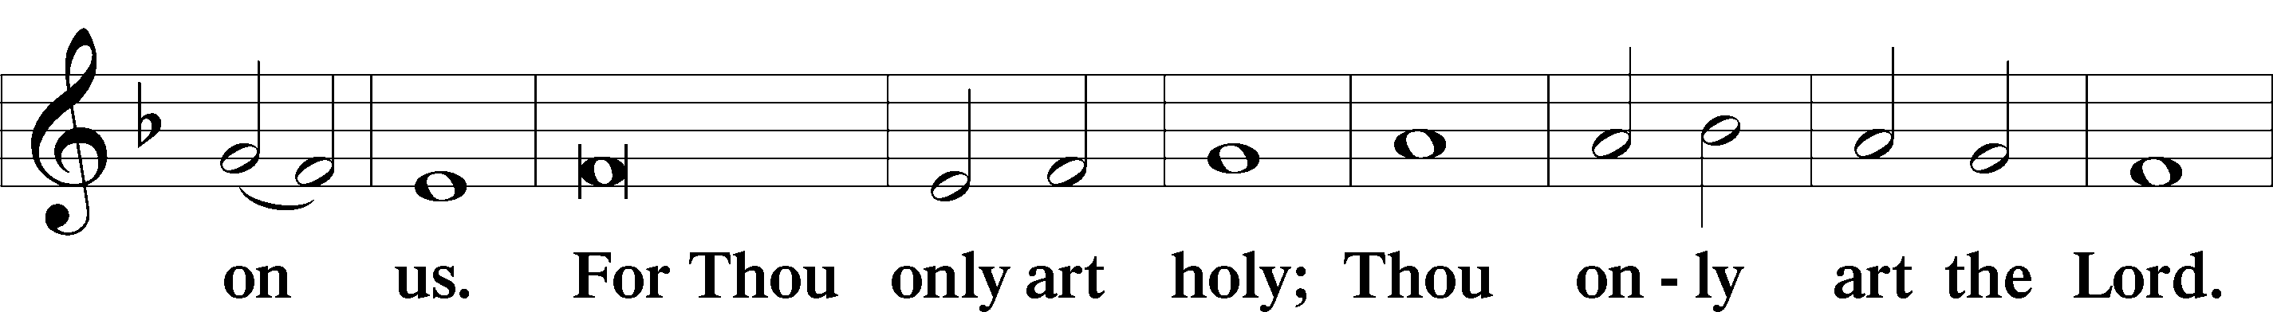
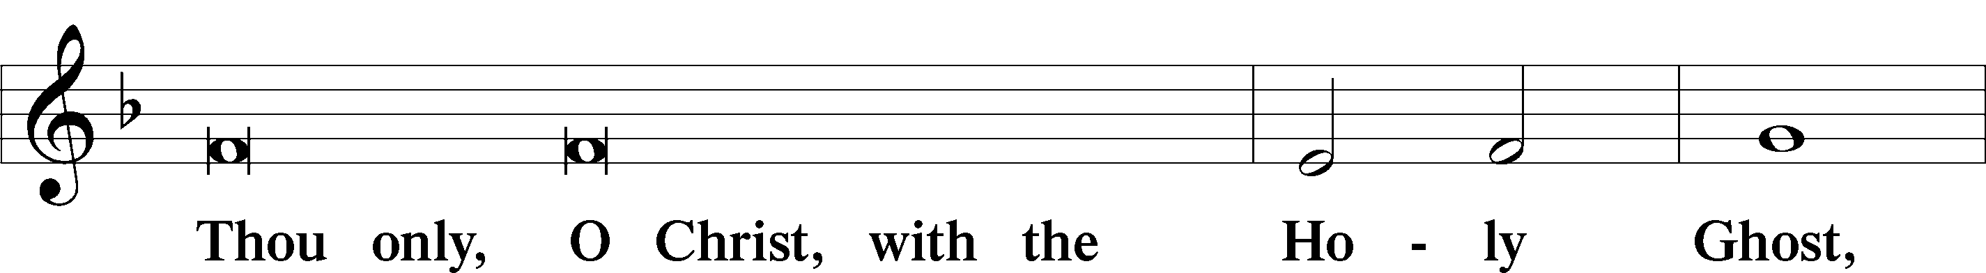
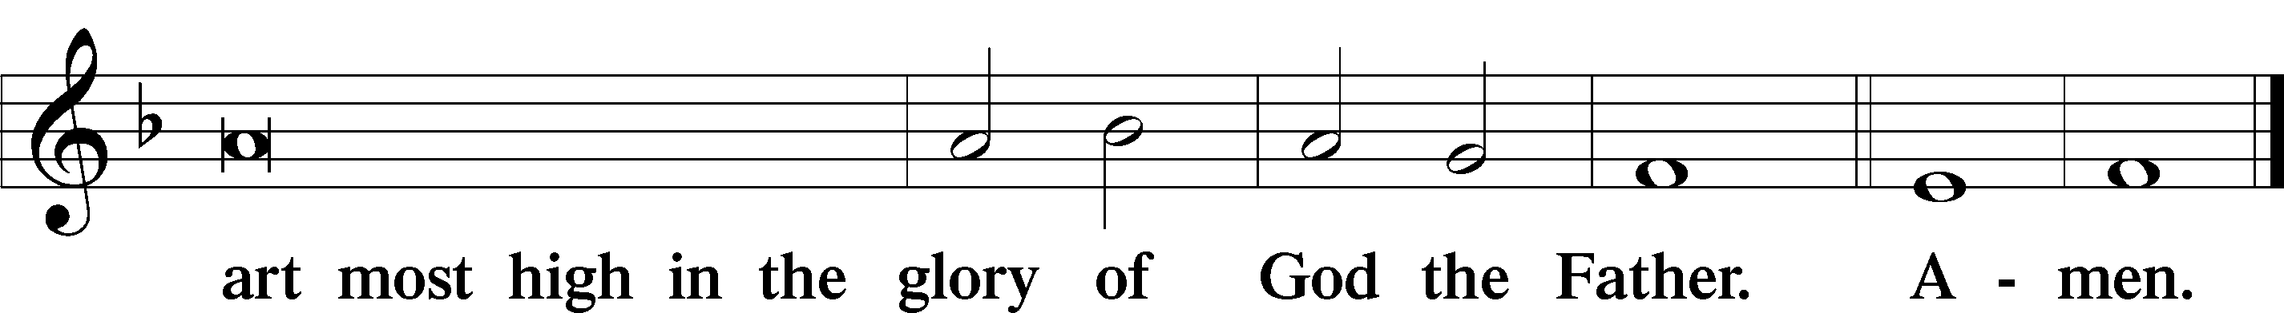

Salutation and Collect of the Day: First Sunday after Trinity
P The Lord be with you.
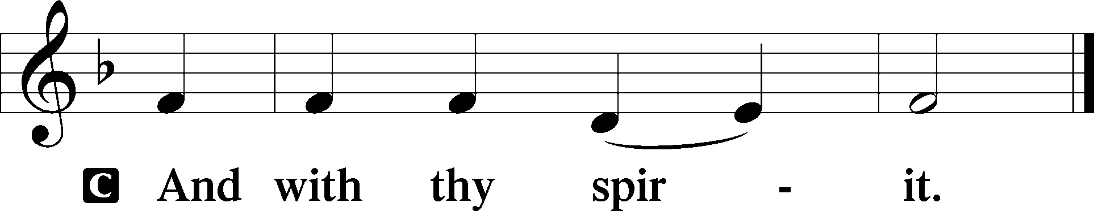

P Let us pray.
O God, the strength of all who trust in You, mercifully accept our prayers; and because through the weakness of our mortal nature we can do no good thing, grant us Your grace to keep Your commandments that we may please You in both will and deed; through Jesus Christ, our Lord, who lives and reigns with You and the Holy Spirit, one God, now and forever.
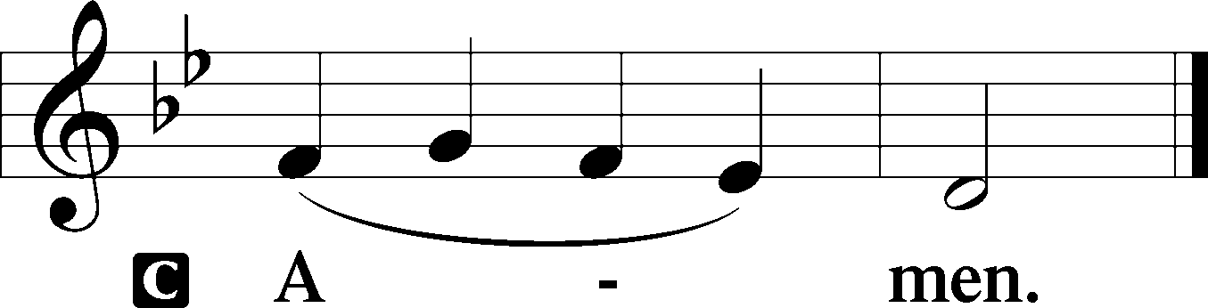

Sit

Prophecy: Deuteronomy 6:4-13 (NKJV)
In those days Moses spoke to the children of Israel, saying: “Hear, O Israel: The Lord our God, the Lord is one! You shall love the Lord your God with all your heart, with all your soul, and with all your strength. And these words which I command you today shall be in your heart. You shall teach them diligently to your children, and shall talk of them when you sit in your house, when you walk by the way, when you lie down, and when you rise up. You shall bind them as a sign on your hand, and they shall be as frontlets between your eyes. You shall write them on the doorposts of your house and on your gates. So it shall be, when the Lord your God brings you into the land of which He swore to your fathers, to Abraham, Isaac, and Jacob, to give you large and beautiful cities which you did not build, houses full of all good things, which you did not fill, hewn-out wells which you did not dig, vineyards and olive trees which you did not plant—when you have eaten and are full—then beware, lest you forget the Lord who brought you out of the land of Egypt, from the house of bondage. You shall fear the Lord your God and serve Him, and shall take oaths in His name.”

P This is the Word of the Lord.
C Thanks be to God.

Gradual Psalm 41:4, 1
I said, “O Lord, be gra- | cious to me;*
heal me, for I have sinned a- | gainst you!”
Blessèd is the one who consid- | ers the poor!*
In the day of trouble the Lord de- | livers him.

Epistle: 1 John 4:8b–21 (NKJV)
Dearly Beloved: God is love. In this the love of God was manifested toward us, that God has sent His only begotten Son into the world, that we might live through Him. In this is love, not that we loved God, but that He loved us and sent His Son to be the propitiation for our sins. Beloved, if God so loved us, we also ought to love one another. No one has seen God at any time. If we love one another, God abides in us, and His love has been perfected in us. By this we know that we abide in Him, and He in us, because He has given us of His Spirit. And we have seen and testify that the Father has sent the Son as Savior of the world. Whoever confesses that Jesus is the Son of God, God abides in him, and he in God. And we have known and believed the love that God has for us. God is love, and he who abides in love abides in God, and God in him. Love has been perfected among us in this: that we may have boldness in the day of judgment; because as He is, so are we in this world. There is no fear in love; but perfect love casts out fear, because fear involves torment. But he who fears has not been made perfect in love. We love Him because He first loved us. If someone says, “I love God,” and hates his brother, he is a liar; for he who does not love his brother whom he has seen, how can he love God whom he has not seen? And this commandment we have from Him: that he who loves God must love his brother also.

P This is the Word of the Lord.
C Thanks be to God.

Stand

Verse Psalm 7:1
Alleluia. O Lord my God, in you do I take refuge; save me from all my pursuers and deliver me. Alleluia.

Alleluia
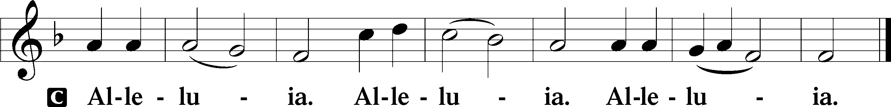
Holy Gospel: Luke 16:19–31 (NKJV)
P The Holy Gospel according to St. Luke, the sixteenth chapter.
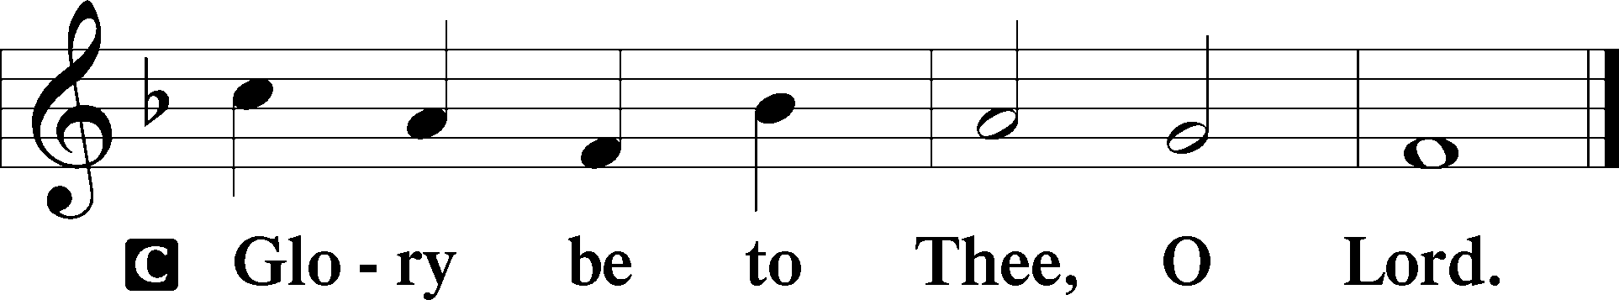

At that time Jesus spoke this parable to His disciples: “There was a certain rich man who was clothed in purple and fine linen and fared sumptuously every day. But there was a certain beggar named Lazarus, full of sores, who was laid at his gate, desiring to be fed with the crumbs which fell from the rich man’s table. Moreover the dogs came and licked his sores. So it was that the beggar died, and was carried by the angels to Abraham’s bosom. The rich man also died and was buried. And being in torments in Hades, he lifted up his eyes and saw Abraham afar off, and Lazarus in his bosom. Then he cried and said, ‘Father Abraham, have mercy on me, and send Lazarus that he may dip the tip of his finger in water and cool my tongue; for I am tormented in this flame.’ But Abraham said, ‘Son, remember that in your lifetime you received your good things, and likewise Lazarus evil things; but now he is comforted and you are tormented. And besides all this, between us and you there is a great gulf fixed, so that those who want to pass from here to you cannot, nor can those from there pass to us.’ Then he said, ‘I beg you therefore, father, that you would send him to my father’s house, for I have five brothers, that he may testify to them, lest they also come to this place of torment.’ Abraham said to him, ‘They have Moses and the prophets; let them hear them.’ And he said, ‘No, father Abraham; but if one goes to them from the dead, they will repent.’ But he said to him, ‘If they do not hear Moses and the prophets, neither will they be persuaded though one rise from the dead.’ ”

P This is the Gospel of the Lord.
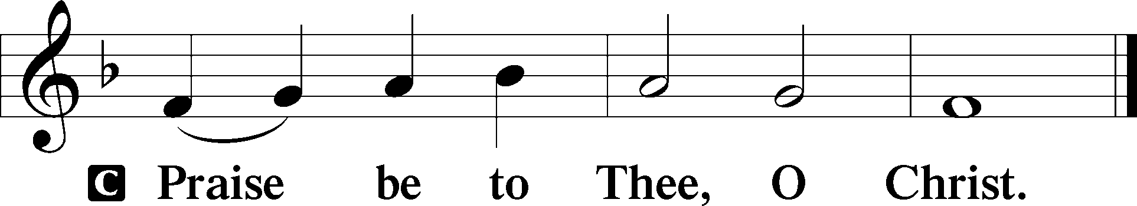

Nicene Creed
C I believe in one God,
the Father Almighty,
maker of heaven and earth
and of all things visible and invisible.

And in one Lord Jesus Christ,
the only-begotten Son of God,
begotten of His Father before all worlds,
God of God, Light of Light,
very God of very God,
begotten, not made,
being of one substance with the Father,
by whom all things were made;
who for us men and for our salvation came down from heaven
and was incarnate by the Holy Spirit of the virgin Mary
and was made man;
and was crucified also for us under Pontius Pilate.
He suffered and was buried.
And the third day He rose again according to the Scriptures
and ascended into heaven
and sits at the right hand of the Father.
And He will come again with glory to judge both the living and the dead,
whose kingdom will have no end.

And I believe in the Holy Spirit,
the Lord and giver of life,
who proceeds from the Father and the Son,
who with the Father and the Son together is worshiped and glorified,
who spoke by the prophets.
And I believe in one holy Christian and apostolic Church,
I acknowledge one Baptism for the remission of sins,
and I look for the resurrection of the dead
and the life T of the world to come. Amen.
Sit

Hymn of the Day: LSB #768 “To God the Holy Spirit Let Us Pray”

Sermon

Stand

Prayer of the Church

Offertory Psalm 51:10–12
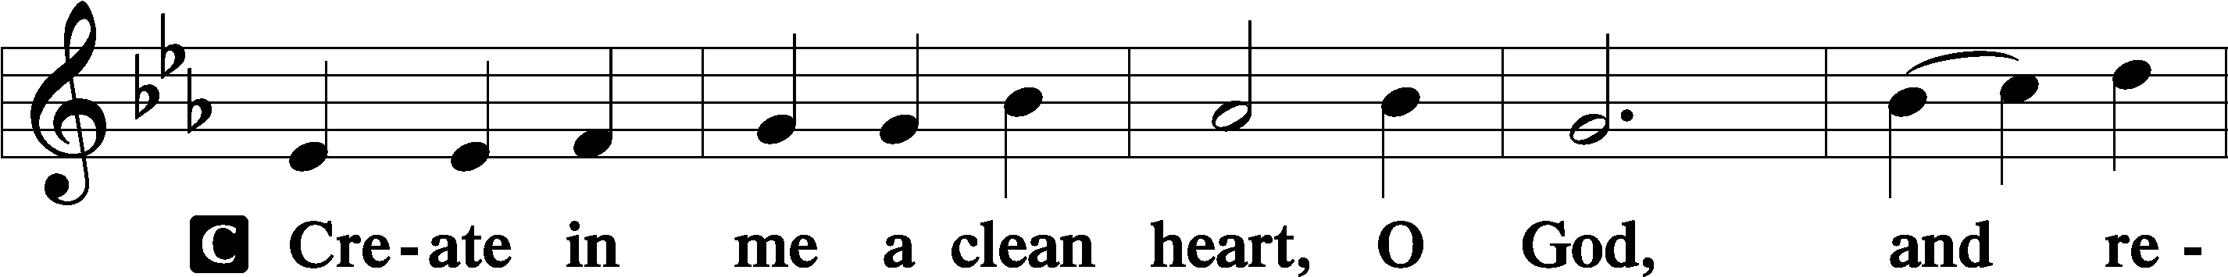
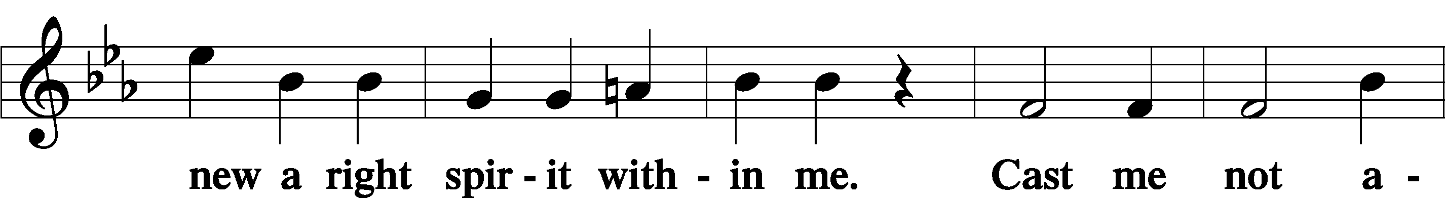
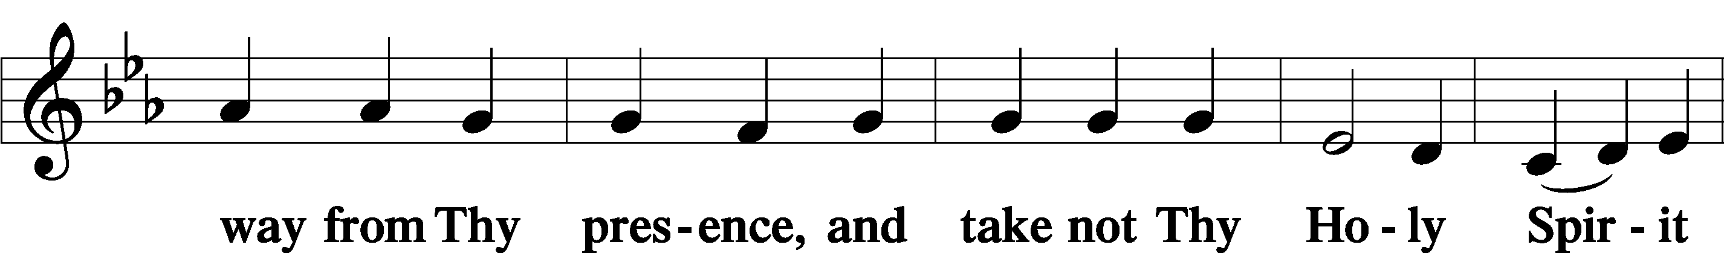
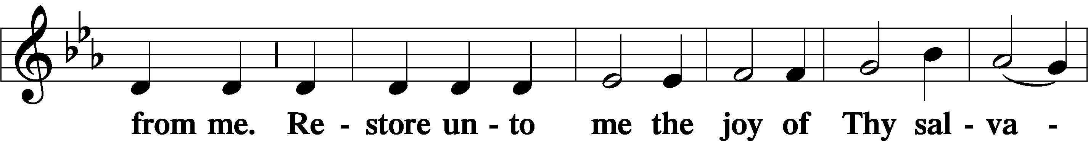
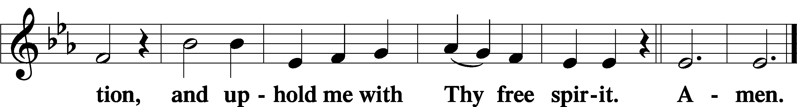
Sit

Preparatory Hymn: LSB #754 “Entrust Your Days and Burdens”

Stand
Service of the Sacrament

Preface 2 Timothy 4:22; Colossians 3:1 Psalm 136
P The Lord be with you.
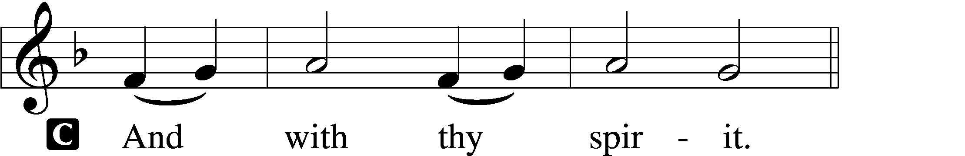

P Lift up your hearts.
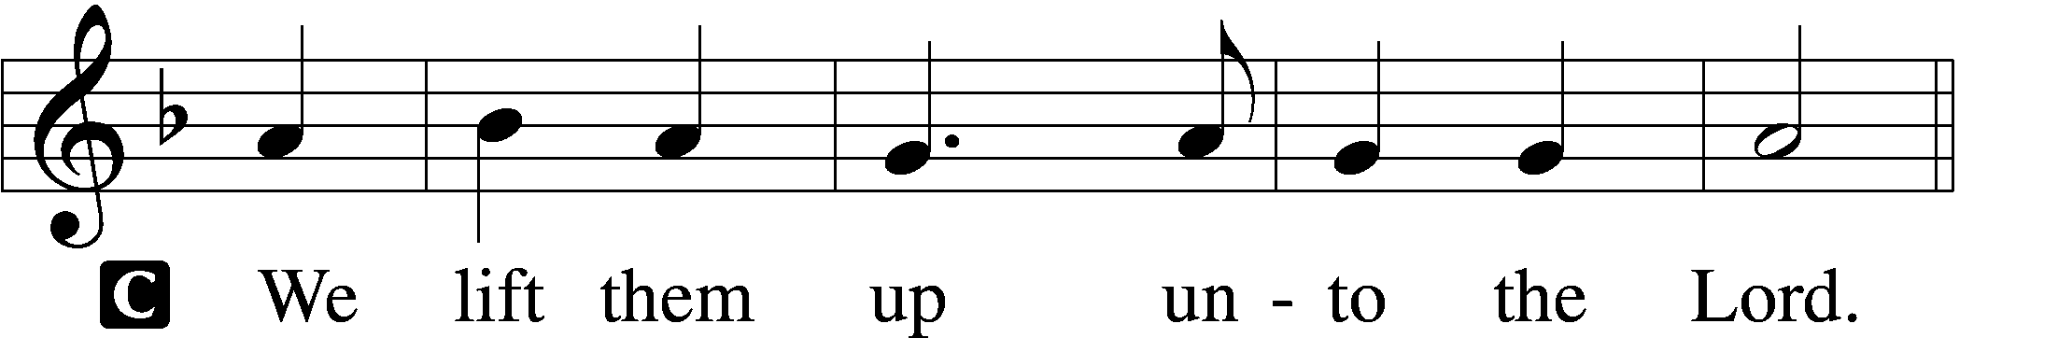

P Let us give thanks unto the Lord, our God.
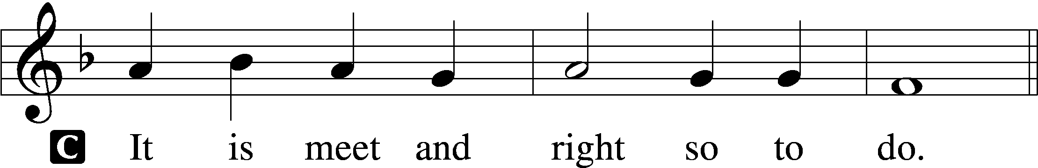

Proper Preface (Abbreviated) LSB 194
P It is truly meet, right, and salutary . . . evermore praising You and saying:

Sanctus Isaiah 6:3; Matthew 21:9
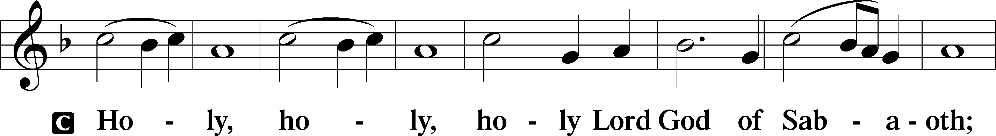
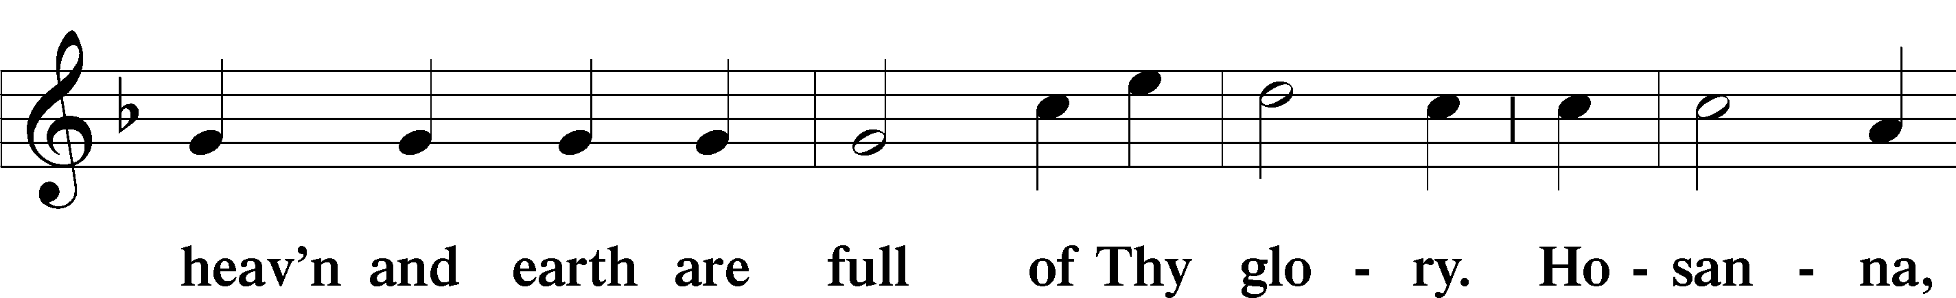
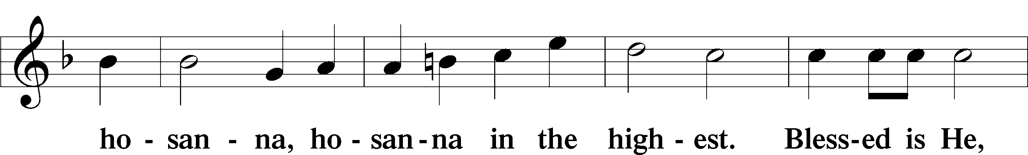
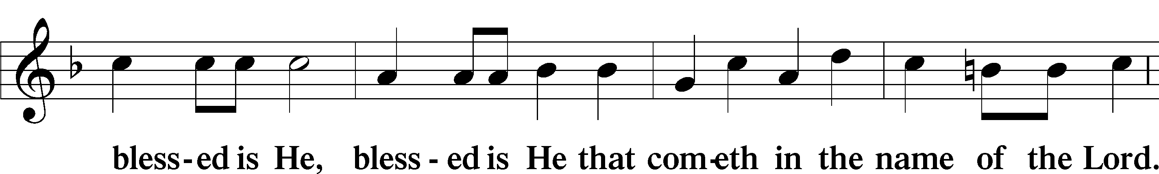
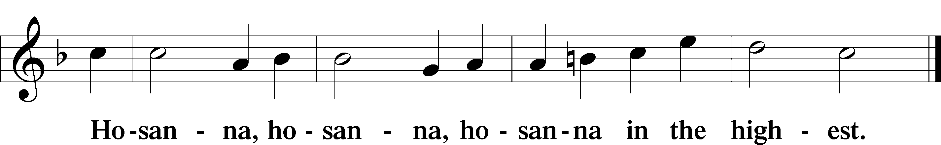

Lord’s Prayer Matthew 6:9–13
C Our Father who art in heaven,
hallowed be Thy name,
Thy kingdom come,
Thy will be done on earth as it is in heaven;
give us this day our daily bread;
and forgive us our trespasses as we forgive those who trespass against us;
and lead us not into temptation,
but deliver us from evil.
For Thine is the kingdom and the power and the glory forever and ever. Amen.

The Words of Our Lord Matthew 26:26–28; Mark 14:22–24; Luke 22:19–20; 1 Corinthians 11:23–25
P Our Lord Jesus Christ, on the night when He was betrayed, took bread, and when He had given thanks, He broke it and gave it to the disciples and said: “Take, eat; this is My T body, which is given for you. This do in remembrance of Me.”

In the same way also He took the cup after supper, and when He had given thanks, He gave it to them, saying: “Drink of it, all of you; this cup is the new testament in My T blood, which is shed for you for the forgiveness of sins. This do, as often as you drink it, in remembrance of Me.”

Pax Domini John 20:19
P The peace of the Lord be with you always.
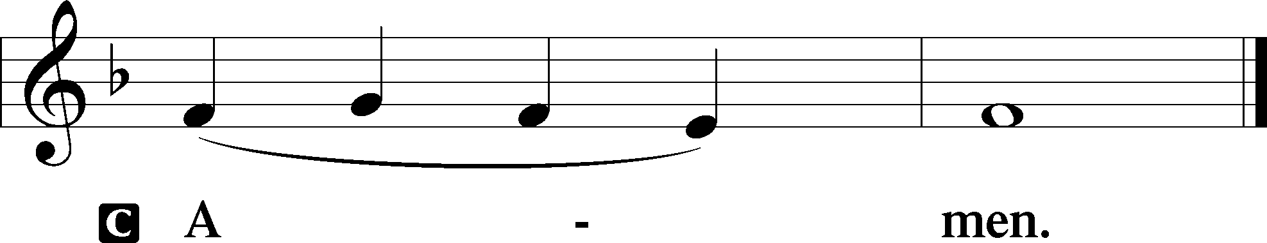

Agnus Dei John 1:29
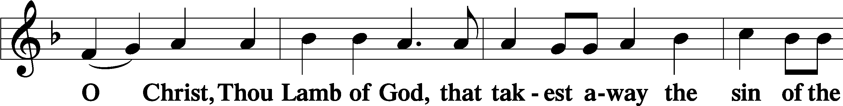
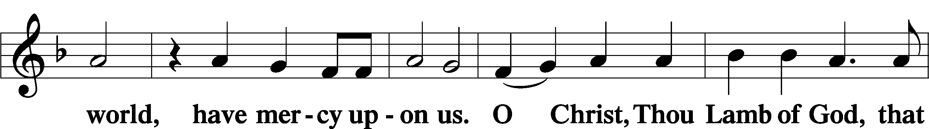
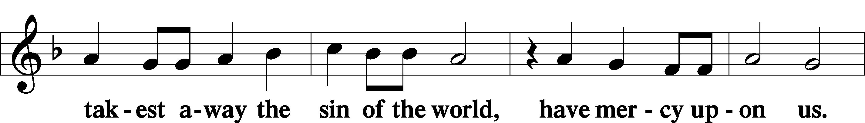
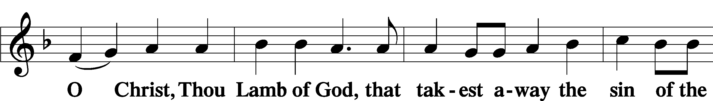
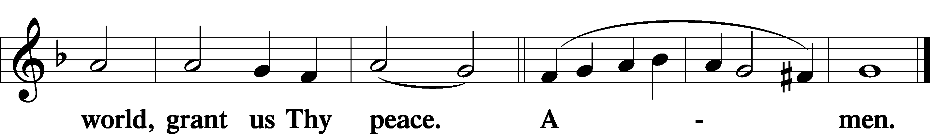

Sit

Distribution
The pastor and those who assist him receive the body and blood of Christ first and then distribute them to those who come to receive, saying:
Take, eat; this is the true body of our Lord and Savior Jesus Christ, given into death for your sins.
Amen.

Take, drink; this is the true blood of our Lord and Savior Jesus Christ, shed for the forgiveness of your sins.
Amen.

In dismissing the communicants, the following is said:
The Dismissal
P The body and blood of our Lord Jesus Christ strengthen and preserve you in body and soul to life everlasting. Depart T in peace.
C Amen.

Distribution Hymn: LSB #585 “Lord Jesus Christ, with Us Abide”

Distribution Hymn: LSB #851 “Lord of Glory, You Have Bought Us”

Distribution Hymn: LSB #544 “O Love, How Deep”

Stand
Nunc Dimittis Luke 2:29–32
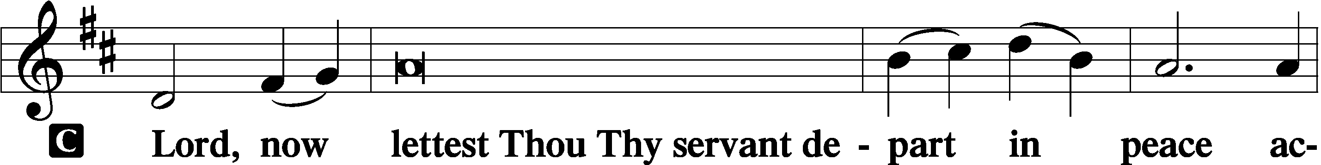
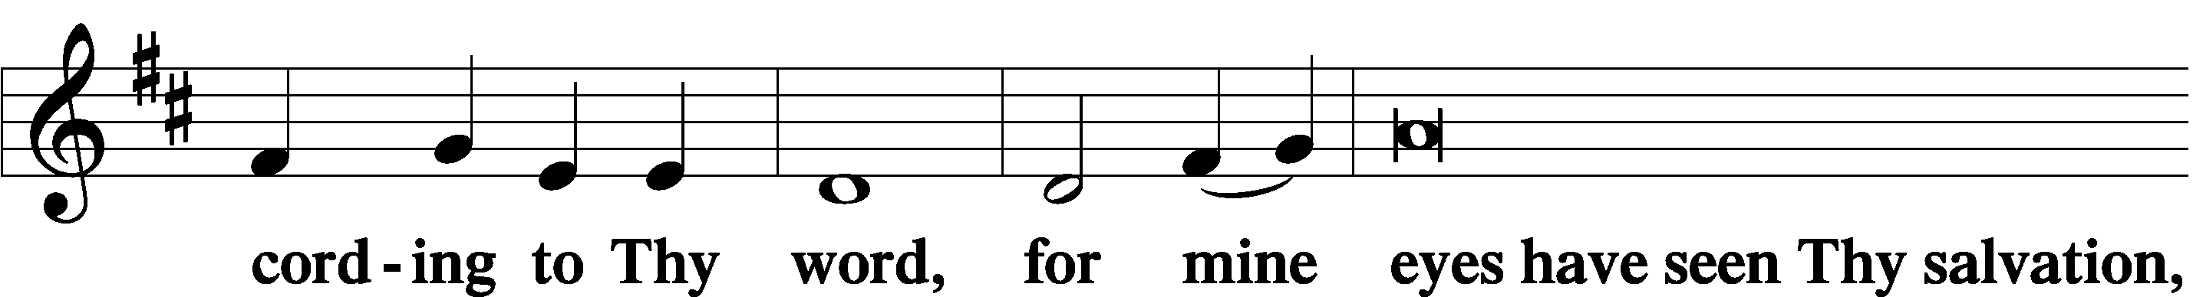
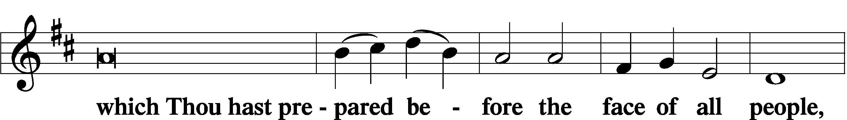
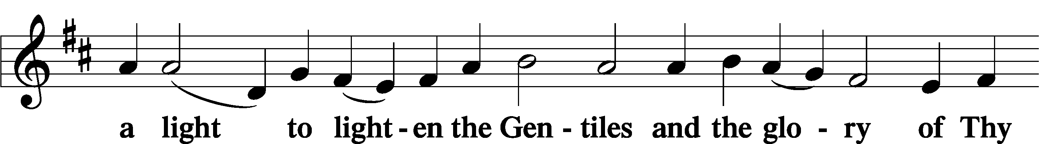
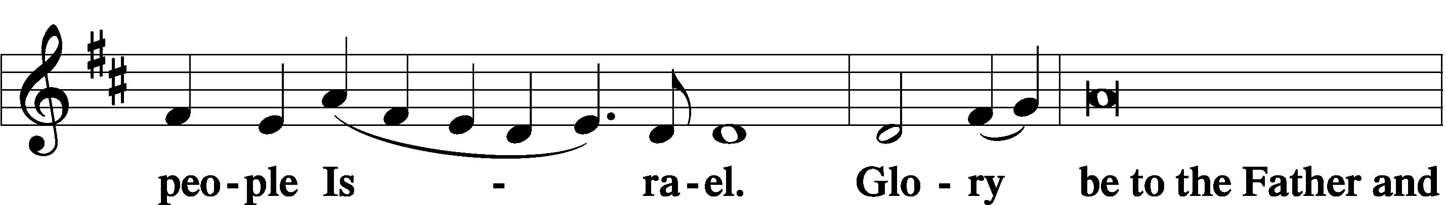
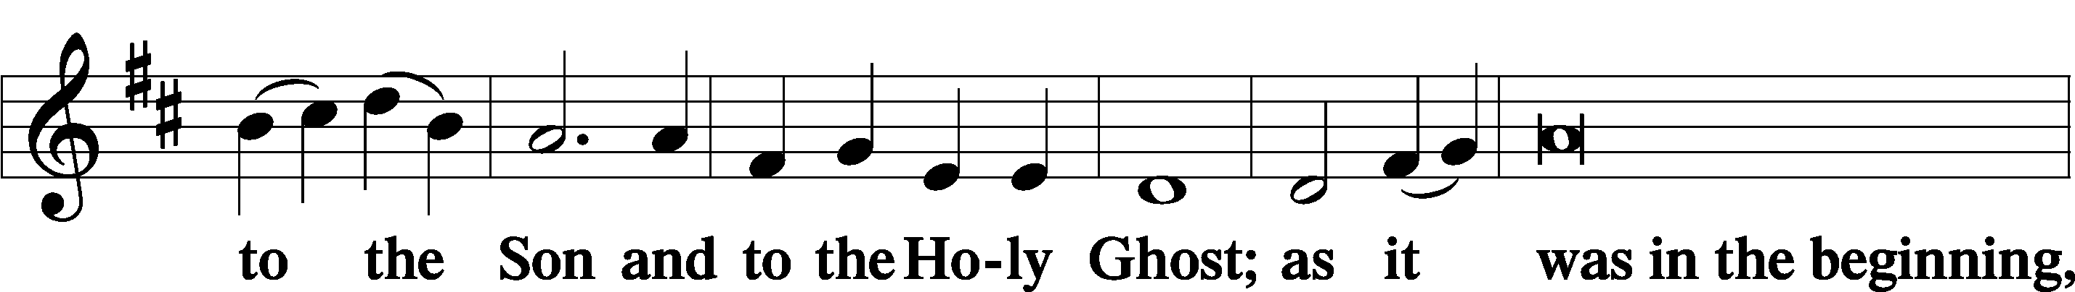
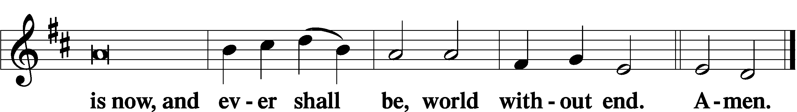
Thanksgiving Psalm 107:1
P O give thanks unto the Lord, for He is good,
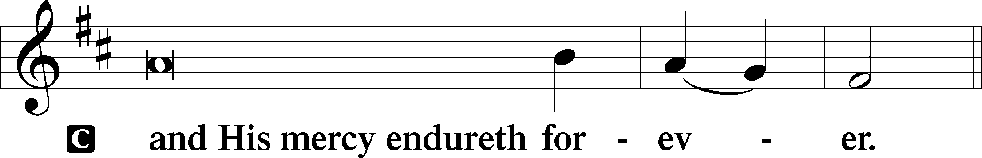

Post-Communion Collect
P Let us pray.
We give thanks to You, almighty God, that You have refreshed us through this salutary gift, and we implore You that of Your mercy You would strengthen us through the same in faith toward You and in fervent love toward one another; through Jesus Christ, Your Son, our Lord, who lives and reigns with You and the Holy Spirit, one God, now and forever.
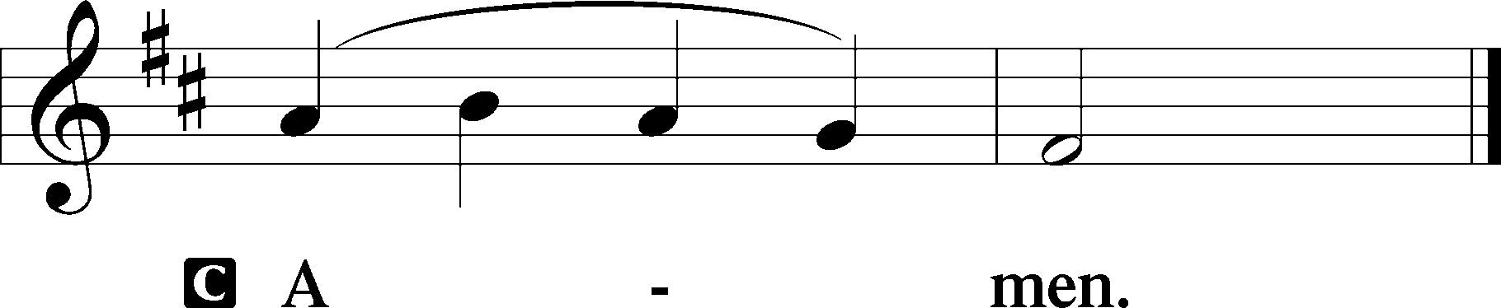

Salutation 2 Timothy 4:22
P The Lord be with you.
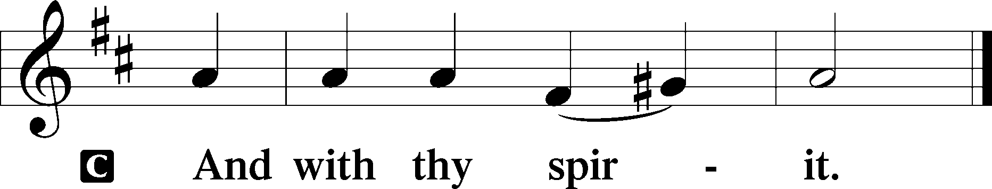

Benedicamus Psalm 103:1
P Bless we the Lord.
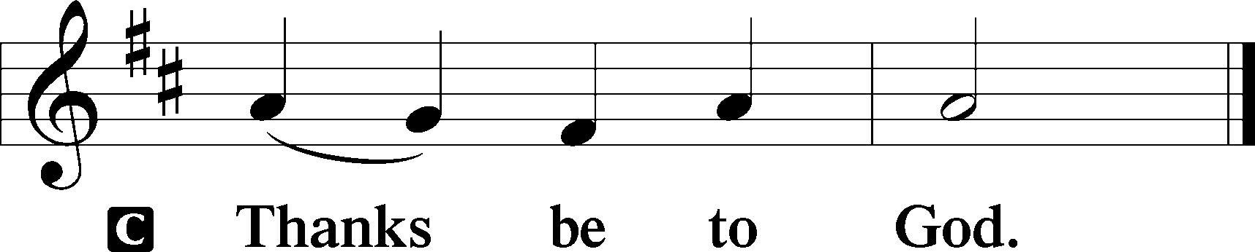

Benediction Numbers 6:24–26
P The Lord bless you and keep you.
The Lord make His face shine upon you and be gracious unto you.
The Lord lift up His countenance upon you and T give you peace.
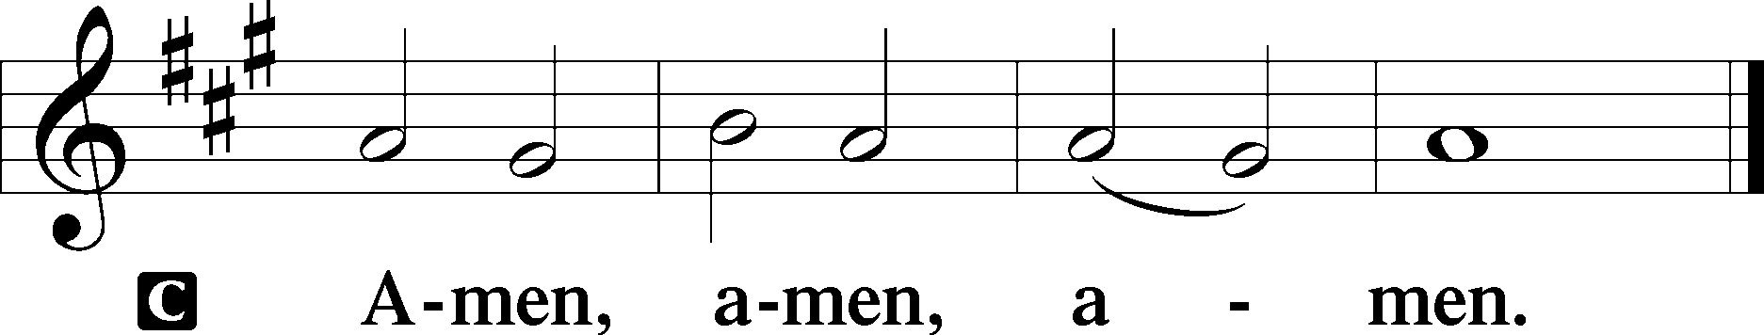

Closing Hymn: LSB #694 “Thee Will I Love, My Strength, My Tower”

Silent prayer after worship: Dear Heavenly Father, let me never forget that I am Your special and dearly loved child in Jesus Christ. Cause me to live in Your love, to love You above all else, and to love my neighbor as myself. In Jesus’ name I pray. Amen.
fffffffffffffffffffffffffffffffffff
Acknowledgments
Unless otherwise indicated, Scripture quotations are from the ESV® Bible (The Holy Bible, English Standard Version®), copyright © 2001 by Crossway, a publishing ministry of Good News Publishers. Used by permission. All rights reserved.
Created by Lutheran Service Builder © 2023 Concordia Publishing House.
fffffffffffffffffffffffffffffffffff
fffffffffffffffffffffffffffffffffff
In Loving Memory of Barry Nelson: Mercer County Chapter of Pennsylvania Association of School Retirees (MCPASR)
fffffffffffffffffffffffffffffffffff
Attendance: Sunday, June 4, 2023: 58
fffffffffffffffffffffffffffffffffff
SCHEDULE THROUGH JUNE 18, 2023:

:

Today, following Worship, Fellowship Hall: Coffee Fellowship
7 pm, Fellowship Hall: AA Meeting
Monday, 7 pm, Library: Trustees’ Meeting
Tuesday, 7-9 pm, Fellowship Hall: Penn-Ohio Singers
Wednesday, 7:30 pm, Fellowship Hall: NA Meeting
Thursday, 10 am, Fellowship Hall: Women’s Bible Study
Saturday, 4 pm, Fellowship Hall: Men’s Bible Study
Next Sunday, 8 am, Fellowship Hall: Bible Study
9 am, Sanctuary: Divine Service
7 pm, Fellowship Hall: AA Meeting
Our Stewardship of Treasures for the Lord:
In order to do the Lord’s work, we need $2,553.63 each week to meet our 2023 budget for general purposes and $76.92 for the SELC.
Online Figures for Monday, June 5, 2023
General Fund: $2,000.00
SELC: $100.00
Food Pantry: $100.00
Figures for Sunday, June 4, 2023
General Fund: $2,245.00 Ahead for the week*: +$1,691.37
SELC: $65.00 Ahead for the week*: +$88.08
Food Pantry: $135.00 *Includes above figures.
Capital Campaign: $615.00

For online giving, check out https://www.saintspeterandpaul.net/online-giving.
fffffffffffffffffffffffffffffffffff
Bible Memory Verses ~ Week of June 11th:
For Adults: The Lord is good to those who wait for him, to the soul who seeks him. It is good that one should wait quietly for the salvation of the Lord.
Lamentations 3:25-26

For Children: The one who hears you hears me, and the one who rejects you rejects me, and the one who rejects me rejects him who sent me.
Luke 10:16
fffffffffffffffffffffffffffffffffff

Congratulations to Bill & Desarae Makis Nelson on the birth of their son, Liam Barry, June 1st! All thanks be to God!
fffffffffffffffffffffffffffffffffff
THANK YOU FOR SERVING IN JUNE: Elder: Jonathan Baisch; Ushers: Cheryl Fedele, Mike Flaugher, & Jesse Riffle; Altarware: (prior) Diane Riefstahl & Marie Flaugher (06/11); (after) Elizabeth Haenftling & Traudi Sulek.
fffffffffffffffffffffffffffffffffff
Minutes from the June 4, 2023, Voters’ Assembly are available on the table in the narthex.
Remember the following in Prayer…
~The Hurting and Healing: Amy, Gerald Arthur, Ellen Baron^{CA}, Lois Bortner^{CA}, John Burdette, Bev & Joe Chlpka, Kathleen Coughenour, Kim, Anna Mae Daris, Susan Davies, Tim Dudash, Millie Elavsky, Joseph Fleet, Judith & Eddy Furey, Tim Haenftling, Austin Hamilton, Joan, Darla Krajci, Barbara Kreske, Donna Kennedy, Jess Lavoie, Joanne Lozier, Paul Lucas^{CA}, Sandy Marshall, Augusta Mennell, Frank Niemeyer^{CA}, Linda Parkany, Juanita Rentschler, Richard Reuning^{CA}, Nancy Robertson^{CA}, Marty Scott, Kara, Fred Tonty, Joel & Peggy Wasson, Angela Weser^{CA}, and Ruth Wolf.
~The Homebound: Rudy & Jean Tomko, Betty Wolf, and Ed & Millie Zachar.
~Celebrating this Week: Birthdays: Isaiah Deal (06.11) & Connor Russell (06.15). Anniversary: Ed & Millie Zachar (06.12).
~Serving in the Military: Alex (Sasha) Carr, Curtis Sinewe and Joshua Solyan.
~Community & World Needs: Those suffering from or affected by the coronavirus; those suffering due to the conflict between Ukraine and Russia; those suffering from loss and dislocation because weather disasters; those suffering from addiction and their families; Local, State, and National Government Leaders; safety for all Police Officers, Firefighters, & First Responders; the unemployed; our Second Quarter Local Mission: The Support of a Concordia, Fort Wayne Seminarian.
*CA represents cancer.
fffffffffffffffffffffffffffffffffff
Join us following worship this morning for Coffee Fellowship. June’s sponsor is Diane Riefstahl.
If interested in sponsoring a Coffee Fellowship, please sign the sheet posted on the bulletin board in the narthex. Sponsors are asked to bring 2-1/2 to 3 dozen “treats” and 1 quart of juice to the Fellowship Hall kitchen prior to worship. All else, including set-up and clean-up, will be provided.
fffffffffffffffffffffffffffffffffff
Women’s Bible Study continues this Thursday morning from 10-11 am. Please use the Clover St. entrance.
fffffffffffffffffffffffffffffffffff
Zachary T. Wessel will be installed as a vicar later this morning at All Saints Lutheran Church in Slippery Rock. Please keep Vicar Wessel in your prayers as he works with Pastor Deal in this capacity.

Here to Serve
Pastor………………………………………………...……………Rev. Jacob Deal
E-mail …………………………….……pastordeal@saintspeterandpaul.net
Phone Number……………………..…………………724-347-3620 (Option 2)
Church Office………………………..…………………724-347-3620 (Option 3)
Website …………………………………………www.saintspeterandpaul.net
Secretary…………………………………………………………Diane Riefstahl
E-mail ………………………………………church@saintspeterandpaul.net
Website …………………………………………www.saintspeterandpaul.net
Food Pantry: Please leave message……………724-347-3620 (Option 3)
AA Contact: Steve………………………………………………..…724-813-2358
NA Contact: Larry………………………………………………..724-977-8733
Choir Director………………………………………………………Chris Nelson
Congregation President……………………………………Jonathan Baisch
Church Elder …………………………………………...…… Jonathan Baisch
fffffffffffffffffffffffffffffffffff
If needing to get into the church building during the week, please phone first to make certain someone is here to let you in.

