Sts. Peter & Paul
Evangelical Lutheran Church
Lutheran Church-Missouri Synod
Founded-1917

July 30, 2023

699 Stambaugh Ave.
Sharon, Pennsylvania 16146

“I was glad when they said to me,
Let us go to the house of the LORD!”
Psalm 122:1
Sts. Peter & Paul Evangelical Lutheran Church, LC-MS
THE EIGHTH SUNDAY AFTER TRINITY
July 30, 2023
A special welcome to our guests this day! If you would like more information about The Lutheran Church - Missouri Synod, or this congregation, please speak with Pastor Deal or an Elder after the service.
Members & Guests: Don’t be embarrassed if your children make noise during the worship service, all children do. We encourage families to worship together but, if you feel the need, there are pews in the rear of the Church which are reserved for young families on both sides of the sanctuary. There is also a quiet room available to you, located next to the sanctuary (formerly the Pastor’s office), where you would be able to follow along with the service.

Today’s service includes the Sacrament of Holy Communion. If during this past year, you have not worshipped with us and been communed, we respectfully ask that you do not partake of this sacrament this day before first speaking with Pastor Deal.
If visiting from a sister congregation of the LC-MS and are in good standing, please inform Pastor Deal of your desire to commune prior to the service.
If wishing to receive a blessing during communion, please approach with your arms crossed.

CONTACT INFORMATION
Pastor Deal: pastordeal@saintspeterandpaul.net or 724-347-3620 (opt. 2)
Church Office: church@saintspeterandpaul.net or 724-347-3620 (opt. 3)
Secretary’s Office will be open Tuesday (8:30-1) and Thursday (8:30-4:30) this week.

Silent prayer before worship: Dear Lord, cast away the darkness of indifference and shine the light of Your love in my heart. Lead me to be in Your Word and in prayer daily, that I may grow in my faith and to share my faith with others. In Jesus’ name. Amen.
Confession and Absolution

Opening Hymn: LSB #851 “Lord of Glory, You Have Bought Us”

Stand

The sign of the cross may be made by all in remembrance of their Baptism.

Invocation
P In the name of the Father and of the T Son and of the Holy Spirit.
C Amen.

Exhortation Hebrews 10:22; Psalm 124:8; Psalm 32:5
P Beloved in the Lord! Let us draw near with a true heart and confess our sins unto God our Father, beseeching Him in the name of our Lord Jesus Christ to grant us forgiveness.

P Our help is in the name of the Lord,
C who made heaven and earth.
P I said, I will confess my transgressions unto the Lord,
C and You forgave the iniquity of my sin.

Silence for reflection on God’s Word and for self-examination.

Confession of Sins
P O almighty God, merciful Father,
C I, a poor, miserable sinner, confess unto You all my sins and iniquities with which I have ever offended You and justly deserved Your temporal and eternal punishment. But I am heartily sorry for them and sincerely repent of them, and I pray You of Your boundless mercy and for the sake of the holy, innocent, bitter sufferings and death of Your beloved Son, Jesus Christ, to be gracious and merciful to me, a poor, sinful being.

Absolution [John 20:19–23]
P Upon this your confession, I, by virtue of my office, as a called and ordained servant of the Word, announce the grace of God unto all of you, and in the stead and by the command of my Lord Jesus Christ I forgive you all your sins in the name of the Father and of the T Son and of the Holy Spirit.
C Amen.
Service of the Word

Introit Psalm 48:1, 3, 11, 14; antiphon: vv. 9–10
We have thought on your steadfast love, | O God,*
in the midst of your | temple.
As your name, O God, so your praise reaches to the ends | of the earth.*
Your right hand is filled with | righteousness.
Great is the Lord and greatly | to be praised*
in the city of our God, his holy | mountain.
Within her | citadels*
God has made himself known as a | fortress.
Let Mount Zion | be glad!*
Let the daughters of Judah rejoice because of your | judgments!
This is God, our God forever and | ever.*
He will guide us for- | ever.
We have thought on your steadfast love, | O God,*
in the midst of your | temple.
As your name, O God, so your praise reaches to the ends | of the earth.*
Your right hand is filled with | righteousness.

Gloria Patri
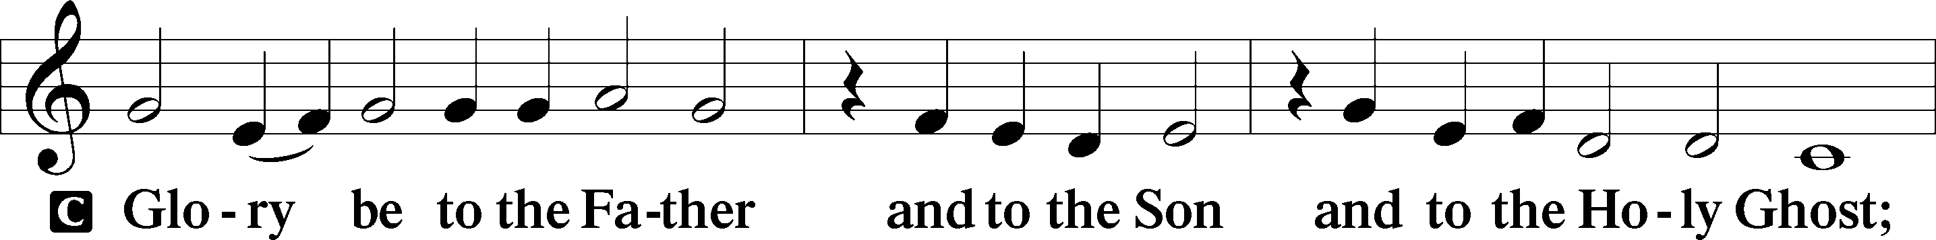
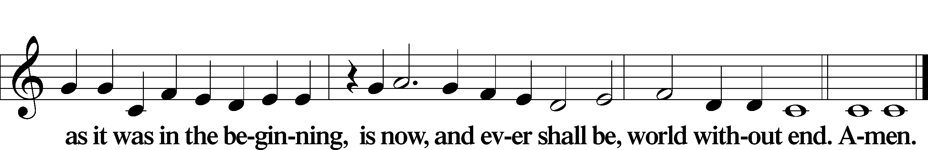

Kyrie Mark 10:47
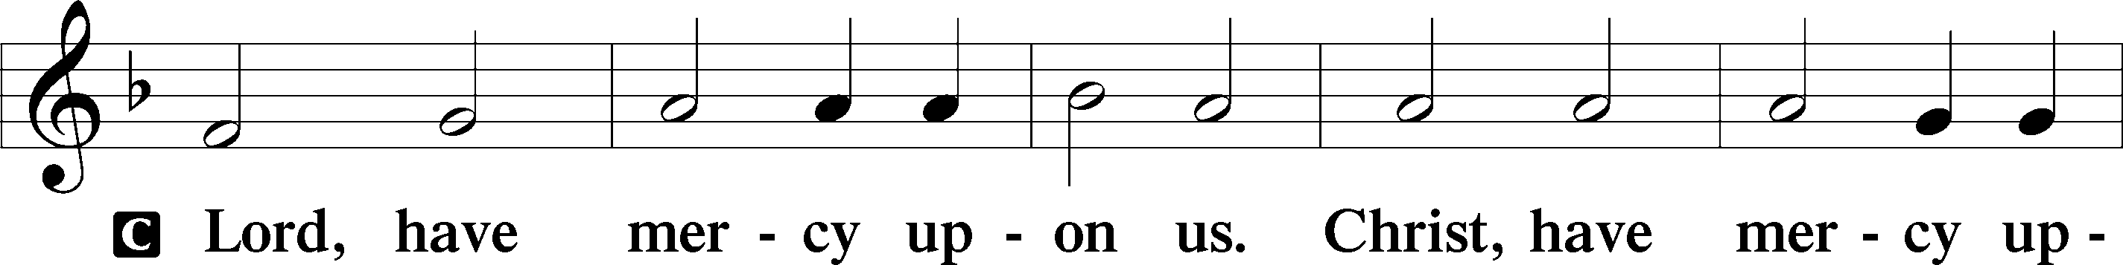
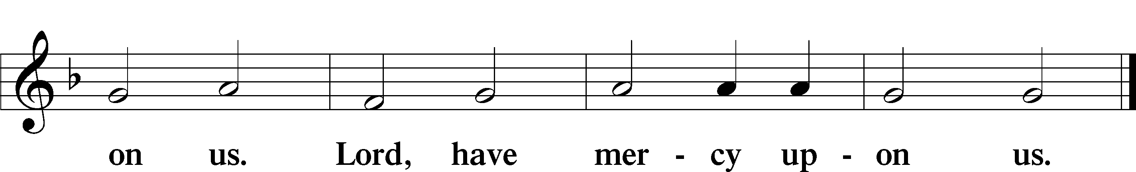

Gloria in Excelsis Luke 2:14; John 1:29
P Glory be to God on high:
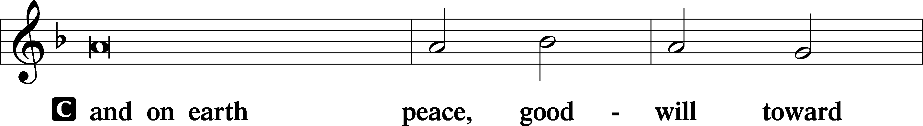
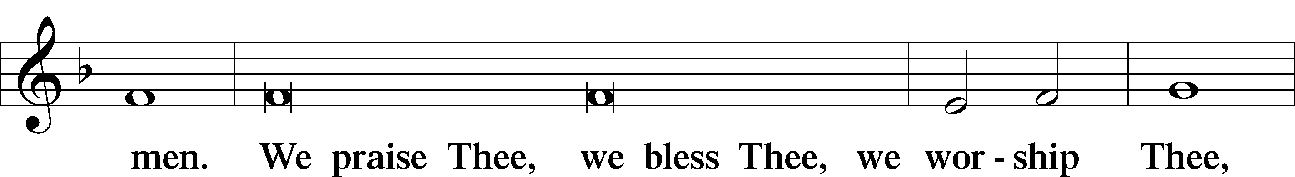
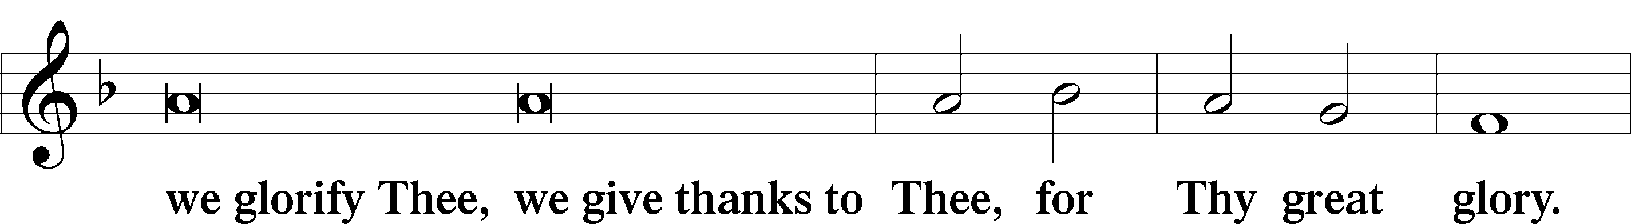
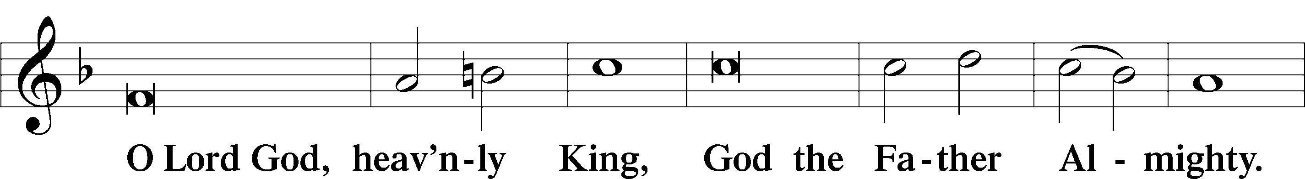
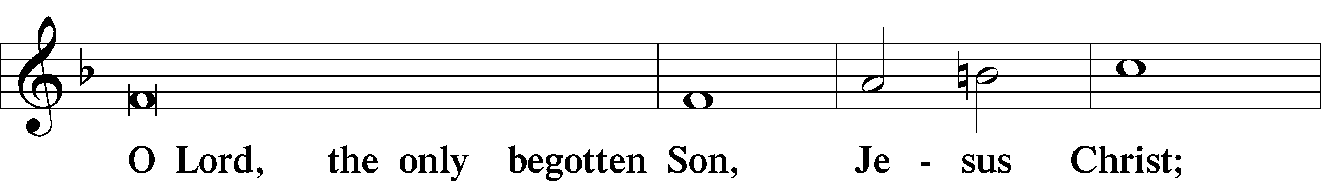
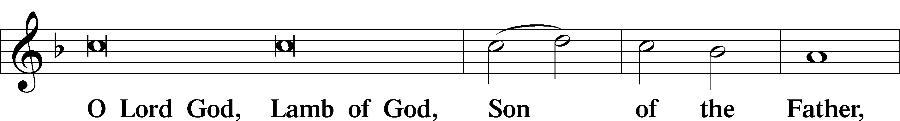
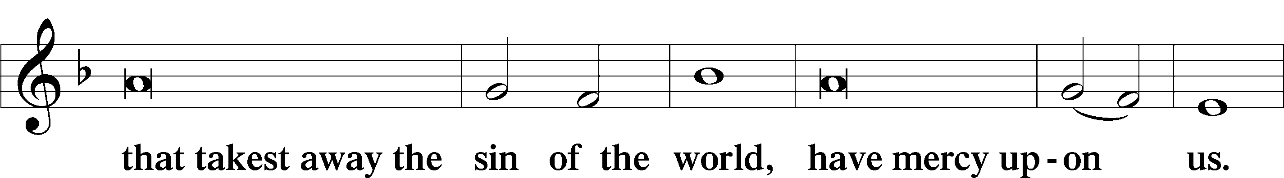
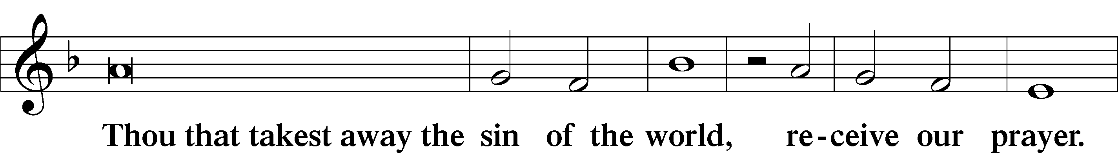
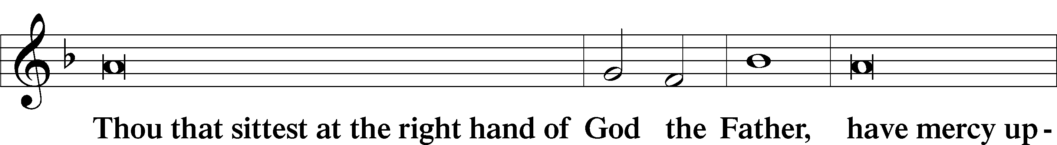
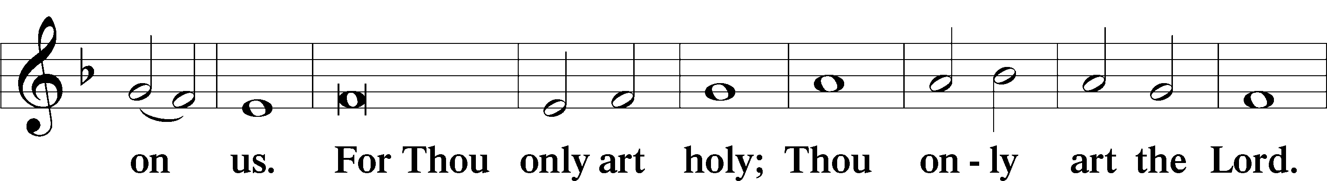
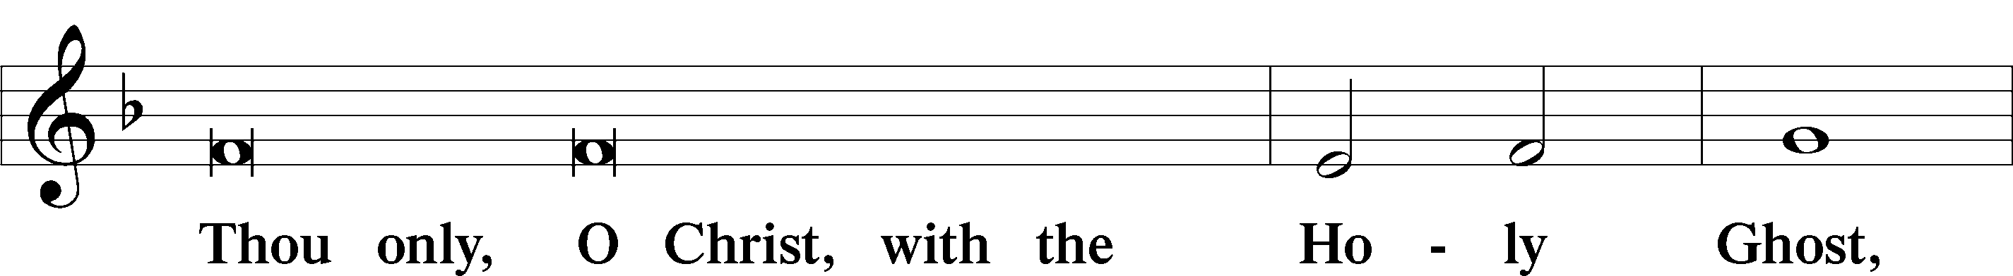
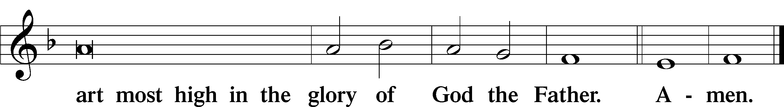

Salutation and Collect of the Day: Trinity 8
P The Lord be with you.
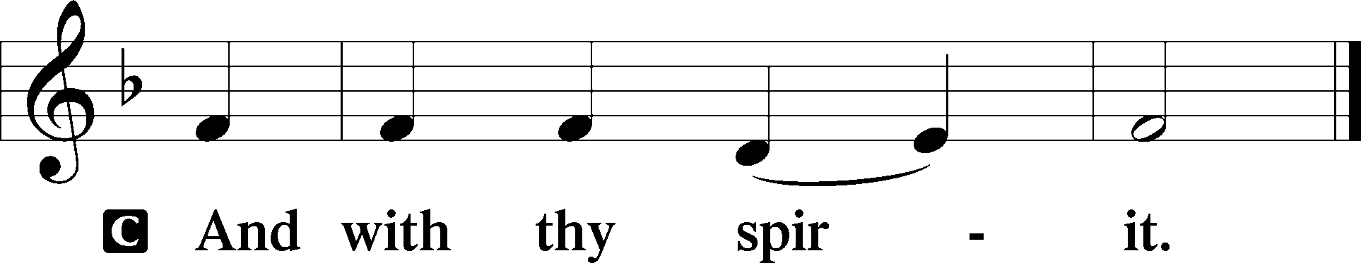

P Let us pray.
Grant to us, Lord, the Spirit to think and do always such things as are right, that we, who cannot do anything that is good without You, may be enabled by You to live according to Your will; through Jesus Christ, Your Son, our Lord, who lives and reigns with You and the Holy Spirit, one God, now and forever.
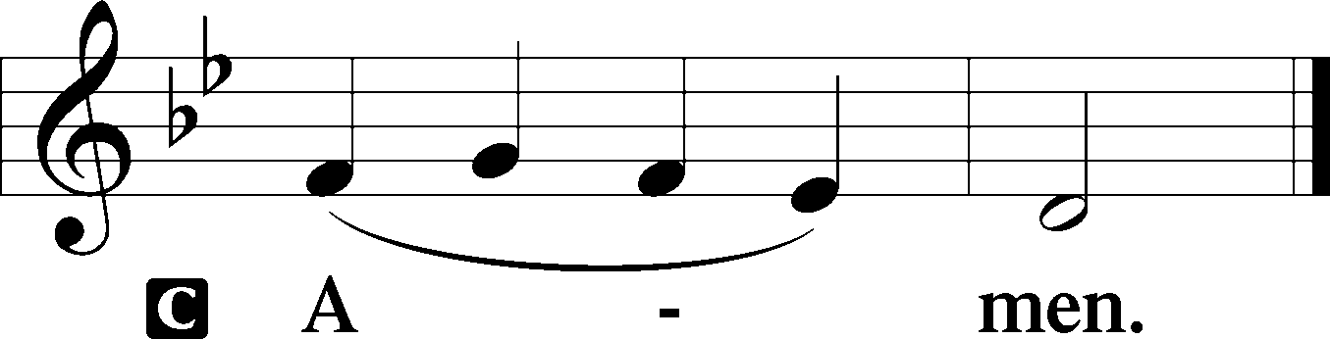
Sit

Prophecy: Jeremiah 23:16–29 (NKJV)
Thus says the Lord of hosts: “Do not listen to the words of the prophets who prophesy to you. They make you worthless; they speak a vision of their own heart, not from the mouth of the Lord. They continually say to those who despise Me, ‘The Lord has said, “You shall have peace” ’; and to everyone who walks according to the dictates of his own heart, they say, ‘No evil shall come upon you.’ ” For who has stood in the counsel of the Lord, and has perceived and heard His word? Who has marked His word and heard it? Behold, a whirlwind of the Lord has gone forth in fury—a violent whirlwind! It will fall violently on the head of the wicked. The anger of the Lord will not turn back until He has executed and performed the thoughts of His heart. In the latter days you will understand it perfectly. “I have not sent these prophets, yet they ran. I have not spoken to them, yet they prophesied. But if they had stood in My counsel, and had caused My people to hear My words, then they would have turned them from their evil way and from the evil of their doings. Am I a God near at hand,” says the Lord, “And not a God afar off? Can anyone hide himself in secret places, so I shall not see him?” says the Lord; “Do I not fill heaven and earth?” says the Lord. “I have heard what the prophets have said who prophesy lies in My name, saying, ‘I have dreamed, I have dreamed!’ How long will this be in the heart of the prophets who prophesy lies? Indeed they are prophets of the deceit of their own heart, who try to make My people forget My name by their dreams which everyone tells his neighbor, as their fathers forgot My name for Baal. The prophet who has a dream, let him tell a dream; and he who has My word, let him speak My word faithfully. What is the chaff to the wheat?” says the Lord. “Is not My word like a fire?” says the Lord, “And like a hammer that breaks the rock in pieces?” says the Lord Almighty.

P This is the Word of the Lord.
C Thanks be to God.
Gradual Psalm 31:2b, 1a
Be a rock of ref- | uge for me,*
a strong fortress to | save me!
In you, O Lord, do I take | refuge;*
let me never be | put to shame.

Epistle: Romans 8:12-17 (NKJV)
Brethren: We are debtors—not to the flesh, to live according to the flesh. For if you live according to the flesh you will die; but if by the Spirit you put to death the deeds of the body, you will live. For as many as are led by the Spirit of God, these are sons of God. For you did not receive the spirit of bondage again to fear, but you received the Spirit of adoption by whom we cry out, “Abba, Father.” The Spirit Himself bears witness with our spirit that we are children of God, and if children, then heirs—heirs of God and joint heirs with Christ, if indeed we suffer with Him, that we may also be glorified together.

P This is the Word of the Lord.
C Thanks be to God.

Stand

Verse Psalm 78:1
Alleluia. Give ear, O my people, to my teaching; incline your ears to the words of my mouth! Alleluia.

Alleluia
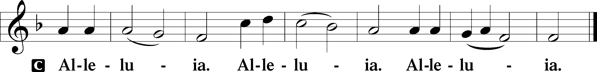

Holy Gospel: Matthew 7:15–23 (NKJV)
P The Holy Gospel according to St. Matthew, the seventh chapter.
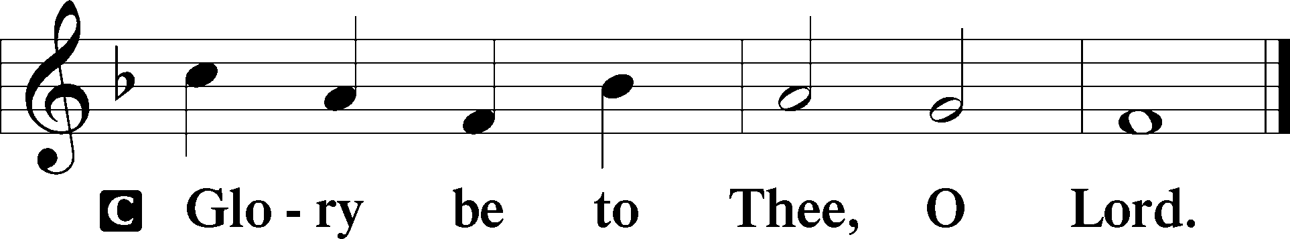

At that time Jesus said to His disciples: “Beware of false prophets, who come to you in sheep’s clothing, but inwardly they are ravenous wolves. You will know them by their fruits. Do men gather grapes from thornbushes or figs from thistles? Even so, every good tree bears good fruit, but a bad tree bears bad fruit. A good tree cannot bear bad fruit, nor can a bad tree bear good fruit. Every tree that does not bear good fruit is cut down and thrown into the fire. Therefore by their fruits you will know them. Not everyone who says to Me, ‘Lord, Lord,’ shall enter the kingdom of heaven, but he who does the will of My Father in heaven. Many will say to Me in that day, ‘Lord, Lord, have we not prophesied in Your name, cast out demons in Your name, and done many wonders in Your name?’ And then I will declare to them, ‘I never knew you; depart from Me, you who practice lawlessness!’ ”

P This is the Gospel of the Lord.
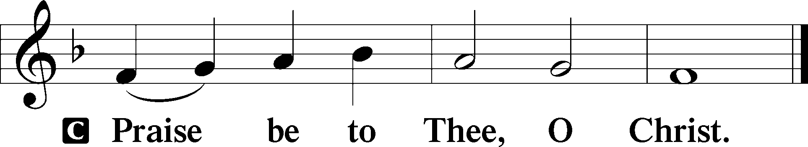

Nicene Creed
C I believe in one God,
the Father Almighty,
maker of heaven and earth
and of all things visible and invisible.

And in one Lord Jesus Christ,
the only-begotten Son of God,
begotten of His Father before all worlds,
God of God, Light of Light,
very God of very God,
begotten, not made,
being of one substance with the Father,
by whom all things were made;
who for us men and for our salvation came down from heaven
and was incarnate by the Holy Spirit of the virgin Mary
and was made man;
and was crucified also for us under Pontius Pilate.
He suffered and was buried.
And the third day He rose again according to the Scriptures
and ascended into heaven
and sits at the right hand of the Father.
And He will come again with glory to judge both the living and the dead,
whose kingdom will have no end.

And I believe in the Holy Spirit,
the Lord and giver of life,
who proceeds from the Father and the Son,
who with the Father and the Son together is worshiped and glorified,
who spoke by the prophets.
And I believe in one holy Christian and apostolic Church,
I acknowledge one Baptism for the remission of sins,
and I look for the resurrection of the dead
and the life T of the world to come. Amen.
Sit

Hymn of the Day: LSB #716 “I Walk in Danger All the Way”

Sermon

Stand

Offertory Psalm 51:10–12
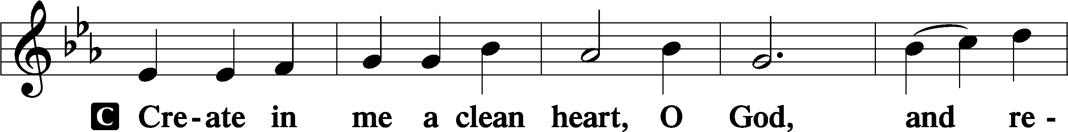
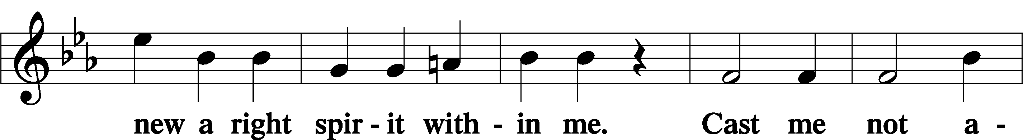
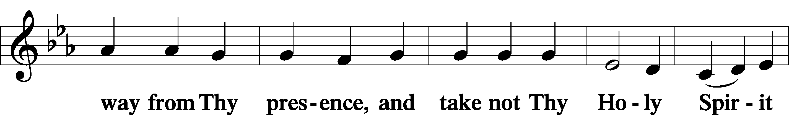
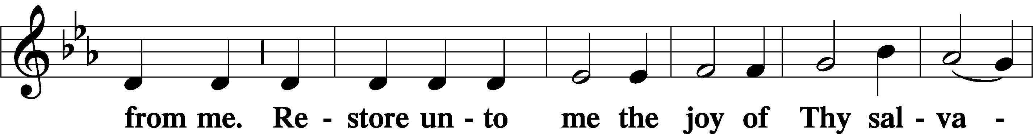
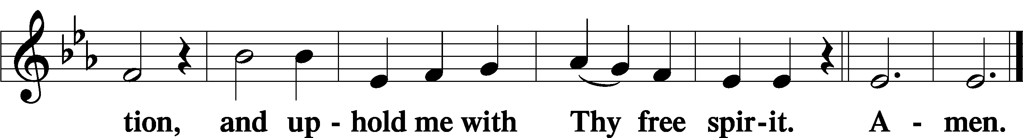

Prayer of the Church

Sit

Preparatory Hymn: LSB #614 “’As Surely as I Live,’ God Said”
Service of the Sacrament

Preface 2 Timothy 4:22; Colossians 3:1 Psalm 136
P The Lord be with you.
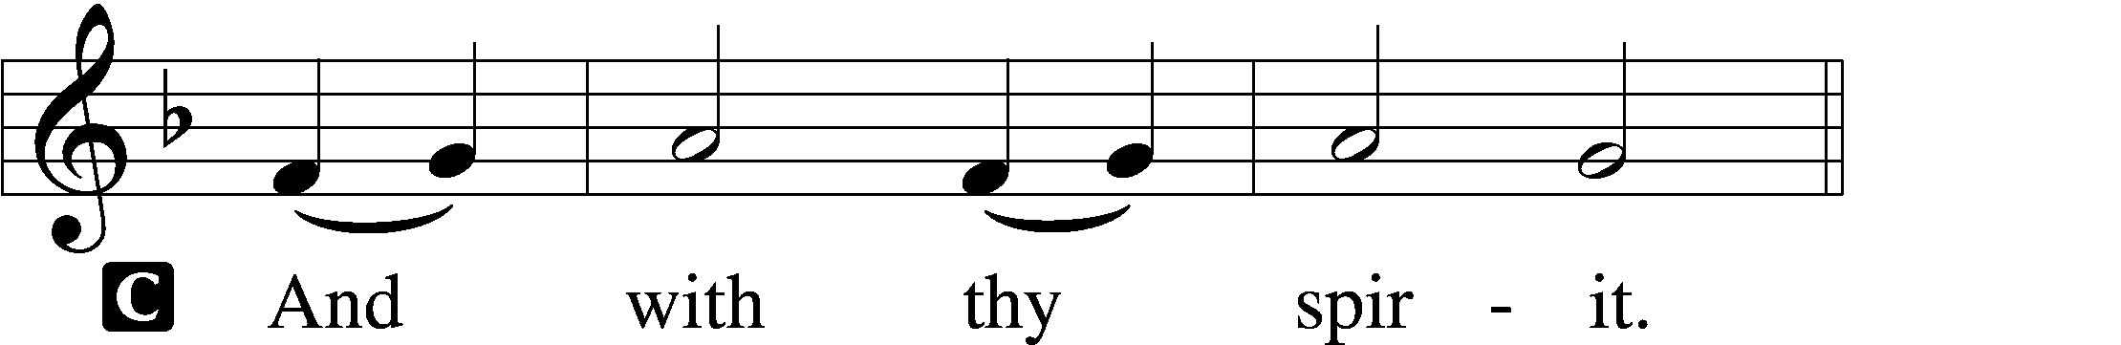

P Lift up your hearts.
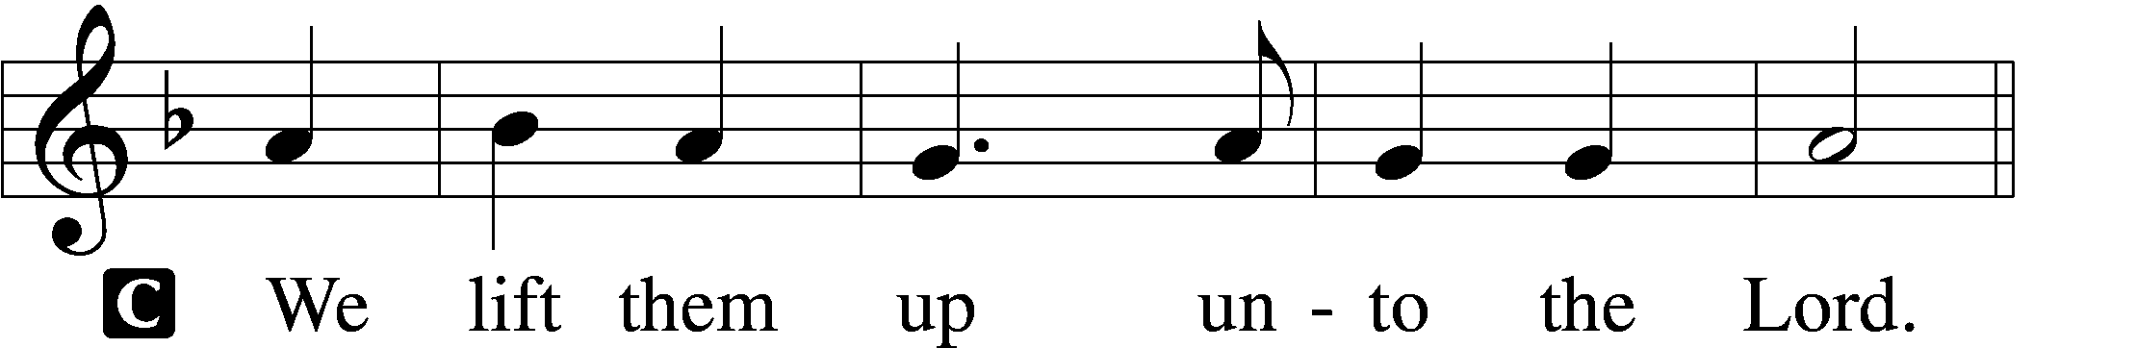

P Let us give thanks unto the Lord, our God.
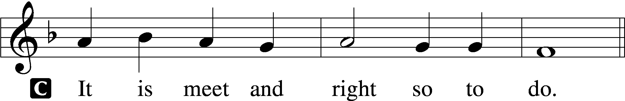
Proper Preface (Abbreviated) LSB 194
P It is truly meet, right, and salutary . . . evermore praising You and saying:

Sanctus Isaiah 6:3; Matthew 21:9
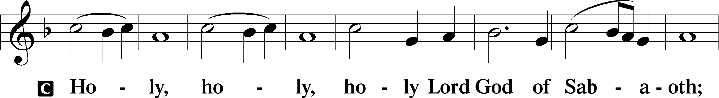
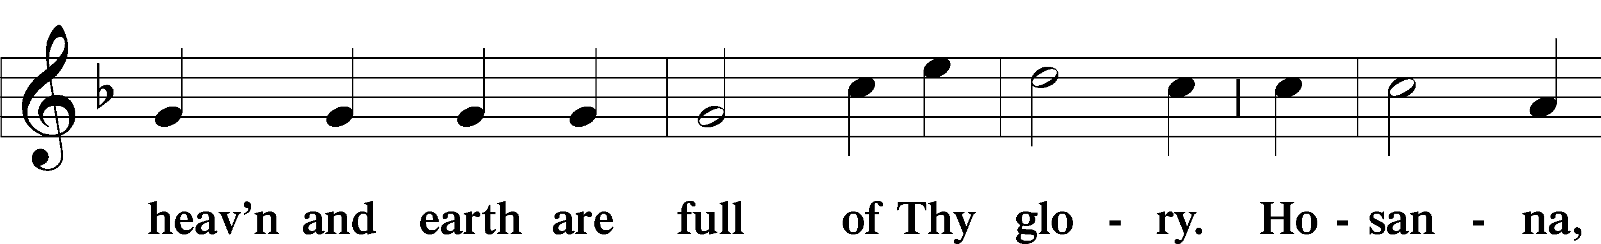
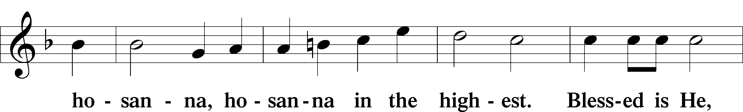
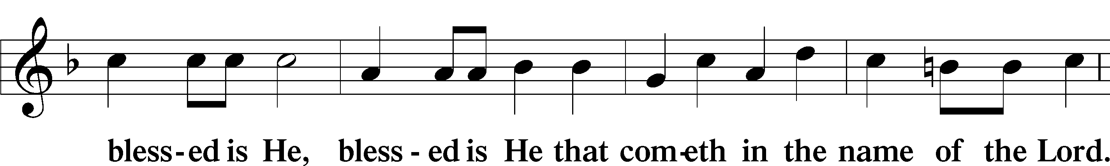
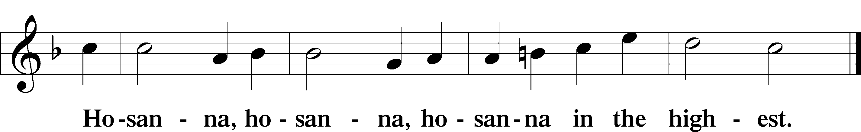

Lord’s Prayer Matthew 6:9–13
C Our Father who art in heaven,
hallowed be Thy name,
Thy kingdom come,
Thy will be done on earth as it is in heaven;
give us this day our daily bread;
and forgive us our trespasses as we forgive those who trespass against us;
and lead us not into temptation,
but deliver us from evil.
For Thine is the kingdom and the power and the glory forever and ever. Amen.
The Words of Our Lord Matthew 26:26–28; Mark 14:22–24; Luke 22:19–20; 1 Corinthians 11:23–25
P Our Lord Jesus Christ, on the night when He was betrayed, took bread, and when He had given thanks, He broke it and gave it to the disciples and said: “Take, eat; this is My T body, which is given for you. This do in remembrance of Me.”

In the same way also He took the cup after supper, and when He had given thanks, He gave it to them, saying: “Drink of it, all of you; this cup is the new testament in My T blood, which is shed for you for the forgiveness of sins. This do, as often as you drink it, in remembrance of Me.”

Pax Domini John 20:19
P The peace of the Lord be with you always.
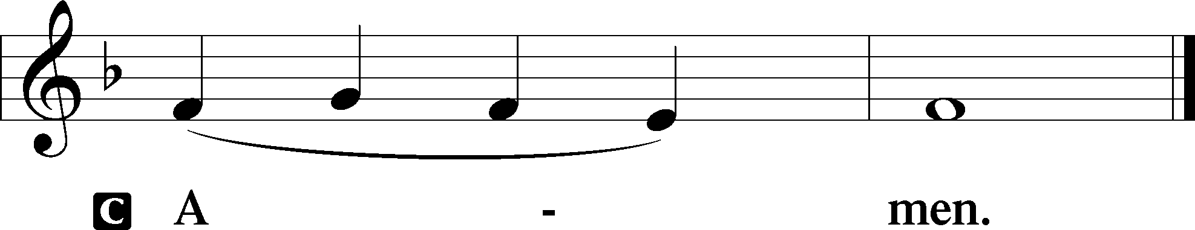

Agnus Dei John 1:29
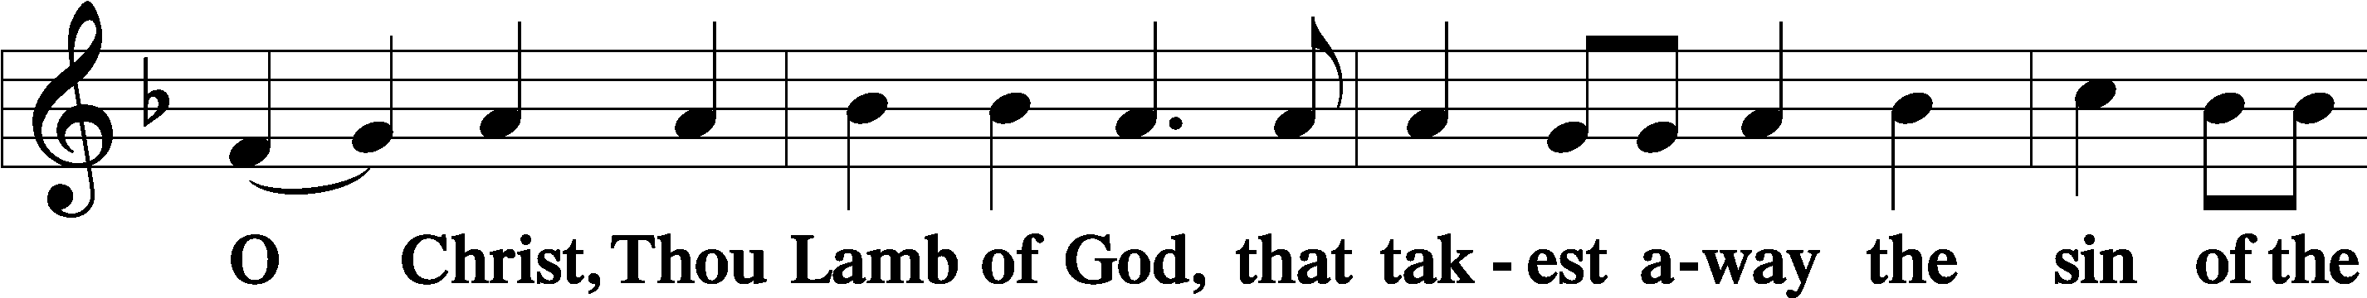
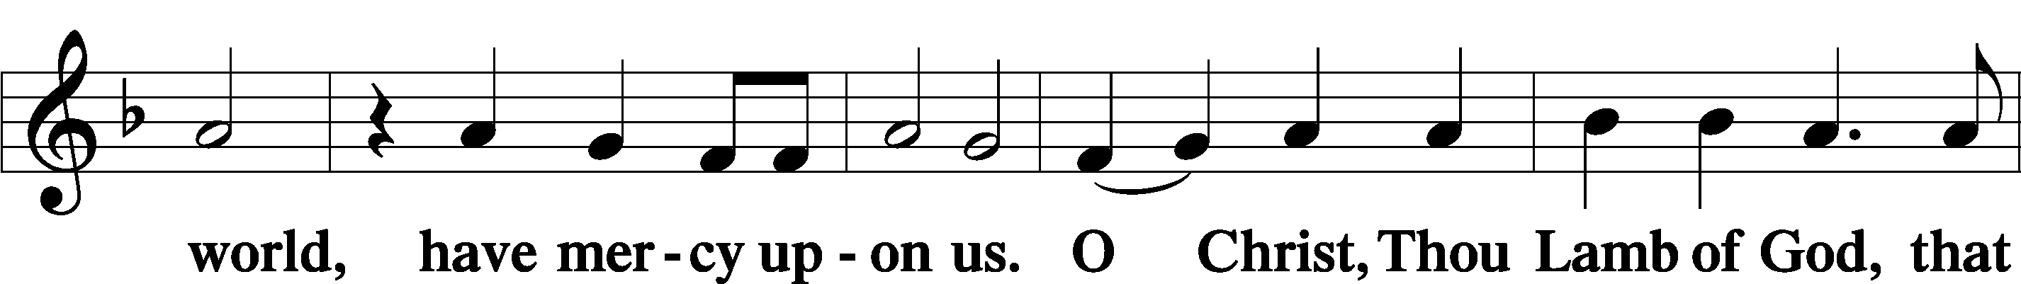
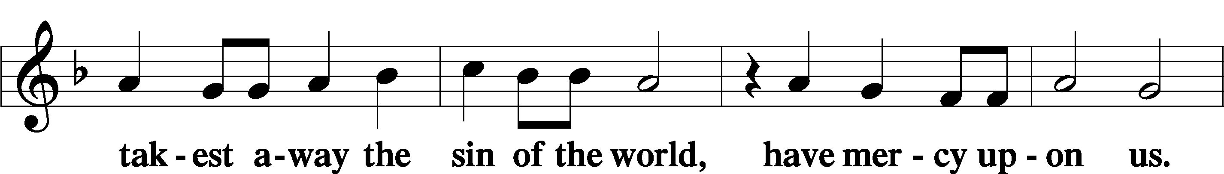
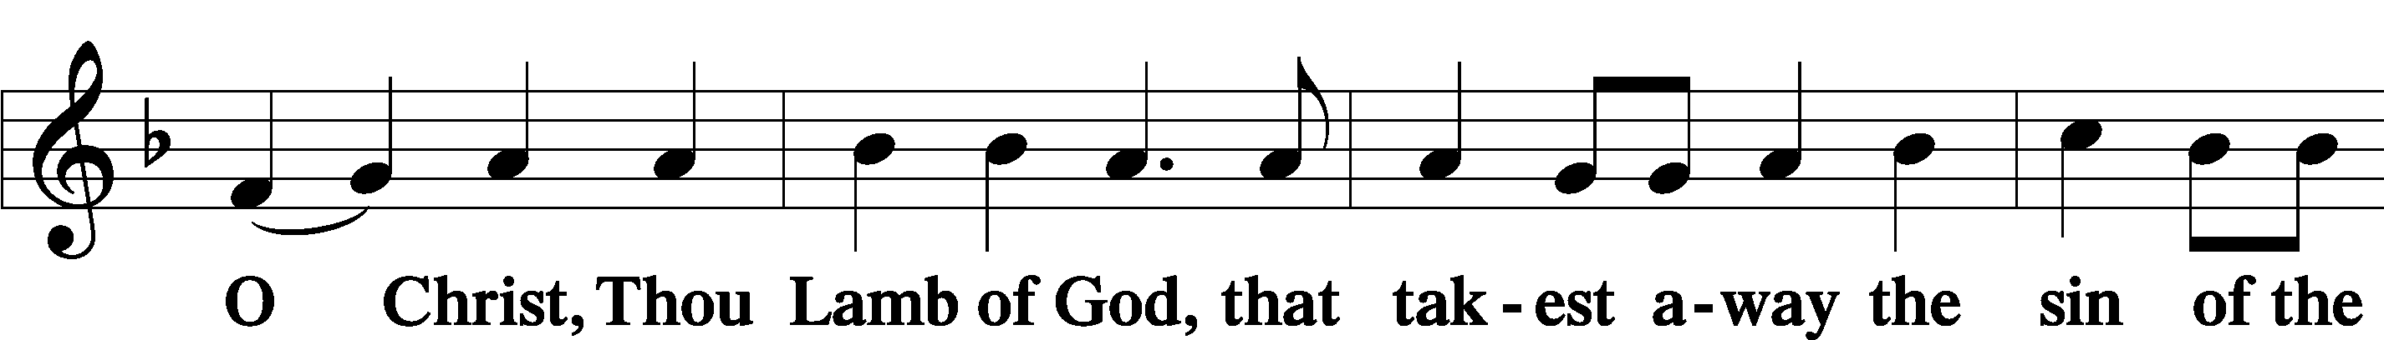
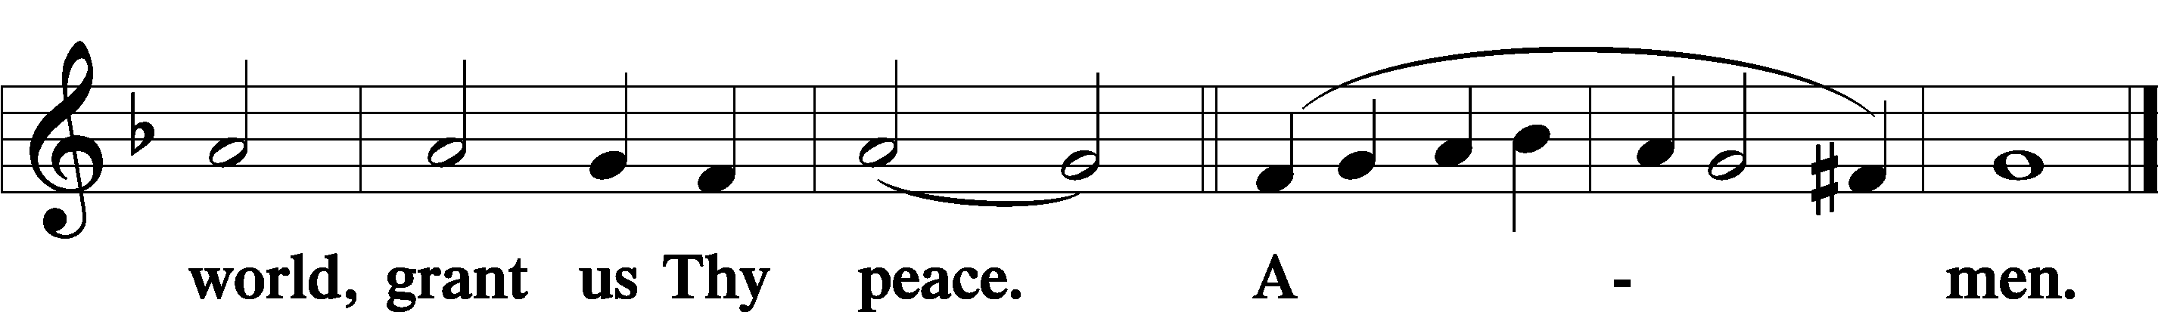
Sit
Distribution
The pastor and those who assist him receive the body and blood of Christ first and then distribute them to those who come to receive, saying:
Take, eat; this is the true body of our Lord and Savior Jesus Christ, given into death for your sins.
Amen.

Take, drink; this is the true blood of our Lord and Savior Jesus Christ, shed for the forgiveness of your sins.
Amen.

In dismissing the communicants, the following is said:
The Dismissal
P The body and blood of our Lord Jesus Christ strengthen and preserve you in body and soul to life everlasting. Depart T in peace.
C Amen.

Distribution Hymn: LSB #623 “Lord Jesus Christ, We Humbly Pray”

Distribution Hymn: LSB#663 “Rise, My Soul, to Watch and Pray”

Distribution Hymn: LSB #619 “Thy Body, Given for Me, O Savior”

Stand

Nunc Dimittis Luke 2:29–32
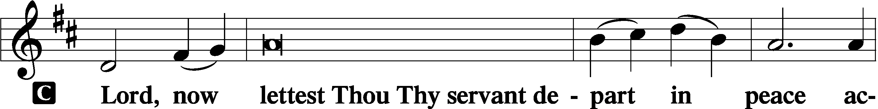
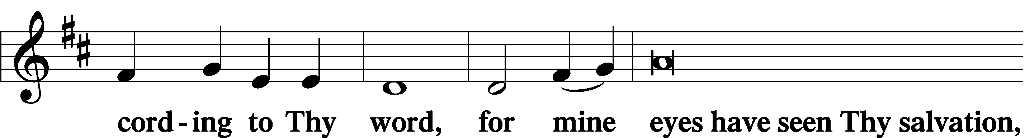
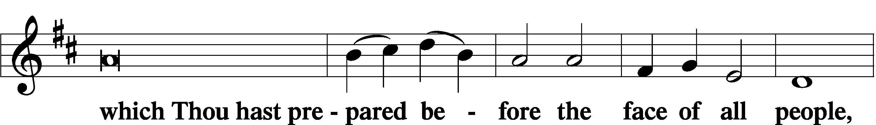
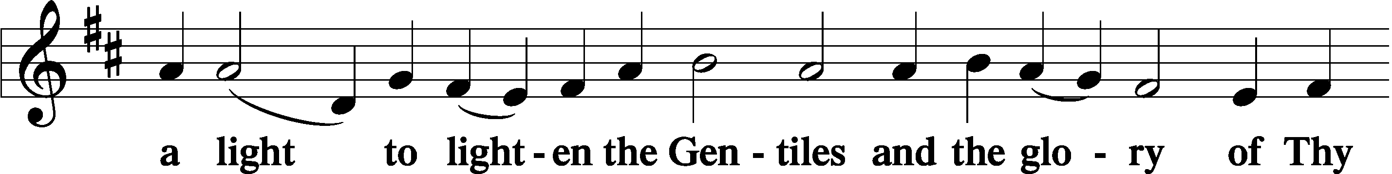
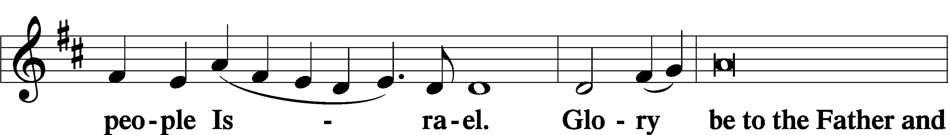
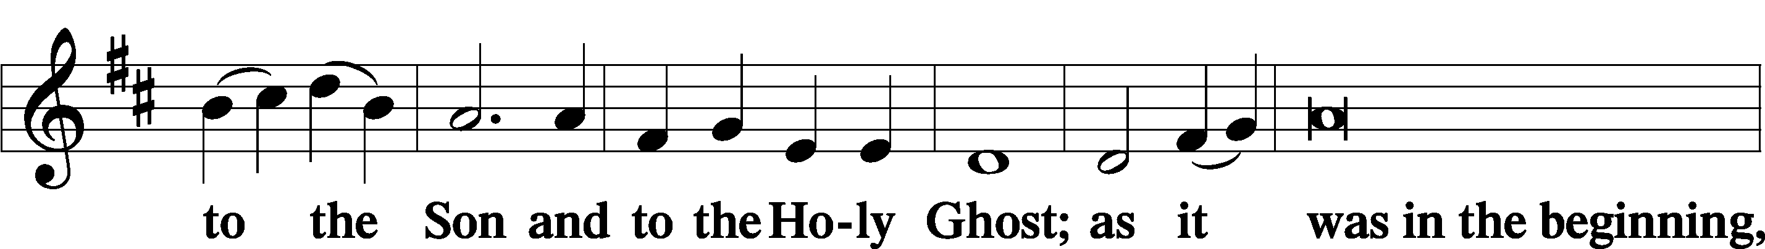
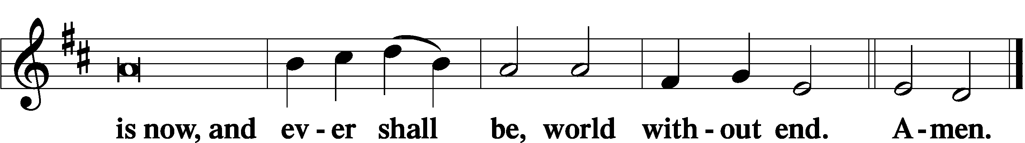

Thanksgiving Psalm 107:1
P O give thanks unto the Lord, for He is good,
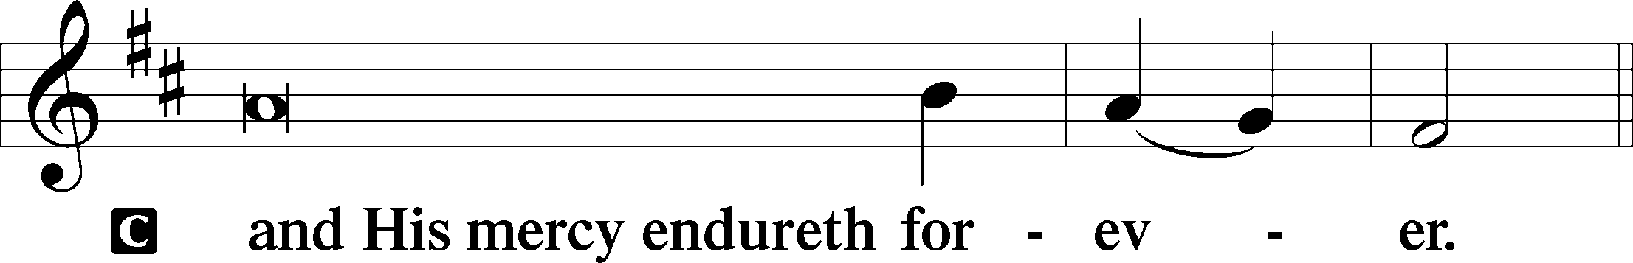

Post-Communion Collect
P Let us pray.
We give thanks to You, almighty God, that You have refreshed us through this salutary gift, and we implore You that of Your mercy You would strengthen us through the same in faith toward You and in fervent love toward one another; through Jesus Christ, Your Son, our Lord, who lives and reigns with You and the Holy Spirit, one God, now and forever.
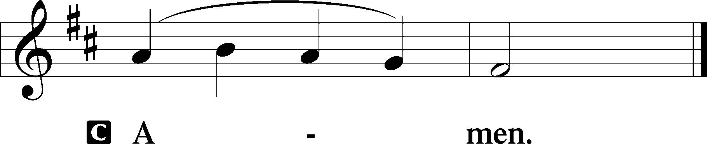

Salutation 2 Timothy 4:22
P The Lord be with you.
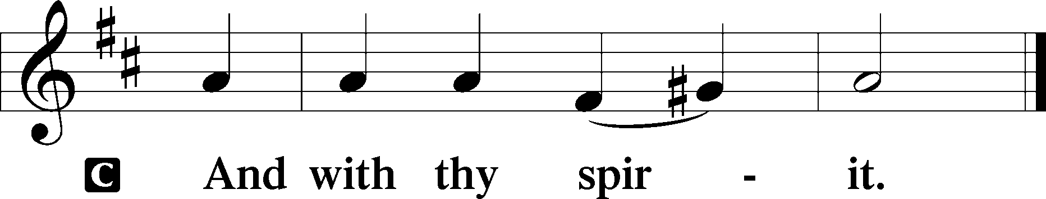

Benedicamus Psalm 103:1
P Bless we the Lord.
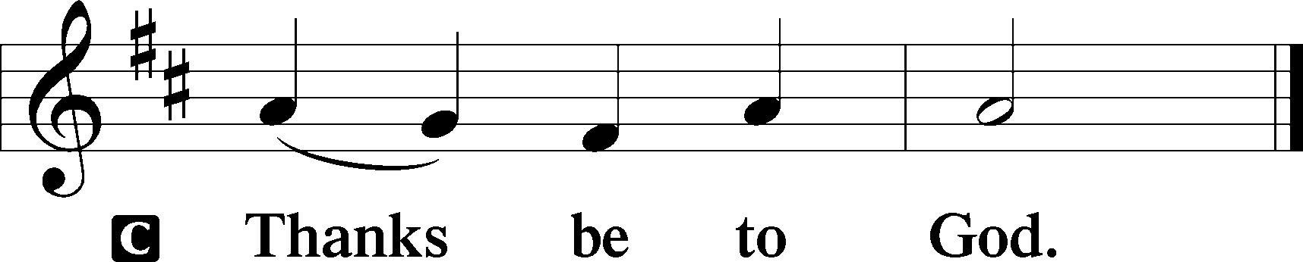

Benediction Numbers 6:24–26
P The Lord bless you and keep you.
The Lord make His face shine upon you and be gracious unto you.
The Lord lift up His countenance upon you and T give you peace.
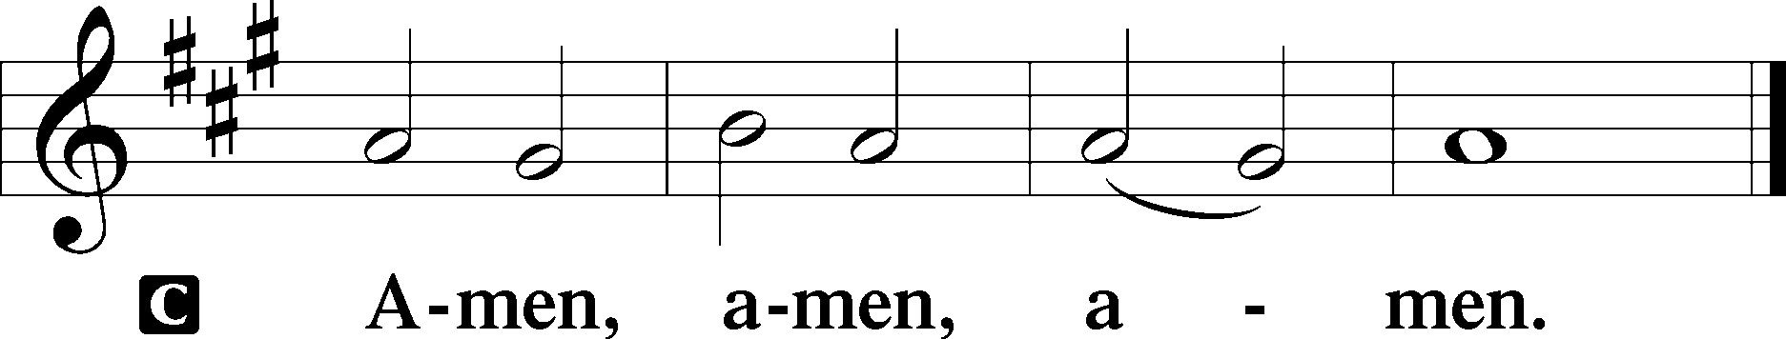

Closing Hymn: LSB #514 “The Bridegroom Soon Will Call Us”

Silent prayer after worship: Heavenly Father, give me a spirit that longs to have Your Word dwell in my heart, that I may have peace, hope and strength to meet all the trials and challenges of life, and may live according to Your will. In Jesus’ name. Amen.
fffffffffffffffffffffffffffffffffff
Acknowledgments
Unless otherwise indicated, Scripture quotations are from the ESV® Bible (The Holy Bible, English Standard Version®), copyright © 2001 by Crossway, a publishing ministry of Good News Publishers. Used by permission. All rights reserved.
Created by Lutheran Service Builder © 2023 Concordia Publishing House.
fffffffffffffffffffffffffffffffffff
fffffffffffffffffffffffffffffffffff
In Loving Memory of Martin Anderson: The Ferrence Family (Food Pantry) and Bob, Barb, Lisa, & Emily Marcellus (Food Pantry).
fffffffffffffffffffffffffffffffffff
SCHEDULE THROUGH AUGUST 6, 2023:

:

Today, 7 pm, Fellowship Hall: AA Meeting
Tuesday, 7-9 pm, Fellowship Hall: Penn-Ohio Singers
Wednesday, 7:30 pm, Fellowship Hall: NA Meeting
Next Sunday, 9 am, Sanctuary: Divine Service
7 pm, Fellowship Hall: AA Meeting
fffffffffffffffffffffffffffffffffff
Attendance: Saturday, July 22, 2023: 12
Sunday, July 23, 2023: 49
fffffffffffffffffffffffffffffffffff
THANK YOU FOR SERVING IN JULY: Elder: Jonathan Baisch; Ushers: Matt Berent, Mark Gabriel, Michael Laird, & Jerome Thomas; Altarware: (prior) Diane Riefstahl & Marie Flaugher (07/09 & 07/30); (after) Elizabeth Haenftling (07/02 & 07/16) & Marie Flaugher (07/09, 07/23, & 07/30).
fffffffffffffffffffffffffffffffffff
Bible Memory Verses ~ Week of July 30th:
For Adults: For our sake he made him to be sin who knew no sin, so that in him we might become the righteousness of God. 2 Corinthians 5:21
For Children: Walk as children of light, for the fruit of light is found in all that is good and right and true. Ephesians 5:8-9
fffffffffffffffffffffffffffffffffff
The 68th Regular Convention of The Lutheran Church—Missouri Synod will be held from July 29 to Aug. 3, 2023, at the Baird Center in Milwaukee, Wisconsin.
The Synod will gather under the convention theme, “We Preach Christ Crucified,” based on 1 Cor. 1:18–25.
Jonathan Baisch will be representing our church at this convention. Please keep Jonathan in prayer for safe travels and during his attendance at the event.
You can get daily updates on convention events via www.lcms.org and checking out the various links.
fffffffffffffffffffffffffffffffffff
There are additional copies of the “Reading the Bible in Six Months” schedule on the tables in the narthex and adjacent to the nursery.
Our Stewardship of Treasures for the Lord:
In order to do the Lord’s work, we need $2,553.63 each week to meet our 2023 budget for general purposes and $76.92 for the SELC.
Figures for Sunday, July 23, 2023
General Fund: $2,268.00 Behind for the week: -$285.63
SELC: $30.00 Behind for the week: -$46.92
Food Pantry: $300.00
Capital Campaign: $541.00
Other: $635.00

For online giving, check out https://www.saintspeterandpaul.net/online-giving.
fffffffffffffffffffffffffffffffffff
Remember the following in Prayer…
~The Hurting and Healing: Amy, Steve Antolovich, Ellen Baron^{CA}, Lois Bortner^{CA}, Dee Bullock, Bev & Joe Chlpka, Susan Davies, Tim Dudash, Judith & Eddy Furey, Griffin, Austin Hamilton, Pastor Charles Henrickson, Joan, Darla Krajci, Barbara Kreske, Pastor Ed Kucera, Jess Lavoie, Elizabeth Loughan, Paul Lucas^{CA}, Sandy Marshall, Gene Moore, Frank Niemeyer^{CA}, Juanita Rentschler, Richard Reuning^{CA}, Nancy Robertson^{CA}, Joel & Peggy Wasson, Angela Weser^{CA}, and Ruth Wolf.
~The Homebound: Anna Mae Daris, Millie Elavsky, Rudy & Jean Tomko, Betty Wolf, and Ed & Millie Zachar.
~Celebrating this Week: Birthday: Selena Thomas (07.30)
~Serving in the Military: Alex (Sasha) Carr, Curtis Sinewe, and Joshua Solyan.
~Community & World Needs: Those suffering from or affected by the coronavirus; those suffering due to the conflict between Ukraine and Russia; those suffering from loss and dislocation because weather disasters; those suffering from addiction and their families; Local, State, and National Government Leaders; safety for all Police Officers, Firefighters, & First Responders; the unemployed; our Third Quarter Local Mission: Luther Classical College.
*CA represents cancer.
fffffffffffffffffffffffffffffffffff
THANK YOU FOR SERVING IN AUGUST: Elder: Jonathan Baisch; Ushers: Cheryl Fedele, Mike Flaugher, & Jesse Riffle; Altarware: (prior) Diane Riefstahl & Marie Flaugher (08/13); (after) Hank Holcroft & Kati Laird.
fffffffffffffffffffffffffffffffffff
The next Voters’ Assembly will take place following worship, Sunday, August 20th. Your attendance will be greatly appreciated.
fffffffffffffffffffffffffffffffffff
Our prayer list has been updated. If you would like someone’s name added or deleted from our Prayer List, please put a note in the secretary’s mail slot. Thank you!
fffffffffffffffffffffffffffffffffff
Our Food Pantry now has its own email address: foodpantry@saintspeterandpaul.net.
Please encourage anyone who needs to contact it to do so !
fffffffffffffffffffffffffffffffffff
Copies of the August issue of “The Rock and the Sword” newsletter are available this morning and can be picked up from either the table in the narthex or the table next to the nursery.
fffffffffffffffffffffffffffffffffff
REMINDER: All Bible Study classes are on hiatus during the month of August. They will resume in September.
fffffffffffffffffffffffffffffffffff
SCRIP ORDERS AND PAYMENTS for August will be due to Matt Berent next Sunday, August 6th. Copies of the order form are available in the narthex and on the sign-in table near the nursery.

Here to Serve
Pastor………………………………………………...……………Rev. Jacob Deal
E-mail …………………………….……pastordeal@saintspeterandpaul.net
Phone Number……………………..…………………724-347-3620 (Option 2)
Church Office………………………..…………………724-347-3620 (Option 3)
Website …………………………………………www.saintspeterandpaul.net
Secretary…………………………………………………………Diane Riefstahl
E-mail ………………………………………church@saintspeterandpaul.net
Website …………………………………………www.saintspeterandpaul.net
Food Pantry (email): ……………foodpantry@saintspeterandpaul.net
Congregation President………………………………….…Jonathan Baisch
Church Elder …………………………………………...……. Jonathan Baisch
Organist………………………………………………..….…Rebecca Marquette
Choir Director…………………………………………………….…Chris Nelson
AA Contact: Steve………………………………………………...…724-813-2358
NA Contact: Larry……………………………………..…………..724-977-8733
fffffffffffffffffffffffffffffffffff
If needing to get into the church building during the week, please phone first to make certain someone is here to let you in.

