Sts. Peter & Paul
Evangelical Lutheran Church
Lutheran Church-Missouri Synod
Founded-1917

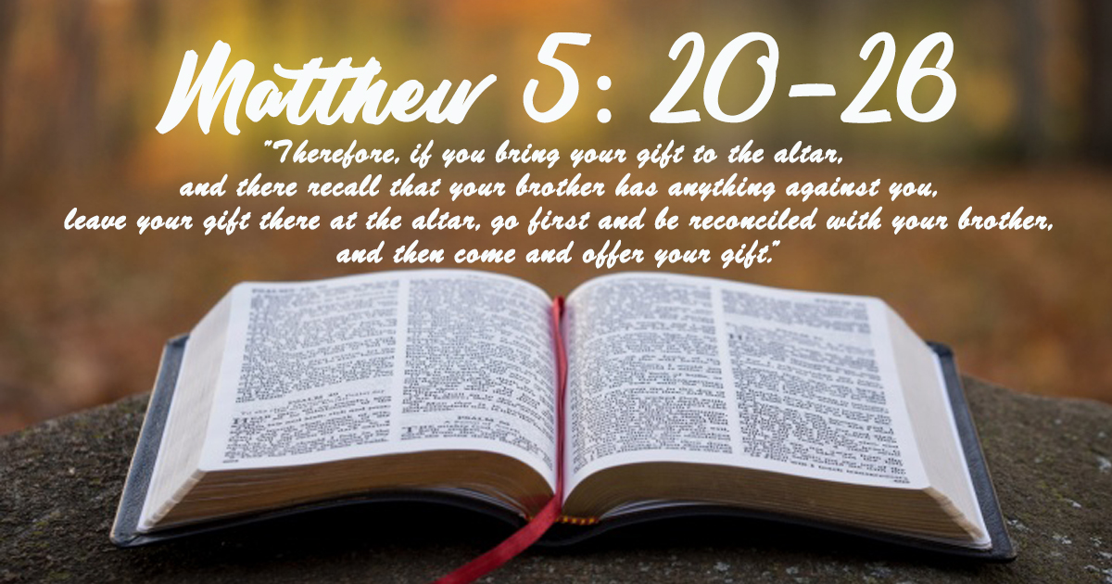

JULY 28, 2019

699 Stambaugh Avenue
Sharon, Pennsylvania 16146

“I was glad when they said to me,
Let us go to the house of the LORD!”
Psalm 122:1
Sts. Peter & Paul Evangelical Lutheran Church, LC-MS
SIXTH SUNDAY AFTER TRINITY
July 28, 2019

Silent prayer before worship: Dear Lord, through Your Word the Holy Spirit enables me to believe. By Your grace, lead me to trust You not only for eternal life, but to strengthen me and lead me through each day. In Jesus’ name. Amen.

Please read Communion Statement found inside the Friendship Booklet prior to taking part in Holy Communion.
CONFESSION AND ABSOLUTION
Opening Hymn: LSB #590 “Baptized into Your Name Most Holy”

Stand
The sign of the cross may be made by all in remembrance of their Baptism.

P In the name of the Father and of the T Son and of the Holy Spirit.
C Amen. Matthew 28: 19b; [18:20]

P If we say we have no sin, we deceive ourselves, and the truth is not in us.
C But if we confess our sins, God, who is faithful and just, will forgive our sins and cleanse us from all unrighteousness.

Silence for reflection on God's Word and for self-examination.

P Let us then confess our sins to God our Father.
C Most merciful God, we confess that we are by nature sinful and unclean. We have sinned against You in thought, word, and deed, by what we have done and by what we have left undone. We have not loved You with our whole heart; we have not loved our neighbors as ourselves. We justly deserve Your present and eternal punishment. For the sake of Your Son, Jesus Christ, have mercy on us. Forgive us, renew us, and lead us, so that we may delight in Your will and walk in Your ways to the glory of Your holy name. Amen.
P Almighty God in His mercy has given His Son to die for you and for His sake forgives you all your sins. As a called and ordained servant of Christ, and by His authority, I therefore forgive you all your sins in the name of the Father and of the T Son and of the Holy Spirit. [John 20: 19-23]
C Amen.

Passing of the Peace.

SERVICE OF THE WORD

Introit: Ps. 28:1–2, 7; antiphon: Ps. 28:8–9
The Lord is the strength of his | people;*
he is the saving refuge of his a- | nointed.
Save your people and bless your | heritage!*
Be their shepherd and carry them for- | ever.
To you, O Lord, I call; my rock, be not | deaf to me,*
lest, if you be silent to me, I become like those who go down | to the pit.
Hear the voice of my pleas for mercy, when I cry to | you for help,*
when I lift up my hands toward your most holy sanctu- | ary.
The Lord is my strength and my shield; in him my heart trusts, and | I am helped;*
my heart exults, and with my song I give | thanks to him.
Glory be to the Father and | to the Son*
and to the Holy | Spirit;
as it was in the be- | ginning,*
is now, and will be forever. | Amen.
The Lord is the strength of his | people;*
he is the saving refuge of his a- | nointed.
Save your people and bless your | heritage!*
Be their shepherd and carry them for- | ever.

Kyrie Mark 10:47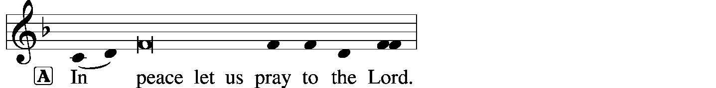
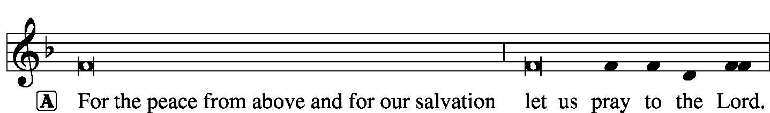
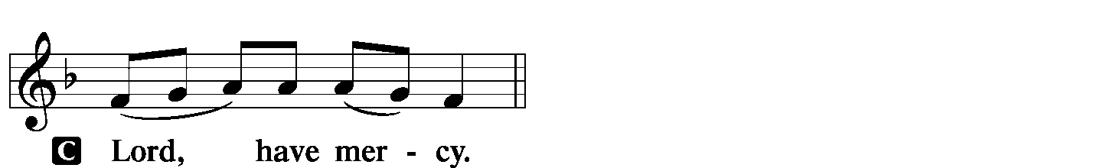
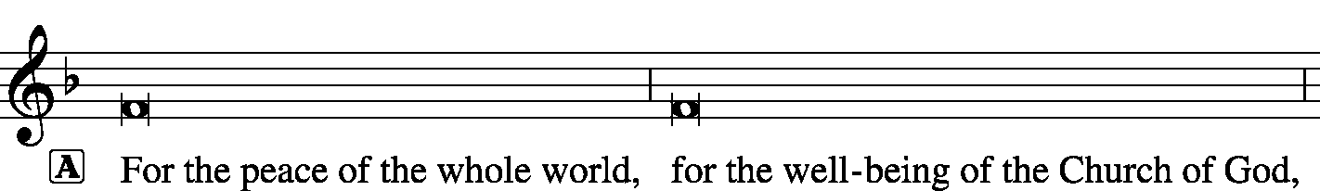
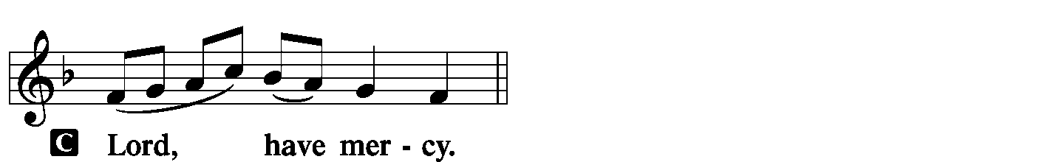
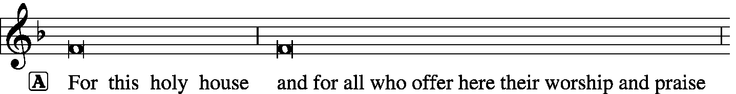
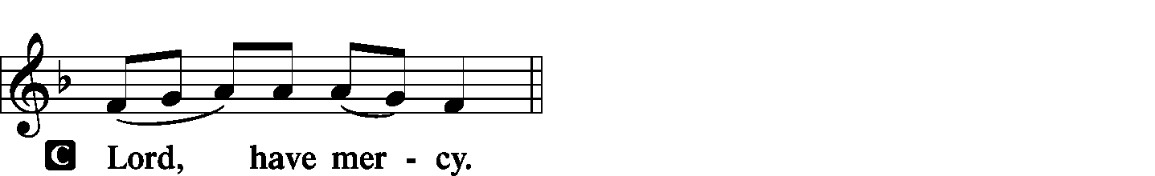
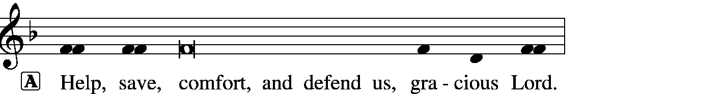

Gloria in Excelsis Luke 2: 14; John 1: 29
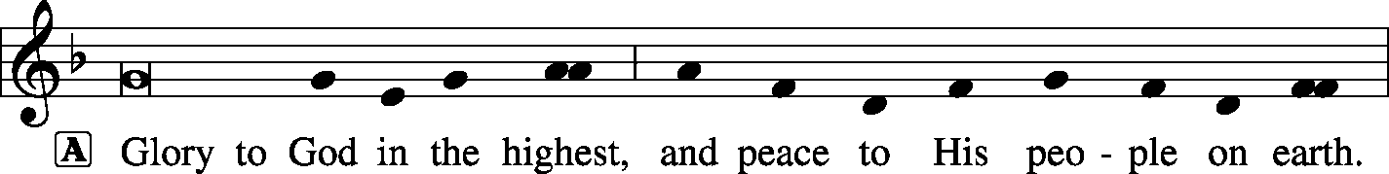
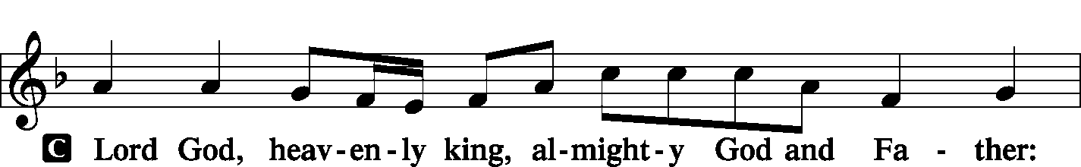
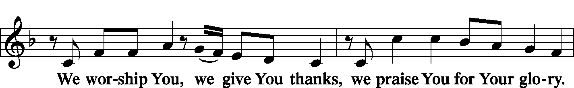
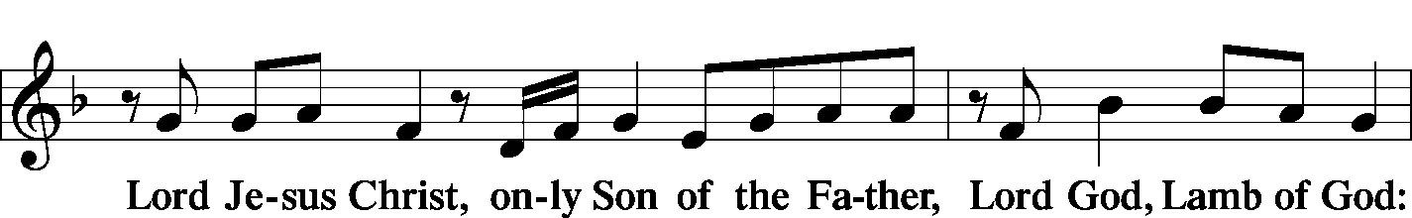
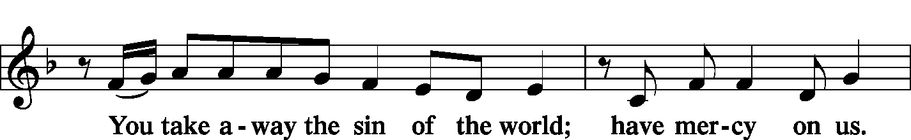
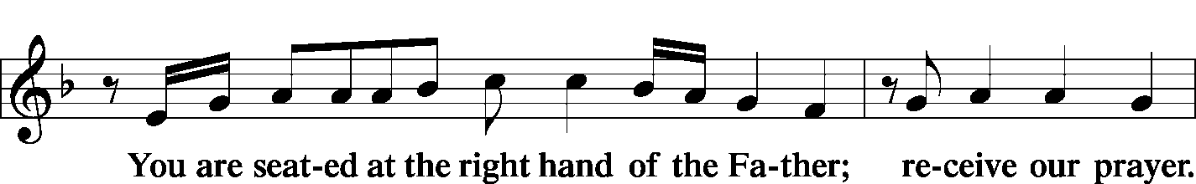
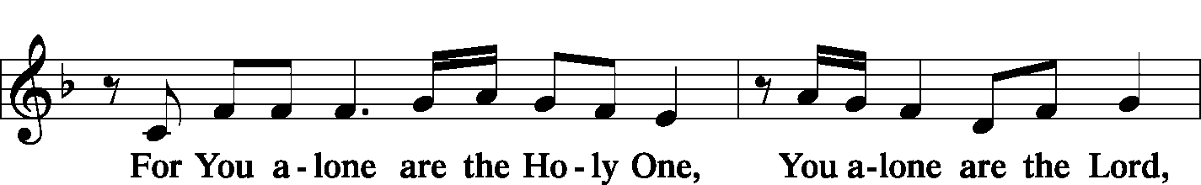
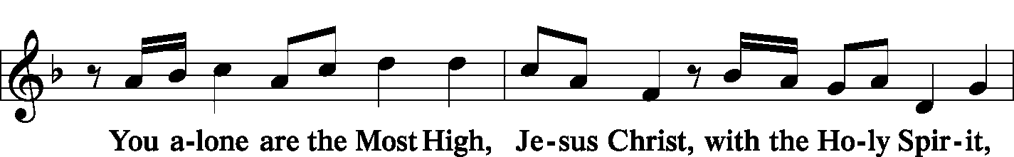
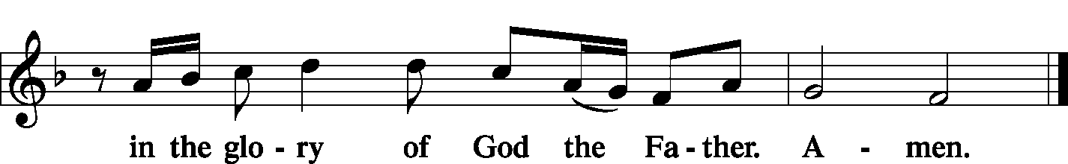

Salutation and Collect of the Day 2 Timothy 4: 22
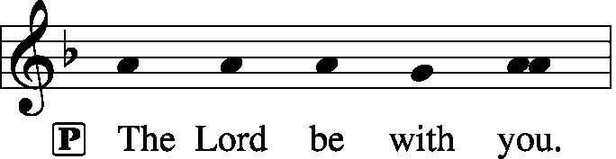
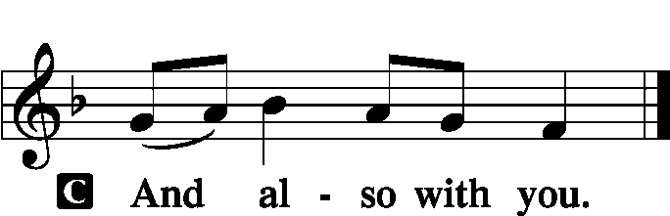

P Let us pray.
Lord of all power and might, author and giver of all good things, graft into our hearts the love of Your name, increase in us true religion, nourish us with all goodness, and of Your great mercy keep us in the same; through Jesus Christ, Your Son, our Lord, who lives and reigns with You and the Holy Spirit, one God, now and forever.

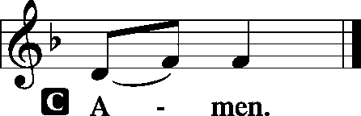

Sit

Old Testament Reading: Exodus 20:1–17
And God spoke all these words, saying,
“I am the Lord your God, who brought you out of the land of Egypt, out of the house of slavery.
“You shall have no other gods before me.
“You shall not make for yourself a carved image, or any likeness of anything that is in heaven above, or that is in the earth beneath, or that is in the water under the earth. You shall not bow down to them or serve them, for I the Lord your God am a jealous God, visiting the iniquity of the fathers on the children to the third and the fourth generation of those who hate me, but showing steadfast love to thousands of those who love me and keep my commandments.
“You shall not take the name of the Lord your God in vain, for the Lord will not hold him guiltless who takes his name in vain.
“Remember the Sabbath day, to keep it holy. Six days you shall labor, and do all your work, but the seventh day is a Sabbath to the Lord your God. On it you shall not do any work, you, or your son, or your daughter, your male servant, or your female servant, or your livestock, or the sojourner who is within your gates. For in six days the Lord made heaven and earth, the sea, and all that is in them, and rested the seventh day. Therefore the Lord blessed the Sabbath day and made it holy.
“Honor your father and your mother, that your days may be long in the land that the Lord your God is giving you.
“You shall not murder.
“You shall not commit adultery.
“You shall not steal.
“You shall not bear false witness against your neighbor.
“You shall not covet your neighbor’s house; you shall not covet your neighbor’s wife, or his male servant, or his female servant, or his ox, or his donkey, or anything that is your neighbor’s.”

P This is the Word of the Lord.
C Thanks be to God.

Gradual: Ps. 90:13, 1, 2b
Return, O Lord! How long?
Have pity on your servants!
Lord, you have been our dwelling place in all generations.
From everlasting to everlasting you are God.

Epistle: Romans 6:3–11
Do you not know that all of us who have been baptized into Christ Jesus were baptized into his death? We were buried therefore with him by baptism into death, in order that, just as Christ was raised from the dead by the glory of the Father, we too might walk in newness of life.
For if we have been united with him in a death like his, we shall certainly be united with him in a resurrection like his. We know that our old self was crucified with him in order that the body of sin might be brought to nothing, so that we would no longer be enslaved to sin. For one who has died has been set free from sin. Now if we have died with Christ, we believe that we will also live with him. We know that Christ being raised from the dead will never die again; death no longer has dominion over him. For the death he died he died to sin, once for all, but the life he lives he lives to God. So you also must consider yourselves dead to sin and alive to God in Christ Jesus.

P This is the Word of the Lord.
C Thanks be to God.

Stand

Verse of the Day: Ps. 31:1
Alleluia. In you, O Lord, do I take refuge; let me never be put to shame; in your righteousness deliver me! Alleluia.

Common Alleluia
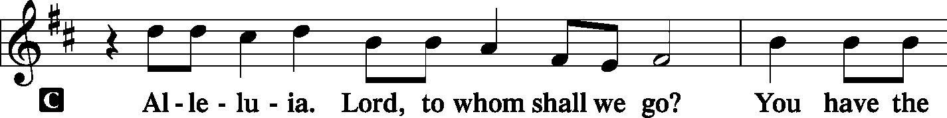
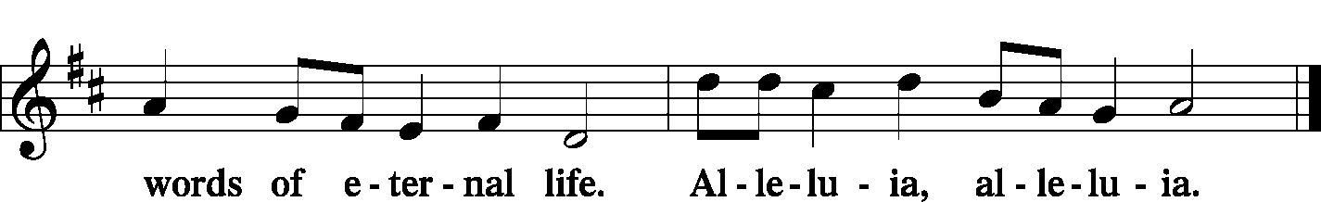

Holy Gospel: Matthew 5:20–26
P The Holy Gospel according to St. Matthew, the fifth chapter.

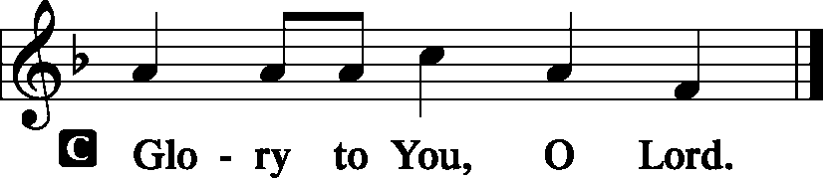

“For I tell you, unless your righteousness exceeds that of the scribes and Pharisees, you will never enter the kingdom of heaven.
“You have heard that it was said to those of old, ‘You shall not murder; and whoever murders will be liable to judgment.’ But I say to you that everyone who is angry with his brother will be liable to judgment; whoever insults his brother will be liable to the council; and whoever says, ‘You fool!’ will be liable to the hell of fire. So if you are offering your gift at the altar and there remember that your brother has something against you, leave your gift there before the altar and go. First be reconciled to your brother, and then come and offer your gift. Come to terms quickly with your accuser while you are going with him to court, lest your accuser hand you over to the judge, and the judge to the guard, and you be put in prison. Truly, I say to you, you will never get out until you have paid the last penny.

P This is the Gospel of the Lord.
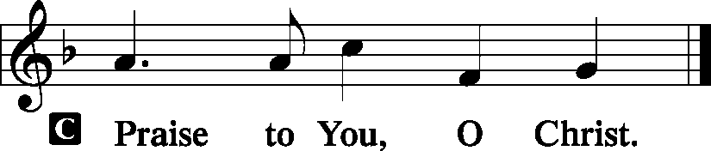

Nicene Creed
C I believe in one God,
the Father Almighty,
maker of heaven and earth
and of all things visible and invisible.
And in one Lord Jesus Christ,
the only-begotten Son of God,
begotten of His Father before all worlds,
God of God, Light of Light,
very God of very God,
begotten, not made,
being of one substance with the Father,
by whom all things were made;
who for us men and for our salvation came down from heaven
and was incarnate by the Holy Spirit of the virgin Mary
and was made man;
and was crucified also for us under Pontius Pilate.
He suffered and was buried.
And the third day He rose again according to the Scriptures
and ascended into heaven
and sits at the right hand of the Father.
And He will come again with glory to judge both the living and the dead,
whose kingdom will have no end.
And I believe in the Holy Spirit,
the Lord and giver of life,
who proceeds from the Father and the Son,
who with the Father and the Son together is worshiped and glorified,
who spoke by the prophets.
And I believe in one holy Christian and apostolic Church,
I acknowledge one Baptism for the remission of sins,
and I look for the resurrection of the dead
and the life T of the world to come. Amen.
Sit

Hymn of the Day: LSB #562 “All Mankind Fell in Adam's Fall”
Sermon
Stand
Prayer of the Church [Timothy 2: 1-4]
Sit
Offertory Psalm 116: 12-13, 17-19
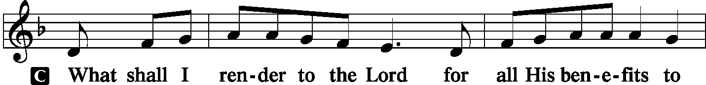
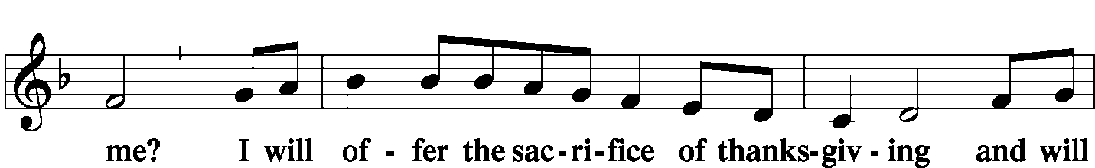
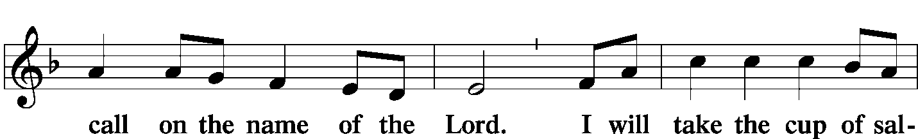
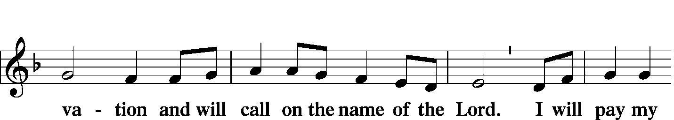
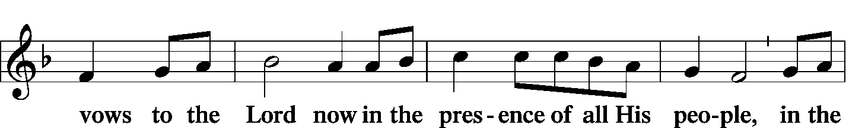
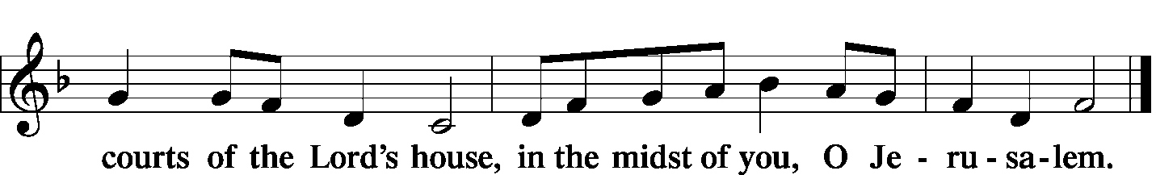

Offering/Offering Hymn: LSB #714 “Who Trusts in God a Strong Abode”
Stand
SERVICE OF THE SACRAMENT
Preface
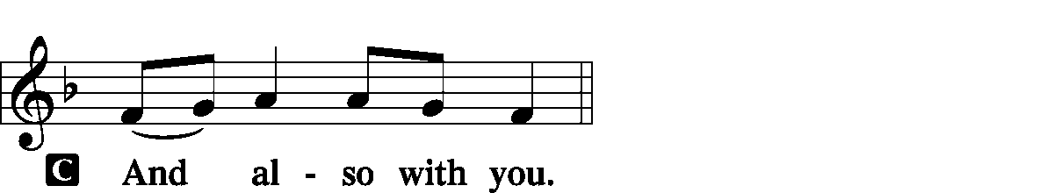
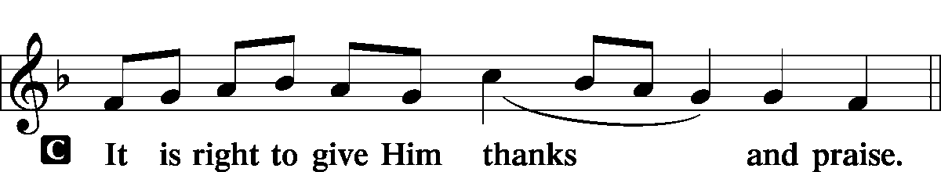

P It is truly good, right, and salutary … evermore praising You and saying:

Sanctus
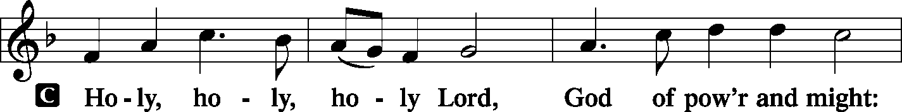
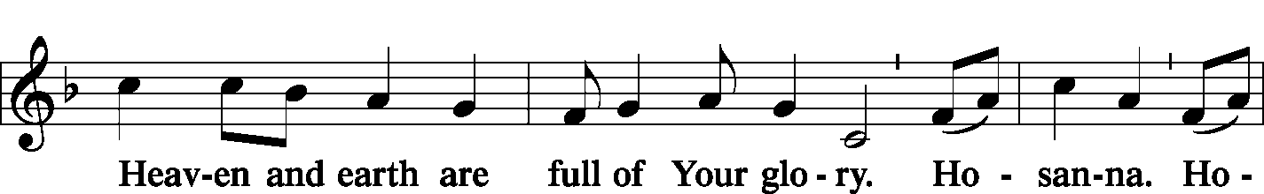
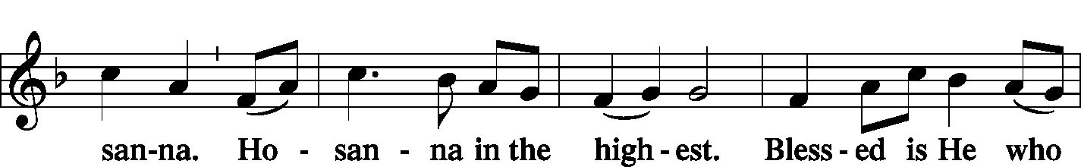
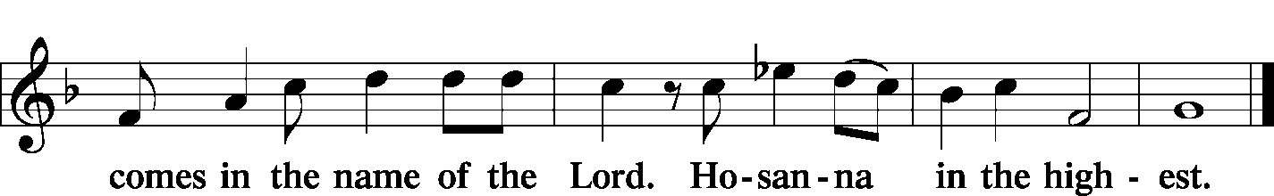

Lord's Prayer Matthew 6: 9-13
P Lord, remember us in Your kingdom and teach us to pray:
C Our Father who art in heaven,
hallowed be Thy name,
Thy kingdom come,
Thy will be done on earth as it is in heaven;
give us this day our daily bread;
and forgive us our trespasses as we forgive those who trespass against us;
and lead us not into temptation,
but deliver us from evil.
For Thine is the kingdom and the power and the glory forever and ever. Amen.

The Words of Our Lord Matthew 26: 26-28; Mark 14: 22-24
Luke 22: 19-20; 1 Corinthians 11: 23-25
P Our Lord Jesus Christ, on the night when He was betrayed, took bread, and when He had given thanks, He broke it and gave it to the disciples and said: “Take, eat; this is My T body, which is given for you. This do in remembrance of Me.”

P In the same way also He took the cup after supper, and when He had given thanks, He gave it to them, saying: “Drink of it, all of you; this cup is the new testament in My T blood, which is shed for you for the forgiveness of sins. This do, as often as you drink it, in remembrance of Me.”

Pax Domini John 20: 19
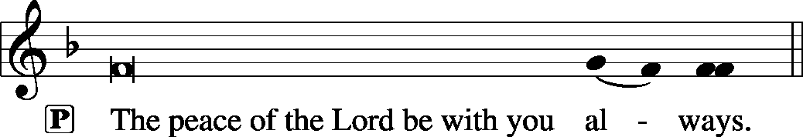

Agnus Dei John 1: 29
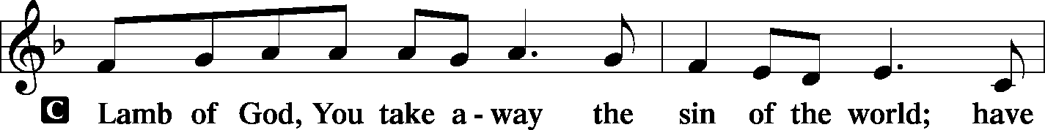
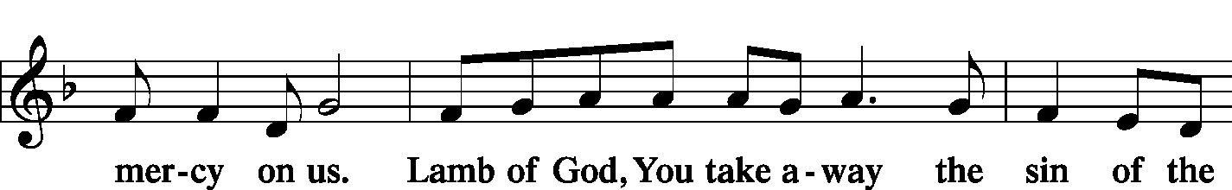
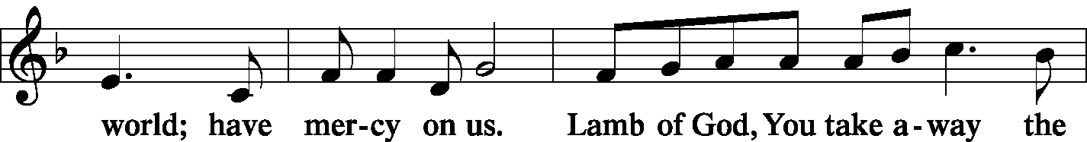
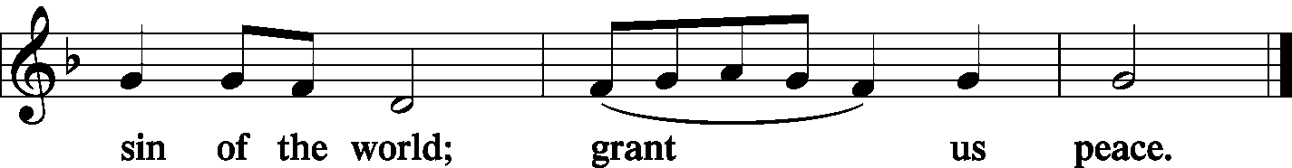

Sit
Distribution
The pastor and those who assist him receive the body and blood of Christ first and then distribute them to those who come to receive, saying:

Take, eat; this is the true body of our Lord and Savior Jesus Christ, given into death for your sins.
Amen.

Take, drink; this is the true blood of our Lord and Savior Jesus Christ, shed for the forgiveness of your sins.
Amen.
In dismissing the communicants, the following is said:
P The body and blood of our Lord Jesus Christ strengthen and preserve you in body and soul to life everlasting. Depart T in peace.
C Amen.

Distribution Hymn: LSB #621 “Let All Mortal Flesh Keep Silence”
Distribution Hymn: LSB #625 “Lord Jesus Christ, Life-Giving Bread”

Stand

Nunc Dimittis Luke 2: 29-32
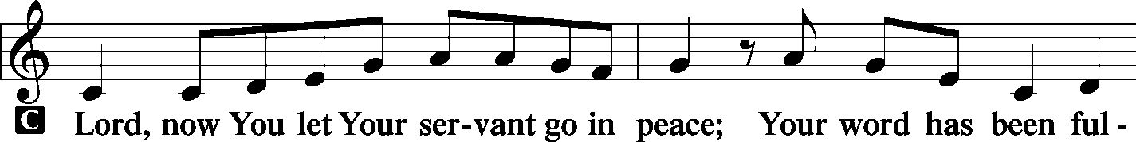
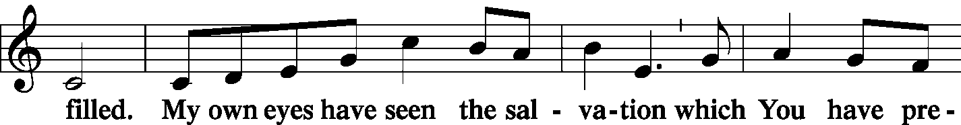
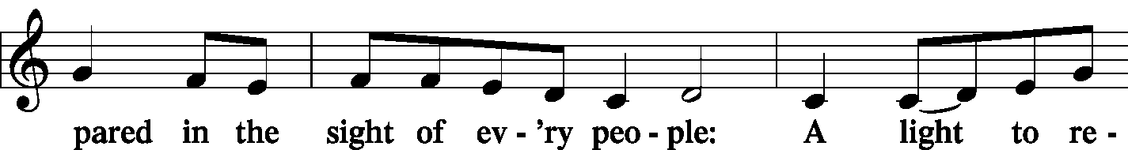
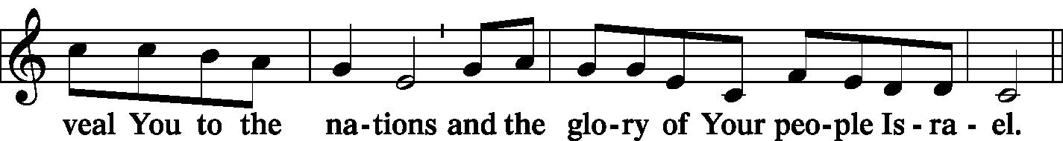
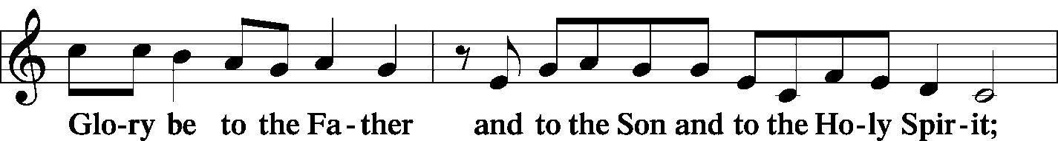
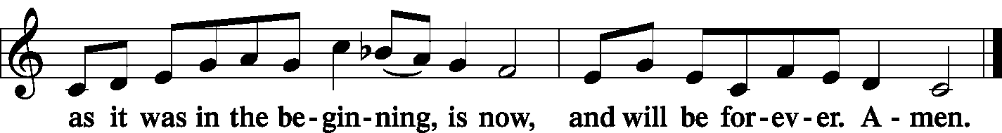

Post-Communion Collect Let us pray…

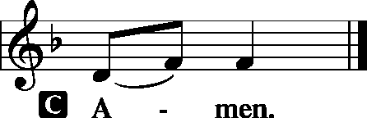

Benediction Numbers 6: 24-26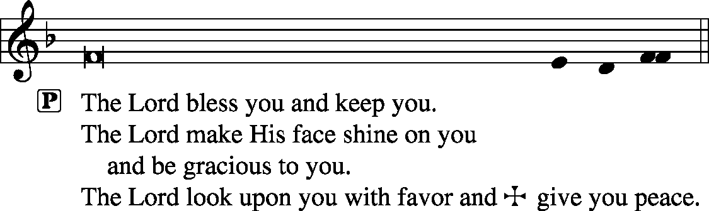
Closing Hymn: LSB #656 “A Mighty Fortress Is Our God”
Silent prayer after worship: Dear Jesus, lead me to daily pray and read Your Word so the Holy Spirit can draw me closer to You. As Your child and heir of Your kingdom, help me to live my life for You. Amen.

The Altar Flowers this morning are given in Loving Remembrance of Brother, Richard Dorfi by Mr. & Mrs. Robert Sulek. We sincerely appreciate this generous gift!

Attendance: Sunday, July 21, 2019…………………………………..….……37.
Please sign the Friendship Book and give your sheet to an usher after the offering.

Thank You for Serving in July:
Today’s Greeters: Anson & Henrietta Holcroft. Assisting Elders: Barry Nelson & Hugh Owen. Ushers: John Dyll, Barry Nelson, Jerome Thomas, Gary Burns, & Bob Sulek (alternate). Altarware: Anne Colt & Traudi Sulek.


Thank You for Serving in August:
Assisting Elders: Bob Sulek & Barry Nelson. Ushers: Ralph Dorman, Jonathan Baisch, Matt Berent, Mark Gabriel, & John Dyll (alternate). Altarware: Clara Krivosh & Cheryl Fedele.
August Greeters: 4 ~ Dolores Fee & Diane Riefstahl; 11 ~ Jeff & Stacy Brandes; 18 ~ Gary & Eileen Burns; 25 ~ Barry & Chris Nelson.

Bible Memory Verses: For the week of July 28th:
For Children: Fear not, for I have redeemed you; I have called you by name, you are mine. Isa. 43:1
For Adults: Heaven and earth will pass away, but my words will not pass away.
Mark 13:31

Reminder! Sunday morning Bible Study resumes next Sunday, August 4th. All are welcome to join!

Acknowledgments: Divine Service, Setting One from Lutheran Service Book Unless otherwise indicated, all scripture quotations are from The Holy Bible, English Standard Version, copyright © 2001 by Crossway Bibles, a division of Good News Publishers. Used by permission. All rights reserved. Created by Lutheran Service Builder © 2006 Concordia Publishing House. CCLI License #3029-446


SCHEDULE FOR TODAY THROUGH AUG. 4th :
:

:

Today, following Worship…………………………………Community Day flyer distribution
7 pm, Downstairs….…………….…………………..………………….……...……AA Meeting
Monday, 4:30 pm, Offices………………………………………………………New Members’ Class
Saturday, 5-8 pm, Church grounds..………………………………3rd Annual Community Day
Next Sunday, 8:45 am, Downstairs……………………………………………..…………Bible Study
10 am, Sanctuary…...........................................................................Divine Service
Following Worship, Library…………………………..……………..Brief Audit Meeting
7 pm, Downstairs…………………………………………..…………………......…AA Meeting

Our Stewardship of Treasures for the Lord:
In order to do the Lord’s work, we need $2,882.02* each week to meet our 2019 budget for general purposes and $38.46 for missions.
Sunday, July 21, 2019:
General Offering: $1575.00
Behind this week*: $1307.02
SELC Missions: $110.00
Ahead this week: $71.54
Local Missions: $0.00
Preschool Tuition: $0.00
Other Offerings: $231.00
*Includes preschool tuition.

Word of Hope: 1-888-217-8679
The only 24/7 CONFIDENTIAL Hotline that is distinctly Lutheran, bringing healing found in Christ, to those whose hearts have been broken by abortion.

This morning, following worship, distribution of Community Day flyers in our neighborhood will take place. Please meet in the Sonshine Room if able to help with this effort.



In Honor of Rev. Kucera’s 60 years in the ministry: Mr. & Mrs. Joseph Chlpka (food pantry) and Patty Parker.
On the Occasion of the 60th Anniversary of Rev. Ed Kucera’s Ordination: Audrey Infante.
In Loving Memory of Sophia Mihm: The Counseling Office at Pelham Memorial High School (Food Pantry).
In Loving Memory of Gene Roberts: John D. Murchek.
In Loving Memory of Caroline Swartzbeck’s birthday, July 28: Viola Sakony (Major Repair).
In Loving Memory of Don’s father, John Voytik, Pat’s mother, Jennie Hoyney, and sister, Ruth Gartner. Don & Pat Voytik.

Be certain to “Save the Date” for
the following up-coming events:

- Saturday, August 3rd. Sts. Peter & Paul’s Third Annual Community Day from 5-8 PM. Your help and presence are needed!
- Monday, August 5th. Church Council meets at 7 pm.
- Saturday, August 10th. Class comparing the teachings and foundations of the LCMS and the ELCA. Class discussion will be led by Pastor Deal and begins at 2 PM. The class will culminate in the Divine Service beginning at 5 PM.
- Sunday, August 25th. Voters’ Assembly meeting following the Divine Service.
- Wednesday, October 2nd or Thursday, October 3rd. Willow Women’s Center’s annual fall banquet hosted at the Avalon at Buhl. Phone 330-503-6512 or email rsvp@willowwomenscenter.com to reserve your spot for either date.
Remember the following in Prayer…
~The Hurting and Healing: Tony¹, Lois Bortner^{CA}, Richard Brandes⁴, Eileen Burns⁴, Beverly Chlpka¹, Kim¹, Tim Dudash¹, John Dyll⁴, Jennifer Hilliard⁴, Anson Holcroft⁴, Betty Knauff^{CA}, Regis Knauff¹, Clara Krivosh², Jess Lavoie³, Paul Lucas^{CA}, Rhonda Moats^{CA}, Barry Nelson¹, David Nelson²,Tom Mulligan^{CA}, Iona Oltman^{CA}, Rudy Pinal^{CA}, Don Voytik⁴, Angela Weser^{CA}, and Ken White^{CA}.
~Our Homebound: Helen Bender, Dan Davis, Edna Krajci, Mary Ann Krajci, Marion Roberts, Barbara Vasconi, and Joanne Wolfe.
~Celebrating: Birthdays: Selena Thomas (07.30), Anne Colt (07.31), and Elaine Kilar (08.03). Anniversary: Jerome & June Thomas (07.28).
~Serving in the Military: Clayton Drnek, Curtis Sinewe, and Joshua Solyan.
~Community & World Needs: Victims of violence and terrorism; those suffering from loss and dislocation because weather disasters; those suffering from addiction and their families; Local, State, and National Government Leaders; Safety for all Police Officers, Firefighters, & First Responders; the unemployed; our Third Quarter Local Mission: MERP (Medical Equipment Recycling Program).
*CA represents cancer; number after other names represents weeks on the prayer list. After 4 weeks names may be resubmitted. This helps us to remember people’s specific needs and reminds us that God is providing healing as people get better and no longer need our prayers. Please submit prayer requests in writing to the church office.
Please keep those listed above in your prayers.

Dear Family Members,
Kind thanks for the celebration for my 60th anniversary of my ordination. It was truly a joyous day! I thank my Savior for guiding and helping me all these years in preaching His holy word. I was blessed to serve God’s dear children here at Sts. Peter & Paul church for 32 joyous and lovely years. May God continue to bless all as we serve Him with faith and love.
~Pastor Ed Kucera

Please note that large print issues of the service bulletin are available. All hymns are printed in addition to the same material as the standard service bulletin. Please speak with Diane if you would like one prepared for you weekly.
Here to Serve You…

Pastor………………………………………………….………..…Rev. Jacob Deal
E-mail ……….…………………….…..pastordeal@saintspeterandpaul.net
Phone Number…………..……………………………724-347-3620 (Option 2)
Church Office………………………………….………724-347-3620 (Option 3)
Website ……….………………….……...…….www.saintspeterandpaul.net
Secretary………………………………………………….……. Diane Riefstahl
E-mail ……….…………………….…….…church@saintspeterandpaul.net
Food Pantry: John Dyll…………….……………………..…..…724-347-1779
Little People Preschool…………….……………….724-347-3620 (Option 4)
Teacher: Paula Ostheimer………….………………….…….....724-981-5846
Email ……….………….…………………….paula@saintspeterandpaul.net
AA Contact: Steve……………………….…………..……...……. 724-813-2358
Organist……………………………………………………..…Carrie Yasnowski
Choir Director……………..…………….…………..….….………Chris Nelson
Congregation President…………………………………………Jeff Brandes
 In general, the secretary’s office is open Monday and Thursdays from 8:30 am -4:30 pm. Pastor Deal is here throughout the week, except Fridays or when ministering offsite. If you need to enter the Church, please call ahead to be sure someone is here to let you in. Thank you.

