Sts. Peter & Paul
Evangelical Lutheran Church
Lutheran Church-Missouri Synod
Founded-1917

July 2, 2023

699 Stambaugh Ave.
Sharon, Pennsylvania 16146

“I was glad when they said to me,
Let us go to the house of the LORD!”
Psalm 122:1
Sts. Peter & Paul Evangelical Lutheran Church, LC-MS
THE VISITATION OF
THE BLESSED VIRGIN MARY
July 2, 2023

A special welcome to our guests this day! If you would like more information about The Lutheran Church - Missouri Synod, or this congregation, please speak with Pastor Deal or an Elder after the service.
Members & Guests: Don’t be embarrassed if your children make noise during the worship service, all children do. We encourage families to worship together but, if you feel the need, there are pews in the rear of the Church which are reserved for young families on both sides of the sanctuary. There is also a quiet room available to you during our service which is located down the hallway past the offices on the right side of the church as well as a children’s area in the Fellowship Hall where you are able to follow along with the service.

Today’s service includes the Sacrament of Holy Communion. If during this past year, you have not worshipped with us and been communed, we respectfully ask that you do not partake of this sacrament this day before first speaking with Pastor Deal.
If visiting from a sister congregation of the LC-MS and are in good standing, please inform Pastor Deal of your desire to commune prior to the service.
If wishing to receive a blessing during communion, please approach with your arms crossed.

CONTACT INFORMATION
Pastor Deal: pastordeal@saintspeterandpaul.net or 724-347-3620 (opt. 2)
Church Office: church@saintspeterandpaul.net or 724-347-3620 (opt. 3)
Secretary’s Office will be open Monday (8:30-5) and Thursday (8:30-10; 11-5) this week.

Silent prayer before worship: Lord Jesus, You gave Your life for me and by Your Holy Spirit made me a new creation. Through Your Word, fill me with joy and new life so that I will truly worship You with gladness. Amen.
Confession and Absolution

Opening Hymn: LSB #401 “From God the Father, Virgin-Born”

The sign of the cross may be made by all in remembrance of their Baptism.

Invocation
P In the name of the Father and of the T Son and of the Holy Spirit.
C Amen.

Exhortation Hebrews 10:22; Psalm 124:8; Psalm 32:5
P Beloved in the Lord! Let us draw near with a true heart and confess our sins unto God our Father, beseeching Him in the name of our Lord Jesus Christ to grant us forgiveness.

P Our help is in the name of the Lord,
C who made heaven and earth.
P I said, I will confess my transgressions unto the Lord,
C and You forgave the iniquity of my sin.

Silence for reflection on God’s Word and for self-examination.

Confession of Sins
P O almighty God, merciful Father,
C I, a poor, miserable sinner, confess unto You all my sins and iniquities with which I have ever offended You and justly deserved Your temporal and eternal punishment. But I am heartily sorry for them and sincerely repent of them, and I pray You of Your boundless mercy and for the sake of the holy, innocent, bitter sufferings and death of Your beloved Son, Jesus Christ, to be gracious and merciful to me, a poor, sinful being.

Absolution [John 20:19–23]
P Upon this your confession, I, by virtue of my office, as a called and ordained servant of the Word, announce the grace of God unto all of you, and in the stead and by the command of my Lord Jesus Christ I forgive you all your sins in the name of the Father and of the T Son and of the Holy Spirit.
C Amen.

Service of the Word

Introit 1 Samuel 2:1–2, 7–8; antiphon: Luke 1:46b–47
My soul magni- | fies the Lord,*
and my spirit rejoices in God my | Savior.
My heart exults in the Lord; my strength is exalted | in the Lord.*
My mouth derides my enemies, because I rejoice in your sal- | vation.
There is none holy like the Lord; there is none be- | sides you;*
there is no rock | like our God.
The Lord makes poor and | makes rich;*
he brings low and | he exalts.
He raises up the poor from the dust; he lifts the needy from the | ash heap*
to make them sit with princes and inherit a seat of | honor.
For the pillars of the earth | are the Lord’s,*
and on them he has | set the world.
My soul magni- | fies the Lord,*
and my spirit rejoices in God my | Savior.

Gloria Patri
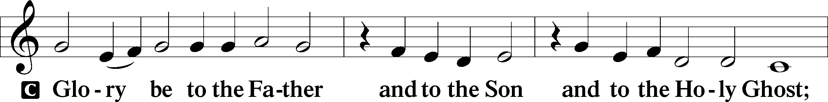
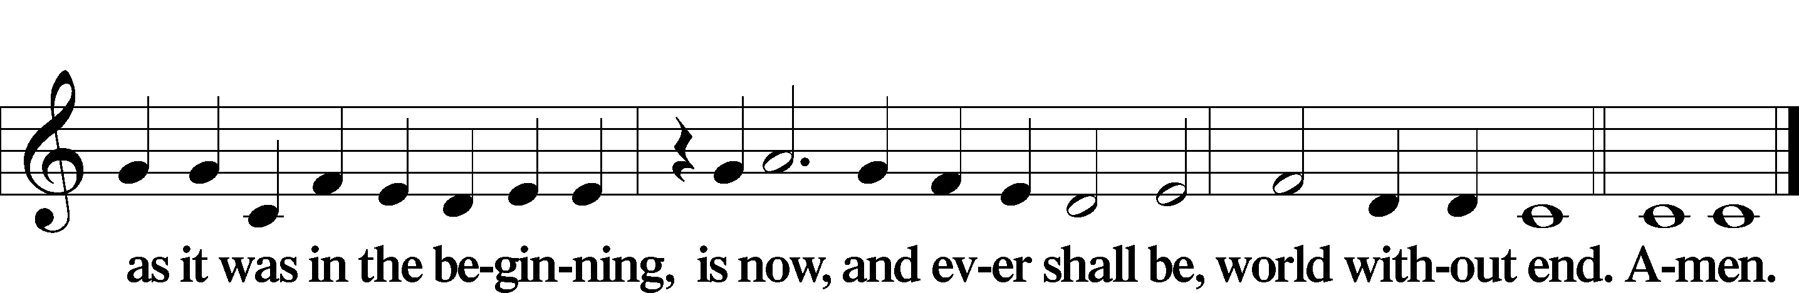

Kyrie Mark 10:47
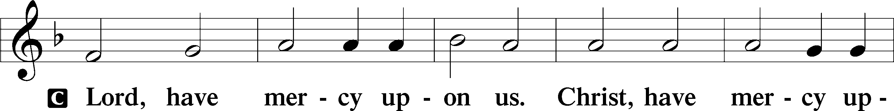
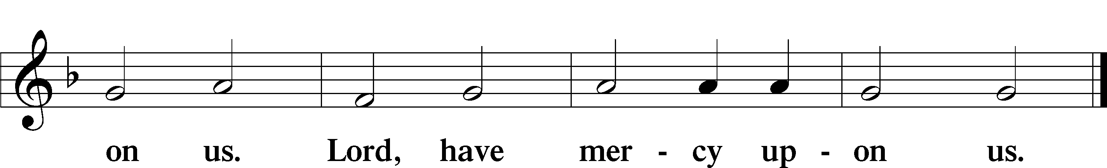

Gloria in Excelsis Luke 2:14; John 1:29
P Glory be to God on high:
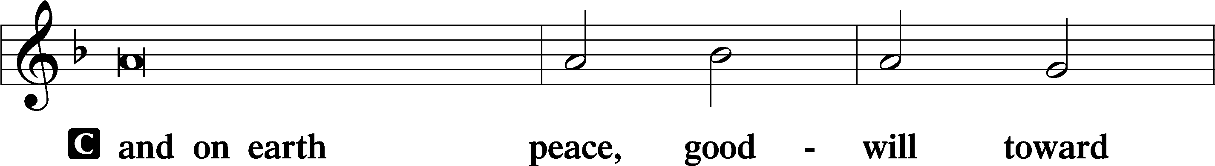
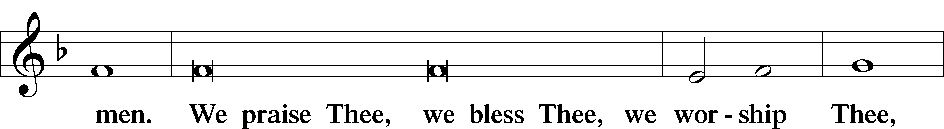
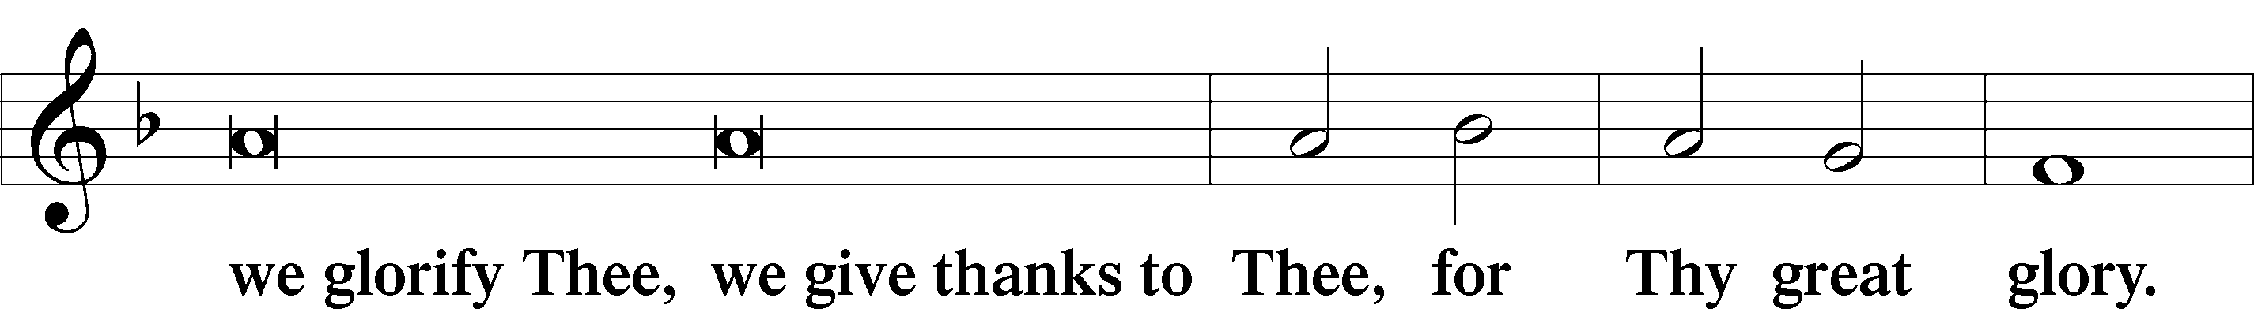
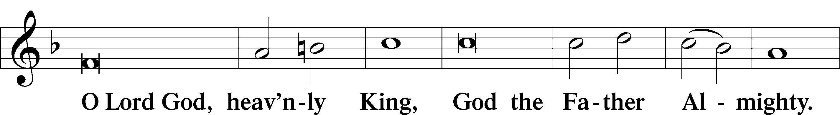
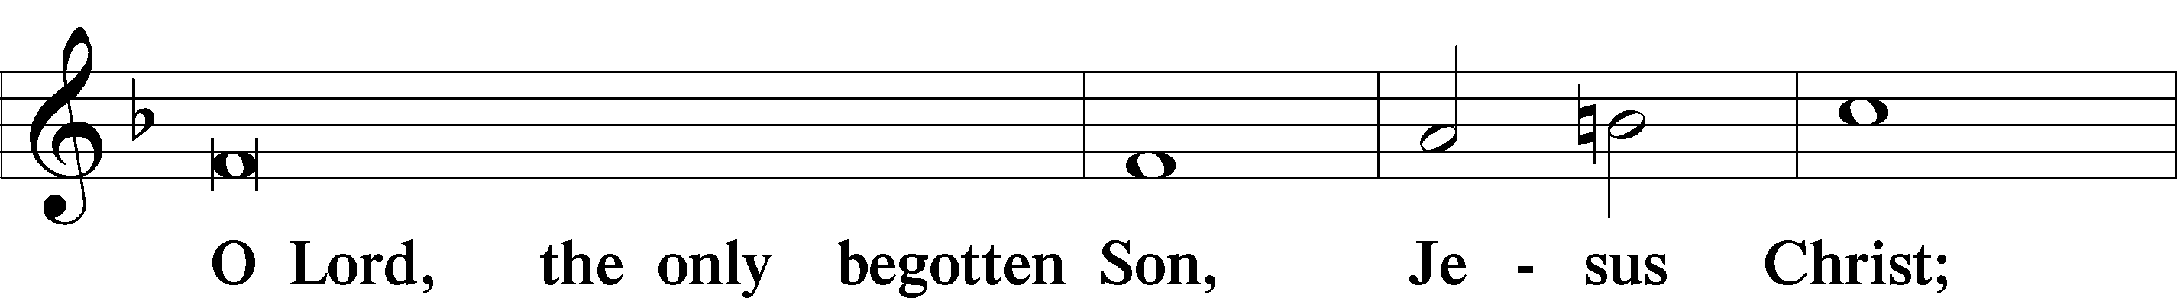
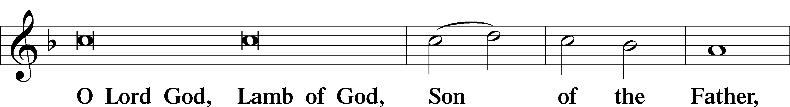
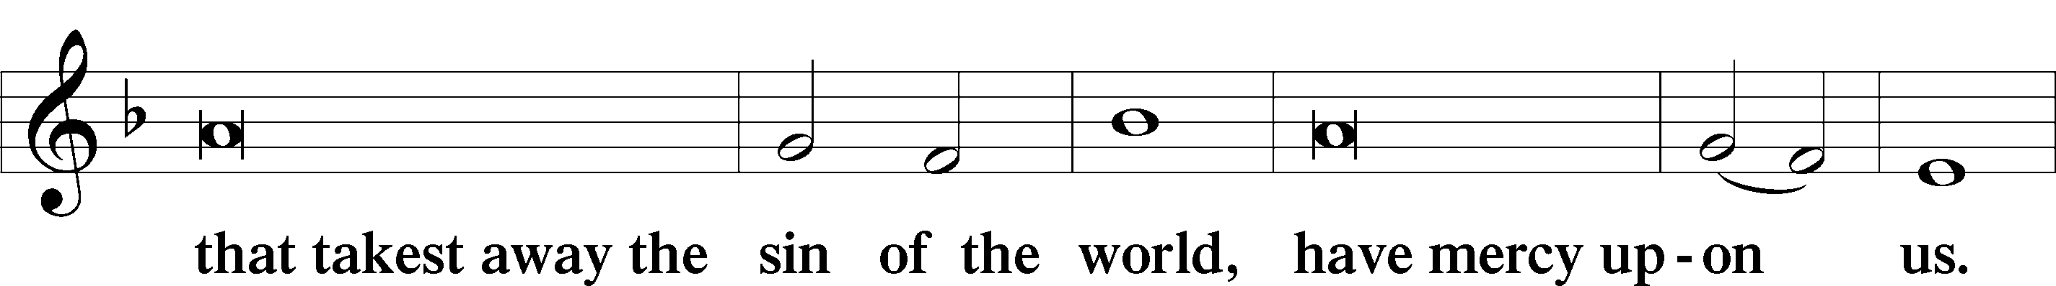
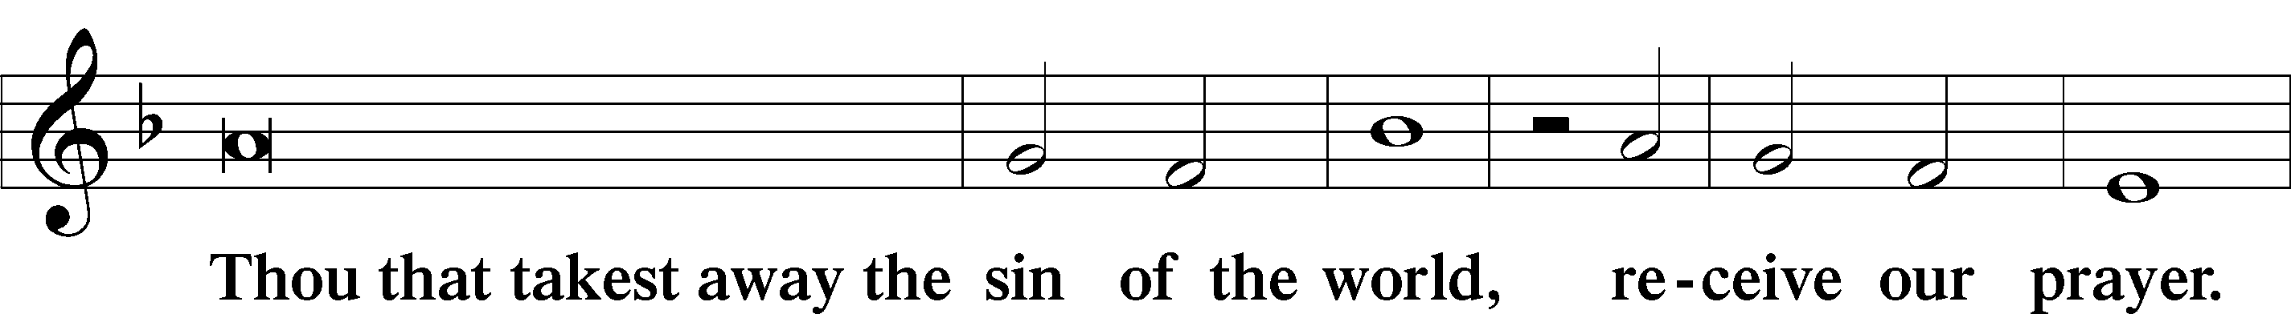
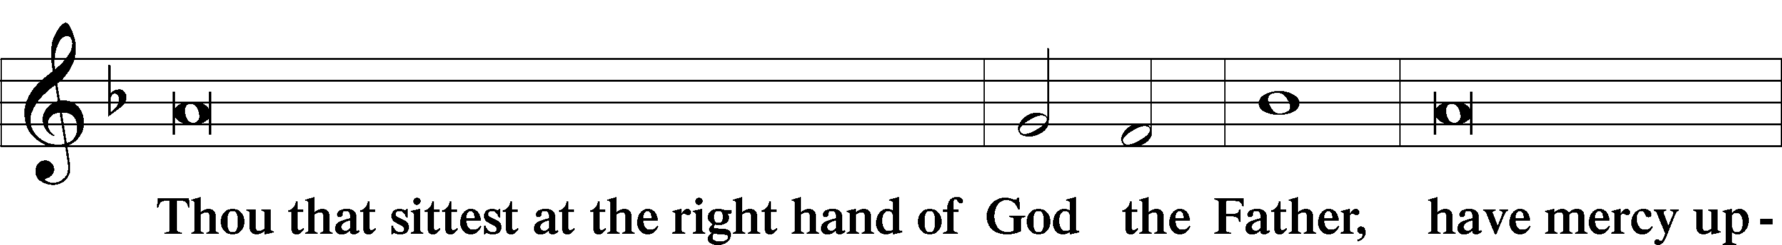
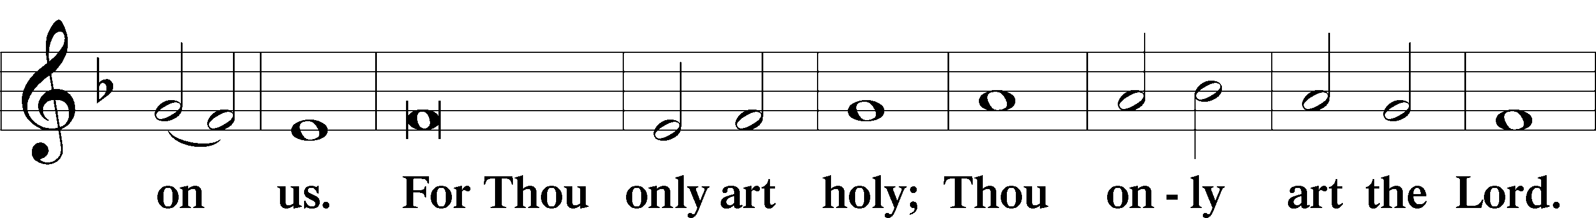
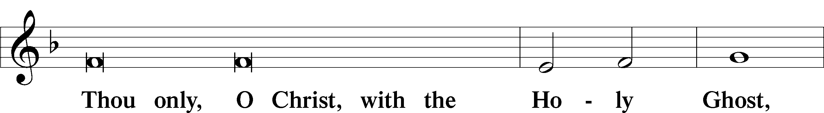
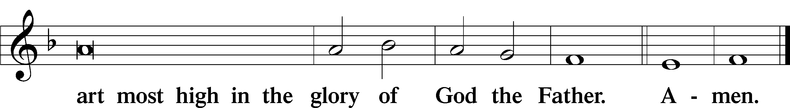

Salutation and Collect of the Day: The Visitation of the Blessed Virgin Mary
P The Lord be with you.
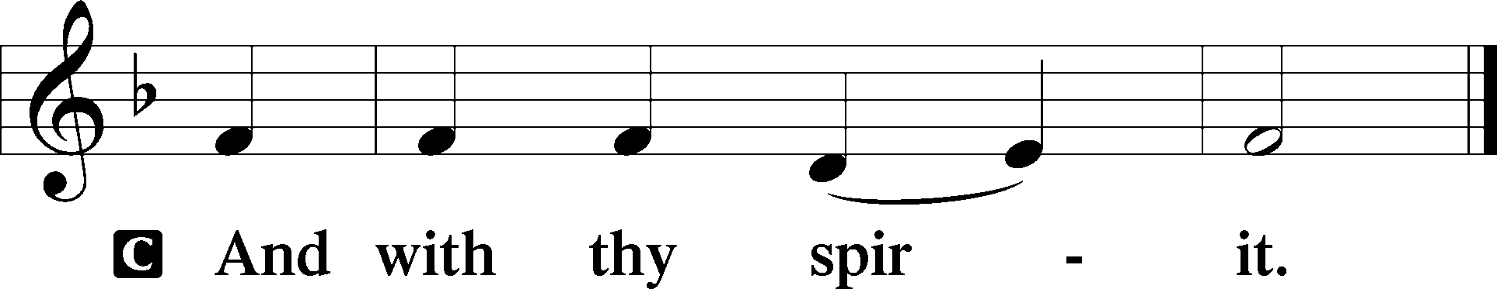

P Let us pray.
Almighty God, You chose the virgin Mary to be the mother of Your Son and made known through her Your gracious regard for the poor and lowly and despised. Grant that we may receive Your Word in humility and faith, and so be made one with Jesus Christ, Your Son, our Lord, who lives and reigns with You and the Holy Spirit, one God, now and forever.
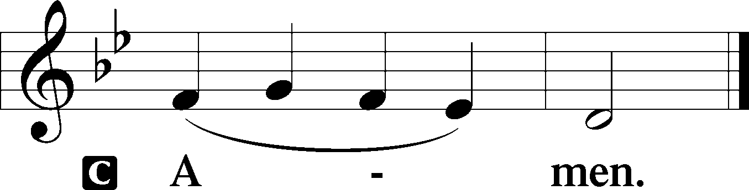
Sit

Prophecy: Song of Solomon 2:8b-14 (NKJV)
Behold, my beloved comes leaping upon the mountains, skipping upon the hills. My beloved is like a gazelle or a young stag. Behold, he stands behind our wall; he is looking through the windows, gazing through the lattice. My beloved spoke, and said to me: “Rise up, my love, my fair one, and come away. For lo, the winter is past, the rain is over and gone. The flowers appear on the earth; the time of singing has come, and the voice of the turtledove is heard in our land. The fig tree puts forth her green figs, and the vines with the tender grapes give a good smell. Rise up, my love, my fair one, and come away! O my dove, in the clefts of the rock, in the secret places of the cliff, let me see your face, let me hear your voice; for your voice is sweet, and your face is lovely.”

P This is the Word of the Lord.
C Thanks be to God.

Gradual Psalm 103:2; 105:5; 100:4
Bless the Lord, | O my soul,*
and forget not all his | benefits.
Remember the wondrous works that | he has done,*
his miracles, and the judgments he | uttered.
Enter his gates with thanksgiving and his | courts with praise!*
Give thanks to him; | bless his name!

Epistle: Romans 12:9–16 (NKJV)
Brethren: Let love be without hypocrisy. Abhor what is evil. Cling to what is good. Be kindly affectionate to one another with brotherly love, in honor giving preference to one another; not lagging in diligence, fervent in spirit, serving the Lord; rejoicing in hope, patient in tribulation, continuing steadfastly in prayer; distributing to the needs of the saints, given to hospitality. Bless those who persecute you; bless and do not curse. Rejoice with those who rejoice, and weep with those who weep. Be of the same mind toward one another. Do not set your mind on high things, but associate with the humble. Do not be wise in your own opinion.

P This is the Word of the Lord.
C Thanks be to God.

Stand

Verse Luke 1:45
Alleluia. Blessed is she who believed that there would be a fulfillment of what was spoken to her from the Lord. Alleluia.

Alleluia
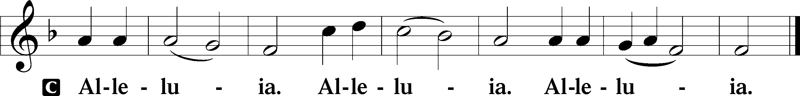

Holy Gospel: Luke 1:39–56 (NKJV)
P The Holy Gospel according to St. Luke, the first chapter.
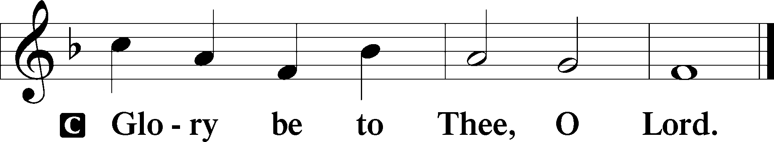

At that time: Mary arose and went into the hill country with haste, to a city of Judah, and entered the house of Zacharias and greeted Elizabeth. And it happened, when Elizabeth heard the greeting of Mary, that the babe leaped in her womb; and Elizabeth was filled with the Holy Spirit. Then she spoke out with a loud voice and said, “Blessed are you among women, and blessed is the fruit of your womb! But why is this granted to me, that the mother of my Lord should come to me? For indeed, as soon as the voice of your greeting sounded in my ears, the babe leaped in my womb for joy. Blessed is she who believed, for there will be a fulfillment of those things which were told her from the Lord.” And Mary said: “My soul magnifies the Lord, and my spirit has rejoiced in God my Savior. For He has regarded the lowly state of His maidservant; for behold, henceforth all generations will call me blessed. For He who is mighty has done great things for me, and holy is His name. And His mercy is on those who fear Him from generation to generation. He has shown strength with His arm; He has scattered the proud in the imagination of their hearts. He has put down the mighty from their thrones, and exalted the lowly. He has filled the hungry with good things, and the rich He has sent away empty. He has helped His servant Israel, in remembrance of His mercy, as He spoke to our fathers, to Abraham and to his seed forever.” And Mary remained with her about three months, and returned to her house.

P This is the Gospel of the Lord.
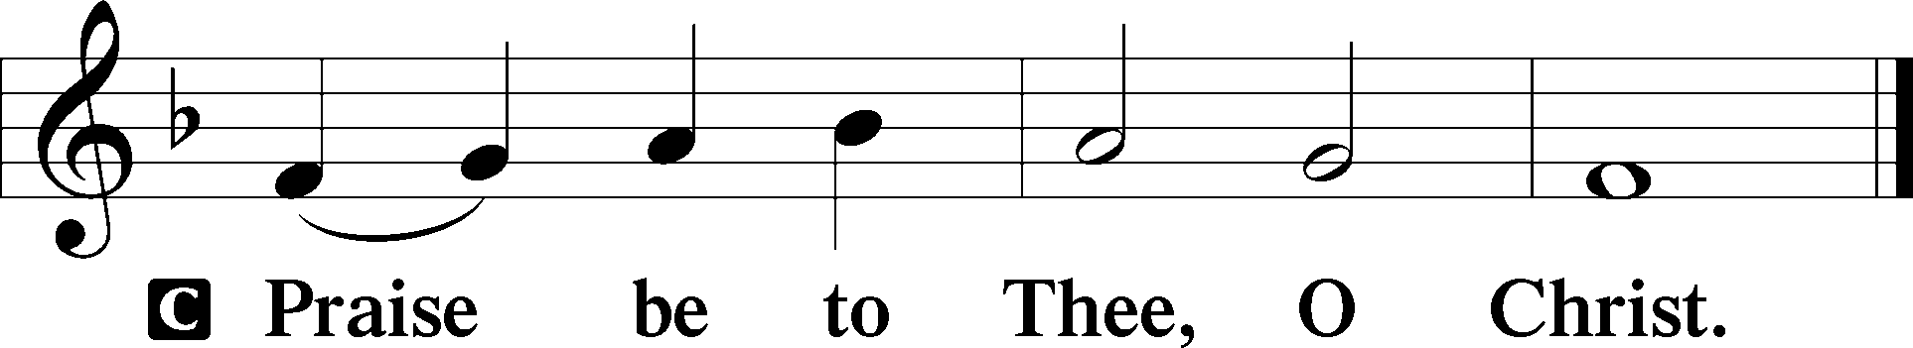

Nicene Creed
C I believe in one God,
the Father Almighty,
maker of heaven and earth
and of all things visible and invisible.

And in one Lord Jesus Christ,
the only-begotten Son of God,
begotten of His Father before all worlds,
God of God, Light of Light,
very God of very God,
begotten, not made,
being of one substance with the Father,
by whom all things were made;
who for us men and for our salvation came down from heaven
and was incarnate by the Holy Spirit of the virgin Mary
and was made man;
and was crucified also for us under Pontius Pilate.
He suffered and was buried.
And the third day He rose again according to the Scriptures
and ascended into heaven
and sits at the right hand of the Father.
And He will come again with glory to judge both the living and the dead,
whose kingdom will have no end.

And I believe in the Holy Spirit,
the Lord and giver of life,
who proceeds from the Father and the Son,
who with the Father and the Son together is worshiped and glorified,
who spoke by the prophets.
And I believe in one holy Christian and apostolic Church,
I acknowledge one Baptism for the remission of sins,
and I look for the resurrection of the dead
and the life T of the world to come. Amen.
Sit

Hymn of the Day: TLH #104 “Now Praise We Christ, the Holy One”
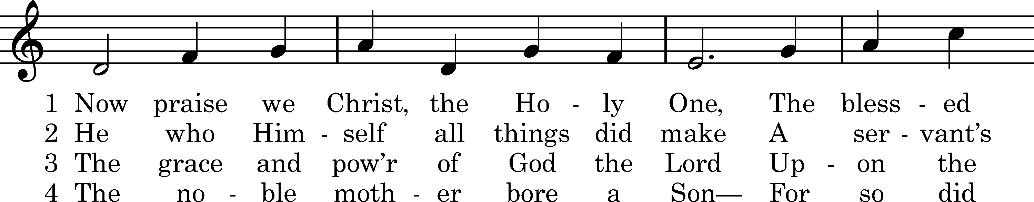
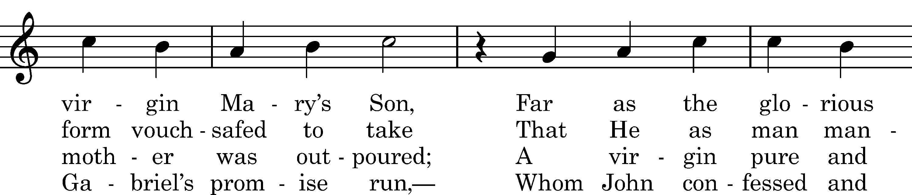
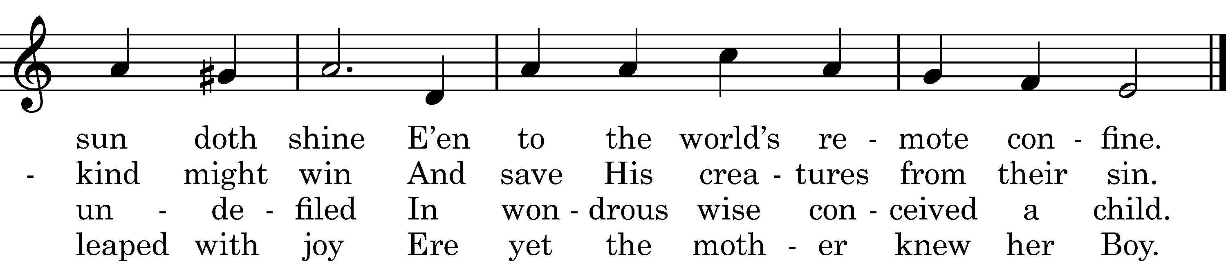

5 Upon a manger filled with hay
In poverty content He lay;
With milk was fed the Lord of all,
Who feeds the ravens when they call.

6 The heav'nly choirs rejoice and raise
Their voice to God in songs of praise.
To humble shepherds is proclaimed
The Shepherd who the world hath framed.

D 7 All honor unto Christ be paid,
Pure Offspring of the favored maid,
With Father and with Holy Ghost,
Till time in endless time be lost.

Text: tr. Richard Massie, 1854, alt.; Martin Luther, 1524, alt.; Coelius Sedulius, c. 450, alt. Tune: Enchiridion, Erfurt, 1524 Text and tune: Public domain

Sermon

Stand

Prayer of the Church

Offertory Psalm 51:10–12
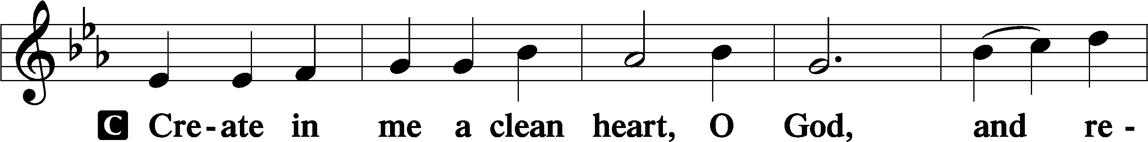
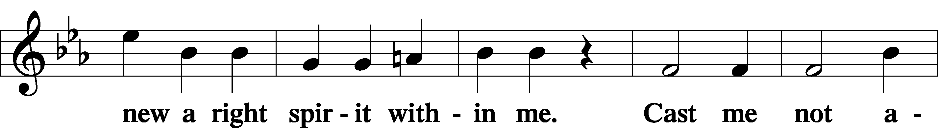
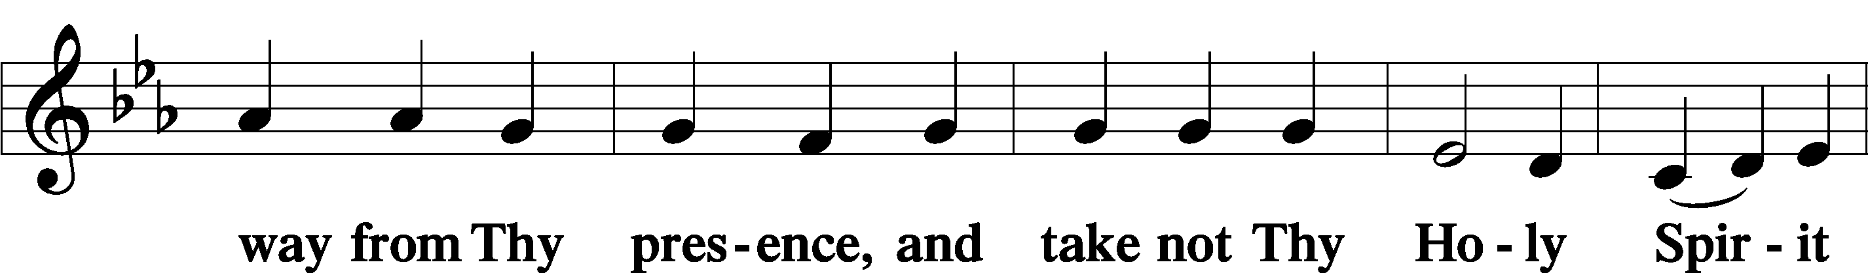
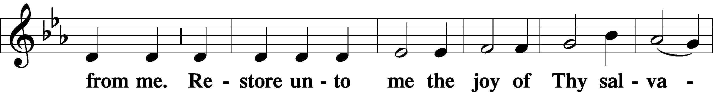
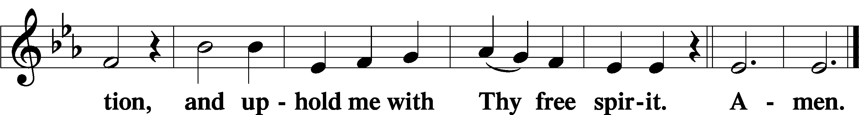
Sit

Preparatory Hymn: LSB #820 “My Soul, Now Praise Your Maker”

Stand

Service of the Sacrament

Preface 2 Timothy 4:22; Colossians 3:1 Psalm 136
P The Lord be with you.
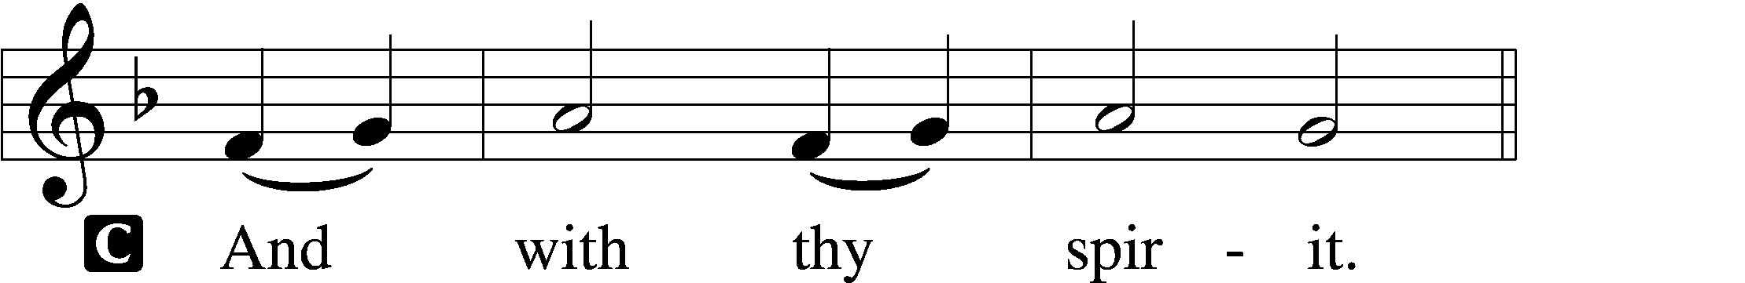

P Lift up your hearts.
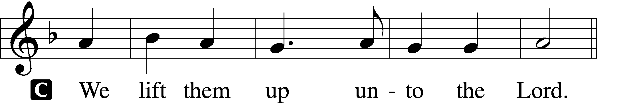

P Let us give thanks unto the Lord, our God.
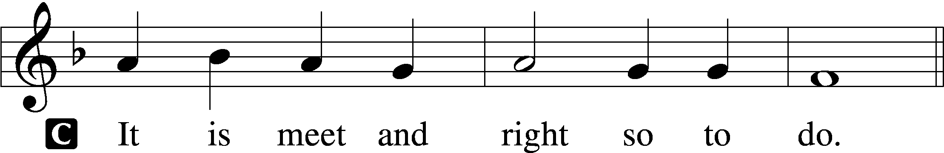

Proper Preface (Abbreviated) LSB 194
P It is truly meet, right, and salutary . . . evermore praising You and saying:

Sanctus Isaiah 6:3; Matthew 21:9
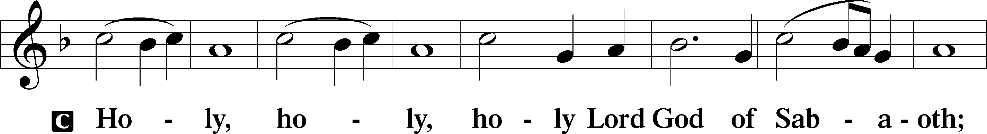
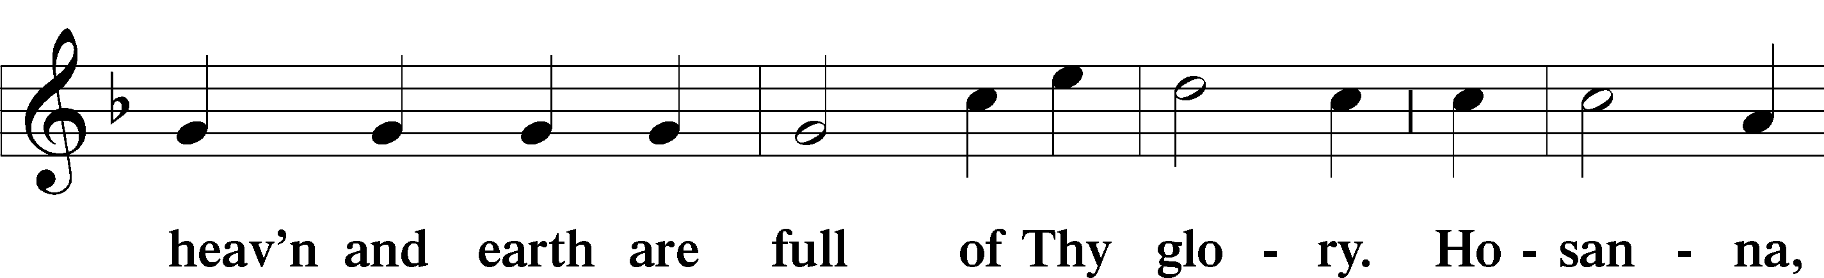
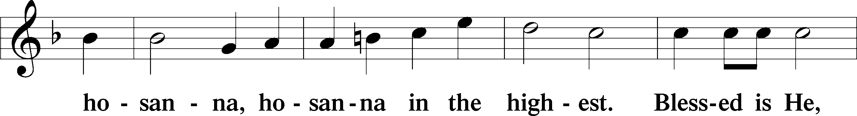
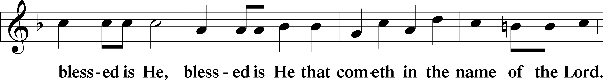
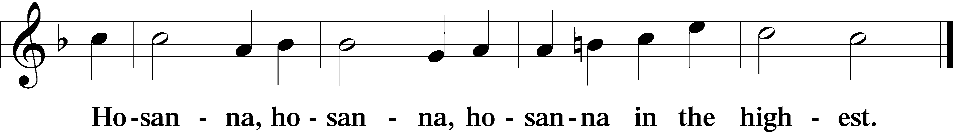

Lord’s Prayer Matthew 6:9–13
C Our Father who art in heaven,
hallowed be Thy name,
Thy kingdom come,
Thy will be done on earth as it is in heaven;
give us this day our daily bread;
and forgive us our trespasses as we forgive those who trespass against us;
and lead us not into temptation,
but deliver us from evil.
For Thine is the kingdom and the power and the glory forever and ever. Amen.

The Words of Our Lord Matthew 26:26–28; Mark 14:22–24; Luke 22:19–20; 1 Corinthians 11:23–25
P Our Lord Jesus Christ, on the night when He was betrayed, took bread, and when He had given thanks, He broke it and gave it to the disciples and said: “Take, eat; this is My T body, which is given for you. This do in remembrance of Me.”

In the same way also He took the cup after supper, and when He had given thanks, He gave it to them, saying: “Drink of it, all of you; this cup is the new testament in My T blood, which is shed for you for the forgiveness of sins. This do, as often as you drink it, in remembrance of Me.”

Pax Domini John 20:19
P The peace of the Lord be with you always.
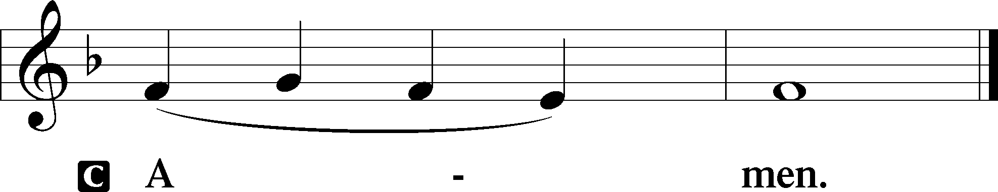

Agnus Dei John 1:29
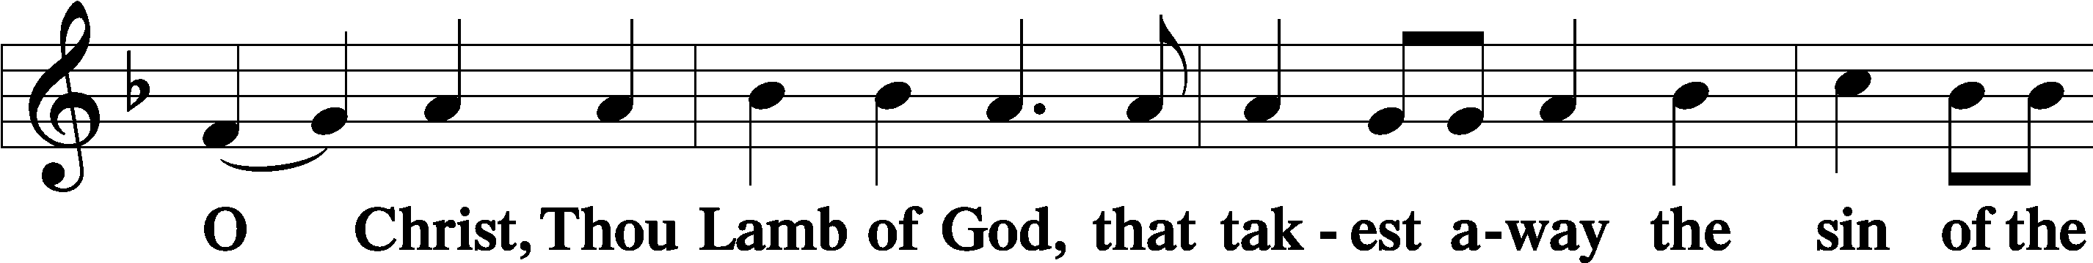
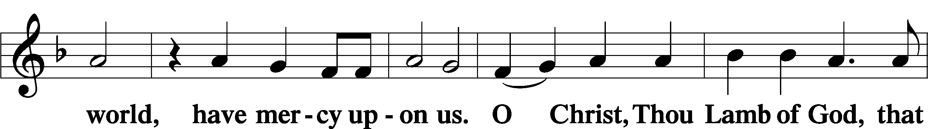
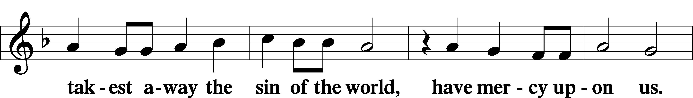
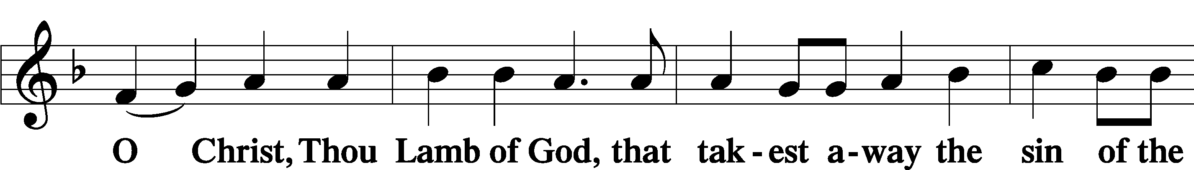
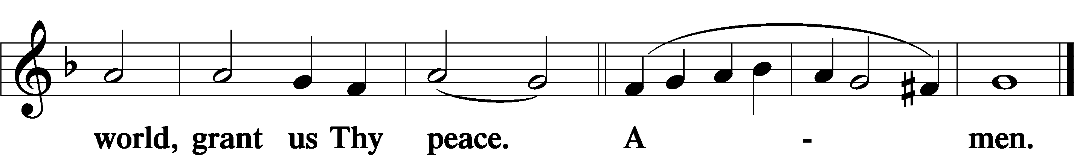
Sit

Distribution
The pastor and those who assist him receive the body and blood of Christ first and then distribute them to those who come to receive, saying:
Take, eat; this is the true body of our Lord and Savior Jesus Christ, given into death for your sins.
Amen.
Take, drink; this is the true blood of our Lord and Savior Jesus Christ, shed for the forgiveness of your sins.
Amen.

In dismissing the communicants, the following is said:
The Dismissal
P The body and blood of our Lord Jesus Christ strengthen and preserve you in body and soul to life everlasting. Depart T in peace.
C Amen.

Distribution Hymn: LSB #395 “O Morning Star, How Fair and Bright”

Distribution Hymn: LSB #621 “Let All Mortal Flesh Keep Silence”

Distribution Hymn: LSB #398 “Hail to the Lord’s Anointed”

Stand
Nunc Dimittis Luke 2:29–32
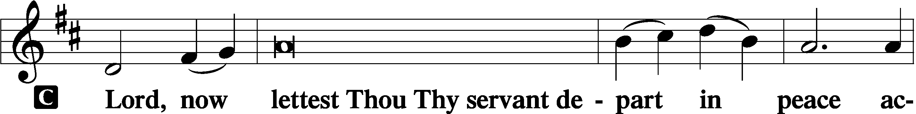
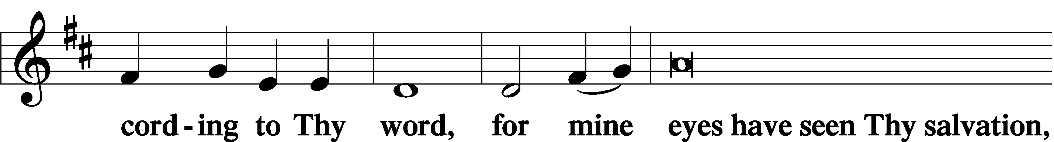
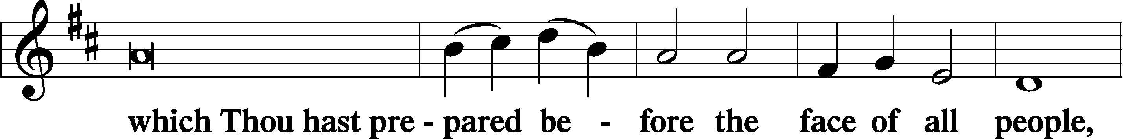
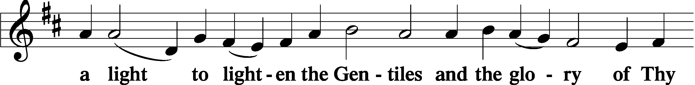
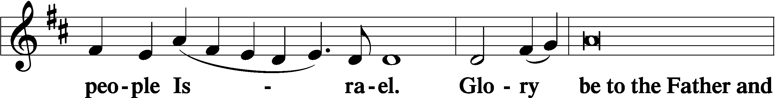
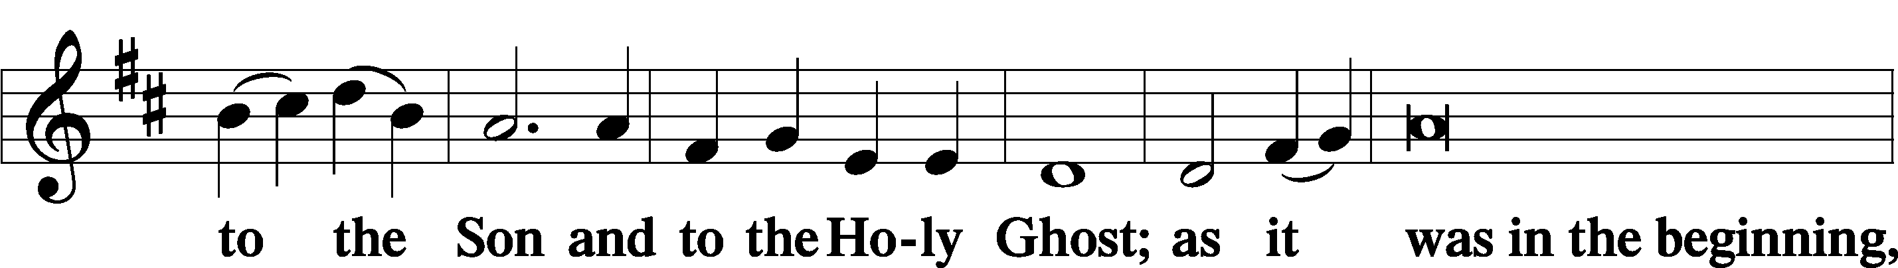
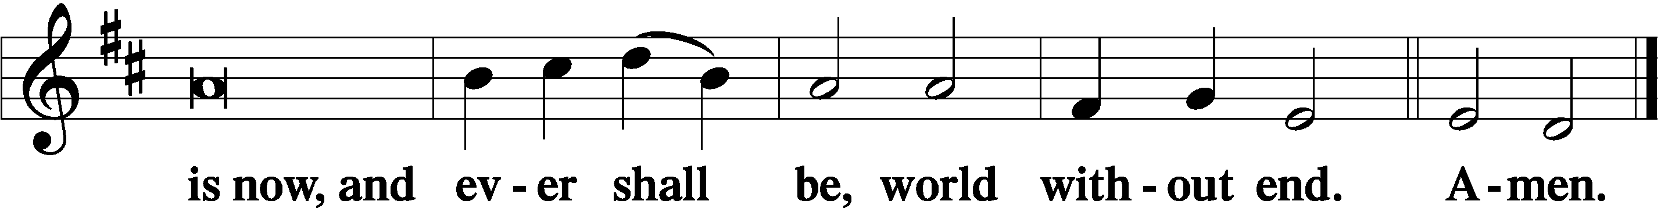

Thanksgiving Psalm 107:1
P O give thanks unto the Lord, for He is good,
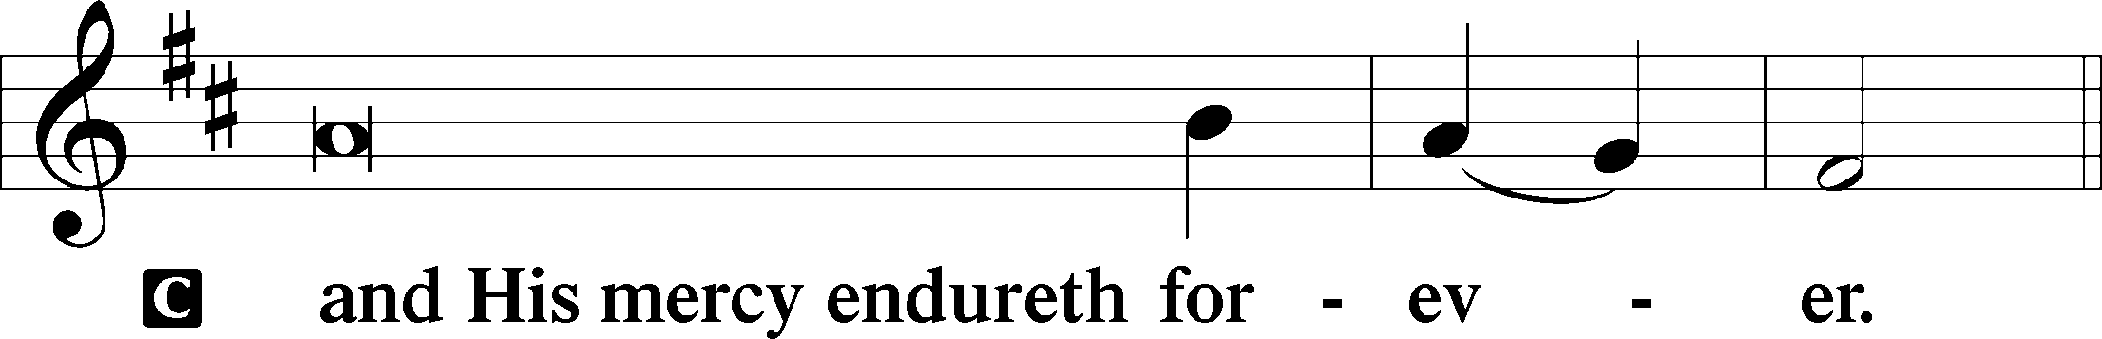

Post-Communion Collect
P Let us pray.
We give thanks to You, almighty God, that You have refreshed us through this salutary gift, and we implore You that of Your mercy You would strengthen us through the same in faith toward You and in fervent love toward one another; through Jesus Christ, Your Son, our Lord, who lives and reigns with You and the Holy Spirit, one God, now and forever.
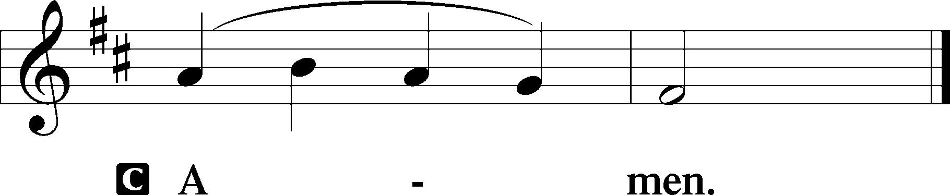

Salutation 2 Timothy 4:22
P The Lord be with you.
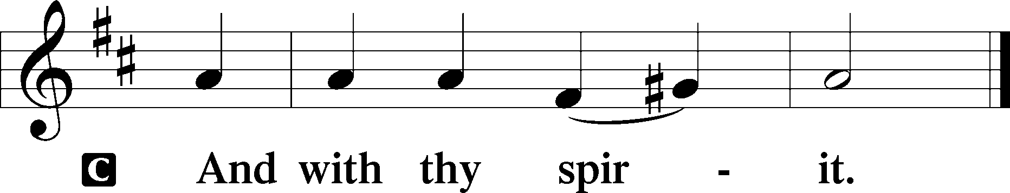

Benedicamus Psalm 103:1
P Bless we the Lord.
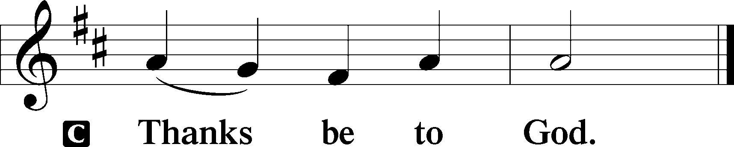

Benediction Numbers 6:24–26
P The Lord bless you and keep you.
The Lord make His face shine upon you and be gracious unto you.
The Lord lift up His countenance upon you and T give you peace.
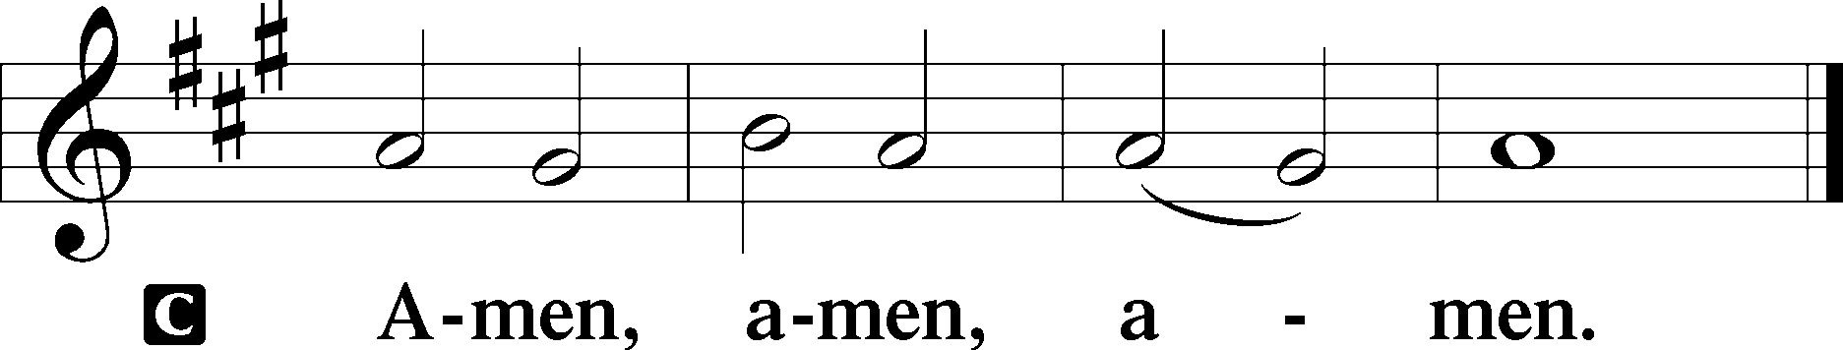

Closing Hymn: LSB #670 “Ye Watchers and Ye Holy Ones”

Silent prayer after worship: Dear Lord, go with me as I leave Your house today. Lead me to be in Your Holy Word daily so that by the Holy Spirit I may grow in my faith and in my love for You. In Jesus’ name. Amen.
fffffffffffffffffffffffffffffffffff
SCHEDULE THROUGH JULY 9, 2023:

:

Today, 7 pm, Fellowship Hall: AA Meeting
Wednesday, 7:30 pm, Fellowship Hall: NA Meeting
Thursday, 10 am, Fellowship Hall: Women’s Bible Study
Next Sunday, 8 am, Fellowship Hall: Bible Study
9 am, Sanctuary: Divine Service
Following, Fellowship Hall: Coffee Fellowship
7 pm, Fellowship Hall: AA Meeting
fffffffffffffffffffffffffffffffffff
Attendance: Sunday, June 25, 2023: 42
fffffffffffffffffffffffffffffffffff
THANK YOU FOR SERVING IN JULY: Elder: Jonathan Baisch; Ushers: Matt Berent, Mark Gabriel, Michael Laird, & Jerome Thomas; Altarware: (prior) Diane Riefstahl & Marie Flaugher (07/09 & 07/30); (after) Elizabeth Haenftling (07/02 & 07/16) & Marie Flaugher (07/09, 07/23, & 07/30).
fffffffffffffffffffffffffffffffffff
Bible Memory Verses ~ Week of July 2nd:
For Adults: God shows his love for us in that while we were still sinners, Christ died for us. John 5:8
For Children: Bear one another's burdens, and so fulfill the law of Christ.
Galatians 6:2
fffffffffffffffffffffffffffffffffff

Our Stewardship of Treasures for the Lord:
In order to do the Lord’s work, we need $2,553.63 each week to meet our 2023 budget for general purposes and $76.92 for the SELC.
Figures for Sunday, June 18, 2023
General Fund: $2,218.00 Behind for the week: -$335.63
SELC: $85.00 Ahead for the week: +$8.08
Food Pantry: $60.00
Quarterly Missions: $155.00
Capital Campaign: $590.00

For online giving, check out https://www.saintspeterandpaul.net/online-giving.
fffffffffffffffffffffffffffffffffff
Remember the following in Prayer…
~The Hurting and Healing: Amy, Steve Antolovich, Gerald Arthur, Ellen Baron^{CA}, Lois Bortner^{CA}, John Burdette, Bev & Joe Chlpka, Kathleen Coughenour, Kim, Anna Mae Daris, Susan Davies, Tim Dudash, Millie Elavsky, Joseph Fleet, Judith & Eddy Furey, Tim Haenftling, Austin Hamilton, Joan, Darla Krajci, Barbara Kreske, Donna Kennedy, Jess Lavoie, Elizabeth Loughan, Paul Lucas^{CA}, Sandy Marshall, Augusta Mennell, Frank Niemeyer^{CA}, Linda Parkany, Juanita Rentschler, Richard Reuning^{CA}, Nancy Robertson^{CA}, Marty Scott, Kara, Fred Tonty, Joel & Peggy Wasson, Angela Weser^{CA}, and Ruth Wolf.
~The Homebound: Rudy & Jean Tomko, Betty Wolf, and Ed & Millie Zachar.
~Celebrating this Week: Birthdays: Paul Petro (07.02), Jesse Riffle (07.04), April Bosnjak (07.08), & Betty Wolf (07.08); Anniversary: Paul & Joyce Petro (07.02).
~Serving in the Military: Alex (Sasha) Carr, Curtis Sinewe, and Joshua Solyan.
~Community & World Needs: Those suffering from or affected by the coronavirus; those suffering due to the conflict between Ukraine and Russia; those suffering from loss and dislocation because weather disasters; those suffering from addiction and their families; Local, State, and National Government Leaders; safety for all Police Officers, Firefighters, & First Responders; the unemployed; our Second Quarter Local Mission: The Support of a Concordia, Fort Wayne Seminarian.
*CA represents cancer.
fffffffffffffffffffffffffffffffffff
“Portals of Prayer” for July~August~September are available on the tables next to the nursery and in the narthex. Take one for a friend!
Old copies of the “Portals of Prayer” and other published devotions (this does not include our weekly bulletins, newsletters, or seasonal devotions) may be recycled in the basket next to the secretary’s office. Recycled materials are periodically mailed to ICLD (International Christian Literature Distributors) for distribution in third-world countries.
fffffffffffffffffffffffffffffffffff
We are grateful this morning to Rebecca Marquette for sharing her musical talents with us as our guest organist.
SCRIP orders and payments for July may be given to Diane Riefstahl this morning. Order forms are available on the tables in the narthex and next to the nursery.
fffffffffffffffffffffffffffffffffff
Copies of the July issue of “The Rock and the Sword” newsletter and the summer issue of “Lutherans Engage” are available this morning.
fffffffffffffffffffffffffffffffffff
A friendly reminder that the Women’s Bible Study meets the first and third Thursdays of the month. Our next session will be held this Thursday, July 6th at 10 am. Please feel free to join us!
fffffffffffffffffffffffffffffffffff
The church offices will be closed this Tuesday, July 4th for Independence Day. Have a safe, enjoyable holiday!
fffffffffffffffffffffffffffffffffff
Gethsemane Lutheran Church invites all to join them for the installation of Pastor Zachary Roll Sunday, July 16, 2023, at 3 pm. A celebratory dinner will follow. If interested in attending, please notify the secretary’s office no later than Thursday, July 6th so that your reservation can be secured.
fffffffffffffffffffffffffffffffffff
Acknowledgments
Unless otherwise indicated, Scripture quotations are from the ESV® Bible (The Holy Bible, English Standard Version®), copyright © 2001 by Crossway, a publishing ministry of Good News Publishers. Used by permission. All rights reserved.
Created by Lutheran Service Builder © 2023 Concordia Publishing House.
fffffffffffffffffffffffffffffffffff

Here to Serve
Pastor………………………………………………...……………Rev. Jacob Deal
E-mail …………………………….……pastordeal@saintspeterandpaul.net
Phone Number……………………..…………………724-347-3620 (Option 2)
Church Office………………………..…………………724-347-3620 (Option 3)
Website …………………………………………www.saintspeterandpaul.net
Secretary…………………………………………………………Diane Riefstahl
E-mail ………………………………………church@saintspeterandpaul.net
Website …………………………………………www.saintspeterandpaul.net
Food Pantry: Please leave message……………724-347-3620 (Option 3)
AA Contact: Steve………………………………………………..…724-813-2358
NA Contact: Larry………………………………………………..724-977-8733
Choir Director………………………………………………………Chris Nelson
Congregation President……………………………………Jonathan Baisch
Church Elder …………………………………………...…… Jonathan Baisch
fffffffffffffffffffffffffffffffffff
If needing to get into the church building during the week, please phone first to make certain someone is here to let you in.

