Sts. Peter & Paul
Evangelical Lutheran Church
Lutheran Church-Missouri Synod
Founded-1917

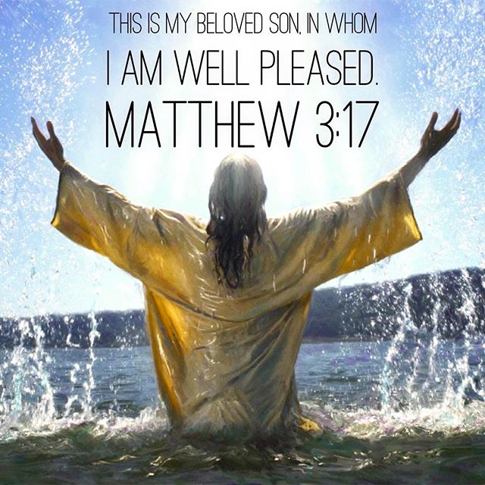

January 7, 2024

699 Stambaugh Ave.
Sharon, Pennsylvania 16146

“I was glad when they said to me,
Let us go to the house of the LORD!”
Psalm 122:1
Sts. Peter & Paul Evangelical Lutheran Church, LC-MS
THE BAPTISM OF OUR LORD
January 7, 2024

A special welcome to our guests this day! If you would like more information about The Lutheran Church - Missouri Synod, or this congregation, please speak with Pastor Deal or an Elder after the service.
Members & Guests: Don’t be embarrassed if your children make noise during the worship service, all children do. We encourage families to worship together but, if you feel the need, there are pews in the rear of the Church which are reserved for young families on both sides of the sanctuary. There is also a quiet room available to you, located next to the sanctuary (formerly the Pastor’s office), where you would be able to follow along with the service.

Today’s service includes the Sacrament of Holy Communion. If during this past year, you have not worshipped with us and been communed, we respectfully ask that you do not partake of this sacrament this day before first speaking with Pastor Deal.
If visiting from a sister congregation of the LC-MS and are in good standing, please inform Pastor Deal of your desire to commune prior to the service.
If wishing to receive a blessing during communion, please approach with your arms crossed.

CONTACT INFORMATION
Pastor Deal: pastordeal@saintspeterandpaul.net or 724-347-3620 (opt. 2)
Church Office: church@saintspeterandpaul.net or 724-347-3620 (opt. 3)
Secretary’s Office: The office will be open Monday and Thursday (8:30 am-4:30 pm).

Silent prayer before worship: Heavenly Father, Your Son took upon Himself the sins of the world to grant eternal life to all who believe. By Your Holy Spirit, grant me faith to live each day to Your glory. In Jesus’ name. Amen.

Confession and Absolution

Opening Hymn: LSB #394 “Songs of Thankfulness and Praise”

Stand

The sign of the cross may be made by all in remembrance of their Baptism.

Invocation
P In the name of the Father and of the T Son and of the Holy Spirit.
C Amen.

Exhortation Hebrews 10:22; Psalm 124:8; Psalm 32:5
P Beloved in the Lord! Let us draw near with a true heart and confess our sins unto God our Father, beseeching Him in the name of our Lord Jesus Christ to grant us forgiveness.

P Our help is in the name of the Lord,
C who made heaven and earth.
P I said, I will confess my transgressions unto the Lord,
C and You forgave the iniquity of my sin.

Silence for reflection on God’s Word and for self-examination.

Confession of Sins
P O almighty God, merciful Father,
C I, a poor, miserable sinner, confess unto You all my sins and iniquities with which I have ever offended You and justly deserved Your temporal and eternal punishment. But I am heartily sorry for them and sincerely repent of them, and I pray You of Your boundless mercy and for the sake of the holy, innocent, bitter sufferings and death of Your beloved Son, Jesus Christ, to be gracious and merciful to me, a poor, sinful being.

Absolution [John 20:19–23]
P Upon this your confession, I, by virtue of my office, as a called and ordained servant of the Word, announce the grace of God unto all of you, and in the stead and by the command of my Lord Jesus Christ I forgive you all your sins in the name of the Father and of the T Son and of the Holy Spirit.
C Amen.

Service of the Word

Introit Psalm 89:1, 26–28; antiphon: Liturgical Text; Psalm 89:20
Behold the Lord, the rul- | er, has come,*
and the kingdom and the power and the glory are | in his hand.
I have found David, my | servant;*
with my holy oil I have a- | nointed him.
I will sing of the steadfast love of the Lord, for- | ever;*
with my mouth I will make known your faithfulness to all gener- | ations.
He shall cry to me, “You are my | Father,*
my God, and the Rock of my sal- | vation.”
And I will make him the | firstborn,*
the highest of the kings | of the earth.
My steadfast love I will keep for him for- | ever,*
and my covenant will stand | firm for him.
Behold the Lord, the rul- | er, has come,*
and the kingdom and the power and the glory are | in his hand.
I have found David, my | servant;*
with my holy oil I have a- | nointed him.

Gloria Patri
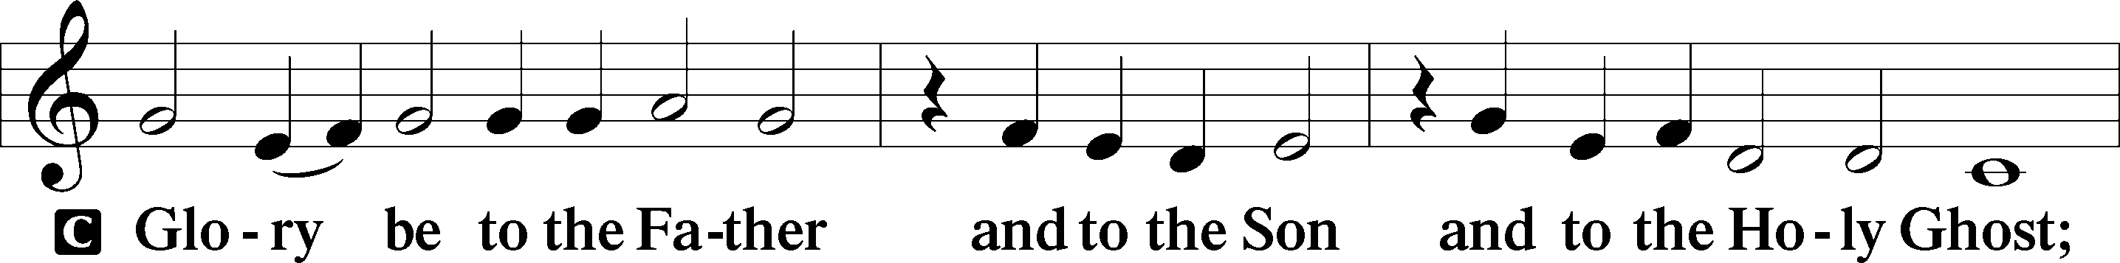
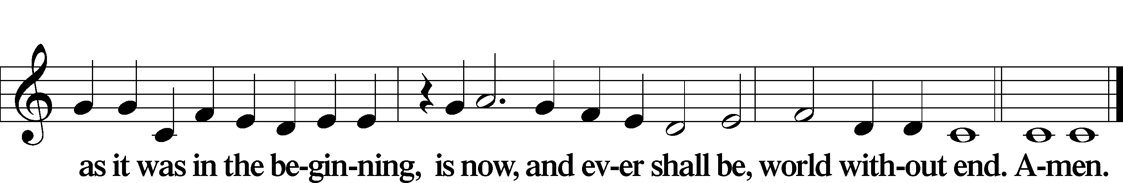

Kyrie Mark 10:47
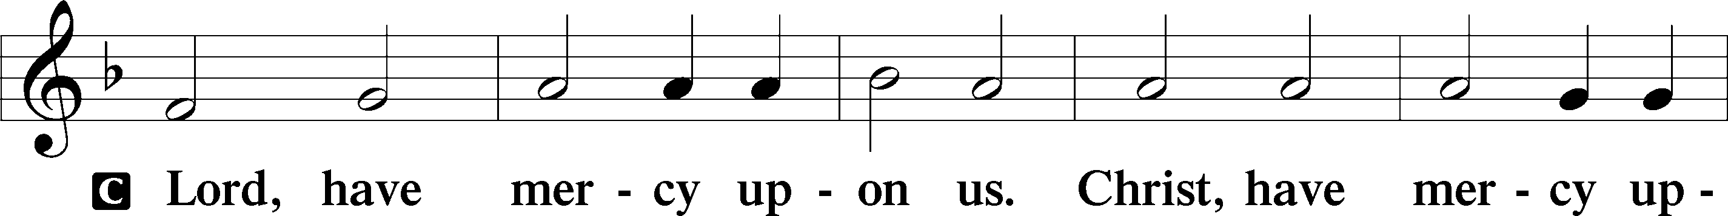
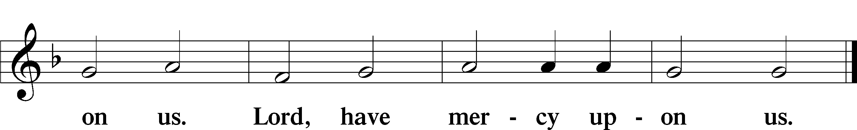

Gloria in Excelsis Luke 2:14; John 1:29
P Glory be to God on high:
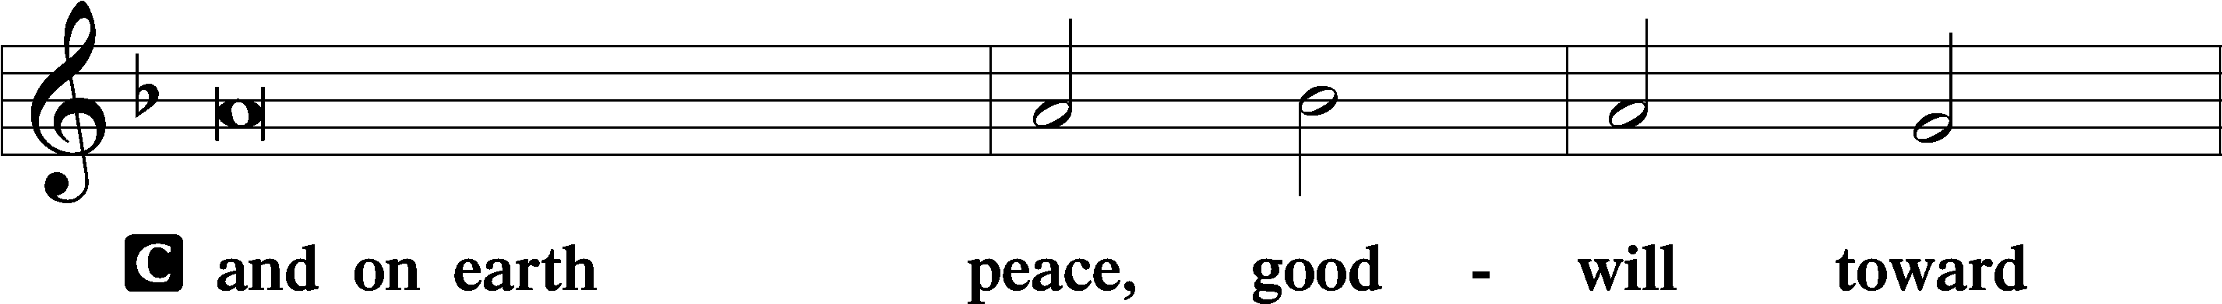
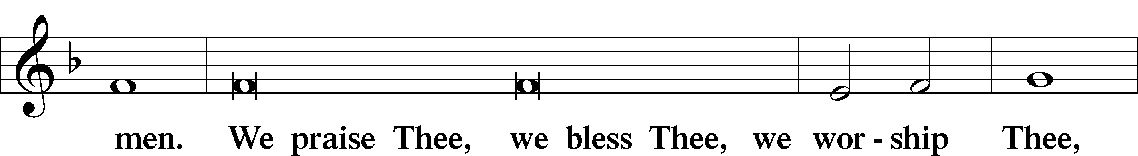
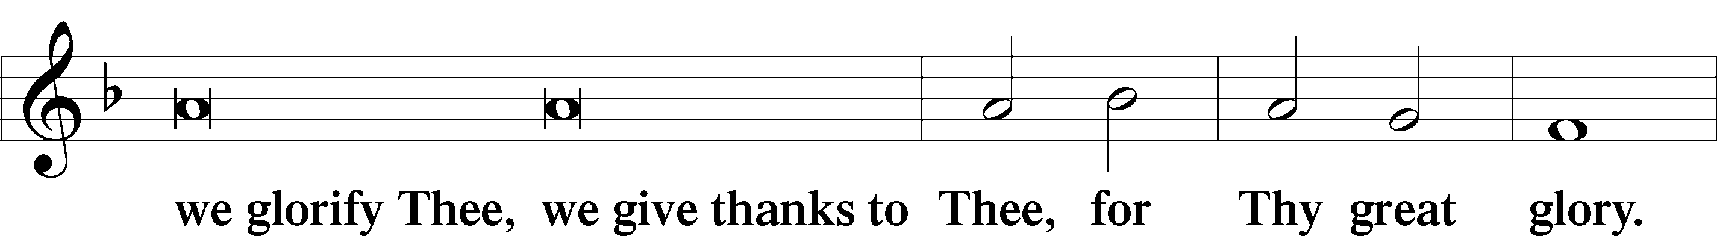
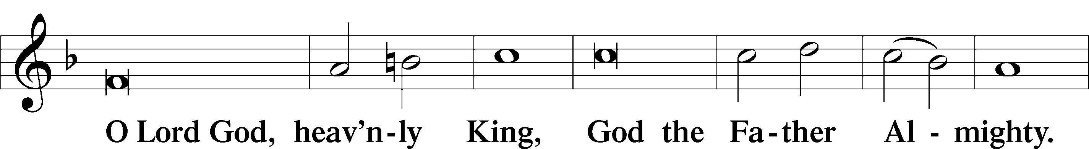
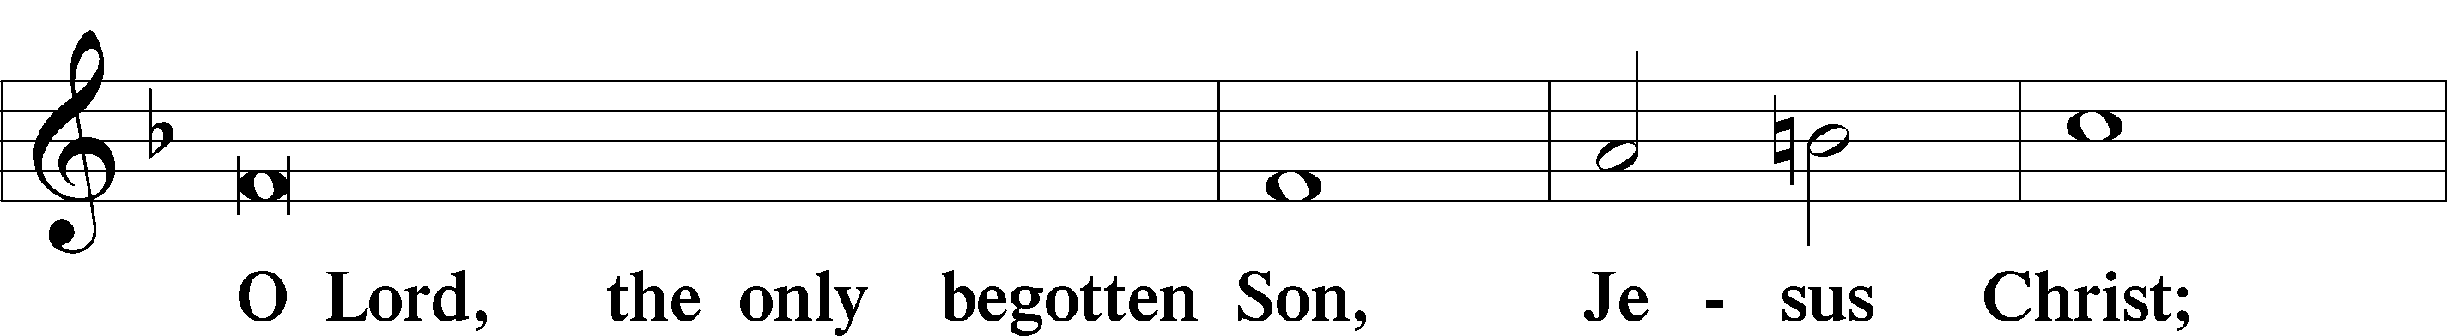
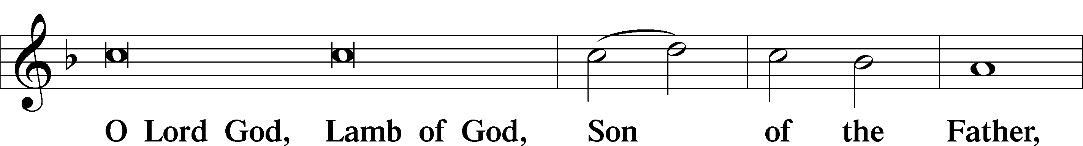
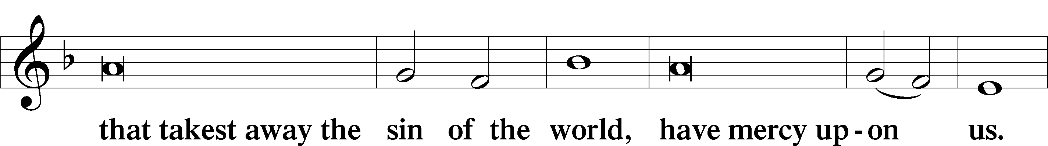
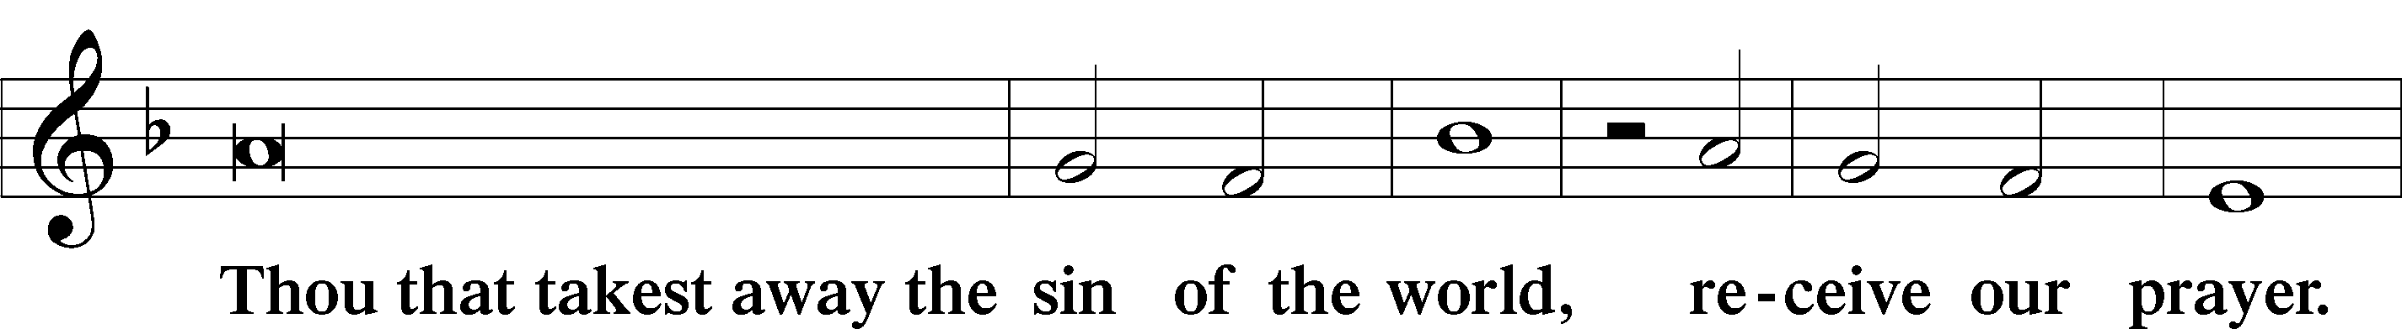
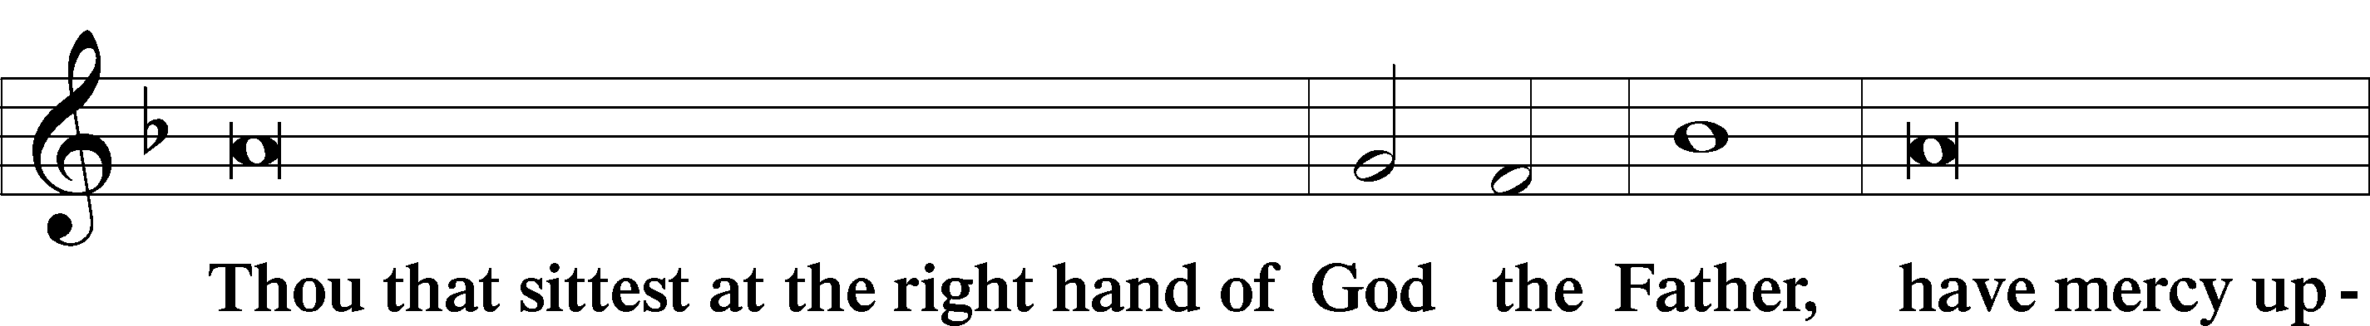
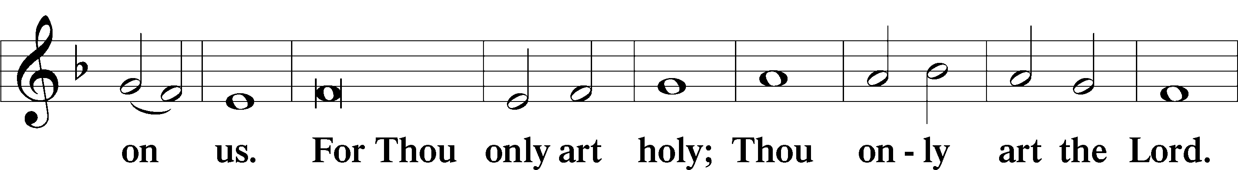
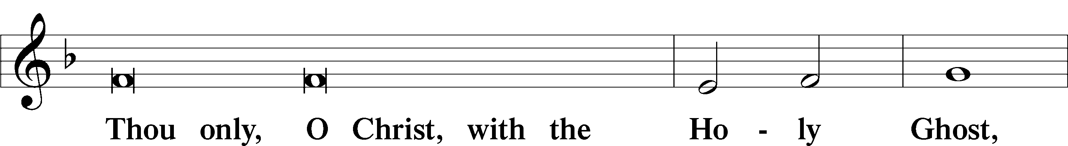
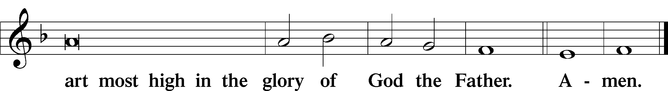

Salutation and Collect of the Day: Baptism of Our Lord
P The Lord be with you.
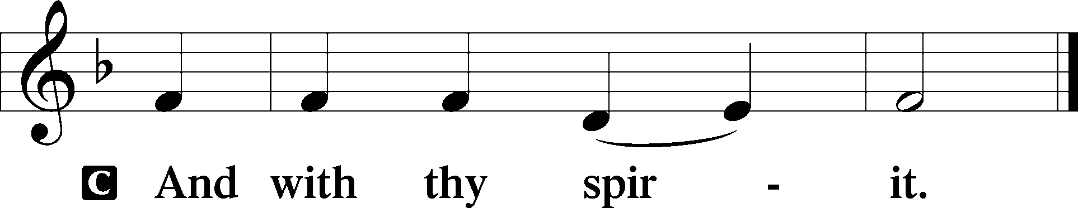

P Let us pray.
Father in heaven, at the Baptism of Jesus in the Jordan River You proclaimed Him Your beloved Son and anointed Him with the Holy Spirit. Make all who are baptized in His name faithful in their calling as Your children and inheritors with Him of everlasting life; through the same Jesus Christ, our Lord, who lives and reigns with You and the Holy Spirit, one God, now and forever.
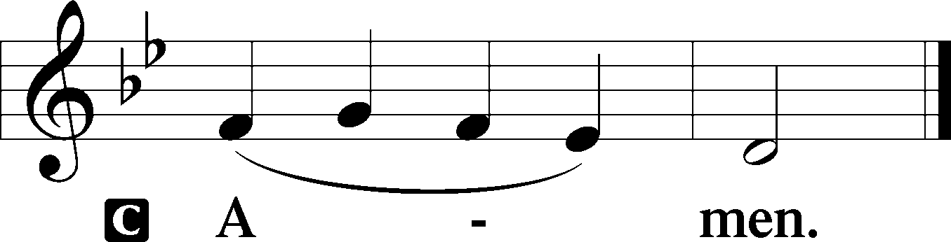
Sit

Prophecy: Isaiah 25:1; 26:11a; 28:5a; 35:1a, 2b, 10a; 41:18a, c; 52:13b; 12:3-5 (NKJV)
In those days the prophet Isaiah spoke, saying: O Lord, You are my God. I will exalt You, I will praise Your name, for You have done wonderful things; Your counsels of old are faithfulness and truth. Lord, let Your hand be lifted up. The Lord of hosts will be for a crown of glory and a diadem of beauty. The wilderness and the wasteland of Jordan shall be glad, and the people shall see the glory of the Lord, the excellency of our God. And the ransomed of the Lord shall return, and come to Zion with singing, with everlasting joy on their heads. “I, the Lord, will open rivers in desolate heights, and fountains in the midst of the valleys; I will make the dry land springs of water. Behold, My Servant shall be exalted and extolled and be very high. Therefore with joy you will draw water from the wells of salvation. And in that day you will say: ‘Praise the Lord, call upon His name; declare His deeds among the peoples, make mention that His name is exalted. Sing to the Lord, for He has done excellent things; This is known in all the earth,’ ” says the Lord Almighty.

P This is the Word of the Lord.
C Thanks be to God.

Gradual Psalm 72:18–19
Blessèd be the Lord, the God of | Israel,*
who alone does | wondrous things.
Blessèd be his glorious name for- | ever;*
may the whole earth be filled with his glory! Amen and | Amen!
Epistle: Ephesians 1:13b-18 (NKJV)
Brethren: After you heard the word of truth, the gospel of your salvation; in Christ also, having believed, you were sealed with the Holy Spirit of promise, who is the guarantee of our inheritance until the redemption of the purchased possession, to the praise of His glory.

Therefore I also, after I heard of your faith in the Lord Jesus and your love for all the saints, do not cease to give thanks for you, making mention of you in my prayers: that the God of our Lord Jesus Christ, the Father of glory, may give to you the spirit of wisdom and revelation in the knowledge of Him, the eyes of your understanding being enlightened; that you may know what is the hope of His calling, what are the riches of the glory of His inheritance in the saints, through Jesus Christ our Lord.
P This is the Word of the Lord.
C Thanks be to God.

Stand

Verse Psalm 143:10
Alleluia. Teach me to do your will, for you are my God! Let your good Spirit lead me on level ground! Alleluia.

Alleluia
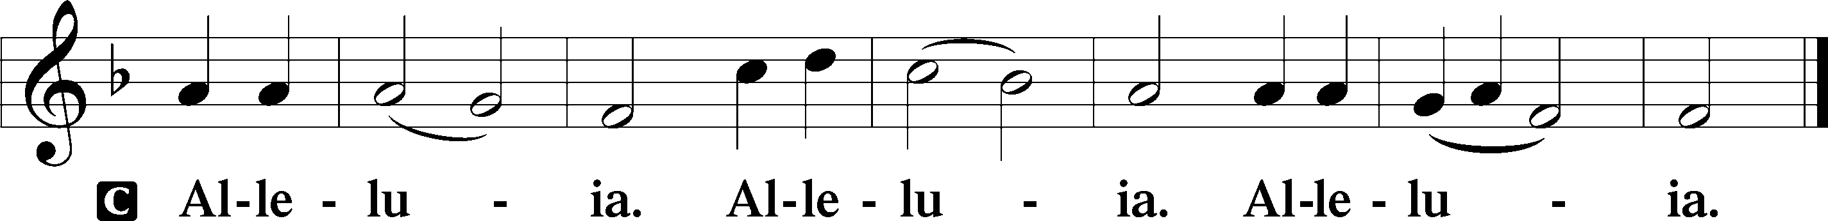

Holy Gospel: John 1:29-34 (NKJV)
P The Holy Gospel according to St. John, the first chapter.
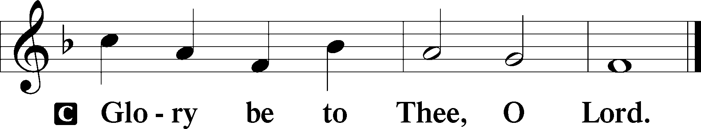

At that time: John saw Jesus coming toward him, and said, “Behold! The Lamb of God who takes away the sin of the world! This is He of whom I said, ‘After me comes a Man who is preferred before me, for He was before me.’ I did not know Him; but that He should be revealed to Israel, therefore I came baptizing with water.”

And John bore witness, saying, “I saw the Spirit descending from heaven like a dove, and He remained upon Him. I did not know Him, but He who sent me to baptize with water said to me, ‘Upon whom you see the Spirit descending, and remaining on Him, this is He who baptizes with the Holy Spirit.’ And I have seen and testified that this is the Son of God.”

P This is the Gospel of the Lord.
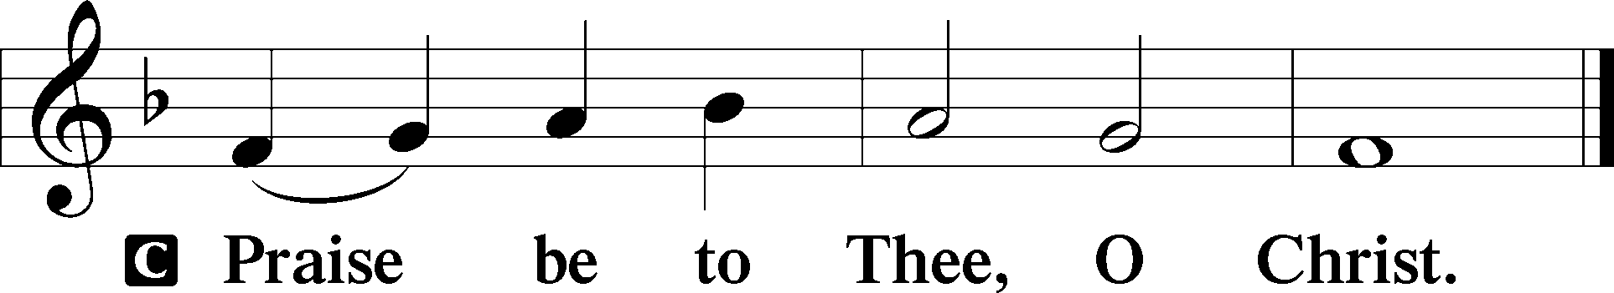

Nicene Creed
C I believe in one God,
the Father Almighty,
maker of heaven and earth
and of all things visible and invisible.

And in one Lord Jesus Christ,
the only-begotten Son of God,
begotten of His Father before all worlds,
God of God, Light of Light,
very God of very God,
begotten, not made,
being of one substance with the Father,
by whom all things were made;
who for us men and for our salvation came down from heaven
and was incarnate by the Holy Spirit of the virgin Mary
and was made man;
and was crucified also for us under Pontius Pilate.
He suffered and was buried.
And the third day He rose again according to the Scriptures
and ascended into heaven
and sits at the right hand of the Father.
And He will come again with glory to judge both the living and the dead,
whose kingdom will have no end.

And I believe in the Holy Spirit,
the Lord and giver of life,
who proceeds from the Father and the Son,
who with the Father and the Son together is worshiped and glorified,
who spoke by the prophets.
And I believe in one holy Christian and apostolic Church,
I acknowledge one Baptism for the remission of sins,
and I look for the resurrection of the dead
and the life T of the world to come. Amen.
Sit

Hymn of the Day: LSB #406 “To Jordan Came the Christ, Our Lord”

Sermon

Stand
Offertory Psalm 51:10–12
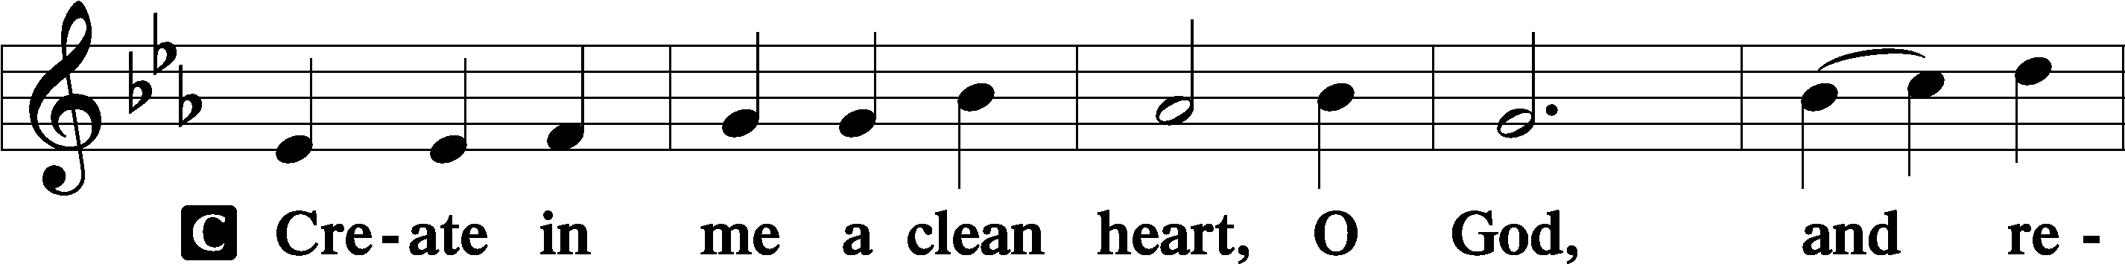
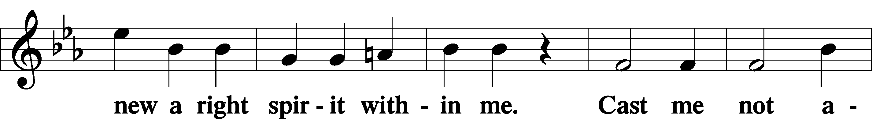
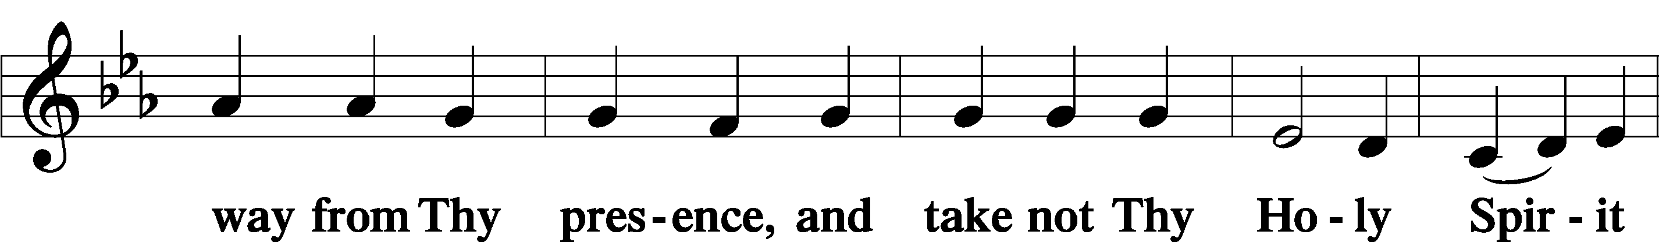
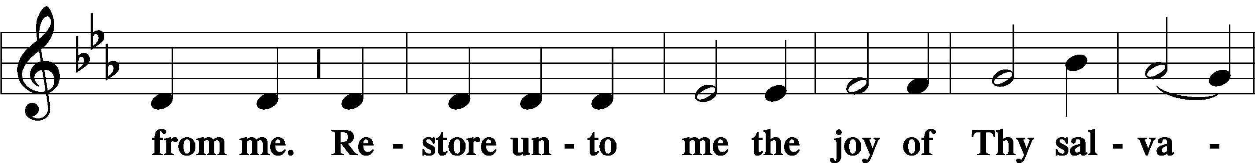
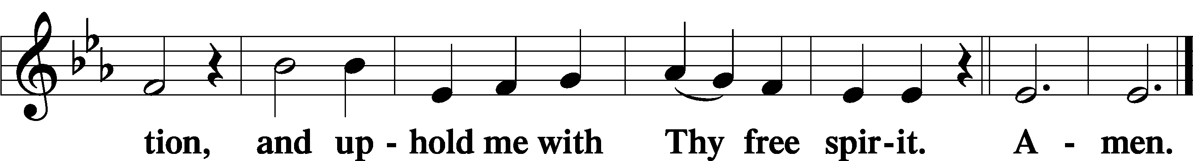

Prayer of the Church

Sit

Preparatory Hymn: LSB #617 “O Lord, We Praise Thee”

Stand
Service of the Sacrament

Preface 2 Timothy 4:22; Colossians 3:1 Psalm 136
P The Lord be with you.

P Lift up your hearts.
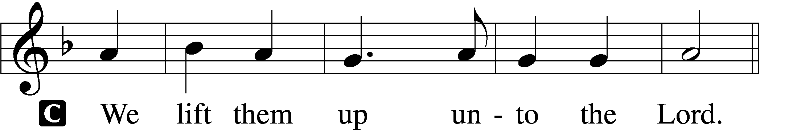
P Let us give thanks unto the Lord, our God.
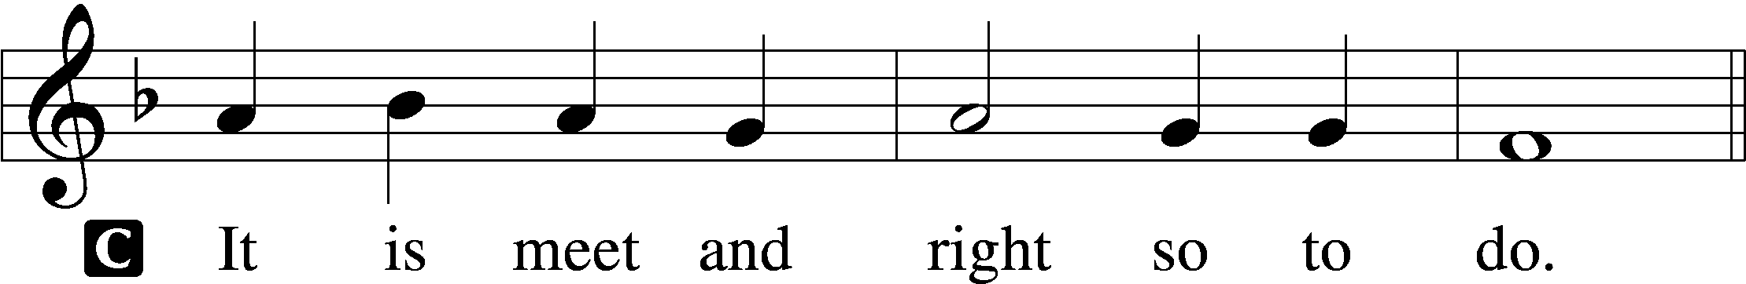

Proper Preface (Abbreviated) LSB 194
P It is truly meet, right, and salutary . . . evermore praising You and saying:
Sanctus Isaiah 6:3; Matthew 21:9
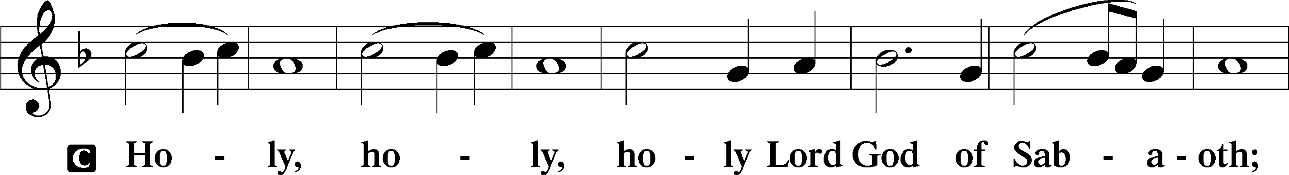
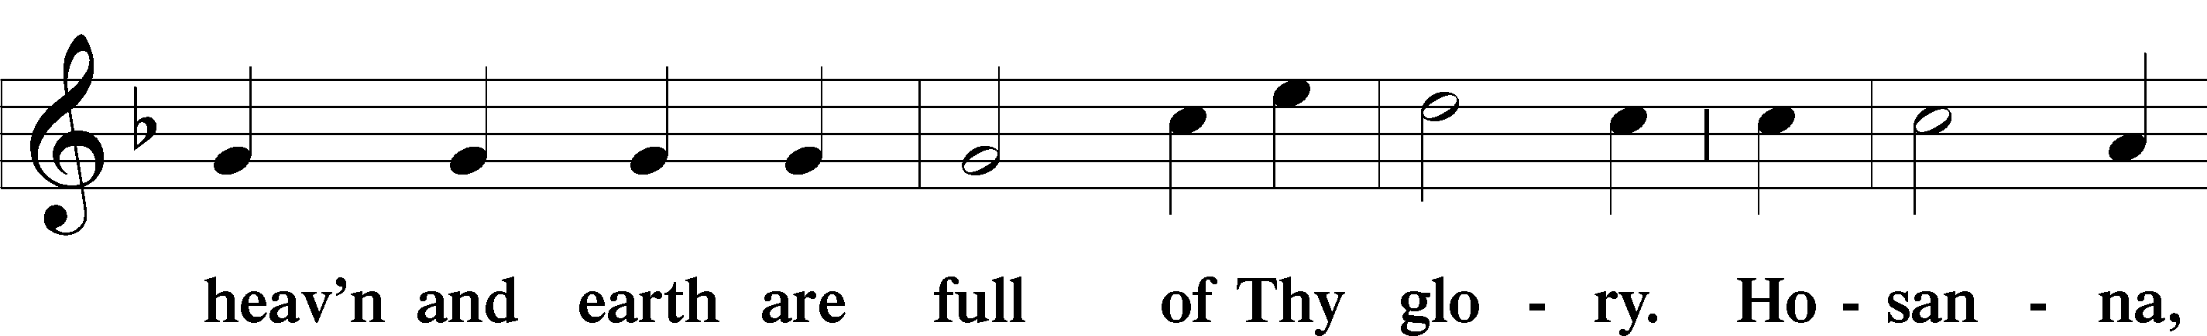
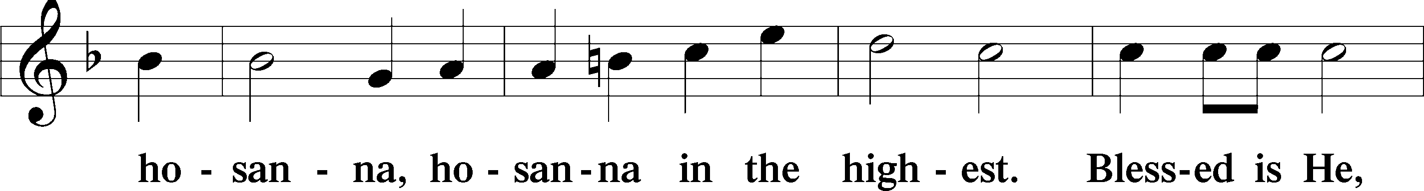
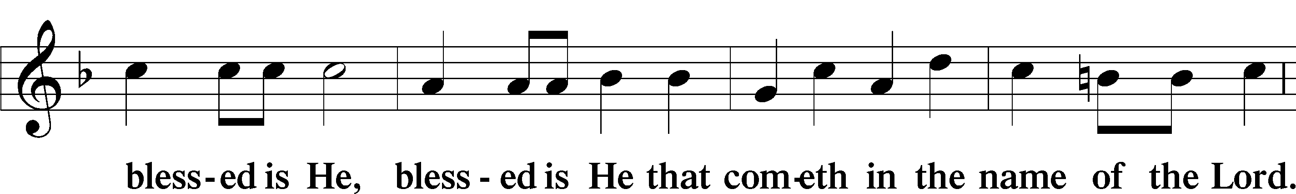
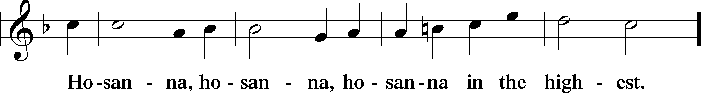

Lord’s Prayer The congregation is encouraged to silently pray the Lord’s Prayer as it is chanted. Matthew 6:9–13
P Our Father who art in heaven,
hallowed be Thy name,
Thy kingdom come,
Thy will be done on earth as it is in heaven;
give us this day our daily bread;
and forgive us our trespasses as we forgive those who trespass against us;
and lead us not into temptation,
but deliver us from evil.
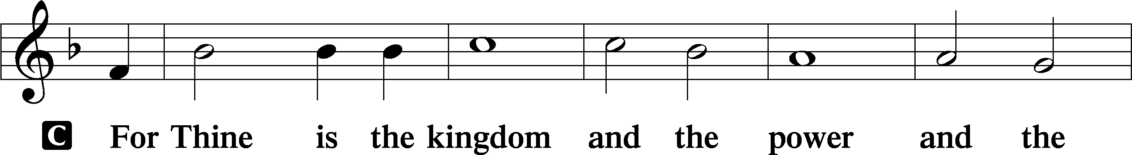
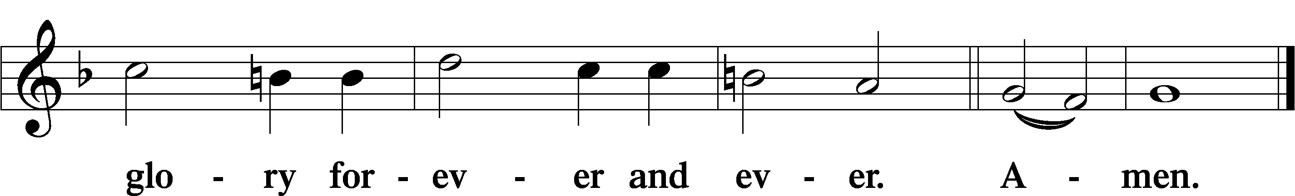

The Words of Our Lord Matthew 26:26–28; Mark 14:22–24; Luke 22:19–20; 1 Corinthians 11:23–25
P Our Lord Jesus Christ, on the night when He was betrayed, took bread, and when He had given thanks, He broke it and gave it to the disciples and said: “Take, eat; this is My T body, which is given for you. This do in remembrance of Me.”

In the same way also He took the cup after supper, and when He had given thanks, He gave it to them, saying: “Drink of it, all of you; this cup is the new testament in My T blood, which is shed for you for the forgiveness of sins. This do, as often as you drink it, in remembrance of Me.”

Pax Domini John 20:19
P The peace of the Lord be with you always.
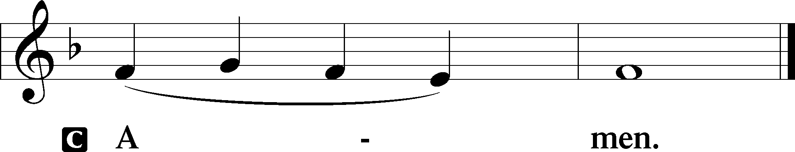

Agnus Dei John 1:29
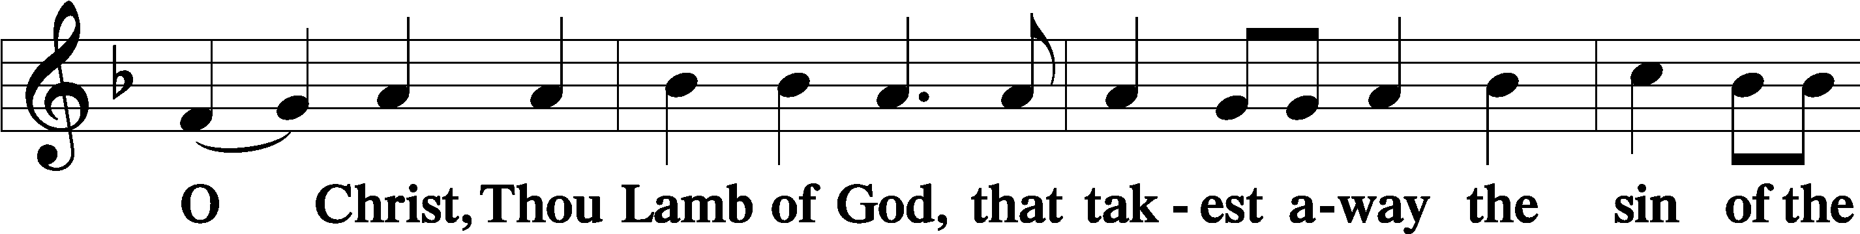
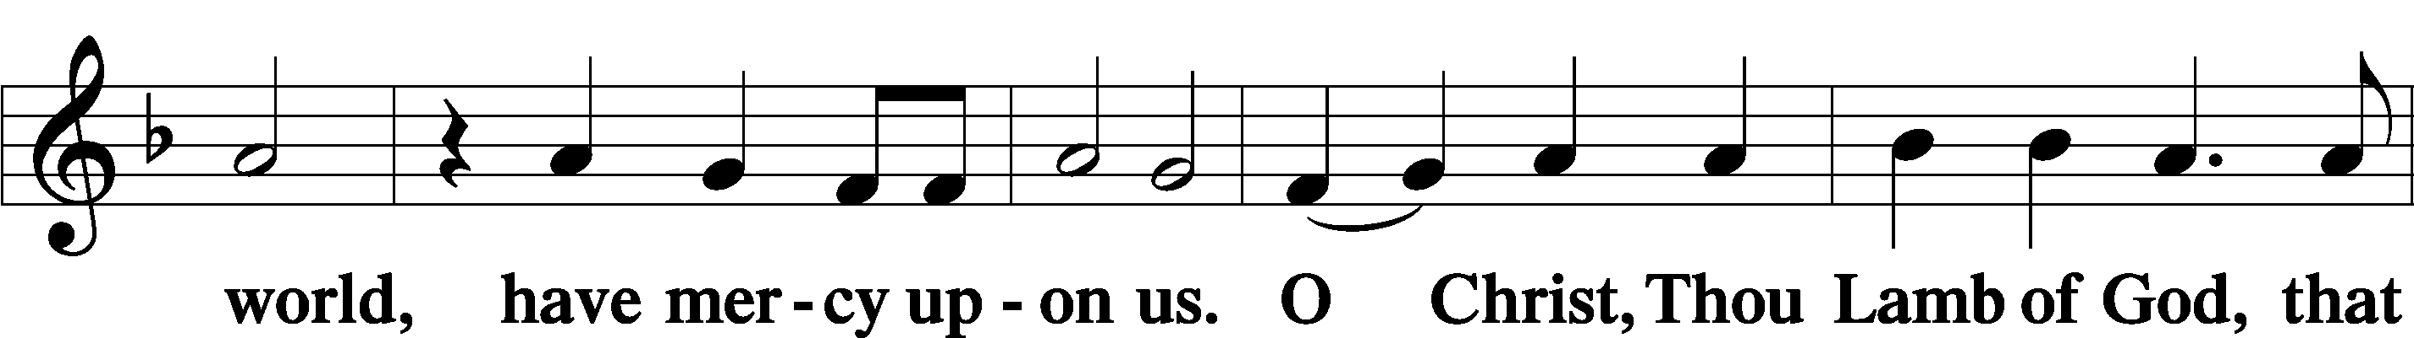
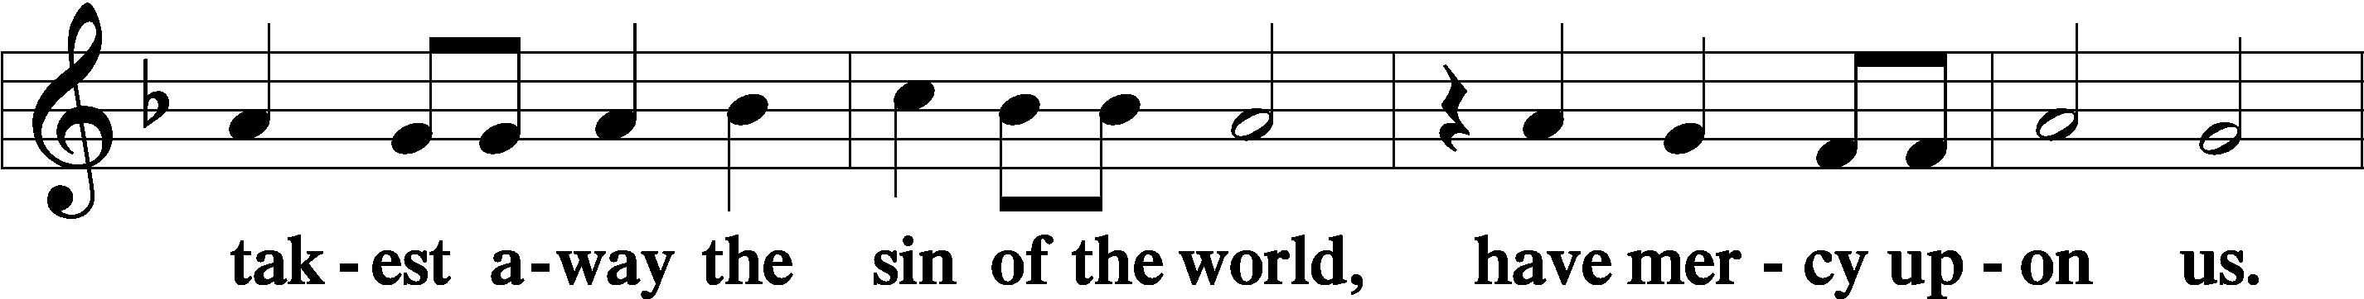
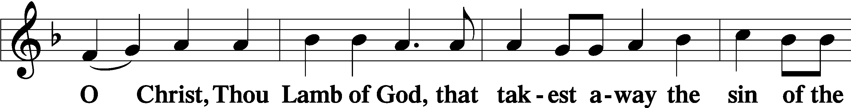
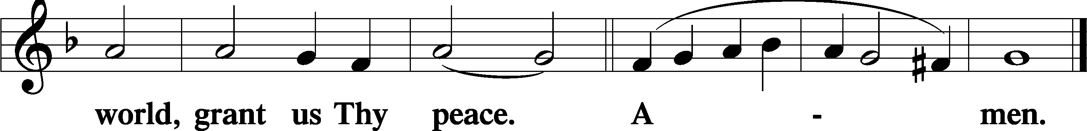
Sit

Distribution
The pastor and those who assist him receive the body and blood of Christ first and then distribute them to those who come to receive, saying:
Take, eat; this is the true body of our Lord and Savior Jesus Christ, given into death for your sins.
Amen.

Take, drink; this is the true blood of our Lord and Savior Jesus Christ, shed for the forgiveness of your sins.
Amen.

In dismissing the communicants, the following is said:
P The body and blood of our Lord Jesus Christ strengthen and preserve you in body and soul to life everlasting. Depart T in peace.
C Amen.

Distribution Hymn: LSB #639 “Wide Open Stand the Gates”

Distribution Hymn: LSB #421 “Jesus, Grant That Balm and Healing”

Distribution Hymn: LSB #544 “O Love, How Deep”

Nunc Dimittis Luke 2:29–32
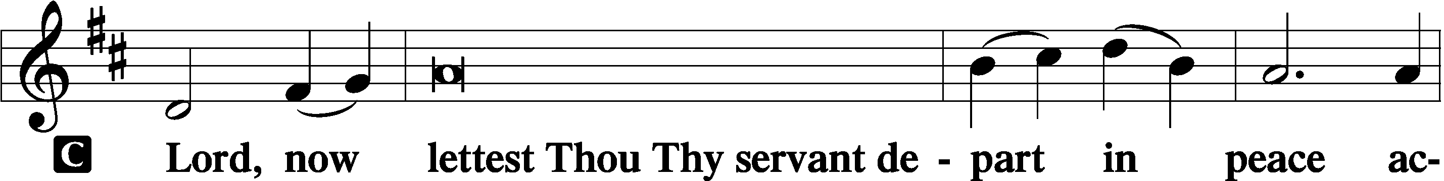
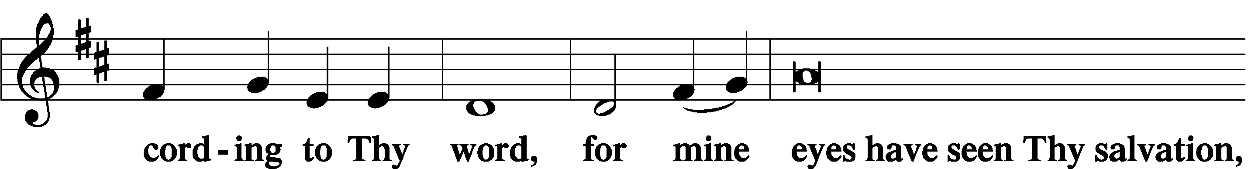
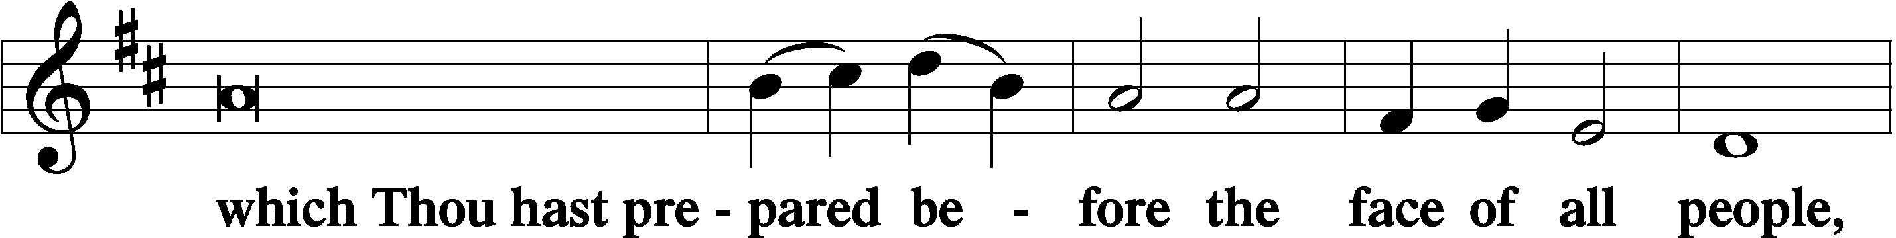
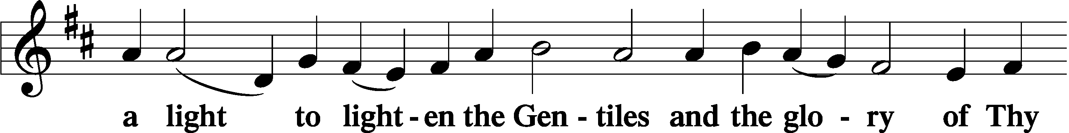
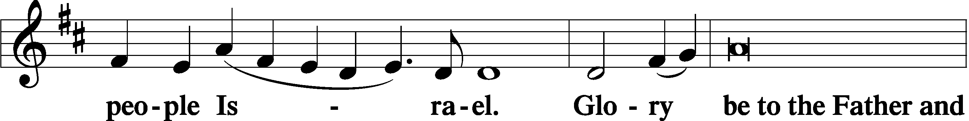
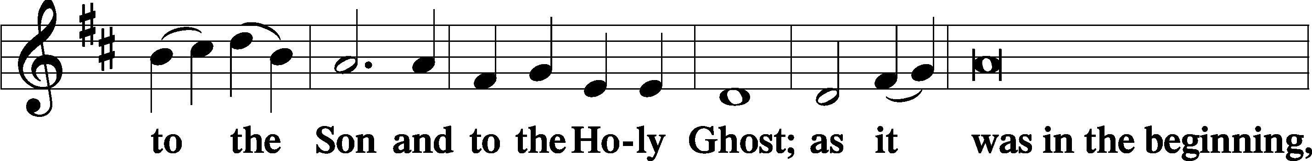
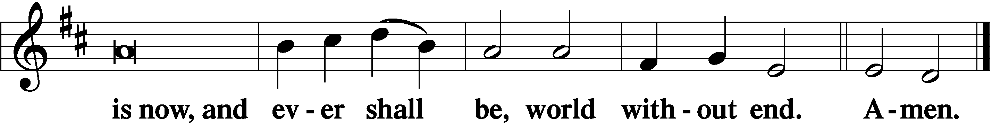

Thanksgiving Psalm 107:1
P O give thanks unto the Lord, for He is good,
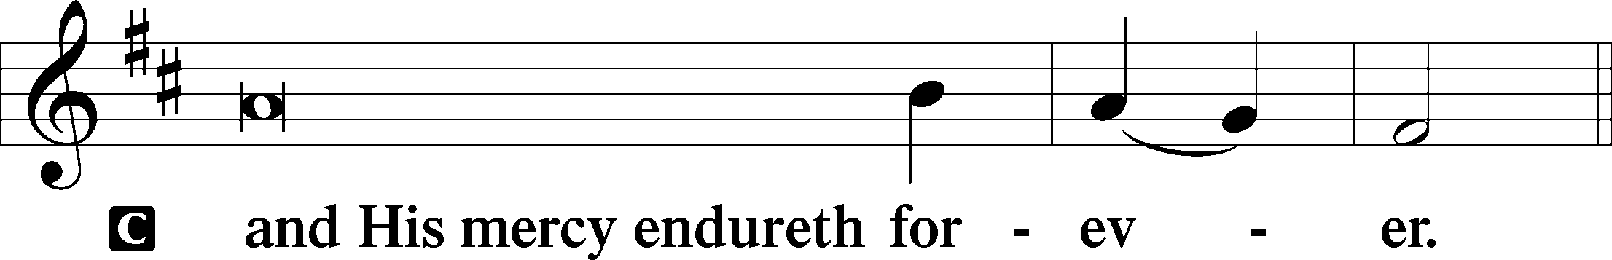

Post-Communion Collect
P Let us pray.
We give thanks to You, almighty God, that You have refreshed us through this salutary gift, and we implore You that of Your mercy You would strengthen us through the same in faith toward You and in fervent love toward one another; through Jesus Christ, Your Son, our Lord, who lives and reigns with You and the Holy Spirit, one God, now and forever.
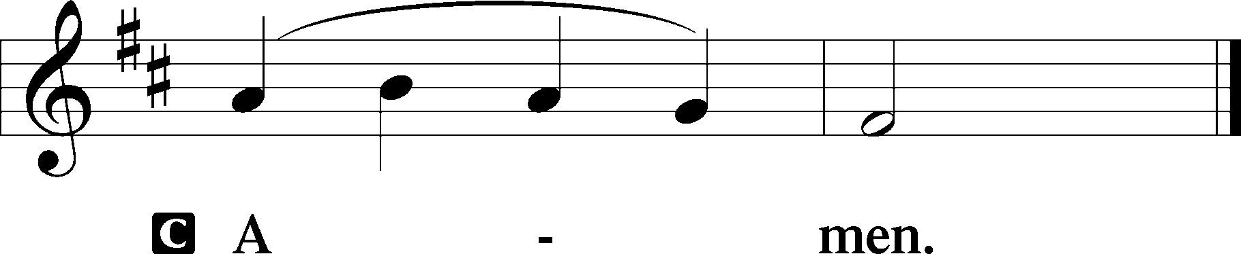

Salutation 2 Timothy 4:22
P The Lord be with you.
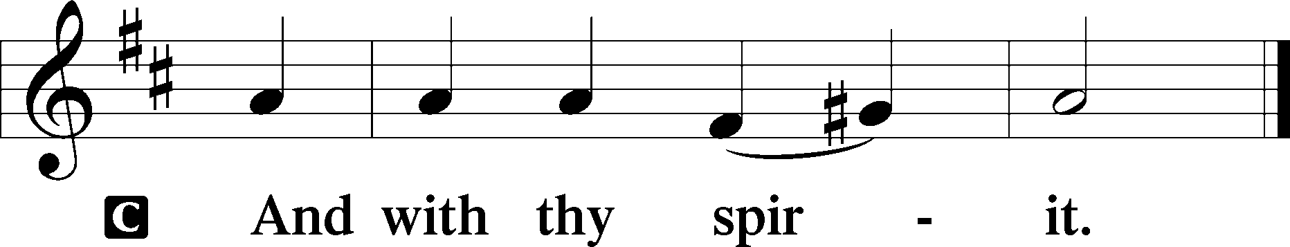

Benedicamus Psalm 103:1
P Bless we the Lord.
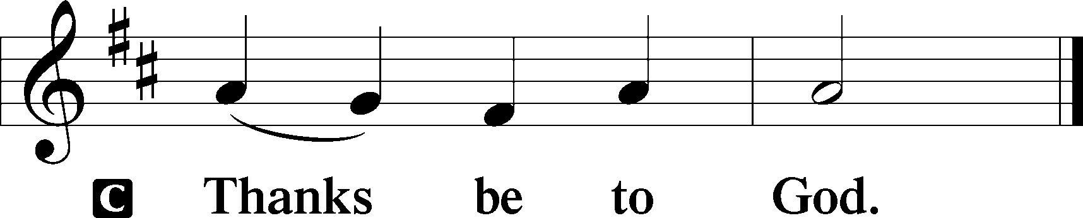

Benediction Numbers 6:24–26
P The Lord bless you and keep you.
The Lord make His face shine upon you and be gracious unto you.
The Lord lift up His countenance upon you and T give you peace.
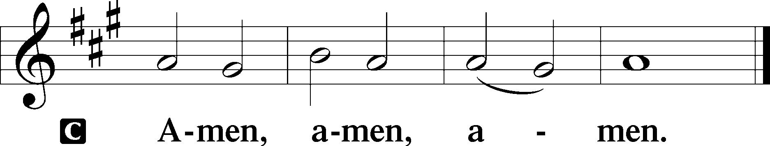

Closing Hymn: LSB #404 “Jesus, Once with Sinners Numbered”

Silent prayer after worship: Lord Jesus, You went the way of cross so that I can have life now and forever. Lead me to faithfully and joyfully live as a baptized child of God by committing my life to You and to the service of Your church. Amen.

Acknowledgments: Unless otherwise indicated, Scripture quotations are from the ESV® Bible (The Holy Bible, English Standard Version®), copyright © 2001 by Crossway, a publishing ministry of Good News Publishers. Used by permission. All rights reserved. Created by Lutheran Service Builder © 2023 Concordia Publishing House.
fffffffffffffffffffffffffffffffffff
fffffffffffffffffffffffffffffffffff
In Loving Memory of Timith Riffle: Linda Tomko.
fffffffffffffffffffffffffffffffffff
Bible Memory Verses ~ Week of January 7th:
For Adults: The Lord is my light and my salvation; whom shall I fear? The Lord is the stronghold of my life; of whom shall I be afraid? Psalm 27:1

For Children: We have seen his glory, glory as of the only Son from the Father. John 1:14

SCHEDULE THROUGH JANUARY 14, 2024:

:

Today, 7 pm, Fellowship Hall: AA Meeting
Tuesday, 7-9 pm, Fellowship Hall: Penn-Ohio Singers
Wednesday, 7 pm, Fellowship Hall: NA Meeting
Thursday, 9 am, Downstairs: Food Pantry
Saturday, 10 am, Sanctuary: “Un-decorating” of Church
Next Sunday, 8 am, Downstairs: Bible Study
9 am, Sanctuary: Divine Service
Following Worship: Coffee Fellowship
7 pm, Fellowship Hall: AA Meeting
fffffffffffffffffffffffffffffffffff
2024 Offering Envelopes are available in the church library. Please stop by and pick yours up!
fffffffffffffffffffffffffffffffffff
Our Stewardship of Treasures for the Lord:

Figures for Sunday, December 31, 2023
General Fund: $787.75
Capital Campaign: $4,535.00

For online giving, check out https://www.saintspeterandpaul.net/online-giving.
fffffffffffffffffffffffffffffffffff
Attendance: Sunday, December 31, 2023: 25
Monday, January 1, 2024: 6
fffffffffffffffffffffffffffffffffff
THANK YOU FOR SERVING IN JANUARY: Elder: Jonathan Baisch; Ushers: Cheryl Fedele, Mike Flaugher, & Jesse Riffle; Altarware ~ Sundays: (prior) Elizabeth Haenftling (01.07), Marie Flaugher (01.14) & Diane Riefstahl (01.21 & 01.28); (after) Cheryl Fedele & Clara Krivosh.
fffffffffffffffffffffffffffffffffff
January SCRIP orders and payments are due today. They may be placed in the offering plate or given to Matt Berent.
fffffffffffffffffffffffffffffffffff

Remember the following in Prayer…
~The Hurting and Healing: Amy, Mary Jane Anderson, Steve Antolovich, Ellen Baron^{CA}, Amy Blomenberg, Lois Bortner^{CA}, Sara Brubaker, Dee Bullock, Bev & Joe Chlpka, Susan Davies, Loretta Deal, Tim Dudash, Judith & Eddy Furey, Griffin, Austin Hamilton, Pastor Charles Henrickson, Joan, Keith Jozwiakowski, Rhyan Kirsch, Darla Krajci, Barbara Kreske, Jess Lavoie, Paul Lucas^{CA}, Sandy Marshall, Frank Niemeyer^{CA}, Juanita Rentschler, Richard Reuning^{CA}, Rosemary (Posey) Rice^{CA}, Nancy Robertson^{CA}, Kriss Svidro^{CA}, Rudy Tomko, Bob Usnarski, Joel & Peggy Wasson, Angela Weser^{CA}, and Ruth Wolf.
~The Homebound: Anna Mae Daris, Millie Elavsky, Jean Tomko, Betty Wolf, and Ed & Millie Zachar.
~Celebrating this Week: Birthday: Gerald Arthur (01.12).
~Serving in the Military: Alex (Sasha) Carr, Duncan Vaupel, Curtis Sinewe, and Joshua Solyan.
~Community & World Needs: Those suffering due to the conflicts in the Middle East and between Ukraine and Russia; those suffering from loss and dislocation because weather disasters; those suffering from addiction and their families; Local, State, and National Government Leaders; safety for all Police Officers, Firefighters, & First Responders; the unemployed; our First Quarter Local Mission: Community Outreach.
*CA represents cancer.
fffffffffffffffffffffffffffffffffff
Copies of the 1st Quarter “Portals of Prayer” for 2024 are available on the table in the narthex and next to the sign-in table by the nursery.
fffffffffffffffffffffffffffffffffff
The Installation of 2024 Church Officers and Boards will take place during the Divine Service next Sunday, January 14th. Please try to be in attendance.
We will also recognize past servants of the church at this time: Pastor Baisch (Financial Staff), Michael Laird (Trustees), and Jesse Riffle (Trustees). We are greatly appreciative of their service to this congregation in these capacities.
fffffffffffffffffffffffffffffffffff
Join us next Sunday following worship for Coffee Fellowship. This month’s sponsors are Jonathan and Rebekah Baisch.
fffffffffffffffffffffffffffffffffff
Your assistance will be appreciated this coming Saturday as the Trustees “un-decorate” the church. Work will begin at 10 am.
fffffffffffffffffffffffffffffffffff
Next Sunday is “Food Pantry Sunday”. Your financial donations to this cause are very much welcomed.
fffffffffffffffffffffffffffffffffff
UP-COMING MEETINGS:
Tuesday, January 16th: Trustees’ organizational meeting at 7 pm in the library.
Saturday, January 20th: Altar Guild meeting at 1 pm in the Fellowship Hall.
Sunday, January 21st: Auditors’ meeting following worship for a quarterly and monthly audit.
Monday, January 29th: Church Council meeting at 7 pm in the Fellowship Hall. (Reports are due to Diane by noon that day.)
fffffffffffffffffffffffffffffffffff
It’s time to begin work on the 2023 Annual Report. If you are responsible for contributing to the report, a copy of your 2022 report has been emailed to you. Please include similar information in your 2023 submission which is due back to Diane on/before January 22nd.
fffffffffffffffffffffffffffffffffff
Please take home any poinsettias which you may have purchased for the Christmas season today. Unclaimed plants will be placed in the main hallway and discarded if not picked up following next Sunday’s service.
fffffffffffffffffffffffffffffffffff

Here to Serve
Pastor………………………………………………...……………Rev. Jacob Deal
E-mail …………………………….……pastordeal@saintspeterandpaul.net
Phone Number……………………..…………………724-347-3620 (Option 2)
Church Office………………………..…………………724-347-3620 (Option 3)
Website …………………………………………www.saintspeterandpaul.net
Secretary…………………………………………………………Diane Riefstahl
E-mail ………………………………………church@saintspeterandpaul.net
Website …………………………………………www.saintspeterandpaul.net
Food Pantry (email): ……………foodpantry@saintspeterandpaul.net
Congregation President………………………………….…Jonathan Baisch
Church Elder …………………………………………...……. Jonathan Baisch
Organist………………………………………………..….…Rebecca Marquette
AA Contact: Steve………………………………………………...…724-813-2358
NA Contact: Larry……………………………………..…………..724-977-8733
fffffffffffffffffffffffffffffffffff
If needing to get into the church building during the week, please phone first to make certain someone is here to let you in.

