Sts. Peter & Paul
Evangelical Lutheran Church
Lutheran Church-Missouri Synod
Founded-1917
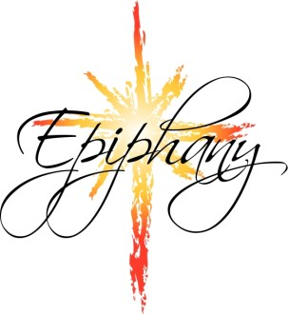
JANUARY 6, 2019

699 Stambaugh Avenue
Sharon, Pennsylvania 16146

“I was glad when they said to me,
Let us go to the house of the LORD!”
Psalm 122:1
Sts. Peter & Paul Evangelical Lutheran Church, LC-MS

THE EPIPHANY OF OUR LORD
January 6, 2019

Silent prayer before worship: Heavenly Father, make the light of Your Gospel shine in my heart that I may have the assurance of salvation in Christ, and be able to share that hope with others. In Jesus’ name. Amen.
CONFESSION AND ABSOLUTION
Opening Hymn: LSB #370 “What Child is This”
Stand

The sign of the cross may be made by all in remembrance of their Baptism.

P In the name of the Father and of the T Son and of the Holy Spirit.
C Amen. Matthew 28: 19b; (18:20)

P Beloved in the Lord! Let us draw near with a true heart and confess our sins unto God our Father, beseeching Him in the name of our Lord Jesus Christ to grant us forgiveness. [Hebrews 10:22]

P Our help is in the name of the Lord,
C who made heaven and earth. Psalm 124: 8
P I said, I will confess my transgressions unto the Lord,
C and You forgave the iniquity of my sin. Psalm 32: 5

Silence for reflection on God's Word and for self-examination.

P O almighty God, merciful Father,
C I, a poor, miserable sinner, confess unto You all my sins and iniquities with which I have ever offended You and justly deserved Your temporal and eternal punishment. But I am heartily sorry for them and sincerely repent of them, and I pray You of Your boundless mercy and for the sake of the holy, innocent, bitter sufferings and death of Your beloved Son, Jesus Christ, to be gracious and merciful to me, a poor, sinful being.

P Upon this your confession, I, by virtue of my office, as a called and ordained servant of the Word, announce the grace of God unto all of you, and in the stead and by the command of my Lord Jesus Christ I forgive you all your sins in the name of the Father and of the T Son and of the Holy Spirit.
[John 20: 19-23]
C Amen.

Passing of the Peace.
SERVICE OF THE WORD
Introit: Ps. 72:1–2, 10–11; antiphon: Liturgical Text
Behold the Lord, the rul- | er, has come,*
and the kingdom and the power and the glory are | in his hand.
Give the king your justice, | O God,*
and your righteousness to the | royal son!
May he judge your people with | righteousness,*
and your poor with | justice!
May the kings of Tarshish and of the coastlands render him | tribute;*
may the kings of Sheba and Seba | bring gifts!
May all kings fall down be- | fore him,*
all nations | serve him!

Gloria Patri
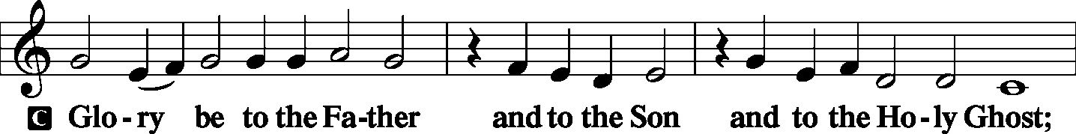
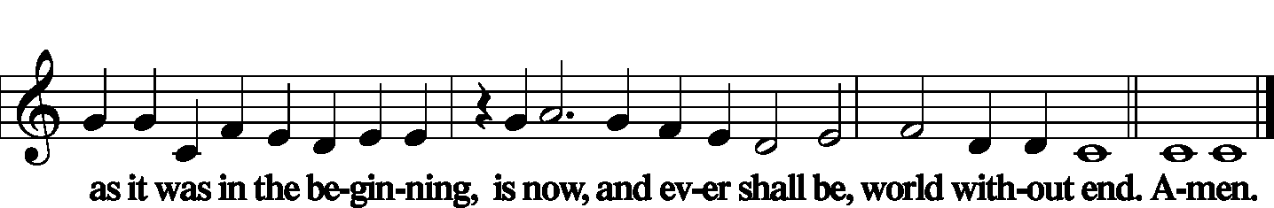

Kyrie Mark 10:47
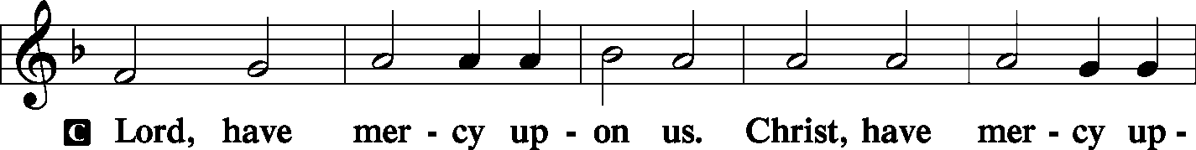
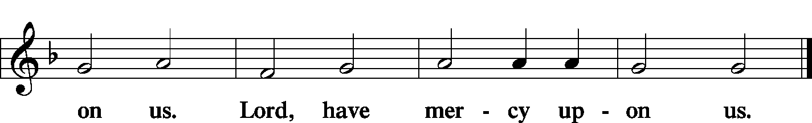

Gloria in Excelsis Luke 2: 14; John 1: 29
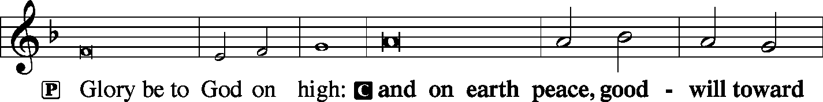
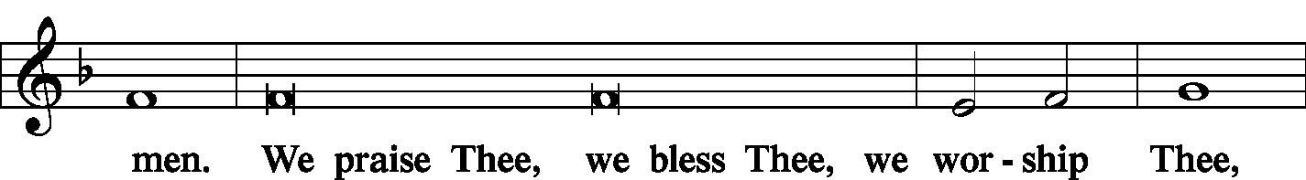
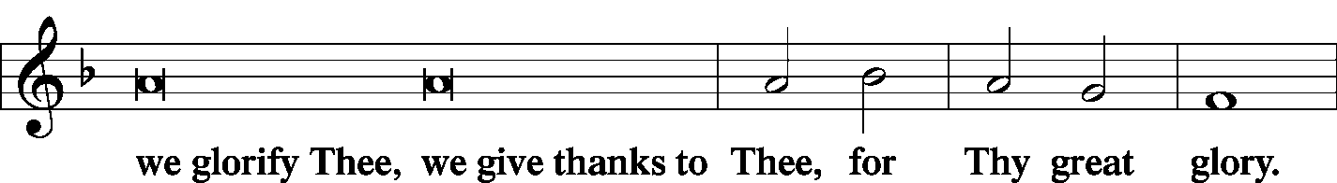
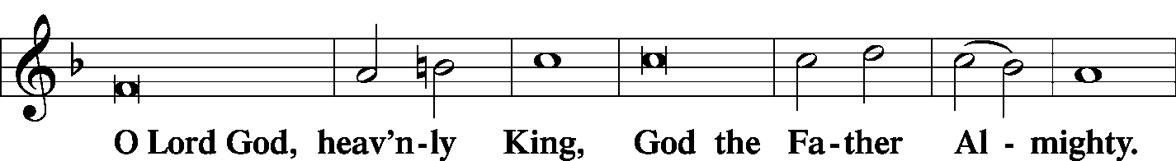
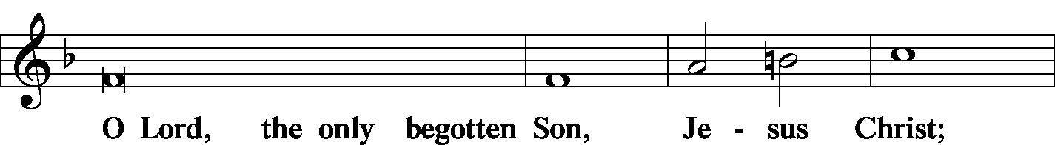
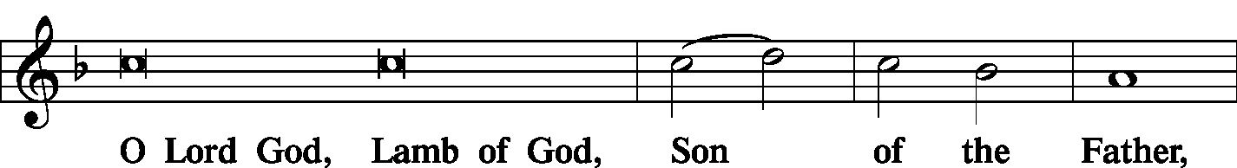
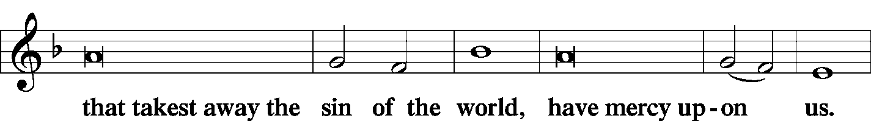
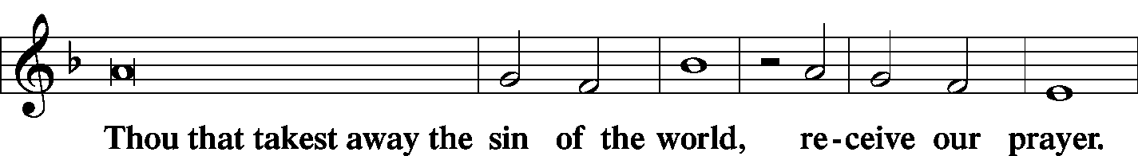
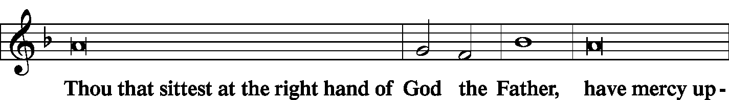
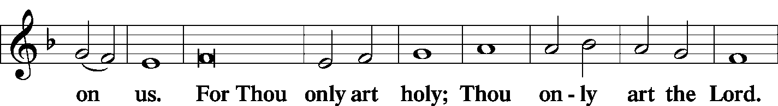
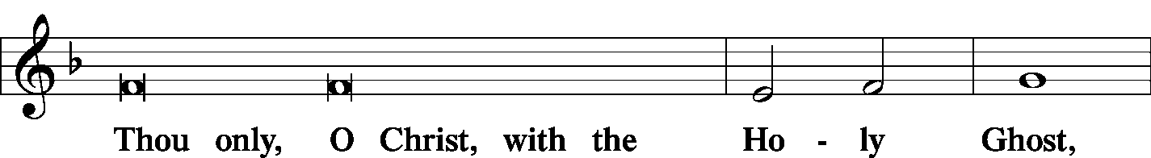
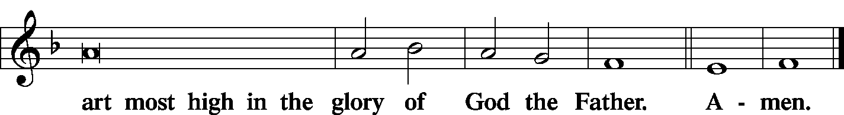

Salutation and Collect of the Day
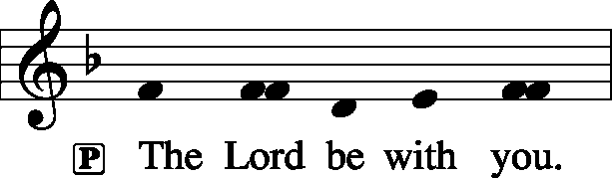 2 Timothy 4: 22
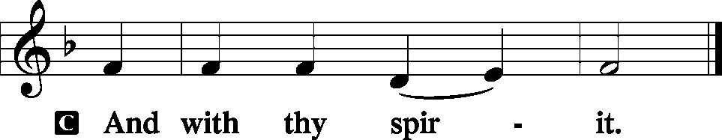

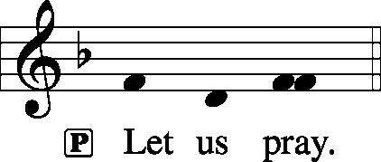

P O God, by the leading of a star You made known Your only-begotten Son to the Gentiles. Lead us, who know You by faith, to enjoy in heaven the fullness of Your divine presence; through the same Jesus Christ, our Lord, who lives and reigns with You and the Holy Spirit, one God, now and forever.

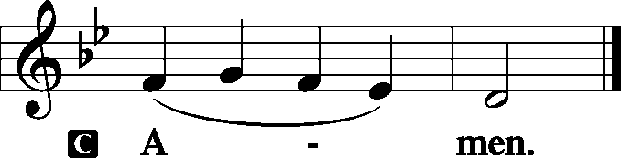

Sit

Old Testament Reading: Isaiah 60:1–6
Arise, shine, for your light has come,
and the glory of the Lord has risen upon you.
For behold, darkness shall cover the earth,
and thick darkness the peoples;
but the Lord will arise upon you,
and his glory will be seen upon you.
And nations shall come to your light,
and kings to the brightness of your rising.
Lift up your eyes all around, and see;
they all gather together, they come to you;
your sons shall come from afar,
and your daughters shall be carried on the hip.
Then you shall see and be radiant;
your heart shall thrill and exult,
because the abundance of the sea shall be turned to you,
the wealth of the nations shall come to you.
A multitude of camels shall cover you,
the young camels of Midian and Ephah;
all those from Sheba shall come.
They shall bring gold and frankincense,
and shall bring good news, the praises of the Lord.
P This is the Word of the Lord.
C Thanks be to God.
Gradual: Is. 60:6b, 1
Those from Sheba shall come.
They shall bring gold and frankincense, and shall bring good news, the praises of the Lord.
Arise, shine, for your light has come,
and the glory of the Lord has risen upon you.

Epistle: Ephesians 3:1–12
For this reason I, Paul, a prisoner for Christ Jesus on behalf of you Gentiles— assuming that you have heard of the stewardship of God’s grace that was given to me for you, how the mystery was made known to me by revelation, as I have written briefly. When you read this, you can perceive my insight into the mystery of Christ, which was not made known to the sons of men in other generations as it has now been revealed to his holy apostles and prophets by the Spirit. This mystery is that the Gentiles are fellow heirs, members of the same body, and partakers of the promise in Christ Jesus through the gospel.
Of this gospel I was made a minister according to the gift of God’s grace, which was given me by the working of his power. To me, though I am the very least of all the saints, this grace was given, to preach to the Gentiles the unsearchable riches of Christ, and to bring to light for everyone what is the plan of the mystery hidden for ages in God who created all things, so that through the church the manifold wisdom of God might now be made known to the rulers and authorities in the heavenly places. This was according to the eternal purpose that he has realized in Christ Jesus our Lord, in whom we have boldness and access with confidence through our faith in him.

P This is the Word of the Lord.
C Thanks be to God.

Stand
Alleluia Verse and Alleluia
P Alleluia. We saw his star when it rose and have come to worship him. Alleluia.
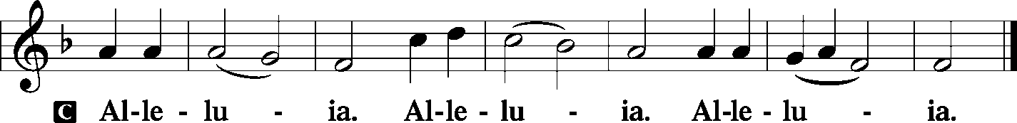
Holy Gospel: Matthew 2:1–12
P The Holy Gospel according to St. Matthew, the second chapter.

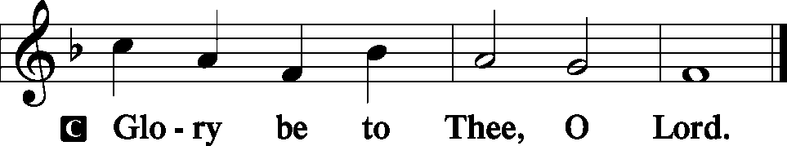

Now after Jesus was born in Bethlehem of Judea in the days of Herod the king, behold, wise men from the east came to Jerusalem, saying, “Where is he who has been born king of the Jews? For we saw his star when it rose and have come to worship him.” When Herod the king heard this, he was troubled, and all Jerusalem with him; and assembling all the chief priests and scribes of the people, he inquired of them where the Christ was to be born. They told him, “In Bethlehem of Judea, for so it is written by the prophet:
“‘And you, O Bethlehem, in the land of Judah,
are by no means least among the rulers of Judah;
for from you shall come a ruler
who will shepherd my people Israel.’”
Then Herod summoned the wise men secretly and ascertained from them what time the star had appeared. And he sent them to Bethlehem, saying, “Go and search diligently for the child, and when you have found him, bring me word, that I too may come and worship him.” After listening to the king, they went on their way. And behold, the star that they had seen when it rose went before them until it came to rest over the place where the child was. When they saw the star, they rejoiced exceedingly with great joy. And going into the house they saw the child with Mary his mother, and they fell down and worshiped him. Then, opening their treasures, they offered him gifts, gold and frankincense and myrrh. And being warned in a dream not to return to Herod, they departed to their own country by another way.

P This is the Gospel of the Lord.

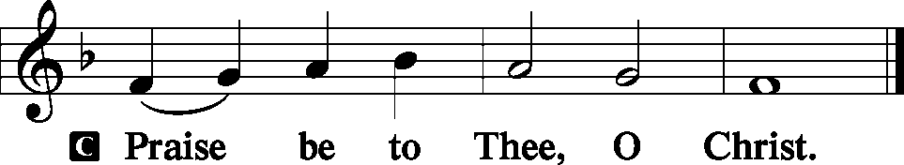
Nicene Creed
C I believe in one God,
the Father Almighty,
maker of heaven and earth
and of all things visible and invisible.
And in one Lord Jesus Christ,
the only-begotten Son of God,
begotten of His Father before all worlds,
God of God, Light of Light,
very God of very God,
begotten, not made,
being of one substance with the Father,
by whom all things were made;
who for us men and for our salvation came down from heaven
and was incarnate by the Holy Spirit of the virgin Mary
and was made man;
and was crucified also for us under Pontius Pilate.
He suffered and was buried.
And the third day He rose again according to the Scriptures
and ascended into heaven
and sits at the right hand of the Father.
And He will come again with glory to judge both the living and the dead,
whose kingdom will have no end.

And I believe in the Holy Spirit,
the Lord and giver of life,
who proceeds from the Father and the Son,
who with the Father and the Son together is worshiped and glorified,
who spoke by the prophets.

And I believe in one holy Christian and apostolic Church,
I acknowledge one Baptism for the remission of sins,
and I look for the resurrection of the dead
and the life T of the world to come. Amen.
Sit

Hymn of the Day: LSB #395 “O Morning Star, How Fair and Bright”

Sermon
Stand

P The peace of God, which passes all understanding, keep your hearts and minds in Christ Jesus. Philippians 4: 7
C Amen.

Installation of 2019 Church Officers and Boards
Prayer of the Church [Timothy 2: 1-4]
Sit

Offertory Psalm 51: 10-12
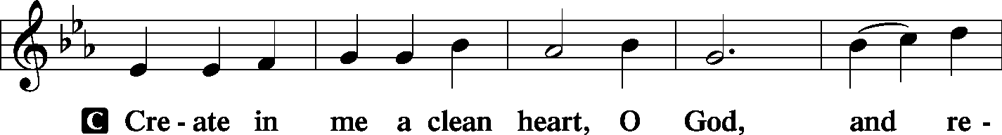
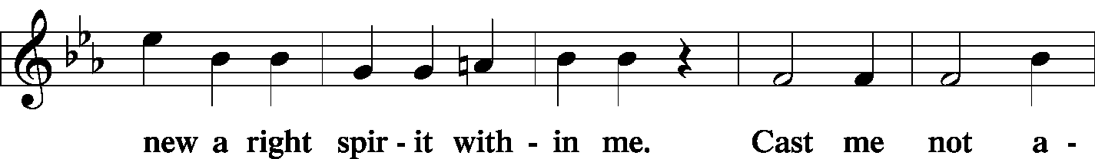
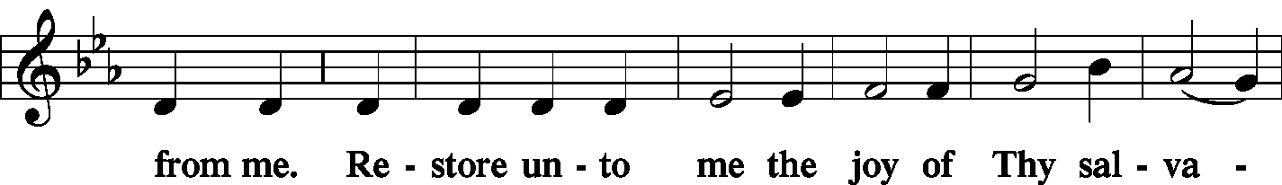
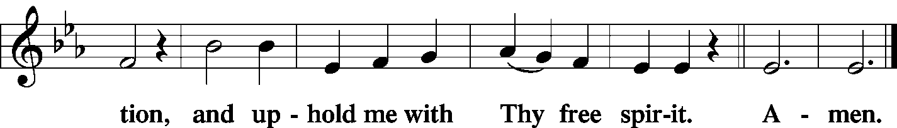

Stand
SERVICE OF THE SACRAMENT
Preface
2 Timothy 4: 22
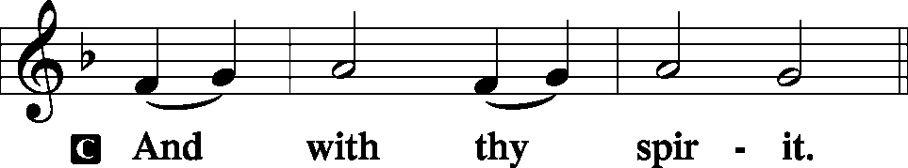
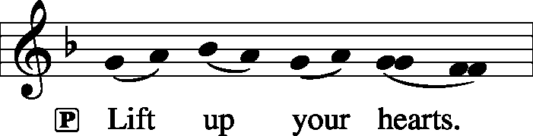 [Colossians 3:1]

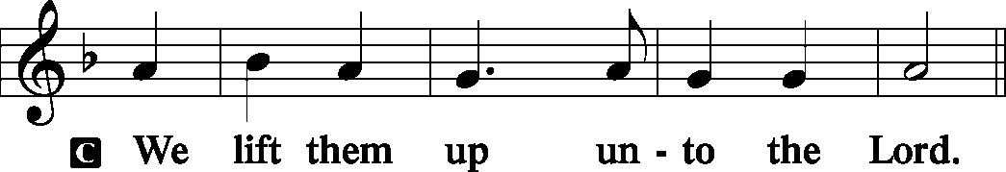

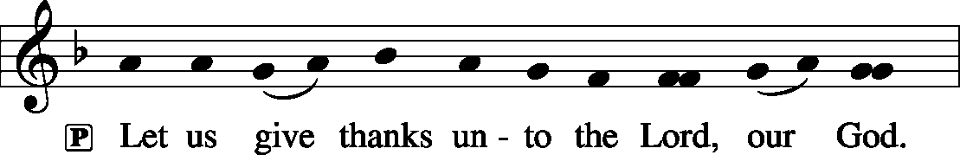 [Psalm 136]

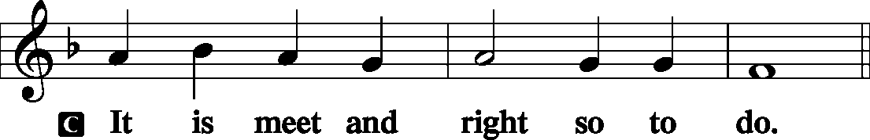

P It is truly meet, right, and salutary . . . evermore praising You and saying:

Sanctus Isaiah 6: 3; Matthew 21: 9
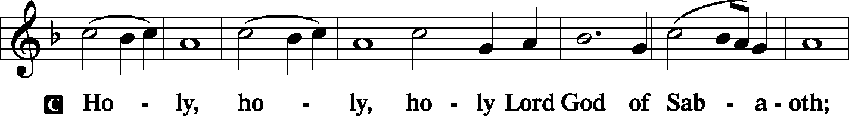
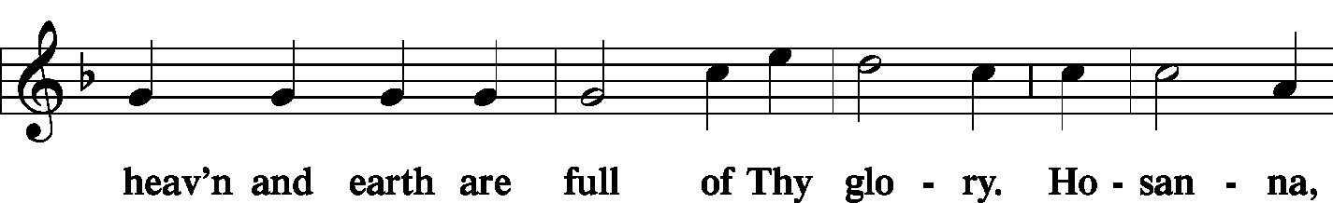
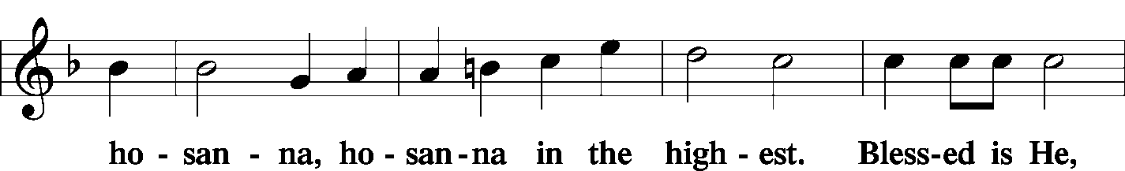
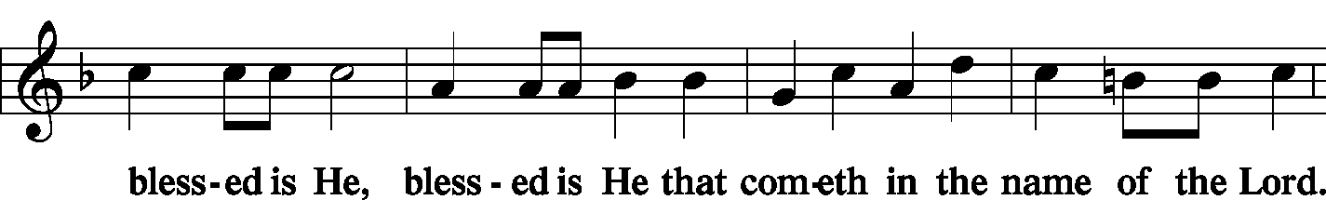
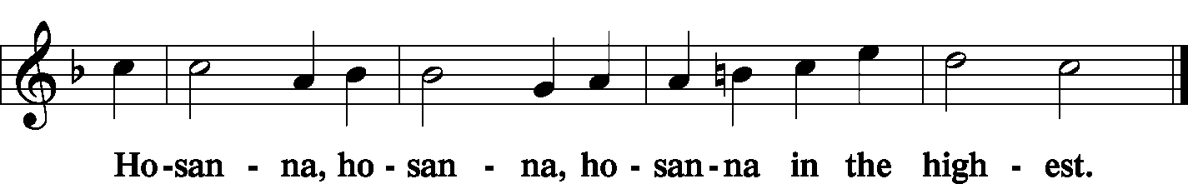

Lord's Prayer Matthew 6: 9-13
P Lord, remember us in Your kingdom and teach us to pray:
C Our Father who art in heaven,
hallowed be Thy name,
Thy kingdom come,
Thy will be done on earth as it is in heaven;
give us this day our daily bread;
and forgive us our trespasses as we forgive those who trespass against us;
and lead us not into temptation,
but deliver us from evil.
For Thine is the kingdom and the power and the glory forever and ever. Amen.

The Words of Our Lord Matthew 26: 26-28; Mark 14: 22-24
Luke 22: 19-20; 1 Corinthians 11: 23-25
P Our Lord Jesus Christ, on the night when He was betrayed, took bread, and when He had given thanks, He broke it and gave it to the disciples and said: “Take, eat; this is My T body, which is given for you. This do in remembrance of Me.”

P In the same way also He took the cup after supper, and when He had given thanks, He gave it to them, saying: “Drink of it, all of you; this cup is the new testament in My T blood, which is shed for you for the forgiveness of sins. This do, as often as you drink it, in remembrance of Me.”
Pax Domini John 20: 19
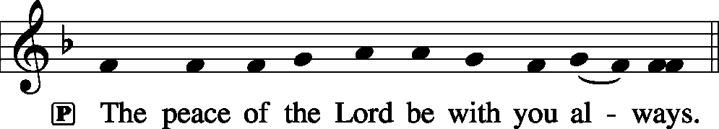

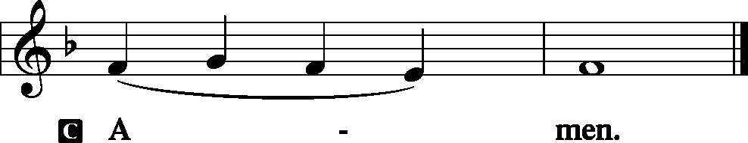
Agnus Dei John 1: 29
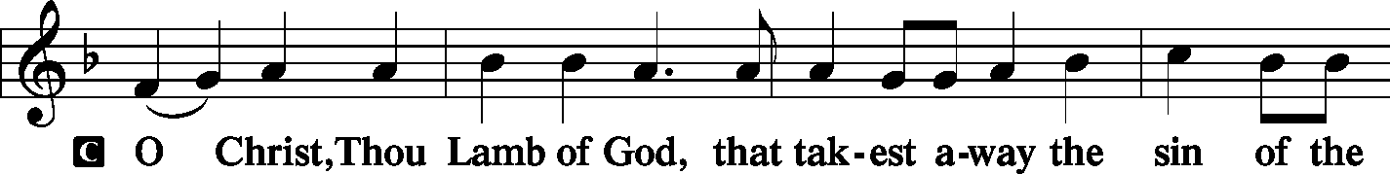
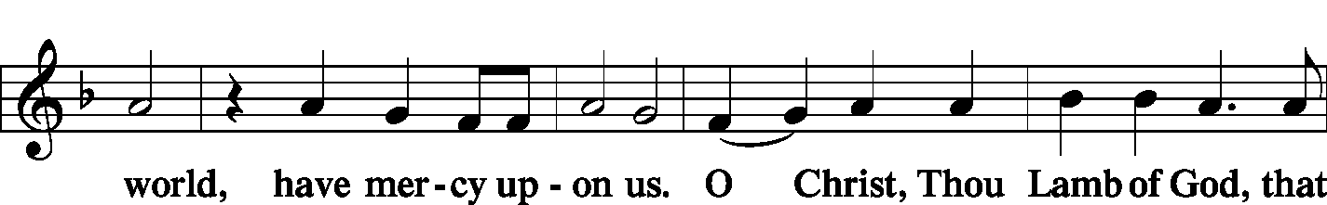
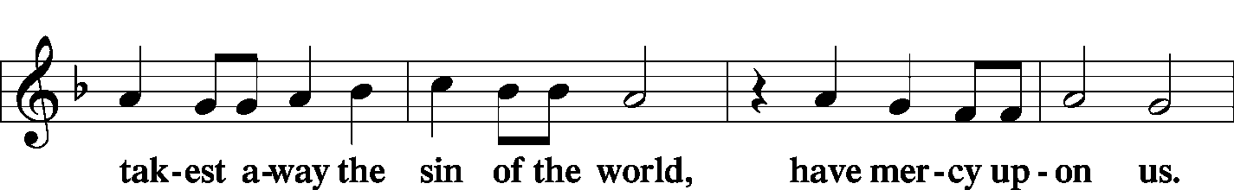
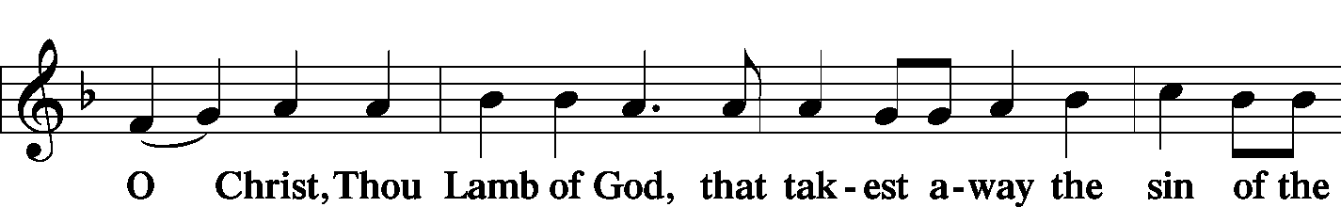
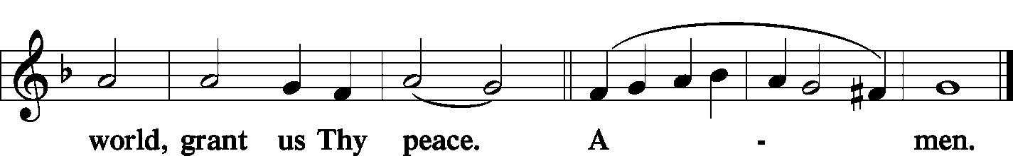
Sit

Distribution
The pastor and those who assist him receive the body and blood of Christ first and then distribute them to those who come to receive, saying:

Take, eat; this is the true body of our Lord and Savior Jesus Christ, given into death for your sins.
Amen.

Take, drink; this is the true blood of our Lord and Savior Jesus Christ, shed for the forgiveness of your sins.
Amen.

In dismissing the communicants, the following is said:
P The body and blood of our Lord Jesus Christ strengthen and preserve you in body and soul to life everlasting. Depart T in peace.
C Amen.

Distribution Hymn: LSB #399 “The Star Proclaims the King Is Here”

Stand
Post-Communion Canticle: Nunc Dimittis Luke 2: 29-32
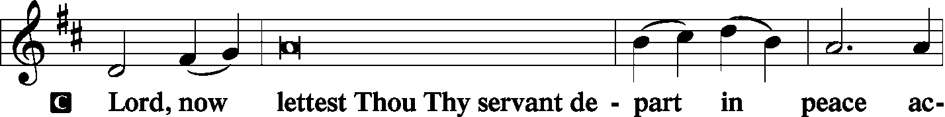
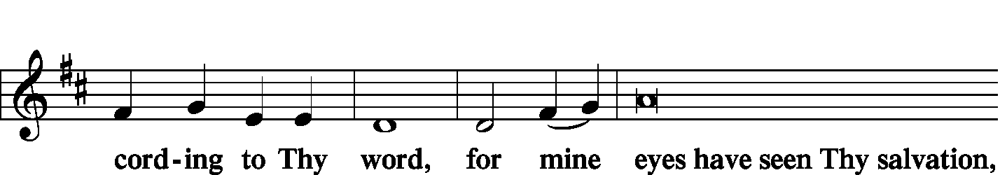
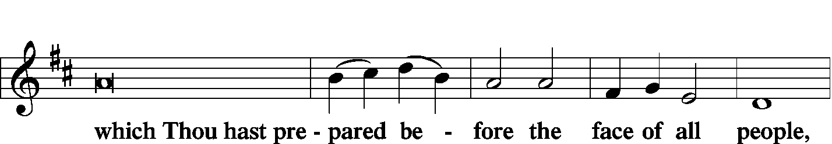
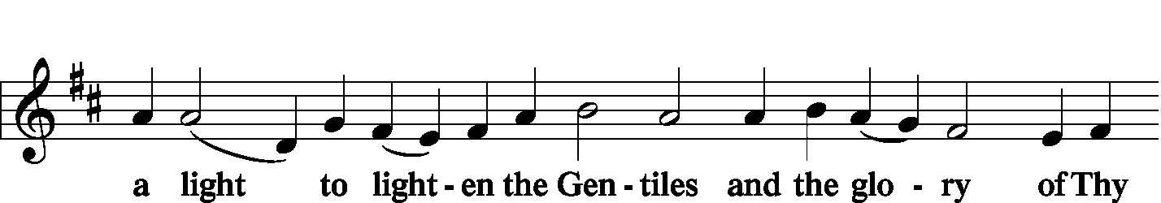
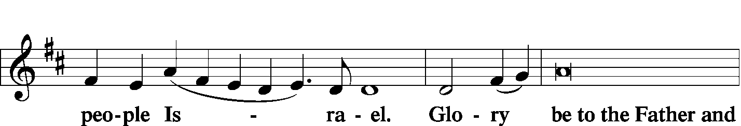
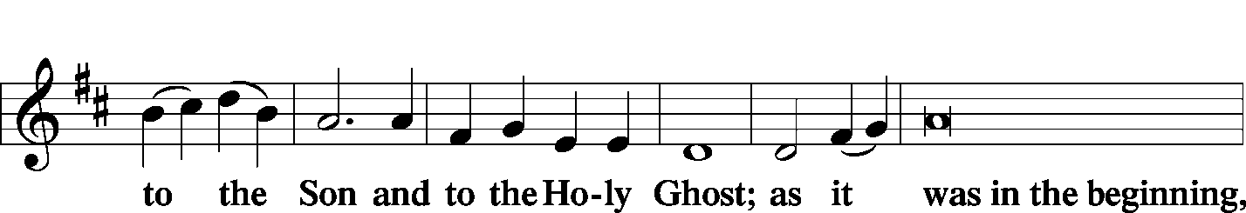
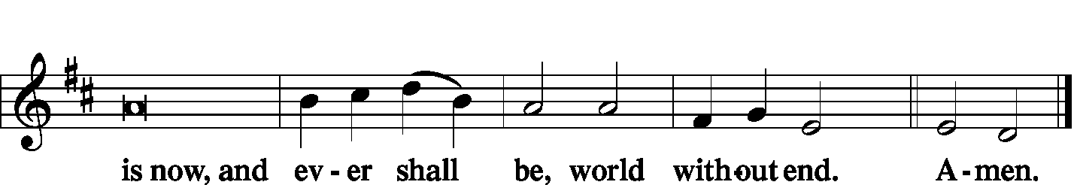

Thanksgiving Psalm 107: 1
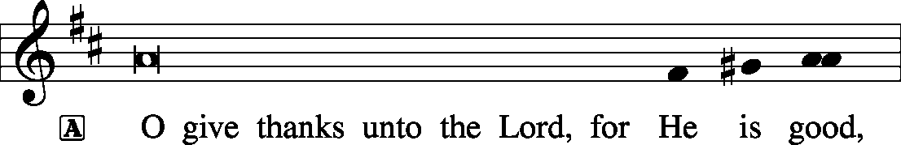
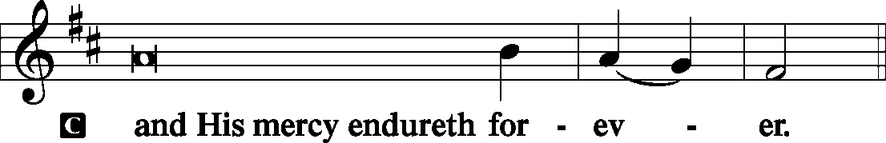

P Let us pray.
We give thanks to You, almighty God, that You have refreshed us through this salutary gift, and we implore You that of Your mercy You would strengthen us through the same in faith toward You and fervent love toward one another; through Jesus Christ, Your Son, our Lord, who lives and reigns with You and the Holy Spirit, one God, now and forever.
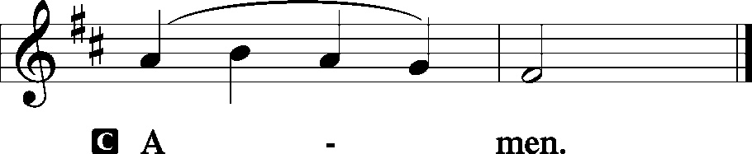
Salutation and Benedicamus
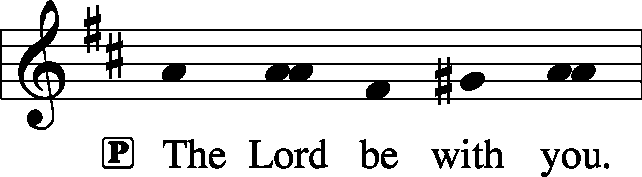 2 Timothy 4: 22

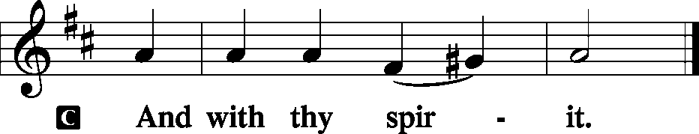
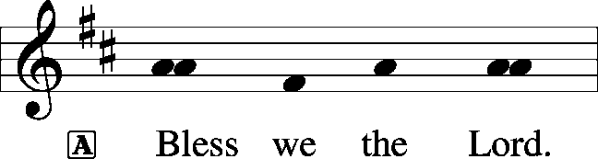 [Psalm 103: 1]

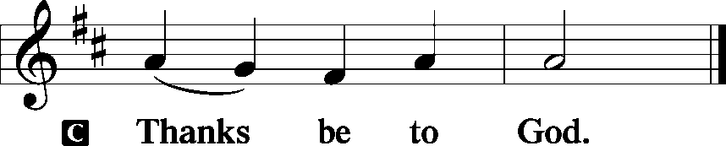

Benediction Numbers 6: 24-26
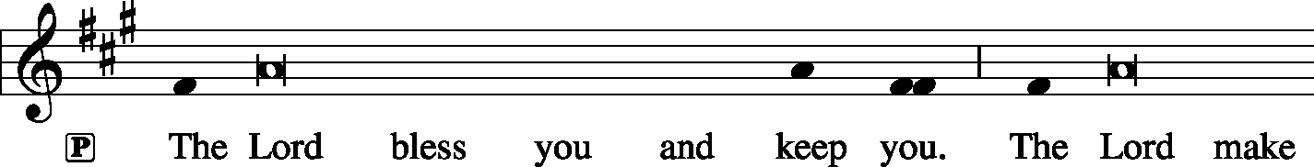
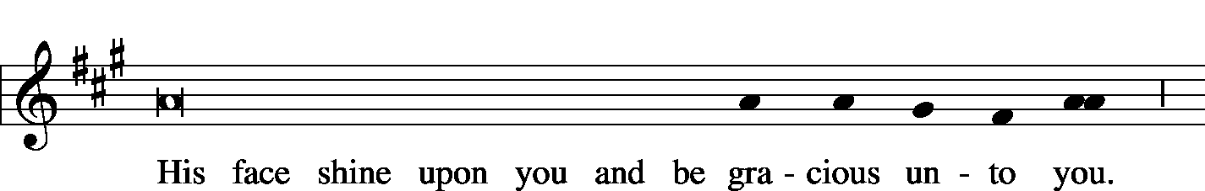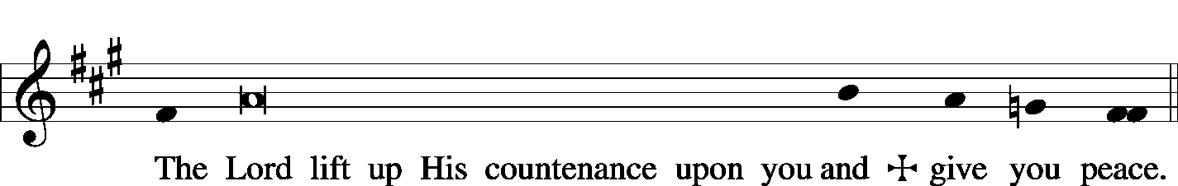

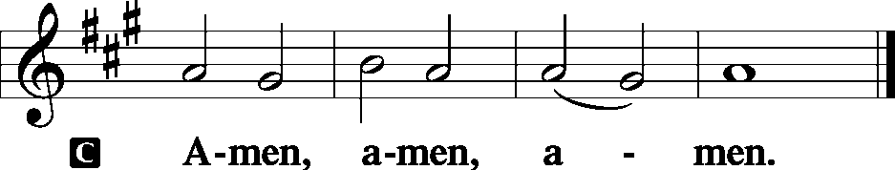

Closing Hymn: LSB #888 “O Gladsome Light, O Grace”
Silent prayer after worship: Lord Jesus, You have come as Savior not just to a few, but to the entire world. Cause the light of Your Word to shine forth in my life, that I may give glory to God and to proclaim to all that You are our Savior. Amen.

Acknowledgments: Divine Service, Setting Three from Lutheran Service Book Unless otherwise indicated, all scripture quotations are from The Holy Bible, English Standard Version, copyright © 2001 by Crossway Bibles, a division of Good News Publishers. Used by permission. All rights reserved. Created by Lutheran Service Builder © 2006 Concordia Publishing House. CCLI License #3029-446


In Loving Memory of Husband, Nick, and the Krivosh Family (including 7 brothers and 5 sisters): Betty Ann Wolf (Major Repair).

Bible Memory Verses:
For Children: The darkness is passing away and the true light is already shining.
1 John 2:8
For Adults: Come to me, all who labor and are heavy laden, and I will give you rest. Take my yoke upon you, and learn from me, for I am gentle and lowly in heart, and you will find rest for your souls. For my yoke is easy, and my burden is light.
Matthew 11:28-30

SCHEDULE FOR TODAY THROUGH JAN. 13th:
:

:

Today, 7 pm, Downstairs….…………………..….……………………………..…..……AA Meeting
Tuesday, 9 am…………………………………………………………………………Church Work Day
Wednesday, 7 pm, Chapel…………………………………………...Wednesday Divine Service
Thursday, 9 am………………………………………………………………………………….Food Pantry
Next Sunday, 8:45 am, Downstairs………………………….…………….…………….Bible Study
10 am, Sanctuary…......................................................................Divine Service
Following worship, Downstairs…………………………………..…..Coffee & Donuts
7 pm, Downstairs………………………………………………………..…....……AA Meeting
Word of Hope: 1-888-217-8679
The only 24/7 CONFIDENTIAL Hotline that is distinctly Lutheran, bringing healing found in Christ, to those whose hearts have been broken by abortion.

Thank You for Serving in January:
Today’s Greeters: John Dyll & Mark Gabriel. Assisting Elders: Ralph Dorman & Hugh Owen. Ushers: John Dyll, Barry Nelson, Jerome Thomas, Gary Burns, Bob Sulek (alternate). Altarware: Clara Krivosh & Cheryl.
January Greeters:
13 ~ Rev. Ed & Irene Kucera
20 ~ Anna Mae Daris & Millie Elavsky
27 ~ Cheryl Fedele & Clara Krivosh

Attendance:
Sunday, December 30, 2018………………………………………………………..35

Remember the following in Prayer…
~The Hurting and Healing: Tony², Lois Bortner^{CA}, John Berent (Matt’s father), Jeff Brandes¹, Richard Brandes¹, Eileen Burns¹, Loretta Deal, Norma Ferringer², Anson Holcroft², Betty Knauff^{CA}, Regis Knauff¹, Jess Lavoie⁴, Paul Lucas^{CA}, Barry Nelson³, David Nelson³,Tom Mulligan^{CA}, Iona Oltman^{CA}, Rudy Pinal^{CA}, Richard Reuning^{CA}, Viola Sakony⁴, Scott^{CA}, and Angela Weser^{CA}.
~Celebrating: Birthdays~Gerald Arthur (01.12).
~Our Homebound: Helen Bender, Dan Davis, Edna Krajci, Mary Ann Krajci, Sophie Mihm, Marion & Gene Roberts, Barbara Vasconi, and Joanne Wolfe.
~Serving in the Military: Clayton Drnek, Curtis Sinewe, and Joshua Solyan.
~Community & World Needs: Victims of violence and terrorism; those suffering from loss and dislocation because weather disasters; those suffering from addiction and their families; safety for teachers, staff, and students; Local, State, and National Government Leaders; Safety for all Police Officers, Firefighters, & First Responders; the unemployed; our First Quarter Local Mission: Shenango Valley Meals on Wheels.
*CA represents cancer; number after other names represents weeks on the prayer list. After 4 weeks names may be resubmitted. This helps us to remember people’s specific needs and reminds us that God is providing healing as people get better and no longer need our prayers. Please submit prayer requests in writing to the church office.
Please keep those listed above in your prayers.

Please remember to take home your donated poinsettias following worship today.
Our Stewardship of Treasures for the Lord:
In order to do the Lord’s work, we need $2,843.00* each week to meet our 2018 budget for general purposes and $99.00 for missions.
Monday, December 24, 2018:
General Offering:…..…..……….......................................................$1,373.00
SELC Missions:……….………..…..……...................................................$0.00
Other Offerings:………….…….…….....................………..………………$5.00
Tuesday, December 25, 2018:
General Offering:…..…..……….......................................................$1,593.00
SELC Missions:……….………..…..……...................................................$8.00
Sunday, December 30, 2018:
General Offering:…..…..……….........................................................$990.00
Ahead this week*^: +$1,113.00
SELC Missions:……….………..…..…….................................................$20.00
Behind this week: ^ -$71.00
Preschool Tuition Payments……………………..............................……..$0.00
Other Offerings:………….…….…….....................………..……..…..……$1.00
*Includes preschool tuition; ^Includes Wednesday’s figures.

Available in the narthex:
- January issues of “The Rock and the Sword” newsletter and “The Lutheran Beacon”
- “Portals of Prayer” for January – March 2019.

All boards and organizations are asked to submit information for the 2018 ANNUAL REPORT to Diane no later than Sunday, January 13th.
Information may be emailed to church@saintspeterandpaul.net.

The secretary’s office hours will be Monday and Thursday (8:30-4:30). Pastor Deal will be in the office Monday through Thursday unless ministering off-site. If you need to enter the Church, please call ahead to be sure someone is here to let you in. Thank you.
2019 Auditors should plan to meet following worship Sunday, January 20th.
Here to Serve…

Pastor………………………………………………….………..…Rev. Jacob Deal
E-mail ……….…………………….…..pastordeal@saintspeterandpaul.net
Phone Number…………..……………………………724-347-3620 (Option 2)
Church Office………………………………….………724-347-3620 (Option 3)
Website ……….………………….……...…….www.saintspeterandpaul.net
Secretary………………………………………………….……. Diane Riefstahl
E-mail ……….…………………….…….…church@saintspeterandpaul.net
Food Pantry: John Dyll…………….……………………..…..…724-347-1779
Little People Preschool…………….……………….724-347-3620 (Option 4)
Teacher: Paula Ostheimer………….………………….…….....724-981-5846
Email ……….………….…………………….paula@saintspeterandpaul.net
AA Contact: Steve……………………….…………..……...……. 724-813-2358
Organist……………………………………………………..…Carrie Yasnowski
Choir Director……………..…………….…………..….….………Chris Nelson
2019 Church Officers and Boards

Jeff Brandes - President
Jonathan Baisch - Vice President
Matt Berent - Recording Secretary
Dolores Fee - Financial Secretary
Rebekah Baisch – Treasurer
Trustees: Cheryl Fedele, Anson Holcroft, Hank Holcroft, Hugh Owen, Jesse Riffle, and Bob Sulek
Auditors: Bev Chlpka, Ana Deal, John Dyll, Diane Riefstahl, Jesse Riffle, and Jerome Thomas
Financial Staff: Katie Laird, Ruth Meszaros, Joan Rice, and John Zachar
Preschool Board: Stacy Brandes and Diane Riefstahl


