Sts. Peter & Paul
Evangelical Lutheran Church
Lutheran Church-Missouri Synod
Founded-1917

January 29, 2023

699 Stambaugh Avenue
Sharon, Pennsylvania 16146

“I was glad when they said to me,
Let us go to the house of the LORD!”
Psalm 122:1
Sts. Peter & Paul Evangelical Lutheran Church, LC-MS
THE TRANSFIGURATION OF OUR LORD
January 29, 2023

A special welcome to our guests this day! If you would like more information about The Lutheran Church - Missouri Synod, or this congregation, please speak with Pastor Deal or an Elder after the service.
Members & Guests: Don’t be embarrassed if your children make noise during the worship service, all children do. We encourage families to worship together but, if you feel the need, there are pews in the rear of the Church which are reserved for young families on both sides of the sanctuary. There is also a quiet room available to you during our service which is located down the hallway past the offices on the right side of the church as well as a children’s area in the Fellowship Hall where you are able to follow along with the service.

Today’s service includes the Sacrament of Holy Communion. If during this past year, you have not worshipped with us and been communed, we respectfully ask that you do not partake of this sacrament this day before first speaking with Pastor Deal.
If visiting from a sister congregation of the LC-MS and are in good standing, please inform Pastor Deal of your desire to commune prior to the service.
If wishing to receive a blessing during communion, please approach with your arms crossed.

CONTACT INFORMATION
Pastor Deal: pastordeal@saintspeterandpaul.net or 724-347-3620 (opt. 2)
Church Office: church@saintspeterandpaul.net or 724-347-3620 (opt. 3)

Silent prayer before worship: Heavenly Father, help me never to forget that by the power of Your word in Christ I have hope, joy, peace and life. Lead me to worship You with my heart, as well as with my lips. In Jesus’ name. Amen.

Confession and Absolution

Opening Hymn: LSB #403 “O Savior of Our Fallen Race”

The sign of the cross may be made by all in remembrance of their Baptism.

Invocation
P In the name of the Father and of the T Son and of the Holy Spirit.
C Amen.

Exhortation Hebrews 10:22; Psalm 124:8; Psalm 32:5
P Beloved in the Lord! Let us draw near with a true heart and confess our sins unto God our Father, beseeching Him in the name of our Lord Jesus Christ to grant us forgiveness.

P Our help is in the name of the Lord,
C who made heaven and earth.
P I said, I will confess my transgressions unto the Lord,
C and You forgave the iniquity of my sin.

Silence for reflection on God’s Word and for self-examination.

Confession of Sins
P O almighty God, merciful Father,
C I, a poor, miserable sinner, confess unto You all my sins and iniquities with which I have ever offended You and justly deserved Your temporal and eternal punishment. But I am heartily sorry for them and sincerely repent of them, and I pray You of Your boundless mercy and for the sake of the holy, innocent, bitter sufferings and death of Your beloved Son, Jesus Christ, to be gracious and merciful to me, a poor, sinful being.

Absolution [John 20:19–23]
P Upon this your confession, I, by virtue of my office, as a called and ordained servant of the Word, announce the grace of God unto all of you, and in the stead and by the command of my Lord Jesus Christ I forgive you all your sins in the name of the Father and of the T Son and of the Holy Spirit.
C Amen.
Service of the Word

Introit Psalm 84:1–2a, 4, 10–11; antiphon: Psalm 77:18b
Your lightnings lighted | up the world;*
the earth trem- | bled and shook.
How lovely is your dwelling place, O | Lord of hosts!*
My soul longs, yes, faints for the courts | of the Lord.
Blessèd are those who dwell | in your house,*
ever sing- | ing your praise!
For a day in your courts is better than a thousand | elsewhere.*
I would rather be a doorkeeper in the house of my God than dwell in the tents of | wickedness.
For the Lord God is a sun and shield; the Lord bestows favor and | honor.*
No good thing does he withhold from those who walk up- | rightly.
Your lightnings lighted | up the world;*
the earth trem- | bled and shook.

Gloria Patri
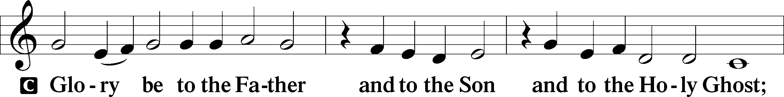
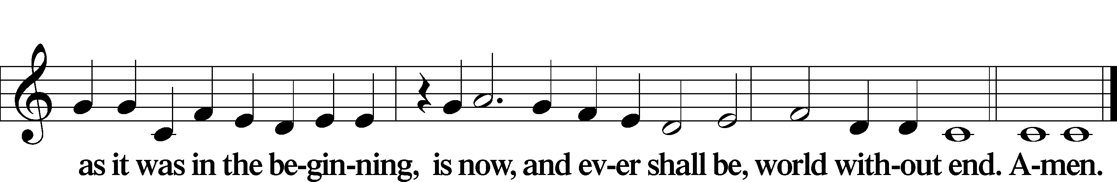

Kyrie Mark 10:47
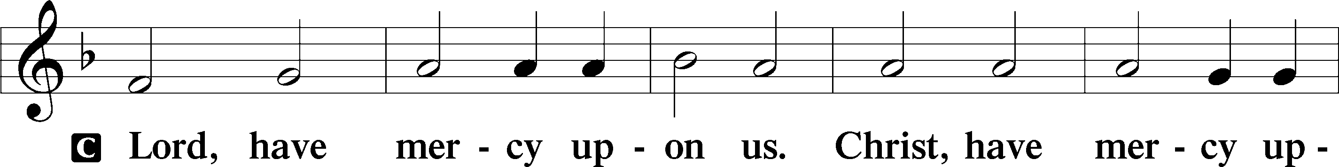
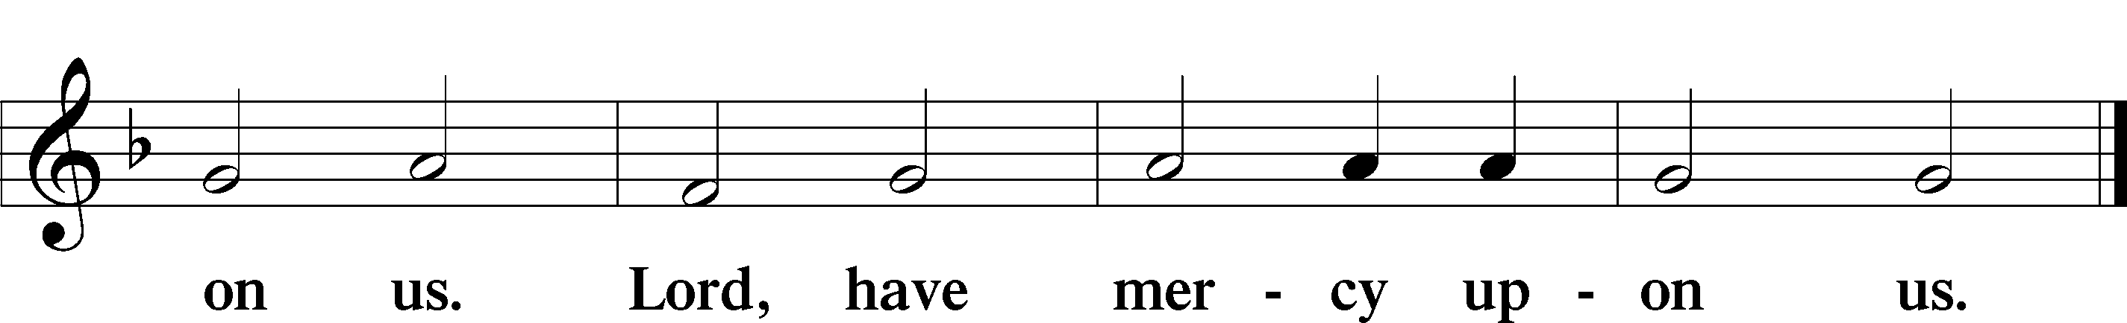

Gloria in Excelsis Luke 2:14; John 1:29
P Glory be to God on high:
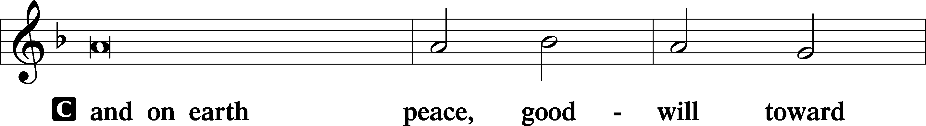
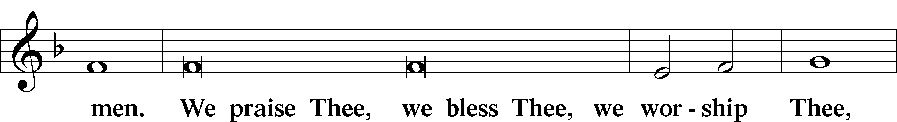
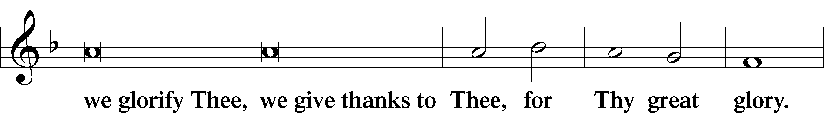
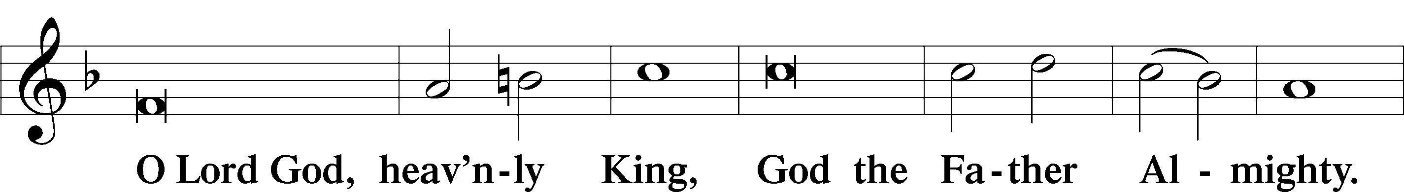
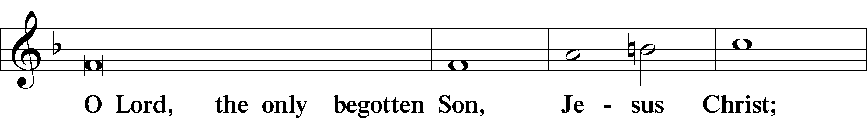
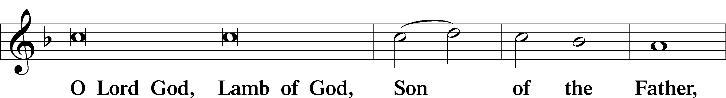
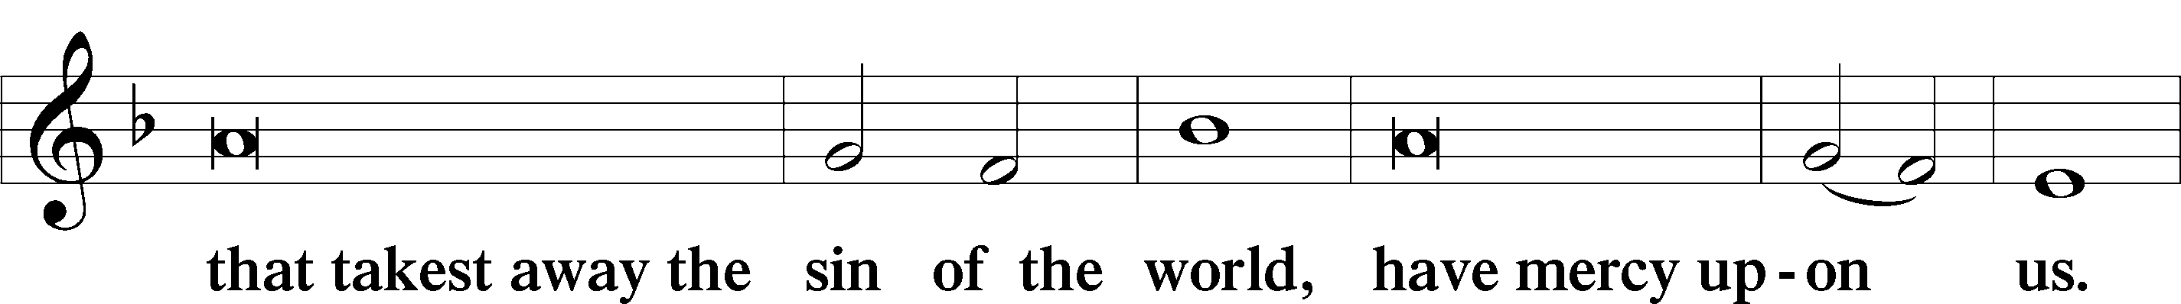
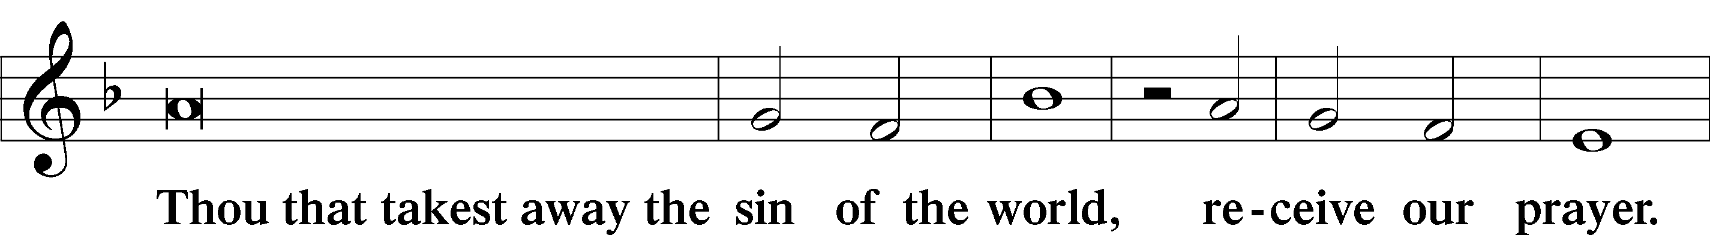
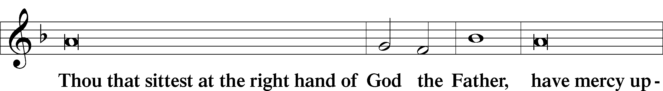
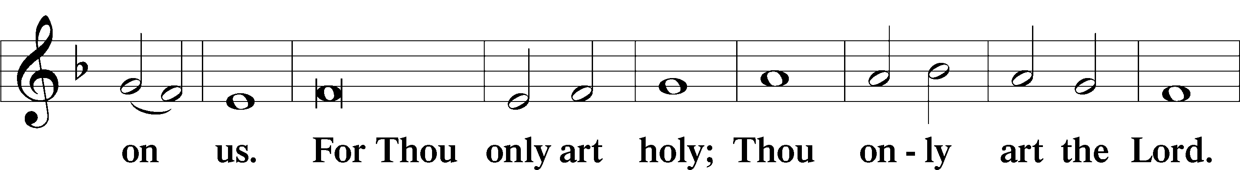
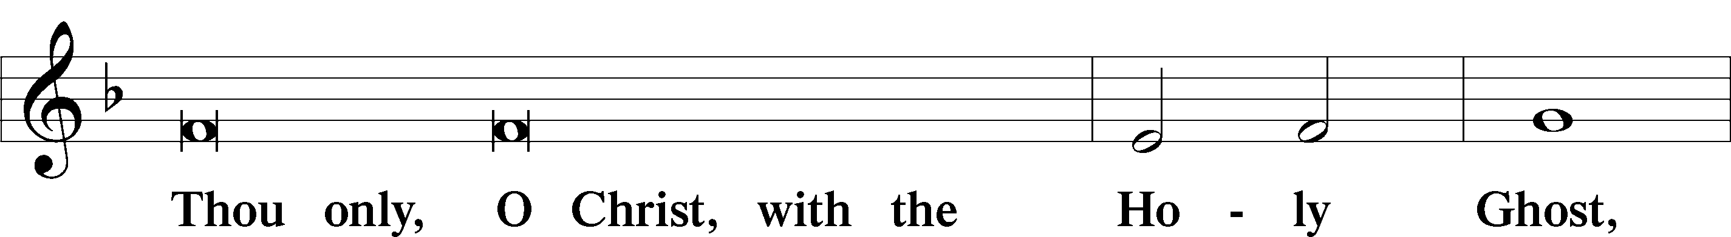
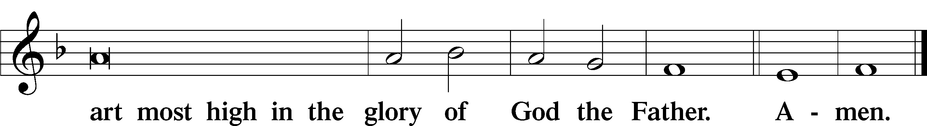

Salutation and Collect of the Day: Transfiguration
P The Lord be with you.
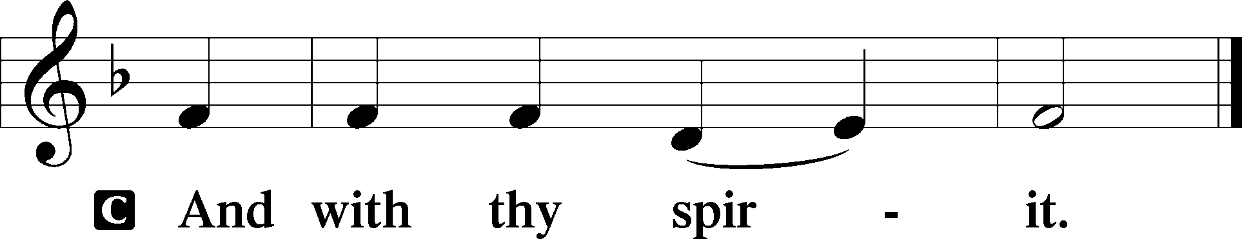

P Let us pray.
O God, in the glorious transfiguration of Your beloved Son You confirmed the mysteries of the faith by the testimony of Moses and Elijah. In the voice that came from the bright cloud You wonderfully foreshowed our adoption by grace. Mercifully make us co-heirs with the King in His glory and bring us to the fullness of our inheritance in heaven; through the same Jesus Christ, our Lord, who lives and reigns with You and the Holy Spirit, one God, now and forever.
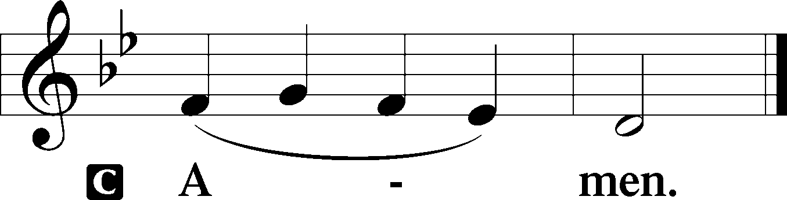
Sit

Prophecy: Exodus 34:29–35 (NKJV)
In those days: When Moses came down from Mount Sinai (and the two tablets of the Testimony were in Moses’ hand when he came down from the mountain), Moses did not know that the skin of his face shone while he talked with Him. So when Aaron and all the children of Israel saw Moses, behold, the skin of his face shone, and they were afraid to come near him. Then Moses called to them, and Aaron and all the rulers of the congregation returned to him; and Moses talked with them. Afterward all the children of Israel came near, and he gave them as commandments all that the Lord had spoken with him on Mount Sinai. And when Moses had finished speaking with them, he put a veil on his face. But whenever Moses went in before the Lord to speak with Him, he would take the veil off until he came out; and he would come out and speak to the children of Israel whatever he had been commanded. And whenever the children of Israel saw the face of Moses, that the skin of Moses’ face shone, then Moses would put the veil on his face again, until he went in to speak with Him.

P This is the Word of the Lord.
C Thanks be to God.

Gradual Psalm 45:2a; 110:1
You are the most handsome of the | sons of men;*
grace is poured up- | on your lips.
The Lord says to my Lord: “Sit at my | right hand,*
until I make your enemies your | footstool.”

Epistle: 2 Peter 1:16–21 (NKJV)
Dearly Beloved: We did not follow cunningly devised fables when we made known to you the power and coming of our Lord Jesus Christ, but were eyewitnesses of His majesty. For He received from God the Father honor and glory when such a voice came to Him from the Excellent Glory: “This is My beloved Son, in whom I am well pleased.” And we heard this voice which came from heaven when we were with Him on the holy mountain. And so we have the prophetic word confirmed, which you do well to heed as a light that shines in a dark place, until the day dawns and the morning star rises in your hearts; knowing this first, that no prophecy of Scripture is of any private interpretation, for prophecy never came by the will of man, but holy men of God spoke as they were moved by the Holy Spirit.

P This is the Word of the Lord.
C Thanks be to God.

Stand

Verse Psalm 96:2–3
Alleluia. Sing to the Lord; tell of his salvation from day to day. Declare his glory among the nations, his marvelous works among all the peoples! Alleluia.

Alleluia
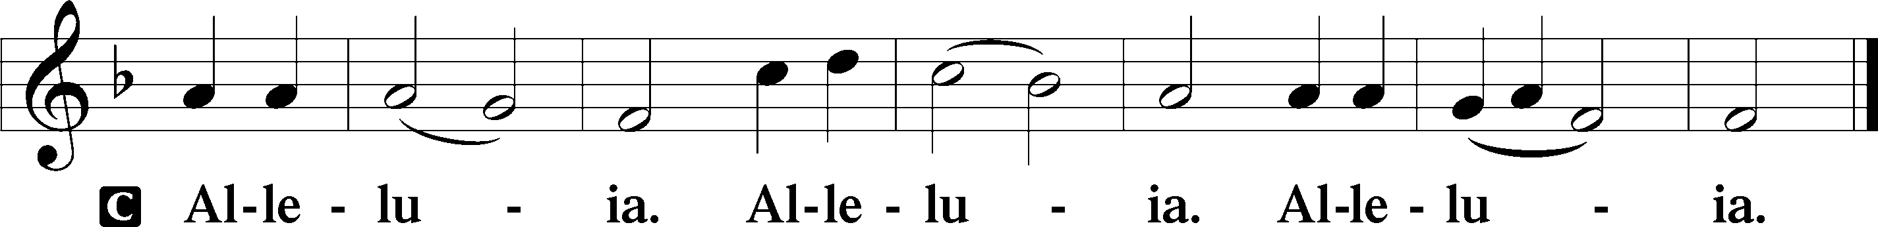

Holy Gospel: Matthew 17:1–9 (NKJV)
P The Holy Gospel according to St. Matthew, the seventeenth chapter.
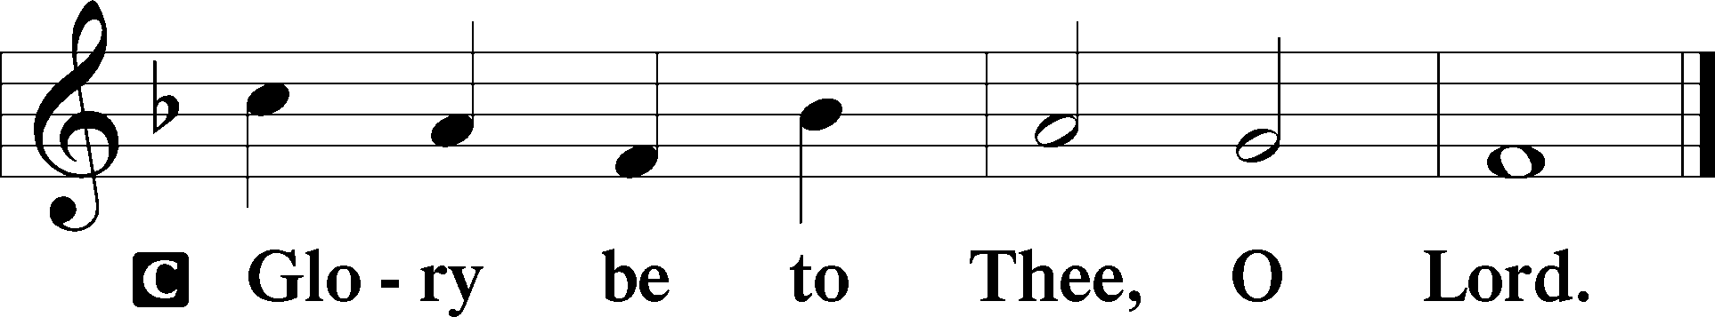

At that time: Jesus took Peter, James, and John his brother, led them up on a high mountain by themselves; and He was transfigured before them. His face shone like the sun, and His clothes became as white as the light. And behold, Moses and Elijah appeared to them, talking with Him. Then Peter answered and said to Jesus, “Lord, it is good for us to be here; if You wish, let us make here three tabernacles: one for You, one for Moses, and one for Elijah.” While he was still speaking, behold, a bright cloud overshadowed them; and suddenly a voice came out of the cloud, saying, “This is My beloved Son, in whom I am well pleased. Hear Him!” And when the disciples heard it, they fell on their faces and were greatly afraid. But Jesus came and touched them and said, “Arise, and do not be afraid.” When they had lifted up their eyes, they saw no one but Jesus only. Now as they came down from the mountain, Jesus commanded them, saying, “Tell the vision to no one until the Son of Man is risen from the dead.”

P This is the Gospel of the Lord.
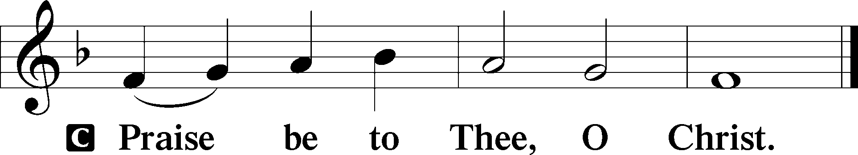

Nicene Creed
C I believe in one God,
the Father Almighty,
maker of heaven and earth
and of all things visible and invisible.

And in one Lord Jesus Christ,
the only-begotten Son of God,
begotten of His Father before all worlds,
God of God, Light of Light,
very God of very God,
begotten, not made,
being of one substance with the Father,
by whom all things were made;
who for us men and for our salvation came down from heaven
and was incarnate by the Holy Spirit of the virgin Mary
and was made man;
and was crucified also for us under Pontius Pilate.
He suffered and was buried.
And the third day He rose again according to the Scriptures
and ascended into heaven
and sits at the right hand of the Father.
And He will come again with glory to judge both the living and the dead,
whose kingdom will have no end.

And I believe in the Holy Spirit,
the Lord and giver of life,
who proceeds from the Father and the Son,
who with the Father and the Son together is worshiped and glorified,
who spoke by the prophets.
And I believe in one holy Christian and apostolic Church,
I acknowledge one Baptism for the remission of sins,
and I look for the resurrection of the dead
and the life T of the world to come. Amen.
Sit

Hymn of the Day: LSB #413 “O Wondrous Type! O Vision Fair”

Sermon

Stand

Prayer of the Church

Offertory Psalm 51:10–12
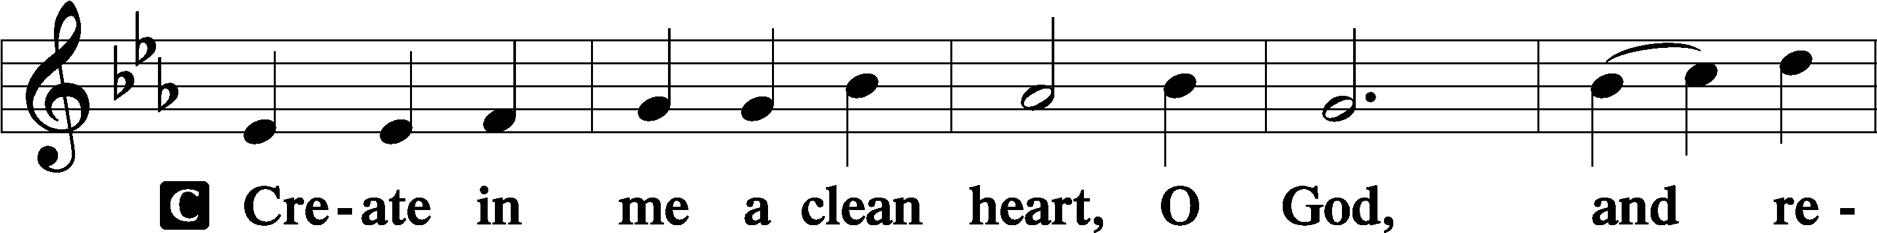
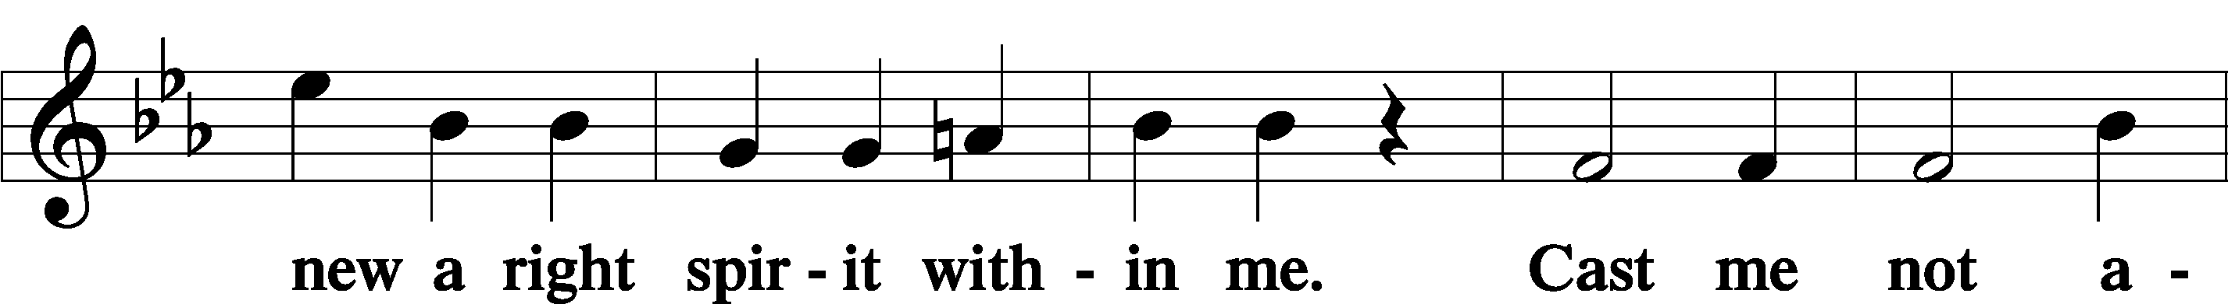
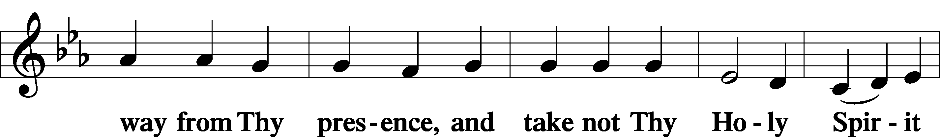
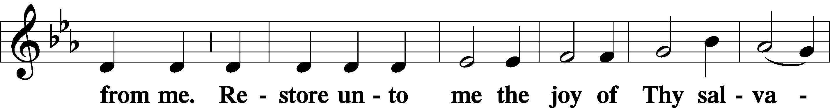
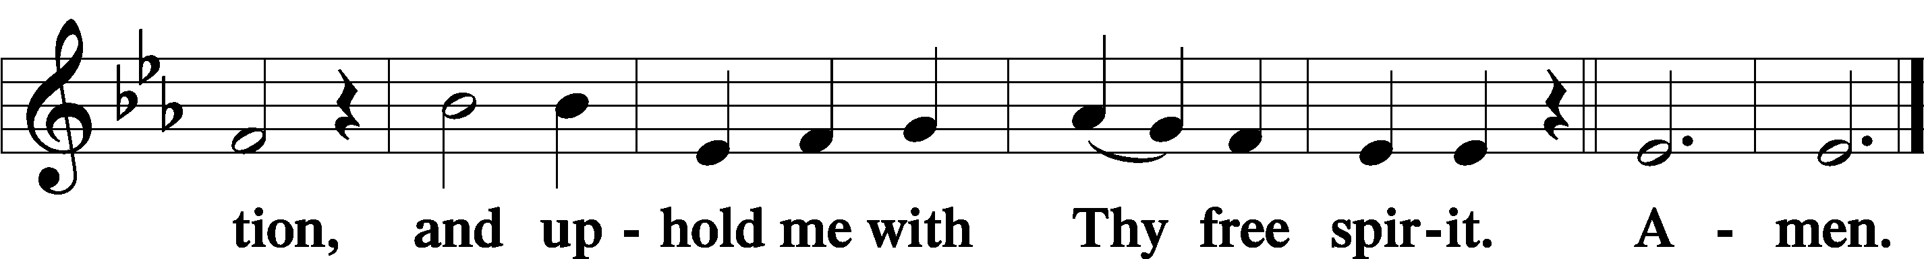
Sit

Preparatory Hymn: LSB #414 “’Tis Good, Lord, to Be Here”

Stand
Service of the Sacrament

Preface 2 Timothy 4:22; Colossians 3:1 Psalm 136
P The Lord be with you.

P Lift up your hearts.
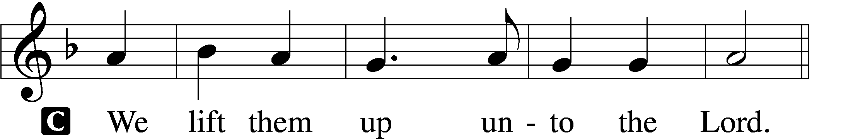

P Let us give thanks unto the Lord, our God.
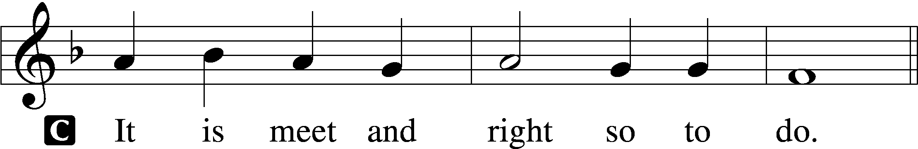

Proper Preface (Abbreviated) LSB 194
P It is truly meet, right, and salutary . . . evermore praising You and saying:

Sanctus Isaiah 6:3; Matthew 21:9
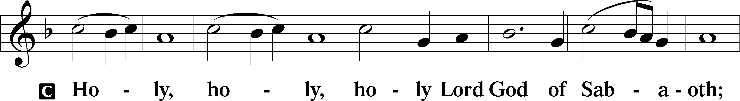
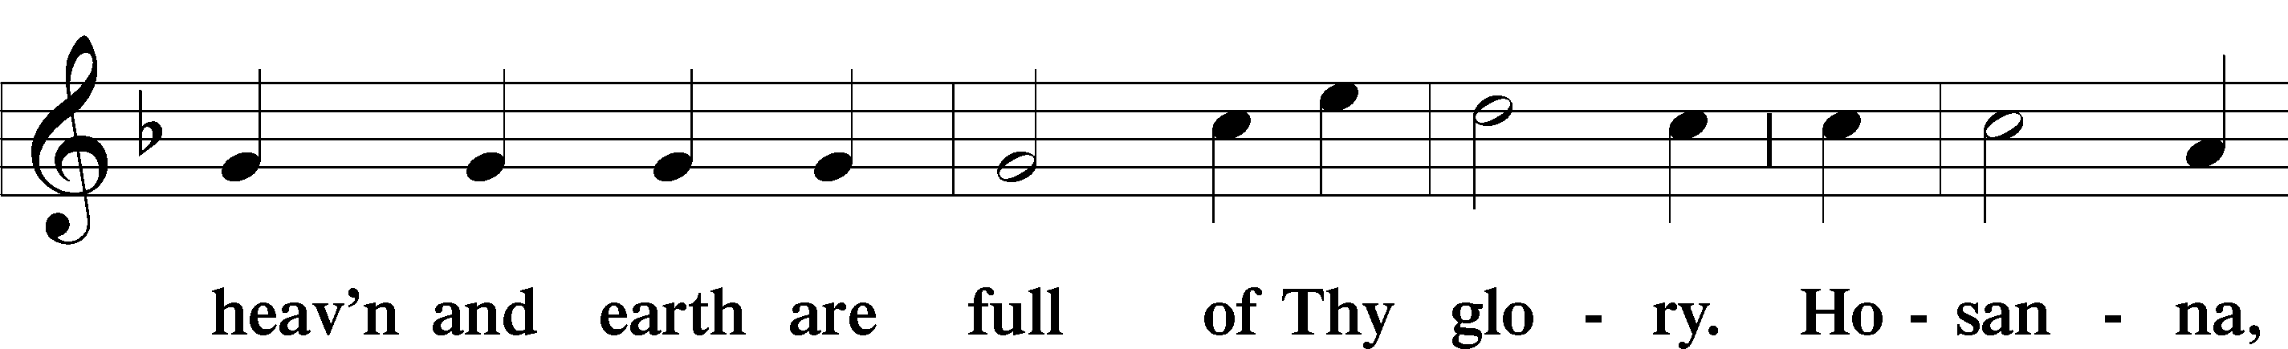
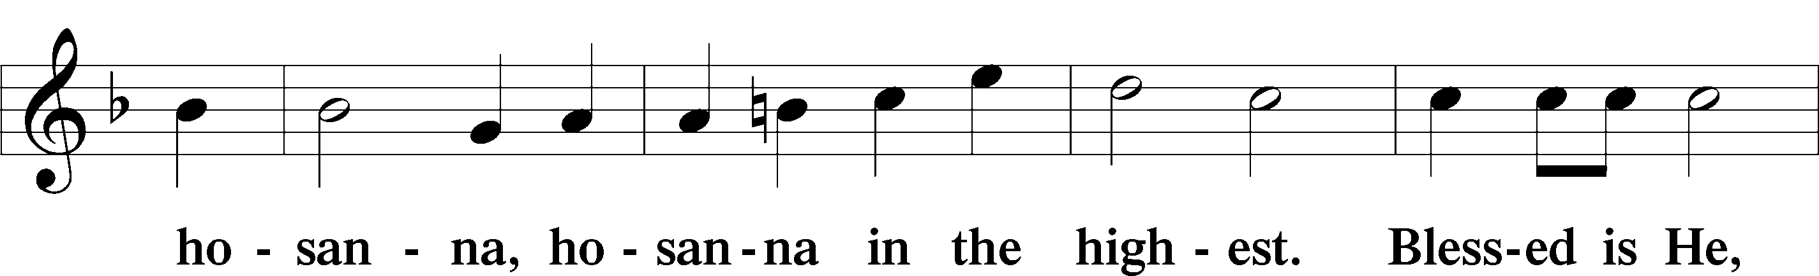
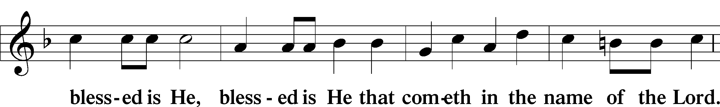
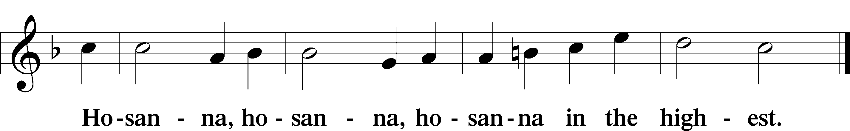

Lord’s Prayer Matthew 6:9–13
C Our Father who art in heaven,
hallowed be Thy name,
Thy kingdom come,
Thy will be done on earth as it is in heaven;
give us this day our daily bread;
and forgive us our trespasses as we forgive those who trespass against us;
and lead us not into temptation,
but deliver us from evil.
For Thine is the kingdom and the power and the glory forever and ever. Amen.

The Words of Our Lord Matthew 26:26–28; Mark 14:22–24; Luke 22:19–20; 1 Corinthians 11:23–25
P Our Lord Jesus Christ, on the night when He was betrayed, took bread, and when He had given thanks, He broke it and gave it to the disciples and said: “Take, eat; this is My T body, which is given for you. This do in remembrance of Me.”

In the same way also He took the cup after supper, and when He had given thanks, He gave it to them, saying: “Drink of it, all of you; this cup is the new testament in My T blood, which is shed for you for the forgiveness of sins. This do, as often as you drink it, in remembrance of Me.”

Pax Domini John 20:19
P The peace of the Lord be with you always.
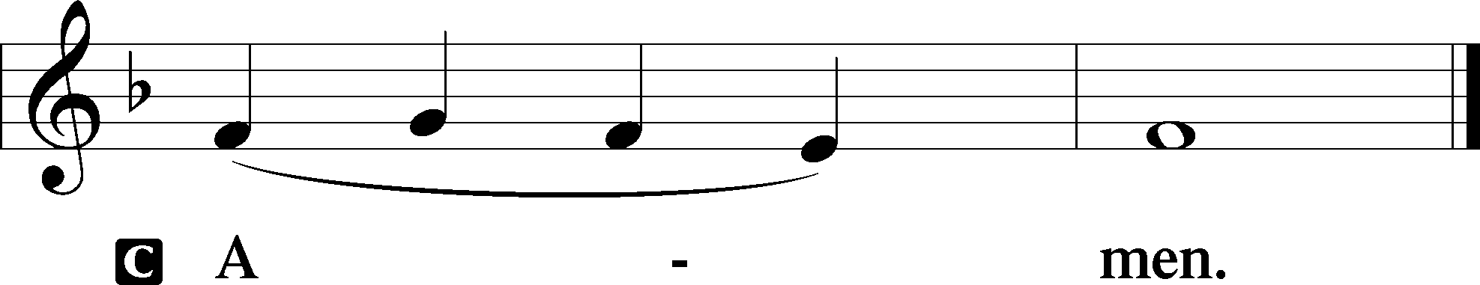

Agnus Dei John 1:29
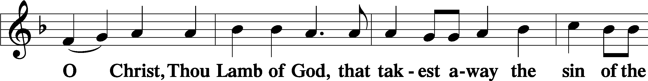
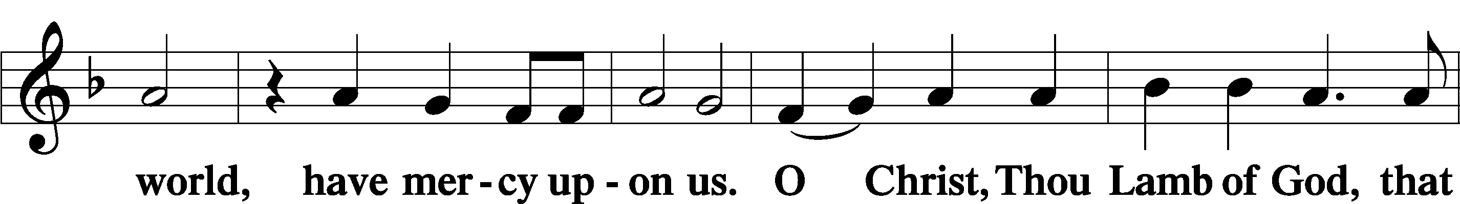
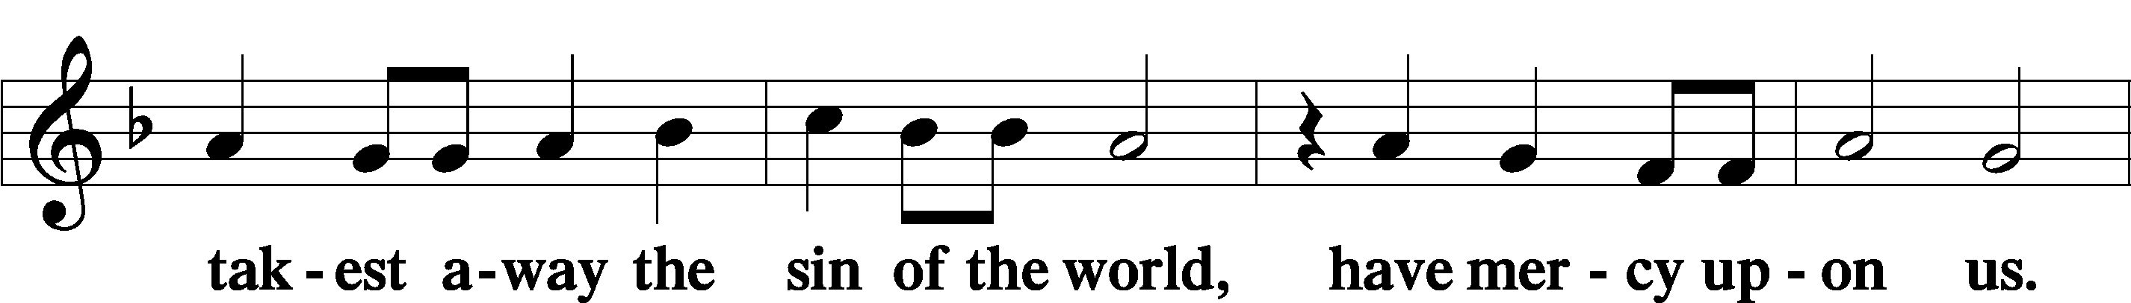
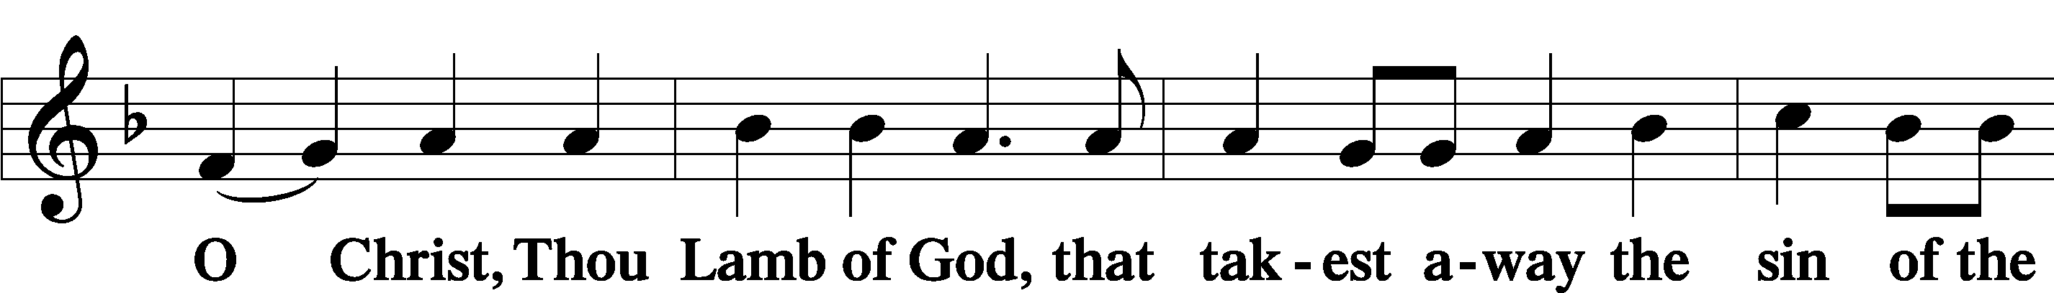
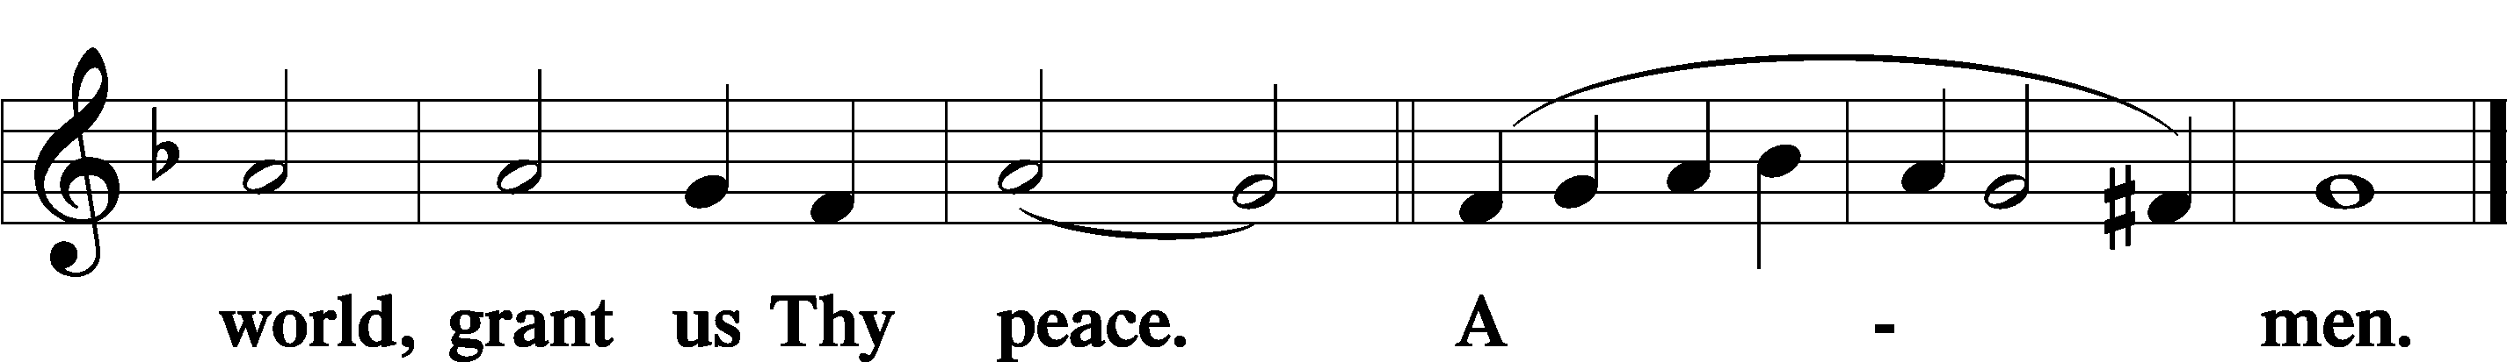
Sit

Distribution
The pastor and those who assist him receive the body and blood of Christ first and then distribute them to those who come to receive, saying:
Take, eat; this is the true body of our Lord and Savior Jesus Christ, given into death for your sins.
Amen.

Take, drink; this is the true blood of our Lord and Savior Jesus Christ, shed for the forgiveness of your sins.
Amen.

In dismissing the communicants, the following is said:
The Dismissal
P The body and blood of our Lord Jesus Christ strengthen and preserve you in body and soul to life everlasting. Depart T in peace.
C Amen.

Distribution Hymn: LSB #873 “Christ, Whose Glory Fills the Skies”

Distribution Hymn: LSB #639 “Wide Open Stand the Gates”

Distribution Hymn: LSB #874 “O Splendor of God’s Glory Bright”

Stand
Nunc Dimittis Luke 2:29–32
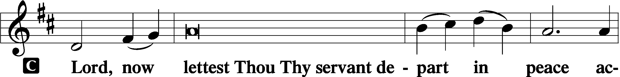
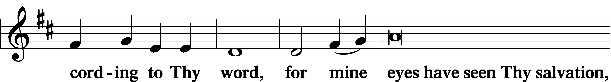
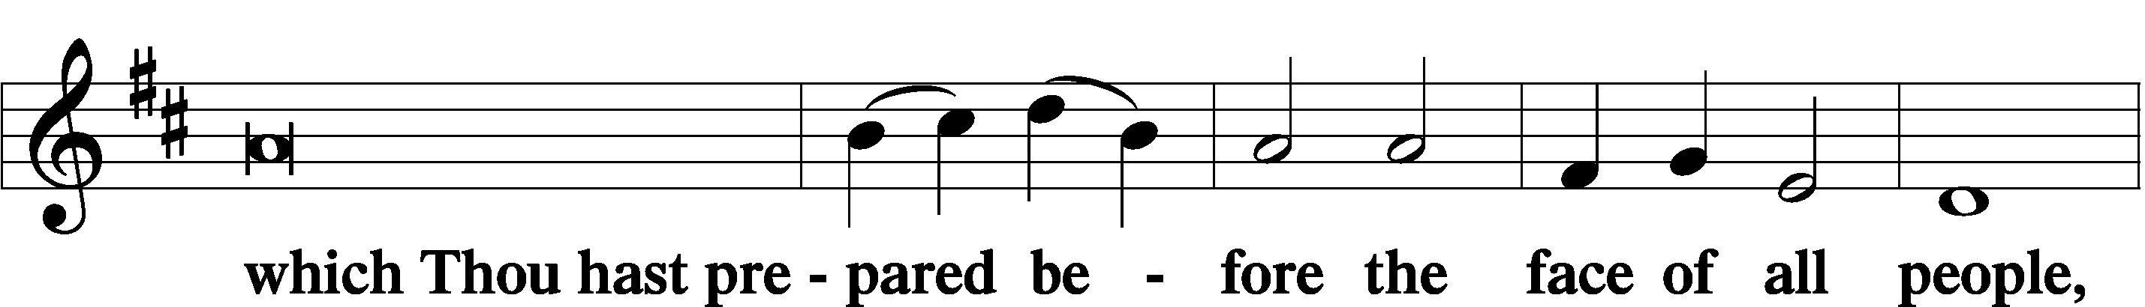
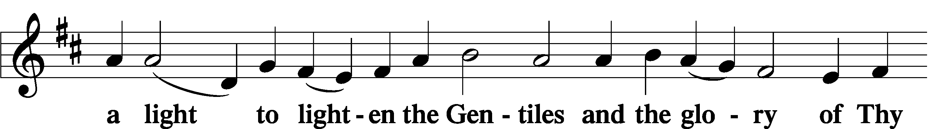
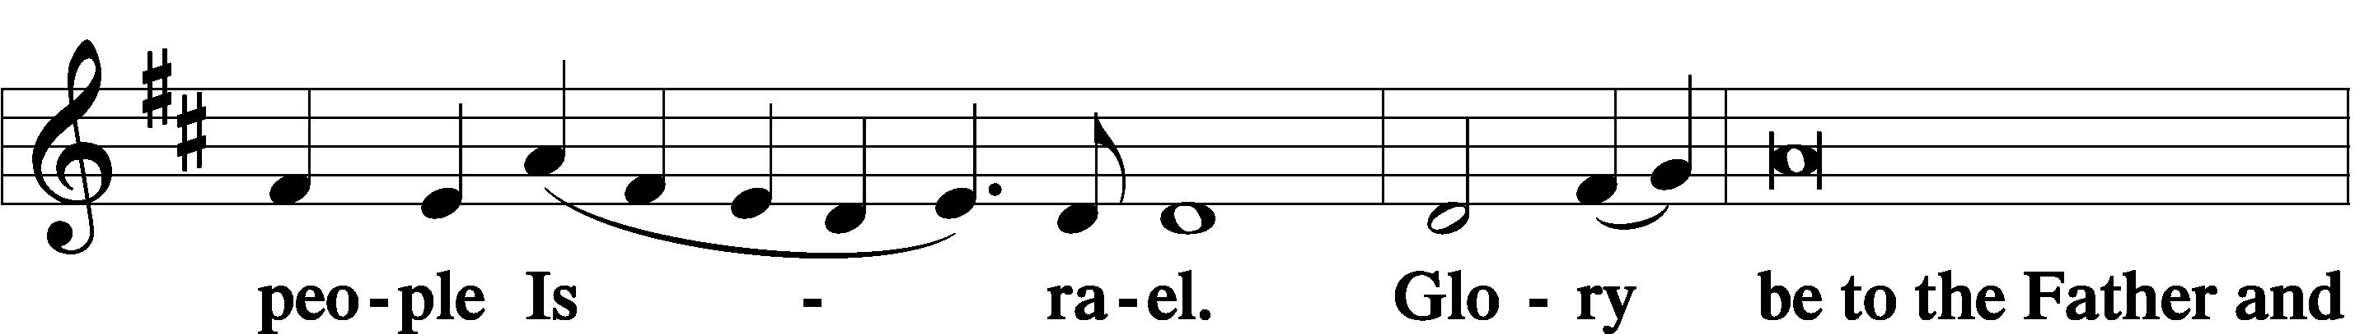
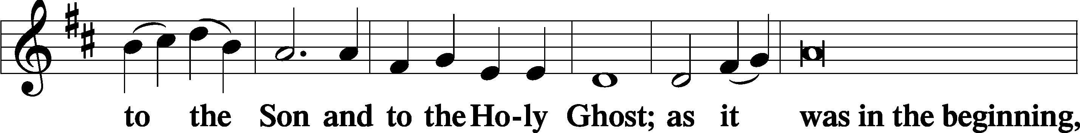
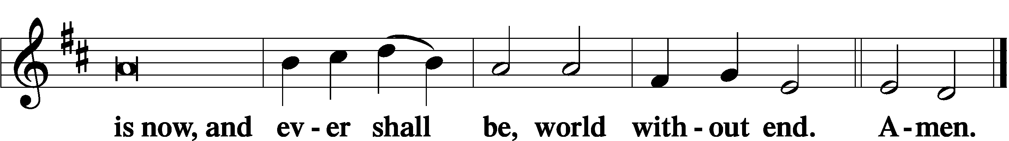

Thanksgiving Psalm 107:1
P O give thanks unto the Lord, for He is good,
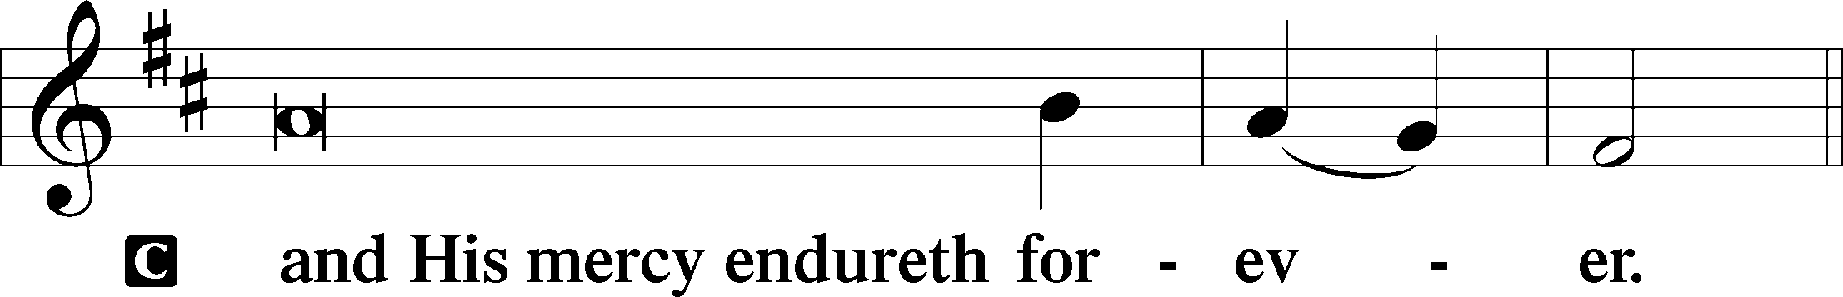

Post-Communion Collect
P Let us pray.
We give thanks to You, almighty God, that You have refreshed us through this salutary gift, and we implore You that of Your mercy You would strengthen us through the same in faith toward You and in fervent love toward one another; through Jesus Christ, Your Son, our Lord, who lives and reigns with You and the Holy Spirit, one God, now and forever.
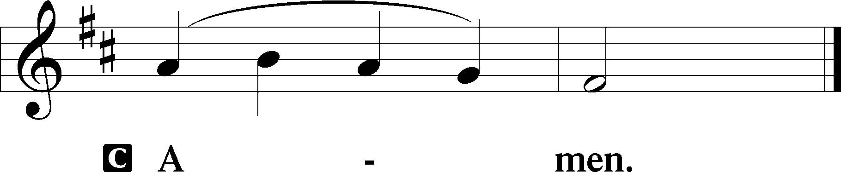

Salutation 2 Timothy 4:22
P The Lord be with you.
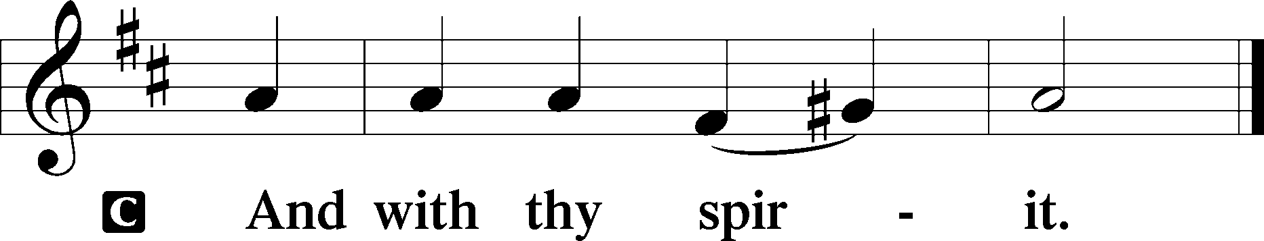

Benedicamus Psalm 103:1
P Bless we the Lord.
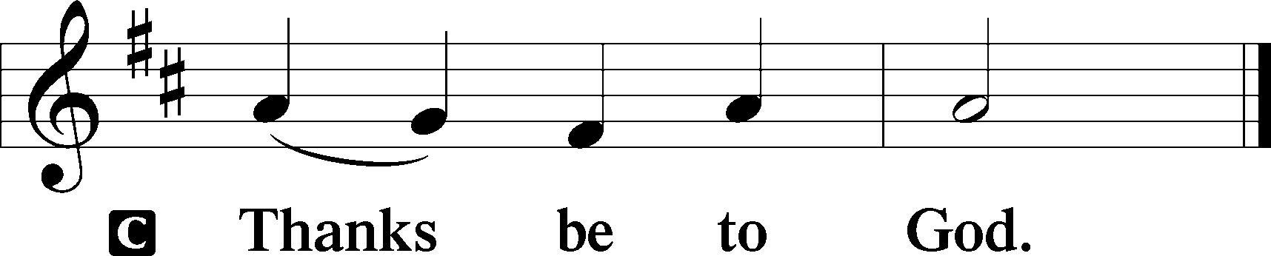
Benediction Numbers 6:24–26
P The Lord bless you and keep you.
The Lord make His face shine upon you and be gracious unto you.
The Lord lift up His countenance upon you and T give you peace.
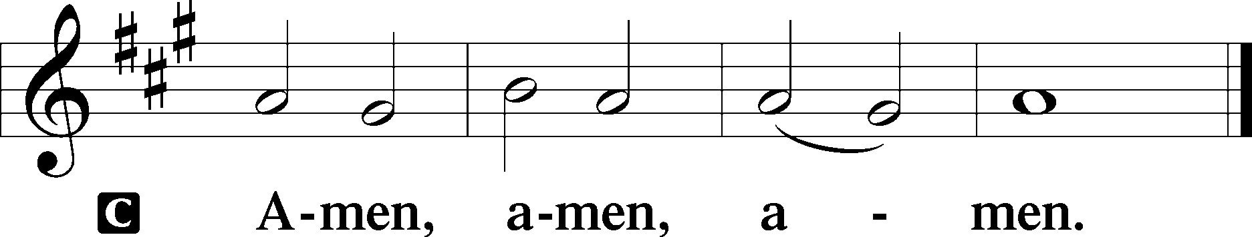

Closing Hymn: LSB #417 “Alleluia, Song of Gladness”

Silent prayer after worship: O gracious God, as I leave this worship service, cause Your holy word to continually live in my heart, and lead me to share Your word with others so they may also know the power of Your love. In Jesus’ name. Amen.
fffffffffffffffffffffffffffffffffff
Acknowledgments: Unless otherwise indicated, Scripture quotations are from the ESV® Bible (The Holy Bible, English Standard Version®), copyright © 2001 by Crossway, a publishing ministry of Good News Publishers. Used by permission. All rights reserved.
Created by Lutheran Service Builder © 2021 Concordia Publishing House.
fffffffffffffffffffffffffffffffffff
fffffffffffffffffffffffffffffffffff
In Loving Memory of Bob Sulek: Mr. & Mrs. Joseph Chlpka and Diane Riefstahl.
In Loving Memory of Husband, Robert Sulek: Edeltraud Sulek (Capital Campaign and Food Pantry).
fffffffffffffffffffffffffffffffffff
Our Stewardship of Treasures for the Lord:
In order to do the Lord’s work, we need $2,553.63 each week to meet our 2023 budget for general purposes and $76.92 for the SELC.
Figures for Sunday, January 15, 2023
General Fund: $2,420.00 Behind for the week: -$133.63
SELC: $120.00 Ahead for the week: +$43.08
Food Pantry: $100.00
1st Quarter Missions: $70.00
Capital Campaign: $75.00
Other: $350.00

For online giving, check out https://www.saintspeterandpaul.net/online-giving.
SCHEDULE THROUGH FEBRUARY 5, 2023:

:

Today, following Worship, Fellowship Hall: Financial Committee Meeting
7 pm, Fellowship Hall: AA Meeting
Monday, 7 pm, Fellowship Hall: Church Council Meeting
Tuesday, 7-9 pm, Fellowship Hall: Penn-Ohio Singers
Wednesday, 7:30 pm, Fellowship Hall: NA Meeting
Thursday, 7 pm, Sanctuary: Vespers Service
Next Sunday, 8 am, Fellowship Hall: Bible Study
9 am, Sanctuary: Divine Service
7 pm, Fellowship Hall: AA Meeting
fffffffffffffffffffffffffffffffffff Remember the following in Prayer…
~The Hurting and Healing: Amy, Gerald Arthur, Evelyn Baisch, Ellen Baron^{CA}, Lois Bortner^{CA}, John Burdette, Bev & Joe Chlpka, Kathleen Coughenour, Kim, Anna Mae Daris, Susan Davies, Tim Dudash, Millie Elavsky, Joseph Fleet, Judith & Eddy Furey, Tim Haenftling, Austin Hamilton, Anson Holcroft, Neil Huston, Darla Krajci, Barbara Kreske, Michelle Kelly^{CA}, Donna Kennedy, Gerald Krivosh, Jess Lavoie, Paul Lucas^{CA}, Sandy Marshall, Ernie Meszaros, David Nelson, Linda Parkany, Juanita Rentschler, Richard Reuning^{CA}, Diane Riefstahl, Nancy Robertson^{CA}, Viola Sakony, Marty Scott, Kara, Fred Tonty, Angela Weser^{CA}, and Ruth Wolf.
~The Homebound: Rudy & Jean Tomko, Betty Wolf, and Ed & Millie Zachar.
~Celebrating: Birthday: Beverly Chlpka (02.04).
~Serving in the Military: Curtis Sinewe and Joshua Solyan.
~Community & World Needs: Those suffering from or affected by the coronavirus; those suffering due to the conflict between Ukraine and Russia; those suffering from loss and dislocation because weather disasters; those suffering from addiction and their families; Local, State, and National Government Leaders; safety for all Police Officers, Firefighters, & First Responders; the unemployed; our First Quarter Local Mission: Sts. Peter & Paul’s Community Day 2023.
*CA represents cancer.
fffffffffffffffffffffffffffffffffff
Attendance: Sunday, January 22, 2023: 34

Bible Memory Verses ~ Week of January 29th:
For Adults: I have been crucified with Christ. It is no longer I who live, but Christ who lives in me. And the life I now live in the flesh I live by faith in the Son of God, who loved me and gave himself for me. Galatians 2:20

For Children: God, who said, “Let light shine out of darkness,” has shone in our hearts to give the light of the knowledge of the glory of God in the face of Jesus Christ. 2 Corinthians 4:6
fffffffffffffffffffffffffffffffffff
Church Council Members are reminded of the meeting tomorrow evening, January 30th, beginning at 7 pm. Please email your reports to Diane by noon tomorrow so that packets can be prepared. Thank you!
fffffffffffffffffffffffffffffffffff
Sunday Bible Study has resumed! We are studying the 14 Minor Prophets. Please consider joining us each Sunday morning at 8 am!
fffffffffffffffffffffffffffffffffff
THANK YOU FOR SERVING IN JANUARY: Elder: Jonathan Baisch; Altarware: Marie Flaugher and Altar Guild Volunteers
fffffffffffffffffffffffffffffffffff
THANK YOU FOR SERVING IN FEBRUARY: Elder: Jonathan Baisch; Altarware: Marie Flaugher (prior) and Cheryl Fedele & Clara Krivosh (after).
fffffffffffffffffffffffffffffffffff
Stop by the Sonshine Room and check out some Christmas items which are no longer being used and are free for the taking. You just might find something you can use!
fffffffffffffffffffffffffffffffffff
MARK YOUR CALENDAR! There will be a Vespers Service this Thursday, February 2nd at 7 pm celebrating the Purification of Mary and the Presentation of Our Lord. Please join us!
fffffffffffffffffffffffffffffffffff
SCRIP ORDERS AND PAYMENTS for February will be due next Sunday, February 5th. Forms are available both in the narthex and on the sign-in table next to Pastor Deal’s office. SCRIP is a wonderful way to support your church at no personal expense to yourself. You will receive the full-value of gift cards purchased. Speak with Matt Berent if you should have any questions about the prog
Here to Serve

Pastor………………………………………………...……………Rev. Jacob Deal
E-mail …………………………….……pastordeal@saintspeterandpaul.net
Phone Number……………………..…………………724-347-3620 (Option 2)
Church Office………………………..…………………724-347-3620 (Option 3)
Website …………………………………………www.saintspeterandpaul.net
Secretary…………………………………………………………Diane Riefstahl
E-mail ………………………………………church@saintspeterandpaul.net
Website …………………………………………www.saintspeterandpaul.net
Food Pantry: Please leave message……………724-347-3620 (Option 3)
AA Contact: Steve………………………………………………..…724-813-2358
NA Contact: Larry………………………………………………..724-977-8733
Choir Director………………………………………………………Chris Nelson
Congregation President……………………………………Jonathan Baisch
Church Elder …………………………………………...…… Jonathan Baisch
fffffffffffffffffffffffffffffffffff
If needing to get into the church building during the week, please phone first to make certain someone is here to let you in.

