Sts. Peter & Paul
Evangelical Lutheran Church
Lutheran Church-Missouri Synod
Founded-1917

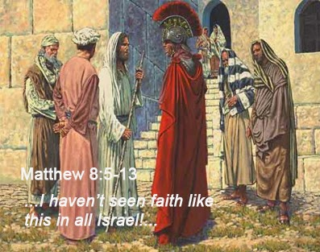

January 22, 2023

699 Stambaugh Avenue
Sharon, Pennsylvania 16146

“I was glad when they said to me,
Let us go to the house of the LORD!”
Psalm 122:1
Sts. Peter & Paul Evangelical Lutheran Church, LC-MS
THE THIRD SUNDAY AFTER EPIPHANY
January 22, 2023

A special welcome to our guests this day! If you would like more information about The Lutheran Church - Missouri Synod, or this congregation, please speak with Pastor Deal or an Elder after the service.
Members & Guests: Don’t be embarrassed if your children make noise during the worship service, all children do. We encourage families to worship together but, if you feel the need, there are pews in the rear of the Church which are reserved for young families on both sides of the sanctuary. There is also a quiet room available to you during our service which is located down the hallway past the offices on the right side of the church as well as a children’s area in the Fellowship Hall where you are able to follow along with the service.

Today’s service includes the Sacrament of Holy Communion. If during this past year, you have not worshipped with us and been communed, we respectfully ask that you do not partake of this sacrament this day before first speaking with Pastor Deal.
If visiting from a sister congregation of the LC-MS and are in good standing, please inform Pastor Deal of your desire to commune prior to the service.
If wishing to receive a blessing during communion, please approach with your arms crossed.

CONTACT INFORMATION
Pastor Deal: pastordeal@saintspeterandpaul.net or 724-347-3620 (opt. 2)
Church Office: church@saintspeterandpaul.net or 724-347-3620 (opt. 3)

Silent prayer before worship: Lord, lead me to worship You with my heart, soul, mind, and lips that I may give You glory and be a blessing to those who worship with me. Graciously accept my worship in Jesus’ name. Amen.

Confession and Absolution

Opening Hymn: LSB #810 “O God of God, O Light of Light”

Stand

The sign of the cross may be made by all in remembrance of their Baptism.

Invocation
P In the name of the Father and of the T Son and of the Holy Spirit.
C Amen.

Exhortation Hebrews 10:22; Psalm 124:8; Psalm 32:5
P Beloved in the Lord! Let us draw near with a true heart and confess our sins unto God our Father, beseeching Him in the name of our Lord Jesus Christ to grant us forgiveness.

P Our help is in the name of the Lord,
C who made heaven and earth.
P I said, I will confess my transgressions unto the Lord,
C and You forgave the iniquity of my sin.

Silence for reflection on God’s Word and for self-examination.

Confession of Sins
P O almighty God, merciful Father,
C I, a poor, miserable sinner, confess unto You all my sins and iniquities with which I have ever offended You and justly deserved Your temporal and eternal punishment. But I am heartily sorry for them and sincerely repent of them, and I pray You of Your boundless mercy and for the sake of the holy, innocent, bitter sufferings and death of Your beloved Son, Jesus Christ, to be gracious and merciful to me, a poor, sinful being.

Absolution [John 20:19–23]
P Upon this your confession, I, by virtue of my office, as a called and ordained servant of the Word, announce the grace of God unto all of you, and in the stead and by the command of my Lord Jesus Christ I forgive you all your sins in the name of the Father and of the T Son and of the Holy Spirit.
C Amen.

Service of the Word

Introit Psalm 97:1, 10–12; antiphon: vv. 6, 9
The heavens proclaim his | righteousness,*
and all the peoples see his | glory.
For you, O Lord, are most high over | all the earth;*
you are exalted far a- | bove all gods.
The Lord reigns, let the | earth rejoice;*
let the many coast- | lands be glad!
O you who love the Lord, hate | evil!*
He preserves the lives of his saints; he delivers them from the hand of the | wicked.
Light is sown for the | righteous,*
and joy for the up- | right in heart.
Rejoice in the Lord, O you | righteous,*
and give thanks to his | holy name!
The heavens proclaim his | righteousness,*
and all the peoples see his | glory.
For you, O Lord, are most high over | all the earth;*
you are exalted far a- | bove all gods.

Gloria Patri
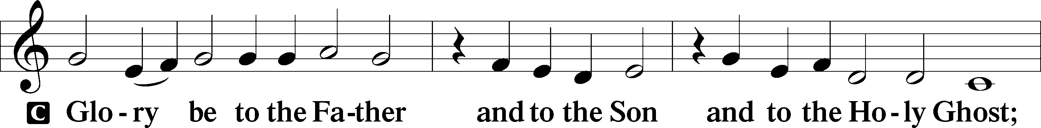
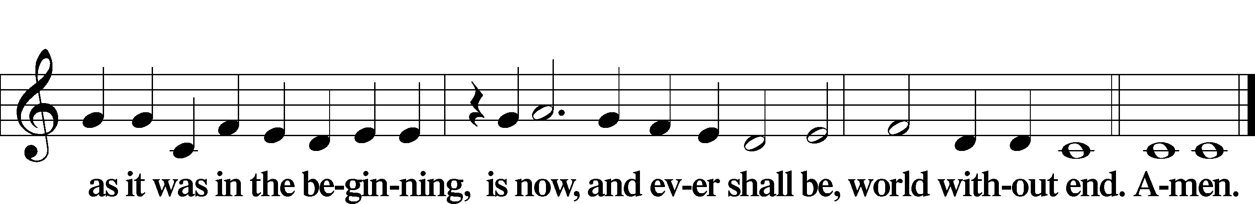

Kyrie Mark 10:47
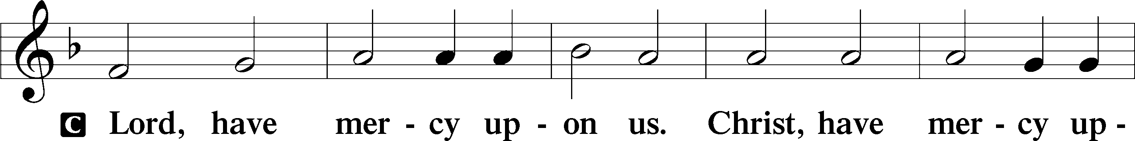
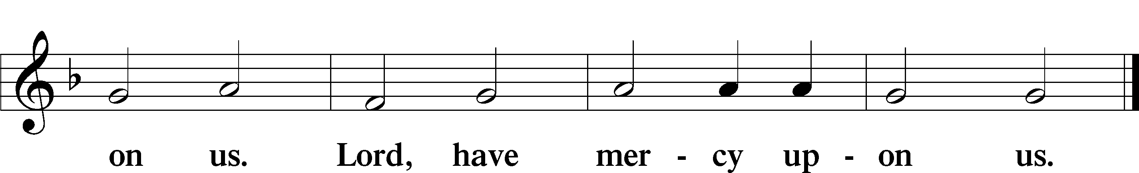

Gloria in Excelsis Luke 2:14; John 1:29
P Glory be to God on high:
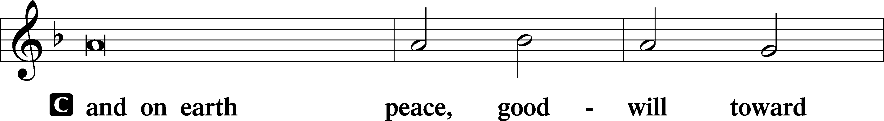
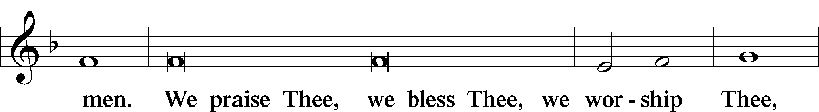
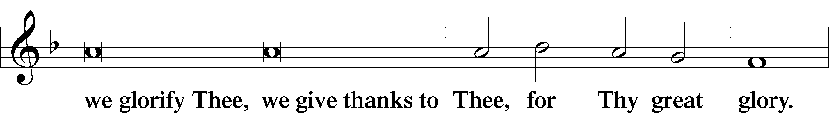
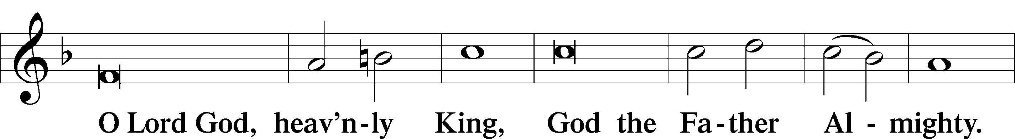
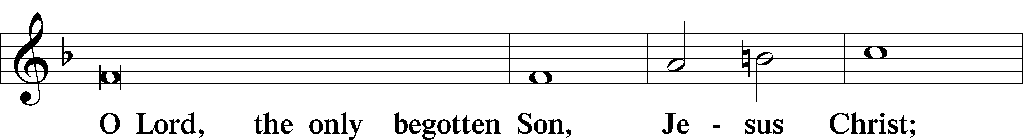
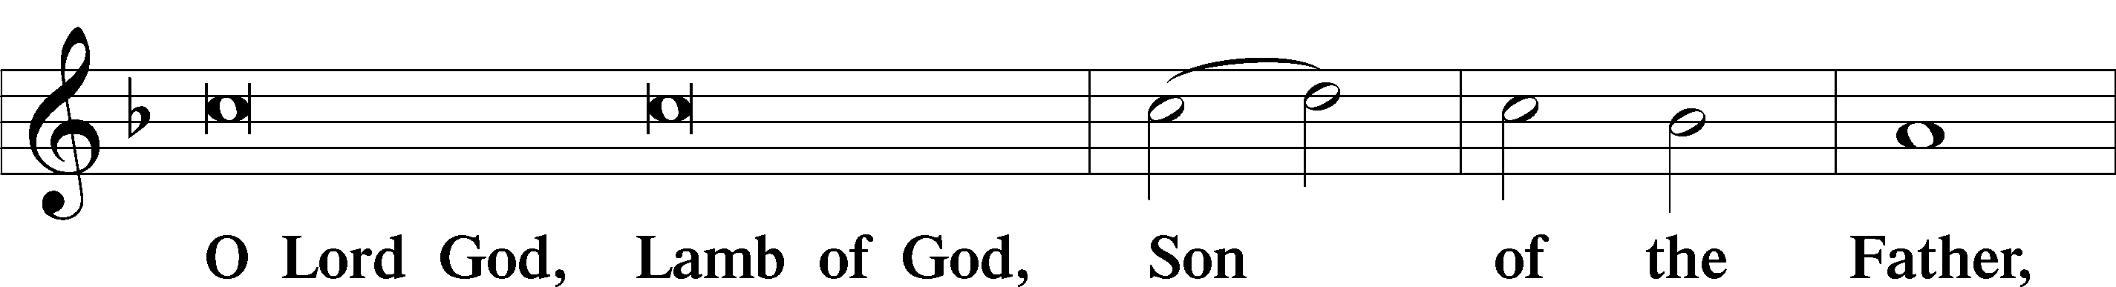
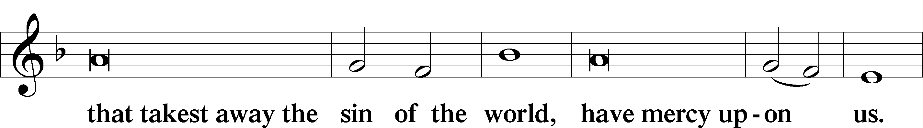
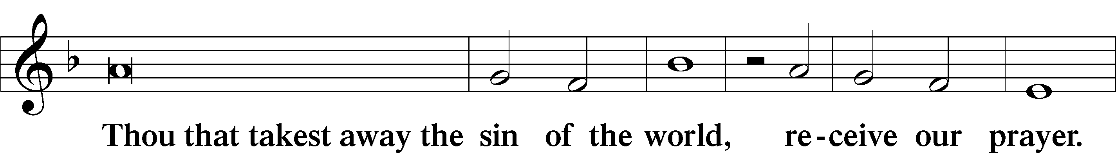
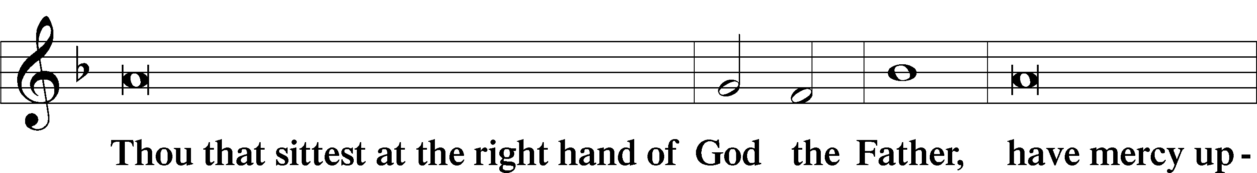
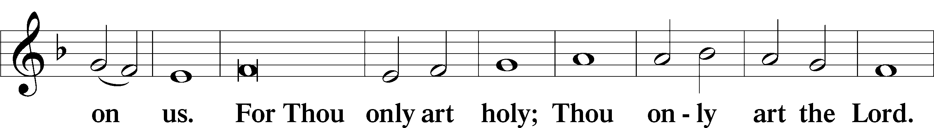
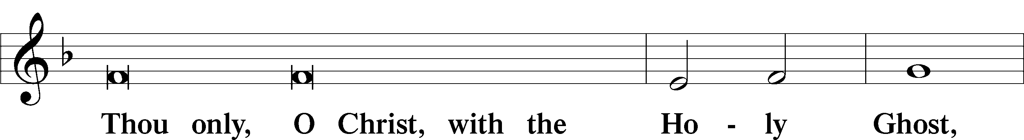
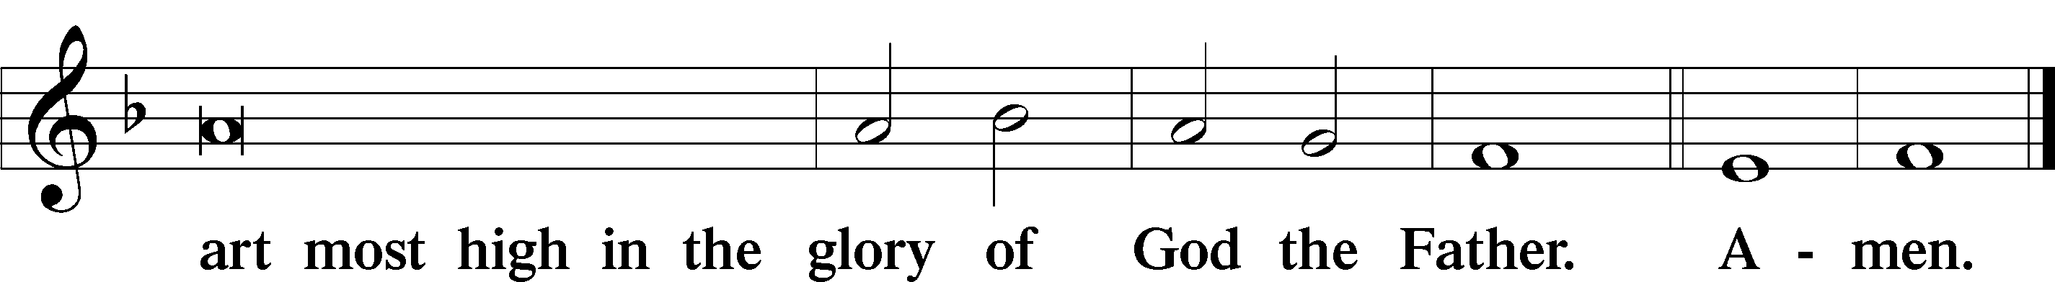

Salutation and Collect of the Day: Epiphany 3
P The Lord be with you.
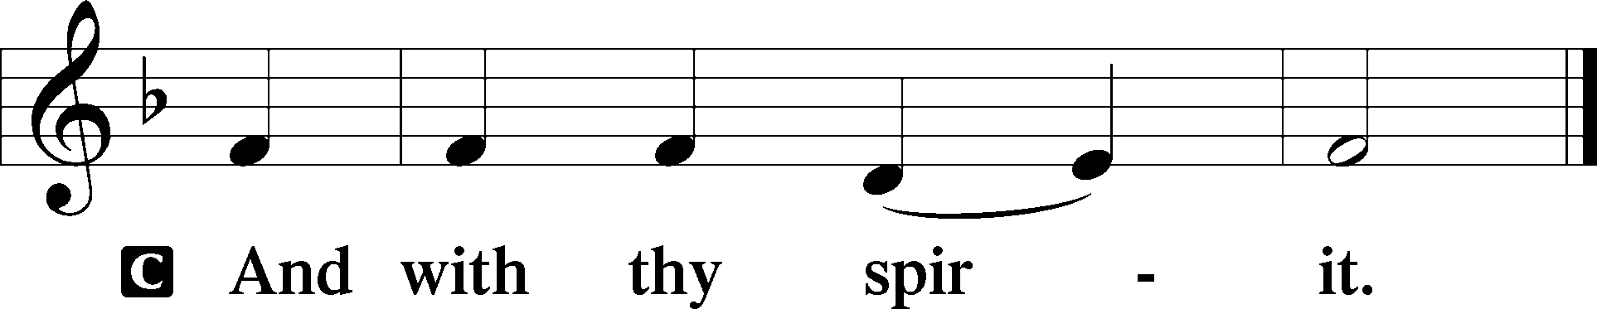

P Let us pray.
Almighty and everlasting God, mercifully look upon our infirmities and stretch forth the hand of Your majesty to heal and defend us; through Jesus Christ, Your Son, our Lord, who lives and reigns with You and the Holy Spirit, one God, now and forever.
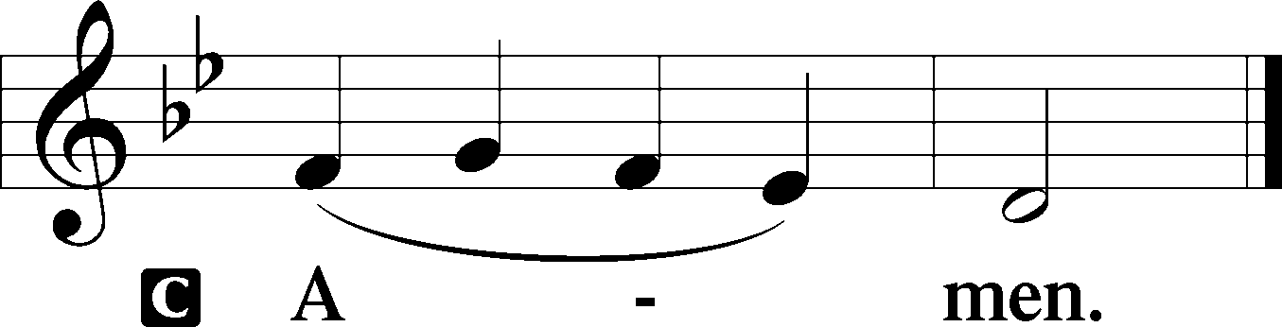
Sit

Prophecy: 2 Kings 5:1–15b (NKJV)
In those days: Naaman, commander of the army of the king of Syria, was a great and honorable man in the eyes of his master, because by him the Lord had given victory to Syria. He was also a mighty man of valor, but a leper. And the Syrians had gone out on raids, and had brought back captive a young girl from the land of Israel. She waited on Naaman’s wife. Then she said to her mistress, “If only my master were with the prophet who is in Samaria! For he would heal him of his leprosy.” And Naaman went in and told his master, saying, “Thus and thus said the girl who is from the land of Israel.” Then the king of Syria said, “Go now, and I will send a letter to the king of Israel.” So he departed and took with him ten talents of silver, six thousand shekels of gold, and ten changes of clothing. Then he brought the letter to the king of Israel, which said, Now be advised, when this letter comes to you, that I have sent Naaman my servant to you, that you may heal him of his leprosy. And it happened, when the king of Israel read the letter, that he tore his clothes and said, “Am I God, to kill and make alive, that this man sends a man to me to heal him of his leprosy? Therefore please consider, and see how he seeks a quarrel with me.” So it was, when Elisha the man of God heard that the king of Israel had torn his clothes, that he sent to the king, saying, “Why have you torn your clothes? Please let him come to me, and he shall know that there is a prophet in Israel.” Then Naaman went with his horses and chariot, and he stood at the door of Elisha’s house. And Elisha sent a messenger to him, saying, “Go and wash in the Jordan seven times, and your flesh shall be restored to you, and you shall be clean.” But Naaman became furious, and went away and said, “Indeed, I said to myself, ‘He will surely come out to me, and stand and call on the name of the Lord his God, and wave his hand over the place, and heal the leprosy.’ Are not the Abanah and the Pharpar, the rivers of Damascus, better than all the waters of Israel? Could I not wash in them and be clean?” So he turned and went away in a rage. And his servants came near and spoke to him, and said, “My father, if the prophet had told you to do something great, would you not have done it? How much more then, when he says to you, ‘Wash, and be clean’?” So he went down and dipped seven times in the Jordan, according to the saying of the man of God; and his flesh was restored like the flesh of a little child, and he was clean. And he returned to the man of God, he and all his aides, and came and stood before him; and he said, “Indeed, now I know that there is no God in all the earth, except in Israel.”

P This is the Word of the Lord.
C Thanks be to God.

Gradual Psalm 102:15–16
Nations will fear the name | of the Lord,*
and all the kings of the earth will fear your | glory.
For the Lord builds up | Zion;*
he appears in his | glory.

Epistle: Romans 12:16b–21 (NKJV)
Brethren: Do not be wise in your own opinion. Repay no one evil for evil. Have regard for good things in the sight of all men. If it is possible, as much as depends on you, live peaceably with all men. Beloved, do not avenge yourselves, but rather give place to wrath; for it is written, “Vengeance is Mine, I will repay,” says the Lord. Therefore “If your enemy is hungry, feed him; if he is thirsty, give him a drink; for in so doing you will heap coals of fire on his head.” Do not be overcome by evil, but overcome evil with good.

P This is the Word of the Lord.
C Thanks be to God.

Stand
Verse Psalm 97:1
Alleluia. The Lord reigns, let the earth rejoice; let the many coastlands be glad! Alleluia.

Alleluia
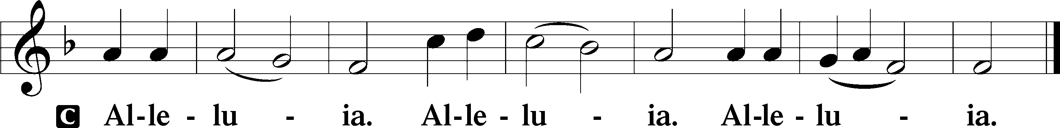

Holy Gospel: Matthew 8:1–13 (NKJV)
P The Holy Gospel according to St. Matthew, the eighth chapter.
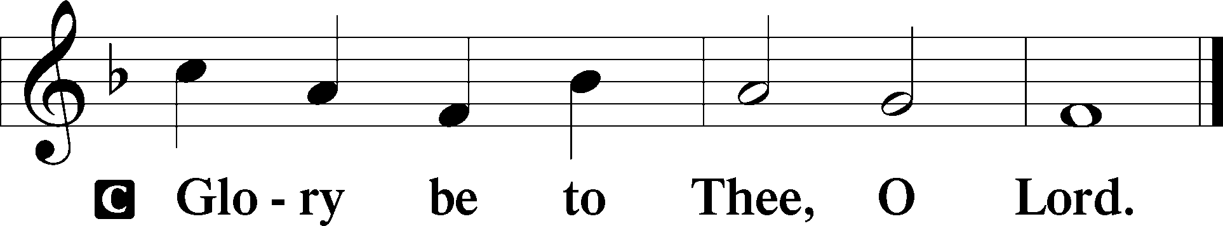

At that time: When Jesus had come down from the mountain, great multitudes followed Him. And behold, a leper came and worshiped Him, saying, “Lord, if You are willing, You can make me clean.” Then Jesus put out His hand and touched him, saying, “I am willing; be cleansed.” Immediately his leprosy was cleansed. And Jesus said to him, “See that you tell no one; but go your way, show yourself to the priest, and offer the gift that Moses commanded, as a testimony to them.” Now when Jesus had entered Capernaum, a centurion came to Him, pleading with Him, saying, “Lord, my servant is lying at home paralyzed, dreadfully tormented.” And Jesus said to him, “I will come and heal him.” The centurion answered and said, “Lord, I am not worthy that You should come under my roof. But only speak a word, and my servant will be healed. For I also am a man under authority, having soldiers under me. And I say to this one, ‘Go,’ and he goes; and to another, ‘Come,’ and he comes; and to my servant, ‘Do this,’ and he does it.” When Jesus heard it, He marveled, and said to those who followed, “Assuredly, I say to you, I have not found such great faith, not even in Israel! And I say to you that many will come from east and west, and sit down with Abraham, Isaac, and Jacob in the kingdom of heaven. But the sons of the kingdom will be cast out into outer darkness. There will be weeping and gnashing of teeth.” Then Jesus said to the centurion, “Go your way; and as you have believed, so let it be done for you.” And his servant was healed that same hour.

P This is the Gospel of the Lord.
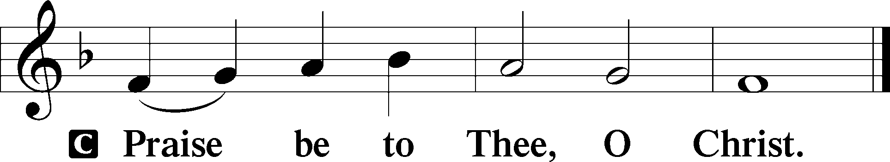

Nicene Creed
C I believe in one God,
the Father Almighty,
maker of heaven and earth
and of all things visible and invisible.

And in one Lord Jesus Christ,
the only-begotten Son of God,
begotten of His Father before all worlds,
God of God, Light of Light,
very God of very God,
begotten, not made,
being of one substance with the Father,
by whom all things were made;
who for us men and for our salvation came down from heaven
and was incarnate by the Holy Spirit of the virgin Mary
and was made man;
and was crucified also for us under Pontius Pilate.
He suffered and was buried.
And the third day He rose again according to the Scriptures
and ascended into heaven
and sits at the right hand of the Father.
And He will come again with glory to judge both the living and the dead,
whose kingdom will have no end.

And I believe in the Holy Spirit,
the Lord and giver of life,
who proceeds from the Father and the Son,
who with the Father and the Son together is worshiped and glorified,
who spoke by the prophets.
And I believe in one holy Christian and apostolic Church,
I acknowledge one Baptism for the remission of sins,
and I look for the resurrection of the dead
and the life T of the world to come. Amen.
Sit

Hymn of the Day: LSB #756 “Why Should Cross and Trial Grieve Me”

Sermon

Stand

Prayer of the Church

Offertory Psalm 51:10–12
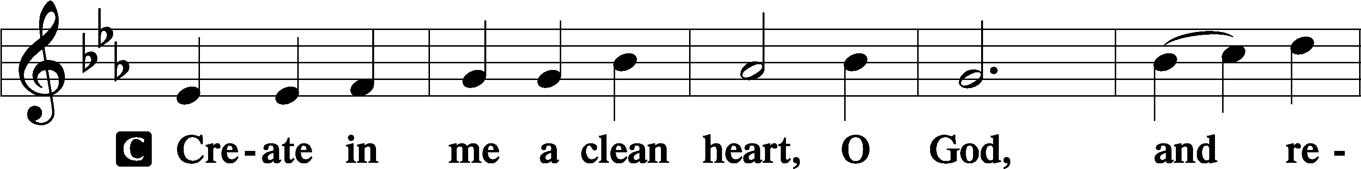
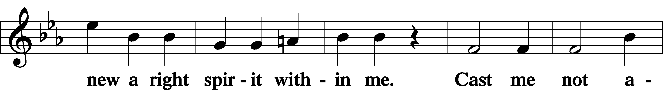
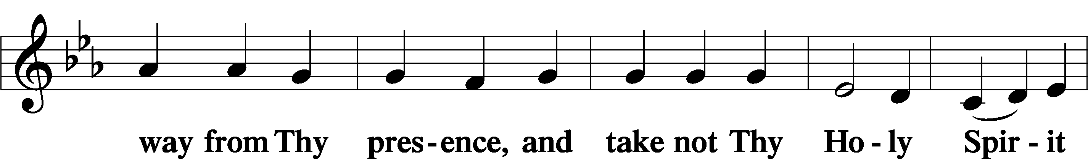
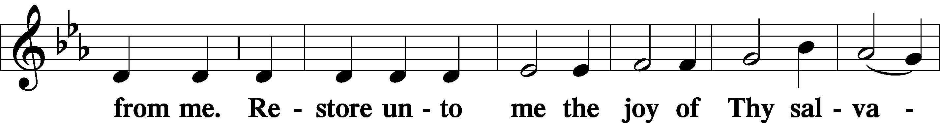
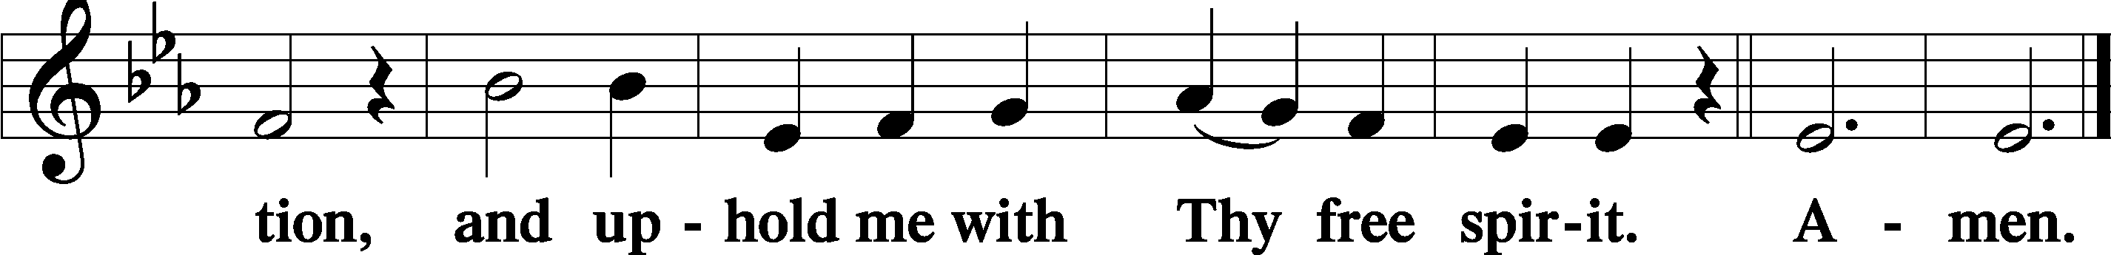
Sit
Preparatory Hymn: LSB #627 “Jesus Christ, Our Blessed Savior”

Stand
Service of the Sacrament

Preface 2 Timothy 4:22; Colossians 3:1 Psalm 136
P The Lord be with you.

P Lift up your hearts.
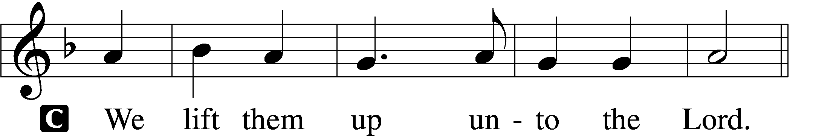

P Let us give thanks unto the Lord, our God.
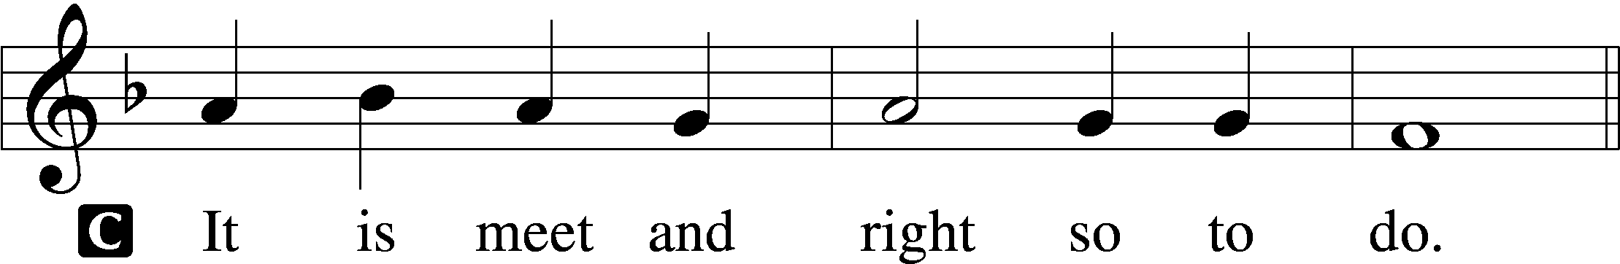

Proper Preface (Abbreviated) LSB 194
P It is truly meet, right, and salutary . . . evermore praising You and saying:

Sanctus Isaiah 6:3; Matthew 21:9
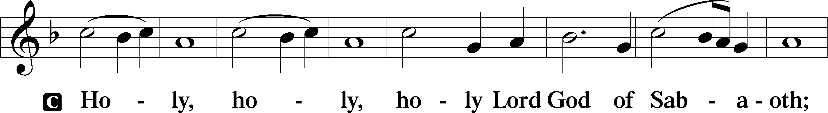
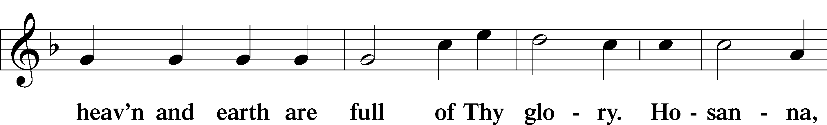
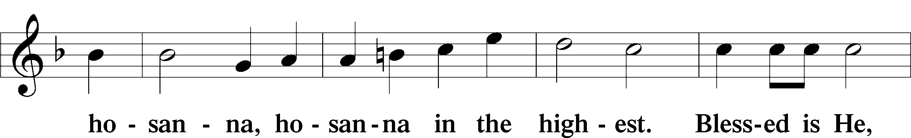
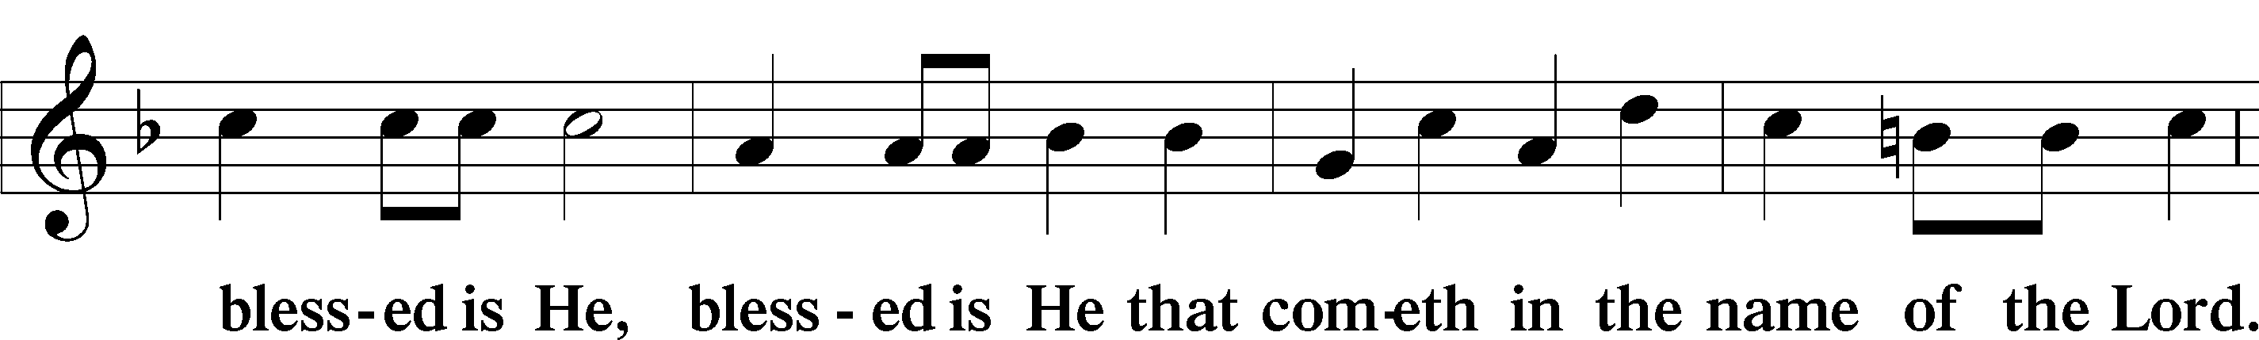
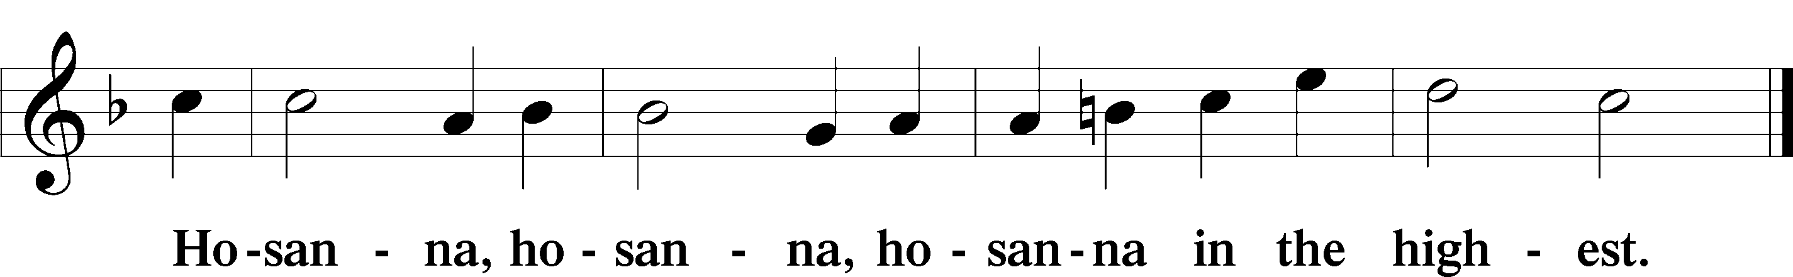

Lord’s Prayer Matthew 6:9–13
C Our Father who art in heaven,
hallowed be Thy name,
Thy kingdom come,
Thy will be done on earth as it is in heaven;
give us this day our daily bread;
and forgive us our trespasses as we forgive those who trespass against us;
and lead us not into temptation,
but deliver us from evil.
For Thine is the kingdom and the power and the glory forever and ever. Amen.

The Words of Our Lord Matthew 26:26–28; Mark 14:22–24; Luke 22:19–20; 1 Corinthians 11:23–25
P Our Lord Jesus Christ, on the night when He was betrayed, took bread, and when He had given thanks, He broke it and gave it to the disciples and said: “Take, eat; this is My T body, which is given for you. This do in remembrance of Me.”

In the same way also He took the cup after supper, and when He had given thanks, He gave it to them, saying: “Drink of it, all of you; this cup is the new testament in My T blood, which is shed for you for the forgiveness of sins. This do, as often as you drink it, in remembrance of Me.”

Pax Domini John 20:19
P The peace of the Lord be with you always.
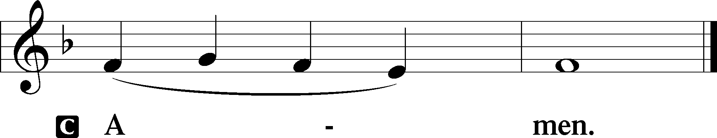

Agnus Dei John 1:29
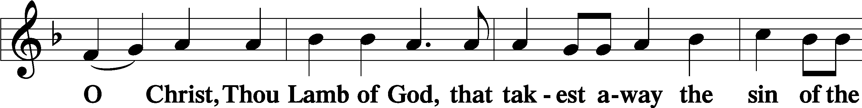
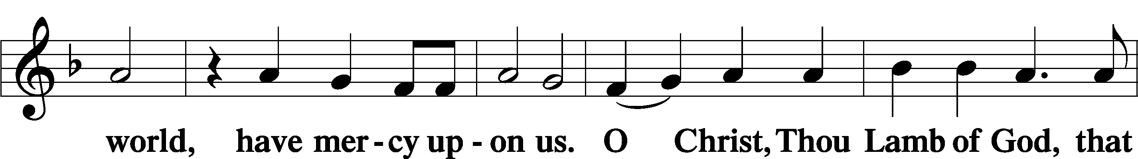
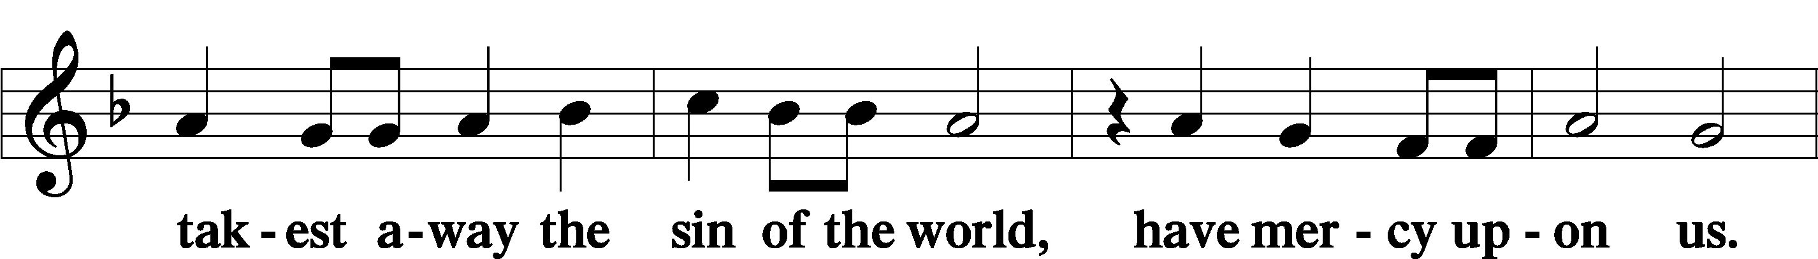
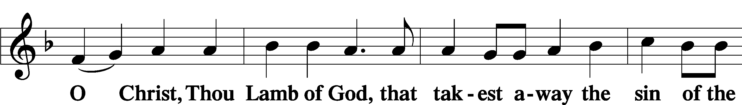
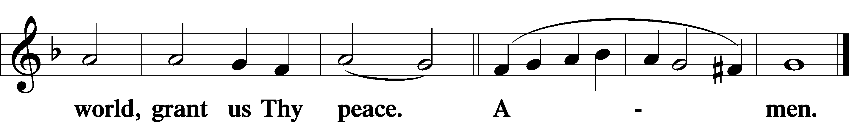
Sit

Distribution
The pastor and those who assist him receive the body and blood of Christ first and then distribute them to those who come to receive, saying:
Take, eat; this is the true body of our Lord and Savior Jesus Christ, given into death for your sins.
Amen.

Take, drink; this is the true blood of our Lord and Savior Jesus Christ, shed for the forgiveness of your sins.
Amen.

In dismissing the communicants, the following is said:
The Dismissal
P The body and blood of our Lord Jesus Christ strengthen and preserve you in body and soul to life everlasting. Depart T in peace.
C Amen.

Distribution Hymn: LSB #635 “O Gracious Lord, I Firmly Am Believing”

Distribution Hymn: LSB #664 “Fight the Good Fight”

Distribution Hymn: LSB #621 “Let All Mortal Flesh Keep Silence”

Stand

Nunc Dimittis Luke 2:29–32
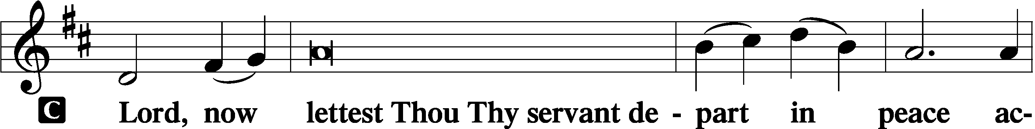
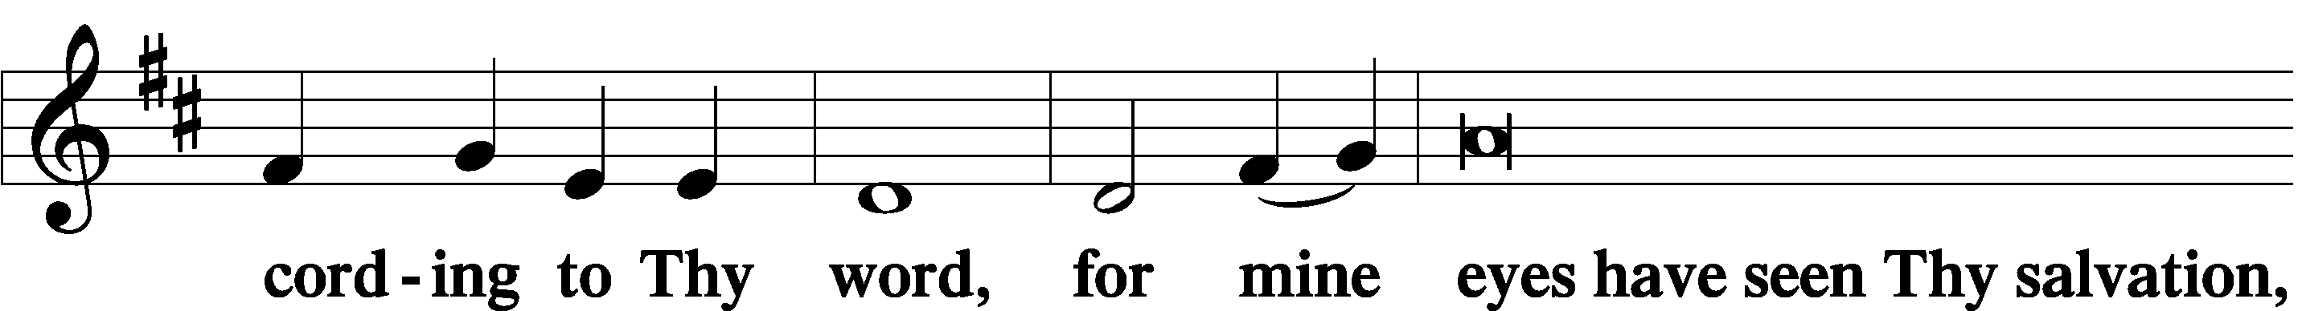
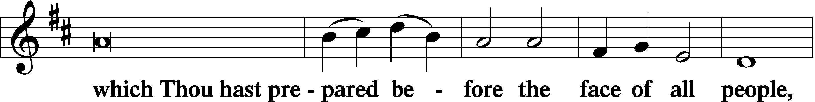
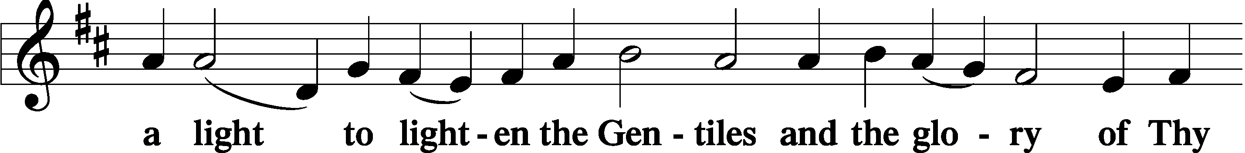
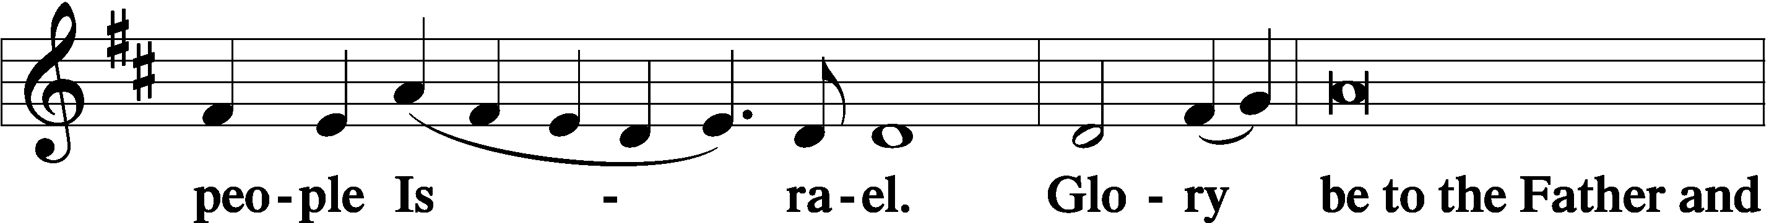
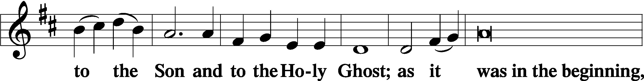
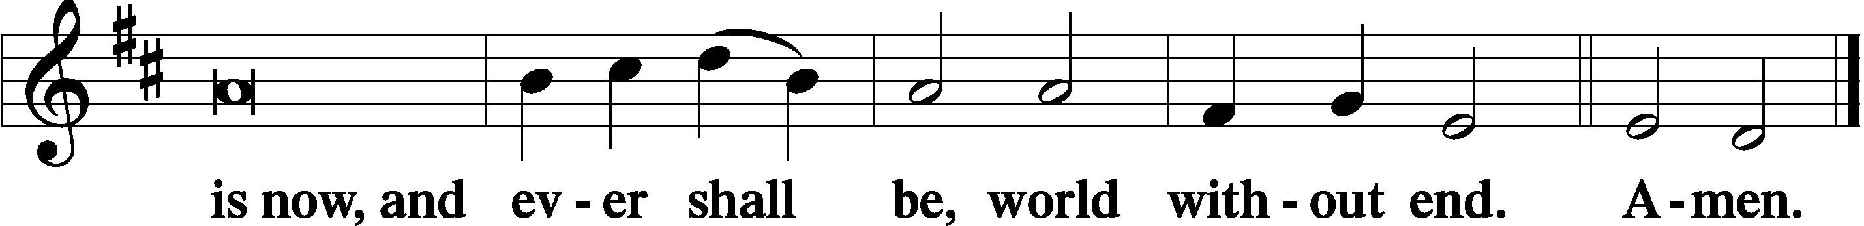

Thanksgiving Psalm 107:1
P O give thanks unto the Lord, for He is good,
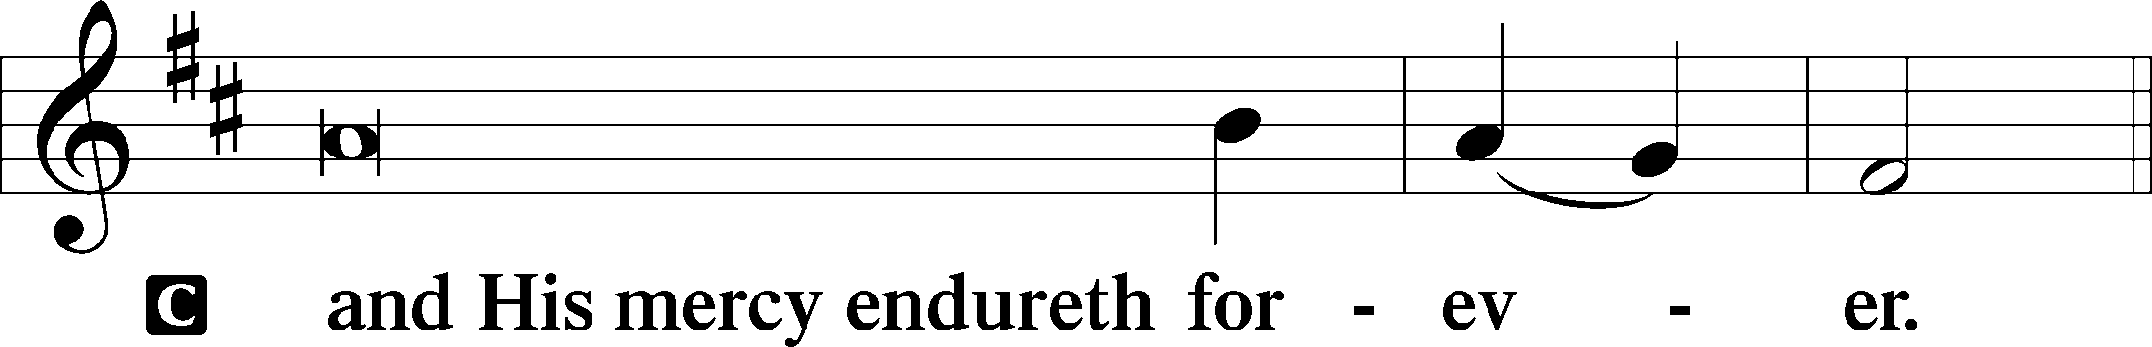

Post-Communion Collect
P Let us pray.
We give thanks to You, almighty God, that You have refreshed us through this salutary gift, and we implore You that of Your mercy You would strengthen us through the same in faith toward You and in fervent love toward one another; through Jesus Christ, Your Son, our Lord, who lives and reigns with You and the Holy Spirit, one God, now and forever.
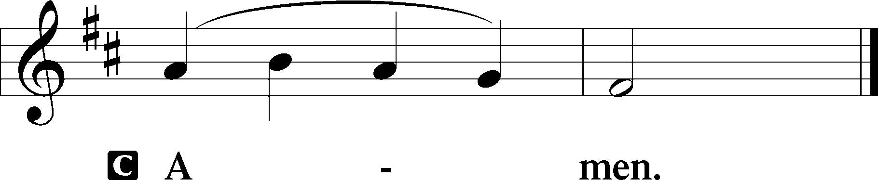

Salutation 2 Timothy 4:22
P The Lord be with you.
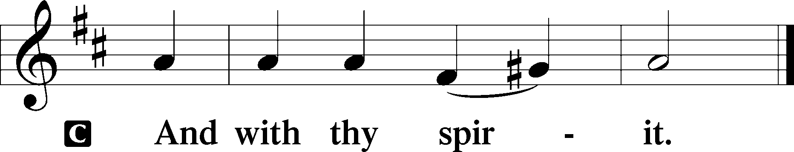

Benedicamus Psalm 103:1
P Bless we the Lord.
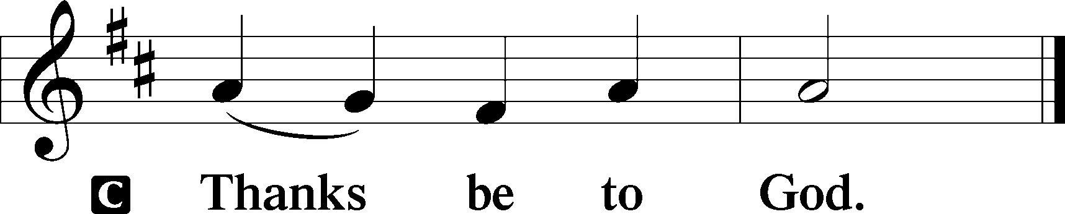

Benediction Numbers 6:24–26
P The Lord bless you and keep you.
The Lord make His face shine upon you and be gracious unto you.
The Lord lift up His countenance upon you and T give you peace.
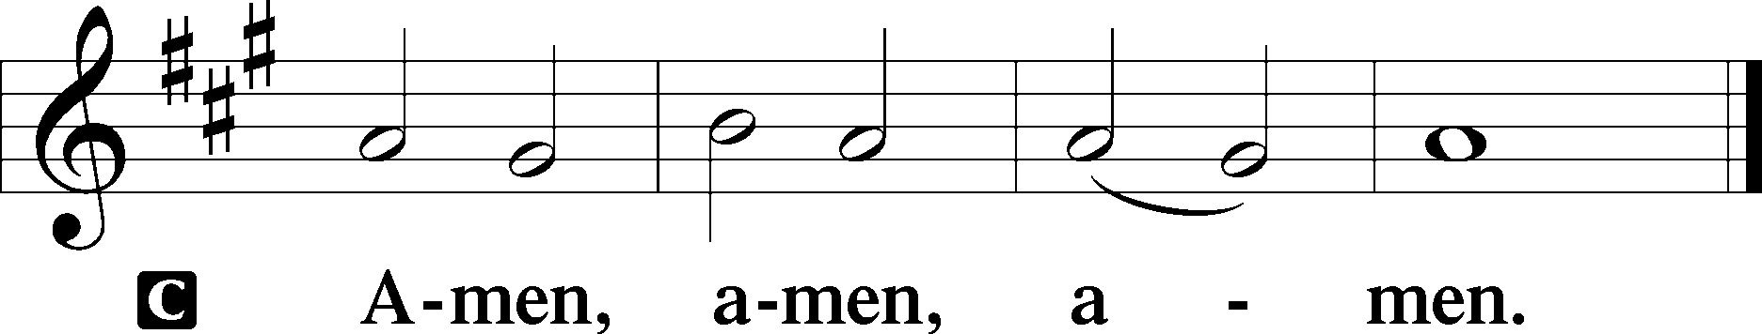

Closing Hymn: LSB #578 “Thy Strong Word”

Silent prayer after worship: Almighty God, You sent Your Son to proclaim Your kingdom and to teach with power and authority. Empower me by Your Holy Spirit to live my life in Christ and to share His love with others. In Jesus’ name. Amen.
fffffffffffffffffffffffffffffffffff
Acknowledgments: Unless otherwise indicated, Scripture quotations are from the ESV® Bible (The Holy Bible, English Standard Version®), copyright © 2001 by Crossway, a publishing ministry of Good News Publishers. Used by permission. All rights reserved.
Created by Lutheran Service Builder © 2021 Concordia Publishing House.
fffffffffffffffffffffffffffffffffff
fffffffffffffffffffffffffffffffffff
In Loving Memory of Bob Sulek: Dolores Fee (Capital Campaign).
fffffffffffffffffffffffffffffffffff
Attendance: Sunday, January 15, 2023: 35
fffffffffffffffffffffffffffffffffff
SCHEDULE THROUGH JANUARY 29, 2023:

:

Today, following Worship, Library: Monthly and Quarterly Audits
7 pm, Fellowship Hall: AA Meeting
Tuesday, 7-9 pm, Fellowship Hall: Penn-Ohio Singers
Wednesday, 7:30 pm, Downstairs: NA Meeting
Thursday, 9 am, Downstairs: Food Pantry
Next Sunday, 8 am, Fellowship Hall: Bible Study
9 am, Sanctuary: Divine Service
Following Worship, Library: Quarterly/Monthly Audit
7 pm, Fellowship Hall: AA Meeting
fffffffffffffffffffffffffffffffffff
Sunday Bible Study has resumed! We are studying the 14 Minor Prophets. Please consider joining us each Sunday morning at 8 am!
fffffffffffffffffffffffffffffffffff
Remember the following in Prayer…
~The Hurting and Healing: Amy, Gerald Arthur, Evelyn Baisch, Ellen Baron^{CA}, Lois Bortner^{CA}, John Burdette, Bev & Joe Chlpka, Kathleen Coughenour, Kim, Anna Mae Daris, Susan Davies, Tim Dudash, Millie Elavsky, Joseph Fleet, Judith & Eddy Furey, Tim Haenftling, Austin Hamilton, Anson Holcroft, Neil Huston, Darla Krajci, Barbara Kreske, Michelle Kelly^{CA}, Donna Kennedy, Gerald Krivosh, Jess Lavoie, Paul Lucas^{CA}, Sandy Marshall, Ernie Meszaros, David Nelson, Linda Parkany, Juanita Rentschler, Richard Reuning^{CA}, Diane Riefstahl, Nancy Robertson^{CA}, Viola Sakony, Marty Scott, Kara, Fred Tonty, Angela Weser^{CA}, and Ruth Wolf.
~The Homebound: Rudy & Jean Tomko, Betty Wolf, and Ed & Millie Zachar.
~Celebrating: Birthday: Rachal Myers (01.22).
~Serving in the Military: Curtis Sinewe and Joshua Solyan.
~Community & World Needs: Those suffering from or affected by the coronavirus; those suffering due to the conflict between Ukraine and Russia; those suffering from loss and dislocation because weather disasters; those suffering from addiction and their families; Local, State, and National Government Leaders; safety for all Police Officers, Firefighters, & First Responders; the unemployed; our First Quarter Local Mission: Sts. Peter & Paul’s Community Day 2023.
*CA represents cancer.
fffffffffffffffffffffffffffffffffff
Our Stewardship of Treasures for the Lord:
In order to do the Lord’s work, we need $2,553.63 each week to meet our 2023 budget for general purposes and $76.92 for the SELC.
Figures for Sunday, January 15, 2023
General Fund: $1,593.00 Behind for the week: -$960.63
SELC: $48.00 Behind for the week: -$28.92
Capital Campaign: $371.00
Other: $14.00

For online giving, check out https://www.saintspeterandpaul.net/online-giving.

fffffffffffffffffffffffffffffffffff
Church Council Members are reminded of the meeting Monday, January 30th beginning at 7 pm. Please email your reports to Diane by noon that day do that packets can be prepared. Thank you!
Bible Memory Verses ~ Week of January 22nd:
For Adults: The fear of the LORD is the beginning of wisdom.
Psalm 111:110

For Children: People will come from east and west, and from north and south, and recline at table in the kingdom of God. Luke 13:29
fffffffffffffffffffffffffffffffffff
Submissions for the February newsletter and calendar are due to the secretary’s office no later than noon, tomorrow, Monday, January 23rd.
fffffffffffffffffffffffffffffffffff
THANK YOU FOR SERVING IN JANUARY: Elder: Jonathan Baisch; Altarware: Marie Flaugher and Altar Guild Volunteers
fffffffffffffffffffffffffffffffffff
Auditors will meet this morning in the library following worship for a monthly audit of deposits and the 4th Quarter audit of accounts.
fffffffffffffffffffffffffffffffffff
If you should note any items (i.e. pew envelopes) which need replenished or attention (i.e. pew pencils), please put a note in the secretary’s door slot.
fffffffffffffffffffffffffffffffffff
Stop by the Sonshine Room and check out some Christmas items which are no longer being used and are free for the taking. You just might find something you can use!
fffffffffffffffffffffffffffffffffff
MARK YOUR CALENDAR! There will be a Vespers Service Thursday, February 2nd at 7 pm celebrating the Purification of Mary and the Presentation of Our Lord. Please join us!
fffffffffffffffffffffffffffffffffff
SCRIP ORDERS AND PAYMENTS for February will be due in two Sundays, February 5th. Forms are available both in the narthex and on the sign-in table next to Pastor Deal’s office. SCRIP is a wonderful way to support your church at no personal expense to yourself. You will receive the full-value of gift cards purchased. Speak with Matt Berent if you should have any questions about the program.

Here to Serve

Pastor………………………………………………...……………Rev. Jacob Deal
E-mail …………………………….……pastordeal@saintspeterandpaul.net
Phone Number……………………..…………………724-347-3620 (Option 2)
Church Office………………………..…………………724-347-3620 (Option 3)
Website …………………………………………www.saintspeterandpaul.net
Secretary…………………………………………………………Diane Riefstahl
E-mail ………………………………………church@saintspeterandpaul.net
Website …………………………………………www.saintspeterandpaul.net
Food Pantry: Please leave message……………724-347-3620 (Option 3)
AA Contact: Steve………………………………………………..…724-813-2358
NA Contact: Larry………………………………………………..724-977-8733
Choir Director………………………………………………………Chris Nelson
Congregation President……………………………………Jonathan Baisch
Church Elder …………………………………………...…… Jonathan Baisch
fffffffffffffffffffffffffffffffffff
If needing to get into the church building during the week, please phone first to make certain someone is here to let you in.

