Sts. Peter & Paul
Evangelical Lutheran Church
Lutheran Church-Missouri Synod
Founded-1917

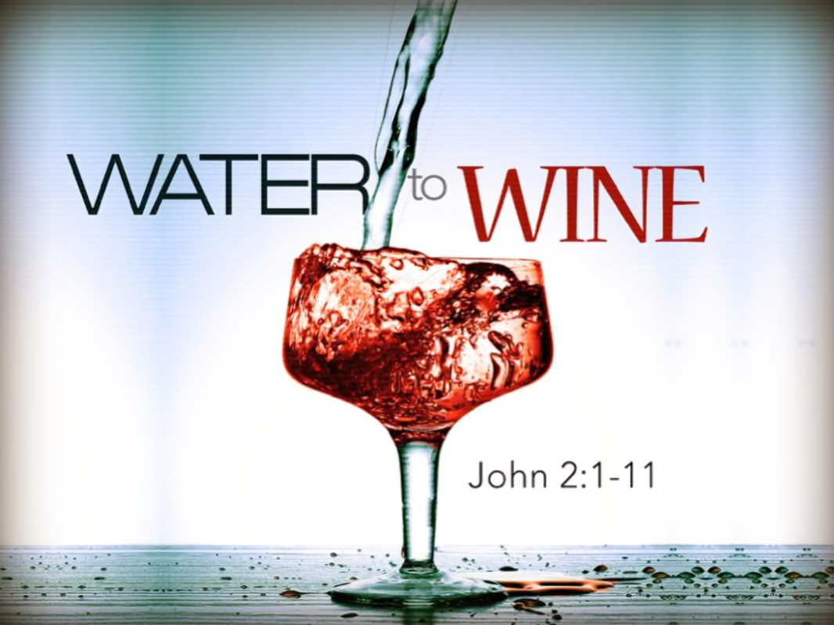

January 15, 2023

699 Stambaugh Avenue
Sharon, Pennsylvania 16146

“I was glad when they said to me,
Let us go to the house of the LORD!”
Psalm 122:1
Sts. Peter & Paul Evangelical Lutheran Church, LC-MS
THE SECOND SUNDAY AFTER EPIPHANY
January 15, 2023

A special welcome to our guests this day! If you would like more information about The Lutheran Church - Missouri Synod, or this congregation, please speak with Pastor Deal or an Elder after the service.
Members & Guests: Don’t be embarrassed if your children make noise during the worship service, all children do. We encourage families to worship together but, if you feel the need, there are pews in the rear of the Church which are reserved for young families on both sides of the sanctuary. There is also a quiet room available to you during our service which is located down the hallway past the offices on the right side of the church as well as a children’s area in the Fellowship Hall where you are able to follow along with the service.

Today’s service includes the Sacrament of Holy Communion. If during this past year, you have not worshipped with us and been communed, we respectfully ask that you do not partake of this sacrament this day before first speaking with Pastor Deal.
If visiting from a sister congregation of the LC-MS and are in good standing, please inform Pastor Deal of your desire to commune prior to the service.
If wishing to receive a blessing during communion, please approach with your arms crossed.

CONTACT INFORMATION
Pastor Deal: pastordeal@saintspeterandpaul.net or 724-347-3620 (opt. 2)
Church Office: church@saintspeterandpaul.net or 724-347-3620 (opt. 3)

Silent prayer before worship: Heavenly Father, by Your Holy Spirit give me the will to follow You faithfully, to serve You, and to proclaim Your Son Jesus to be the only Savior from sin and death. Amen.

Confession and Absolution

Opening Hymn: LSB #399 “The Star Proclaims the King Is Here”

The sign of the cross may be made by all in remembrance of their Baptism.

Invocation
P In the name of the Father and of the T Son and of the Holy Spirit.
C Amen.

Exhortation Hebrews 10:22; Psalm 124:8; Psalm 32:5
P Beloved in the Lord! Let us draw near with a true heart and confess our sins unto God our Father, beseeching Him in the name of our Lord Jesus Christ to grant us forgiveness.

P Our help is in the name of the Lord,
C who made heaven and earth.
P I said, I will confess my transgressions unto the Lord,
C and You forgave the iniquity of my sin.

Silence for reflection on God’s Word and for self-examination.

Confession of Sins
P O almighty God, merciful Father,
C I, a poor, miserable sinner, confess unto You all my sins and iniquities with which I have ever offended You and justly deserved Your temporal and eternal punishment. But I am heartily sorry for them and sincerely repent of them, and I pray You of Your boundless mercy and for the sake of the holy, innocent, bitter sufferings and death of Your beloved Son, Jesus Christ, to be gracious and merciful to me, a poor, sinful being.

Absolution [John 20:19–23]
P Upon this your confession, I, by virtue of my office, as a called and ordained servant of the Word, announce the grace of God unto all of you, and in the stead and by the command of my Lord Jesus Christ I forgive you all your sins in the name of the Father and of the T Son and of the Holy Spirit.
C Amen.

Service of the Word

Introit Psalm 66:1–5, 20; antiphon: v. 4; 92:1
All the earth worships you and sings prais- | es to you;*
they sing praises | to your name.
It is good to give thanks | to the Lord,*
to sing praises to your name, | O Most High.
Shout for joy to God, | all the earth;*
sing the glory of his name; give to him | glorious praise!
Say to God, “How awesome | are your deeds!*
So great is your power that your enemies come cringing | to you.
All the earth worships you and sings prais- | es to you;*
they sing praises | to your name.”
Come and see what | God has done:*
he is awesome in his deeds toward the chil- | dren of man.
Blessèd | be God,*
because he has not rejected my prayer or removed his steadfast | love from me!
All the earth worships you and sings prais- | es to you;*
they sing praises | to your name.
It is good to give thanks | to the Lord,*
to sing praises to your name, | O Most High.
Gloria Patri
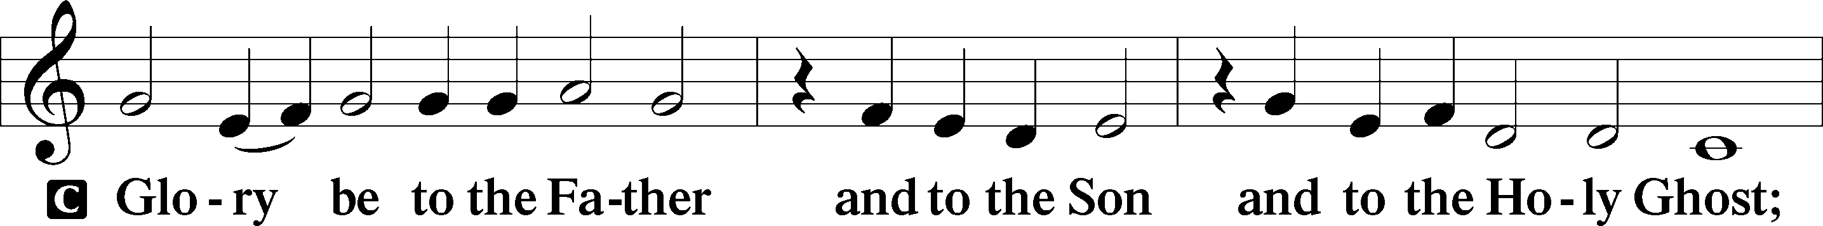
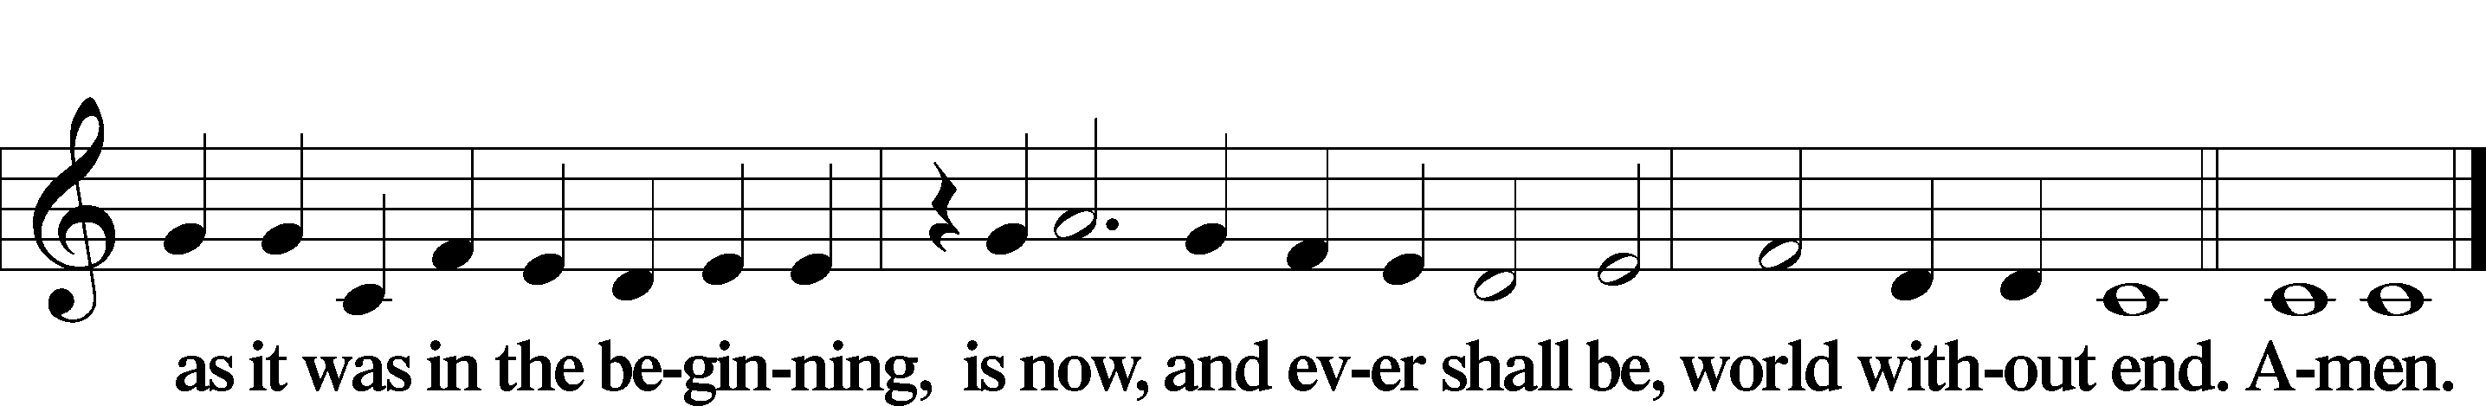

Kyrie Mark 10:47
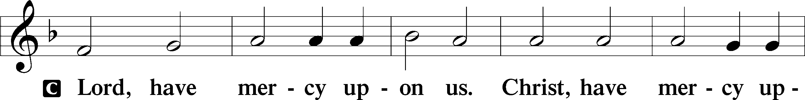
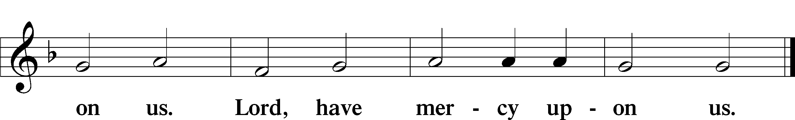

Gloria in Excelsis Luke 2:14; John 1:29
P Glory be to God on high:
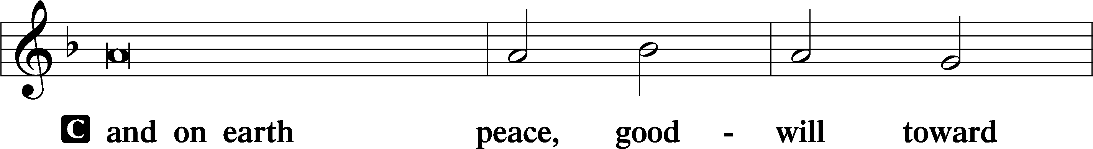
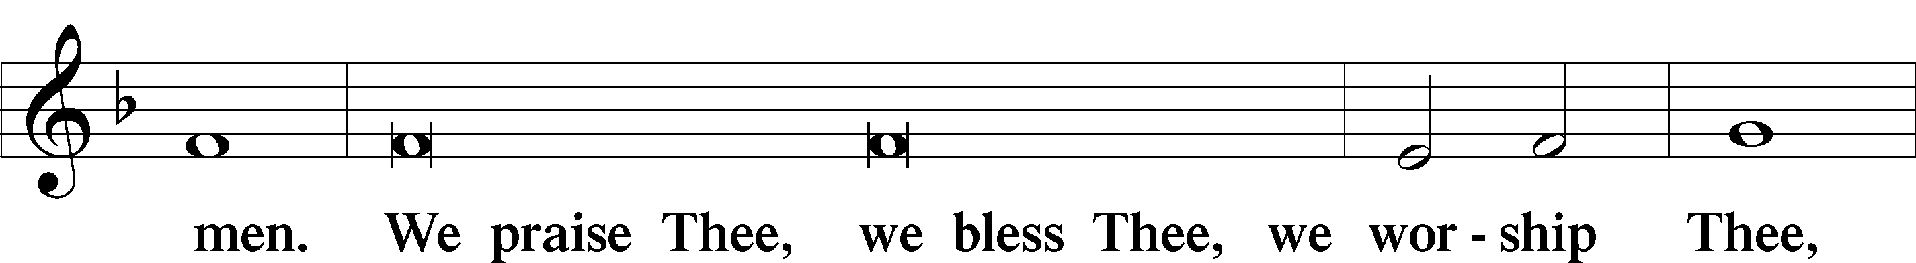
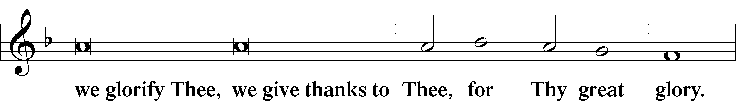
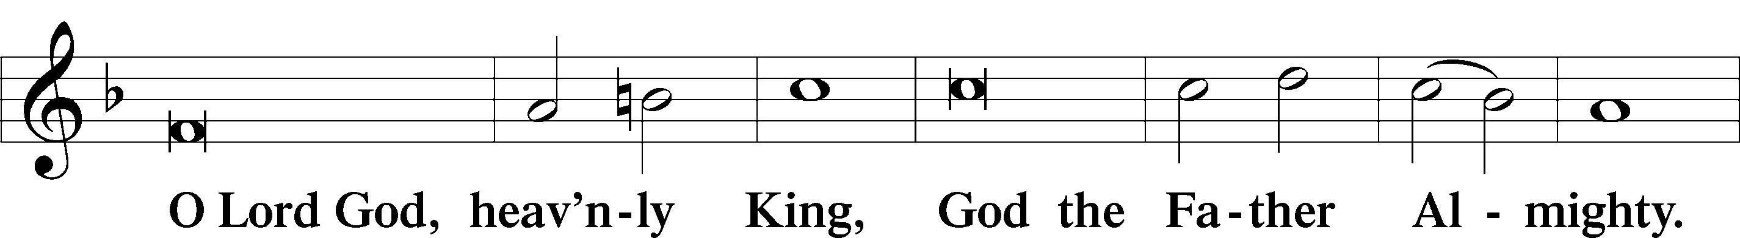
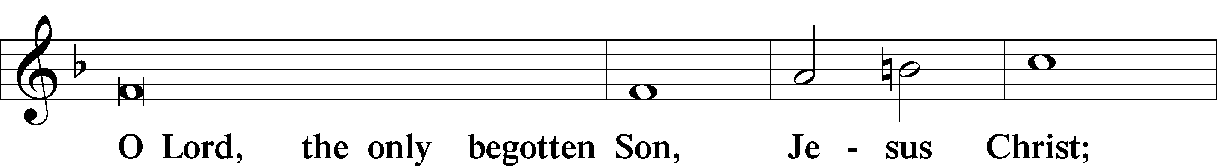
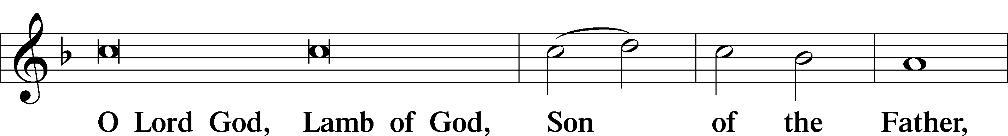
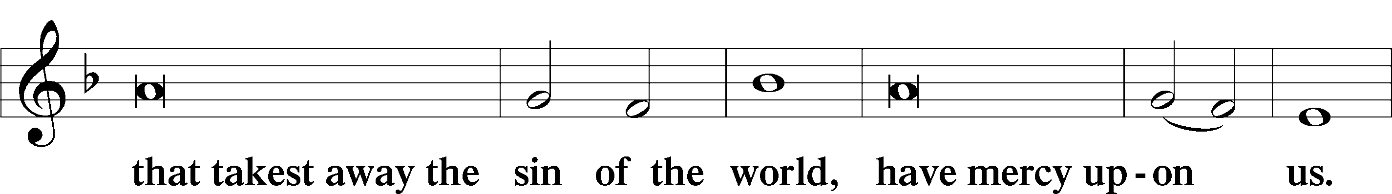
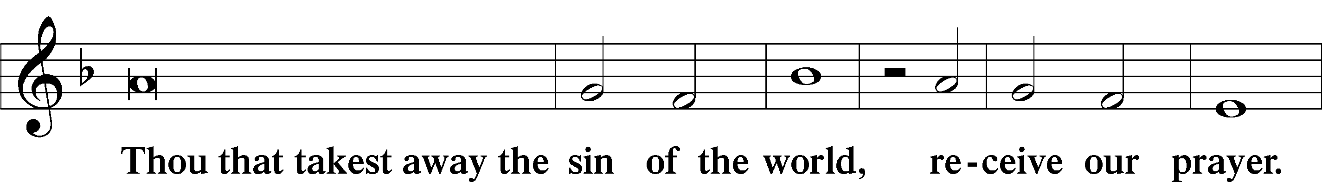
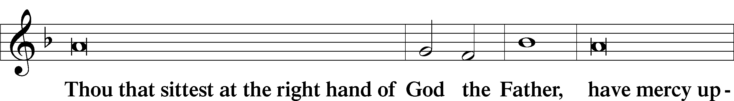
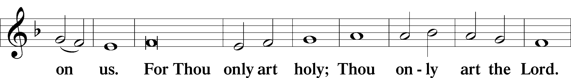
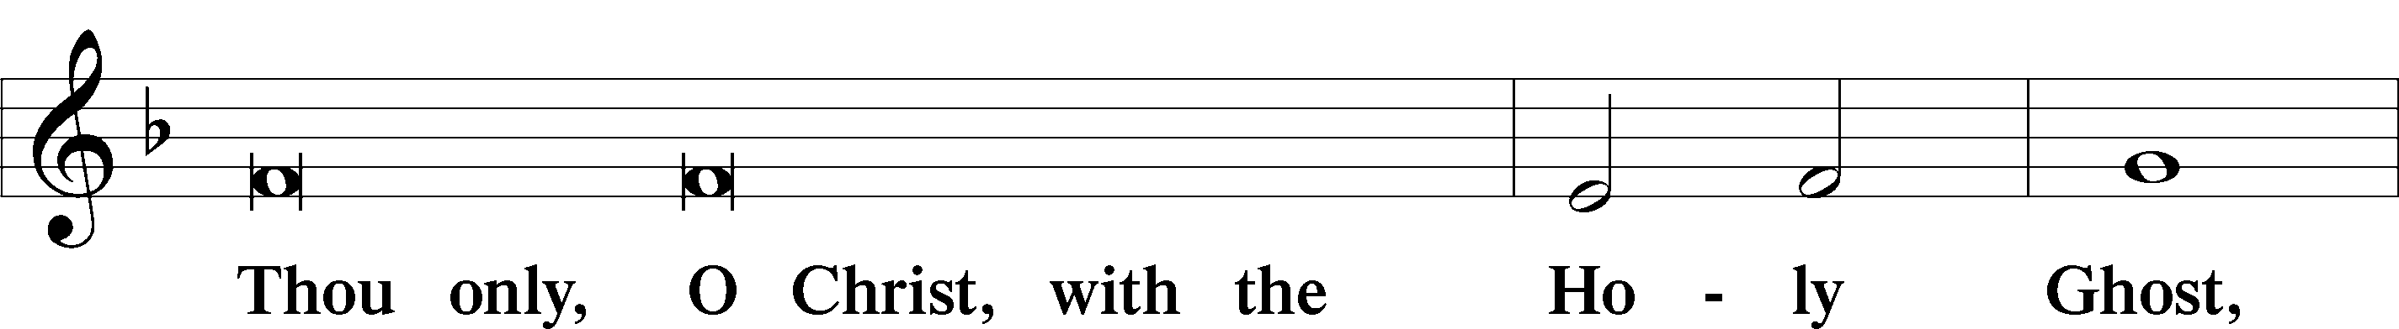
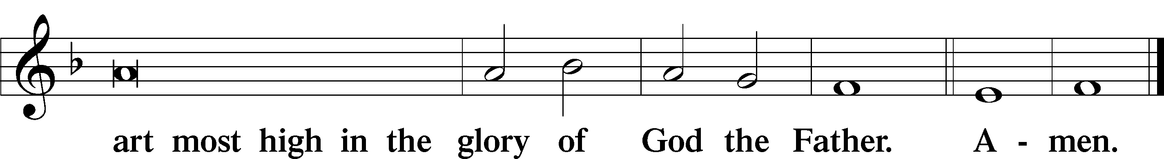

Salutation and Collect of the Day: Epiphany 2
P The Lord be with you.
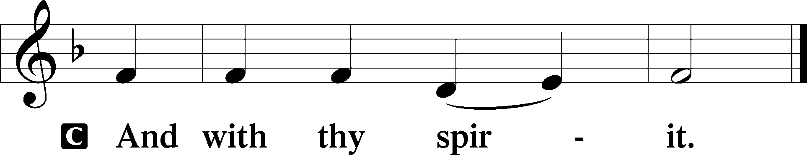

P Let us pray.
Almighty and everlasting God, who governs all things in heaven and on earth, mercifully hear the prayers of Your people and grant us Your peace through all our days; through Jesus Christ, Your Son, our Lord, who lives and reigns with You and the Holy Spirit, one God, now and forever.
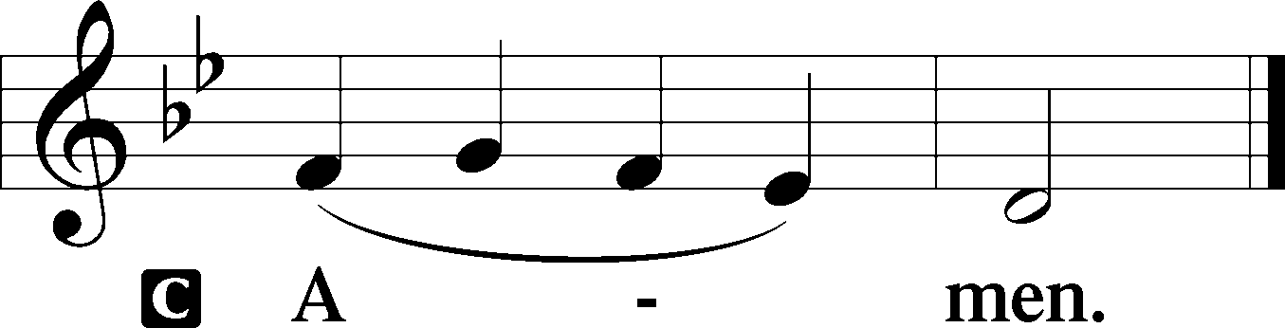
Sit

Prophecy: Amos 9:11–15 (NKJV)
Thus says the Lord God: “I will raise up the tabernacle of David, which has fallen down, and repair its damages; I will raise up its ruins, and rebuild it as in the days of old; that they may possess the remnant of Edom, and all the Gentiles who are called by My name,” says the Lord who does this thing. “Behold, the days are coming,” says the Lord, “When the plowman shall overtake the reaper, and the treader of grapes him who sows seed; the mountains shall drip with sweet wine, and all the hills shall flow with it. I will bring back the captives of My people Israel; they shall build the waste cities and inhabit them; they shall plant vineyards and drink wine from them; they shall also make gardens and eat fruit from them. I will plant them in their land, and no longer shall they be pulled up from the land I have given them,” says the Lord Almighty.

P This is the Word of the Lord.
C Thanks be to God.

Gradual Psalm 107:20–21
He sent out his word and | healed them,*
and delivered them from their de- | struction.
Let them thank the Lord for his | steadfast love,*
for his wondrous works to the chil- | dren of men!

Epistle: Romans 12:6–16a (NKJV)
Brethren: Having gifts differing according to the grace that is given to us, let us use them: if prophecy, let us prophesy in proportion to our faith; or ministry, let us use it in our ministering; he who teaches, in teaching; he who exhorts, in exhortation; he who gives, with liberality; he who leads, with diligence; he who shows mercy, with cheerfulness. Let love be without hypocrisy. Abhor what is evil. Cling to what is good. Be kindly affectionate to one another with brotherly love, in honor giving preference to one another; not lagging in diligence, fervent in spirit, serving the Lord; rejoicing in hope, patient in tribulation, continuing steadfastly in prayer; distributing to the needs of the saints, given to hospitality. Bless those who persecute you; bless and do not curse. Rejoice with those who rejoice, and weep with those who weep. Be of the same mind toward one another. Do not set your mind on high things, but associate with the humble.

P This is the Word of the Lord.
C Thanks be to God.

Stand

Verse Psalm 148:2
Alleluia. Praise him, all his angels; praise him, all his hosts! Alleluia.

Alleluia
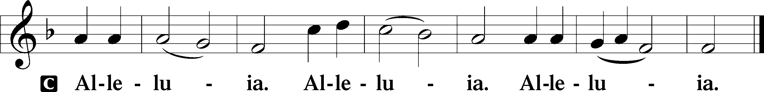

Holy Gospel: John 2:1–11 (NKJV)
P The Holy Gospel according to St. John, the second chapter.
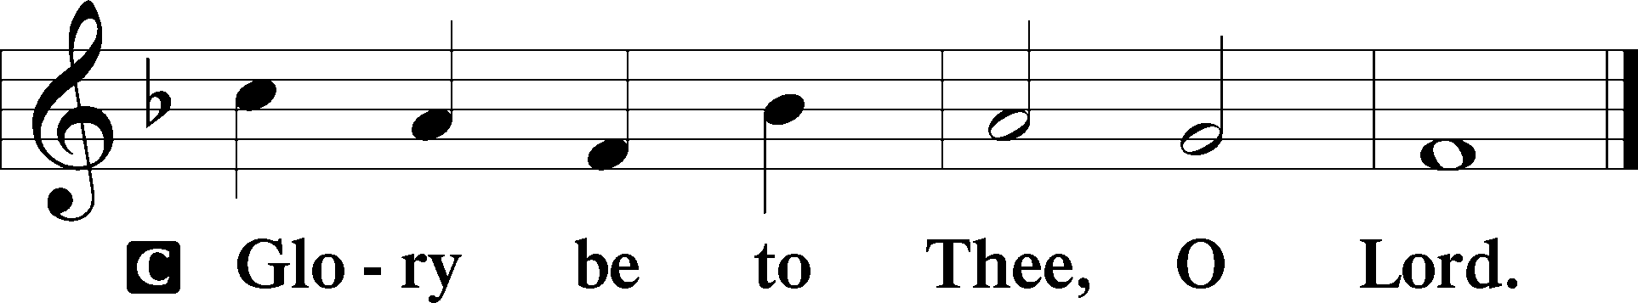

At that time: There was a wedding in Cana of Galilee, and the mother of Jesus was there. Now both Jesus and His disciples were invited to the wedding. And when they ran out of wine, the mother of Jesus said to Him, “They have no wine.” Jesus said to her, “Woman, what does your concern have to do with Me? My hour has not yet come.” His mother said to the servants, “Whatever He says to you, do it.” Now there were set there six waterpots of stone, according to the manner of purification of the Jews, containing twenty or thirty gallons apiece. Jesus said to them, “Fill the waterpots with water.” And they filled them up to the brim. And He said to them, “Draw some out now, and take it to the master of the feast.” And they took it. When the master of the feast had tasted the water that was made wine, and did not know where it came from (but the servants who had drawn the water knew), the master of the feast called the bridegroom. And he said to him, “Every man at the beginning sets out the good wine, and when the guests have well drunk, then the inferior. You have kept the good wine until now!” This beginning of signs Jesus did in Cana of Galilee, and manifested His glory; and His disciples believed in Him.

P This is the Gospel of the Lord.
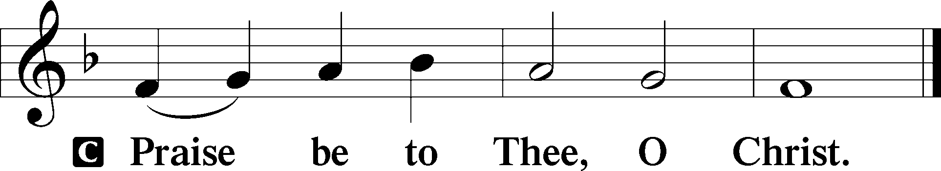

Nicene Creed
C I believe in one God,
the Father Almighty,
maker of heaven and earth
and of all things visible and invisible.

And in one Lord Jesus Christ,
the only-begotten Son of God,
begotten of His Father before all worlds,
God of God, Light of Light,
very God of very God,
begotten, not made,
being of one substance with the Father,
by whom all things were made;
who for us men and for our salvation came down from heaven
and was incarnate by the Holy Spirit of the virgin Mary
and was made man;
and was crucified also for us under Pontius Pilate.
He suffered and was buried.
And the third day He rose again according to the Scriptures
and ascended into heaven
and sits at the right hand of the Father.
And He will come again with glory to judge both the living and the dead,
whose kingdom will have no end.

And I believe in the Holy Spirit,
the Lord and giver of life,
who proceeds from the Father and the Son,
who with the Father and the Son together is worshiped and glorified,
who spoke by the prophets.
And I believe in one holy Christian and apostolic Church,
I acknowledge one Baptism for the remission of sins,
and I look for the resurrection of the dead
and the life T of the world to come. Amen.
Sit

Hymn of the Day: LSB #737 “Rejoice, My Heart, Be Glad and Sing”

Sermon

Stand

Prayer of the Church

Offertory Psalm 51:10–12
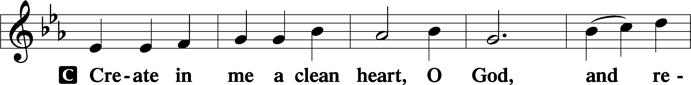
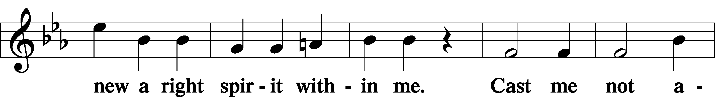
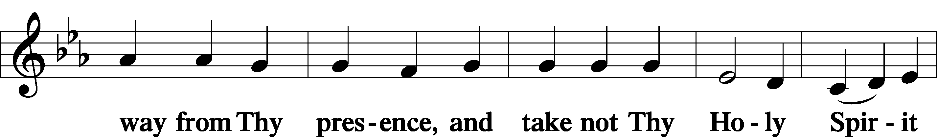
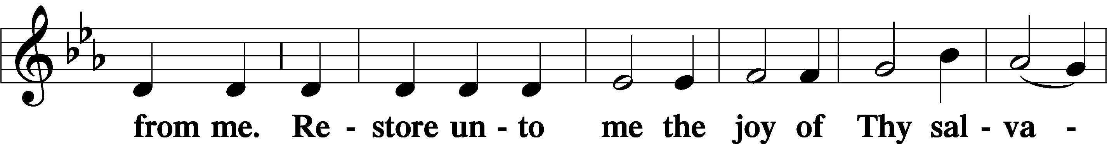
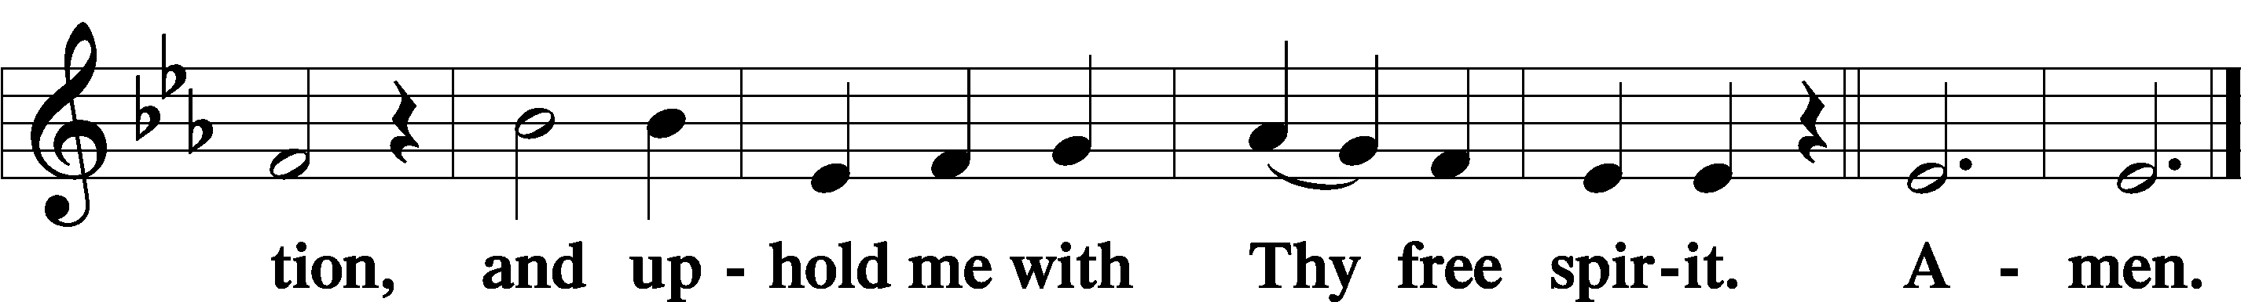
Sit

Preparatory Hymn: LSB #859 “Lord, When You Came as Welcome Guest”

Stand

Service of the Sacrament

Preface 2 Timothy 4:22; Colossians 3:1 Psalm 136
P The Lord be with you.
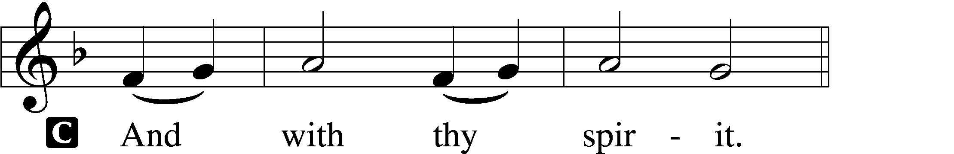

P Lift up your hearts.
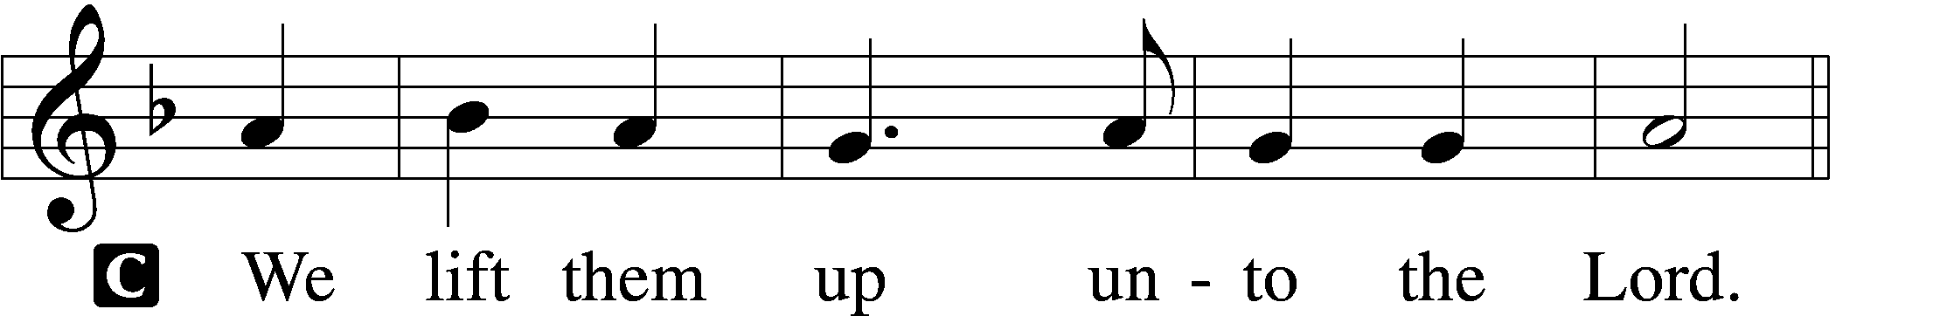

P Let us give thanks unto the Lord, our God.
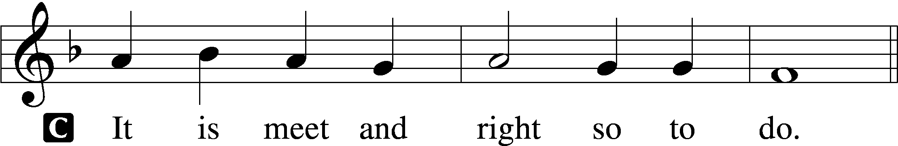

Proper Preface (Abbreviated) LSB 194
P It is truly meet, right, and salutary . . . evermore praising You and saying:

Sanctus Isaiah 6:3; Matthew 21:9
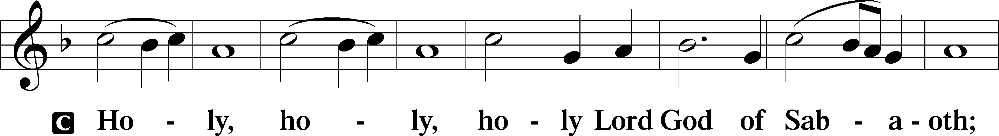
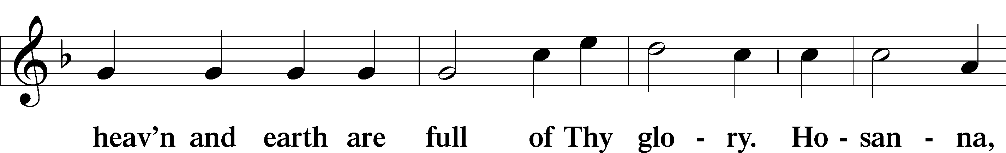
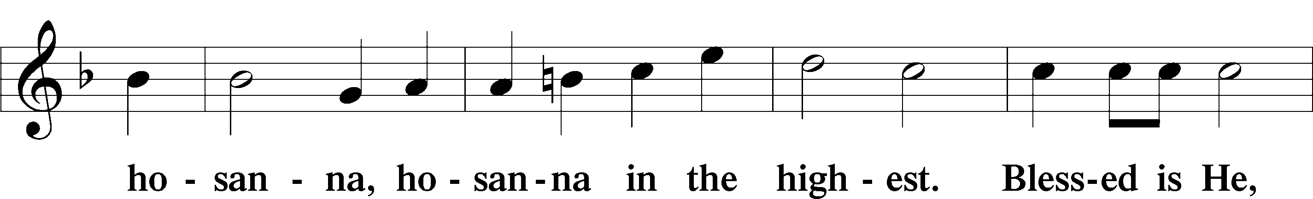
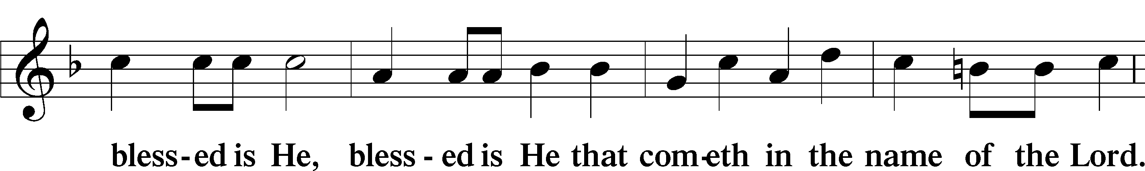
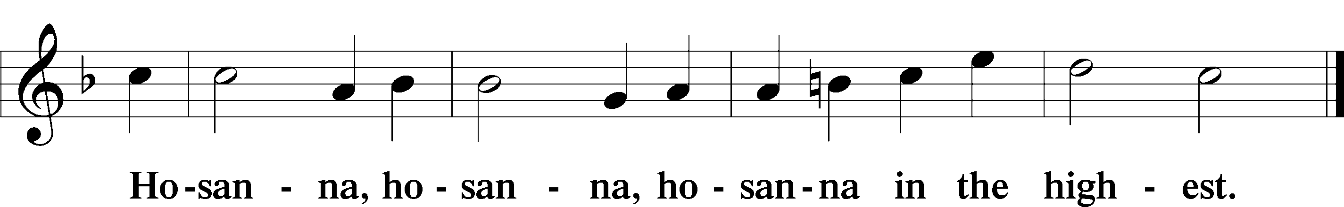

Lord’s Prayer Matthew 6:9–13
C Our Father who art in heaven,
hallowed be Thy name,
Thy kingdom come,
Thy will be done on earth as it is in heaven;
give us this day our daily bread;
and forgive us our trespasses as we forgive those who trespass against us;
and lead us not into temptation,
but deliver us from evil.
For Thine is the kingdom and the power and the glory forever and ever. Amen.

The Words of Our Lord Matthew 26:26–28; Mark 14:22–24; Luke 22:19–20; 1 Corinthians 11:23–25
P Our Lord Jesus Christ, on the night when He was betrayed, took bread, and when He had given thanks, He broke it and gave it to the disciples and said: “Take, eat; this is My T body, which is given for you. This do in remembrance of Me.”

In the same way also He took the cup after supper, and when He had given thanks, He gave it to them, saying: “Drink of it, all of you; this cup is the new testament in My T blood, which is shed for you for the forgiveness of sins. This do, as often as you drink it, in remembrance of Me.”

Pax Domini John 20:19
P The peace of the Lord be with you always.
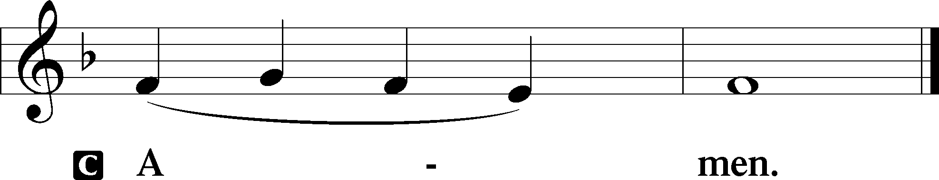

Agnus Dei John 1:29
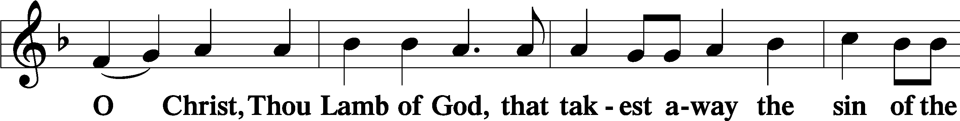
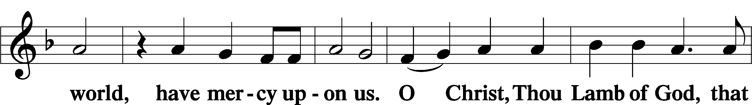
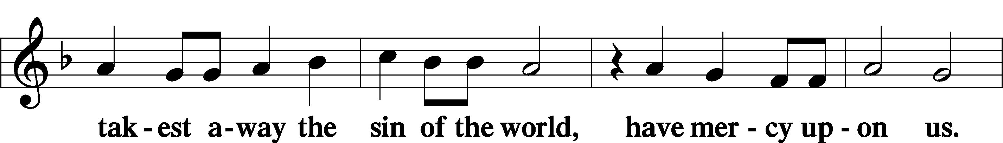
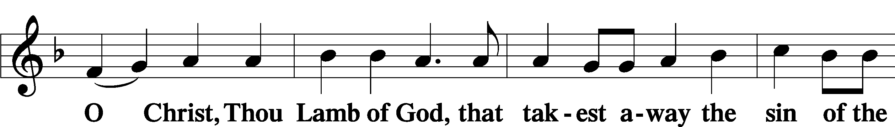
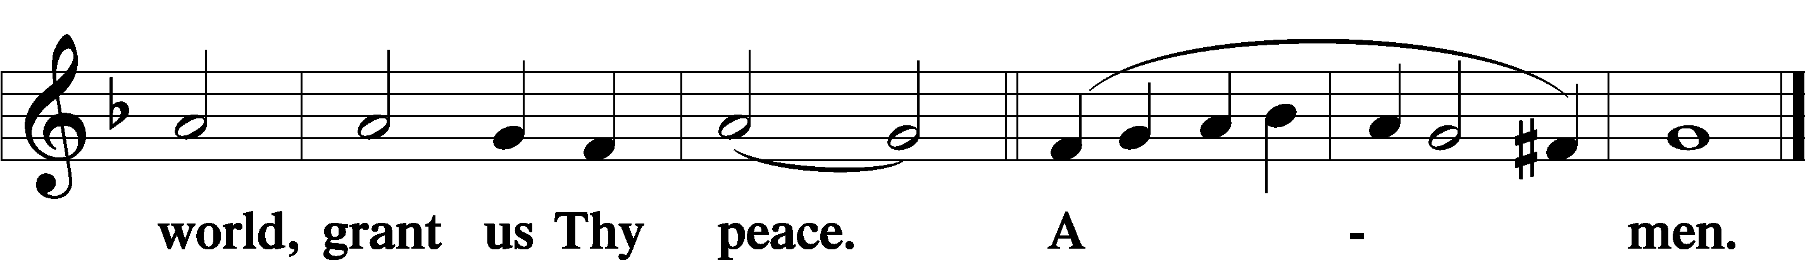
Sit
Distribution
The pastor and those who assist him receive the body and blood of Christ first and then distribute them to those who come to receive, saying:
Take, eat; this is the true body of our Lord and Savior Jesus Christ, given into death for your sins.
Amen.

Take, drink; this is the true blood of our Lord and Savior Jesus Christ, shed for the forgiveness of your sins.
Amen.

In dismissing the communicants, the following is said:
The Dismissal
P The body and blood of our Lord Jesus Christ strengthen and preserve you in body and soul to life everlasting. Depart T in peace.
C Amen.

Distribution Hymn: LSB #631 “Here, O My Lord, I See Thee Face to Face”

Distribution Hymn: LSB #398 “Hail to the Lord’s Anointed”

Distribution Hymn: LSB #822 “Alleluia! Let Praises Ring”

Stand

Nunc Dimittis Luke 2:29–32
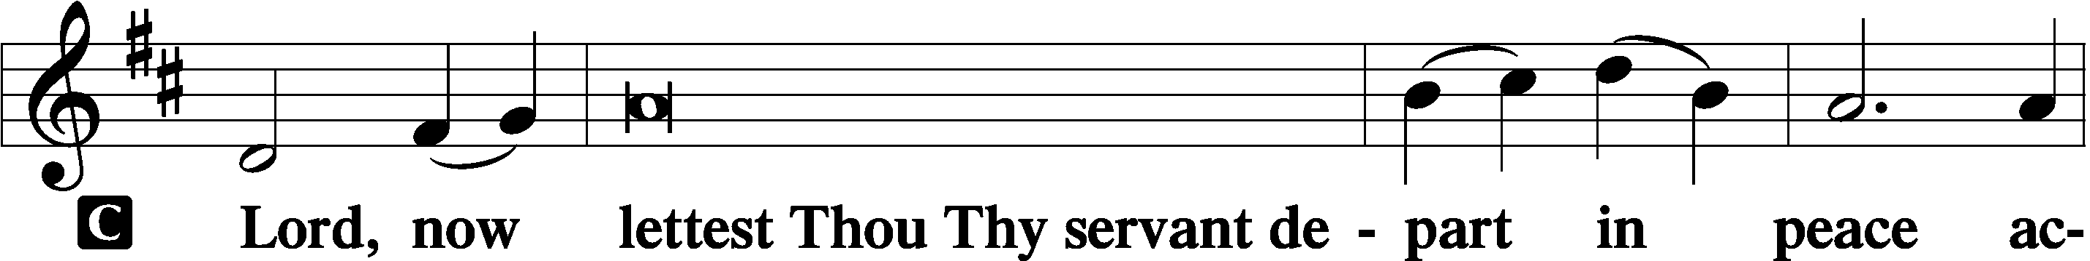
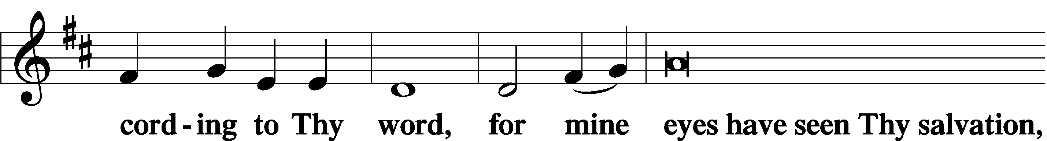
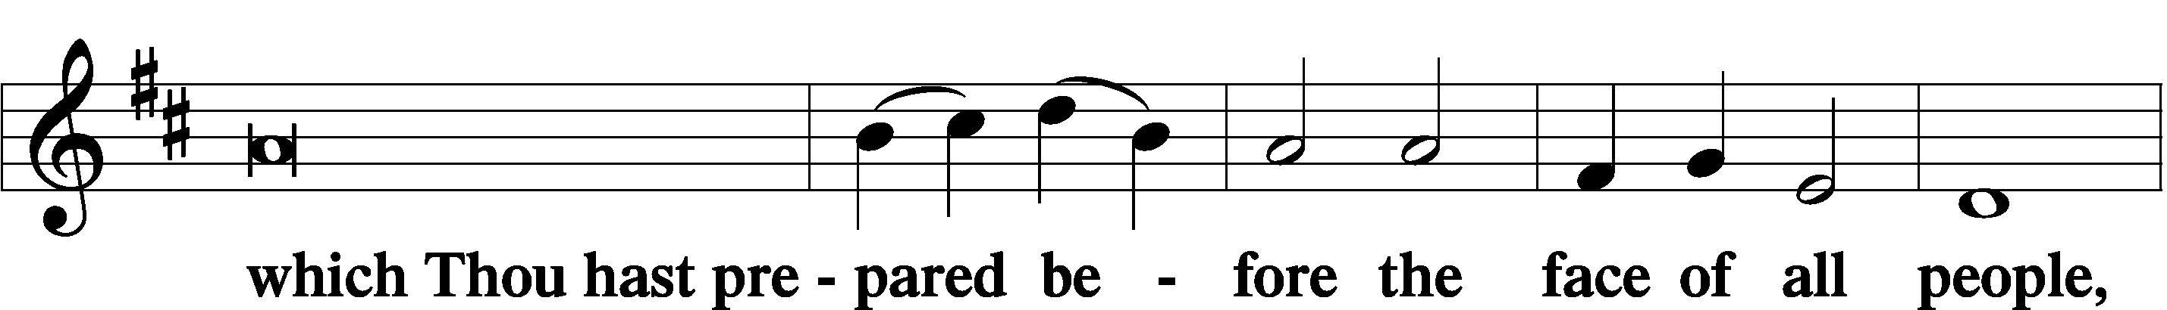
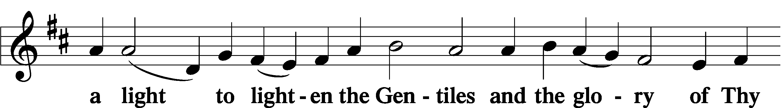
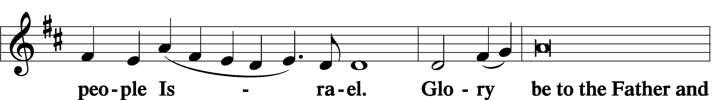
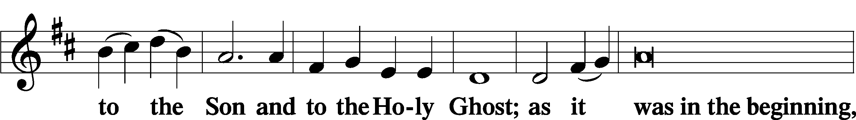
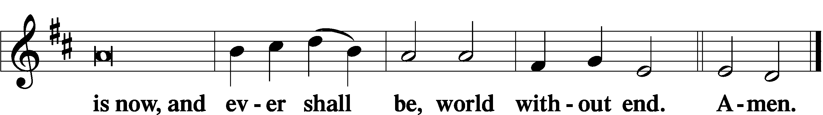

Thanksgiving Psalm 107:1
P O give thanks unto the Lord, for He is good,
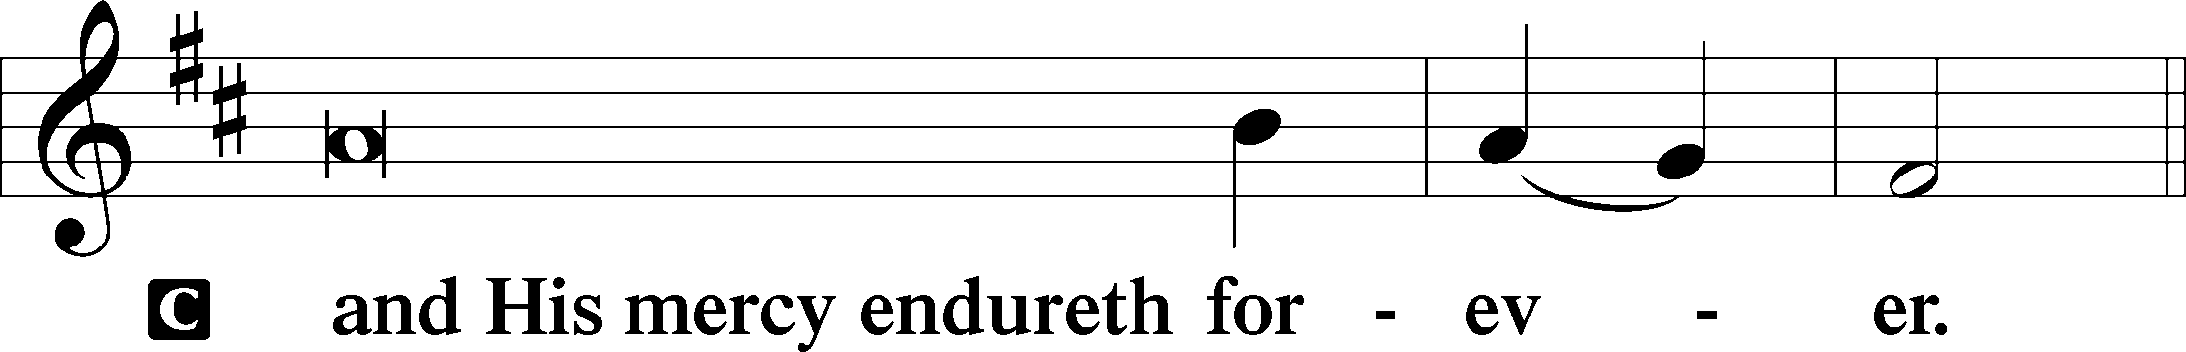

Post-Communion Collect
P Let us pray.
We give thanks to You, almighty God, that You have refreshed us through this salutary gift, and we implore You that of Your mercy You would strengthen us through the same in faith toward You and in fervent love toward one another; through Jesus Christ, Your Son, our Lord, who lives and reigns with You and the Holy Spirit, one God, now and forever.
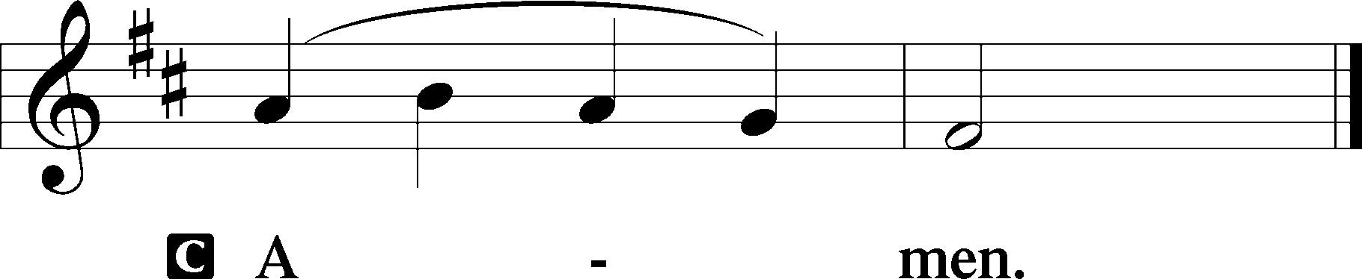

Salutation 2 Timothy 4:22
P The Lord be with you.
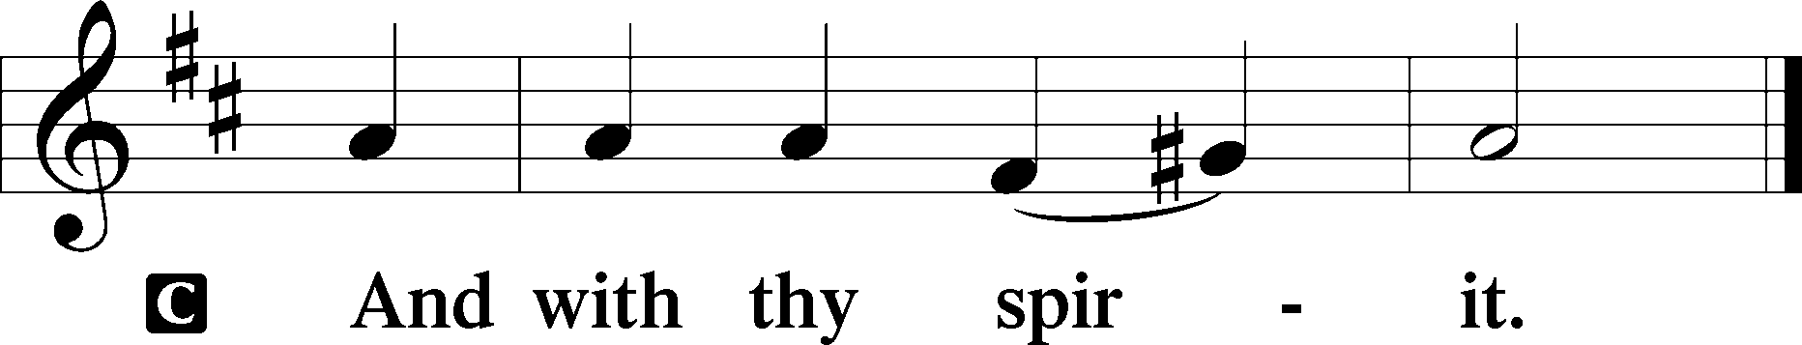

Benedicamus Psalm 103:1
P Bless we the Lord.
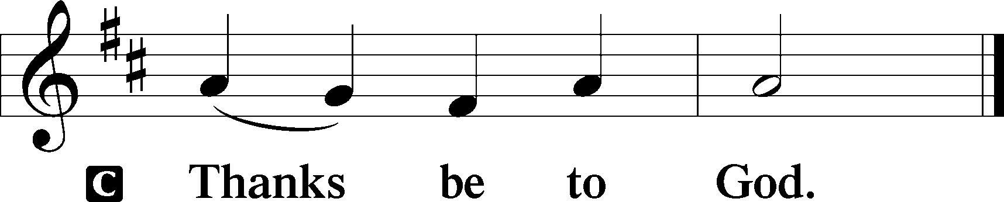

Benediction Numbers 6:24–26
P The Lord bless you and keep you.
The Lord make His face shine upon you and be gracious unto you.
The Lord lift up His countenance upon you and T give you peace.
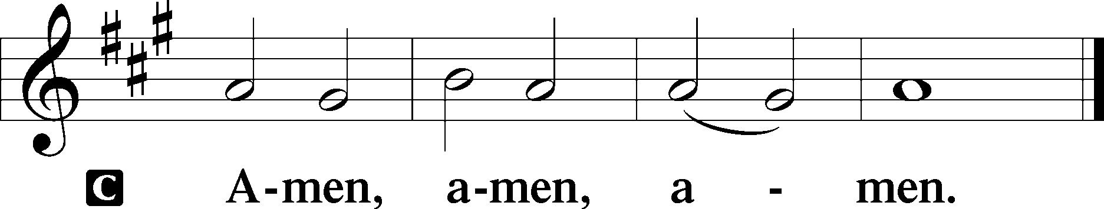

Closing Hymn: LSB #533 “Jesus Has Come and Brings Pleasure”

Silent prayer after worship: Lord Jesus, You have come to be my guide and Savior, cause me to trust in You not only for my eternal salvation, but also to trust that You guide and protect me each day until You return to receive me into heaven. Amen.
fffffffffffffffffffffffffffffffffff
Acknowledgments: Unless otherwise indicated, Scripture quotations are from the ESV® Bible (The Holy Bible, English Standard Version®), copyright © 2001 by Crossway, a publishing ministry of Good News Publishers. Used by permission. All rights reserved.
Created by Lutheran Service Builder © 2021 Concordia Publishing House.
fffffffffffffffffffffffffffffffffff
Attendance: Friday, January 6, 2023: 17
Sunday, January 8, 2023: 37
fffffffffffffffffffffffffffffffffff
Sunday Bible Study has resumed! We are studying the 14 Minor Prophets. Please consider joining us!
fffffffffffffffffffffffffffffffffff
THANK YOU FOR SERVING IN JANUARY: Elder: Jonathan Baisch; Altarware: Marie Flaugher and Altar Guild Volunteers
SCHEDULE THROUGH JANUARY 22, 2023:

:

Today, 7 pm, Fellowship Hall: AA Meeting
Tuesday, 7-9 pm, Fellowship Hall: Penn-Ohio Singers
Wednesday, 7:30 pm, Downstairs: NA Meeting
Saturday, 1 pm, Fellowship Hall: Women’s Bible Study
2:15 pm, Fellowship Hall: Altar Guild Meeting
4-6 pm, Fellowship Hall: Men’s Bible Study
Next Sunday, 8 am, Fellowship Hall: Bible Study
9 am, Sanctuary: Divine Service
Following Worship, Library: Quarterly/Monthly Audit
7 pm, Fellowship Hall: AA Meeting
fffffffffffffffffffffffffffffffffff
Remember the following in Prayer…
~The Hurting and Healing: Amy, Gerald Arthur, Evelyn Baisch, Ellen Baron^{CA}, Lois Bortner^{CA}, John Burdette, Bev & Joe Chlpka, Kathleen Coughenour, Kim, Anna Mae Daris, Susan Davies, Tim Dudash, Millie Elavsky, Joseph Fleet, Eddy Furey, Tim Haenftling, Austin Hamilton, Anson Holcroft, Neil Huston, Darla Krajci, Barbara Kreske, Michelle Kelly^{CA}, Donna Kennedy, Gerald Krivosh, Jess Lavoie, Paul Lucas^{CA}, Sandy Marshall, Ernie Meszaros, David Nelson, Linda Parkany, Juanita Rentschler, Richard Reuning^{CA}, Nancy Robertson^{CA}, Viola Sakony, Marty Scott, Kara, Fred Tonty, Angela Weser^{CA}, and Ruth Wolf.
~The Homebound: Rudy & Jean Tomko, Betty Wolf, and Ed & Millie Zachar.
~Celebrating: Birthday: Evelyn Baisch (01.15).
~Serving in the Military: Curtis Sinewe and Joshua Solyan.
~Community & World Needs: Those suffering from or affected by the coronavirus; those suffering due to the conflict between Ukraine and Russia; those suffering from loss and dislocation because weather disasters; those suffering from addiction and their families; Local, State, and National Government Leaders; safety for all Police Officers, Firefighters, & First Responders; the unemployed; our First Quarter Local Mission: Sts. Peter & Paul’s Community Day 2023.
*CA represents cancer.
fffffffffffffffffffffffffffffffffff
Our Stewardship of Treasures for the Lord:
In order to do the Lord’s work, we need $2,553.63 each week to meet our 2023 budget for general purposes and $76.92 for the SELC.
Figures for Sunday, January 1, 2023
General Fund: $1,544.35
SELC: $65.00
Capital Campaign: $565.00
Other: $10.00
Online Figure for January 5, 2023:
General Fund: $80.00
Figure for Friday, January 6, 2023:
General Fund: $125.00
Figures for Sunday, January 8, 2023
General Fund: $890.00
SELC: $25.00
Food Pantry: $175.00
Capital Campaign: $135.00
Other: $18.00
Online Figures for January 9, 2023
General Fund: $1,250.00 Behind for the week*: -$208.63
SELC: $100.00 Ahead for the week*: +$48.08
Food Pantry: $100.00
1st Quarter Missions: $100.00 *January 5-9, 2023
Capital Campaign: $200.00

For online giving, check out https://www.saintspeterandpaul.net/online-giving.

fffffffffffffffffffffffffffffffffff
Church Council Members are reminded of the meeting Monday, January 30th beginning at 7 pm. Please email your reports to Diane by noon that day do that packets can be prepared. Thank you!
fffffffffffffffffffffffffffffffffff
Submissions for the February newsletter and calendar are due to the secretary’s office no later than noon, Monday, January 23rd.
Bible Memory Verses ~ Week of January 15th:
For Adults: But he said to me, “My grace is sufficient for you, for my power is made perfect in weakness.” Therefore I will boast all the more gladly of my weaknesses, so that the power of Christ may rest upon me. 2 Corinthians 12:9

For Children: The law was given through Moses; grace and truth came through Jesus Christ. John 1:17
fffffffffffffffffffffffffffffffffff
Women’s and Men’s BIBLE STUDY opportunities with Pastor Deal resume Saturday, January 21st! The women will meet at 1 pm that day with the men meeting from 4-6 pm. Attendees are asked to use the Clover St. entrance. An Altar Guild meeting will follow the Women’s Bible Study with an anticipated 2:15 start.
fffffffffffffffffffffffffffffffffff
“Thanks” are extended to all who assisted with the un-decorating of the church yesterday!

Here to Serve

Pastor………………………………………………...……………Rev. Jacob Deal
E-mail …………………………….……pastordeal@saintspeterandpaul.net
Phone Number……………………..…………………724-347-3620 (Option 2)
Church Office………………………..…………………724-347-3620 (Option 3)
Website …………………………………………www.saintspeterandpaul.net
Secretary…………………………………………………………Diane Riefstahl
E-mail ………………………………………church@saintspeterandpaul.net
Website …………………………………………www.saintspeterandpaul.net
Food Pantry: Please leave message……………724-347-3620 (Option 3)
AA Contact: Steve………………………………………………..…724-813-2358
NA Contact: Larry………………………………………………..724-977-8733
Choir Director………………………………………………………Chris Nelson
Congregation President……………………………………Jonathan Baisch
Church Elder …………………………………………...…… Jonathan Baisch
fffffffffffffffffffffffffffffffffff
If needing to get into the church building during the week, please phone first to make certain someone is here to let you in.

