Sts. Peter & Paul
Evangelical Lutheran Church
Lutheran Church-Missouri Synod
Founded-1917

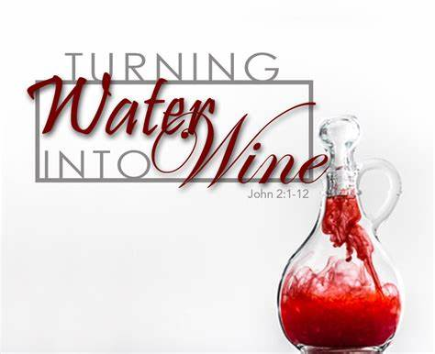

January 14, 2024

699 Stambaugh Ave.
Sharon, Pennsylvania 16146

“I was glad when they said to me,
Let us go to the house of the LORD!”
Psalm 122:1
Sts. Peter & Paul Evangelical Lutheran Church, LC-MS
THE SECOND SUNDAY AFTER EPIPHANY
January 14, 2024

A special welcome to our guests this day! If you would like more information about The Lutheran Church - Missouri Synod, or this congregation, please speak with Pastor Deal or an Elder after the service.
Members & Guests: Don’t be embarrassed if your children make noise during the worship service, all children do. We encourage families to worship together but, if you feel the need, there are pews in the rear of the Church which are reserved for young families on both sides of the sanctuary. There is also a quiet room available to you, located next to the sanctuary (formerly the Pastor’s office), where you would be able to follow along with the service.

Today’s service includes the Sacrament of Holy Communion. If during this past year, you have not worshipped with us and been communed, we respectfully ask that you do not partake of this sacrament this day before first speaking with Pastor Deal.
If visiting from a sister congregation of the LC-MS and are in good standing, please inform Pastor Deal of your desire to commune prior to the service.
If wishing to receive a blessing during communion, please approach with your arms crossed.

CONTACT INFORMATION
Pastor Deal: pastordeal@saintspeterandpaul.net or 724-347-3620 (opt. 2)
Church Office: church@saintspeterandpaul.net or 724-347-3620 (opt. 3)
Secretary’s Office: The office will be open Monday (8:30 am – 4:30 pm), Thursday (8:30 am – 1 pm), and Friday (9:30 am-2 pm).

Silent prayer before worship: Heavenly Father, You sent Your only begotten Son to be the Lamb of God who takes away the sins of the world. Cause me to hear Your words with my heart and to believe that through Jesus alone I have eternal life. Amen.
Confession and Absolution

Opening Hymn: LSB #398 “Hail to the Lord’s Anointed”

Stand

The sign of the cross may be made by all in remembrance of their Baptism.

Invocation
P In the name of the Father and of the T Son and of the Holy Spirit.
C Amen.

Exhortation Hebrews 10:22; Psalm 124:8; Psalm 32:5
P Beloved in the Lord! Let us draw near with a true heart and confess our sins unto God our Father, beseeching Him in the name of our Lord Jesus Christ to grant us forgiveness.

P Our help is in the name of the Lord,
C who made heaven and earth.
P I said, I will confess my transgressions unto the Lord,
C and You forgave the iniquity of my sin.

Silence for reflection on God’s Word and for self-examination.

Confession of Sins
P O almighty God, merciful Father,
C I, a poor, miserable sinner, confess unto You all my sins and iniquities with which I have ever offended You and justly deserved Your temporal and eternal punishment. But I am heartily sorry for them and sincerely repent of them, and I pray You of Your boundless mercy and for the sake of the holy, innocent, bitter sufferings and death of Your beloved Son, Jesus Christ, to be gracious and merciful to me, a poor, sinful being.

Absolution [John 20:19–23]
P Upon this your confession, I, by virtue of my office, as a called and ordained servant of the Word, announce the grace of God unto all of you, and in the stead and by the command of my Lord Jesus Christ I forgive you all your sins in the name of the Father and of the T Son and of the Holy Spirit.
C Amen.

Service of the Word

Introit Psalm 66:1–5, 20; antiphon: v. 4; 92:1
All the earth worships you and sings prais- | es to you;*
they sing praises | to your name.
It is good to give thanks | to the Lord,*
to sing praises to your name, | O Most High.
Shout for joy to God, | all the earth;*
sing the glory of his name; give to him | glorious praise!
Say to God, “How awesome | are your deeds!*
So great is your power that your enemies come cringing | to you.
All the earth worships you and sings prais- | es to you;*
they sing praises | to your name.”
Come and see what | God has done:*
he is awesome in his deeds toward the chil- | dren of man.
Blessèd | be God,*
because he has not rejected my prayer or removed his steadfast | love from me!
All the earth worships you and sings prais- | es to you;*
they sing praises | to your name.
It is good to give thanks | to the Lord,*
to sing praises to your name, | O Most High.
Gloria Patri
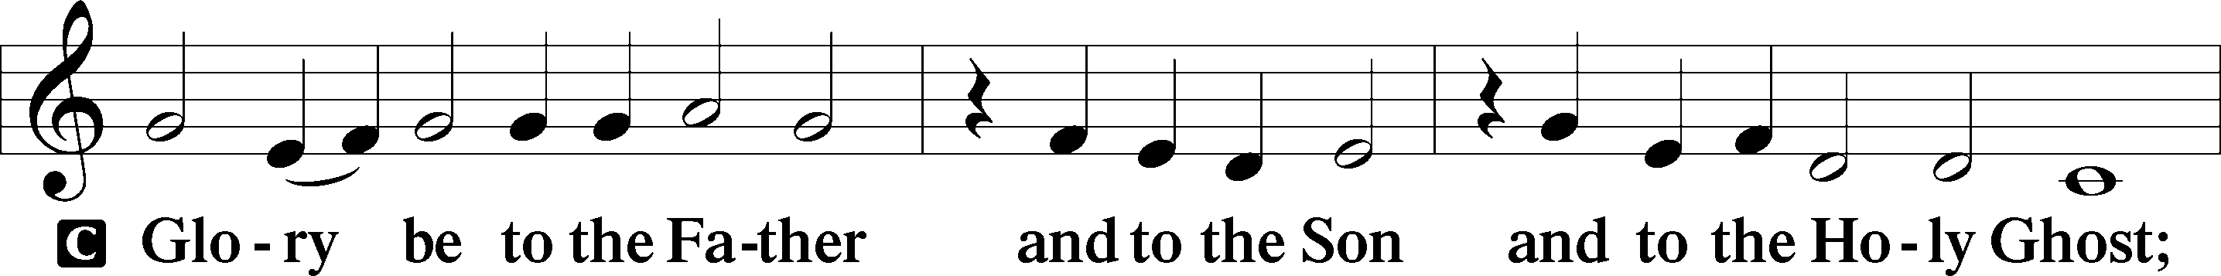
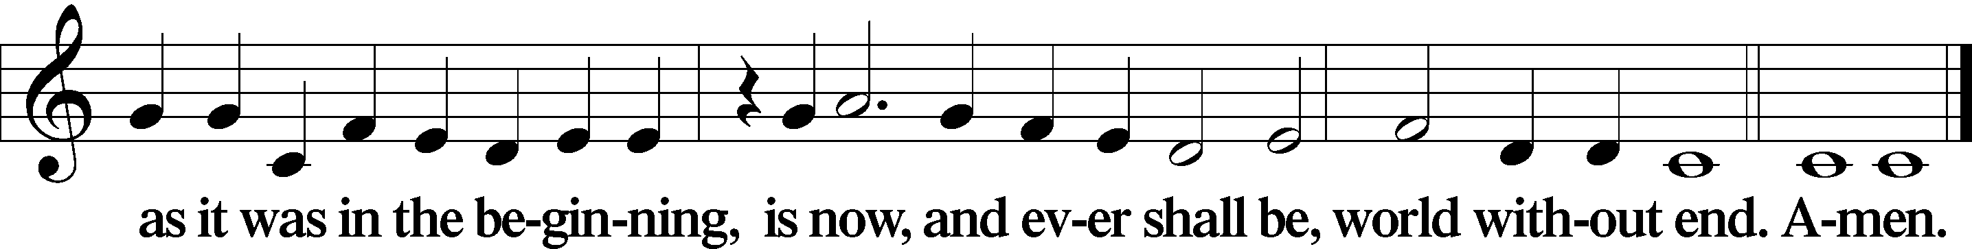

Kyrie Mark 10:47
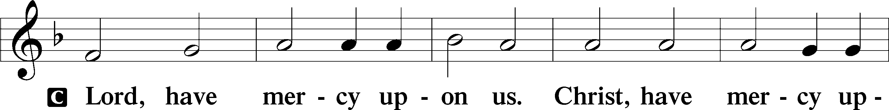
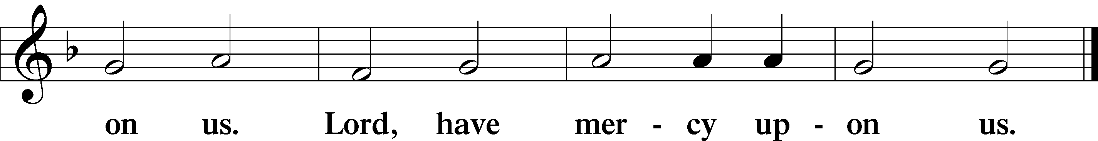

Gloria in Excelsis Luke 2:14; John 1:29
P Glory be to God on high:
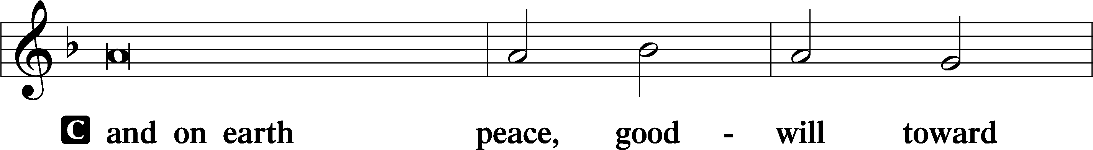
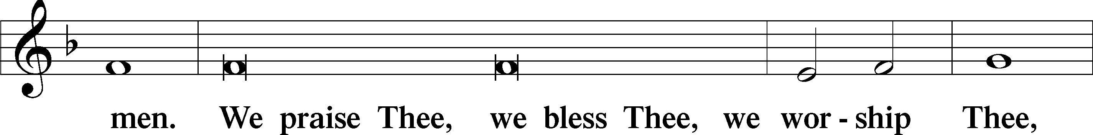
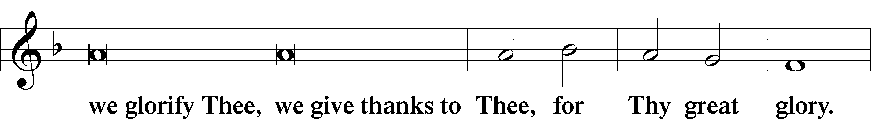
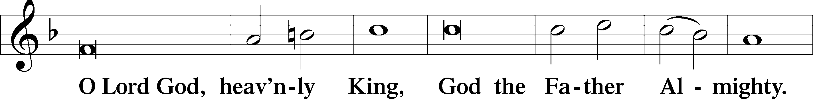
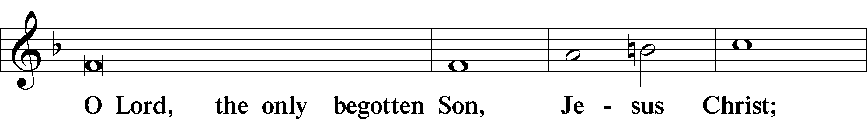
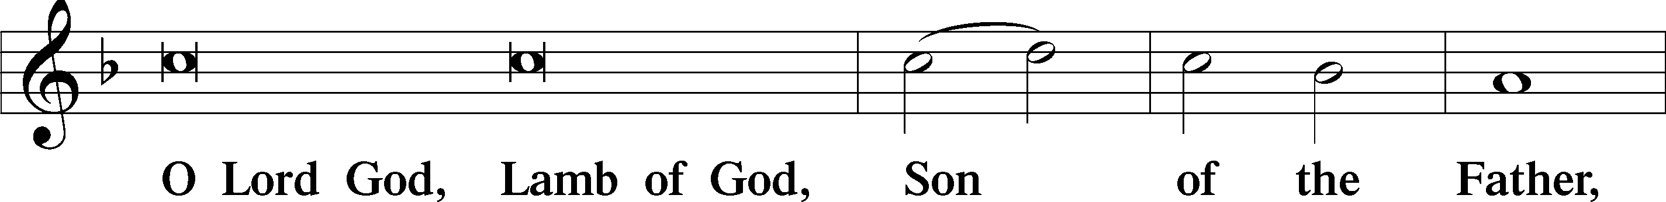
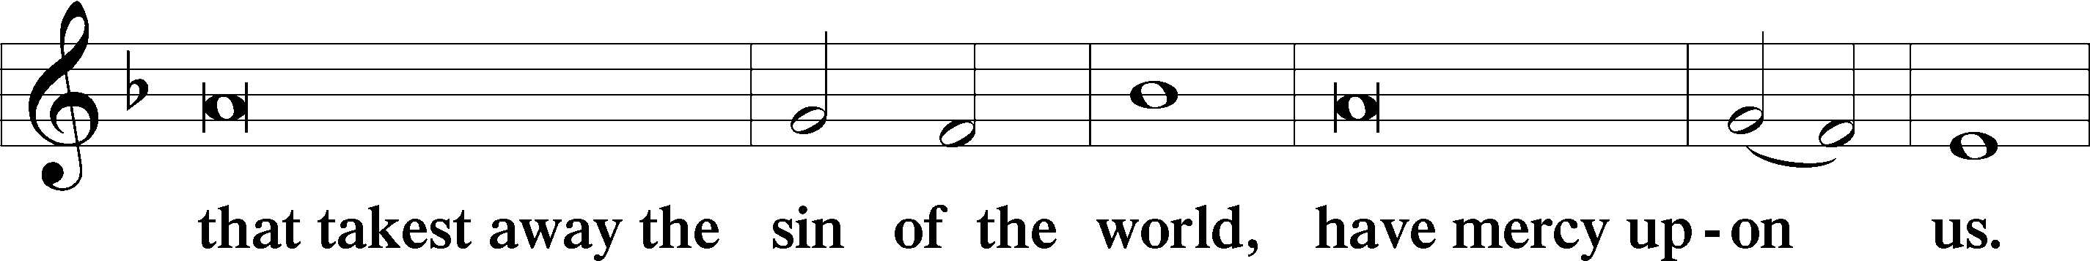
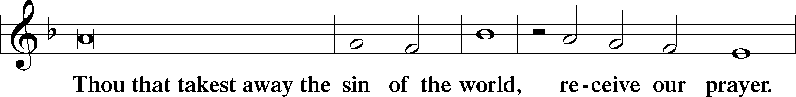
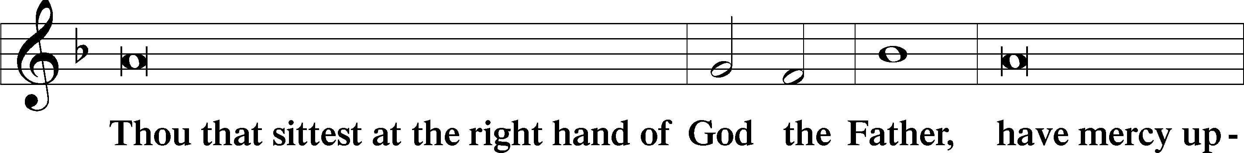
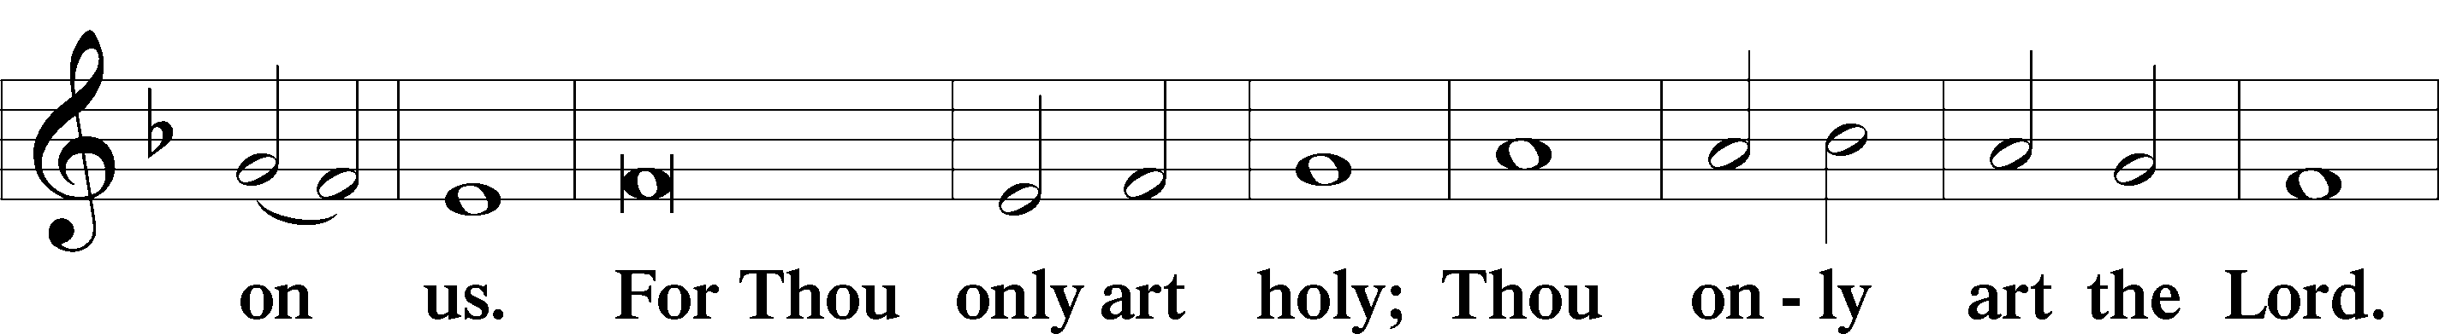
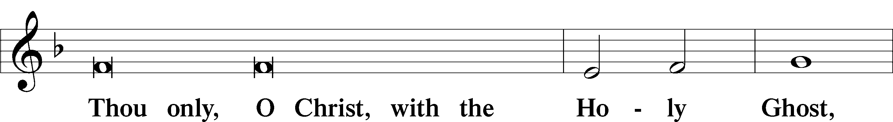
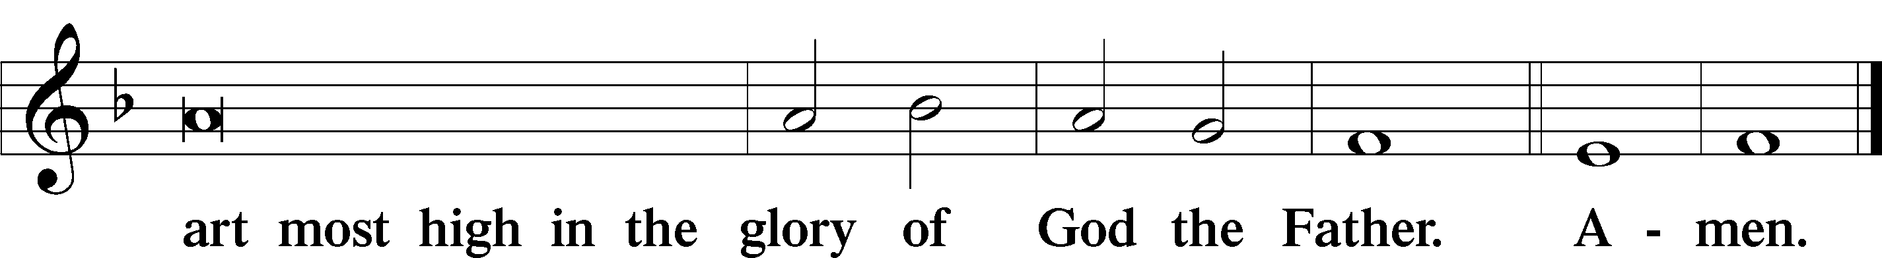

Salutation and Collect of the Day: Epiphany 2
P The Lord be with you.
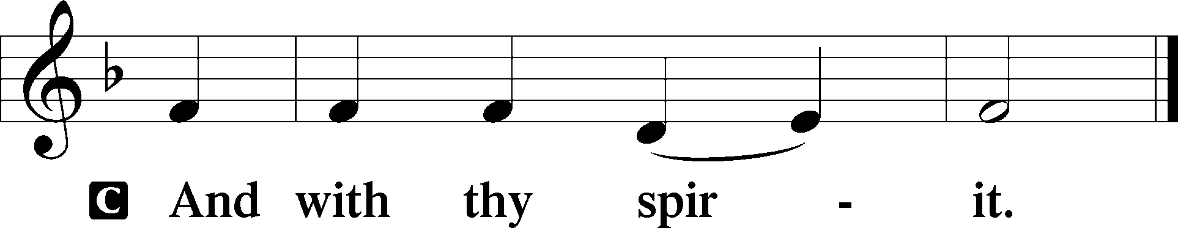

P Let us pray.
Almighty and everlasting God, who governs all things in heaven and on earth, mercifully hear the prayers of Your people and grant us Your peace through all our days; through Jesus Christ, Your Son, our Lord, who lives and reigns with You and the Holy Spirit, one God, now and forever.
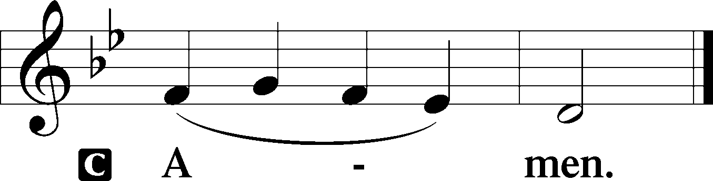
Sit

Prophecy: Amos 9:11–15 (NKJV)
Thus says the Lord God: “I will raise up the tabernacle of David, which has fallen down, and repair its damages; I will raise up its ruins, and rebuild it as in the days of old; that they may possess the remnant of Edom, and all the Gentiles who are called by My name,” says the Lord who does this thing. “Behold, the days are coming,” says the Lord, “When the plowman shall overtake the reaper, and the treader of grapes him who sows seed; the mountains shall drip with sweet wine, and all the hills shall flow with it. I will bring back the captives of My people Israel; they shall build the waste cities and inhabit them; they shall plant vineyards and drink wine from them; they shall also make gardens and eat fruit from them. I will plant them in their land, and no longer shall they be pulled up from the land I have given them,” says the Lord Almighty.

P This is the Word of the Lord.
C Thanks be to God.

Gradual Psalm 107:20–21
He sent out his word and | healed them,*
and delivered them from their de- | struction.
Let them thank the Lord for his | steadfast love,*
for his wondrous works to the chil- | dren of men!

Epistle: Romans 12:6–16a (NKJV)
Brethren: Having gifts differing according to the grace that is given to us, let us use them: if prophecy, let us prophesy in proportion to our faith; or ministry, let us use it in our ministering; he who teaches, in teaching; he who exhorts, in exhortation; he who gives, with liberality; he who leads, with diligence; he who shows mercy, with cheerfulness. Let love be without hypocrisy. Abhor what is evil. Cling to what is good. Be kindly affectionate to one another with brotherly love, in honor giving preference to one another; not lagging in diligence, fervent in spirit, serving the Lord; rejoicing in hope, patient in tribulation, continuing steadfastly in prayer; distributing to the needs of the saints, given to hospitality. Bless those who persecute you; bless and do not curse. Rejoice with those who rejoice, and weep with those who weep. Be of the same mind toward one another. Do not set your mind on high things, but associate with the humble.

P This is the Word of the Lord.
C Thanks be to God.

Stand
Verse Psalm 148:2
Alleluia. Praise him, all his angels; praise him, all his hosts! Alleluia.

Alleluia
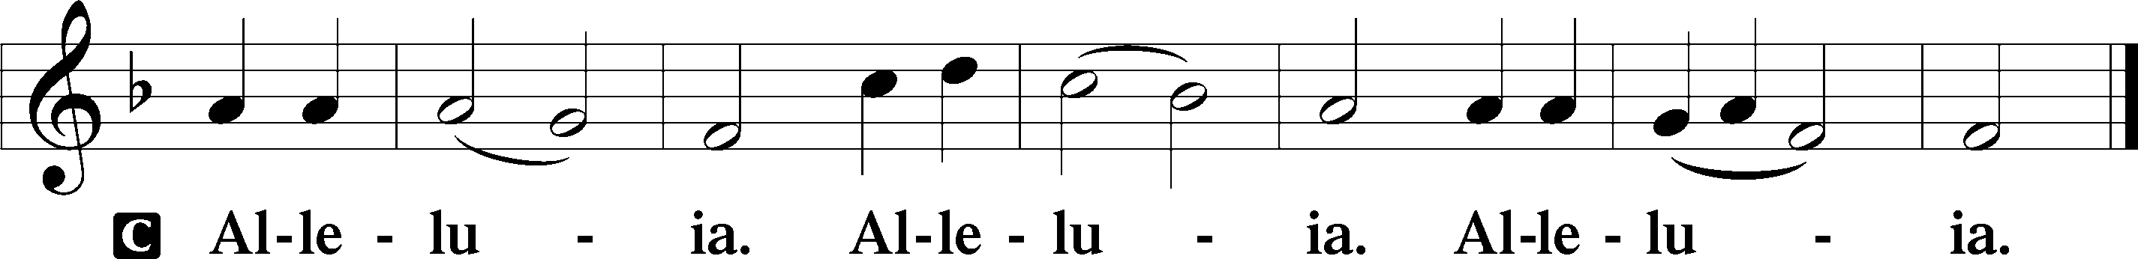

Holy Gospel: John 2:1–11 (NKJV)
P The Holy Gospel according to St. John, the second chapter.
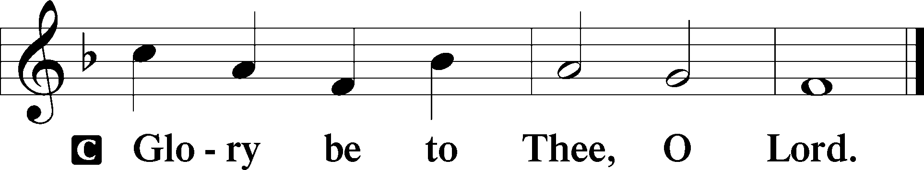

At that time: There was a wedding in Cana of Galilee, and the mother of Jesus was there. Now both Jesus and His disciples were invited to the wedding. And when they ran out of wine, the mother of Jesus said to Him, “They have no wine.” Jesus said to her, “Woman, what does your concern have to do with Me? My hour has not yet come.” His mother said to the servants, “Whatever He says to you, do it.” Now there were set there six waterpots of stone, according to the manner of purification of the Jews, containing twenty or thirty gallons apiece. Jesus said to them, “Fill the waterpots with water.” And they filled them up to the brim. And He said to them, “Draw some out now, and take it to the master of the feast.” And they took it. When the master of the feast had tasted the water that was made wine, and did not know where it came from (but the servants who had drawn the water knew), the master of the feast called the bridegroom. And he said to him, “Every man at the beginning sets out the good wine, and when the guests have well drunk, then the inferior. You have kept the good wine until now!” This beginning of signs Jesus did in Cana of Galilee, and manifested His glory; and His disciples believed in Him.

P This is the Gospel of the Lord.
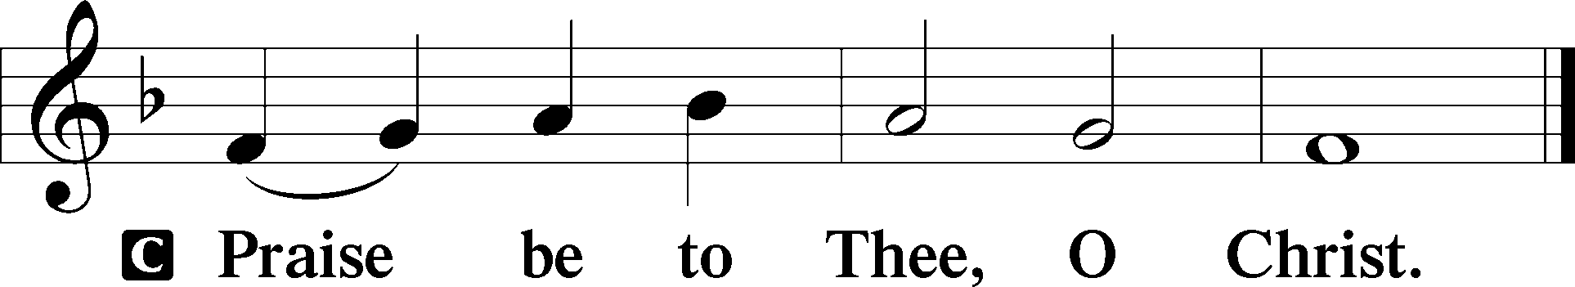

Nicene Creed
C I believe in one God,
the Father Almighty,
maker of heaven and earth
and of all things visible and invisible.

And in one Lord Jesus Christ,
the only-begotten Son of God,
begotten of His Father before all worlds,
God of God, Light of Light,
very God of very God,
begotten, not made,
being of one substance with the Father,
by whom all things were made;
who for us men and for our salvation came down from heaven
and was incarnate by the Holy Spirit of the virgin Mary
and was made man;
and was crucified also for us under Pontius Pilate.
He suffered and was buried.
And the third day He rose again according to the Scriptures
and ascended into heaven
and sits at the right hand of the Father.
And He will come again with glory to judge both the living and the dead,
whose kingdom will have no end.

And I believe in the Holy Spirit,
the Lord and giver of life,
who proceeds from the Father and the Son,
who with the Father and the Son together is worshiped and glorified,
who spoke by the prophets.
And I believe in one holy Christian and apostolic Church,
I acknowledge one Baptism for the remission of sins,
and I look for the resurrection of the dead
and the life T of the world to come. Amen.
Sit

Hymn of the Day: LSB #737 “Rejoice, My Heart, Be Glad and Sing”

Sermon

Installation of Congregational Officers

Recognition of Servants of the Congregation

Stand
Offertory Psalm 51:10–12
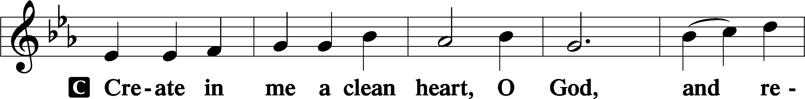
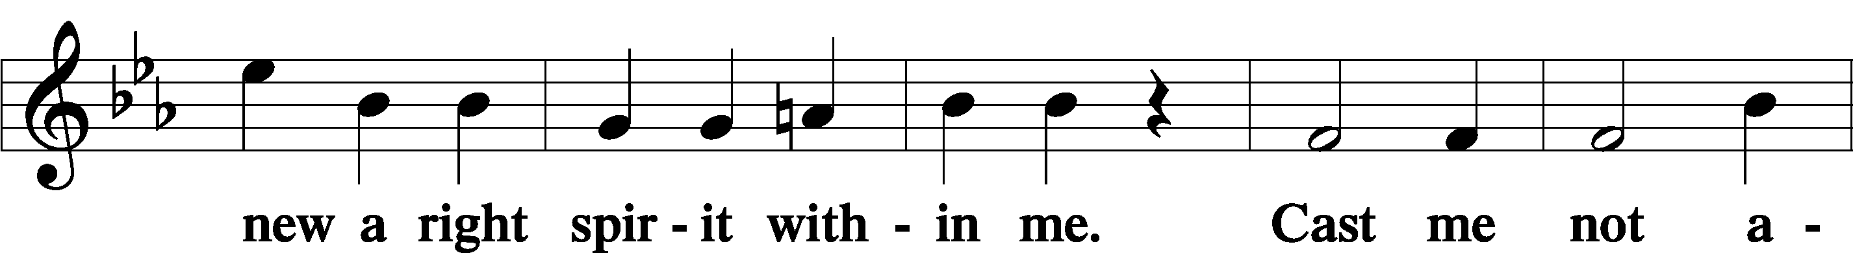
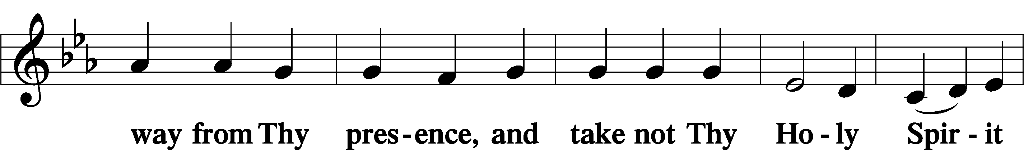
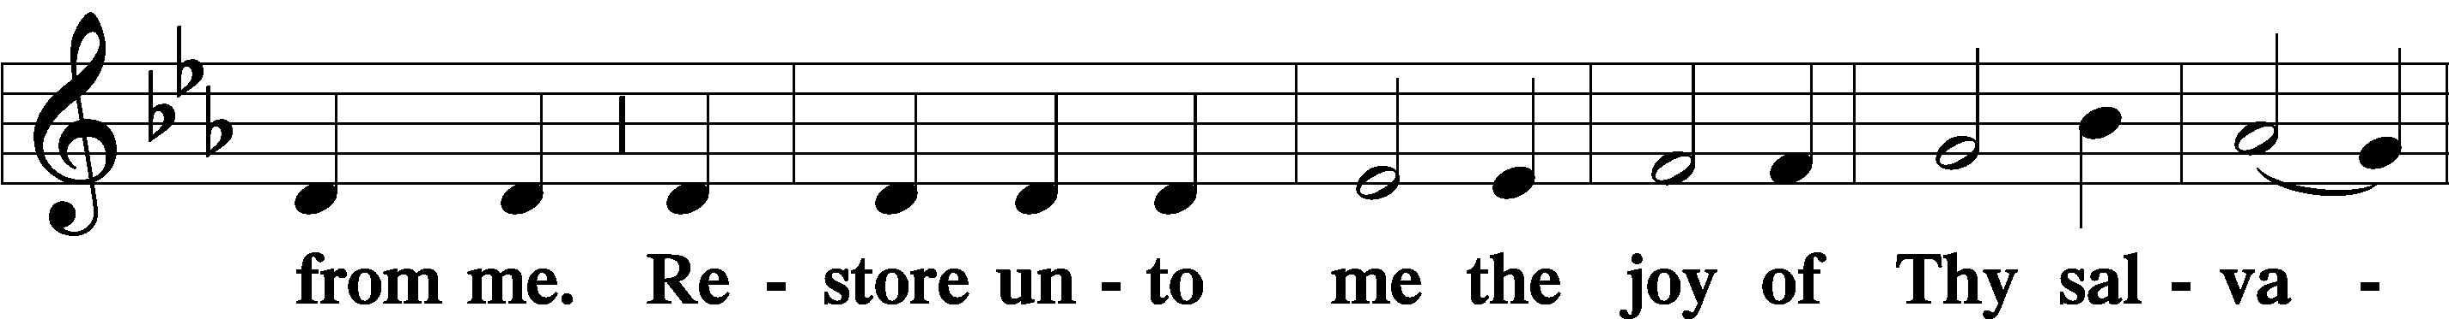
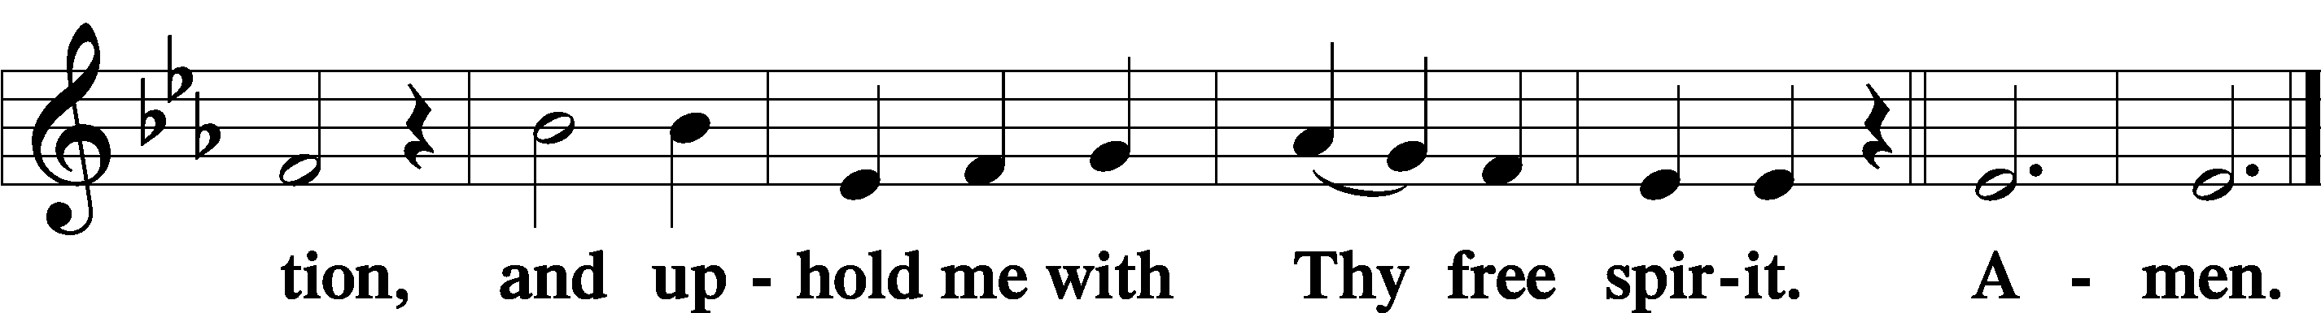

Prayer of the Church

Sit

Preparatory Hymn: LSB #637 “Draw Near and Take the Body of the Lord”

Stand
Service of the Sacrament

Preface 2 Timothy 4:22; Colossians 3:1 Psalm 136
P The Lord be with you.

P Lift up your hearts.
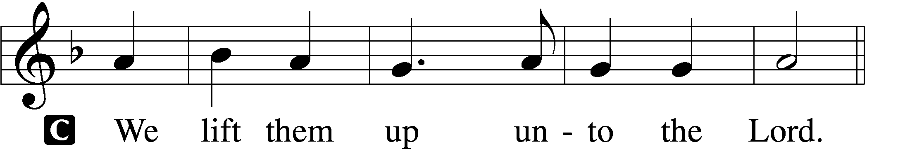

P Let us give thanks unto the Lord, our God.
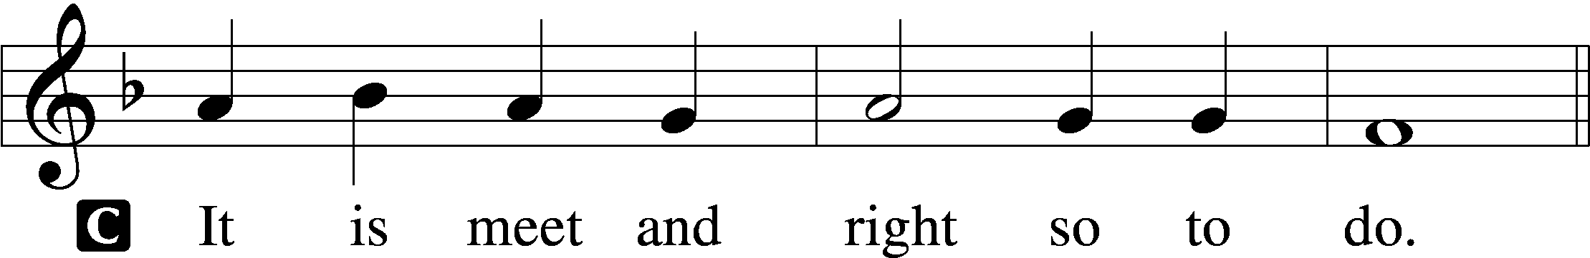

Proper Preface (Abbreviated) LSB 194
P It is truly meet, right, and salutary . . . evermore praising You and saying:

Sanctus Isaiah 6:3; Matthew 21:9
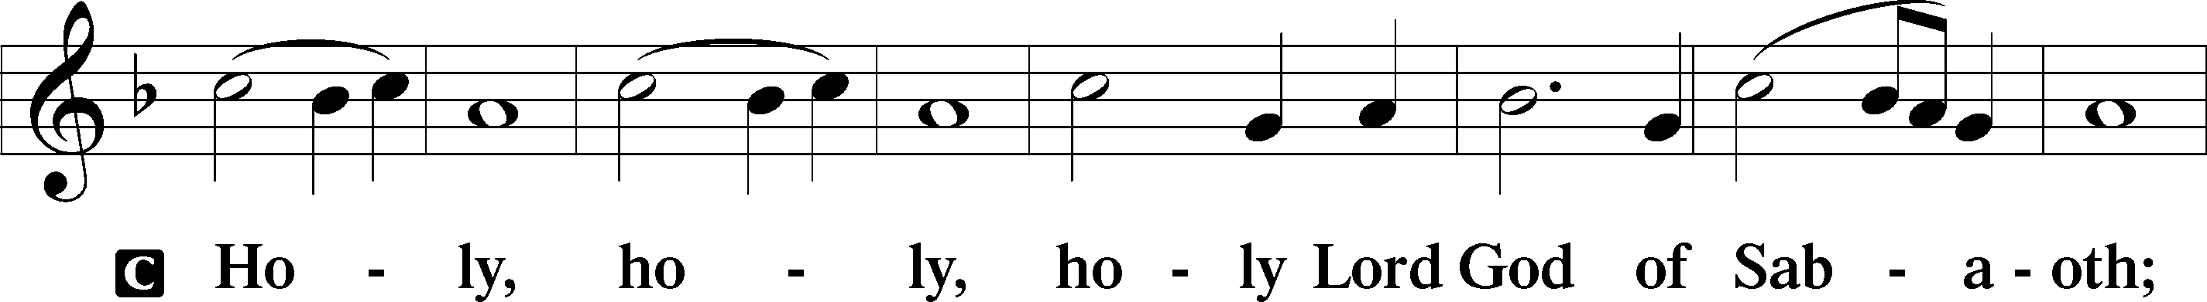
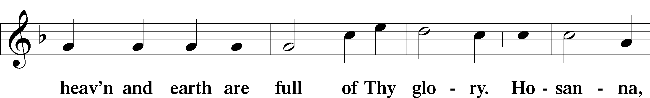
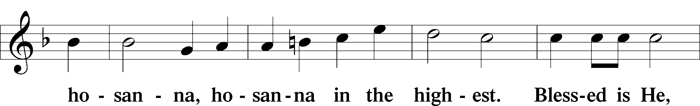
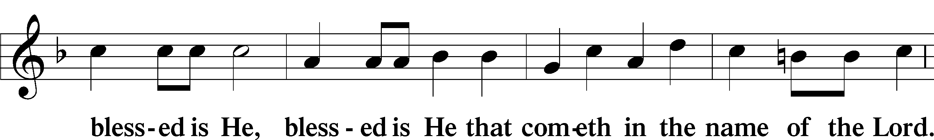
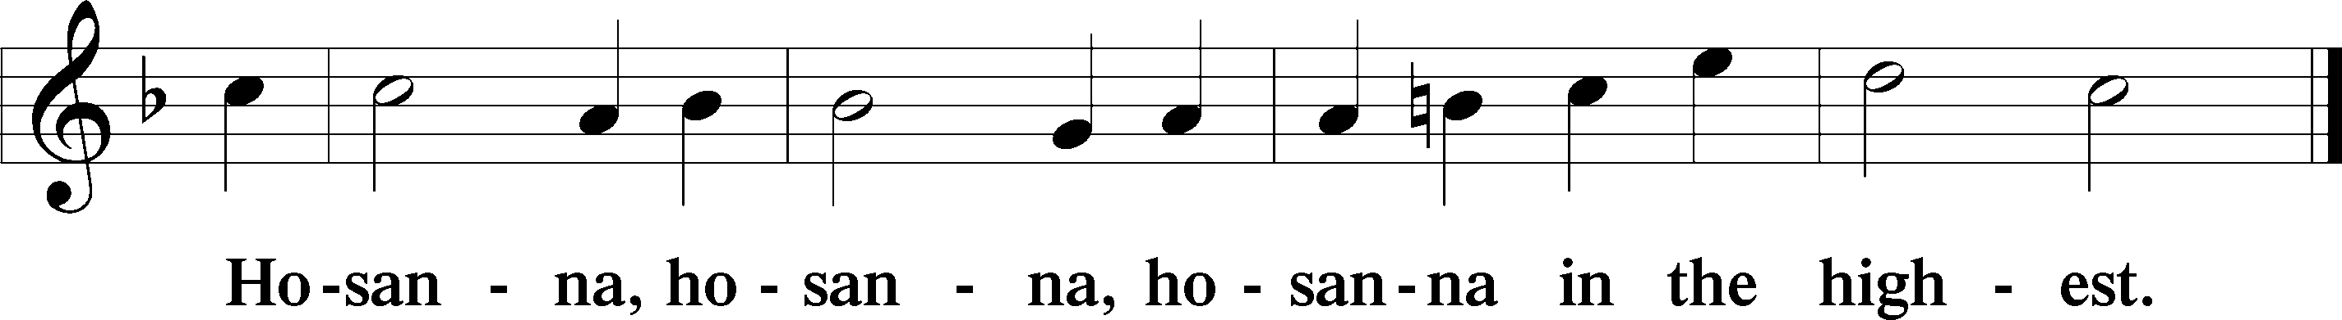

Lord’s Prayer The congregation is encouraged to silently pray the Lord’s Prayer as it is chanted. Matthew 6:9–13
P Our Father who art in heaven,
hallowed be Thy name,
Thy kingdom come,
Thy will be done on earth as it is in heaven;
give us this day our daily bread;
and forgive us our trespasses as we forgive those who trespass against us;
and lead us not into temptation,
but deliver us from evil.
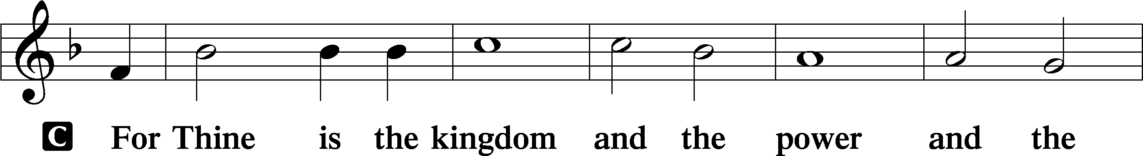
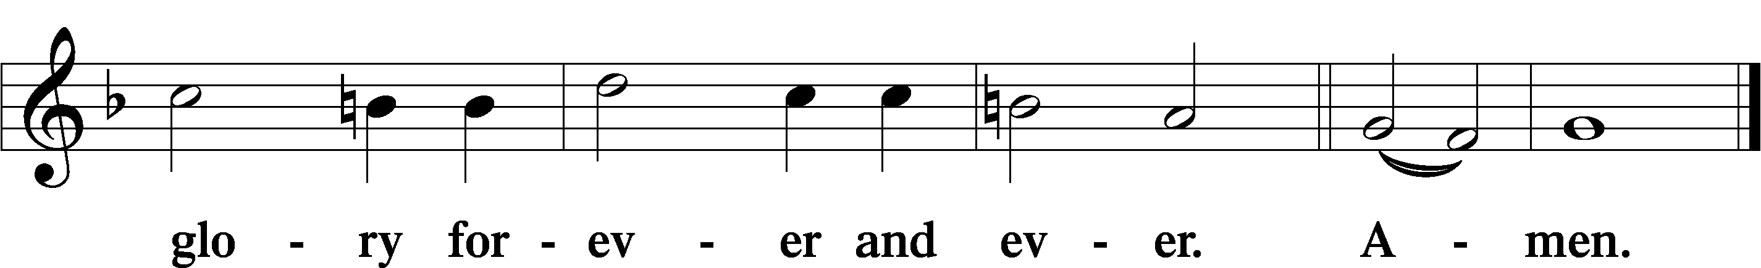

The Words of Our Lord Matthew 26:26–28; Mark 14:22–24; Luke 22:19–20; 1 Corinthians 11:23–25
P Our Lord Jesus Christ, on the night when He was betrayed, took bread, and when He had given thanks, He broke it and gave it to the disciples and said: “Take, eat; this is My T body, which is given for you. This do in remembrance of Me.”

In the same way also He took the cup after supper, and when He had given thanks, He gave it to them, saying: “Drink of it, all of you; this cup is the new testament in My T blood, which is shed for you for the forgiveness of sins. This do, as often as you drink it, in remembrance of Me.”

Pax Domini John 20:19
P The peace of the Lord be with you always.
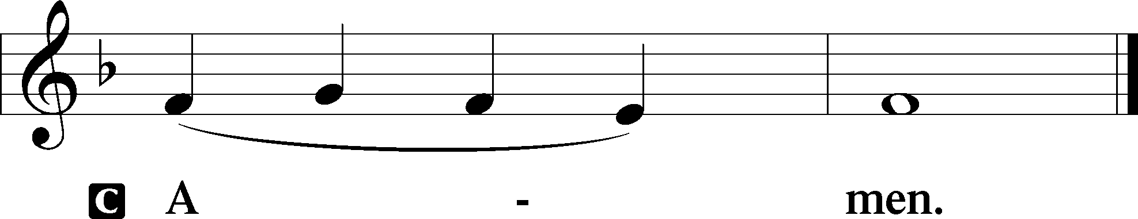

Agnus Dei John 1:29
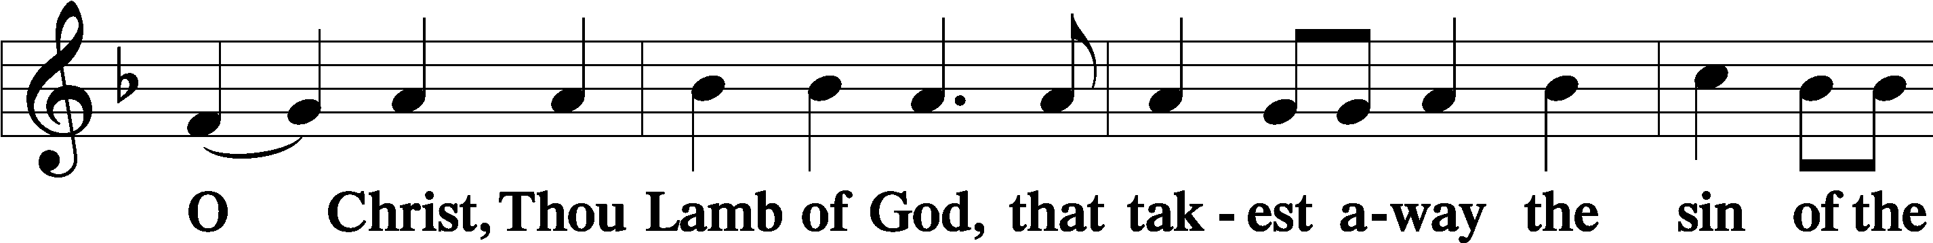
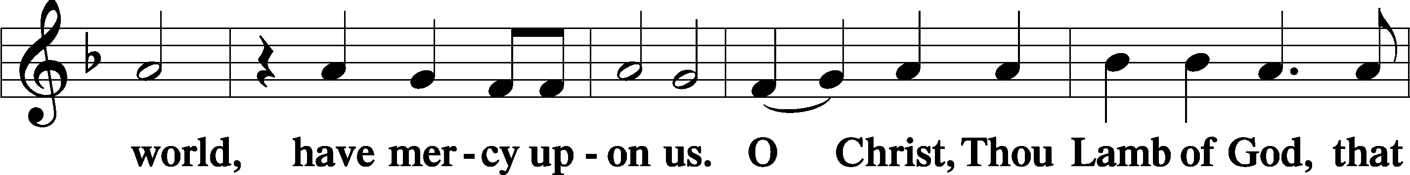
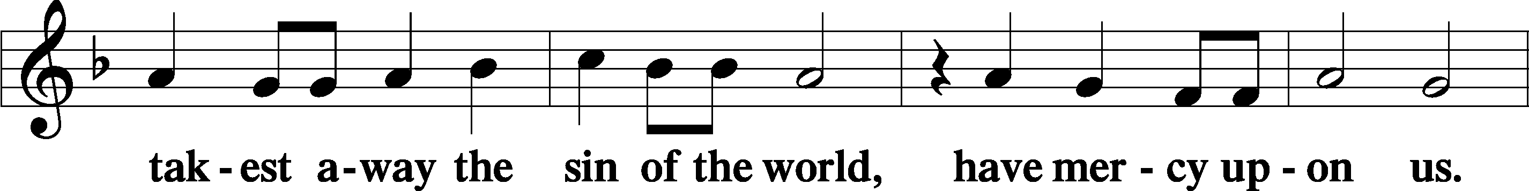
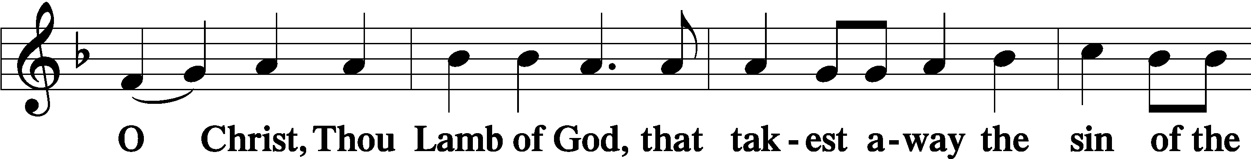
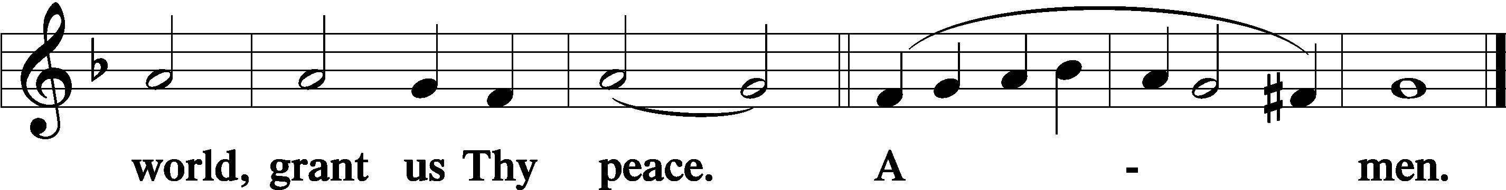
Sit

Distribution
The pastor and those who assist him receive the body and blood of Christ first and then distribute them to those who come to receive, saying:
Take, eat; this is the true body of our Lord and Savior Jesus Christ, given into death for your sins.
Amen.

Take, drink; this is the true blood of our Lord and Savior Jesus Christ, shed for the forgiveness of your sins.
Amen.

In dismissing the communicants, the following is said:
The Dismissal
P The body and blood of our Lord Jesus Christ strengthen and preserve you in body and soul to life everlasting. Depart T in peace.
C Amen.

Distribution Hymn: LSB #623 “Lord Jesus Christ, We Humbly Pray”

Distribution Hymn: LSB #631 “Here, O My Lord, I See Thee Face to Face”

Distribution Hymn: TLH #353 “Lord Jesus Christ, My Savior Blest”
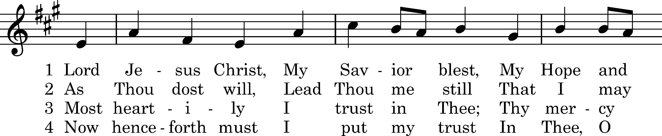
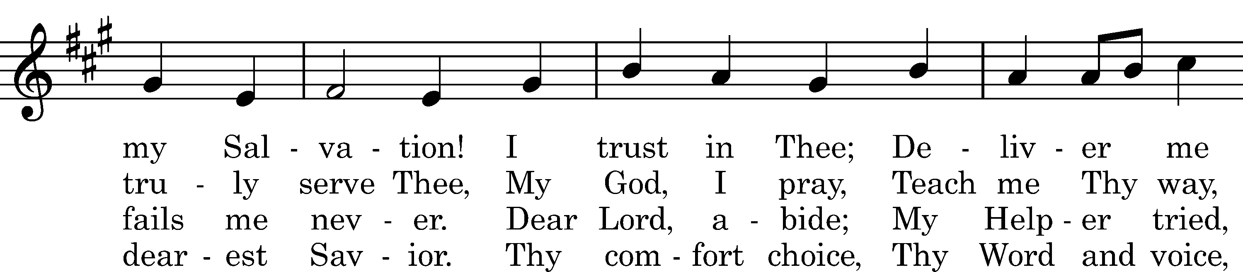
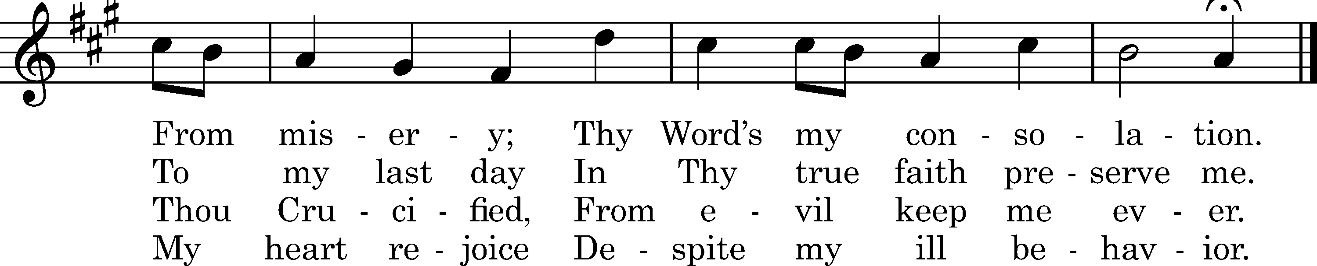

5 When sorrows rise, 6 I have Thy Word,
My refuge lies Christ Jesus, Lord;
In Thy compassion tender. Thou never wilt forsake me.
Within Thine arm This will I plead
Can naught alarm; In time of need.
Keep me from harm, Oh, help me speed
Be Thou my strong Defender. When troubles overtake me!

7 Grant, Lord, I pray,
Thy grace each day
That I, Thy Law revering,
May live with Thee
And happy be
Eternally,
Before Thy throne appearing.

Text: tr. Harriet R. Spaeth, 1898; Hans C. Sthen, c. 1500 Tune: Ludvig M. Lindeman, 1971 Text and tune: Public domain

Stand

Nunc Dimittis Luke 2:29–32
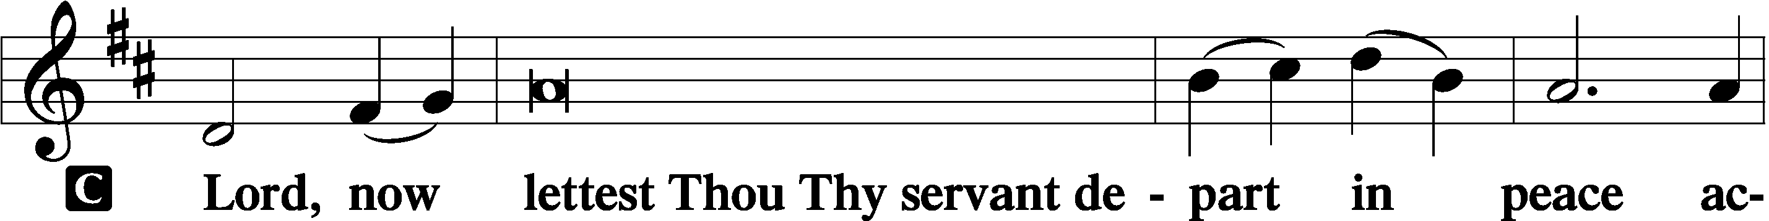
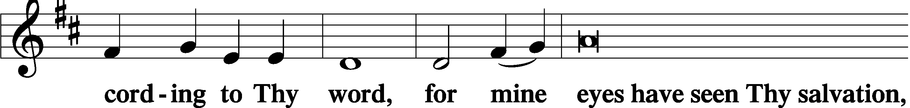
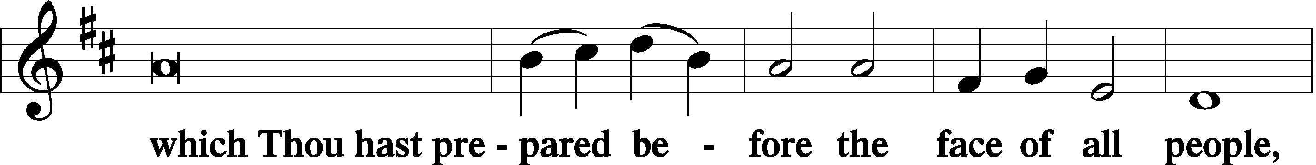
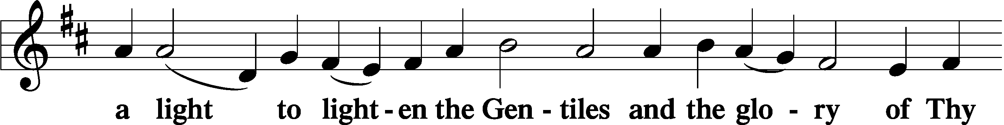
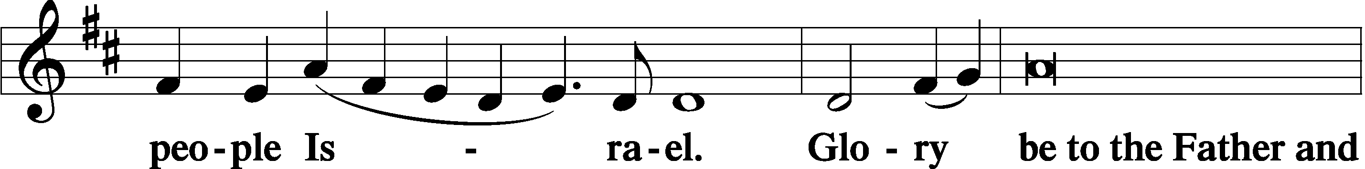
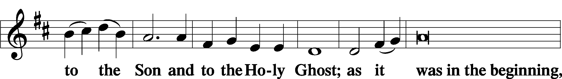
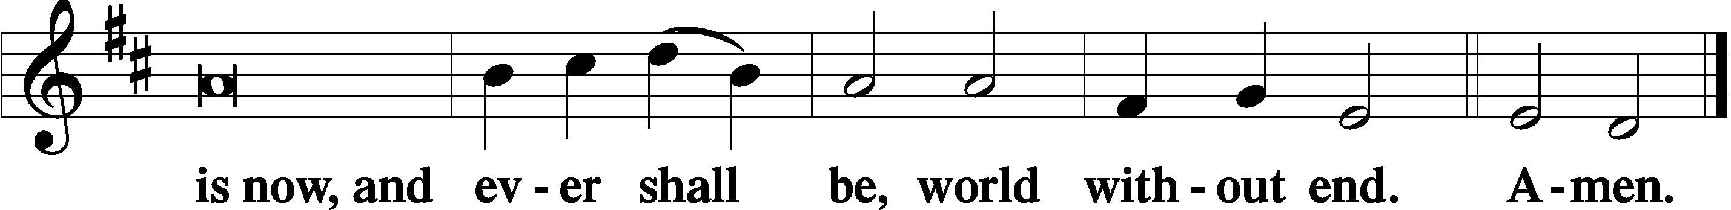

Thanksgiving Psalm 107:1
P O give thanks unto the Lord, for He is good,
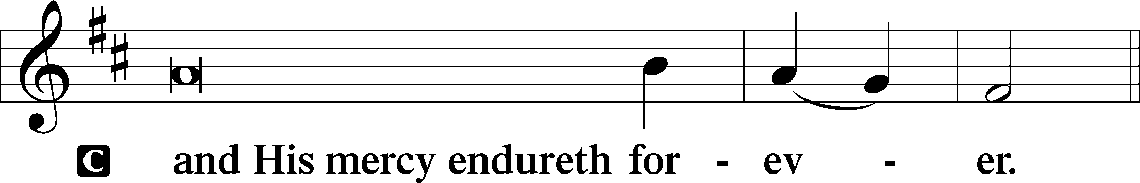

Post-Communion Collect
P Let us pray.
We give thanks to You, almighty God, that You have refreshed us through this salutary gift, and we implore You that of Your mercy You would strengthen us through the same in faith toward You and in fervent love toward one another; through Jesus Christ, Your Son, our Lord, who lives and reigns with You and the Holy Spirit, one God, now and forever.
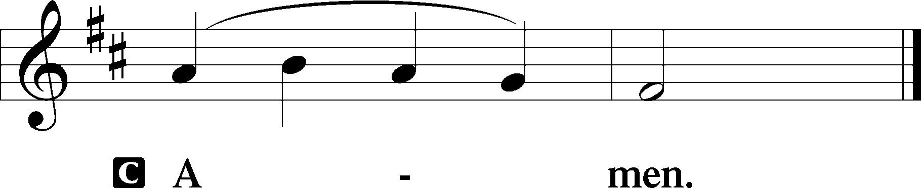

Salutation 2 Timothy 4:22
P The Lord be with you.
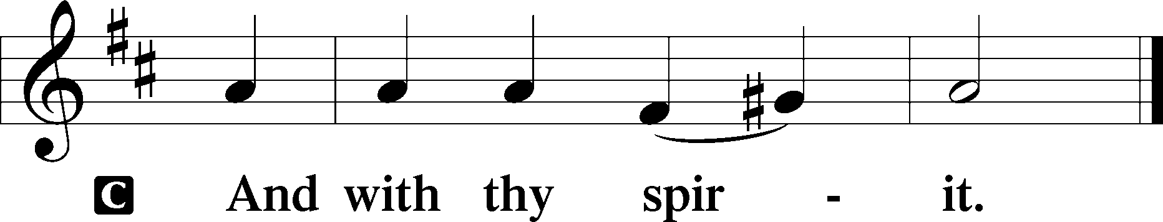

Benedicamus Psalm 103:1
P Bless we the Lord.
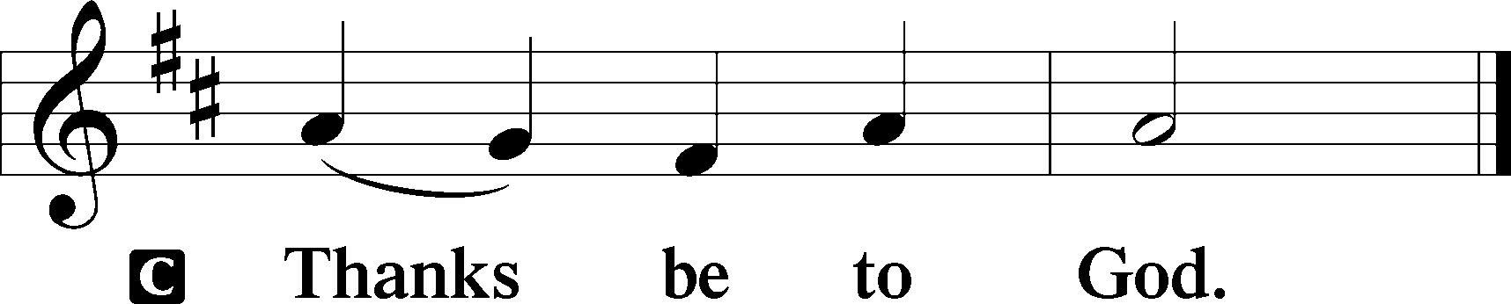

Benediction Numbers 6:24–26
P The Lord bless you and keep you.
The Lord make His face shine upon you and be gracious unto you.
The Lord lift up His countenance upon you and T give you peace.
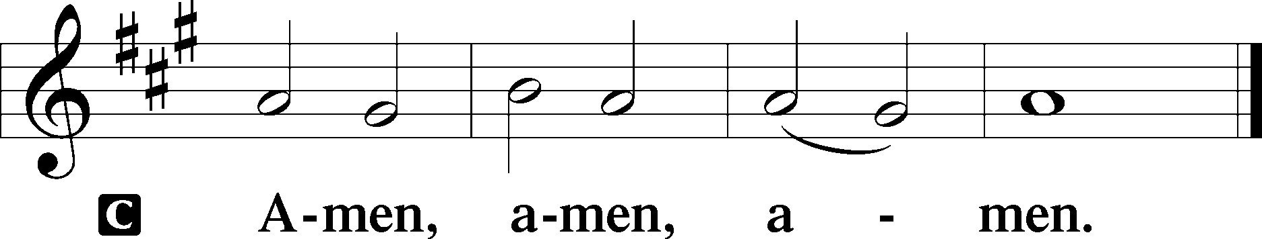

Closing Hymn: LSB #533 “Jesus Has Come and Brings Pleasure”

Silent prayer after worship: Lord Jesus, You have come to be my guide and Savior, cause me to trust in You not only for my eternal salvation, but also to trust that You guide and protect me each day until You return to receive me into heaven. Amen.

Acknowledgments
Unless otherwise indicated, Scripture quotations are from the ESV® Bible (The Holy Bible, English Standard Version®), copyright © 2001 by Crossway, a publishing ministry of Good News Publishers. Used by permission. All rights reserved.
Created by Lutheran Service Builder © 2024 Concordia Publishing House.
fffffffffffffffffffffffffffffffffff
THANK YOU FOR SERVING IN JANUARY: Elder: Jonathan Baisch; Ushers: Cheryl Fedele, Mike Flaugher, & Jesse Riffle; Altarware ~ Sundays: (prior) Marie Flaugher (01.14) & Diane Riefstahl (01.21 & 01.28); (after) Cheryl Fedele & Clara Krivosh.
fffffffffffffffffffffffffffffffffff
Attendance: Saturday, January 6, 2024: 13
Sunday, January 7, 2024: 38
fffffffffffffffffffffffffffffffffff
This morning is “Food Pantry Sunday”. Your financial donations to this cause are very much welcomed.

SCHEDULE THROUGH JANUARY 21, 2024:

:

Today, following Worship, Fellowship Hall: Coffee Fellowship
Following Worship, Library: Meeting for 2024 Financial Staff Members
7 pm, Fellowship Hall: AA Meeting
Tuesday, 7 pm, Library: Trustees Organizational Meeting
7-9 pm, Fellowship Hall: Penn-Ohio Singers
Wednesday, 7 pm, Fellowship Hall: NA Meeting
Thursday, 10 am, Fellowship Hall: Women’s Bible Study
Saturday, 1 pm, Sanctuary: Altar Guild Meeting
Next Sunday, 8 am, Downstairs: Bible Study
9 am, Sanctuary: Divine Service
Following Worship, Library: Quarterly and Monthly Audit
7 pm, Fellowship Hall: AA Meeting
fffffffffffffffffffffffffffffffffff
Our Stewardship of Treasures for the Lord:

Online Figure for Saturday, January 6, 2024
General Fund: $80.00
Figures for Saturday, January 6, 2024
General Fund: $850.00
SELC: $35.00
Quarterly Missions: $35.00
Capital Campaign: $125.00
Figures for Sunday, January 7, 2024
General Fund: $2,784.50
SELC: $115.00
Food Pantry: $100.00
Capital Campaign: $350.00

For online giving, check out https://www.saintspeterandpaul.net/online-giving.
fffffffffffffffffffffffffffffffffff
2024 Offering Envelopes are available in the church library. Please stop by and pick yours up!
fffffffffffffffffffffffffffffffffff
Remember the following in Prayer…
~The Hurting and Healing: Amy, Steve (cousin of Paul Andolina), Mary Jane Anderson, Steve Antolovich, Ellen Baron^{CA}, Amy Blomenberg, Lois Bortner^{CA}, Sara Brubaker and her son, Canaan; Dee Bullock, Bev & Joe Chlpka, Susan Davies, Loretta Deal, Tim Dudash, Judith & Eddy Furey, Griffin, Pastor Charles Henrickson, Joan, Keith Jozwiakowski, Rhyan Kirsch, Darla Krajci, Barbara Kreske, Jess Lavoie, Paul Lucas^{CA}, Sandy Marshall, Lynn Price, Juanita Rentschler, Richard Reuning^{CA}, Rosemary (Posey) Rice^{CA}, Nancy Robertson^{CA}, Kriss Svidro^{CA}, Rudy Tomko, Bob Usnarski, Joel & Peggy Wasson, Angela Weser^{CA}, Ruth Wolf, and Michelle Young.
~The Homebound: Anna Mae Daris, Millie Elavsky, Jean Tomko, Betty Wolf, and Ed & Millie Zachar.
~Celebrating this Week: Birthday: Evelyn Baisch (01.15).
~Serving in the Military: Alex (Sasha) Carr, Duncan Vaupel, Curtis Sinewe, and Joshua Solyan.
~Community & World Needs: Those suffering due to the conflicts in the Middle East and between Ukraine and Russia; those suffering from loss and dislocation because weather disasters; those suffering from addiction and their families; Local, State, and National Government Leaders; safety for all Police Officers, Firefighters, & First Responders; the unemployed; our First Quarter Local Mission: Community Outreach. *CA represents cancer.
fffffffffffffffffffffffffffffffffff
Join us following worship this morning for Coffee Fellowship. This month’s sponsors are Jonathan and Rebekah Baisch.
fffffffffffffffffffffffffffffffffff
UP-COMING MEETINGS:
Tuesday, January 16th: Trustees’ organizational meeting at 7 pm in the library.
Saturday, January 20th: Altar Guild meeting at 1 pm in the Fellowship Hall.
Sunday, January 21st: Auditors’ meeting following worship for a quarterly and monthly audit.
Monday, January 29th: Church Council meeting at 7 pm in the Fellowship Hall. (Reports are due to Diane by noon that day.)
fffffffffffffffffffffffffffffffffff

Bible Memory Verses ~ Week of January 14th:
For Adults: But he said to me, “My grace is sufficient for you, for my power is made perfect in weakness.” Therefore I will boast all the more gladly of my weaknesses, so that the power of Christ may rest upon me.
2 Corinthians 12:9

For Children: The law was given through Moses; grace and truth came through Jesus Christ. John 1:17
fffffffffffffffffffffffffffffffffff
Financial Staff Members are asked to meet in the library following worship this morning for a brief meeting.
fffffffffffffffffffffffffffffffffff
Items for the 2023 Annual Report and the February Calendar & Newsletter will be due to Diane on/before Monday, January 22nd.
fffffffffffffffffffffffffffffffffff
Please take home any poinsettias which you may have purchased for the Christmas season today. Unclaimed plants have been placed in the main hallway and will be discarded if not picked up following this morning’s service.
fffffffffffffffffffffffffffffffffff
Additional contact information:

Church Website …...…………………………www.saintspeterandpaul.net
Food Pantry (email): ……………foodpantry@saintspeterandpaul.net
AA Contact: Steve………………………………………………...…724-813-2358
NA Contact: Larry……………………………………..…………..724-977-8733
fffffffffffffffffffffffffffffffffff
If needing to get into the church building during the week, please phone first to make certain someone is here to let you in.

