Sts. Peter & Paul
Evangelical Lutheran Church
Lutheran Church-Missouri Synod
Founded-1917
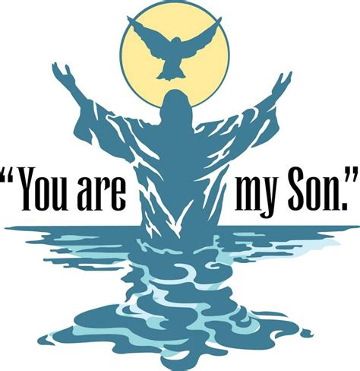
JANUARY 13, 2019

699 Stambaugh Avenue
Sharon, Pennsylvania 16146

“I was glad when they said to me,
Let us go to the house of the LORD!”
Psalm 122:1
Sts. Peter & Paul Evangelical Lutheran Church, LC-MS

THE BAPTISM OF OUR LORD
January 13, 2019

Silent prayer before worship: Heavenly Father, Your Son took upon Himself the sins of the world to grant eternal life to all who believe. By Your Holy Spirit, grant me faith to live each day to Your glory. In Jesus’ name. Amen.
CONFESSION AND ABSOLUTION
Opening Hymn: LSB #594 “God's Own Child, I Gladly Say It”
Stand

The sign of the cross may be made by all in remembrance of their Baptism.

P In the name of the Father and of the T Son and of the Holy Spirit.
C Amen. Matthew 28: 19b; (18:20)

P Beloved in the Lord! Let us draw near with a true heart and confess our sins unto God our Father, beseeching Him in the name of our Lord Jesus Christ to grant us forgiveness. [Hebrews 10:22]

P Our help is in the name of the Lord,
C who made heaven and earth. Psalm 124: 8
P I said, I will confess my transgressions unto the Lord,
C and You forgave the iniquity of my sin. Psalm 32: 5

Silence for reflection on God's Word and for self-examination.

P O almighty God, merciful Father,
C I, a poor, miserable sinner, confess unto You all my sins and iniquities with which I have ever offended You and justly deserved Your temporal and eternal punishment. But I am heartily sorry for them and sincerely repent of them, and I pray You of Your boundless mercy and for the sake of the holy, innocent, bitter sufferings and death of Your beloved Son, Jesus Christ, to be gracious and merciful to me, a poor, sinful being.

P Upon this your confession, I, by virtue of my office, as a called and ordained servant of the Word, announce the grace of God unto all of you, and in the stead and by the command of my Lord Jesus Christ I forgive you all your sins in the name of the Father and of the T Son and of the Holy Spirit.
[John 20: 19-23]
C Amen.

Passing of the Peace.
SERVICE OF THE WORD
Introit: Ps. 89:1, 26–28; antiphon: Liturgical Text; Ps. 89:20
Behold the Lord, the rul- | er, has come,*
and the kingdom and the power and the glory are | in his hand.
I have found David, my | servant;*
with my holy oil I have a- | nointed him.
I will sing of the steadfast love of the Lord, for- | ever;*
with my mouth I will make known your faithfulness to all gener- | ations.
He shall cry to me, “You are my | Father,*
my God, and the Rock of my sal- | vation.”
And I will make him the | firstborn,*
the highest of the kings | of the earth.
My steadfast love I will keep for him for- | ever,*
and my covenant will stand | firm for him.
Gloria Patri
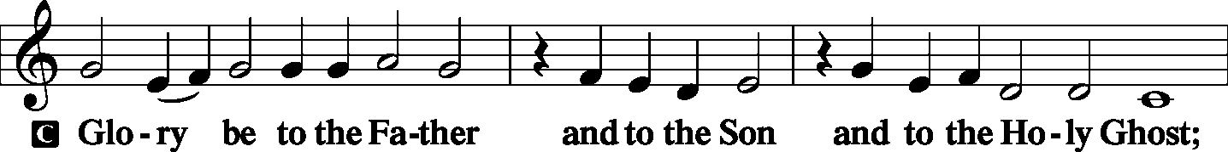
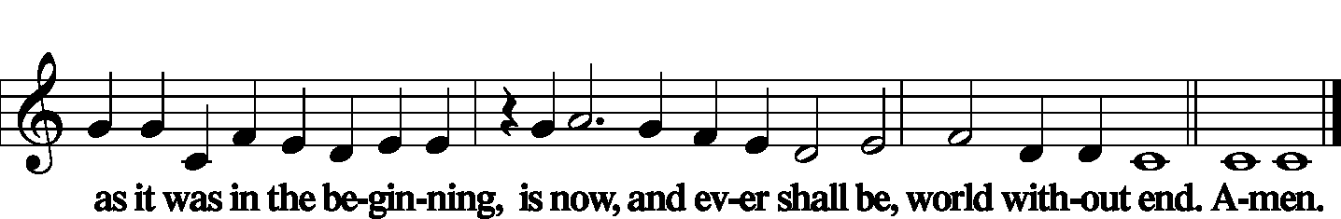

Kyrie Mark 10:47
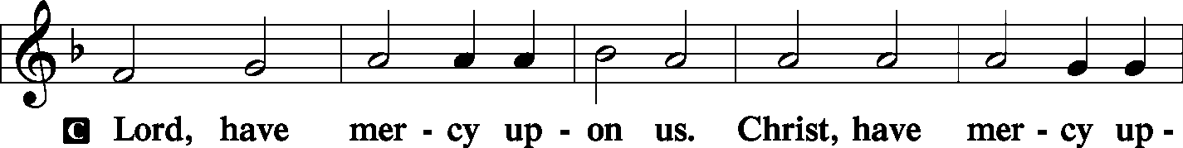
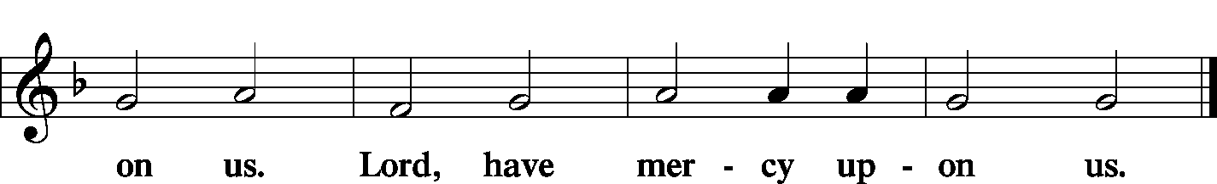

Gloria in Excelsis Luke 2: 14; John 1: 29
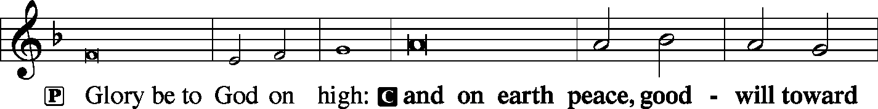
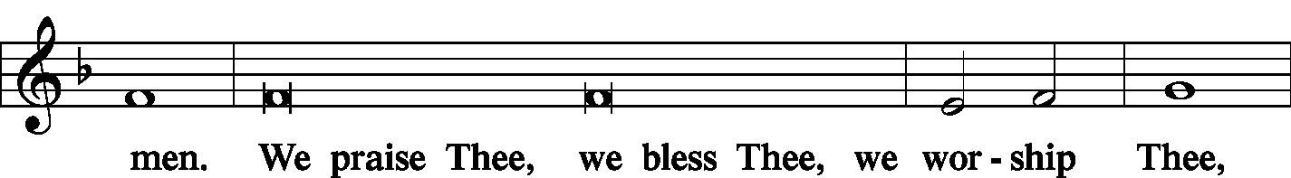
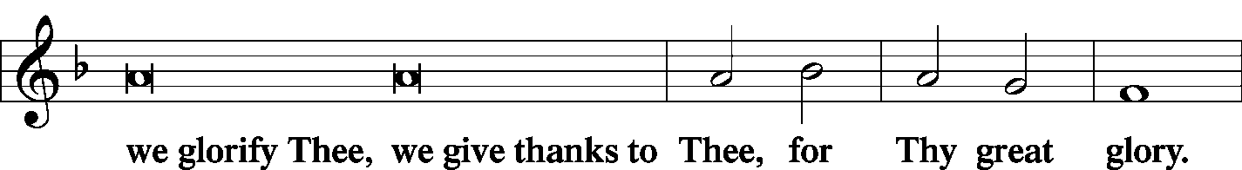
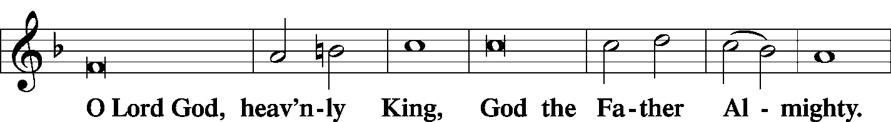
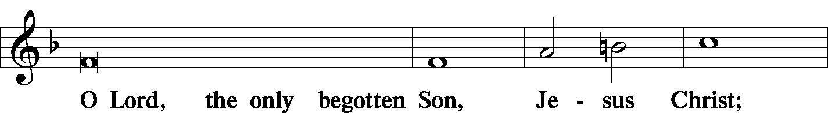
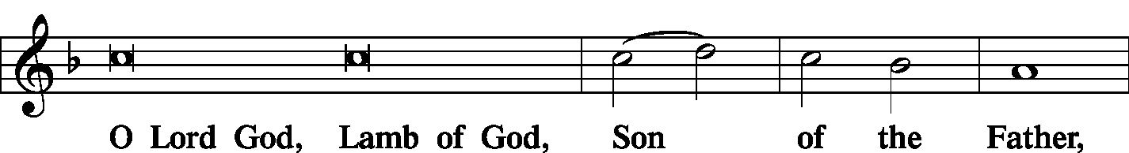
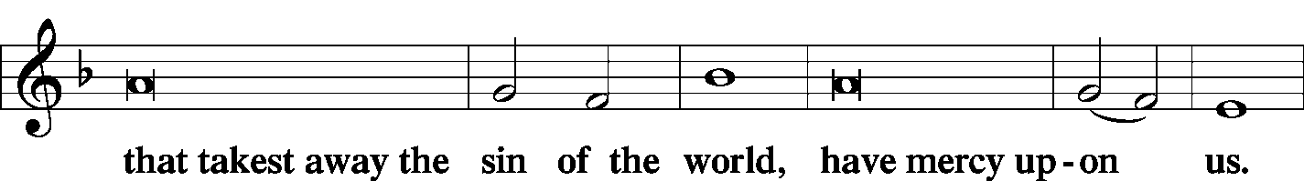
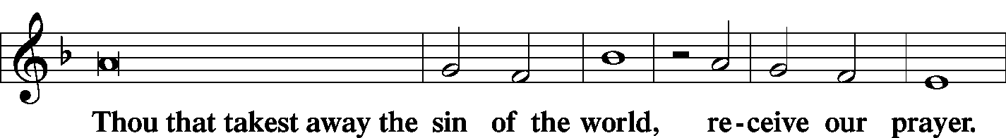
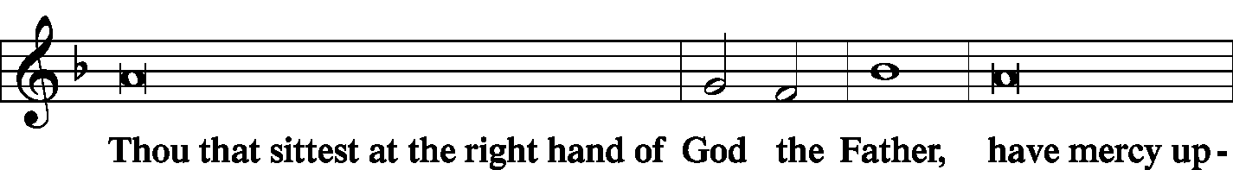
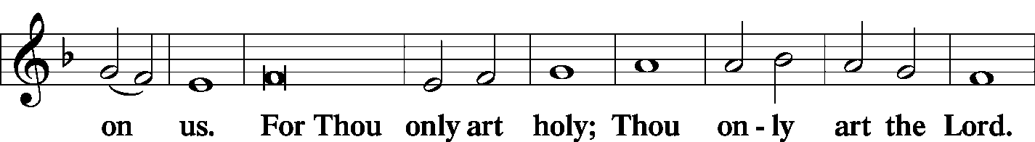
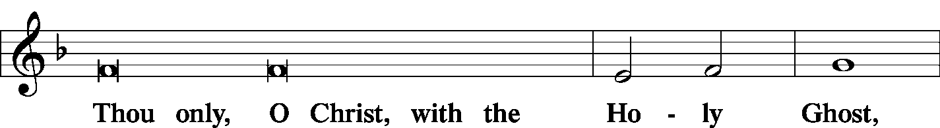
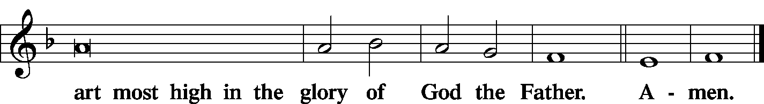

Salutation and Collect of the Day
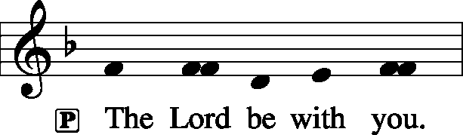 2 Timothy 4: 22
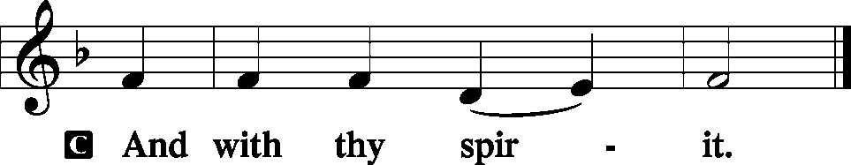

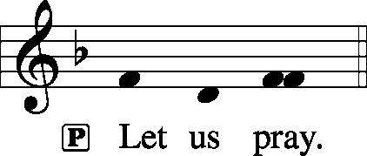

P Father in heaven, at the Baptism of Jesus in the Jordan River You proclaimed Him Your beloved Son and anointed Him with the Holy Spirit. Make all who are baptized in His name faithful in their calling as Your children and inheritors with Him of everlasting life; through the same Jesus Christ, our Lord, who lives and reigns with You and the Holy Spirit, one God, now and forever.

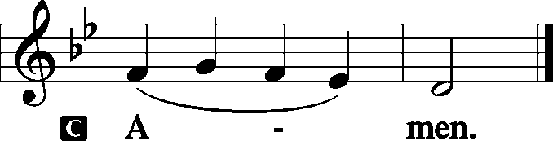

Sit

Old Testament Reading: Joshua 3:1–3, 7–8, 13–17
Then Joshua rose early in the morning and they set out from Shittim. And they came to the Jordan, he and all the people of Israel, and lodged there before they passed over. At the end of three days the officers went through the camp and commanded the people, “As soon as you see the ark of the covenant of the Lord your God being carried by the Levitical priests, then you shall set out from your place and follow it.
The Lord said to Joshua, “Today I will begin to exalt you in the sight of all Israel, that they may know that, as I was with Moses, so I will be with you. And as for you, command the priests who bear the ark of the covenant, ‘When you come to the brink of the waters of the Jordan, you shall stand still in the Jordan.’”
“And when the soles of the feet of the priests bearing the ark of the Lord, the Lord of all the earth, shall rest in the waters of the Jordan, the waters of the Jordan shall be cut off from flowing, and the waters coming down from above shall stand in one heap.”
So when the people set out from their tents to pass over the Jordan with the priests bearing the ark of the covenant before the people, and as soon as those bearing the ark had come as far as the Jordan, and the feet of the priests bearing the ark were dipped in the brink of the water (now the Jordan overflows all its banks throughout the time of harvest), the waters coming down from above stood and rose up in a heap very far away, at Adam, the city that is beside Zarethan, and those flowing down toward the Sea of the Arabah, the Salt Sea, were completely cut off. And the people passed over opposite Jericho. Now the priests bearing the ark of the covenant of the Lord stood firmly on dry ground in the midst of the Jordan, and all Israel was passing over on dry ground until all the nation finished passing over the Jordan.

P This is the Word of the Lord.
C Thanks be to God.

Gradual: Ps. 72:18–19
Blessèd be the Lord, the God of Israel,
who alone does wondrous things.
Blessèd be his glorious name forever;
may the whole earth be filled with his glory! Amen and Amen!

Epistle: 1 Corinthians 1:26–31
For consider your calling, brothers: not many of you were wise according to worldly standards, not many were powerful, not many were of noble birth. But God chose what is foolish in the world to shame the wise; God chose what is weak in the world to shame the strong; God chose what is low and despised in the world, even things that are not, to bring to nothing things that are, so that no human being might boast in the presence of God. He is the source of your life in Christ Jesus, whom God made our wisdom and our righteousness and sanctification and redemption. Therefore, as it is written, “Let the one who boasts, boast in the Lord.”

P This is the Word of the Lord.
C Thanks be to God.

Stand
Alleluia Verse and Alleluia
P Alleluia. Teach me to do your will, for you are my God! Let your good Spirit lead me on level ground! Alleluia.

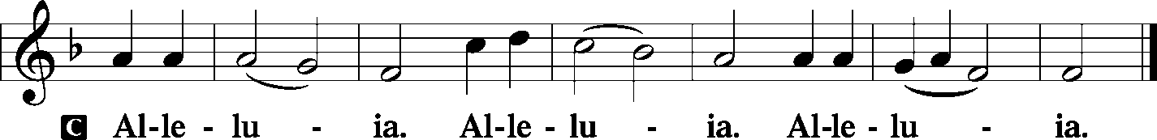

Holy Gospel: Matthew 3:13–17
P The Holy Gospel according to St. Matthew, the third chapter.

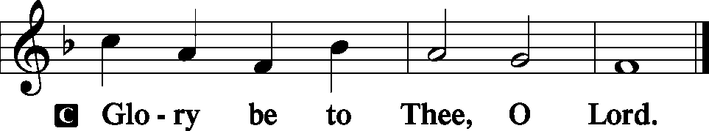

Then Jesus came from Galilee to the Jordan to John, to be baptized by him. John would have prevented him, saying, “I need to be baptized by you, and do you come to me?” But Jesus answered him, “Let it be so now, for thus it is fitting for us to fulfill all righteousness.” Then he consented. And when Jesus was baptized, immediately he went up from the water, and behold, the heavens were opened to him, and he saw the Spirit of God descending like a dove and coming to rest on him; and behold, a voice from heaven said, “This is my beloved Son, with whom I am well pleased.”

P This is the Gospel of the Lord.

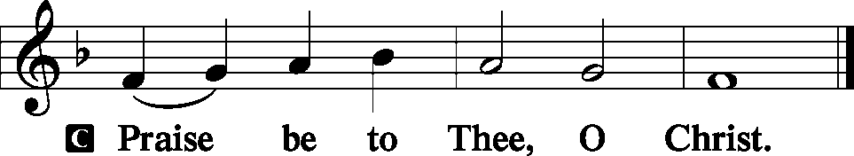

Nicene Creed
C I believe in one God,
the Father Almighty,
maker of heaven and earth
and of all things visible and invisible.
And in one Lord Jesus Christ,
the only-begotten Son of God,
begotten of His Father before all worlds,
God of God, Light of Light,
very God of very God,
begotten, not made,
being of one substance with the Father,
by whom all things were made;
who for us men and for our salvation came down from heaven
and was incarnate by the Holy Spirit of the virgin Mary
and was made man;
and was crucified also for us under Pontius Pilate.
He suffered and was buried.
And the third day He rose again according to the Scriptures
and ascended into heaven
and sits at the right hand of the Father.
And He will come again with glory to judge both the living and the dead,
whose kingdom will have no end.

And I believe in the Holy Spirit,
the Lord and giver of life,
who proceeds from the Father and the Son,
who with the Father and the Son together is worshiped and glorified,
who spoke by the prophets.

And I believe in one holy Christian and apostolic Church,
I acknowledge one Baptism for the remission of sins,
and I look for the resurrection of the dead
and the life T of the world to come. Amen.
Sit

Hymn of the Day: LSB #406 “To Jordan Came the Christ, Our Lord”

Sermon
Stand

P The peace of God, which passes all understanding, keep your hearts and minds in Christ Jesus. Philippians 4: 7
C Amen.

Prayer of the Church [Timothy 2: 1-4]
Sit

Offertory Psalm 51: 10-12
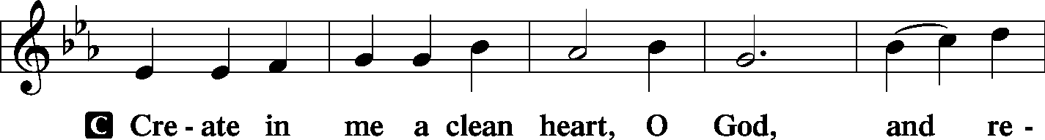
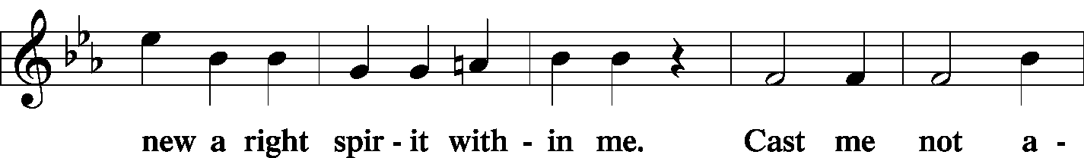
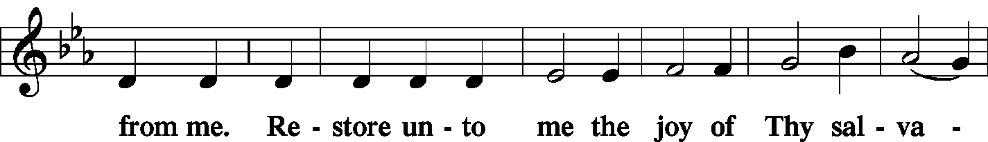
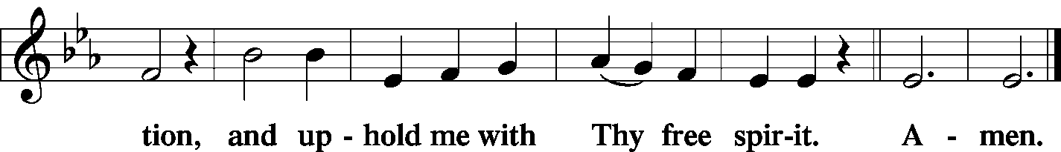

Stand
SERVICE OF THE SACRAMENT
Preface
2 Timothy 4: 22
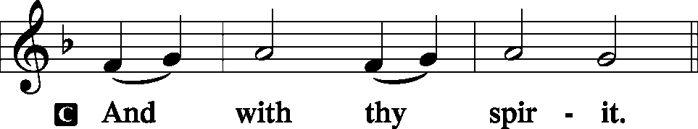
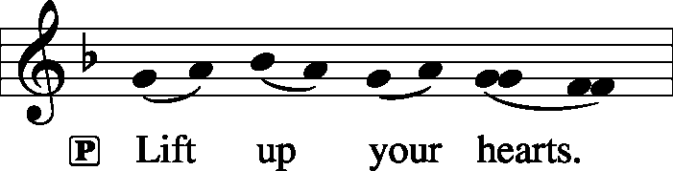 [Colossians 3:1]

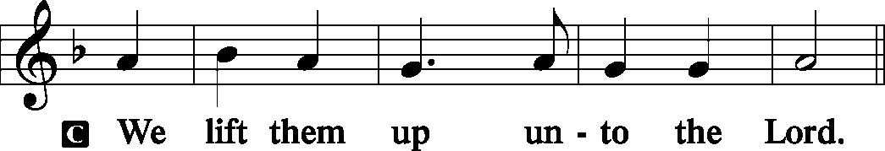

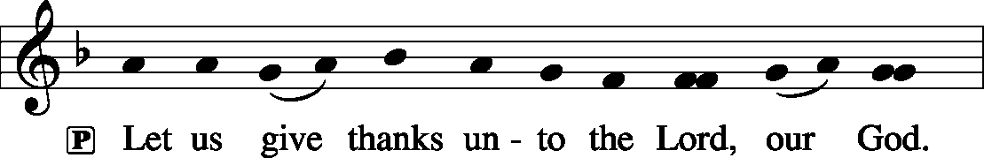 [Psalm 136]

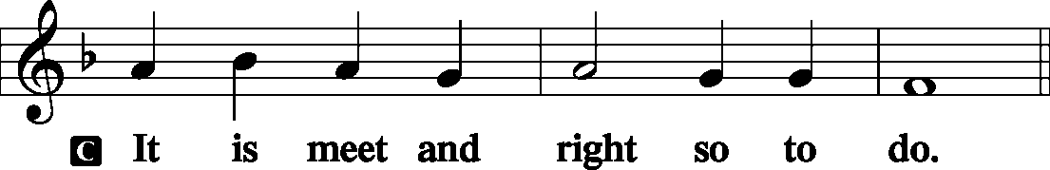

P It is truly meet, right, and salutary . . . evermore praising You and saying:

Sanctus Isaiah 6: 3; Matthew 21: 9
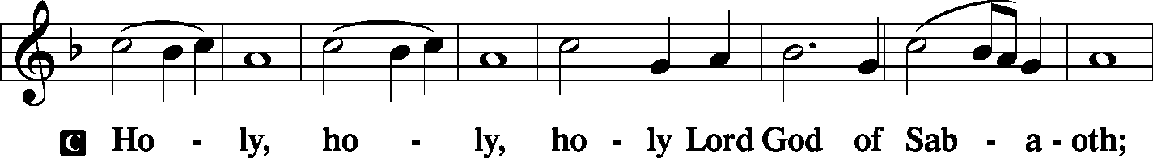
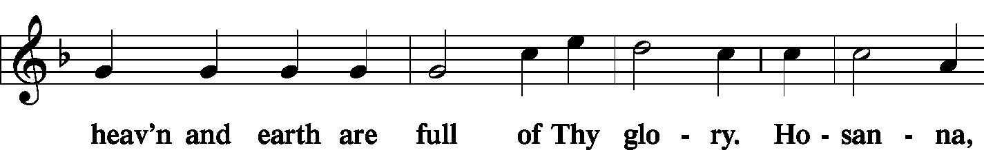
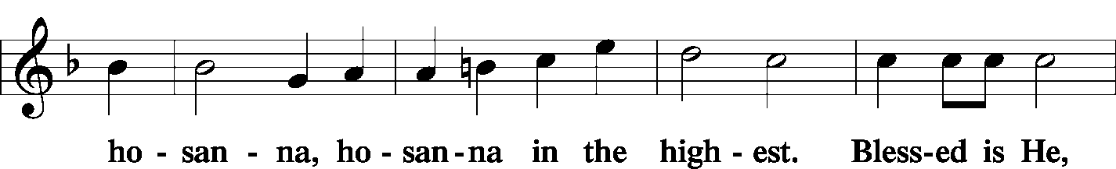
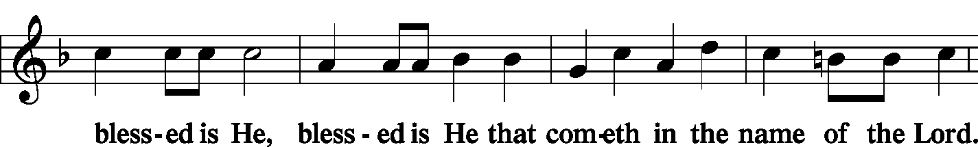
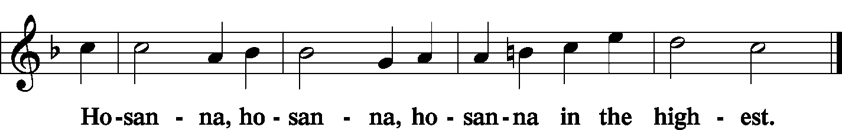

Lord's Prayer Matthew 6: 9-13
P Lord, remember us in Your kingdom and teach us to pray:
C Our Father who art in heaven,
hallowed be Thy name,
Thy kingdom come,
Thy will be done on earth as it is in heaven;
give us this day our daily bread;
and forgive us our trespasses as we forgive those who trespass against us;
and lead us not into temptation,
but deliver us from evil.
For Thine is the kingdom and the power and the glory forever and ever. Amen.

The Words of Our Lord Matthew 26: 26-28; Mark 14: 22-24
Luke 22: 19-20; 1 Corinthians 11: 23-25
P Our Lord Jesus Christ, on the night when He was betrayed, took bread, and when He had given thanks, He broke it and gave it to the disciples and said: “Take, eat; this is My T body, which is given for you. This do in remembrance of Me.”

P In the same way also He took the cup after supper, and when He had given thanks, He gave it to them, saying: “Drink of it, all of you; this cup is the new testament in My T blood, which is shed for you for the forgiveness of sins. This do, as often as you drink it, in remembrance of Me.”

Pax Domini John 20: 19
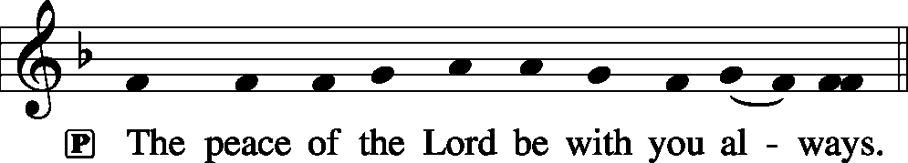
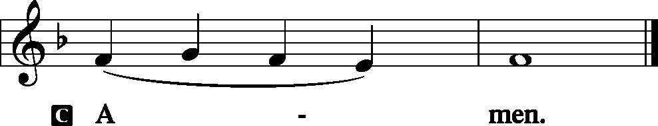

Agnus Dei John 1: 29
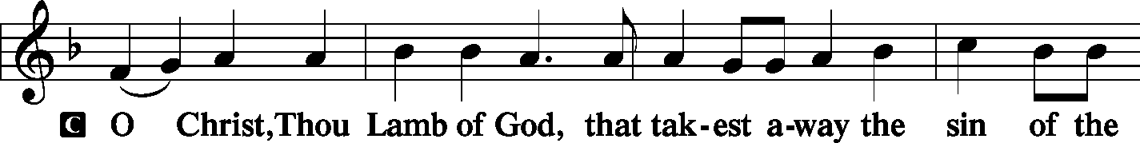
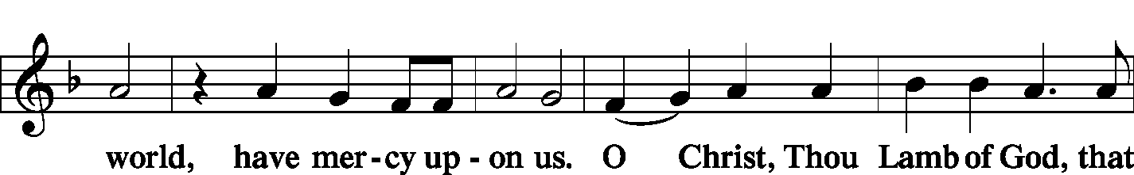
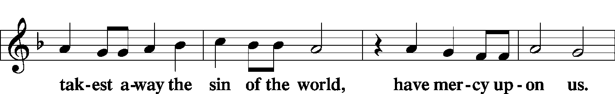
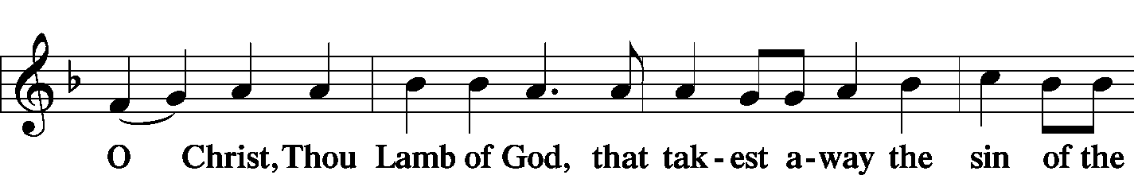
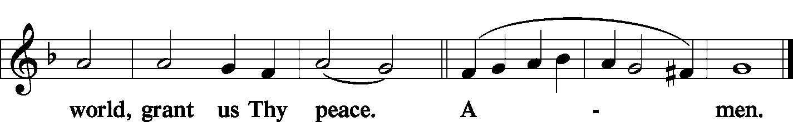
Sit

Distribution
The pastor and those who assist him receive the body and blood of Christ first and then distribute them to those who come to receive, saying:

Take, eat; this is the true body of our Lord and Savior Jesus Christ, given into death for your sins.
Amen.

Take, drink; this is the true blood of our Lord and Savior Jesus Christ, shed for the forgiveness of your sins.
Amen.

In dismissing the communicants, the following is said:
P The body and blood of our Lord Jesus Christ strengthen and preserve you in body and soul to life everlasting. Depart T in peace.
C Amen.

Distribution Hymn: LSB #575 “My Hope Is Built on Nothing Less”

Stand

Post-Communion Canticle: Nunc Dimittis Luke 2: 29-32
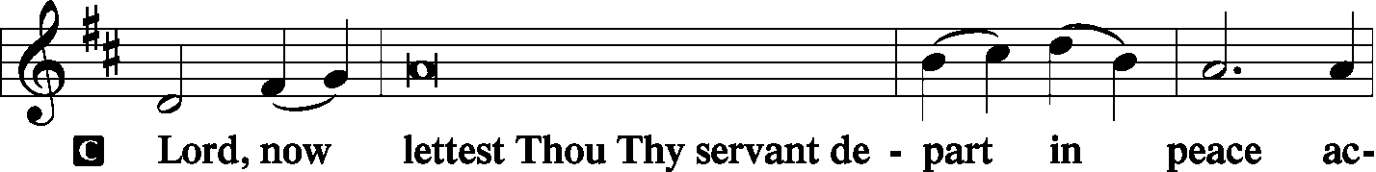
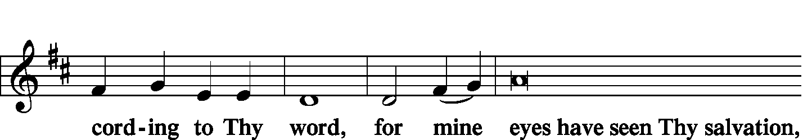
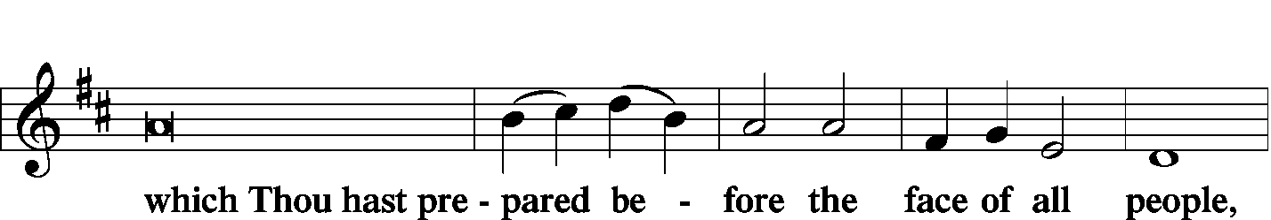
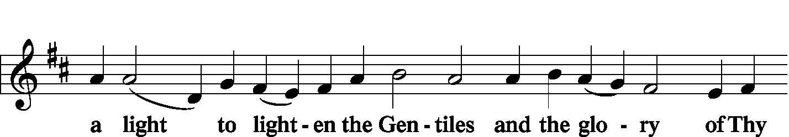
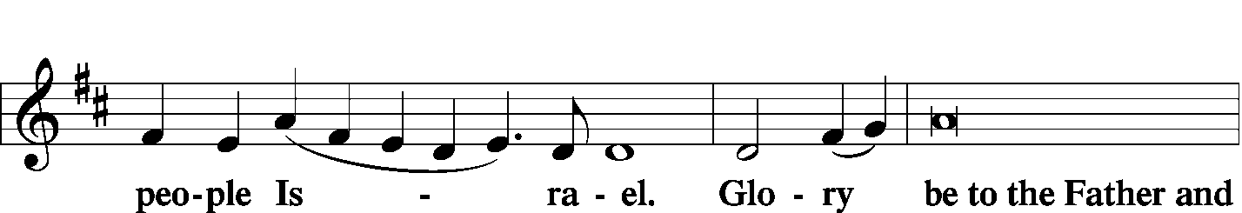
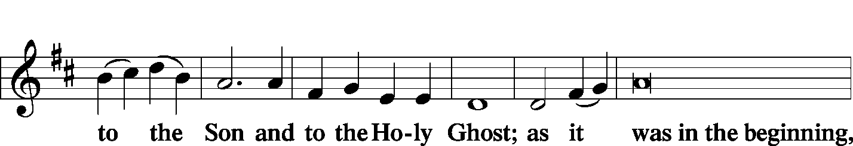
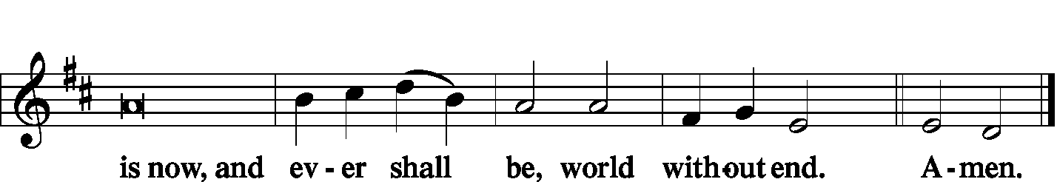
Thanksgiving Psalm 107: 1
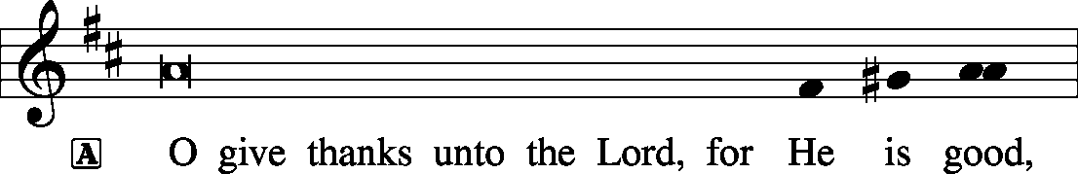
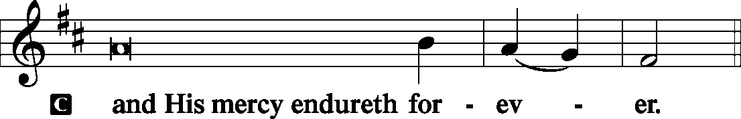

P Let us pray.
We give thanks to You, almighty God, that You have refreshed us through this salutary gift, and we implore You that of Your mercy You would strengthen us through the same in faith toward You and fervent love toward one another; through Jesus Christ, Your Son, our Lord, who lives and reigns with You and the Holy Spirit, one God, now and forever.
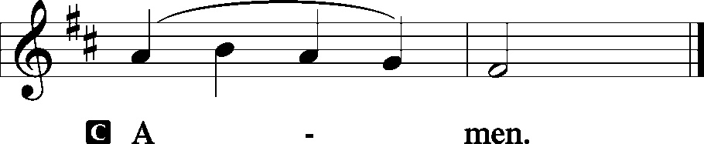
Salutation and Benedicamus
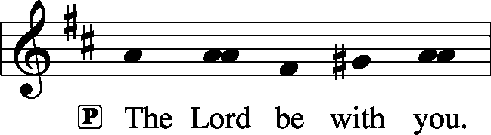 2 Timothy 4: 22

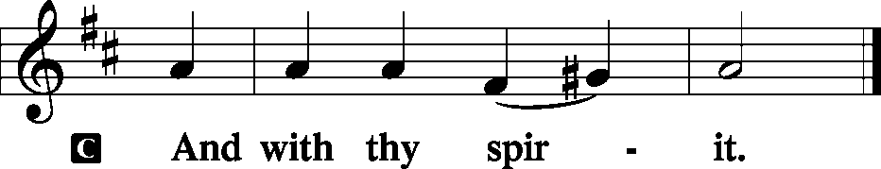
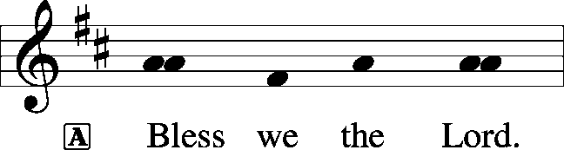 [Psalm 103: 1]

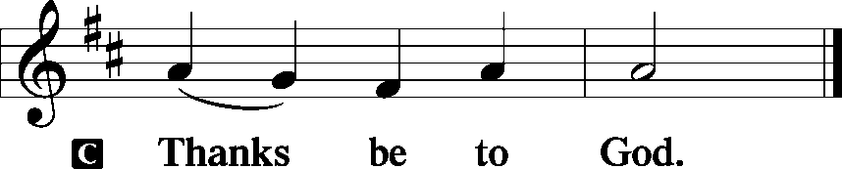

Benediction Numbers 6: 24-26
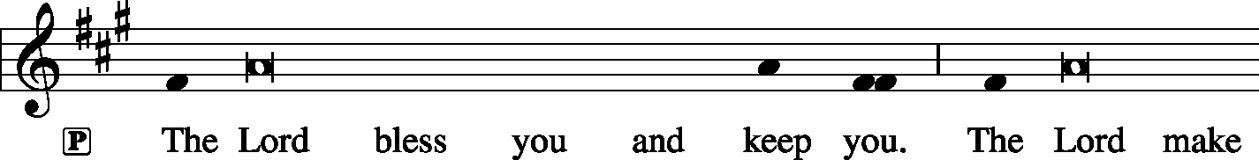
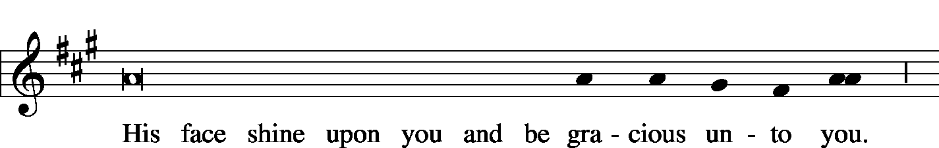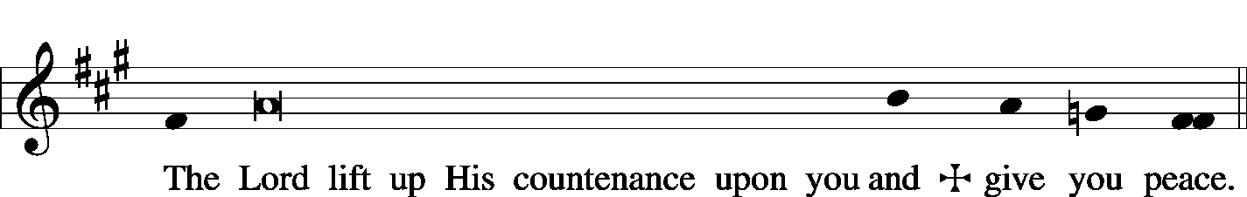

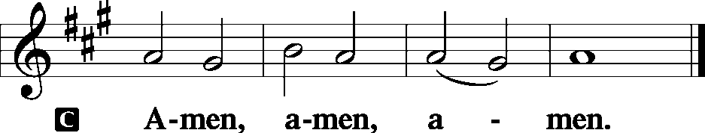

Closing Hymn: LSB #403 “O Savior of Our Fallen Race”
Silent prayer after worship: Lord Jesus, You went the way of cross so that I can have life now and forever. Lead me to faithfully and joyfully live as a baptized child of God by committing my life to You and to the service of Your church. Amen.

Acknowledgments: Divine Service, Setting Three from Lutheran Service Book Unless otherwise indicated, all scripture quotations are from The Holy Bible, English Standard Version, copyright © 2001 by Crossway Bibles, a division of Good News Publishers. Used by permission. All rights reserved. Created by Lutheran Service Builder © 2006 Concordia Publishing House. CCLI License #3029-446

Word of Hope: 1-888-217-8679
The only 24/7 CONFIDENTIAL Hotline that is distinctly Lutheran, bringing healing found in Christ, to those whose hearts have been broken by abortion.

Attendance:
Sunday, January 6, 2018…………………………………………………………….35
2019 Auditors will meet following worship Sunday, January 20th.

In Loving Memory of Kimberly Harmony: Joani Rice (file cabinets, for use by the Financial Staff).

Bible Memory Verses:
For Children: We have seen his glory, glory as of the only Son from the Father.
John 1:14
For Adults: Come to me, all who labor and are heavy laden, and I will give you rest. Take my yoke upon you, and learn from me, for I am gentle and lowly in heart, and you will find rest for your souls. For my yoke is easy, and my burden is light.
Matthew 11:28-30

SCHEDULE FOR TODAY THROUGH JAN. 20th:
:

:

Today, following Worship……………………………………….Coffee & Donuts Fellowship
7 pm, Downstairs….…………………..….……………………………..…..……AA Meeting
Monday, 12:30 pm……………………………………………………..……Preschool Board Meeting
Saturday, 10 am……………………………………………………..…Un-decorating of the Church
Next Sunday, 10 am, Sanctuary…..........................................................Divine Service
Following worship, Library………………………………..Audit Committee Meeting
7 pm, Downstairs………………………………………………………..…....……AA Meeting

The Altar Flowers this morning are given by Hugh Owen in honor of his daughter Rachel’s birthday. We sincerely appreciation this generous gift.

This morning is “Stock the Food Pantry” Sunday!

Your donations will be greatly appreciated.

A piece of jewelry was found on Stambaugh Avenue. Please phone the secretary’s office to claim.
Thank You for Serving in January:
Today’s Greeters: Rev. Ed & Irene Kucera. Assisting Elders: Ralph Dorman & Hugh Owen. Ushers: John Dyll, Barry Nelson, Jerome Thomas, Gary Burns, Bob Sulek (alternate). Altarware: Clara Krivosh & Cheryl.
January Greeters:
20 ~ Anna Mae Daris & Millie Elavsky; 27 ~ Cheryl Fedele & Clara Krivosh

Remember the following in Prayer…
~The Hurting and Healing: The family and friends of John Berent (Matt Berent’s father) on his passing January 4, 2019, and the family and friends of Rochelle Bliss (Tiffany Bale’s grandmother) who passed January 5, 2019; Tony³, Lois Bortner^{CA}, Jeff Brandes², Richard Brandes², Eileen Burns², Loretta Deal³, Norma Ferringer³, Anson Holcroft³, Betty Knauff^{CA}, Regis Knauff², Jess Lavoie¹, Paul Lucas^{CA}, Barry Nelson⁴, David Nelson⁴,Tom Mulligan^{CA}, Iona Oltman^{CA}, Rudy Pinal^{CA}, Richard Reuning^{CA}, Viola Sakony¹, Scott^{CA}, and Angela Weser^{CA}.
~Celebrating: Birthdays~Sophia Mihm (01.18).
~Our Homebound: Helen Bender, Dan Davis, Edna Krajci, Mary Ann Krajci, Sophie Mihm, Marion & Gene Roberts, Barbara Vasconi, and Joanne Wolfe.
~Serving in the Military: Clayton Drnek, Curtis Sinewe, and Joshua Solyan.
~Community & World Needs: Victims of violence and terrorism; those suffering from loss and dislocation because weather disasters; those suffering from addiction and their families; safety for teachers, staff, and students; Local, State, and National Government Leaders; Safety for all Police Officers, Firefighters, & First Responders; the unemployed; our First Quarter Local Mission: Shenango Valley Meals on Wheels.
*CA represents cancer; number after other names represents weeks on the prayer list. After 4 weeks names may be resubmitted. This helps us to remember people’s specific needs and reminds us that God is providing healing as people get better and no longer need our prayers. Please submit prayer requests in writing to the church office.
Please keep those listed above in your prayers.

IMPORTANT: Please note that Sunday morning Bible Study and Wednesday evening Divine Worship in the Chapel are suspended until further notice. Your understanding in this matter is greatly appreciated.

PLEASE NOTE: Please remember to take home any remaining poinsettias you may have donated TODAY. Any poinsettias remaining following worship this morning will be discarded.
Our Stewardship of Treasures for the Lord:
In order to do the Lord’s work, we need $2,882.02* each week to meet our 2019 budget for general purposes and $99.00 for missions.
Sunday, January 6, 2018:
General Offering:…..…..……….......................................................$1,096.00
Behind this week*: -$1,786.02
SELC Missions:……….………..…..…….................................................$45.00
Behind this week: -$54.00
Preschool Tuition Payments:...…………………..............................……..$0.00
Other Offerings:………….…….…….....................………..……..…..……$1.00
*Includes preschool tuition
All boards and organizations are reminded that information for the 2018 ANNUAL REPORT is due to Diane no later than TODAY.
Information may be emailed to church@saintspeterandpaul.net.

Please consider lending a hand this Saturday morning at
10 am as we “un-decorate” the church.

Preschool Board Members are reminded of the meeting tomorrow, January 14th at 12:30 pm in the Library.

Join us downstairs following worship this morning for Coffee & Donuts Fellowship. This month’s sponsor is Diane Riefstahl.

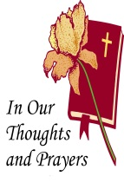
Sincere sympathy goes out to Matt & Cathy Berent on the passing of Matt’s father, John, January 4, 2019 and to Anthony & Tiffany Bale and family on the passing of Tiffany’s grandmother, Rochelle Bliss, January 5, 2019.
Here to Serve…

Pastor………………………………………………….………..…Rev. Jacob Deal
E-mail ……….…………………….…..pastordeal@saintspeterandpaul.net
Phone Number…………..……………………………724-347-3620 (Option 2)
Church Office………………………………….………724-347-3620 (Option 3)
Website ……….………………….……...…….www.saintspeterandpaul.net
Secretary………………………………………………….……. Diane Riefstahl
E-mail ……….…………………….…….…church@saintspeterandpaul.net
Food Pantry: John Dyll…………….……………………..…..…724-347-1779
Little People Preschool…………….……………….724-347-3620 (Option 4)
Teacher: Paula Ostheimer………….………………….…….....724-981-5846
Email ……….………….…………………….paula@saintspeterandpaul.net
AA Contact: Steve……………………….…………..……...……. 724-813-2358
Organist……………………………………………………..…Carrie Yasnowski
Choir Director……………..…………….…………..….….………Chris Nelson
Congregation President…………………………………………Jeff Brandes

The secretary’s office hours will be Monday and Thursday (8:30-4:30). Pastor Deal will be in the office Monday through Thursday unless ministering off-site. If you need to enter the Church, please call ahead to be sure someone is here to let you in. Thank you.

