Sts. Peter & Paul
Evangelical Lutheran Church
Lutheran Church-Missouri Synod
Founded-1917

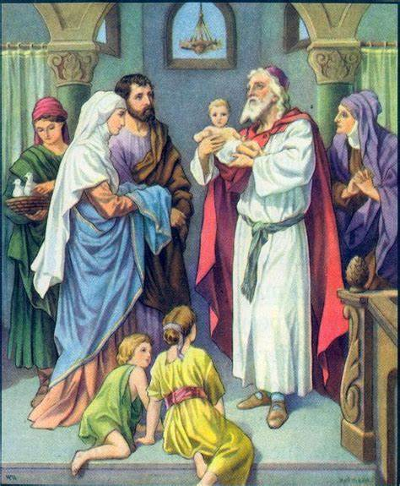

January 1, 2023

699 Stambaugh Avenue
Sharon, Pennsylvania 16146

“I was glad when they said to me,
Let us go to the house of the LORD!”
Psalm 122:1
Sts. Peter & Paul Evangelical Lutheran Church, LC-MS
THE CIRCUMCISION AND NAME OF JESUS
January 1, 2023

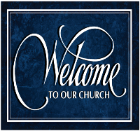
A special welcome to our guests this day! If you would like more information about The Lutheran Church - Missouri Synod, or this congregation, please speak with Pastor Deal or an Elder after the service.
Members & Guests: Don’t be embarrassed if your children make noise during the worship service, all children do. We encourage families to worship together but, if you feel the need, there are pews in the rear of the Church which are reserved for young families on both sides of the sanctuary. There is also a quiet room available to you during our service which is located down the hallway past the offices on the right side of the church as well as a children’s area in the Fellowship Hall where you are able to follow along with the service.

Today’s service includes the Sacrament of Holy Communion. If during this past year, you have not worshipped with us and been communed, we respectfully ask that you do not partake of this sacrament this day before first speaking with Pastor Deal.
If visiting from a sister congregation of the LC-MS and are in good standing, please inform Pastor Deal of your desire to commune prior to the service.
If wishing to receive a blessing during communion, please approach with your arms crossed.

CONTACT INFORMATION
Pastor Deal: pastordeal@saintspeterandpaul.net or 724-347-3620 (opt. 2)
Church Office: church@saintspeterandpaul.net or 724-347-3620 (opt. 3)

Silent prayer before worship: Heavenly Father, give me a humble and thankful heart so that I may worship You not just with my lips, but with my heart, soul and mind. In Jesus’ name. Amen.

Confession and Absolution

Opening Hymn: LSB #900 “Jesus! Name of Wondrous Love”

Stand

The sign of the cross may be made by all in remembrance of their Baptism.

Invocation
P In the name of the Father and of the T Son and of the Holy Spirit.
C Amen.

Exhortation Hebrews 10:22; Psalm 124:8; Psalm 32:5
P Beloved in the Lord! Let us draw near with a true heart and confess our sins unto God our Father, beseeching Him in the name of our Lord Jesus Christ to grant us forgiveness.

P Our help is in the name of the Lord,
C who made heaven and earth.
P I said, I will confess my transgressions unto the Lord,
C and You forgave the iniquity of my sin.

Silence for reflection on God’s Word and for self-examination.

Confession of Sins
P O almighty God, merciful Father,
C I, a poor, miserable sinner, confess unto You all my sins and iniquities with which I have ever offended You and justly deserved Your temporal and eternal punishment. But I am heartily sorry for them and sincerely repent of them, and I pray You of Your boundless mercy and for the sake of the holy, innocent, bitter sufferings and death of Your beloved Son, Jesus Christ, to be gracious and merciful to me, a poor, sinful being.

Absolution [John 20:19–23]
P Upon this your confession, I, by virtue of my office, as a called and ordained servant of the Word, announce the grace of God unto all of you, and in the stead and by the command of my Lord Jesus Christ I forgive you all your sins in the name of the Father and of the T Son and of the Holy Spirit.
C Amen.

Service of the Word

Introit Psalm 40:6–8; antiphon: 40:16
May all who seek you rejoice and be | glad in you;*
may those who love your salvation say continually, “Great | is the Lord!”
Sacrifice and offering you have not desired, but you have given me an | open ear.*
Burnt offering and sin offering you have | not required.
Then I said, “Behold, | I have come;*
in the scroll of the book it is writ- | ten of me:
I desire to do your will, | O my God;*
your law is with- | in my heart.”
May all who seek you rejoice and be | glad in you;*
may those who love your salvation say continually, “Great | is the Lord!”

Gloria Patri
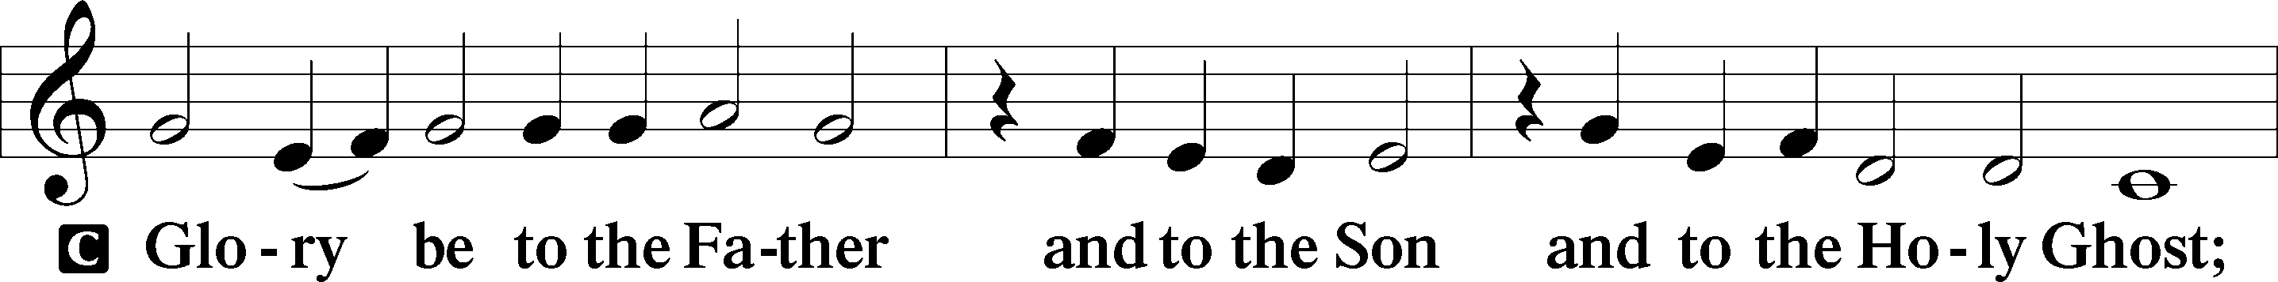
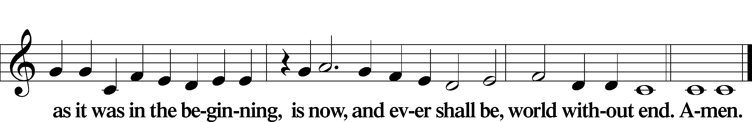
Kyrie Mark 10:47
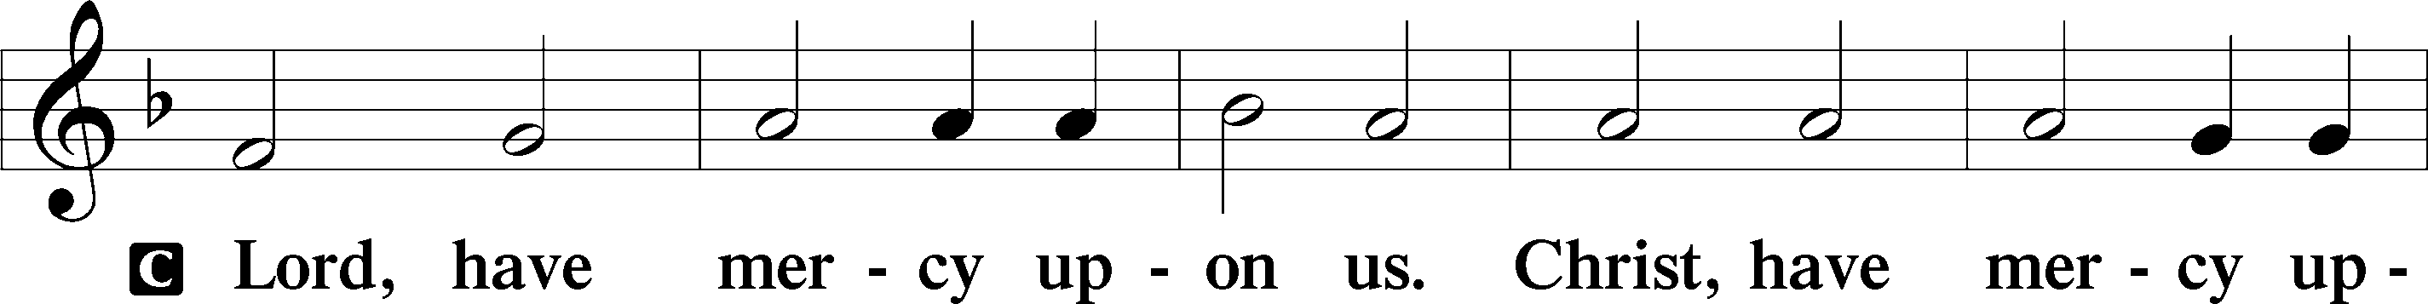
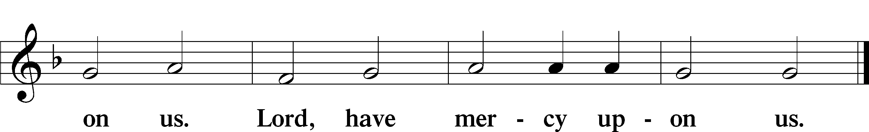

Gloria in Excelsis Luke 2:14; John 1:29
P Glory be to God on high:
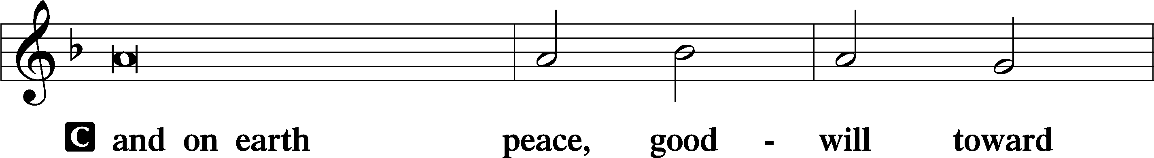
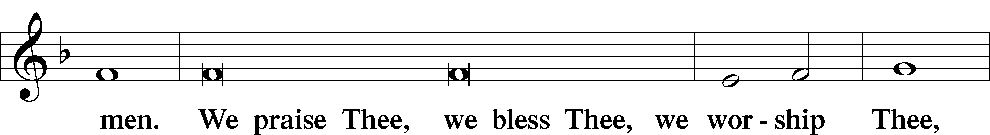
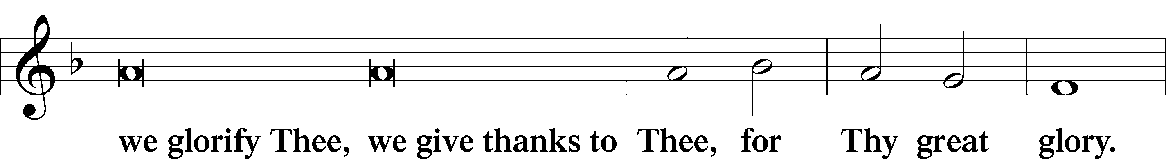
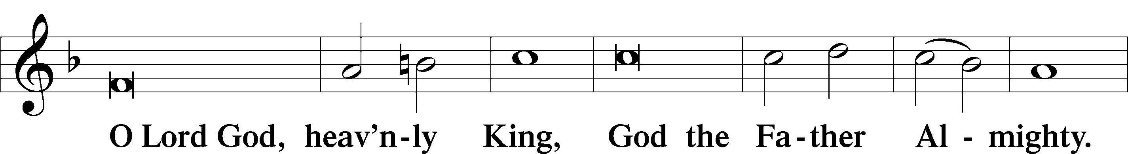
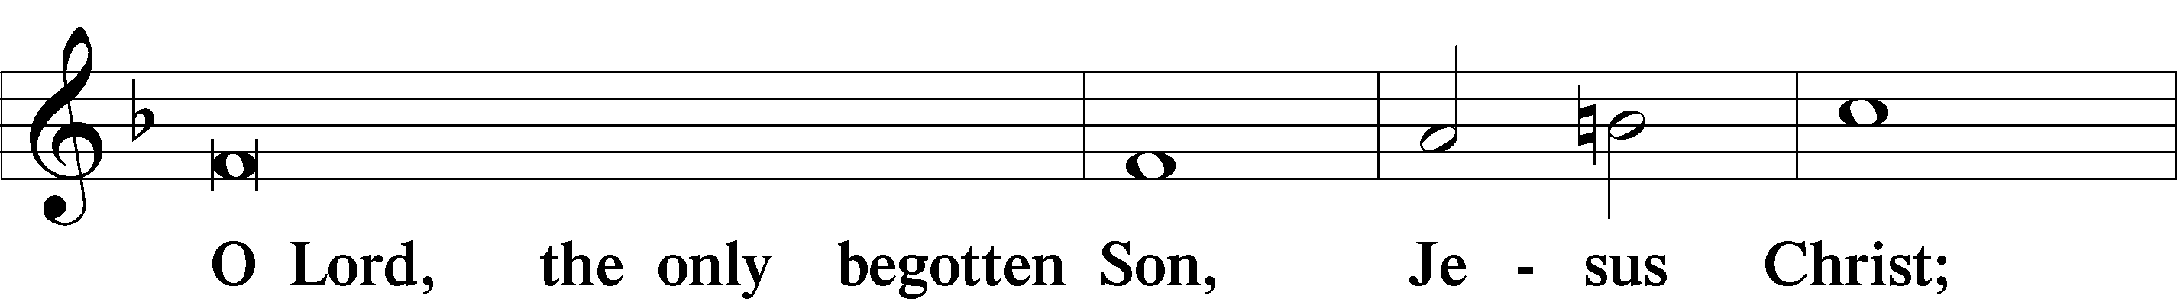
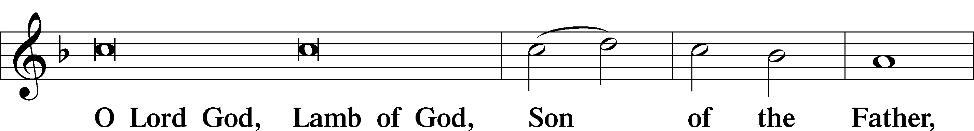
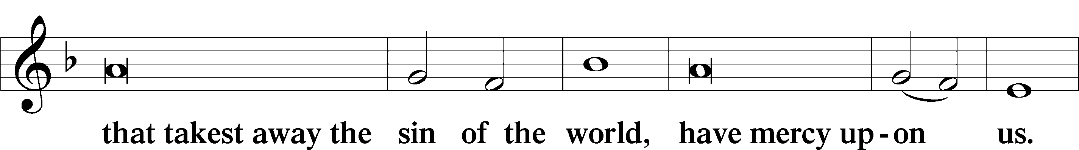
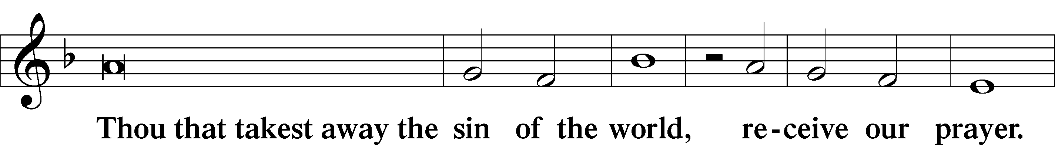
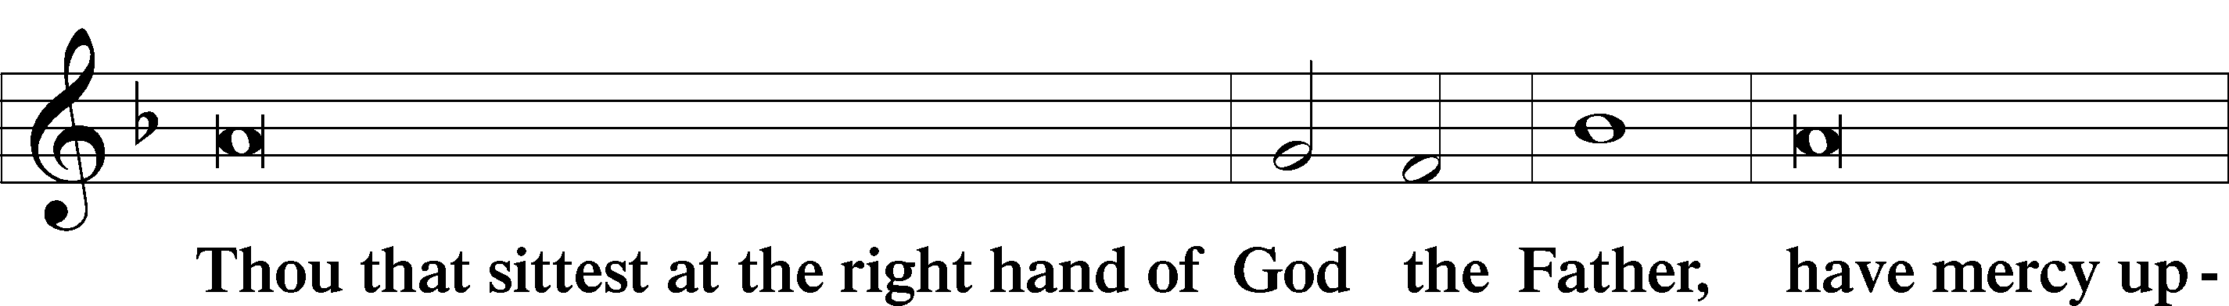
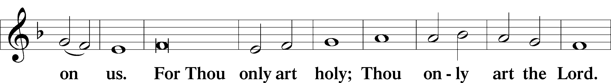
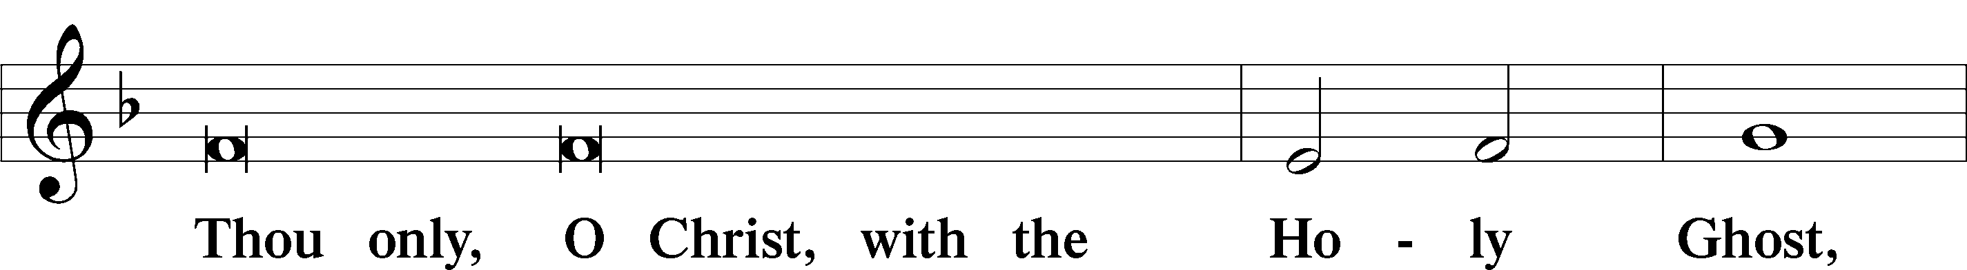
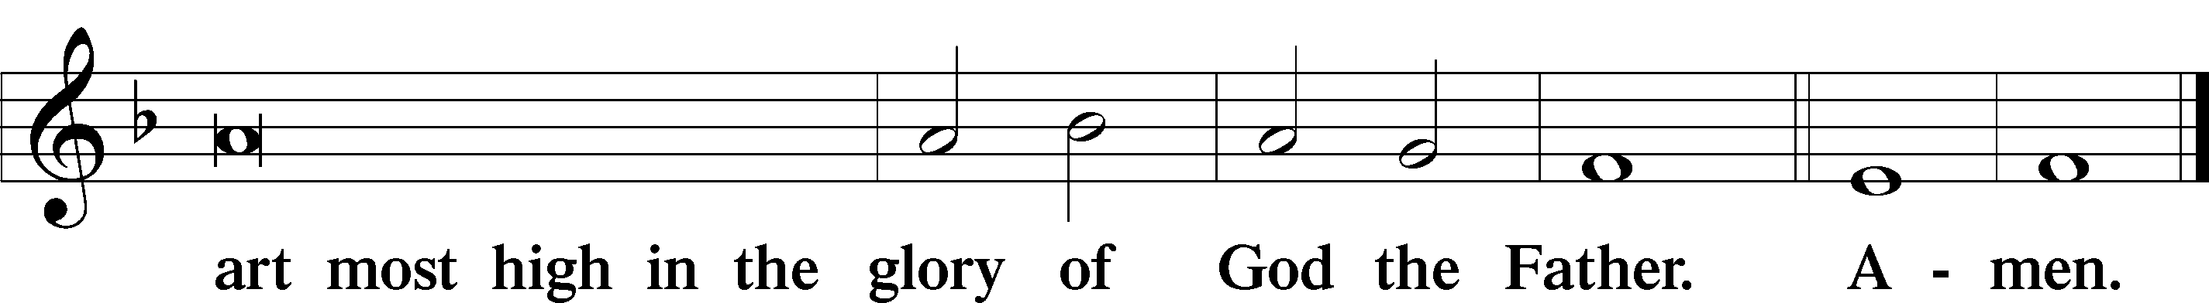

Salutation and Collect of the Day: Circumcision of Jesus and Christmas 1
P The Lord be with you.
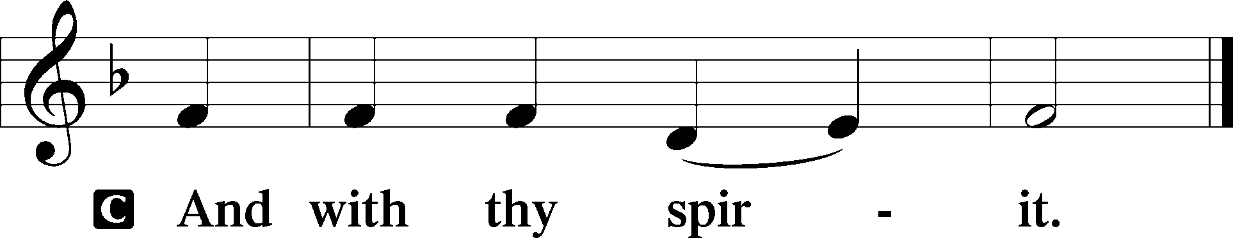

P Let us pray.
Lord God, You made Your beloved Son, our Savior, subject to the Law and caused Him to shed His blood on our behalf. Grant us the true circumcision of the Spirit that our hearts may be made pure from all sins; through Jesus Christ, our Lord, who lives and reigns with You and the Holy Spirit, one God, now and forever.

O God, our Maker and Redeemer, You wonderfully created us and in the incarnation of Your Son yet more wondrously restored our human nature. Grant that we may ever be alive in Him who made Himself to be like us; through Jesus Christ, our Lord, who lives and reigns with You and the Holy Spirit, one God, now and forever.
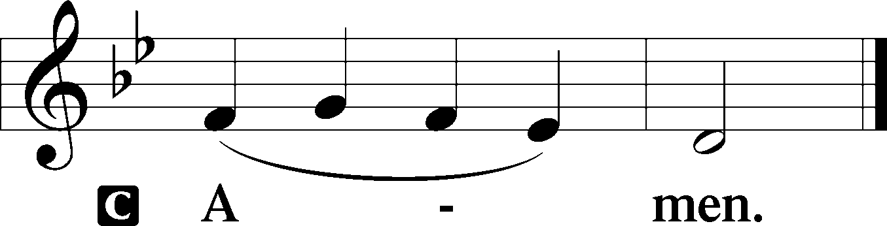
Sit

Prophecy: Genesis 17:3b–14
In those days the Lord spoke to Abram, saying: “Behold, My covenant is with you, and you shall be a father of many nations. No longer shall your name be called Abram, but your name shall be Abraham; for I have made you a father of many nations. I will make you exceedingly fruitful; and I will make nations of you, and kings shall come from you. And I will establish My covenant between Me and you and your descendants after you in their generations, for an everlasting covenant, to be God to you and your descendants after you. Also I give to you and your descendants after you the land in which you are a stranger, all the land of Canaan, as an everlasting possession; and I will be their God.” And God said to Abraham: “As for you, you shall keep My covenant, you and your descendants after you throughout their generations. This is My covenant which you shall keep, between Me and you and your descendants after you: Every male child among you shall be circumcised; and you shall be circumcised in the flesh of your foreskins, and it shall be a sign of the covenant between Me and you. He who is eight days old among you shall be circumcised, every male child in your generations, he who is born in your house or bought with money from any foreigner who is not your descendant. He who is born in your house and he who is bought with your money must be circumcised, and My covenant shall be in your flesh for an everlasting covenant. And the uncircumcised male child, who is not circumcised in the flesh of his foreskin, that person shall be cut off from his people; he has broken My covenant.”

P This is the Word of the Lord.
C Thanks be to God.

Gradual Hebrews 8:10; 10:17
This is the covenant that I will make with the house of | Israel*
after those days, de- | clares the Lord:
I will put my laws in- | to their minds,*
and write them | on their hearts.
I will be their God, and they shall be my | people.*
I will remember their sins and their lawless | deeds no more.

Epistle: Galatians 3:23–29
Brethren: Before faith came, we were kept under guard by the law, kept for the faith which would afterward be revealed. Therefore the law was our tutor to bring us to Christ, that we might be justified by faith. But after faith has come, we are no longer under a tutor. For you are all sons of God through faith in Christ Jesus. For as many of you as were baptized into Christ have put on Christ. There is neither Jew nor Greek, there is neither slave nor free, there is neither male nor female; for you are all one in Christ Jesus. And if you are Christ’s, then you are Abraham’s seed, and heirs according to the promise.

P This is the Word of the Lord.
C Thanks be to God.

Stand
Verse Matthew 1:21
Alleluia. She will bear a son, and you shall call his name Jesus, for he will save his people from their sins. Alleluia.

Alleluia
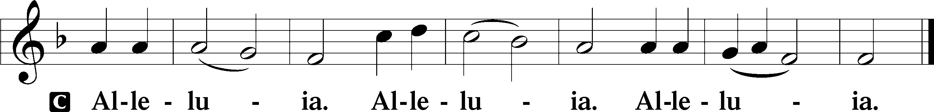

Holy Gospel: Luke 2:21
P The Holy Gospel according to St. Luke, the second chapter.
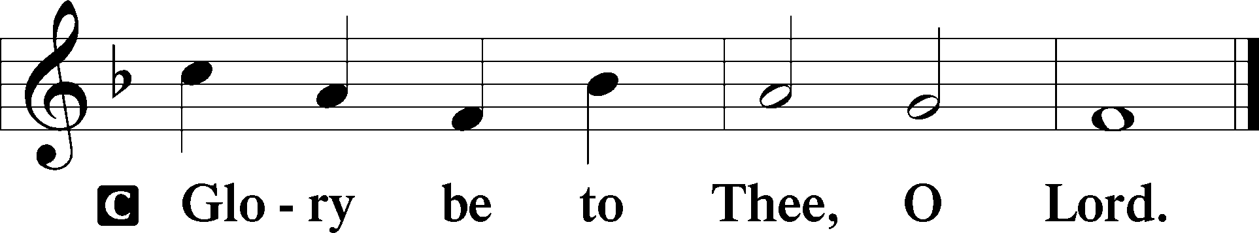
At that time: When eight days were completed for the circumcision of the Child, His name was called Jesus, the name given by the angel before He was conceived in the womb.

P This is the Gospel of the Lord.
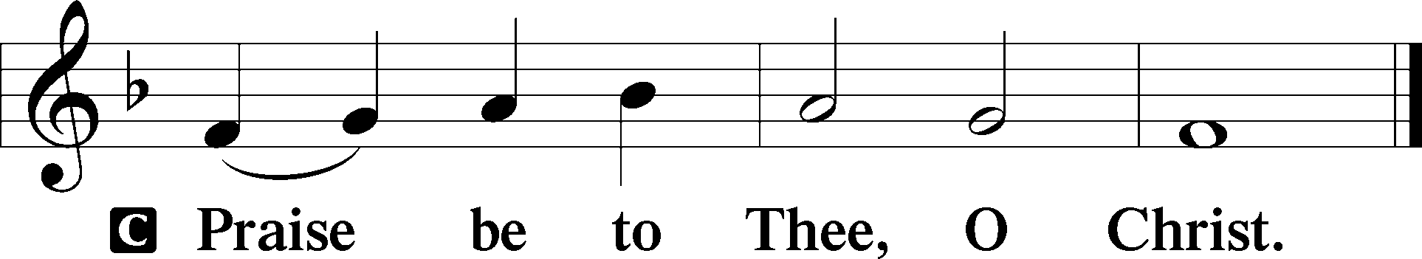

Nicene Creed
C I believe in one God,
the Father Almighty,
maker of heaven and earth
and of all things visible and invisible.

And in one Lord Jesus Christ,
the only-begotten Son of God,
begotten of His Father before all worlds,
God of God, Light of Light,
very God of very God,
begotten, not made,
being of one substance with the Father,
by whom all things were made;
who for us men and for our salvation came down from heaven
and was incarnate by the Holy Spirit of the virgin Mary
and was made man;
and was crucified also for us under Pontius Pilate.
He suffered and was buried.
And the third day He rose again according to the Scriptures
and ascended into heaven
and sits at the right hand of the Father.
And He will come again with glory to judge both the living and the dead,
whose kingdom will have no end.
And I believe in the Holy Spirit,
the Lord and giver of life,
who proceeds from the Father and the Son,
who with the Father and the Son together is worshiped and glorified,
who spoke by the prophets.
And I believe in one holy Christian and apostolic Church,
I acknowledge one Baptism for the remission of sins,
and I look for the resurrection of the dead
and the life T of the world to come. Amen.
Sit

Hymn of the Day: TLH #115 “O Blessed Day When First Was Poured”
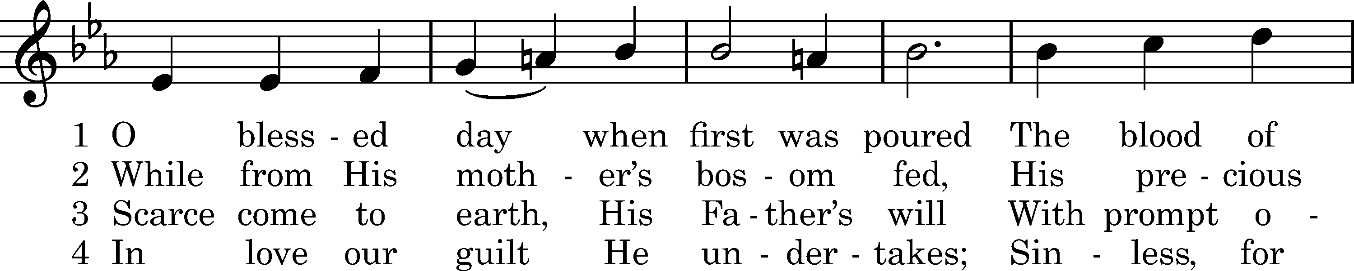
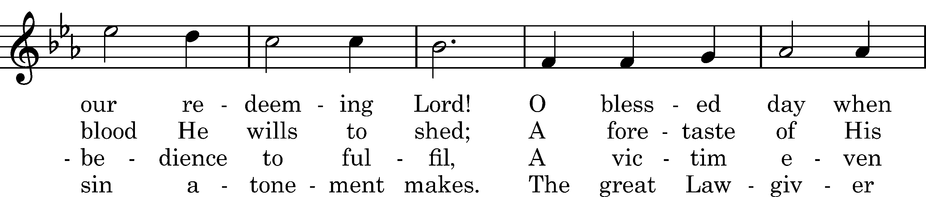
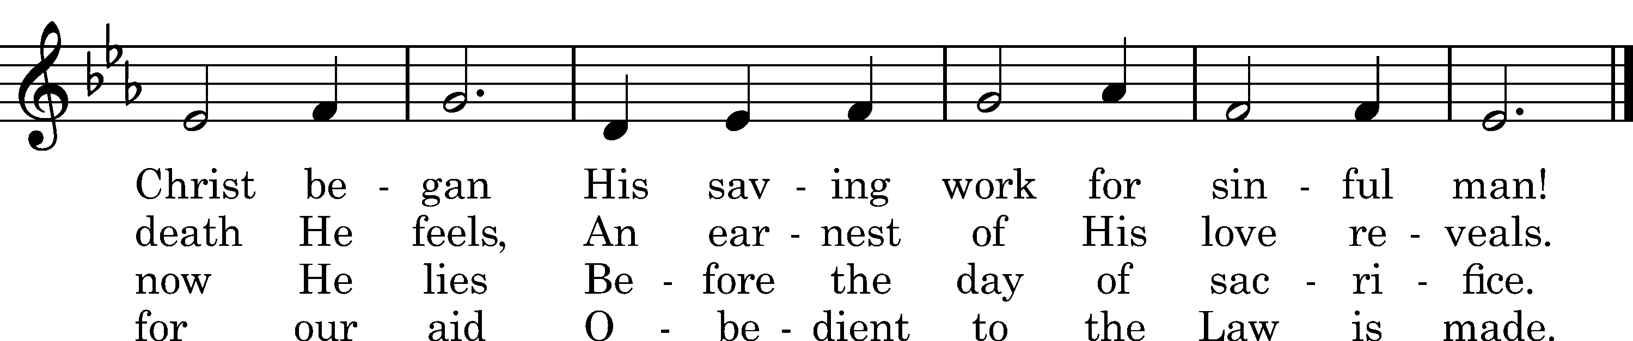

5 Lord, circumcise our heart, we pray,
And take what is not Thine away.
Write Thine own name upon our hearts,
Thy Law within our inward parts.

D 6 O Lord, the Virgin-born, to Thee
Eternal praise and glory be,
Whom with the Father we adore
And Holy Ghost forevermore.
Text: tr. John Chandler, 1837, alt.; Sebastian Besnault, †1724
Tune: Heilige Seelenlust, Breslau, 1657
Text and tune: Public domain

Sermon

Stand

Prayer of the Church

Offertory Psalm 51:10–12
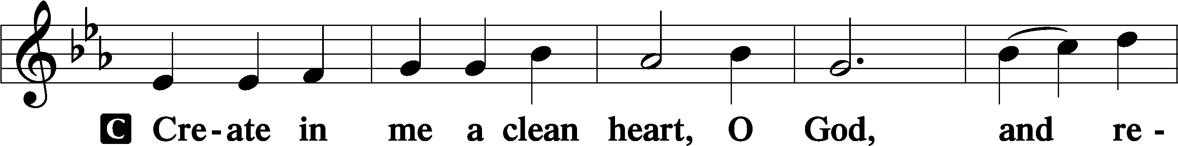
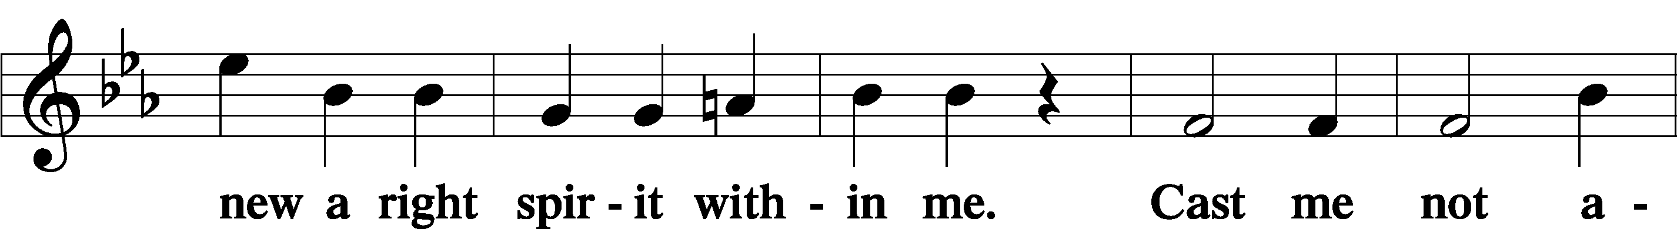
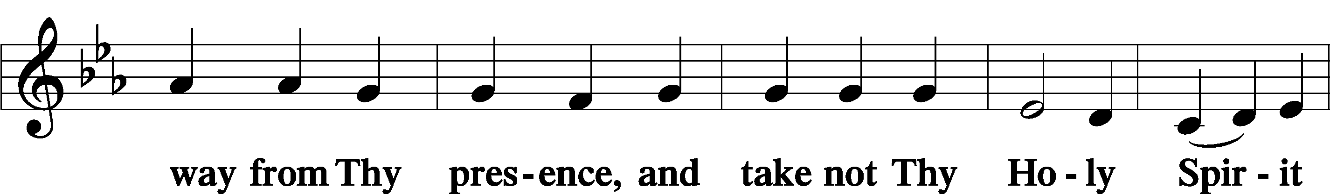
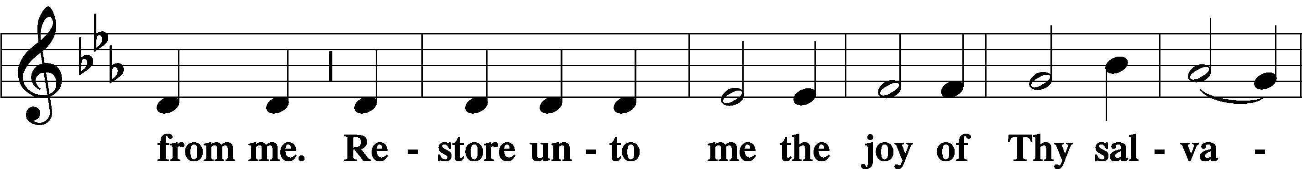
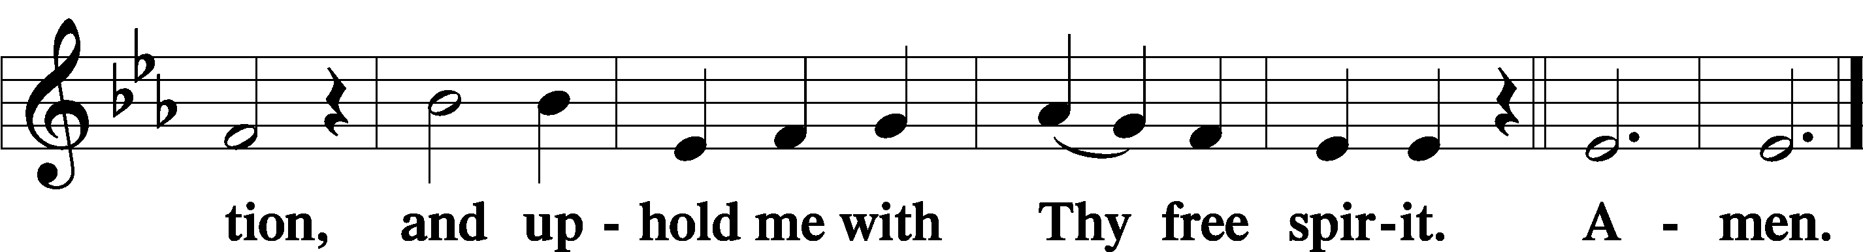
Sit

Preparatory Hymn: LSB #372 “O Jesus Christ, Thy Manger Is”

Stand

Service of the Sacrament

Preface 2 Timothy 4:22; Colossians 3:1 Psalm 136
P The Lord be with you.
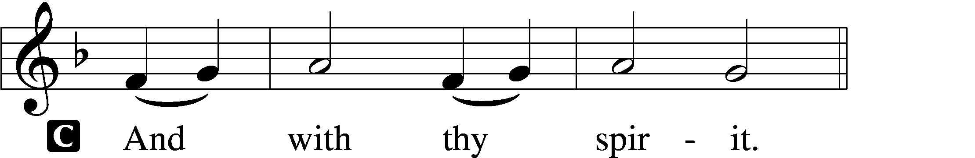

P Lift up your hearts.
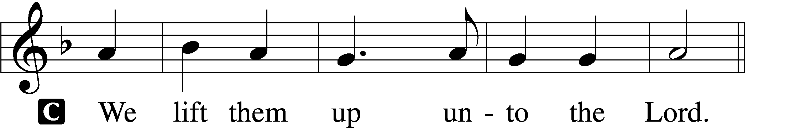

P Let us give thanks unto the Lord, our God.
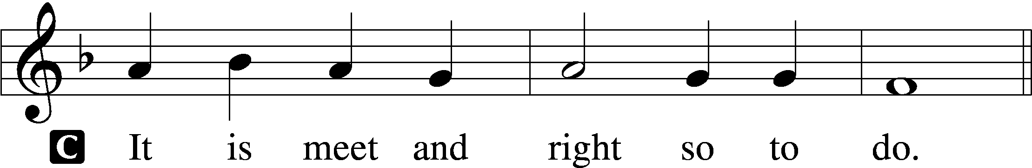

Proper Preface (Abbreviated) LSB 194
P It is truly meet, right, and salutary . . . evermore praising You and saying:

Sanctus Isaiah 6:3; Matthew 21:9
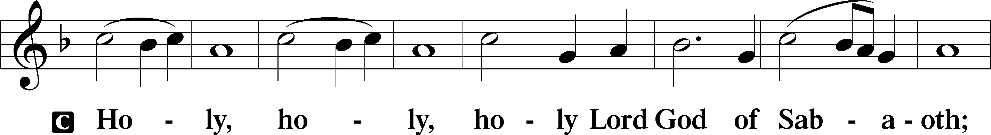
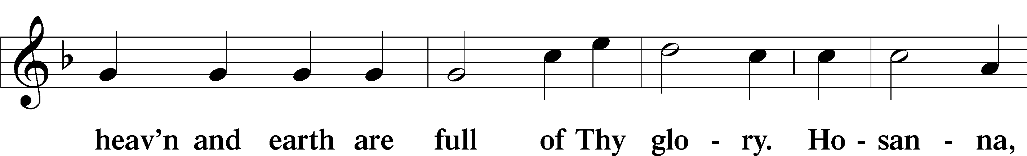
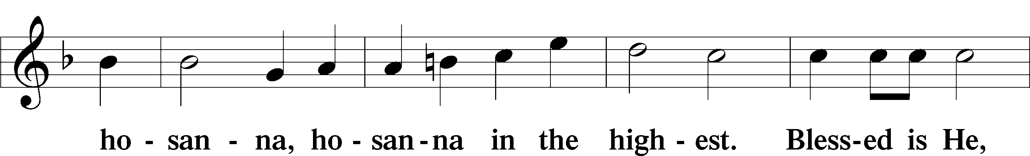
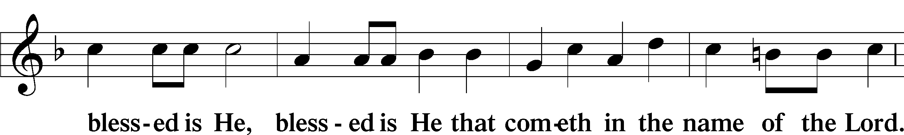
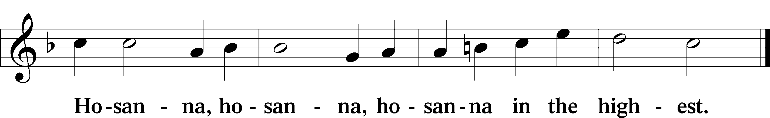

Lord’s Prayer Matthew 6:9–13
C Our Father who art in heaven,
hallowed be Thy name,
Thy kingdom come,
Thy will be done on earth as it is in heaven;
give us this day our daily bread;
and forgive us our trespasses as we forgive those who trespass against us;
and lead us not into temptation,
but deliver us from evil.
For Thine is the kingdom and the power and the glory forever and ever. Amen.

The Words of Our Lord Matthew 26:26–28; Mark 14:22–24; Luke 22:19–20; 1 Corinthians 11:23–25
P Our Lord Jesus Christ, on the night when He was betrayed, took bread, and when He had given thanks, He broke it and gave it to the disciples and said: “Take, eat; this is My T body, which is given for you. This do in remembrance of Me.”

In the same way also He took the cup after supper, and when He had given thanks, He gave it to them, saying: “Drink of it, all of you; this cup is the new testament in My T blood, which is shed for you for the forgiveness of sins. This do, as often as you drink it, in remembrance of Me.”

Pax Domini John 20:19
P The peace of the Lord be with you always.
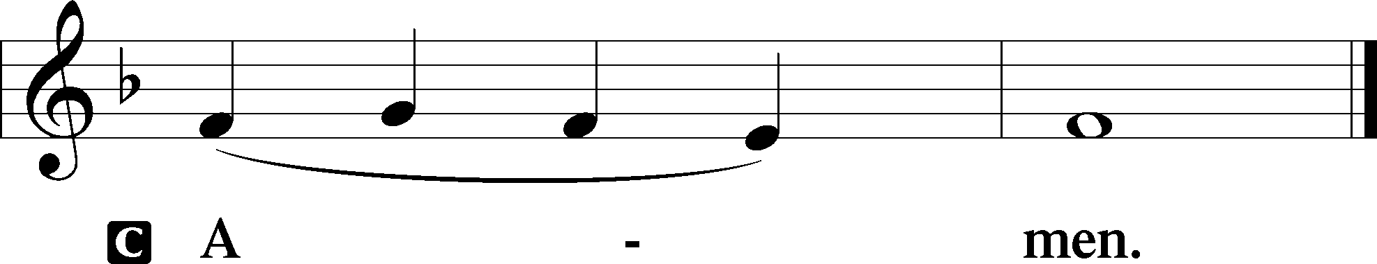

Agnus Dei John 1:29
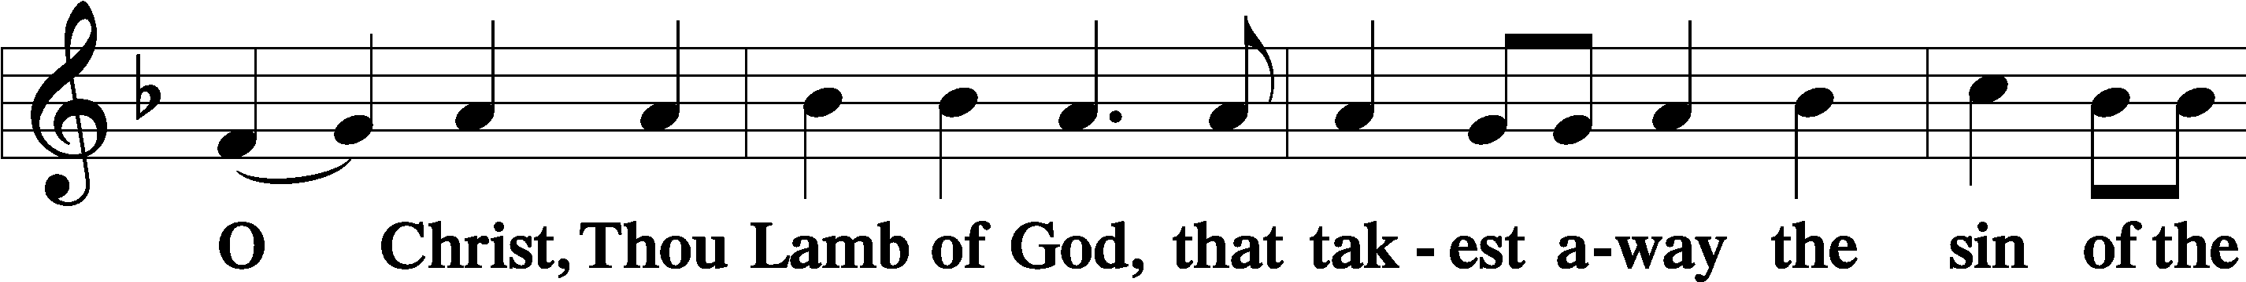
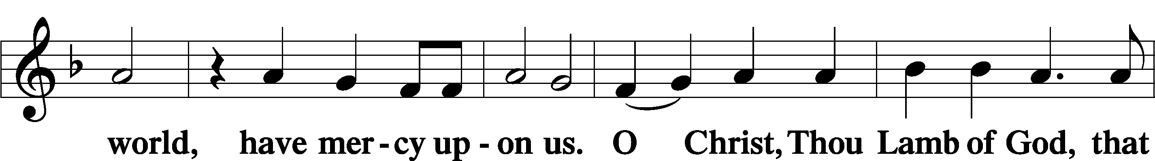
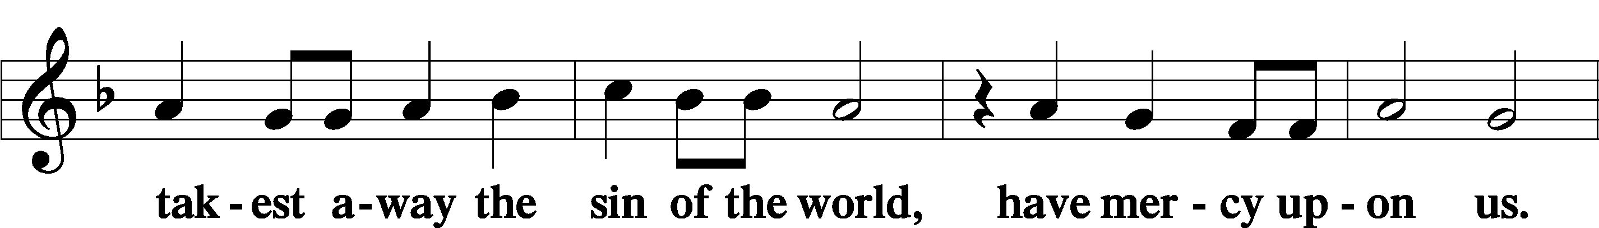
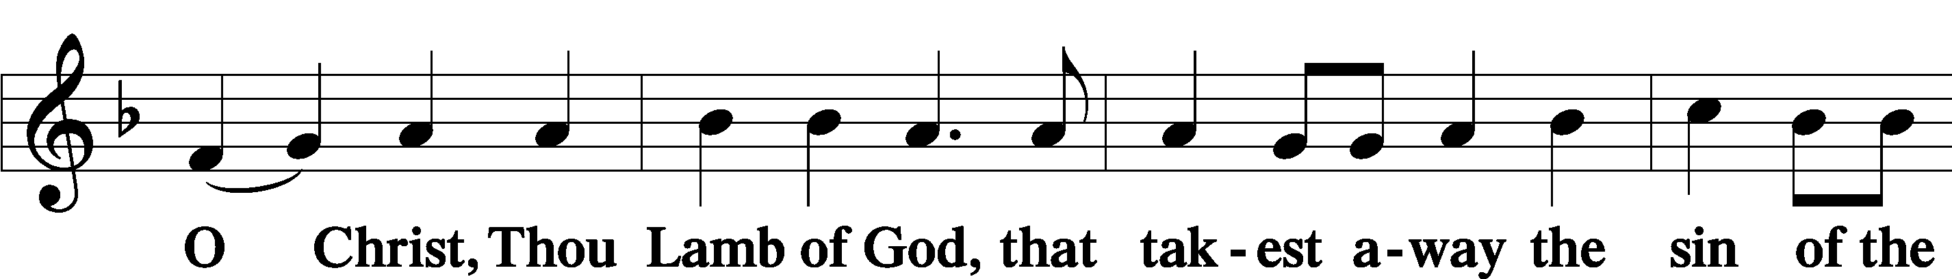
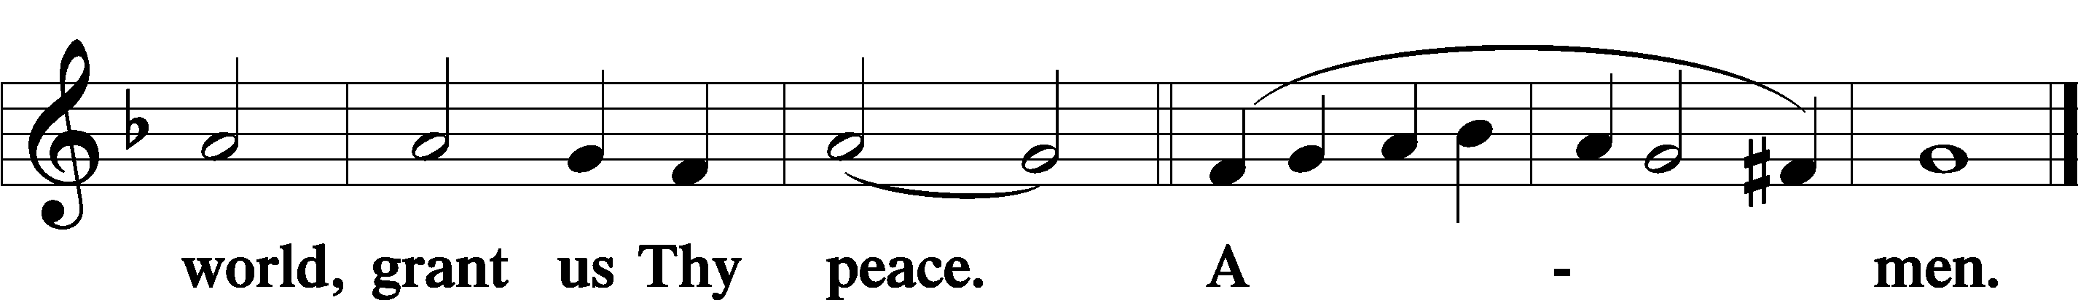
Sit

Distribution
The pastor and those who assist him receive the body and blood of Christ first and then distribute them to those who come to receive, saying:
Take, eat; this is the true body of our Lord and Savior Jesus Christ, given into death for your sins.
Amen.

Take, drink; this is the true blood of our Lord and Savior Jesus Christ, shed for the forgiveness of your sins.
Amen.

In dismissing the communicants, the following is said:
The Dismissal
P The body and blood of our Lord Jesus Christ strengthen and preserve you in body and soul to life everlasting. Depart T in peace.
C Amen.
Distribution Hymn: LSB #725 “Children of the Heavenly Father”

Distribution Hymn: LSB #897 “O Rejoice, Ye Christians, Loudly”

Distribution Hymn: LSB #594 “God’s Own Child, I Gladly Say It”

Stand

Nunc Dimittis Luke 2:29–32
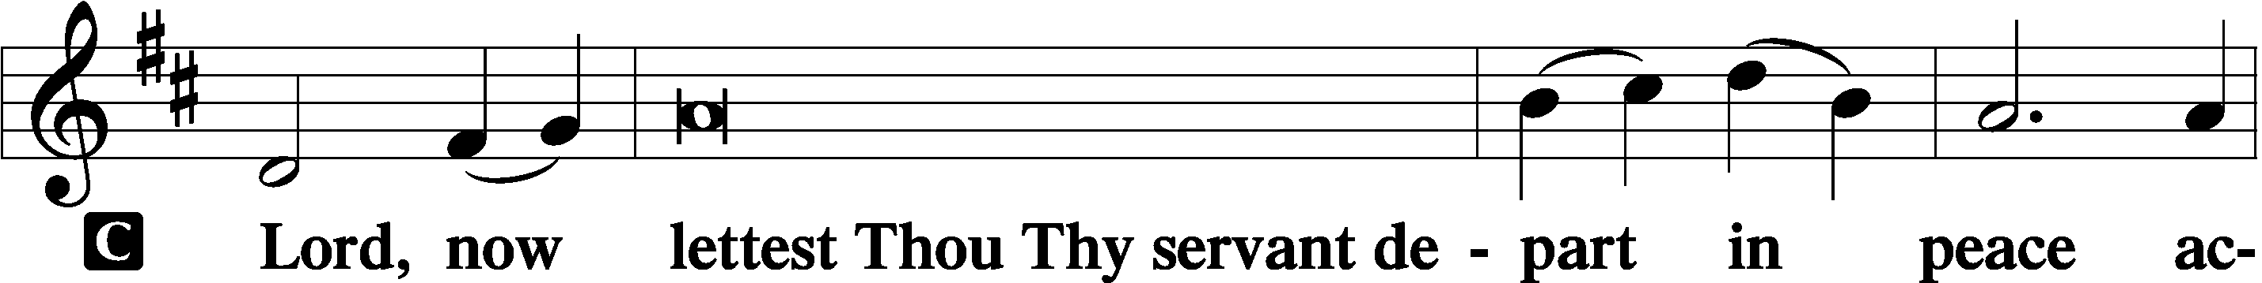
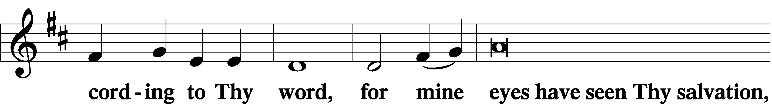
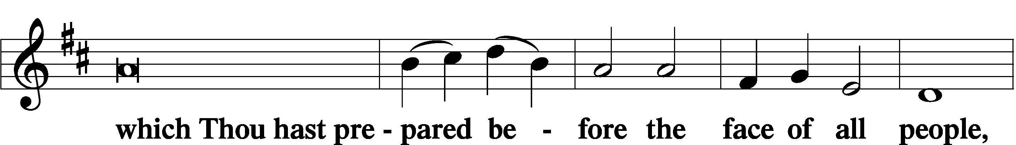
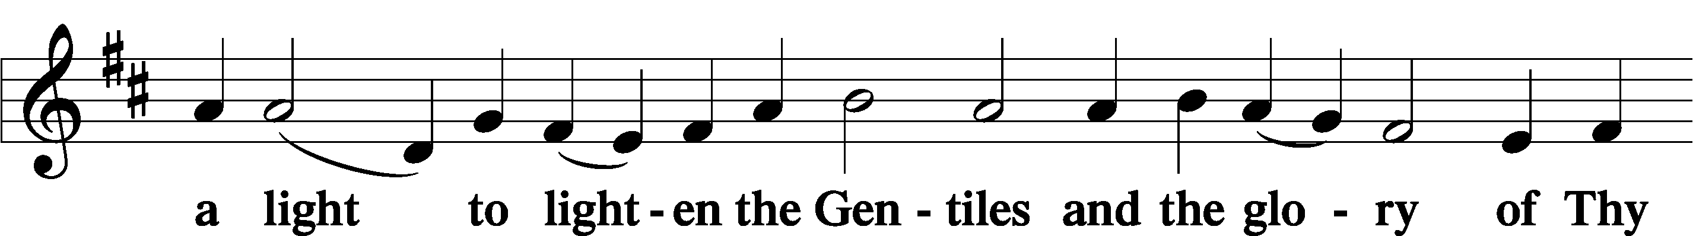
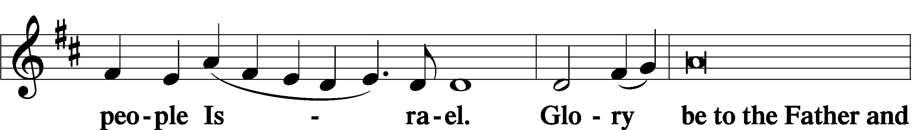
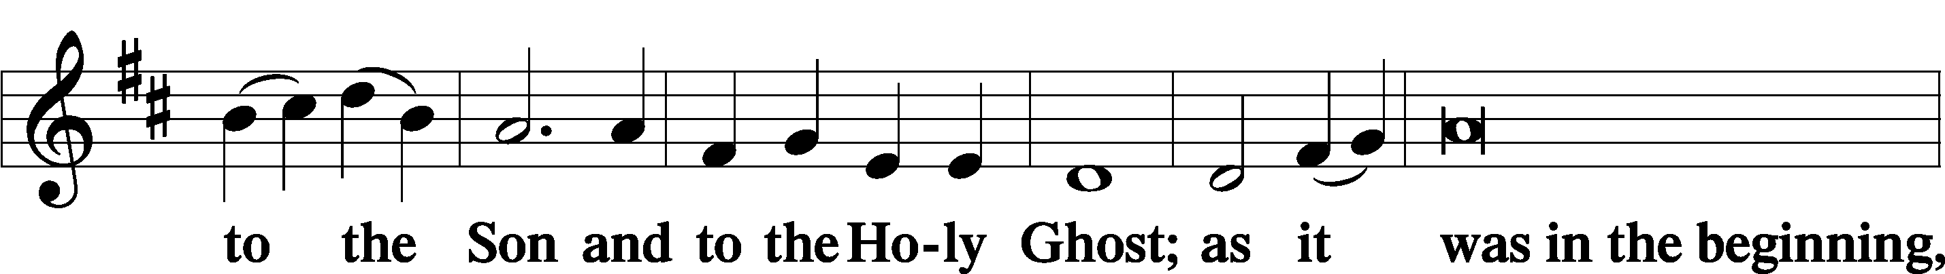
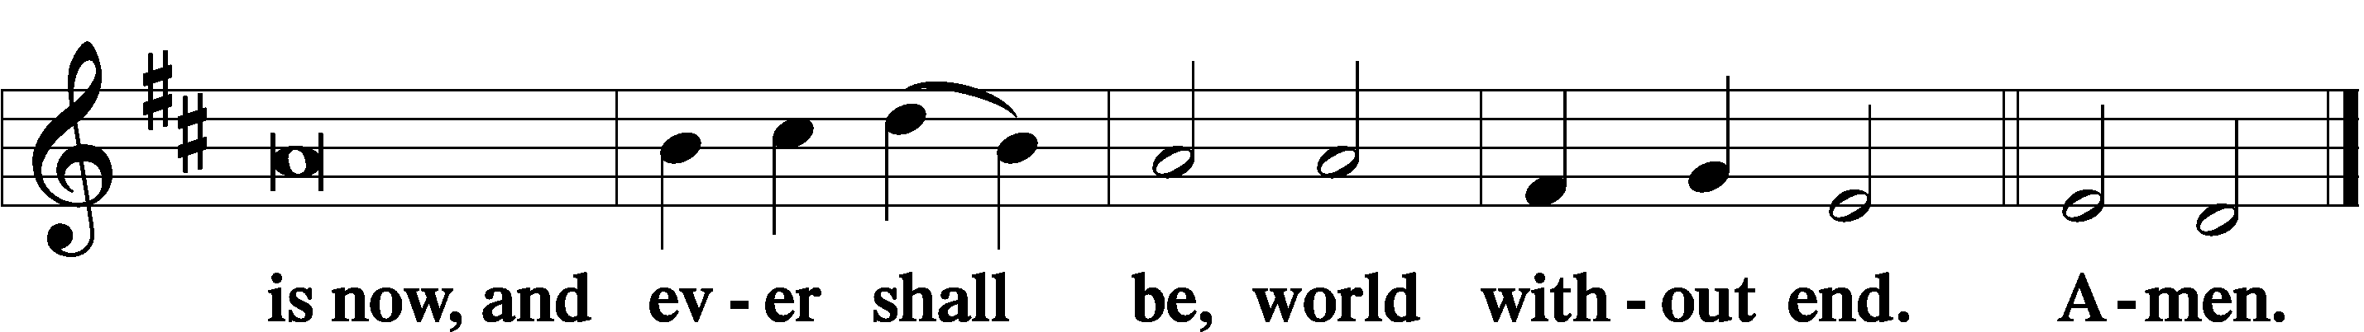

Thanksgiving Psalm 107:1
P O give thanks unto the Lord, for He is good,
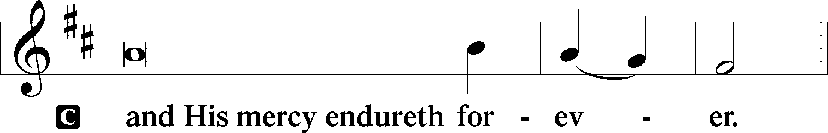

Post-Communion Collect
P Let us pray.
We give thanks to You, almighty God, that You have refreshed us through this salutary gift, and we implore You that of Your mercy You would strengthen us through the same in faith toward You and in fervent love toward one another; through Jesus Christ, Your Son, our Lord, who lives and reigns with You and the Holy Spirit, one God, now and forever.
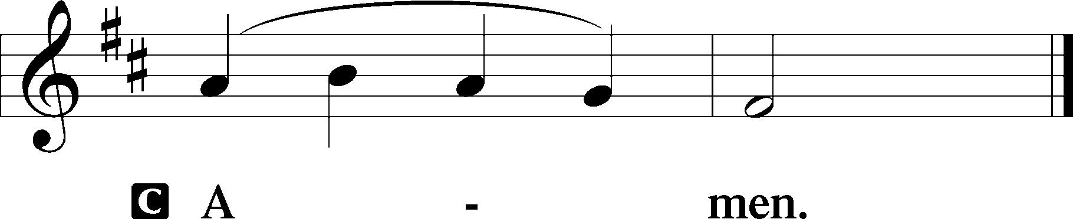

Salutation 2 Timothy 4:22
P The Lord be with you.
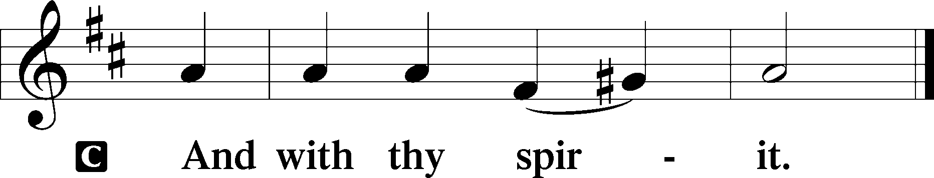

Benedicamus Psalm 103:1
P Bless we the Lord.
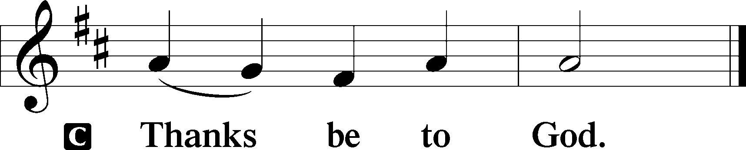

Benediction Numbers 6:24–26
P The Lord bless you and keep you.
The Lord make His face shine upon you and be gracious unto you.
The Lord lift up His countenance upon you and T give you peace.
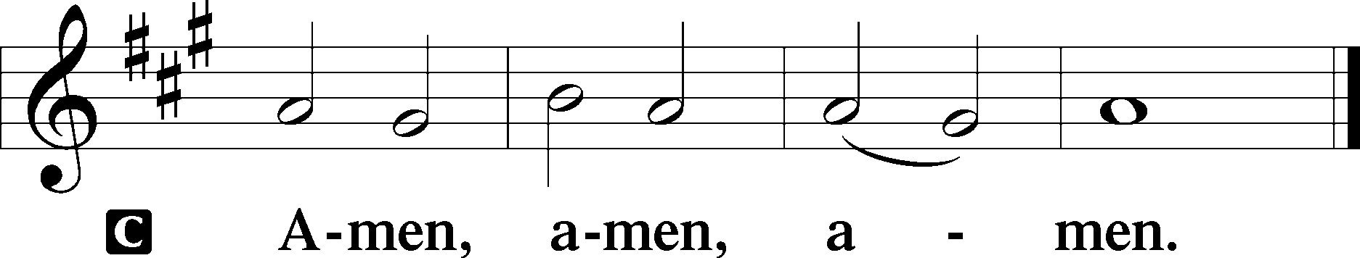

Closing Hymn: LSB #683 “Jesus, Thy Boundless Love to Me”

Silent prayer after worship: Lord Jesus, You have been given the name above all names. Forgive me for my hesitance to call on Your name in prayer, and for the times I have dishonored Your name. Lead me to honor Your holy name through all that I do and say. Amen.
fffffffffffffffffffffffffffffffffff
Acknowledgments: Unless otherwise indicated, Scripture quotations are from the ESV® Bible (The Holy Bible, English Standard Version®), copyright © 2001 by Crossway, a publishing ministry of Good News Publishers. Used by permission. All rights reserved.
Created by Lutheran Service Builder © 2021 Concordia Publishing House.
fffffffffffffffffffffffffffffffffff
fffffffffffffffffffffffffffffffffff
In Loving Memory of Uncle Andy Petro (December 30, 1998) and Uncle Mike Petro (January 3, 2018): Patty Parker (Capital Campaign).
In Celebration of my Mother, Millie Elavsky’s, 96 Christmases: John Elavsky (Major Repair Fund).
In Loving Memory of Husband, Bob Sulek: Edeltraud Sulek (Capital Campaign)
fffffffffffffffffffffffffffffffffff
SCHEDULE THROUGH JANUARY 8, 2023:

:

Today, 7 pm, Fellowship Hall: AA Meeting
Tuesday, 7-9 pm, Fellowship Hall: Penn-Ohio Singers
Wednesday, 7:30 pm, Downstairs: NA Meeting
Friday, 7 pm, Sanctuary: Epiphany Divine Service
Next Sunday, 9 am, Sanctuary: Divine Service & Installation / Recognition
Following Worship, Fellowship Hall: Coffee Fellowship
7 pm, Fellowship Hall: AA Meeting
fffffffffffffffffffffffffffffffffff
The 2023 Coffee Fellowship sign-up sheet has been posted on the bulletin board in the narthex along with the 2023 Altar Flower Sponsorship sheet. Consider signing up to be a sponsor!
fffffffffffffffffffffffffffffffffff
Join us this Friday evening at 7 pm for a special Epiphany Divine Service.
Attendance: Wednesday, December 21, 2022: 25 (noon: 14; eve: 11)
Saturday, December 24, 2022: 39
Sunday, December 25, 2022: 21
Monday, December 26, 2022: 5
Tuesday, December 27, 2022: 7
Wednesday, December 28, 2022: 8 fffffffffffffffffffffffffffffffffff
THANK YOU FOR SERVING IN JANUARY: Elder: Jonathan Baisch; Altarware: Marie Flaugher and Altar Guild Volunteers
fffffffffffffffffffffffffffffffffff
REMINDER: The installation of 2023 Church Officers and Boards will take place during the Divine Service next Sunday, January 8, 2023. We will also be recognizing past servants of the church that day. Your attendance that day will be greatly appreciated.
fffffffffffffffffffffffffffffffffff
Our Stewardship of Treasures for the Lord:
In order to do the Lord’s work, we need $2,462.92 each week to meet our 2022 budget for general purposes and $80.00 for the SELC.
Online Figures (12.22.22)
General Fund: $80.00
Figures for Wednesday, December 21, 2022
General Fund: $965.00
SELC: $0.00
Capital Campaign: $35.00
Other: $500.00
Figures for Sunday, December 25, 2022:
General Fund: $781.00 Behind for the week*: -$636.92
SELC: $20.00 Behind for the week*: -$60.00
Quarterly Missions: $400.00
Capital Campaign: $25.00 *Includes above figures.
Other: $500.00

For online giving, check out https://www.saintspeterandpaul.net/online-giving.

fffffffffffffffffffffffffffffffffff
Remember the following in Prayer…
~The Hurting and Healing: Amy, Gerald Arthur, Evelyn Baisch, Ellen Baron^{CA}, Lois Bortner^{CA}, John Burdette, Bev & Joe Chlpka, Kathleen Coughenour, Kim, Anna Mae Daris, Susan Davies, Tim Dudash, Millie Elavsky, Joseph Fleet, Eddy Furey, Tim Haenftling, Austin Hamilton, Anson Holcroft, Neil Huston, Darla Krajci, Barbara Kreske, Michelle Kelly^{CA}, Donna Kennedy, Gerald Krivosh, Jess Lavoie, Paul Lucas^{CA}, Sandy Marshall, Ernie Meszaros, David Nelson, Linda Parkany, Juanita Rentschler, Richard Reuning^{CA}, Nancy Robertson^{CA}, Viola Sakony, Marty Scott, Kara, Fred Tonty, Angela Weser^{CA}, and Ruth Wolf.
~The Homebound: Rudy & Jean Tomko, Betty Wolf, and Ed & Millie Zachar.
~Celebrating: Birthday: Mike Flaugher (01.04).
~Serving in the Military: Curtis Sinewe and Joshua Solyan.
~Community & World Needs: Those suffering from or affected by the coronavirus; those suffering due to the conflict between Ukraine and Russia; those suffering from loss and dislocation because weather disasters; those suffering from addiction and their families; Local, State, and National Government Leaders; safety for all Police Officers, Firefighters, & First Responders; the unemployed; our First Quarter Local Mission: Sts. Peter & Paul’s Community Day 2023
*CA represents cancer.
fffffffffffffffffffffffffffffffffff
Bible Memory Verses ~ Week of January 1st:
For Adults: Come to me, all who labor and are heavy laden, and I will give you rest. Take my yoke upon you, and learn from me, for I am gentle and lowly in heart, and you will find rest for your souls. For my yoke is easy, and my burden is light. Matthew 11:28-30
For Children: For he will command his angels concerning you to guard you in all your ways. Psalm 91:11
fffffffffffffffffffffffffffffffffff
It’s time to prepare for the 2022 Annual Report! If you are responsible for a report, a copy of your 2021 report should have been emailed to you. Please email 2022 information to church@saintspeterandpaul.net on or before Monday, January 9th. Material will be formatted for you. See Diane with any questions.
fffffffffffffffffffffffffffffffffff
Next Sunday is Food Pantry Sunday! Financial donations will be appreciated!
Here to Serve

Pastor………………………………………………...……………Rev. Jacob Deal
E-mail …………………………….……pastordeal@saintspeterandpaul.net
Phone Number……………………..…………………724-347-3620 (Option 2)
Church Office………………………..…………………724-347-3620 (Option 3)
Website …………………………………………www.saintspeterandpaul.net
Secretary…………………………………………………………Diane Riefstahl
E-mail ………………………………………church@saintspeterandpaul.net
Website …………………………………………www.saintspeterandpaul.net
Food Pantry: Please leave message……………724-347-3620 (Option 3)
AA Contact: Steve………………………………………………..…724-813-2358
NA Contact: Larry………………………………………………..724-977-8733
Choir Director………………………………………………………Chris Nelson
Congregation President……………………………………Jonathan Baisch
Church Elder …………………………………………...…… Jonathan Baisch
fffffffffffffffffffffffffffffffffff
If needing to get into the church building during the week, please phone first to make certain someone is here to let you in.

