Sts. Peter & Paul
Evangelical Lutheran Church
Lutheran Church-Missouri Synod
Founded-1917
FEBRUARY 24, 2019

699 Stambaugh Avenue
Sharon, Pennsylvania 16146

“I was glad when they said to me,
Let us go to the house of the LORD!”
Psalm 122:1
Sts. Peter & Paul Evangelical Lutheran Church, LC-MS

SEXAGESIMA
February 24, 2019

Silent prayer before worship: Heavenly Father, You sent Your only Son Jesus to wash away my sins and to give me eternal life. Open my heart this day, so that I can receive Your Word and Sacrament and be assured of Your gracious love. In Jesus’ name. Amen.
CONFESSION AND ABSOLUTION
Opening Hymn: LSB #907 “God Himself Is Present”
Stand

The sign of the cross may be made by all in remembrance of their Baptism.

P In the name of the Father and of the T Son and of the Holy Spirit.
C Amen. Matthew 28: 19b; (18:20)

P Beloved in the Lord! Let us draw near with a true heart and confess our sins unto God our Father, beseeching Him in the name of our Lord Jesus Christ to grant us forgiveness. [Hebrews 10:22]

P Our help is in the name of the Lord,
C who made heaven and earth. Psalm 124: 8
P I said, I will confess my transgressions unto the Lord,
C and You forgave the iniquity of my sin. Psalm 32: 5

Silence for reflection on God's Word and for self-examination.

P O almighty God, merciful Father,
C I, a poor, miserable sinner, confess unto You all my sins and iniquities with which I have ever offended You and justly deserved Your temporal and eternal punishment. But I am heartily sorry for them and sincerely repent of them, and I pray You of Your boundless mercy and for the sake of the holy, innocent, bitter sufferings and death of Your beloved Son, Jesus Christ, to be gracious and merciful to me, a poor, sinful being.

P Upon this your confession, I, by virtue of my office, as a called and ordained servant of the Word, announce the grace of God unto all of you, and in the stead and by the command of my Lord Jesus Christ I forgive you all your sins in the name of the Father and of the T Son and of the Holy Spirit.
[John 20: 19-23]
C Amen.

Passing of the Peace.
SERVICE OF THE WORD
Introit: Ps. 44:1–2, 7–8; antiphon: Ps. 44:23, 25a, 26a
Awake! Why are you sleeping, | O Lord?*
Rouse yourself! Do not reject us for- | ever!
For our soul is bowed down | to the dust.*
Rise up; come | to our help!
O God, we have heard with our ears, our fathers have | told us,*
what deeds you performed in their days, in the | days of old:
you with your own hand drove out the nations, but them you | planted;*
you afflicted the peoples, but them you | set free.
But you have saved us | from our foes*
and have put to shame those who | hate us.
In God we have boasted con- | tinually,*
and we will give thanks to your name for- | ever.

Gloria Patri
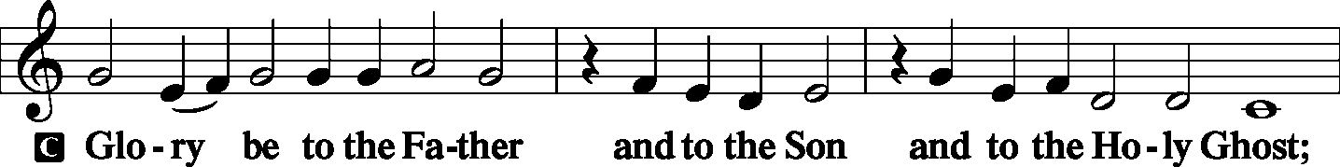
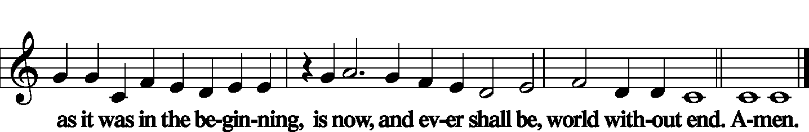

Kyrie Mark 10:47
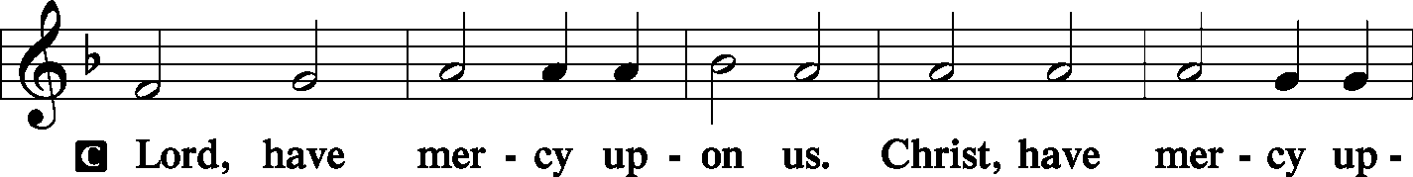
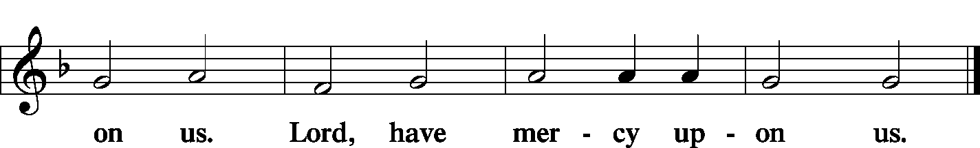

Gloria in Excelsis Luke 2: 14; John 1: 29
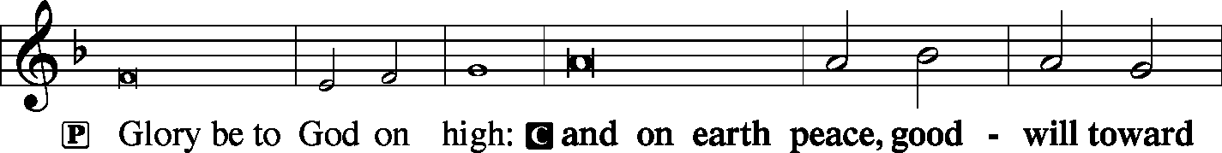
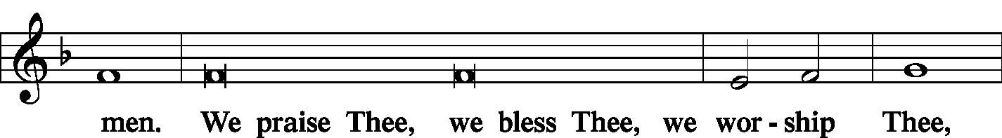
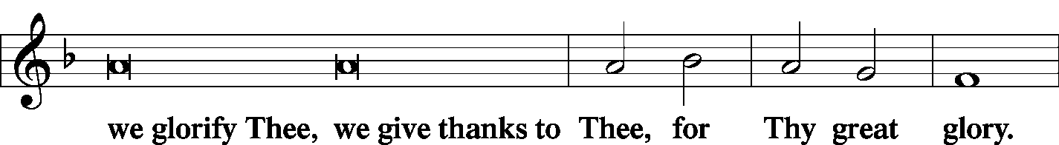
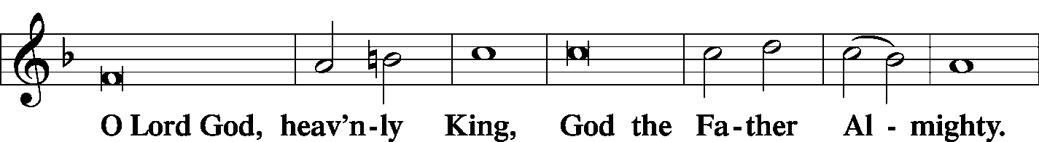
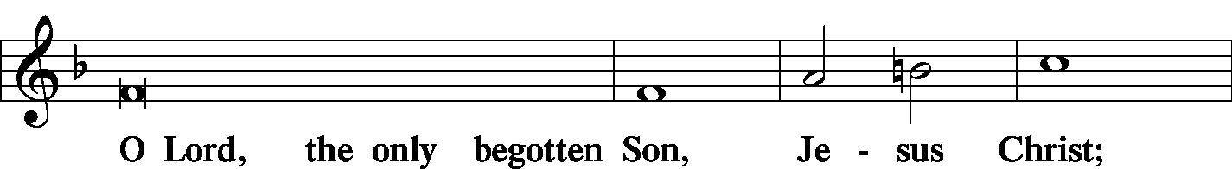
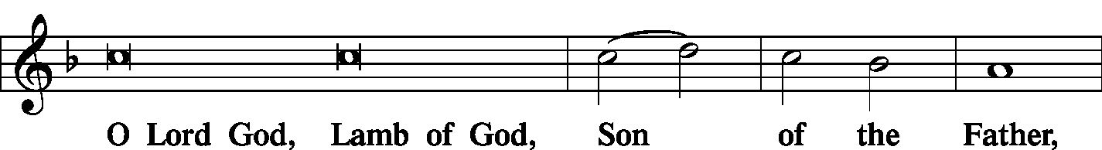
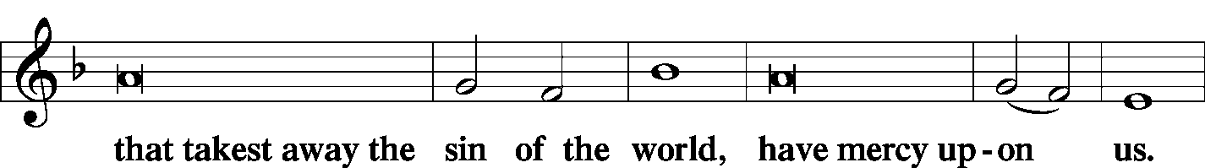
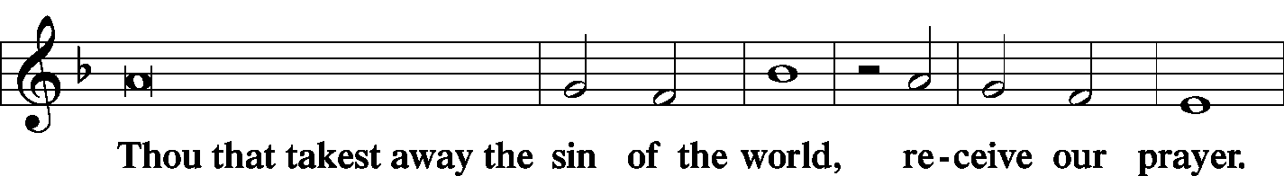
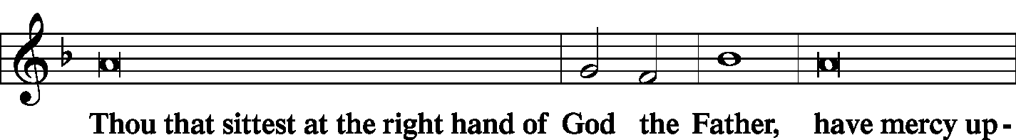
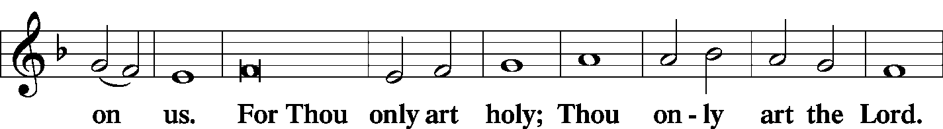
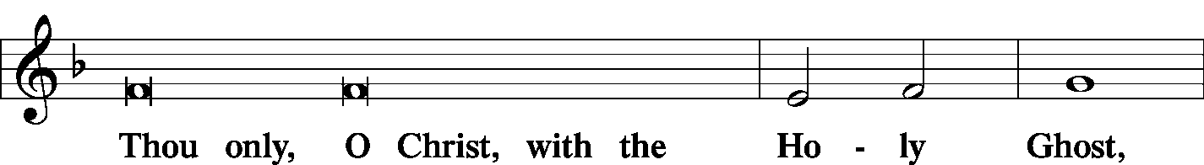
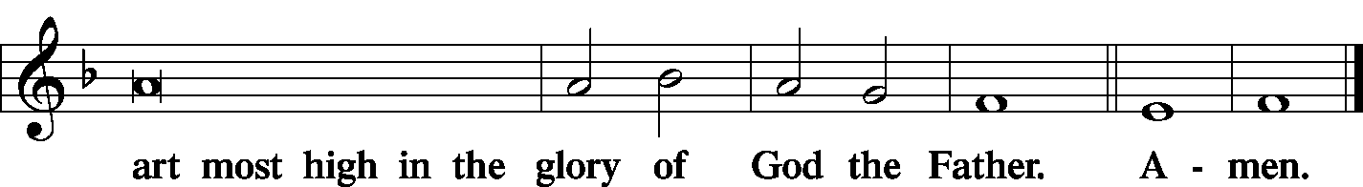

Salutation and Collect of the Day
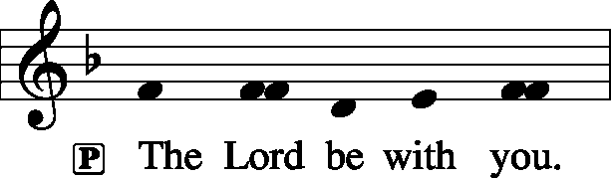 2 Timothy 4: 22
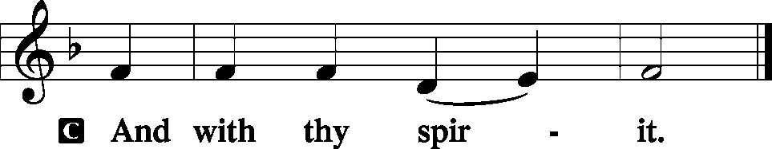

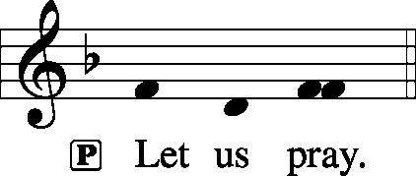
P O God, the strength of all who put their trust in You, mercifully grant that by Your power we may be defended against all adversity; through Jesus Christ, Your Son, our Lord, who lives and reigns with You and the Holy Spirit, one God, now and forever.
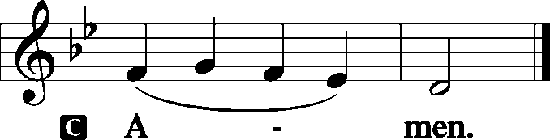

Sit

Old Testament Reading: Isaiah 55:10–13
“For as the rain and the snow come down from heaven
and do not return there but water the earth,
making it bring forth and sprout,
giving seed to the sower and bread to the eater,
so shall my word be that goes out from my mouth;
it shall not return to me empty,
but it shall accomplish that which I purpose,
and shall succeed in the thing for which I sent it.
“For you shall go out in joy
and be led forth in peace;
the mountains and the hills before you
shall break forth into singing,
and all the trees of the field shall clap their hands.
Instead of the thorn shall come up the cypress;
instead of the brier shall come up the myrtle;
and it shall make a name for the Lord,
an everlasting sign that shall not be cut off.”

P This is the Word of the Lord.
C Thanks be to God.

Gradual: Ps. 83:18, 13
[Let your enemies] know that you alone, whose name is the Lord,
are the Most High over all the earth.
O my God, make them like whirling dust,
like chaff before the wind.
Epistle: 2 Corinthians 11:19—12:9
For you gladly bear with fools, being wise yourselves! For you bear it if someone makes slaves of you, or devours you, or takes advantage of you, or puts on airs, or strikes you in the face. To my shame, I must say, we were too weak for that!
But whatever anyone else dares to boast of—I am speaking as a fool—I also dare to boast of that. Are they Hebrews? So am I. Are they Israelites? So am I. Are they offspring of Abraham? So am I. Are they servants of Christ? I am a better one—I am talking like a madman—with far greater labors, far more imprisonments, with countless beatings, and often near death. Five times I received at the hands of the Jews the forty lashes less one. Three times I was beaten with rods. Once I was stoned. Three times I was shipwrecked; a night and a day I was adrift at sea; on frequent journeys, in danger from rivers, danger from robbers, danger from my own people, danger from Gentiles, danger in the city, danger in the wilderness, danger at sea, danger from false brothers; in toil and hardship, through many a sleepless night, in hunger and thirst, often without food, in cold and exposure. And, apart from other things, there is the daily pressure on me of my anxiety for all the churches. Who is weak, and I am not weak? Who is made to fall, and I am not indignant?
If I must boast, I will boast of the things that show my weakness. The God and Father of the Lord Jesus, he who is blessed forever, knows that I am not lying. At Damascus, the governor under King Aretas was guarding the city of Damascus in order to seize me, but I was let down in a basket through a window in the wall and escaped his hands.
I must go on boasting. Though there is nothing to be gained by it, I will go on to visions and revelations of the Lord. I know a man in Christ who fourteen years ago was caught up to the third heaven—whether in the body or out of the body I do not know, God knows. And I know that this man was caught up into paradise—whether in the body or out of the body I do not know, God knows— and he heard things that cannot be told, which man may not utter. On behalf of this man I will boast, but on my own behalf I will not boast, except of my weaknesses. Though if I should wish to boast, I would not be a fool, for I would be speaking the truth. But I refrain from it, so that no one may think more of me than he sees in me or hears from me. So to keep me from being too elated by the surpassing greatness of the revelations, a thorn was given me in the flesh, a messenger of Satan to harass me, to keep me from being too elated. Three times I pleaded with the Lord about this, that it should leave me. But he said to me, “My grace is sufficient for you, for my power is made perfect in weakness.” Therefore I will boast all the more gladly of my weaknesses, so that the power of Christ may rest upon me.

P This is the Word of the Lord.
C Thanks be to God.

Stand
Tract: Ps. 60: 1-2, 5
P O God, you have rejected us, broken our defenses;
you have been angry; oh, restore us.
You have made the land to quake; you have torn it open;
repair its breaches, for it totters.
That your beloved ones may be delivered,
give salvation by your right hand and answer us!

Holy Gospel: Luke 8:4–15
P The Holy Gospel according to St. Luke, the eighth chapter.

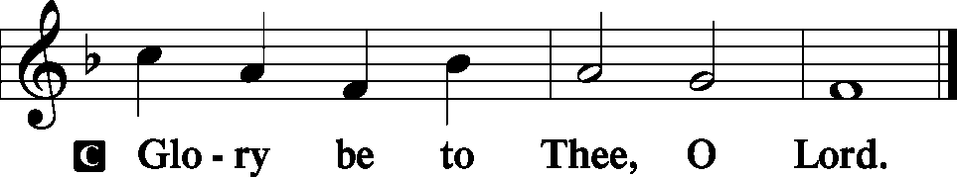

When a great crowd was gathering and people from town after town came to [Jesus], he said in a parable:
“A sower went out to sow his seed. And as he sowed, some fell along the path and was trampled underfoot, and the birds of the air devoured it.
And some fell on the rock, and as it grew up, it withered away, because it had no moisture. And some fell among thorns, and the thorns grew up with it and choked it. And some fell into good soil and grew and yielded a hundredfold.” As he said these things, he called out, “He who has ears to hear, let him hear.”
And when his disciples asked him what this parable meant, he said, “To you it has been given to know the secrets of the kingdom of God, but for others they are in parables, so that ‘seeing they may not see, and hearing they may not understand.’ Now the parable is this: The seed is the word of God. The ones along the path are those who have heard. Then the devil comes and takes away the word from their hearts, so that they may not believe and be saved. And the ones on the rock are those who, when they hear the word, receive it with joy. But these have no root; they believe for a while, and in time of testing fall away. And as for what fell among the thorns, they are those who hear, but as they go on their way they are choked by the cares and riches and pleasures of life, and their fruit does not mature. As for that in the good soil, they are those who, hearing the word, hold it fast in an honest and good heart, and bear fruit with patience.

P This is the Gospel of the Lord.
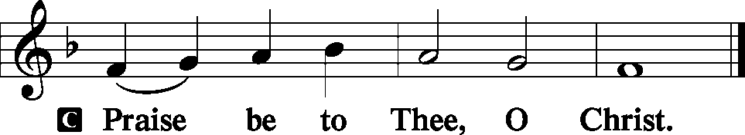

Nicene Creed
C I believe in one God,
the Father Almighty,
maker of heaven and earth
and of all things visible and invisible.
And in one Lord Jesus Christ,
the only-begotten Son of God,
begotten of His Father before all worlds,
God of God, Light of Light,
very God of very God,
begotten, not made,
being of one substance with the Father,
by whom all things were made;
who for us men and for our salvation came down from heaven
and was incarnate by the Holy Spirit of the virgin Mary
and was made man;
and was crucified also for us under Pontius Pilate.
He suffered and was buried.
And the third day He rose again according to the Scriptures
and ascended into heaven
and sits at the right hand of the Father.
And He will come again with glory to judge both the living and the dead,
whose kingdom will have no end.
And I believe in the Holy Spirit,
the Lord and giver of life,
who proceeds from the Father and the Son,
who with the Father and the Son together is worshiped and glorified,
who spoke by the prophets.
And I believe in one holy Christian and apostolic Church,
I acknowledge one Baptism for the remission of sins,
and I look for the resurrection of the dead
and the life T of the world to come. Amen.
Sit

Hymn of the Day: LSB #823 “May God Bestow on Us His Grace”

Sermon
Stand

P The peace of God, which passes all understanding, keep your hearts and minds in Christ Jesus. Philippians 4: 7
C Amen.

Prayer of the Church [Timothy 2: 1-4]
Sit

Offertory Psalm 51: 10-12
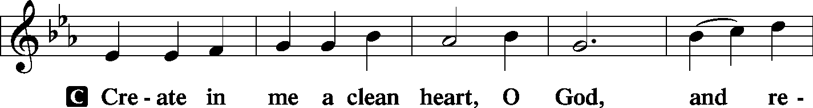
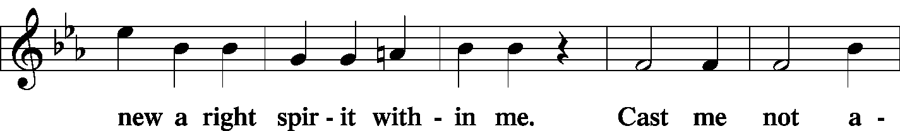
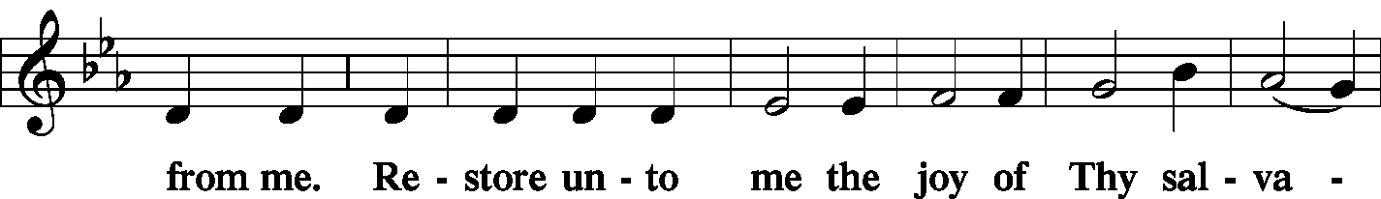
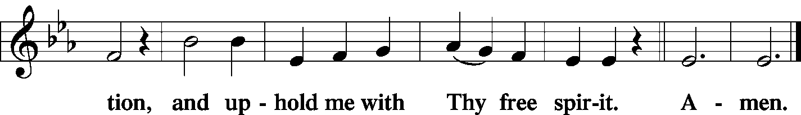

Offering Hymn: LSB #655 “Lord, Keep Us Steadfast in Your Word”

Stand
SERVICE OF THE SACRAMENT
Preface
2 Timothy 4: 22
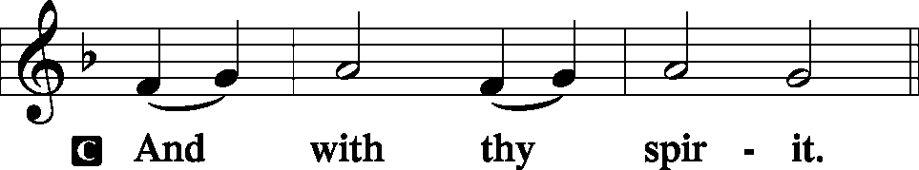
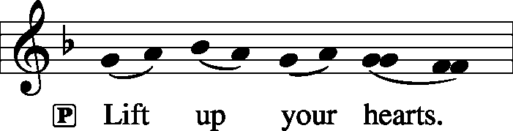 [Colossians 3:1]

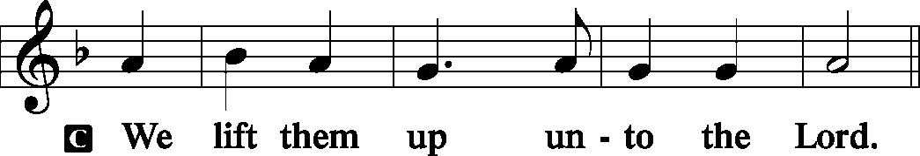

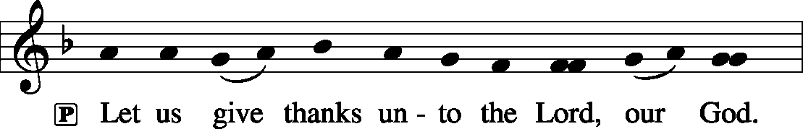 [Psalm 136]

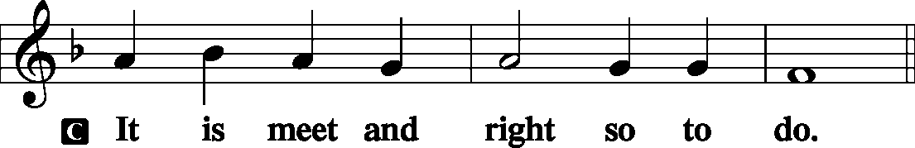

P It is truly meet, right, and salutary . . . evermore praising You and saying:

Sanctus Isaiah 6: 3; Matthew 21: 9
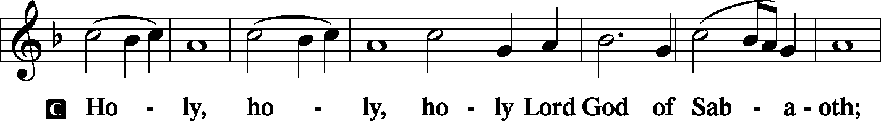
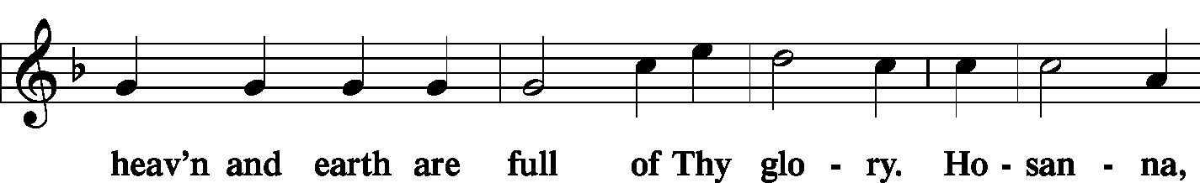
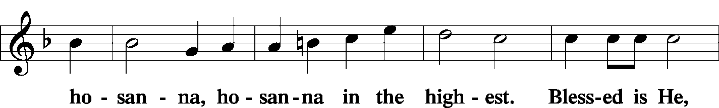
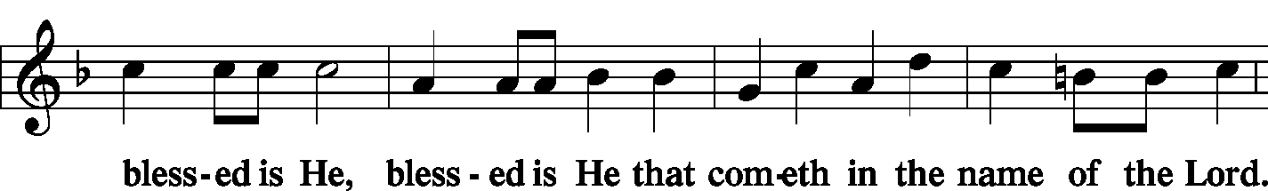
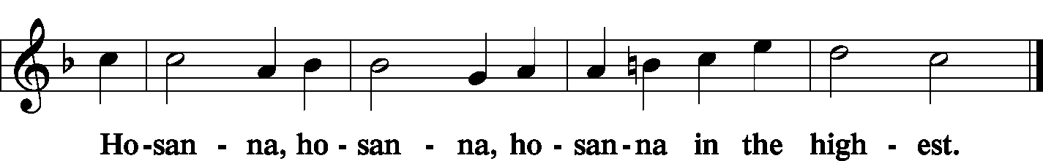

Lord's Prayer Matthew 6: 9-13
P Lord, remember us in Your kingdom and teach us to pray:
C Our Father who art in heaven,
hallowed be Thy name,
Thy kingdom come,
Thy will be done on earth as it is in heaven;
give us this day our daily bread;
and forgive us our trespasses as we forgive those who trespass against us;
and lead us not into temptation,
but deliver us from evil.
For Thine is the kingdom and the power and the glory forever and ever. Amen.

The Words of Our Lord Matthew 26: 26-28; Mark 14: 22-24
Luke 22: 19-20; 1 Corinthians 11: 23-25
P Our Lord Jesus Christ, on the night when He was betrayed, took bread, and when He had given thanks, He broke it and gave it to the disciples and said: “Take, eat; this is My T body, which is given for you. This do in remembrance of Me.”

P In the same way also He took the cup after supper, and when He had given thanks, He gave it to them, saying: “Drink of it, all of you; this cup is the new testament in My T blood, which is shed for you for the forgiveness of sins. This do, as often as you drink it, in remembrance of Me.”

Pax Domini John 20: 19
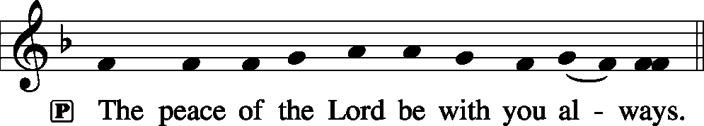
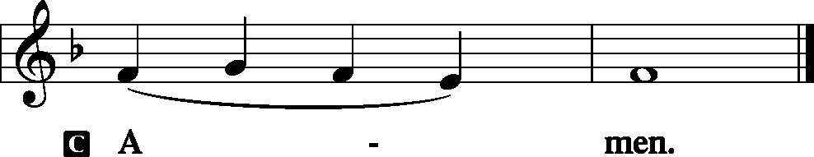

Agnus Dei John 1: 29
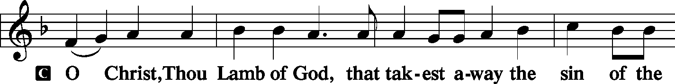
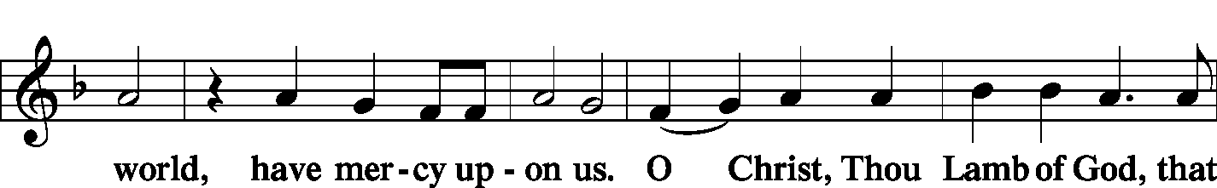
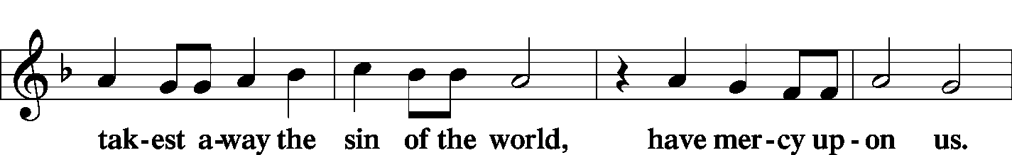
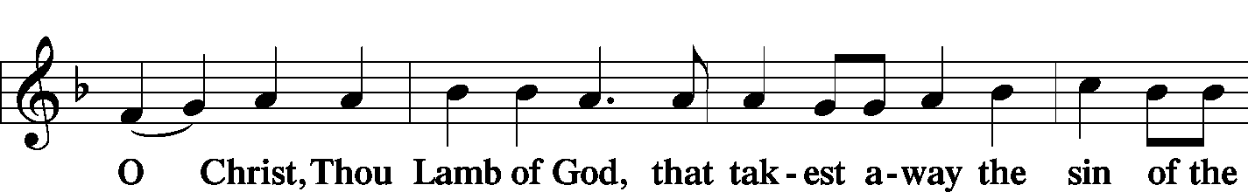
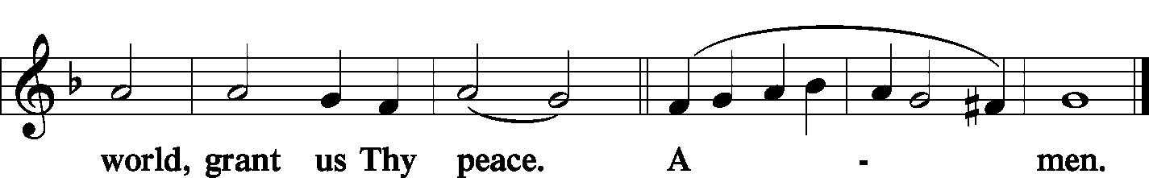
Sit

Distribution
The pastor and those who assist him receive the body and blood of Christ first and then distribute them to those who come to receive, saying:

Take, eat; this is the true body of our Lord and Savior Jesus Christ, given into death for your sins.
Amen.

Take, drink; this is the true blood of our Lord and Savior Jesus Christ, shed for the forgiveness of your sins.
Amen.

In dismissing the communicants, the following is said:
P The body and blood of our Lord Jesus Christ strengthen and preserve you in body and soul to life everlasting. Depart T in peace.
C Amen.

Distribution Hymn: LSB #621 “Let All Mortal Flesh Keep Silence”
Stand

Post-Communion Canticle: Nunc Dimittis Luke 2: 29-32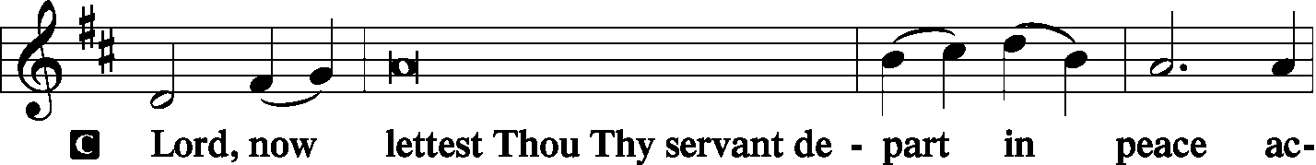
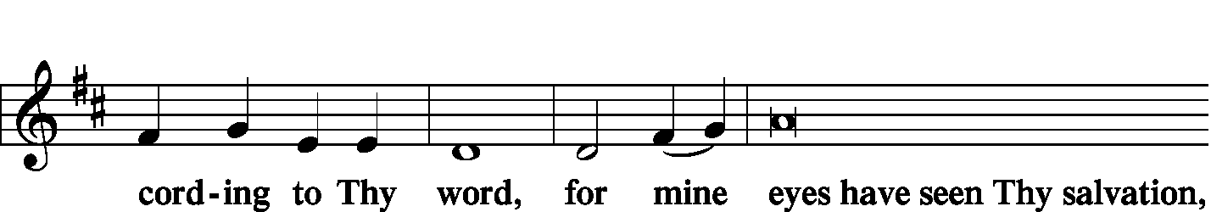
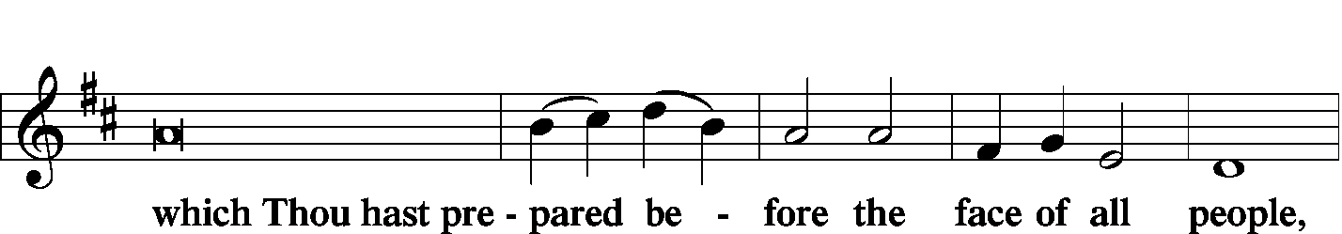
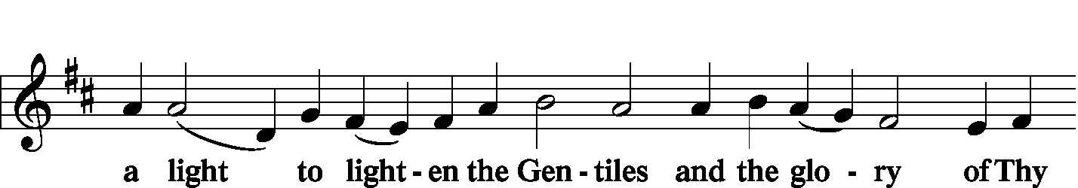
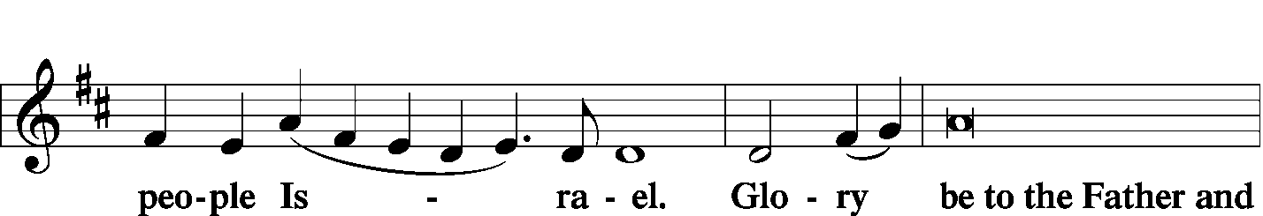
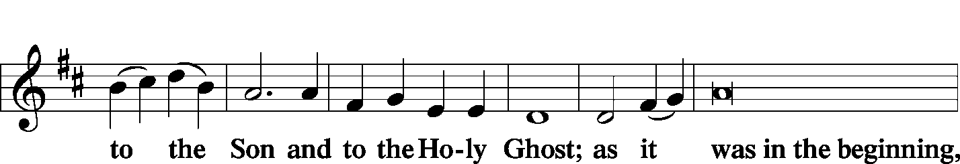
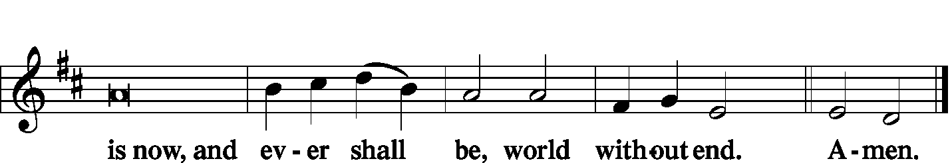

Thanksgiving Psalm 107: 1
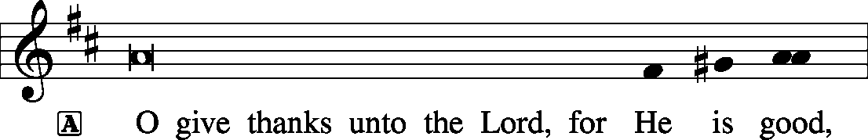
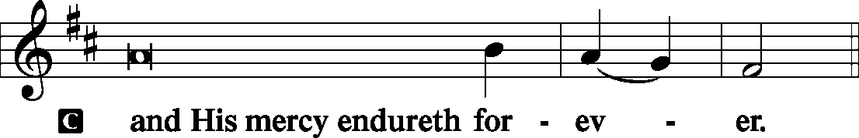

P Let us pray.
We give thanks to You, almighty God, that You have refreshed us through this salutary gift, and we implore You that of Your mercy You would strengthen us through the same in faith toward You and fervent love toward one another; through Jesus Christ, Your Son, our Lord, who lives and reigns with You and the Holy Spirit, one God, now and forever.
Salutation and Benedicamus
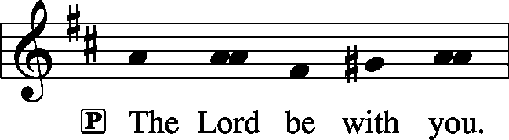 2 Timothy 4: 22

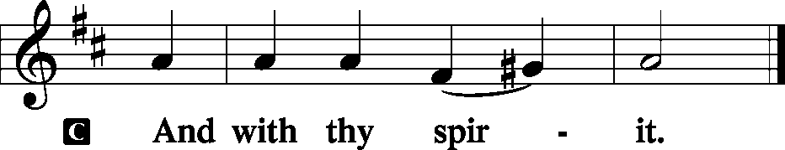
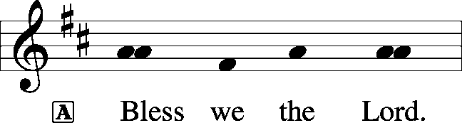 [Psalm 103: 1]

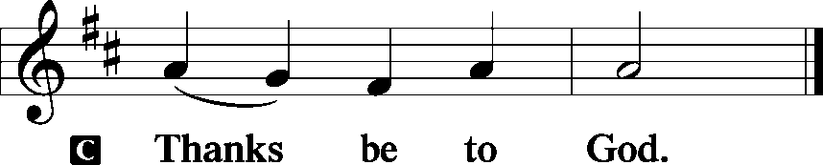

Benediction Numbers 6: 24-26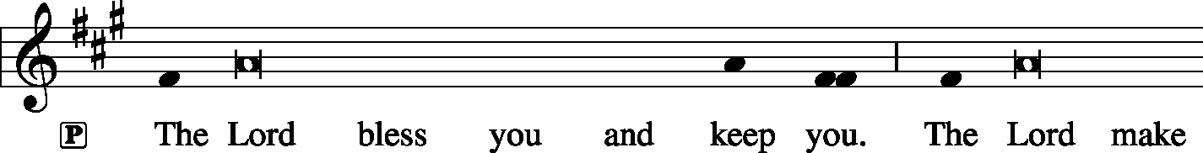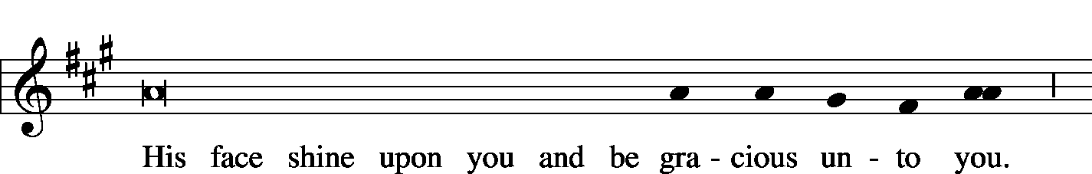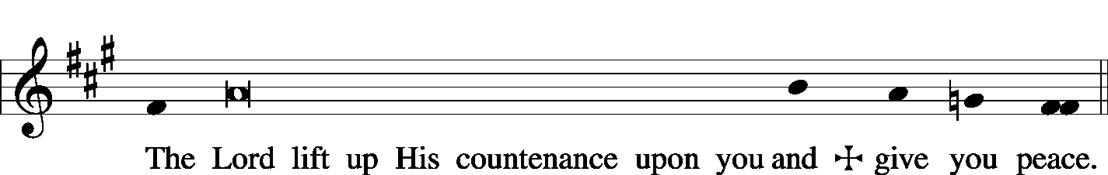

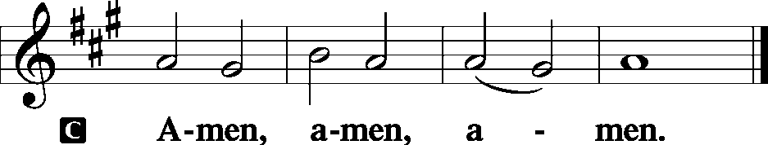

Closing Hymn: LSB #729 “I Am Trusting Thee, Lord Jesus”
Silent prayer after worship: Lord Jesus, as I go forth from this worship service, cause me to remember Your great love for me and all people. Give me boldness and faith to share Your love with others through my words and deeds. Amen.

Acknowledgments: Divine Service, Setting Three from Lutheran Service Book Unless otherwise indicated, all scripture quotations are from The Holy Bible, English Standard Version, copyright © 2001 by Crossway Bibles, a division of Good News Publishers. Used by permission. All rights reserved. Created by Lutheran Service Builder © 2006 Concordia Publishing House. CCLI License #3029-446

We are blessed this morning to welcome as our guest preacher Rev. Todd Seaver, Associate Pastor at All Saints in Slippery Rock, PA.


In Loving Memory of Father, Paul Petro, on his birthday, February 25th : Patty Parker.
In Sympathy to Matt & Cathy Berent upon the recent passing of John Berent, Matt’s father: Sophia Mihm, Max & Lisa Jelinek

Attendance:
Sunday, February 17, & Wednesday, February 20, 2019………………...……….49
SCHEDULE FOR TODAY THROUGH MAR. 3rd:
:

:

Today, following Worship, Library……………………………………….Altar Guild Meeting
Following Worship, Downstairs……………..……Financial Committee Meeting
7 pm, Downstairs….…………….…………………………………..…..…..……AA Meeting
Monday, 12:30 pm, Office……………………………………….……….Preschool Board Meeting
Wednesday, 5:30 pm, Sanctuary…………………………………………..………….Choir Practice
7 pm, Chapel…………..……………………………………………Divine Worship Service
Thursday, 9 am, Downstairs………………………………….…………………………..Food Pantry
Next Sunday, 8:45 am, Downstairs…………………..………………………………….Bible Study
10 am, Sanctuary…......................................................................Divine Service
7 pm, Downstairs………………………………………………………..…....……AA Meeting

Bible Memory Verses: For the week of February 24th
For Children: Today, if you hear his voice, do not harden your hearts.
Ps. 95:7-8
For Adults: You shall love the Lord your God with all your heart and with all your soul and with all your mind and with all your strength. Mark 12:30

Our Stewardship of Treasures for the Lord:
In order to do the Lord’s work, we need $2,882.02* each week to meet our 2019 budget for general purposes and $38.46 for missions.
Sunday, February 17, and Wednesday, February13, 2018:
General Offering:…..…..……….............................................................$1,970.00
Behind this week*: -$912.02
SELC Missions:……….………..…..……......................................................$175.00 Ahead this week: +$136.54
Quarterly Local Mission:……………………………………………………..….$25.00
Preschool Tuition Payments:...………………….................................…...…..$0.00
Other Offerings:………….…….…….....................………..……..…………$435.00
*Includes preschool tuition

The Altar Flowers this morning are given by Hugh Owen in Loving Memory of his Wedding Anniversary. We sincerely appreciate this generous gift.
Available in the narthex:
- Minutes from the February 17th Voters’ Assembly Meeting.
- Copies of the 2018 Annual Report.

Remember the following in Prayer…
~The Hurting and Healing: Tony⁴, Lois Bortner^{CA}, Richard Brandes³, Eileen Burns³, Mark Chirdon (Susan Bender’s brother-in-law who is having surgery Feb. 28th, Loretta Deal⁴, Norma Ferringer⁴, Anson Holcroft⁴, Betty Knauff^{CA}, Regis Knauff¹, Jess Lavoie², Paul Lucas^{CA}, Barry Nelson¹, David Nelson¹,Tom Mulligan^{CA}, Iona Oltman^{CA}, Rudy Pinal^{CA}, Richard Reuning^{CA}, Katie Sass (friend of Hugh Owen), Viola Sakony², Scott^{CA}, and Angela Weser^{CA}.
~Celebrating: Birthday~ Traudi Sulek (02.28). Anniversary~ Gary & Eileen Burns (02.24).
~Our Homebound: Helen Bender, Dan Davis, Edna Krajci, Mary Ann Krajci, Sophie Mihm, Marion & Gene Roberts, Barbara Vasconi, and Joanne Wolfe.
~Serving in the Military: Clayton Drnek, Curtis Sinewe, and Joshua Solyan.
~Community & World Needs: Victims of violence and terrorism; those suffering from loss and dislocation because weather disasters; those suffering from addiction and their families; safety for teachers, staff, and students; Local, State, and National Government Leaders; Safety for all Police Officers, Firefighters, & First Responders; the unemployed; our First Quarter Local Mission: Shenango Valley Meals on Wheels.
*CA represents cancer; number after other names represents weeks on the prayer list. After 4 weeks names may be resubmitted. This helps us to remember people’s specific needs and reminds us that God is providing healing as people get better and no longer need our prayers. Please submit prayer requests in writing to the church office. Please keep those listed above in your prayers.

Thank You for Serving in February:
Today’s Greeters: Jeff & Stacy Brandes. Assisting Elders: Barry Nelson & John Dyll. Ushers: Ralph Dorman, Jonathan Baisch, Matt Berent, Mark Gabriel, and John Dyll (alternate). Altarware: Clara Krivosh & Cheryl Fedele.

Thank You for Serving in March:
Assisting Elders: Bob Sulek & Barry Nelson. Ushers: Bob Sulek, Hugh Owen, Cheryl Fedele, Jesse Rifle, & Ralph Dorman (alternate). Altarware: Hank Holcroft & Kati Laird. March Greeters: 3~Gary & Eileen Burns; 6~Barry & Chris Nelson (7 pm); 10~Ralph Dorman & Diane Riefstahl; 17~John Dyll & Mark Gabriel; 24~Rev. Ed & Irene Kucera; 31~Anna Mae Daris & Millie Elavsky.

Reminder: Pastor Deal will be out of town thru Tuesday of this week. Please contact Elder, John Dyll, if in need of pastoral care.
Here to Serve…

Pastor………………………………………………….………..…Rev. Jacob Deal
E-mail ……….…………………….…..pastordeal@saintspeterandpaul.net
Phone Number…………..……………………………724-347-3620 (Option 2)
Church Office………………………………….………724-347-3620 (Option 3)
Website ……….………………….……...…….www.saintspeterandpaul.net
Secretary………………………………………………….……. Diane Riefstahl
E-mail ……….…………………….…….…church@saintspeterandpaul.net
Food Pantry: John Dyll…………….……………………..…..…724-347-1779
Little People Preschool…………….……………….724-347-3620 (Option 4)
Teacher: Paula Ostheimer………….………………….…….....724-981-5846
Email ……….………….…………………….paula@saintspeterandpaul.net
AA Contact: Steve……………………….…………..……...……. 724-813-2358
Organist……………………………………………………..…Carrie Yasnowski
Choir Director……………..…………….…………..….….………Chris Nelson
Congregation President…………………………………………Jeff Brandes

The secretary’s office hours will be Monday and Thursday (8:30-4:30). Pastor Deal will be in the office Monday through Thursday unless ministering off-site. If you need to enter the Church, please call ahead to be sure someone is here to let you in. Thank you.

