Sts. Peter & Paul
Evangelical Lutheran Church
Lutheran Church-Missouri Synod
Founded-1917
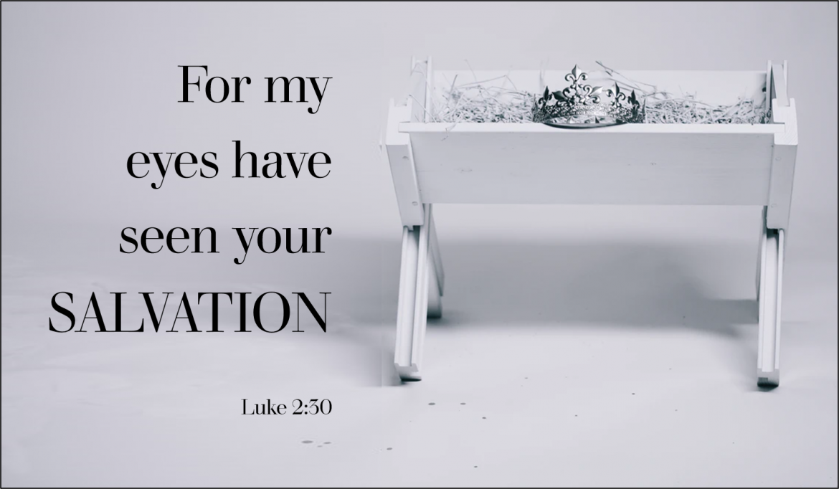

February 2, 2024

699 Stambaugh Avenue
Sharon, Pennsylvania 16146

“I was glad when they said to me,
Let us go to the house of the LORD!”
Psalm 122:1

VESPERS
The Purification of Mary and the Presentation of Our Lord

Silent prayer before worship: Almighty God, through Your Word, make me aware of Your awesome power and of Your boundless love in Jesus Christ, and lead me to worship You with my heart as well as my lips. In Jesus’ name. Amen.

Opening Hymn: LSB #754 “Entrust Your Days and Burdens”

Stand

Common Versicles LSB 229

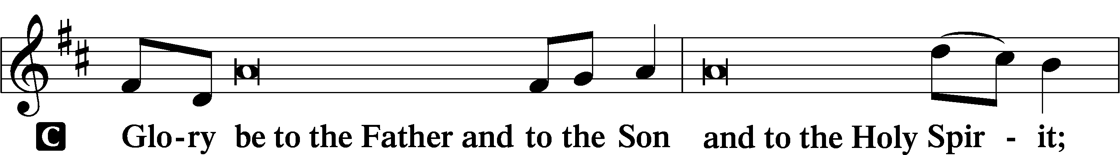
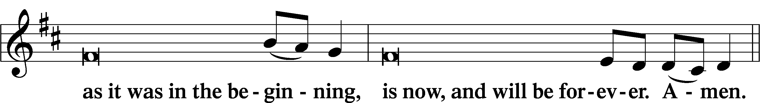
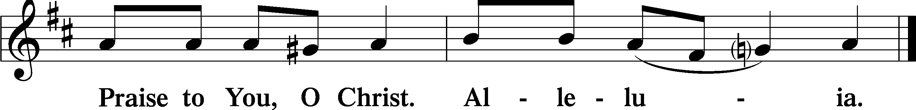
Psalmody
Psalm: Psalm 84
How lovely is your dwelling place,
O Lord of hosts!
My soul longs, yes, faints
for the courts of the Lord;
my heart and flesh sing for joy
to the living God.
Even the sparrow finds a home,
and the swallow a nest for herself,
where she may lay her young,
at your altars, O Lord of hosts,
my King and my God.
Blessèd are those who dwell in your house,
ever singing your praise!
Blessèd are those whose strength is in you,
in whose heart are the highways to Zion.
As they go through the Valley of Baca
they make it a place of springs;
the early rain also covers it with pools.
They go from strength to strength;
each one appears before God in Zion.
O Lord God of hosts, hear my prayer;
give ear, O God of Jacob!
Behold our shield, O God;
look on the face of your anointed!
For a day in your courts is better
than a thousand elsewhere.
I would rather be a doorkeeper in the house of my God
than dwell in the tents of wickedness.
For the Lord God is a sun and shield;
the Lord bestows favor and honor.
No good thing does he withhold
from those who walk uprightly.
O Lord of hosts,
blessèd is the one who trusts in you!
Sit

Hymn of the Day: LSB #519 “In His Temple Now Behold Him”
Readings

Prophecy: Malachi 3:1-4 (NKJV)
Thus says the Lord God: “Behold, I send My messenger, and he will prepare the way before Me. And the Lord, whom you seek, will suddenly come to His temple, even the Messenger of the covenant, in whom you delight. Behold, He is coming,” says the Lord of hosts. “But who can endure the day of His coming? And who can stand when He appears? For He is like a refiner’s fire and like launderers’ soap. He will sit as a refiner and a purifier of silver; He will purify the sons of Levi, and purge them as gold and silver, that they may offer to the Lord an offering in righteousness. Then the offering of Judah and Jerusalem will be pleasant to the Lord, as in the days of old, as in former years,” says the Lord Almighty.

P O Lord, have mercy on us.
C Thanks be to God.

Epistle: Hebrews 2:14–18 (NKJV)
Brethren: Inasmuch as the children have partaken of flesh and blood, He Himself likewise shared in the same, that through death He might destroy him who had the power of death, that is, the devil, and release those who through fear of death were all their lifetime subject to bondage. For indeed He does not give aid to angels, but He does give aid to the seed of Abraham. Therefore, in all things He had to be made like His brethren, that He might be a merciful and faithful High Priest in things pertaining to God, to make propitiation for the sins of the people. For in that He Himself has suffered, being tempted, He is able to aid those who are tempted, even Jesus Christ our Lord.

P O Lord, have mercy on us.
C Thanks be to God.

Gospel: Luke 2:22–32 (NKJV)
When the days of Mary’s purification according to the law of Moses were completed, they brought Jesus to Jerusalem to present Him to the Lord (as it is written in the law of the Lord, “Every male who opens the womb shall be called holy to the Lord”), and to offer a sacrifice according to what is said in the law of the Lord, “A pair of turtledoves or two young pigeons.” And behold, there was a man in Jerusalem whose name was Simeon, and this man was just and devout, waiting for the Consolation of Israel, and the Holy Spirit was upon him. And it had been revealed to him by the Holy Spirit that he would not see death before he had seen the Lord’s Christ. So he came by the Spirit into the temple. And when the parents brought in the Child Jesus, to do for Him according to the custom of the law, he took Him up in his arms and blessed God and said: “Lord, now You are letting Your servant depart in peace, according to Your word; for my eyes have seen Your salvation which You have prepared before the face of all peoples, a light to bring revelation to the Gentiles, and the glory of Your people Israel.”

P O Lord, have mercy on us.
C Thanks be to God.

Sermon

Canticle
Stand
Antiphon (Common) 231
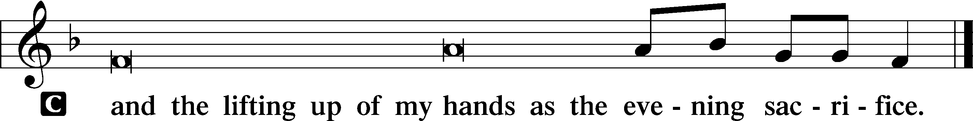

Hymn of Praise: LSB #933 “My Soul Rejoices”

Prayer

Kyrie LSB 233
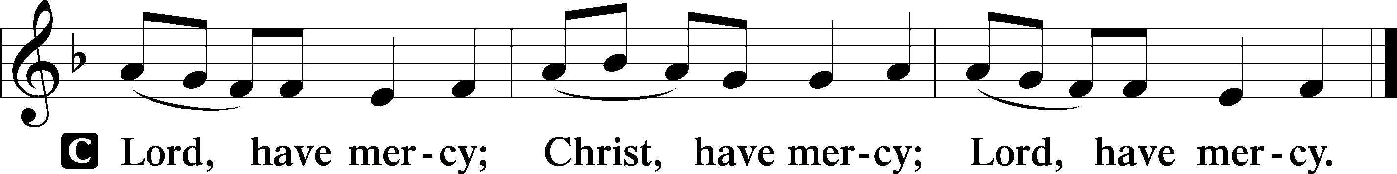

Lord’s Prayer
C Our Father who art in heaven,
hallowed be Thy name,
Thy kingdom come,
Thy will be done on earth
as it is in heaven;
give us this day our daily bread;
and forgive us our trespasses
as we forgive those
who trespass against us;
and lead us not into temptation,
but deliver us from evil.
For Thine is the kingdom
and the power and the glory
forever and ever. Amen.

Collects LSB 233
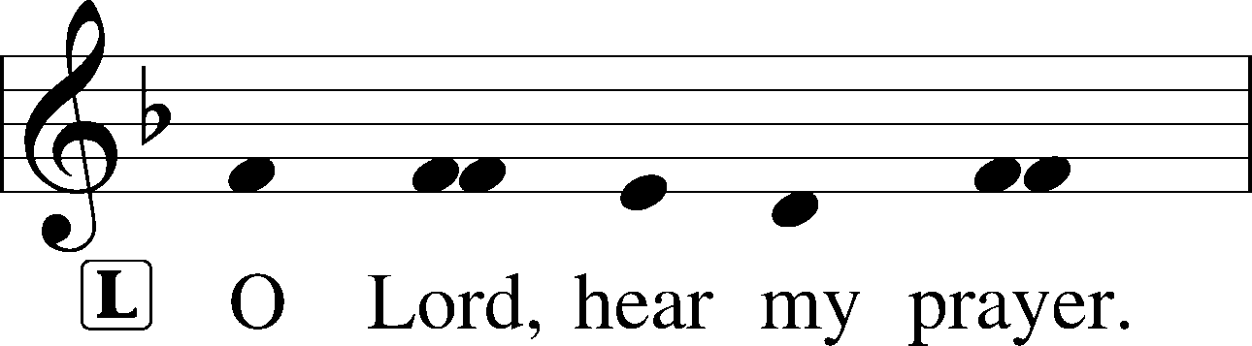
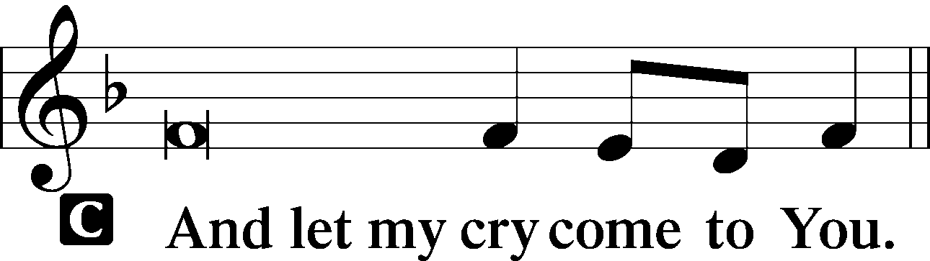

Collect of the Day: Presentation
P Almighty and ever-living God, as Your only-begotten Son was this day presented in the temple in the substance of our flesh, grant that we may be presented to You with pure and clean hearts; through Jesus Christ, our Lord, who lives and reigns with You and the Holy Spirit, one God, now and forever.

Collect for Peace
P O God, from whom come all holy desires, all good counsels, and all just works, give to us, Your servants, that peace which the world cannot give, that our hearts may be set to obey Your commandments and also that we, being defended from the fear of our enemies, may live in peace and quietness; through Jesus Christ, Your Son, our Lord, who lives and reigns with You and the Holy Spirit, one God, now and forever.
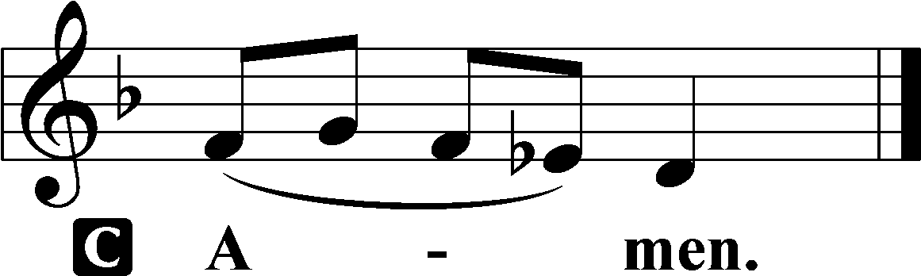

Benedicamus LSB 234
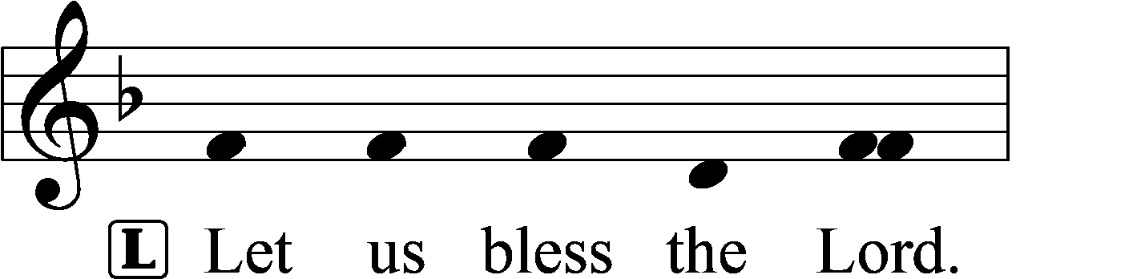
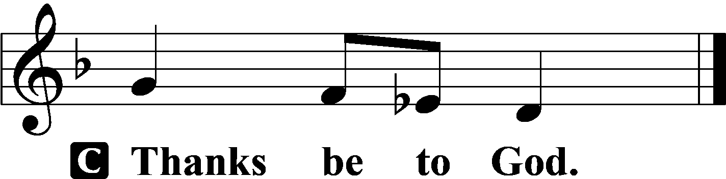

Benediction LSB 234
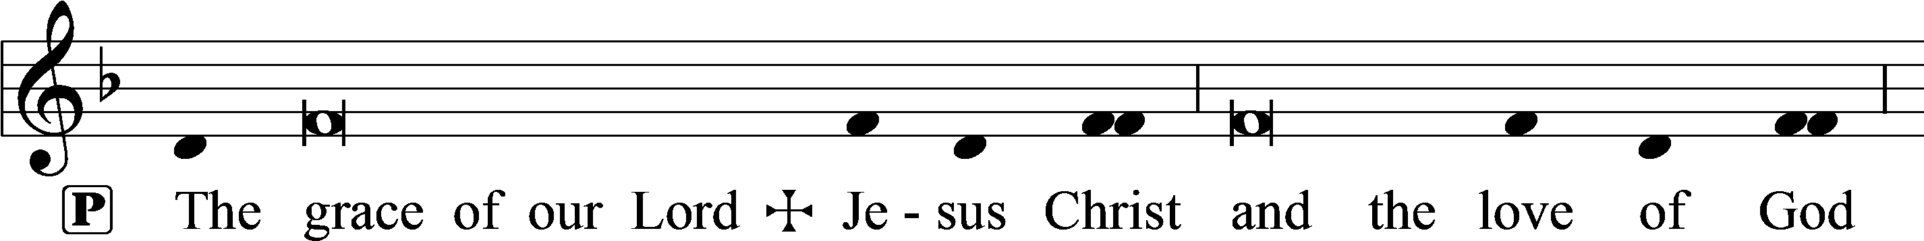
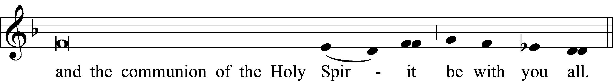

Closing Hymn: LSB #530 “No Temple Now, No Gift of Price”


Silent prayer after worship: O Lord, lead me to daily read Your word and pray that I may receive Your blessings and grow in my faith, so that my life may be a light that gives You glory and directs others to You. In Jesus’ name. Amen.

Acknowledgments
Unless otherwise indicated, Scripture quotations are from the ESV® Bible (The Holy Bible, English Standard Version®), copyright © 2001 by Crossway, a publishing ministry of Good News Publishers. Used by permission. All rights reserved.
Created by Lutheran Service Builder © 2024 Concordia Publishing House.

