Sts. Peter & Paul
Evangelical Lutheran Church
Lutheran Church-Missouri Synod
Founded-1917

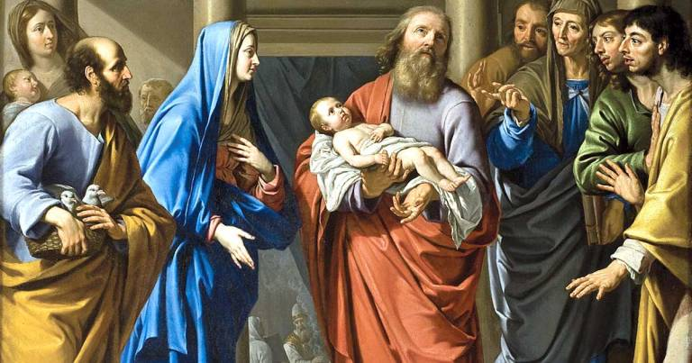

THE PURIFICATION OF MARY
AND
THE PRESENTATION OF OUR LORD

VESPERS SERVICE
February 2, 2023

699 Stambaugh Avenue
Sharon, Pennsylvania 16146

“I was glad when they said to me,
Let us go to the house of the LORD!”
Psalm 122:1
Sts. Peter & Paul Evangelical Lutheran Church, LC-MS
THE PURIFICATION OF MARY AND THE PRESENTATION OF OUR LORD
February 2, 2023

A special welcome to our guests this day! If you would like more information about The Lutheran Church - Missouri Synod, or this congregation, please speak with Pastor Deal or an Elder after the service.
Members & Guests: Don’t be embarrassed if your children make noise during the worship service, all children do. We encourage families to worship together but, if you feel the need, there are pews in the rear of the Church which are reserved for young families on both sides of the sanctuary. There is also a quiet room available to you during our service which is located down the hallway past the offices on the right side of the church as well as a children’s area in the Fellowship Hall where you are able to follow along with the service.

CONTACT INFORMATION
Pastor Deal: pastordeal@saintspeterandpaul.net or 724-347-3620 (opt. 2)
Church Office: church@saintspeterandpaul.net or 724-347-3620 (opt. 3)

Silent prayer before worship: Heavenly Father, help me never to forget that by the power of Your word in Christ I have hope, joy, peace and life. Lead me to worship You with my heart, as well as with my lips. In Jesus’ name. Amen.

Vespers Service
LSB pp. 229-234

Opening Hymn: LSB #367 “Angels from the Realms of Glory”

Stand

Common Versicles LSB 229
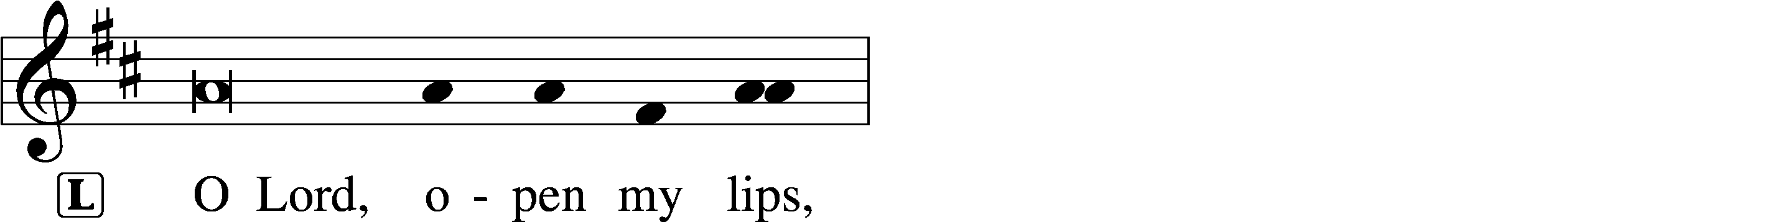
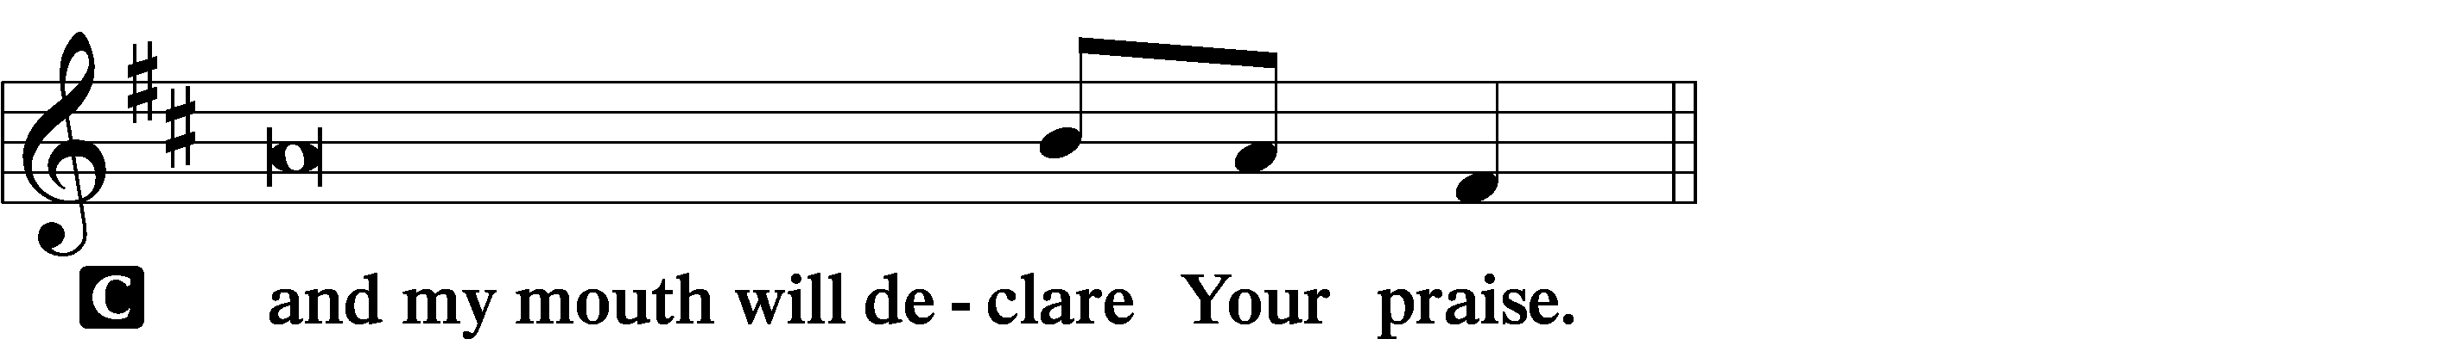

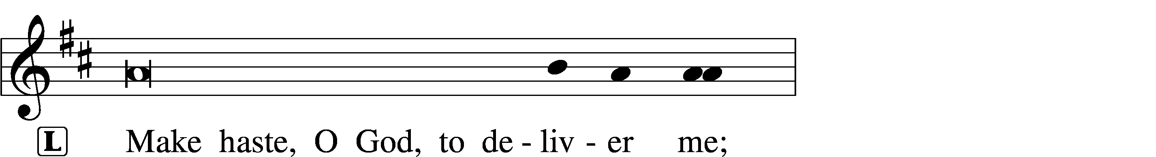
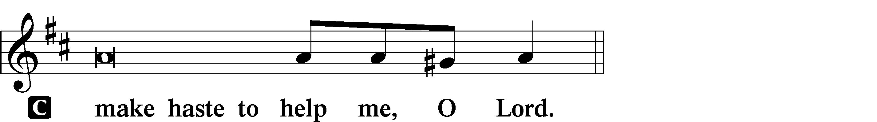

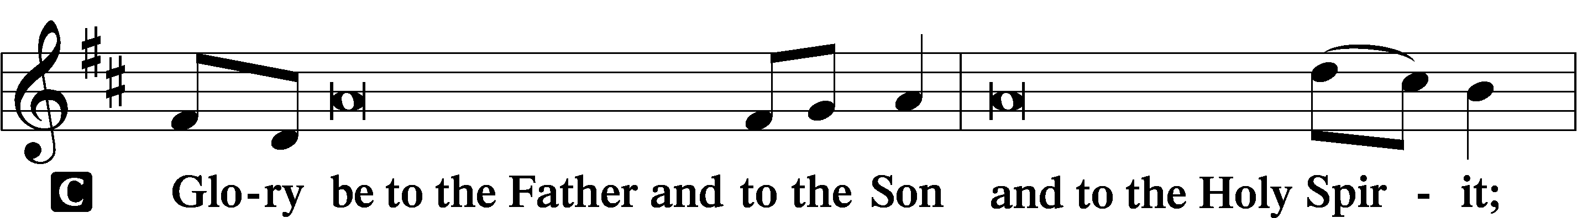
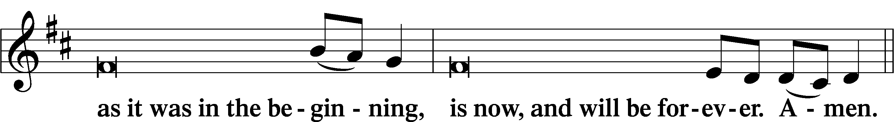
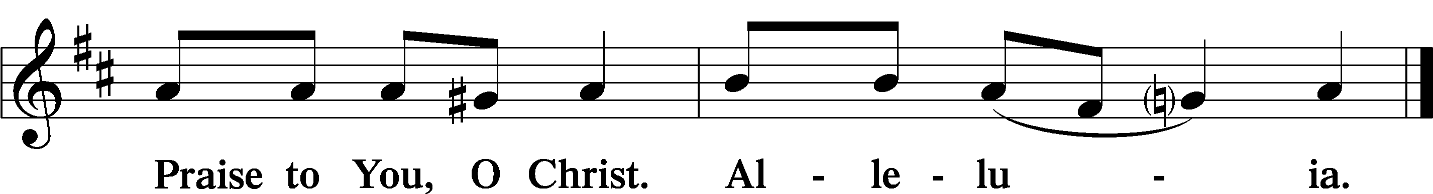

Psalmody

Psalm 84
How lovely is your dwelling place,
O Lord of hosts!
My soul longs, yes, faints
for the courts of the Lord;
my heart and flesh sing for joy
to the living God.
Even the sparrow finds a home,
and the swallow a nest for herself,
where she may lay her young,
at your altars, O Lord of hosts,
my King and my God.
Blessèd are those who dwell in your house,
ever singing your praise!
Blessèd are those whose strength is in you,
in whose heart are the highways to Zion.
As they go through the Valley of Baca
they make it a place of springs;
the early rain also covers it with pools.
They go from strength to strength;
each one appears before God in Zion.
O Lord God of hosts, hear my prayer;
give ear, O God of Jacob!
Behold our shield, O God;
look on the face of your anointed!
For a day in your courts is better
than a thousand elsewhere.
I would rather be a doorkeeper in the house of my God
than dwell in the tents of wickedness.
For the Lord God is a sun and shield;
the Lord bestows favor and honor.
No good thing does he withhold
from those who walk uprightly.
O Lord of hosts,
blessèd is the one who trusts in you!
Sit

Hymn of the Day: LSB #519 “In His Temple Now Behold Him”
Readings

Reading: 1 Samuel 1:21–28
The man Elkanah and all his house went up to offer to the Lord the yearly sacrifice and to pay his vow. But Hannah did not go up, for she said to her husband, “As soon as the child is weaned, I will bring him, so that he may appear in the presence of the Lord and dwell there forever.” Elkanah her husband said to her, “Do what seems best to you; wait until you have weaned him; only, may the Lord establish his word.” So the woman remained and nursed her son until she weaned him. And when she had weaned him, she took him up with her, along with a three-year-old bull, an ephah of flour, and a skin of wine, and she brought him to the house of the Lord at Shiloh. And the child was young. Then they slaughtered the bull, and they brought the child to Eli. And she said, “Oh, my lord! As you live, my lord, I am the woman who was standing here in your presence, praying to the Lord. For this child I prayed, and the Lord has granted me my petition that I made to him. Therefore I have lent him to the Lord. As long as he lives, he is lent to the Lord.”
And he worshiped the Lord there.

P This is the Word of the Lord.
C Thanks be to God.

Reading: Hebrews 2:14–18
Since therefore the children share in flesh and blood, he himself likewise partook of the same things, that through death he might destroy the one who has the power of death, that is, the devil, and deliver all those who through fear of death were subject to lifelong slavery. For surely it is not angels that he helps, but he helps the offspring of Abraham. Therefore he had to be made like his brothers in every respect, so that he might become a merciful and faithful high priest in the service of God, to make propitiation for the sins of the people. For because he himself has suffered when tempted, he is able to help those who are being tempted.

P O Lord, have mercy on us.
C Thanks be to God.

Reading: Luke 2:22–40
P A reading from Luke, chapter 2.
When the time came for their purification according to the Law of Moses, [Mary and Joseph] brought [Jesus] up to Jerusalem to present him to the Lord (as it is written in the Law of the Lord, “Every male who first opens the womb shall be called holy to the Lord”) and to offer a sacrifice according to what is said in the Law of the Lord, “a pair of turtledoves, or two young pigeons.” Now there was a man in Jerusalem, whose name was Simeon, and this man was righteous and devout, waiting for the consolation of Israel, and the Holy Spirit was upon him. And it had been revealed to him by the Holy Spirit that he would not see death before he had seen the Lord’s Christ. And he came in the Spirit into the temple, and when the parents brought in the child Jesus, to do for him according to the custom of the Law, he took him up in his arms and blessed God and said,
“Lord, now you are letting your servant depart in peace,
according to your word;
for my eyes have seen your salvation
that you have prepared in the presence of all peoples,
a light for revelation to the Gentiles,
and for glory to your people Israel.”
And his father and his mother marveled at what was said about him. And Simeon blessed them and said to Mary his mother, “Behold, this child is appointed for the fall and rising of many in Israel, and for a sign that is opposed (and a sword will pierce through your own soul also), so that thoughts from many hearts may be revealed.”
And there was a prophetess, Anna, the daughter of Phanuel, of the tribe of Asher. She was advanced in years, having lived with her husband seven years from when she was a virgin, and then as a widow until she was eighty-four. She did not depart from the temple, worshiping with fasting and prayer night and day. And coming up at that very hour she began to give thanks to God and to speak of him to all who were waiting for the redemption of Jerusalem.
And when they had performed everything according to the Law of the Lord, they returned into Galilee, to their own town of Nazareth. And the child grew and became strong, filled with wisdom. And the favor of God was upon him.

P O Lord, have mercy on us.
C Thanks be to God.

P This is the Word of the Lord.
C Thanks be to God.

Responsory LSB 230
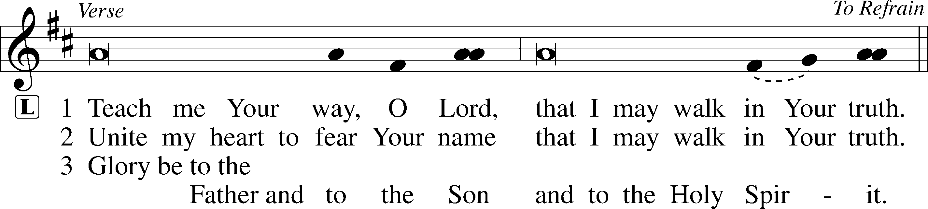
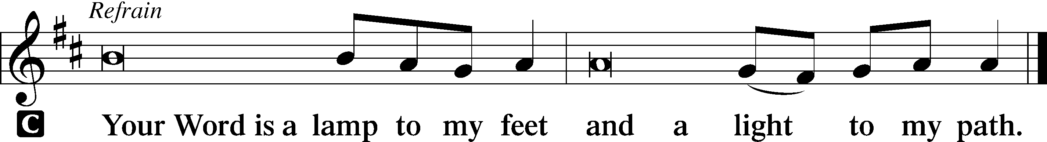

Sermon
Canticle
Stand

Antiphon (Common) 231
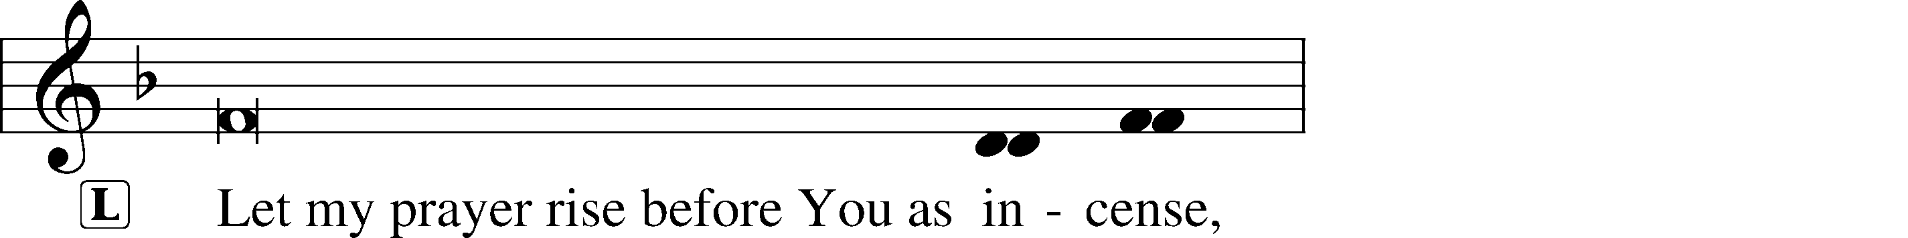
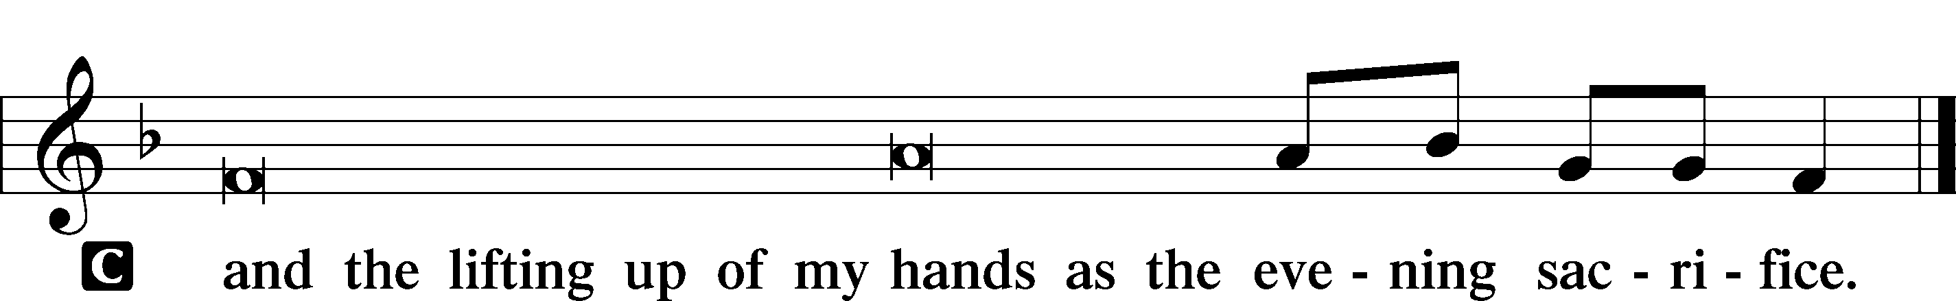

Magnificat 231
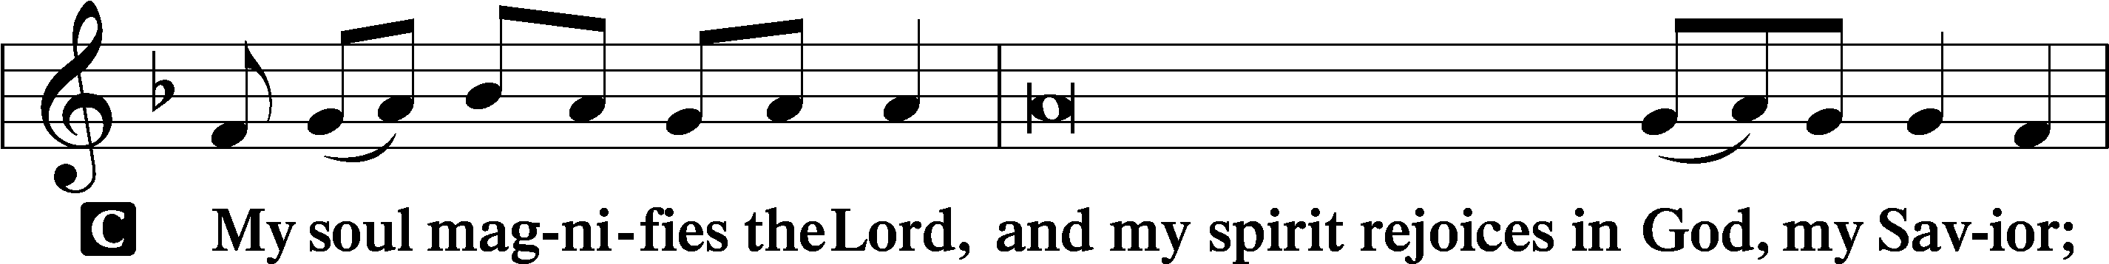
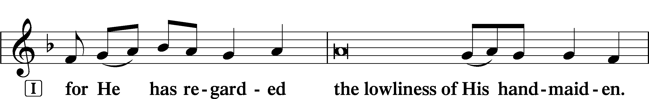
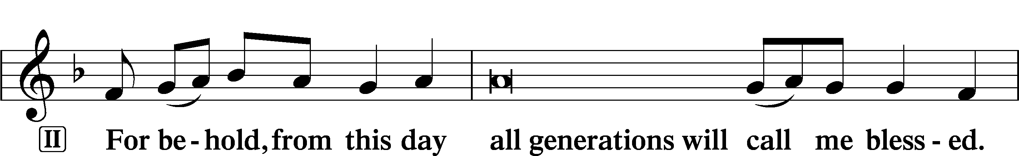
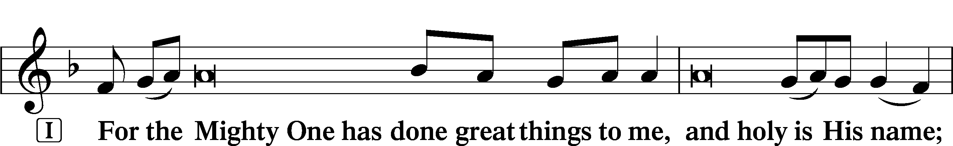
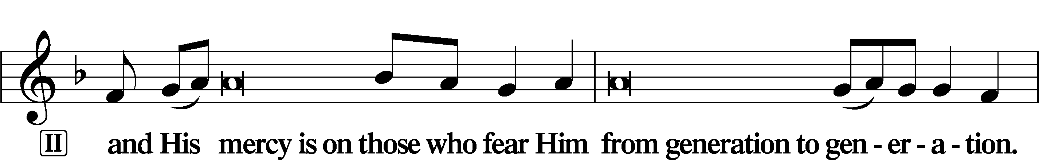
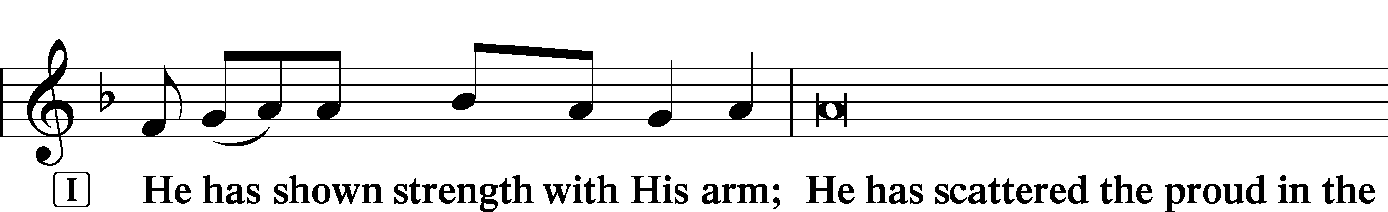
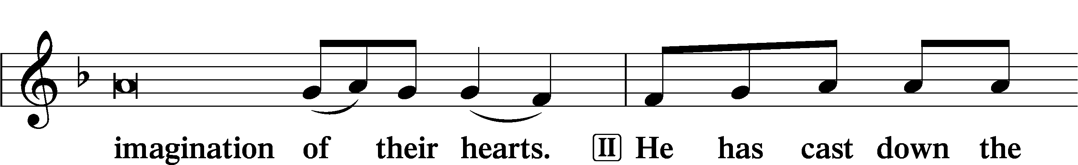
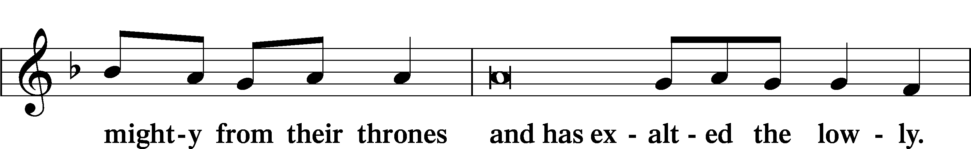
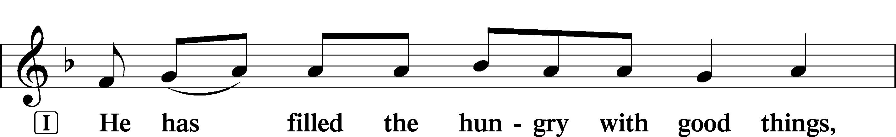
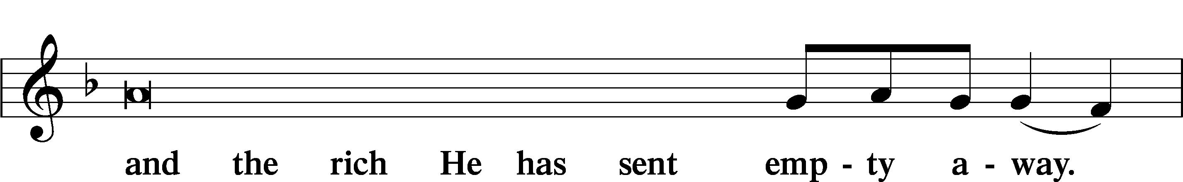
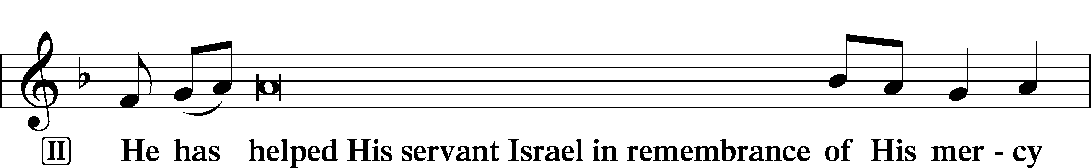
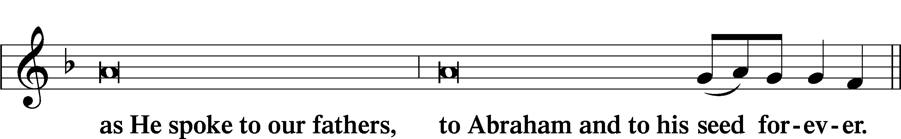
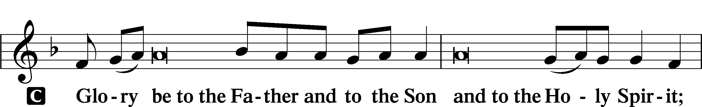
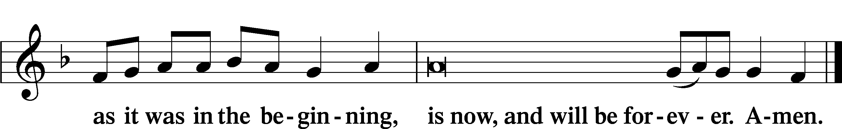

Prayer
Kyrie LSB 233
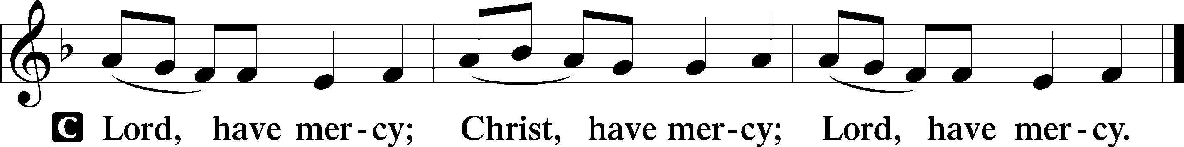
Lord’s Prayer
C Our Father who art in heaven,
hallowed be Thy name,
Thy kingdom come,
Thy will be done on earth
as it is in heaven;
give us this day our daily bread;
and forgive us our trespasses
as we forgive those
who trespass against us;
and lead us not into temptation,
but deliver us from evil.
For Thine is the kingdom
and the power and the glory
forever and ever. Amen.

Collects
Introduction to Collects LSB 233
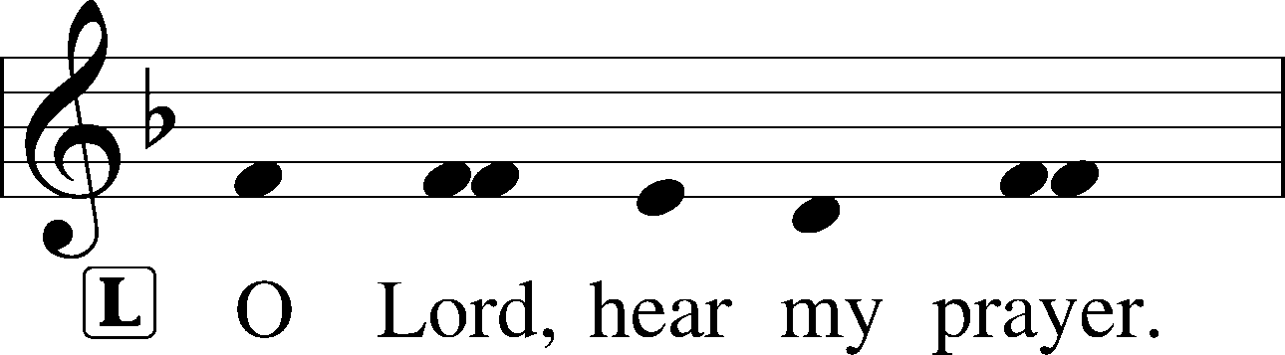
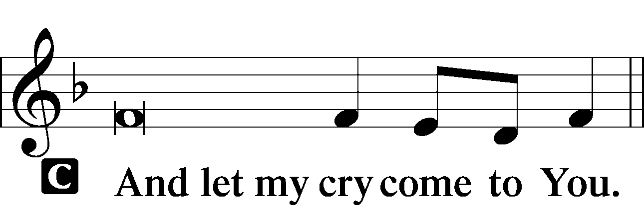

Collect of the Day: Presentation
P Almighty and ever-living God, as Your only-begotten Son was this day presented in the temple in the substance of our flesh, grant that we may be presented to You with pure and clean hearts; through Jesus Christ, our Lord, who lives and reigns with You and the Holy Spirit, one God, now and forever.

Collect for Peace
P O God, from whom come all holy desires, all good counsels, and all just works, give to us, Your servants, that peace which the world cannot give, that our hearts may be set to obey Your commandments and also that we, being defended from the fear of our enemies, may live in peace and quietness; through Jesus Christ, Your Son, our Lord, who lives and reigns with You and the Holy Spirit, one God, now and forever.
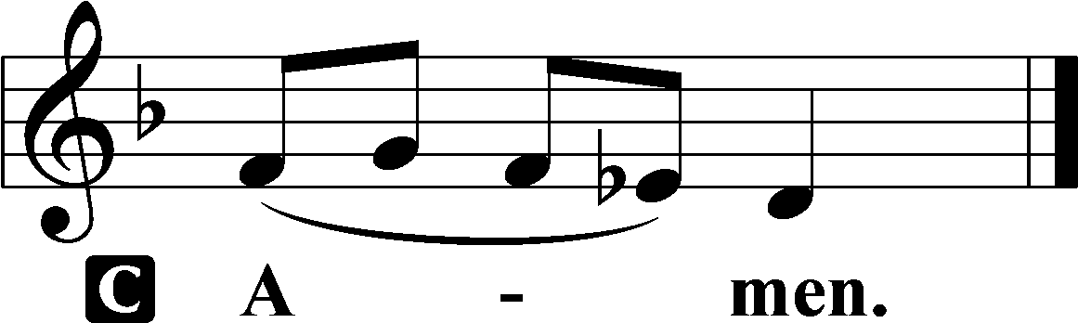

Benedicamus LSB 234
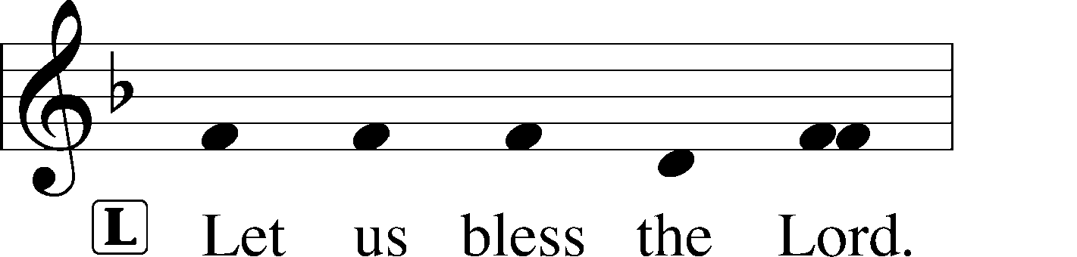
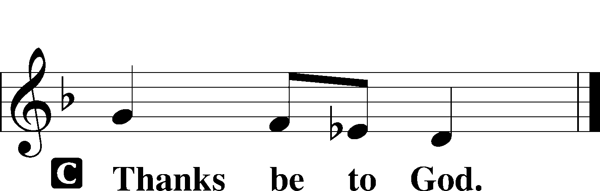

Benediction LSB 234
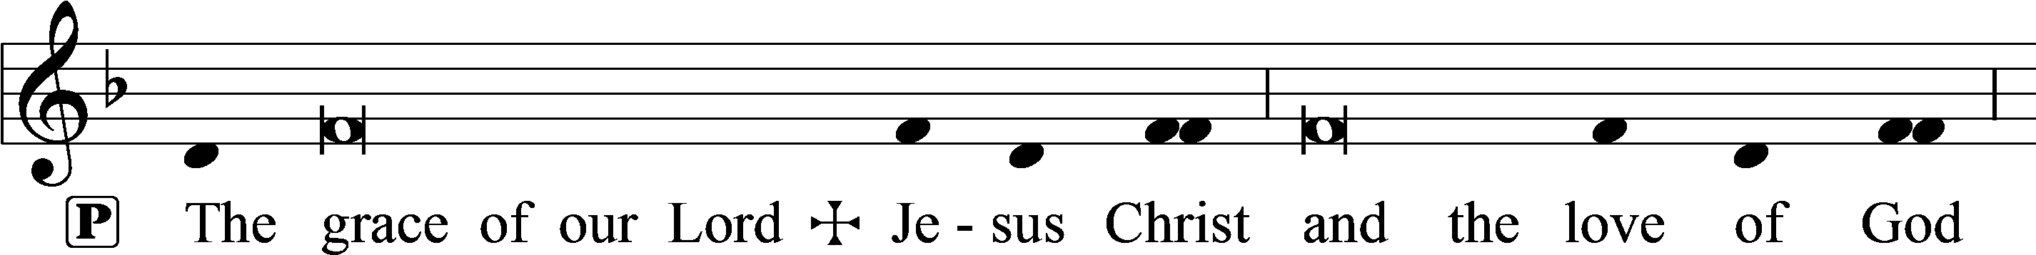
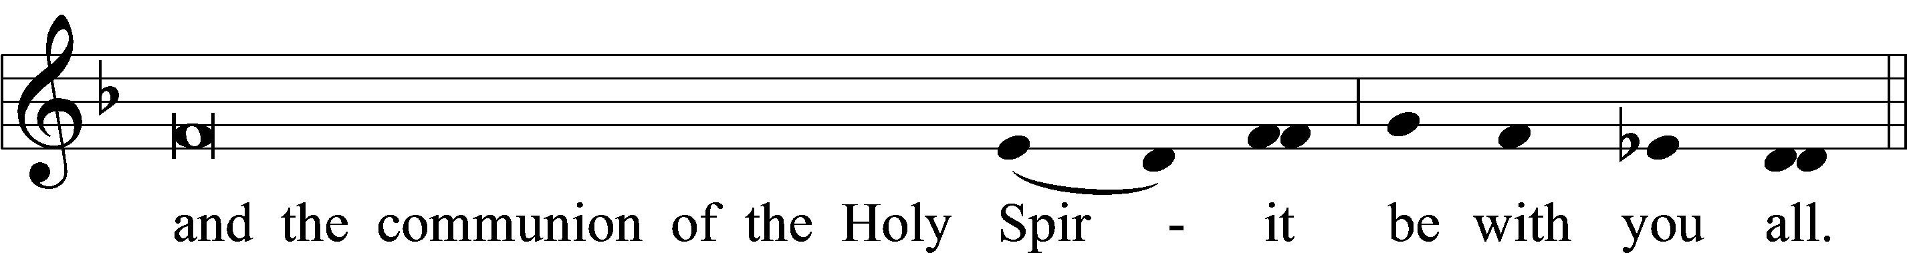

Closing Hymn: LSB #530 “No Temple Now, No Gift of Price”

Silent prayer after worship: O gracious God, as I leave this worship service, cause Your holy word to continually live in my heart, and lead me to share Your word with others so they may also know the power of Your love. In Jesus’ name. Amen.
fffffffffffffffffffffffffffffffffff
Acknowledgments
Unless otherwise indicated, Scripture quotations are from the ESV® Bible (The Holy Bible, English Standard Version®), copyright © 2001 by Crossway, a publishing ministry of Good News Publishers. Used by permission. All rights reserved.
Created by Lutheran Service Builder © 2023 Concordia Publishing House.

