Sts. Peter & Paul
Evangelical Lutheran Church
Lutheran Church-Missouri Synod
Founded-1917

February 18, 2024

699 Stambaugh Ave.
Sharon, Pennsylvania 16146

“I was glad when they said to me,
Let us go to the house of the LORD!”
Psalm 122:1
Sts. Peter & Paul Evangelical Lutheran Church, LC-MS
INVOCAVIT
February 18, 2024

A special welcome to our guests this day! If you would like more information about The Lutheran Church - Missouri Synod, or this congregation, please speak with Pastor Deal or an Elder after the service.
Members & Guests: Don’t be embarrassed if your children make noise during the worship service, all children do. We encourage families to worship together but, if you feel the need, there are pews in the rear of the Church which are reserved for young families on both sides of the sanctuary. There is also a quiet room available to you, located next to the sanctuary (formerly the Pastor’s office), where you would be able to follow along with the service.

Today’s service includes the Sacrament of Holy Communion. If during this past year, you have not worshipped with us and been communed, we respectfully ask that you do not partake of this sacrament this day before first speaking with Pastor Deal.
If visiting from a sister congregation of the LC-MS and are in good standing, please inform Pastor Deal of your desire to commune prior to the service.
If wishing to receive a blessing during communion, please approach with your arms crossed.

CONTACT INFORMATION
Pastor Deal: pastordeal@saintspeterandpaul.net or 724-347-3620 (opt. 2)
Church Office: church@saintspeterandpaul.net or 724-347-3620 (opt. 3)
Secretary’s Office: The office will be open Monday & Wednesday (8:30 am – 4:30 pm) and Thursday/Friday, as needed.

Silent prayer before worship: Almighty God, You sent Your Son to die and rise again that all who believe in him may live. Grant that I may faithfully walk the way of the cross and show forth true love for You and for my neighbors. In Jesus’ name. Amen.
Confession and Absolution

Opening Hymn: LSB #668 “Rise! To Arms! With Prayer Employ You”

Stand

The sign of the cross may be made by all in remembrance of their Baptism.

Invocation
P In the name of the Father and of the T Son and of the Holy Spirit.
C Amen.

Exhortation Hebrews 10:22; Psalm 124:8; Psalm 32:5
P Beloved in the Lord! Let us draw near with a true heart and confess our sins unto God our Father, beseeching Him in the name of our Lord Jesus Christ to grant us forgiveness.

P Our help is in the name of the Lord,
C who made heaven and earth.
P I said, I will confess my transgressions unto the Lord,
C and You forgave the iniquity of my sin.

Silence for reflection on God’s Word and for self-examination.

Confession of Sins
P O almighty God, merciful Father,
C I, a poor, miserable sinner, confess unto You all my sins and iniquities with which I have ever offended You and justly deserved Your temporal and eternal punishment. But I am heartily sorry for them and sincerely repent of them, and I pray You of Your boundless mercy and for the sake of the holy, innocent, bitter sufferings and death of Your beloved Son, Jesus Christ, to be gracious and merciful to me, a poor, sinful being.

Absolution [John 20:19–23]
P Upon this your confession, I, by virtue of my office, as a called and ordained servant of the Word, announce the grace of God unto all of you, and in the stead and by the command of my Lord Jesus Christ I forgive you all your sins in the name of the Father and of the T Son and of the Holy Spirit.
C Amen.

Service of the Word

Introit Psalm 91:1–2, 9–10, 13; antiphon: vv. 15a, c, 16
When he calls to me, I will | answer him;*
I will rescue him and | honor him.
With long life I will sat- | isfy him*
and show him my sal- | vation.
He who dwells in the shelter of the | Most High*
will abide in the shadow of the Al- | mighty.
I will say to the Lord, “My refuge and my | fortress,*
my God, in | whom I trust.”
Because you have made the Lord your | dwelling place—*
the Most High, who is my | refuge—
no evil shall be allowed to be- | fall you,*
no plague come | near your tent.
You will tread on the lion and the | adder;*
the young lion and the serpent you will trample | underfoot.
Glory be to the Father and | to the Son*
and to the Holy | Spirit;
as it was in the be- | ginning,*
is now, and will be forever. | Amen.
Kyrie Mark 10:47
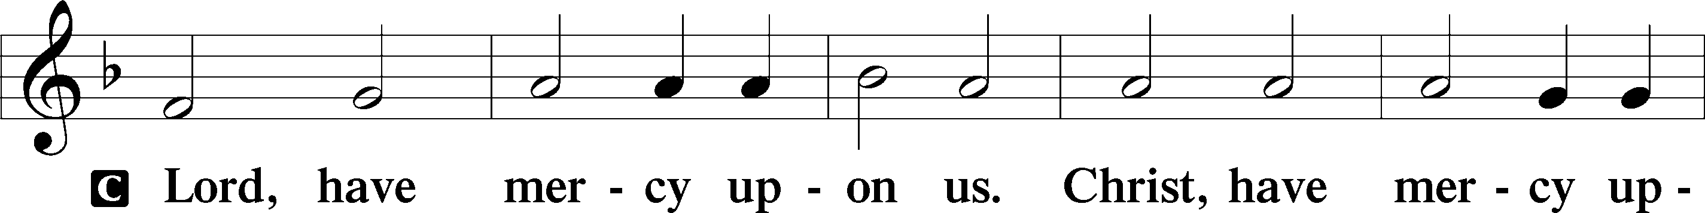
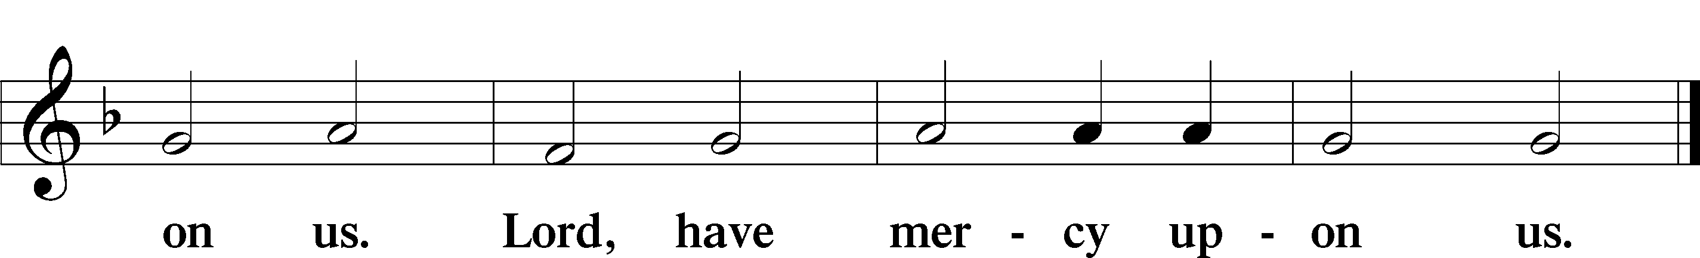

Salutation and Collect of the Day: Invocavit
P The Lord be with you.
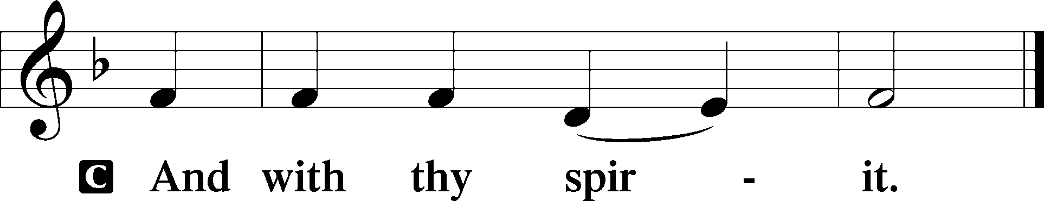

P Let us pray.
O Lord God, You led Your ancient people through the wilderness and brought them to the promised land. Guide the people of Your Church that following our Savior we may walk through the wilderness of this world toward the glory of the world to come; through Jesus Christ, Your Son, our Lord, who lives and reigns with You and the Holy Spirit, one God, now and forever.
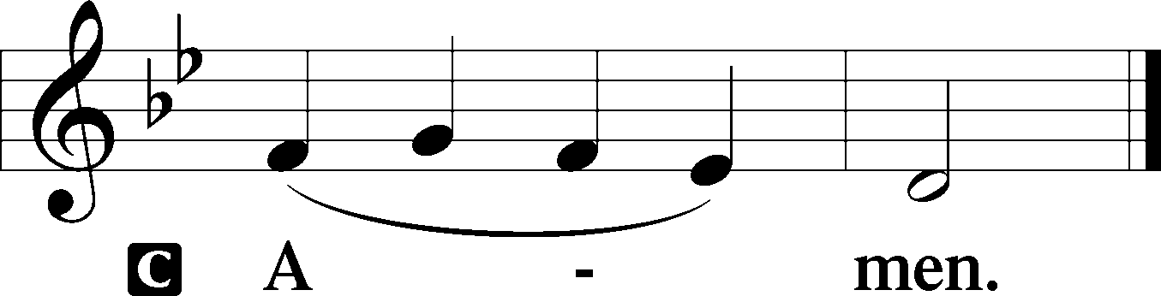
Sit

Prophecy: Genesis 3:1–21 (NKJV)
In those days: The serpent was more cunning than any beast of the field which the Lord God had made. And he said to the woman, “Has God indeed said, ‘You shall not eat of every tree of the garden’?” And the woman said to the serpent, “We may eat the fruit of the trees of the garden; but of the fruit of the tree which is in the midst of the garden, God has said, ‘You shall not eat it, nor shall you touch it, lest you die.’ ” Then the serpent said to the woman, “You will not surely die. For God knows that in the day you eat of it your eyes will be opened, and you will be like God, knowing good and evil.” So when the woman saw that the tree was good for food, that it was pleasant to the eyes, and a tree desirable to make one wise, she took of its fruit and ate. She also gave to her husband with her, and he ate. Then the eyes of both of them were opened, and they knew that they were naked; and they sewed fig leaves together and made themselves coverings. And they heard the sound of the Lord God walking in the garden in the cool of the day, and Adam and his wife hid themselves from the presence of the Lord God among the trees of the garden. Then the Lord God called to Adam and said to him, “Where are you?” So he said, “I heard Your voice in the garden, and I was afraid because I was naked; and I hid myself.” And He said, “Who told you that you were naked? Have you eaten from the tree of which I commanded you that you should not eat?” Then the man said, “The woman whom You gave to be with me, she gave me of the tree, and I ate.” And the Lord God said to the woman, “What is this you have done?” The woman said, “The serpent deceived me, and I ate.” So the Lord God said to the serpent: “Because you have done this, you are cursed more than all cattle, and more than every beast of the field; on your belly you shall go, and you shall eat dust all the days of your life. And I will put enmity between you and the woman, and between your seed and her Seed; He shall bruise your head, and you shall bruise His heel.” To the woman He said: “I will greatly multiply your sorrow and your conception; in pain you shall bring forth children; your desire shall be for your husband, and he shall rule over you.” Then to Adam He said, “Because you have heeded the voice of your wife, and have eaten from the tree of which I commanded you, saying, ‘You shall not eat of it’: Cursed is the ground for your sake; in toil you shall eat of it all the days of your life. Both thorns and thistles it shall bring forth for you, and you shall eat the herb of the field. In the sweat of your face you shall eat bread till you return to the ground, for out of it you were taken; for dust you are, and to dust you shall return.” And Adam called his wife’s name Eve, because she was the mother of all living. Also for Adam and his wife the Lord God made tunics of skin, and clothed them.

P This is the Word of the Lord.
C Thanks be to God.

Gradual Psalm 91:11–12
He will command his angels con- | cerning you*
to guard you in | all your ways.
On their hands they will | bear you up,*
lest you strike your foot a- | gainst a stone.

Epistle: 2 Corinthians 6:1-10 (NKJV)
Brethren: We plead with you not to receive the grace of God in vain. For He says: “In an acceptable time I have heard you, and in the day of salvation I have helped you.” Behold, now is the accepted time; behold, now is the day of salvation. We give no offense in anything, that our ministry may not be blamed. But in all things we commend ourselves as ministers of God: in much patience, in tribulations, in needs, in distresses, in stripes, in imprisonments, in tumults, in labors, in sleeplessness, in fastings; by purity, by knowledge, by longsuffering, by kindness, by the Holy Spirit, by sincere love, by the word of truth, by the power of God, by the armor of righteousness on the right hand and on the left, by honor and dishonor, by evil report and good report; as deceivers, and yet true; as unknown, and yet well known; as dying, and behold we live; as chastened, and yet not killed; as sorrowful, yet always rejoicing; as poor, yet making many rich; as having nothing, and yet possessing all things.

P This is the Word of the Lord.
C Thanks be to God.

Stand

Tract Psalm 91:1, 4a, 15a, 16
He who dwells in the shelter of the | Most High*
will abide in the shadow of the Al- | mighty.
He will cover you with his | pinions,*
and under his wings you will find | refuge.
When he calls to me, I will | answer him;*
I will be with him in | trouble.
With long life I will sat- | isfy him*
and show him my sal- | vation.

Holy Gospel: Matthew 4:1–11 (NKJV)
P The Holy Gospel according to St. Matthew, the fourth chapter.
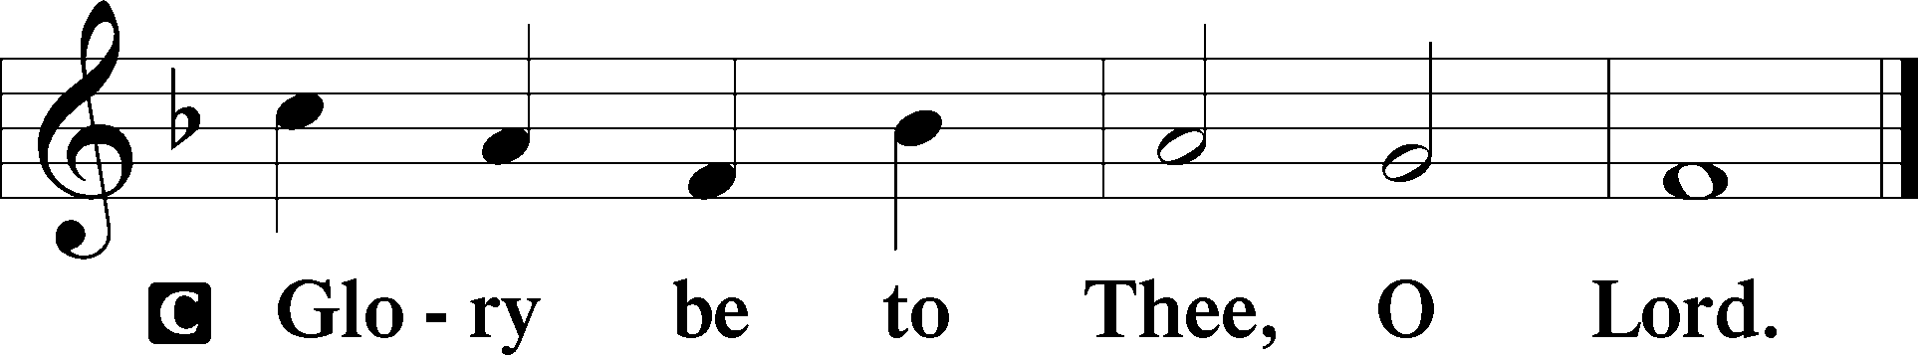

Then Jesus was led up by the Spirit into the wilderness to be tempted by the devil. And after fasting forty days and forty nights, he was hungry. And the tempter came and said to him, “If you are the Son of God, command these stones to become loaves of bread.” But he answered, “It is written,
“‘Man shall not live by bread alone,
but by every word that comes from the mouth of God.’”
Then the devil took him to the holy city and set him on the pinnacle of the temple and said to him, “If you are the Son of God, throw yourself down, for it is written,
“‘He will command his angels concerning you,’
and
“‘On their hands they will bear you up,
lest you strike your foot against a stone.’”
Jesus said to him, “Again it is written, ‘You shall not put the Lord your God to the test.’” Again, the devil took him to a very high mountain and showed him all the kingdoms of the world and their glory. And he said to him, “All these I will give you, if you will fall down and worship me.” Then Jesus said to him, “Be gone, Satan! For it is written,
“‘You shall worship the Lord your God
and him only shall you serve.’”
Then the devil left him, and behold, angels came and were ministering to him.

P This is the Gospel of the Lord.
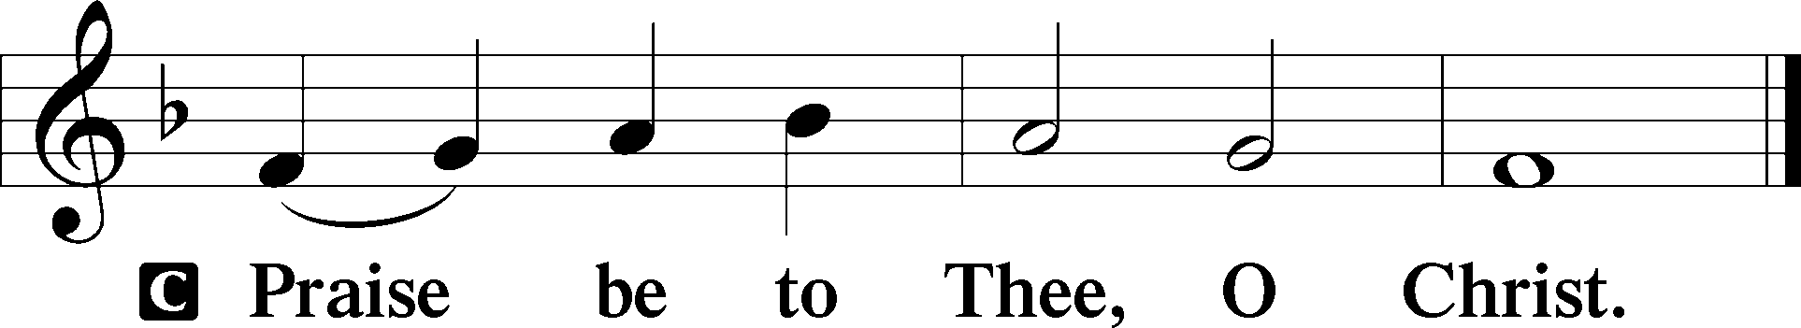

Nicene Creed
C I believe in one God,
the Father Almighty,
maker of heaven and earth
and of all things visible and invisible.

And in one Lord Jesus Christ,
the only-begotten Son of God,
begotten of His Father before all worlds,
God of God, Light of Light,
very God of very God,
begotten, not made,
being of one substance with the Father,
by whom all things were made;
who for us men and for our salvation came down from heaven
and was incarnate by the Holy Spirit of the virgin Mary
and was made man;
and was crucified also for us under Pontius Pilate.
He suffered and was buried.
And the third day He rose again according to the Scriptures
and ascended into heaven
and sits at the right hand of the Father.
And He will come again with glory to judge both the living and the dead,
whose kingdom will have no end.
And I believe in the Holy Spirit,
the Lord and giver of life,
who proceeds from the Father and the Son,
who with the Father and the Son together is worshiped and glorified,
who spoke by the prophets.
And I believe in one holy Christian and apostolic Church,
I acknowledge one Baptism for the remission of sins,
and I look for the resurrection of the dead
and the life T of the world to come. Amen.
Sit

Hymn of the Day: LSB #656 “A Mighty Fortress Is Our God” Please rise.

Sermon

Stand

Offertory Psalm 51:10–12
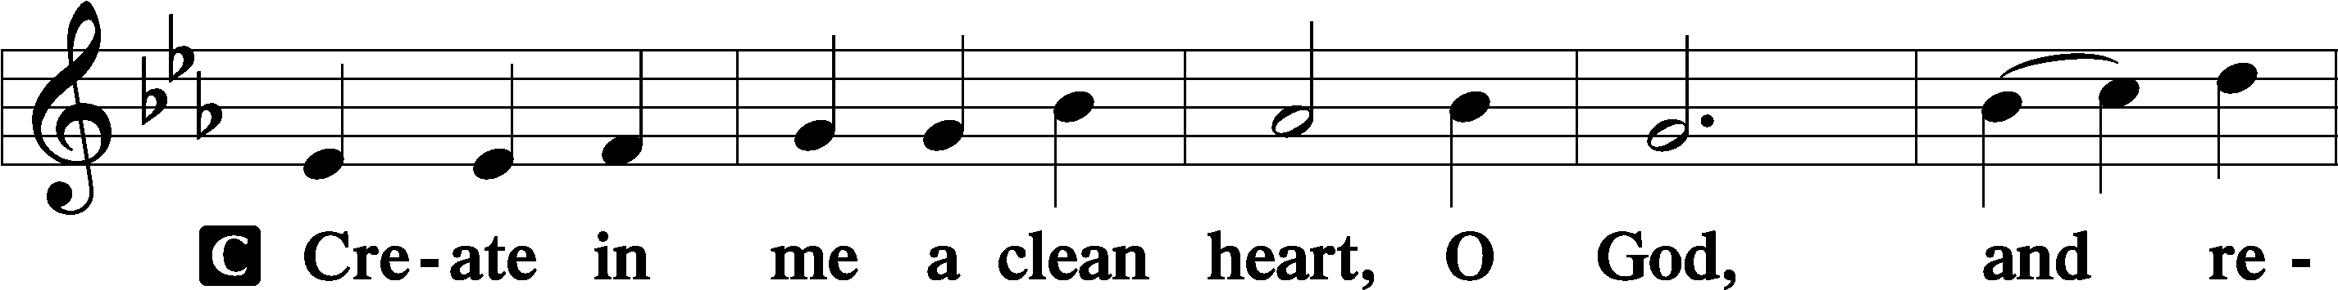
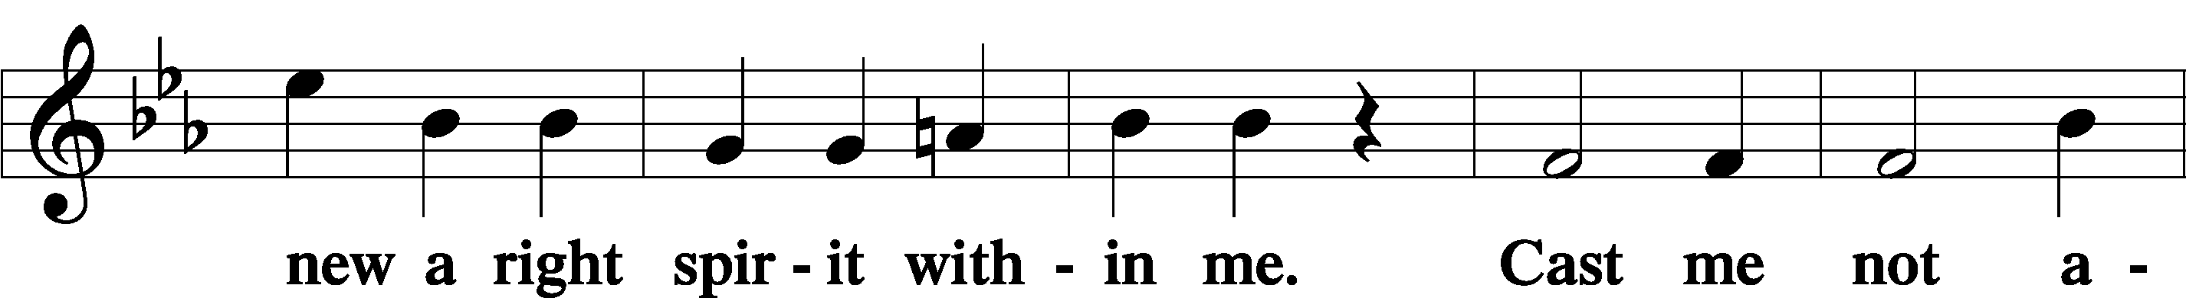
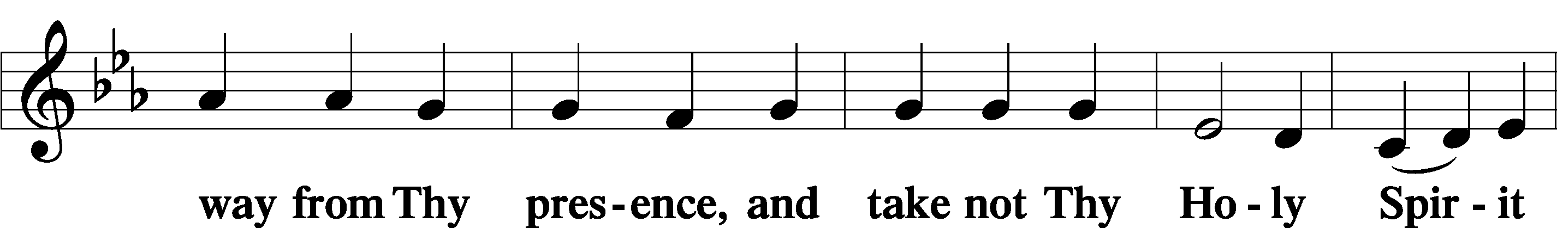
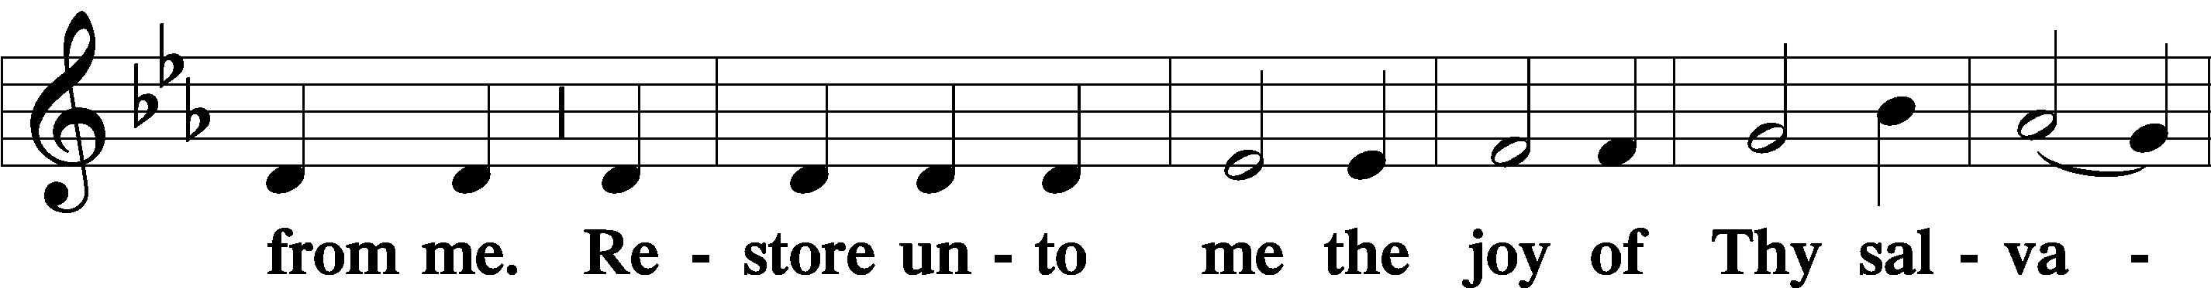
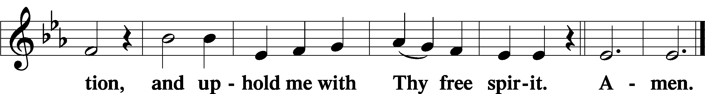

Prayer of the Church

Sit
Preparatory Hymn: LSB #620 “Jesus Comes Today with Healing”

Stand
Service of the Sacrament
Preface 2 Timothy 4:22; Colossians 3:1 Psalm 136
P The Lord be with you.

P Lift up your hearts.
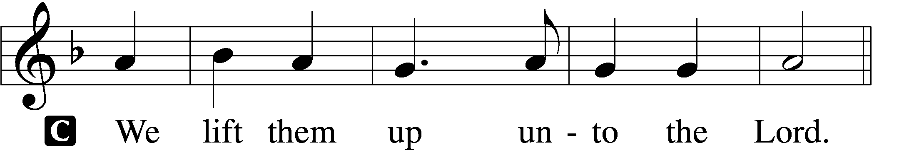

P Let us give thanks unto the Lord, our God.
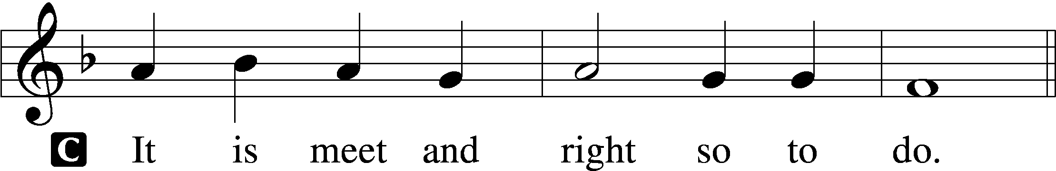

Proper Preface (Abbreviated) LSB 194
P It is truly meet, right, and salutary . . . evermore praising You and saying:

Sanctus Isaiah 6:3; Matthew 21:9
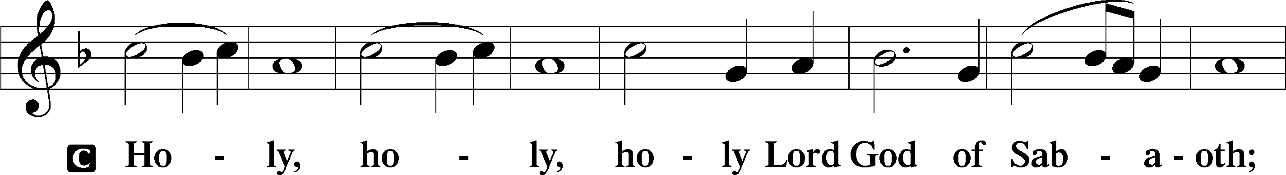
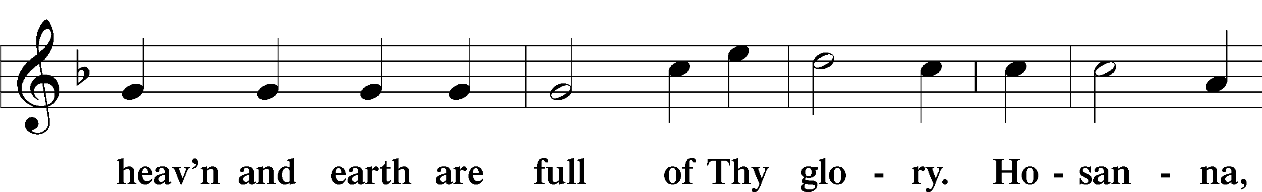
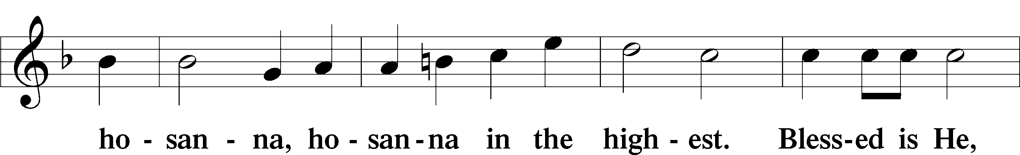
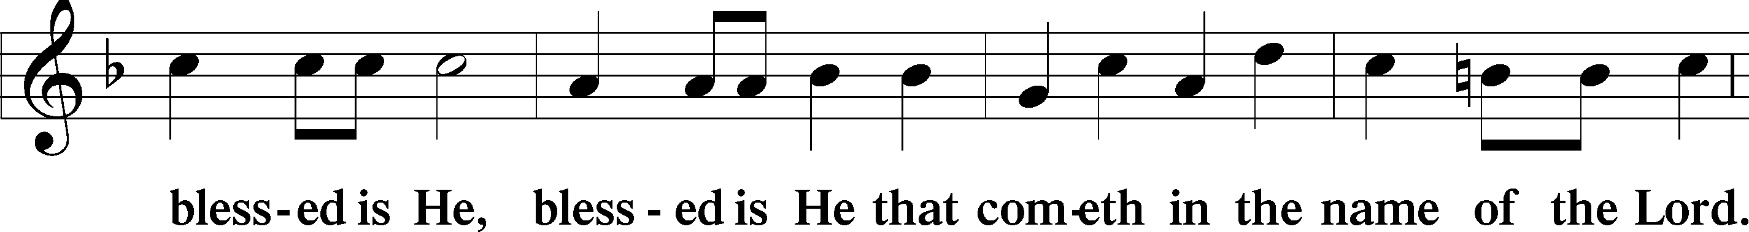
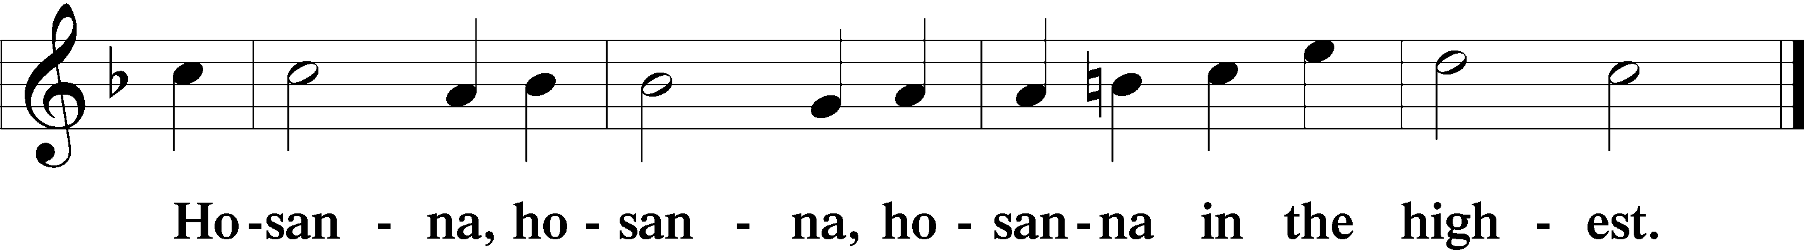

Lord’s Prayer The congregation is encouraged to silently pray the Lord’s Prayer as it is chanted. Matthew 6:9–13
P Our Father who art in heaven,
hallowed be Thy name,
Thy kingdom come,
Thy will be done on earth as it is in heaven;
give us this day our daily bread;
and forgive us our trespasses as we forgive those who trespass against us;
and lead us not into temptation,
but deliver us from evil.
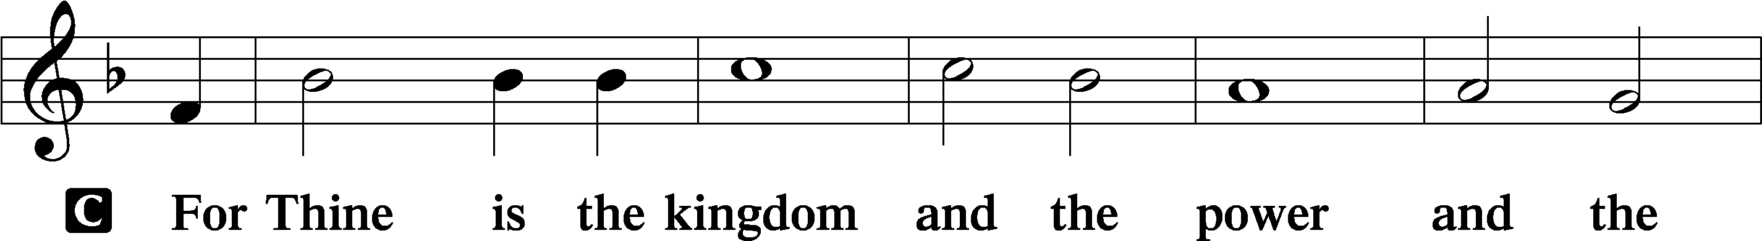
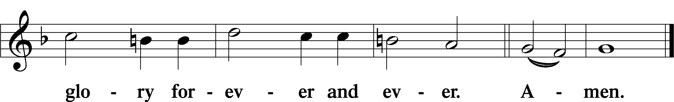

The Words of Our Lord Matthew 26:26–28; Mark 14:22–24; Luke 22:19–20; 1 Corinthians 11:23–25
P Our Lord Jesus Christ, on the night when He was betrayed, took bread, and when He had given thanks, He broke it and gave it to the disciples and said: “Take, eat; this is My T body, which is given for you. This do in remembrance of Me.”

In the same way also He took the cup after supper, and when He had given thanks, He gave it to them, saying: “Drink of it, all of you; this cup is the new testament in My T blood, which is shed for you for the forgiveness of sins. This do, as often as you drink it, in remembrance of Me.”

Pax Domini John 20:19
P The peace of the Lord be with you always.
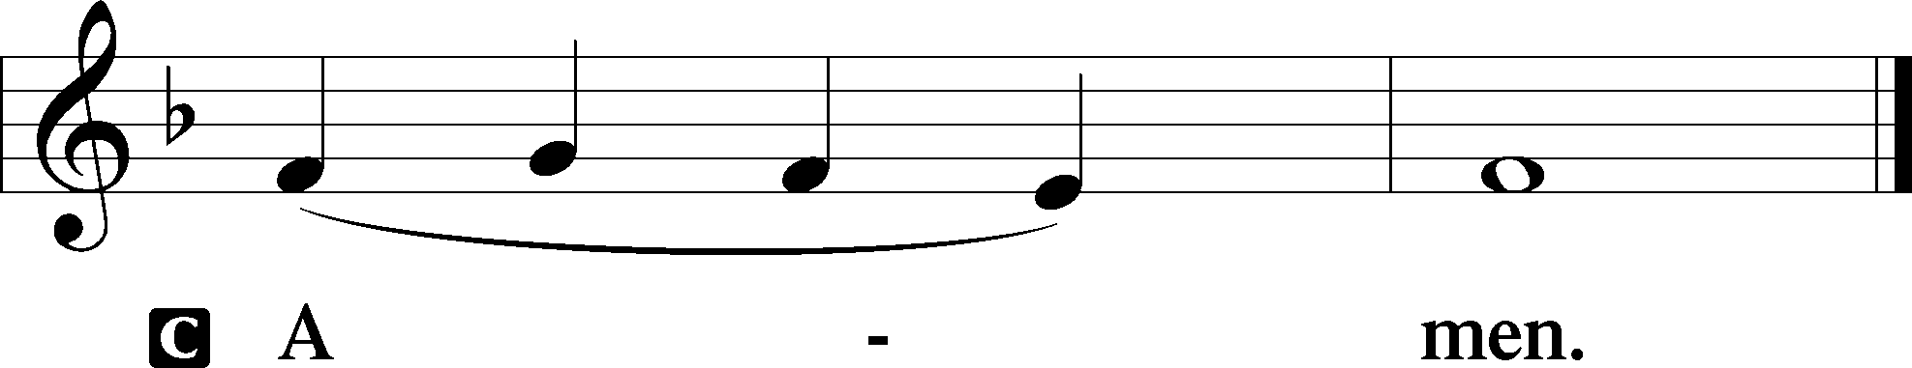

Agnus Dei John 1:29
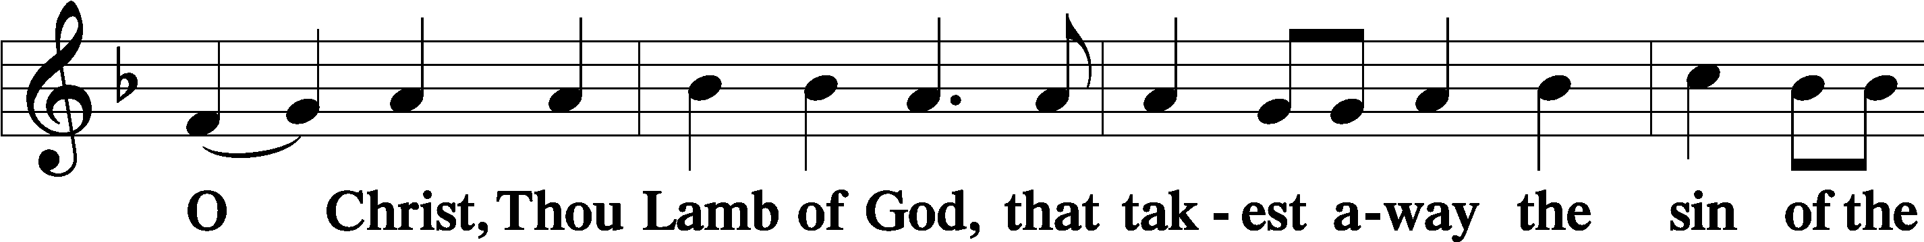
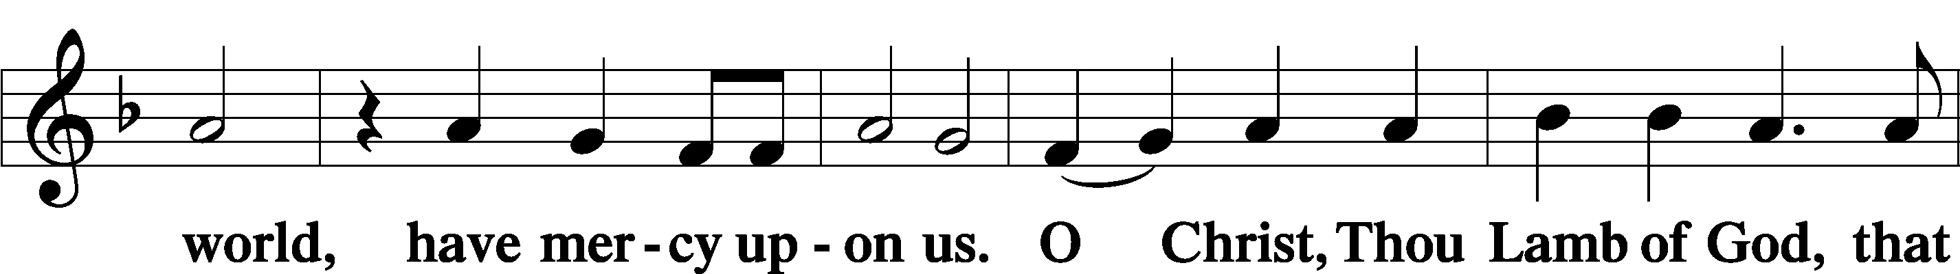
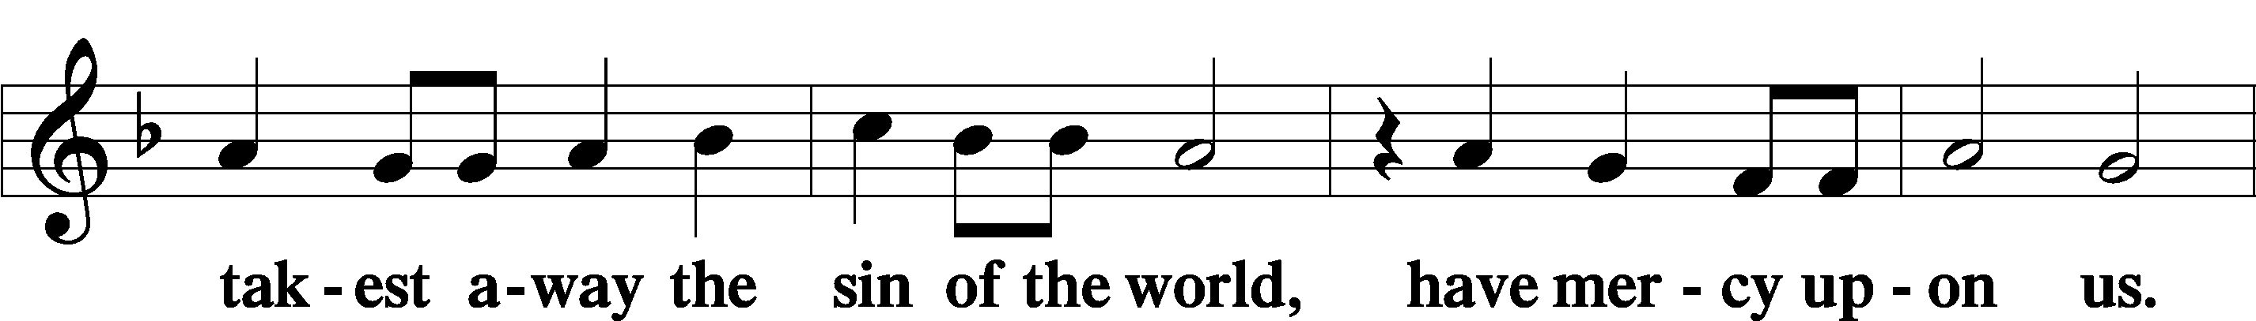
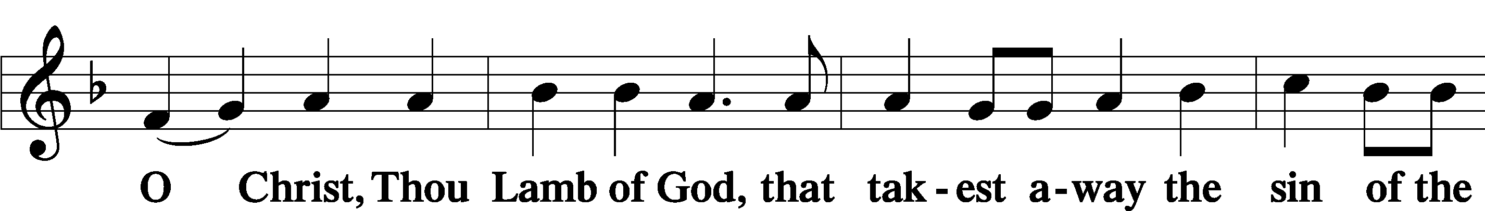
Sit

Distribution
The pastor and those who assist him receive the body and blood of Christ first and then distribute them to those who come to receive, saying:
Take, eat; this is the true body of our Lord and Savior Jesus Christ, given into death for your sins.
Amen.

Take, drink; this is the true blood of our Lord and Savior Jesus Christ, shed for the forgiveness of your sins.
Amen.

In dismissing the communicants, the following is said:
The Dismissal
P The body and blood of our Lord Jesus Christ strengthen and preserve you in body and soul to life everlasting. Depart T in peace.
C Amen.

Distribution Hymn: LSB #716 “I Walk in Danger All the Way”

Distribution Hymn: TLH #157 “There Is a Fountain Filled with Blood”
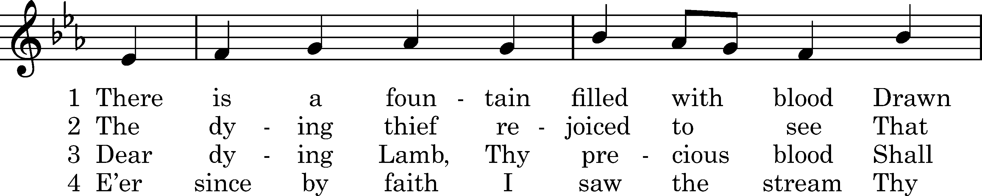
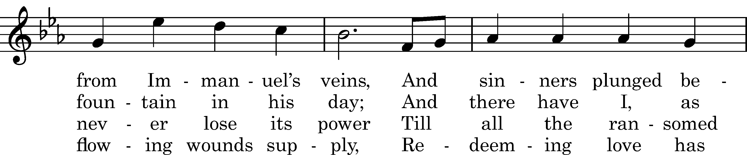
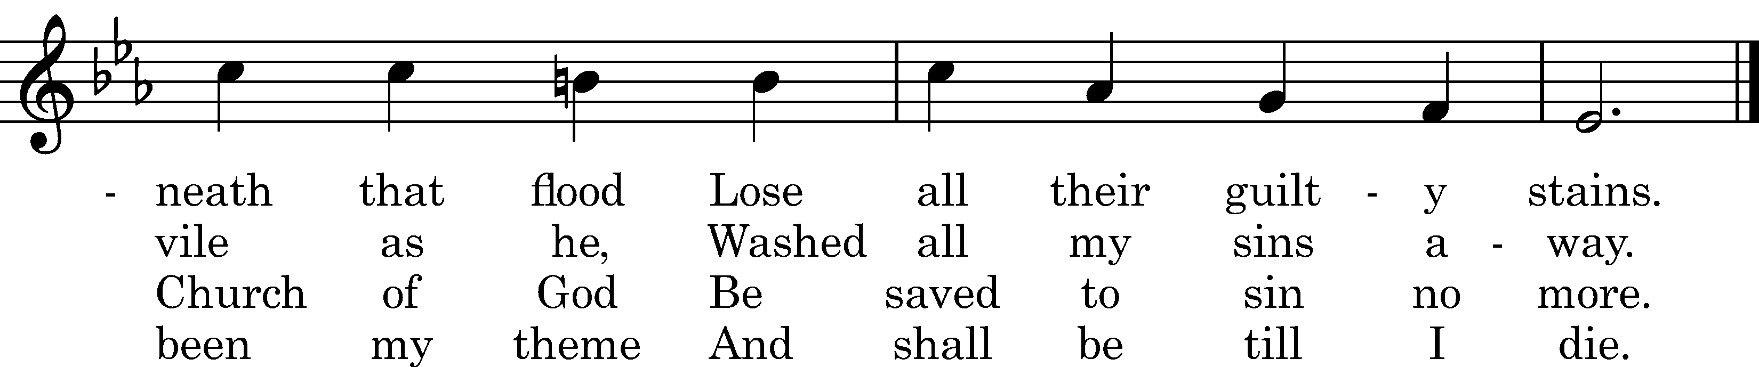

5 When this poor lisping, stamm'ring tongue
Lies silent in the grave,
Then in a nobler, sweeter song
I'll sing Thy pow'r to save.

Text: William Cowper, 1771, cento Tune: William Horsley, 1844 Text and tune: Public domain
Distribution Hymn: LSB #724 “If God Himself Be for Me”

Stand
Nunc Dimittis Luke 2:29–32
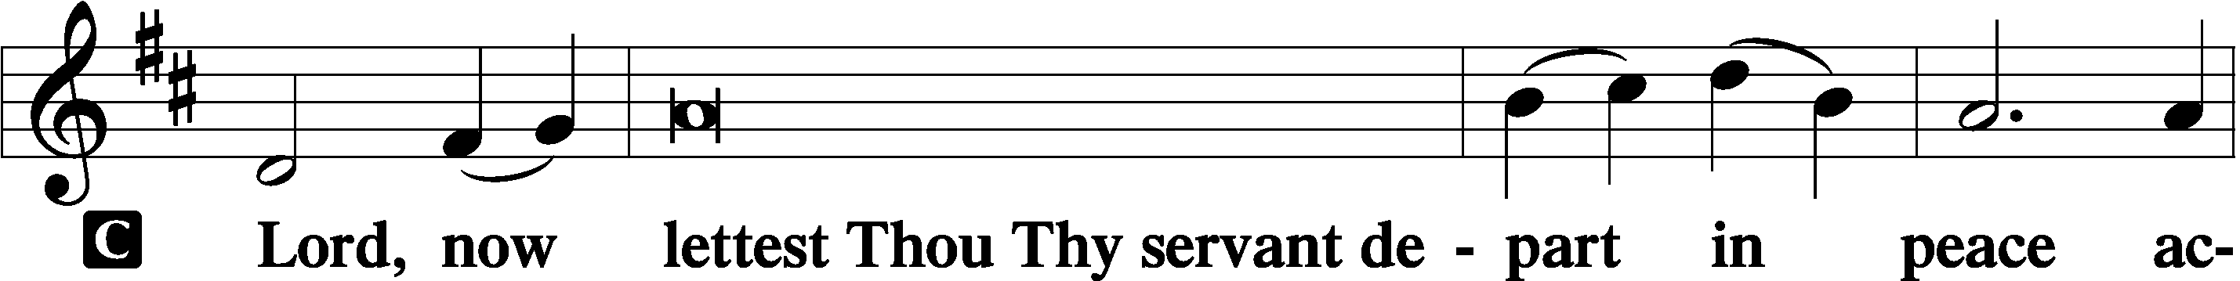
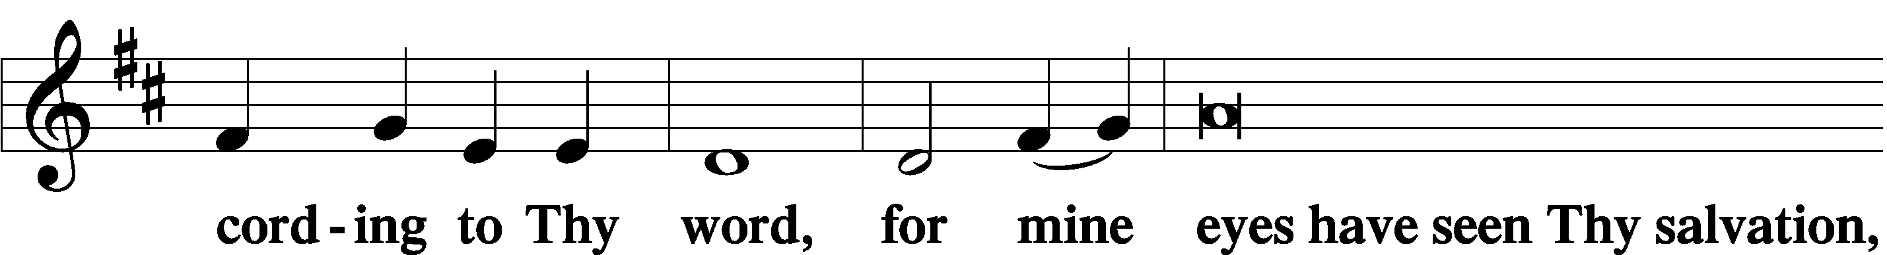
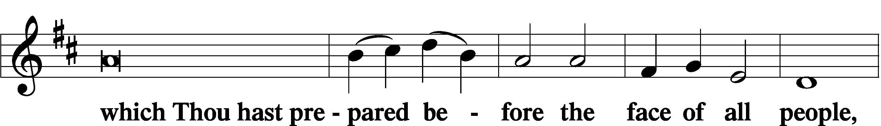
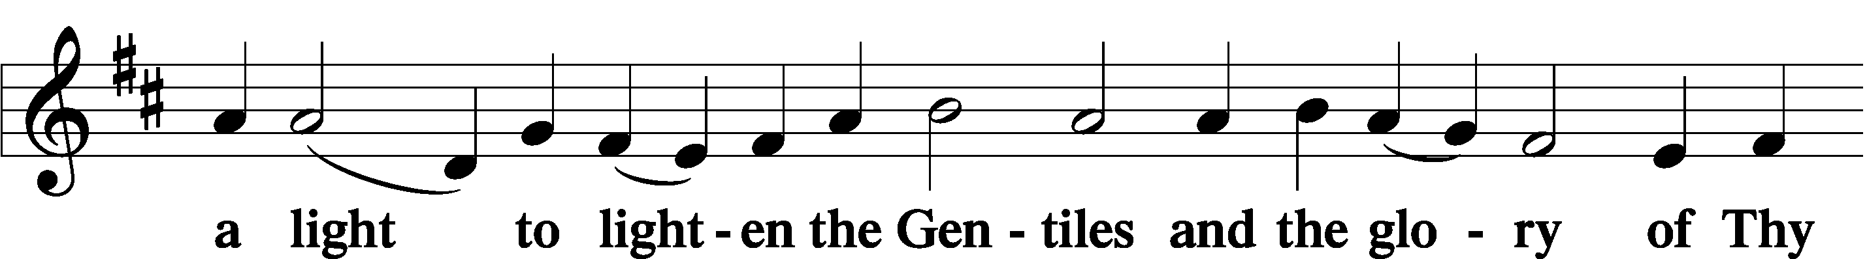
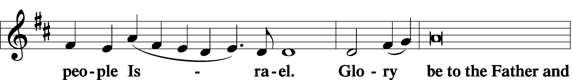
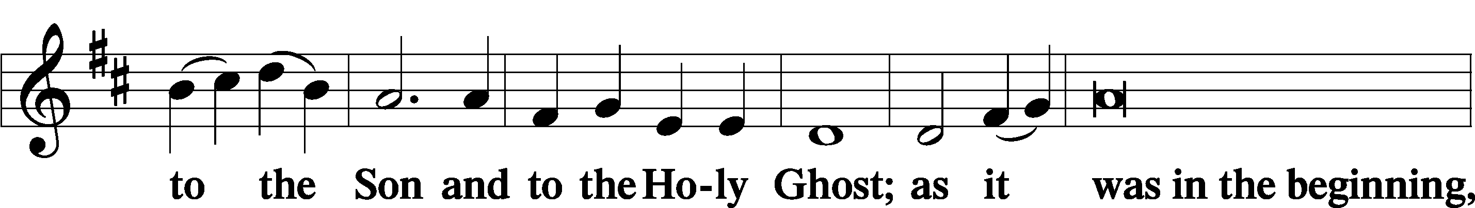
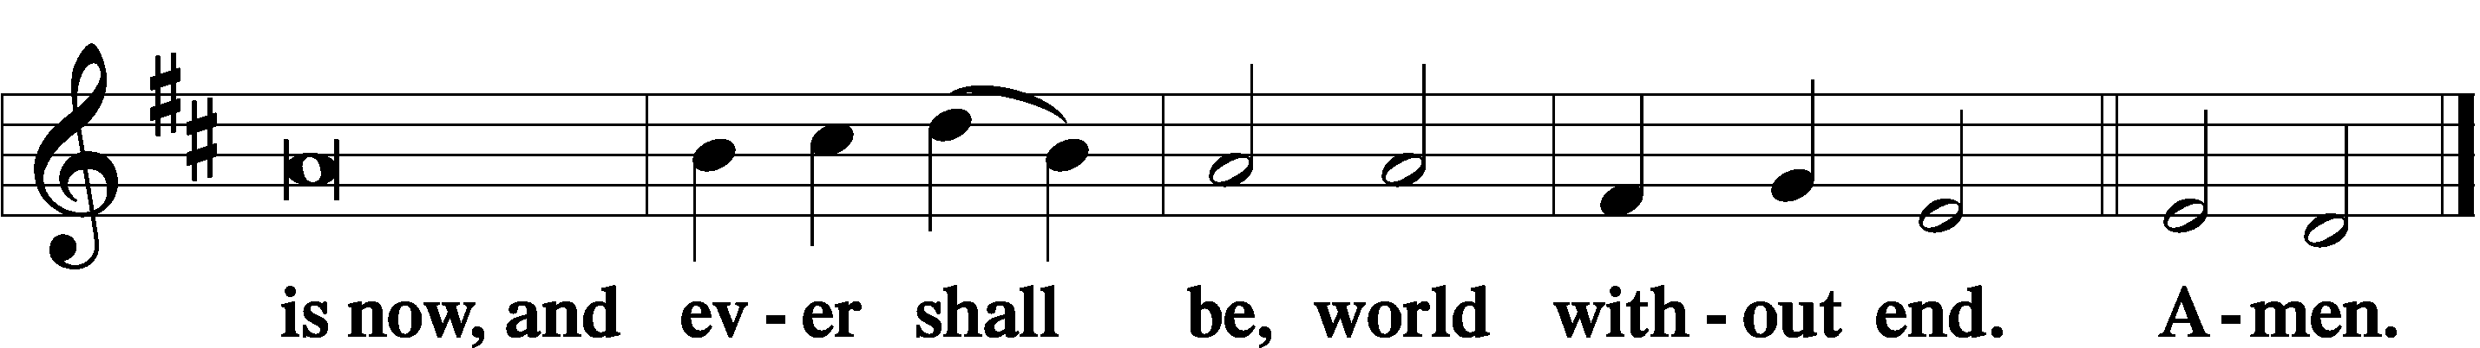

Thanksgiving Psalm 107:1
P O give thanks unto the Lord, for He is good,
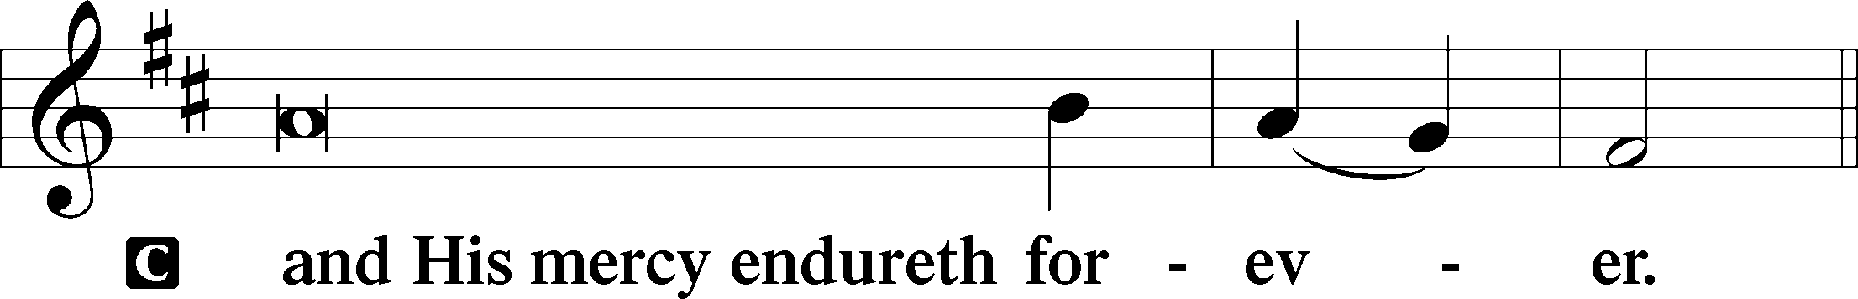

Post-Communion Collect
P Let us pray.
We give thanks to You, almighty God, that You have refreshed us through this salutary gift, and we implore You that of Your mercy You would strengthen us through the same in faith toward You and in fervent love toward one another; through Jesus Christ, Your Son, our Lord, who lives and reigns with You and the Holy Spirit, one God, now and forever.

Salutation 2 Timothy 4:22
P The Lord be with you.
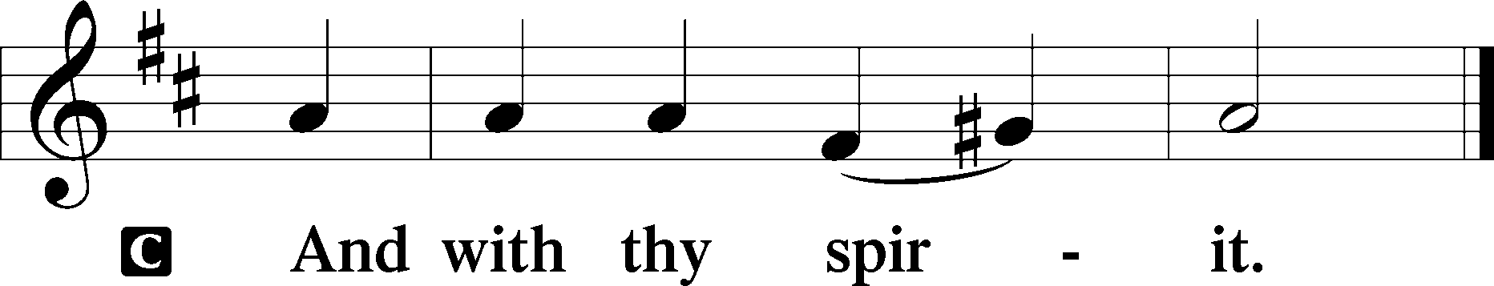

Benedicamus Psalm 103:1
P Bless we the Lord.
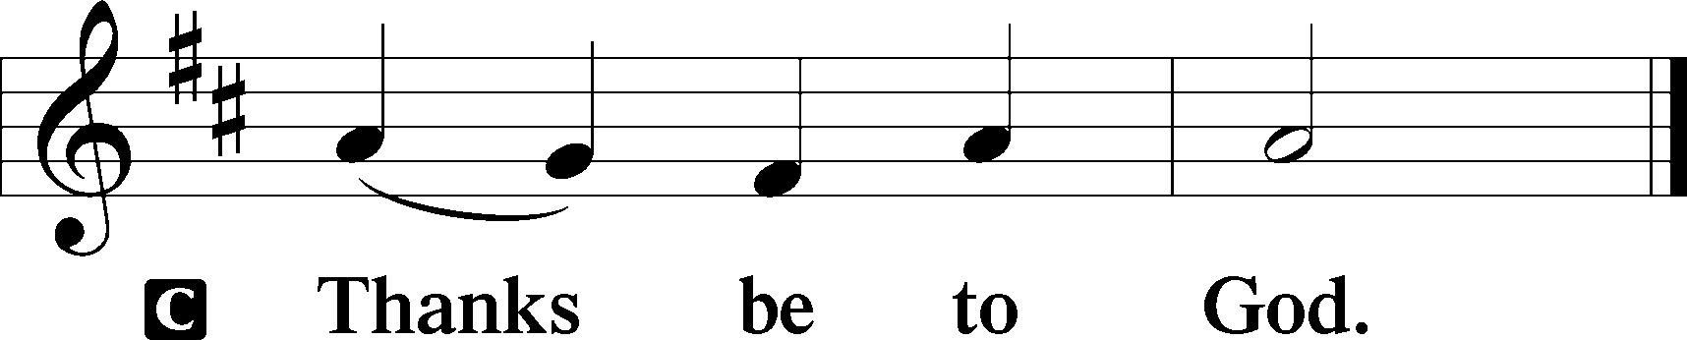

Benediction Numbers 6:24–26
P The Lord bless you and keep you.
The Lord make His face shine upon you and be gracious unto you.
The Lord lift up His countenance upon you and T give you peace.
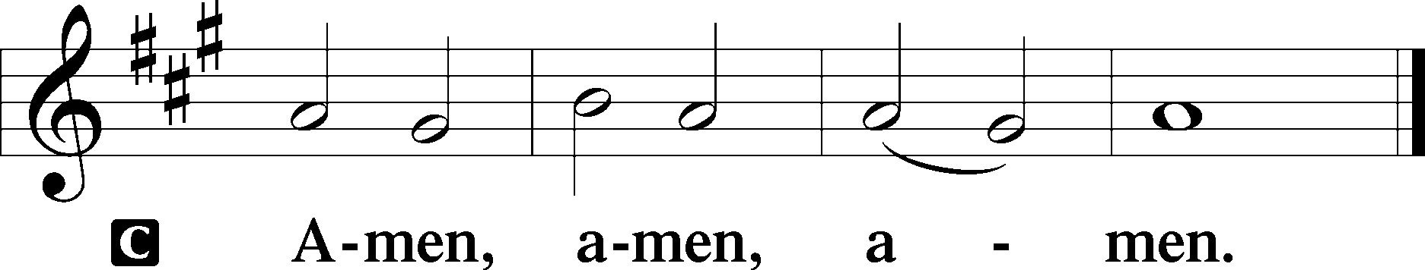

Closing Hymn: LSB #454 “Sing, My Tongue, the Glorious Battle”

Silent prayer after worship: Lord Jesus, You overcame Satan by the power of the Word. Lead me to be in Your Word daily, that I also may overcome the devil’s temptations, die to sin, and live in Your righteousness. Amen.

Acknowledgments
Unless otherwise indicated, Scripture quotations are from the ESV® Bible (The Holy Bible, English Standard Version®), copyright © 2001 by Crossway, a publishing ministry of Good News Publishers. Used by permission. All rights reserved.Created by Lutheran Service Builder © 2024 Concordia Publishing House.
SCHEDULE THROUGH FEBRUARY 25, 2024:

:

Today, following Worship, Fellowship Hall: Church Council Meeting
Following Worship, Library: Monthly Audit
7 pm, Fellowship Hall: AA Meeting
Tuesday, 7-9 pm, Fellowship Hall: Penn-Ohio Singers
Wednesday, 10 am, Sanctuary: Lenten Midweek Matins Service
11 am, Fellowship Hall: Lenten Soup Luncheon & Bible Study
6 pm, Fellowship Hall: Lenten Soup Supper
7 pm, Sanctuary: Lenten Midweek Vespers Service
7 pm, Fellowship Hall: NA Meeting
Thursday, 9 am, Downstairs: Food Pantry
Friday, 10 am, Fellowship Hall: Craft Fellowship
Saturday, 7 pm, Sanctuary: Feast of Saint Mathias, Apostle, Vespers Service
Next Sunday, 8 am, Fellowship Hall: Bible Study
9 am, Sanctuary: Divine Service
7 pm, Deal Home: Sunday Evening Bible Study
7 pm, Fellowship Hall: AA Meeting
fffffffffffffffffffffffffffffffffff
Bible Memory Verses ~ Week of February 18th:
For Adults: Above all, keep loving one another earnestly, since love covers a multitude of sins. 1 Peter 4:8

For Children: The reason the Son of God appeared was to destroy the works of the devil. 1 John 3:8
fffffffffffffffffffffffffffffffffff
Attendance: Sunday, February 11, 2024: 39
Wednesday, February 14, 2024: 38
fffffffffffffffffffffffffffffffffff
Did you know? In 2023, Sts. Peter & Paul’s was the recipient of $1,015.00 in Thrivent Choice dollars! We thank those who so generously named our church as their recipient. It is not too late to direct funds to our church for 2023! Contact your Thrivent representative by March 31, 2024, if you wish to do so.
fffffffffffffffffffffffffffffffffff
Our Stewardship of Treasures for the Lord:
Figures for Sunday, February 11, 2024
General Fund: $1,685.00
SELC: $27.00
Food Pantry: $113.00
Quarterly Missions: $0.00
Capital Campaign: $135.00
Other: $875.00
YTD Giving/Budget (as of February 4, 2024)
General Fund: $12,420.50/$13,562.60
SELC: $377.00/$384.60

For online giving, check out https://www.saintspeterandpaul.net/online-giving.
fffffffffffffffffffffffffffffffffff
THANK YOU FOR SERVING IN FEBRUARY: Elder: Jonathan Baisch; Ushers: Matt Berent, Mark Gabriel, Michael Laird, and Jerome Thomas; Altarware ~ Sundays: (prior) Diane Riefstahl; (after) Marie Flaugher.
fffffffffffffffffffffffffffffffffff
Sunday Morning Bible Study has resumed. Join us at 8 am Sunday mornings as we study the Minor Prophets.
Next Sunday evening at 7 pm is the first Sunday Evening Bible Study at the Deal home. This Bible Study group will meet the second and fourth Sunday evenings of the month and is open to all church members!
fffffffffffffffffffffffffffffffffff
The Sunday evening AA group wishes to thank all who generously donated to their Sober New Year’s Eve party. Your support of their mission to live a sober life is greatly appreciated.
fffffffffffffffffffffffffffffffffff
Items for the March calendar and newsletter are due to Diane by 9 am tomorrow, February 19th.
fffffffffffffffffffffffffffffffffff
Mark Your Calendar! The next Voters’ Assembly will be held following worship March 5th. Your attendance will be greatly appreciated!
fffffffffffffffffffffffffffffffffff
Remember the following in Prayer…
~The Hurting and Healing: Amy, Ralph, Steve, Mary Jane Anderson, Steve Antolovich, Ellen Baron^{CA}, Amy Blomenberg, Lois Bortner^{CA}, Sara Brubaker and her son, Canaan; Dee Bullock, Bev & Joe Chlpka, Susan Davies, Tim Dudash, Mike Flaugher, Judith & Eddy Furey, Griffin, Pastor Charles Henrickson, Joan, Keith Jozwiakowski, Darla Krajci, Barbara Kreske, Jess Lavoie, Paul Lucas^{CA}, Sandy Marshall, Lynn Price, Juanita Rentschler, Richard Reuning^{CA}, Nancy Robertson^{CA}, Kriss Svidro^{CA}, Rudy Tomko, Bob Usnarski, Joel & Peggy Wasson, Angela Weser^{CA}, and Ruth Wolf.
~The Homebound: Anna Mae Daris, Millie Elavsky, Jean Tomko, Betty Wolf, and Ed & Millie Zachar.
~Celebrating: Birthday-Bradley Dirgo (02.21)
~Serving in the Military: Alex (Sasha) Carr, Duncan Vaupel, Curtis Sinewe, and Joshua Solyan.
~Community & World Needs: Those suffering due to the conflicts in the Middle East and between Ukraine and Russia; those suffering from loss and dislocation because weather disasters; those suffering from addiction and their families; Local, State, and National Government Leaders; safety for all Police Officers, Firefighters, & First Responders; the unemployed; our First Quarter Local Mission: Community Outreach. *CA represents cancer.
fffffffffffffffffffffffffffffffffff
A box has been placed on the pew outside the library for donations of diapers, baby clothes, and wipes to Katharina’s Closet, an outreach mission of Trinity Evangelical Lutheran Church in Warren, OH. Sts. Peter & Paul’s will be collecting items here through Sunday, March 3rd. If you would like to make a financial donation to this cause, which will aid area women and families in need, please make your check out to Katharina’s Closet/Trinity Ev. Lutheran Church and give it directly to Matt Berent.
fffffffffffffffffffffffffffffffffff
Calling All Crafters! Bring whatever craft you are working on and join us this Friday morning at 10 am for Craft Fellowship! Please enter the building using the Clover St. door.
fffffffffffffffffffffffffffffffffff
There is a sign-up sheet on the table in the narthex for those wishing to provide soup for Lenten soup luncheons/suppers beginning Wednesday, February 21st. Please speak with Pastor Deal if you should have any questions.
fffffffffffffffffffffffffffffffffff
Additional copies of the 2024 Lenten Devotions are available this morning on the tables in the narthex and next to the nursery. Take a copy for a friend!
Help yourself to a tri-fold explanation of “Spiritual Discipline: Almsgiving, Praying, & Fasting”. Copies are available on the table next to the nursery.
fffffffffffffffffffffffffffffffffff
Join us throughout Lent for our Wednesday Lenten Midweek Worship Services:
10 am Matins Service followed by a soup luncheon & Bible Study
6 pm Soup Supper
7 pm Vespers Service
All are welcomed!
fffffffffffffffffffffffffffffffffff
Interested in singing in the choir Easter Sunday? Please let Rebecca Marquette or Pastor Deal know of your interest. Thirty-minute rehearsals will take place following the midweek Vespers services.
fffffffffffffffffffffffffffffffffff
Pittsburgh Area Lutheran Ministries (PALM) Lenten Update: PALM invites you to support over a dozen ministries in and around Pittsburgh this Lenten season. Your prayers for the next six weeks are appreciated. Please pray for PALM and its partnering missions in Gospel, fellowship, and mercy, and be on the lookout for more updates from PALM this season. www.palmpa.org
fffffffffffffffffffffffffffffffffff
Additional Contact Information:
- Church Website: www.saintspeterandpaul.net
- Food Pantry email: foodpantry@saintspeterandpaul.net
- Food Pantry phone number: 724-347-3620 (opt. 4)
- AA Contact: Steve @ 724-813-2358
- NA Contact: Larry @ 724-977-8733
fffffffffffffffffffffffffffffffffff

