Sts. Peter & Paul
Evangelical Lutheran Church
Lutheran Church-Missouri Synod
Founded-1917
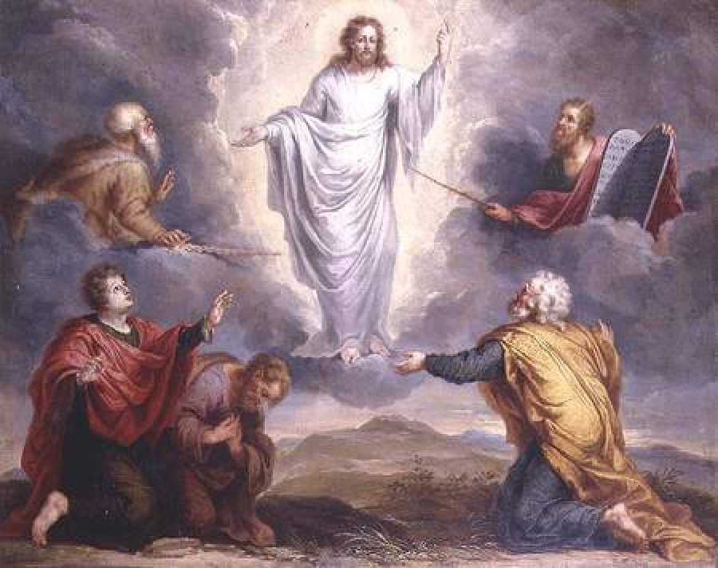
FEBRUARY 10, 2019

699 Stambaugh Avenue
Sharon, Pennsylvania 16146

“I was glad when they said to me,
Let us go to the house of the LORD!”
Psalm 122:1
Sts. Peter & Paul Evangelical Lutheran Church, LC-MS

THE TRANSFIGURATION OF OUR LORD
February 10, 2019

Silent prayer before worship: Lord of Light, cause the light of Your Word to shine within my heart so that I can know Your wondrous mercy and power as the King of kings, and may be blessed with joy and peace. Amen.
CONFESSION AND ABSOLUTION
Opening Hymn: LSB #414 “'Tis Good, Lord, to Be Here’”
Stand

The sign of the cross may be made by all in remembrance of their Baptism.

P In the name of the Father and of the T Son and of the Holy Spirit.
C Amen. Matthew 28: 19b; (18:20)

P Beloved in the Lord! Let us draw near with a true heart and confess our sins unto God our Father, beseeching Him in the name of our Lord Jesus Christ to grant us forgiveness. [Hebrews 10:22]

P Our help is in the name of the Lord,
C who made heaven and earth. Psalm 124: 8
P I said, I will confess my transgressions unto the Lord,
C and You forgave the iniquity of my sin. Psalm 32: 5

Silence for reflection on God's Word and for self-examination.

P O almighty God, merciful Father,
C I, a poor, miserable sinner, confess unto You all my sins and iniquities with which I have ever offended You and justly deserved Your temporal and eternal punishment. But I am heartily sorry for them and sincerely repent of them, and I pray You of Your boundless mercy and for the sake of the holy, innocent, bitter sufferings and death of Your beloved Son, Jesus Christ, to be gracious and merciful to me, a poor, sinful being.

P Upon this your confession, I, by virtue of my office, as a called and ordained servant of the Word, announce the grace of God unto all of you, and in the stead and by the command of my Lord Jesus Christ I forgive you all your sins in the name of the Father and of the T Son and of the Holy Spirit.
[John 20: 19-23]
C Amen.

Passing of the Peace.
SERVICE OF THE WORD
Introit: Ps. 84:1–2a, 4, 10–11; antiphon: Ps. 77:18b
Your lightnings lighted | up the world;*
the earth trem- | bled and shook.
How lovely is your dwelling place, O | Lord of hosts!*
My soul longs, yes, faints for the courts | of the Lord.
Blessèd are those who dwell | in your house,*
ever sing- | ing your praise!
For a day in your courts is better than a thousand | elsewhere.*
I would rather be a doorkeeper in the house of my God than dwell in the tents of | wickedness.
For the Lord God is a sun and shield; the Lord bestows favor and | honor.*
No good thing does he withhold from those who walk up- | rightly.

Gloria Patri
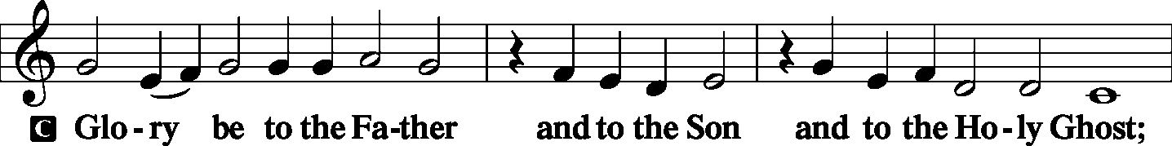
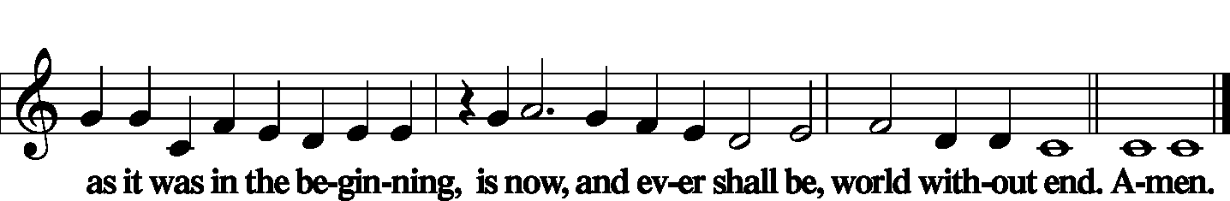

Kyrie Mark 10:47
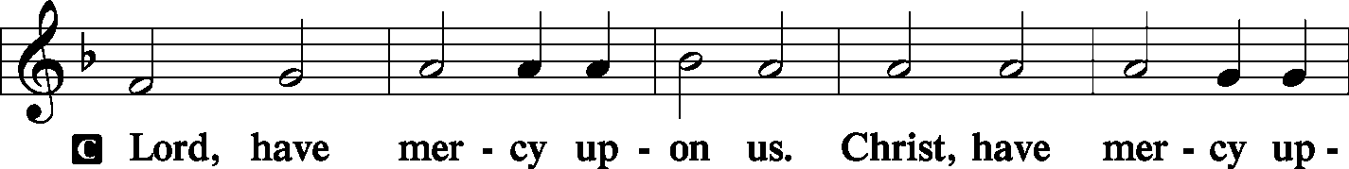
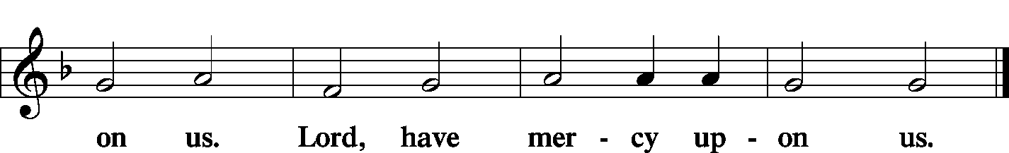

Gloria in Excelsis Luke 2: 14; John 1: 29
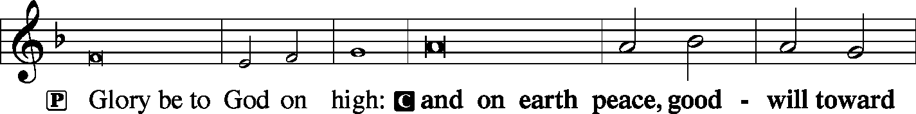
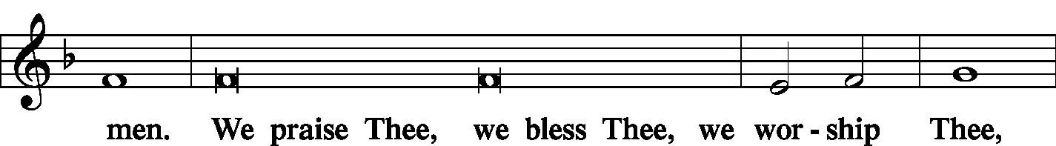
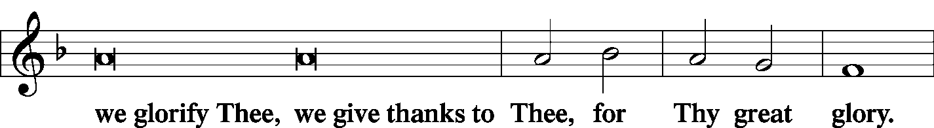
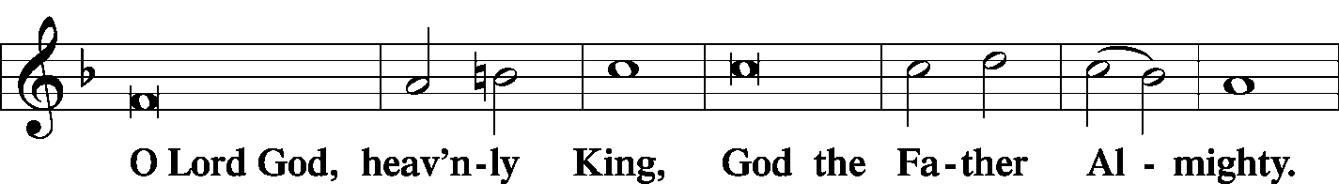
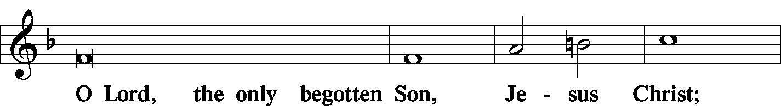
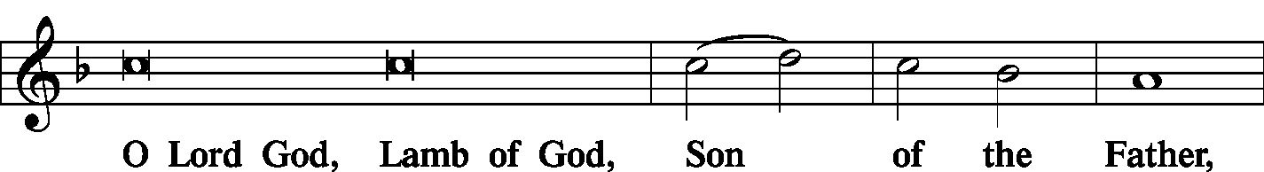
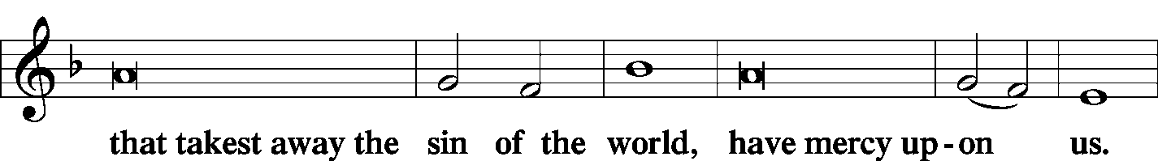
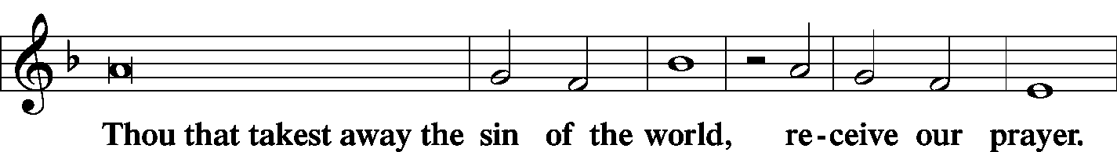
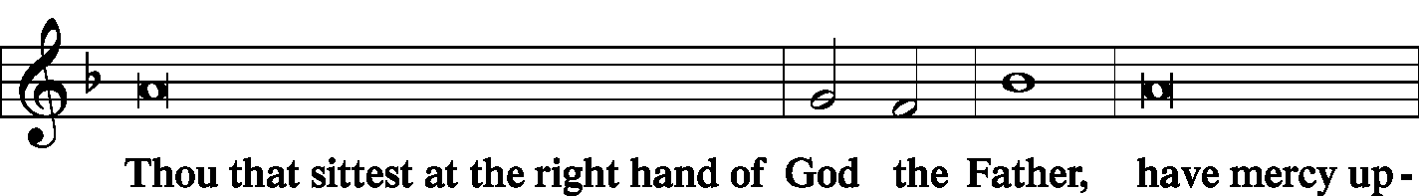
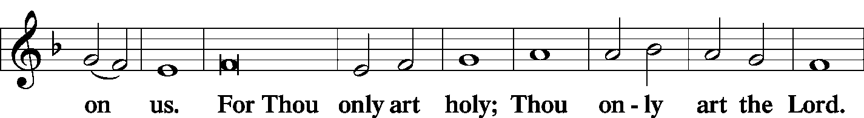
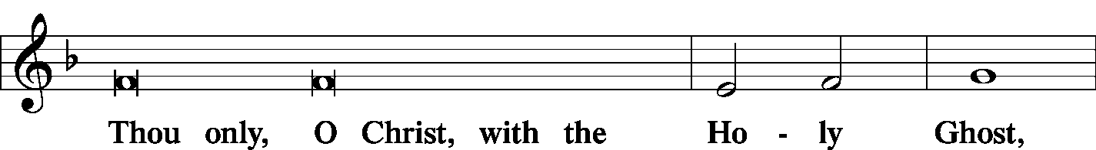
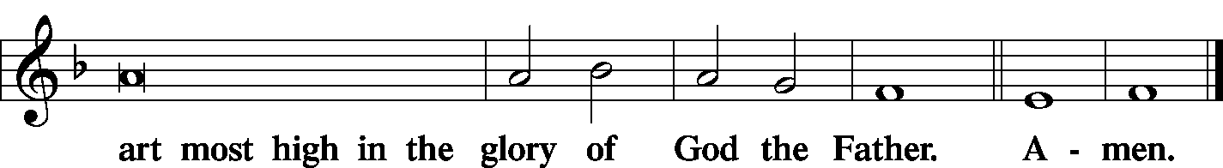

Salutation and Collect of the Day
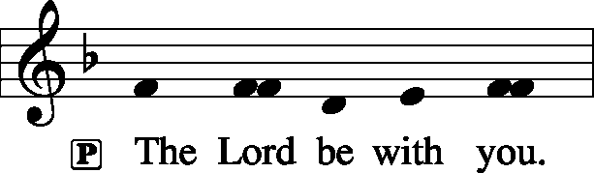 2 Timothy 4: 22
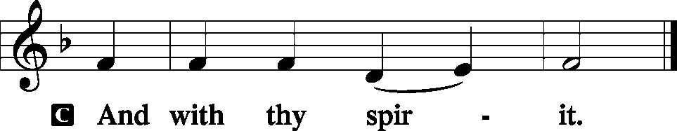

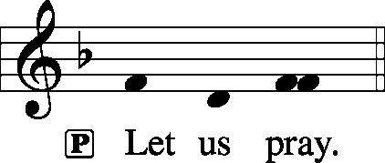

P O God, in the glorious transfiguration of Your beloved Son You confirmed the mysteries of the faith by the testimony of Moses and Elijah. In the voice that came from the bright cloud You wonderfully foreshowed our adoption by grace. Mercifully make us co-heirs with the King in His glory and bring us to the fullness of our inheritance in heaven; through the same Jesus Christ, our Lord, who lives and reigns with You and the Holy Spirit, one God, now and forever.

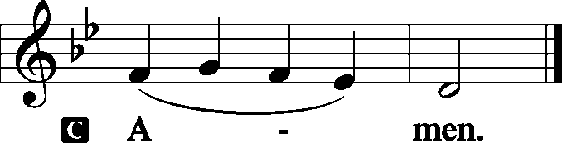

Sit

Old Testament Reading: Exodus 34:29–35
When Moses came down from Mount Sinai, with the two tablets of the testimony in his hand as he came down from the mountain, Moses did not know that the skin of his face shone because he had been talking with God. Aaron and all the people of Israel saw Moses, and behold, the skin of his face shone, and they were afraid to come near him. But Moses called to them, and Aaron and all the leaders of the congregation returned to him, and Moses talked with them. Afterward all the people of Israel came near, and he commanded them all that the Lord had spoken with him in Mount Sinai. And when Moses had finished speaking with them, he put a veil over his face.
Whenever Moses went in before the Lord to speak with him, he would remove the veil, until he came out. And when he came out and told the people of Israel what he was commanded, the people of Israel would see the face of Moses, that the skin of Moses’ face was shining. And Moses would put the veil over his face again, until he went in to speak with him.

P This is the Word of the Lord.
C Thanks be to God.

Gradual: Ps. 45:2a; 110:1
You are the most handsome of the sons of men;
grace is poured upon your lips.
The Lord says to my Lord: “Sit at my right hand,
until I make your enemies your footstool.”
Epistle: 2 Peter 1:16–21
For we did not follow cleverly devised myths when we made known to you the power and coming of our Lord Jesus Christ, but we were eyewitnesses of his majesty. For when he received honor and glory from God the Father, and the voice was borne to him by the Majestic Glory, “This is my beloved Son, with whom I am well pleased,” we ourselves heard this very voice borne from heaven, for we were with him on the holy mountain. And we have something more sure, the prophetic word, to which you will do well to pay attention as to a lamp shining in a dark place, until the day dawns and the morning star rises in your hearts, knowing this first of all, that no prophecy of Scripture comes from someone’s own interpretation. For no prophecy was ever produced by the will of man, but men spoke from God as they were carried along by the Holy Spirit.

P This is the Word of the Lord.
C Thanks be to God.

Stand
Alleluia Verse and Alleluia
P Alleluia. Sing to the Lord; tell of his salvation from day to day. Declare his glory among the nations, his marvelous works among all the peoples! Alleluia.
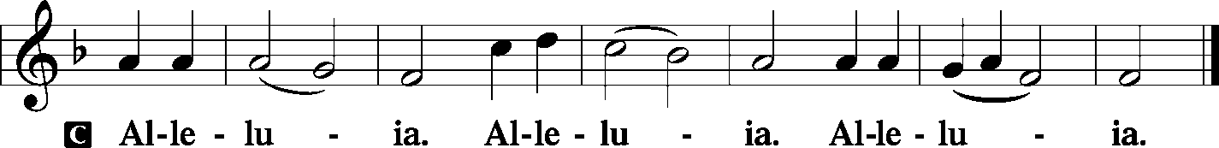

Holy Gospel: Matthew 17:1–9
P The Holy Gospel according to St. Matthew, the seventeenth chapter.
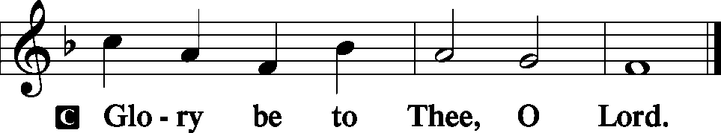

And after six days Jesus took with him Peter and James, and John his brother, and led them up a high mountain by themselves. And he was transfigured before them, and his face shone like the sun, and his clothes became white as light. And behold, there appeared to them Moses and Elijah, talking with him. And Peter said to Jesus, “Lord, it is good that we are here. If you wish, I will make three tents here, one for you and one for Moses and one for Elijah.” He was still speaking when, behold, a bright cloud overshadowed them, and a voice from the cloud said, “This is my beloved Son, with whom I am well pleased; listen to him.” When the disciples heard this, they fell on their faces and were terrified. But Jesus came and touched them, saying, “Rise, and have no fear.” And when they lifted up their eyes, they saw no one but Jesus only.
And as they were coming down the mountain, Jesus commanded them, “Tell no one the vision, until the Son of Man is raised from the dead.”

P This is the Gospel of the Lord.
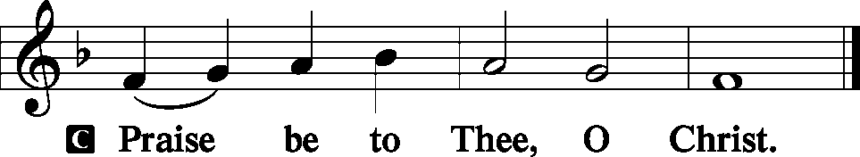

Nicene Creed
C I believe in one God,
the Father Almighty,
maker of heaven and earth
and of all things visible and invisible.
And in one Lord Jesus Christ,
the only-begotten Son of God,
begotten of His Father before all worlds,
God of God, Light of Light,
very God of very God,
begotten, not made,
being of one substance with the Father,
by whom all things were made;
who for us men and for our salvation came down from heaven
and was incarnate by the Holy Spirit of the virgin Mary
and was made man;
and was crucified also for us under Pontius Pilate.
He suffered and was buried.

And the third day He rose again according to the Scriptures
and ascended into heaven
and sits at the right hand of the Father.
And He will come again with glory to judge both the living and the dead,
whose kingdom will have no end.
And I believe in the Holy Spirit,
the Lord and giver of life,
who proceeds from the Father and the Son,
who with the Father and the Son together is worshiped and glorified,
who spoke by the prophets.
And I believe in one holy Christian and apostolic Church,
I acknowledge one Baptism for the remission of sins,
and I look for the resurrection of the dead
and the life T of the world to come. Amen.
Sit

Hymn of the Day: LSB #395 “O Morning Star, How Fair and Bright”

Sermon
Stand

P The peace of God, which passes all understanding, keep your hearts and minds in Christ Jesus. Philippians 4: 7
C Amen.

Recognition of Service

Prayer of the Church [Timothy 2: 1-4]
Sit

Offertory Psalm 51: 10-12
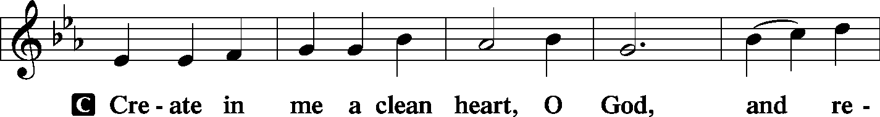
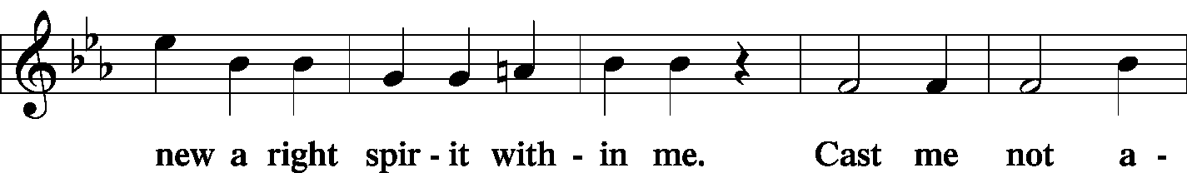
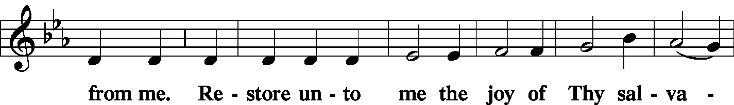
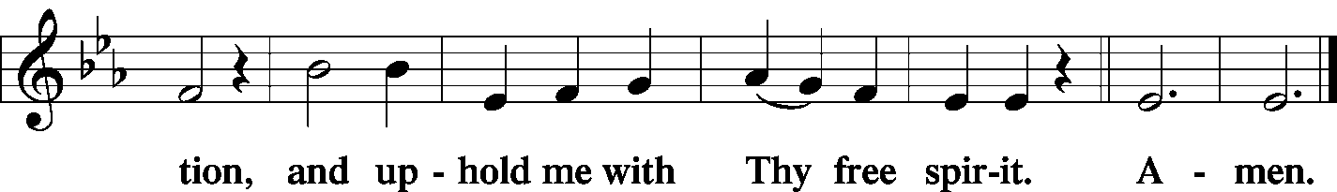

Offering Hymn: LSB #904 “Blessed Jesus, at Your Word”
Stand
SERVICE OF THE SACRAMENT
Preface
2 Timothy 4: 22
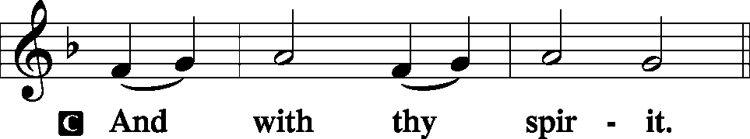
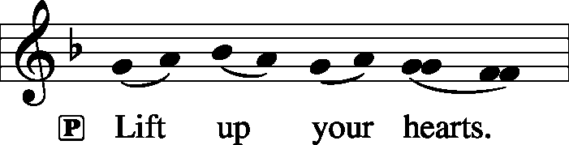 [Colossians 3:1]

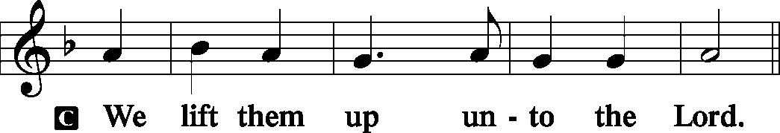

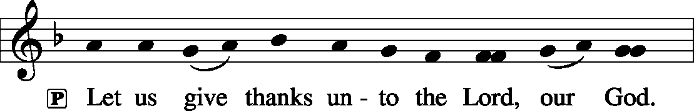 [Psalm 136]

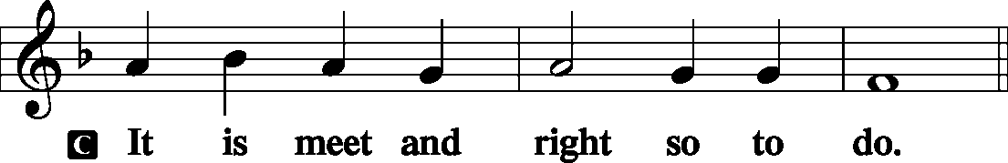

P It is truly meet, right, and salutary . . . evermore praising You and saying:

Sanctus Isaiah 6: 3; Matthew 21: 9
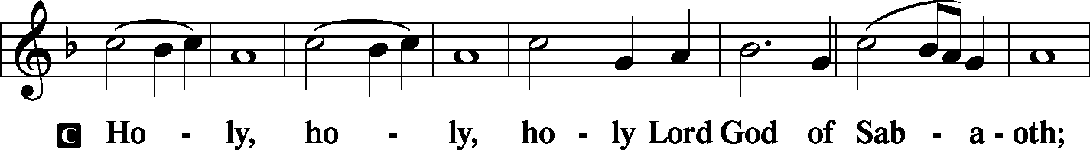
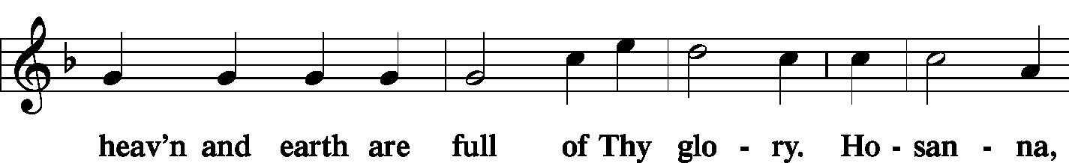
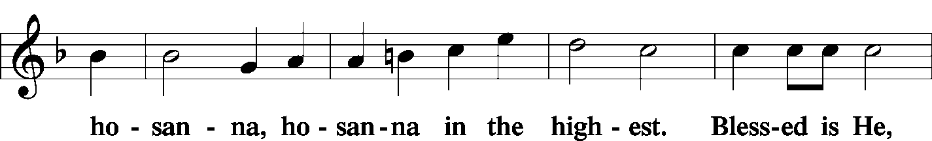
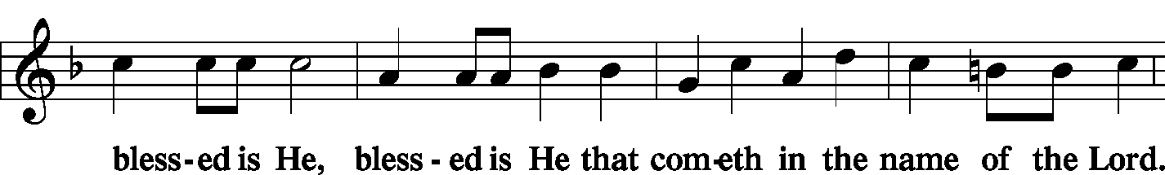
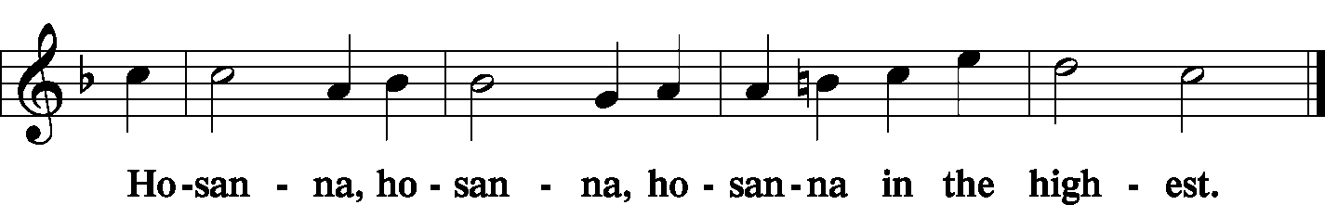

Lord's Prayer Matthew 6: 9-13
P Lord, remember us in Your kingdom and teach us to pray:
C Our Father who art in heaven,
hallowed be Thy name,
Thy kingdom come,
Thy will be done on earth as it is in heaven;
give us this day our daily bread;
and forgive us our trespasses as we forgive those who trespass against us;
and lead us not into temptation,
but deliver us from evil.
For Thine is the kingdom and the power and the glory forever and ever. Amen.

The Words of Our Lord Matthew 26: 26-28; Mark 14: 22-24
Luke 22: 19-20; 1 Corinthians 11: 23-25
P Our Lord Jesus Christ, on the night when He was betrayed, took bread, and when He had given thanks, He broke it and gave it to the disciples and said: “Take, eat; this is My T body, which is given for you. This do in remembrance of Me.”

P In the same way also He took the cup after supper, and when He had given thanks, He gave it to them, saying: “Drink of it, all of you; this cup is the new testament in My T blood, which is shed for you for the forgiveness of sins. This do, as often as you drink it, in remembrance of Me.”

Pax Domini John 20: 19
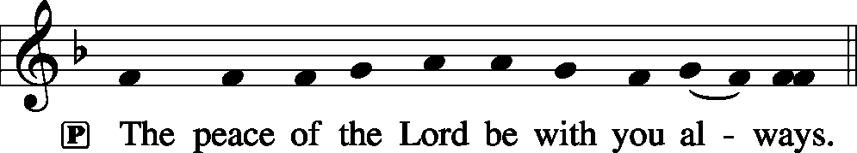
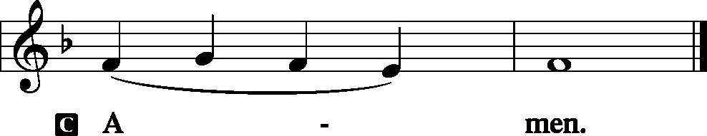

Agnus Dei John 1: 29
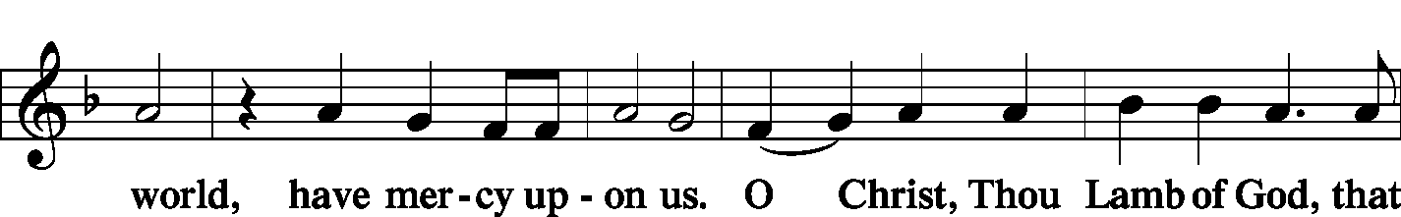
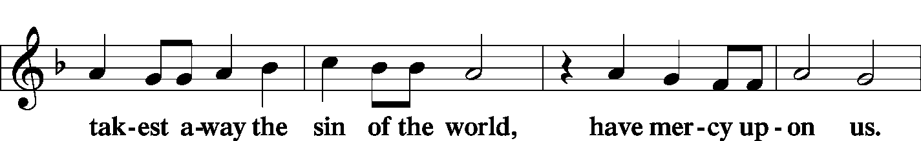
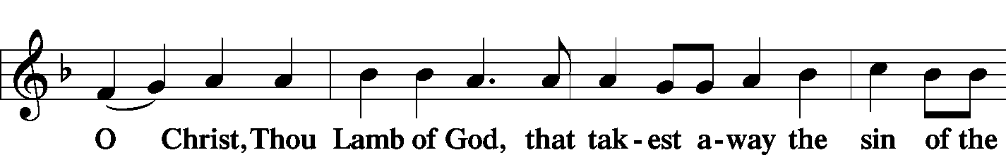
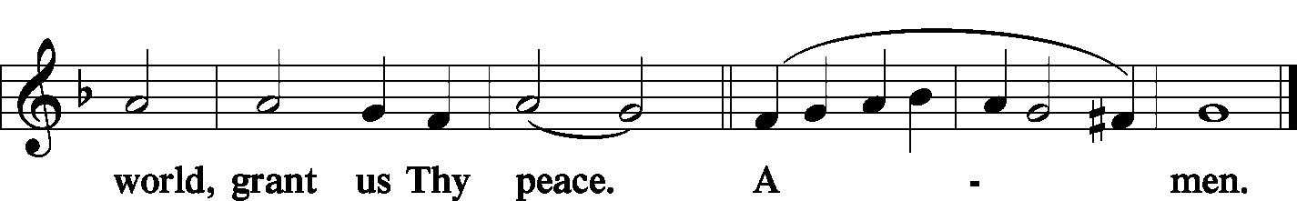
Sit

Distribution
The pastor and those who assist him receive the body and blood of Christ first and then distribute them to those who come to receive, saying:

Take, eat; this is the true body of our Lord and Savior Jesus Christ, given into death for your sins.
Amen.

Take, drink; this is the true blood of our Lord and Savior Jesus Christ, shed for the forgiveness of your sins.
Amen.

In dismissing the communicants, the following is said:
P The body and blood of our Lord Jesus Christ strengthen and preserve you in body and soul to life everlasting. Depart T in peace.
C Amen.

Distribution Hymn: LSB #549 “All Hail the Power of Jesus' Name”
Distribution Hymn: LSB #641 “You Satisfy the Hungry Heart”
Stand

Post-Communion Canticle: Nunc Dimittis Luke 2: 29-32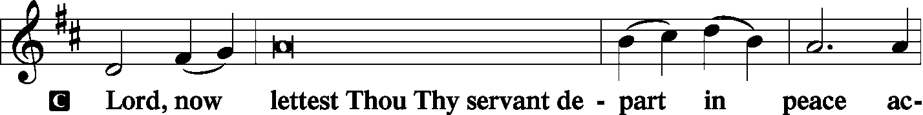
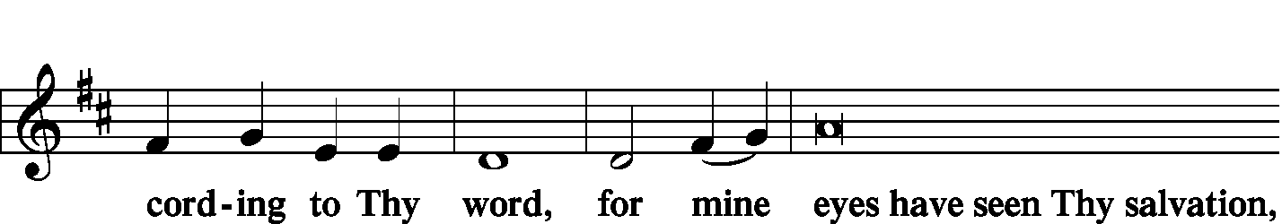
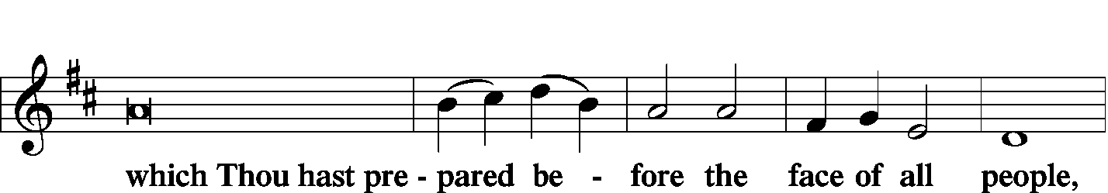
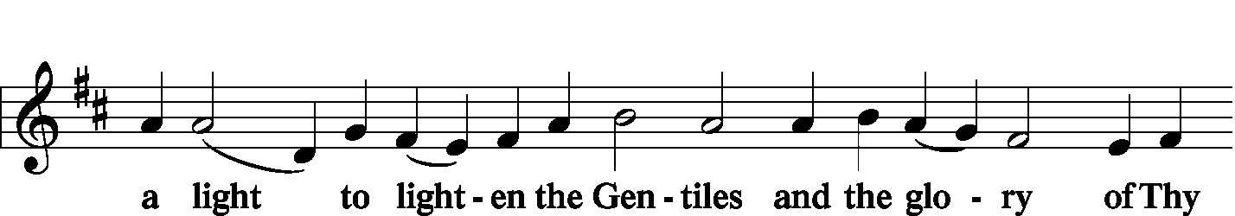
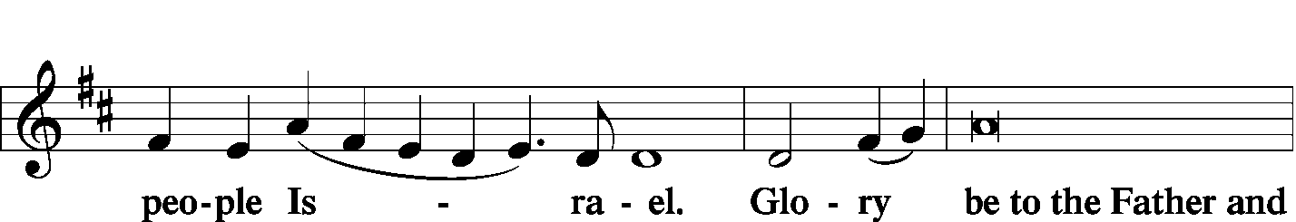
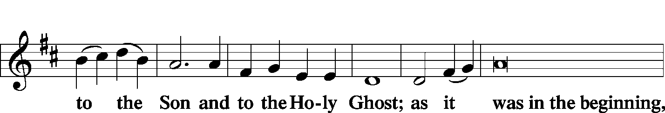
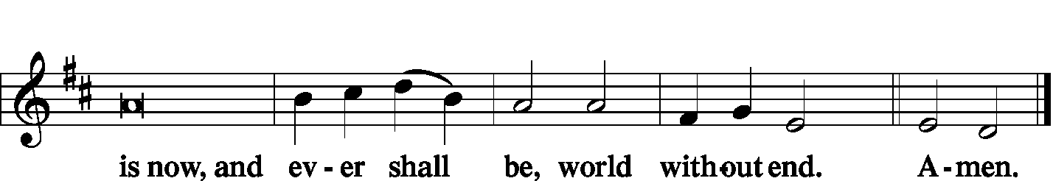

Thanksgiving Psalm 107: 1
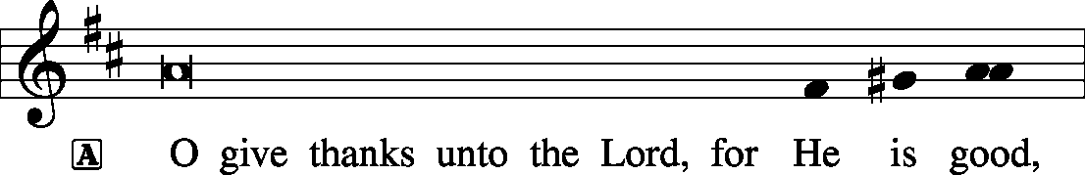
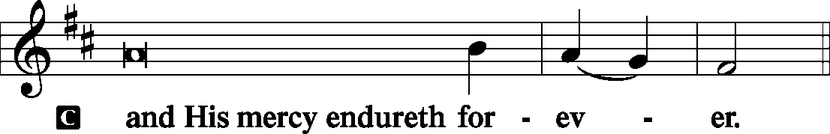

P Let us pray.
We give thanks to You, almighty God, that You have refreshed us through this salutary gift, and we implore You that of Your mercy You would strengthen us through the same in faith toward You and fervent love toward one another; through Jesus Christ, Your Son, our Lord, who lives and reigns with You and the Holy Spirit, one God, now and forever.
Salutation and Benedicamus
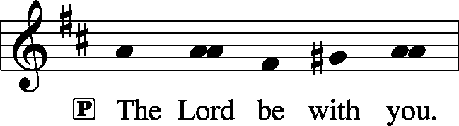 2 Timothy 4: 22

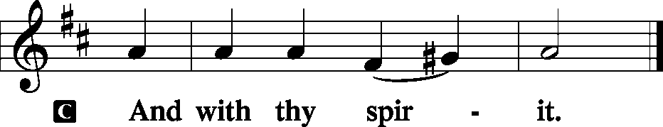
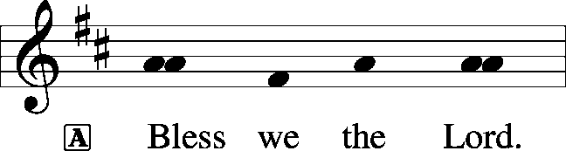 [Psalm 103: 1]

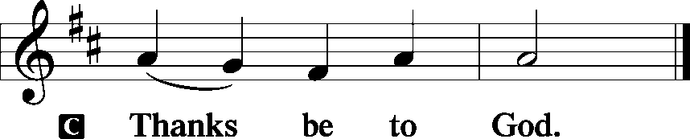

Benediction Numbers 6: 24-26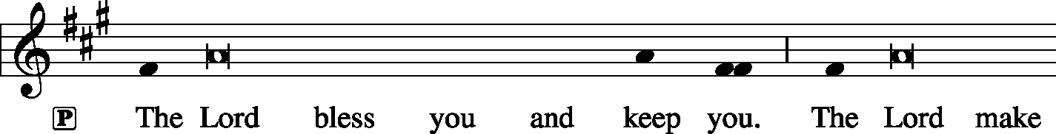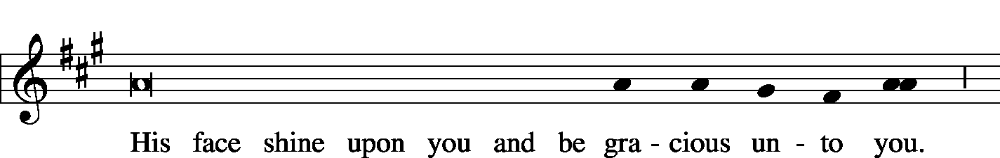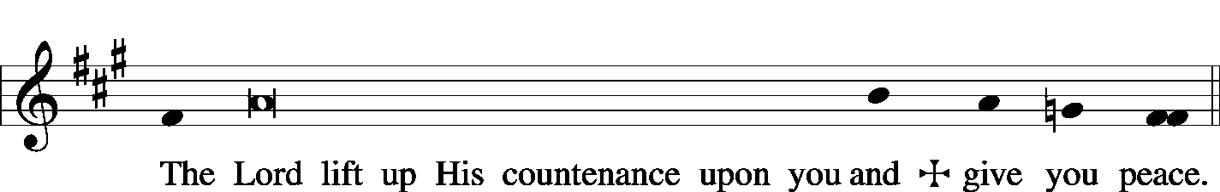

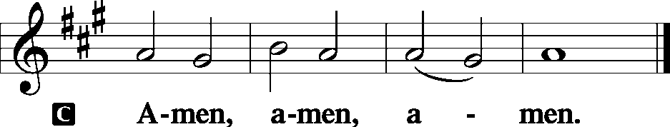

Closing Hymn: LSB #525 “Crown Him with Many Crowns”
Silent prayer after worship: Almighty God, on the mountain You showed Your glory in the transfiguration of Your Son, Jesus. Cause my faith to shine within my heart and to shine forth in my life through my words and actions. In Jesus’ name. Amen.

Acknowledgments: Divine Service, Setting Three from Lutheran Service Book Unless otherwise indicated, all scripture quotations are from The Holy Bible, English Standard Version, copyright © 2001 by Crossway Bibles, a division of Good News Publishers. Used by permission. All rights reserved. Created by Lutheran Service Builder © 2006 Concordia Publishing House. CCLI License #3029-446

Word of Hope: 1-888-217-8679
The only 24/7 CONFIDENTIAL Hotline that is distinctly Lutheran, bringing healing found in Christ, to those whose hearts have been broken by abortion.


In Sympathy to Matt & Cathy Berent on the passing of John Berent, Matt’s father: Joan Rice (missions) .

Bible Memory Verses: For the week of February 10th
For Children: God, who said, “Let light shine out of darkness,” has shone in our hearts to give the light of the knowledge of the glory of God in the face of Jesus Christ.
2 Cor. 4:6
For Adults: I have been crucified with Christ. It is no longer I who live, but Christ who lives in me. And the life I now live in the flesh I live by faith in the Son of God, who loved me and gave himself for me. Galatians 2:20

Attendance:
Sunday, February 3, & Wednesday, February 6, 2019………………...………63.

Our Stewardship of Treasures for the Lord:
In order to do the Lord’s work, we need $2,882.02* each week to meet our 2019 budget for general purposes and $99.00 for missions.
Sunday, February 3, and Wednesday, January 30, 2018:
General Offering:…..…..……….............................................................$2,355.00
Behind this week*: -$317.02
SELC Missions:……….………..…..…….......................................................$115.00
Ahead this week: +$16.00
Preschool Tuition Payments:...…………………..............................…...…..$210.00
Other Offerings:………….…….…….....................………..……..…..….……$70.00
*Includes preschool tuition

Our 1st Quarter Local Mission is
Shenango Valley Meals on Wheels!
Although monetary donations are always appreciated, there are other ways to assist this organization as well. They are always looking for home-made desserts to share with their patrons, including diabetic-friendly treats. Items may be dropped off between 8:30-9 am at Christ Lutheran Church, 396 Buhl Blvd., Sharon, PA.

Additional copies of LCMS President Matthew Harrison’s statement regarding gubernatorial actions expanding abortion in New York and Illinois are available in the narthex. Feel free to take a copy to share.
SCHEDULE FOR TODAY THROUGH FEB. 17th:
:

:

Today, following Worship.............................................Coffee & Donuts Fellowship
7 pm, Downstairs….…………………..….….…………………………..…..……AA Meeting
Tuesday, 9 am…………………………………………………………………………Church Work Day
Wednesday, 7 pm, Chapel…………..……………………………………Divine Worship Service
Thursday, 9 am.………………………………………………………………………..……….Food Pantry
Next Sunday, 8:45 am, Downstairs…………………………………….………..……….Bible Study
10 am, Sanctuary….......................................................................Divine Service
After Worship……………………………….……….…………Voters’ Assembly Meeting
7 pm, Downstairs………………………………………………………..…....……AA Meeting

The Altar Flowers this morning are given anonymously to the Glory of God. We sincerely appreciation this generous gift.

Thank You for Serving in February:
Today’s Greeters: Anson & Henrietta Holcroft. Assisting Elders: Barry Nelson & John Dyll. Ushers: Ralph Dorman, Jonathan Baisch, Matt Berent, Mark Gabriel, and John Dyll (alternate). Altarware: Clara Krivosh & Cheryl Fedele.
February Greeters: 17~ Dolores Fee & Diane Riefstahl, and 24~Jeff & Stacy Brandes.

Available in the narthex:
- February issues of “The Rock and the Sword” newsletter and “The Lutheran Beacon”.
- Minutes from the February 4th meeting of Church Council.
- The Winter 2019 edition of “Lutherans Engage” magazine.
- 2019 offering envelopes.

Happy Valentine’s Day February 14th! Remember that the greatest gift of love ever given was Christ’s sacrifice for you on the cross. Thanks be to God.
Remember the following in Prayer…
~The Hurting and Healing: Tony², Lois Bortner^{CA}, Richard Brandes¹, Eileen Burns¹, Loretta Deal², Norma Ferringer², Anson Holcroft², Betty Knauff^{CA}, Regis Knauff³, Jess Lavoie⁴, Paul Lucas^{CA}, Barry Nelson³, David Nelson³,Tom Mulligan^{CA}, Iona Oltman^{CA}, Rudy Pinal^{CA}, Richard Reuning^{CA}, Viola Sakony⁴, Scott^{CA}, and Angela Weser^{CA}.
~Celebrating: Birthday~ Julie Zachar (02.14). Anniversary~ Joseph & Beverly Chlpka (02.10).
~Our Homebound: Helen Bender, Dan Davis, Edna Krajci, Mary Ann Krajci, Sophie Mihm, Marion & Gene Roberts, Barbara Vasconi, and Joanne Wolfe.
~Serving in the Military: Clayton Drnek, Curtis Sinewe, and Joshua Solyan.
~Community & World Needs: Victims of violence and terrorism; those suffering from loss and dislocation because weather disasters; those suffering from addiction and their families; safety for teachers, staff, and students; Local, State, and National Government Leaders; Safety for all Police Officers, Firefighters, & First Responders; the unemployed; our First Quarter Local Mission: Shenango Valley Meals on Wheels.
*CA represents cancer; number after other names represents weeks on the prayer list. After 4 weeks names may be resubmitted. This helps us to remember people’s specific needs and reminds us that God is providing healing as people get better and no longer need our prayers. Please submit prayer requests in writing to the church office.
Please keep those listed above in your prayers.

Annual Spiritual Fellowship Retreat
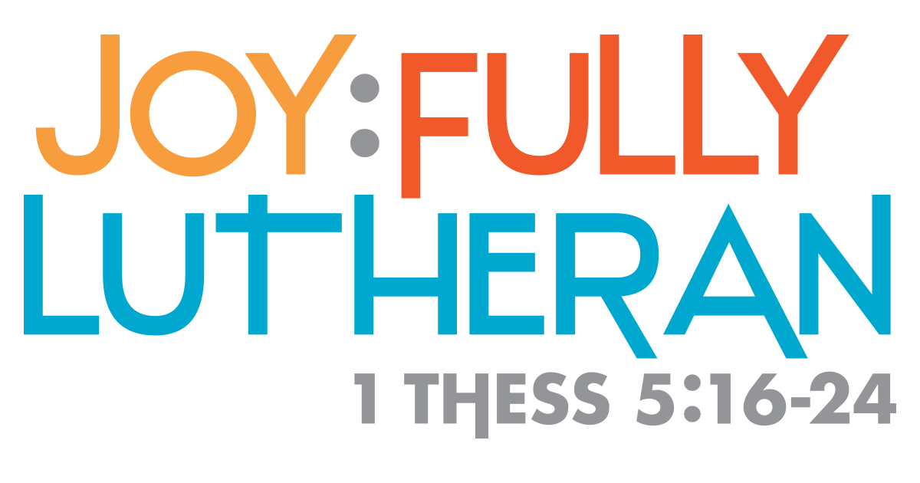
When we are fully Lutheran,
we are full of joy!
Date: Saturday, March 2rd, 2019
Time: 9 am – 3:30pm
Location: Dutch Valley Restaurant
Sugarcreek, Ohio
Deadline for Registration: Sunday, February 24th
For more information please call St John Lutheran Church at 330-837-4645
Here to Serve…

Pastor………………………………………………….………..…Rev. Jacob Deal
E-mail ……….…………………….…..pastordeal@saintspeterandpaul.net
Phone Number…………..……………………………724-347-3620 (Option 2)
Church Office………………………………….………724-347-3620 (Option 3)
Website ……….………………….……...…….www.saintspeterandpaul.net
Secretary………………………………………………….……. Diane Riefstahl
E-mail ……….…………………….…….…church@saintspeterandpaul.net
Food Pantry: John Dyll…………….……………………..…..…724-347-1779
Little People Preschool…………….……………….724-347-3620 (Option 4)
Teacher: Paula Ostheimer………….………………….…….....724-981-5846
Email ……….………….…………………….paula@saintspeterandpaul.net
AA Contact: Steve……………………….…………..……...……. 724-813-2358
Organist……………………………………………………..…Carrie Yasnowski
Choir Director……………..…………….…………..….….………Chris Nelson
Congregation President…………………………………………Jeff Brandes

The secretary’s office hours will be Monday and Thursday (8:30-4:30). Pastor Deal will be in the office Monday through Thursday unless ministering off-site. If you need to enter the Church, please call ahead to be sure someone is here to let you in. Thank you.

